• Volume 48 • https://doi.org/10.33321/cdi.2024.48.48 • Electronic publication date: 21/08/2024

Age of hepatitis B e antigen loss in Aboriginal, Torres Strait Islander and non-Indigenous residents of tropical Australia; implications for clinical care

Liana Neldner, Sharna Radlof, Simon Smith, Margaret Littlejohn, Allison Hempenstall, Josh Hanson

# Abstract

This study determined the hepatitis B e antigen (HBeAg) status of people living with chronic hepatitis B (CHB) in Far North Queensland (FNQ), Australia and their age of HBeAg loss. It was hoped that this would provide data to explain the stark difference in the incidence of hepatocellular carcinoma (HCC) between Aboriginal and Torres Strait Islander individuals living with CHB in FNQ, a finding that has been hypothesised to relate to differences in hepatitis B virus genotype. We identified every FNQ resident with CHB, determined their country of birth, their HBeAg status, the age they lost HBeAg and whether they identified as an Aboriginal, a Torres Strait Islander or a non-Indigenous individual. We then ascertained whether these demographic and virological variables were correlated. Of 1,474 individuals living with CHB in FNQ, 278 (19%) were Aboriginal, 507 (34%) were Torres Strait Islanders and 689 (47%) were non-Indigenous. Aboriginal individuals were less likely to be HBeAg positive (26/278, 9%) than Torres Strait Islander (91/507, 18%) and non-Indigenous (126/689, 18%) individuals, *p* < 0.0001. Aboriginal individuals lost HBeAg at an earlier age (median (interquartile range): 30 (23–39) years) than Torres Strait Islander (38 (29–49) years) and non-Indigenous (36 (29–47) years) individuals, *p* < 0.0001. Aboriginal individuals with CHB in FNQ are more likely to be HBeAg negative than Torres Strait Islander and non-Indigenous individuals and lose HBeAg at a younger age. This provides a biological basis for local clinicians’ observation that Aboriginal individuals with CHB in FNQ are at a lower risk of HCC and data to support the principle of genotype-based care in the region.

Keywords: Hepatitis B virus; HBeAg; hepatocellular carcinoma; hepatitis B genotype; Indigenous health; rural and remote health

# Introduction

The prevalence of chronic hepatitis B (CHB) among Aboriginal and Torres Strait Islander Australians is almost five times that seen in non-Indigenous Australians, and this contributes to a significantly greater burden of liver disease.1,2 In the Northern Territory, where greater than 5% of Aboriginal Australians living in remote communities have CHB, the incidence of hepatocellular carcinoma (HCC) is almost six times greater in the Aboriginal population than the non-Indigenous population.1,3,4 These data provide the basis for national recommendations that suggest that all Aboriginal and Torres Strait Islander Australians living with CHB receive biannual ultrasound surveillance for HCC from 50 years of age.5

However, there are significant regional differences in the incidence of CHB-related HCC in Aboriginal and Torres Strait Islander Australians that may influence the cost-effectiveness of these national recommendations. In Far North Queensland (FNQ), a region where approximately 17% of the population of almost 290,000 identify as an Aboriginal or Torres Strait Islander Australian, HCC has been diagnosed in only a single Aboriginal individual with CHB in this century. This is despite a community prevalence of CHB of greater than 2% in some Aboriginal communities and a significant burden of comorbidities that increases HCC risk.6,7 In contrast, Torres Strait Islander Australians living with CHB in the region continue to be diagnosed regularly with HCC.6,7 This is unlikely to be explained by access to care, as the rate of engagement in CHB care across the FNQ region is one of the highest in the country.1,6,8 Instead, it is hypothesised that the striking difference in the incidence of CHB-related HCC between Aboriginal and Torres Strait Islander Australians in FNQ is explained by differences in hepatitis B virus (HBV) genotype between the two populations.7

The hepatitis B virus can be classified into at least ten genotypes (A–J), with genotypes A, B, C, D and F divided further into sub-genotypes.9 There is significant heterogeneity in the prevailing HBV genotypes in different populations, and this partly explains the geographical variation in the incidence of HCC and cirrhosis in people living with CHB.10,11 Individuals with an HBV/C genotype infection, for instance, tend to have high levels of HBV DNA for longer, delayed hepatitis B e antigen (HBeAg) seroconversion, a longer period of immune clearance and greater likelihood of HBeAg reversion which all increase the risk of cirrhosis and HCC.10,12–14

Aboriginal Australians in the Northern Territory universally have an HBV/C4 genotype, and this is believed, at least partly, to explain the high local incidence of cirrhosis and HCC.15,16 Torres Strait Islander Australians with CHB also have high rates of cirrhosis and HCC, and in one FNQ study every Torres Strait Islander individual in whom genotype could be determined had an HBV/C genotype infection. However, in contrast, there were no cases of cirrhosis or HCC in Aboriginal Australians with CHB in this FNQ study, 80% of whom had an infection with the less oncogenic HBV/D genotype.7 Despite the potential impact of genotype on the clinical phenotype of CHB, current Australian guidelines do not yet suggest any role for HBV genotype in guiding clinical decision making.5,10,17

In populations where few patients have had their HBV genotype status determined, the age of HBeAg loss may act as a proxy for genotype, with studies demonstrating that individuals with an HBV/C genotype lose HBeAg later in life than individuals with an HBV/B and HBV/D genotype.7,10,18 We therefore conducted a retrospective cohort study looking at the age of HBeAg loss in people living with CHB in FNQ. We hypothesised that, within this population, Aboriginal Australians with CHB—who we have identified to have a higher rate of HBV/D infection—would lose HBeAg at an earlier age than would Torres Strait Islander Australians, who are more likely to have an HBV/C genotype.6,7 We also examined the age of HBeAg loss of non-Indigenous individuals with CHB. As HBV/C is also the most common HBV genotype in the Asia Pacific region—the most common origin of migrants to the region—we hypothesised that the age of HBeAg loss among non-Indigenous individuals would most resemble the age of HBeAg loss of the Torres Strait Islander individuals.19,20

# Methods

Hepatitis B is a notifiable disease in Queensland. Public and private laboratories report all positive HBsAg and HBV DNA results to the state’s Notifiable Conditions System (NOCS) database. The FNQ HBV clinical database was constructed using NOCS data to identify every FNQ resident diagnosed with CHB (defined as two positive HBsAg tests at least 6 months apart) since 1990. This retrospective study used the FNQ HBV clinical database to identify all individuals in FNQ with confirmed CHB.

The age and country of birth of all eligible individuals was recorded, as was their identification as an Aboriginal or Torres Strait Islander Australian; individuals were categorised as Aboriginal, Torres Strait Islander, both Aboriginal and Torres Strait Islander, or non-Indigenous. Previous analysis of the prevailing genotypes in the region has demonstrated a marked similarity between the HBV genotypes of individuals identifying as Torres Strait Islanders and those identifying as both Aboriginal and Torres Strait Islander.7 Accordingly, for the purposes of the primary analysis, the individuals identifying as both Aboriginal and Torres Strait Islander Australians were designated as having Torres Strait Islander heritage.

Sequential HBeAg results until 31 August 2023 were reviewed for all individuals with blood collected in both the public and private health system. The individuals’ age at the end of the study period was recorded, as was their most recent HBeAg result. The earliest age after which HBeAg was negative without a subsequent positive HBeAg was identified. A ‘borderline’ HBeAg result was considered negative, and a ‘weak positive’ result was considered positive.

It is a statutory requirement in Queensland for all hospitals, nursing homes and pathology services to notify a cancer diagnosis to the Queensland Cancer Registry. The Queensland Cancer Registry provided the demographic details of all individuals diagnosed with HCC in the FNQ region between 1 January 2000 and 31 December 2021. The HBV serology results of these individuals at the time of HCC diagnosis were determined by examining public and private laboratory records. If the individual was identified as also having CHB, their country of birth and the age of diagnosis of the HCC was recorded.

Data were entered into an electronic database and analysed with statistical software (Stata version 14.2). Groups were compared using Wilcoxon’s rank sum test, Student’s t test, the chi-squared or Fisher’s exact test as appropriate. Kaplan-Meier curves were constructed to present the age of HBeAg loss graphically.

The study was approved by the FNQ Human Research Ethics Committee (HREC/16/QCH/109 and HREC/15/QCH/96). Given the retrospective, de-identified and aggregated nature of the data, the committee waived the requirement for informed consent.

# Results

There were 1,477 individuals who satisfied the inclusion criteria for the study: three of these individuals were missing demographic data, leaving 1,474 individuals that were included in the analysis (Figure 1). The majority (785/1,474; 53%) identified as Aboriginal or Torres Strait Islander Australians; 81/785 (10%) identified as both Aboriginal and Torres Strait Islander individuals. Of the 689 non-Indigenous individuals, 543 were born overseas with 237 (44%) born in Asia and 193 (36%) born in Papua New Guinea. The predominant countries where these 543 individuals were born, and the most common HBV genotypes reported in those countries, are presented in Table 1.

Figure 1: Consort diagram showing individuals living in FNQ with CHB, their Aboriginal and Torres Strait Islander status, and their most recent HBeAg statusa

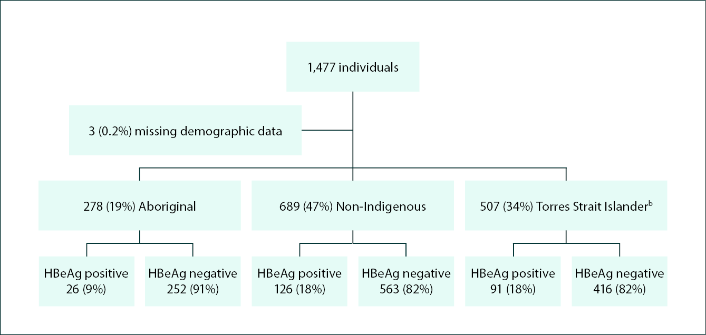

a FNQ: Far North Queensland; CHB: chronic hepatitis B; HBeAg: hepatitis B e antigen.

b Includes those identifying as both Aboriginal and Torres Strait Islander.

Table 1: Countries of birth of those individuals (n = 543) born overseas, with the prevailing HBV genotypes in their country of birth, as reported in the literaturea

| Country of birth | Number of cohort (%)b | Genotypes reported in country | | Reference |
| --- | --- | --- | --- | --- |
| Most common | Less commonc |
| Papua New Guinea | 193 (13.0%) | C (89%) | D (11%) | 19 |
| Philippines | 46 (3.1%) | A (51%) | C (27%), B (22%) | 21 |
| Thailand | 33 (2.2%) | C (73%) | B (21%), A (3%), other (3%) | 22 |
| C (72%) | B (25%), D (3%) B (11%) | 23 |
| C (88%) | B (11%) | 24 |
| China | 33 (2.2%) | C (51%), B (41%) | D (1%), A (1%), other (6%) | 19 |
| New Zealand | 31 (2.1%) | D (86%) | C (14%) | 19 |
| Laos | 26 (1.8%) | C (71%) | B (26%) | 25 |
| Taiwan | 17 (1.2%) | B (63%) | C (33%), other (3%) | 26 |
| Indonesia | 15 (1.0%) | B (66%) | C (26%), D (7%), A (1%) | 27 |
| B (71%) | C (28%), D (2%) | 28 |
| Myanmar | 14 (0.9%) | C (100%) | — | 29 |
| C (98%) | B (1%) | 25 |
| Vietnam | 11 (0.7%) | B (75%) | C (19%), other (5%) | 19 |
| B (65%) | C (31%), other (3%) | 30 |
| Other | 124 (8.4%) | — | — | — |

a The only countries presented are those with > 10 individuals within the entire cohort.

b Proportion of entire cohort (N = 1,477).

c ‘Other’: genotype other than A–D, mixed infection with two genotypes or recombinants.

The Aboriginal Australians within the cohort were, on average, younger than the Torres Strait Islander individuals (Table 2); but despite their younger age, Aboriginal Australians were more likely to be HBeAg negative and lost HBeAg at a younger age (median [interquartile range (IQR)]: 30 [23–39] years versus 38 [29–49] years, *p* < 0.0001). The Aboriginal Australians within the cohort were also both younger and more likely to be HBeAg negative than the non-Indigenous individuals; again, the Aboriginal Australians also lost HBeAg at a younger age (median [IQR]: 30 [23–39] years versus 36 [29–47] years, *p* < 0.0001). In contrast, there was no significant difference in the age of Torres Strait Islander and non-Indigenous individuals at the end of the study, in the respective proportions that were HBeAg negative, and in the respective ages of their HBeAg loss (Table 2 and Figure 2).

A smaller proportion of individuals who identified as both Aboriginal and Torres Strait Islander individuals were HBeAg positive than were individuals who identified only as Torres Strait Islander Australians, although this difference did not meet statistical significance (10/81, 12% versus 81/426, 19%; *p* = 0.15). Individuals who identified as both Aboriginal and Torres Strait Islander lost their HBeAg earlier than individuals who identified only as Torres Strait Islanders (median age [IQR]: 36 [26–44] years versus 42 [39–44] years; *p* = 0.02), but later than Aboriginal Australians (*p* = 0.005) (Appendix A, Table A.1 and Figure A.1). At the end of the study, the mean age of the 193 individuals born in Papua New Guinea was 45 years (95% confidence interval: 44–47 years) and yet 45/193 (23%) were still HBeAg positive; the median age of HBeAg loss in individuals born in Papua New Guinea was 34 years (IQR: 25–44 years).

Table 2: HBeAg positivity prevalence and median age of HBeAga loss in Aboriginal, non-Indigenous and Torres Strait Islander individuals

| Property | Aboriginal n = 278 | non-Indigenous n = 689 | Torres Strait Islanderb n = 507 | Comparison, within cohort, between | | |
| --- | --- | --- | --- | --- | --- | --- |
| Aboriginal vs. Torres Strait Islander | Aboriginal vs. non-Indigenous | Torres Strait Islander vs. non-Indigenous |
| Mean age, years (95% CI)c,d | 44.3 (43.0–45.6) | 48.4 (47.3–49.4) | 49.4 (48.1–50.6) | *p* < 0.0001 | *p* < 0.0001 | *p* = 0.21 |
| Number HBeAg positive (%)d | 26 (9%) | 126 (18%) | 91 (18%) | *p* < 0.0001 | *p* < 0.0001 | *p* = 0.88 |
| Median age at HBeAg loss, years (IQR)e | 30 (23–39) | 36 (29–47) | 38 (29–49) | *p* < 0.0001 | *p* < 0.0001 | *p* = 0.28 |

a HBeAg: hepatitis B e antigen.

b Includes those identifying as both Aboriginal and Torres Strait Islander Australian.

c 95% CI: 95% confidence interval.

d At the end of the study period.

e IQR: interquartile range.

Figure 2: Kaplan Meier curve demonstrating the HBeAg loss over time, stratified by Aboriginal,  
Non-Indigenous and Torres Strait Islander statusa,b

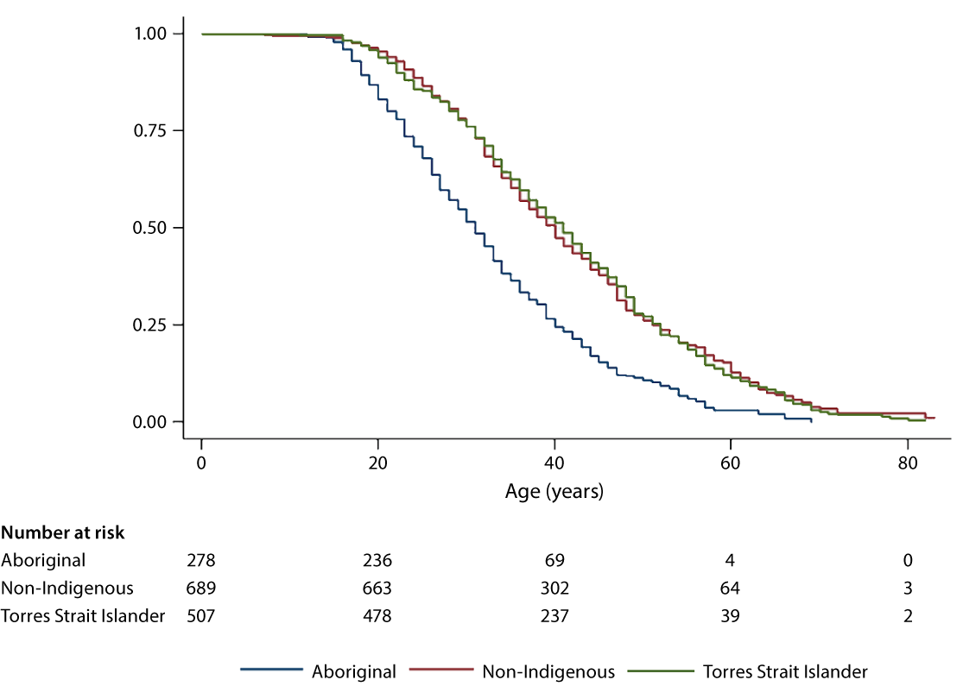

a HBeAg: hepatitis B e antigen.

b As noted in text, ‘Torres Strait Islander’ here includes those identifying as both Aboriginal and Torres Strait Islander.

There were 346 diagnoses of HCC in FNQ residents that were reported to the Queensland Cancer Registry in the study period; 260/346 (75%) had accessible HBV serology results. There were 40/260 (15%) who were HBsAg positive at the time of their diagnosis (Table 3). Aboriginal individuals diagnosed with HCC were less likely to be HBsAg positive than Torres Strait Islander individuals diagnosed with HCC (1/32, 3% versus 22/32, 69%; *p* < 0.0001) and overseas born individuals diagnosed with HCC (1/32, 3% versus 14/72, 19%; *p* = 0.03). There was no significant difference in the proportion of Aboriginal individuals and Australian born non-Indigenous individuals diagnosed with HCC who were HBsAg positive (1/32, 3% versus 3/121, 2%; *p* = 1.0). The sole Aboriginal individual diagnosed with HCC who was HBsAg positive also had cirrhosis; had ongoing hazardous alcohol use; and lived in a community where Aboriginal Australians have universally been diagnosed with HBV/C4 genotype infections.7

Table 3: Number and proportion of all hepatocellular carcinoma (HCC) diagnosed in individuals living with chronic hepatitis B (CHB) in Far North Queensland, 2000-2021, stratified by Aboriginal and Torres Strait Islander status and country of birth

| Categorya | All | Aboriginal | Non-Indigenous born in Australia | Non-Indigenous born overseas | Torres Strait Islanderb |
| --- | --- | --- | --- | --- | --- |
| Number (%) of HCCs diagnosed | 346 | 38 (11%) | 186 (54%) | 88 (25%) | 34 (10%) |
| Accessible HBsAg data | 260 (75%) | 32 (84%) | 124 (67%) | 72 (82%) | 32 (94%) |
| Number (%) HBsAg positive | 40 (15%) | 1 (3%) | 3 (2%) | 14 (19%)c | 22 (69%) |
| Accessible HBcAb data | 232 (67%) | 15 (39%) | 118 (63%) | 71 (81%) | 28 (82%) |
| Number (%) HBcAb positive | 76 (33%) | 3 (20%) | 20 (17%) | 27 (38%) | 26 (93%) |
| Total with evidence of any HBV infection | 76 (29%) | 3 (9%) | 20 (11%) | 27 (31%) | 25 (83%) |
| Median (IQR) age at HCC diagnosis if HBsAg positive | 60 (53–70) | 63d | 59e | 63 (57–72) | 57 (49–66) |
| Median (IQR) age at HCC diagnosis if HBsAg negative | 64 (58–72) | 65 (57–72) | 64 (57–72) | 64 (58–72) | 65 (57–74) |

a HBsAg: hepatitis B surface antigen; HBcAb: hepatitis B core antibody; IQR: interquartile range.

b Includes those identifying as both Aboriginal and Torres Strait Islander Australian.

c The countries of birth of these 14 individuals were: China (2), Papua New Guinea (2), Philippines (2), Cyprus (1), Italy (1), Myanmar (1), Republic of the Congo (1), Samoa (1), Slovakia (1), South Korea (1), Vietnam (1).

d Only one individual, precluding presentation of an interquartile range.

e Only three individuals in this group, aged 56, 59 and 61.

# Discussion

Although Aboriginal Australians with CHB in this region of Australia were younger than the Torres Strait Islander and non-Indigenous Australians, they were more likely to be HBeAg negative. Indeed, Aboriginal Australians with CHB lost HBeAg almost 10 years earlier than did the Torres Strait Islander and non-Indigenous Australians in the cohort. Earlier HBeAg loss is associated with less liver inflammation, with lower rates of cirrhosis and HCC, and with improved overall survival.31–33 The study’s findings provide a pathophysiological mechanism for the observation that CHB uncommonly causes cirrhosis and HCC in Aboriginal Australians in the FNQ region.6,7 The study also supports the contention that HBV genotype—when considered with previous work that has identified marked differences in the HBV genotype between Aboriginal and Torres Strait Islanders in FNQ—might be used to assist clinical decision making in First Nations Australians.7,16

Despite Aboriginals representing 19% of the CHB population at the end of the study period, only one Aboriginal HBsAg-positive individual was diagnosed with an HCC over a 20-year period. In contrast, despite representing only 34% of the CHB population at the end of the study period, almost 70% of Torres Strait Islanders diagnosed with HCC between 2000 and 2021 were HBsAg positive. In a previous study in the FNQ region, all three cases of HCC and all ten cases of cirrhosis were diagnosed in Torres Strait Islanders; 98% of the individuals with Torres Strait Islander heritage in whom a genotype was determined had an HBV/C genotype.7 In contrast, there were no cases of cirrhosis or HCC in an Aboriginal Australian in this earlier study, despite a significant burden of comorbidities that might be expected to increase their incidence.7 Over 80% of Aboriginal Australians in whom a genotype was determined in this study had the less oncogenic HBV/D genotype associated with earlier HBeAg loss.7

Together these data provide more support for the contention that HBV genotype has a significant impact on the clinical course of CHB infection in Aboriginal and Torres Strait Islanders in the region and might be used to inform cost-effective clinical care. The earlier age of HBeAg loss and the associated decline in circulating HBV DNA would result in a lower rate of maternal to child transmission, which may contribute to the lower prevalence of CHB in local Aboriginal Australians.14,34 Although 9.1% of the FNQ population identify as Aboriginal, 4.7% identify as Torres Strait Islander and 3.0% identify as both, there are almost twice as many Torres Strait Islander individuals living with CHB.35

The present study also examined non-Indigenous individuals living with CHB in the region and found that their age at HBeAg loss was similar to that of Torres Strait Islanders. This is likely to be at least partly explained by the fact that almost 80% of the overseas born individuals in the cohort were born in Papua New Guinea and Asia where HBV/C is the most common genotype and where there is a high incidence of HCC.19,20,36,37 It was notable, for instance, that in the present study, almost a quarter of individuals born in Papua New Guinea—where almost 90% of individuals tested have had the HBV/C genotype—were HBeAg positive. Recent work has highlighted the similarity between HBV/C sequences in the Torres Strait Islands and Papua New Guinea,38 which, in turn, are similar to the HBV/C4 genotypes seen in the Northern Territory of Australia and speak to ancient human migration patterns.39 Aboriginal Australians with CHB in the Northern Territory universally have the HBV/C4 genotype and, like other individuals with a HBV/C genotype including Torres Strait islander Australians, have delayed HBeAg loss and a high incidence of HCC.3,15,16

This disparity in clinical phenotype between Aboriginal Australians and Torres Strait Islanders in FNQ, and between Aboriginal Australians in different parts of the country, appears to have significant implications for clinical management, but this is not currently reflected in Australian HBV management guidelines which have a uniform approach to the HCC screening of all Aboriginal and Torres Strait Islanders with CHB.5 Certainly, the single case of HCC in an Aboriginal with CHB in the region in over 20 years (which was diagnosed in a community where HBV/C4 is universally seen) suggests that, after the initiation of anti-viral therapy where it is indicated and the optimisation of comorbidities that increase the risk of cirrhosis and HCC, routine HCC surveillance in Aboriginals infected with HBV/D in the FNQ region is likely to be a low-value investigation in the absence of cirrhosis or a strong family history of HCC.

Indeed, there is limited evidence for the cost-efficacy of HCC surveillance in non-cirrhotic individuals with CHB in Australia.40,41 One modelling study—which did not include genotype, ethnicity or remoteness—suggested that surveillance of individuals with CHB was not cost-effective due to low progression rates to cirrhosis or HCC.41 The costs of delivering this surveillance are significant in a region which spans 380,000 km2 and where some patients would need two flights for confirmatory imaging of any ultrasound abnormality. Indeed, the present incidence of HCC in the Aboriginal population with HBV/D genotype infection in the FNQ region is below the incident threshold of > 2/1000 patient-years recommended by the American Association for the Study of Liver Diseases as cost-effective for HCC surveillance.42

A prediction model that identifies the patients at highest risk of HCC would facilitate more cost-effective care; although such a model has not yet been devised for Aboriginal and Torres Strait Islanders living with CHB, our data suggest that the presence of HBeAg and HBV genotype may be helpful in these prediction tools.14,32,43,44 While there are additional costs associated with HBV genotyping, it is likely these costs would be saved many times over in more cost-effective subsequent CHB care. And while access to HBV genotyping is not yet widely available, people living in the FNQ region experienced little difficulty in accessing hepatitis C genotyping, which informed cost-effective hepatitis C care in an early phase of direct acting antiviral therapy rollout in Australia.45

The sole case of HCC to occur in an Aboriginal Australian with CHB in the last 20 years occurred in a cirrhotic individual with ongoing hazardous alcohol consumption.7 De-intensifying surveillance in non-cirrhotic Aboriginal individuals living with CHB—a population which has not had a single HCC diagnosis in the past 20 years—would allow redeployment of finite resources into addressing the health conditions that are actually causing morbidity and premature death in this population in the region, including macrovascular disease, diabetes mellitus, lung cancer, chronic obstructive pulmonary disease and sepsis.8,46–48 Several of these comorbidities are associated with risk factors – namely obesity, cigarette smoking and hazardous alcohol use – which are also closely linked to liver health.49

This study has several limitations. Its retrospective nature precluded the collection of comprehensive data. Detailed laboratory data were only available from the from the public health system after 1998 and the private health system from the early 2000s. Most individuals did not have their data collected regularly, potentially delaying the recognition of HBeAg loss or missing a period of HBeAg reversion, although it is important to note that the present engagement in care in the FNQ region is one of the highest in the country.1,8 It was not possible to collect data on the presence of cirrhosis in enough individuals to determine any correlation between the age of HBeAg loss and cirrhosis in this population. The non-Indigenous population is highly heterogeneous – there were no fewer than 52 separate countries of birth ‒ and it is likely that genotypes differ substantially within this population. Although studies have been performed to identify prevailing genotypes in many of these countries, inevitably only a small number of individuals in these countries will have had a genotype collected. Using data from these small studies to describe entire country’s populations is necessarily fraught, particularly in the countries where there is a mixture of circulating genotypes. Although HBV genotype has a significant impact on the age of HBeAg loss, there are other factors—most importantly treatment—that influence it, which were not examined in this study.50

Acknowledging these limitations, the study provides data to support the contribution of HBV genotype to the clinical phenotype in individuals living with CHB in this region of Australia and provides further data to support genotype-based care.16,17,51 Future studies might collect genotype and age of HBeAg loss prospectively while recording clinical data that might be correlated with an individual’s clinical course, including factors that might increase (obesity, hazardous alcohol use, other liver diseases) or decrease (anti-viral therapy) the risk of disease progression.

# Conclusions

In this region of Australia, HBeAg loss occurs at a significantly younger age in Aboriginal Australians than in Torres Strait Islander and non-Indigenous Australians. This provides a pathophysiological explanation for the clinical observation that cirrhosis and HCC are very rare in Aboriginal Australians in the region and provides more data to support the concept of genotype-based CHB care.

# Acknowledgement

The authors would like to thank all the health care workers involved in the care of people living with chronic hepatitis B in Far North Queensland.

# Author details

Dr Liana Neldner,1

Ms Sharna Radlof,1

Dr Simon Smith,1

Dr Margaret Littlejohn,2

Dr Allison Hempenstall,3,4

Dr Josh Hanson1,5

1. Department of Medicine, Cairns Hospital, Cairns, Queensland, Australia
2. Victorian Infectious Diseases Reference Laboratory, Royal Melbourne Hospital, and Department of Infectious Disease, University of Melbourne, at the Peter Doherty Institute for Infection and Immunity, Melbourne, Australia
3. Public Health Unit, Torres and Cape Hospital and Health Service, Queensland, Australia
4. College of Medicine and Dentistry, James Cook University, Queensland, Australia
5. Kirby Institute, University of New South Wales, Sydney, New South Wales, Australia

Corresponding author

Dr Josh Hanson

The Kirby Institute, Level 6, Wallace Wurth Building, University of New South Wales, High Street, Sydney, Kensington NSW 2052

Email: jhanson@kirby.unsw.edu.au

# References

1. MacLachlan JH, Romero N, Purcell I, Cowie BC. *Viral Hepatitis Mapping Project: Hepatitis B. Geographic diversity in chronic hepatitis prevalence, management and treatment. National Report 2021*. Sydney: Australasian Society for HIV, Viral Hepatitis, and Sexual Health Medicine (ASHM); 2023. Available from: https://ashm.org.au/wp-content/uploads/2023/09/Viral-Hepatitis-Mapping-Project_National-Report-Hepatitis-B-2021.pdf.
2. Howell J, Ward JS, Davies J, Clark PJ, Davis JS. Hepatocellular carcinoma in Indigenous Australians: a call to action. *Med J Aust*. 2021;214(5):201–2.e1. doi: https://doi.org/10.5694/mja2.50961.
3. Parker C, Tong SYC, Dempsey K, Condon J, Sharma SK, Chen JWC et al. Hepatocellular carcinoma in Australia’s Northern Territory: high incidence and poor outcome. *Med J Aust*. 2014;201(8):470–4. doi: https://doi.org/10.5694/mja13.11117.
4. Davies J, Li SQ, Tong SY, Baird RW, Beaman M, Higgins G et al. Establishing contemporary trends in hepatitis B sero-epidemiology in an Indigenous population. *PLoS One*. 2017;12(9):e0184082. doi: https://doi.org/10.1371/journal.pone.0184082.
5. Lubel JS, Strasser SI, Thompson AJ, Cowie BC, MacLachlan J, Allard NL et al. Australian consensus recommendations for the management of hepatitis B. *Med J Aust*. 2022;216(9):478–86. doi: https://doi.org/10.5694/mja2.51430.
6. Hanson J, Fox M, Anderson A, Fox P, Webster K, Williams C et al. Chronic hepatitis B in remote, tropical Australia; successes and challenges. *PLoS One*. 2020;15(9):e0238719. doi: https://doi.org/10.1371/journal.pone.0238719.
7. Hanson J, Radlof S, Littlejohn M, Hempenstall A, Edwards R, Nakata Y et al. Hepatitis B genotypes in Aboriginal and Torres Strait Islander Australians: correlation with clinical course and implications for management. *Intern Med J*. 2024;54(4):647–56. doi: https://doi.org/10.1111/imj.16181.
8. Riddell J, Hempenstall A, Nakata Y, Gregson S, Hayes R, Smith S et al. The high burden of comorbidities in Aboriginal and Torres Strait Islander Australians living with chronic hepatitis B in Far North Queensland, Australia, and the implications for patient management. *PLoS One*. 2023;18(4):e0284151. doi: https://doi.org/10.1371/journal.pone.0284151.
9. Revill PA, Tu T, Netter HJ, Yuen LKW, Locarnini SA, Littlejohn M. The evolution and clinical impact of hepatitis B virus genome diversity. *Nat Rev Gastroenterol Hepatol*. 2020;17(10):618–34. doi: https://doi.org/10.1038/s41575-020-0296-6.
10. McMahon BJ, Nolen LD, Snowball M, Homan C, Negus S, Roik E et al. HBV genotype: a significant risk factor in determining which patients with chronic HBV infection should undergo surveillance for HCC: the Hepatitis B Alaska Study. *Hepatology*. 2021;74(6):2965–73. doi: https://doi.org/10.1002/hep.32065.
11. Lin CL, Kao JH. The clinical implications of hepatitis B virus genotype: recent advances. *J Gastroenterol Hepatol*. 2011;26(Suppl 1):123–30. doi: https://doi.org/10.1111/j.1440-1746.2010.06541.x.
12. Chan HLY, Wong GLH, Tse CH, Chim AML, Yiu KKL, Chan HY et al. Hepatitis B virus genotype C is associated with more severe liver fibrosis than genotype B. *Clin Gastroenterol Hepatol*. 2009;7(12):1361–6. doi: https://doi.org/10.1016/j.cgh.2009.08.004.
13. Chan HLY, Hui AY, Wong ML, Tse AML, Hung LCT, Wong VWS et al. Genotype C hepatitis B virus infection is associated with an increased risk of hepatocellular carcinoma. *Gut*. 2004;53(10):1494–8. doi: https://doi.org/10.1136/gut.2003.033324.
14. Livingston SE, Simonetti JP, Bulkow LR, Homan CE, Snowball MM, Cagle HH et al. Clearance of hepatitis B e antigen in patients with chronic hepatitis B and genotypes A, B, C, D, and F. *Gastroenterology*. 2007;133(5):1452–7. doi: https://doi.org/10.1053/j.gastro.2007.08.010.
15. Littlejohn M, Davies J, Yuen L, Edwards R, Sozzi T, Jackson K et al. Molecular virology of hepatitis B virus, sub-genotype C4 in northern Australian Indigenous populations. *J Med Virol*. 2014;86(4):695–706. doi: https://doi.org/10.1002/jmv.23888.
16. Davies J, Smith EL, Littlejohn M, Edwards R, Sozzi V, Jackson K et al. Towards genotype-specific care for chronic hepatitis B: the first 6 years follow up from the CHARM cohort study. *Open Forum Infect Dis*. 2019;6(11):ofz469. doi: https://doi.org/10.1093/ofid/ofz469.
17. Graham Cooksley W. Hepatitis B genotypes: role of testing in clinical practice. *Curr Hepatitis Rep*. 2011;10(2):79-86. doi: https://doi.org/https://doi.org/10.1007/s11901-011-0097-z.
18. Chu CJ, Hussain M, Lok ASF. Hepatitis B virus genotype B is associated with earlier HBeAg seroconversion compared with hepatitis B virus genotype C. *Gastroenterology*. 2002;122(7):1756–62. doi: https://doi.org/10.1053/gast.2002.33588.
19. Liu Z, Zhang Y, Xu M, Li X, Zhang Z. Distribution of hepatitis B virus genotypes and subgenotypes: a meta-analysis. *Medicine (Baltimore)*. 2021;100(50):e27941. doi: https://doi.org/10.1097/MD.0000000000027941.
20. Velkov S, Ott JJ, Protzer U, Michler T. The global hepatitis B virus genotype distribution approximated from available genotyping data. *Genes (Basel)*. 2018;9(10):495. doi: https://doi.org/10.3390/genes9100495.
21. Sakamoto T, Tanaka Y, Orito E, Co J, Clavio J, Sugauchi F et al. Novel subtypes (subgenotypes) of hepatitis B virus genotypes B and C among chronic liver disease patients in the Philippines. *J Gen Virol*. 2006;87(Pt 7):1873–82. doi: https://doi.org/10.1099/vir.0.81714-0.
22. Tangkijvanich P, Mahachai V, Komolmit P, Fongsarun J, Theamboonlers A, Poovorawan Y. Hepatitis B virus genotypes and hepatocellular carcinoma in Thailand. *World J Gastroenterol*. 2005;11(15):2238–43. doi: https://doi.org/10.3748/wjg.v11.i15.2238.
23. Sugauchi F, Chutaputti A, Orito E, Kato H, Suzuki S, Ueda R et al. Hepatitis B virus genotypes and clinical manifestation among hepatitis B carriers in Thailand. *J Gastroenterol Hepatol*. 2002;17(6):671–6. doi: https://doi.org/10.1046/j.1440-1746.2002.02754.x.
24. Louisirirotchanakul S, Olinger CM, Arunkaewchaemsri P, Poovorawan Y, Kanoksinsombat C, Thongme C et al. The distribution of hepatitis B virus genotypes in Thailand. *J Med Virol*. 2012;84(10):1541–7. doi: https://doi.org/10.1002/jmv.23363.
25. Sa-Nguanmoo P, Tangkijvanich P, Thawornsuk N, Vichaiwattana P, Prianantathavorn K, Theamboonlers A et al. Molecular epidemiological study of hepatitis B virus among migrant workers from Cambodia, Laos, and Myanmar to Thailand. *J Med Virol*. 2010;82(8):1341–9. doi: https://doi.org/10.1002/jmv.21828.
26. Chen CJ, Yang HI. Natural history of chronic hepatitis B REVEALed. *J Gastroenterol Hepatol*. 2011;26(4):628–38. doi: https://doi.org/10.1111/j.1440-1746.2011.06695.x.
27. Mulyanto, Depamede SN, Surayah K, Tsuda F, Ichiyama K, Takahashi M et al. A nationwide molecular epidemiological study on hepatitis B virus in Indonesia: identification of two novel subgenotypes, B8 and C7. *Arch Virol*. 2009;154(7):1047–59. doi: https://doi.org/10.1007/s00705-009-0406-9.
28. Thedja MD, Muljono DH, Nurainy N, Sukowati CHC, Verhoef J, Marzuki S. Ethnogeographical structure of hepatitis B virus genotype distribution in Indonesia and discovery of a new subgenotype, B9. *Arch Virol*. 2011;156(5):855–68. doi: https://doi.org/10.1007/s00705-011-0926-y.
29. Huy TTT, Ushijima H, Win KM, Luengrojanakul P, Shrestha PK, Zhong ZH et al. High prevalence of hepatitis B virus pre-s mutant in countries where it is endemic and its relationship with genotype and chronicity. *J Clin Microbiol*. 2003;41(12):5449–55. doi: https://doi.org/10.1128/JCM.41.12.5449-5455.2003.
30. Hoan NX, Hoechel M, Tomazatos A, Anh CX, Pallerla SR, Linh LTK et al. Predominance of HBV genotype B and HDV genotype 1 in Vietnamese patients with chronic hepatitis. *Viruses*. 2021;13(2):346. doi: https://doi.org/10.3390/v13020346.
31. Liaw YF, Tai DI, Chu CM, Pao CC, Chen TJ. Acute exacerbation in chronic type B hepatitis: comparison between HBeAg and antibody-positive patients. *Hepatology*. 1987;7(1):20–3. doi: https://doi.org/10.1002/hep.1840070106.
32. Yang HI, Lu SN, Liaw YF, You SL, Sun CA, Wang LY et al. Hepatitis B e antigen and the risk of hepatocellular carcinoma. *N Engl J Med*. 2002;347(3):168–74. doi: https://doi.org/10.1056/NEJMoa013215.
33. de Jongh FE, Janssen HL, de Man RA, Hop WC, Schalm SW, van Blankenstein M. Survival and prognostic indicators in hepatitis B surface antigen-positive cirrhosis of the liver. *Gastroenterology*. 1992;103(5):1630–5. doi: https://doi.org/10.1016/0016-5085(92)91188-a.
34. Wen WH, Chang MH, Zhao LL, Ni YH, Hsu HY, Wu JF et al. Mother-to-infant transmission of hepatitis B virus infection: significance of maternal viral load and strategies for intervention. *J Hepatol*. 2013;59(1):24–30. doi: https://doi.org/10.1016/j.jhep.2013.02.015.
35. Australian Bureau of Statistics (ABS). Census of Population and Housing: Socio-Economic Indexes for Areas (SEIFA), Australia, 2016. [Webpage.] Canberra: ABS; 27 March 2018. Available from: https://www.abs.gov.au/ausstats/abs@.nsf/mf/2033.0.55.001.
36. Country fact sheet: Papua New Guinea. [Webpage.] Geneva: International Agency for Research on Cancer, World Health Organization; 2020. Available from: https://canscreen5.iarc.fr/?page=countryfactsheet&q=PNG.
37. Zhang CH, Cheng Y, Zhang S, Fan J, Gao Q. Changing epidemiology of hepatocellular carcinoma in Asia. *Liver Int*. 2022;42(9):2029–41. doi: https://doi.org/10.1111/liv.15251.
38. Littlejohn M, Jaskowski LA, Edwards R, Jackson K, Yuen L, Crawford D et al. Molecular epidemiology of hepatitis B among Indigenous Australians in Queensland and the Torres Strait Islands. *Intern Med J*. 2024;54(1):129–38. doi: https://doi.org/10.1111/imj.16166.
39. Yuen LKW, Littlejohn M, Duchêne S, Edwards R, Bukulatjpi S, Binks P et al. Tracing ancient human migrations into Sahul using hepatitis B virus genomes. *Mol Biol Evol*. 2019;36(5):942–54. doi: https://doi.org/10.1093/molbev/msz021.
40. Hui S, Bell S, Le S, Dev A. Hepatocellular carcinoma surveillance in Australia: current and future perspectives. *Med J Aust*. 2023;219(9):432–8. doi: https://doi.org/10.5694/mja2.52124.
41. Nguyen ALT, Si L, Lubel JS, Shackel N, Yee KC, Wilson M et al. Hepatocellular carcinoma surveillance based on the Australian Consensus Guidelines: a health economic modelling study. *BMC Health Serv Res*. 2023;23(1):378. doi: https://doi.org/10.1186/s12913-023-09360-4.
42. Terrault NA, Lok ASF, McMahon BJ, Chang KM, Hwang JP, Jonas MM et al. Update on prevention, diagnosis, and treatment of chronic hepatitis B: AASLD 2018 hepatitis B guidance. *Hepatology*. 2018;67(4):1560–99. doi: https://doi.org/10.1002/hep.29800.
43. Chen YC, Chu CM, Liaw YF. Age-specific prognosis following spontaneous hepatitis B e antigen seroconversion in chronic hepatitis B. *Hepatology*. 2010;51(2):435–44. doi: https://doi.org/10.1002/hep.23348.
44. Wong VWS, Janssen HLA. Can we use HCC risk scores to individualize surveillance in chronic hepatitis B infection? *J Hepatol*. 2015;63(3):722–32. doi: https://doi.org/10.1016/j.jhep.2015.05.019.
45. Lee A, Hanson J, Fox P, Spice G, Russell D, Boyd P. A decentralised, multidisciplinary model of care facilitates treatment of hepatitis C in regional Australia. *J Virus Erad*. 2018;4(3):160–4. doi: https://doi.org/10.1016/S2055-6640(20)30270-3.
46. Basaglia A, Kang K, Wilcox R, Lau A, McKenna K, Smith S, et al. The aetiology and incidence of infective endocarditis in people living with rheumatic heart disease in tropical Australia. *Eur J Clin Microbiol Infect Dis*. 2023;42(9):1115–23. doi: https://doi.org/10.1007/s10096-023-04641-6.
47. Leading Causes of Death by Indigenous Status Far North Queensland, Cairns and Hinterland HHS, Torres and Cape HHS 2005 to 2019. 2022. [Not available online.]
48. Hanson J, Smith S, Brooks J, Groch T, Sivalingam S, Curnow V et al. The applicability of commonly used predictive scoring systems in Indigenous Australians with sepsis: an observational study. *PLoS One*. 2020;15(7):e0236339. doi: https://doi.org/10.1371/journal.pone.0236339.
49. Nivukoski U, Niemelä M, Bloigu A, Bloigu R, Aalto M, Laatikainen T et al. Combined effects of lifestyle risk factors on fatty liver index. *BMC Gastroenterol*. 2020;20(1):109. doi: https://doi.org/10.1186/s12876-020-01270-7.
50. Liaw YF. HBeAg seroconversion as an important end point in the treatment of chronic hepatitis B. *Hepatol Int*. 2009;3(3):425–33. doi: https://doi.org/10.1007/s12072-009-9140-3.
51. Han C, Karamatic R, Hanson J. Chronic hepatitis B care in regional Australia: implications for clinical practice and public health policy. *Intern Med J. 2024*. doi: https://doi.org/10.1111/imj.16364.

# Appendix A

Table A.1: HBeAg positivity prevalence and median age of HBeAga seroconversion in individuals identifying as Aboriginal, Torres Strait Islander, and as both Aboriginal and Torres Strait Islander individuals

| Property | Aboriginal n = 278 | Both Aboriginal and Torres Strait Islander n = 81 | Torres Strait Islander n = 426 | Comparison, within cohort, between | |
| --- | --- | --- | --- | --- | --- |
| Aboriginal vs. both Aboriginal and Torres Strait Islander | Torres Strait Islander vs.  both Aboriginal and Torres Strait Islander |
| Mean age, years (95% CI)b,c | 44.3 (43.0–45.6) | 47.5 (44.7–50.3) | 49.7 (48.4–51.1) | *p* = 0.10 | *p* = 0.10 |
| Number HBeAg positive (%)c | 26 (9%) | 10 (12%) | 81 (19%) | *p* = 0.43 | *p* = 0.15 |
| Median age at HBeAg seroconversion, years (IQR)d | 31 (29–33) | 35 (26–44) | 42 (39–44) | *p* = 0.005 | *p* = 0.02 |

a HBeAg: hepatitis B e antigen.

b 95% CI: 95% confidence interval.

c At the end of the study period.

d IQR: interquartile range.

Figure A.1: Kaplan Meier curve demonstrating the HBeAg loss over time, stratified by Aboriginal, Torres Strait Islander, and both Aboriginal and Torres Strait Islander statusa

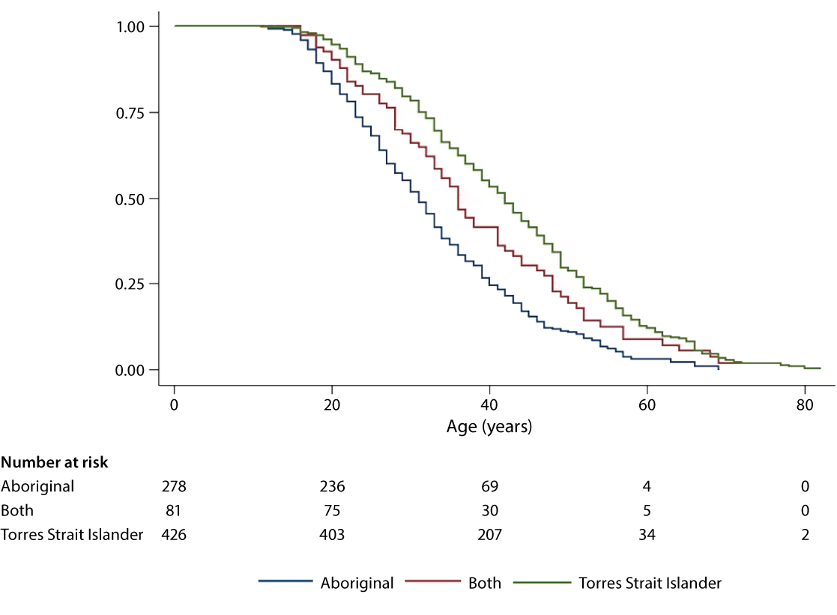

a HBeAg: hepatitis B e antigen.

About Communicable Diseases Intelligence

Communicable Diseases Intelligence (CDI) is a peer-reviewed scientific journal published by the Health Security & Emergency Management Division, Department of Health and Aged Care. The journal aims to disseminate information on the epidemiology, surveillance, prevention and control of communicable diseases of relevance to Australia.

© 2024 Commonwealth of Australia as represented by the Department of Health and Aged Care

ISSN: 2209-6051 Online

This journal is indexed by Index Medicus and Medline.

This publication is licensed under a Creative Commons Attribution-NonCommercial-NoDerivatives 4.0 International Licence (CC BY-NC-ND) available from https://creativecommons.org/licenses/by-nc-nd/4.0/legalcode (Licence). You must read and understand the Licence before using any material from this publication.

Restrictions

The Licence does not cover, and there is no permission given for, use of any of the following material found in this publication (if any):

* the Commonwealth Coat of Arms (by way of information, the terms under which the Coat of Arms may be used can be found at www.pmc.gov.au/resources/commonwealth-coat-arms-information-and-guidelines);
* any logos (including the Department of Health and Aged Care’s logo) and trademarks;
* any photographs and images;
* any signatures; and
* any material belonging to third parties.

Disclaimer

Opinions expressed in *Communicable Diseases Intelligence* are those of the authors and not necessarily those of the Australian Government Department of Health and Aged Care or the Communicable Diseases Network Australia. Data may be subject to revision.

Enquiries

Enquiries regarding any other use of this publication should be addressed to the CDI Editor at: [cdi.editor@health.gov.au](mailto:cdi.editor@health.gov.au)

Communicable Diseases Network Australia

Communicable Diseases Intelligence contributes to the work of the Communicable Diseases Network Australia. www.health.gov.au/cdna

**Editor**: Christina Bareja • **Deputy Editor**: Simon Petrie • **Design and Production**: Lisa Thompson

**Editorial Advisory Board**: David Durrheim, Mark Ferson, Clare Huppatz, John Kaldor, Martyn Kirk, Meru Sheel and Stephanie Williams

Contacts

CDI is produced by:

Health Security & Emergency Management Division, Australian Government Department of Health and Aged Care,  
GPO Box 9848, (MDP 6) CANBERRA ACT 2601

Website: [www.health.gov.au/cdi](http://www.health.gov.au/cdi)

Email: [cdi.editor@health.gov.au](mailto:cdi.editor@health.gov.au)

Submit an Article

You are invited to submit your next communicable disease related article to the *Communicable Diseases Intelligence* (CDI) for consideration. More information regarding CDI can be found at: www.health.gov.au/cdi.

Further enquiries should be directed to: [cdi.editor@health.gov.au](mailto:cdi.editor@health.gov.au)