2024 • Volume 48 • https://doi.org/10.33321/cdi.2024.48.49 • Electronic publication date: 23/10/2024

Community-led diphtheria vaccination campaign to manage a diphtheria outbreak in a remote Aboriginal community

Allison Hempenstall, Joanne Neville, Caroline Taunton, Valmay Fisher, Vince Connellan, Alice Tayley, Georgina Keys, Josh Hanson

# Abstract

In 2022, five cases of diphtheria were identified in and around Wujal Wujal, a discrete Aboriginal community in Far North Queensland. This prompted a mass diphtheria vaccination campaign in the community which increased the proportion of residents aged ≥14 years receiving a diphtheria containing vaccine in the prior twelve months from 5% to 74%. No further cases were detected in the subsequent twenty-two months.

Keywords: diphtheria; *Corynebacterium diphtheriae*; vaccination; Aboriginal; public health; outbreak

# Background and methods

Diphtheria (caused by exotoxin-producing *Corynebacterium diphtheriae*, *Corynebacterium ulcerans* and very rarely *Corynebacterium pseudotuberculosis*) typically presents as respiratory or cutaneous disease, although absorption and dissemination of diphtheria toxin can result in damage to the heart and nervous system.1 A diphtheria outbreak from toxigenic *C. diphtheriae* was declared by the Torres and Cape Public Health Team in August 2022 after four laboratory-confirmed cases (three respiratory and one cutaneous) were reported to the Queensland notifiable conditions register between April 2022 and August 2022. All four cases occurred in and around Wujal Wujal, a discrete Aboriginal community in eastern Cape York, 345 km north of Cairns, 70 km south of Cooktown, and home to the Kuku Yalanji, Kuku Nyungual and Jalunji peoples.2 Wujal Wujal has a population of 282 people with 94% of the community identifying as Aboriginal and/or Torres Strait Islander.3 This report describes the public health outbreak response and ensuing mass vaccination campaign undertaken in Wujal Wujal during August 2022. An ethics exemption was granted by the Far North Queensland Human Research Ethics Committee (1847OR).

# Description of outbreak

Definitive diagnosis of diphtheria requires culture of *C. diphtheriae* or *C. ulcerans* from respiratory tract secretions or cutaneous lesions, and a positive toxin assay.4 A total of five cases who had lived in or visited Wujal Wujal or Cooktown were associated with this local outbreak. The first case was notified to the Torres and Cape Public Health Team on 10 April 2022. Appropriate contact tracing and management of close contacts was performed, and a public health alert was released, emphasising the importance of ensuring up-to-date vaccination. An outbreak was declared, and a response team was established after the fourth case was notified in early August 2022 (Figure 1). A fifth case was identified from contact tracing during the mass vaccination campaign. Among the cases, 1/5 presented with classic pharyngeal diphtheria, 3/5 presented with mild pharyngeal diphtheria and 1/5 presented with a cutaneous infection. Two cases required hospitalisation, including one who required Intensive Care Unit admission.4 The median age of cases was 27 years (range: 17–49 years); 4/5 cases were female and 4/5 identified as Aboriginal. All cases reported receiving a complete primary diphtheria-vaccination schedule in childhood and 3/5 had received a diphtheria booster in the ten years prior to onset. Notably, three female cases had not received a diphtheria-tetanus-pertussis (dTpa) vaccination during their most recent pregnancies, which had all occurred after July 2014, when the State of Queensland commenced funding this vaccine in the third trimester of pregnancy.5

Figure 1: Diphtheria outbreak curve for the Wujal Wujal area, by presentation type

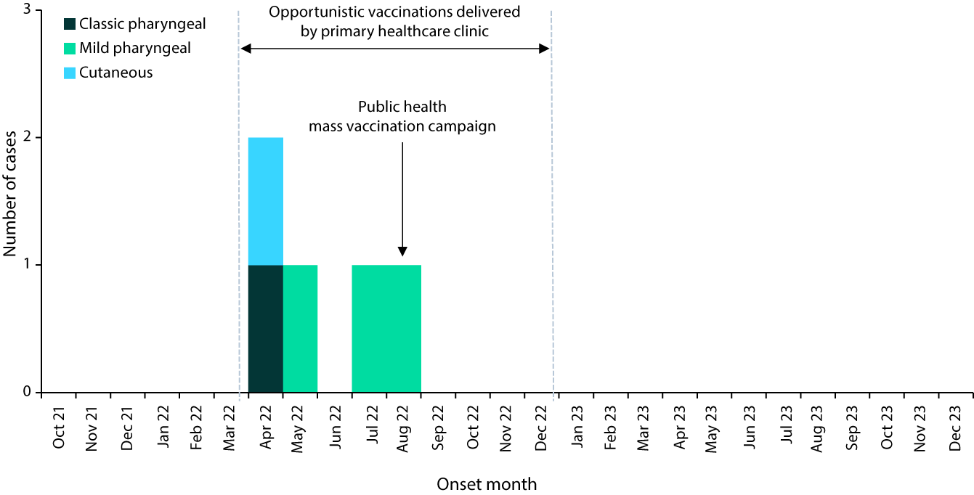

# Public health response

A state-wide expert advisory group meeting was convened after the fourth case. The group recommended increasing vaccination coverage through a mass vaccination campaign in and around Wujal Wujal. After community consultation, the local mayor and Aboriginal Shire Council were supportive of a swift public health response. The Torres and Cape public health outbreak response team coordinated a mass vaccination campaign between 15 and 19 August 2022. The team consisted of an Indigenous public health officer, two registered nurses, a pharmacist and a public health medical officer who all worked in close partnership with staff at the Wujal Wujal Primary Healthcare Centre. The team was supported by an epidemiologist, a data officer, a communications officer, and logistics staff. A month-long standing drug order was created for registered nurses and Indigenous health workers to administer Boostrix® and Adacel® (dTpa) to further increase vaccination rates beyond the week-long response.

The vaccination campaign targeted all current residents of Wujal Wujal and surrounding areas aged ≥ 14 years and who had not received a diphtheria-containing vaccination in the prior twelve-month period (eligible individuals). An initial population list was obtained from local electronic medical records (n = 604) and refined by local primary healthcare staff to identify those currently residing or working in the community (n = 479). The diphtheria vaccination history of each eligible resident was checked on the Australian Immunisation Register (AIR). There had been a recent increase in diphtheria vaccinations offered to community members by the local primary healthcare centre after the first case was notified in April 2022, with the centre increasing the number of residents who had been vaccinated for diphtheria in the prior twelve months, from 28/479 (6%) in January 2022 to 108/479 (23%) in August 2022 when the mass vaccination campaign commenced.

Eligible individuals were offered a dTpa booster vaccine during the one-week campaign. Trained immunisers obtained verbal consent, and assessed that all individuals under 18 years of age were Gillick competent, before they administered the vaccine. Vaccinations were administered in the Wujal Wujal Primary Healthcare Centre, in the community hall, at the local store, under the Mango Trees (a community meeting space), and in residents’ homes. Community messaging occurred through local radio interviews, electronic notice boards, text messages to mobiles, social media, and paper flyers. A whole-of-community meeting was held during the vaccination campaign to provide education about diphtheria.

During the week-long vaccination campaign, a total of 279/479 community members (58%) were screened for diphtheria vaccination eligibility, with 248/279 (89%) eligible for a vaccination and 224/248 (90%) accepting vaccination (Figure 2). All vaccinations were recorded on the AIR and in the local electronic medical record. The local primary healthcare centre continued to offer vaccinations opportunistically to eligible residents throughout 2022. At the end of the one-week response, the proportion of eligible community members aged ≥ 14 years who received a diphtheria vaccination in the prior 12-months was 333/479 (70%) and in the prior ten-years was 366/479 (76%) (Table 1). By the end of 2022, coverage rates had increased from 5% to 74% in those who received a vaccine in the prior twelve months and from 24% to 81% in those who received a vaccine in the prior 10 years (Figure 2). An outbreak response team debrief was held for the team on 31 August 2022.

The Wujal Wujal outbreak was later genomically linked to a wider outbreak of 29 toxigenic diphtheria cases who were residents of North Queensland or who had epidemiological links to this region between 2020 and 2022.6 A North Queensland public heath working group was established and clinicians were alerted in response to the wider outbreak.7 No further cases linked to the wider outbreak were detected among residents of the Torres and Cape region in the 22 months following the mass vaccination campaign.

Figure 2: Diphtheria vaccination recency among Wujal Wujal residents, 2022

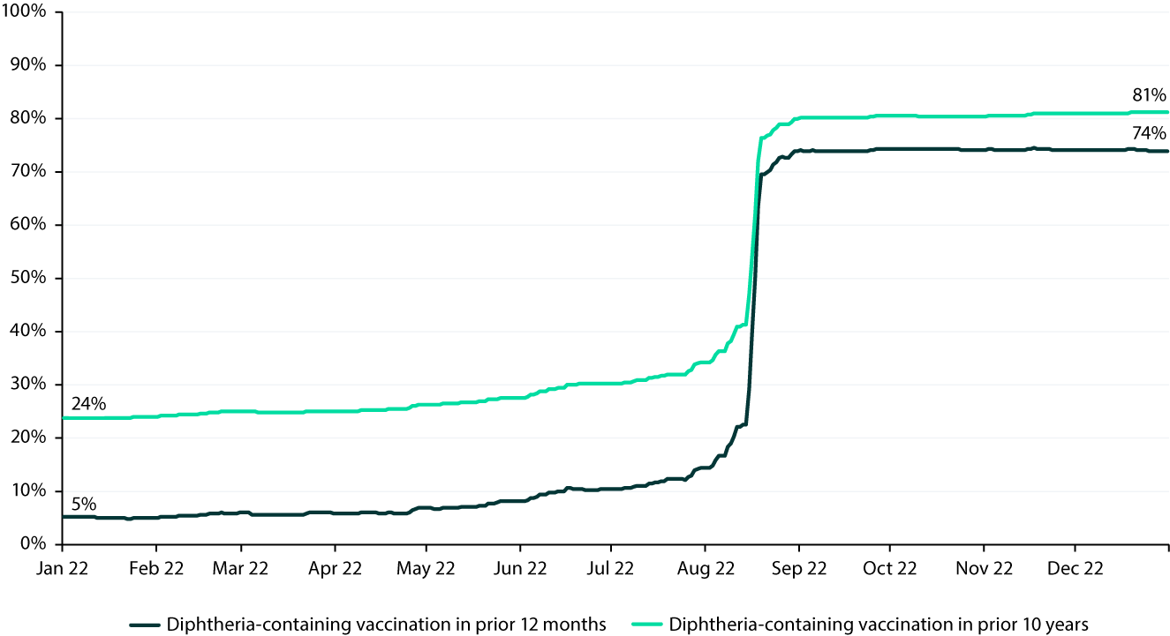

Table 1: Diphtheria vaccination coverage among residents aged ≥ 14 years, after week-long mass vaccination campaign (19 August 2022), by age group

| Age group | Residents (n) | Screened (n) | Eligible for vaccination (n) | Declined  (n) | Accepting vaccination (n) |
| --- | --- | --- | --- | --- | --- |
| 14 to 19 years | 15 | 8 | 8 | 0 | 8 |
| 20 to 39 years | 153 | 95 | 83 | 8 | 75 |
| 40 to 59 years | 174 | 99 | 87 | 8 | 79 |
| 60 years and over | 134 | 74 | 67 | 8 | 59 |
| Unknown | 3 | 3 | 3 | 0 | 3 |
| Total | 479 | 279 | 248 | 24 | 224 |

# Discussion

This diphtheria outbreak response increased the vaccination rate in eligible residents, who had received a diphtheria-containing vaccine within the prior ten years, from 24% at the start of 2022 to 81% by the end of 2022. The vaccination rates were achieved with important contributions by both the primary healthcare centre and the public health team, with vaccinations offered by the primary healthcare centre opportunistically on an ongoing basis augmenting the week-long public health vaccination campaign.

The vaccination campaign increased individual protection against symptomatic diphtheria disease for those vaccinated; however, the extent to which the campaign achieved sufficient herd immunity to interrupt ongoing transmission within the local population is unclear. While the diphtheria-toxoid vaccine does not prevent colonisation, asymptomatic pharyngeal carriers cause 75% fewer infections than symptomatic cases, suggesting primary course vaccination may reduce transmission by 60%.8 No further cases of this potentially life-threatening infection were detected across the Torres Strait and Cape York in the subsequent 22 months, with the successful local vaccination campaign likely playing some role in this outcome.

The successful implementation of this response was multifactorial. Public health laboratory toxin-gene testing of both pharyngeal and cutaneous *C. diphtheriae* isolates, and laboratory notification of results to the Queensland notifiable conditions register, expedited recognition of the outbreak. Early detection was followed by prompt contact tracing of cases and again highlighted the importance of close coordination between public health and primary care services in Far North Queensland.9–12 Cases were closely monitored, and local healthcare workers remained vigilant to the possibility of further cases. The mass vaccination campaign was led by local Indigenous Health Workers and was enhanced by their local knowledge. Fewer than 10% of those screened declined a diphtheria containing vaccine, highlighting Wujal Wujal residents’ understanding of this important public health measure.

Whole genome sequencing of Queensland *C. diphtheriae* isolates later enabled apparently disparate cases to be linked and allowed a wider public health response to be coordinated across Far North Queensland. This included bolstering local health facilities’ awareness of diphtheria and recommended booster vaccination schedules in North Queensland. The dTpa vaccination campaign may have also provided additional protection for many Wujal Wujal residents during a pertussis outbreak in the nearby community of Cooktown in March 2024, highlighting the potential utility of using a diphtheria, tetanus, and pertussis–containing vaccine in diphtheria or tetanus outbreak settings in preference to bivalent diphtheria-tetanus vaccines.

Diphtheria can be life-threatening. Although the disease is now very rarely seen in Australia due to high vaccination coverage, this outbreak highlights the need for ongoing vigilance not only in maintaining adequate diphtheria vaccination coverage, but also for clinicians to be alert to potential cases of diphtheria across the country.13 Finally, this response, the resulting mass vaccination and the successful engagement with the local community and its primary healthcare workers, provides a model for an approach to outbreaks of other vaccine-preventable infections in remote First Nations communities.

# Acknowledgments

The authors wish to extend our thanks for the support and partnership of the Wujal Wujal Aboriginal Shire Council throughout this response.

# Author details

Dr Allison Hempenstall,1

Ms Joanne Neville,2

Ms Caroline Taunton,3

Ms Valmay Fisher,4

Mr Vince Connellan,5

Ms Alice Tayley,6

Ms Georgina Keys,7

Dr Josh Hanson,8

1. Public Health Medical Officer, Torres and Cape Hospital and Health Service
2. Public Health Clinical Nurse Consultant, Torres and Cape Hospital and Health Service
3. Epidemiologist, Torres and Cape Hospital and Health Service
4. Indigenous Public Health Officer, Torres and Cape Hospital and Health Service
5. Director of Nursing, Wujal Wujal Primary Healthcare Centre, Torres and Cape Hospital and Health Service
6. Advanced Health Worker, Wujal Wujal Primary Healthcare Centre, Torres and Cape Hospital and Health Service
7. Pharmacist, Torres and Cape Hospital and Health Service
8. General Physician, Cairns Hospital, Cairns and Hinterland Hospital and Health Service

Corresponding author

Allison Hempenstall

Torres and Cape Hospital and Health Service, 120 Bunda Street, Cairns, Queensland 4870

Telephone: +61 438 755 738

Email: Allison.hempenstall@health.qld.gov.au

# References

1. Jain A, Samdani S, Meena V, Sharma MP. Diphtheria: It is still prevalent!!! I*nt J Pediatr Otorhinolaryngol*. 2016;86:68–71. doi: https://doi.org/10.1016/j.ijporl.2016.04.024.
2. Wujal Wujal Aboriginal Shire Council. Wujal Wujal. “Yulmbarril Bubungu” – Come to our land. [Webpage.] Queensland: Wujal Wujal Aboriginal Shire Council; 2022. Available from: https://www.wujalwujalcouncil.qld.gov.au/.
3. Australian Bureau of Statistics. Wujal Wujal QuickStats. [Webpage.] Canberra: Australian Bureau of Statistics; 2021. Available from:  
   https://abs.gov.au/census/find-census-data/quickstats/2021/SAL33171.
4. Smith S, Stewart J, Hanson J, Harris J, Chuang FJJ, Quail G et al. Locally acquired respiratory diphtheria in Australia. *Med J Aust*. 2023;218(10):446–8. doi: https://doi.org/10.5694/mja2.51938.
5. National Centre for Immunisation Research and Surveillance (NCIRS). *Significant events in diphtheria, tetanus and pertussis vaccination practice in Australia*. Sydney: NCIRS; July 2018. Available from: https://www.ncirs.org.au/sites/default/files/2018-11/Diphtheria-tetanus-pertussis-history-July-2018.pdf.
6. Graham RMA, Rathnayake IU, Sandhu S, Bhandari M, Taunton C, Fisher V et al. Genomic analysis of an outbreak of toxin gene bearing *Corynebacterium diphtheriae* in Northern Queensland, Australia reveals high level of genetic similarity. *Epidemiol Infect*. 2023;151:e92. doi: https://doi.org/10.1017/S0950268823000699.
7. Hempenstall A, Short J, Marquardt T, Fisher V, Johnson J. Clinician alert: toxigenic diphtheria cases across North Queensland are on the rise. *Med J Aust*. 2023;218(5):238. doi: https://doi.org/10.5694/mja2.51858.
8. Truelove SA, Keegan LT, Moss WJ, Chaisson LH, Macher E, Azman AS et al. Clinical and epidemiological aspects of diphtheria: a systematic review and pooled analysis. *Clin Infect Dis*. 2020;71(1):89–97. doi: https://doi.org/10.1093/cid/ciz808.
9. Smith S, Marquardt T, Jennison AV, D’Addona A, Stewart J, Yarwood T et al. Clinical manifestations and genomic evaluation of melioidosis outbreak among children after sporting event, Australia. *Emerg Infect Dis*. 2023 Nov;29(11):2218–28. doi: https://doi.org/10.3201/eid2911.230951.
10. Marquardt T, Hanson J, Preston-Thomas A, Thirlwell C, Kakkanat A, Goncalves N. Public health response to an outbreak of meningococcal B disease in a secondary school in Far North Queensland. *Commun Dis Intell (2018)*. 2023;47. doi: https://doi.org/10.33321/cdi.2023.47.50.
11. Hawthorn L, Matysek R, Neville J, Gibson I, Taunton C, Thomas R et al. A mixed-methods evaluation: COVID Care in the Home, a public health response to the first omicron wave across the Torres and Cape region, Queensland. *Aust N Z J Public Health*. 2024;48(2):100147. doi: https://doi.org/10.1016/j.anzjph.2024.100147.
12. Taunton C, Hawthorne L, Matysek R, Neville J, Coates M, Pickering E et al. A low burden of severe illness: the COVID-19 Omicron outbreak in the remote Torres and Cape region of Far North Queensland. *Commun Dis Intell (2018)*. 2023;47. doi: https://doi.org/10.33321/cdi.2023.47.41.
13. Winkler NE, Dey A, Quinn HE, Pourmarzi D, Lambert S, McIntyre P et al. Australian vaccine preventable disease epidemiological review series: diphtheria 1999–2019. *Commun Dis Intell (2018)*. 2022;46. doi: https://doi.org/10.33321/cdi.2022.46.42.

About Communicable Diseases Intelligence

Communicable Diseases Intelligence (CDI) is a peer-reviewed scientific journal published by the Health Security & Emergency Management Division, Department of Health and Aged Care. The journal aims to disseminate information on the epidemiology, surveillance, prevention and control of communicable diseases of relevance to Australia.

© 2024 Commonwealth of Australia as represented by the Department of Health and Aged Care

ISSN: 2209-6051 Online

This journal is indexed by Index Medicus and Medline.

This publication is licensed under a Creative Commons Attribution-NonCommercial-NoDerivatives 4.0 International Licence (CC BY-NC-ND) available from https://creativecommons.org/licenses/by-nc-nd/4.0/legalcode (Licence). You must read and understand the Licence before using any material from this publication.

Restrictions

The Licence does not cover, and there is no permission given for, use of any of the following material found in this publication (if any):

* the Commonwealth Coat of Arms (by way of information, the terms under which the Coat of Arms may be used can be found at www.pmc.gov.au/resources/commonwealth-coat-arms-information-and-guidelines);
* any logos (including the Department of Health and Aged Care’s logo) and trademarks;
* any photographs and images;
* any signatures; and
* any material belonging to third parties.

Disclaimer

Opinions expressed in *Communicable Diseases Intelligence* are those of the authors and not necessarily those of the Australian Government Department of Health and Aged Care or the Communicable Diseases Network Australia. Data may be subject to revision.

Enquiries

Enquiries regarding any other use of this publication should be addressed to the CDI Editor at: [cdi.editor@health.gov.au](mailto:cdi.editor@health.gov.au)

Communicable Diseases Network Australia

Communicable Diseases Intelligence contributes to the work of the Communicable Diseases Network Australia. www.health.gov.au/cdna

**Editor**: Christina Bareja • **Deputy Editor**: Simon Petrie • **Design and Production**: Lisa Thompson

**Editorial Advisory Board**: David Durrheim, Mark Ferson, Clare Huppatz, John Kaldor, Martyn Kirk and Meru Sheel

Contacts

CDI is produced by:

Health Security & Emergency Management Division, Australian Government Department of Health and Aged Care,  
GPO Box 9848, (MDP 6) CANBERRA ACT 2601

Website: [www.health.gov.au/cdi](http://www.health.gov.au/cdi)

Email: [cdi.editor@health.gov.au](mailto:cdi.editor@health.gov.au)

Submit an Article

You are invited to submit your next communicable disease related article to the *Communicable Diseases Intelligence* (CDI) for consideration. More information regarding CDI can be found at: www.health.gov.au/cdi.

Further enquiries should be directed to: [cdi.editor@health.gov.au](mailto:cdi.editor@health.gov.au)