2024 • Volume • • Electronic publication date:

An outbreak of dengue virus type 3 on Mer Island in the Torres Strait, Australia in 2024

A Hempenstall, A Pyke, C Taunton, U Sabatino, S Kaigey, E Pickering, G Ehlers, MO Muzari, J Davis, C Paton, C Taylor, A van den Hurk, G Hewitson, S Schlebusch, J Hanson

# Abstract

In early 2024, there were eight confirmed cases of locally acquired dengue on Mer Island in the Torres Strait. This dengue outbreak prompted an in-community public health response which included active case finding, health promotion and vector control. This was the first detected dengue outbreak in the Torres Strait since 2017. It highlights the importance of testing in primary healthcare, vector control and ongoing public health surveillance to minimise the risk of local transmission and establishment of endemic viruses which may cause significant and potentially life-threatening disease within populations in northern Australia.

Keywords: dengue; outbreak; First Nations health; public health; Aboriginal and Torres Strait Islander people

# Background and methods

Mer Island (also known as Murray Island) is a remote tropical island in the Torres Strait, Queensland, Australia, 131 km from the Papua New Guinea (PNG) mainland (Figure 1). It is a basaltic island formed from an extinct volcano, has rich tropical vegetation, and is populated by around 370 Melanesian Meriam people.1 Mer Island residents have family and cultural ties with neighbouring PNG villages; under the Torres Strait Treaty, Torres Strait Islanders and PNG nationals from treaty villages can move freely (without passports or visas) between Australia and PNG for traditional activities including cultural events and trade.2

Dengue is caused by infection with any of the four related dengue viruses (DENV-1–4). It is transmitted predominantly by *Aedes aegypti* and *Aedes albopictus* mosquitoes and is considered a major public health challenge by the World Health Organization.3 Each year, an estimated 390 million dengue infections occur around the world, resulting in up to 36,000 deaths.4 Dengue is endemic in PNG and previous outbreaks in the Torres Strait have been linked with PNG.5–7 In May 2024, an outbreak of DENV-3 was identified on Mer Island. This is the first recognised outbreak in the Torres Strait since a series of outbreaks occurred across four islands in 2016 and 2017, which resulted in 26 reported cases.5 This report describes the Torres and Cape Public Health Unit response and laboratory findings associated with the 2024 Mer Island dengue outbreak. An ethics exemption was granted for this report by the Far North Queensland Human Research Ethics Committee.

Figure 1: Map of the Torres Strait, Australia, showing the location of Mer, where the 2024 DENV-3 outbreak occurred

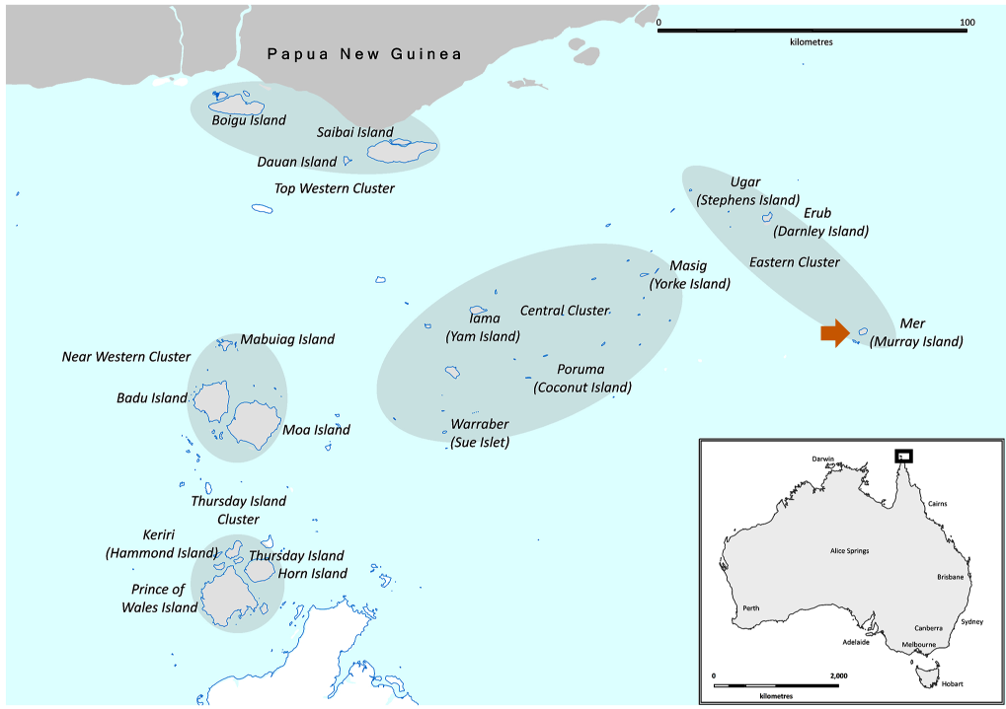

# Description of outbreak

On 22 May 2024, the Torres and Cape Public Health Unit (TCPHU) received notification of a confirmed dengue case in a hospitalised Cairns resident who had visited Mer Island within their exposure period. No other local or international travel was reported. There were no locally acquired DENV infections in Cairns during the same time period. It was therefore unlikely that the patient acquired the infection in Cairns, as the threat of local DENV transmission in this city has been minimised by the establishment of the *Wolbachia* bacterium in *Ae. aegypti* populations as a biocontrol strategy since 2011.8 However, a high population of *Ae. albopictus* is present on Mer Island.9 The Cairns resident’s DENV infection was therefore believed to be acquired on Mer Island. An outbreak was declared, and a public health response initiated. Outbreak case definitions were established for confirmed and probable cases based on the Communicable Diseases Network Australia surveillance case definitions for dengue, with a possible case definition later added based on the World Health Organization clinical case definition (Box 1).10 A total of 77 cases were associated with this outbreak, including eight confirmed cases, 37 probable cases and 32 possible cases (Figure 2). The median age of the cases was 36 years (range 9–77 years) and 42/77 (55%) were female. One case was hospitalised, and another case was medically evacuated to Thursday Island for further investigations; however, there were no deaths or long-term complications.

Box 1: Outbreak case definitions

Onset between 1 January and 26 July 2024, and

On Mer Island during any part of exposure period (3–14 days prior to onset), and

**Confirmed case**

* Detection of dengue virus by nucleic acid testing, or
* Detection of dengue non-structural protein 1 (NS1) antigen in blood.

**Probable case**

* Does not meet confirmed case definition, and
* Detection of dengue virus-specific IgM in blood, and
* Screened by PHU or presented to local clinic and reported at least one dengue symptom (fever or headache or arthralgia or myalgia or rash or nausea or vomiting).

**Possible case**

* Does not meet confirmed or probable case definition for dengue above, and
* Screened by PHU or presented to local clinic and reported dengue symptoms of:

a. fever, and

b. at least two of:

i. nausea or vomiting

ii. rash

iii. headache or eye pain or myalgia or arthralgia

iv. leukopenia

v. positive tourniquet test or low platelets, and

c. no alternative clinical diagnosis made.

Excluded as possible case if dengue bloods taken and both IgM and IgG were non-reactive.

Figure 2: Epidemiological curve of dengue cases, by case definition on Mer Island, 1 January to 26 July 2024

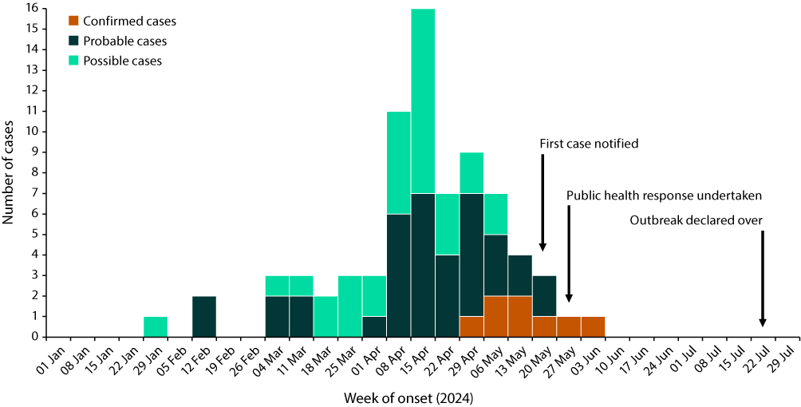

# Public health response and laboratory investigations

The public health response to the outbreak focussed on four areas: active case finding, health education, health promotion and vector control. The outbreak response team included public heath clinicians from the TCPHU and vector control officers from Tropical Public Health Services in Cairns. Team members were on site in the community within five days of the notification of the first confirmed case. There was education of clinic staff about the assessment and management of people presenting with symptoms consistent with dengue and then, in partnership with the local council and primary healthcare centre, the team undertook door-to-door active case finding. Those with a clinically compatible illness were offered testing. Testing involved collecting blood samples for DENV-1–4 real-time reverse transcription polymerase chain reaction (rRT-PCR), DENV non-structural protein 1 (NS1) antigen detection and DENV immunoglobulin M (IgM) serology for those who were unwell, or had been within the prior week. Those who were unwell more than one week earlier were offered collection of blood samples for DENV IgM and immunoglobulin G (IgG) serology. Blood specimens were sent to Cairns for processing by Pathology Queensland, with onward referral to the Public and Environmental Health Reference Laboratories (PEHRL), Brisbane. Serology and real-time reverse transcriptase polymerase chain reaction (rRT-PCR) were performed in seven of the eight confirmed cases, with DENV-3 detected in all seven.

This door-to-door response commenced at the houses of cases and screened 258/329 residents (78%) present on the island. Another 32/329 (10%) were seen by the primary healthcare centre in the days prior – or in the days following – the week-long public health response. Health promotion was also delivered door-to-door alongside local council workers and included the distribution of diethyltoluamide (DEET) mosquito repellent and information leaflets. There was further health promotion, more broadly across the Torres Strait, via social media and radio, reminding people of the symptoms of dengue and of strategies to prevent mosquito bites and to decrease mosquito breeding sites around the home (such as cleaning up home gardens and ensuring receptables were emptied of water).

During the response, Mer Island residents reported that a large funeral had been held on the island in January 2024 which was attended by around 100 PNG nationals. Active case finding determined that many residents had been unwell with clinically compatible dengue symptoms since late January, with 80 of the 258 residents screened (31%) reporting two or more dengue symptoms. The possible case definition was derived during the response to estimate the total number of infections, given the time which had lapsed since initial illnesses, the feasibility of collecting blood specimens from all residents reporting prior symptoms and the individual variability in dengue IgM persistence following infection. The possible case definition was later found to have 100% sensitivity for symptoms reported by confirmed cases and 70% sensitivity for symptoms reported by probable cases. A total of 44/69 (64%) of the retrospectively diagnosed probable and possible cases reported seeking healthcare during their acute infection.

Queensland Health vector control staff and local council environmental health workers undertook mosquito harbourage spraying, which involved application of a residual pyrethroid insecticide (lambda-cyhalothrin) to vegetation around the residential areas of Mer Island. Many conspicuous larval habitats were tipped over and/or sprayed with lambda-cyhalothrin, but most effort was targeted at rapid completion of harbourage (vegetation) spraying. Samples of mosquito larvae were also collected from various water-filled containers in the community during the response for morphological and molecular analysis (Mic qPCR Cycler, BMS Bio Molecular Systems, Australia) to identify the mosquito species involved in the outbreak. *Ae. albopictus* was the only potential dengue vector found among mosquito larval samples; no *Ae. aegypti* were detected. Vector control activities were completed on 2 June 2024, and no further transmission occurred thereafter. The outbreak was declared over on 26 July 2024 after two intrinsic and extrinsic incubation periods had passed in humans and mosquitoes, respectively.

At the PEHRL, sera collected from clinically suspected cases were analysed for recent DENV infections by DENV-1-4 rRT-PCRs, and flavivirus serology.11 Serology included anti-IgG and anti-IgM screen microsphere immunoassays (MIAs) and anti-flavivirus IgM typing MIA on samples demonstrating IgM reactivity in the screening assay.10 Flavivirus serology was also performed on sera collected from individuals who were potentially in the convalescent phase (unwell ≥ 1 week earlier) of their illness. Diagnostic laboratory findings are summarised in Table 1. Sera of two acute DENV positive patients were also subjected to viral sequencing and isolation.11–12 DENV-3 near whole genome sequences (QLD_11575S_2024 and QLD_12384S with GenBank accession numbers PQ119855 and PQ119856 respectively) and DENV-3 isolates were obtained from each of the two patients. Phylogenetic analysis of the patient sequences demonstrated both shared 100% nucleotide identity and clustered together within DENV-3 genotype I in the phylogenetic tree (Figure 3).

Table 1: Laboratory results for dengue cases, 1 January to 29 July 2024, on Mer Island

| Testa | Result | Cases | | |
| --- | --- | --- | --- | --- |
| Confirmed (n = 8) | Probable (n = 37) | Possible (n = 32) |
| DENV-1-4 rRT-PCR | Detected | 7b | — | — |
| Not detected | 1 | — | — |
| NS1 antigen | Detected | 7 | — | — |
| Not detected | 1 | — | — |
| Dengue IgM | Reactive | 4 | 37 | — |
| Equivocal | — | — | 1 |
| Non-reactive | 4 | — | 6 |
| Dengue IgG | Reactive | 3 | 37 | 7 |
| Equivocal | 1 | — | — |
| Non-reactive | 4 | — | — |

a rRT-PCR: real-time reverse transcription polymerase chain reaction (rRT-PCR); NS1: non-structural protein 1 antigen; IgM: immunoglobulin M; IgG: immunoglobulin G.

b All seven DENV rRT-PCR positive samples were subsequently positive by DENV-3 specific rRT-PCR. Some samples were detected in multiple methods of analysis.

Figure 3: DENV-3 phylogenetic tree generated from complete coding regions of locally acquired viral strains and sequences from GenBanka

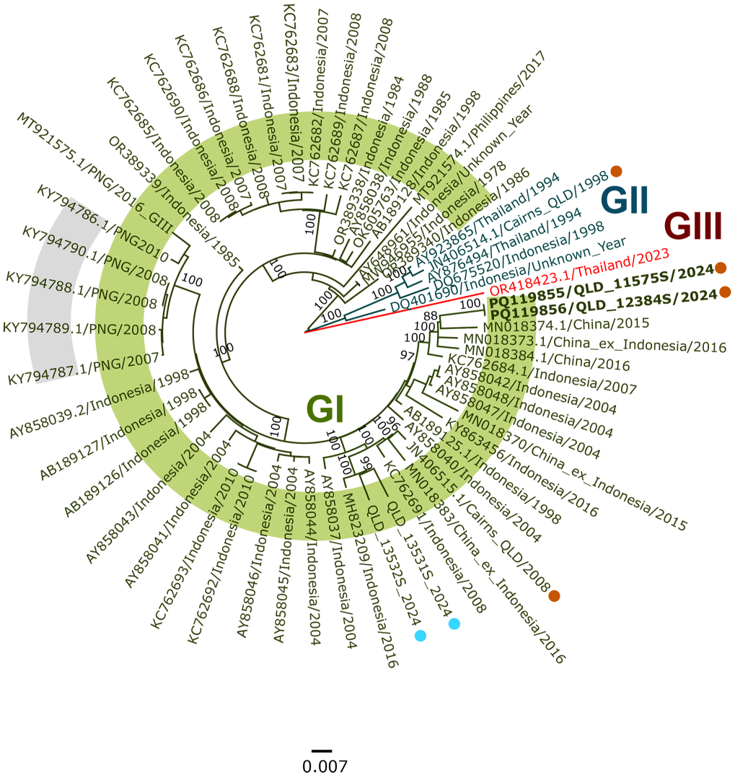

a Midpoint rooted maximum likelihood (ML) tree inferred from 58 available DENV-3 (genotypes I, II and III) complete coding region sequences (10,174 nucleotides) using the GTR+F+I nucleotide substitution model. Multiple sequence alignments were performed using the Multiple Alignment using Fast Fourier Transform (MAFFT) program, version 7.490 within Geneious Prime software, version 2024.0.7. The tree was constructed using IQTree v2.2.5 with bootstrap support estimated from 1000 replicates and percentage values are shown on key nodes. Locally transmitted Queensland DENV-3 strains are highlighted with an orange dot and the Mer Island 2024 GI sequences (QLD_11575S and QLD_12384S, GenBank accession numbers PQ119855 and PQ119856 respectively) are in bold font. Queensland DENV-3 sequences obtained from overseas travellers are highlighted with a blue dot. Recent DENV-3 GI sequences from Papua New Guinea (PNG) are highlighted by the grey background.

# Discussion

Dengue viruses are not endemic in Australia but are introduced by infected travellers. Although there have been outbreaks of other serotypes, this is the first known DENV-3 outbreak on a Torres Strait Island. In Australia, DENV-3 has periodically caused local outbreaks in far north Queensland, notably during 1997–1999 (70 weeks duration, 498 cases) and in 2008–2009 (931 cases and one death).13–15

The key strengths of the 2024 public health response were local leadership and strong partnerships between TCPHU, Cairns Hospital, Tropical Public Health Service medical entomology team, Mer Island Primary Healthcare Centre, and the local council, which were underpinned by robust and responsive diagnostic laboratory support. These partnerships were instrumental in ensuring a swift and comprehensive response. The response was led on the ground by Queensland Health local Indigenous Health Workers and council workers (including environmental health workers, housing officers and healthy lifestyle officers) who knew the local language and understood the needs of the community, replicating other recent successful public health responses in the region.16–17

Phylogenetic DENV-3 sequence analysis indicated that the outbreak near whole genome sequences, QLD_11575S_2024 and QLD_12384S_2024, were most closely related to 2015 and 2016 sequences from China (GenBank accession numbers MN018374.1, MN018373.1, and MN018384.1), sharing between 97.4% to 97.8% nucleotide identity. Of note, MN018373.1 was obtained from an Indonesian traveller to China. In addition, another Indonesian sequence from 2007 (KC762684.1) was positioned basal to the clade containing the above five sequences. Further comparison of DENV-3 E gene partial genome nucleotide sequences also indicated that the Mer Island 2024 DENV-3 outbreak sequences were most closely related to an Indonesian 2019 sequence (MW362804.1, sharing 99.3% nucleotide identity). Whilst the Mer Island DENV-3 sequences were not shown to be closely related to any publicly available sequences from PNG, the current phylogeny and evidence of relatedness between the Mer Island and historical Chinese/Indonesian DENV-3 strains could indicate seeding of DENV-3 from Southeast Asia into the Torres Strait either directly or via an alternate route such as nearby PNG. Both PNG and Indonesia have been major sources of imported DENV cases into Queensland since 1990; however, as the index case was not identified, a definitive source of the outbreak ultimately remains unknown.18–19

The Mer 2024 DENV-3 outbreak highlights both the strengths and the potential gaps in local outbreak recognition and public health responses. The first confirmed case was diagnosed nearly three months after the first possible case; indeed, most cases associated with the outbreak were diagnosed retrospectively. Delays in case recognition have previously been described in other dengue outbreaks in Australia, including the Torres Strait.20 While the majority of cases reported seeking healthcare during their acute infection, recognition of dengue appeared to have been complicated by laboratory diagnosis of influenza, COVID-19 and respiratory syncytial virus among other Mer Island residents between January and April 2024; a recent increase in imported malaria cases to the Torres Strait; and the several years since the last locally acquired (or indeed imported) dengue case was identified in the region. Further, Mer Island Primary Healthcare Centre did not have point-of-care testing for dengue and there are many challenges in the processing and transporting of pathology specimens across remote Australia, including in the Torres Strait. Nonetheless, the delay in recognising the outbreak highlights the need for regular community and health service education to ensure patients’ early presentation, the consideration of a comprehensive range of potential pathogens and prompt specimen collection for laboratory testing. As a result of this outbreak, rapid diagnostic tests that detect the dengue NS1 antigen within 20 minutes are now available at all Primary Healthcare Centres across the Torres Strait. The TCPHU now also ensures that health staff have regular education sessions to keep dengue and other infectious diseases that might be imported from PNG (including malaria, Japanese encephalitis, and typhoid) front-of-mind.

The current *Aedes* mosquito management programs in the Torres Strait include the Torres Strait Island Regional Council Environmental Health Program, where local environmental health workers undertake routine vector control activities, and the Queensland Health *Ae. albopictus* Elimination Program. The strategies of the latter program, including harbourage spraying, which focus on supressing *Ae. albopictus* on the main transport hubs of Thursday Island and Horn Island, were directly applied to the Mer outbreak.21 These two programs also ensure that there is community participation by including door-to-door inspections and community clean-up events. Harbourage spraying varies between islands depending on the skillset of the local environmental health workers and availability of vector control equipment. Ongoing mosquito management will be critical in reducing the risk of dengue and other arbovirus outbreaks. Ensuring the local environmental health workers have the appropriate training and equipment to undertake appropriate vector control is also crucial. With ongoing travel between small communities on either side of the PNG and Australian border, the local health service and public health unit must remain vigilant for future cases to minimise, and ideally prevent, future outbreaks of dengue and other potentially life-threatening infectious diseases.

# Acknowledgments

The authors would like to sincerely thank the Mer Island local council for their partnership and support throughout this response. We also wish to thank Kirsten Smyth, Dr Wei Wang, Nirdesh Poudel, Duncan Hamshere, Sarah Wheatley, Dr Peter Moore, Sean Moody, Heather Gauld, Dr Anna Brischetto and Dr Jacob Tickner at Public Health Virology, Public and Environmental Health Reference Laboratories who provided assistance in laboratory and genomics investigations.

# Author details

Hempenstall A,1

Pyke A,2

Taunton C,1

Sabatino U,1

Kaigey S,3

Pickering E,1

Ehlers G,4

Muzari MO,4

Davis J,4

Paton C,4

Taylor C,2

van den Hurk A,2

Hewitson G,2

Schlebusch S,2

Hanson J.5

1. Torres and Cape Public Health Unit, Torres and Cape Hospital and Health Service
2. Public Health, Virology, Public and Environmental Health Reference Laboratories, Pathology Queensland, Queensland Health
3. Mer Island Primary Healthcare Centre, Torres and Cape Hospital and Health Service
4. Tropical Public Health Services Cairns, Cairns and Hinterland Hospital and Health Service
5. Cairns Hospital, Cairns Hospital and Hinterland Health Service

**Corresponding author**

Allison Hempenstall

Torres and Cape Hospital and Health Service, 120 Bunda Street, Cairns, Queensland 4870

Telephone: +61 438 755 738

Email: allison.hempenstall@health.qld.gov.au

# References

1. Torres Strait Island Regional Council. Mer. [Internet.] Australia: Torres Strait Island Regional Council; 20 September 2020. Available from: https://www.tsirc.qld.gov.au/communities/mer.
2. Australian Government Department of Foreign Affairs and Trade. The Torres Strait Treaty. [Internet.] Canberra: Australian Government Department of Foreign Affairs and Trade; 2024. Available from: https://www.dfat.gov.au/geo/torres-strait/the-torres-strait-treaty.
3. Hasan S, Jamdar SF, Alalowi M, Al Ageel Al Beaiji SM. Dengue virus: a global human threat: review of literature. *J Int Soc Prev Community Dent*. 2016;6(1):1–6.   
   doi: https://doi.org/10.4103/2231-0762.175416.
4. World Health Organisation (WHO). Dengue and severe dengue. [Internet.] Geneva: WHO; 2024. Available from: https://www.who.int/health-topics/dengue-and-severe-dengue#tab=tab_1.
5. Muzari MO, Davis J, Bellwood R, Crunkhorn B, Gunn E, Sabatino U et al. Dominance of the tiger: the displacement of Aedes aegypti by Aedes albopictus in parts of the Torres Strait, Australia. *Commun Dis Intell (2018)*. 2019;43. doi: https://doi.org/10.33321/cdi.2019.43.17.
6. Hanna JN, Ritchie SA. Outbreaks of dengue in north Queensland, 1990–2008. *Commun Dis Intell Q Rep*. 2009;33(1):32–3.
7. Senn N, Luang-Suarkia D, Manong D, Siba PM, McBride WJ. Contribution of dengue fever to the burden of acute febrile illnesses in Papua New Guinea: an age-specific prospective study. *Am J Trop Med Hyg*. 2011;85(1):132–7. doi: https://doi.org/10.4269/ajtmh.2011.10-0482.
8. Ryan PA, Turley AP, Wilson G, Hurst TP, Retzki K, Brown-Kenyon J et al. Establishment of *w*Mel *Wolbachia* in *Aedes aegypti* mosquitoes and reduction of local dengue transmission in Cairns and surrounding locations in northern Queensland, Australia. *Gates Open Res*. 2020;3:1547. doi: https://doi.org/10.12688/gatesopenres.13061.2.
9. Hanna JN, Ritchie SA, Merritt AD, van den Hurk AF, Phillips DA, Serafin IL et al. Two contiguous outbreaks of dengue type 2 in north Queensland. *Med J Aust*. 1998;168(5):221–5. doi: https://doi.org/10.5694/j.1326-5377.1998.tb140134.x.
10. Communicable Disease Network of Australia (CDNA). *Dengue CDNA National Guidelines for Public Health Units*. Canberra: Australian Government Department of Health, CDNA; 22 May 2015. Available from: https://www.health.gov.au/sites/default/files/documents/2020/02/dengue-cdna-national-guidelines-for-public-health-units.pdf.
11. Pyke AT, Gunn W, Taylor C, Mackay IM, McMahon J, Jelley L et al. Erratum: Pyke, A.T. et al. On the home front: specialized reference testing for dengue in the Australasian region. *Trop. Med. Infect. Dis*. 2018, 3, 75. *Top Med Infect Dis*. 2019;4(4):129. doi: https://doi.org/10.3390/tropicalmed4040129.
12. Taylor CT, Mackay IM, McMahon JL, Wheatley SL, Moore PR, Finger MJ et al. Detection of specific ZIKV IgM in travelers using a multiplexed flavivirus microsphere immunoassay. *Viruses*. 2018;10(5):253. doi: https://doi.org/https://doi.org/10.3390/v10050253.
13. (a) Ritchie SA, Pyke AT, Hall-Mendelin S, Day A, Mores CN, Christofferson RC et al. An explosive epidemic of DENV-3 in Cairns, Australia. *PLoS One*. 2013 Jul;8(7):e68137. doi: 10.1371/journal.pone.0068137. (b) ibid (erratum). *PLoS One*. 2014;8(12). doi: https://doi.org/10.1371/annotation/a8dfd4ee-f4b7-443e-bf78-ebb0dab4e55b. (c) ibid (erratum). *PLoS One*. 2014;9(8):e105846.
14. Dillon J, McBride JH. A review of hospitalised cases of dengue in Cairns, Queensland, during a dengue serotype 3 virus epidemic in 2008-2009. *Ann Australas Coll Trop Med*. 2009;15(2):41–4. Available from: https://www.tropmed.org/wp-content/uploads/2015/07/annalsV15N2.pdf.
15. Hanna JN, Ritchie SA, Phillips DA, Serafin IL, Hills SL, van den Hurk AF et al. An epidemic of dengue 3 in far north Queensland, 1997–1999. *Med J Aust*. 2001;174(4):178–82. doi: https://doi.org/10.5694/j.1326-5377.2001.tb143213.
16. Hawthorn L, Matysek R, Neville J, Gibson I, Taunton C, Thomas R et al. A mixed-methods evaluation: COVID Care in the Home, a public health response to the first omicron wave across the Torres and Cape region, Queensland. *Aust N Z J Public Health*. 2024;48(2):100147. doi: https://doi.org/j.anzjph.2024.100147.
17. Muzari MO, Devine G, Davis J, Crunkhorn B, van den Hurk A, Whelan P et al. Holding back the tiger: successful control program protects Australia from *Aedes albopictus* expansion. *Plos Negl Trop Dis*. 2017;11(2):e0005286. doi: https://doi.org/10.1371/journal.pntd.0005286.
18. Warrilow D, Northill JA, Pyke AT. Sources of dengue viruses imported into Queensland, Australia, 2002–2010. *Emerg Infect Dis*. 2012;18(11):1850–7. doi: https://doi.org/10.3201/eid1811.120014.
19. Pyke AT. The origins of dengue outbreaks in northern Queensland, Australia, 1990–2017. *Microbiol Aust*. 2018;39(2):93–5. doi: https://doi.org/10.1071/MA18027.
20. Hanna JN, Ritchie SA, Richards AR, Taylor CT, Pyke AT, Montgomery BL et al. Multiple outbreaks of dengue serotype 2 in north Queensland, 2003/04. *Aust N Z J Public Health*. 2006;30(3):220–5. doi: https://doi.org/10.1111/j.1467-842x.2006.tb00861.x.
21. Allen T, Crouch A, Russell TL, Topp SM. Factors influencing the community participation approaches used in *Aedes* mosquito management in the Torres Strait, Australia. *BMC Public Health*. 2023;23(1):1993. doi: https://doi.org/10.1186/s12889-023-16942-8.

About Communicable Diseases Intelligence

Communicable Diseases Intelligence (CDI) is a peer-reviewed scientific journal published by the Health Security & Emergency Management Division, Department of Health and Aged Care. The journal aims to disseminate information on the epidemiology, surveillance, prevention and control of communicable diseases of relevance to Australia.

© Commonwealth of Australia as represented by the Department of Health and Aged Care

ISSN: 2209-6051 Online

This journal is indexed by Index Medicus and Medline.

This publication is licensed under a Creative Commons Attribution-NonCommercial-NoDerivatives 4.0 International Licence (CC BY-NC-ND) available from https://creativecommons.org/licenses/by-nc-nd/4.0/legalcode (Licence). You must read and understand the Licence before using any material from this publication.

Restrictions

The Licence does not cover, and there is no permission given for, use of any of the following material found in this publication (if any):

* the Commonwealth Coat of Arms (by way of information, the terms under which the Coat of Arms may be used can be found at www.pmc.gov.au/resources/commonwealth-coat-arms-information-and-guidelines);
* any logos (including the Department of Health and Aged Care’s logo) and trademarks;
* any photographs and images;
* any signatures; and
* any material belonging to third parties.

Disclaimer

Opinions expressed in *Communicable Diseases Intelligence* are those of the authors and not necessarily those of the Australian Government Department of Health and Aged Care or the Communicable Diseases Network Australia. Data may be subject to revision.

Enquiries

Enquiries regarding any other use of this publication should be addressed to the CDI Editor at: [cdi.editor@health.gov.au](mailto:cdi.editor@health.gov.au)

Communicable Diseases Network Australia

Communicable Diseases Intelligence contributes to the work of the Communicable Diseases Network Australia. www.health.gov.au/cdna

**Editor**: Christina Bareja • **Deputy Editor**: Simon Petrie • **Design and Production**: Lisa Thompson

**Editorial Advisory Board**: David Durrheim, Mark Ferson, Clare Huppatz, John Kaldor, Martyn Kirk and Meru Sheel

Contacts

CDI is produced by:

Health Security & Emergency Management Division, Australian Government Department of Health and Aged Care,  
GPO Box 9848, (MDP 6) CANBERRA ACT 2601

Website: [www.health.gov.au/cdi](http://www.health.gov.au/cdi)

Email: [cdi.editor@health.gov.au](mailto:cdi.editor@health.gov.au)

Submit an Article

You are invited to submit your next communicable disease related article to the *Communicable Diseases Intelligence* (CDI) for consideration. More information regarding CDI can be found at: www.health.gov.au/cdi.

Further enquiries should be directed to: [cdi.editor@health.gov.au](mailto:cdi.editor@health.gov.au)