2024 • Volume 48 • https://doi.org/10.33321/cdi.2024.48.20 • Electronic publication date: 10/04/2024

Investigation and response to an outbreak of Neisseria meningitidis serogroup Y ST-1466 urogenital infections, Australia
MM Lahra, NH Latham, DJ Templeton, P Read, C Carmody, N Ryder, SE Ellis, EF Madden, A Parasuraman, J Wells, V Sheppeard, BH Armstrong, J Holland, S Pendle, N Sherry, L Leong, L Papanicolas, CE Selvey and SJ Van Hal

Abstract
In 2023, an increased number of urogenital and anorectal infections with Neisseria meningitis serogroup Y (MenY) were reported in New South Wales (NSW). Whole genome sequencing (WGS) found a common sequence type (ST-1466), with limited sequence diversity. Confirmed outbreak cases were NSW residents with a N. meningitidis isolate matching the cluster sequence type; probable cases were NSW residents with MenY isolated from a urogenital or anorectal site from 1 July 2023 without WGS testing. Of the 41 cases, most were men (n = 27), of whom six reported recent contact with women in sex work. Five cases were men who have sex with men and two were women in sex work. Laboratory alerts regarding the outbreak were sent to all Australian jurisdictions through the laboratories in the National Neisseria Network. Two additional states identified urogenital MenY ST-1466 infections detected in late 2023. Genomic analysis showed all MenY ST-1466 sequences were interspersed, indicative of a multi-jurisdictional outbreak. The incidence of these infections remains unknown, due to varied testing and reporting practices both within and across jurisdictions. Isolates causing invasive meningococcal disease (IMD) in Australia are typed, and there has been no MenY ST-1466 IMD recorded in Australia to end of March 2024. Concerns remain regarding the risk of IMD, given the similarity of these sequences with a MenY ST-1466 IMD strain causing a concurrent outbreak in the United States of America.
Keywords: Neisseria meningitidis; urogenital infection; MenY ST-1466

Background and methods
Neisseria meningitidis and Neisseria gonorrhoeae generally display contrasting pathogenic characteristics. N. meningitidis is an obligate human commensal of the nasopharynx rarely causing invasive disease, whereas N. gonorrhoeae is an obligate pathogen that is primarily sexually transmitted and generally infects the mucosa of the urogenital tract, anorectum and pharynx. However, there is an overlap in clinical syndromes between the species, with invasive disease and mucosal colonisation and infection caused by both.¹
In Australia, IMD infections are currently predominantly attributed to MenB (84% in 2023).² This follows a change from monovalent MenC vaccine to a quadrivalent MenACWY vaccine in the National Immunisation Programme in 2018, following the emergence of MenW clonal cluster 11 (CC11) outbreaks and an increase in MenY IMD with sequence types other than ST-1466 reported nationally from 2017.³
Urogenital infections with N. meningitidis were first reported in 1942.⁴ Since then, numerous reports have been published of meningococci causing urethritis clinically indistinguishable from gonococcal urethritis.⁵ In one study of a large cluster of N. meningitidis urethritis in the United States of America (USA), 20% of urethritis cases were caused by N. meningitidis.⁶
The incidence of urogenital and anorectal N. meningitidis infections in Australia is difficult to determine, as the majority of patients with clinical urogenital and anorectal infections are tested by molecular assays that do not detect N. meningitidis. In Australia, more than 75% of N. gonorrhoeae infection diagnoses are by molecular testing alone.⁷ Public health notification practices, for N. meningitidis cultured from urogenital sites, vary across Australian jurisdictions; furthermore, laboratory practices vary widely with respect to the identification, work-up and reporting of N. meningitidis isolates from such sites, leading to urogenital meningococcal infections not being routinely diagnosed or reported. Similarly, in settings where syndromic diagnosis is made based on clinical presentation in conjunction with a Gram stain, N. meningitidis would not be differentiated from N. gonorrhoeae.
In 2023 in New South Wales (NSW), Australia, a cluster of symptomatic urogenital infections with N. meningitidis serogroup Y ST-1466 (MenY ST-1466) was detected through laboratory-based surveillance and referral. Cases were interviewed by public health unit or sexual health clinic staff to identify sexual contacts and risk factors.
Following the initial reports and whole genome sequencing (WGS) analysis in NSW, alerts were sent through the jurisdictional laboratories of the National Neisseria Network (NNN). Two further Australian states reported clinically similar cases with the same sequence type and serogroup as NSW: Victoria (n = 7) and South Australia (n = 2). To further characterise the NSW cluster, Victorian and South Australian sequences were shared through the NNN to facilitate a multi-jurisdictional analysis.

Description of outbreak
Between 10 July 2023 and 9 February 2024, forty-one urogenital MenY cases were reported in NSW (Figure 1). Confirmed outbreak cases (n = 30) were NSW residents with a MenY ST-1466 isolate notified since 1 July 2023; probable cases (n = 11) were NSW residents with MenY isolated from a urogenital/anorectal site without sequence typing.
Figure 1: Epidemic curve for urogenital/anorectal MenY cases, July 2023 – February 2024, New South Wales, by symptom onset date^{a,b}
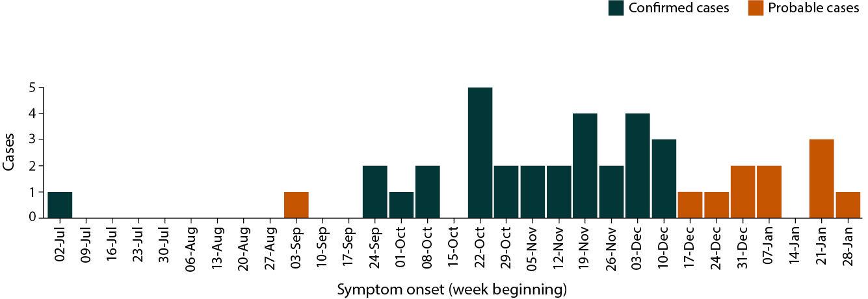
a For asymptomatic cases, or cases with missing symptom onset date, the date of specimen collection was used.
b A confirmed case was defined as urogenital/anorectal ST-1466 MenY in a New South Wales (NSW) resident notified since 1 July 2023; a probable case was defined as urogenital/anorectal MenY in a NSW resident, notified since 1 July 2023, for which WGS was unavailable.
Cases were distributed across metropolitan Sydney; no regional or rural cases were reported. Most cases were men (67%; n = 27), of whom six reported recent contact with one or more women in sex work, and five were men who have sex with men (MSM). Two cases were women in sex work. All but two cases presented with urogenital symptoms, most often urethral or vaginal discharge. Six cases had N. gonorrhoeae or C. trachomatis co-infection (Table 1). Cases were diagnosed in general practice (n = 29) and sexual health clinics (n = 11); the remaining case was diagnosed in an emergency department.

Table 1: Characteristics of confirmed and probable urogenital/anorectal MenY cases in New South Wales, July 2023 – February 2024a
Category | Characteristic | Confirmed cases  (N = 30) | Probable cases  (N = 11) | Overall  (N = 41)
Age (years) | Median | 33 | 32 | 33
 | Interquartile range | 27–38 | 32–46 | 29–39
Gender | Men | 21 (70.0%) | 6 (54.5%) | 27 (65.9%)
 | Women | 9 (30.0%) | 5 (45.5%) | 14 (34.1%)
Sexual history | Men who have sex with women only (MSWO) | 14 (46.7%) | 4 (36.4%) | 18 (43.9%)
 | MSWO, recent contact with one or more women in sex work | 6 (20.0%) | 0 (0%) | 6 (14.6%)
 | Women in sex work | 2 (6.7%) | 0 (0%) | 2 (4.9%)
 | Men who have sex with men (MSM) | 5 (16.7%) | 0 (0%) | 5 (12.2%)
 | Men; partner(s) not recorded | 2 (6.7%) | 1 (9.1%) | 3 (7.3%)
Specimen type | Genitourinary swab | 26 (86.7%) | 10 (90.9%) | 36 (87.8%)
 | Urine | 3 (10.0%) | 1 (9.1%) | 4 (9.8%)
 | Anorectal swab | 1 (3.3%) | 0 (0%) | 1 (2.4%)
Symptomatic illness |  | 28 (93.3%) | 11 (100%) | 39 (95.1%)
Gonorrhoea or chlamydia co-infection | Chlamydia | 2 (6.7%) | 2 (18%) | 4 (9.8%)
 | Gonorrhoea | 3 (10%) | 0 (0%) | 3 (7.3%)
 | Both | 1 (3.3%) | 0 (0%) | 1 (2.4%)
 | Neither | 24 (80%) | 9 (82%) | 33 (80%)
a A confirmed case was defined as urogenital/anorectal ST-1466 MenY in a New South Wales (NSW) resident notified since 1 July 2023; a probable case was defined as urogenital/anorectal MenY in a NSW resident, notified since 1 July 2023, for which WGS was unavailable.

Laboratory investigations
Most isolates underwent whole genome sequencing at jurisdictional laboratories. Fastq files were shared amongst the NNN with a centralised analysis performed using a previously published bioinformatic workflow.⁸ Subsequent WGS analysis confirmed all sequenced NSW cases to be genomically linked with a median single nucleotide polymorphism (SNP) count of 45 between all isolates and with the majority of isolates within 12 SNPs of each other. Inclusion of additional MenY ST-1466 sequences demonstrated that the South Australian and Victorian sequences were interspersed between NSW sequences, indicating a multi-jurisdictional outbreak (Figure 2).
Figure 2: Maximum likelihood phylogeny of Australian MenY ST-1466 isolates^{a,b}
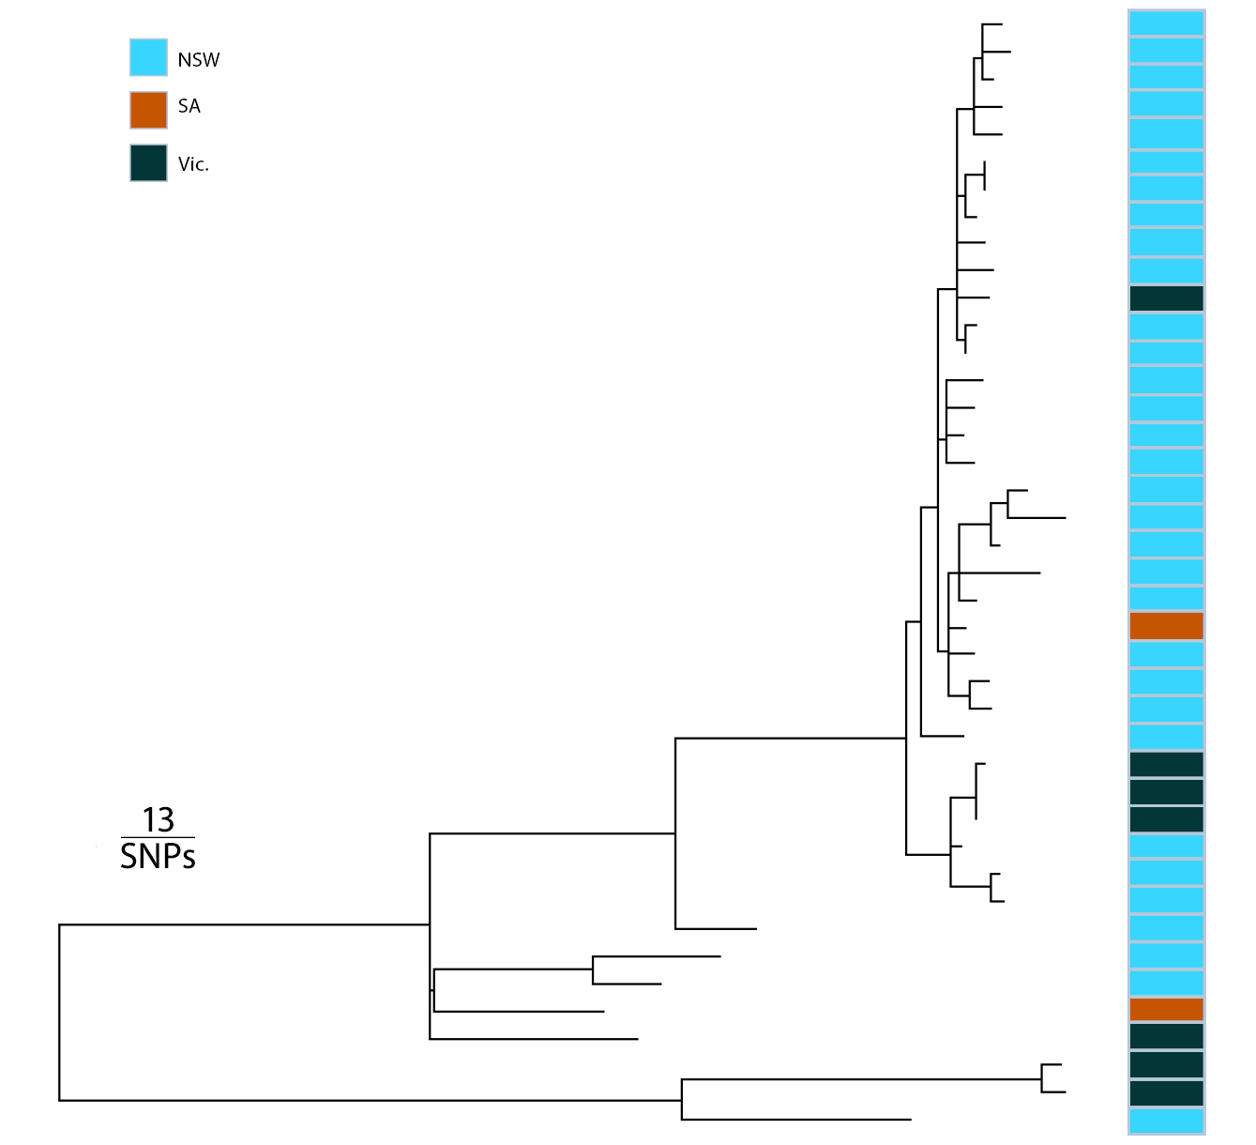
a The median SNP count between all isolates was 45; the majority of isolates were within 12 SNPs of each other.
b The South Australian (SA) and Victorian (Vic.) sequences are interspersed between New South Wales (NSW) sequences, indicating a multi-jurisdictional phenomenon.

Public health response
In NSW, most cases were treated presumptively on presentation for gonococcal infection. Sexual contacts in the seven days preceding case symptom onset were advised to monitor for symptoms of IMD and were offered clearance antibiotics and vaccination with a quadrivalent (ACWY) conjugate vaccine, in accordance with guidance endorsed by a NSW multi-disciplinary expert panel in 2019.

Discussion
Although sporadic cases of MenY urethritis have been previously reported,⁵ this is the first documented geo-temporal cluster of MenY urogenital disease. Investigation of previous unexpected outbreaks of N. meningitidis urethritis in multiple cities in the USA in 2015 led to the identification of a novel, unencapsulated clade adapted to infect the genitourinary tract (US_NmUC).⁶ By identifying genomically-linked cases of urogenital and anorectal MenY spanning multiple risk groups and jurisdictions, we highlight a new paradigm for encapsulated Neisseria meningitidis.
The risk of progression from urogenital or anorectal disease to IMD is unknown, though invasion following local epithelial inflammation is biologically plausible, since IMD is known to be associated with antecedent influenza where nasopharyngeal epithelial injury from influenza infection permits colonising N. meningitidis to invade.³ The risk of IMD in sexual contacts of people with urogenital or anorectal infection is similarly not well understood, though colonisation of these sites with hyperinvasive, encapsulated lineages has previously been proposed as a mediator of IMD outbreaks in MSM.⁹ Whilst MenY ST-1466 IMD has been reported internationally, no cases have been reported in Australia to the end of March 2024.
Nonetheless, the concurrent outbreak of MenY ST-1466 IMD in the USA is of significant concern.¹⁰ A Health Alert published in March 2024, by the Centers for Disease Control and Prevention (US CDC), reports an increase in the number and proportion of MenY IMD cases in the USA, of which 68% (101/148) is attributed to MenY ST-1466 (based on available sequence type data to date; the number is expected to increase with additional laboratory testing data).¹⁰ The MenY ST-1466 IMD in the USA has disproportionately occurred in those aged 30–60 years (65%); in Black or African American people (63%); and in people with HIV (15%). In addition, most cases of IMD caused by ST-1466 have had a clinical presentation other than meningitis, with 64% presenting with bacteremia and 4% with septic arthritis. The case-fatality rate was 18%, higher than the historical case-fatality rate of 11% reported for MenY IMD in 2017–2021 in the USA.¹⁰ It is unknown if there was any history of antecedent urogenital or rectal infections in the US cases or their sexual contacts.
Our analysis suggests this is likely a wider outbreak of MenY ST-1466 urogenital infections in Australia. Of concern are the clinical and public health implications including uncertainty regarding the risk of IMD in cases and their sexual contacts; the risk of vertical transmission;¹¹ and the potential for transfer of antimicrobial resistance in persons with N. gonorrhoeae and N. meningitidis co-infection.⁹

Acknowledgements
The Australian Meningococcal Surveillance Programme is funded by the Australian Government Department of Health and Aged Care. We wish to acknowledge and thank members of National Neisseria Network, Australia.

Author details
MM Lahra,^{1,2}
NH Latham,^{3,4}
DJ Templeton,⁵
P Read,⁶
C Carmody,⁷
N Ryder,⁸
SE Ellis,³
EF Madden,³
A Parasuraman,³
J Wells,³
V Sheppeard,⁶
BH Armstrong,^{2,9}
J Holland,¹⁰
S Pendle,¹¹
N Sherry,¹²
L Leong,¹³
L Papanicolas,¹⁴
CE Selvey,³
SJ Van Hal.^{15,16}
- World Health Organization Collaborating Centre for STI and AMR, New South Wales Health Pathology Microbiology, The Prince of Wales Hospital, Randwick, New South Wales, Australia
- Faculty of Medicine, The University of New South Wales, Sydney, New South Wales, Australia
- Health Protection NSW, St Leonards, New South Wales, Australia
- New South Wales Public Health Training Program, New South Wales Ministry of Health, St Leonards, New South Wales, Australia
- Sexual Health Medicine, Royal Prince Alfred Hospital, Camperdown, New South Wales, Australia
- South Eastern Sydney Local Health District, Randwick, New South Wales, Australia
- South Western Sydney Local Health District, Liverpool, New South Wales, Australia
- Centre for Population Health NSW Health, St Leonards, New South Wales, Australia
- Douglass Hanly Moir Pathology, New South Wales, Australia
- Laverty Pathology, New South Wales, Australia
- Australian Clinical Laboratories, New South Wales, Australia
- Microbiological Diagnostic Unit Public Health Laboratory, Department of Microbiology & Immunology, University of Melbourne at The Peter Doherty Institute for Infection and Immunity, Melbourne, Victoria, Australia
- Department of Infectious Diseases & Immunology, Austin Health, Heidelberg, Victoria, Australia
- SA Pathology, Adelaide, South Australia, Australia
- New South Wales Health Pathology, Royal Prince Alfred Hospital, Sydney, New South Wales, Australia
- Central Clinical School, University of Sydney, Sydney, New South Wales, Australia
Corresponding author
Professor Monica M Lahra
The World Health Organization Collaborating Centre for STI and AMR, Sydney and Neisseria Reference Laboratory, NSW Health Pathology Microbiology, The Prince of Wales Hospital, Randwick, NSW 2031, Australia
Telephone: +61 2 9382 3678
Facsimile: +61 2 9382 3720
Email: monica.lahra@health.nsw.gov.au

References
- Burns BL, Rhoads DD. Meningococcal urethritis: old and new. J Clin Microbiol. 2022;60(11):e00575-22. doi: https://doi.org/10.1128/jcm.00575-22.
- Lahra MM, George CR, Van Hal SJ, Hogan TR. Australian Meningococcal Surveillance Programme Annual Report 2023. Commun Dis Intell (2018). 2024;48. In press.
- George CRR, Booy R, Nissen MD, Lahra MM. The decline of invasive meningococcal disease and influenza in the time of COVID‐19: the silver linings of the pandemic playbook. Med J Aust. 2022;216(10):504–7. doi: https://doi.org/10.5694/mja2.51463.
- Carpenter CM, Charles R. Isolation of meningococcus from the genitourinary tract of seven patients. Am J Public Health Nations Health. 1942;32(6):640–3. doi: https://doi.org/10.2105/ajph.32.6.640.
- Ladhani SN, Lucidarme J, Parikh SR, Campbell H, Borrow R, Ramsay ME. Meningococcal disease and sexual transmission: urogenital and anorectal infections and invasive disease due to Neisseria meningitidis. Lancet. 2020;395(10240):1865–77. doi: https://doi.org/10.1016/S0140-6736(20)30913-2.
- Bazan JA, Turner AN, Kirkcaldy RD, Retchless AC, Kretz CB, Briere E et al. Large cluster of Neisseria meningitidis urethritis in Columbus, Ohio, 2015. Clin Infect Dis. 2017;65(1):92–9. doi: https://doi.org/10.1093/cid/cix215.
- Lahra MM, Van Hal SJ, Hogan TR. Australian Gonococcal Surveillance Programme Annual Report 2022. Commun Dis Intell (2018). 2023;47. doi: https://doi.org/10.33321/cdi.2023.47.45.
- Van Hal SJ, Whiley DM, Le T, Ray S, Kundu RL, Kerr E et al. Rapid expansion of Neisseria gonorrhoeae ST7827 clone in Australia, with variable ceftriaxone phenotype unexplained by genotype. J Antimicrob Chemother. 2023;78(9):2203–8. doi: https://doi.org/10.1093/jac/dkad221.
- Harrison OB, Cole K, Peters J, Cresswell F, Dean G, Eyre DW et al. Genomic analysis of urogenital and rectal Neisseria meningitidis isolates reveals encapsulated hyperinvasive meningococci and coincident multidrug-resistant gonococci. Sex Transm Infect. 2017;93(6):445–51. doi: https://doi.org/10.1136/sextrans-2016-052781.
- Health Alert Network. Increase in invasive serogroup Y meningococcal disease in the United States. [Online health advisory.] Atlanta: United States Government Department of Health and Human Resources, Centers for Disease Control and Prevention (CDC), CDC Health Alert Network; 28 March 2024. [Accessed on 31 March 2024.] Available from: https://emergency.cdc.gov/han/2024/han00505.asp.
- Sunderland WA, Harris HH, Spence DA, Lawson HW. Meningococcemia in a newborn infant whose mother had meningococcal vaginitis. J Pediatr. 1972;81(4):856. doi: https://doi.org/10.1016/s0022-3476(72)80120-3.

Communicable Diseases Intelligence
Communicable Diseases Intelligence (CDI) is a peer-reviewed scientific journal published by the Health Protection Policy & Surveillance Division, Department of Health and Aged Care. The journal aims to disseminate information on the epidemiology, surveillance, prevention and control of communicable diseases of relevance to Australia.
© 2024 Commonwealth of Australia as represented by the Department of Health and Aged Care
ISSN: 2209-6051 Online
This journal is indexed by Index Medicus and Medline.
This publication is licensed under a Creative Commons Attribution-NonCommercial-NoDerivatives 4.0 International Licence (CC BY-NC-ND) available from https://creativecommons.org/licenses/by-nc-nd/4.0/legalcode (Licence). You must read and understand the Licence before using any material from this publication.
Restrictions
The Licence does not cover, and there is no permission given for, use of any of the following material found in this publication (if any):
- the Commonwealth Coat of Arms (by way of information, the terms under which the Coat of Arms may be used can be found at www.pmc.gov.au/resources/commonwealth-coat-arms-information-and-guidelines);
- any logos (including the Department of Health and Aged Care’s logo) and trademarks;
- any photographs and images;
- any signatures; and
- any material belonging to third parties.
Disclaimer
Opinions expressed in Communicable Diseases Intelligence are those of the authors and not necessarily those of the Australian Government Department of Health and Aged Care or the Communicable Diseases Network Australia. Data may be subject to revision.
Enquiries
Enquiries regarding any other use of this publication should be addressed to the CDI Editor at: cdi.editor@health.gov.au
Communicable Diseases Network Australia
Communicable Diseases Intelligence contributes to the work of the Communicable Diseases Network Australia. www.health.gov.au/cdna
Editor: Christina Bareja • Deputy Editor: Simon Petrie • Design and Production: Lisa Thompson
Editorial Advisory Board: David Durrheim, Mark Ferson, Clare Huppatz, John Kaldor, Martyn Kirk, Meru Sheel and Stephanie Williams
Contacts
CDI is produced by:
Health Protection Policy & Surveillance Division, Australian Government Department of Health and Aged Care,
GPO Box 9848, (MDP 6) CANBERRA ACT 2601
Website: www.health.gov.au/cdi
Email: cdi.editor@health.gov.au
Submit an Article
You are invited to submit your next communicable disease related article to the Communicable Diseases Intelligence (CDI) for consideration. More information regarding CDI can be found at: www.health.gov.au/cdi.
Further enquiries should be directed to: cdi.editor@health.gov.au.

