Quick Reference Guide - Setup Remote Access Windows 10

Overview
This Quick Reference Guide provides the steps for the initial setup of Windows 10 devices for remote access to the HealthIT network.
Prior to remotely accessing the HealthIT network, each computer must first have two applications/clients installed:
- BIG-IP Edge Client
- VMware Horizon Client
Note: Please follow the Quick Reference Guide – Establish Remote Access Windows 10 to connect to the HealthIT Network.

Support
For assistance, contact the IT Service Desk on (02) 6289 8444 (Central Office) or 1800 500 380 (all other locations).

Procedures
This Quick Reference Guide is split into five parts:
- Part 1 - Remove existing remote access software (if applicable)
- Part 2 - Download Software
- Part 3 - Installing the BIG-IP Edge Client
- Part 4 - Pin the BIG-IP Edge Client to your Start Menu (optional)
- Part 5 - Installing the VMware Horizon Client

Part 1 – Remove existing remote access software (if applicable)
Part 1 only needs to be completed if you have previous versions of Health Remote access software installed.

Step 1
Click Settings from your Start menu.
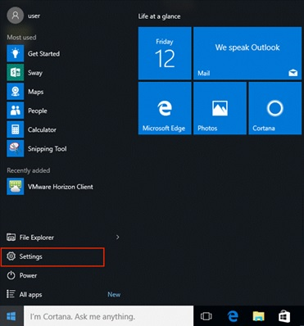

Step 2
Click System in the Settings window.
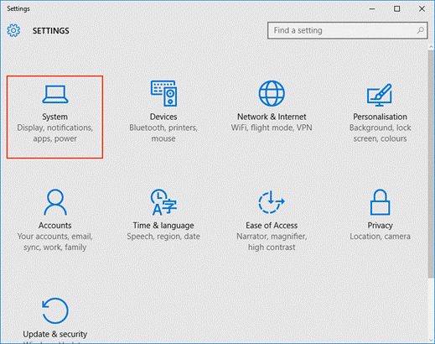

Step 3
Select the Apps & features menu item in the System settings window.
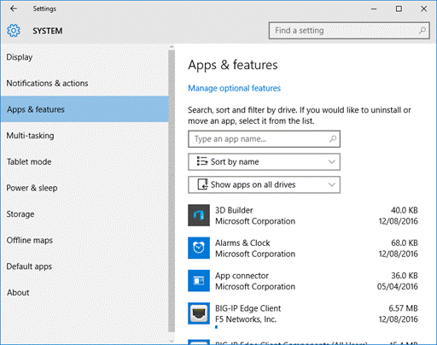

Step 4
Select BIG-IP Edge Client Components from the list and click Uninstall. Skip to step 8 if you don’t have the BIG-IP Edge Client installed.
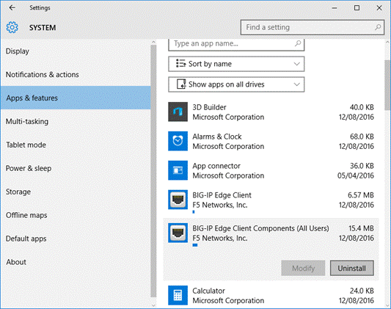

Step 5
Click Yes to agree to the User Account Control message to proceed with the uninstall process of the selected app.
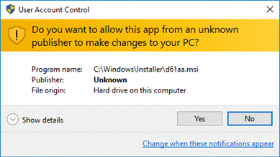

Step 6
Click Yes in the BIG-IP Edge Client Component Removal window to confirm the removal of all components and deletion of user settings.
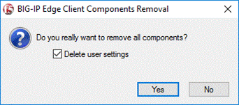

Step 7
Click Yes in the Windows Installer window to confirm that you wish to uninstall the product and proceed with the uninstall process.
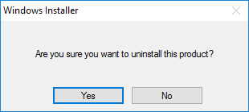
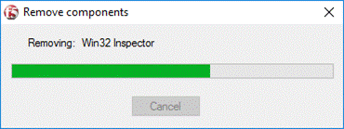

Step 8
Once the process has completed, select VMware Horizon View in the Apps & features list and click Uninstall. Skip to step 10 if you don’t have the Horizon View Client installed.
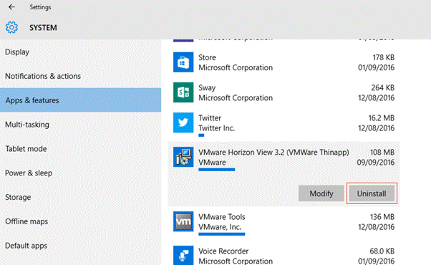

Step 9
Click Yes to agree to the User Account Control message to proceed with the uninstall process of the selected app.
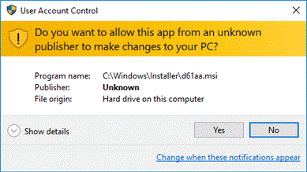
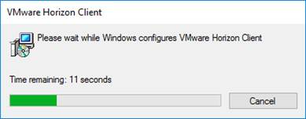

Step 10
Once the process has completed, click Yes in the VMware Horizon Client window to restart your system.
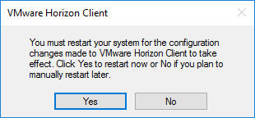

Part 2 – Download Software

Step 1
With an internet connection, browse to http://www.health.gov.au/remote and download the new versions of the BIP-IP Edge Client and the VMware Horizon Client to your computer.

Part 3 – Installing the BIG-IP Edge Client

Step 1
Open the location you downloaded the BIG-IP Edge Client to (by default this will be your Downloads folder) and double click the BIGIPEdgeClient.exe file to launch the installation.
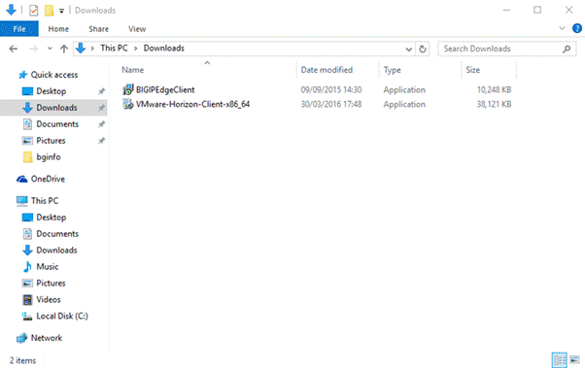

Step 2
Click Next in the BIG-IP Edge Client Setup Wizard window to proceed.
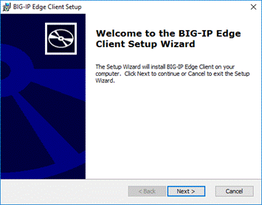

Step 3
Click Install in the Ready to Install window to start the installation process.
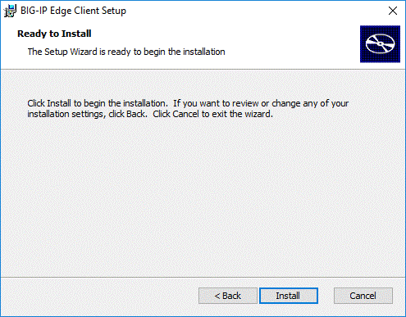

Step 4
Click Yes to agree to the User Account Control message to proceed with installation process.
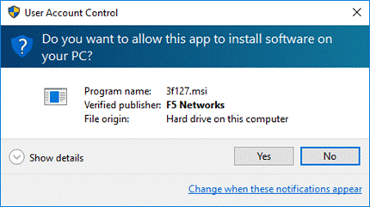

Step 5
Click Finish in the Completing the BIG-IP Edge Client Setup Wizard window to finish the installation process and exit the Setup Wizard.
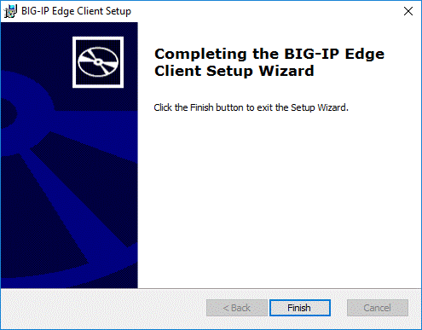

Part 4 – Pin the BIG-IP Edge Client to your Start Menu (optional)

Step 1
Click the Start button and select All Apps.
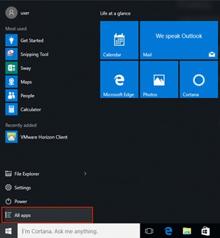

Step 2
Right click BIG-IP Edge Client and select the Pin to Start menu item.
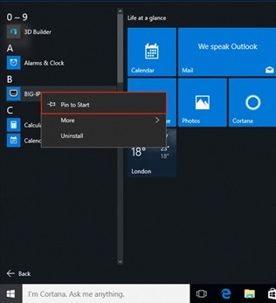

Step 3
The BIG-IP Edge Client icon will now be available in your start menu
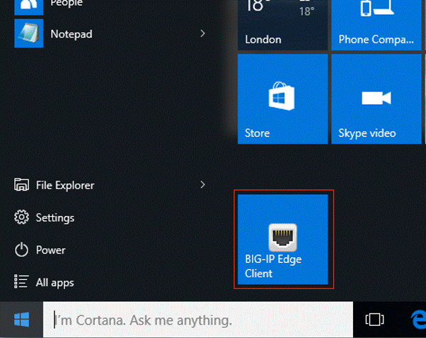

Part 5 – Installing the VMware Horizon Client

Step 1
Open the location you downloaded the VMware Horizon Client to (by default this will be your Downloads folder) and double click the VMware-Horizon-Client-x86_64 file to launch the installation. Note if you are running an older 32 bit Windows version, you will need to use the VMware-Horizon-Client-x86 file instead.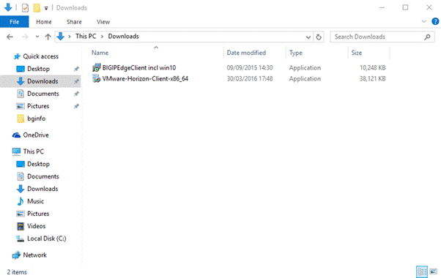

Step 2
Click Yes to agree to the User Account Control message to proceed with installation process.
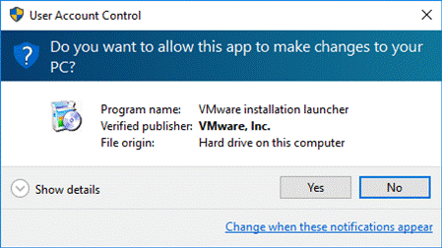

Step 3
Click I Agree & Install in the VMware Horizon Client Setup window to proceed.
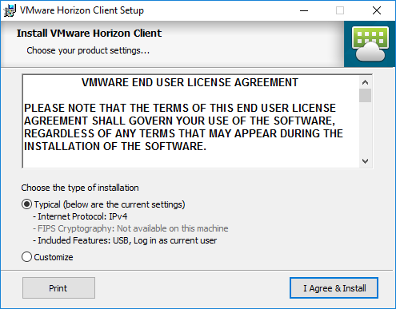

Step 4
Wait while the client installs
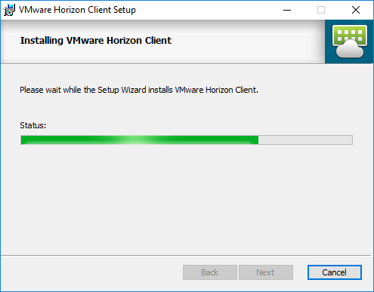

Step 5
Click Finish in the Completed the VMware Horizon Client Setup Wizard to finish the installation process and exit the Setup Wizard.
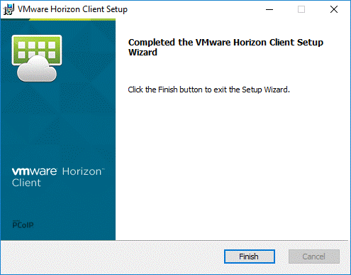

Step 6
Click Yes in the VMware Horizon Client Setup window to restart your system.
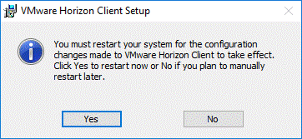

You can now logon to the Health IT Network using remote access.

