Application 1396 – Noninvasive prenatal testing for common trisomies.
The Department of Health is seeking your feedback on the draft protocol for Application 1396 – Noninvasive prenatal testing for common trisomies. Please note, this protocol is yet to be considered by the Protocol Advisory Sub-committee (PASC), a sub-committee of the Medical Services Advisory Committee.

Please reply to the HTA Team
Postal: MDP 853 GPO 9848 Canberra ACT 2601
Fax: 02 6289 3561
Phone 02 6289 7550
Email: HTA@health.gov.au

Your feedback is required by cob 14 November 2014 to enable PASC to consider, when it reviews this protocol, at its meeting of 11-12 December 2014.

PERSONAL AND ORGANISATIONAL INFORMATION
1. What is your name? ____________________________________________________________________
2. Is the feedback being provided on an individual basis or by a collective group?
Individual
Collective group. Specify name of group (if applicable) _____________________________________
3. What is the name of the organisation you work for (if applicable)? _______________________________
4. What is your e-mail address? _____________________________________________________________
5. Are you a:
- General practitioner
- Specialist
- Researcher
- Consumer
- Care giver
- Other (please specify) ___________________________________________________________________________

MEDICAL CONDITION (DISEASE)
Trisomies 21, 18 and 13 together account for ~70% of all major chromosomal aneuploidies. All three trisomies are associated with physical and intellectual disability, and increased mortality.

PROPOSED INTERVENTION
Prenatal testing for fetal Down syndrome, which is caused by trisomy 21 (T21), and testing for other genetic conditions is the standard of care for the majority of the three hundred thousand women who give birth each year in Australia.
Harmony is a genetic test which assesses the risk of fetal aneuploidies via analysis of cell-free DNA (cfDNA) in maternal blood. As fetal cfDNA represents a direct analyte of Down syndrome (trisomy 21) and other aneuploidies (trisomies 18 and 13), the Harmony test is a more accurate screening test for these trisomies than traditional screening tests such as ultrasound and maternal blood testing. Harmony has been analytically validated as per the Clinical Laboratory Improvement Act and College of American Pathologists regulatory requirements

CLINICAL NEED AND PUBLIC HEALTH SIGNIFICANCE
- Describe your experience with the medical condition (disease) and/or proposed intervention relating to the draft protocol?

- What do you see as the benefits of this proposed intervention for the person involved and/or their family and carers?

- What do you see as the disadvantages of this proposed intervention for the person involved and/or their family and carers?

- How do you think a person’s life and that of their family and/or carers can be improved by this proposed intervention?

- What other benefits can you see from having this proposed intervention publicly funded on the Medical Benefits Schedule (MBS)?

INDICATION(S) FOR THE PROPOSED INTERVENTION AND CLINICAL CLAIM
Flowchart of existing and potential management with the proposed intervention for this medical condition.

Current pathway for first trimester prenatal screening
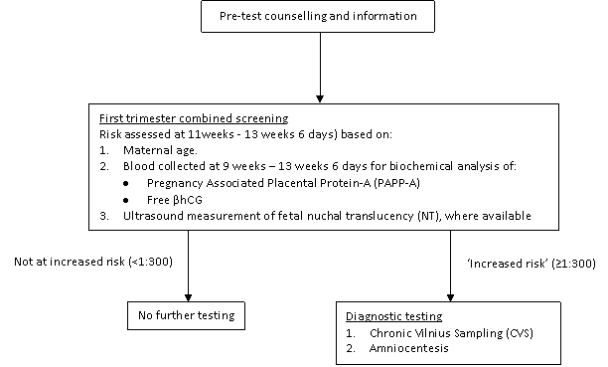
Source: Adapted from RANZCOG (2010)

Expected pathway with Harmony funded for a general pregnancy population

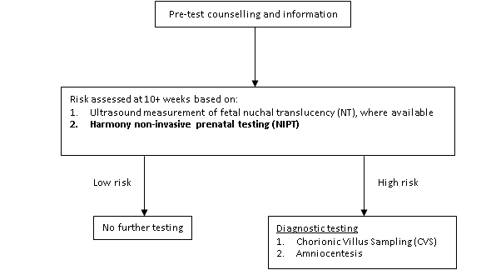

- Do you agree or disagree with the eligible population for the proposed intervention as specified in the proposed management flowcharts?

Strongly agree
Agree
Disagree
Strongly disagree
Why or why not?

- Do you agree or disagree with the comparator for the proposed intervention as specified in the current management flowchart?

Strongly agree
Agree
Disagree
Strongly disagree
Why or why not?

- Do you agree or disagree with the clinical claim (outcomes) made for the proposed intervention?

Strongly agree
Agree
Disagree
Strongly disagree
Why or why not?

- Have all associated interventions been adequately captured in the flowchart?
Yes
No

If not, please move any misplaced interventions, remove any superfluous intervention, or suggest any missing interventions to indicate how they should be captured on the flowcharts. Please explain the rationale behind each of your modifications.

ADDITIONAL COMMENTS
- Do you have any additional comments on the proposed intervention and/or medical condition (disease) relating to the proposed intervention?

- Do you have any comments on this feedback form and process? Please provide comments or suggestions on how this process could be improved.

Thank you again for taking the time to provide your valuable feedback.
If you experience any problems completing this on-line survey please contact the HTA Team
Phone 02 6289 7550
Postal: MDP 853 GPO 9848 Canberra ACT 2601
Fax: 02 6289 3561
Email: HTA@health.gov.au

