Public Summary Document

Application No. 1313– Bone mineral density analyses using Dual Energy X-ray Absorptiometry (DXA) in breast cancer patients receiving aromatase inhibitor treatment

Applicant: Australian and New Zealand Bone Mineral Society

Date of MSAC consideration: MSAC 64th Meeting, 30-31 July 2015

Context for decision: MSAC makes its advice in accordance with its Terms of Reference, see at www.msac.gov.au

Purpose of application and links to other applications

An application requesting MBS listing of bone densitometry dual energy X-ray absorptiometry (DXA) for post-menopausal women with early stage breast cancer who receive, or are being considered for, treatment with aromatase inhibitors, was received from the Australian and New Zealand Bone and Mineral Society (ANZBMS).

MSAC deferred the application in November 2014 and requested further external evaluation of the economic modelling. The evidence for assessment of this application was submitted in May 2015.

MSAC’s advice to the Minister

After considering the available evidence presented in relation to safety, clinical effectiveness and cost-effectiveness of bone densitometry dual energy X-ray absorptiometry (DXA), MSAC did not support public funding because of uncertain and unacceptably high cost-effectiveness in the proposed setting.

Summary of consideration and rationale for MSAC’s advice

MSAC recalled that the previous application was deferred to seek further external evaluation of the economic modelling, especially of the estimates of elevated fracture risks and prescription drug costs.

MSAC noted there were no studies presented of the analytical or clinical validity of DXA in women taking aromatase inhibitors, and so these needed to be extrapolated from other studies of DXA. The results for the updated data indicated that DXA scanning and anti-resorptive therapy in women receiving aromatase inhibitor treatment is superior to placebo for BMD loss in the lumbar spine and hip and may be effective at reducing the relative risk of fractures (but with a high level of unexplained between study heterogeneity). MSAC noted that there were fewer bone fractures in women taking aromatase inhibitors who also took anti-resorptives than in women taking aromatase inhibitors who did not take anti-resorptives, the difference in rate of fracture was not statistically significant. However, MSAC considered that the claimed superiority was biologically plausible, particularly as there is no clinical reason why anti-resorptives would work differently in patients taking aromatase inhibitors.

MSAC noted that the cost estimates used in this application assume that the target population can access PBS-subsidised anti-resorptives, however this would require an application to the PBAC for at least one of these medicines in order to broaden the current eligibility criteria to include women who meet the proposed criteria to start anti-resorptive treatment.

MSAC considered that most of the amended model inputs to the economic model were reasonable but expressed concern with the limited clinical benefit. MSAC noted that the ICERs were considerably less favourable than generated by the versions of the model considered previously. MSAC expressed concern with the large difference in the ICER for the base case scenario, which was approximately $47,000 when only women (aged 60 years) with osteoporosis on aromatase inhibitors were included, compared to when women with osteopenia were also included and the ICER increased to over $250,000. MSAC also noted that the ICER increased in the younger population (aged 50 years) and decreased for the older population (aged 65 years). Overall, MSAC judged that use of DXA scanning in the population of women over 50 years with osteopenia or osteoporosis that are taking aromatase inhibitors was not acceptably cost-effective. MSAC considered that it would be impractical in this context to attempt to limit the use of non-subsidised anti-resorptives to osteoporosis and not osteopenia.

Background

At the November 2014 meeting, MSAC deferred the application to seek further external evaluation of the economic modelling, especially of the estimates of elevated fracture risks and prescription drug costs.

MSAC separately supported amending the current MBS items for BMD analysis to allow trained technicians to perform DXA scanning under the supervision of a medical practitioner. MSAC considered that this should also involve a fee review of these items.

Comparative safety

In November 2014, MSAC noted that there were no studies that assessed the safety of DXA scans in the population of interest. However, DXA in general, is a widely used technique that is considered to be safe, being non-invasive, and using low levels of radiation, the equivalent of two to four days of background radiation.

Comparative effectiveness

Information of DXA performance
DXA came into practice in 1987 and has since been recognised as the gold standard of BMD measurement. It has very low radiation doses, high image resolution, precision and stable calibration of the instruments. With supporting data on normal BMD ranges for different population groups, DXA allows for an immediate diagnosis of whether a person has osteopenia or osteoporosis.

The Assessment Report identified seven studies which assessed the effectiveness of DXA in predicting fractures compared with fracture risk tools. The performance of DXA is also determined by manufacturer quality control factors. Analytical performance of BMD is influenced by device, operator performance, and physiological composition, therefore good quality control of the DXA device and use is important (Homik and Hailey 1999).

Methods to assess treatment effects on change in BMD
A systematic review of fourteen studies was undertaken on the efficacy of treatments for aromatase-inhibitor-associated bone loss.

Although there were several systematic reviews and meta-analyses on anti-resorptive bone treatment efficacy in women taking aromatase-inhibitors (Perez and Weilbaecher 2006, Hadji, Aapro et al. 2011), they included many studies that have been superseded by more recent reports of outcomes from longer follow-ups. With updated data, the findings were presented both descriptively, using bar graphs and summary table, and statistically using a random-effects meta-analysis. The key treatment outcome in the main trials was percentage change in BMD of the lumbar spine and hip. Negative BMD change values indicate bone density loss while a positive BMD change indicate the favourable outcome of bone density gain.

The percentage change in BMD results are summarised graphically below.

Figure 1: % change in BMD lumbar spine of studies on treatments for AI-associated bone loss

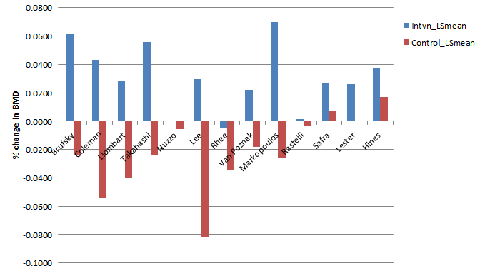

NB: Control group for Bruksky, Coleman, Llombart, Hines and Takahashi was ‘delayed zoledronic acid’ not placebo.

Figure 2: % change in BMD total hip of studies on treatments for AI-associated bone loss
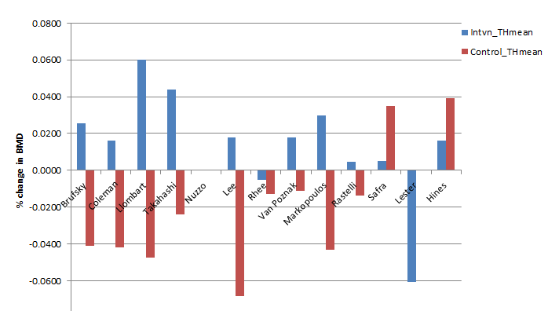
NB: Control group for Bruksky, Coleman, Llombart, Hines and Takahashi wais ‘delayed zoledronic acid’ not placebo.

A meta-analysis was performed using a random effects model. Where BMD was recorded for different follow-up times, the BMD of the longest follow-up period was included. Study heterogeneity was assessed using the I² statistic where >50-74% was considered moderate heterogeneity and ≥75% was considered high heterogeneity. Analyses were undertaken for BMD lumbar spine and total hip outcomes. Subgroup analyses were undertaken, by early or longer follow up period (≤ or > 24 months) and by zoledronic acid versus other bone treatment.

Interpretation of results of change in BMD
The presentation of the trial results for ‘percentage change in BMD’ was in terms of standardised mean difference. For BMD lumbar spine, the standardised mean difference between the intervention and comparator arms were 1.46% and for BMD total hip was 1.48%.

The revised meta-analyses present the results of the mean difference across treatment arms in percentage change in BMD over time in Tables 1 and 2, consistent with the bar graphs in the Assessment Report.
Table 1: Mean difference in treatment arms in percentage change in BMD (hip) by study

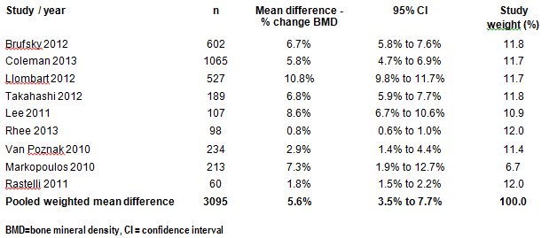
Figure 3: Forest plot of mean difference in % change in BMD (total hip)
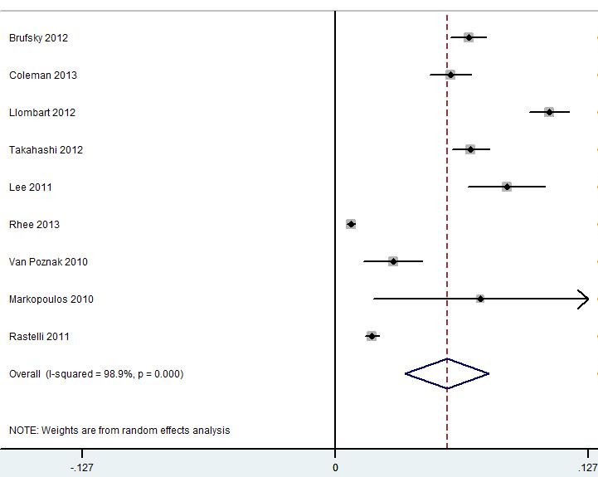
Favours comparator Favours treatment
Table 2: Mean difference in treatment arms in percentage change in BMD (lumbar spine) by study

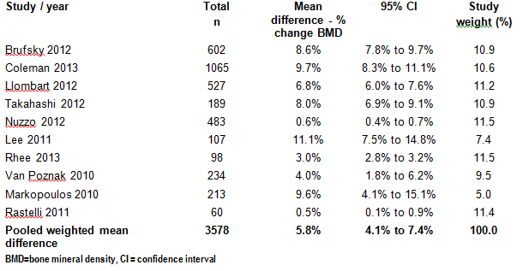

Figure 4: Forest plot of mean % change in BMD (lumbar spine)
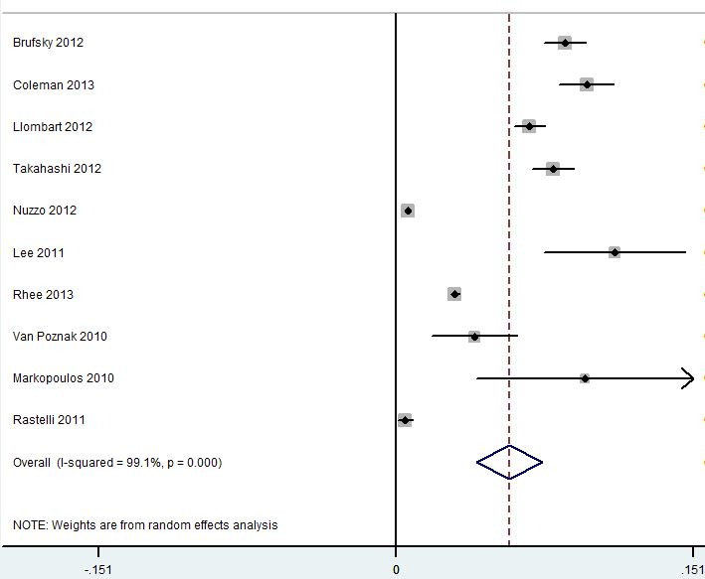
Favours comparator Favours treatment

The findings of the meta-analysis show a pooled effect of 5.6% difference across groups in the change in BMD (95%CI: 3.5% to 7.7%) at the hip and 5.8% (95%CI: 4.1% to 7.4%) at the lumbar spine. The pooled findings show positive bone density and are consistent and significant. Based on updated data, they indicate a superior benefit of anti-resorptive therapy for women with breast cancer on aromatase inhibitors for increasing bone density compared with no treatment.

However, study heterogeneity was problematic and high as indicated by I² ≥90.0%. No study dominated these results as they equally contributed to the final results (between 9-12%) (Tables 1 and 2). The three key studies with the largest sample sizes and five-year follow-ups, Brufsky 2012, Coleman 2013 and Llombart 2012, produced consistent results.

Balance of benefits and harms for BMD management
The intervention proposed in the application, DXA and anti-resorptive treatment, as shown by the evidence in this assessment, is superior to placebo for BMD loss in the lumbar spine and hip and may be superior in terms of bone fractures. Although fewer bone fractures were observed in the trials in women taking AR, the numbers were low and a lack of statistical power was the likely reason for a lack of statistical significance.

Table 3 below summarises the comparative benefits and harms for ‘DXA plus anti-resorptives’ compared with placebo, based on the trials identified in the systematic review.

The common adverse events reported by women in the AI trials on anti-resorptive treatments were arthralgia, hot flushes, fatigue, myalgia, bone pain and fever. Arthralgia, fever, hot flushes and fatigue are also common symptoms for AI treatment making the attribution of them to AI or AR therapy blurred.

Table 3: Summary of comparative benefits and harms for DXA plus ARs and PBO

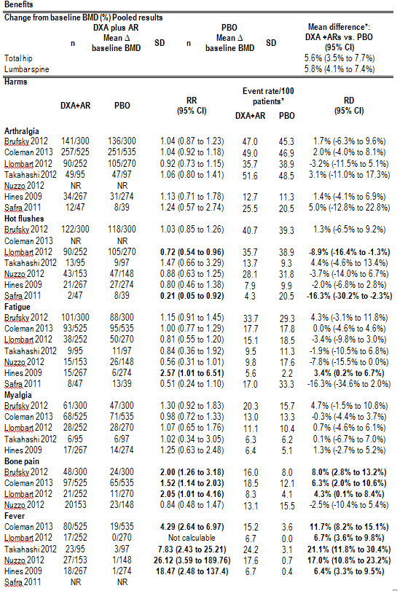
* Median duration of follow-up; 5 years (Brufsky 2012, Coleman 2013, Llombart 2012, Safra 2011), 24 months (Hines), 12 months (Takahashi 2012, Nuzzo 2012)
Abbreviations: PBO = placebo; RD = risk difference; RR = risk ratio
Source: Compiled during the evaluation

Zoledronic acid was the only anti-resorptive used in the studies reporting harms in Table 3. With women on AR therapy, there were a significantly higher proportion of women experiencing bone pain and fever in the studies. There appeared to be a protective effect of hot flushes in two studies (Safra, Bernstein-Molho et al. 2011, Llombart, Frassoldati et al. 2012). Also fatigue was found in one study (Hines, Mincey et al. 2009). Not all studies reported all types of adverse events or only reported them selectively.

Due to the higher occurrence of bone pain and fever in patients and fever that would likely be managed by over-the-counter medication, these additional resources were considered in the financial estimates for consumers. They were not included in the economic model as they would not likely to impact over a 40-year duration.

Economic evaluation

A summary of the revisions in the economic model are provided in Table 4 below.

Table 4: Changes to inputs for the revised economic model
Concern | Current model estimates | Revised model estimates
DXA frequency | Annual | Baseline, 24 months, 48 months
RR of fx due to osteoporosis | 3.75, sensitivity analysis: 3.5 and 4.0 | 3.75, sensitivity analysis: 2.0 and 5.0
RR of fx due to AR therapy | 0.66, sensitivity analysis: 0.40 and 0.85 | 0.70¹, sensitivity analysis: 0.40 and 0.85
Cost of fx | - Hip fx $17,515 (±30% $12258, $22766)  - Spine fx $11,974 (±30% $8381, $15566)  - Other fx $2,416 (±30% $1691, $3141) | Taking a wider account of costs and allowing for inpatient and outpatient scenarios:  - Hip fx $23,695 (±30% $16,586, $30,803)  - Spine fx $5,753 (±30% $4,027, $7,479)  - Other fx $9,158 (±30% $6,411, $11,905)
Survival of women on AR | QALYs only | Life years saved added as an outcome
AR therapy adherence | 100% adherence | 40.5% adherence² (applied in model through RR of fx while on AR allowing for non-adherence)
RR of fx while on AR allowing for non-adherence | Not applicable | RR of fx 1.20 (1.07, 1.35)²
AR price allowing for non-adherence | $619.80 per year | $428.28 per year (modified by non-adherence)
Cost of zoledronic acid treatment | $1252 per year | $589 per year
Correction to probability of fracture in model | Model originally had fractures underestimated and not cycling through the fracture risk tables correctly. | Corrected.
AR = Anti-resorptive, DXA = dual absorptiometry X-ray, fx = fracture, RR = relative risk, QALYs = quality adjusted life years
- Based on a meta-analysis during evaluation.
- Based on Modi 2015 where the non-adherence rate was 59.5%, or adherence 40.5% (Modi, Siris et al. 2015).

The model was revised and the updated results are provided below in Tables 5 and 6. Table 5 presents the outcomes for a 60 year old cohort over their remaining lifetime and costs and effects discounted at 5%. The results for the subgroup of DXA and AR for all women with breast cancer on AI therapy (i.e., regardless of T-score) is not shown as this subgroup is unlikely to be realistic in clinical practice. The costs are in 2014 Australian dollars.
Table 5: Key results of economic evaluation
60 year old cohort, discounted | Mean Costs | Mean QALYs | Inc Costs | Inc QALYs | ICER
Previous base case | - | - | - | - | -
No DXA and lifestyle advice only (all women) | $4,056 | 11.657 | ref | ref | ref
DXA + ARtx (osteoporosis) | $5,331 | 11.956 | $1,275 | 0.299 | $4,264
DXA + ARtx (osteoporosis + osteopenia) | $10,249 | 11.959 | $6,193 | 0.302 | $20,507
Revised base case | - | - | - | - | -
No DXA and lifestyle advice only (all women) | $7,545 | 11.822 | ref | ref | ref
DXA + ARtx (osteoporosis) | $7,973 | 11.831 | $428 | 0.009 | $47,556
DXA + ARtx (osteoporosis + osteopenia) | $10,581 | 11.834 | $3,036 | 0.012 | $253,000
ARtx = Anti-resorptive therapy, DXA = dual absorptiometry X-ray, ICER = incremental cost effectiveness ratio, inc = incremental, QALYs = quality adjusted life years

Over their remaining lives, for a cohort of 60 year old women with breast cancer taking AIs, the mean cost for DXA plus AR therapy for osteoporosis was estimated at $7,973 compared with $7,545 for risk assessment plus lifestyle advice. The corresponding mean QALYs were 11.831 and 11.822, respectively. Consequently, the incremental cost per QALY ratio, for women with osteoporosis, was $47,556 per QALY gained. The ICER was considerably higher for women receiving DXA plus AR therapy with osteoporosis or osteopenia where the mean costs drove up the ICER to $253,000.

The results for fractures and life years saved are presented in Table 6. The costs and effects are undiscounted. Fractures are expressed as per 1000 women.

Table 6: Results of economic evaluation (60 year old cohort, undiscounted, life years saved and fractures)
Intervention | Mean Costs | Mean Effects | Inc Costs | Inc Effects | ICER
- | - | LYS | - | LYS | LYS
No DXA and lifestyle advice only (all women) | $21,062 | 25.593 | ref | ref | ref
DXA + ARtx (osteoporosis) | $21,449 | 25.626 | $387 | 0.033 | $11,727
DXA + ARtx (osteoporosis + osteopenia) | $25,811 | 25.632 | $4,749 | 0.039 | $121,769
- | - | Fx per 1000 | - | Fx avoided | ICER  Fx avoided
No DXA and lifestyle advice only (all women) | $21,062 | 887 | ref | ref | ref
DXA + ARtx (osteoporosis) | $21,449 | 831 | $387 | 56 | $6,911
DXA + ARtx (osteoporosis + osteopenia) | $25,811 | 810 | $4,749 | 77 | $61,675
ARtx = Anti-resorptive therapy, DXA = dual absorptiometry X-ray, fx = fracture, ICER = incremental cost effectiveness ratio, LYS = life years saved, QALYs = quality adjusted life years

The predicted additional survival was 12-14 days for women in the two DXA and AR therapy treatment groups. The small survival gain is most likely due to women in all three groups having similar outcomes as they age, irrespective of the short-lived benefits of the reduced fracture risk during the five years of AI treatment when women are 60 years old at the start. The number of fractures avoided was 56-77 over the 40 year model duration.

Sensitivity analyses were completed for different starting age cohorts; 50 and 65 year old women and presented in Table 7.

Table 7: Results of economic model by starting age cohorts
Type of sensitivity analysis | Costs | QALYs | Inc Costs | Inc QALYs | ICER
60 year olds (base case) | - | - | - | - | -
No DXA and lifestyle advice | $7,545 | 11.822 | ref | ref | ref
DXA and ARtx (osteoporosis) | $7,973 | 11.831 | $428 | 0.009 | $47,556
DXA and ARtx (osteoporosis and osteopenia) | $10,581 | 11.834 | $3,036 | 0.012 | $253,000
50 year olds | - | - | - | - | -
No DXA and lifestyle advice | $5,098 | 13.648 | ref | ref | ref
DXA and ARtx (osteoporosis) | $5,797 | 13.654 | $699 | 0.006 | $116,500
DXA and ARtx (osteoporosis and osteopenia) | $8,991 | 13.656 | $3,893 | 0.008 | $486,625
65 year olds | - | - | - | - | -
No DXA and lifestyle advice | $7,616 | 10.679 | ref | ref | ref
DXA and ARtx (osteoporosis) | $8,009 | 10.689 | $393 | 0.010 | $39,300
DXA and ARtx (osteoporosis and osteopenia) | $10,370 | 10.693 | $2,754 | 0.014 | $196,714
ARtx = Anti-resorptive therapy, DXA = dual absorptiometry X-ray, ICER = incremental cost effectiveness ratio, QALYs = quality adjusted life years

The model predicted that interventions confined to 50 year old women with breast cancer on AI therapy would not be cost effective (ICERs >$116,000) due to the lack of benefit arising. In older women aged 65 years, the interventions were more cost-effective due to lower incremental costs and QALYs proportionally. In no age group was the intervention cost-effective in the larger group of women with osteoporosis or osteopenia.

One-way sensitivity analyses were conducted for all other variables in the model. The most influential inputs are presented in Table 8.

Table 8: One-way sensitivity analysis for incremental cost per QALY (discounted)
Parameter | Range tested | ICER ($/QALY) DXA + AR Osteoporosis  (T-score≤-2.5) | ICER ($/QALY)  DXA + AR Osteoporosis  or osteopenia  (T-score≤-1.0)
Base case | - | $47,556 | $253,000
Probability of osteoporosis at start | 0.089 - 0.21 | -$1068, $155,358 | $177,356, $334,789
Weighted RR of fracture in all women | 1.57 to 1.80 | $16,409, $147,892 | $161,529, $433,450
RR of a fracture in osteoporosis | 2.0-5.0 | $11,898, $76,326 | $241,289, $241,289
Discount rate for effects | 0.0 - 0.07 | $12,621, $74,531 | $74,161, $373,184
RR of excess death from 1st fracture | 2.52 - 3.27 | $41,424, $93,528 | $218,414, $472,116
RR of fracture in aromatase inhibitors therapy with AR | 0.4 - 0.85 | $14,188, $64,428 | $52,680, $117,1183
Cost of AR therapy | $428 – $626 | $45,913, $80,780 | $241,289, $373,073
Fracture risk adjustment factor for non-adherence with AR treatment | 1.07 - 1.35 | $36,971, $56,854 | $152,960, $499,737
Background utility for early stage breast cancer | 0.728 - 0.986 | $41,094, $52,013 | $217,006, $271,689
RR of excess death from 2nd fracture | 1.74 - 2.92 | $40,758, $50,803 | $214,480, $266,659
Probability of a 2nd fracture | 0.57 - 0.92 | $41,270, $50,465 | $220,775, $261,528
Cost of a hip fracture | $16,586-$30,803 | $41,613, $49,725 | $236,356, $245,661
Cost of spine fracture | $4,027-$7,479 | $43,856, $47,152 | $238,854, $242,755
Discount rate for costs | 0.07 - 0.0 | $41,478, $44,040 | $208,076, $377,391
AR = Anti-resorptive therapy, DXA = dual absorptiometry X-ray, ICER = incremental cost effectiveness ratio, QALYs = quality adjusted life years; RR = relative risk
Bolded = 5 most influential variables for broader group.

These one-way sensitivity findings show that the model is relatively unstable to changes in the above variables. The ICER moves below or above $50,000 per QALY with variation to the estimates. The most important drivers of the model were the probability of women with osteoporosis, the relative risk of fracture for all women, relative risk of fracture in osteoporosis discount rate of QALYs, relative risk of fracture in AI and AR and the non-adherence of AR (via reduced bone treatment effect).

A probabilistic sensitivity analysis was undertaken using 5000 simulations. This provides the likelihood of the model having cost-effective results below the cost per QALY threshold of $50,000. The results of these analyses are provided in Table 9.

Table 9: Results of the probabilistic sensitivity analysis
Type of Sensitivity Analysis | % cost-effective (<$50,000 per QALY gain)
No DXA and lifestyle advice | ref
DXA and ARtx (osteoporosis) | 50.8%
DXA and ARtx (osteoporosis and osteopenia) | 6.0%
AR = Anti-resorptive therapy, DXA = dual absorptiometry X-ray, QALYs = quality adjusted life years

The outcome of the above analysis suggests that in about half of the interventions, the intervention of DXA plus AR therapy for women with osteoporosis is cost-effective when a threshold of $50,000 per QALY is used. It would not be a cost-effective intervention for a broader group of women who had either osteoporosis or osteopenia.

Model validation

The model was assessed for internal and external validity.

To assess the reliability of the model outputs, the predicted survival and number of fractures were compared with those from other Australian sources. These are summarised in Table 10. The type of model, the starting age and source for the relative fracture risk estimate were the same (Table 10).

Table 10: Comparison of outcomes from our model with external studies
Parameter | External evidence | Economic model predictions
Survival | ABS Life Tables: 60 year old women life expectancy is 26.4 years or age 86.4 years. | Mean survival (LYS) = 25.593-25.632 years or age 85.6 years
Survival | AIHW Cancer in Australia Women with early-stage breast cancer 5-year survival rate 97% | Adjustment in the model was made for early-stage breast cancer survival and would contribute to the lower mean survival above.
Incidence of fractures | Lifetime risk of osteoporotic fractures >50 years : 440 to 560 cases per 1000 women  Tasmanian Older Adult Cohort = 44%  Geelong Osteoporosis Study = 42%  Dubbo Study = 56%  Source: (Watts, Abimanyi-Ochom et al. 2013) | 810 to 887 fractures per 1000 women. Although this seems high in the economic model, the model includes women experiencing second fractures which are a large proportion (73%) (Kanis, Johnell et al. 2004).
Incidence of fractures | Fractures during AR therapy, observational US data >32,000 women, 50% osteoporosis  Fractures: % women with first fracture at 12 months ranged 1.2% to 1.5%, therefore 1.5% x 1000 x 40 years = 600 fractures expected per 1000 women.  Source: (Silverman, Watts et al. 2007) | As above. Includes first fractures only.  Although this is not Australian, it is a prospective observational study including women from all backgrounds.
ABS = Australian Bureau of Statistics; AIHW = Australian Institute of Health and Welfare; LYS = life years saved

The economic model predicted reasonably close estimates of numbers of fractures and survival as expected when compared with other sources.

External validity of the revised model was assessed by comparing the model features and outcomes to those from existing cost-effectiveness studies from other countries.

Overall, the results from the applicant’s model seem to be reasonably close for the group of women with osteoporosis but somewhat outside the other findings for the larger group with osteoporosis or osteopenia. The incremental QALYs in the applicant’s model were similar compared with the UK and US study findings. The incremental costs appear similar across all three studies. The model findings were closest to the values from the UK report with ICERs of £16,069 to £24,868 per QALY (Logman, Heeg et al. 2010). The number of fractures averted predicted from the applicant’s model, 53-73 per 1,000 patients appear to be at the high end of the UK study.

Financial/budgetary impacts

Current pricing issues of anti-resorptive therapies

The bone anti-resorptive medications available on the PBS for osteoporosis are available to persons if they have osteoporosis as defined by a T-score ≤-2.5 and they are at least 70 years old. In women diagnosed with breast cancer in Australia, 64% are aged between 45-69 years and on average are diagnosed at age 60 (Australian Institute of Health and Welfare 2014). Therefore, anti-resorptives for two-thirds of the target group are not currently available for PBS subsidy and would currently need to be prescribed outside the PBS and paid for by the patient.

If a sponsor applied for broader eligibility criteria to women of earlier ages or specifically aligned with the population proposed in this application, the pricing would apply as detailed further below. The financial estimates therefore assume that risedronate is available through the PBS to the target population of this application.

Frequency of DXA scans

Annual DXA scan frequency was the base case in the Assessment Report. This was because annual scans matched the proposed MBS item description for the target population where it is worded as ‘no more than every 12 months’, which aligns with current practice guidelines and appears to be current practice for a proportion of women with breast cancer in Australia according to the feedback from the Breast Cancer Network Australia. Two-yearly scans were tested in sensitivity analyses. The Australian and New Zealand Bone and Mineral Society (ANZBMS) has said there is no consensus on the frequency of scans in the target population.

At the request of ESC and MSAC, both the economic model and financial estimates have been revised to include an initial scan in the first year and follow up scans at Years 3 and 5.

Eligibility for DXA scans via existing MBS items and for PBS therapies

For existing MBS items for DXA scans, the most applicable items that could apply to the target group are items relating to persons with comorbid conditions; 12306, 12309, 12312, 12315, and 12318 (Box 1). All these items have the same scheduled fee $102.40 and this is also the nominated fee for the proposed MBS item. Assessing any replacement of one MBS DXA item for the proposed MBS item would therefore mean a cost-neutral effect on the financial assessment. Therefore, no adjustments in the financial estimates were made for this issue.
The number of women with early-stage breast cancer and taking AI therapy with the concurrent conditions listed in Box 1 is unknown. The MBS item 12312 for DXA BMD is available for women with premature menopause before the age of 45 years with one service only in a period of 12 months. This may apply to women where premature menopause is an adverse event of chemotherapy treatment and possibly other adjuvant treatments for breast cancer. It is estimated up to 50% of women younger than 40 years would develop permanent premature menopause. However, this would represent a small number of women each year diagnosed with breast cancer (approximately 767 x 50% = 384) and not all of these would have early-stage disease.

Box 1. Eligibility for DXA items on MBS where concurrent conditions apply

For Items 12306 and 12309 the referral should specify the indication for the test, namely:
(a) 1 or more fractures occurring after minimal trauma; or
(b) monitoring of low bone mineral density proven by previous bone densitometry.

For Item 12312 the referral should specify the indication for the test, namely:
(a) prolonged glucocorticoid therapy;
(b) conditions associated with excess glucocorticoid secretion;
(c) male hypogonadism; or
(d) female hypogonadism lasting more than 6 months before the age of 45.

For Item 12315 the referral should specify the indication for the test, namely:
(a) primary hyperparathyroidism;
(b) chronic liver disease;
(c) chronic renal disease;
(d) proven malabsorptive disorders;
(e) rheumatoid arthritis; or
(f) conditions associated with thyroxine excess.

For Item 12318 the referral should specify the indication for the test, namely:
(a) prolonged glucocorticoid therapy;
(b) conditions associated with excess glucocorticoid secretion;
(c) male hypogonadism;
(d) female hypogonadism lasting more than 6 months before the age of 45;
(e) primary hyperparathyroidism;
(f) chronic liver disease;
(g) chronic renal disease;
(h) proven malabsorptive disorders;
(i) rheumatoid arthritis; or
(j) conditions associated with thyroxine excess.

Costs to the MBS for general practitioner visits

The applicant’s financial estimates have been revised to include two standard GP visits (item 23), originally there was only one GP visit added.

Co-payment for risedronate and safety net considerations

Based on the prescriptions for aromatase inhibitors medications on the PBS for the previous 12 months, letrozole, anastrazole and exemestane, the total number of scripts were $486,604. The financial estimates were modified to account for the PBS and patient co-payment disbursements above.

Adherence to risedronate

The adherence rate of risedronate was revised down according to Modi 2015 reflecting osteoporotic medication in the general post-menopausal women population, 40.5% were adherent. This was assumed to be constant for five years.

Revised financial estimates

The financial estimates were updated to include the revised estimates above. Also, the cost of fractures avoided used a weighted cost $14,855 based on updated fracture costs.

The PBS costs assume access to anti-resorptives by the target population. Currently this is not the case and an alternative approach is to view PBS costs as zero and view these as paid by consumers in full.

The results of the revised calculations are provided in Table 11.

Table 11: Results of the financial estimates over the next five years
Eligible population | Year 1 | Year 2 | Year 3 | Year 4 | Year 5
Incidence of women with brca aged 50-69 | 8108 | 8293 | 8479 | 8665 | 8851
Proportion with early stage | 7297 | 7464 | 7631 | 7798 | 7966
Proportion taking aromatase inhibitors | 5911 | 6046 | 6181 | 6317 | 6452
Total number of women each year | 5911 | 11956 | 18138 | 24454 | 30906
Estimated uptake of DXA scans | Year 1 | Year 2 | Year 3 | Year 4 | Year 5
Number of scans if at baseline, then at 24 and 48 mths | 5911 | 6046 | 12092 | 12363 | 18544
Estimated women taking anti-resorptives | Year 1 | Year 2 | Year 3 | Year 4 | Year 5
Proportion of women with osteoporosis | 866 | 1752 | 2657 | 3583 | 4528
Total women treated | 866 | 1752 | 2657 | 3583 | 4528
MBS Costs | Year 1 | Year 2 | Year 3 | Year 4 | Year 5
DXA scans | $514,510 | $1,040,770 | $1,578,913 | $2,128,721 | $2,690,367
Vitamin D tests | $150,969 | $154,427 | $157,886 | $161,344 | $164,802
GP visits | $429,103 | $868,036 | $1,316,798 | $1,775,389 | $2,243,810
PBS Costs of anti-resorptives (risedronate 8749Y) | Year 1 | Year 2 | Year 3 | Year 4 | Year 5
General ordinary patients 36% | $29,551 | $59,779 | $90,684 | $122,266 | $154,525
General safety net patients 2% | $8,209 | $16,605 | $25,190 | $33,963 | $42,924
Concessional ordinary 50% | $205,216 | $415,133 | $629,750 | $849,069 | $1,073,088
Concessional free safety net 12% | $56,858 | $115,018 | $174,481 | $235,246 | $297,313
Compliance rate of anti-resorptive | 40.5% | 40.5% | 40.5% | 40.5% | 40.5%
Total cost of anti-resorptives | $121,433 | $245,647 | $372,643 | $502,420 | $634,979
Hospital cost savings from fracture prevention | Year 1 | Year 2 | Year 3 | Year 4 | Year 5
Expected incidence of fractures (all women on AI) | 85 | 172 | 261 | 352 | 445
Number of women untreated (no osteoporosis) | 5045 | 10205 | 15481 | 20872 | 26379
Number of fractures in untreated women | 73 | 147 | 223 | 301 | 380
Number of fractures in treated women | 9 | 18 | 27 | 36 | 46
Fractures prevented | 4 | 8 | 11 | 15 | 20
Cost of fractures avoided (weighted mean AR-DRG) | $14,855 | $14,855 | $14,855 | $14,855 | $14,855
Total cost savings | - $55,567 | - $112,406 | - $170,518 | - $229,903 | - $290,561
TOTAL MBS COSTS | $1,094,583 | $1,548,759 | $2,527,275 | $3,012,896 | $4,022,857
TOTAL PBS COSTS | $121,433 | $245,647 | $372,643 | $502,420 | $634,979
TOTAL STATE GOVT COST SAVINGS | -$55,567 | -$112,406 | -$170,518 | -$229,903 | -$290,561
TOTAL COSTS | $1,160,449 | $1,682,000 | $2,729,400 | $3,285,413 | $4,367,275
AI = aromatase inhibitor, AR-DRG = Australian Related Diagnosis Relative Group, brca = breast cancer, DXA = dual x-ray absorptiometry, GP = general practitioner, MBS = Medical Benefits Schedule, PBS= Pharmaceutical Benefits Schedule.

The costs estimated in Table 11 are for women with osteoporosis. The results increase when the patient group is extended for women with osteoporosis or osteopenia; five-year totals are MBS costs $12,206,371, PBS costs $8,168,360, state government cost savings $3,737,758, overall total $16,636,973.

The financial estimates for patients are in Table 12. The cost for bone pain and fever as an adverse event of anti-resorptive therapies was based on over-the-counter consumer purchase of paracetamol (48 tablets 500mg) at a cost of $2.70 per patient (www.onlinepharmacy.com.au). This cost was applied once only for all new patients in each year.

Table 12: Estimated patient out-of-pocket costs for MBS and PBS items
MBS & PBS Costs | Patient co-payment | Year 1 | Year 2 | Year 3 | Year 4 | Year 5
MBS costs to patients | Unit cost | - | - | - | - | -
DXA Scan - 15% co-payment | 15.36 | 90785 | 92865 | 185730 | 189889 | 284834
Vitamin D test - 15% co-payment | 4.51 | 26656 | 27267 | 27878 | 28488 | 29099
GP visits -assume $140 for 2 x item 23 | 67.40 | 58361 | 118059 | 179094 | 241465 | 305174
Total cost to patient (MBS) |  | $175,803 | $238,191 | $392,701 | $459,843 | $619,106
PBS medication costs: AR therapy | Annual | - | - | - | - | 0
General ordinary patients =36% | 162.86 | 141022 | 285275 | 432758 | 583472 | 737415
General safety net patients =2% | 1.46 | 1264 | 2557 | 3879 | 5231 | 6611
Concessional ordinary =50% | 36.60 | 31692 | 64109 | 97253 | 131122 | 165717
Concessional free safety net =12% | 0 | 0 | 0 | 0 | 0 | 0
Sub-total | - | 173978 | 351942 | 533890 | 719824 | 909743
Adherence rate to AR therapy | - | 40.5% | 40.5% | 40.5% | 40.5% | 40.5%
Total cost to patient (PBS) AR therapy | - | $70,461 | $142,536 | $216,226 | $291,529 | $368,446
Cost for bone pain and fever | 2.70 | $2,338 | $4,729 | $7,174 | $9,673 | $12,225
Total out-of-pocket cost (MBS+PBS) | - | $248,602 | $385,457 | $616,101 | $761,044 | $999,778
AR = anti-resorptives, DXA = dual x-ray absorptiometry, GP = general practitioner, MBS = Medical Benefits Schedule, PBS= Pharmaceutical Benefits Schedule.

In summary, over the next five years, the results of the financial estimates were:
- total eligible patients: 91,366 (includes women continuing treatment)
- additional costs to MBS for DXA scans: $4.8 million
- total costs to MBS: $12.2 million
- total costs to PBS: $1.9 million
- total costs to other health budgets: savings $0.9 million
- total costs to consumers for out-of-pocket expenses: $3.0 million.

Key issues from ESC for MSAC

ESC noted that the revised analysis indicated that the intervention was less cost-effective than the original analysis; and considered that the populations including those with osteopenia and women from age 50 could no longer be considered cost-effective.

ESC recommended that, should MSAC support funding, the proposed item descriptor should be restricted to ‘one service only in a period of 24 consecutive months’ to reflect the new model as indicated in the clinical management algorithm, that is, once every two years.

ESC was satisfied with the quality of the revised economic analysis and noted that all issues raised by MSAC had been addressed.

Other significant factors

Nil.

Applicant’s comments on MSAC’s Public Summary Document

The Australia and New Zealand Bone and Mineral Society (ANZBMS) highlights that the use of aromatase inhibitors in the treatment of breast cancer is associated with accelerated bone loss and an increased risk of fracture. This loss is analogous to the accelerated bone loss and increased fracture risk observed in men with prostate cancer treated with androgen deprivation therapy, which process is mediated by identical underlying pathophysiology. The MSAC acknowledges that there is some evidence supporting the use of DXA measurement and anti-fracture therapy in women receiving aromatase inhibitor therapy. The MSAC also recognises that under the current rules, only a subset of these women meet the criteria for Medicare-funded DXA measurement, namely those who have had a premature menopause before the age of 45 years, those aged > 70 years and those who have sustained a low trauma fracture. By contrast, all men receiving androgen deprivation therapy are eligible for a Medicare-funded DXA measurements under the male hypogonadism indication. Thus, a gender inequality exists with respect to access to DXA scanning in patients effected by cancer therapy-induced bone loss. The current lack of a PBS indication for antiresorptive therapy to prevent bone loss and fractures due to both aromatase inhibitor and androgen deprivation therapy represents a treatment gap that should be addressed. The MSAC-commissioned economic modelling has indicated that detection and treatment of women with osteoporosis, aged over 60 years, commencing aromatase inhibitor therapy, would be cost-effective with an ICER of approximately $47,000 whereas extending detection and intervention to the population with low bone mass (osteoporosis and osteopenia) would not be cost-effective. ANZBMS would advocate that extending Medicare-funded DXA measurement to women with breast cancer aged 60 years and older, as a logical and appropriate step to begin to address equity and treatment gaps in cancer therapy-induced bone loss and fracture.

Further information on MSAC

MSAC Terms of Reference and other information are available on the MSAC Website at: www.msac.gov.au.

