

Application Form

The reduction of   
mitral regurgitation (MR) through tissue approximation using transvenous / transeptal techniques

(New and Amended

Requests for Public Funding)

(Version 2.4)

This application form is to be completed for new and amended requests for public funding (including but not limited to the Medicare Benefits Schedule (MBS)). It describes the detailed information that the Australian Government Department of Health requires in order to determine whether a proposed medical service is suitable.

Please use this template, along with the associated Application Form Guidelines to prepare your application. Please complete all questions that are applicable to the proposed service, providing relevant information only. Applications not completed in full will not be accepted.

Should you require any further assistance, departmental staff are available through the Health Technology Assessment Team (HTA Team) on the contact numbers and email below to discuss the application form, or any other component of the Medical Services Advisory Committee process.

Phone: +61 2 6289 7550

Fax: +61 2 6289 5540

Email: [hta@health.gov.au](mailto:hta@health.gov.au)

Website: [www.msac.gov.au](http://www.msac.gov.au/)

# PART 1 – APPLICANT DETAILS

## Applicant details (primary and alternative contacts)

Corporation / partnership details (where relevant): XXXXXXX

Corporation name: XXXX

ABN: XXXX

Business trading name: XXXX

**Primary contact name:**

Primary contact numbers

Business: XXXX

Mobile: XXXX

Email: XXXX

**Alternative contact name:**

Alternative contact numbers

Business: XXXX

Mobile: XXXX

Email: XXXX

## (a) Are you a lobbyist acting on behalf of an Applicant?

Yes

No

## If yes, are you listed on the Register of Lobbyists?

Yes

No

# PART 2 – INFORMATION ABOUT THE PROPOSED MEDICAL SERVICE

## Application title

The reduction of mitral regurgitation (MR) through tissue approximation using transvenous/transeptal techniques

## Provide a succinct description of the medical condition relevant to the proposed service (no more than 150 words – further information will be requested at Part F of the Application Form)

MR occurs when the leaflets (or flaps) of the heart’s mitral value do not close properly and leak. The mitral valve is a one-way valve that separates the left atrium (a chamber in the heart which collects blood from the lungs) from the left ventricle (a chamber in the heart which pumps blood to the rest of the body). During pumping, the leak in the mitral valve causes blood to flow backwards into the left atrium (also known as regurgitant volume), thereby decreasing blood flow to the body (resulting in lower cardiac output and stroke volume). To maintain blood flow to the body and compensate for the MR, the left ventricle must pump harder. Back flow due to MR places an extra burden on the left ventricle and lungs. Eventually, this burden can cause other problems such as: stroke, sudden death, irregular heartbeat, increasing damage to the heart muscle (progressive myocardial injury); and/or the inability to maintain adequate circulation of blood (congestive heart failure).

## Provide a succinct description of the proposed medical service (no more than 150 words – further information will be requested at Part 6 of the Application Form)

The proposed medical service refers to percutaneous reconstruction of an insufficient mitral valve through tissue approximation using transvenous/transeptal techniques. The procedure is performed using a catheter-based device that enables physicians to perform percutaneous, transvenous/transseptal mitral valve repair in patients with MR while the heart is beating. It provides an alternative to ongoing medical management in patients not suitable for conventional open chest, arrested heart surgery; and in whom existing comorbidities would not preclude the expected benefit from correction of the MR. The procedure is based on the principle of edge-to-edge repair, but a mechanical clip is used in place of a suture to allow permanent coaptation (‘approximation’) of the two mitral valve leaflets.

This Application refers to the proposed medical service as transcatheter mitral valve repair (TMVr).

## ****(a) Is this a request for MBS funding?****

Yes

No

## ****If yes, is the medical service(s) proposed to be covered under an existing MBS item number(s) or is a new MBS item(s) being sought altogether?****

Amendment to existing MBS item(s)

New MBS item(s)

## ****If an amendment to an existing item(s) is being sought, please list the relevant MBS item number(s) that are to be amended to include the proposed medical service:****

N/A

## ****If an amendment to an existing item(s) is being sought, what is the nature of the amendment(s)?****

1. **An amendment to the way the service is clinically delivered under the existing item(s)**
2. **An amendment to the patient population under the existing item(s)**
3. **An amendment to the schedule fee of the existing item(s)**
4. **An amendment to the time and complexity of an existing item(s)**
5. **Access to an existing item(s) by a different health practitioner group**
6. **Minor amendments to the item descriptor that does not affect how the service is delivered**
7. **An amendment to an existing specific single consultation item**
8. **An amendment to an existing global consultation item(s)**
9. **Other (please describe below):**

## ****If a new item(s) is being requested, what is the nature of the change to the MBS being sought?****

1. **A new item which also seeks to allow access to the MBS for a specific health practitioner group**
2. **A new item that is proposing a way of clinically delivering a service that is new to the MBS (in terms of new technology and / or population)**
3. **A new item for a specific single consultation item**
4. **A new item for a global consultation item(s)**

## ****Is the proposed service seeking public funding other than the MBS?****

Yes

No

## ****If yes, please advise:****

## What is the type of service:

Therapeutic medical service

Investigative medical service

Single consultation medical service

Global consultation medical service

Allied health service

Co-dependent technology

Hybrid health technology

## For investigative services, advise the specific purpose of performing the service *(which could be one or more of the following)*:

1. To be used as a screening tool in asymptomatic populations
2. Assists in establishing a diagnosis in symptomatic patients
3. Provides information about prognosis
4. Identifies a patient as suitable for therapy by predicting a variation in the effect of the therapy
5. Monitors a patient over time to assess treatment response and guide subsequent treatment decisions

## Does your service rely on another medical product to achieve or to enhance its intended effect?

Pharmaceutical / Biological

Prosthesis or device

No

## (a) If the proposed service has a pharmaceutical component to it, is it already covered under an existing Pharmaceutical Benefits Scheme (PBS) listing?

Yes

No

## If yes, please list the relevant PBS item code(s):

## If no, is an application (submission) in the process of being considered by the Pharmaceutical Benefits Advisory Committee (PBAC)?

Yes (please provide PBAC submission item number below)

No

## If you are seeking both MBS and PBS listing, what is the trade name and generic name of the pharmaceutical?

Trade name:

Generic name:

## (a) If the proposed service is dependent on the use of a prosthesis, is it already included on the Prostheses List?

Yes

No

## If yes, please provide the following information (where relevant):

Billing code(s):

Trade name of prostheses:

Clinical name of prostheses:

Other device components delivered as part of the service:

## If no, is an application in the process of being considered by a Clinical Advisory Group or the Prostheses List Advisory Committee (PLAC)?

Yes

No

## Are there any other sponsor(s) and / or manufacturer(s) that have a similar prosthesis or device component in the Australian market place which this application is relevant to?

Yes

No

## If yes, please provide the name(s) of the sponsor(s) and / or manufacturer(s):

## Please identify any single and / or multi-use consumables delivered as part of the service?

**Single use consumables:**

CDS0602-NTR MitraClip NTR Clip Delivery system,

CDS0602-XTR MitraClip XTR Clip Delivery System,

SGC0302 Steerable Guide Catheter

**Multi-use consumables:** Lift, stabiliser, support plate.

Additional accessories and equipment such as transseptal kit, step-up dilators, pressure bags, syringes etc. might also be used which is not included with the MitraClip system.

# PART 3 – INFORMATION ABOUT REGULATORY REQUIREMENTS

## (a) If the proposed medical service involves the use of a medical device, in-vitro diagnostic test, pharmaceutical product, radioactive tracer or any other type of therapeutic good, please provide the following details:

Type of therapeutic good: MitraClip Clip Delivery System - Mitral valve clip

Manufacturer’s name: Abbott Vascular

Sponsor’s name: Abbott Vascular Division of Abbott Australasia Pty Ltd

## Is the medical device classified by the TGA as either a Class III or Active Implantable Medical Device (AIMD) against the TGA regulatory scheme for devices?

Class III

AIMD

N/A

## (a) Is the therapeutic good to be used in the service exempt from the regulatory requirements of the *Therapeutic Goods Act 1989*?

Yes (If yes, please provide supporting documentation as an attachment to this application form)

No

## If no, has it been listed or registered or included in the Australian Register of Therapeutic Goods (ARTG) by the Therapeutic Goods Administration (TGA)?

Yes (if yes, please provide details below)

No

The MitraClip which is used to perform the TMVr is registered on the Australian Register of Therapeutic Goods (Table 1). The intended purpose is not restricted by stage of MR.

Table 1 List of ARTGs for MitraClip

| **ARTG** | **Functional description** | **Intended purpose** | **Manufacturer** |
| --- | --- | --- | --- |
| 309700  Date: 26/09/2018 | Mitral valve tissue repair system  The MitraClip NTR/XTR Systems consists of the Clip Delivery System (CDS) and the Steerable Guide Catheter (SGC). The CDS is introduced into the body through a SGC which includes a dilator. The CDS is used to advance and manipulate the MitraClip NTR/XTR device for proper positioning and placement on the mitral valve leaflets. | The MitraClip System is intended for reconstruction of the insufficient mitral valve through tissue approximation | Abbott Vascular |
| 309701  Date: 26/09/2018 | Mitral valve clip  The MitraClip NTR/ XTR Clip Delivery System (CDS0602) consists of three major components: the Delivery Catheter, the Steerable Sleeve and the MitraClip Device. The MitraClip NTR/XTR device is a percutaneously implantable mechanical Clip that grasps and coapts the mitral valve leaflets resulting in fixed approximation of the mitral leaflets throughout the cardiac cycle. | The MitraClip NTR/XTR CDS is used to advance and manipulate the MitraClip device which is intended for reconstruction of the insufficient mitral valve through tissue approximation | Abbott Vascular |
| 289168  Date: 19/05/2017 | Mitral valve clip  The MitraClip NT Clip Delivery System (CDS0502) consists of three major components: the Delivery Catheter, the Steerable Sleeve and the MitraClip NT Device. The MitraClip NT device is a percutaneously implantable mechanical Clip that grasps and coapts the mitral valve leaflets resulting in fixed approximation of the mitral leaflets throughout the cardiac cycle. | The MitraClip NT CDS is used to advance and manipulate the MitraClip NT device which is intended for reconstruction of the insufficient mitral valve through tissue approximation | Abbott Vascular |
| 289167  Date: 19/05/2017 | Mitral valve tissue repair system  The MitraClip NT System consists of the Clip Delivery System (CDS) and the Steerable Guide Catheter(SGC). The CDS is introduced into the body through a SGC which includes a dilator. The CDS is used to advance and manipulate the MitraClip NT device for proper positioning and placement on the mitral valve leaflets | The MitraClip NT System is intended for reconstruction of the insufficient mitral valve through tissue approximation | Abbott Vascular |

## If the therapeutic good has not been listed, registered or included in the ARTG, is the therapeutic good in the process of being considered for inclusion by the TGA?

Yes (please provide details below)

No

**N/A**

Date of submission to TGA:

Estimated date by which TGA approval can be expected:

TGA Application ID:

TGA approved indication(s), if applicable:

TGA approved purpose(s), if applicable:

## If the therapeutic good is not in the process of being considered for listing, registration or inclusion by the TGA, is an application to the TGA being prepared?

Yes (please provide details below)

No

Estimated date of submission to TGA:

Proposed indication(s), if applicable:

Proposed purpose(s), if applicable:

# PART 4 – SUMMARY OF EVIDENCE

## Provide an overview of all key journal articles or research published in the public domain related to the proposed service that is for your application (limiting these to the English language only). *Please do not attach full text articles, this is just intended to be a summary.*

|  | Type of study design* | Title of journal article or research project (including any trial identifier or study lead if relevant) | Short description of research (max 50 words)** | Website link to journal article or research (if available) | Date of publication*** |
| --- | --- | --- | --- | --- | --- |
| 1. | RCT, OL, MC, MN; NHMRC level II | COAPT  Transcatheter Mitral-Valve Repair in Patients with Heart Failure | FMR  The study includes patients with moderate to severe (Grade 3+) or severe (grade 4+) FMR, symptomatic NYHA class II, III or IVa despite MM. Patients were randomised to MitraClip + MM (N=302) or MM alone (N=312). The annualised rate of hospitalisations for HF was 35.8% vs 67.9% in MitraClip vs MM groups (p<0.001) at 24 months. The rate of freedom form device related complications at 12 months was 96.6%, exceeding the objective performance goal of 88% for the primary safety endpoint (p <0.0001). All-cause mortality within 24 months was significantly lower with MitraClip than MM (29.1% vs. 46.1%; hazard ratio, 0.62; 95% CI, 0.46 to 0.82; P<0.001). | https://www.nejm.org/doi/full/10.1056/NEJMoa1806640 | 2018 |
| 2. | RCT, OL, MC, MN; NHMRC level II | MITRA FR  Percutaneous Repair or Medical Treatment for Secondary Mitral Regurgitation | FMR  The study includes patients with moderate to severe FMR (EROA > 20 mm2 or regurgitant volume of > 30 ml/beat), symptomatic (NYHA class II, III or IV) despite MM. At 12 months, the rate of death due to any cause or hospitalisation for HF was 54.6% in the MitraClip group and 51.3% (78 of 152 patients) in the MM group (odds ratio, 1.16; 95% confidence interval [CI], 0.73 to 1.84; P = 0.53). The rate of death from any cause was 24.3% in the MitraClip group and 22.4% (34 of 152 patients) in the MM group (hazard ratio, 1.11; 95% CI, 0.69 to 1.77). The rate of unplanned hospitalization for HF was 48.7% in the MitraClip group and 47.4% in the MM group (hazard ratio, 1.13; 95% CI, 0.81 to 1.56). | https://www.nejm.org/doi/full/10.1056/NEJMoa1805374 | 2018 |
| 3 | Propensity score matched analysis; NHMRC level III-2 | Giannini 2016  Comparison of Percutaneous Mitral Valve Repair Versus Conservative Treatment in Severe Functional Mitral Regurgitation | FMR  The study includes patients with symptomatic severe (49% grade 3+, 46% grade 4+) FMR, 75% NYHA functional class III or IV. Patients treated with OMT (n=60) were compared with a propensity-matched cohort of patients treated with MitraClip (n=60). Overall survival at three years was significantly higher in the MitraClip group (61.4%) than in the OMT group (34.9%) (HR=2.31, 95% CI: 1.30-4.09, p=0.007). Survival free from readmission due to cardiac disease in the MitraClip and OMT group were 57.2% vs. 36.5% at three years 9HR= 1.86, 95% CI: 1.05-3.29, p=0.04). After a median follow-up of 515 days three patients received reintervention (2.5%). | https://www.sciencedirect.com/science/article/pii/S0002914915022080 | 2016 |
| 4 | Retrospective, propensity score matched analysis; NHMRC level III-3 | Armeni 2016  Real-world cost effectiveness of MitraClip combined with Medical Therapy Versus Medical therapy alone in patients with moderate or severe mitral regurgitation | FMR  The study includes patients with moderate to severe FMR, treated with MitraClip plus OMT (n=232) or OMT alone (n=151). Survival of MitraClip patients was higher at 12 months compared with OMT patients (91.4% vs. 82.2%, p<0.01). A higher decrease in re-hospitalisation at 12 months was observed for MitraClip patients compared with OMT patients (0.16 vs. 0.70, p<0.01). | https://www.sciencedirect.com/science/article/pii/S016752731630211X | 2016 |
| 5 | Propensity score matched analysis; prospective; NHMRC level III-3 | Asgar 2017  Clinical outcomes and economic impact of transcatheter mitral leaflet repair in heart failure patients | FMR (few DMR)  The study includes patients with symptomatic or asymptomatic moderate to severe (grade 3+) or severe (grade 4+) MR (90% FMR) and were considered high risk for surgical intervention, 98% NYHA class III or IV, treated with MitraClip (n=50) or OMT (n=42). All-cause mortality at 12 months was 18% and 24% in the MitraClip and OMT cohorts, respectively. The number of hospitalisations for heart failure was 0.16 and 0.57 per patients in MitraClip and OMT cohorts, respectively. At a mean follow-up of 22 and 33 months for MitraClip and OMT, respectively, all-cause mortality was lower in the MitraClip cohort compared with the OMT cohort (21% vs. 42%, p=0.007) | https://www.tandfonline.com/doi/abs/10.1080/13696998.2016.1227828?journalCode=ijme20 | 2017 |
| 6 | Propensity score matched analysis; consecutive, retrospective; NHMRC level III-3 | Swaans 2014  Survival of transcatheter mitral valve repair compared with surgical and conservative treatment in high-surgical-risk patients. | FMR and DMR  Patients with MR (74% FMR) treated with MitraClip (n=139) were compared with patients treated with surgery (n=53) and OMT (n=59). After 1 year of follow-up the MitraClip group and surgery group showed similar survival rates (85.8% vs. 85.2%) and were comparatively higher than OMT patients (67.7%) (MitraClip vs. OMT: HR=0.52, 95% CI:0.30-0.88, p=0.014). | https://www.ncbi.nlm.nih.gov/pubmed/25147032 | 2014 |
| 7 | Propensity score matched analysis; NHMRC level III-3 | Velazquez 2015  The MitraClip and survival in patients with mitral regurgitation at high risk for surgery: A propensity-matched comparison | FMR and DMR  The study includes patients with moderately severe or severe (grade 3+ and 4+) MR (87% FMR), 79% NYHA class III or IV, managed with either MitraClip (n=239) or non-surgically treated patients (n=239) from Duke Echocardiography Laboratory Database. Mortality was lower for MitraClip patients (22.4%) than Duke patients (32.0%) at one-year follow-up (HR= 0.66, 95% CI: 0.45-0.99, p=0.43). | https://www.ncbi.nlm.nih.gov/pubmed/26542516 | 2015 |
| 8 | Single arm, prospective study NHMRC IV with unmatched, concurrent controls NHMRC III-3 | Whitlow 2012  Acute and 12-month results with catheter-based mitral valve leaflet repair: the EVEREST II (Endovascular Valve Edge-to-Edge Repair) High Risk Study.  (EVEREST II HRS) | FMR and DMR  The study includes patients with severe (grade 3+ or 4+) symptomatic MR (~60% FMR) at high risk of surgery treated with MitraClip (n=78) or SOC (n=36) (86% OMT vs. 14% surgery), NYHA class III or IV in approximately 85% of patients. Survival at one year was significantly higher in the MitraClip group compared with the SOC (76.4% vs. 55.3%, p=0.047). | https://www.ncbi.nlm.nih.gov/pubmed/22222076 | 2012 |
| 9 | Single arm, prospective study | Kar 2017  EVEREST II HRS | FMR and DMR  The study is the 5-year follow-up results from the EVEREST II HR reported above in Whitlow (2012). Clinical follow-up at 5 years was achieved in 90% of enrolled patients in the MitraClip group. At 5 years survival estimates were 42.5% for patients receiving MitraClip. Through 5-year follow-up 18 (42.9%) deaths were due to cardiac-related causes. Non-cardiac causes were reported in 14 (33.3%) patients and 10 (23.8%) of patients had unknown cause of death. | https://www.ncbi.nlm.nih.gov/pubmed/30077993 | 2017 |

**Abbreviations:** DMR, degenerative mitral regurgitation; FMR, functional mitral regurgitation; HF, heart failure; MC, multicentre; MM, medical management; MN, multinational; NYHA, New York Heart Association; OMT, optimal medical therapy; RCT, randomised controlled trial; SOC, standard of care; RCT**,** Randomised Controlled Trial; OL, Open Label; NHMRC, The National Health and Medical Research Council.

*\* Categorise study design, for example meta-analysis, randomised trials, non-randomised trial or observational study, study of diagnostic accuracy, etc.*

*\*\*Provide high level information including population numbers and whether patients are being recruited or in post-recruitment, including providing the trial registration number to allow for tracking purposes.*

*\*\*\* If the publication is a follow-up to an initial publication, please advise*

## Identify yet to be published research that may have results available in the near future that could be relevant in the consideration of your application by MSAC (limiting these to the English language only). *Please do not attach full text articles, this is just intended to be a summary.*

|  | Type of study design* | Title of research (including any trial identifier if relevant) | Short description of research (max 50 words)** | Website link to research (if available) | Date*** |
| --- | --- | --- | --- | --- | --- |
| 1. | RCT, MC, OL | MITRA-HR  Multicentre Study of MITRACLIP® Transcatheter Mitral Valve Repair in Patients With Severe Primary Mitral Regurgitation Eligible for High-risk Surgery (MITRA-HR) | DMR  The study is recruiting patients with severe (grade3+ or 4+) DMR eligible for high-risk surgery (NYHA class II-IV). Patients will be randomised to MitraClip or cardiac surgery and clinically followed for two years. Primary outcome measure includes all-cause mortality, unplanned hospitalisations for heart failure and mitral valve reinterventions. | NCT0327176 | Recruiting  Expected completion date June 2023 |
| 2. | RCT, OL | ISAR-CLIP  Abrogation of Mitral Regurgitation Using the MitraClip System in High-Risk Patients Unsuitable for Surgery (ISAR-CLIP) | The study will include symptomatic (NYHA ≥III) patients with severe (grade ≥2) mitral regurgitation. Patients will be randomised to MitraClip or OMT. The primary outcome measure is improvement of dyspnoea of at least one NYHA class after 6 months. Recruitment status unknown. | NCT01431222 | Recruitment status unknown |
| 3. | RCT, OL | Reshape-HF2  A Clinical Evaluation of the Safety and Effectiveness of the MitraClip System in the Treatment of Clinically Significant Functional Mitral Regurgitation | FMR  The study is recruiting symptomatic (NYHA class II-IV), moderate to severe FMR. Patients will be randomised to MitraClip or OMT. The primary outcome is cardiovascular death and recurrent heart failure hospitalisations at 24 months. | NCT02444338 | Recruiting  Estimated completion date March 2021 |
| 4. | RCT | EVOLVE-MR  MitraClip for the Treatment of Moderate Functional Mitral Regurgitation: EVOLVE-MR | FMR  The study is not yet recruiting patients with symptomatic (NYHA Class II-IV), moderate (2+, 2-3+), low ejection fraction (LVEDV 75-110 ml/m2) FMR. Patients will be randomised to MitraClip or OMT. The primary outcome is change in LVEDV and change in distance walk on six-minute walk test at 12 months. | NCT03705312 | Not yet recruiting  Estimated completion date January 2021 |

**Abbreviations:** DMR, degenerative mitral regurgitation; FMR, functional mitral regurgitation; MC, multicentre; MM, medical management; MN, multinational; NYHA, New York Heart Association; OMT, optimal medical therapy; RCT, randomised controlled trial; SOC, standard of care; RCT**,** Randomised Controlled Trial; OL, Open Label.

*\* Categorise study design, for example meta-analysis, randomised trials, non-randomised trial or observational study, study of diagnostic accuracy, etc.*

*\*\*Provide high level information including population numbers and whether patients are being recruited or in post-recruitment.*

*\**\*\**Date of when results will be made available (to the best of your knowledge).*

# PART 5 – CLINICAL ENDORSEMENT AND CONSUMER INFORMATION

## List all appropriate professional bodies / organisations representing the group(s) of health professionals who provide the service (please attach a statement of clinical relevance from each group nominated):

Cardiac Society of Australian and New Zealand (CSANZ) and the Australia and New Zealand Society of Cardiac and Thoracic Surgeons (ANZSCTS)

## List any professional bodies / organisations that may be impacted by this medical service (i.e. those who provide the comparator service):

Cardiothoracic surgeons and Interventional cardiologists.

## List the relevant consumer organisations relevant to the proposed medical service (please attach a letter of support for each consumer organisation nominated): XXXXXXXxxxxxxX

## List the relevant sponsor(s) and / or manufacturer(s) who produce similar products relevant to the proposed medical service: XXxxxxxxxxxXX

## Nominate two experts who could be approached about the proposed medical service and the current clinical management of the service(s): XXXXXXXxxxxxxX

*Please note that the Department may also consult with other referrers, proceduralists and disease specialists to obtain their insight.*

# PART 6 – POPULATION (AND PRIOR TESTS), INDICATION, COMPARATOR, OUTCOME (PICO)

PART 6a – INFORMATION ABOUT THE PROPOSED POPULATION

## Define the medical condition, including providing information on the natural history of the condition and a high-level summary of associated burden of disease in terms of both morbidity and mortality:

The mitral valve permits the flow of blood from the left atrium to the left ventricle. MR occurs when the leaflets (or flaps) of the heart’s mitral value do not close properly and leak. The mitral valve is a one-way valve that separates the left atrium (a chamber in the heart which collects blood from the lungs) from the left ventricle (a chamber in the heart which pumps blood to the rest of the body). During pumping, the leak in the mitral valve causes blood to flow backwards (MR) into the left atrium, thereby decreasing blood flow to the body. To maintain blood flow to the body and compensate for the MR, the left ventricle must pump harder. Back flow due to MR places an extra burden on the left ventricle and lungs. Eventually, this burden can cause other problems such as: stroke, sudden death, irregular heartbeat, increasing damage to the heart muscle (progressive myocardial injury); inability to maintain adequate circulation of blood (congestive heart failure).

There are two aetiologies of chronic MR, degenerative mitral regurgitation (DMR) and functional mitral regurgitation (FMR). Alternate terms used for DMR and FMR are primary MR and secondary MR, however for the purpose of this Application DMR and FMR terms are used. In DMR, a disorder of the valvular apparatus, where the pathology of at least one of the components of the valve, including the leaflets, chordae tendineae, papillary muscles and annulus, cause the valve to be incompetent with consequent MR. The most common cause of DMR is mitral valve prolapse with other less common causes including infective endocarditis, connective tissue disorders, rheumatic heart disease. Prolonged volume overload of DMR causes myocardial damage, heart failure and ultimately patient death. Once the valve is corrected, however, the condition is corrected (American College of Cardiology/American Heart Association [ACC/AHA] guidelines 2014).

In contrast, in FMR, the regurgitation is caused by left ventricular dilatation and dysfunction. That is, regional wall motion abnormalities, the displacement of the papillary muscles and the dilatation of the mitral annulus pulls on the mitral valve which in turn prevents it from sealing tight (coapting) and allows blood to leak back into the left atrium. Severe LV dysfunction is caused by underlying coronary artery disease (CAD), related myocardial infarction or idiopathic myocardial disease. Ischaemic secondary MR is a subtype of FMR which is caused by CAD. Non-ischaemic MR refers to FMRs caused by non-CAD related conditions. Because MR is only one of the components of the disease, simply fixing the valve to ensure coapting is not by itself curative (AHA guidelines 2014).

The severity of MR is graded using echocardiography and range from mild to severe as further discussed in Q25.

The prevalence of MR in a prospective study of 79,043 patients who, between 2001 and 2011, were referred to a community open access echocardiography service for suspected heart failure, was 12.5% and was the most common left-sided valve pathology (Marciniak et al., 2017). The prevalence of mitral valve disease increases with advancing age, as outlined in Figure 1 .

Disease progression commonly leads to severe symptomatic MR. A study of heart valve disease, conducted in multiple centres in Europe (Euro Heart Study, Mirabel et al., 2007), reported that 45% of patients presenting with MR were severe and symptomatic. These patients present with HF symptoms due to MR which persist despite either or both revascularization and optimization of medical therapy, as well as decreased exercise tolerance and exertional dyspnoea (AHA/ACC guidelines, 2017, Table 2, pg. e1167).

Source: AIHW National Hospital Morbidity Database
The annual rate of mortality among patients with severe symptomatic MR is reported to range between 6–10%; rising to 20–90% within 5–10 years (Prakash et al., 2014; Goel et al., 2014). Among those with DMR due to flail leaflet morphology, the 5 and 10-year mortality rates are reported to be around 25% and 46%, respectively (Avierinos et al., 2013).

Figure 1 Prevalence of I34.0 Mitral (valve) insufficiency by age

Source: AIHW National Hospital Morbidity Database

The annual rate of mortality among patients with severe symptomatic MR is reported to range between 6–10%; rising to 20–90% within 5–10 years (Prakash et al., 2014; Goel et al., 2014). Among those with DMR due to flail leaflet morphology, the 5 and 10-year mortality rates are reported to be around 25% and 46%, respectively (Avierinos et al., 2013).

Regardless of aetiology, the prognosis for patients with MR is poor with the risk of mortality increasing with MR severity, left atrial size, LV ejection fraction, NYHA class, advanced age, diabetes, and the presence of multiple comorbidities (Trochu et al., 2014). A study by Goel et al. (2014) reported that the overall 1-year and 5-year mortality rate in unoperated patients with severe MR was 20% and 50%, respectively and in these unoperated patients, the proportion of surviving patients hospitalized for heart failure increased from 41% in the first year to 90% by 5 years, see Figure 2.

y-axis % of patients, x-axis Years 1 to 5

Figure 2 Outcomes of unoperated patients with severe symptomatic MR and heart Failure

Source: Goel et al., 2014, Figure 1, p. 185

As demonstrated in Goel (2014), the economic burden of MR is related to repeat HF-related hospitalisations and premature death. The cost of hospitalisations for HF-related illness can vary widely. For example, in 312 medical managed patients in COAPT (FMR), 151 hospitalisations related to heart failure occurred, of which 22 (14.6%) involved LVAD implantation or heart transplantation which are highly costly procedures, for example hospitalisation for heart transplant costs $180,914 (NHCDC, Round 20, AR-DRG: A05Z).

## Specify any characteristics of patients with the medical condition, or suspected of, who are proposed to be eligible for the proposed medical service, including any details of how a patient would be investigated, managed and referred within the Australian health care system in the lead up to being considered eligible for the service:

The proposed populations are as follows:

**Population 1: DMR**

Patients with moderate-severe or severe DMR as determined by echocardiography and objective and subjective measures (i.e. MR grading of 3+ [moderate-severe] or 4+ [severe]), who are symptomatic (NYHA functional class II or greater), who are determined by a multi-disciplinary heart team (MDHT) to be at high risk of complications with surgical intervention.

*Rationale*

The proposed population for DMR is consistent with that in MSAC Application 1192.2 for DMR. MSAC has recognised that *“there is a clinical need in a small patient population identified as being eligible for the intervention”* (MSAC Application 1192.2 public summary document [PSD]). Clinicians feedback confirmed that there is an unmet clinical need in patients with DMR that are determined to be at high risk of complications with surgical intervention, consistent with the population proposed. As discussed below, the MDHT will provide a key role in determining which patients are or ‘high risk of complications with surgical intervention’ and that would benefit from the TMVr procedure. Further details of the MDHT is provided below.

**Population 2: FMR**

Patients with moderate-severe or severe FMR , as determined by echocardiography and objective and subjective measures (i.e. MR grading of 3+ [moderate-severe] or 4+ [severe]), who have left ventricular ejection fraction (LVEF) 20-50%, considered by the MDHT to be at high risk of complications with surgical intervention, and whose symptoms (NYHA functional class II or greater) persist despite maximally tolerated guideline directed medical therapy (GDMT) as determined by the MDHT, whose MR is disproportionate to their left ventricular end diastolic volume (LVEDV).

*Rationale*

The proposed restriction of the FMR population is consistent with feedback from the clinicians that expressed a clinical need for TMVr in FMR patients considered to be at high risk of surgical complications and that are symptomatic despite maximal dose of guideline directed medical therapy.

The rationale for the proposed FMR indication is to ensure the eligibility for public funding for the patient population where the therapy has proven its comparative effectiveness (as per the COAPT trial) and not for those where comparative effectiveness is more uncertain (as per the MITRA-FR trial).

To be eligible for TMVr based on the proposed FMR population, the MDHT must consider a patient’s MR to be disproportionate to their LVEDV.

This is also demonstrated in the framework put forward by Grayburn et al., (2018), which characterises the severity of MR as proportionate or disproportionate to LVEDV (Figure 3). That is, according to Grayburn et al., (2018) the FMR population can be subdivided based on the concept that the effective regurgitant orifice area (EROA) is dependent on LVEDV, utilising the Gorlin hydraulic orifice equation. Based on this relationship, a patient in whom the MR severity is consistent with the amount of LV dilatation would fall close to the line of proportionality (blue area). In this patient, the MR can be entirely explained by left ventricular enlargement that in turn leads to distortions in the valve function, and as such we would not expect this patient to improve following interventions directed towards fixing the mitral valve. In contrast, a patient with a disproportionately large degree of MR compared with the degree of LV enlargement (pink area), could be expected to respond to a mitral valve repair intervention that works to directly ameliorate the degree of MR. In this patient, it is the disease process within the left ventricle itself that disproportionally injure the ventricular muscles that support normal mitral valve coaptation The green area in the figure represent patients with an EROA to LVEDV ratio that is well below the line of proportionality consistent with non-severe MR that is unlikely to benefit from a procedure directed towards fixing the mitral valve.

As it turns out, the results from the two trials COAPT and MITRA FR, supported the concept put forward by Grayburn et al., (2018). The MR of the patients included in the MITRA-FR trial was proportionate to the degree of LV dilatation, and consistent with the concept by Grayburn et al., (2018), the LVEDV and clinical outcomes of these patients were not significantly different to those on optimal medical management. In contrast, the patients included in the COAPT trial had an EROA that were approximately 30% higher but LV volumes that were approximately 30% smaller, consistent with disproportionate MR. In COAPT, TMVr reduced the risk of death and hospitalization for heart failure, and on average patients achieved meaningful reduction in LVEDV. Therefore, characterization of MR as proportionate or disproportionate to LVEDV appears to important in the selection of patients with FMR who would benefit the most from TMVr.

To better ensure appropriate selection of patients eligible for TMVr on the MBS, the Applicant anticipates a consensus/position statement from the Australian Clinical society to provide a set of guidelines to be used by the MDHT in identifying patients. Further details of the MDHT and Position Paper is provided below.

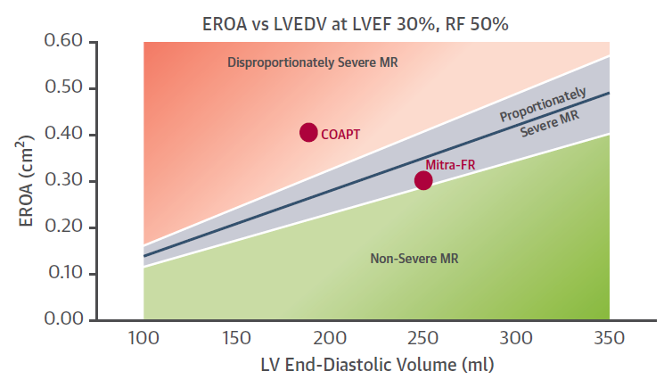

Figure 3 Relationship between EROA and LVEDV illustrating domains that define disproportionately severe, proportionately severe and non-severe FMR

Source: Grayburn et al (2018), Figure 2.

It should also be noted that the Food and Drug Authority (FDA), recently approved the use of MitraClip in patients with FMR, based on the following conditions:

*“The MitraClipTM NTR/XTR Clip Delivery System, when used with maximally tolerated guideline-directed medical therapy (GDMT), is indicated for the treatment of symptomatic, moderate-to-severe or severe secondary (or functional) mitral regurgitation (MR; MR ≥ Grade III per American Society of Echocardiography criteria) in patients with a left ventricular ejection fraction (LVEF) ≥ 20% and ≤ 50%, and a left ventricular end systolic dimension (LVESD) ≤ 70 mm whose symptoms and MR severity persist despite maximally tolerated GDMT as determined by a multidisciplinary heart team experienced in the evaluation and treatment of heart failure and mitral valve disease”.*

MDHT and Consensus/Position Statement

Based on feedback from Australian clinical experts, it is proposed that the MBS item descriptor for TMVr be based on the TAVI MBS item descriptor, and that similarly, eligibility be determined by a MDHT. The framework for the patient eligibility and the service criteria is anticipated to be provided in a Consensus/Position Statement, prepared by a Working Group, including multi-disciplinary key opinion leaders in the treatment of heart failure and mitral valve disease, that provide guidelines to the MDHT in determining which patients with FMR and DMR that should get access to the TMVr procedure should it be reimbursed on the MBS. This Statement will provide guidance on how to determine which patients are considered ‘high risk’ surgical candidates. In the case of FMR, the position paper will also provide context around the framework by Grayburn et al., (2018) and how to apply this framework in identifying patients whose MR is disproportionate to the LVEDV and thus constitute suitable candidates for TMVr. The Working Group will include representative of the Cardiac Society of the Australian and New Zealand (CSANZ) and the Australia and New Zealand Society of Cardiac and Thoracic Surgeons (ANZSCTS) but would also include other specialists such as echocardiographers. It is proposed that this Consensus/Position Statement should underpin the criteria for TMVr on the MBS, similar to the TAVI listing.

The proposed MBS item descriptor for TMVr (refer to Q53), stipulates that TMVr be performed by TMVr practitioners at a TMVr hospitals on a TMVr patient. The Position paper will provide guidelines on what constitute a TMVr hospital, practitioner and patients to ensure appropriate access of treatment.

The TMVr practitioner will include interventional cardiologists and cardiothoracic surgeons. It is also proposed that an initial case conference be conducted by the MDHT comprising at least an interventional cardiologist, a cardiothoracic surgeon and an echocardiologist. An extended team could additionally include: a general cardiologist, a geriatrician, a cardiac anaesthetist, or an intensive care physician. Utilising the Position Paper, the MDHT act as a gatekeeper for patient access by screening patients deemed to be ‘high risk’ surgical candidates as determined by combining surgical risk assessment, frailty, major organ system dysfunction, and procedure-specific impediments. Pertinent to the FMR population, the MDHT will also identify patients that have disproportionately severe MR and that are symptomatic despite maximum tolerated guideline directed therapy. Other eligibility considerations for the MDHT include a patient’s anatomical suitability for MitraClip. It is proposed that the functioning of this MDHT be built around the framework of the TAVI case conference associated with the MBS item for TAVI (MBS item 38495).

Mitral valve pathologies: DMR and FMR

A patient will generally be referred by a general practitioner to a cardiologist if the presence of MR is suspected, who in turn refers the patient to either an interventional cardiologist or a cardiothoracic surgeon.

The first step after MR has been detected is to perform an assessment of the anatomy to determine the mechanism of regurgitation, FMR or DMR. In DMR there is leaflet abnormally whereas in FMR there is ventricular remodelling (Figure 4, Table 2) (Nishimura et al 2014, Zhogbi et al 2017) .

* DMR is characterised by pathology of the mitral valve and/or sub-valvular apparatus that causes a structural abnormality. For example, abnormally thickened leaflets lead to mitral valve prolapse and elongation or rupture of the chordae tendineae results in flail leaflets. Common aetiologies of DMR include myxomatous degeneration (seen more often in younger populations) and fibroelastic deficiency disease (seen more often in older populations), in which lack of connective tissue leads to chordal rupture. The left ventricle is usually normal in size and function, but with the onset of MR, LV contractility increases to cope with the increased volume load. Over time LV dilatation and systolic impairment occur. In the case of severe DMR there may be a prolonged asymptomatic phase, followed by substantial morbidity and mortality due to arrhythmia and HF. In patients with DMR, complete restoration of mitral valve competence is curative.
* FMR is where the valve anatomy is normal however there is incomplete coaptation of the mitral leaflets due to lack of valve support secondary to leaflet tethering with associated annular dilatation. This occurs as result of LV dysfunction that is due to either localised (e.g. coronary artery disease, myocardial infarction) or global (e.g. idiopathic cardiomyopathy) pathologies. Patients with FMR usually have a poorer LV contractile reserve and, as such, are less able to increase LV stroke volume in response to MR. FMR is associated with a poorer prognosis than DMR, and correction of the MR does not address the other components of the disease.

Figure 4 Mitral valve pathologies: DMR and FMR

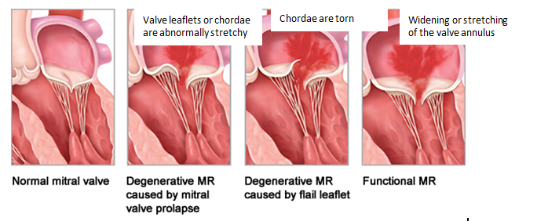

Table 2 Aetiology of DMR and FMR

| DMR |  |
| --- | --- |
| MVP myxomatous | Prolapse, flail, ruptured or elongated chordae |
| Degenerative changes | Calcification, thickening |
| Infectious | Endocarditis vegetations,  perforations, aneurysm |
| Inflammatory | Rheumatic, collagen  vascular disease,  radiation, drugs |
| Congenital | Cleft leaflet, parachute MV |
| FMR |  |
| Ischemic aetiology secondary to coronary artery disease |  |
| Nonischemic cardiomyopathy |  |
| Annular dilation | Atrial fibrillation, restrictive  Cardiomyopathy |

Source: Zhogbi et al 2017, table 5.

Severity of MR

The Doppler Echocardiography (transthoracic echocardiography [TTE] is the primary imaging used to determine severity of MR, however, it should be noted that no single Doppler and echocardiographic parameter is sufficiently precise for MR to be quantified in an individual patient. Thus, an integrated approach to determining the severity of MR is suggested by the American Society of Echocardiography (ASE) (Zhogbi et al 2017; Table 3).

There are some differences between European guidelines and American guidelines on the specific cut-offs with respect to the quantitative parameters used to determine severity of MR. The European Society of Cardiology/European Association for Cardio-Thoracic Surgery (ESC/EACT) guidelines for the management of valvular heart disease (VHD) (2017) specifies a lower EROA and regurgitant volume cut offs for severe FMR (Table 4) than the ASE guidelines. In the ASE guidelines, severe FMR is defined as EROA ≥ 0.40 cm2 and regurgitant volume ≥ 60 ml/beat whereas the ESC/EACT guidelines specifies significantly lower cut-offs (EROA ≥ 0.20 cm2 and regurgitant volume ≥ 30 ml/beat. For classification of severe DMR, the ACC/AHA (2017) and ES/EACT (2017) guidelines are consistent in regards to EROA and regurgitant volume (>0.40 cm2 and ≥ 60 ml/beat). Thus, ESC/EACT (2019) provides different cut-offs for DMR and FMR, whereas the ASE guidelines does not differentiate between aetiology in the classification of severity of MR.

Table 3 Grading of the severity of chronic MR by echocardiography (ASE)

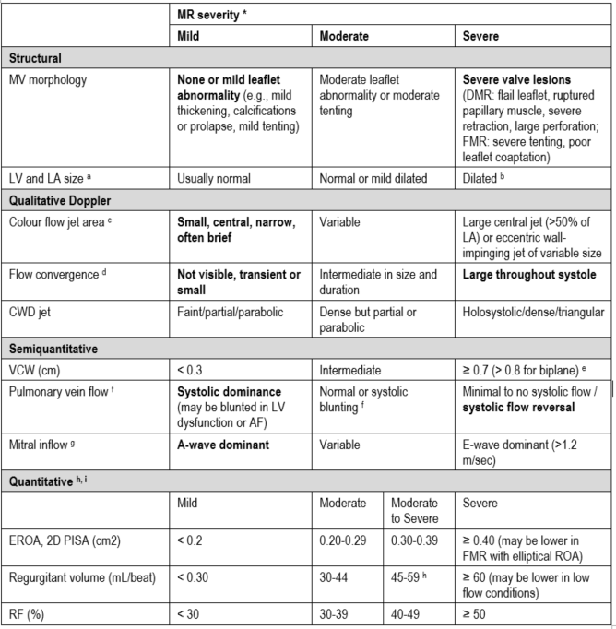

Abbreviations: AF, atrial fibrillation; CWD, Continuous wave Doppler, DMR, degenerative mitral regurgitation; EROA, Effective regurgitant orifice area, FMR, functional mitral regurgitation; LA, Left atrium, atrial, LV, Left ventricle, ventricular; MR, mitral regurgitation; PISA, Proximal isovelocity surface area; RF, Regurgitant fraction; VCW, Vena contracta width.

**Bolded qualitative and semiquantitative signs are considered specific for their MR grade.**

*All parameters have limitations, and an integrated approach must be used that weighs the strength of each echocardiographic measurement. All signs and measures should be interpreted in an individualised manner that accounts for body size, sex, and all other patient characteristics

a This pertains mostly to DMR

b LV and LA can be within the ‘‘normal’’ range for patients with acute severe MR or with chronic severe MR who have small body size, particularly women, or with small LV size preceding the occurrence of MR.

c With Nyquist limit 50-70 cm/sec.

d Small flow convergence is usually <0.3 cm, and large is $ 1 cm at a Nyquist limit of 30-40 cm/sec.

e For average between apical two- and four-chamber views.

f Influenced by many other factors (LV diastolic function, atrial fibrillation, LA pressure).

g Most valid in patients >50 years old and is influenced by other causes of elevated LA pressure.

h Discrepancies among EROA, RF, and regurgitant volume may arise in the setting of low or high flow states.

i Quantitative parameters can help subclassify the moderate regurgitation group.

Source: Zhogbi et al., (2017), table 8.

Table 4 Classification of severe MR based on ESC/EACT 2017 guidelines

|  |  |  |
| --- | --- | --- |
| **Quantitative** | **DMR** | **FMR d** |
| EROA (cm2) | ≥0.40 | ≥0.20 |
| Regurgitant volume (mL/beat) | ≥60 | ≥30 |
| + enlargement of cardiac chambers/vessels | LV, LA |  |
| **Semiquantitative** |  | |
| Vena contracta width (mm) | ≥7 (>8 for biplane) a | |
| Upstream vein flow b | Systolic pulmonary vein flow reversal | |
| Inflow | E-wave dominant ≥1.5 m/s c | |
| Other | TVI mitral/TVI aortic >1.4 | |
| **Qualitative** |  | |
| Valve morphology | Flail leaflet/ruptured papillary muscle/large coaptation defect | |
| Colour flow regurgitant jet | Very large central jet or eccentric jet adhering, swirling | |
| CW signal of regurgitant jet | Dense/triangular | |
| Other | Large flow convergence zone | |

Abbreviations: CW, continuous wave; EROA, effective regurgitant orifice area; LA, left atrium/atrial; LV, left ventricle/ventricular; TVI, time-velocity integral.

a For average between apical four- and two-chamber views

b Unless other reasons for systolic blunting (atrial fibrillation, elevated atrial pressure)

c In the absence of other causes for elevated LA pressure and of mitral stenosis

d Different thresholds are used in secondary mitral regurgitation where an EROA >20mm2 and regurgitant volume >30 mL identify a subset of patients at increased risk of cardiac events.

Source: ESC (2017) Table 4, pg. 2744

## Define and summarise the current clinical management pathway *before* patients would be eligible for the proposed medical service (supplement this summary with an easy to follow flowchart [as an attachment to the Application Form] depicting the current clinical management pathway up to this point):

A search of the literature identified no Australian specific clinical management pathways for patients with mitral regurgitation. The ESC/EACT (2017) and the AHA/ACC (2017) guidelines were identified and reviewed for this Application. In addition, clinician feedback was sought to establish the clinical management pathways before DMR and FMR patients are eligible for the proposed medical service in Australia

DMR

ESC/EACTS (2017) recommend TMVr procedure in patients with symptomatic severe DMR who are inoperable or at high surgical risk. ESC/EACTS acknowledge that general recommendation for TMVr cannot be made yet, however state that the TMVr procedure is safe and can improve symptoms in patients who are unfit for surgery. Similarly, the AHA/ACC (2017) guidelines recommend TMVr procedure in severely symptomatic patients (NYHA class III to IV) despite OMT, with severe DMR who have a prohibitive surgical risk of surgery (Table 5).

Table 5 Indications for TMVr in DMR: ACC/AHA (2017) and ESC/EACTS (2017 guidelines)

|  |  |  |
| --- | --- | --- |
|  | **AHA/ACC (2017)** | **ESC/EACTS (2017)** |
| Indications for TMVr | TMVr may be considered for severely symptomatic patients (NYHA class III to IV) with chronic severe DMR (stage D) who have favourable anatomy for the repair procedure and a reasonable life expectancy but who have a prohibitive surgical risk because of severe comorbidities and remain severely symptomatic despite optimal guideline-direct medications for heart failure | TMVr may be considered in patients with symptomatic severe primary mitral regurgitation who fulfil the echocardiographic criteria of eligibility and are judged inoperable or at high surgical risk by the Heart Team, avoiding futility. |

Source: AHA/ACC 2017 Section 7.3.3, pg e1169; ESC/EACTS (2017) guidelines pg 2760

The clinical algorithm evaluated by MSAC in Application 1192.2 in 2016 was reviewed by four KOLs in January 2019. The resultant adapted clinical management algorithm for patients with severe DMR is provided in Figure 5. The standard treatment of patients with severe DMR (grade 3+ or 4+) is surgical repair (or replacement if repair is not feasible). However, in patients that are considered by the MDHT to be high risk surgical candidates, but considered suitable for MitraClip, TMVr provides a treatment option. The alternate treatment option in these patients is medical management.

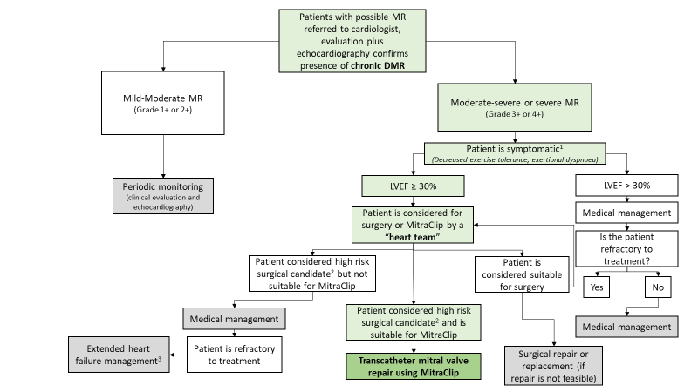Figure 5 Clinical management algorithm for DMR

DMR, degenerative mitral regurgitation; MR, mitral regurgitation; NYHA, New York Heart Association; LVEF, left ventricular ejection fraction.

1 Symptomatic = NYHA functional class II or greater

2 Patients considered ‘high risk surgical candidate’ for surgery as determined by a multidisciplinary heart team, combining surgical risk assessment, frailty, major organ system dysfunction, and procedure-specific impediments.

3. Extended heart failure management includes cardiac resynchronisation therapy, ventricular assist devices, cardiac restraint devices and heart transplant

FMR

An overview of recommendations specific to TMVr from the ACC/AHA (2017) and ESC/EACTS (2017) guidelines for management of patients with valvular heart disease is provided in Table 6.

The TMVr is considered a low-risk option, however ESC/EACTS (2017) acknowledge that it is inferior to surgery in reducing MR. ESC/EACTS note that a survival benefit of TMVr compared with medical management has not yet been proven. However, this statement preceded the completion of RCT evidence supporting that TMVr is superior to medical management (refer to Part 4). ESC/EACTS recommend that that TMVr be considered for the treatment of severe FMR in those who are symptomatic despite optimal medical management when revascularization is not indicated, and surgical risk is not low.

The AHA/ACC (2017) do not recommend the TMVr procedure for the treatment of FMR. However, the FMR indication has recently (March 2019) been approved for clinical use in this indication in the United States by the FDA. AHA/ACC (2017) state that RCT evidence is needed to provide information on the TMVr procedure in this patient group. As noted previously, this statement also precedes the completion of RCT evidence supporting superiority (refer to Part 4) thus is outdated. XXX anticipates a multi-society consensus statement later in 2019 to update this viewpoint based on the RCT for MitraClip that has become available after the 2017 AHA/ACC guidelines were published.

Table 6 Indications for TMVr in FMR: ACC/AHA (2017) and ESC/EACTS (2017 guidelines)

| **Population** | **ACC/AHA** | **ESC/EACTS** |
| --- | --- | --- |
| Indications for MitraClip  In FMR | Not recommended:  TMVr provides a less invasive alternative to surgery but is not approved for clinical use for this indication in the United States. The results of RCTs examining the efficacy of TMVr in patients with secondary MR are needed to provide information on this patient group”. | When revascularization is not indicated and surgical risk is not low, a TMVr procedure may be considered in patients with severe FMR and Left ventricular ejection fraction (LVEF) >30% who remain symptomatic despite optimal medical management (including cardiac resynchronisation therapy (CRT) if indicated) and who have a suitable valve morphology by echocardiography, avoiding futility. |
|  |  | In patients with severe FMR and LVEF <30% who remain symptomatic despite optimal medical management (including CRT if indicated) and who have no option for revascularization, the Heart Team may consider a TMVr or valve surgery after careful evaluation for a ventricular assist device or heart transplant according to individual patient characteristics. |

Based on discussion with four Australian KOLs, a consensus on the current clinical management algorithm for patients with severe FMR was provided (Figure 6). Severe FMR results in volume overload to a decompensated left ventricle which in turn leads to worsening the prognosis of the patient. In contrast to the DMR population, there is only scant evidence to indicate that correcting the MR in these patients with FMR results in increased survival or extended symptom improvement. Hence in this population, there is much less focus on surgical repair and the mainstay treatment is medical management. Given the less invasive nature of the TMVr compared with standard surgical approaches, this treatment option provides patients and clinicians with an alternate to medical management. Given the superiority of TMVr over optimal medial management (Stone et al., 2018), there is a high clinical need for this to be reimbursed on the MBS in Australia.

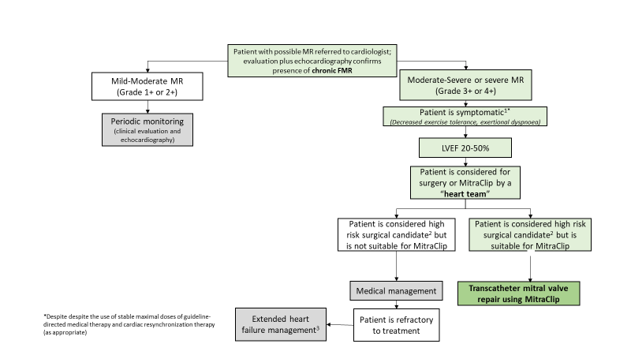

Figure 6 Clinical management algorithm for FMR

FMR, functional mitral regurgitation; MR, mitral regurgitation; NYHA, New York Heart Association; LVEF, left ventricular ejection fraction.

1 Symptomatic = NYHA functional class II or greater

2 Patients considered ‘high risk surgical candidate’ for surgery as determined by a multidisciplinary heart team, combining surgical risk assessment, frailty, major organ system dysfunction, and procedure-specific impediments.

3 Extended heart failure management includes cardiac resynchronisation therapy, ventricular assist devices, cardiac restraint devices and heart transplant

PART 6b – INFORMATION ABOUT THE INTERVENTION

## Describe the key components and clinical steps involved in delivering the proposed medical service:

The MitraClip procedure is based on the principle of edge-to-edge repair (also known as the ‘Alfieri technique’) but a mechanical clip is used in place of a suture to allow permanent coaptation (‘approximation’) of the two mitral valve leaflets. The Alfieri technique is an accepted surgical technique for the treatment of MR. The suture (or Clip) is placed through the middle scallops of the mitral leaflets to form a double orifice valve. The double orifice structure enables adequate blood flow through the valve during diastole, but as the overall area is less, there is reduced regurgitant flow. The suture (or Clip) assures the two leaflets come together, as required, during systole.

TMVr using MitraClip is performed under general anaesthesia by an interventional cardiologist and/or cardiothoracic surgeon in facilities with real-time intraoperative echocardiographic and fluoroscopic guidance. The procedure is performed while the heart is beating, which allows better the identification of the origin of MR. The guide catheter and Clip Delivery System are introduced through the femoral vein and into the left atrium after transseptal puncture. The Clip is then advanced into the left atrium and steered until positioned over the origin of the regurgitant jet. The Clip arms are opened and advanced into the left ventricle and then retracted until both leaflets are grasped. Closure of the Clip draws the mitral leaflets together.

Echocardiographic and fluoroscopic guidance is used throughout the procedure to visualise the device position. Leaflet coaptation and MR reduction is assessed prior to final deployment of the MitraClip device. If the implant is not positioned properly, or the MR has not been adequately reduced, the Clip can be reopened, leaflets released, and the Clip repositioned. When adequate reduction of MR has been achieved, the Clip is deployed from the delivery catheter.

If placement of one MitraClip device does not result in acceptable reduction in MR, a second MitraClip device may be placed using the same Steerable Guide Catheter. After Clip deployment, the Delivery System and Catheter are withdrawn, and the venous puncture site is closed.

## Does the proposed medical service include a registered trademark component with characteristics that distinguishes it from other similar health components?

No, the proposed medical service does not include a registered trademark, however, the medical device used in the medical service, MITRACLIP® CLIP DELIVERY SYSTEM includes a registered trademark.

## If the proposed medical service has a prosthesis or device component to it, does it involve a new approach towards managing a particular sub-group of the population with the specific medical condition?

The proposed medical service includes a device component as part of the procedure, the implantation of MitraClip(s). That proposed patient populations are currently managed with medical management. As such, the proposed medical service involves a new approach towards management the proposed populations. The main difference between the proposed intervention and the main comparator as set out in this application is that the objective of the proposed medical service is to repair the mitral valve, whereas the proposed comparator provides symptom relief only.

## If applicable, are there any limitations on the provision of the proposed medical service delivered to the patient (i.e. accessibility, dosage, quantity, duration or frequency):

Accessibility is a barrier to patient access to TMVr under the proposed circumstances in the sense that there will be limited number of hospitals designated as ‘TMVr hospitals’. Also, the MDHT will act as a gatekeeper for patient access by screening patients deemed to be ‘high risk’ for surgery as determined by combining surgical risk assessment, frailty, major organ system dysfunction, and procedure-specific impediments. Other eligibility considerations for the MDHT include a patient’s anatomical suitability for MitraClip. It is proposed that a Consensus/Position Statement be prepared by a Working Group including a multi-disciplinary team of KOLs (with representatives from the CSANZ and ANZSCTS) that defines TMVr hospitals, practitioners and patients.

## If applicable, identify any healthcare resources or other medical services that would need to be delivered at the same time as the proposed medical service:

Healthcare resources associated with MitraClip include the proposed resources to identify eligible population as well as the resources required to deliver the intervention, these are outlined below.

Proposed resources to identify eligible population: TTE, TOE, anaesthesiology for TOE, electrocardiography, chest x-ray, cardiac catheterisation, cardiology consultation, surgical consultation, anaesthetic consultation, heart team consultation.

Resources to deliver MitraClip intervention: MitraClip procedure (incl. two operators), surgical assistant, MitraClip device and delivery system, TOE, anaesthesiology, catheterisation/hybrid lab, intensive care unit, coronary care unit, TTE, cardiology consultation, pharmaceuticals

Table 7 presents the associated medical services that are needed to perform the MitraClip procedure, this includes any clinic or hospital related costs.

Table 7 Medical services included in the MitraClip procedure

| **Resource** | **Reference** |
| --- | --- |
| Pre-procedural heart team assessment | Based on MBS Item 6080 |
|  | Based on MBS Item 6081 |
| MitraClip implantation fee | Proposed MBS fee |
| Anaesthesia | MBS Item 21936 |
| Intra-operative transoesophageal echocardiography | MBS Item 55135 |
| Fluoroscopy | MBS Item 61109 |
| Hospital associated costs | AR-DRG – F09B ($11,916) less prosthesis cost component ($3,453) |
| Post-procedural/Pre-discharge transoesophageal echocardiography | MBS Item 55113 |

## If applicable, advise which health professionals will primarily deliver the proposed service:

The proposed medical service will be performed by interventional cardiologists and cardiothoracic surgeons. In addition, a case conference will be conducted by a MDHT comprised of the practitioner that performs the procedure, who will also chair the conference, the interventional cardiologist and an echocardiologist. An extended team could additionally include: a general cardiologist, a geriatrician, a cardiac anaesthetist, or an intensive care physician. The functioning of this MDHT will be built around the framework of the TAVI case conference associated with the MBS item for TAVI. The explanatory notes for TAVI defines the TAVI practitioner(s), TAVI Hospital, and TAVI patients and the TAVI Case conference (AN.33.1, TN8.135). There are separate items for coordination of a TAVI Case conference by a TAVI practitioner (MBS 6080) and attendance at a TAVI Case conference by a specialist or consultant who does not perform the procedure (MBS 6081). It is anticipated a similar structure of explanatory notes and associated item numbers will be created for TMVr in the event it gets accepted for listing.

## If applicable, advise whether the proposed medical service could be delegated or referred to another professional for delivery:

N/A

## If applicable, specify any proposed limitations on who might deliver the proposed medical service, or who might provide a referral for it:

As outlined in the responses to questions 30 and 32 the MDHT case conference will be chaired by the surgeon that performs the procedure and the MDHT will form a decision on the patient’s eligibility for MitraClip.

## If applicable, advise what type of training or qualifications would be required to perform the proposed service as well as any accreditation requirements to support service delivery:

Physicians and hospital staff are required to complete the MitraClip training program prior to use of the system. The entire training process (MitraClip Therapy Program) is a 4 to 6 week modular process. It includes didactic coursework (e.g. lectures and presentations) and ‘hands on’ use of a demonstration system that includes a heart model.

In order to be eligible for the training program the physician must meet the following requirements:

* Be either a cardiologist or a cardiac surgeon.
* Have experience in transseptal technique and have an understanding or experience in structural heart disease (patent foramen ovale, atrial septal defect, aortic valve, etc.).
* Have a multidisciplinary team to support the procedure, including:
  + A dedicated echocardiologist for patient screening and to be present during the procedure.
  + A cardiac surgeon or interventional cardiologist to provide support.
* Identify five suitable patients prior to training.
* Be able to continue to have a reasonable volume of patients so as to maintain minimum skills levels and optimal patient outcomes.

As noted previosly, it is anticipated that a Working Group of multi-disciplinary key opinion leaders (including representatives from the CSANZ and ANZSCTS) prepare a position paper that describes the minimum operator and institutional requirements necessary to establish a successful TMVr program. This may include a framework for proceduralist experience, institutional requirements, and volume and outcome monitoring requirements.

## (a) Indicate the proposed setting(s) in which the proposed medical service will be delivered (select all relevant settings):

Inpatient private hospital

Inpatient public hospital

Outpatient clinic

Emergency Department

Consulting rooms

Day surgery centre

Residential aged care facility

Patient’s home

Laboratory

Other – please specify below

1. **Where the proposed medical service is provided in more than one setting, please describe the rationale related to each:**

The procedure is performed in the in-hospital setting with patients admitted.

## Is the proposed medical service intended to be entirely rendered in Australia?

Yes

No – please specify below

PART 6c – INFORMATION ABOUT THE COMPARATOR(S)

## Nominate the appropriate comparator(s) for the proposed medical service, i.e. how is the proposed population currently managed in the absence of the proposed medical service being available in the Australian health care system (including identifying health care resources that are needed to be delivered at the same time as the comparator service):

The main comparator for the proposed medical service is optimal medical management (or ‘standard care’ or ‘usual care’). This is because the focus of this submission is patients with DMR and FMR (grade 3+ or 4+) who are denied surgery due to the presence of various risk factors (e.g. existing damage to the heart, cardiopulmonary bypass risk, advanced age, multiple comorbidities). In such patients, medical management is the most appropriate comparator because patients who are not eligible for surgical intervention are offered medical therapy to mitigate symptoms. The proposed comparator to MitraClip in this Application is consistent with the comparator in Application 1192.2 (Application 1192.2 Public Summary Document [PSD]).

The following interventions may be administered to provide symptom relief in patients with severe MR:

• Non-pharmacologic strategies (e.g., physical activity programs, dietary or fluid management protocols)

• Best practice pharmacotherapy in patients with HF (including: angiotensin converting enzyme [ACE] inhibitors, angiotensin receptor blocker [ARB], mineralocorticoid receptor antagonist [MRA], beta-blockers, diuretics).

In the PSD for Application 1192.1 MSAC noted that patients with HF may also be treated with cardiac resynchronisation therapy. The Applicant concurs with this statement and notes that extended HF management includes cardiac resynchronisation therapy, ventricular assist devices, cardiac restraint devices and heart transplant. These interventions would apply in patients once they progress to HF as part of usual care, as outlined in Figure 7.

Shows the management of patients with heart failure with reduced ejection fraction.

Figure 7 Management of patients with heart failure with reduced ejection fraction

Source: National Heart Foundation of Australia and Cardiac Society of Australia and New Zealand: guidelines for the prevention, detection and management of Heart Failure. 2018 – Figure 3 pg 1155.

## Does the medical service that has been nominated as the comparator have an existing MBS item number(s)?

Yes (please provide all relevant MBS item numbers below)

No

## Define and summarise the current clinical management pathways that patients may follow *after* they receive the medical service that has been nominated as the comparator (supplement this summary with an easy to follow flowchart [as an attachment to the Application Form] depicting the current clinical management pathway that patients may follow from the point of receiving the comparator onwards including health care resources):

The comparator to TMVr in both populations is medial management. Patients would be monitored regularly, and treatment optimised. KOL advice that patients who are managed on medical therapy are monitored every 3 months and that they have an echocardiograph every 6 months. There are no alternate treatment options for these patients currently. The clinical management pathway for medical management closely corresponds with that of symptomatic heart failure, as depicted in Figure 5 and Figure 6.

Healthcare resources required include hospitalisation due to heart failure. As reported in the COAPT study, patients managed on medical therapy had a statistically significantly higher annualized rate of hospitalisation due to heart failure than those who received TMVr (67.9 vs 35.8 events per patient-years; p< 0.0001).

## (a) Will the proposed medical service be used in addition to, or instead of, the nominated comparator(s)?

Yes

No

## If yes, please outline the extent of which the current service/comparator is expected to be substituted:

The proposed medical service, TMVr, will be used in additional to medial management. In the FMR population, patients must be symptomatic despite optimal medial management to be eligible for the TMVr procedure.

## Define and summarise how current clinical management pathways (from the point of service delivery onwards) are expected to change as a consequence of introducing the proposed medical service including variation in health care resources (Refer to Question 39 as baseline):

A patient deemed ineligible for surgery (due to feasibility and safety concerns such as multiple comorbidities, advanced age, etc.) the option of receiving the TMVr procedure may be considered as a direct substitute to continued medical management. It is expected that the introduction of the TMVr procedure using MitraClip relative to continued use of medical management will result in reduced use of health care resources. Indeed, as noted in Q.40 the COAPT study showed a significantly lower annualized rate of hospitalisation due to heart failure in those who received TMVr versus those on medical management over 24 months (35.8 vs 67.9 events per patient-years; p< 0.0001). Furthermore, COAPT reported significantly lower rate of implantation of a left ventricular assist device (LVAD) or heart transplantation following TMVr compared with optimal medical management (4.4% versus 9.5%; p=0.01; Stone et al 2018).

PART 6d – INFORMATION ABOUT THE CLINICAL OUTCOME

## Summarise the clinical claims for the proposed medical service against the appropriate comparator(s), in terms of consequences for health outcomes (comparative benefits and harms):

TMVr is superior to medical management with respect to effectiveness in patients with DMR and FMR.

## Please advise if the overall clinical claim is for:

Superiority

Non-inferiority

## Below, list the key health outcomes (major and minor – prioritising major key health outcomes first) that will need to be specifically measured in assessing the clinical claim of the proposed medical service versus the comparator:

| **Safety outcomes:** Patient mortality (procedural), clinical adverse events, procedure-specific adverse events (clip embolism, chordal rupture, clip detachment, vascular complication needing reintervention)  **Effectiveness outcomes:** Survival, freedom from MR grade 3+ or 4+, clinical measures of benefit (NYHA functional class, quality of life, LVEF function, rehospitalisation for CHF)  **Measures of technical success:** MR reduction by two grades or more at discharge; clip placement (1 or 2 clips placed or removed and failure to place successfully), need for reintervention, post-procedural hospitalisation duration, post-procedural patient recovery time, procedure time  **Healthcare resources (TMVr**):  *Proposed resources to identify eligible population:* TTE, TOE, anaesthesiology for TOE, electrocardiography, chest x-ray, cardiac catheterisation, cardiology consultation, surgical consultation, anaesthetic consultation, heart team consultation.  *Resources to deliver proposed intervention*: MitraClip procedure (incl. two operators), surgical assistant, MitraClip device and delivery system, TOE, anaesthesiology, catheterisation/hybrid lab, theatres, intensive care unit, coronary care unit, TTE, cardiology consultation, pharmaceuticals  **Healthcare resources OMT:**  Resources provided to identify eligible population: TTE, TOE, anaesthesiology for TOE, electrocardiography, chest x-ray, cardiac catheterisation, cardiology consultation, surgical consultation, heart team consultation.  Resources provided to deliver comparator: TOE, anaesthesiology for TOE, coronary care unit, TTE, cardiology consultation, pharmaceuticals. |
| --- |

# PART 7 – INFORMATION ABOUT ESTIMATED UTILISATION

## Estimate the prevalence and/or incidence of the proposed population:

There are several MBS items related to mitral valve and hence MR procedures. Figure , outlines that separations for MR procedures have increased at an average rate of approximately 125 separations per year. Over this time period, mitral valve replacement procedures (MBS items: 338488, 38489) have comprised roughly half of all MR procedures and has been the main driver in the increase in total number of services. These data are useful in so far as describing the current context for MR procedures in the Australian setting. However, these services data do not specify the type or severity of mitral valve condition being treated or the number of procedures per patient. Also, the MBS utilisation data is applicable to patient suitable for surgery, and not for the proposed populations of patients that are at high risk of surgery. As such this data does not provide a basis for a market share approach as it does not isolate patients with severe MR who are eligible for TMVr.

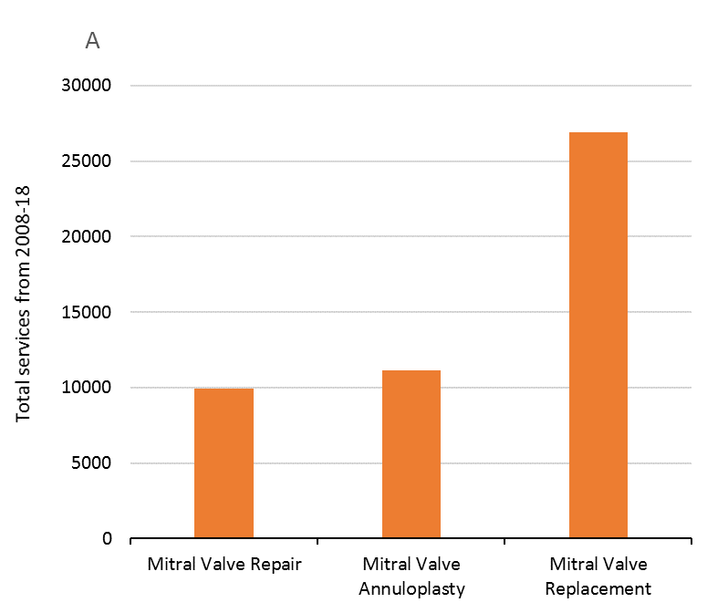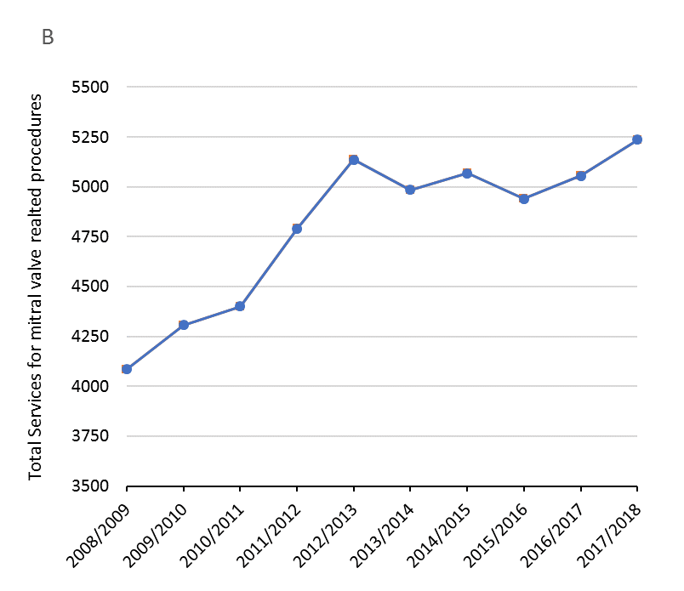

Figure 8 Total services for MBS items related to MR surgery by item category (A) and financial year (B) from 2008 to 2018

Notes: MBS Item Numbers grouped by category: mitral repair- 34480, 34481; mitral annuloplasty- 38475, 38477; mitral replacement- 38488, 38489.

Source: Medicare Australia, MBS statistics.

Therefore, given the limited available market share data, a preliminary epidemiological approach has been undertaken based on the prevalence of severe MR among heart failure patients in Australia. This approach is consistent with MSAC advise in previous applications that “an alternative approach may be more appropriate” (MSAC Application 1192.2 PSD, p.11). A pragmatic review of the literature identified a range of epidemiological inputs, Table 8 summarises the most appropriate epidemiological inputs for estimating the proposed patient population eligible for TMVr. The prevalence of severe MR in the Australian setting is substantiated by a relatively robust set of epidemiological inputs derived from large cohorts, the majority of which are specific to the Australian setting. The severe MR population can be further divided into severe DMR and FMR patients.

Table 8 Epidemiological inputs for the determining prevalence of severe MR in Australia

| **Parameter** | **Value** | **Source** | **Source Description** |
| --- | --- | --- | --- |
| Prevalence of heart failure in Australia | XXX | XXX | XXX |
| Proportion of heart failure patients with MR | XXX | XXX | XXX |
| Proportion of MR patients with severe (≥3+/4+), symptomatic MR | XXX | XXX | XXX |
| Proportion of severe MR patients who have FMR mechanism | XXX | XXX | XXX |
| Proportion of severe MR patients who have DMR mechanism | XXX |

Abbreviations: ABS, Australian Bureau of Statistics; DMR, degenerative mitral regurgitation; EROA, effective regurgitant orifice area; FMR, functional mitral regurgitation; MR, mitral regurgitation; NHS, National Health Survey.

MSAC has previously accepted a gate keeper role for a multidisciplinary heart team (MDHT) for recommending TAVI surgery to “high risk” patients who are prohibitive of surgery. The position of the TMVr in the treatment algorithm for MR requires that several clinical characteristics be assessed before a patient is indicated for TMVr. Therefore, the functioning of the MDHT as a gatekeeper to TMVr, as is the case for TAVI procedures, aims to provide a framework for selecting patients that are eligible for TMVr and that would benefit from this procedure.

In the current treatment algorithm, a patient is eligible for TMVr if they have LVEF ≥30% or ≥20% and ≤50% for DMR and FMR respectively. Having met this criterion, a MDHT will assess if the patient is anatomically suitable for the device (MitraClip) implantation and if they are at high risk of complications with surgery.

Mirabel et al., (2007), reported clinical characteristics of severe symptomatic MR patients from the Euro Heart Survey on valvular heart disease (2001). The Euro Heart Survey was conducted between April and July 2001 in 92 centres from 25 European countries. Recruitment took place in medical and surgical wards, as well as in outpatient clinics in a variety of hospitals. In Mirabel et al. (2007), 58% of severe symptomatic MR patients who were given a decision not to operate, had a LVEF of 30%-60% and 85.2% of patients had LVEF >30%. In the absence of more precise data, it is assumed that 45% of severe symptomatic FMR patients have LVEF 20%-50% and 85.2% of DMR patients have LVEF ≥80%. Mirabel also reported that patients with LVEF<60% were less likely to receive surgery. Figure 6 shows that the decision not to operate occurred at a rate of 50%, 62% and 86% in patients with an LVEF of 40-50%, 30-40% and <30%, respectively. Therefore, as a conservative estimate 50% of severe DMR patients with LVEF 20-50% are predicted to be high risk of surgical complications, given that the average LVEF in Mirabel et al., (2007) was 48% and that 61% of patients that did not receive surgery had DMR.

The proportion of patients that are at high risk of complications with surgical intervention is likely to be even higher in the FMR population given the risk of surgery and uncertainty around the benefits of mitral valve surgery in the FMR population. In turn, a pragmatic literature search identified, a single-centre observational study, Goel et al., (2014), conducted in a large tertiary referral centre, which reported that 64% (520 of 814) of FMR patients did not receive MV surgery. Thus, it is assumed that 64% of FMR patients and 50% of DMR patients are at high risk of complications with surgical intervention.

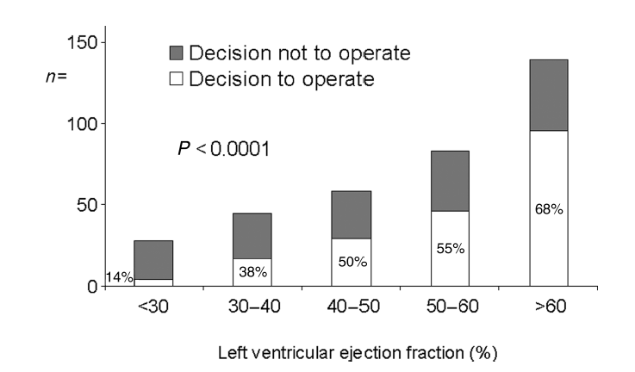

Figure 9 Mirabel et al. (2007) the effect of LVEF on the decision to operate in severe symptomatic MR patients

Table 9 presents estimates for the proportion of severe MR patients eligible for TMVr who are at high risk of complications with surgical intervention and anatomically suitable for implantation.

Table 9 Epidemiological inputs for determining proportion of severe DMR and FMR patients eligible for Mitra Clip

| **Parameter** | **Value** | **Source** |
| --- | --- | --- |
| **Severe DMR population** | | |
| Proportion of with severe symptomatic DMR patients who have LVEF ≥30% | XXX | XXX |
| Proportion of severe symptomatic DMR patients who are at high risk of complications with surgical intervention | XXX | XXX |
| Proportion of severe symptomatic MR patients who are anatomically suitable for TMVr (MitraClip implantation) | XXX | XXX |
| **Severe FMR population** | | |
| Proportion of severe symptomatic FMR patients who have LVEF20% - 50% | XXX | XXX |
| Proportion of severe symptomatic FMR patients who are at high risk of complications with surgical intervention | XXX | XXX |
| Proportion of severe symptomatic MR patients who are anatomically suitable for TMVr (MitraClip implantation) | XXX | XXX |

Abbreviations: DMR, degenerative mitral regurgitation; FMR, functional mitral regurgitation; MR, mitral regurgitation.

## Estimates of the number of times TMVr would be delivered to a patient per year

The proposed medical service is intended to be delivered once only. Based on the COAPT trial, 3.7% and 6.6% of patients having TMVr and medical management had additional unplanned MitraClip implantations respectively (Stone et al 2018).

## How many years would the proposed medical service(s) be required for the patient?

As stated in Q.47, the proposed medical service is to be a once off service.

## Estimate the projected number of patients who will utilise the proposed medical service(s) for the first full year:

The total number of patients with severe MR is derived from the prevalence of heart failure in the Australian population. In turn, projections of heart failure prevalence are based on 2017/18 NHS data and ABS projections of the Australian population for the first full year. This approach of estimating MR prevalence addresses previous concerns by MSAC that *“the prevalence of heart failure and therefore mitral regurgitation are difficult to assess … (and the) statistics are based on 2004 data and have not been adjusted to increases in the Australian population”* (MSAC Application 1992.2 PSD, March 2016, p. 10). The prevalence of MR is not expected to change given the steady number of MR related services utilised over the last decade, as presented in Figure .

Table 10 presents estimates of the total patient population eligible for TMVr for the first year of listing. Based on these estimates there are approximately x patients with severe, symptomatic MR in Australia of which approximately xxxxx are eligible for TMVr. It is estimated that xxxxx patients with severe symptomatic MR comprises patients who will be currently treated with medical management and surgery. This is likely to be a reasonable estimate given that approximately xxxxx mitral valve related surgery procedures are reimbursed annually in Australia, which is a figure that includes patients with other mitral valve conditions and a range of MR severity.

The estimated total number of severe DMR patients eligible for TMVr in year one is xxxxx and xxxxx in the first year for FMR. These estimates will be further explored in the SBA.

Table 10 Estimated number of patients eleigble for TMVr in the first years of listing

| **Row** | **Parameter** | **2020**  **(1ST year)** | **Source** |
| --- | --- | --- | --- |
| Defining Severe MR Population | | | |
| A | Australian Population Projections (18 years and older) | xxx | xxx |
| B | Prevalence of heart failure in Australia | xxx | xxx |
| C | Total number of heart failure patients | xxx | xxx |
| D | Proportion of heart failure patients with MR | xxx | xxx |
| E | Proportion of MR patients with severe (≥3+/4+), symptomatic MR | xxx | xxx |
| F | Total number of patients with severe, symptomatic MR | xxx | xxx |
|  | | | |
|  | | | |
| G | Proportion of severe, symptomatic MR patients who have DMR mechanism | xx | xx |
| H | Total number of patients with severe, symptomatic DMR |  |  |
| I | Proportion of severe, symptomatic DMR patients who have LVEF ≥30% | xx | xx |
| J | Proportion of severe, symptomatic DMR patients who are at high risk of complications with surgical intervention | xx | xx |
| K | Proportion of severe, symptomatic DMR patients who are anatomically suitable for TMVr (MitraClip implantation) | xx | xx |
| L | Total number of patients with severe, symptomatic DMR eligible for TMVr | xx | xx |
|  | | | |
| M | Proportion of severe, symptomatic MR patients who have FMR mechanism | xx | xx |
| N | Total number of patients with severe, symptomatic FMR | xx | xx |
| O | Proportion of severe, symptomatic FMR patients who have LVEF 20-50% | xx | xx |
| P | Proportion of severe, symptomatic FMR patients who are at high risk of complications with surgical intervention | xx | xx |
| Q | Proportion of severe, symptomatic FMR patients who are anatomically suitable for TMVr (MitraClip implantation) | xx | xx |
| R | Total number of patients with severe, symptomatic FMR eligible for TMVr | xx | xx |
|  | | | |
| S | **Total number of patients with severe, symptomatic MR eligible for TMVr** | xx | xx |

Abbreviations: ABS, Australian bureau of statistics; DMR, degenerative mitral regurgitation; FMR, functional mitral regurgitation; MR, mitral regurgitation.

## Estimate the anticipated uptake of the proposed medical service over the next three years factoring in any constraints in the health system in meeting the needs of the proposed population (such as supply and demand factors) as well as provide commentary on risk of ‘leakage’ to populations not targeted by the service:

Expected uptake among the eligible patient populations would be high among patients given the paucity of existing therapeutical options other than medical management, for MR patients who are at high risk of complications with surgical intervention, and the superior outcomes realised with TMVr in terms of quality of life and survival outcomes relative to medical management. However, patient uptake would be limited by the number of centres able to provide both patient assessment by the MDHT and the intervention itself.

MSAC have previously highlighted how limited supply of complex cardiovascular procedures can regulate uptake. For example, in the case of TAVI *“MSAC noted concerns that the size of the inoperable patient population may be underestimated ... However, MSAC anticipated that the uptake would be limited by the number of centres and operators accredited to perform the procedure.”* (MSAC Application 1361.2 PSD, March 2016, p. 4). Accordingly, there is expected to initially be a limited number of centres able to offer MDHT assessment and hence the TMVr procedure.

Uptake of TMVr is estimated to start at x% in the first year of listing and increase to x% and x% in the second and third years respectively. A patient treated with TMVr should receive only one procedure and consequently the patient population, to which annual uptake rates are applied, is comprised of annual incidence of MR and untreated patients from previous years. Table 11 outlines the number of patients expected to be treated with TMVr in the first three years. The estimations will be confirmed in the Submission Based Assessment (SBA)

Table 11 Estimated number of patients treated with TMVr over the next three years

| **Row** | **Parameter** | **2020 (1st year)** | **2021 (2nd year)** | **2022 (3rd year)** | **Source** |
| --- | --- | --- | --- | --- | --- |
|
|  |
| Defining severe MR population | | | | | |
| A | Australian Population Projections (18 years and older) | xx | xx | xx | xx |
| B | Prevalence of heart failure in Australia |  | | |  |
| C | Total number of heart failure patients | xx | xx | xx | xx |
| D | Proportion of heart failure patients with MR | xx | | | xx |
| E | Proportion of MR patients with severe (≥3+/4+), symptomatic MR | xx | | | xx |
| F | Total number of patients with severe, symptomatic MR | xx | xx | xx | xx |
| Proportion of Severe MR population eligible for TMVr | | | | | |
| Severe DMR population | | | | | |
| G | Proportion of severe, symptomatic MR patients who have DMR mechanism | xx | | | xx |
| H | Total number of patients with severe, symptomatic DMR | xx | xx | xx | xx |
| I | Proportion of severe, symptomatic DMR patients who have LVEF ≥30% | xx | | | xx |
| J | Proportion of severe, symptomatic DMR patients who are at high risk of complications with surgical intervention | xx | | | xx |
| K | Proportion of severe, symptomatic DMR patients who are anatomically suitable for TMVr (MitraClip implantation) | xx | | | xx |
| L | Total number of patients with severe, symptomatic DMR eligible for TMVr | xx | xx | xx | xx |
|  | | | | | |
| M | Proportion of severe, symptomatic MR patients who have FMR mechanism | xx | | | xx |
| N | Total number of patients with severe, symptomatic FMR | xx | xx | xx | xx |
| O | Proportion of severe, symptomatic FMR patients who have LVEF 20-50% | xx | | | xx |
| P | Proportion of severe, symptomatic FMR patients who are at high risk of complications with surgical intervention | xx | | | xx |
| Q | Proportion of severe, symptomatic FMR patients who are anatomically suitable for TMVr (MitraClip implantation) | xx | | | xx |
| R | Total number of patients with severe, symptomatic FMR eligible for TMVr | xx | xx | xx | xx |
|  | | | | | |
| **S** | **Total number of patients with severe MR eligible for TMVr** | xx | xx | xx | xx |
| Applying uptake rates to eligible population | | | | | |
| Severe DMR Population | | | | | |
| T | Prevalence of severe, symptomatic DMR patients eligible for TMVr | xx | xx | xx | xx |
| U | Incident population | xx | xx | xx | xx |
| V | Proportion of severe, symptomatic DMR patients who have not received treatment with TMVr | xx | xx | xx | xx |
| W | Uptake rates | xx | xx | xx | xx |
| X | Patients treated with TMVr | xx | xx | xx | xx |
| Y | OMT managed patients | xx | xx | xx | xx |
| Severe FMR Population | | | | | |
| Z | Prevalence of severe, symptomatic FMR patients eligible for TMVr | xx | xx | xx | xx |
| AA | Incident Population | xx | xx | xx | xx |
| AB | Proportion of severe, symptomatic FMR patients who have not received treatment with TMVr | xx | xx | xx | xx |
| AC | Uptake rates | xx | xx | xx | xx |
| AD | Patients treated with TMVr | xx | xx | xx | xx |
| AE | OMT managed patients | xx | xx | xx | xx |
|  | | | | | |
| **AF** | **Total number of MR patients treated with TMVr** | xx | xx | xx | xx |

Abbreviations: ABS, Australian bureau of statistics; DMR, degenerative mitral regurgitation; FMR, functional mitral regurgitation; MR, mitral regurgitation

Note: Rounding errors might apply.

a. Incident Population is calculated by subtracting the previous from the current year’s prevalent population, e.g. In 2021 and 2020 prevalence of DMR is 379 and 373 respectively, the incidence population in 2021 is 6.

# PART 8 – COST INFORMATION

## Indicate the likely cost of providing the proposed medical service. Where possible, please provide overall cost and breakdown:

A cost breakdown of the TMVr procedure is presented in Table 12, and includes the cost of assessing a patient’s eligibility for TMVr as well as the procedural and device costs. The total procedural cost of providing TMVr is estimated at $10,643.79.

The values in Table 12 are indicative only. Table 12 is intended to provide an understanding of the resource use involved (e.g: MBS items and hospital resources) and to a lesser extent the magnitude of the costs associated with these resources which will be fully detailed in the SBA.

Table 12 Total cost of providing TMVr procedure

| **Row** | **Resource** | **Utilisation per patient** | **Unit cost** | **Reference** |
| --- | --- | --- | --- | --- |
| Procedural Cost | | | | |
| A | Pre-procedural heart team assessment | $50.90 | $50.90 | Based on MBS Item 6080 |
| $50.90 | $37.95 | Based on MBS Item 6081 |
| B | TMVr implantation fee | $50.90 | $1,720.90 | Proposed MBS fee |
| C | Anaesthesia | $50.90 | $118.80 | MBS Item 21936 |
| F | Index Hospitalisation costs | $50.90 | $8,446.64 | For example: AR-DRG – F09B ($12581.99) less prosthesis cost component ($4,136.35) |
| G | Post-procedural/Pre-discharge trans-thoracic echocardiogram | $50.90 | $230.65 | MBS Item 55113 |
| H | Total procedural cost | | **$10,643.79** |  |
| Device Cost | | | | |
| I | Total device cost | | XXXXxxx | xxxxxxx |
| J | **Total Cost= Procedural cost + Device cost** | | **TBD** | H + I |

## Specify how long the proposed medical service typically takes to perform:

TMVr® procedure time

COAPT Trial reported the total procedure time of 162.9 $±$ 118.1 (n=293) (CSR, Table 14)

Total procedure time refers to time elapsed from the first of any of the following: intravascular catheter placement, anaesthesia or sedation, or Transoesophageal Echocardiogram (TEE), to the removal of the last catheter and TEE.

## If public funding is sought through the MBS, please draft a proposed MBS item descriptor to define the population and medical service usage characteristics that would define eligibility for MBS funding.

Given advice from Australian clinical experts, the proposed MBS item descriptor for TMVr is modelled on the transcatheter aortic valve implantation (TAVI) descriptor (MBS item 38495). The proposed MBS item is provided below. The proposed fee of $1720.90 will be justified in the submission-based assessment.

Consistent with TAVI, it is proposed that the following additional items be listed for coordination of the TMVr service:

* Coordination of a TMVr Case Conference by a TMVr practitioner where the TMVr Case Conference has a duration of 10 minutes or more (MBS item 6080)
* Attendance at a TMVr Case Conference by a specialist or consultant physician who does not also perform the service described in the item above for the same case conference where the TMVr Case Conference has a duration of 10 minutes or more.

It is also expected that explanatory notes, like those for item 38495, be included for the TMVr item.

Category 3 – therapeutic procedures

**MBS item #####**

Transvenous/transeptal techniques for permanent coaptation of mitral valve leaflets using 1 or more tissue approximation devices in patients with moderate-severe or severe symptomatic mitral regurgitation (Grade 3+, 4+) who have been determined by a multi-disciplinary heart team (MDHT) to be at high risk of complications with surgical intervention in a transmitral valve repair (TMVr) Hospital on a TMVr Patient by a TMVr Practitioner – includes all intraoperative diagnostic imaging that the TMVr Practitioner performs upon the TMVr Patient.

(Not payable more than once per patient in a five-year period)

(See paragraph XX, XX of explanatory notes to this Category)

Fee: $1720.90

# References

American Heart Association/American College of Cardiology (AHA/ACC). Task Force on Clinical Practice guidelines. 2014. 2014 AHA/ACC Guidelines for the management of patients with valvular heart disease. A report of the American College of Cardiology /American Heart Association Task Force on Practice guidelines.

American Heart Association/American College of Cardiology (AHA/ACC). Task Force on Clinical Practice Guidelines. 2017. 2017 AHA/ACC Focused Update of the 2014 AHA/ACC Guideline for the Management of Patients With Valvular Heart Disease A Report of the American College of Cardiology/American Heart Association Task Force on Clinical Practice Guidelines

Armeni P, Boscolo PR, Tarricone R, Capodanno D, Maggioni AP, Grasso C, Tamburino C, Maisano F. Real-world cost effectiveness of MitraClip combined with medical therapy versus medical therapy alone in patients with moderate or severe mitral regurgitation. Int J Cardiol 2016; 209: 153–160.

Asgar AW, Khairy P, Guertin MC, Cournoyer D, Ducharme A, Bonan R, Basmadjian A, Tardif JC, Cohen DJ. Clinical outcomes and economic impact of transcatheter mitral leaflet repair in heart failure patients. J Med Econ 2017;20: 82–90.

Avierinos JF, Tribouilloy C, Grigioni F et al. Impact of ageing on presentation and outcome of mitral regurgitation due to flail leaflet: a multicentre international study. *Eur Heart J* 2013;34:2600-2609.

European Society of Cardiology/European Association for Cardio-Thoracic Surgery (ESC/EACT). Guidelines for the management of valvular heart disease. European Heart Journal. 2017;38:2739-2791.

Gaasch WH, Meyer TE. Left ventricular response to mitral regurgitation: implications for management. Circulation 2008;118:2298–303.

Giannini C, Fiorelli F, De Carlo M, Guarracino F, Faggioni M, Giordano P, Spontoni P, Pieroni A, Petronio AS. Comparison of percutaneous mitral valve repair versus conservative treatment in severe functional mitral regurgitation. Am J Cardiol 2016; 117: 271–277.

Goel SS, Bajaj N, Aggarwal B et al. Prevalence and outcomes of unoperated patients with severe symptomatic mitral regurgitation and heart failure: comprehensive analysis to determine the potential role of MitraClip for this unmet need. *Journal Of The American College Of Cardiology* 2014;63:185-186.

Grayburn P, Sannino A, Packer M. Proportionate and Disproportionate Functional Mitral Regurgitation: A New Conceptual Framework That Reconciles the Results of the MITRA-FR and COAPT Trials. JACC Cardiovasc Imaging. 2019;12(2):353-362.

Kar S, Feldman T, Qasim A, et al. Five-year outcomes of transcatheter reduction of significant mitral regurgitation in high-surgical-risk patients. Heart. 2017;0:1-7.

Marciniak A, Glover K, & Sharma R (2017). Cohort profile: prevalence of valvular heart disease in community patients with suspected heart failure in UK. BMJ open 7: e012240.

Medical Services Advisory Committee. Public Summary Document. Application No. 1192.2 – The reduction of mitral regurgitation through tissue approximation using transvenous/transeptal techniques. MSAC 67th Meeting, 28-29 July 2016.

Mirabel M, Lung B, Baron G, et al. What are the characteristics of patients with severe, symptomatic, mitral regurgitation who are denied surgery?. Eur Heart J. 2007;28(11):1358-1365.

National Heart Foundation of Australia and Cardiac Society of Australia and New Zealand: guidelines for the prevention, detection and management of Heart Failure. 2018. Heart, Lung and Circulation 27:1123–1208.

Nishimura RA, Otto CM, Bonow RO et al. 2014 AHA/ACC guideline for the management of patients with valvular heart disease: a report of the American College of Cardiology/American Heart Association Task Force on Practice Guidelines. *J Thorac Cardiovasc Surg* 2014;148(1):e1-e132.

Obadia J, Messika-Zeitoun D, Leurent G, et al. Percutaneous repair of medical treatment for secondary mitral regurgitation. The New England Journal of Medicine. 2018: DOI: 10.1056/NEJMoa1805374

Prakash R, Horsfall M, Markwick A et al. Prognostic impact of moderate or severe mitral regurgitation (MR) irrespective of concomitant comorbidities: a retrospective matched cohort study. *BMJ Open* 2014;4:e004984. doi: 10.1136/bmjopen-2014-004984.

Stone G, Lindenfeld J, Abraham W, et al. Transcatheter mitral-valve repair in patients with heart failure. The New England Journal of Medicine. 2018: DOI: 10.1056/NEJMoa1806640

Swaans MJ, Bakker AL, Alipour A, Post MC, Kelder JC, de Kroon TL, Eefting FD, Rensing BJ, Van der Heyden JA. Survival of transcatheter mitral valve repair compared with surgical and conservative treatment in high-surgical-risk patients. JACC Cardiovasc Interv 2014; 7:875–881.

Trochu JN, Dillon R, Gustafsson F, Mitchell SA, Mitrovic V, Alfieri O. Mitral regurgitation - Unmet need for improved management strategies. *IJC Heart & Vasculature* 2014;5:26-41.

Velazquez EJ, Samad Z, Al-Khalidi HR, Sangli C, Grayburn PA, Massaro JM, Stevens SR, Feldman TE, Krucoff MW. The MitraClip and survival in patients with mitral regurgitation at high risk for surgery: a propensity-matched comparison. Am Heart J 2015; 170:1050–1059.e3.

Whitlow P, Feldman T, Pedersen W, et al. Acute and 12-month results with catheter-based mitral valve leaflet repair. Journal of the American College of Cardiology. 2012;59(2):131-139.

Zhogbi et al 2017. Recommendations for Noninvasive Evaluation of Native Valvular Regurgitation A Report from the American Society of Echocardiography Developed in Collaboration with the Society for Cardiovascular Magnetic Resonance. Journal of the American Society of Echocardiography 30(4): 303-371

# PART 9 – FEEDBACK

The Department is interested in your feedback.

## How long did it take to complete the Application Form?

2 weeks

## (a) Was the Application Form clear and easy to complete?

Yes

No

## If no, provide areas of concern:

Describe areas of concern here

## (a) Are the associated Guidelines to the Application Form useful?

Yes

No

## If no, what areas did you find not to be useful?

Insert feedback here

## (a) Is there any information that the Department should consider in the future relating to the questions within the Application Form that is not contained in the Application Form?

Yes

No

## If yes, please advise:

Insert feedback here