1365

Protocol to guide the assessment of active middle ear implants for sensorineural hearing loss
October 2014

Table of Contents
MSAC and PASC 4
Purpose of this document 4
Purpose of Application 4
Background to Previous Assessment 1137 5
Patient ………..…………………………………………………………………………………………………………………………………5
Intervention 5
Comparators 5
Clinical Claims 5
Evidence of Outcomes 5
Safety..........................................................................................................................................5
Effectiveness 5
Cost-effectiveness 6
MSAC Recommendation for 1137 6
Comparison of agreed PICO criteria – 1137 versus 1365 6
Current Application 1365 8
Patient population 8
Current arrangements for public reimbursement 8
Regulatory status 8
Intervention 9
Hearing and Hearing Loss 9
Hearing Loss Thresholds 9
Type of Hearing Loss 10
Surgical Options for Hearing Loss 10
Prevalence in Australia 10
Applicant’s Prevalence Calculation 11
The Medical Service 11
Delivery of the intervention 12
Prerequisites 12
Co-administered and associated interventions 12
Listing proposed and options for MSAC consideration 13
Clinical place for proposed intervention 13
Comparator 14
Clinical claim 14
Outcomes and health care resources affected by proposed intervention 15
Outcomes .................................................................................................................................15
Health care resources 16
Proposed structure of economic evaluation (decision-analytic) 16
Clinical Questions 17
Attachment A 18
References 22

MSAC and PASC
The Medical Services Advisory Committee (MSAC) is an independent expert committee appointed by the Australian Government Health Minister to strengthen the role of evidence in health financing decisions in Australia. MSAC advises the Commonwealth Minister for Health on the evidence relating to the safety, effectiveness, and cost-effectiveness of new and existing medical technologies and services and under what circumstances public funding should be supported.
The Protocol Advisory Sub-Committee (PASC) is a standing sub-committee of MSAC. Its primary objective is the determination of protocols to guide clinical and economic assessments of medical interventions proposed for public funding.

Purpose of this document
This document is intended to provide a draft decision analytic protocol that will be used to guide the assessment of an intervention for a particular population of patients. The draft protocol will be finalised after inviting relevant stakeholders to provide input to the protocol. The final protocol will provide the basis for the assessment of the intervention.
The protocol guiding the assessment of the health intervention has been developed using the widely accepted “PICO” approach. The PICO approach involves a clear articulation of the following aspects of the research question that the assessment is intended to answer:
Patients – specification of the characteristics of the patients in whom the intervention is to be considered for use;
Intervention – specification of the proposed intervention
Comparator – specification of the therapy most likely to be replaced by the proposed intervention
Outcomes – specification of the health outcomes and the healthcare resources likely to be affected by the introduction of the proposed intervention

Purpose of Application
An application requesting Medicare Benefits Schedule (MBS) listing of middle ear implants (MEI) for the treatment of sensorineural hearing loss (SNHL) was received from MED-EL Implant Systems Australia Pty Ltd (the Applicant) by the Department of Health in September 2013. The proposal is a resubmission for a new MBS service.

Background to Previous Assessment 1137
In November 2008, Application 1137 was made for an MBS service for implantation of middle ear implants for the treatment of SNHL. The following overview of that assessment provides context for the current Application. While Application 1137 also included additional indications (conductive hearing loss (CHL), mixed hearing loss (MHL)) these are the subject of a separate current Application (1364) and are not discussed here.

Patients
The patient population identified for the service were adults with mild to severe SNHL who could not achieve success or adequate benefit from established therapy having failed a hearing aid trial of ≧3 months. The MSAC was unable to identify any suitable sub-groups for the MEI.

Intervention
The intervention was described as a medical service to implant a generic MEI but was not described in detail. Evidence included both partially and fully implantable MEIs.

Comparators
The MSAC agreed the comparators were the bone conduction implant (BCI) for mild to moderate SNHL and the cochlear implant (CI) for severe SNHL.

Clinical Claims
The clinical claims were superior effectiveness and non-inferior safety. The clinical questions were:
- in people with mild or moderate SNHL is the MEI more effective than, and as safe as, the BCI?
- in people with severe SNHL is the MEI more effective than, and as safe as, the CI?

Evidence of Outcomes
The MSAC expressed concern about a lack of data on the long term safety and clinical outcomes for the use of MEI.

Safety
The MSAC noted that there had not been a rigorous assessment of the MEI and that there were no comparative studies of the safety of MEI versus BCI or CI. Therefore a comparison of the rate of adverse events between devices could not be undertaken. However, an assessment of absolute safety was completed using data from case series. The MSAC agreed that:
- the complexity and risk of the MEI service was similar to that of the CI service.
- the MEI service was likely to be at least as safe as the BCI and CI services.
- the MEI device avoided the site problems associated with BCI device.

Effectiveness
The MSAC noted the absence of high level evidence and agreed that:
- the MEI service was not superior in effectiveness to the CI service or BCI service.
- the MEI service may be less effective than the CI service.
- the MEI service was not more effective than the BCI service in any population.

Cost-effectiveness
The MSAC noted that a cost effectiveness analysis was not undertaken due to lack of evidence.

MSAC Recommendation for 1137
Having considered the evidence, the MSAC:
- agreed that MEI was for people who could not tolerate occlusion of the ear canal.
- noted that some people may opt for the MEI out of convenience.
- noted that substituting the MEI for the BCI and CI services would lead to an overall cost saving.
- agreed that the MEI was more expensive than the BCI, but less expensive than the CI.
- concluded that substituting:
  - the MEI for the CI would lead to a cost saving but the outcome may be less effective; and
  - the MEI for the BCI would lead to a cost increase but with no increase in effectiveness.

Comparison of agreed PICO criteria – 1137 versus 1365
Following significant discussion, and after consultation with the relevant member of the Health Expert Standing Panel and the Applicant, the PASC has agreed upon a PICO that differs significantly from the previous application. Table 1 summarises the key differences.
Table 1: Differences in PICO – Assessment 1137 compared to Current Application 1365
 | 1137 Previous | 1365 Current
Population | Adults with mild to severe SNHL who cannot achieve success or adequate benefit from established therapy having failed a trial of external hearing aid (at least 3 months duration). | Adults and children with stable, mild to severe SNHL and:  - outer ear pathology preventing use of a HA and:  - bilateral, symmetrical SNHL; and  - speech perception discrimination of ≧65% correct with amplified sound: and  - no history of inner ear disorders; and  - a normal middle ear; and  - normal tympanometry; and  - on audiometry the air-bone gap is ≦10 dBHL_{0.5-4kHz} at two or more frequencies).
Intervention | Middle ear implant | Vibroplasty
Comparator | Bone conduction implant (mild to moderate SNHL)  Cochlear implant (severe SNHL) | No treatment
Outcome | Same | Effectiveness: Abbreviated Profile of Hearing Aid Benefit (APHAB); Client-orientated scale of improvement; Functional gain; Speech recognition; Sound-field assessment; Speech comprehension scores; Self-assessment scales/patient preference.  Safety: Complications; Adverse events; Infection rates; Taste disturbance; Fibrosis; Aural fullness; Acoustic trauma; Dizziness; Damage to the middle ear; Revision surgery; Explant rate; Device failure; Mortality.
PICO summarised not replicated in full. SNHL = sensorineural hearing loss. CHL – conductive hearing loss. MHL = mixed hearing loss. BCI = bone conduction implant. CI = cochlear implant. MEI = middle ear implant. Hearing aid = HA. dbHL = decibels hearing level. kHz = kilohertz.
The Applicant has confirmed that medical service to position the MEI is a vibroplasty. This was not articulated during the previous assessment 1137. It is relevant because the MSAC will review the medical service to implant the device and not the device itself.

The other changes in the PICO flow from the changes to the population. The Applicant has identified a sub-group of people for whom a MEI appears to be the only option. This population has been defined with reference to air conduction thresholds, speech perception discrimination scores and a requirement to have an outer ear pathology that prevents the use of conventional hearing aids.
The changes to the population also impact on the selection of comparators. At present, there are no other suitable devices for the identified population. Although the BCI and CI were used as comparators for Assessment 1137, they are not suitable for the sub-group identified in current application 1365. The BCI is only suitable for a unilateral SNHL, CHL or MHL; while the CI requires a bilateral SNHL that meets the following indications:
- children with bilateral SNHL and moderate to profound hearing loss in the low speech frequencies and severe to profound hearing loss in the high frequencies who obtain little or no benefit from hearing aids.
- adults with bilateral, post-linguistic SNHL with moderate to profound hearing loss in the low speech frequencies and severe to profound hearing loss in the high speech frequencies who achieve little benefit from hearing aids.
- adults with pre-linguistic or peri-linguistic deafness who have profound SNHL and who obtain no benefit from a hearing aid.

Table 2 provides a visual representation of the place of each type of device in the treatment of hearing loss.
Table 2: Candidacy criteria for hearing implantable solutions
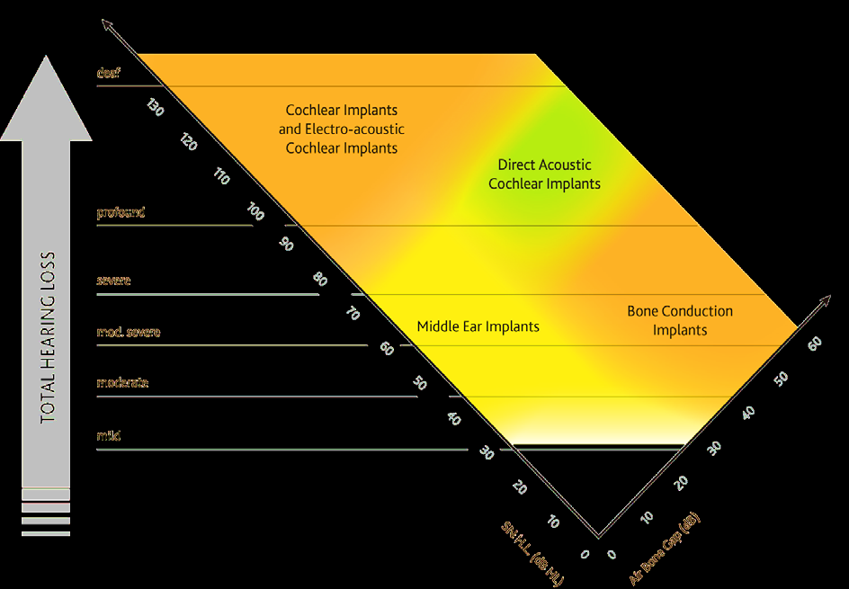
Source: (Cochlear Australia 2014).

Current Application 1365

Patient population
The PASC have identified a population sub-group for whom the MEI is suitable. This population comprises people with outer ear pathology that prevents the use of conventional hearing aids who meet all of the following criteria:
- stable SNHL; AND
- PTA₄ below 80 dBHL with one of the following air conduction thresholds:
  - mild hearing loss - 25 dB ≤ BEHL_{0.5-4kHz} < 40 dB; or
  - moderate hearing loss - 40 dB ≤ BEHL_{0.5–4 kHz} < 70 dB; or
  - severe hearing loss - 70 dB ≤ BEHL_{0.5–4 kHz} < 95 dB; AND
- speech understanding of >65% for word lists with appropriately amplified sound: AND
- bilateral, symmetrical HL with PTA thresholds in both ears within 20 dBHL_{0.5-4 kHz} of each other; AND
- normal middle ear with:
  - no history of middle ear surgery; AND
  - no history of post-adolescent, chronic middle ear infections; AND
  - normal tympanometry; AND
  - on audiometry, an air-bone gap of no greater than 10 dBHL_{0.5-4 kHz} at two or more frequencies; AND
- no history of other inner ear disorders such as Meniere’s disease.

Current arrangements for public reimbursement
The device is implanted in public and private hospitals in Australia and may be funded by public hospital surgical budgets, private health fund ex-gratia payments and people who self-fund. The medical service is not available on the MBS and the device is not on the Prosthesis List (PL).

Regulatory status
The Vibrant Soundbridge system (VSB) is the only MEI device registered for use in Australia. The following device components are registered for use in Australia
Table 3: MEI components listed on the ARTG
ARTG | Product | Indication
170179 | Amade audio processor - Middle ear implant system sound processor | The Amade audio processor is an external part of the VSB. The VSB is indicated for patients with mild to severe hearing impairment who cannot achieve success or adequate benefit from traditional therapy.
161702 | Vibrating Ossicular Prosthesis (VORP) 502X - Hearing aid, middle ear implant. | For SNHL, the VORP is crimped to the long process of the incus to directly drive the ossicular chain.
185533 | Vibroplasty Coupler -Hearing aid, middle ear implant. | Vibroplasty Couplers are combined with the VSB to facilitate coupling between the FMT and a vibratory structure of the middle ear. Prosthesis type is chosen on the basis of the ossicular remnants once all primary disease has been removed.
Another partially implantable device, the Ototronix Maxum system is registered for use internationally (Europe and USA). Two others, the Rion Device E-type (discontinued 2005) and Soundtec Direct Drive Hearing System (withdrawn 2004), upon which the Maxum device is based, are no longer available

Intervention

Hearing and Hearing Loss
The function of the ear is to convert sound waves occurring in the environment into electrical impulses that can be interpreted by the brain. The ear is comprised of three parts - outer, middle and inner. The outer ear consists of the pinna, the external auditory canal and the tympanic membrane. The pinnae funnel sound waves into the external auditory canal resulting in increased sound wave pressure levels at the tympanic membrane. The resulting vibration of the membrane is transmitted to the auditory ossicles (the malleus, incus and stapes) that are contained within the air-filled middle ear. The footplate of the stapes is connected to the oval window, through which vibration of the ossicles is transmitted into the fluid-filled cochlea of the inner ear. Vibration of the fluid within the cochlea results in stimulation of the hair cells of the organ of Corti. This stimulation results in the generation of action potentials and the transmission of electrical impulses to the brain via the cochlear nerve.
 | Figure 1: External, middle and inner ear
Air conduction occurs when sound is transmitted via the external auditory canal and middle ear to the fluid of the inner ear.  Bone conduction occurs when sound is transmitted to the fluid of the inner ear via bone. This occurs when the sound source is applied directly to the bones of the skull. | 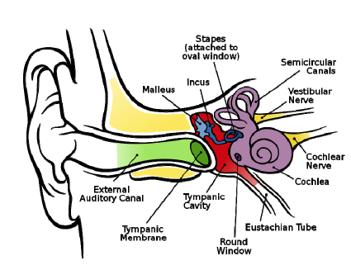

Hearing Loss Thresholds
The intensity of sound is measured using the decibel (dB) scale. The threshold of hearing is defined as the minimum effective sound pressure of a signal that is capable of provoking an auditory sensation (Keith 2002). Normal hearing thresholds are between 0 and 20 dB.
The severity of hearing loss is categorised using variable thresholds. Government organisations in Australia reference different thresholds with Australian Hearing using the levels described in Table 4, while the Australian Institute of Health and Welfare and others use variations of these thresholds.
Table 4: Hearing loss thresholds
Hearing threshold (dB) | Interpretation
0-20 | Normal hearing
21-45 | Mild hearing loss
46-65 | Moderate hearing loss
66-90 | Severe hearing loss
>95 | Profound hearing loss
Source: Australian Hearing July 2014

Type of Hearing Loss
Hearing loss is classified as being conductive, sensorineural or mixed. Sensorineural HL results from any dysfunction of the hair cells in the inner ear or the cochlear nerve. Conductive HL arises from an inability of the ear to conduct sound energy to the inner ear. It may be caused by lesions in the outer or middle ear. Mixed HL occurs when both CHL and SNHL are present in the same ear (Kesser and Friedman 2002). There are multiple potential causes of both CHL and SNHL with the type of hearing loss determined using audiometry.

Surgical Options for Hearing Loss
There are a range of surgical interventions for different types and severity of hearing loss including:
- CIs for severe to profound SNHL.
- BCIs for CHL and MHL (e.g. Bonebridge, BAHA, Sophono Alpha, Ponto).
- middle ear surgery mainly for CHL and possibly MHL (such as ossicular chain reconstruction, mastoidectomy, stapedectomy, tympanostomy tubes).
Surgical options may be explored refractory to conservative medical treatment. Attachment A lists the MBS services available for each type of hearing loss.

Prevalence in Australia
Overall hearing loss prevalence in Australia is reported as 22.2% (Application). In Australia, SNHL is the most common form of hearing loss. The overall prevalence of hearing loss ≧25dBHTL in adults is 20.2% for SNHL, 0.4% for CHL and 1.6% for MHL (Table 5). In adults, SNHL is largely caused by ageing, with most people aged over 50 years. Sensorineural hearing loss may also be caused by congenital malformation and exposure to noise or ototoxic substances. There are more adult males with hearing loss than females (26.3%% males vs 17.1% females). In adults, 66% have mild hearing loss; 23% have moderate hearing loss and 11% have severe to profound hearing loss.
Table 5: Overall prevalence of hearing impairment, South Australian population
 | ≧ 25dBHTL |  |  | ≧ 21dBHTL
Age yr | SNHL | CHL | MHL | SNHL | CHL | MHL
15-50 | 4.0 (0.0-8.3) | 0.5 (0.2-0.7) | 0.8 (0.0-2.0) | 5.5 (0.9-10.2) | 1.0 (0.0-3.2) | 0.8 (0.1-1.5)
51-60 | 25.5 (10.8-40.3) | 0.4 (0.0-1.1) | 2.4 (0.6-4.1) | 28.5 (13.6-43.4) | 0.4 (0.0-1.1) | 1.6 (0.2-3.0)
61-70 | 55.5 (37.4-73.6) | 0.5 (0.0-1.2) | 2.7 (1.2-4.3) | 64.2 (45.7-82.7) | 0.5 (0.0-1.2) | 3.6 (1.9-5.3)
>70 | 68.5 (41.3-95.7) | 0.0 | 5.0 (0.0-11.8) | 77.7 (51.4-100.0) | 4.8 (0.0-11.5) | 4.1 (0.0-10.6)
Total | 20.2 (14.9-25.4) | 0.4 (0.1-0.7) | 1.6 (0.7-2.5) | 23.6 (18.3-29.0) | 1.3 (0.0-2.9) | 1.5 (0.9-2.1)
Source: Wilson et al 1998

The overall prevalence of hearing loss in children (<15 years) is 2.5 in 1,000. Of these, it is estimated that 36.7% have mild hearing loss; 38.3% have moderate hearing loss, 13.3% have severe hearing loss and 11.7% have profound hearing loss. Sensorineural hearing loss in children may be caused by genetics, maternal infection, birthing issues or childhood infections such as meningitis.
Certain population groups such as communities of Aboriginal or Torres Strait Islander people have a significantly higher prevalence of ear disease and hearing loss. For example, the rate of hearing loss in Aboriginal children is estimated at between 10% and 41%.
Based on the adult SNHL prevalence rates in Table 3, and using December 2013 population data, approximately 1,043,438 Australian adults may be affected by SNHL:
- 689,000 may have mild SNHL;
- 240,000 may have moderate SNHL; and
- 115,000 may have severe to profound SNHL (rounded to nearest 1,000).

Applicant’s Prevalence Calculation
According to the Applicant, a chart review of 45,350 German patients, who were admitted into ENT clinics over a period of 16 years and diagnosed with SNHL, identified 0.76 % patients as possible candidates for a MEI based on pure tone audiogram (Junker et al. 2002). Of the 220 patients contacted for follow up, most were not interested in receiving an MEI (due to satisfaction with their existing hearing aid, anxiety about the surgery involved, or wanting to wait for further technological improvements). Only 0.09% of the total population were identified as good candidates for MEIs.
At December 2013 the total Australian population was estimated to be 23`319`400 (Australian Bureau of Statistics). Wilson et al. (1998) reported prevalence rates for SNHL of 20.2% (4`710`519). If 0.76% of the Australian SNHL population meet the criteria proposed for MEI, this would translate to 0.15% of the total population.

The Applicant has conservatively estimated the prevalence of common outer ear conditions that prevent the use of hearing aids (chronic otitis externa, ear canal stenosis/exostosis, cerumen removal) at 2.95% of the Australian population.

The Applicant therefore estimates that 4.4 in 10,000 Australians will have both SNHL and pathology in the outer ear. This translates to a suitable population of 1,032 Australia to be treated over a 10-15 year period. This would provide an average of 69-103 cases per year. Alternatively in 2012, 0.57% of the German ENT population received a MEI for SNHL, CHL or MHL representing a prevalence of 0.052 in 10`000. Applying this prevalence rate to the Australian population there would be 121 cases per year suitable for MEI for SNHL, CHL or MHL.

The Medical Service
Middle ear implants bypass the external auditory canal to directly vibrate the ossicular chain. Partially implantable devices have:
- an external processor to convert sound into electrical signals.
- a receiver that is implanted behind the ear.
- a transducer which is attached to the ossicular chain to transform the electric signals from the external processor into vibration which the brain translates into sound.

The medical service to implant the MEI device comprises a vibroplasty. Two surgical routes to the middle ear are commonly used - the facial recess route or the transmeatal route. The route used is determined from the medical status of the ear. The two approaches may also be combined.

With the facial recess route a simple mastoidectomy is performed to allow visualization of the long process of the incus. Then a posterior tympanotomy is done to access the ossicular chain and to introduce the transducer. With the transmeatal route, via the ear canal, a partial mastoidectomy is used to create space to position the conductor link. Then the tympanomeatal flap of the external auditory canal and tympanic membrane are lifted to visualize the middle ear space.

Once the middle ear is visible the device components are positioned and sutured into place. The transducer is crimped to the long process of the incus, having been positioned to be in contact with the stapes. The incision is then sutured.
Once implanted, the microphone in the device detects sounds, and a processor changes the sounds to electrical impulses. The electrical impulses are then converted to mechanical vibrations by transducer that is directly attached to the ossicular chain in the middle ear. A diagram of the VSB, which is a partially implantable device, is at Figure 2.
Figure 2: Vibrant Soundbridge Middle Ear Implant

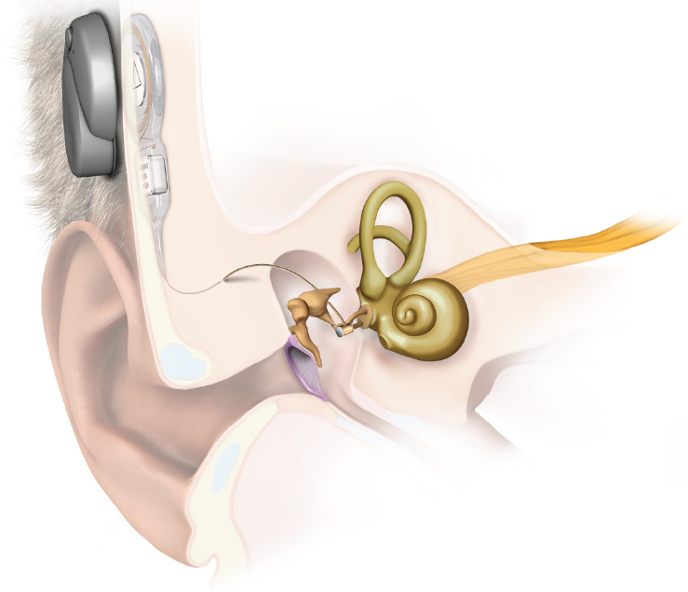

Delivery of the intervention
The implantation procedure is a one-off intervention. According to the applicant, an overall rate of revision surgery of 7% is reported in the literature.

Prerequisites
Otolaryngologist s deliver the implantation procedure. Expert colleagues, supported by the device manufacturer, would provide training. The procedure is performed, either as day surgery or in the hospital setting with an overnight stay. The duration of the procedure is approximately 1.0 to 2.5 hours.

Co-administered and associated interventions
A pre-surgical consultation with the otolaryngologist is required. An anaesthetist is required to administer the general anaesthetic.
Following surgery, an outpatient consultation (45 minutes) with an audiologist is required to activate the device following programming of the audio processor. A further follow-up consultation (30 minutes) is required 1 month later.

Listing proposed and options for MSAC consideration
Table 6 shows the proposed MBS listing.
Table 6: Proposed MBS item descriptor for MIDDLE EAR IMPLANT, Insertion of,
Category 3 – Therapeutic Procedures
MBS [item number]
MIDDLE EAR IMPLANT, partially implantable, insertion of, including mastoidectomy, for patients with stable sensorineural hearing loss with outer ear pathology that prevents the use of a conventional hearing aid and with:
- a PTA₄ below 80 dBHL with one of the following air conduction thresholds:
  - mild hearing loss - 25 dB ≤ BEHL_{0.5-4kHz} < 40 dB; or
  - moderate hearing loss - 40 dB ≤ BEHL_{0.5–4 kHz} < 70 dB; or
  - severe hearing loss - 70 dB ≤ BEHL_{0.5–4 kHz} < 95 dB; and
- speech perception discrimination of ≧65% correct with appropriately amplified sound; and
- bilateral, symmetrical hearing loss with PTA thresholds in both ears within 20 dbHL_{0.5-4 kHz} of each other; and
- a normal middle ear (no history of middle ear surgery or of post-adolescent, chronic middle ear infections); and
- normal tympanometry;
- on audiometry, the air-bone gap is ≦10 dBHL_{0.5-4 kHz} at two or more frequencies.
- no history of other inner ear disorders such as Meniere’s disease.
(Anaes)
Fee: $1,876.59 (based on mastoidectomy item).
A separate listing is proposed for explantation and revision surgery for MEI.
Table 7: Proposed MBS item descriptor for MIDDLE EAR IMPLANT, revision or explantation surgery
Category 3 – Therapeutic Procedures
MBS [item number]
MIDDLE EAR IMPLANT, partially implantable, revision or explantation of. (Anaes)
Fee: $TBA.

Clinical place for proposed intervention
The proposed population for the intervention are people with sensorineural hearing loss who have outer ear pathology that prevents the use of conventional hearing aids who meet all of the criteria listed in the PICO.
The clinical management algorithm proposed by the applicant is shown in Figure 4.

Figure 4: Clinical management algorithm

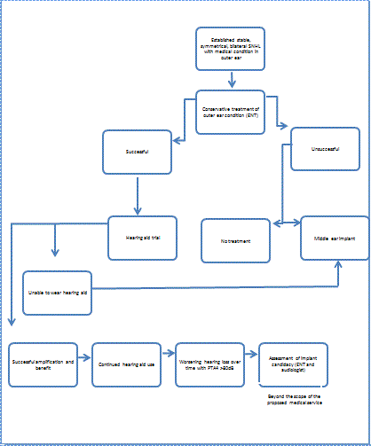

Comparator
The appropriate comparator is no treatment.

Clinical claim
The clinical claims are:
- Is the partially implantable MEI superior in effectiveness compared to no treatment.
- Is the partially implantable MEI as safe as other comparable procedures.
A cost effectiveness analysis is appropriate.

Table 8: Classification of an intervention for determination of economic evaluation to be presented
 |  | Comparative effectiveness versus comparator
 |  | Superior |  | Non-inferior | Inferior
Comparative safety versus comparator | Superior | CEA/CUA |  | CEA/CUA | Net clinical benefit | CEA/CUA
 |  |  |  |  | Neutral benefit | CEA/CUA*
 |  |  |  |  | Net harms | None^
 | Non-inferior | CEA/CUA |  | CEA/CUA* | None^
 | Inferior | Net clinical benefit | CEA/CUA | None^ | None^
 |  | Neutral benefit | CEA/CUA*
 |  | Net harms | None^
Abbreviations: CEA = cost-effectiveness analysis; CUA = cost-utility analysis
* May be reduced to cost-minimisation analysis. Cost-minimisation analysis should only be presented when the proposed service has been indisputably demonstrated to be no worse than its main comparator(s) in terms of both effectiveness and safety, so the difference between the service and the appropriate comparator can be reduced to a comparison of costs. In most cases, there will be some uncertainty around such a conclusion (i.e., the conclusion is often not indisputable). Therefore, when an assessment concludes that an intervention was no worse than a comparator, an assessment of the uncertainty around this conclusion should be provided by presentation of cost-effectiveness and/or cost-utility analyses.
^ No economic evaluation needs to be presented; MSAC is unlikely to recommend government subsidy of this intervention

Outcomes and health care resources affected by proposed intervention

Outcomes
The PASC agreed outcome measures for MEI versus the comparators for effectiveness are:
- Abbreviated Profile of Hearing Aid Benefit
- Client-orientated scale of improvement
- Functional gain
- Speech recognition
- Sound-field assessment
- Speech comprehension scores
- Self-assessment scales/patient preference

The PASC agreed outcome measures for MEI versus the comparators for safety are:
- Complications
- Adverse events
- Infection rates
- Taste disturbance
- Fibrosis
- Aural fullness
- Acoustic trauma
- Dizziness
- Damage to the middle ear
- Revision surgery
- Explant rate
- Device failure
- Mortality

Health care resources
The health care resources required for MEI, as proposed by the applicant, are shown in Table 9.
Table 9: List of resources to be considered in the economic analysis
 | Provider of resource | Setting in which resource is provided | Proportion of patients receiving resource | Number of units of resource per relevant time horizon per patient receiving resource | Disaggregated unit cost
 |  |  |  |  | MBS | Safety nets* | Other govt budget | Private health insurer | Patient | Total cost
Resources provided to identify eligible population
Resources provided to deliver proposed intervention
Prosthesis | Public/  PHI fund | Hospital |  | 1.0 |  |  |  | 13,970 |  | 13,970
Pre-assessment audiogram  MBS 82315 (11327) | Audiologist  (ENT) | Outpatient |  | 1.0 | 33.45 (41.85)
Impedance audiogram  MBS 82327 (11327) | Audiologist  (ENT) | Outpatient |  | 1.0 | 13.45 (16.80)
CT scanning  MBS 56016 | MBS | Outpatient |  | 1.0 | 246.50
ENT consultation  MBS 104 | MBS | Outpatient |  | 1.0 | 72.75
Anaesthesia prep  MBS17610 | Anaesthetist | Hospital |  | 1.0 | 32.25
Anaesthesia  MBS 20120 | Anaesthetist | Hospital |  | 1.0 | 74.25
Facial stem monitoring  MBS 11015 | ENT | Hospital |  | 1.0 | 112.45
Implant procedure Proposed fee based on mastoidectomy item | ENT | Hospital |  | 1.0 | 1876.59
Surgical assistant  MBS 51303 |  |  |  |  | 375.92
Hospital stay |  | Hospital |  |  |  |  |  |  |  | TBA
Post-op audiometry  MBS 82300 (11300) | Audiologist  / ENT | Outpatient |  | 1.0 | 130.90  (163.60)
Resources provided in association with proposed intervention
Follow-up ENT consult  MBS 105 | ENT | Outpatient |  |  | 36.55
Fitting of processor  MBS 10952 | Audiologist | Outpatient |  | 1.0 | 52.95
Follow-up audiometry  MBS 82300 (11300) | Audiologist  (ENT) | Outpatient |  | 1.0 | 130.90  (163.60)
Battery cost |  | Outpatient |  | 52.0
* Include costs relating to both the standard and extended safety net.

Proposed structure of economic evaluation (decision-analytic)
The PASC has agreed that this Application:
- should be limited to partially implantable MEIs.
- should consider evidence relating to partially implantable MEIs generally.
- include a class to class assessment of each partially implantable MEI device to establish whether:
  - the medical service to implant other MEI devices is similar to that of the vibroplasty required for the VSB.
  - the outcomes of the medical service for other MEI devices are similar.
  - the cost effectiveness of implanting other MEI devices is similar.
The PICO for comparison of MEI versus the comparators is shown in 10.

Table 10: Summary of extended PICO to define research question that assessment will investigate
Population | Intervention | Comparator | Outcomes to be assessed
Patients with stable, sensorineural hearing loss with an outer ear pathology that prevents the wearing of a hearing aid and who have:  - a PTA₄ below 80 dBHL with one of the following air conduction thresholds:  - mild HL - 25 dB ≤ BEHL_{0.5-4kHz} < 40 dB; or  - moderate HL - 40 dB ≤ BEHL_{0.5–4 kHz} < 70 dB; or  - severe HL - 70 dB ≤ BEHL_{0.5–4 kHz} < 95 dB; AND  - have speech perception discrimination of ≧65% correct with appropriately amplified sound; and  - bilateral, symmetrical SNHL with PTA thresholds in both ears within 20 dBHL_{0.5-4kHz} of each other; and  - a normal middle ear (no history of middle ear surgery or of post-adolescent, chronic middle ear infections); and  - normal tympanometry; and  - on audiometry the air-bone gap is ≦10 dBHL_{0.5-4kHz} at two or more frequencies); and  - no history of other inner ear disorders such as Meniere’s disease. | Middle ear implant | No treatment | Effectiveness outcomes:  - Abbreviated Profile of Hearing Aid Benefit  - Client-orientated scale of improvement  - Functional gain  - Speech recognition  - Sound-field assessment  - Speech comprehension scores  - Self-assessment scales  - Patient preference  Safety outcomes:  - Complications  - Adverse events  - Infection rates  - Taste disturbance  - Fibrosis  - Aural fullness  - Acoustic trauma  - Dizziness  - Damage to the middle ear  - Revision surgery  - Explant rate  - Device failure  - Mortality

Clinical Questions

1. In patients with outer ear pathology the prevents use of a conventional hearing aid, who have mild, moderate or severe SNHL that is stable, bilateral and symmetrical and who meet all other criteria set out in Table 10, is the MEI more effective compared to no treatment?

2. In patients with outer ear pathology the prevents use of a conventional hearing aid, who have mild, moderate or severe SNHL that is stable, bilateral and symmetrical and who meet all other criteria set out in Table 10, is the middle ear implant as safe as other comparable procedures?

Attachment A MBS services available for each type of hearing loss
MBS item | Descriptor | Medical Service | Hearing loss type | Hearing loss cause
41527 | Myringoplasty, trans-canal approach (Rosen incision) | Procedure using a skin graft to repair a perforated in tympanic membrane (eardrum). May include drain fluid from middle ear and insertion of typanostomy tube. | CHL | Severe ear infection or otitis media Perforation of tympanic membrane and intermittent discharge.
41539 | Ossicular chain reconstruction | Ossiculoplasty to repair or reconstruct middle ear and restore function. May include:  - total ossicular replacement prosthesis (TORP)  - partial ossicular replacement prosthesis (PORP)  - tympanoplasty (repair of tympanic membrane)  - stapedectomy or stapedotomy (partial or full replacement of stapes, for patients with otosclerosis or congenital malformation). | CHL (moderate to severe) | Trauma, neoplasms, inflammatory processes and/or cholesteatoma. Discontinuity of ossicular chain caused by eroded incudostapedial joint, absent incus, or absent incus and stapes superstructure. Fixation of ossicular chain caused by malleus head ankylosis or ossicular tympanosclerosis.
41542 | Ossicular chain reconstruction and myringoplasty
41545 | Mastoidectomy (cortical) | The mastoidectomy procedure varies according to extent of infection:  - simple: mastoid bone is exposed, infected air cells removed, incision in eardrum to drain middle ear.  - radical: tympanic membrane and most middle ear structures are removed, Eustachian tube is closed. Stapes usually retained.  - modified radical: retains ossicles. Tympanic membrane is reconstructed by tympanoplasty.  - complete (canal wall up): removal of mastoid air cells, tegmen, sigmoid sinus, presigmoid dural plate, posterior wall of external auditory canal. Posterior wall of external auditory canal is retained.  - canal wall down: complete mastoidectomy plus removal of posterior and superior osseous external auditory canal. Tympanic membrane reconstructed to separate the middle ear and mastoid cavity and ear canal.  With or without myringoplasty and/or ossiculoplasty. | CHL (moderate to severe) | Ear infections such as otitis media (chronic or acute) or mastoiditis.  Cholesteatoma.  Complications such as intra-temporal or intracranial suppuration, abscess formation, lateral venous sinus thrombosis.  Failure to respond to IV antibiotics.  Lateral skull base neoplasms.
41548 | Obliteration of the mastoid cavity
41551 | Mastoidectomy, intact wall technique, with myringoplasty
41554 | Mastoidectomy, intact wall technique, with myringoplasty and ossicular chain reconstruction
41557 | Mastoidectomy (radical or modified radical)
41560 | Mastoidectomy (radical or modified radical) and myringoplasty
41563 | Mastoidectomy (radical or modified radical), myringoplasty and ossicular chain reconstruction
41564 | Mastoidectomy (radical or modified radical), obliterate mastoid cavity, blind sac closure of external auditory canal and obliterate Eustachian tube
41566 | Revision of mastoidectomy (radical, modified radical or intact wall), including myringoplasty
41603 | Osseo-integration procedure, implantation of titanium fixture for use with implantable bone conduction hearing system device, in patients: with permanent or long term hearing loss; and unable to use conventional air or bone conduction hearing aid for medical or audiological reasons; and with bone conduction thresholds that accord to recognised criteria for the hearing device being inserted. Not associated with items 41554, 45794 or 45797 | Procedure for implantation of bone conduction implants (BCI). A titanium plate is anchored to the skull and attached to an external hearing aid. External device captures sound and transforms it into vibratory signals which are transmitted to the implanted plate and associated bone and conveyed to the brain. | CHL (with ≧ moderate hearing in better ear)  MHL with bone conduction thresholds ≦45 dB  Single sided deafness (severe to profound unilateral SNHL) with bone conduction threshold ≦45dB | Canal or middle ear malformation  Infection resulting in chronic draining ears  Chronic otitis media  Congenital atresia  Cholesteatoma  Middle ear dysfunction or disease  Sudden hearing loss  Acoustic neuroma  Meniere’s disease
41604 | Osseo-integration procedure, fixation of transcutaneous abutment implantation of titanium fixture for use with implantable bone conduction hearing system device, in patients (as for 41603).
41608 | Stapedectomy | Procedure to partially or fully replace stapes. Diseased part of stapes footplate is removed and replaced with a prosthesis which is attached to incus restoring continuity of ossicular movement. This enables sound to be transmitted from eardrum to inner ear. May be part of ossiculoplasty (repair or reconstruction of middle ear). | CHL with air bone gap of ≧30dB | Otosclerosis  Congenital malformation of stapes  Severe middle ear infections  Previous middle ear surgery
41611 | Stapes mobilisation | Procedure to remobilise stapes footplate.
41614 | Round window surgery including repair of cochleotomy | Procedures may be used to:  - correct a defect in round or oval window (or both) to prevent perilymph fistula (PLF) from leaking from inner ear to middle ear. Using trans-canal approach, small soft tissue grafts are used to patch fistula.  - correct superior canal dehiscence syndrome by reinforcing the round and oval windows fascia from a post-auricular incision. | CHL  MHL  SNHL | Otosclerosis  Trauma (head or ear)  Perforated eardrum  Ear block (plane descent or scuba diving)  Rapid increase in cranial pressure  Superior canal dehiscence syndrome
41615 | Oval window surgery including repair of fistula, not being a service associated with a service to which any other item in this Group applies.
41617 | Cochlear implant, insertion of, including mastoidectomy | Procedure to implant CI device which bypasses damaged inner ear and directly stimulates the auditory nerve. External component captures sound and transforms it into electromagnetic signal. Signal is conveyed to implant located behind auricle and changed into vibration which is conveyed to cochlea stimulating auditory nerve. | Adult – bilateral severe-profound SNHL  Children:  2-17 yr: severe-profound SNHL  12-24 mth: profound SNHL | Damaged hair cells in the cochlear (inner ear) and/or nerve to brain
41632 | Middle ear, insertion of tube for DRAINAGE OF (including myringotomy) | Procedure to insert a tube to drain fluid from middle ear in peoples with severe ear infection or otitis media with effusion. With or without myringotomy to enable release of fluid from middle ear. | CHL | Otitis media with effusion.  Cholesteatomas from severe infection, perforated eardrum, chronic middle ear problems or congenital issues.
41635 | Clearance of middle ear for granuloma, cholesteatoma and polyp, 1 or more, with or without myringoplasty | Procedure to remove granuloma, cholesteatomas and polyps from middle ear. May be performed with:  - myringoplasty (skin graft to repair perforated tympanic membrane).  - insertion of typanostomy tube.  - ossiculoplasty (41638).
41638 | Clearance of middle ear for granuloma, cholesteatoma and polyp, 1 or more, with or without myringoplasty with ossicular chain reconstruction
45794 | Osseo-integration procedure - extra-oral, implantation of titanium fixture, not for implantable bone conduction hearing system device | Placement of titanium prostheses as part of a TORP or PORP procedure to repair or reconstruct the middle ear (ossicular chain reconstruction).  Reconstruction of the external ear with osseo-integrated prostheses. Auricular deficit or absence may or may not be associated with hearing loss. | CHL (moderate-severe)  severe MHL | Discontinuity or fixation of ossicular chain, trauma, neoplasm, inflammatory processes, cholesteatoma.  Auricular deficit due to aplasia, auricle avulsion or amputation injuries, blunt trauma, burns, composite defect, frost bite, lacerations, superficial defects.
45797 | Osseo-integration procedure, fixation of transcutaneous abutment, not for implantable bone conduction hearing system device

References
Access Economics (2006). Listen Hear! The economic impact and cost of hearing loss in Australia.
Cochlear Australia (2014). http://www.cochlear.com/wps/wcm/connect/au/home
Keith RW; Clinical Tests. In: Seiden AM et al (eds) (2002). Otolaryngology: The Essentials. New York: Thieme, 2002, pp. 13-27.
Kesser BW and Friedman RA; Functional disorders. In: Seiden AM et al (eds). (2002). Otolaryngology: The Essentials. New York: Thieme, pp. 33-38.
Kulkarni K and Hartley DEH, 2008. ‘Recent advances in hearing restoration’, Journal of the Royal Society of Medicine, 2008: 101, 116-124.
Perera C, Thavaneswaran P, Lee I and Church J (2010) Middle ear implant for sensorineural, conductive and mixed hearing losses Assessment Report for Medical Services Advisory Committee Application 1137. Commonwealth of Australia.
Seiden AM et al (eds) (2002). Otolaryngology: The Essentials. New York: Thieme.
Wilson D, Walsh PG, Sanchez L, Read P. Hearing impairment in an Australian population. 1998 Centre for Population Studies in Epidemiology, South Australian Department of Human Services.

PTA₄ = the pure-tone average of air-conduction thresholds at 0.5, 1, 2, & 4 kHz.
BEHL = better ear hearing level. dB = decibels.
dBHL = decibels hearing level. kHz = hertz.
SNHL is an inner ear disorder. ‘Other inner ear disorders’ refers to additional conditions including Meniere’s disease, otosclerosis, etc.
BHTL = decibels hearing threshold level.

