1293
Final Decision Analytic Protocol (DAP) to guide the assessment of Epidermal Growth Factor Receptor (EGFR) gene mutation testing for eligibility for afatinib treatment in patients with stage IIIB or stage IV non-small cell lung cancer (NSCLC)

January 2013

Table of Contents
MSAC and PASC 3
Purpose of this document 3
Purpose of application 4
Background 5
Current arrangements for public reimbursement 5
Regulatory status 6
Intervention 7
Description 7
Delivery of the intervention 13
Prerequisites 13
Co-administered and associated interventions 14
Listing proposed and options for MSAC consideration 15
Proposed MBS listing 15
Clinical place for proposed intervention 16
Outcomes for safety and effectiveness evaluation 21
Effectiveness 21
Comparison of test performance 21
Safety 22
Summary of PICO to be used for assessment of evidence (systematic review) 22
Clinical claim 24
Outcomes and health care resources affected by introduction of proposed intervention 25
Outcomes for economic evaluation 25
Health care resources 25
Proposed structure of economic evaluation (decision-analytic) 30

MSAC and PASC
The Medical Services Advisory Committee (MSAC) is an independent expert committee appointed by the Australian Government Health Minister to strengthen the role of evidence in health financing decisions in Australia. MSAC advises the Commonwealth Minister for Health and Ageing on the evidence relating to the safety, effectiveness, and cost-effectiveness of new and existing medical technologies and procedures and under what circumstances public funding should be supported.
The Protocol Advisory Sub-Committee (PASC) is a standing sub-committee of MSAC. Its primary objective is the determination of protocols to guide clinical and economic assessments of medical interventions proposed for public funding.

Purpose of this document
This document is intended to provide a draft decision analytic protocol (DAP) that will be used to guide the assessment of epidermal growth factor receptor (EGFR) mutation testing for eligibility for afatinib treatment in patients with stage IIIB or stage IV non-small cell lung cancer (NSCLC). The draft protocol was finalised after inviting relevant stakeholders to provide input. This final protocol will provide the basis for the assessment of the intervention.
The protocol guiding the assessment of the health intervention has been developed using the widely accepted “PICO” approach. The PICO approach involves a clear articulation of the following aspects of the research question that the assessment is intended to answer:
Patients – specification of the characteristics of the patients in whom the intervention is to be considered for use;
Intervention – specification of the proposed intervention;
Comparator – specification of the therapy most likely to be replaced by the proposed intervention; and
Outcomes – specification of the health outcomes and the healthcare resources likely to be affected by the introduction of the proposed intervention.

Purpose of application
An application requesting Medicare Benefits Schedule (MBS) listing of EGFR mutation testing for eligibility for afatinib treatment in patients with stage IIIB or stage IV NSCLC was received from Boehringer Ingelheim Pty Ltd (BI) by the Department of Health and Ageing (D0HA) in May 2012.
BI is seeking funding support for EGFR testing at the time of histological diagnosis in patients with NSCLC, and non-squamous cell (adenocarcinoma and large cell carcinoma) or not otherwise specified (NOS) histology. The applicant is proposing afatinib treatment for EGFR mutation positive (M+) and previously untreated patients. This DAP will guide the assessment of this proposal.
EGFR mutation testing is a co-dependent service. EGFR mutation testing for determination of eligibility for the novel therapy afatinib in stage IIIB or stage IV NSCLC patients is a new intervention, although applications requesting MBS funding for EGFR mutation testing have been considered previously by MSAC for eligibility for the treatments gefitinib and erlotinib, also in NSCLC patients.
An independent assessment group, Adelaide Health Technology Assessment, School of Population Health, University of Adelaide, as part of its contract with the Department of Health and Ageing, drafted this decision analytic protocol to guide the assessment of the safety, effectiveness and cost-effectiveness of the proposed intervention in order to inform MSAC’s decision-making regarding public funding of the intervention.

Background

Current arrangements for public reimbursement
Approval is being sought for public funding for EGFR mutation testing in association with afatinib treatment. There is currently no MBS listing for EGFR testing to determine eligibility for treatment with afatinib in patients with NSCLC.
MSAC has previously considered and approved public funding for EGFR mutation testing to determine eligibility for gefitinib treatment in patients with locally advanced or metastatic NSCLC as a second-line treatment, resulting in its listing on the MBS from 1 May 2012 (see Table 1). Afatinib is a novel TKI which binds irreversibly with EGFR, unlike the other TKI treatments gefitinib and erlotinib which undergo reversible binding with EGFR.
The TKI gefitinib has been approved for PBS funding in NSCLC patients who have undergone disease progression after previous treatment with chemotherapy, and who are found to be mutation positive on EGFR mutation testing. The TKI erlotinib has been approved for PBS funding in locally advanced or metastatic NSCLC patients who have either undergone disease progression following first line platinum-based chemotherapy or for whom chemotherapy cannot be tolerated or is contra-indicated. Second-line treatment with erlotinib is currently not dependent upon EGFR mutation status. While applications are in progress requesting the approval of funding for gefitinib and erlotinib as first-line therapies for advanced NSCLC patients, to date the PBS does not list these therapies as first-line treatment.
Afatinib has been proposed by the applicant as an effective first-line therapy in NSCLC patients who test positive for activating EGFR mutations.
Table 1: Current MBS item descriptor for EGFR gene mutation testing for access to gefitinib
Category 6 – Pathology Services
73328
A test of tumour cells from a patient with locally advanced or metastatic non-small cell lung cancer requested by, or on behalf of, a specialist or consultant physician to determine if the requirements relating to epidermal growth factor receptor (EGFR) gene status for access to gefitinib under the Pharmaceutical Benefits Scheme (PBS) are fulfilled.
Fee: $400.00 Benefit: 75% = $300.00 85% = $340.00

Regulatory status
In vitro diagnostic medical devices (IVDs) are, in general, pathology tests and related instrumentation used to carry out testing on human samples, where the results are intended to assist in clinical diagnosis or in making decisions concerning clinical management (Therapeutic Goods Administration 2009).
Manufacturers of Class 2, Class 3 and Class 4 commercial IVDs must hold certification from a regulatory body to show compliance with a suitable conformity assessment procedure (Therapeutic Goods Administration 2009). The Therapeutic Goods Administration (TGA) regulatory framework for IVDs changed in July 2010, such that in-house laboratory tests now also receive regulatory scrutiny. Laboratories that manufacture in-house Class 3 IVDs are required to notify the TGA of the types of IVDs manufactured in each laboratory for inclusion on a register. These laboratories must have National Association of Testing Authorities (NATA) accreditation, with demonstrated compliance with the suite of standards on the validation of in-house IVDs, as published by the National Pathology Accreditation Advisory Committee (NPAAC), for each test manufactured.
Class 3 IVDs present a moderate public health risk, or a high individual risk, and include those used to target patients for selective therapy and management, or for disease staging, or in the diagnosis of cancer including cancer staging, where initial therapeutic decisions will be made based on the outcome of the test results, for example, personalised medicine (Therapeutic Goods Administration 2009) (see Figure 1). Manufactured kits and in-house IVDs used for EGFR mutation testing to selectively determine access to targeted therapies including afatinib would be considered as Class 3 IVDs.
To date, afatinib has not been listed with TGA.
Figure 1: Classification of Class 3 In Vitro Diagnostic (IVD) medical devices
Source: http://www.tga.gov.au/industry/ivd-framework-overview.htm [accessed 2nd August 2011]
Therapeutic Goods (Medical Devices) Regulations 2002 –Schedule 2A
1.3 Detection of transmissible agents or biological characteristics posing a moderate public health risk or high personal risk
- An IVD is classified as Class 3 IVD medical devices or a Class 3 in-house IVD if it is intended for any of the following uses:
  - detecting the presence of, or exposure to, a sexually transmitted agent;
  - detecting the presence in cerebrospinal fluid or blood of an infectious agent with a risk of limited propagation;
  - detecting the presence of an infectious agent where there is a significant risk that an erroneous result would cause death or severe disability to the individual or foetus being tested;
  - pre-natal screening of women in order to determine their immune status towards transmissible agents;
  - determining infective disease status or immune status where there is a risk that an erroneous result will lead to a patient management decision resulting in an imminent life-threatening situation for the patient;
  - the selection of patients for selective therapy and management, or for disease staging, or in the diagnosis of cancer;
  - human genetic testing;
  - to monitor levels of medicines, substances or biological components, when there is a risk that an erroneous result will lead to a patient management decision resulting in an immediate life-threatening situation for the patient;
  - the management of patients suffering from a life-threatening infectious disease;
  - screening for congenital disorders in the foetus.
Note: For paragraph (f) An IVD medical device would fall into Class 2 under clause 1.5 if:
  - a therapy decisions would usually be made only after further investigation; or
  - the device is used for monitoring.
- Despite subsection (1) an IVD is classified as a Class 3 IVD medical device or a Class 3 in-house IVD if it is used to test for transmissible agents included in the Australian National Notifiable Diseases Surveillance System (NNDSS) list as published from time to time by the Australian government.

Intervention

Description
In Australia in 2008 lung cancer was the fourth most commonly reported cancer, comprising 8.9% of all cancer cases. AIHW statistics show a trend of increasing incidence in females with case numbers increasing from 18 to 32 per 100,000 females between 1982 and 2008, and a decreasing rate in males, with case numbers dropping from 85 to 57 per 100,000 in males over the same time period. Lung cancer was also the highest cause of cancer mortality in 2007 with 7,626 deaths reported (62% of deaths were male) and these numbers are expected to increase in males despite a falling in mortality rate (AIHW 2011a).

Lung cancer is diagnosed most often in the advanced stages of the disease (43% in Stage IV or metastatic cancer and 25% in stage IIIB or locally advanced cancer) with as few as approximately 35% of patients expected to survive beyond one year after diagnosis (DoHA 2010). The median survival for patients with stage III or stage IV lung cancer is two years and the number of lung cancer deaths for one year is predictive of the total number of patients with advanced disease two years prior. For example there were an estimated 7,826 deaths from lung cancer in 2010 which is indicative of a total of 7,826 patients with locally advanced or metastatic disease in 2008.
NSCLC is by far the most common form of lung cancer, accounting for approximately 80% of cases (CrinoA & Metro 2011), and can be further defined by the following subgroups: i. adenocarcinoma, ii. squamous cell carcinoma, and iii. large-cell carcinoma. Until recently, when developed targeted molecular therapies became available, treatment for all three subgroups was similar (Armour & Watkins 2010). While treatment for NSCLC diagnosed in the early stages has made advances, patients with locally advanced or metastatic tumours face chemotherapy (platinum-based doublet chemotherapy is most common) and its subsequent symptoms of toxicity, with response rates reported at less than 30% (Cataldo et al. 2011).
Studies have found that approximately 10% to 20% of NSCLC tumours harbour somatic mutations in the EGFR gene (Ishibe et al. 2011; Keedy et al. 2011). Recent trials with drugs (such as gefitinib, and erlotinib in the first-line setting) targeted towards tumours harbouring activating mutations in the EGFR gene have significantly improved the response rate in a subgroup of patients who test positive for one of these mutations (Sequist et al. 2011). Despite the design of targeted therapies approximately 20-30% of EGFR mutation positive patients have been found not to respond to treatment with ‘first-generation’ TKIs (gefitinib and erlotinib) (CrinoA & Metro 2011).
EGFR mutation screening data have shown that female sex, Asian origin, never smoking and lung adenocarcinoma are all predictors of activating EGFR gene mutations (Mazzoni et al. 2011; Rosell et al. 2009). Further data indicate that 30% of EGFR gene mutations occur in males, 33% in current or former smokers, and 9% occur in large cell carcinomas (Rosell et al. 2009). However squamous cell carcinoma (SCC) has rarely been found to harbour EGFR gene mutations and where a mutation has occurred, response to TKI treatment (gefitinib) has been poor when compared to adenocarcinoma. Exclusion of SCC patients for testing on the basis of histological diagnosis has been suggested (Rosell et al. 2009).
An NSCLC sub-group with activating EGFR gene mutations
The EGFR gene encodes a transmembrane receptor protein with tyrosine kinase activating ability and has a role in the regulation of various developmental and metabolic processes. Under normal circumstances, ligand binding on the cell surface triggers dimerisation of the receptor and phosphorylation of the intracellular tyrosine kinase domain, followed by a cascade of molecular reactions in the EGFR signalling pathway, leading to changes in cell survival and proliferation. There are several known receptors in the EGFR family including HER1 (known as EGFR), HER2 (known for its involvement in breast and gastric cancers), HER3 and HER4. Ligand molecules including epidermal growth factor and other growth factors are known to bind the receptors and trigger the signalling cascade (Armour & Watkins 2010; Cataldo et al. 2011) .

A sub-group of NSCLC patients harbour an EGFR gene mutation which results in an over-activated intracellular kinase pathway (an activation mutation) and is associated with a form of NSCLC tumour which tends to be resistant to standard platinum-based doublet chemotherapy. So far data suggest that approximately 90% of these mutations occur between exons 18 and 21 of the tyrosine kinase activation domain, with the majority occurring in exon 19 (in-frame deletion or insertion mutations) or in exon 21 at codon 858 (a missense mutation resulting in a leucine to arginine substitution - L858R) (Mazzoni et al. 2011). These mutations increase activation of the EGFR pathway by triggering phosphorylation at the tyrosine kinase binding site, adenosine triphosphate (ATP) binding, and downstream signalling which leads to cell proliferation and development of metastases.
The novel TKI afatinib binds in an irreversible reaction at the ATP binding site of the kinase domain. The irreversible covalent binding of afatinib is reputed to block signalling from all of the homo- and hetero-dimers formed by the ErbB family of receptor molecules EGFR (ErbB1), HER2 (ErbB2), ErbB3 and ErbB4 (CrinoA & Metro 2011). Binding at the ATP site inhibits phosphorylation and receptor signalling, enabling restoration of the normal downstream cellular processes such as apoptosis (cell death), leading to decreased tumour cell proliferation.
Although erlotinib and gefitinib are similarly designed to compete and bind at the ATP binding site of the kinase domain, their binding action is reversible. Because of its irreversible action, afatinib is reputed to be a more effective treatment for some patients with EGFR mutations less susceptible to erlotinib or gefitinib (CrinoA & Metro 2011). Patients with tumours carrying the exon 20 T790M mutation have a poorer prognosis than those with more common mutations in exons 19 and 21. Mutation T790M acts to prevent binding of erlotinib or gefitinib but allows constitutive binding of ATP. Moreover patients who are successfully treated with erlotinib or gefitinib all eventually gain resistance to these inhibitors as new mutations develop in the course of their disease. In some of these cases, afatinib is expected to be more effective than the reversible binders erlotinib and gefitinib.
BI is applying for MBS funding to support EGFR mutation testing for determination of afatinib eligibility for first-line treatment. By identifying those patients with tumours carrying activating EGFR gene mutations (M+), first-line afatinib treatment can be allocated most effectively, and those without the mutations (WT) can be treated with other first-line platinum-based chemotherapy regimens.
Methods for identification of EGFR gene mutation
EGFR genetic status can be determined by testing cells retrieved from the lung tumour using one of a number of laboratory methods. Gene sequencing (Sanger sequencing) is a commonly used method for mutation detection in Australia and has the advantage that it can detect any mutation (Ishibe et al. 2011), however this method requires at least 20% tumour cells present in the sample, and can be inaccurate if there is a lower proportion. Many M+ EGFR tumours are heterozygous for the mutant allele (Soh et al. 2009), with biopsy samples needing tumour cells present at a rate of at least 20% to provide reliable sequencing results. Low tumour cell numbers can lead to false negative results. Tumour sample preparation techniques can also cause artefacts as formalin fixation and paraffin embedding used for biopsy preparation can cause fragmentation and chemical modification of the DNA sequence of interest (John, Liu & Tsao 2009). There is currently one ARTG listed test for EGFR gene mutation detection (Roche cobas® EGFR Mutation Test is registered as Acquired Genetic Alteration IVD #194319).

There are some in-house (laboratory developed) methods that are used for EGFR gene mutation screening, for example the High Resolution Melt (HRM) method. HRM identifies samples harbouring an EGFR gene defect but must be followed by sequencing for confirmation and specific identification of the mutation (John, Liu & Tsao 2009). Various other methods of EGFR identification are available in kit form and often include PCR amplification of the DNA of interest (this can overcome the need for at least 20% tumour cells in the tumour sample) followed by mutation detection. Most kits are capable of detecting only a specific mutation or set of mutations.
A dual HRM and direct DNA sequencing method was proposed by AstraZeneca in its submission to MSAC for approval of funding for EGFR gene mutation testing for access to PBS listed gefitinib. The IPASS gefitinib study used the Therascreen EGFR 29 kit to screen for trial eligibility(Fukuoka et al. 2011). Roche Diagnostics developed the cobas® 4800 EGFR gene mutation test which is a Real Time PCR diagnostic assay capable of identifying 41 mutations in exons 18 to 21. In the Canadian based erlotinib trial BR.21, EGFR gene mutation status was identified using Sanger sequencing.
In the Lux 3 clinical trial of afatinib genotyping was performed by a central laboratory with an established real time PCR protocol together with fluorescence detection using the Therascreen EGFR29 Mutation Kit (Qiagen Ltd, Manchester, UK). In the Lux Lung 2 trial EGFR mutations within exons 18 – 21 were amplified by PCR and analysed for somatic mutations by direct sequencing at one of two laboratories (Genzyme, Cambridge MA, USA; Translational Laboratory National Taiwan University, Taipei, Taiwan) (Boehringer Ingelheim Pty Ltd). BI has no proprietary EGFR mutation test associated with this application.
Timing of EGFR identification within disease progression
BI is requesting that MBS funding for current EGFR mutation testing be extended to include testing at the time of histological diagnosis for first-line access to afatinib in patients with stage III or stage IV non-squamous NSCLC or NSCLC NOS. (Note: applications for approval of gefitinib and erlotinib as first-line therapies are currently under consideration by PBAC; it is possible that PBAC may approve afatinib for PBS listing without specification of any line of therapy.)
PASC has agreed that all patients with NSCLC (non-squamous or NOS) should be EGFR mutation tested at histological diagnosis regardless of the stage of the disease. Although outright cure may be achieved in a small proportion of early stage NSCLC patients through surgery and chemo- or radiotherapy, relapse rates are high. The majority of patients either present or progress quickly on to late stage cancer, requiring EGFR gene mutation status to determine the best treatment strategy. It is likely that a relatively low absolute number of tests would be performed on patients who present with early stage disease and never progress to advanced stage disease. The clinical and cost benefits of early testing and treatment planning may outweigh the cost of unnecessary testing.
An advantage of having the test performed at initial diagnosis for those in earlier stages of disease is having the test result recorded in the patient’s medical record, thereby avoiding the 2-3 week delay in commencing treatment after disease progresses. There may also be considerable time and cost savings by having the reporting pathologist arrange for the test to be performed while actively reporting the case rather than having the test laboratory retrieve the samples from another laboratory. Similarly, it would become apparent early in the course of the disease that a sample was unsuitable for testing and a biopsy could be performed before the patient’s condition deteriorated.
If EGFR mutation testing is conducted simultaneously with histological diagnosis, the same specimen could be used for both assays. It would be assumed that a patient’s tumour EGFR mutation status would remain stable with disease progression and no further biopsy or mutation testing would be required after progression if mutation status has been established at diagnosis.

Sample collection and preparation
The two methods commonly used in Australia for tumour sampling for EGFR gene mutation testing are (i) bronchoscopy and (ii) percutaneous fine needle aspiration (FNA). Bronchoscopy may allow sampling of endobronchial disease (biopsies, wash, brush); mediastinal masses or lymph nodes (transbronchial needle aspiration with or without endobronchial ultrasound guidance or EBUS); or sampling of peripheral lung lesions (transbronchial biopsies, brushes or washes with or without EBUS). Bronchoscopy is usually carried out by a respiratory physician and is the preferred method for sample collection as a greater cell mass can usually be obtained. When bronchoscopy is not possible FNA is the method used, usually carried out by radiologists, and is guided by computed tomography (CT) (DoHA 2010). However, core biopsies with a larger bore needle can also be performed by a CT guided percutaneous approach and can provide a larger specimen.
It is critical that sufficient tumour sample is obtained to carry out a reliable DNA preparation and screening procedure. As previously mentioned, a tumour proportion of at least 20% is required for detection of EGFR gene mutations with Sanger sequencing, due to the heterogeneous nature of the tumour, and the sensitivity of the technique. Tumour biopsy is preferred to FNA, as the latter method is less likely to supply sufficient material for testing (John, Liu & Tsao 2009), and MSAC has noted previously that the quantity of tumour cells currently collected by either method is often insufficient to conduct satisfactory mutation testing (DoHA 2010). FNA also carries a higher risk to the patient than sample collection via bronchoscopy. Sputum samples and bronchial brushings are unlikely to provide sufficient cellular material for DNA analysis. To reduce the necessity for repeat sampling and testing, sample size and quality should be made a priority. It should be noted that there may be clinical consequences of more invasive sampling, such as an increased rate of adverse effects associated with tumour sample retrieval. Costs associated with sample retrieval, re-testing, re-biopsy, as well as additional costs such as patient hospital stay and second opinion consultancy fees, should be assessed.
For the detection of somatic EGFR gene mutations, tumour samples are normally processed into formalin-fixed, paraffin-embedded tissue blocks (FFPE) which are then sectioned, stained and mounted onto glass slides. Following mounting, samples would be examined by a suitably qualified medical scientist. For direct sequencing, samples with a low tumour cell proportion should be enriched by micro-dissection after which DNA extraction can be carried out using a commercially available kit. PCR amplification of the EGFR TK domain exons is followed by sequencing for identification of mutations (John, Liu & Tsao 2009). Where necessary, samples will be transported to a laboratory accredited to carry out EGFR gene mutation testing.

Delivery of the intervention
It is expected that NSCLC patients would require one EGFR gene mutation test in their lifetime. This test would be performed immediately following histological diagnosis of NSCLC and irrespective of the stage of disease, utilising the same biopsy material used for this diagnosis. Approximately 60% to 70% of NSCLC cases are first diagnosed at stage IIIB or stage IV (Mazzoni et al. 2011; Molina et al. 2008), with the remaining 30% to 40% diagnosed at earlier stages. If the DNA analysis was inconclusive a repeat test may be necessary. At the Peter MacCallum Cancer Centre the rate of re-testing is estimated at 10% of EGFR tests however this rate may be reduced if testing is limited to bronchoscopy and core biopsy samples. FNA and pleural effusion samples give a lower cellular yield and the highest re-test rates. Where possible, the repeat test should be carried out using the original biopsy sample, however in some cases further biopsy may be required and should be quantified. Re-biopsy is likely to have a greater negative impact on a patient with a more advanced tumour than a patient at an earlier stage of disease.
EGFR activating mutations occur with greatest frequency in adenocarcinoma NSCLC patients, however they are also known to occur in large-cell NSCLC (Rosell et al. 2009). By restricting EGFR gene mutation testing to those with a diagnosis of non-squamous cell NSCLC and NSCLC NOS the testing regime will include patient populations most likely to be affected by the mutation (adenocarcinoma and large-cell carcinoma). EGFR gene mutations have been reported to be found in only 0-1.1% of squamous cell NSCLC (Shukuya et al. 2011). NSCLC that has not been categorised by histological diagnosis (i.e. not otherwise specified or NOS) should also be included in the testing regime so as to avoid missing patients who may benefit from first-line TKI treatment.

Prerequisites
EGFR mutation testing, according to MBS item 73328, is “requested by, or on behalf of, a specialist or consultant physician” which in the case of NSCLC is likely to be a medical oncologist. A tumour sample will be resected by the surgeon at the time of diagnosis of lung cancer, which may also be made available for mutation testing. Alternatively a sample may be obtained by a respiratory physician by bronchoscopy or fine needle aspiration. To enable efficient EGFR mutation testing at the point of diagnosis, the pathologist who has made a histological diagnosis of non-squamous NSCLC or NSCLC NOS may also request EGFR mutation testing on the same patient’s tumour sample (reflex testing).
Once the tumour sample has been retrieved by the testing laboratory, an anatomical pathologist would carry out macro-dissection or micro-dissection of the tumour cells so that an appropriate sample is available for DNA extraction. DNA extraction and assay would be performed by a molecular scientist or technician, under the supervision of a senior scientist or pathologist according to NPAAC laboratory supervision standards. Supervising senior scientists are required by the NPAAC to have a PhD or Fellowship in the appropriate discipline, 10 years experience and a minimum of two years as a supervisor in a clinical laboratory. Pathologists require a medical degree followed by five years of specialist training in pathology and examination by the Fellow of the Royal College of Pathologists of Australasia (FRPCA).
In December 2010 MSAC recommended that all EGFR gene mutation testing should only be performed in NATA accredited laboratories. To gain NATA accreditation a laboratory must satisfy standards set by NPAAC. In this instance, such a laboratory would have demonstrated proficiency in its Director’s choice of technique for EGFR gene mutation testing. Competence to perform the test will be monitored through the RCPA Quality Assurance Program (QAP).
While it is not proposed that a specific method for EGFR gene mutation testing should be included in the MBS item listing, the choice of technique may depend on factors such as available equipment, skill and experience of staff, case load and case mix. Where laboratories in Australia are already conducting EGFR gene mutation testing it could be expected that no further investment in equipment or staff would be required, although upgrades driven by technology changes may be necessary. Laboratories wishing to establish EGFR gene mutation testing would need to outlay for the testing platform of their choice, and additional outlays to seek NATA accreditation and staff training will be required.
Analysis of EGFR gene mutations is a complex task and depends on a number of conditions for successful completion. Sample size, proportion of tumour cells, artefacts of tissue preparation and interpretation of results all present particular challenges in the detection of somatic mutations (John, Liu & Tsao 2009). For this reason it is likely that the majority of EGFR gene mutation testing will be performed in specialist referral laboratories, located in the major metropolitan areas of Australia. Currently patients are usually required to attend a metropolitan or large regional facility to have a biopsy taken. If EGFR gene mutation testing is not available at the laboratory where the diagnostic analysis is performed, the biopsy sample would be retrieved by the testing laboratory and prepared for DNA analysis. Patients would not be further inconvenienced by this process.

Co-administered and associated interventions
EGFR gene mutation testing is a co-dependent service and is required to determine eligibility for treatment with the TKI afatinib in previously untreated patients with stage III or stage IV non-squamous NSCLC or NSCLC NOS. Patients with tumours testing positive for any EGFR activating mutation will be eligible for afatinib treatment. Afatinib comes in tablet form and is taken orally, with available doses of 20 mg, 30 mg, 40 mg and 50mg. The applicant has recommended that the dose of afatinib in first-line treatment would be 40 mg daily, with the option of titration across the dose range to optimise efficacy and tolerability. When there is further disease progression or toxicity prevents further use, treatment would be ceased.
Should approval be given for MBS listing of EGFR gene mutation testing and PBS listing of afatinib, it is likely that the utilisation of afatinib would increase as a first-line therapy for NSCLC patients. At the same time, utilisation of standard platinum-based chemotherapy is likely to decrease for these patients, and the utilisation of gefitinib and erlotinib as a treatment after failure of chemotherapy is also likely to decrease. If gefitinib and erlotinib are approved for first-line treatment they would compete with afatinib for utilisation.

Listing proposed and options for MSAC consideration

Proposed MBS listing
The applicant is proposing an extension of the description for MBS item 73328 to include access to afatinib in addition to gefitinib and erlotinib (see Table 2).
Table 2: Proposed MBS item descriptor for EGFR gene mutation testing for access to gefitinib, erlotinib or afatinib
Category 6 – Pathology Services
Group P7 - Genetics
73328
A test of tumour cells from a patient with locally advanced or metastatic non-small cell lung cancer requested by, or on behalf of, a specialist or consultant physician to determine if the requirements relating to epidermal growth factor receptor (EGFR) gene status for access to gefitinib, or erlotinib or afatinib under the Pharmaceutical Benefits Scheme (PBS) are fulfilled.
Fee: $397.35
Relevant explanatory notes
The test will, ordinarily, be initiated by a pathologist, medical oncologist or respiratory physician (or occasionally a surgeon). Samples with low quality DNA or low tumour cell content relevant to the sample size available and chosen testing method may require tumour cell enrichment or the use of a method more sensitive than Sanger sequencing

Targeted population
It is proposed that EGFR gene mutation testing would be performed on the patient population at diagnosis of non-squamous NSCLC or NSCLC NOS irrespective of disease stage.

Clinical place for proposed intervention
Current scenario clinical management
In the current scenario there is no EGFR gene mutation testing for afatinib treatment for patients with previously untreated stage IIIB or stage IV NSCLC. Treatment offered to these patients is first-line chemotherapy, with platinum-based doublet chemotherapy (such as carboplatin and gemcitabine) generally being the preferred choice. Newer therapeutic agents such as bevacizumab or pemetrexed are also options for treatment (Cataldo et al. 2011; Mazzoni et al. 2011; Riccardi S 2011). The choice of agent will depend on the NSCLC sub-grouping of the tumour, with squamous cell carcinoma sometimes requiring different agents to non-squamous cell types (Riccardi S 2011). Not all patients are likely to be able to meet the requirements for chemotherapy due to poor performance status.

Proposed clinical management if MBS listing of EGFR gene mutation testing for afatinib is approved
Under the proposed scenario, patients diagnosed with NSCLC would be assayed for EGFR gene mutation status immediately after diagnosis of non-squamous NSCLC or NSCLC NOS.

Patient tumour status would be recorded as EGFR M+ if an activating EGFR gene mutation is found or EGFR WT if no activating EGFR gene mutation is found. If diagnosed when the disease is at Stage IIIB or IV, patients would be treated according to their EGFR gene mutation status: afatinib (alternatively gefitinib or erlotinib if PBS listed for first-line therapy) for those who are EGFR M+ and standard platinum-based doublet chemotherapy for those who are EGFR WT. If diagnosed at an earlier stage, the patient would be treated according to their mutation status once the disease progresses to stage IIIB or stage IV. Any identified EGFR activating mutation will give the patient access to afatinib treatment.

In those cases where EGFR gene mutation status is unknown because insufficient tumour cells have been retrieved for accurate EGFR gene mutation testing, and the decision is made not to re-biopsy, patients would receive treatment with standard platinum-based doublet chemotherapy.

Clinical need
The applicant is proposing EGFR mutation testing for eligibility for afatinib treatment as a first-line treatment in non-squamous NSCLC and NSCLC NOS patients. This proposal provides access to an alternative treatment to platinum-based doublet chemotherapy for this patient population. To date two other TKIs (gefitinib and erlotinib) have been approved for treatment of this patient group but only as a second or subsequent line of therapy.

Should gefitinib and erlotinib be approved for first-line therapy, afatinib will provide a third alternative to platinum-based doublet chemotherapy in patients that test EGFR M+. Studies have shown that 20-30% of NSCLC trial patients carrying EGFR mutations do not respond to gefitinib or erlotinib (CrinoA & Metro 2011). Afatinib has been shown to be active against tumours with the EGFR T790M mutation which can confer resistance to gefitinib and erlotinib.

In the proposed management algorithm (see Figure 3) EGFR gene mutation testing follows histological diagnosis of NSCLC (with/without progression of disease to stage IIIB or stage IV) and can therefore be restricted to patients with non-squamous-cell NSCLC or NSCLC NOS. By identifying activating EGFR gene mutation early in the patient’s progression afatinib can be offered promptly as a first-line treatment for stage IIIB or IV NSCLC. First-line afatinib treatment would not be given unless the patient’s disease was diagnosed at, or progressed to, stage IIIB (locally advanced) or stage IV (metastatic stage).

Patients in the current management pathway (see Figure 2) would be offered monotherapy (most likely docetaxel or pemetrexed) or platinum-based doublet chemotherapy (most likely gemcitabine/carboplatin) provided their performance status indicates they are likely to tolerate the treatment.

Other considerations
It should be noted that there can be risks to the patient associated with obtaining a biopsy sample and this risk may increase with deterioration of the patient’s health status. As has been discussed, not all biopsies provide a sufficient or suitable sample for DNA analysis and in these cases a second biopsy may be considered. By carrying out EGFR gene mutation testing immediately following histological diagnosis of the tumour, the suitability of the sample could be determined early in the history of the patient’s disease and if a second biopsy is required it could be carried out at lower risk to the patient. Conversely if disease progresses, sometimes it may be easier to biopsy an accessible extrapulmonary metastasis (such as a supraclavicular lymph node or cutaneous metastasis).

While lower risk of biopsy provides an argument for carrying out EGFR gene mutation testing on all NSCLC patients at diagnosis, both early and late stage, patients may be disadvantaged by incorrect assignment of EGFR gene mutation status. In the proposed scenario, patients who have a test result of EGFR M+ could be given afatinib as a first-line treatment which may to be less effective than platinum-based chemotherapy if the test result is false. Alternatively, those patients who are falsely found to be EGFR WT are likely to miss out on the benefits of first-line afatinib treatment. In the current scenario all patients are offered platinum-based doublet chemotherapy as a first-line treatment and do not undergo screening for EGFR gene mutation status. Different EGFR gene mutation testing methods are likely to provide varying levels of accuracy. While Sanger sequencing is considered highly accurate in identifying mutations, it can also be insensitive when the proportion of tumour cells in the sample is low.

Figure 2 illustrates the current scenario of management for non-squamous NSCLC and NSCLC NOS in which EGFR testing may occur for access to second-line gefitinib treatment. Figure 3 illustrates the proposed scenario, in which EGFR mutation status is determined immediately following histological diagnosis.
Figure 2: Current management algorithm for non-squamous or NOS non-small cell lung cancer
WT = wild type (i.e. M- or no pathological gene mutation)
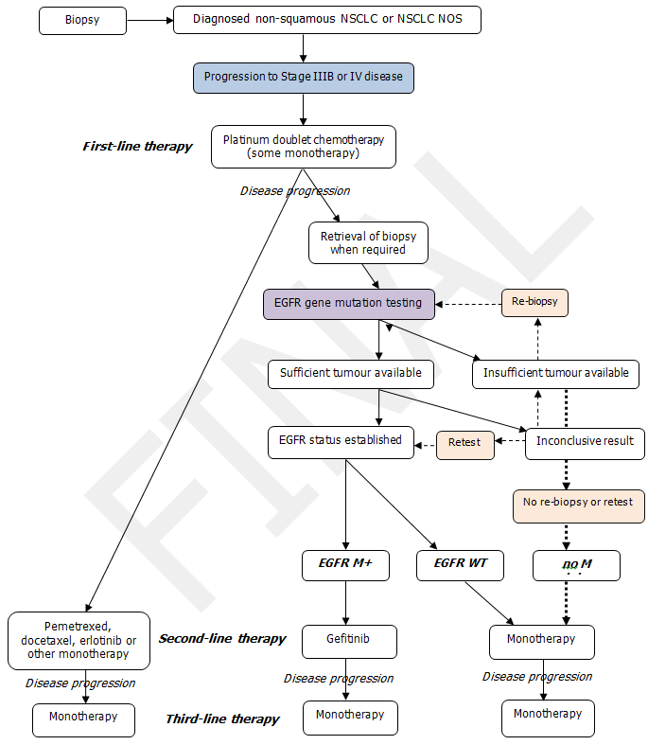

Figure 3: Proposed management algorithm for non-squamous or NOS non-small cell lung cancer
WT = wild type (i.e. M- or no pathological gene mutation)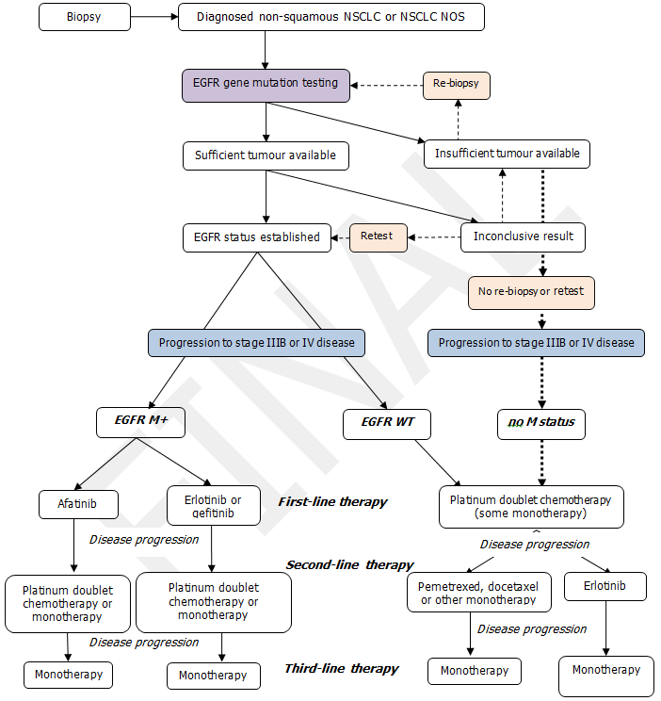
Comparator
In the current treatment pathway for locally advanced or metastatic NSCLC, there is no EGFR gene mutation testing for previously untreated patients. The comparator is therefore ‘no testing’. In the current scenario of ‘no testing’, platinum-based doublet chemotherapy (mostly carboplatin + gemcitabine) is usually the preferred treatment offered to all locally advanced and metastatic NSCLC patients as a first-line therapy. Under the proposed intervention, ‘EGFR gene mutation testing to determine eligibility for afatinib in previously untreated stage IIIB and stage IV non-squamous NSCLC or NSCLC NOS patients’ will provide the opportunity for using afatinib as a first-line therapy to EGFR M+ patients. As EGFR gene mutation testing is being proposed as a co-dependent service, the comparator would be ‘no testing and platinum-based doublet chemotherapy’ for first-line therapy in locally advanced or metastatic NSCLC.
PBAC submissions for the TKIs gefitinib and erlotinib for the treatment of patients with previously untreated locally advanced or metastatic NSCLC harbouring activating EGFR gene mutations have been submitted. Therefore, if listed, gefitinib and/or erlotinib could be considered a comparator to afatinib in this patient population. In this scenario, the comparison is EGFR gene mutation testing plus afatinib or chemotherapy versus EGFR gene mutation testing plus gefitinib/erlotinib or chemotherapy.

Outcomes for safety and effectiveness evaluation
The health outcomes, upon which the comparative clinical performance of EGFR gene mutation testing to determine eligibility for treatment with afatinib as a first-line therapy in patients with locally advanced or metastatic NSCLC will be measured, are described below.

Effectiveness
- Progression free survival
- Overall survival
- Objective tumour response rate
- Quality of life
- Comparison of test performance

Comparison of test performance
In a consideration of EGFR gene mutation testing, available test options and combination test strategies (e.g. PCR amplification and sequencing) should be identified and a comparative assessment performed. Comparison should be made to the EGFR gene mutation testing methods used in clinical trials where there is evidence supporting the co-dependent EGFR test and afatinib treatment. For this protocol the evidentiary standard will be the Therascreen EGFR29 Mutation Kit (Qiagen Ltd, Manchester, UK) which was used in the Lux Lung 3 clinical trial for afatinib. A comparative assessment should consider the method of testing, analytic performance of the tests, and also include a consideration of the collection and handling methods of samples for the test to assess the impact of inadequate samples and re-sampling.

Safety
- Toxic effects from subsequent treatment (including skin rash, diarrhoea)
- Adverse events associated with biopsies
- Rate of re-biopsy

Summary of PICO to be used for assessment of evidence (systematic review)
Table 3 provides a summary of the PICO used to:
- define the question for public funding,
- select the evidence to assess the safety and effectiveness of EGFR mutation testing and first-line treatment with afatinib for those testing M+ with non-squamous NSCLC or NSCLC NOS, and
- provide the evidence-based inputs for any decision-analytical modelling to determine the cost-effectiveness of EGFR mutation testing and first-line treatment with afatinib for those testing M+ with non-squamous NSCLC or NSCLC NOS.
Table 3 Summary of PICO to define research questions that assessment will investigate
Patients  (population eligible for testing) | Prior tests | Intervention | Comparator | Reference standard [for diagnostic tests] | Outcomes to be assessed
Patients with previously untreated non-squamous NSCLC or NSCLC NOS | Histological diagnosis of non-squamous NSCLC or NSCLC NOS | EGFR gene mutation testing and, after presenting with stage IIIB or stage IV disease, use of first-line afatinib in patients with tumours expressing EGFR gene mutations  and  use of first-line platinum-based doublet chemotherapy in patients not expressing EGFR gene mutations and in those patients whose EGFR gene mutation status is unknown | Primary comparator:  No EGFR gene mutation testing and first-line treatment with platinum-based doublet chemotherapy after presenting with stage IIIB or stage IV disease | No agreed reference standard currently available, but comparisons should be made against the specific tests used to generate the evidence to support the effectiveness of first-line afatinib (the “evidentiary” standard), specifically:  - Qiagen Ltd Therascreen® EGFR29 Mutation Kit (Lux Lung 3 trial) | Safety  - Toxic effects of treatment  - Adverse events from biopsies  - Rate of re-biopsy  Effectiveness  - Progression free survival  - Overall survival  - Objective tumour response rate  - Quality of life  - Comparison of test performance  Cost effectiveness  - Cost per QALY
 |  |  | Secondary comparator:  EGFR gene mutation testing and, after presenting with stage IIIB or stage IV disease, use of first-line gefitinib or erlotinib in patients with tumours testing positive for an EGFR activating gene mutation and use of first-line platinum-based doublet chemotherapy in patients with tumours testing negative for an EGFR activating gene mutations and in those whose EGFR gene mutation status is unknown | No agreed reference standard currently available, but comparisons should be made against the specific tests used to generate the evidence to support the effectiveness of gefitinib or erlotinib
Questions
Primary question: is EGFR gene mutation testing and, after presenting with locally advanced or metastatic disease, use of afatinib or chemotherapy (dependent on mutation status) safe, effective and cost effective compared to no testing and treatment with chemotherapy, in previously untreated patients with non-squamous NSCLC or NSCLC not otherwise specified?
Secondary question: is EGFR gene mutation testing and, after presenting with locally advanced or metastatic disease, use of afatinib or chemotherapy (dependent on mutation status) safe, effective and cost effective compared to EGFR gene mutation testing and, after presenting with locally advanced or metastatic disease, use of gefitinib or erlotinib or chemotherapy (dependent on mutation status), in previously untreated patients with non-squamous NSCLC or NSCLC not otherwise specified?
Abbreviations - NSCLC: non-small cell lung cancer, NOS: not otherwise specified, EGFR: epidermal growth factor receptor, PCR: polymerase chain reaction, QALY: quality-adjusted life year

Clinical claim
The applicant claims that EGFR mutation testing for first-line access to afatinib (with afatinib as the first-line treatment for patients who are found to be EGFR M+ and platinum doublet chemotherapy for those found to be EGFR WT) is superior in terms of comparative effectiveness and safety health outcomes to the comparator (where the comparator is no testing and first-line platinum doublet chemotherapy for all patients). A cost-effectiveness analysis or cost-utility analysis is appropriate for this comparison (see Table 4).
Table 4: Classification of EGFR mutation testing with first-line afatinib for EGFR M+ patients and chemotherapy for EGFR WT patients for determination of economic evaluation to be presented for the comparison versus no testing and first-line chemotherapy for all patients
 |  | Comparative effectiveness versus comparator
 |  | Superior |  | Non-inferior | Inferior
Comparative safety versus comparator | Superior | CEA/CUA |  | CEA/CUA | Net clinical benefit | CEA/CUA
 |  |  |  |  | Neutral benefit | CEA/CUA*
 |  |  |  |  | Net harms | None^
 | Non-inferior | CEA/CUA |  | CEA/CUA* | None^
 | Inferior | Net clinical benefit | CEA/CUA | None^ | None^
 |  | Neutral benefit | CEA/CUA*
 |  | Net harms | None^
Abbreviations: CEA = cost-effectiveness analysis; CUA = cost-utility analysis
* May be reduced to cost-minimisation analysis. Cost-minimisation analysis should only be presented when the proposed service has been indisputably demonstrated to be no worse than its main comparator(s) in terms of both effectiveness and safety, so the difference between the service and the appropriate comparator can be reduced to a comparison of costs. In most cases, there will be some uncertainty around such a conclusion (i.e., the conclusion is often not indisputable). Therefore, when an assessment concludes that an intervention was no worse than a comparator, an assessment of the uncertainty around this conclusion should be provided by presentation of cost-effectiveness and/or cost-utility analyses.
^ No economic evaluation needs to be presented; MSAC is unlikely to recommend government subsidy of this intervention
The applicant further claims that EGFR mutation testing for first-line access to afatinib (with afatinib as the first-line treatment for patients who are found to be EGFR M+ and platinum doublet chemotherapy for those found to be EGFR WT) is non-inferior in terms of comparative effectiveness and safety health outcomes to the comparator (where the comparator is EGFR mutation testing and gefitinib or erlotinib treatment for EGFR M+ patients and first-line platinum doublet chemotherapy for EGFR WT patients). Cost-effectiveness analysis or cost-utility analysis may be appropriate for this comparison, however this may be reduced to a cost-minimisation analysis (see Table 5).
Table 5: Classification of EGFR mutation testing with first-line afatinib for EGFR M+ patients and chemotherapy in EGFR WT patients for determination of economic evaluation to be presented for the comparison versus EGFR mutation testing with first-line gefitinib or erlotinib for EGFR M+ patients and chemotherapy for EGFR WT patients
 |  | Comparative effectiveness versus comparator
 |  | Superior |  | Non-inferior | Inferior
Comparative safety versus comparator | Superior | CEA/CUA |  | CEA/CUA | Net clinical benefit | CEA/CUA
 |  |  |  |  | Neutral benefit | CEA/CUA*
 |  |  |  |  | Net harms | None^
 | Non-inferior | CEA/CUA |  | CEA/CUA* | None^
 | Inferior | Net clinical benefit | CEA/CUA | None^ | None^
 |  | Neutral benefit | CEA/CUA*
 |  | Net harms | None^
Abbreviations: CEA = cost-effectiveness analysis; CUA = cost-utility analysis
* May be reduced to cost-minimisation analysis. Cost-minimisation analysis should only be presented when the proposed service has been indisputably demonstrated to be no worse than its main comparator(s) in terms of both effectiveness and safety, so the difference between the service and the appropriate comparator can be reduced to a comparison of costs. In most cases, there will be some uncertainty around such a conclusion (i.e., the conclusion is often not indisputable). Therefore, when an assessment concludes that an intervention was no worse than a comparator, an assessment of the uncertainty around this conclusion should be provided by presentation of cost-effectiveness and/or cost-utility analyses.
^ No economic evaluation needs to be presented; MSAC is unlikely to recommend government subsidy of this intervention

Outcomes and health care resources affected by introduction of proposed intervention

Outcomes for economic evaluation
An economic evaluation will compare health outcomes for the proposed scenario of EGFR gene mutation testing plus afatinib or platinum-based doublet chemotherapy versus the current scenario where there is no EGFR gene mutation testing and patients with previously untreated locally advanced or metastatic NSCLC are treated with platinum-based doublet chemotherapy.

Health care resources
Table 6 provides a list of resources that would need to be considered in the economic analysis comparing EGFR gene mutation testing and first-line afatinib or platinum-based doublet chemotherapy (depending on mutation status) versus no EGFR gene mutation testing and treatment with chemotherapy. The resources required to identify the population eligible for EGFR gene mutation testing would be identical to the resources required to identify those suitable for platinum-based doublet chemotherapy, and therefore do not need to be considered.

Table 6: List of resources to be considered in the economic analysis
 | Provider of resource | Setting in which resource is provided | Proportion of patients receiving resource | Number of units of resource per relevant time horizon per patient receiving resource | Disaggregated unit cost
 |  |  |  |  | MBS | Safety nets* | Other govt budget | Private health insurer | Patient | Total cost
Resources provided in association with the proposed medical service to deliver the proposed intervention (from Step 1, e.g., pre-treatments, co-administered interventions). Identify variations where these may vary across different decision options
Test and intervention: EGFR testing and first line afatinib treatment for patients who are EGFR mutation positive and first line platinum doublet chemotherapy for patients who are EGFR mutation wild type
EGFR testing costs
Re-biopsy (if inadequate tumour sample) | Respiratory physician or surgeon | Hospital | 1 unit (5-10% of patients eligible for EGFR testing) | Estimate
Specimen collection including Patient Episode Initiation (PEI) fee | MBS | Collection centre | To be provided in submission | To be provided in submission
Specimen referred fee (P11) | MBS | Pathology Lab | To be provided in submission | To be provided in submission |  |  |  |  |  | 10.30
Perform EGFR testing | Molecular pathologist | Laboratory | 1 unit (100% of patients eligible for EGFR testing) | Proposed frequency of testing | 300.00 (75%)  340.00 (85%) |  |  |  |  | 400.00
If EGFR mutation positive, patient is eligible for first line treatment with afatinib
Consultation for initiation of afatinib (oral tablet) | Medical oncologist | Private rooms or inpatient/ outpatient clinic | 1 unit/EGFR mutation positive patient | Epidemiological data for proportion of first line patients EGFR mutation positive  Estimate from Lux Lung 3 trial
Cost of afatinib (PBS cost ) | Proposed PBS item | Community pharmacy | 1 unit/month/EGFR mutation positive patient | Weighted cost per dose and for duration of treatment from Lux Lung 3 trial
Follow up consultation monitoring disease and treatment (MBS item) | Medical oncologist | Private rooms or inpatient/ outpatient clinic | 1 unit/2 months/EGFR mutation positive patient | Estimate from Lux Lung 3 trial
If EGFR wild type, patient is eligible for first line treatment with platinum doublet chemotherapy
Consultation for initiation of chemotherapy (MBS 116) | Medical oncologist | Private rooms or inpatient/outpatient clinic | 1 unit / EGFR WT patient/cycle | Epidemiological data for proportion of first line patients EGFR WT estimated from Lux Lung 3 trial | 72.65
Cost of chemotherapy (1 x 45mg carboplatin) (PBS cost per maximum quantity) | PBS item | day treatment facility, private or public hospital outpatient clinic | 1 unit / EGFR WT patient / cycle | Estimate number of cycles form Lux Lung 3 trial |  |  | 265.32
Cost of chemotherapy (1 x 3000mg gemcitabine) (PBS cost per maximum quantity) | PBS item | day treatment facility, private or public hospital outpatient clinic | 1 unit / EGFR WT patient / cycle | Estimate number of cycles form Lux Lung 3 trial
Drug administration cost for <1 hour infusion (MBS item 13915) |  | Day patient |  | Once every 3 weeks. No. of infusions per patient TBD | $62.60
Public hospital outpatient admission for administration |  | Out-patient | ~86% (EGFR negative pts) | Once every 3 weeks. No. of infusions per patient TBD |  |  | $560.00
Full day hospital admission for chemotherapy administration in a public hospital setting (excluding average pharmacy component) |  | Day patient | ~86% (EGFR negative pts) | Once every 3 weeks. No. of infusions per patient TBD |  |  | $562.00
Full day hospital admission for chemotherapy administration in a private hospital setting |  | Day patient | ~86% (EGFR negative pts) | Once every 3 weeks. No. of infusions per patient TBD |  |  | $331.00
Follow up consultation monitoring disease and treatment (MBS item) | Medical oncologist | Private rooms or inpatient/ outpatient clinic | 1 unit/2 months/EGFR mutation positive patient | Estimate from Lux Lung 3 trial
Resources provided in association with proposed intervention
Management of side effects of afatinib
Management of side effects of chemotherapy
Resources provided to deliver the comparator to the current intervention (from Step 4, e.g., pre-treatments, co-administered interventions). Identify variations where there may be more than one comparator or where these may vary across different decision options
Main comparator: no EGFR testing and first line platinum doublet chemotherapy for all patients
Consultation for initiation of chemotherapy (MBS 116) | Medical oncologist | Private rooms or inpatient/outpatient clinic | 1 unit / EGFR WT patient/cycle | Epidemiological data for proportion of first line patients EGFR WT estimated from Lux Lung 3 trial | 72.65
Cost of chemotherapy (1 x 45mg carboplatin) (PBS cost per maximum quantity | PBS item | day treatment facility, private or public hospital outpatient clinic | 1 unit / EGFR WT patient / cycle | Estimate number of cycles form Lux Lung 3 trial
Cost of chemotherapy (1 x 3000mg gemcitabine) (PBS cost per maximum quantity) | PBS item | day treatment facility, private or public hospital outpatient clinic | 1 unit / EGFR WT patient / cycle | Estimate number of cycles form Lux Lung 3 trial
Drug administration cost for <1 hour infusion (MBS item 13915) |  | Day patient | 100% | Once every 3 weeks. No. of infusions per patient TBD | $62.60
Public hospital outpatient admission for administration |  | Out-patient | 100% | Once every 3 weeks. No. of infusions per  patient TBD |  |  | $560.00
Full day hospital admission for chemotherapy administration in a public hospital setting (excluding average pharmacy component) |  | Day patient | 100% | Once every 3 weeks. No. of infusions per patient TBD |  |  | $562.00
Full day hospital admission for chemotherapy administration in a private hospital setting |  | Day patient | 100% | Once every 3 weeks. No. of infusions per patient TBD |  |  | $331.00
Follow up consultation monitoring disease and treatment MBS item | Medical oncologist | Private rooms or inpatient/ outpatient clinic | 1 unit/2 months/all patients | Estimate from Lux/Lung 3 trial
Resources provided in association with the comparator: platinum-based doublet chemotherapy
Resources to manage side effects of chemotherapy
Alternative comparator: EGFR testing and first line erlotinib treatment for patients who are EGFR mutation positive and first line platinum doublet chemotherapy for patients who are EGFR mutation wild type
Resources as for test and intervention (above) with the following variation
Cost of erlotinib (PBS cost ) | Proposed PBS item | Community pharmacy | 1 unit/month/EGFR mutation positive patients | Weighted cost per dose and for duration of treatment from first line erlotinib trials
Alternative comparator: EGFR testing and first line gefitinib treatment for patients who are EGFR mutation positive and first line platinum doublet chemotherapy for patients who are EGFR mutation wild type
Resources as for test and intervention (above) with the following variation
Cost of gefitinib (PBS cost ) | Proposed PBS item | Community pharmacy | 1 unit/month/EGFR mutation positive patient | Duration of treatment from first line gefitinib trials
* Include costs relating to both the standard and extended safety net.

Proposed structure of economic evaluation (decision-analytic)
Figure 4 and Figure 5 outline the current and proposed scenario decision analyses as a means of summarising the comparisons the assessment report should investigate and present for those patients with non-squamous NSCLC or NSCLC NOS, who progress to having stage IIIB or stage IV disease. As in the clinical management algorithms in Figures 3 and 4, it is assumed that all patients tested early will progress to an eligible stage of disease for afatinib or comparator treatment. If a discernable proportion of patients would not progress to require such treatment, additional branches will be needed to reflect the true number needed to test per treated patient and true test cost per treated patient.
It should be noted that there is currently no reference standard for EGFR mutation testing and the evidentiary standard will be used to determine true and false positive and negative values.

Figure 4: Decision tree representing current scenario decision options for EGFR testing and first and second line afatinib treatment in patients with stage IIIB or stage IV non-squamous NSCLC or NSCLC NOS (comparison arm of this tree can be seen in Figure 5)

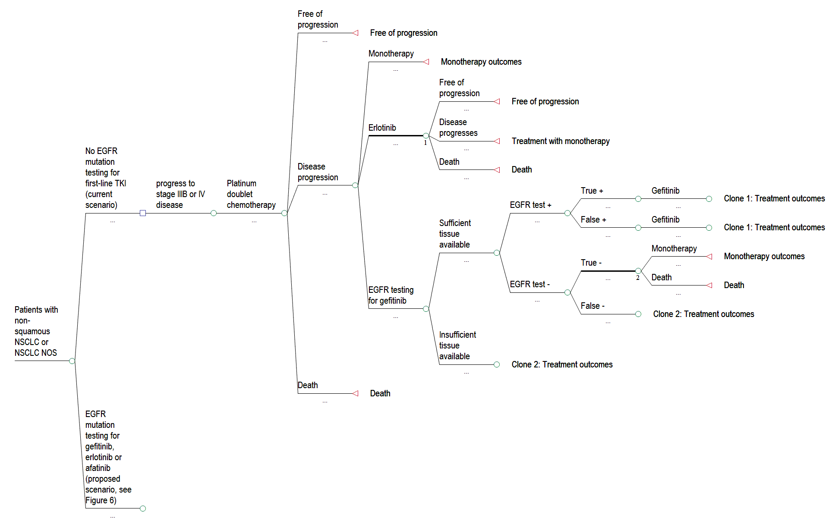
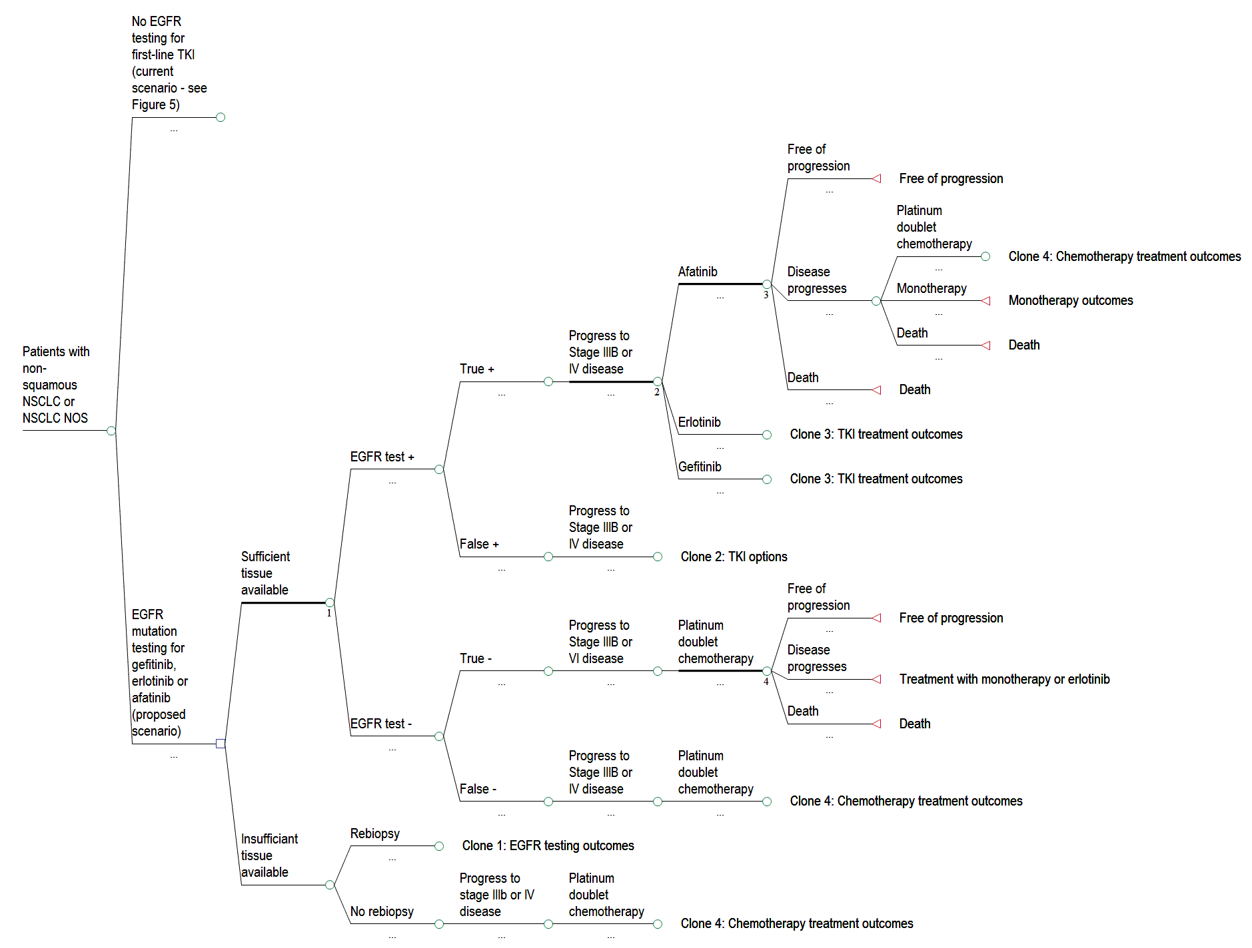
Figure 5: Decision tree representing proposed scenario decision options for EGFR testing and first treatment in patients with stage IIIB or stage IV non-squamous NSCLC or NSCLC NOS (comparison arm of this tree can be seen in Figure 4)

References
AIHW 2011a, Australian Cancer Incidence and Mortality (ACIM) books, Cancer.

—— 2011b, Lung Cancer in Australia: an overview, Australian Institute of Health and Welfare & Cancer Australia, Canberra.

Armour, AA & Watkins, CL 2010, 'The challenge of targeting EGFR: experience with gefitinib in nonsmall cell lung cancer', European Respiratory Review, vol. 19, no. 117, September 1, 2010, pp. 186-196.

Cataldo, VD, Gibbons, DL, Perez-Soler, R & Quintas-Cardama, A 2011, 'Treatment of non-small-cell lung cancer with erlotinib or gefitinib', N Engl J Med, vol. 364, no. 10, Mar 10, pp. 947-955.

Chang, S-C, Chang, C-Y & Shih, J-Y 2011, 'The Role of Epidermal Growth Factor Receptor Mutations and Epidermal Growth Factor Receptor-Tyrosine Kinase Inhibitors in the Treatment of Lung Cancer', Cancers, vol. 3, no. 2, pp. 2667-2678.

CrinoA, L & Metro, G 2011, 'The LUX-Lung clinical trial program of afatinib for non-small-cell lung cancer', Expert Review of Anticancer Therapy, vol. 11, no. 5, 2011/05//, p. 673+.

DoHA 2010, 'Epidermal Growth Factor Receptor Testing and Access to PBS listed Gefitinib', Medical Services Advisory Committee Public Summary Document, no. Reference 41, <http://www.msac.gov.au/internet/msac/publishing.nsf/Content/ref41-1.

Fukuoka, M, Wu, Y-L, Thongprasert, S, Sunpaweravong, P, Leong, S-S, Sriuranpong, V, Chao, T-Y, Nakagawa, K, Chu, D-T, Saijo, N, Duffield, EL, Rukazenkov, Y, Speake, G, Jiang, H, Armour, AA, To, K-F, Yang, JC-H & Mok, TSK 2011, 'Biomarker Analyses and Final Overall Survival Results From a Phase III, Randomized, Open-Label, First-Line Study of Gefitinib Versus Carboplatin/Paclitaxel in Clinically Selected Patients With Advanced Non–Small-Cell Lung Cancer in Asia (IPASS)', Journal of Clinical Oncology, vol. 29, no. 21, July 20, 2011, pp. 2866-2874.

Ishibe, N, Carlson, J, Ramsey, SD, Freedman, A & Schully, S 2011, 'Use of epidermal growth factor receptor mutation analysis in patients with advanced non-small-cell lung cancer to determine erlotinib use as first-line therapy', PLoS Curr, vol. 3, p. RRN1245.

John, T, Liu, G & Tsao, MS 2009, 'Overview of molecular testing in non-small-cell lung cancer: mutational analysis, gene copy number, protein expression and other biomarkers of EGFR for the prediction of response to tyrosine kinase inhibitors', Oncogene, vol. 28 Suppl 1, Aug, pp. S14-23.

Keedy, VL, Temin, S, Somerfield, MR, Beasley, MB, Johnson, DH, McShane, LM, Milton, DT, Strawn, JR, Wakelee, HA & Giaccone, G 2011, 'American Society of Clinical Oncology provisional clinical opinion: epidermal growth factor receptor (EGFR) Mutation testing for patients with advanced non-small-cell lung cancer considering first-line EGFR tyrosine kinase inhibitor therapy', J Clin Oncol, vol. 29, no. 15, May 20, pp. 2121-2127.

Mazzoni, F, Rotella, V, Pratesi, N, Boni, L, Simi, L, Orlando, C, Comin, CE, Maddau, C & Di Costanzo, F 2011, 'From clinical trials to clinical practice: predictors of response to erlotinib in advanced non-small cell lung cancer patients pretreated with chemotherapy', Tumori, vol. 97, no. 2, Mar-Apr, pp. 160-165.

Miller, VA, Hirsh, V, Cadranel, J, Chen, Y-M, Park, K, Kim, S-W, Zhou, C, Su, W-C, Wang, M, Sun, Y, Heo, DS, Crino, L, Tan, E-H, Chao, T-Y, Shahidi, M, Cong, XJ, Lorence, RM & Yang, JC-H 2012, 'Afatinib versus placebo for patients with advanced, metastatic non-small-cell lung cancer after failure of erlotinib, gefitinib, or both, and one or two lines of chemotherapy (LUX-Lung 1): a phase 2b/3 randomised trial', The Lancet Oncology, vol. 13, no. 5, pp. 528-538.

Molina, JR, Yang, P, Cassivi, SD, Schild, SE & Adjei, AA 2008, 'Non-Small Cell Lung Cancer: Epidemiology, Risk Factors, Treatment, and Survivorship', Mayo Clinic Proceedings, vol. 83, no. 5, May 1, 2008, pp. 584-594.

Riccardi S, TS, de Marinis F, 2011, 'Efficacy and safety of erlotinib in the treatment of metastatic non-small-cell lung cancer', Lung Cancer: Targets and Therapy, vol. 2, pp. 1-9.

Rosell, R, Moran, T, Queralt, C, Porta, R, Cardenal, F, Camps, C, Majem, M, Lopez-Vivanco, G, Isla, D, Provencio, M, Insa, A, Massuti, B, Gonzalez-Larriba, JL, Paz-Ares, L, Bover, I, Garcia-Campelo, R, Moreno, MA, Catot, S, Rolfo, C, Reguart, N, Palmero, R, Sánchez, JM, Bastus, R, Mayo, C, Bertran-Alamillo, J, Molina, MA, Sanchez, JJ & Taron, M 2009, 'Screening for Epidermal Growth Factor Receptor Mutations in Lung Cancer', New England Journal of Medicine, vol. 361, no. 10, pp. 958-967.

Sartori G, Cavazza A, Bertolini F, L., L, A., M, Costantini M, Barbieri F, Migaldi M & G, R 2008, '- A subset of lung adenocarcinomas and atypical adenomatous hyperplasia-associated', no. - 0002-9173 (Print).

Sequist, LV, Waltman, BA, Dias-Santagata, D, Digumarthy, S, Turke, AB, Fidias, P, Bergethon, K, Shaw, AT, Gettinger, S, Cosper, AK, Akhavanfard, S, Heist, RS, Temel, J, Christensen, JG, Wain, JC, Lynch, TJ, Vernovsky, K, Mark, EJ, Lanuti, M, Iafrate, AJ, Mino-Kenudson, M & Engelman, JA 2011, 'Genotypic and histological evolution of lung cancers acquiring resistance to EGFR inhibitors', Sci Transl Med, vol. 3, no. 75, Mar 23, p. 75ra26.

Shukuya, T, Takahashi, T, Kaira, R, Ono, A, Nakamura, Y, Tsuya, A, Kenmotsu, H, Naito, T, Kaira, K, Murakami, H, Endo, M, Takahashi, K & Yamamoto, N 2011, 'Efficacy of gefitinib for non-adenocarcinoma non-small-cell lung cancer patients harboring epidermal growth factor receptor mutations: A pooled analysis of published reports', Cancer Science, vol. 102, no. 5, pp. 1032-1037.

Soh, J, Okumura, N, Lockwood, WW, Yamamoto, H, Shigematsu, H, Zhang, W, Chari, R, Shames, DS, Tang, X, MacAulay, C, Varella-Garcia, M, Vooder, T, Wistuba, II, Lam, S, Brekken, R, Toyooka, S, Minna, JD, Lam, WL & Gazdar, AF 2009, 'Oncogene Mutations, Copy Number Gains and Mutant Allele Specific Imbalance (MASI) Frequently Occur Together in Tumor Cells', PLoS ONE, vol. 4, no. 10, p. e7464.

Sun, L, Zhang, Q, Luan, H, Zhan, Z, Wang, C & Sun, B 2011, 'Comparison of KRAS and EGFR gene status between primary non-small cell lung cancer and local lymph node metastases: implications for clinical practice', J Exp Clin Cancer Res, vol. 30, p. 30.

Therapeutic Goods Administration 2009, Overview of the new regulatory framework for in vitro diagnostic medical devices (IVDs), Commonwealth of Australia, Canberra.

Yang, P, Allen, MS, Aubry, MC, Wampfler, JA, Marks, RS, Edell, ES, Thibodeau, S, Adjei, AA, Jett, J & Deschamps, C 2005, 'Clinical Features of 5,628 Primary Lung Cancer Patients*', Chest, vol. 128, no. 1, July 1, 2005, pp. 452-462.

