1203

Final Decision Analytic Protocol (DAP) to guide the assessment of catheter-free (wireless) ambulatory oesophageal pH-monitoring for Gastro Oesophageal Reflux Disease (GORD)
September 2012

Table of Contents
MSAC and PASC 3
Purpose of this document 3
Purpose of application 4
Background 4
Current arrangements for public reimbursement 4
Regulatory status 5
Intervention 5
Description of the medical condition 5
Description of current MBS approved pH monitoring test for GORD 6
Description and delivery of proposed new intervention 7
Prerequisites 8
Co-administered and associated interventions 9
Listing proposed and options for MSAC consideration 9
Proposed MBS listing 9
Clinical place for proposed intervention 10
Clinical claim 12
Potential benefits of proposed technology 12
Potential disadvantages of technology 13
Comparator 13
Outcomes and health care resources affected by introduction of proposed intervention 14
Proposed structure of economic evaluation (decision-analytic) 14
Health care resources 15
References 17

MSAC and PASC
The Medical Services Advisory Committee (MSAC) is an independent expert committee appointed by the Minister for Health and Ageing (the Minister) to strengthen the role of evidence in health financing decisions in Australia. MSAC advises the Minister on the evidence relating to the safety, effectiveness, and cost-effectiveness of new and existing medical technologies and procedures and under what circumstances public funding should be supported.
The Protocol Advisory Sub-Committee (PASC) is a standing sub-committee of MSAC. Its primary objective is the determination of protocols to guide clinical and economic assessments of medical interventions proposed for public funding.

Purpose of this document
This document is intended to provide a decision analytic protocol that will be used to guide the assessment of an intervention for a particular population of patients. The protocol has been finalised after inviting relevant stakeholders to provide input.
The protocol guiding the assessment of the health intervention has been developed using the widely accepted “PICO” approach. The PICO approach involves a clear articulation of the following aspects of the research question that the assessment is intended to answer:
Patients – specification of the characteristics of the patients in whom the intervention is to be considered for use
Intervention – specification of the proposed intervention and how it is delivered
Comparator – specification of the therapy most likely to be replaced by the proposed intervention
Outcomes – specification of the health outcomes and the healthcare resources likely to be affected by the introduction of the proposed intervention

Purpose of application
A proposal for an application requesting MBS listing of catheter-free (wireless) ambulatory oesophageal pH-monitoring for Gastro Oesophageal Reflux Disease (GORD) was received from Given Imaging Pty Ltd by the Department of Health and Ageing in January 2012. Catheter-based oesophageal pH-monitoring for the diagnosis of GORD is currently reimbursed through the MBS (MBS item 11810). This proposal relates to an alternative catheter-free approach, which would be restricted to patients who have previously failed a catheter-based monitoring or in whom the use of the latter is anatomically inappropriate.
NHMRC Clinical Trials Centre (CTC), as part of its contract with the Department of Health and Ageing, developed this decision analytical protocol to guide the assessment of the safety, effectiveness and cost-effectiveness of catheter-free (wireless) ambulatory oesophageal pH-monitoring GORD in order to inform MSAC’s decision-making regarding public funding of the intervention.

Background

Current arrangements for public reimbursement
A test for GORD, twenty four hours ambulatory catheter-based pH monitoring, is currently reimbursed on the MBS (item 11810 – Table 1). There were 3,045 claims on this item in the financial year 2010-2011.

Table 1: Current MBS item descriptor for twenty four hour ambulatory pH monitoring
Category 2 – Diagnostic procedures and interventions
MBS 11810
CLINICAL ASSESSMENT of GASTRO-OESOPHAGEAL REFLUX DISEASE involving 24 hour pH monitoring, including analysis, interpretation and report and including any associated consultation

Fee: $171.20 Benefit 75% = $128.40 85%= $145.55

The applicant has proposed that a new item would be listed as an alternative in those patients for whom the catheter-based approach above is not tolerated, is inappropriate, or has failed.

During consideration of this proposal, PASC determined that this test should be used in those patients for whom pH monitoring is clinically indicated, and these indications are set out on page 6 of this document. It determined however that a restriction should apply in that the test should only be used in those patients in whom a catheter-based test had already failed, or in those for whom it is anatomically inappropriate to undertake. This necessitated a change to the descriptor submitted by the applicant, and a change to the proposed patient population in which the effectiveness and safety of the test is to be assessed. The final descriptor for the new item to be considered in the assessment is shown on page 10 of this document.

Regulatory status
The TGA registration number for this device is ARTG # 194555 with an ARTG start date of 14/02/2012. The manufacturer of the device is Given Image Ltd. The intended purpose of the device is “to be used for gastroesophageal pH measurement and monitoring of gastric reflux”.

The requested MBS listing is consistent with the TGA approved indication.

Intervention

Description of the medical condition
Reflux of gastric contents into the oesophagus is a normal physiological event, occurring usually during the postprandial period. Gastro-oesophageal reflux disease occurs when reflux exposes the patient to the risk of physical complications, or symptoms lead to a significant impairment of wellbeing or quality of life. Clinically significant impairment of wellbeing (quality of life) usually occurs when symptoms are present on two or more days a week. Reflux disease carries the risk of reflux (peptic) oesophagitis and complications such as columnar-lined (Barrett’s) oesophagus and oesophageal adenocarcinoma. However, the absolute risk of oesophageal cancer in an individual with reflux is small (Gastroenterological Society of Australia 2011). Up to 15 percent of patients with chronic reflux disease undergoing endoscopic evaluation may be shown to develop a pre-cancerous condition called Barrett’s oesophagus (Shaheen and Richter 2009)

Reflux disease is common. Between 15-20% of adults experience heartburn at least once a week. Obesity, alcohol consumption and a first-degree relative with heartburn increase the risk of having reflux symptoms. Patients with connective tissue diseases such as scleroderma, chronic respiratory diseases such as asthma and cystic fibrosis, institutionalised and intellectually handicapped people, and patients nursed in a supine position for prolonged periods are at increased risk of reflux disease and its complications (Gastroenterological Society of Australia 2011).

Only about one-third of patients with reflux disease have reflux oesophagitis as evidenced by endoscopically visible mucosal breaks (erosions or ulceration) or columnar-lined (Barrett’s) oesophagus. It is considered that endoscopy has a limited role in its definitive diagnosis (Gastroenterological Society of Australia 2011). Confirmatory diagnoses may be required in a number of clinical situations when endoscopy does not indicate that oesophagitis is present, including in those patients for whom the relationship between symptoms and reflux remains unclear despite a therapeutic trial of acid suppression and endoscopy. Excluding reflux disease may also be necessary when other diagnoses seem possible. The confirmatory diagnosis of persistent GORD following such tests can guide future treatment decisions and monitor the effectiveness of existing ones. These treatments include pharmacologic therapies (PPIs, H2 antagonists) and surgical interventions in some patients. Reflux disease patients with severe oesophagitis, for example, may be treated with standard dose PPIs on an ongoing basis. Laparoscopic fundoplication (MBS items 43951 and 43954) may be indicated in those patients whose symptoms cannot be controlled using medical therapies, or in those who want to avoid long term medications and accept the risks associated with the procedure. More recently, endoscopic treatments for GORD potentially offer a minimally invasive alternative to current treatment options (McLoughlin et al. 2006), although these tend not to be used in routine clinical practice.

pH monitoring (described below) is one such test. The usefulness of pH monitoring in GORD patients, and its potential impact on future treatment decisions, has been documented by the American College of Gastroenterology (Hirano and Richter 2007). Recommendations on the clinical applications of oesophageal reflux pH testing included:
- Documentation of abnormal oesophageal acid exposure in an endoscopy-negative individual being considered for surgical anti-reflux repair
- Evaluation of endoscopy-negative patients with typical reflux symptoms that are refractory to PPI therapy
- Documentation of adequacy of PPI therapy in oesophageal acid control in patients with complications of reflux disease that include Barrett’s oesophagus
- Evaluation of endoscopy-negative patients with atypical reflux symptoms that are refractory to twice daily PPI therapy
- Evaluation of endoscopy-negative patients with complaints of heartburn or regurgitation despite PPI therapy in whom documentation of non-acid reflux will alter clinical management.

In submissions to PASC, the Gastroenterological Society of Australia emphasised the importance of pH monitoring in documenting the association of symptoms and reflux in patients being considered for surgical management. Another common reason for referral for oesophageal pH monitoring would be the evaluation of either endoscopy positive or endoscopy negative patients with atypical reflux symptoms that are refractory to twice daily PPI therapy. If their symptoms are due to reflux then altering their acid suppression therapy may provide benefit or anti reflux surgery could be an option. Other patients for whom monitoring could be indicated included those with persistent symptoms of heartburn despite medical or surgical treatment. GESA were also concerned that the assessment report would consider best practice in relation to pH monitoring technologies in terms of their relative safety, effectiveness and cost-effectiveness.

The relatively low usage of the current MBS item (3,045 claims in the 2010-2011 year) together with low usage of surgical treatments for GORD (25 claims for MBS item 43951 and 5 claims for item 43954 on average per year) indicates that while pH monitoring is useful, it is not used a lot for the study of this common condition. The applicant states that the proposed listing of the new intervention would not affect the indications for performing the test. Part of the low usage of the current test could, however, reflect the discomfort and inconvenience of having an NG catheter in place for 24 hours.

Description of current MBS approved pH monitoring test for GORD
Ambulatory oesophageal pH monitoring assesses the exposure of the oesophagus to acid reflux over a given period of time. The 24 hour catheter-based pH-monitoring test is currently listed on the MBS.

The test involves the trans-nasal passing of a catheter with manometric guidance (often the source of discomfort for a patient) which is then taped to the nose. Although two (or more sensors) could be placed on this catheter, the majority of pH monitoring tests that are undertaken in Australia use single channel pH sensors. The determinant is the existence of reflux above the lower oesophageal sphincter rather than the height of refluxate. The patient returns to the clinic in 24 hours to have the catheter removed and the data analysed for reflux events and the concordance of symptoms (Weber et al. 2011).

The major drawbacks of the 24 hour catheter-based pH-monitoring test are patient discomfort and alteration of daily activities. Other drawbacks include the potential lack of sensitivity, specificity, reproducibility of the results, and the need to ensure that sensors are correctly placed in order for the results to be valid (Weber, Davis, & Fisichella 2011).

The information gathered from the 24 hour pH monitoring test can be used to guide subsequent patient management. Positive diagnoses could lead, for example, to alterations in doses of medications being used to treat the disease. Surgical options, or newer endoscopic treatments, may also be considered in those with positive diagnoses who do not wish to persist with pharmacological agents in the longer term. Tests that do not indicate that reflux is present may lead to a re-assessment of the treatment strategy for the patient.

Description and delivery of proposed new intervention
Bravo® pH Monitoring System is proposed as an alternative to the 24 hour catheter-based pH monitoring test currently in use. This is a catheter-free (wireless) ambulatory oesophageal pH-monitoring technology used in the diagnosis of GORD. The technology utilizes a small pH capsule that is temporarily attached to the wall of the oesophagus to transmit pH data for a minimum of 48 hours.

The pH monitoring capsule is applied in a standardised fashion in each patient. Oesophago-gastro-duodenoscopy is performed and during the procedure the location of the squamo-columnar junction, in terms of the distance from the incisors, is determined. Subsequently, the endoscope is removed and the self-contained delivery system is passed transorally into the patient's oesophagus.

The delivery system consists of an application catheter with an attached pH capsule and suction channel. The capsule itself measures 6 mm × 5.5 mm × 25 mm and contains a 3.5-mm deep well that is connected to an external vacuum unit. The catheter is advanced until the capsule is located at a point 6 cm above the squamo-columnar junction, thereby providing a single sensor. Suction is then applied through the suction channel to the catheter for at least 30 seconds, causing the adjacent mucosa to be drawn into the well of the capsule. At this point, the plunger-type handle on the application catheter is depressed and a spring-loaded mechanism advances a stainless steel pin through the well of the capsule, securing the mucosa within the well. Then, a button on the handle is turned, resulting in the removal of suction pressure and the release of the capsule from the application catheter. The delivery system is then removed. Medical advice obtained during the development of this protocol has indicated that the re-insertion of the endoscope to verify correct placement is a standard routine.

The capsule is activated with a magnetic switch before application so that data collection can begin as soon as the capsule was in place. pH data are obtained at 6-s intervals and transmitted via radiotelemetry to a small, pager-sized receiver worn by the patient. Patients are encouraged to go about their usual activities, including work and exercise. They are also instructed to consume their usual diet without restrictions. The patient must stay within one metre of the receiver during the pH study except, as necessary, for bathing. The receiver is not water resistant, and it should not be worn in the shower or in other wet environments. It can be left nearby on a bathroom counter. When resting or sleeping, if a night stand or bedside table is not near the bed, the patient should clip the receiver to the pillow. If the receiver is too far from the capsule, a beep will be heard for up to 30 seconds and the display will flash. This indicates that the transmission from the capsule to the receiver has been interrupted.

At the end of the recording period (usually 48 h), the patients returns the receivers and the data are uploaded to a personal computer, analysed using software provided by the manufacturer and interpreted by a physician. Patients also keep a diary recording food intake, symptoms and activity, including position changes, and this information is used in the interpretation of the pH data, as during traditional pH testing. The capsule is designed to dislodge from the oesophageal mucosa within 3-7 days and subsequently pass through the gastrointestinal tract to be expelled in the stool.

Prerequisites
As this test is a specialist test performed by a gastroenterologist, and directly associated at the time of delivery with an endoscopy, the service would be delivered by a specialist or consultant physician with endoscopic training that is recognised by The Conjoint Committee for the Recognition of Training in Gastrointestinal Endoscopy.

This test would be provided in day only facilities that routinely offer endoscopic services. PASC had considered that the performance of this test and associated endoscopy is not a minor skill. In addition to the delivery of the test by the specialist physician referred to above, it is expected that that they would also have experience and expertise in the assessment of pH data produced during the test and would have experience in the operation of the specialist computerised equipment that is necessary to download the data. The applicant estimates that the time taken for this procedure would be 25 minutes. The download of data, the review of 48 hours of information on computer, the generation of reports and comments, findings and diagnosis would take an additional 25 minutes.

Initial analysis of data for item 11810 for catheter-based pH monitoring indicates that the vast majority of claims are for out-of-hospital services. PASC determined that the assessment of this technology should consider whether it is intended that the service would be provided in different settings than the comparator – that is, whether the service is to be provided to patients day-admitted to a hospital (i.e. as admitted inpatients). If provided in an out-patient setting, the cost risks associated with the Extended Medicare Safety Net should be examined.

The capsule itself and its self-contained delivery system are required resources. The availability of the specialist reader system for obtaining the subsequent data within the endoscopy suite is a further requirement.

Co-administered and associated interventions
An endoscopy is required in order to deliver this test, so as to determine suitability for the test and to determine correct placement. An endoscopy may also be required following placement as noted above. The proposed MBS item number however includes any endoscopy performed as part of the procedure in addition to the insertion of the capsule, the reading of the results and the communication of these results to the patient.

In addition to the MBS fee for the physician, there will also be a facility fee and a fee for an anaesthetist. It is anticipated that both of these will be similar to those currently MBS listed for upper endoscopy.

Listing proposed and options for MSAC consideration

Proposed MBS listing
The MBS listing originally proposed by the applicant was considered by PASC at its April 2012 meeting and again in August 2012 following a period of public consultation. The final listing is shown in table 2 below. As noted, modifications to the originally proposed item and the one ratified by the Committee included that eligible patients would have previously failed (rather than being intolerant of) a catheter-based approach or that it is anatomically inappropriate. Following advice from GESA, PASC determined at its August 2012 meeting that an original restriction that eligible patients would be endoscopically negative should be removed.
The fee listed in the item was also provided by the applicant. It includes a $350 fee for professional time for performing the test, $430.40 for the capsule itself, and $133.25 for the reader system (based on a depreciation of capital investment, 50 patients per year over 3 years: $19,990 cost of purchasing system). The Department of Health and Ageing indicated however that a fit-for-purpose input-based assessment of this fee should be undertaken. The assessment should be in line with the principles underpinning the new input-based MBS fee setting methodology that is being developed. The department may request further inputs to support the fee assessment, and the proposed fee should be included in the economic evaluation.
Table 2: PASC determined MBS item descriptor for catheter-free (wireless) ambulatory oesophageal pH-monitoring for Gastro Oesophageal Reflux Disease (GORD)
Category [2]– [Diagnostic procedures and interventions]
MBS [item number]
CLINICAL ASSESSMENT of GASTRO-OESOPHAGEAL REFLUX DISEASE that involves 48 hour catheter-free wireless ambulatory oesophageal pH monitoring including administration of the device and any endoscopy associated with this, analysis and interpretation of the data and all attendances for providing the service, if
(a) the service is performed by a specialist or consultant physician with endoscopic training that is recognised by The Conjoint Committee for the Recognition of Training in Gastrointestinal Endoscopy; and
(b) the patient has previously failed (rather than intolerant of) a catheter-based ambulatory oesophageal pH-monitoring or is anatomically inappropriate for a catheter based system.
Fee: $913.64

Clinical place for proposed intervention
It is recognised that only a certain number of patients with symptoms of GORD would clinically be considered appropriate for pH monitoring to be undertaken. Where pH monitoring is indicated, however, the algorithm shown in figure 1 depicts the currently funded monitoring modalities available to GORD patients. Patients undergoing the 24 hour catheter-based pH monitoring may have post diagnostic test guided treatments. These include pharmacological treatments, which may be maintained or increased. Surgical options may be considered as an alternative. Patients with a negative test may have their management re-assessed. Patients unable to undergo this testing, however, will continue to be managed empirically based on their symptoms.
Figure 2 depicts the comparitive pathways between those patients who cannot undego catheter-based monitoring and the alternative proposed 48 hour monitoring. It shows that those patients who undergo the latter could, in theory, have the same clinical outcomes as the group of patients who underwent 24 hour monitoring. Patients not tested continue to have more limited options.
The standard recommendation is to be off all medication that inhibit acid secretion for at least a week. Use of other medication, such as antacids, need only be restricted for a shorter period.
In the majority of cases, this procedure would be utilised only once per patient in any given year.

Figure 1: Current treatment algorithm

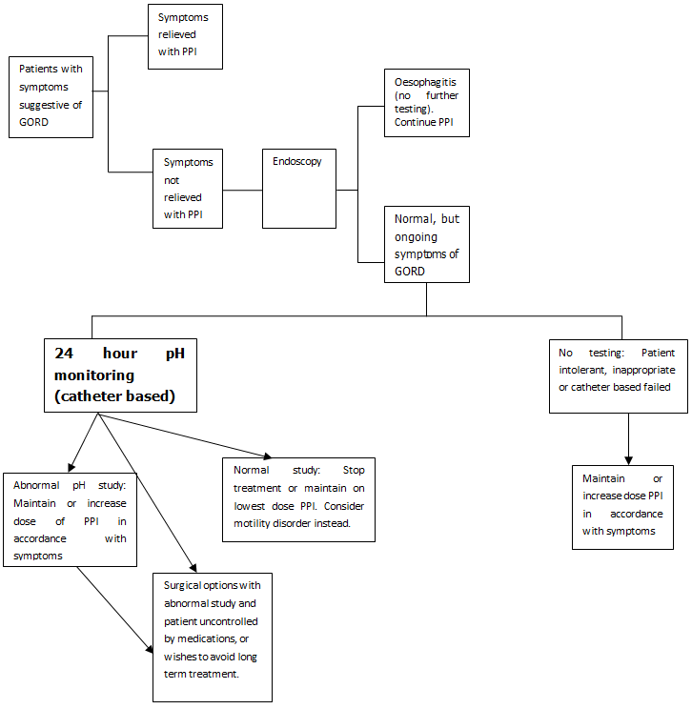
Figure 2: Treatment algorithm for proposed new intervention
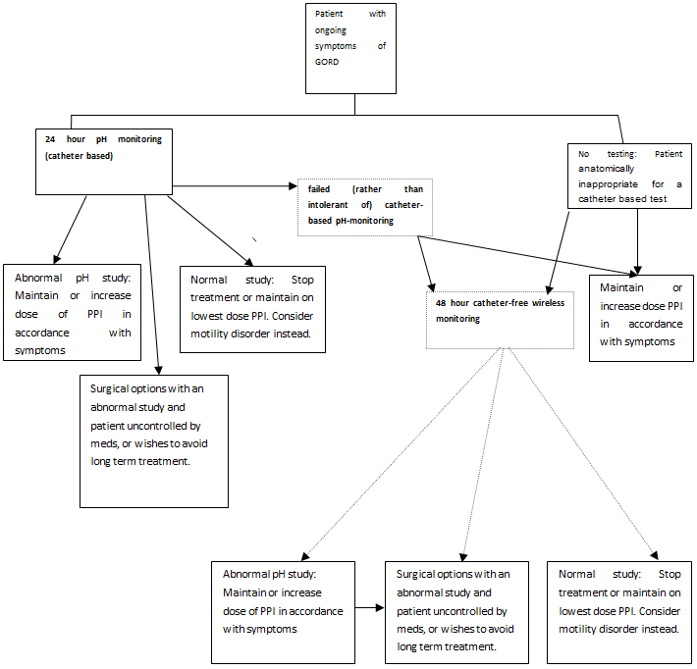

Clinical claim

Potential benefits of proposed technology
If it is demonstrated that the diagnostic sensitivity, specificity and safety of the proposed new test is at least equivalent to the 24 hour catheter-based monitoring, then the major benefit of introducing the 48 hour test would be the ability to perform pH monitoring in a subset of patients for whom monitoring would not otherwise be possible. This would lead to improved patient outcomes in this group as a result of test guided treatments.
By direct comparison with catheter-based tests, wireless monitoring is less uncomfortable or more acceptable to patients. A decrease in interference with daily activities, eating or sleeping may therefore provide more reliable results. Another advantage for the capsule based system is that it enables a longer period of monitoring than the traditional approach – this may increase the sensitivity of the test, particularly since patients are likely to undertake “normal” activities during extended periods (Weber, Davis, & Fisichella 2011).

Potential disadvantages of technology
Early comparative studies have suggested that while there may be significant correlation between the two techniques, they may not be completely interchangeable in clinical practice (des Varannes et al. 2005;Hakanson et al. 2009) Other potential disadvantages to the capsule based system that have been documented include oesophageal injury, patient discomfort and chest pain. Early detachment of the capsule from the oesophageal mucosa into the stomach can give false low pH readings. The capsule based system has an inability to measure both distal and proximal pH, although the majority of pH monitoring tests that are undertaken in Australia use single channel pH sensors. It is considered that the determinant is the existence of reflux above the lower oesophageal sphincter rather than the height of refluxate.

Comparator
As the proposed intervention is the alternative to the currently available catheter-based test in a particular subgroup of patients in whom the latter has failed or cannot be employed, the comparator will be no pH testing in this subgroup and empirical therapy. PASC re-affirmed in August 2012 that 24 hour catheter-based testing would be the evidentiary standard upon which the diagnostic performance of the proposed new intervention would be based although the assessment should consider best practice in relation to pH monitoring technologies in terms of their relative safety, effectiveness and cost-effectiveness.

It would be expected that the appropriate type of economic evaluation in this assessment, using table 3 as a guide, would be a cost-effectiveness or cost-utility analysis. This is based on a claim in the application of superior clinical outcomes for patients receiving diagnostic guided treatment by comparison with those who don’t receive this test. Although the test itself (by comparison with failed or no testing) would be inferior in terms of safety, there would be a net clinical benefit in those tested. Any other economic approach adopted following review of the evidence would have to be justified in the report.
Table 3: Classification of an intervention for determination of economic evaluation to be presented
 |  | Comparative effectiveness versus comparator
 |  | Superior |  | Non-inferior | Inferior
Comparative safety versus comparator | Superior | CEA/CUA |  | CEA/CUA | Net clinical benefit | CEA/CUA
 |  |  |  |  | Neutral benefit | CEA/CUA*
 |  |  |  |  | Net harms | None^
 | Non-inferior | CEA/CUA |  | CEA/CUA* | None^
 | Inferior | Net clinical benefit | CEA/CUA | None^ | None^
 |  | Neutral benefit | CEA/CUA*
 |  | Net harms | None^
Abbreviations: CEA = cost-effectiveness analysis; CUA = cost-utility analysis
* May be reduced to cost-minimisation analysis. Cost-minimisation analysis should only be presented when the proposed service has been indisputably demonstrated to be no worse than its main comparator(s) in terms of both effectiveness and safety, so the difference between the service and the appropriate comparator can be reduced to a comparison of costs. In most cases, there will be some uncertainty around such a conclusion (i.e., the conclusion is often not indisputable). Therefore, when an assessment concludes that an intervention was no worse than a comparator, an assessment of the uncertainty around this conclusion should be provided by presentation of cost-effectiveness and/or cost-utility analyses.
^ No economic evaluation needs to be presented; MSAC is unlikely to recommend government subsidy of this intervention

Outcomes and health care resources affected by introduction of proposed intervention
This assessment will consider the following outcomes:
Effectiveness of the diagnostic test:
Sensitivity
Specificity
Positive Predictive value
Negative Predictive value
Diagnostic yield
(by reference to the gold standard)

Safety of the diagnostic test
Any adverse events arising from testing including oesophageal injury, reported chest pain, stricture, early detachment, late detachment.

Therapeutic impact
% change in management plan (eg surgeries carried out, number of medications ceased modified or increased.)

Health outcomes
Quality of life
Reduction in progression of disease to Barretts Oesophagus

Proposed structure of economic evaluation (decision-analytic)
The structure of the PICO table is shown in table 4 below.

Table 4: Summary of extended PICO to define research question that assessment will investigate
Patients | Intervention | Comparator | Outcomes to be assessed | Healthcare resources to be considered
Patients with (or suspected) GORD for whom pH monitoring is indicated | Catheter-free (wireless) ambulatory oesophageal pH-monitoring and test guided therapy (assessed against evidentiary standard of catheter-based testing) | Failed catheter based pH monitoring or no diagnostic testing and empirical therapy | Test effectiveness  Sensitivity  Specificity  Positive Predictive value  Negative Predictive value  (by reference to the gold standard)  Safety  Any adverse events arising from testing including  Oesophageal injury  Chest pain  Early detachment  Late detachment  Stricture  Clinical  Patient quality of life  Reduction in progression to Barretts Oesophagus  % change in management plan including surgeries performed and changes in medication plans | Test itself  Total number of MBS claims for a newly approved listing.  Treatments  Laparascopic fundoplication (MBS items 43951 and 43954)  H2 antagonists (A02BA) and PPIs (A02BC)
What is the safety, effectiveness, and cost-effectiveness of catheter-free (wireless) ambulatory oesophageal pH-monitoring for GORD in patients who have previously failed a catheter-based test or where it is anatomically inappropriate.

PASC determined that the completed assessment of the new intervention should consider its impact, and the impact to the MBS, in the different sub-groups of patients with GORD (or suspected of having GORD) for whom pH monitoring is clinically indicated. These are listed on page 7 of this document.
The completed assessment should also consider best practice in relation to pH monitoring technologies, taking into account their relative safety, effectiveness and cost-effectiveness.

Health care resources
It is anticipated that the funding of the proposed intervention, leading to a positive diagnosis of GORD in the subgroup of patients for whom it is intended, would have an impact on a number of resources. For each test performed there would be an associated MBS claim for the test. In relation to the subsequent management of the patient, there would be an alteration in the net usage of pharmacological agents used to treat the disease (proton pump inhibitors and H2 antagonists) as well as an alteration in the net performance of surgical treatments that may be employed to manage it.

These resources include:
Procedure related
pH monitoring (new intervention)
Surgery
MBS 43951 : Laparatomy and fundoplication for GORD with or without hiatus hernia – without gastronomy
MBS 43954: Laparatomy and fundoplication for GORD with or without hiatus hernia – with gastronomy
PBS listings
A02BA – H2 receptor antagonists
A02BC – proton pump inhibitors

Table 4: List of resources to be considered in the economic analysis
 | Provider of resource | Setting in which resource is provided | Proportion of patients receiving resource | Number of units of resource per relevant time horizon per patient receiving resource | Disaggregated unit cost
 |  |  |  |  | MBS | Safety nets* | Other govt budget | Private health insurer | Patient | Total cost
Resources provided to identify eligible population
- Resource 1 | Gastroenterologist | Out-patient |  |  | Professional consultaton | EMSN
    - Resource 2, etc
Resources provided to deliver proposed intervention
- Resource 1 | Gastroenterologist | In patient day case |  |  | New MBS item
- Resource 2, etc | Anaesthetist | In patient day case |  |  | Professional fee
- Resource 3 | Hospital/clinic |  |  |  |  |  | Facility fee
Resources provided to deliver evidentiary standard
- Resource 1 | Gastroenterologist | Out-patient |  |  | 11810 | EMSN
    - Resource 2, etc
Resources used to manage patients successfully treated with the proposed intervention
- Resource 1 | Gastroenterologist | In patient |  |  | 43951
- Resource 2, | Gastroenterologist | In patient |  |  | 43954
- Resource 3 |  |  |  |  |  |  | PBAC items
Resources used to manage patients who are unsuccessfully treated with the proposed intervention
- Resource 1 |  |  |  |  |  |  | PBAC items
    - Resource 2, etc
Resources used to manage patients who undergo no testing (the comparator)
- Resource 1 |  |  |  |  |  |  | PBAC items
    - Resource 2, etc
* If provided in an out-patient setting, the costs risks associated with the Extended Medicare Safety Net should be examined.

References
des Varannes, S.B., Mion, F., Ducrott, P., Zerbib, F., Denis, P., Ponchon, T., Thibault, R., & Galmiche, J.P. 2005. Simultaneous recordings of oesophageal acid exposure with conventional pH monitoring and a wireless system (Bravo). Gut, 54, (12) 1682
Gastroenterological Society of Australia. Gastro-oesophageal Reflux Disease in Adults (5th ed). 2011. Digestive Health Foundation.
Ref Type: Pamphlet
Hakanson, B.S., Berggren, P., Granqvist, S., Ljungqvist, O., & Thorell, A. 2009. Comparison of wireless 48-h (Bravo) versus traditional ambulatory 24-h esophageal pH monitoring. Scandinavian journal of gastroenterology, 44, (3) 276-283
Hirano, I. & Richter, J.E. 2007. ACG practice guidelines: esophageal reflux testing. The American journal of gastroenterology, 102, (3) 668-685
McLoughlin, P., Jamieson, G.G., & Maddern, G.J. 2006. Endoscopic treatments for gastro-oesophageal reflux disease (GORD): an Accelerated Systematic Review. ASERNIP-S Review No 54.Adelaide, South Australia; ASERNIP-S,
Shaheen, N.J. & Richter, J.E. 2009. Barrett's oesophagus. The Lancet, 373, (9666) 850-861 available from: http://www.sciencedirect.com/science/article/pii/S0140673609604876
Weber, C., Davis, C.S., & Fisichella, P.M. 2011. Current applications of evolving methodologies in gastroesophageal reflux disease testing. Digestive and Liver Disease, 43, (5) 353-357

https://www.medicareaustralia.gov.au/cgi-bin/broker.exe?_PROGRAM=sas.mbs_item_standard_report.sas&_SERVICE=default&DRILL=ag&_DEBUG=0&group=11810&VAR=services&STAT=count&RPT_FMT=by+state&PTYPE=finyear&START_DT=201007&END_DT=201106 [Accessed 21 February 2012]

