1360.1

Protocol to guide the assessment of asynchronous specialist dermatology services delivered by telecommunications
February 2016

MSAC and PASC 3
Purpose of this document 3
Purpose of application 4
Intervention 5
Description 5
Delivery of the intervention 6
Site of provision of services 7
Prerequisites 8
Co-administered and associated interventions 9
Background 10
Current arrangements for public reimbursement of telehealth 10
Regulatory status 11
Patient population 11
Proposed MBS listing 12
Clinical place for proposed intervention 13
Comparator 15
Clinical claim 16
Outcomes and health care resources affected by introduction of proposed intervention 17
Clinical outcomes 17
Health care resources 18
Proposed structure of economic evaluation (decision-analytic) 19
References 22

MSAC and PASC
The Medical Services Advisory Committee (MSAC) is an independent expert committee appointed by the Minister for Health (the Minister) to strengthen the role of evidence in health financing decisions in Australia. MSAC advises the Minister on the evidence relating to the safety, effectiveness, and cost-effectiveness of new and existing medical technologies and procedures and under what circumstances public funding should be supported.
The Protocol Advisory Sub-Committee (PASC) is a standing sub-committee of MSAC. Its primary objective is the determination of protocols to guide clinical and economic assessments of medical interventions proposed for public funding.

Purpose of this document
This document is intended to provide a protocol that will be used to guide the assessment of an intervention for a particular population of patients. The draft protocol will be finalised after inviting relevant stakeholders to provide input to the protocol. The final protocol will provide the basis for the assessment of the intervention.
The protocol guiding the assessment of the health intervention has been developed using the widely accepted “PICO” approach. The PICO approach involves a clear articulation of the following aspects of the question for public funding the assessment is intended to answer:
Patients – specification of the characteristics of the patients in whom the intervention is to be considered for use
Intervention – specification of the proposed intervention and how it is delivered
Comparator – specification of the therapy most likely to be replaced by the proposed intervention
Outcomes – specification of the health outcomes and the healthcare resources likely to be affected by the introduction of the proposed intervention

Purpose of application
A proposal for an application requesting MBS listing of specialist dermatology services delivered by asynchronous store and forward technology (ADT) for inflammatory skin conditions was received from Australasian College of Dermatologists by the Department of Health in May 2013. The evidence pertaining to safety, effectiveness and cost-effectiveness was considered by MSAC in November 2014, and public funding was not supported. The present application has been amended in light of MSAC and PASC feedback.

Issues arising from the previous consideration of application 1360
In its previous consideration of the evidence pertaining to safety, effectiveness and cost-effectiveness for Application 1360, MSAC did not support public funding based on the key issues discussed below.
- Uncertainty that the appropriate comparator had been identified for comparative evaluation and costing
MSAC noted that ADT was expected to substitute for the standard MBS telehealth items for professional attendance of specialist dermatologist in real-time by videoconference including patient-end telehealth items. MSAC considered it may also be appropriate to compare ADT against other funded telehealth and teledermatology services such as TeleDerm (Public Summary Document page 2).
PASC noted the concerns of MSAC, and considered that both face-to-face and video-conferencing based consultations should be included as comparators, and that asynchronous services should be treated as a replacement for either service.
- Uncertainty that an interaction between the GP and dermatologist (only) meets the requirements of a consultation, which in all other cases includes direct interaction between the patient and the medical practitioner(s) billing for the item(s).
PASC noted that the proposed service did not fit with the strict definition of a consultation for MBS purposes, and that the definition of professional services in the MBS legislation requires direct patient involvement. PASC suggested that the intervention may be best evaluated as an investigative service for the purpose of diagnosing the proposed conditions.
- Lack of clarity on the eligible population for those patients where it is proposed that eligibility be determined based on ‘disability’; and concern about the comparator for populations in major cities.
The proposed populations of “people with disability in all areas” and “people who reside in outer metropolitan areas and have difficulty travelling to face-to-face consultations” have been removed from the revised protocol at the request of the Applicant.

- Insufficient evidence regarding diagnostic performance equivalence between ADT and video conferencing; and uncertain cost effectiveness of ADT against VC and with other existing services (e.g., Telederm);
These issues of diagnostic performance and cost-effectiveness should be addressed in any new assessment prepared on the basis of this revised protocol.

Intervention

Description
This is a specialist dermatology service delivered using store and forward technology. Store-and-forward services capture patient health care data and digital images (such as digital images of dermatological conditions), package it as a case file, and transfer it via telecommunication services to a clinician (specialist dermatologist), who then provides a diagnosis and therapeutic recommendations (asynchronous telecommunication). Store-and-forward delivered services do not require the patient and the clinician to be present in real time; the service is delivered by telecommunications.
PASC noted that there were concerns around privacy and patient consent in respect to the transmission and storage of patient data.
The equipment required is a digital camera or mobile phone, and standard broadband internet, although bandwidth requirements are not as high as are necessary for videoconferencing. The patient is referred to a specialist dermatologist by a general practitioner or nurse practitioner. The applicant has indicated that the dermatologist’s website would be able to be accessed by smart phone, tablet or fixed computer in any location where there is basic internet access speed. According to the applicant, no specialist software is required to encrypt and send a patient’s clinical information securely. The referrer only requires a standard computer with a major commercial browser, and when the referrer accesses the dermatologist’s site and uploads information it is sent under encryption established by the dermatologist’s site.
A number of different store and forward teledermatology applications are currently used around the world. They differ in their technical specifications and requirements on referrers and providers. Armstrong et al (2010) reviewed four commercially available store-and-forward technologies suitable for teledermatology: AFHCAN, Medweb, TeleDerm, and Second Opinion. The review concluded that the technologies were mature, and capable of addressing the basic needs of store-and-forward teledermatology referrals and consultations. However, areas in need of improvement common to these major applications included: (1) increased compatibility and integration with established electronic medical record systems, (2) development of fully integrated billing capability, (3) simplifying user interface and allowing user-designed templates to communicate recommendations and patient education, and (4) reducing the cost of the applications (Heyes, 2011).

There is currently no Australian technical or medical guidance for photographic imaging for store-and-forward consultations. Technical guidance is available in the UK (Quality Standards for Teledermatology using store and forward images; British Association of Dermatologists, 2011) and the US (American Telemedicine Association Practice Guidelines for Teledermatology; American Telemedicine Association, 2007). Attempts in the prescription of technical areas within teledermatology are impractical due to continuous advances in the technology associated with teledermatology. The two aforementioned guidelines do, however, assist in the guidance of issues such as image capture, storage format, compression, and monitor resolution suggestions. This guidance suggests a digital image taken with a standard digital camera by a general practitioner should:
- Consist of an image resolution of between 640x470 to 1600x1200 pixels (depending on what in the skin is needed to be imaged).
- The image should be in 24 bit colour,
- The image should be stored in a JPEG format, and
- The image should be read by the dermatologist on a viewing monitor with 1280x1024 pixel resolution.
The decision to accept or reject a store and forward consultation request resides with the consulting dermatologist. This decision in part rests on the quality of the images received. It is therefore up to the consulting dermatologist to dictate the quality of images required in a qualitative fashion for each case.
MSAC does not usually describe the technology required to deliver a certain health intervention because this has the potential for locking in obsolete technology over time. The applicant indicated that it is envisaged that a number of different dermatology groups will develop different software to undertake asynchronous consultations. The technology will be available in both the public and private sectors, with the former integrated into the overall public hospital information systems. The Australian College of Dermatologists does not see itself having a role specifying particular software. The individual specialist or group will require that referrers meet basic information system and encryption criteria.
As the proposed service is currently outlined, different specialists would develop different templates that referrers would need to fill out. Referrals need to have patient consent, meet Medicare record keeping and audit requirements and maintain security of patient data.
PASC agreed that a standardised referral template and minimum data set need to be developed for this purpose, and noted that a universal referral template developed by the Australian College of Dermatologists may be appropriate.

Delivery of the intervention
The proposed service requires the participation of two parties: the referrer and the specialist dermatologist.
Referrer
The requirements of the referrer are that they:
- Identify a suitable patient and obtain their consent
- Contact the dermatologist and request an asynchronous consult
- Document patient history and presenting complaint using dermatologists pre-prepared on-line template, and capture images of relevant condition using camera and devices in accordance with store and forward guidelines developed by the dermatologist
- Provide additional information or images if requested by the dermatologist
- If the consult is accepted, receive advice from dermatologist and treat patient accordingly.
The following is outlined in the application as the information required by the dermatologist from the referrer:
- General:
  - date and time of consult
  - Patient details: name, Medicare number, ID, phone, address, DOB, sex
  - Referrer details: name, site/organisation, email, health provider identifier
  - Consultant details: name, site/organisation, email, health provider ID
  - Urgency of response: e.g. within 24 hours, 2-3 days, 1 week
- Clinical Data:
  - reason for consultation
  - patient’s chief complaint
  - duration of condition
  - associated signs and symptoms
  - exacerbating factors
  - pregnancy status
  - medications
  - allergies
  - investigations biopsy results/laboratory data
  - diagnosis (provisional)
- Post consultation:
  - recommendations
  - clinical responsibilities
  - management plan

Specialist dermatologists
The proposed specialist dermatology service involves the following steps:
- The specialist dermatologist develops a standardised digital template and store and forward guidelines (this will include security or encryption standards)
- The referrer accesses the dermatology template, provides to the dermatologist a completed information template and digital image, and uploads this information to a telehealth portal as indicated in the guidelines
- The specialist dermatologist accesses the clinical information and/or a clinical pro-forma provided by the referrer
- After carefully reading all the clinical notes, the dermatologist accesses the provided digital images and advises the referrer if they require additional information, and whether the consult is unsuitable or suitable
- If the proposed consult is suitable for an asynchronous consult, the process follows the rule of classical consultation and the dermatologist provides diagnosis and management advice.
The Applicant advises that approximately 2-3% of consultations are initially refused, most due to poor quality images being supplied. In these cases, the referring clinical may provide additional images, although this may require the patient to attend an additional consultation.

Site of provision of services
It is proposed that the delivery of asynchronous specialist dermatology consultations delivered by telecommunications will able to be provided in an:
- Inpatient private hospital
- Inpatient public hospital
- Outpatient clinic
- Emergency department
- Consulting rooms
- Day surgery centre
- Residential aged care facility
These settings only address where a specialist may conduct the consultation, not where they actually will. PASC advises that it is not necessary for the purpose of the MBS item descriptor to stipulate where the specialist dermatologist will conduct the asynchronous consultation, however, the specialist will have to be physically present in Australia, as Medicare benefits are only payable for services provided in Australia.
As per the requirements for telehealth services, for the proposed asynchronous specialist dermatology consultation, the patient and specialist must be located a minimum of 15km apart at the time of the consultation. Minimum distance between specialist and patient consultations are measured by the most direct (i.e. least distance) route by road. The patient or the specialist is not permitted to travel to an area outside the minimum 15 km distance in order to claim the proposed services. This rule will not apply to specialist consultations with patients who are a care recipient in a residential care service; or at an Aboriginal Medical Service or an Aboriginal Community Controlled Health Service for which a direction made under subsection 19(2) of the Health Insurance Act 1973 as these patients are able to receive telehealth services anywhere in Australia.

Prerequisites

Technology training
All referrers to this service will require familiarity with the software, and may require training to be able to use the software and refer a patient to the specialist.
The specialist dermatologist may require training in the use of the technology to access the clinical information provided by the referrer, and to provide their diagnosis and management if the patient is considered suitable for an asynchronous consultation. The College of Dermatologists has indicated that they are developing a program to train hospital registrars in the software. Presently, there is no formal training for existing dermatologists. A number of dermatologists are already participating in the government Medicare Telehealth program, however, and experts advise that the same skill sets are required.

Referral
MBS explanatory notes, G6.1, “Referral of Patients to Specialists or Consultant Physicians” defines a "referral" as a request to a specialist or a consultant physician for investigation, opinion, treatment and/or management of a condition or problem of a patient or for the performance of a specific examination(s) or test(s). Aside from GPs, and other medical practitioners, these notes clarify that a participating nurse practitioner is able to refer to specialists and consultant physicians.
A practice nurse or an ATSI health practitioner is salaried or contracted to a GP. A GP can claim under Item 10987 where a follow up service is provided by a practice nurse or Aboriginal and Torres Strait Islander health practitioner on behalf of that medical practitioner, for an Indigenous person who has received a health check. In all cases, the GP under whose supervision the health check follow-up is being provided retains responsibility for the health, safety and clinical outcomes of the patient. The referring practitioner in this case will be the GP.
For a valid "referral" to take place, the following conditions must be met:
(i) the referring practitioner must have undertaken a professional attendance with the patient and turned his or her mind to the patient's need for referral and have communicated relevant information about the patient to the specialist or consultant physician (this need not mean an attendance on the occasion of the referral);
(ii) the instrument of referral must be in writing as a letter or note to a specialist or to a consultant physician and must be signed and dated by the referring practitioner; and
(iii) the specialist or consultant physician to whom the patient is referred must have received the instrument of referral on or prior to the occasion of the professional service to which the referral relates
Department of Health advises that a web template may be considered a valid referral under Medicare but that it would be the responsibility of the referring and treating practitioner to confirm the appropriateness of the final template with the Department.
According to the MBS explanatory notes, the prima facie evidence that a valid referral exists is the provision of the referral particulars on the specialist's or the consultant physician's account. A specialist or a consultant physician is required to retain the instrument of referral for 18 months from the date the service was rendered. A specialist or a consultant physician is required, if requested by the Medicare Australia CEO, to produce to a medical practitioner who is an employee of Medicare Australia, the instrument of referral within seven days after the request is received.

Consultation
MBS reimburses face to face consultations, including videoconferencing (if certain criteria listed are met). Medicare benefit is attracted for an attendance on a patient even where the attendance is solely for the purpose of issuing a referral letter or note. Legislative changes may be required to accommodate the proposed service, in which images are interpreted by a specialist without the patient present, and a report provided to the referring practitioner.
PASC noted that an asynchronous specialist dermatology consultation delivered by telecommunication does not fit with the strict definition of a consultation for MBS purposes, and that the definition of professional services in the MBS legislation requires direct patient involvement. PASC suggested that the intervention may be best evaluated as an investigative service for the purpose of diagnosing the proposed conditions.

Co-administered and associated interventions
The application does not identify any co-administered and associated interventions. No co-administered and associated interventions were identified by the assessment group.

Background

Current arrangements for public reimbursement of telehealth
Table 1 summarises the current MBS items available for specialist consultations, including dermatology.
Table 1: Current MBS item descriptor for MBS items used to deliver specialist dermatology consultations
Category 1 – Professional attendances
MBS 104
SPECIALIST, REFERRED CONSULTATION - SURGERY OR HOSPITAL
(Professional attendance at consulting rooms or hospital by a specialist in the practice of his or her specialty where the patient is referred to him or her)
-INITIAL attendance in a single course of treatment, not being a service to which ophthalmology items 106, 109 or obstetric item 16401 apply.
Fee: $85.55 Benefit: 75% = $64.20 85% = $72.75
Extended Medicare Safety Net Cap: $256.65
MBS 105
Each attendance SUBSEQUENT to the first in a single course of treatment
Fee: $43.00 Benefit: 75% = $32.25 85% = $36.55
Extended Medicare Safety Net Cap: $129.00

On 1 July 2011, Medicare rebates for specialist video consultations were introduced to address some of the barriers to accessing medical services by specialists, consultant physicians and consultant psychiatrist, faced by Australians in remote, regional and outer metropolitan areas. These items allow a range of existing MBS attendance items to be provided via video conferencing, with a derived fee adding to the base item fee.
New MBS items were also introduced for Patient-end Services. These items enable GPs, other medical practitioners, nurse practitioners, midwives, Aboriginal health workers and practice nurses to provide face-to-face clinical services to the patient during the consultation with the specialist.
Telehealth MBS items may be billed where a specialist consultation is conducted via video conferencing with a patient who is:
- not an admitted patient; and
- is eligible for Medicare rebates; and
- located in an Eligible Geographical Area (see: http://www.doctorconnect.gov.au/internet/otd/Publishing.nsf/Content/locator#metro); or
- a care recipient at an eligible Residential Aged Care Facility (RACF); or
- at an eligible Aboriginal Medical Service (AMS); or
- at an eligible Aboriginal Community Controlled Health Service (Medicare 2014).

MBS currently lists the following Telehealth items for videoconferencing by which specialist dermatology services can be delivered by synchronous telecommunication: 99, 113, 2100, 2122, 2125, 2126, 2137, 2138, 2143, 2147, 2147, 2179, 2195, 2199, 2200. There are presently no MBS items available for providing asynchronous specialist dermatology consultations delivered by telecommunications.

Regulatory status
This intervention requires delivery of a consultation service via the telecommunications network and does not require TGA approval.

Patient population
The patient population for the proposed service includes: patients with suspected skin cancer and patients with inflammatory skin conditions. According to the most recent (2013-14) BEACH data, skin problems accounted for 17.9 out of each 100 encounters with a general practitioner in Australia – of these, contact dermatitis and malignant skin cancers were the most common (Britt 2014)
There are 3 main types of skin cancers: basal cell carcinoma, squamous cell carcinoma, and melanoma. Basal cell carcinoma is the most common of the three, and least dangerous form of cancer. Squamous cell carcinoma is second most common form of skin cancer; it is more dangerous than basal cell carcinoma. There is currently no data collection at national level on basal and squamous cell carcinomas.
Melanoma is a malignant form of skin cancer, which if not treated quickly, can spread to other body parts. Its risk increases with exposure to UV radiation. In 2012, there were 12,510 people diagnosed with melanoma of the skin, with 1560 deaths from melanoma that year. In 2006-10, the 5-year survival rate was 89% for men and 94% of women (AIHW 2015)
Inflammatory skin conditions that are the subject of this application, may include, but are not limited to: eczema, psoriasis, acne, bacterial impetigo, viral exanthemas, and fungal dermatoses adverse drug reactions. An analysis of Australia GP practice management (BEACH) of inflammatory skin conditions (ISC), including eczema (dermatitis) – atopic, discoid, asteatotic, stasis - seborrhoeic dermatitis, psoriasis, acne rosacea, urticaria, and photosensitivity recorded them 3097 times during 2003–2004 at a rate of 3.1 per 100 encounters. This represents an average of approximately 3 million ISC encounters in general practice across Australia in any 1 year. If patients were referred it was mostly to a dermatologist with 5.8 per 100 ISC encounters recorded (Charles 2005).
Skin problems are reported to be the primary reason for 16% of GP consultations by indigenous people. An audit of Perth outpatient clinics in 2010, identified skin infections to be the most common skin condition in indigenous groups, followed by fungal infection, with a high number of bacterial, viral and ectoparasite infections (Heyes 2011).

Proposed MBS listing
PASC noted departmental advice that the proposed service may not be appropriate for inclusion within the professional attendances section of the MBS. PASC advised that the issues regarding the classification of the service for MBS purposes, and its potential location within the schedule should be resolved in consultation with the department.
It is proposed that the service is made available on the basis of geographic location, attendance at an indigenous medical clinic or Aboriginal Medical Service. Table 2, below, provides details of the proposed MBS listing for the service referrer.
Table 2: Proposed MBS item descriptor for [item]
Category [category number] – [Category description]
MBS [item number]
Dermatology-Asynchronous Initial Consultation for patients with inflammatory skin conditions or suspected skin cancer, who is not an admitted patient, and:
- resides in telehealth eligible areas, and, at the time of the attendance, at least 15 kms by road from the specialist; or
- is a care recipient at an eligible Residential Aged Care Facility; or
- is a patient of Aboriginal Medical Service; or
- is a patient of an Aboriginal Community Controlled Health Service; for which a direction made under subsection 19 (2) of the Act applies
Fee: $72.72
Referrer is required to complete dermatologist template and provide photos, both to a standard whereby the dermatologist can decide if asynchronous consultation is suitable
MBS [item number]
Dermatology-Asynchronous Follow-up Consultation for patients with inflammatory skin conditions or suspected skin cancer, who is not an admitted patient, and:
- resides in telehealth eligible areas, and, at the time of the attendance, at least 15 kms by road from the specialist; or
- is a care recipient at an eligible Residential Aged Care Facility; or
- is a patient of Aboriginal Medical Service; or
- is a patient of an Aboriginal Community Controlled Health Service; for which a direction made under subsection 19 (2) of the Act applies
Fee: $36.36
Referrer is required to complete dermatologist template and provide photos, both to a standard whereby the dermatologist can decide if asynchronous consultation is suitable

Under the MBS TeleHealth Item 99, specific eligibility criteria are listed specifying when a patient is eligible for the videoconference service. The criteria are as follows:
- the patient is not an admitted patient; and
- the patient:
  - is located both:
    - within a telehealth eligible area; and
    - at the time of the attendance-at least 15 kms by road from the specialist; or
- is a care recipient in a residential care service; or
- is a patient of:
  - an Aboriginal Medical Service; or
  - an Aboriginal Community Controlled Health Service (for which a direction made under subsection 19 (2) of the Act applies).
Table 3 presents the proposed MBS item descriptor for the part of the proposed service undertaken by a specialist dermatologist.
PASC expressed concern that, under the current description of the intervention, there was potential for costs to escalate where a dermatologist required additional information from a patient. PASC advised that the point at which the service would be considered complete and could be billed required clarification.
Table 3: Proposed MBS item descriptor for asynchronous dermatology consultation
Category 1 – Professional attendances
MBS [item number]
Professional attendance on a patient by a specialist practicing in his or her specialty if:
(a) the attendance is by asynchronous telecommunications; and
(b) the attendance is for a service:
(c) the patient is not an admitted patient; and
- resides in telehealth eligible areas, and, at the time of the attendance, at least 15 kms by road from the specialist; or
- is a care recipient at an eligible Residential Aged Care Facility; or
- is a patient of Aboriginal Medical Service; or
- is a patient of an Aboriginal Community Controlled Health Service; for which a direction made under subsection 19 (2) of the Act applies
Fee: $72.72
[Relevant explanatory notes]
Referrer is required to complete an online template, using store and forward technology, specified by the dermatologist, to a standard whereby the dermatologist is able to decide if asynchronous consultation is suitable

Clinical place for proposed intervention
Under the current situation (Figure 1), a patient with suspected skin cancer or skin inflammation, will be referred by a GP (or another specialist or participating nurse practitioner), to a specialist dermatologist using a written referral. The dermatologist has a face-to-face consult with the patient and provides them with a diagnosis, treatment and advice. The dermatologist sends a report to the referrer, and, depending on the skin condition, a follow-up appointment may be required. Patients in rural and remote areas are more likely to have their skin conditions managed by their GP because of their geographical isolation and the lack of specialist dermatologists outside major cities. Alternatively, for patients in rural and remote areas this consultation may take the form of a videoconference, in which all parties are present at the same time, referrer, patient and consultant, to discuss the patient’s skin condition. In the event that a videoconference is insufficient to manage the patient’s condition, patients may have to travel for a face-to-face consultation with a specialist dermatologist. In these instances, the state-based rural patient transport schemes may cover some of the associated travel costs.
Figure 1: Current pathway for managing patients with suspected skin cancers and inflammatory skin conditions
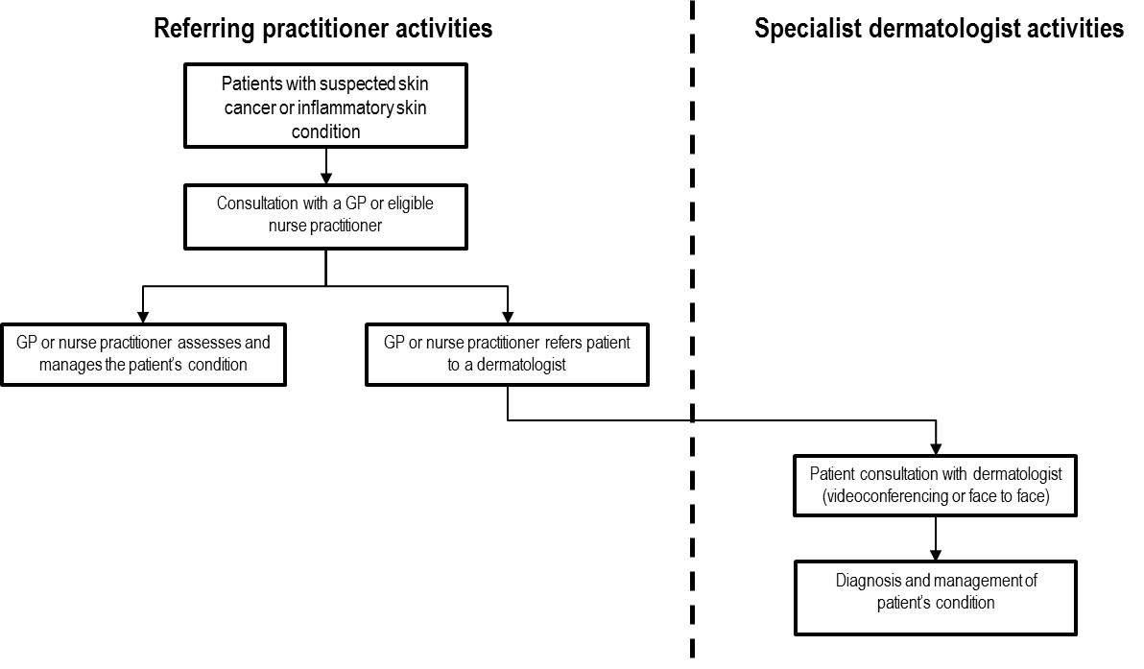
The clinical pathway incorporating the proposed service is shown in Figure 2 below. Under the proposed clinical pathway, a patient with suspected skin cancer or skin inflammation, will be referred by a GP (or another specialist or participating nurse practitioner), to a specialist dermatologist using a written referral after receiving patient’s consent. The referral will be in the form of digital images, and a completed template according to guidelines prepared by the dermatologist. The GP or referrer will access the dermatologist’s template and provide the required clinical information and digital images to a secure portal or web. The dermatologist will then access the online information, and if the information and images are of sufficient quality, will provide an online report to the referrer with a diagnosis and treatment plan. If the information or images are inadequate the dermatologist will request additional information, after which they will provide the referrer with a diagnosis and treatment plan. If the dermatologist decides the patient is unsuitable for an asynchronous consultation they will advise the GP accordingly. Where the specialist dermatologist provides a diagnosis and treatment plan back to the referrer, the referrer then will provide feedback to the patient and implement the dermatologist’s advice. Similar to the current situation, depending on the skin condition a follow-up appointment may be required but, instead of a face-to-face consult, this may also be an asynchronous consultation via telecommunications.
Figure 2: Proposed pathway for managing patients with suspected skin cancers and inflammatory skin condition
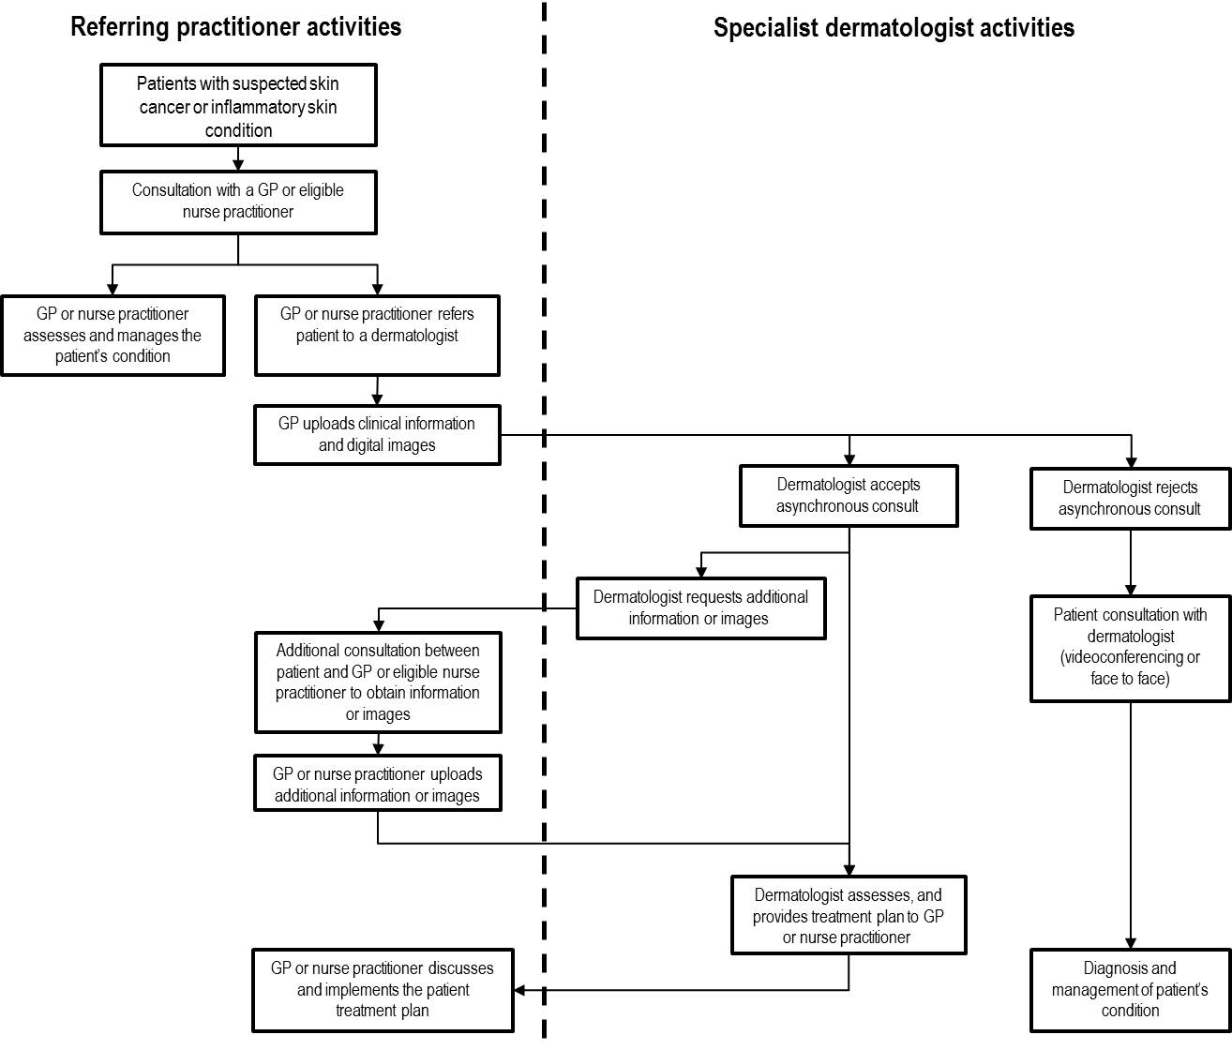

Comparator
The Applicant proposes that the comparator is a face to face consultation with a dermatologist, as this is the comparator used in relevant studies, and is also the gold standard.
The Public Summary Document for Application 1360 that was previously considered by MSAC, stated that for the population in eligible telehealth areas, the comparator is “professional attendance of specialist dermatologist in real-time by videoconference” (page 9).
PASC considered that both face-to-face and video-conferencing based consultations should be included as comparators, and that asynchronous services should be treated as a replacement for either service.

Reference Standard
The reference standard agreed between PASC and the Applicant is face-to-face consultations.

Clinical claim
It is anticipated that the assessment report considering the comparative effectiveness and safety of the proposed asynchronous specialist dermatology consultation delivered by telecommunications will claim non-inferiority compared to videoconference specialist dermatology consultation. Consequently, the most appropriate economic evaluation would be a cost minimisation analysis.
However, the application does assume that asynchronous consultation will be superior on the basis of timeliness of diagnosis. Earlier diagnosis is assumed to improve outcomes, and is particularly desirable where a suspected skin cancer may be malignant. On this basis, the economic evaluation should be a cost-effectiveness analysis (or cost-utility, as early diagnosis of malignant lesions may improve survival), in which asynchronous consultation is considered to be superior to face-to-face consultation. PASC advises that a cost effectiveness analysis would be required to include any superiority of outcomes, if evidence is found, and will need to include modelling of increased access for patients.

Table 4: Classification of an intervention for determination of economic evaluation to be presented
 |  | Comparative effectiveness versus comparator
 |  | Superior |  | Non-inferior | Inferior
Comparative safety versus comparator | Superior | CEA/CUA |  | CEA/CUA | Net clinical benefit | CEA/CUA
 |  |  |  |  | Neutral benefit | CEA/CUA*
 |  |  |  |  | Net harms | None^
 | Non-inferior | CEA/CUA |  | CEA/CUA* | None^
 | Inferior | Net clinical benefit | CEA/CUA | None^ | None^
 |  | Neutral benefit | CEA/CUA*
 |  | Net harms | None^
Abbreviations: CEA = cost-effectiveness analysis; CUA = cost-utility analysis
* May be reduced to cost-minimisation analysis. Cost-minimisation analysis should only be presented when the proposed service has been indisputably demonstrated to be no worse than its main comparator(s) in terms of both effectiveness and safety, so the difference between the service and the appropriate comparator can be reduced to a comparison of costs. In most cases, there will be some uncertainty around such a conclusion (i.e., the conclusion is often not indisputable). Therefore, when an assessment concludes that an intervention was no worse than a comparator, an assessment of the uncertainty around this conclusion should be provided by presentation of cost-effectiveness and/or cost-utility analyses.
^ No economic evaluation needs to be presented; MSAC is unlikely to recommend government subsidy of this intervention

Outcomes and health care resources affected by introduction of proposed intervention

Clinical outcomes
The proposal expects there to be no change in the following general outcomes from the delivery of specialist dermatology consultations using asynchronous teledermatology for the treatment of suspected skin cancer or inflammatory skin conditions compared to face-to-face consultation.
Effectiveness
- Correct diagnosis of clinical condition
- Equivalent long term outcome to face to face consultations
- Resolution of disease
The specific outcomes that can be used to provide evidence of clinical accuracy and that patients are receiving a more timely service are:
- Diagnostic concordance between the teledermatologists and reviewing dermatologists
- Management concordance between the teledermatologists and reviewing dermatologists
- Time to correct diagnosis
- Survival (this outcome is of most relevance to melanoma)

Other outcomes to determine the efficacy of the intervention and access include:
- Proportion of patients that are refused an asynchronous consult (limitation of the technology)
- Specialist request for additional images
- Costs to the patient
- Patient satisfaction or other measures of the patient experience
- Uptake of intervention in remote communities
Safety:
- Number of misdiagnoses
- Inappropriate management

Health care resources
The proposal has identified direct costs required to deliver the intervention as a health care resource:
- Computer and software (both referrer and specialist)
- IT system with secure online portal (specialist only)
- High speed internet (both referrer and specialist)
- Maintenance of software and regular upgrades (both referrer and specialist)
- Digital camera of sufficient quality to take the images. The applicant has clarified that a mobile phone is able to take an image of sufficient quality.
The proposal has identified there is likely to be a change in the staff time required for specialist to have up front training on the software.
A reported benefit of the use of proposed service is an increase in the productivity of the specialist dermatologist because the asynchronous consults take less time than normal face-to-face consults. The proposal estimates that the intra-service consult time will be approximately 23-28 minutes. This reduction will need to be estimated and costed.
The likely extent of the substitution for MBS items 99, 113, 2100, 2122, 2125, 2126, 2137, 2138, 2143, 2147, 2179, 2195, 2199, and 2220 by the proposed service and their fee should be included in the model.
There is likely to be an increase in the time the referrer needs to spend with patients, which is not presented in the application:
- to take a detailed clinical history and digital images and to insert this information onto online forms and to upload these forms to a secure portal
- follow-up appointments with the patient to obtain additional images or information, or to explain the specialist’s diagnosis and instigate the treatment plan will most likely result in an increase the number of MBS items for GP or nurse practitioner attendance (except if the patient was being seen regularly for other conditions).
These likely additional GP fees from managing patients under the proposed service will need to be estimated and their costs calculated. The proposed service may lead to an increase in the out-of-pocket costs to patients if multiple GP consultations are required to attain additional images.
Although not counted as health care costs, the intervention may have a reduction in patients’ out of pocket expenses for travel.

Proposed structure of economic evaluation (decision-analytic)
Table 5 sets out a summary of the extended PICO for the comparison of asynchronous specialist dermatologist consultation delivered by telecommunications compared to face-to-face specialist dermatologist consultation for skin lesions and inflammatory skin conditions.
Table 5: Summary of extended PICO to define the question for public funding that assessment will investigate
Patients | Intervention | Comparator | Outcomes to be assessed | Healthcare resources to be considered
Patients with suspected skin cancer or inflammatory skin conditions who require referral to a specialist dermatologist | Asynchronous specialist dermatology services delivered by telecommunications | - Videoconferencing  - Face to face consultation with a dermatologist | - Diagnostic concordance  - Management concordance  - Time to correct diagnosis  - Survival (melanoma only)  - Proportion of patients refused an asynchronous consult  - Rate of requests for additional images or information  - Patient satisfaction  - Number of misdiagnoses  - Rates of inappropriate management  - Uptake in remote communities | - MBS telehealth items  - Direct costs of intervention ( IT service & support)  - Increase in referrer time  - Reduction in specialist time  - Staff training costs  - Costs to the patient

Table 6 provides a list of the resources to be considered in the economic analysis.
Table 6: List of resources to be considered in the economic analysis
 | Provider of resource | Setting in which resource is provided | Proportion of patients receiving resource | Number of units of resource per relevant time horizon per patient receiving resource | Disaggregated unit cost
 |  |  |  |  | MBS | Safety nets* | Other govt budget | Private health insurer | Patient | Total cost
Resources provided to identify eligible population (asynchronous consult)
- referrer | GP | Clinic |  |  | 2504 (Level) C | Extended  210.90 |  |  | 0 | 70.30
- referrer | GP | Aged care |  | Divided by pts seen (max 6) | 35 (incl item 23) | Extended  Lesser of 300% of derived fee or $500 |  |  | 0 | (36.60 +45.80)/?
- Referrer | nurse | Home or aged care |  |  | 82224 | 161.10 |  |  | 8.05 | 53.70
- Referrer (health check) | GP | Rooms, elsewhere not institution |  | Once every 9 mths | A34 or 715 | Extended  $500 |  |  | 0 | $208.10
- referrer | nurse | Home or camp |  | At least 20 mins | 82210 | Extended 119.25 |  |  | 5.95 | 39.75
Resources provided to deliver proposed intervention (asynchronous consult)
- diagnosis | specialist | rooms |  |  | 104 (85%) |  |  |  | 10.92 | 72.75
- follow-up | specialist | rooms |  |  | 105 (85%) |  |  |  | 6.45 | 36.55
- treatment | GP | Clinic |  | Depend on management plan | 23 | Extended 108.90 |  |  | 0 | 36.30
- treatment | nurse | Home or aged care facilities |  | Depend on management plan | 82200 | Extended  $28.80 |  |  | 1.40 | 9.60
- treatment | GP or GP aboriginal MS | Video (pt of ACCHS |  | “ | 2126  LevelB | 146.85 |  |  | 0 | 48.95
- treatment | GP | aged care  institution |  | “ | 2125 (incl 2100) | extended  Lesser of 300% of derived fee or $500 |  |  | 0 | (22.45+45.80)/?
Resources provided in association with proposed intervention
- software | ?
    - maintenance of software
    - portal
- staff training | specialist
- staff training | referrer
Resources provided to identify eligible population (comparator)
- referrer | GP | Clinic |  |  | 23 | Extended  108.90 |  |  | 0 | 36.30
- referrer | GP | Aged care |  | Divided by pts seen (max 6) | 20 (incl item 3) | Extended  Lesser of 300% of derived fee or $500 |  |  | 0 | (16.60 +45.80)/?
- Referrer | nurse | Home or aged care |  |  | 82205 | 62.85 |  |  | 3.10 | 20.95
- Referrer (health check) | GP | Rooms, elsewhere not institution |  | Once every 9 mths | A34 or 715 | Extended  $500 |  |  | 0 | $208.10
Resources provided to deliver comparator 1 (face-to-face or via videoconference)
- initial | dermatologist | rooms |  |  | 104 | 256.65 |  |  | 10.92 | 85.55
- follow-up | dermatologist | rooms |  | ? | 105 | 129.00 |  |  | 6.45 | 43.00
- Telehealth | specialist | video
- Telehealth | nurse | Video ( for aged care person) |  |  | 82224 | 161.10 |  |  | 8.05 | 53.70
- Telehealth | GP or GP aboriginal MS | Video (pt of ACCHS |  |  | 2126  Level B | 146.85 |  |  | 0 | 48.95
- Telehealth | GP | Video (aged care) |  |  | 2125 (incl 2100) | Less or 300% of derived fee or $500 |  |  | 0 | (22.45+45.80)/?
Resources provided to treat skin conditions,
- Drugs or ointments to treat different inflammatory skin conditions | Doctor or specialist | Outpatient or clinic
    - treatment of skin cancer
    - surgery
    - staging of Ca
    - chemotherapy
    - (average cost of successful treatment)
    - (average cost of unsuccessful treatment)
* Include costs relating to both the standard and extended safety net.
In estimating the health resources used to identify the population MBS items at the higher cost end have been included to try to cost the extra time required to take a fuller clinical history and to upload the information to a portal. As the comparator and the intervention place different time impositions on the referrer, health resources to identify the population are separated between the current situation (comparator 1) and the intervention to reflect this.

References

AIHW (2015) Skin Cancer. Accessed on: 9 June 2015. Available from the AIHW website
American Telemedicine Association (2007) Practice guidelines for teledermatology. Available from the American Telemedicine Association website
Armstrong AW, Sanders C, et al (2010) Evaluation and Comparison of Store-and-Forward Teledermatology Applications. Telemedicine and e-Health 16(4): 424-439
British Association of Dermatologists (2011) Quality standards for teledermatology: Using ‘store and forward’ images. Primary Care Commissioning. Available from the British Association of Dermatologists website
Britt H, Miller G, Henderson J et al (2014) General practice activity in Australia: 2013–14. Available from the Sydney eScholarship Depository
Charles J, Britt H, Ng A (2005) Management of inflammatory skin conditions in Australian general practice. Australian Family Physician, 34(5):316-317
Heyes C, Chan J, Halbert A (2011) Dermatology outpatient population profiling: Indigenous and non-indigenous dermatoepidemiology Australasian Journal of Dermatology, 52: 202–206
Medicare (2014) Telehealth. Accessed on: 9 June 2015. Available from the Medicare Australia website

