MSAC Application 1700
Totally thoracoscopic exclusion of the left atrial appendage for patients with non-valvular atrial fibrillation
This application form is to be completed for new and amended requests for public funding (including but not limited to the Medicare Benefits Schedule (MBS)). It describes the detailed information that the Australian Government Department of Health requires to determine whether a proposed medical service is suitable.
Please use this template, along with the associated Application Form Guidelines to prepare your application. Please complete all questions that are applicable to the proposed service, providing relevant information only. Applications not completed in full will not be accepted.
Should you require any further assistance, departmental staff are available through the Health Technology Assessment Team (HTA Team) on the contact numbers and email below to discuss the application form, or any other component of the Medical Services Advisory Committee process.
Email: hta@health.gov.au
Website: www.msac.gov.au

PART 1 – APPLICANT DETAILS

Applicant details (primary and alternative contacts)
Corporation / partnership details (where relevant): Atricure Inc
Corporation name: Atricure Inc
ABN: -
Business trading name: Atricure Inc
Primary contact name: REDACTED
Primary contact numbers
Business: REDACTED
Mobile: REDACTED
Email: REDACTED
Alternative contact name: REDACTED
Business: REDACTED
Mobile: REDACTED
Email: REDACTED

(a) Are you a lobbyist acting on behalf of an Applicant?
Yes
No

If yes, are you listed on the Register of Lobbyists?
Yes
No

PART 2 – INFORMATION ABOUT THE PROPOSED MEDICAL SERVICE

Application title
Totally Thoracoscopic (TT) Exclusion of the left atrial appendage (LAA) for patients with non-valvular atrial fibrillation (NVAF) who have contraindication for oral anticoagulant therapy (OAT)

Provide a succinct description of the medical condition relevant to the proposed service (no more than 150 words – further information will be requested at Part F of the Application Form)
Atrial Fibrillation (AF) is recognized as a key risk factor for ischaemic strokes. It is the most common sustained cardiac arrhythmia. Thrombus may form when blood becomes trapped in the LAA due to the fibrillation effectively causing intermittent stasis of the blood. This thrombus is able to enter the systemic circulation upstream of the cerebral vasculature, creating the risk of it migrating to the cerebral circulation and causing ischaemic stroke via occlusion of one or more cerebral arteries. Ischaemic strokes are often devastating to the patient, with sequalae including but not limited: to hemi-paralysis, speech deficits, dysphasia, and death.

Provide a succinct description of the proposed medical service (no more than 150 words – further information will be requested at Part 6 of the Application Form)
The medical service is exclusion of the left atrial appendage via implantation of an epicardial clip via TT access. The left atrial appendage is sized via direct measurement under view of the thorascope, an epicardial LAA exclusion device is then positioned and deployed under thorascope visualization at the base of the LAA. The result is electrical and haemodynamic isolation of the LAA from the left atrium. The implantation procedure, assuming no pathology or abnormal anatomy which limits the ability of the surgeon to safely place the closure device at the base of the LAA, normally takes 20-40 minutes to complete.

(a) Is this a request for MBS funding?
Yes
No

If yes, is the medical service(s) proposed to be covered under an existing MBS item number(s) or is a new MBS item(s) being sought altogether?
Amendment to existing MBS item(s)
New MBS item(s)

If an amendment to an existing item(s) is being sought, please list the relevant MBS item number(s) that are to be amended to include the proposed medical service:
N/A

If an amendment to an existing item(s) is being sought, what is the nature of the amendment(s)?
N/A
- If a new item(s) is being requested, what is the nature of the change to the MBS being sought?
A new item which also seeks to allow access to the MBS for a specific health practitioner group
A new item that is proposing a way of clinically delivering a service that is new to the MBS (in terms of new technology and / or population)
A new item for a specific single consultation item
A new item for a global consultation item(s)

Is the proposed service seeking public funding other than the MBS?
Yes
No
Prosthesis list funding.

If yes, please advise:
N/A

What is the type of service:
Therapeutic medical service
Investigative medical service
Single consultation medical service
Global consultation medical service
Allied health service
Co-dependent technology
Hybrid health technology

For investigative services, advise the specific purpose of performing the service (which could be one or more of the following):
To be used as a screening tool in asymptomatic populations
Assists in establishing a diagnosis in symptomatic patients
Provides information about prognosis
Identifies a patient as suitable for therapy by predicting a variation in the effect of the therapy
Monitors a patient over time to assess treatment response and guide subsequent treatment decisions

Does your service rely on another medical product to achieve or to enhance its intended effect?
Pharmaceutical / Biological
Prosthesis or device
No

(a) If the proposed service has a pharmaceutical component to it, is it already covered under an existing Pharmaceutical Benefits Scheme (PBS) listing?
Yes
No

If yes, please list the relevant PBS item code(s):
N/A

If no, is an application (submission) in the process of being considered by the Pharmaceutical Benefits Advisory Committee (PBAC)?
Yes (please provide PBAC submission item number below)
No

If you are seeking both MBS and PBS listing, what is the trade name and generic name of the pharmaceutical?
Trade name: Insert trade name here
Generic name: Insert generic name here

(a) If the proposed service is dependent on the use of a prosthesis, is it already included on the Prostheses List?
Yes
No

If yes, please provide the following information (where relevant):
Billing code(s): Insert billing code(s) here
Trade name of prostheses

If no, is an application in the process of being considered by a Clinical Advisory Group or the Prostheses List Advisory Committee (PLAC)?
Yes
No
- Are there any other sponsor(s) and/or manufacturer(s) that have a similar prosthesis or device component in the Australian marketplace which this application is relevant to?
Yes
No

If yes, please provide the name(s) of the sponsor(s) and / or manufacturer(s):
N/A

Please identify any single and / or multi-use consumables delivered as part of the service?
Single use consumables: Atriclip Pro2 LAA exclusion system
Multi-use consumables: N/A

PART 3 – INFORMATION ABOUT REGULATORY REQUIREMENTS

(a) If the proposed medical service involves the use of a medical device, in-vitro diagnostic test, pharmaceutical product, radioactive tracer or any other type of therapeutic good, please provide the following details:
Type of therapeutic good: Implantable medical device
Manufacturer’s name: Atricure
Sponsor’s name: AA-Med Pty Ltd

Is the medical device classified by the TGA as either a Class III or Active Implantable Medical Device (AIMD) against the TGA regulatory scheme for devices?
Class III
AIMD
N/A

(a) Is the therapeutic good to be used in the service exempt from the regulatory requirements of the Therapeutic Goods Act 1989?
Yes (If yes, please provide supporting documentation as an attachment to this application form)
No

If no, has it been listed or registered or included in the Australian Register of Therapeutic Goods (ARTG) by the Therapeutic Goods Administration (TGA)?
Yes (if yes, please provide details below)
No
ARTG listing, registration or inclusion number: 308864
TGA approved indication(s), if applicable: The AtriClip LAA Exclusion System is indicated for the occlusion of the heart's left atrial appendage.

If the therapeutic good has not been listed, registered or included in the ARTG, is the therapeutic good in the process of being considered for inclusion by the TGA?
N/A

If the therapeutic good is not in the process of being considered for listing, registration or inclusion by the TGA, is an application to the TGA being prepared?
N/A

PART 4 – SUMMARY OF EVIDENCE

Provide an overview of all key journal articles or research published in the public domain related to the proposed service that is for your application (limiting these to the English language only). Please do not attach full text articles, this is just intended to be a summary.
 | Type of study design | Title of journal article or research project | Short description of research | Website link to journal article or research | Date of publication
1. | Consecutive enrolment retrospective analysis | Epicardial standalone left atrial appendage clipping for prevention of ischemic stroke in patients with atrial fibrillation contraindicated for oral anticoagulation | Retrospective analysis of 45 consecutive patients undergoing standalone TT clipping showed no procedure-related complications. Complete LAA occlusion in all patients at a mean follow-up of 16.4 ± 9.1 months (range, 2-34), with all patients off (N)OAC or APT, no ischemic stroke or hemorrhagic complications reported. | https://onlinelibrary.wiley.com/doi/abs/10.1111/jce.14599 | June 2020
2. | Consecutive enrolment retrospective analysis | Thoracoscopic Occlusion of the Left Atrial Appendage | 30 LAA occlusions with the AtriClip from left thoracoscopy approach, procedural success was reported in 29 cases (97%). Patients were followed up for 3 months, at the end of this period 28 (93%) were shown to have complete LAA exclusions | https://journals.sagepub.com/doi/abs/10.1097/imi.0000000000000169 | May 2015
3. | Prospective CT angiography (CTA) study | Angiographic Efficacy of the Atriclip Left Atrial Appendage (LAA) Exclusion Device Placed by Minimally Invasive Thoracoscopic Approach | Closure as assessed by CTA was achieved in 59 (~93%) of the 63 subjects. Prospective follow-up over 143 observed patient-years reveals 1 stroke in a patient with documented complete LAA closure and no thrombus. | https://www.ahajournals.org/doi/abs/10.1161/circ.134.suppl_1.11638 | March, 2018
4. | Cohort analysis | Thoracoscopic Left Atrial Appendage Clipping: A Multicenter Cohort Analysis | A total of 222 patients across 4 sites in the Netherlands and the USA with mean CHA₂DS₂-VASc score was 2.3 ± 1.0. Complete LAA closure was achieved in 95.0% of patients. There were no intraoperative or clip-related complications, and the overall 30-day freedom from any complication rate was 96.4%. The freedom from cerebrovascular events after surgery was 99.1% after median follow-up of 20 months (interquartile range: 14 to 25 months; 369 patient-years of follow-up), and overall survival was 98.6 | https://www.jacc.org/doi/full/10.1016/j.jacep.2018.03.009 | July, 2018
5. | Case series report | First Australian Series of Totally Thoracoscopic Left Atrial Appendage Occlusion With AtriClip PRO2TM Device in Australia: An Alternative to Percutaneous Device | Report of first 8 patients undergoing LAA occlusion with Atriclip pro2 device. All devices successfully implanted with 100% closure rate and no adverse events reported. | https://www.heartlungcirc.org/article/S1443-9506(19)30122-2/abstract | 2019

Identify yet to be published research that may have results available in the near future that could be relevant in the consideration of your application by MSAC (limiting these to the English language only). Please do not attach full text articles, this is just intended to be a summary.
 | Type of study design | Title of research | Short description of research | Website link to research | Date
1. | Retrospective  Propensity Matched Cohort Study (n> 1,000) | Sole Therapy AtriClip Comparison in OAC Intolerant patients | 1 Year Comparison of High Risk Patients Treated with Stand Alone Atriclip or No Treatment – A Stroke and Mortality Comparison | Not Published | To be Submitted to Journal in Nov.-Dec 2021

PART 5 – CLINICAL ENDORSEMENT AND CONSUMER INFORMATION

List all appropriate professional bodies / organisations representing the group(s) of health professionals who provide the service (please attach a statement of clinical relevance from each group nominated):
The Australian and New Zealand Society of Cardiac and Thoracic Surgeons

List any professional bodies / organisations that may be impacted by this medical service (i.e. those who provide the comparator service):
Cardiac Society of Australia and New Zealand
Australia and New Zealand Association of Neurologists

List the consumer organisations relevant to the proposed medical service (please attach a letter of support for each consumer organisation nominated):
hearts4heart

List the relevant sponsor(s) and / or manufacturer(s) who produce similar products relevant to the proposed medical service:
N/A

Nominate two experts who could be approached about the proposed medical service and the current clinical management of the service(s):
REDACTED

PART 6 – POPULATION (AND PRIOR TESTS), INTERVENTION, COMPARATOR, OUTCOME (PICO)

PART 6a – INFORMATION ABOUT THE PROPOSED POPULATION

Define the medical condition, including providing information on the natural history of the condition and a high level summary of associated burden of disease in terms of both morbidity and mortality:
The presence of atrial fibrillation is a strong independent predictor of stroke incidence, the 1991 Framingham study showed the risk of ischaemic stroke to be near fivefold when atrial fibrillation was present (p<0.001)^{1,2}. The Framingham study also concluded attributable risk of stroke for all cardiovascular contributors decreased with age except for atrial fibrillation, for which the attributable risk increased significantly (p<0.001), with stroke risk for those aged 85 years and older being ~23% in the presence of atrial fibrillation.
In most cases of stroke in the presence of AF, the LAA is the anatomical source of the ebolism². Exclusion of the LAA is the accepted therapy for patients who have relative contraindications for long term oral anticoagulation therapy.
Stroke occurs when a blood vessel supplying blood to the brain either suddenly becomes blocked (ischaemic stroke) or ruptures and begins to bleed (haemorrhagic stroke). Either may result in part of the brain dying, leading to sudden impairment that can affect a number of functions. Stroke often causes paralysis of parts of the body normally controlled by the area of the brain affected by the stroke, or speech problems and other symptoms, such as difficulties with swallowing, vision and thinking.
In 2018, stroke was recorded as the underlying cause of 8,400 deaths, accounting for 5.3% of all deaths in Australia. https://www.aihw.gov.au/reports/australias-health/stroke
In 2018, an estimated 387,000 people—214,000 males and 173,000 females—had had a stroke at some time in their lives, based on self-reported data from the Australian Bureau of Statistics 2018 Survey of Disability, Ageing and Carers (ABS 2019).
Though the mortality rate from stroke has been and continues to improve; between 1980 and 2018, overall death rates for stroke have fallen by three-quarters (75%), or 3.5% a year, the impact is stroke on Australian society is still profound.
People disabled by stroke are more likely to need ongoing assistance with activities of daily living compared with people disabled by other diseases. For example, those disabled by stroke were twice as likely to need ongoing assistance with these activities as those whose disability was caused by coronary heart disease (42.1% compared with 21.6%) (AIHW: Heart, stroke and vascular diseases 2004).

Specify any characteristics of patients with the medical condition, or suspected of, who are proposed to be eligible for the proposed medical service, including any details of how a patient would be investigated, managed and referred within the Australian health care system in the lead up to being considered eligible for the service:
The symptoms of AF include palpitations, dizziness, chest pain and shortness of breath, often noticed as an inability to tolerate exercise. Approximately 10–30 per cent of people with AF have no symptoms; many of these people are not diagnosed and thus do not receive appropriate treatment for stroke risk (Department of Health and ageing (DoHA): review of anticoagulation therapies in atrial fibrillation 2012). A definitive diagnosis of AF is obtained from ECG monitoring, management of both the AF and associated stroke risk performed by a cardiologist. A certain proportion of patients with AF are at a higher risk of embolic stroke, as defined by their respective CHA₂DS₂-VASc score. The CHA₂DS₂-VASc score risk indicative score can be calculated from patient attributes obtained in routine clinical evaluation.
https://www.mdcalc.com/cha2ds2-vasc-score-atrial-fibrillation-stroke-risk

Proposed patient population:
Patients with NVAF assessed by a non-interventional physician as has having an absolute contraindication to life‐long oral anticoagulation therapy, and at increased risk for thromboembolism, as demonstrated by any of the following; as per MBS item 38276:
(a) a prior stroke (whether of an ischaemic or unknown type), transient ischaemic attack or non‐central nervous system systemic embolism; or
(b) at least 2 of the following risk factors:
(i) an age of 65 years or more;
(ii) hypertension;
(iii) diabetes mellitus;
(iv) heart failure or left ventricular ejection fraction of 35% or less (or both);
(v) vascular disease (prior myocardial infarction, peripheral artery disease or aortic plaque)
(c ) the patient has an absolute and permanent contraindication to oral anticoagulation (confirmed by written documentation that is provided by a medical practitioner, independent of the practitioner rendering the service)
Absolute contraindication to life‐long oral anticoagulation therapy assessment criteria -
- A previous major bleeding complication experienced whilst undergoing treatment with oral anticoagulation therapy without remedial cause, or
- History of intracranial, intraocular, spinal, retroperitoneal or atraumatic intra-articular bleeding, or
- Chronic, irreversible, recurrent gastrointestinal bleeding of any cause (eg, radiation proctitis, gut angiodysplasia, hereditary haemorrhagic telangiectasia, gastric antral vascular ectasia (GAVE), portal hypertensive gastropathy, refractory radiation proctitis, obscure source), or
- Life-long spontaneous impairment of haemostasis, or
- A vascular abnormality predisposing to potentially life threatening haemorrhage, or
- Irreversible hepatic disease with coagulopathy and increased bleeding risk (Child Pugh B and C), or
- Receiving concomitant medications with strong inhibitors of both CYP3A4 and P-glycoprotein (P-gp), or
- Severe renal impairment defined as creatinine clearance (CrCL) < 15 ml/min or undergoing dialysis and where warfarin is inappropriate, or
- Known hypersensitivity to the direct oral anticoagulant (DOAC) or to any of the excipients

Define and summarise the current clinical management pathway before patients would be eligible for the proposed medical service (supplement this summary with an easy to follow flowchart [as an attachment to the Application Form] depicting the current clinical management pathway up to this point):
The current clinical management pathway for stroke prevention in AF, based on the NHF of Australia and CSANZ (2018) guidelines for AF, is provided in Figure 1. The pathway considers both NVAF and valvular AF, however, the focus of this Application is NVAF.
The CHA2DS2-VA score is recommended for predicting stroke risk in AF and determines management.
According to the CSANZ guidelines, patients with a CHA2DS2-VA score of ≥ 2 and contraindications to OAT, should be considered for exclusion of the LAA.
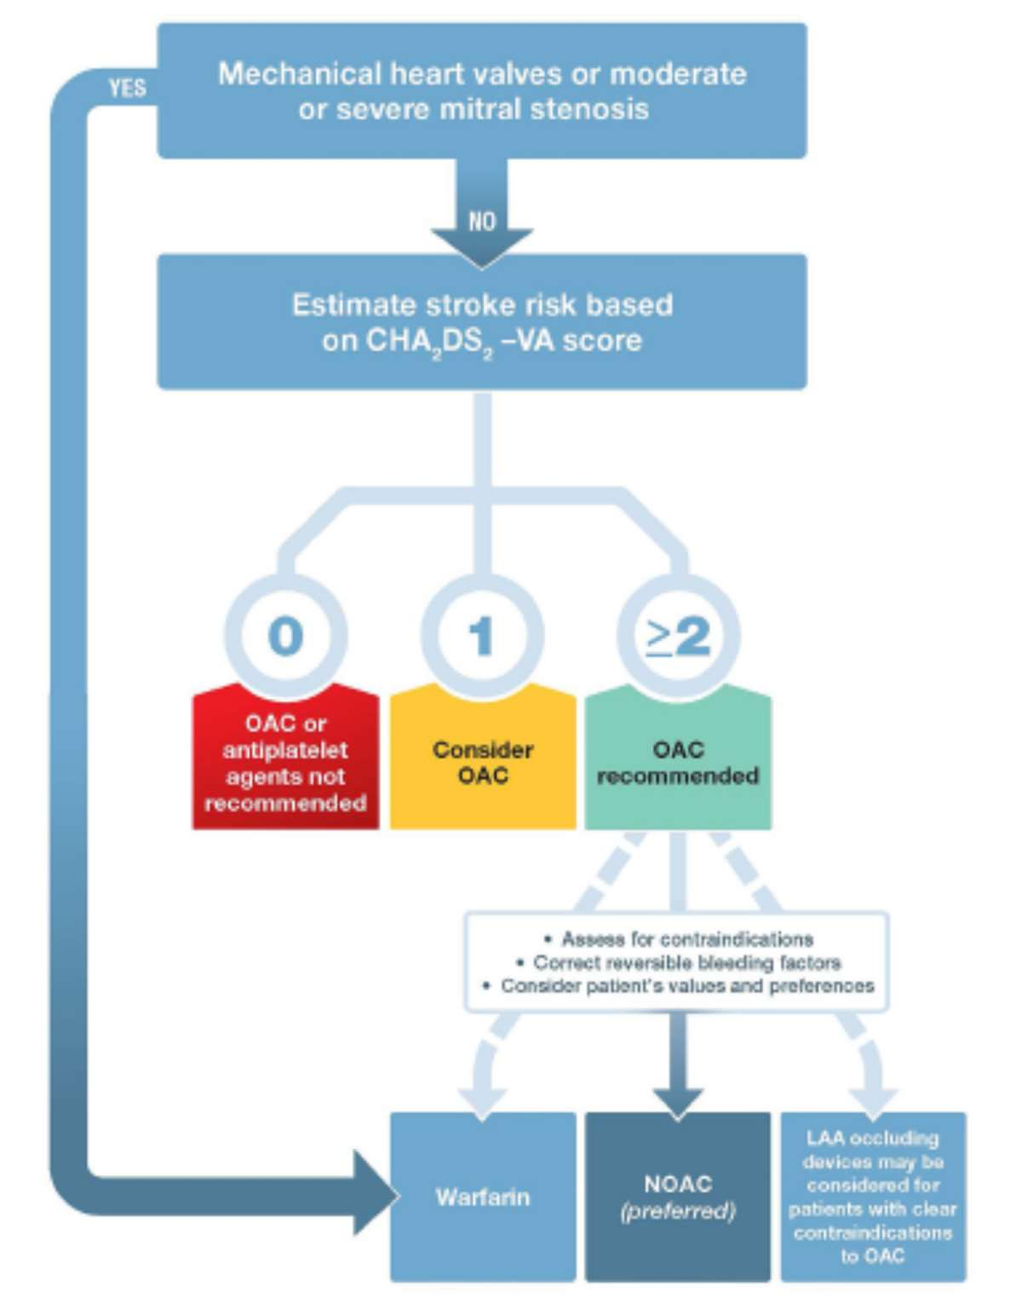
Figure 1 Management of stroke prevention in AF
OAC=oral anticoagulant; NOAC=non-vitamin K oral anticoagulant; LAA left atrial appendage.
Source: Source: National Heart Foundation (NHF) of Australia and the Cardiac Society of Australia and New Zealand (CSANZ) (2018) Figure 6 pg. 1238.
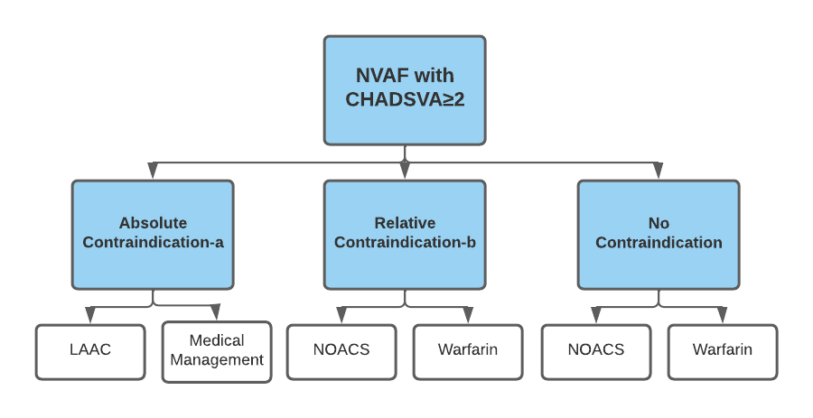
Figure 2 Current clinical management pathway for stroke prevention in patients with AF
TT LAA=Totally Thoracoscopic Left Atrial Appendage ; NOAC= Non-Vitamin K antagonist oral anticoagulants; SoC=standard of care. aAbsolute contraindications = contraindication to lifelong anticoagulation is defined as (as per q25): b Defined as: i) a previous major bleeding complication, or ii) a blood dyscrasia, or iii) a vascular abnormality predisposing to potentially life-threatening haemorrhage, or iv) anaemia, or v) prior gastrointestinal bleed, or vi) thrombocytopenia, or vii) haematological malignancy, or viii) traumatic intracranial haemorrhage
The proposed clinical management pathway for managing stroke prevention in AF, specifically LAA management, is provided in Figure 3.
Percutaneous devices come with the risk of technical issues and failures, along with the need for antiplatelet therapy, which in patients with a high HASBLED score presents a problem.
A totally thoracoscopic standalone epicardial approach with a safe and effective LAAE device not requiring anticoagulation nor antiplatelet therapy is an appropriate therapeutic option for patients indicated for exclusion of the LAA.
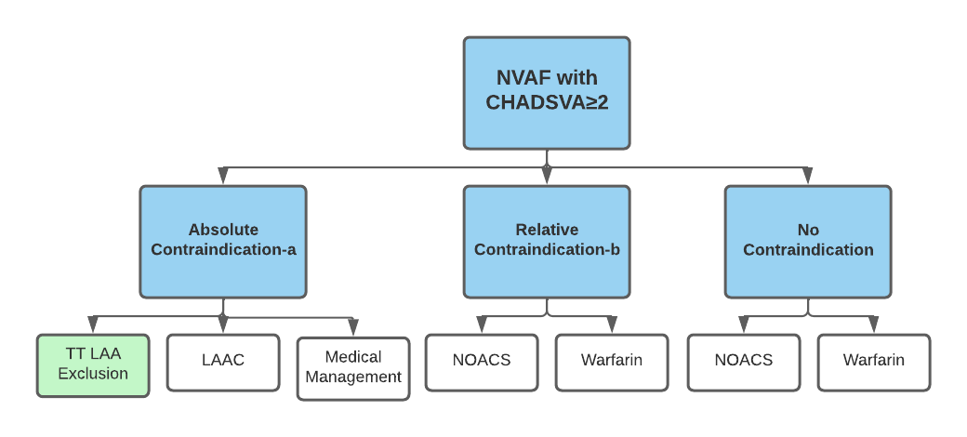Figure 3 Proposed clinical management pathway for stroke prevention in patients with AF
TT LAA=Totally Thoracoscopic Left Atrial Appendage ; NOAC= Non-Vitamin K antagonist oral anticoagulants; SoC=standard of care. aAbsolute contraindications = contraindication to lifelong anticoagulation is defined as (as per q25): b Defined as: i) a previous major bleeding complication, or ii) a blood dyscrasia, or iii) a vascular abnormality predisposing to potentially life-threatening haemorrhage, or iv) anaemia, or v) prior gastrointestinal bleed, or vi) thrombocytopenia, or vii) haematological malignancy, or viii) traumatic intracranial haemorrhage

PART 6b – INFORMATION ABOUT THE INTERVENTION

Describe the key components and clinical steps involved in delivering the proposed medical service:
Three thoracoscopic access ports are created on the left side of the patient chest, carbon dioxide CO₂ is insufflated into the left thoracic cavity to deflate the left lung.
After entering the chest cavity with the camera all structures are visualized and under direct endocavitary view the two additional accesses are gained. The second port (camera port) is placed at least 4 cm caudally along the posterior axillary line (5th intercostal space) and the lowest port is placed in the intercostal space at the intersection between a sagittal line crossing the xiphoid and line between the anterior and midaxillary line (7th intercostal space).
Under video guidance the perciadium an incision is made on the pericardium on the anterior lateral surface, exposing the LAA.
The LAA is measured with a sizing device to determine which, if any, size of epicardial exclusion device is appropriate.
The device is placed on the epicardial surface at the base of the LAA. Consistent /atraumatic force is equalized over tissue variations and trabeculation of the LAA via parallel titanium crossbars which apply pressure without crushing or damaging tissue. The device position is assessed via TOE to ensure complete haemodynamic exclusion of the LAA.
The device is then deployed leaving the LAA permanently hemodynamically and electrically isolated from the left atrium.

Does the proposed medical service include a registered trademark component with characteristics that distinguishes it from other similar health components?
AtriClip® PRO2 is a self-closing, sterile, implantable clip that is made of two parallel rigid titanium tubes with elastic nitinol springs and covered with a knit-braided polyester sheath. It comes in four clip sizes: 35 mm, 40 mm, 45 mm, and 50 mm. It is the only device listed on the ARTG for epicardial exclusion of the LAA.

If the proposed medical service has a prosthesis or device component to it, does it involve a new approach towards managing a particular sub-group of the population with the specific medical condition?
No, the proposed medical service simply makes safer and more effective the current interventional paradigm of isolating the LAA. Rather than ‘plugging’ the LAA with an image guided percutaneously delivered endocardial device, the proposed service completely and permanently excludes the LAA via direct visualization implantation of an epicardial clip.

If applicable, are there any limitations on the provision of the proposed medical service delivered to the patient (i.e. accessibility, dosage, quantity, duration or frequency):
The size and orientation of the LAA, previously cardiothoracic surgery which has resulted in pericardial adhesions, the presence of LAA thrombus, all are conditions which preclude implantation, as per the Atriclip PRO2 contraindications.

If applicable, identify any healthcare resources or other medical services that would need to be delivered at the same time as the proposed medical service:
The health care resources delivered at the same time as the proposed medical service are general anaesthesia, TOE imaging, TT video assisted thoracoscopic (VAT) devices to facilitate TT access and a procedure room with VAT display capabilities.

If applicable, advise which health professionals will primarily deliver the proposed service:
Cardiothoracic Surgeons with training in VAT surgery.

If applicable, advise whether the proposed medical service could be delegated or referred to another professional for delivery:
N/A

If applicable, specify any proposed limitations on who might deliver the proposed medical service, or who might provide a referral for it:
The delivery of the service is limited to qualified and accredited cardiothoracic surgeons.

If applicable, advise what type of training or qualifications would be required to perform the proposed service, as well as any accreditation requirements to support service delivery:
The cardiothoracic surgeon must be skilled in performing video assisted thoracoscopic surgery.

(a) Indicate the proposed setting(s) in which the proposed medical service will be delivered (select ALL relevant settings):
Inpatient private hospital (admitted patient)
Inpatient public hospital (admitted patient)
Private outpatient clinic
Public outpatient clinic
Emergency Department
Private consulting rooms - GP
Private consulting rooms – specialist
Private consulting rooms – other health practitioner (nurse or allied health)
Private day surgery clinic (admitted patient)
Private day surgery clinic (non-admitted patient)
Public day surgery clinic (admitted patient)
Public day surgery clinic (non-admitted patient)
Residential aged care facility
Patient’s home
Laboratory
Other – please specify below
- Where the proposed medical service is provided in more than one setting, please describe the rationale related to each:
Patients will be treated in an Inpatient setting in both the public and private system.

Is the proposed medical service intended to be entirely rendered in Australia?
Yes
No – please specify below

PART 6c – INFORMATION ABOUT THE COMPARATOR(S)

Nominate the appropriate comparator(s) for the proposed medical service, i.e. how is the proposed population currently managed in the absence of the proposed medical service being available in the Australian health care system (including identifying health care resources that are needed to be delivered at the same time as the comparator service):
Currently patients with NVAF and contraindication to OAT are treated via transcatheter implantation of an occlusion device, referred to in past MSAC applications are Left Atrial appendage closure (LAAC).
The implantation procedure uses standard transseptal techniques. The access sheath and delivery catheter permit device placement in the LAA via femoral venous access and inter-atrial septum crossing into the left atrium. The device is unsheathed when in the appropriate position. The procedure is performed under local or general anaesthesia by an interventional cardiologist or cardiac electrophysiologist in a catheterisation laboratory under guidance of fluoroscopy and TOE. The procedure takes approximately 60 minutes.
Despite the proposed population being contraindicated for OAT, the comparator medical service requires that patients remain on OAT for a period of 45 days post service provision to prevent device related thrombus^{(Watchman IFU)}.

Resource | Provider of resource | Price per unit of resource | Quantity | Source
Medical Services – screening prior to intervention
Non-intra-operative transesophageal echocardiography | Cardiologist | $282.15 | 1 | MBS Item 55118
Cardiology consultation | Cardiologist | $77.90 | 1 | MBS Item 116
Anaesthesiology for transoesophageal echocardiography | Anaesthetist | $103.00 | 1 | MBS Item 21936
Administration of anaesthesia for 15 mins or less | Anaesthetist | $20.60 | 1 | MBS Item 23010
Medical Services – intervention
Transcatheter occlusion of LAA | Cardiologist | $949.25 | 1 | MBS Item 38276
Intra-operative transesophageal echocardiography | Anaesthetist | $185.40 | 1 | MBS Item 22051
Initiation of management of  anaesthesia for cardiac catheterisation | Anaesthetist | $144.20 | 1 | MBS Item 21941
Intra-arterial cannulation when performed in association with the administration of anaesthesia | Anaesthetist | $82.40 | 1 | MBS Item 22025
Blood pressure monitoring | Anaesthetist | $61.80 | 1 | MBS Item 22012
Prostheses Costs
LAA occluder | Prostheses | $11,400 | 1.07 | Occluder Device and  Delivery System – SOURCE  PROSTHESIS LIST
Hospital Services
Hospital procedure and admission costs e.g. OR, accommodation, nursing, allied health etc. | Hospital | $6,116.00 |  | AR-DRG: F42B - prosthesis cost
Total Cost Per Patient (excluding occluder and Hospital Stay) |  | $2,457.80
Total cost of LAAC procedure/patient- |  | $21,880.50
Figure 3 Estimated recourses required for comparator service

Does the medical service (that has been nominated as the comparator) have an existing MBS item number(s)?
Yes (please list all relevant MBS item numbers below)
No
MBS item number - 38276

Define and summarise the current clinical management pathway/s that patients may follow after they receive the medical service that has been nominated as the comparator (supplement this summary with an easy to follow flowchart [as an attachment to the Application Form] depicting the current clinical management pathway that patients may follow from the point of receiving the comparator onwards, including health care resources):
Post percutaneous LAAC, patients are required to remain on OAT for 45 days post implantation of LAAC device, then undergo a TOE examination to assess for closure of the LAA. If closure is not complete (ie the LAA seal is >5mm) the patient must remain on OAT until TOE imaging confirms adequate seal of the LAA or the treating physician deems the bleeding risk too high to continue OAT, in some cases the patient is required to remain on OAT indefinitely. Upon cessation of OAT the patient is required to receive anti platelet medication out to 6 months post implant. Patients are required to remain on aspirin indefinitely.
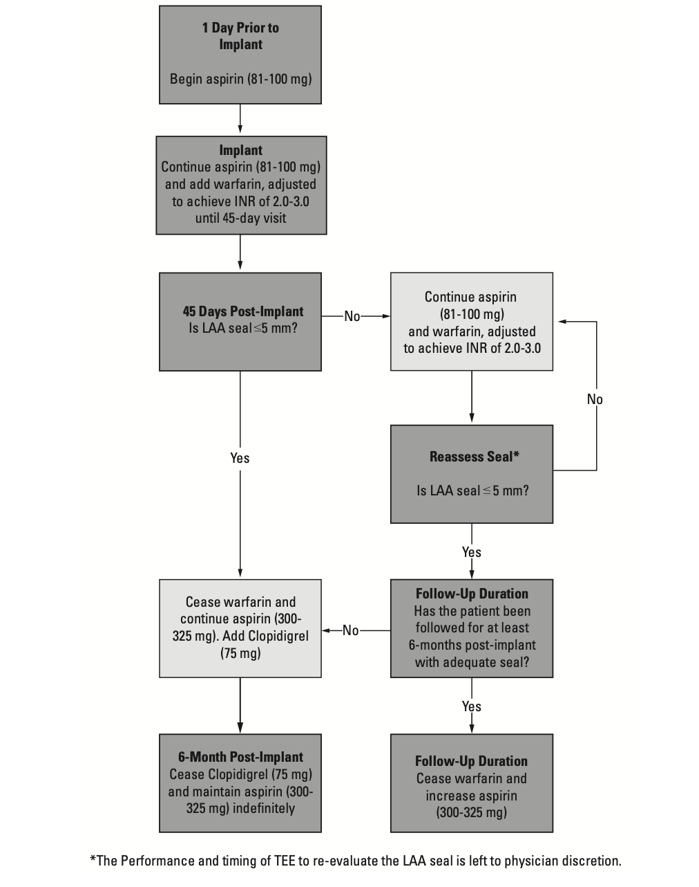Figure 4 Current treatment pathway post comparator service

Medical Services – post intervention follow-up within six months
Cardiology consultation | Cardiologist | $77.90 | 3 | MBS Item 116
Non-intra-operative transesophageal echocardiography | Cardiologist | $282.15 | 3 | MBS Item 55118
Anaesthesiology for transesophageal echocardiography | Anaesthetist | $103.00 | 3 | MBS Item 21936
Administration of anaesthesia for 15 mins | Anaesthetist | $20.60 | 3 | MBS Item 23010
Figure 5 Estimated recourses required post comparator service

(a) Will the proposed medical service be used in addition to, or instead of, the nominated comparator(s)?
In addition to (i.e. it is an add-on service)
Instead of (i.e. it is a replacement or alternative)

If instead of (i.e. alternative service), please outline the extent to which the current service/comparator is expected to be substituted:
The proposed medical service is expected to be the substitute for the comparator in the majority of cases; the lack of requirement for post procedure anticoagulation medication in patients who are known to be not suited for anticoagulation therapy, electrical isolation of the LAA which is known to be a source of triggers for AF and elegance of procedure will likely result in the proposed service not replacing the comparator only in cases where the patient is not suitable or the proposed service is not able to be provided to the patient due to clinician capability (ie no trained CT surgeon available).
Listing the proposed medical service for patients suffering NVAF with contraindications to OAT provides a patients with a faster, safer, less expensive alternative treatment to percutaneous plugging of the LAA.

Define and summarise how current clinical management pathways (from the point of service delivery onwards) are expected to change as a consequence of introducing the proposed medical service, including variation in health care resources (Refer to Question 39 as baseline):
The changes in terms of health care resources from the point of service delivery onwards:
- There is no requirement for anti-platelet therapy post service delivery
- Post procedure OAC therapy is not required, therefore
  - Monitoring of adherence is not required. NOACs and warfarin require long term treatment, with effectiveness dependent on adherence. In contrast, LAAC is a once off procedure, thus effectiveness is not dependent on compliance.
  - Monitoring of INR is not required. Regular, ongoing INR monitoring is relevant to all patients prescribed warfarin to ensure adequate coagulation whilst balancing the risk of bleeding. Monitoring will continue for as long as the patient is treated with warfarin.
As the patient is contraindicated to received OAT, the decision to remain on OAT is dependent on the exclusion of LAA. The proposed service excluded the LAA with an in-situ location that is epicardial, hence there is no requirement, assuming complete exclusion of the LAA, for OAT post implantation as there is no risk of device related thromboembolism.

PART 6d – INFORMATION ABOUT THE CLINICAL OUTCOME

Summarise the clinical claims for the proposed medical service against the appropriate comparator(s), in terms of consequences for health outcomes (comparative benefits and harms):
The proposed service results in a higher LAA closure rate with decreased risk of adverse events and the requirement for ongoing anti platelet/coagulation therapy. Incomplete closure and the requirement for some period of OAC therapy in patients contraindicated for OAC therapy, is associated with an increased risk of all cause stroke and significant bleeding events.

Please advise if the overall clinical claim is for:
Superiority
Non-inferiority

Below, list the key health outcomes (major and minor – prioritising major key health outcomes first) that will need to be specifically measured in assessing the clinical claim of the proposed medical service versus the comparator:
Safety Outcomes:
- Major bleeding events (procedural and post-procedural)
- Procedural adverse events related to TT LAA exclusion
- Procedural adverse events with percutaneous LAA closure vs TT LAA exclusion
- Post procedural adverse events percutaneous LAA closure vs TT LAA exclusion
Clinical Effectiveness Outcomes:
Primary
- Procedure success i.e. successful occlusion of LAA as confirmed by US/CT imaging.
- Incidence of all cause stroke
- Mortality
- Failure rate
Secondary
- Requirement for ongoing anti platelet/coagulation therapy.
- Cost to deliver intervention

PART 7 – INFORMATION ABOUT ESTIMATED UTILISATION

Estimate the prevalence and/or incidence of the proposed population:
The proposed patient population is patients with contraindications to life-long OAT, as defined in both Q.25 and the approved MSAC application No 1615. Patients must also meet the following anatomic and pathology suitability criteria to be suitable for the proposed service.
- No previous cardiac surgery or chest procedure which resulted in pericardial adhesions affecting access to the LAA
- LAA less than 29mm in width and 1.0mm wall thickness.
- LAA greater than 50mm when tissue is uncompressed.
- Patient has no known allergy to Nitinol
According to a 2012 report from the by the Department of Health and Ageing (DoHA), the prevalence of AF in Australia is 1–2% (DoHA: review of anticoagulation therapies in atrial fibrillation 2012, Section 5.2; Go et al 2001; Miyasaka et al 2006; Sturm et al 2002).
O’Brien et al., (2014) reported rates of contraindications in 10,130 patients from the Outcomes Registry for Better Informed Treatment of Atrial Fibrillation (ORBIT-AF) between June 2010 and August 2011. This study reported an overall contraindication rate of 13.1% (both event and patients related contraindications)¹².
Parameter | Estimate | Source
AF prevalence | 1-2% | DOHA 2012/ Sturm et al 2002
NVAF proportion | 88.58% | Bista 2017
Contraindicated to OAT | 13.1% | O’Brien et al (2014)
Patients referred to cardiac surgeon for LAA exclusion | 10% | Assumption
Patients anatomically suitable for proposed service | 50% | Consensus Expert opinion – Pragnesh Joshi/ Adrian Pick/Paul Jansz
Figure 6 Inputs for estimate of prevalence of NVAF patients with high risk of stroke in the Australian population
The comparator, LAAC procedure (MBS item number: 38276), was listed on the MBS in November 2017, with an amendment to the approval being granted in 2021 to expand the list of absolute contraindications; the comparator offers the service to the same patient population and the number of services provided provides insights into the prevalence. It should be noted that the clinicians capable of performing the comparator service (interventional cardiologists and electrophysiologist), vastly outnumber the clinicians able to provide the proposed service (cardiothoracic surgeons).
The number of reimbursed MBS services for the LAAC procedure over time since its listing is provided in Figure 7

Figure 7 Utilization of comparator service

Estimate the number of times the proposed medical service(s) would be delivered to a patient per year:
The service is delivered once per lifetime of a patient.

How many years would the proposed medical service(s) be required for the patient?
As per Q48, the service is delivered once per lifetime of the patient.

Estimate the projected number of patients who will utilise the proposed medical service(s) for the first full year:
Based on feedback from the Australian cardiac surgeons, it is estimated that 50% of patients referred for the service will be provided with the service in the first year. This number being constrained by the limited number of surgeons with TT skills.

Estimate the anticipated uptake of the proposed medical service over the next three years factoring in any constraints in the health system in meeting the needs of the proposed population (such as supply and demand factors) as well as provide commentary on risk of ‘leakage’ to populations not targeted by the service:
The uptake of the proposed medical service is anticipated to be significantly less than the uptake observed by the comparator medical service. This being due to the following constraints
- Limited number of CT surgeons with thoracoscopic skills relative to number cardiologists with interventional skills
- Limited number of sites with CT surgery relative to number of sites with interventional cardiology
- Referral pathway currently does not involve consultation with CT surgeon
- Patients with previous cardiac surgery that has resulted in pericardial adhesions which prevent access to the LAA are contraindicated for the proposed service
Previously, MSAC has highlighted how limited capacity to provide complex cardiovascular procedures can regulate uptake. It is estimated that there are currently 5 centres and 7 operators, inclusive of public and private, in Australia preforming the proposed service. While acknowledging there is potential to increase capacity within existing centres and expand to new centres, the number of centres and operators performing the proposed service is likely to limit access to the procedure.
REDACTED
It is unlikely there will be significant ‘leakage’ to populations not indicated for the proposed service as the patients must be referred by a cardiologist, and also seen by a non-interventionist who both have decided the patient is suitable for the proposed service.

PART 8 – COST INFORMATION

Indicate the likely cost of providing the proposed medical service. Where possible, please provide overall cost and breakdown:

Resource | Provider of resource | Price per unit of resource | Quantity | Source
Medical Services – screening prior to intervention
Computed tomography - angiography | Radiologist | $522.39 | 1 | MBS Item 57351
Cardiology consultation | Cardiologist | $77.90 | 1 | MBS Item 116
Cardiothoracic consultation | Cardiac Surgeon | $77.90 | 1 | MBS Item 116
Medical Services – intervention
Totally thoracoscopic exclusion of left atrial appendage | Cardiac Surgeon | $1698.30 | 1 | Proposed Service
Intra-operative transesophageal echocardiography | Anaesthetist | $185.40 | 1 | MBS Item 22051
Initiation of the management of anaesthesia for:  open procedures on the heart, pericardium or great vessels of the chest | Anaesthetist | $412.00 | 1 | MBS Item 20560
Intra-arterial cannulation when performed in association with the administration of anaesthesia | Anaesthetist | $82.40 | 1 | MBS Item 22025
Prosthesis Cost
Epicardial Clip | Prosthesis | REDACTED | 1
Hospital Services
Other Cardiothoracic Procedures W/O CPB Pump, Minor Complexity | Hospital | $11 396 | 1 | DRG F09C – Prosthesis cost
Total cost of service |  | REDACTED

Specify how long the proposed medical service typically takes to perform:
20-40 minutes assuming no issues in accessing the pericardial space.

If public funding is sought through the MBS, please draft a proposed MBS item descriptor to define the population and medical service usage characteristics that would define eligibility for MBS funding.
Category 3 – THERAPEUTIC PROCEDURE
proposed item number
Proposed item descriptor:
Totally Thoracoscopic Exclusion of the left atrial appendage for patients with non-valvular atrial fibrillation who have contraindication for oral anticoagulant therapy, and are at increased risk of thromboembolism demonstrated by:
(a) a prior stroke (whether of an ischaemic or unknown type), transient ischaemic attack or non‐central nervous system systemic embolism; or
(b) at least 2 of the following risk factors:
(i) an age of 65 years or more;
(ii) hypertension;
(iii) diabetes mellitus;
(iv) heart failure or left ventricular ejection fraction of 35% or less (or both);
(v) vascular disease (prior myocardial infarction, peripheral artery disease or aortic plaque)
(c) the patient has an absolute and permanent contraindication to oral anticoagulation (confirmed by written documentation that is provided by a medical practitioner, independent of the practitioner rendering the service); and
Fee: $1698.30 Benefit: 75% = $1273.73

TN.-----
Totally Thoracoscopic Exclusion of the left atrial appendage for stroke prevention (proposed item)
Explanatory Note
Absolute contraindication to life‐long oral anticoagulation therapy assessment criteria -

- A previous major bleeding complication experienced whilst undergoing treatment with oral anticoagulation therapy without remedial cause, or
- History of intracranial, intraocular, spinal, retroperitoneal or atraumatic intra-articular bleeding, or
- Chronic, irreversible, recurrent gastrointestinal bleeding of any cause (eg, radiation proctitis, gut angiodysplasia, hereditary haemorrhagic telangiectasia, gastric antral vascular ectasia (GAVE), portal hypertensive gastropathy, refractory radiation proctitis, obscure source), or
- Life-long spontaneous impairment of haemostasis, or
- A vascular abnormality predisposing to potentially life threatening haemorrhage, or
- Irreversible hepatic disease with coagulopathy and increased bleeding risk (Child Pugh B and C), or
- Receiving concomitant medications with strong inhibitors of both CYP3A4 and P-glycoprotein (P-gp), or
- Severe renal impairment defined as creatinine clearance (CrCL) < 15 ml/min or undergoing dialysis and where warfarin is inappropriate, or
- Known hypersensitivity to the direct oral anticoagulant (DOAC) or to any of the excipients
The procedure is performed as a hospital service.

References
- Kirchhof, P., Benussi, S., Kotecha, D., Ahlsson, A., Atar, D., Casadei, B., ... & Hindricks, G. (2016). 2016 ESC Guidelines for the management of atrial fibrillation developed in collaboration with EACTS. European journal of cardio-thoracic surgery, 50(5), e1-e88.
- Yaghi, S., Song, C., Gray, W. A., Furie, K. L., Elkind, M. S., & Kamel, H. (2015). Left atrial appendage function and stroke risk. Stroke, 46(12), 3554-3559.
- https://www.aihw.gov.au/reports/australias-health/stroke
- Caliskan, E., Sahin, A., Yilmaz, M., Seifert, B., Hinzpeter, R., Alkadhi, H., Cox, J. L., Holubec, T., Reser, D., Falk, V., Grünenfelder, J., Genoni, M., Maisano, F., Salzberg, S. P., & Emmert, M. Y. (2018). Epicardial left atrial appendage AtriClip occlusion reduces the incidence of stroke in patients with atrial fibrillation undergoing cardiac surgery. Europace : European pacing, arrhythmias, and cardiac electrophysiology : journal of the working groups on cardiac pacing, arrhythmias, and cardiac cellular electrophysiology of the European Society of Cardiology, 20(7), e105–e114. https://doi.org/10.1093/europace/eux211
- Atrial fibrillation as an independent risk factor for stroke: the Framingham Study. P A Wolf, R D Abbott and W B Kannel Stroke. 1991;22:983-988
- Kanderian, A. S., Gillinov, A. M., Pettersson, G. B., Blackstone, E., & Klein, A. L. (2008). Success of surgical left atrial appendage closure: assessment by transesophageal echocardiography. Journal of the American College of Cardiology, 52(11), 924-929.
- Viles-Gonzalez JF, Kar S, Douglas P, Dukkipati S, Feldman T, Horton R et al. The clinical impact of incomplete left atrial appendage closure with the watchman device in patients with atrial fibrillation: a PROTECT AF (Percutaneous closure of the left atrial appendage versus warfarin ther- apy for prevention of stroke in patients with atrial fibrillation) substudy. J Am Coll Cardiol 2012;59:923–9.
- Ellis, Christopher R., Sam G. Aznaurov, Neel J. Patel, Jennifer R. Williams, Kim Lori Sandler, Steven J. Hoff, Stephen K. Ball, S. Patrick Whalen, and John Jeffrey Carr. "Angiographic efficacy of the Atriclip left atrial appendage exclusion device placed by minimally invasive thoracoscopic approach." JACC: Clinical Electrophysiology 3, no. 12 (2017): 1356-1365.
- van Laar, Charlotte, Niels J. Verberkmoes, Hendrik W. van Es, Thorsten Lewalter, Gan Dunnington, Stephen Stark, James Longoria et al. "Thoracoscopic left atrial appendage clipping: a multicenter cohort analysis." JACC: Clinical Electrophysiology4, no. 7 (2018): 893-901.
- Mokracek, Ales, Vojtech Kurfirst, Alan Bulava, Jiri Hanis, Richard Tesarik, and Ladislav Pesl. "Thoracoscopic occlusion of the left atrial appendage." Innovations 10, no. 3 (2015): 179-182.
- O'Brien, Emily C., DaJuanicia N. Holmes, Jack E. Ansell, Larry A. Allen, Elaine Hylek, Peter R. Kowey, Bernard J. Gersh et al. "Physician practices regarding contraindications to oral anticoagulation in atrial fibrillation: findings from the Outcomes Registry for Better Informed Treatment of Atrial Fibrillation (ORBIT-AF) registry." American heart journal 167, no. 4 (2014): 601-609.

