Medical Services Advisory Committee (MSAC)
Public Summary Document
Application No. 1690.1 – Ciltacabtagene autoleucel, a B-cell maturation antigen-directed chimeric antigen receptor T cell to treat refractory or relapsed multiple myeloma
Applicant: Janssen-Cilag Pty Ltd
Date of MSAC consideration: 4-5 April 2024
Context for decision: MSAC makes its advice in accordance with its Terms of Reference, visit the MSAC website

Purpose of application
A funding proposal was received from Janssen-Cilag (the applicant) by the Department of Health and Aged Care in relation to the public funding of ciltacabtagene autoleucel (cilta-cel, CARVYKTI®)) for the treatment of adult patients with relapsed or refractory multiple myeloma (RRMM) who have received at least 4 prior lines of therapy (i.e. fifth line or later treatment), including a proteasome inhibitor (PI), an immunomodulatory agent (IMiD) and an anti-CD38 antibody (5L+ RRMM). The applicant is seeking public funding for cilta-cel in patients with RRMM as a Highly Specialised Therapy through the National Health Reform Agreement (NHRA), jointly funded by the Commonwealth and State and Territory governments.

MSAC’s advice to the Minister
Following the MSAC’s decision to defer its advice on the public funding of cilta-cel for 5L+ RRMM at the November 2023 meeting, the applicant re-submitted details of a funding proposal. MSAC considered it was necessary to establish an alternative way forward to enable the public funding of cilta-cel than what had been proposed by the applicant. MSAC supported the public funding of cilta-cel for 5L+ RRMM at its April 2024 meeting based on an alternative funding model that appropriately managed the clinical, economic and financial uncertainty associated with the public funding of cilta-cel, in conjunction with a Risk Sharing Arrangement (RSA) that appropriately managed the risk of the applicant’s financial estimates being exceeded.
MSAC recalled it deferred its advice on the basis of an unacceptably high and underestimated incremental cost-effectiveness ratio (ICER); the higher cost of cilta-cel compared to other CAR-T therapies previously supported by MSAC; and highly uncertain and underestimated estimates of the costs associated with cilta-cel therapy. MSAC deferred its advice to see whether a lower ICER could be achieved through adjusting inputs in the economic model (particularly hospital costs and health benefits gained - to be verified by jurisdictions) and for a significant price reduction to be offered by the company. MSAC advised that an ICER in the range of those for other treatments in later line RRMM recommended by PBAC would be more likely to be acceptable. Furthermore, MSAC requested the Department negotiate a pay-for-performance (PfP) arrangement to incentivise payment on the performance of the deeper level of clinical response achieved at
12-months after cilta-cel infusion.
MSAC reviewed the funding proposal re-submitted by the applicant at its April 2024 meeting and considered that, despite being the third application, there had been no attempt from Janssen-Cilag to adequately address MSAC’s concerns following the November 2023 deferral of its advice. MSAC also noted Janssen-Cilag’s claim that this was its final price offer in order to secure supply of cilta-cel for Australia.
MSAC considered the proposal by Janssen-Cilag, to limit the number of patients who could receive treatment with cilta-cel in a given funding year (i.e. a fixed cap) to compensate for the high-cost of the treatment and provide certainty around its financial estimates, was inequitable and unethical. MSAC noted that if implemented, the proposal would mean that a patient’s eligibility to receive cilta-cel would be influenced by the time of year they were deemed eligible for treatment, meaning that an eligible patient presenting at the beginning of the year had a higher likelihood of receiving the treatment than an eligible patient presenting at the end of the year. MSAC considered it was unacceptable in any circumstance for patients to be denied effective treatment based on when they became eligible, as a mechanism for Janssen-Cilag to provide certainty its financial estimates would not be exceeded. MSAC noted Janssen-Cilag presented the proposal as a Risk Sharing Arrangement (RSA) however MSAC rejected this characterisation, noting that RSAs are a long-established practice used to provide budget certainty for publicly funded treatments, but they require the treatment provider to bear the financial risk associated with the financial estimates being exceeded and, in no circumstances, the patient.
MSAC considered the applicant’s unwillingness to negotiate on the unit price of cilta-cel since its initial application in July 2022 and failure to address the MSAC’s concerns was delaying access to publicly funded treatment for Australian patients. Given the high and unmet clinical need for an effective treatment option to be available in the 5L+ RRMM setting, MSAC considered it was necessary to establish an alternative way forward to that proposed by the sponsor in order to enable the public funding of cilta-cel. Hence, MSAC supported the public funding of cilta-cel for patients with 5L+ RRMM at the requested unit price of $||||||, but only in conjunction with a PfP arrangement that appropriately managed the clinical, economic and financial uncertainty associated with the public funding of cilta-cel.
In reviewing the clinical data, MSAC noted the CARTITUDE-1 phase 1b/2 single arm study, where the treated cohort continued to accrue disease progression events over a period 4 years
(Figure 1, Figure 2) and therefore considered a |||||| |||||| to estimate a durable response would not be appropriate. MSAC advised an extended PfP arrangement reflecting that patients continued to relapse over a period of 4 years was required to appropriately balance the high ICER and very high price of cilta-cel against the uncertainty related to the magnitude of benefit and durability of response cilta-cel claims to provide to patients.
MSAC advised that an acceptable RSA should also be implemented, where the risk of exceeding the financial estimates is borne by the applicant and did not limit the number of eligible patients who could receive treatment in any funding year.

Consumer summary
This was a funding proposal from Janssen-Cilag Pty Ltd (the company) to support the public funding of ciltacabtagene autoleucel (cilta-cel) to treat adults with myeloma that has not responded to previous treatment (refractory) or has come back after treatment (relapsed). This funding proposal is to use cilta-cel as a fifth-line treatment, which means after four other treatments have already been tried and have not resulted in remission (disappearance of evidence of cancer). This is the third time that MSAC has considered this application. In July 2022, MSAC did not support funding of cilta-cel for this condition and in November 2023 it deferred providing its advice on the public funding of cilta-cel.
At its November 2023 meeting, MSAC considered that the treatment was effective and safe enough for people as a fifth-line therapy, but considered the actual cost of cilta-cel to be too high. This affected MSAC’s view about the value for money offered by cilta-cel, as the cost of cilta-cel was much higher than alternative myeloma treatments when measured against the health benefits it provided and much higher than other funded CAR-T cell therapies. Therefore, MSAC determined that additional work should be done on the price and how payments to the company would be made for supplying cilta-cel.
MSAC noted the applicant put forward a revised pay for performance arrangement. MSAC also noted that the Department of Health and Aged Care requested the applicant provide an arrangement (called risk sharing arrangements) that sought to address MSAC’s concerns from the November 2023 meeting.
MSAC noted the company did not address any of its concerns from its November 2023 meeting and did not offer a lower price, stating this was its final price offer. MSAC noted that despite this being the third time it had considered this application, the company had been unwilling to negotiate on the price of cilta-cel since the first time the application was considered by MSAC in July 2022.
MSAC was concerned by the arrangement put forward by the company that proposed a fixed number of patients would receive treatment with cilta-cel per year and once that number was reached, no more patients could receive treatment until the following year. The company considered this was an appropriate, alternative way of limiting the total amount of money the Commonwealth and state and territory governments would pay to fund cilta-cel each year.
MSAC considered any proposal to deny an eligible patient access to treatment was unacceptable. MSAC noted arrangements that offer governments financial certainty in relation to the total amount of money they will pay for a treatment over a set period are common practice in the public funding of therapies. However, MSAC noted these arrangements are constructed in a way that both governments and companies share the risk of more money being spent on the treatment than initially estimated (for example, the price of the treatment reducing if more patients are treated per year than expected), and do not impact patients’ access to treatment.

MSAC’s advice to the Commonwealth Minister for Health and Aged Care
MSAC proposes an alternative funding model to allow Australian patients to access cilta-cel
MSAC considered the company was delaying access to treatment for patients by being unwilling to negotiate on its price and not putting forward any meaningful proposals for funding over the course of 3 applications. MSAC considered it was necessary for it to establish an alternative way forward to enable the public funding of cilta-cel. Therefore, MSAC supported the public funding of cilta-cel at the price requested by the company, however MSAC considered that payment should be made to the company in instalments over a 4-year period, where there was evidence that the patient remained with no signs of myeloma progressing. MSAC considered this arrangement was appropriate based on the evidence available through the clinical trial conducted for cilta-cel, which showed that in some patients their myeloma returned following treatment with cilta-cel within 4 years after receiving treatment. MSAC considered it was only appropriate to pay the high price requested by the company for those people who remained well after receiving cilta-cel and pay less for cilta-cel in cases where the myeloma returned, and the treatment proved to be less effective.
MSAC welcomed the company’s statement that it was open to discussions about its proposal to limit the number of patients that could receive treatment with cilta-cel in a given year if MSAC supported the funding of cilta-cel. MSAC accepted the company’s estimates of the number of patients likely to be treated per year and considered that instead of limiting the number of patients that could receive treatment with cilta-cel per year, if more patients than estimated were treated, the company should continue to supply cilta-cel for eligible patients at a reduced cost. MSAC considered if the company was not able to provide supply of cilta-cel for Australian patients until |||||| as it had indicated to the Department of Health and Aged Care, then there was adequate time for the company to reach agreement on the alternative funding model recommended by MSAC and to ensure the right measures were in place to monitor how well the treatment worked over time.

Summary of consideration and rationale for MSAC’s advice
MSAC noted that this funding proposal from Janssen-Cilag Pty Ltd, was for using ciltacabtagene autoleucel (cilta-cel) to treat adult patients with RRMM who have received at least four prior lines of therapy (i.e., fifth line or later treatment), including a proteasome inhibitor (PI), an immunomodulatory agent (IMiD) and an anti-CD38 antibody (5L+ RRMM). The applicant was seeking public funding for cilta-cel in patients with 5L+ RRMM as a Highly Specialised Therapy (HST) through the National Health Reform Agreement (NHRA), jointly funded by the Commonwealth and state and territory governments.
MSAC recalled it had considered an application for public funding of cilta-cel for the treatment of RRMM on two previous occasions, at its July 2022 and November 2023 meetings. MSAC noted that at its November 2023 meeting it considered the ICER was both unacceptably high and underestimated. In addition, MSAC noted the cost of cilta-cel was higher compared to other
CAR-T cell therapies previously supported by MSAC. MSAC recalled it deferred its advice on that occasion to see whether a lower ICER could be achieved through adjusting inputs in the economic model (particularly hospital costs and health benefits gained - to be verified by jurisdictions) and for a significant price reduction to be offered by the company. MSAC advised that an ICER in the range of those for other treatments in later line RRMM recommended by the PBAC was more likely to be acceptable. Furthermore, MSAC requested the Department negotiate a pay-for-performance (PfP) arrangement to incentivise payment on the performance of a deeper level of clinical response.
MSAC noted that cilta-cel is a high-cost therapy, with a high ICER and high annual financial expenditure, that is supported by evidence generated from a single phase 1b/2 single arm study, CARTITUDE-1. MSAC noted that it has supported the public funding of other CAR-T cell therapies based on single-arm studies however these were for lower prevalence conditions. In Australia, myeloma has an incidence of approximately 2,600 people and a prevalence of approximately 20,000 people, with those having received at least 4 prior lines of therapy representing a subset of this population. MSAC again noted the price of cilta-cel was substantially higher compared to all other CAR-T cell therapies considered by MSAC and much higher than any therapy currently listed on the Pharmaceutical Benefits Scheme (PBS) for the treatment of multiple myeloma.
MSAC noted that the applicant did not address any of MSAC’s matters of concern from its November 2023 consideration. On the contrary, it introduced an additional new concern (a fixed cap characterised as a RSA). MSAC noted the applicant did not address its request to lower the ICER via adjustments to modelled hospital costs, health benefits gained and/or by offering a significant price reduction. MSAC noted the applicant’s assertion that “traditional ICER thresholds” should not be applied to cilta-cel because it was not a conventional medicine and that its price should not be compared to other CAR-T cell therapies given incremental benefits vary across therapies and the complexity associated in the supply and manufacturing process of cilta-cel. MSAC considered these reasons did not adequately justify the magnitude of difference between the cost of the currently funded CAR-T cell therapies and the price being requested by Janssen-Cilag for cilta-cel, with no evidence provided to substantiate these claims. MSAC also noted the very high cost of cilta-cel relative to other PBS listed medicines for multiple myeloma, and that in its considerations, MSAC (and PBAC) is primarily informed by the strength and quality of evidence in relation to the comparative health gain offered by the therapy and not by the complexity or cost associated with manufacturing.
MSAC confirmed the patient eligibility criteria outlined in the November 2023 application remained appropriate for determining access to treatment (November 2023 1690.1 PSD, Table 3, p.10). MSAC noted that cilta-cel was currently supplied only in a limited number of countries, the United States, Germany, and Austria. MSAC noted that other international HTA bodies, such as the Canadian Agency for Drugs and Technologies in Health (CADTH) had supported the public funding of cilta-cel contingent on a 70%-80% price reduction, however publicly funded access to the therapy remains unavailable.
MSAC noted that despite the applicant emphasising that it is operating within a |||||| |||||| |||||| no assurance was provided by Janssen-Cilag that if the MSAC supported public funding of cilta-cel, Janssen-Cilag would guarantee supply of treatment to all eligible Australian patients in a timely manner. MSAC noted advice from the Department of Health and Aged Care that the applicant indicated supply for Australia would be available from |||||| onwards, at the earliest. MSAC considered that penalties should exist in the Deed of Agreement if the company failed to provide supply of cilta-cel to eligible patients in a timely manner.
MSAC noted this was the third time it had considered a request for the public funding of cilta-cel and for the third consecutive time since an initial application for public funding was considered in July 2022, the applicant remained unwilling to negotiate on the unit price. MSAC noted the pricing proposal presented a minor adjustment to the weighting of the initial and subsequent payments (payment 1 and payment 2) of the PfP arrangement outlined in the November 2023 application, thereby reducing the estimated average price per successfully infused patient by less than ||||||% ($|||||| to $||||||) (Table 1). MSAC considered the minimal reduction in the average price of cilta-cel did not represent a meaningful price reduction.
Table 1 Overview of the revised pay for performance model proposed for cilta-cel
Description | November 2023 | April 2024
Cilta-cel unit cost | $|||| | $||||
|||| |||| |||| |||| |||| |||| | $|||| |||| | $|||| ||||
|||| |||| |||| |||| |||| |||| |||| |||| |||| |||| |||| |||| |||| |||| |||| |||| |||| |||| |||| | $|||| |||| | $|||| ||||
|||| |||| |||| |||| |||| |||| |||| | $|||| | $||||
Source: 1690.1 ADAR and resubmission letter for cilta-cel received 01 March 2024
MSAC considered the applicant’s persistent unwillingness to negotiate on the price of cilta-cel and address MSAC’s concerns was delaying access to funded treatment for Australian patients. Given the high and unmet clinical need for an effective treatment option to be available to patients in the 5L+ RRMM setting, MSAC considered it was necessary to establish an alternative way forward than what was proposed by the applicant to enable publicly funded access to cilta-cel.
MSAC supported the public funding of cilta-cel for patients with 5L+ RRMM at the requested unit price of $||||||, but only if based on a PfP arrangement that appropriately managed the clinical, economic and financial uncertainty associated with the public funding of cilta-cel. In reviewing the clinical data, MSAC noted the CARTITUDE-1 phase 1b/2 single arm study, where the treated cohort continued to accrue disease progression events over a period 4 years
(Figure 1, Figure 2) and therefore considered a |||||| |||||| |||||| to estimate a durable response would not be appropriate. MSAC advised an extended PfP arrangement reflecting that patients continued to relapse over a period of 4 years was required to appropriately balance the high ICER and very high price of cilta-cel against the uncertainty related to the magnitude of benefit and durability of response cilta-cel claims to provide to patients. This included:
- A PfP arrangement composed of the following payment structure:
  - an initial payment only on successful infusion (up to $|); and
  - Subsequent equal payments ($| per payment) at 12, 24, 36 and 48 months upon confirmation that the patient has not died and is in stringent complete response (sCR) (as defined by the IMWG criteria) at 12 months post infusion, and with no evidence of progressive disease (as defined by the IMWG criteria) at 24, 36, or 48 months thereafter (refer to Table 2).
- a maximum price per responder that does not exceed the unit price of $ | ; and
- in order for payments beyond the initial payment for successful infusion to be paid, the patient must not have received active anti-myeloma treatment for RRMM following infusion with cilta-cel, including non-PBS subsidised therapies or autologous stem cell transplant; and
- a reduced payment only on successful infusion to be paid for each patient treated above the patient estimates in a given funding year; and
- treatment to be limited to a single infusion of cilta-cel, as there is no evidence currently available informing the effectiveness or safety of multiple infusions; and
- mandatory data collection via a registry; and
- a review conducted by the MSAC no later than 2 years post the commencement of public subsidy.
MSAC considered the nominated response measures reflected the outcomes used in the CARTITUDE-1 trial as well as standard clinical practice, noting it was not appropriate to require patients to receive repeated bone marrow biopsies if not otherwise clinically indicated post 12 months. MSAC considered that if the company was not able to supply treatment to Australia until ||||||, there was adequate time to negotiate the details of this PfP arrangement and to ensure the appropriate infrastructure was in place to report on patient outcomes.
Figure 1 Kaplan-Meier curves of PFS for the ITT 5L+ population of CARTITUDE-1 vs CE-MRDR main cohort
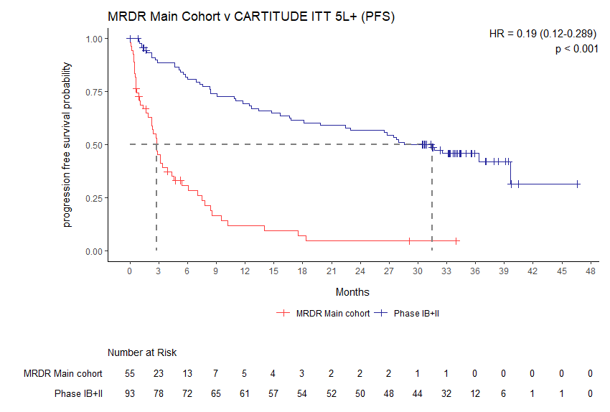
Source: Figure 2-3, Section 2.3.2.1. of the ADAR 1690.1.
Figure 2 Kaplan-Meier curves of OS for the ITT 5L+ population of CARTITUDE-1 vs CE-MRDR main cohort
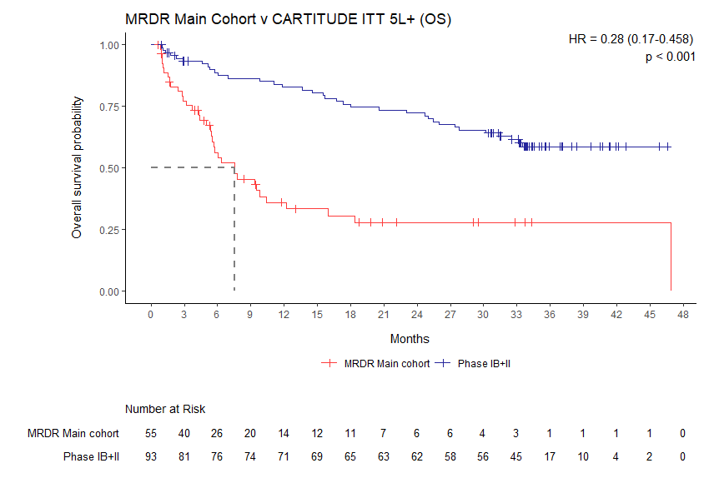
Source: Figure 2-11, Section 2.3.2.2. of the ADAR 1690.1.
Table 2 Supported PfP schedule for cilta-cel
Description | Payment schedule
Cilta-cel unit cost/maximum cost | $||||
Conditional payment 1 at successful infusion | $||||
Conditional payment 2 at 12 months and sCR | $||||
Conditional payment 3 for patients at sCR 12 months and no progressive disease at 24 months | $||||
Conditional payment 4 for patients at sCR 12 months and no progressive disease at 24 and 36 months | $||||
Conditional payment 5 for patients at sCR 12 months and no progressive disease at 24, 36 and 48 months | $||||
Additional Requirements | In order to receive payment at 12, 24, 36 or 48 months:  - the patient must not have died; and  - the patient must not have received treatment with active anti-myeloma therapy post successful infusion with cilta-cel, including non-PBS subsidised therapies or autologous stem cell transplant
Source: Resubmission letter for cilta-cel received 01 March 2024
MSAC noted the applicant revised the financial estimates based on the updated PfP arrangement proposed by them, with an estimated total expenditure of $|||||| |||||| over 5 years (Table 3). MSAC considered the financial estimates were substantial and noted they only accounted for the cost of the cilta-cel. MSAC noted an additional net budget impact to the health system of $2.5million to $9million per year was likely given the ancillary costs associated with providing cilta-cel, and that the estimates were likely underestimated.
Table 3 Overview of patient numbers and budget impact
 |  | Year 1 (of NHRA funding) |  | Year 2 |  | Year 3 | Year 4 |  |  | Year 5 | Years 1 – 5
April 2024 proposal: 5L+ MM population patient numbers
Initiating patients | |||| |  | |||| |  | |||| |  |  | |||| | |||| |  |  | ||||
Infused patients | |||| |  | |||| |  | |||| |  |  | |||| | |||| |  |  | ||||
April 2024 proposal: Maximum budget impact of 5L+ MM population with revised payment for outcome model |||| ||||
Financial estimates | $|||| |  | $|||| |  | $|||| |  |  | $|||| | $|||| |  |  | $||||
Source: Resubmission letter for cilta-cel received 08 March 2024
Abbreviations: 5L = fifth-line; MM = multiple myeloma; NHRA = National Health Reform Agreement
MSAC noted that the Department of Health and Aged Care requested the applicant provide a risk sharing arrangement that sought to address MSAC’s concerns from the November 2023 meeting. MSAC noted the proposal by Janssen-Cilag to limit the number of patients who could receive treatment with cilta-cel in any given funding year, with the patient number limit resetting at the end of each funding year. MSAC noted that if implemented, the proposal would mean that a patient’s eligibility to receive cilta-cel would be influenced by the time of year they were deemed eligible for treatment, meaning that an eligible patient presenting at the beginning of the year had a higher likelihood of receiving the treatment than an eligible patient presenting at the end of the year. MSAC considered it was unacceptable in any circumstance for patients to be denied access to effective treatment as a mechanism for Janssen-Cilag to provide certainty its financial estimates would not be exceeded. At the end of a funding year, the applicant proposed that if the “infused patient number” limit was not reached, these patients could be carried over to the subsequent funding year, should Janssen-Cilag be able to meet the additional supply demand in that timeframe. This further concerned MSAC that Janssen-Cilag could not guarantee adequate supply of cilta-cel for Australian patients.
Janssen-Cilag proposed that the National CAR-T Prioritisation Committee (NPC), which includes a specialist group of physicians working in multi-disciplinary teams delivering CAR-T therapy in approved hospitals, could oversee patient selection for CAR-T cell therapy at the national level, thereby managing the proposed limit on the number of patients treated with cilta-cel per year. MSAC noted feedback provided by the states and territories that Australia does not have a national entity with authority to arbitrate on which patients do or do not receive CAR-T cell therapy, and that the NPC was set up to provide clinical advice and support very early in implementation of CAR-T cell therapies and was not tasked to manage patient caps. MSAC noted that final determination of patient eligibility does not sit with this group, with each state and territory determining this through their own multi-disciplinary teams, and therefore it would be inappropriate for the NPC to now be charged to facilitate or otherwise manage a cap on patient numbers.
MSAC noted that in the case a proposed annual allocation was reached, Janssen-Cilag would be willing to amend the parameters of its current compassionate daratumumab program for RRMM to ensure cilta-cel eligible patients could instead access an additional option that is not available on the PBS and that these patients may also potentially have alternative PBS options available to manage their RRMM until the next funding year starts. MSAC agreed with the state and territory feedback and considered the use of daratumumab in this setting was questionable given all patients deemed eligible to receive cilta-cel would have already received daratumumab, and offering patients alternative therapies if they were eligible to receive cilta-cel and had already exhausted all other treatment options went against good clinical practice.
MSAC considered the proposal put forward by Janssen-Cilag was not a genuine RSA, with the applicant bearing no financial risk if the utilisation estimates were to be exceeded. MSAC considered Janssen-Cilag’s proposal transferred all the risk associated with exceeding their proposed financial estimates to the patients and the health system. MSAC considered that any suggestion to limit the number of eligible patients who could receive treatment with cilta-cel per year was inequitable and unethical. MSAC welcomed Janssen-Cilag’s statement that it was open to further discussion on this matter should MSAC support funding of cilta-cel. MSAC considered that should the patient estimates be exceeded an acceptable RSA would be one where a reduced payment on successful infusion only was paid for each eligible patient treated above the patient estimates in a given funding year.
MSAC noted feedback on the funding proposal was provided by four states and territories. MSAC noted all states and territories except one shared the same concerns as the Committee, particularly that the company had not made a sufficient attempt to address the MSAC’s concerns and that the pricing proposal and limit on patient numbers put forward by the applicant were inadequate and unacceptable.
MSAC considered data collection was mandatory for the public funding of cilta-cel. More broadly, MSAC considered there should be a single national registry that collected standardised sets of data for all cell and gene therapies, independent of the condition. MSAC reiterated its previous advice that there is an urgent and important need for the Commonwealth, jurisdictions and other relevant stakeholders to work together to determine the most appropriate data collection mechanism for highly specialised therapies.

Background
Cilta-cel was considered by the Medical Services Advisory Committee (MSAC) in November 2023 for the treatment of adult patients with RRMM who have received at least 4 prior lines of therapy, including a PI, an IMiD and an anti-CD38 antibody. MSAC deferred its advice in relation to the public funding of cilta-cel to see whether a lower ICER could be achieved through adjusting inputs in the economic model (particularly hospital costs and health benefits gained - to be verified by jurisdictions) and for a significant price reduction to be offered by the company. MSAC advised that an ICER in the range of those for other treatments in later line RRMM recommended by PBAC would be more likely to be acceptable. Furthermore, MSAC requested the Department negotiate a pay-for-performance arrangement to incentivise payment on the performance of the deeper level of clinical response achieved at 12-months after cilta-cel infusion.
Following the MSAC’s decision to defer its advice on the public funding of cilta-cel for 5L+ RRMM at the November 2023 meeting, the applicant re-submitted details of a funding proposal and a RSA.

Prerequisites to implementation of any funding advice
Cilta-cel qualifies as a high-cost, highly specialised therapy as per the NHRA definition (Addendum to the NHRA 2020–2025 (NHRA 2020–2025).

TGA details
Cilta-cel (CARVYKTI®) was included on the Australian Register of Therapeutic Goods (ARTG) on 6 June 2023. Cilta-cel was registered on the ARTG as a Class 4 biological.
The TGA approved indication is: ‘cilta-cel is indicated for the treatment of adult patients with RRMM, who have received at least 3 prior lines of therapy, including a PI, an IMiD, and an anti-CD38 antibody.’

Summary of public consultation input
A summary of previous consultation feedback received for MSAC Application 1690 is available in the Public Summary Document. Please refer to application 1690 Public Summary Document July 2022 (pp10-12). A summary of previous consultation feedback received for MSAC Application 1690.1 considered at the November 2023 meeting is available in the November 2023 1690.1 Public Summary Document (pp.13-15). Please refer to application 1690.1 PSD November 2023 (pp13-15).
Consultation input to this resubmission was received from 2 health professional organisations The organisations that submitted input was:
- Myeloma Australia
- The National CAR T Patient Prioritisation Committee (NPC)
All consultation feedback received was supportive of making this therapy available to patients with refractory or relapsed multiple myeloma (RRMM).

Applicant comments on MSAC’s Public Summary Document
Johnson & Johnson welcomes MSAC’s recommendation to publicly fund CAR T-cell therapy for myeloma patients who have received four prior lines of therapy. Johnson & Johnson will work through the further negotiations with Federal and State Governments which are necessary to navigate the complexities of bringing this highly specialised therapy to Australian patients.

Further information on MSAC
MSAC Terms of Reference and other information are available on the MSAC Website: visit the MSAC website

http://www.msac.gov.au/internet/msac/publishing.nsf/Content/28CCF400501579E3CA2589CD000B2D68/$File/1690.1%20Final%20PSD%20-%20Nov2023%20(redacted).pdf
https://www.tga.gov.au/resources/artg/410143
http://www.msac.gov.au/internet/msac/publishing.nsf/Content/62970FEB7C513544CA25874F008251EB/$File/1690%20Final%20PSD_Jul2022%20-%20Redacted_Final.pdf
http://www.msac.gov.au/internet/msac/publishing.nsf/Content/28CCF400501579E3CA2589CD000B2D68/$File/1690.1%20Final%20PSD%20-%20Nov2023%20(redacted).pdf

