Population
Describe the population in which the proposed health technology is intended to be used:

Patients with confirmed relapsed/refractory large B-cell lymphoma (LBCL)

Specify any characteristics of patients with the medical condition, or suspected of, who are proposed to be eligible for the proposed health technology, describing how a patient would be investigated, managed and referred within the Australian health care system in the lead up to being considered eligible for the technology:

There are no updates from the initial Application 1722.
It is proposed that the current availability of axicabtagene ciloleucel, which permits use of axicabtagene ciloleucel as a third-line agent, be modified to also permit use of axicabtagene ciloleucel in the second-line setting, as follows:
Patients with confirmed relapsed or refractory large B-cell lymphoma (LBCL). Patients are required to have evidence of progressing disease despite treatment with at least one prior systemic therapy.
The population for whom reimbursement of axicabtagene ciloleucel is proposed is intended to be consistent with the eligibility criteria that were applied in recruiting patients to the ZUMA-7 pivotal trial.
Patients treated for LBCL will be in the care of an expert haematologist or haematologist-oncologist who will monitor patients following first-line chemoimmunotherapy for response and maintenance of a disease-free state. Should a patient be refractory to or relapse after first-line treatment, the specialist will be able to refer the patient to a qualified treatment centre that is qualified to deliver treatment with axicabtagene ciloleucel.

Provide a rationale for the specifics of the eligible population:

Consistency with the eligibility criteria of the trial population (ZUMA-7)
Intervention
Name of the proposed health technology:

Axicabtagene ciloleucel

Describe the key components and clinical steps involved in delivering the proposed health technology:

Axicabtagene ciloleucel is a CAR T-cell product produced using a patient’s own T-cells, making the product unique to each patient. A patient’s T-cells are collected via a process called leukapheresis. The T-cells are genetically modified in a lab to express an anti-CD19 chimeric antigen receptor (CAR) which targets the lymphoma B-cells. Following modification and subsequent proliferation, the T-cells are infused back into the patient where they target and kill the lymphoma B-cells.
The manufacturing and treatment process are described in greater detail below.
Step 1: Leukapheresis
Leukocytes (white blood cells) are collected from the patient at their clinical centre. This is done by leukapheresis, whereby whole blood is withdrawn from the patient, leukocytes are extracted and then the remainder of the blood is transfused back into the patient. The collected white blood cells are then transported immediately to the axicabtagene ciloleucel manufacturing facility.
Step 2: Procurement of axicabtagene ciloleucel
The manufacturing process is undertaken in an off-shore facility in Redacted. The manufacturing process involves isolation and activation of T-cells, genetic modification of T-cells to encode the CAR gene, and growth and expansion of engineered T-cells. The final product is washed, cryopreserved, and tested for identity, potency, and sterility. After meeting acceptance criteria, the product is transported back to the patient’s qualified delivery centre in Australia using a validated cryo-shipper.
Step 3: Bridging therapy (if necessary)
Patients are monitored while the production of CAR T-cells is in progress. If necessary, patients may receive bridging therapy with corticosteroids (typically dexamethasone) to ensure the patient remains viable for infusion of axicabtagene ciloleucel.
Step 3: Lymphodepleting chemotherapy
Prior to infusion, patients are treated with low-dose lymphodepleting chemotherapy to eliminate the patient’s lymphocytes and allow space for the T-cells to expand. Lymphodepleting chemotherapy consists of fludarabine (30 mg/m2/day) plus cyclophosphamide (500 mg/m2/day) for three days (on the fifth, fourth, and third day before the infusion of axicabtagene ciloleucel on Day 0).
Step 4: Treatment infusion
Axicabtagene ciloleucel is a single infusion product. Each bag for intravenous (IV) infusion contains a suspension of a patient’s own genetically modified anti-CD19 CAR T-cells. Following infusion, patients require daily monitoring for at least 7 days to monitor for signs and symptoms of CRS or neurologic events.
Identify how the proposed technology achieves the intended patient outcomes:

The evidentiary basis for achieving the intended patient outcomes is demonstrated in the ZUMA-7 trial.

Does the proposed health technology include a registered trademark component with characteristics that distinguishes it from other similar health components?
Yes

Explain whether it is essential to have this trademark component or whether there would be other components that would be suitable:

Provide a response if you answered 'Yes' to the question above

Are there any proposed limitations on the provision of the proposed health technology delivered to the patient (For example: accessibility, dosage, quantity, duration or in frequency):
Yes

Provide details and explain:

Axicabtagene cilocleucel infusion can only be provided in public hospitals qualified as a treatment centre

If applicable, advise which health professionals will be needed to provide the proposed health technology:

Expert haematologist or haematologist-oncologist

If applicable, advise whether delivery of the proposed health technology can be delegated to another health professional:

If applicable, provide a description of any related health professionals here

If applicable, advise if there are any limitations on which health professionals might provide a referral for the proposed health technology:

Expert haematologist or haematologist-oncologist

Is there specific training or qualifications required to provide or deliver the proposed service, and/or any accreditation requirements to support delivery of the health technology?
Yes

Provide details and explain:
Each treatment centre needs to be trained and qualified

Indicate the proposed setting(s) in which the proposed health technology will be delivered: (select all relevant settings)

Consulting rooms
Day surgery centre
Emergency Department
Inpatient private hospital
Inpatient public hospital
Laboratory
Outpatient clinic
Patient’s home
Point of care testing
Residential aged care facility
Other (please specify)

Specify further details here

Is the proposed health technology intended to be entirely rendered inside Australia?
Yes

Please provide additional details on the proposed health technology to be rendered outside of Australia:

Provide a response if you answered 'No' to the question above

Comparator
Nominate the appropriate comparator(s) for the proposed medical service (i.e. how is the proposed population currently managed in the absence of the proposed medical service being available in the Australian health care system). This includes identifying health care resources that are needed to be delivered at the same time as the comparator service:
(please copy the below questions and complete for each comparator)

Please provide a name for your comparator:

Standard of care

Please provide an identifying number for your comparator (if applicable):

Specify the identifying number here
Please provide a rationale for why this is a comparator:

At the March 2023 meeting, the MSAC noted that the comparator outlined by the ADAR appears to be appropriate.

Pattern of substitution – Will the proposed health technology wholly replace the proposed comparator, partially replace the proposed comparator, displace the proposed comparator or be used in combination with the proposed comparator? (please select your response)

None – used with the comparator
Displaced – comparator will likely be used following the proposed technology in some patients
Partial – in some cases, the proposed technology will replace the use of the comparator, but not in all cases
Full – subjects who receive the proposed intervention will not receive the comparator

Please outline and explain the extent to which the current comparator is expected to be substituted:

Provide your response here
Outcomes

(Please copy the below questions and complete for each outcome)

List the key health outcomes (major and minor – prioritising major key health outcomes first) that will need to be measured in assessing the clinical claim for the proposed medical service/technology (versus the comparator):

Health benefits
Health harms
Resources

Outcome description – please include information about whether a change in patient management, or prognosis, occurs as a result of the test information:

Provide your response here
Claims
In terms of health outcomes (comparative benefits and harms), is the proposed technology claimed to be superior, non-inferior or inferior to the comparator(s)? (please select your response)
Superior
Non-inferior
Inferior

Please state what the overall claim is, and provide a rationale:

Axicabtagene cilocleucel is clinically superior to standard of care in the proposed patient population

Why would the requestor seek to use the proposed investigative technology rather than the comparator(s)?

Axicabtagene cilocleucel is not an investigative technology

Identify how the proposed technology achieves the intended patient outcomes:

The evidentiary basis for achieving the intended patient outcomes is demonstrated in the ZUMA-7 trial. This question is a duplicate and was posed earlier.

For some people, compared with the comparator(s), does the test information result in: Axicabtagene cilocleucel does not provide any test information

A change in clinical management? Yes No

A change in health outcome? Yes No

Other benefits? Yes No

Please provide a rationale, and information on other benefits if relevant:

Provide your response here

In terms of the immediate costs of the proposed technology (and immediate cost consequences, such as procedural costs, testing costs etc.), is the proposed technology claimed to be more costly, the same cost or less costly than the comparator? (please select your response)
More costly
Same cost
Less costly
Provide a brief rationale for the claim:

Provide your response here

Summary of Evidence
Provide one or more recent (published) high quality clinical studies that support use of the proposed health service/technology.
Identify yet-to-be-published research that may have results available in the near future (that could be relevant to your application).
Do not attach full text articles; this is just a summary (repeat columns as required)
 | Type of study design* | Title of journal article or research project (including any trial identifier or study lead if relevant) | Short description of research (max 50 words)** | Website link to journal article or research (if available) | Date of publication***
1. | Phase 3, randomised, open-label, multicentre study | ZUMA-7 trial  NCT03391466  Westin et al. Survival with axicabtagene cilocleucel in large B-cell lymphoma. N Engl J Med. 2023.  DOI: 10.1056/NEJMoa2301665  Locke et al. Axicabtagene Ciloleucel as Second-Line Therapy for Large B-Cell Lymphoma. N Engl J Med. 2022;386(7):640-654. DOI: 10.1056/NEJMoa2116133 | Evaluation of the comparative efficacy and safety of axicabtagene ciloleucel (N=180) versus standard of care# (N=179) in patients with LBCL that were refractory to or had relapsed within 12 months following frontline chemotherapy treatment.  Over a median follow up of 25 months, compared to SoC, axicabtagene ciloleucel resulted in a significant improvement in event-free survival (8.3 months versus 2.0 months). The response rate was 83% in axicabtagene ciloleucel-treated patients and 50% in the standard-care group. The safety profile of axicabtagene ciloleucel was consistent with previous experience (Locke et al 2022).  The result of the prespecified overall survival analysis at 5 years demonstrated superiority of axicabtagene cilocleucel over standard of care with 4-year OS of 54.6% vs. 46.0% with HR=0.73 (95% CI: 0.38-0.67) (Westin et al 2023). | https://www.nejm.org/doi/full/10.1056/NEJMoa2301665 [Last accessed: 19 July 2023]  https://www.nejm.org/doi/full/10.1056/NEJMoa2116133 [Last accessed: 28 Feb 2022] | July 13, 2023  February 17, 2022
* Categorise study design, for example meta-analysis, randomised trials, non-randomised trial or observational study, study of diagnostic accuracy, etc.
**Provide high level information including population numbers and whether patients are being recruited or in post-recruitment, including providing the trial registration number to allow for tracking purposes. For yet to be published research, provide high level information including population numbers and whether patients are being recruited or in post-recruitment.
*** If the publication is a follow-up to an initial publication, please advise. For yet to be published research, include the date of when results will be made available (to the best of your knowledge).
Algorithms
Preparation for using the health technology
Define and summarise the clinical management algorithm, including any required tests or healthcare resources, before patients would be eligible for the proposed health technology:

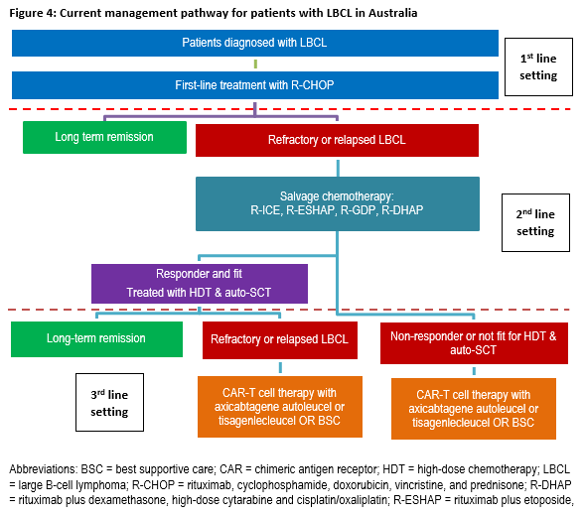

Is there any expectation that the clinical management algorithm before the health technology is used will change due to the introduction of the proposed health technology?
Yes
Describe and explain any differences in the clinical management algorithm prior to the use of the proposed health technology vs. the comparator health technology:

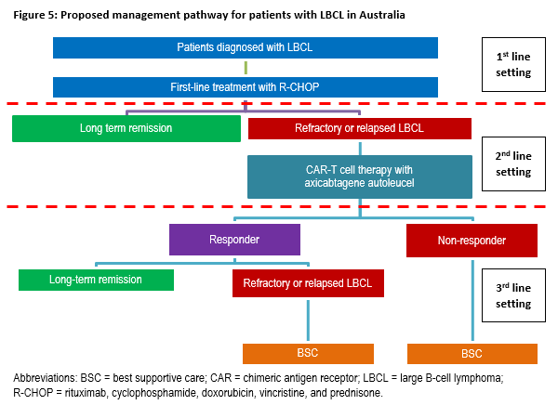
Use of the health technology

Explain what other healthcare resources are used in conjunction with delivering the proposed health technology:

Bridging therapy may be administered to some patients in the period between the collection of cells and the infusion of axicabtagene ciloleucel. Bridging therapy may be required in patients who have a high disease burden to ensure that the patient remains viable to have axicabtagene ciloleucel infused. The most commonly administered bridging therapy in the key study was dexamethasone, which is PBS-listed as an unrestricted benefit.
A 3-day lymphodepleting chemotherapy regimen, consisting of fludarabine 30 mg/m2/day and cyclophosphamide 500 mg/m2/day is administered on the 5th, 4th, and 3rd days (followed by 2 rest days) before axicabtagene ciloleucel infusion. Both chemotherapy drugs are listed on the PBS as unrestricted benefits.
Paracetamol 500 -1000 mg and diphenhydramine 12.5 mg should be administered approximately one hour prior to infusion with axicabtagene ciloleucel.
Axicabtagene ciloleucel is administered by IV infusion in an inpatient hospital setting, under the supervision of a haematologist or haematologist-oncologist.
Some patients may require administration of treatments following infusion of axicabtagene ciloleucel as supportive care and for management of adverse events (e.g., blood products, antiemetics, tocilizumab).

Explain what other healthcare resources are used in conjunction with the comparator health technology:

Provide your response here

Describe and explain any differences in the healthcare resources used in conjunction with the proposed health technology vs. the comparator health technology:

Provide your response here
Clinical management after the use of health technology

Define and summarise the clinical management algorithm, including any required tests or healthcare resources, after the use of the proposed health technology:

Provide your response here

Define and summarise the clinical management algorithm, including any required tests or healthcare resources, after the use of the comparator health technology:

Provide your response here

Describe and explain any differences in the healthcare resources used after the proposed health technology vs. the comparator health technology:

Provide your response here

Algorithms
Insert diagrams demonstrating the clinical management algorithm with and without the proposed health technology:

Note: Please ensure that the diagrams provided do not contain information under copyright.

