MSAC Application 1761

Faecal calprotectin for the monitoring of disease activity in patients with IBD

Population
Describe the population in which the proposed health technology is intended to be used:

This application is for the use of FC in monitoring of disease activity in patients with known inflammatory bowel disease (IBD) managed by a gastroenterologist.

IBD refers to a group of chronic inflammatory conditions of the gastrointestinal tract, primarily consisting of Crohn's disease (CD) and ulcerative colitis (UC). Crohn's disease can affect any part of the digestive tract, from the mouth to the anus, and involves transmural inflammation with a patchy distribution. Ulcerative colitis primarily affects the colon and rectum, featuring continuous mucosal inflammation starting from the rectum and extending proximally. They are characterised by an influx of inflammatory cells into the gut wall, resulting in various clinical manifestations including abdominal pain, diarrhoea, rectal bleeding, fatigue and weight loss.

The few epidemiologic studies from Australia show high incidence and prevalence of IBD, and it is estimated that approximately 100,000 Australians are living with IBD (1). While methodology differs across the studies, Australia has amongst the highest reported incidence of IBD worldwide, up to 24.7-32.4 cases per 100,000 people (2). IBD generally occurs with similar frequency in men and women with peak onset of incidence in the second and third decades (3). Although the aetiology of IBD is incompletely understood, it is thought to result from an aberrant immune response to environmental triggers in genetically susceptible individuals (4)

IBD is characterized by periods of active disease interspersed with periods of remission. The disease course varies among individuals and is unpredictable, with some experiencing a more indolent course, while others may have frequent relapses. Gut inflammation over time leads to poor outcomes with complications such as structural damage, strictures, fistulas, and an increased risk of colorectal cancer.

Patients with IBD have an overall similar or slightly increased mortality risk (5,6). Advancements in medical therapies and multidisciplinary care have led to improved outcomes and reduced mortality rates in recent years (6). Subgroups of patients such as males over 40 years of age and those with colonic disease may have a higher mortality rate(6,7). There is also emerging data indicating higher risk of death in elderly patients with IBD, with cardiovascular disease and serious infection major contributors (8,9).

IBD exerts a substantial burden on patients' quality of life. The unpredictable disease course, chronic symptoms, and frequent healthcare interactions impact physical, psychological, and social well-being (10). Fatigue, pain, and impaired functional capacity contribute to limitations in daily activities and work productivity. IBD-related complications, such as strictures and fistulas, can result in hospitalizations, surgeries, and a need for long-term medical management. The disease also places a significant psychological burden on patients, with higher rates of anxiety, depression, and impaired body image (11).

In addition to impacts on patients and their families, IBD imposes a substantial economic burden on the Australian healthcare system. In 2012, direct costs from hospitalizations were estimated to be over $100 million(1). Productivity losses attributable to IBD were estimated at $380 million and additional financial and economic costs estimated at over $2.7 billion.

This application directly supports the findings of the Australian Government’s Inflammatory Bowel Disease National Action Plan 2019 (12) which documented the most important short to medium term actions that will impact the improvement of quality of care for people living with IBD in Australia. Priority area 7 promotes the use of faecal calprotectin which “in the IBD clinical management setting…can assist in monitoring relapse and response of current treatment type and as a surrogate marker of mucosal healing or post-operative recurrence” (Page 20).

Specify any characteristics of patients with the medical condition, or suspected of, who are proposed to be eligible for the proposed health technology, describing how a patient would be investigated, managed and referred within the Australian health care system in the lead up to being considered eligible for the technology:

This application is for patients who are being managed by a gastroenterologist with an established diagnosis of IBD.

Diagnosis of IBD
There is no one test that can reliably diagnose all cases of IBD, and many people require a number of investigations (or testing on more than one occasion). Patients presenting to primary care with symptoms and/or investigations consistent with IBD are eligible for MBS funded FC test for the purposes of diagnosis (items 66522/3) to help distinguish between IBD and functional gut disorders, and to determine which patients should be referred to a specialist (gastroenterologist) for further investigations. The diagnosis of IBD is made by a gastroenterologist based on a combination of clinical, endoscopic, histopathological, imaging and laboratory findings.

At the specialist stage of diagnosis, colonoscopy with histology and radiology are used to establish the diagnosis and to assess its severity and extent. Colonoscopy with ileoscopy with multiple biopsy specimens is well established as the first line procedure to establish the diagnosis and extent of disease (13,14). Colonoscopy allows for visualisation of the lining of the entire large intestine and the terminal ileum, examining for ulcers, inflammation, bleeding and stenoses. Multiple biopsies are taken from the colon and terminal ileum, and IBD has well established histopathological findings (15). Upper gastrointestinal endoscopy may also be performed in patients with upper gastrointestinal symptoms (e.g. nausea, vomiting, epigastric pain). Where detailed cross-sectional anatomy needs to be defined, magnetic resonance imaging (MRI) is preferred, but in patients with diagnosed IBD, it is only currently rebated on the Medicare Benefits Schedule (MBS) for small bowel Crohn’s disease and to assess fistulising perianal disease (MBS items 63740/43).

After the diagnosis and severity is established, IBD management involves initiation of a treatment plan by the gastroenterologist and a program of regular follow up. This application only applies at this stage in the investigation/referral/management algorithm.

Provide a rationale for the specifics of the eligible population:

IBD is a chronic, complex condition that is managed by specialist gastroenterologists who are best placed to make decisions on when to order a faecal calprotectin and accurately interpret the result. We anticipate that the restriction of the eligible population to those with a previous diagnosis of IBD, and ordering of the test only by specialist gastroenterologists will result in minimal ‘leakage’ of the test being used inappropriately or unnecessarily. Australian gastroenterologists are strongly supportive of the use of faecal calprotectin for this indication, and would be more likely to use the test in clinical practice if it was MBS listed (16).

Are there any prerequisite tests?
No
(apart from the diagnostic tests as outlined under heading “Diagnosis of IBD” above).

Are the prerequisite tests MBS funded?
N/A

Please provide details to fund the prerequisite tests:

N/A

Intervention
Name of the proposed health technology:

Quantitative enzyme-linked immunosorbent assay (ELISA) of faecal calprotectin (hereafter referred to as FC) is a quantitative determination of a protein biomarker in the stool that reliably correlates with both clinical and endoscopic disease activity in IBD. Calprotectin is found in the cytosol of human neutrophils and raised levels of calprotectin in the stool (FC) reflects the migration of neutrophils into the gut lumen during active intestinal inflammation. As our previously successful application item number 66522/3 highlights, FC provides a non-invasive, accurate and inexpensive (~$80) method to assess for intestinal inflammation in IBD.

High FC levels indicate active inflammation, allowing for timely adjustments in treatment leading to improved disease management, cessation of ineffective therapies and better outcomes in IBD care including avoidance of irreversible bowel damage, surgery, hospitalisations and morbidity. A low FC is reliable in suggesting no disease activity in IBD, allowing clinicians to avoid unnecessary invasive and expensive investigations such as colonoscopy in many patients.

Describe the key components and clinical steps involved in delivering the proposed health technology:

A patient with an existing diagnosis of IBD would be reviewed by a gastroenterologist. Note that the existing MBS item numbers for use of faecal calprotectin test (66522 and 66523) are used prior to this clinical pathway (i.e. at the diagnostic stage). If the gastroenterologist determines that a FC for assessment of disease activity is warranted for the patient, a pathology request would be completed. The patient would submit a faecal sample to a local pathology service who will perform quantitative enzyme-linked immunosorbent assay (ELISA) of faecal calprotectin. These results would be available to the referring gastroenterologist who would then make decisions on management.

Identify how the proposed technology achieves the intended patient outcomes:

A primary goal of IBD management is to alleviate both symptoms and objective inflammation to reduce avoidable complications such as colorectal cancer, fistula, strictures which may require surgery and lead to further morbidity. Management includes treatment of inflammation (e.g. with medications and/or surgery), monitoring for adverse drug reactions, education and counselling, psychological and dietary support, vaccination, bone health assessment and management and screening/surveillance for cancer.

Tight control of inflammation in IBD improves outcomes
Tight control of IBD related inflammation (“disease activity”) is well established as the best practice management paradigm to optimise outcomes, improve the long-term prognosis of patients with IBD and avoid complications and hospitalisations. The STRIDE (Selecting Therapeutic Targets in Inflammatory Bowel Disease)-II guidelines by the International Organization for the Study of Inflammatory Bowel Diseases provide evidence-based recommendations for achieving and maintaining tight control in IBD management and have been adopted by major Australian and international gastrointestinal societies (17). These guidelines emphasize the importance of “treating to target”, which involves setting specific treatment goals and regularly assessing disease activity to ensure those goals are met. The guidelines highlight the use of objective measures, such as clinical indices, biomarkers (including faecal calprotectin), and endoscopic evaluation, to monitor disease activity. Frequent and regular assessment allows for early detection of inflammation and prompt adjustment of treatment to achieve mucosal healing and symptom control.

The clinical course of IBD is chronic, remitting and relapsing which means regular monitoring of disease activity is important. Mucosal healing (lack of activity on endoscopy) has been shown to improve outcomes and reduce flares, complications and surgeries (18–21). Lengthy waiting lists for colonoscopy(22) and the invasive/expensive nature of this investigation means that close monitoring of disease activity purely through this method is not feasible. Moreover, colonoscopy is not only expensive but invasive and requires bowel preparation and time away from work for patients, alongside a small but real risk of complication such as intestinal perforation. This has led to the search for surrogate markers of mucosal disease activity (and healing) that allow for the tight control of inflammation.

Although symptomatic relief is one of the primary goals of treatment in IBD, there is a poor correlation between clinical symptoms alone and mucosal inflammatory burden (23,24). Without the use of adjunct biomarkers such as faecal calprotectin, this may lead to undesirable outcomes:
- Unnecessary intensification of medical therapy (with associated risk of adverse effects and costs) given functional gut disorders (such as irritable bowel syndrome) with symptoms that can mimic those seen in IBD are common in patients with IBD. Between 20% and 44% of patients with controlled IBD have symptoms such as bloating, abdominal pain and diarrhoea consistent with irritable bowel syndrome (25,26).
- Delay in the identification of undetected mucosal inflammation which is present in a large proportion of patients with no symptoms (27). This may lead to adverse outcomes such as hospitalisation, resectional surgery and cancer as outlined above. The multicentre, randomised, controlled phase 3 CALM trial demonstrated that a treatment strategy based on symptoms alone was inferior to combining symptoms with biomarkers of disease activity (CRP and FC) (28).
For these reasons, using symptoms alone to guide management in IBD is inadequate and investigations are necessary adjuncts at routine clinical review.

Faecal calprotectin is the best tool for frequent assessment of disease activity in IBD
FC has emerged as the best tool to allow for close IBD monitoring and assessment as it is non-invasive, safe, cheap, acceptable to patients and correlates highly with endoscopic and histological activity (29–33). Recent meta-analyses demonstrate a high specificity and sensitivity to detect mucosal healing and disease activity in IBD (34–37). Normalisation of FC has also been shown to be associated with reduced risk of disease progression (38). Furthermore, there is a large body of data supporting the utility of faecal calprotectin in predicting relapse (39,40), to assist in de-escalation of therapy (41–43), and monitoring for post-operative recurrence(44). Australian gastroenterologists endorse the use of FC to assess for mucosal healing and disease activity in IBD and to help avoid unnecessary colonoscopies (16), and use of FC for monitoring has been incorporated into NPS MedicineWise guidelines produced with funding by the Australian Government Department of Health and incorporated into national gastroenterology society guidelines (45).

Normalisation of FC has been incorporated into the STRIDE-II guidelines as an intermediate target (Figure 1). By implementing a tight control approach in IBD management, the STRIDE-II guidelines aim to achieve sustained remission, prevent disease progression, reduce hospitalizations, minimize the need for surgeries, and improve patients' overall well-being. Tight control not only focuses on symptom management but also targets mucosal healing and long-term disease control, with the ultimate goal of improving patients' quality of life and minimizing the impact of IBD on daily activities.

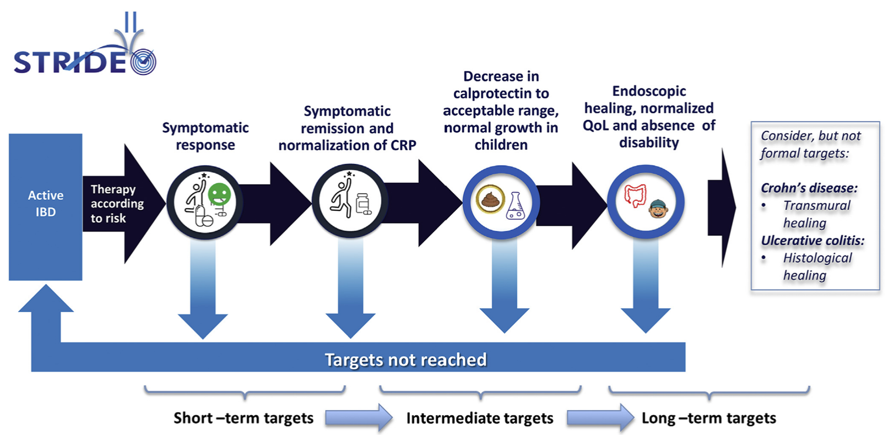
Figure 1: STRIDE-II guidelines (17) by the International Organization for the Study of Inflammatory Bowel Diseases.

Does the proposed health technology include a registered trademark component with characteristics that distinguishes it from other similar health components?
No

Explain whether it is essential to have this trademark component or whether there would be other components that would be suitable:

N/A

Are there any proposed limitations on the provision of the proposed health technology delivered to the patient (For example: accessibility, dosage, quantity, duration or frequency):
Yes

Provide details and explain:

Limit to a maximum of four times (n=4) per year. This is consistent with national and international guidelines (17,45)for monitoring of IBD disease activity as outlined above, and would enable closer monitoring of select patients when clinically appropriate (e.g. active disease, recent change of therapy, recent surgery, reassessment after high result).

If applicable, advise which health professionals will be needed to provide the proposed health technology:

- FC test to be ordered by gastroenterology specialists.
- FC test to be performed by pathologists.

If applicable, advise whether delivery of the proposed health technology can be delegated to another health professional:

N/A

If applicable, advise if there are any limitations on which health professionals might provide a referral for the proposed health technology:

Restricted to ordering by specialist gastroenterologists. IBD is a chronic, complex condition that is managed by specialist gastroenterologists who are best placed to make decisions on when to order a FC and interpret the result. We anticipate that this restriction will result in minimal ‘leakage’ of the test being used inappropriately or unnecessarily. Australian gastroenterologists are strongly supportive of the use of FC for this indication, and are more likely to use the test in clinical practice if it was MBS listed (16).

Is there specific training or qualifications required to provide or deliver the proposed service, and/or any accreditation requirements to support delivery of the health technology?
Yes

Provide details and explain:

A pathologist in an accredited laboratory will perform the analysis of the test, based on a pathology request from a gastroenterology specialists.
Indicate the proposed setting(s) in which the proposed health technology will be delivered: (select all relevant settings)

Consulting rooms
Day surgery centre
Emergency Department
Inpatient private hospital
Inpatient public hospital
Laboratory
Outpatient clinic
Patient’s home
Point of care testing
Residential aged care facility
Other (please specify)

The test will be ordered from consulting rooms & outpatient clinics and the analysis of the test performed in a laboratory.

Is the proposed health technology intended to be entirely rendered inside Australia?
Yes

Please provide additional details on the proposed health technology to be rendered outside of Australia:

N/A

Comparator
Nominate the appropriate comparator(s) for the proposed medical service (i.e. how is the proposed population currently managed in the absence of the proposed medical service being available in the Australian health care system). This includes identifying health care resources that are needed to be delivered at the same time as the comparator service:

The comparator is colonoscopy and biopsy.
The indications and contraindications for both the proposed medical service and the main comparator (colonoscopy and biopsy) are the same. The adverse events that are to be included in the economic evaluation are perforations and bleeding (rate ~1:1000), and anaesthetic risk. Perforations, bleeding and anaesthetic risk occur in colonoscopy. There are no identifiable adverse events occurring from the proposed medical service (FC) itself.

Other healthcare resources that need to be delivered at the same time as the comparator include anaesthetic staff (anaesthetist, anaesthetic nurse) and endoscopy nursing staff as well as use of an appropriately fitted hospital or day centre endoscopy room, recovery area and use of endoscopic equipment (including preparing and cleaning). It should also be considered that patients are required to take time off work for a colonoscopy (~36 hours minimum time, usually 2 working days), hence increasing patient costs.

List any existing MBS item numbers that are relevant for the nominated comparators:
Colonoscopy/endoscopy (MBS item number 32222[h]), biopsy (histopathology: MBS item numbers 72823, 72824) and anaesthetic services relating to colonoscopy (MBS items 20810, 17610 and 23025):
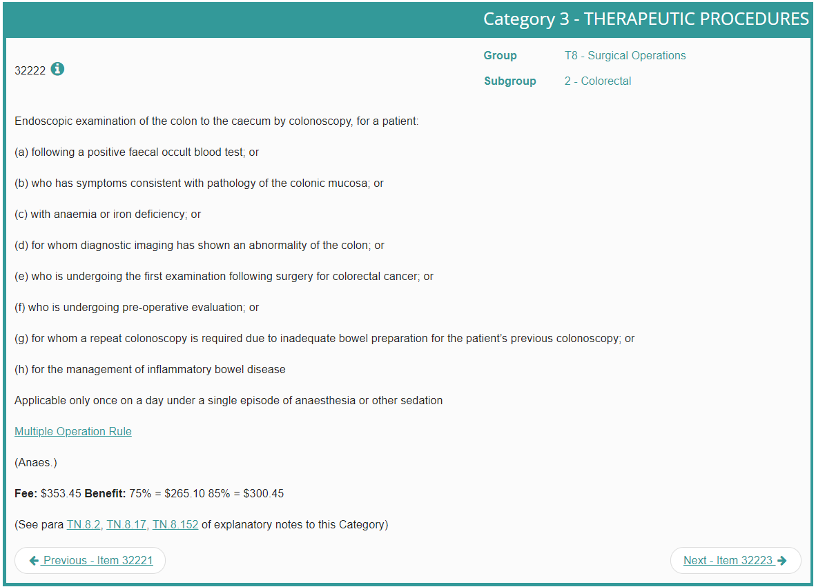
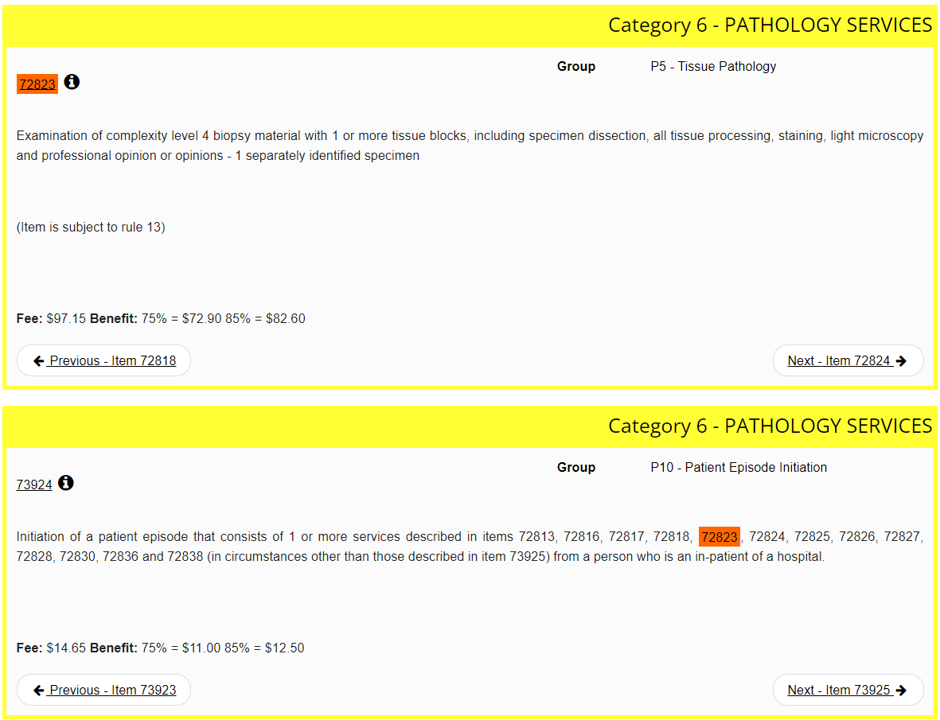
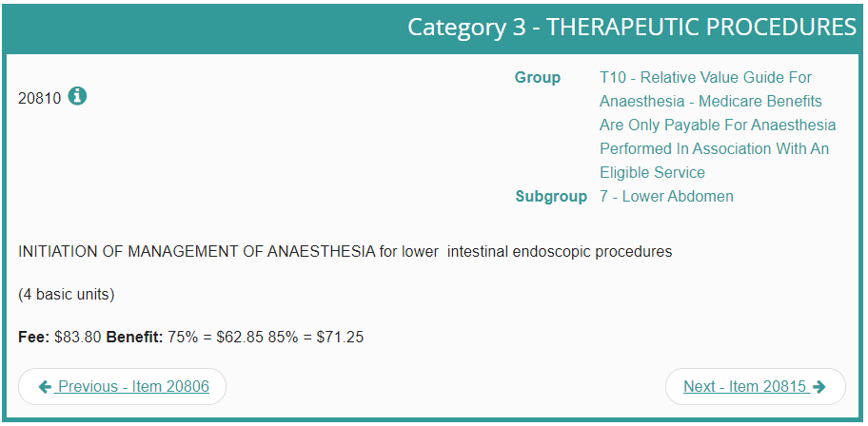
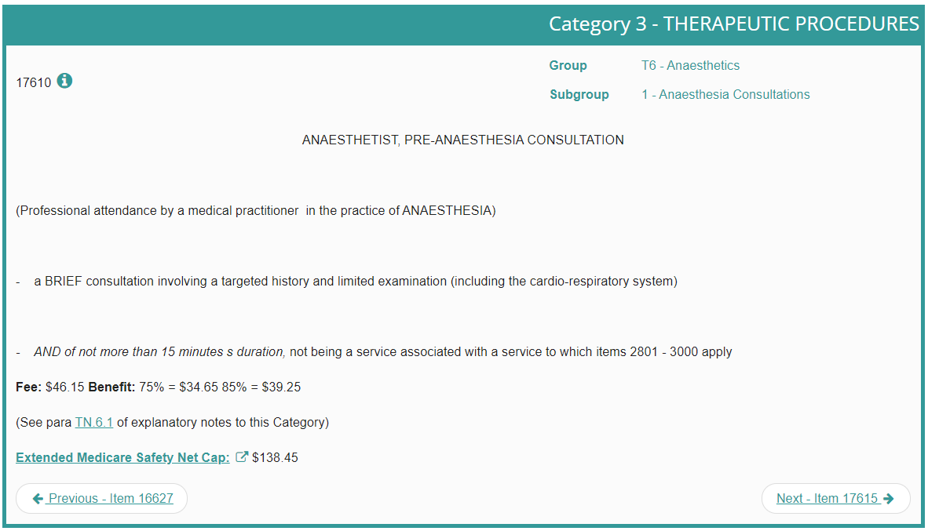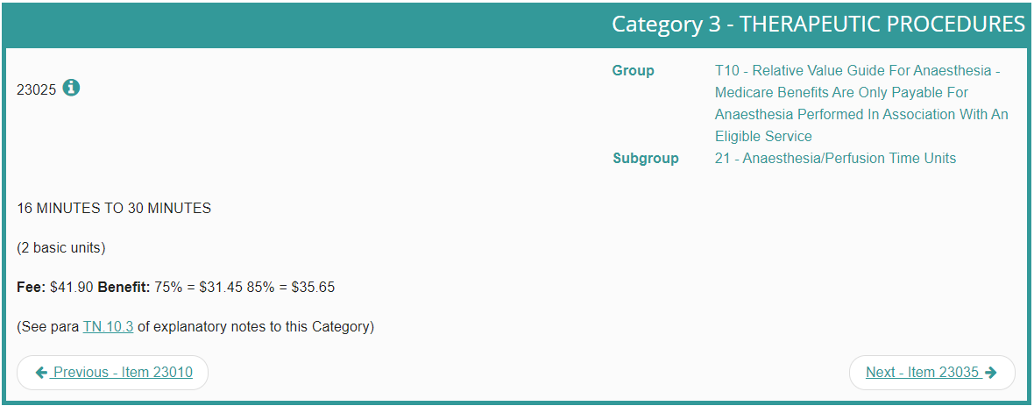

Please provide a rationale for why this is a comparator:

For patients previously diagnosed with IBD seeing a gastroenterologist for ongoing management, the gold standard for assessment of disease activity is colonoscopy and biopsy. In addition to colonoscopy/biopsy, CRP is another test used for assessing disease activity that could be considered as comparator. However this test alone performs poorly in assessing for endoscopic activity and will generally be performed in conjunction with a FC test. CRP may still be normal in an unacceptably high number of Crohn’s disease patients with clinically active Crohn’s disease (up to 30%) and in most patients with UC, particularly when disease is mild (46,47). Elevated CRP has a high specificity but poor specificity for detection of endoscopic activity in both Crohn’s and UC (34). As such we recommend colonoscopy and biopsy as the primary comparators.

Pattern of substitution – Will the proposed health technology wholly replace the proposed comparator, partially replace the proposed comparator, displace the proposed comparator or be used in combination with the proposed comparator? (please select your response)

None – used with the comparator
Displaced – comparator will likely be used following the proposed technology in some patients
Partial – in some cases, the proposed technology will replace the use of the comparator, but not in all cases
Full – subjects who receive the proposed intervention will not receive the comparator

Please outline and explain the extent to which the current comparator is expected to be substituted:

As the initial test to assess for disease activity in IBD, it is anticipated that the majority of colonoscopies (comparator) will be substituted by FC. An Australian real-world study found colonoscopies for (re)assessment of disease activity over a five-year time frame after introduction of free FC testing dropped from 450 to 196 compared to the previous five years (56.4% drop) (48). The figure of 196 includes colonoscopies which were performed subsequent to initial faecal calprotectin (for example, if the FC value was intermediate) so the substitution figure is likely to be higher for the initial test to assess for disease activity. Australian gastroenterologists are strongly supportive of the use of FC for this indication, and would be more likely to use the test in clinical practice if it was MBS listed (16).

Outcomes

(Please copy the below questions and complete for each outcome)

List the key health outcomes (major and minor – prioritising major key health outcomes first) that will need to be measured in assessing the clinical claim for the proposed medical service/technology (versus the comparator): (please select your response)

Health benefits
Health harms
Resources
Value of knowing

Outcome description – please include information about whether a change in patient management, or prognosis, occurs as a result of the test information:

A FC result in a patient with IBD offers gastroenterologists important information on disease activity allowing for timely adjustment to therapy (escalation, continuation or de-escalation). In addition, it can provide valuable insights into prognosis. Figure 2 highlights the potential changes in management based on FC.

Recent meta-analyses demonstrate a high specificity and sensitivity to detect mucosal healing and disease activity in IBD (34–37). Normalisation of FC has also been shown to be associated with reduced risk of disease progression (38). Furthermore, there is a large body of data supporting the utility of FC in predicting relapse (39,40), to assist in de-escalation of therapy (41–43), and monitoring for post-operative recurrence (44)..

Proposed MBS items
How is the technology/service funded at present? (for example: research funding; State-based funding; self-funded by patients; no funding or payments):
Self-funded by patients.

Please provide at least one proposed item with their descriptor and associated costs, for each population/Intervention: (please copy the below questions and complete for each proposed item)

Proposed item details

MBS item number (where used as a template for the proposed item) | Specify MBS item number here
Category number | 6
Category description | Pathology Services
Proposed item descriptor | Faecal Calprotectin test for assessment of disease activity if all the following apply:  - the patient has diagnosed inflammatory bowel disease;  - the service is requested by a specialist or consultant physician practising as a specialist gastroenterologist;
Proposed MBS fee | $68 (85% of the total cost per test of $80)
Indicate the overall cost per patient of providing the proposed health technology | $80 * 1.08 tests per year = $86.4 (please see Appendix 1 at the end of this document for methods)
Please specify any anticipated out of pocket expenses | $0
Provide any further details and explain | Maximum of 4 tests per year

Algorithms
Preparation for using the health technology
Define and summarise the clinical management algorithm, including any required tests or healthcare resources, before patients would be eligible for the proposed health technology:

Prior to patients being eligible for the proposed health technology, the patient must have been diagnosed with IBD.

Patients presenting to primary care with symptoms and/or investigations consistent with IBD are eligible for MBS funded FC test for the purposes of diagnosis (items 66522/3) to help distinguish between IBD and functional gut disorders, and to determine which patients should be referred to a specialist (gastroenterologist) for further investigations. The diagnosis of IBD is made by a gastroenterologist based on a combination of clinical, endoscopic, histopathological, imaging and laboratory findings.

At the specialist stage of diagnosis, colonoscopy with histology and radiology are used to establish the diagnosis and to assess its severity and extent. Colonoscopy with ileoscopy with multiple biopsy specimens is well established as the first line procedure to establish the diagnosis and extent of disease (13,14). Colonoscopy allows for visualisation of the lining of the entire large intestine and the terminal ileum, examining for ulcers, inflammation, bleeding and stenoses. Multiple biopsies are taken from the colon and terminal ileum, and IBD has well established histopathological findings (15). Upper gastrointestinal endoscopy may also be performed in patients with upper gastrointestinal symptoms (e.g. nausea, vomiting, epigastric pain). Where detailed cross-sectional anatomy needs to be defined, magnetic resonance imaging (MRI) is preferred, but in patients with diagnosed IBD, it is only currently rebated on the Medicare Benefits Schedule (MBS) for small bowel Crohn’s disease and to assess fistulising perianal disease (MBS items 63740/43).

After the diagnosis and severity is established, IBD management involves initiation of a treatment plan by the gastroenterologist and a program of regular follow up. This application only applies at this stage in the investigation/referral/management algorithm.

Is there any expectation that the clinical management algorithm before the health technology is used will change due to the introduction of the proposed health technology?
No

Describe and explain any differences in the clinical management algorithm prior to the use of the proposed health technology vs. the comparator health technology:

N/A

Use of the health technology

Explain what other healthcare resources are used in conjunction with delivering the proposed health technology:

Clinical patient consultation with a specialist gastroenterologist.

Explain what other healthcare resources are used in conjunction with the comparator health technology:

Clinical patient consultation with a specialist gastroenterologist.
As indicated in the “Comparator” section above, other healthcare resources that need to be delivered at the same time as the comparator include anaesthetic staff (anaesthetist, anaesthetic nurse) and endoscopy nursing staff as well as use of an appropriately fitted hospital or day centre endoscopy room, recovery area and use of endoscopic equipment (including preparing and cleaning). It should also be considered that patients are required to take time off work for a colonoscopy (~36 hours minimum time, usually 2 working days), hence increasing patient costs.

Describe and explain any differences in the healthcare resources used in conjunction with the proposed health technology vs. the comparator health technology:

The major differences are the additional associated resources with the comparator health technology (colonoscopy):
- Health resources associated with adverse events including perforations and bleeding (rate ~1:1000), and anaesthetic risk.
- Healthcare resources that need to be delivered at the same time as the comparator including other nursing/medical staff, endoscopy equipment and procedure/recovery rooms (outlined in more detail in the previous question).

Clinical management after the use of health technology

Define and summarise the clinical management algorithm, including any required tests or healthcare resources, after the use of the proposed health technology:

As per the STRIDE-II management guidelines (Figure 1), regular follow up is initiated to assess for short term targets of symptomatic response/remission (improvement in clinical markers) and biochemical markers (e.g. CRP). During the follow up, the patient may present a) symptomatic or b) asymptomatic:

- Symptomatic patient
If the gastroenterologist assesses that the patient is symptomatic (PR bleeding, abdominal pain, fatigue, increase in bowel frequency or loose stool), and after exclusion of gastrointestinal infection if appropriate, a FC laboratory-based test could be ordered to assess for disease activity. The results of this test (FC) along with clinical assessment of the individual patient would then inform the gastroenterologist’s next management steps. These may include continuing existing management/therapy, further investigation such as endoscopy or change (escalation or de-escalation) in therapy.

As per the 2021 NPS MedicineWise / GESA “Faecal Calprotectin in Inflammatory Bowel Disease” guideline (45), a test of <100 μg/g in this setting is indicative of a non-inflammatory cause for symptoms (such as functional gut disorders). In this situation, colonoscopy may be avoided (compared to the Usual Care situation) leading to cost savings and reduced risks associated with an invasive procedure. A test of 100-250 μg/g indicates an intermediate result which needs to be interpreted in the clinical context including checking of adherence to therapy, consideration of change from baseline / trends in FC in the patient and other factors which may contribute to an increased FC e.g. diverticulitis and medications such as non-steroidal anti-inflammatory use. Based on this specialist assessment, the gastroenterologist will then decide on next appropriate management steps which may include consideration of further investigation such as colonoscopy / imaging. A result of >250 μg/g is indicative of active disease and would generally warrant adjustment to therapy.

- Asymptomatic patient
If the gastroenterologist assesses that the patient is asymptomatic, a FC laboratory-based test could be ordered to monitor for disease activity on a 6 monthly basis. The results of this test (FC) along with clinical assessment of the individual patient would then inform the gastroenterologist’s next management steps.

As per the 2021 NPS MedicineWise / GESA “Faecal Calprotectin in Inflammatory Bowel Disease” guideline (45), a test of <100 μg/g in this setting is indicative of mucosal healing which help the gastroenterologist make clinical decisions such as weaning/cessation of corticosteroids, continuation of effective therapy or consideration of de-escalation of therapy if indicated. A test of 100-250 μg/g indicates an intermediate result which needs to be interpreted in the clinical context including checking of adherence to therapy, consideration of change from baseline / trends in FC in the patient and other factors which may contribute to an increased FC e.g. diverticulitis and medications such as non-steroidal anti-inflammatory use. Based on this specialist assessment, the gastroenterologist will then decide on next appropriate management steps which may include consideration of further investigation such as colonoscopy / imaging.

A result of >250 μg/g is indicative of intestinal inflammation and may warrant escalation of therapy and/or further evaluation such as colonoscopy / imaging. Timely and appropriate therapeutic escalation will avoid complications emerging and progression to hospitalisation and/or surgery.

Define and summarise the clinical management algorithm, including any required tests or healthcare resources, after the use of the comparator health technology:

During regular follow up with the patient’s gastroenterologist, assessment will occur of symptomatic response/remission (improvement in clinical markers) and biochemical markers (e.g. CRP). The patient may present a) symptomatic or b) asymptomatic:

Symptomatic patient
If the gastroenterologist assesses that the patient is symptomatic (PR bleeding, abdominal pain, fatigue, increase in bowel frequency or loose stool), and after exclusion of gastrointestinal infection if appropriate, a colonoscopy with or without imaging may be ordered to assess for disease activity. The results of this test (colonoscopy) would then be used by the gastroenterologist to determine next management steps for the patient. Active disease on colonoscopy may indicate suboptimal or non-response to therapy, leading to adjustment of the therapy. No active disease on colonoscopy and imaging may lead to consideration of non-inflammatory causes of symptoms such as irritable bowel syndrome overlap (common in patients with IBD).

- Asymptomatic patient
If the gastroenterologist assesses that the patient is asymptomatic, the gastroenterologist will generally use blood-based biomarkers such as CRP in combination with clinical assessment to assess response to therapy and mucosal healing. As outlined earlier, this is a suboptimal assessment with poor sensitivity and specificity for mucosal healing. Due to the expensive and invasive nature of colonoscopy, assessment using this method may not happen frequently enough to make important clinical decisions.

In the situation where colonoscopy is performed and mucosal healing is achieved (no active disease on colonoscopy), this may lead to continuation of effective therapy or consideration of de-escalation. If active disease is identified on colonoscopy, adjustment of therapy can be made.

Describe and explain any differences in the healthcare resources used after the proposed health technology vs. the comparator health technology:

The major differences in healthcare resources used after the proposed health technology vs comparator health technology relate to a) the adverse events associated with the comparator (colonoscopy and biopsy) or b) the deferral of disease activity assessment due to the comparator being invasive, expensive and associated with risks.

- Health resources associated with adverse events including perforations and bleeding (rate ~1:1000), and anaesthetic risk.
- Deferral of disease activity assessment may delay identification of active disease leading to poor health outcomes, and identification of non-response to therapy to make timely adjustments to management.
Algorithms
Insert diagrams demonstrating the clinical management algorithm with and without the proposed health technology:
With proposed health technology (Intervention Algorithm; FC)
After the use of MBS funded proposed health technology, the results of this test (FC) would then be used by the gastroenterologist to help determine next steps in the management of the patient including continuing current therapy, adjusting therapy or further investigation (Figure 2). This effectively precludes the need for further expensive/invasive investigations such as colonoscopy or radiology in some situations (Figure 2). Intermediate results (100-250µg/g) should be interpreted in the clinical context including checking adherence to therapy, consideration of change from baseline / trends in FC in the individual patient and other factors which may increase FC (diverticulitis, medications such as non-steroidal anti-inflammatory drugs).
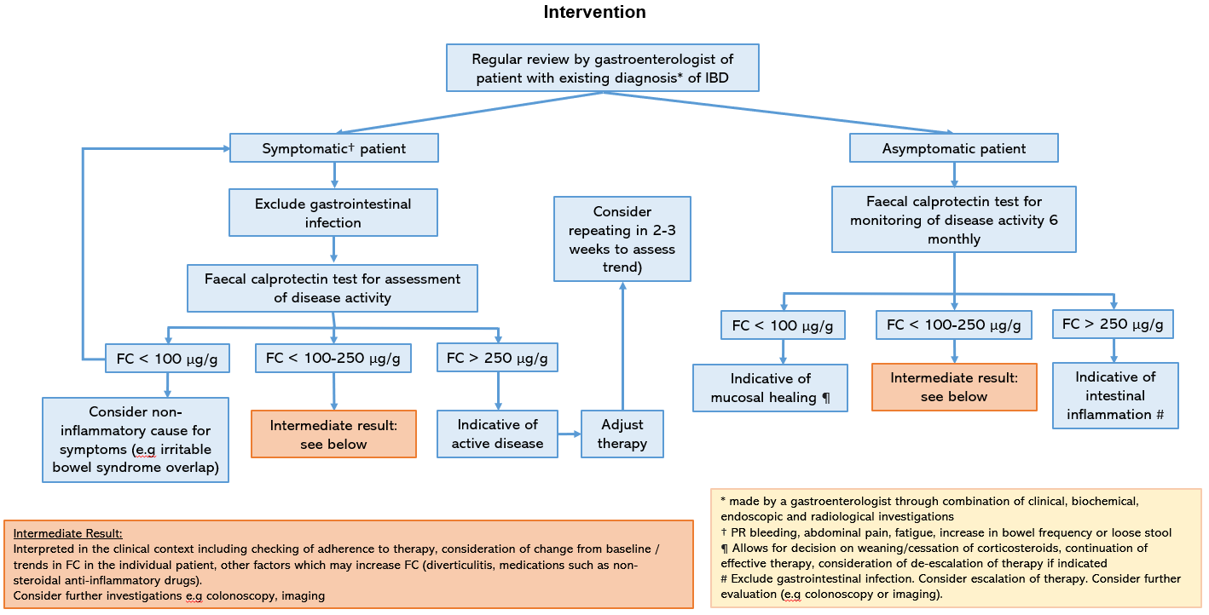
Figure 2: Proposed health technology / Intervention care algorithm. Highlighted in red are pathways where expensive and invasive colonoscopy may be avoided in comparison to the Comparator algorithm (Figure 3).

Without proposed health technology (Comparator Algorithm)

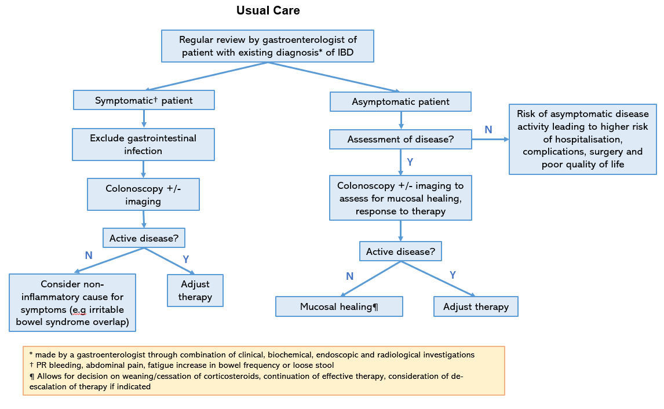
Figure 3: Comparator (Usual Care) algorithm

Claims
In terms of health outcomes (comparative benefits and harms), is the proposed technology claimed to be superior, non-inferior or inferior to the comparator(s)? (please select your response)
Superior
Non-inferior
Inferior

Please state what the overall claim is, and provide a rationale:

This application makes the following well supported clinical claims: FC testing is cheaper, safer, and clinically non-inferior as the present alternative of performing colonoscopy & biopsy/histopathology for regular assessment of disease activity in patients with established IBD.

Why would the requestor seek to use the proposed investigative technology rather than the comparator(s)?
The proposed investigative technology is safer, more acceptable to patients, non-inferior in disease activity assessment and allows for tighter control of IBD leading to better clinical outcomes.

Identify how the proposed technology achieves the intended patient outcomes:

- Safer: There has been no evidence of adverse events from the use of the FC test identified in the literature. The safety benefits of FC include: reduced adverse events via perforations avoided, and bleeding. This has been widely established.
- Non-inferior in disease activity assessment: high sensitivity, specificity, NPV, PPV, AUROC, additional true positives, additional true negatives, test reproducibility (coefficient of variance) and repeatability
- Better health outcomes: Tight control of IBD through the use of non-invasive FC testing will also ensure active IBD is detected earlier and avoidable complications of IBD will be reduced (disease specific morbidity, disease progression, perforation, anaemia, hospital admission, resectional surgery).

For some people, compared with the comparator(s), does the test information result in:
A change in clinical management? Yes

A change in health outcome? Yes

Other benefits? Yes

Please provide a rationale, and information on other benefits if relevant:

- Socioeconomic benefits:
  - Economic: cost-effective compared to colonoscopy
  - Social: less time spent away from work and family
- Health outcomes for patients in rural & remote Australia: Access to repeat colonoscopy in rural, remote and regional Australia is poor (49) (Figure 4). Furthermore, colonoscopy rates are lower in areas with lower socioeconomic status in major cities and remote areas (49).
- Through telehealth & local pathology testing, FC will allow for accurate assessment of disease activity in IBD patients who live in these areas, without the need for extended time off work and travel/accommodation costs associated with colonoscopy.
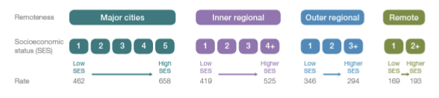
Figure 4: Number of MBS-subsidised services for repeat colonoscopy per 100,000 people of all ages, age and sex standardised, by Statistical Area Level 3 (SA3) of patient residence, 2018-19 (49)

In terms of the immediate costs of the proposed technology (and immediate cost consequences, such as procedural costs, testing costs etc.), is the proposed technology claimed to be more costly, the same cost or less costly than the comparator? (please select your response)
More costly
Same cost
Less costly

Provide a brief rationale for the claim:

Cost Breakdown
The cost of the FC test is $80 of which the MBS would pay $68.0 (85%). This cost is based on costs of the FC test for a separate indication (items: 66522/23) which was determined in consultation with the Royal College of Pathologists of Australasia (RCPA).

The total cost to the MBS for the provision of FC for assessment of disease activity in patients with IBD is estimated to be $5.31 million in 2024 (Table 1). Note that there are no changes to blood/biochemistry tests as all patients are assumed to receive these tests regardless of whether the patient receives a FC test.

Colonoscopy rates (and abdominal radiology) are expected to decrease when the FC test is incorporated into the clinical pathway.
A drop in colonoscopy rates in the IBD population after introduction of FC testing (free for the patient) has been established in real-world data from Lothian, Scotland, UK (50). Figure 5 shows a drop in colonoscopy and flexible sigmoidoscopy as a proportion of patients with IBD after introduction of faecal calprotectin testing (free to their patient population as part of the NHS) from approximately 22% to 14% (36% reduction). Figure 6 shows the corresponding rise in faecal calprotectin use during the same period.
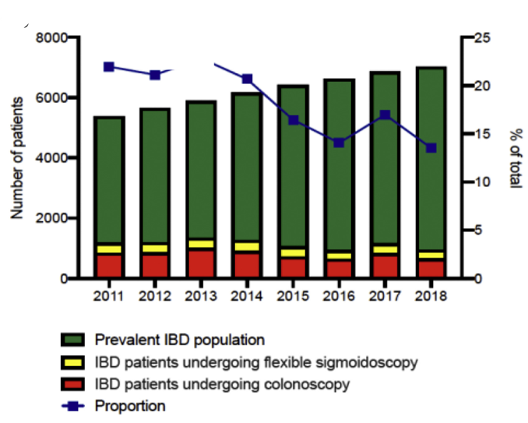
Figure 5: Number and proportion of prevalent IBD population in Lothian, Edinburgh, undergoing flexible sigmoidoscopy or colonoscopy from 2011 to 2018 (50)
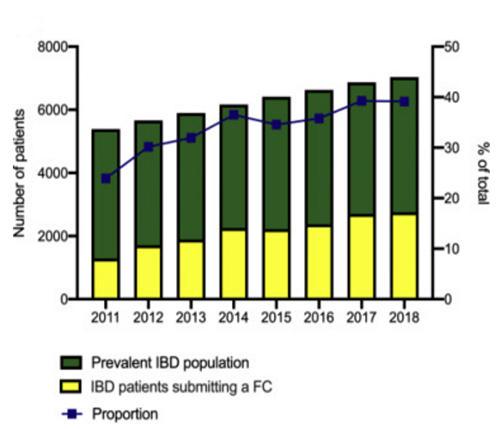
Figure 6: Number and proportion of prevalent IBD population in Lothian, Edinburgh, submitting a stool sample for FC from 2011 to 2018 (50).

This is consistent with an Australian real-world study which found colonoscopies for (re)assessment of disease activity over a five-year time frame after introduction of free FC testing dropped from 450 to 196 compared to the previous five years (56.4% drop), with an associated cost reduction per patient per year from $1887 to $969 (Figure 7) (48).

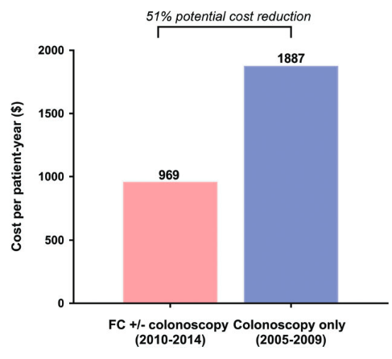
Figure 7: Cost comparison of colonoscopy-only use (2005–2009) versus FC-colonoscopy use (2010–2014) for disease activity assessment (48)

Further Australian data from Wright et al found routine FC testing in asymptomatic patients in post-operative Crohn’s disease and performing colonoscopy only in patients with FC > 100 reduced the rate of colonoscopy by 47% (51). Post-operative care costs in this setting would have been reduced by $1010 over 18 months using this strategy with FC testing at 6 and 18 months (52).

The following details the cost assumptions and expected cost impacts that the FC test will have on the comparator of colonoscopy and more generally:

- Cost of colonoscopy to the healthcare system
  - Estimate 1: $3,146 (cost of colonoscopy + [cost of endoscopic complications * 0.12% complication rate in adults]). This estimate is based on MSAC 1353.1 final report (D4.7, Table 66) using MBS fee schedule (2019) and National Hospitals Cost Data Collection (NHCDC) report (IHPA 2019). This does not account for healthcare inflation since 2019.
  - Estimate 2: $6,735 (includes direct and indirect costs but excluding costs associated with time off work / loss of productivity). This estimate used the NSW Health Activity Based Management casemix database to provide estimates of colonoscopy expenditure associated with providing the procedure but not any follow-up expenditure that may have resulted at a later date due to the index event (53).
- 1.08 FC tests performed per year (high estimate used; see Appendix 1 of the PICO document for methods for this estimate) for each patient with IBD.
- $80 cost per FC test
The proportion of FC tests in the IBD population for monitoring with results <100 μg/mL, 100-250μg/mL and ≥250 μg/mL is estimated from a real-world Australian study (48).
  - <100 μg/mL: 38.0%
  - 100-250 19.8%
  - ≥250 μg/mL: 42.2%
However, it is acknowledged that it is unclear how these proportions would differ between the symptomatic and asymptomatic arms of the intervention.

The cost of the intervention
1.08 * $80 = $86.40 per patient with IBD.

The savings of the intervention
0.38 * $3,146 - $6,735 = $1,195.48 - $2559.30 saved per FC performed (up to 38% would avoid a colonoscopy due to FC < 100).
 | 2024 | 2025 | 2026
Total IBD population year ending assuming 1.7% growth (1) | 102,423 | 104,164 | 105,935
Estimated uptake | 60% | 60% | 65%
Cost per person with IBD of test to MBS | $86.40 (1.08 tests per person * $80)
Total costs of the intervention ($ million) | $5.31 million | $5.40 million | $5.95 million
Estimated total number of tests (IBD population x estimated update x 1.08 tests per person) | 66,370 | 67,498 | 74,366
Savings per FC test of the intervention | $1,195.48 - $2,559.30
Savings per FC test of the intervention ($ million) | $79.34 - $169.86 million | $80.69 - $172.75 million | $88.90 - $190.32 million
Overall net savings of the intervention | $74.03 - $164.55 million | $75.29 - $167.35 million | $82.95 - $184.35 million
Table 8.1: Estimated costs & savings of the intervention

Total costs avoided by the introduction of the FC test in 2026 is expected to equal $88.90 – 190.32 million with the cost of the intervention being $5.95 million in that year. As such, the introduction of FC testing in diagnosis results in a decrease in direct costs of approximately $82.95 - $184.35 million in the 2026 financial year.

Note that savings from the intervention with regards to reducing hospitalisations, surgery and improved quality of life has not been included in these estimates.

Summary of Evidence
Provide one or more recent (published) high quality clinical studies that support use of the proposed health service/technology.
Identify yet-to-be-published research that may have results available in the near future (that could be relevant to your application).
Do not attach full text articles; this is just a summary (repeat columns as required).
 | Type of study design* | Title of journal article or research project (including any trial identifier or study lead if relevant) |  | Short description of research (max 50 words)** |  | Website link to journal article or research (if available) |  | Date of publication***
Faecal Calprotectin is sensitive and specific to identify disease activity and mucosal healing in IBD
1 | Systematic review & meta-analysis | The Utility of Faecal Calprotectin, Lactoferrin and Other Faecal Biomarkers in Discriminating Endoscopic Activity in Crohn’s Disease: A Systematic Review and Meta-Analysis |  | Assessed the utility of FC in Crohn’s disease comparing it to endoscopic activity. Pooled sensitivity was 81% (95% CI, 77-84%) with specificity of 74% (95% CI, 70-80%) and an AUC of 0.85. Subanalysis for mucosal healing: DOR of 18.17 (95% CI [11.08-29.82]) and a negative likelihood ratio of 0.19 [0.14-0.26]. |  | https://www.ncbi.nlm.nih.gov/pmc/articles/PMC10216423/ |  | May 2023
2. | Systematic review & meta-analysis | Fecal Calprotectin in Assessing Inflammatory Bowel Disease Endoscopic Activity: a Diagnostic Accuracy Meta-analysis |  | Adult patients with IBD and with symptomatic active disease which was confirmed endoscopically. 298 controls and 2,822 patients. FC had pooled sensitivity of 85%, specificity of 75%, DOR of 16.3 and AUC of 0.88 in diagnosing active disease. Pooled sensitivity using bivariate analysis was 88% (84-90) and specificity was 72% (64-79). |  | https://www.jgld.ro/jgld/index.php/jgld/article/view/63 |  | September 2018
3. | Systematic review & meta-analysis | Faecal Calprotectin in Assessment of Mucosal Healing in Adults with Inflammatory Bowel Disease: A Meta-Analysis |  | Crohn’s: 16 studies with 1333 patients. Faecal calprotectin had a diagnostic OR of 13.8 in detecting mucosal healing. Summary sensitivity was 82.8% (76.9-87.4), specificity was 75.9% (68.3-82.1). AUC was 0.829 with estimated DOR of 11.20.  UC: 35 studies with 5826 patients. Provided similarly strong results. |  | https://www.ncbi.nlm.nih.gov/pmc/articles/PMC8161009/ |  | May 2021
4. | Systematic review & meta-analysis | C-Reactive Protein, Fecal Calprotectin, and Stool Lactoferrin for Detection of Endoscopic Activity in Symptomatic Inflammatory Bowel Disease Patients: A Systematic Review and Meta-Analysis |  | Patients with IBD and active disease as determined by endoscopy as gold standard. 19 studies included. Pooled sensitivity and specificity estimates of FC were 0.88 (0.84 – 0.90) and 0.73 (0.66-0.79). |  | https://journals.lww.com/ajg/Abstract/2015/06000/C_Reactive_Protein,_Fecal_Calprotectin,_and_Stool.10.aspx |  | June 2015
Real world data to demonstrate reduction in colonoscopy rates and cost savings after introduction of FC testing
5. | Real world, retrospective cohort |  | Faecal calprotectin delivers on convenience, cost reduction and clinical decision-making in inflammatory bowel disease: a real-world cohort study |  | This Australian study compared colonoscopies and FC tests in confirmed IBD patients in two cohorts: a) assessment during the first 5 years that FC was available at the centre and b) assessment performed in the preceding 5 year period. Colonoscopy rates dropped by ~56% and overall cost reduction of 51% seen after introduction of FC testing. |  | https://onlinelibrary.wiley.com/doi/10.1111/imj.14027 | 02/07/2018
6 | Narrative review with data presented from Edinburgh FC database |  | Disease Monitoring in Inflammatory Bowel Disease: Evolving Principles and Possibilities |  | (Box 1 relevant)  The proportion of the prevalent IBD patients in Edinburgh undergoing FC monitoring has increased over the years with a mirrored reduction in colonoscopy.  This study also provides estimates of the number of FC tests performed in a real life setting using a treat to target tight control strategy. |  | https://www.gastrojournal.org/article/S0016-5085(22)00078-6/fulltext | April 2022
7 | Analysis of data from a prospective, randomised, controlled trial |  | Measurement of fecal calprotectin improves monitoring and detection of recurrence of Crohn's disease after surgery |  | 2015 Australian study of patients with post-operative Crohn’s disease.  In this cohort, if colonoscopy restricted to only those patients with FC concentrations >100, 47% of patients without post-operative recurrence (disease activity) would have avoided colonoscopy. |  | https://pubmed.ncbi.nlm.nih.gov/25620670/ | May 2015
8 | Survey data from a multicenter, prospective cohort study |  | FOCUS: Future of fecal calprotectin utility study in inflammatory bowel disease |  | In the known IBD subset of this study which included FC assessment for disease activity assessment and also determination of whether symptoms were IBS overlap (n=122), 55 patients had a FC<100µg and of these, 24 patients had colonoscopy deferred. |  | https://pubmed.ncbi.nlm.nih.gov/27688663/ | September 2016
Australian gastroenterologists’ perception of FC use in IBD
9 | Electronic surveys sent out to Australian gastroenterologists |  | Faecal calprotectin: current usage and perceived beneficial effects of third-party funding on rates of colonoscopy by Australian gastroenterologists |  | 24% of non-users of FC cited cost as a factor. Even in users of FC, 69% cited funding as a major deciding factor.  Of non-users, 78 and 58%, respectively, would use FC to differentiate IBD from IBS and assess for mucosal healing in IBD, if FC testing was Medical Benefits Schedule (MBS) listed.  Both users (79%) and non-users (68%) reported that use of FC to defer or avoid colonoscopies was likely if the test was MBS funded. |  | https://onlinelibrary.wiley.com/doi/10.1111/imj.13056 | March 2016
Publications supportive of the use of a treat to target algorithm in IBD including use of FC
10 | Systematic review followed by iterative surveys of 89 International Organization for the Study of Inflammatory Bowel Diseases (IOIBD) members |  | STRIDE-II: An Update on the Selecting Therapeutic Targets in Inflammatory Bowel Disease (STRIDE) Initiative of the International Organization for the Study of IBD (IOIBD): Determining Therapeutic Goals for Treat-to-Target strategies in IBD |  | Normalisation of Faecal calprotectin is an intermediate goal in a treat to target algorithm in IBD that aims for optimal outcomes including clinical remission, mucosal healing, restoration of quality of life, and absence of disability. |  | https://pubmed.ncbi.nlm.nih.gov/33359090/ | April 2021
11 | Open label, randomised controlled phase 3 multicentre study |  | Effect of tight control management on Crohn's disease (CALM): a multicentre, randomised, controlled phase 3 trial |  | Patients were randomly assigned to the ‘tight control’ or ‘clinical management’ groups. Tight control also included CRP and FC. Escalation of adalimumab was based on either CDAI (clinical activity) in the clinical management group, or CDAI, FC>250 or CRP>5). A significantly higher proportion of patients in the tight control group achieved the primary endpoint of mucosal healing at week 48 (risk difference of 16.1% (3.9-28.3). |  | https://www.thelancet.com/journals/lancet/article/PIIS0140-6736(17)32641-7/fulltext | December 23 2017
FC as a predictor of relapse in IBD
12 | Systematic review and meta-analysis |  | Fecal calprotectin for detection of postoperative endoscopic recurrence in Crohn’s disease: systematic review and meta-analysis |  | 9 studies included. Optimal diagnostic accuracy obtained for FC value of 150µg/g with pooled sensitivity of 70% (59-81%), specificity of 69% (61-77%) and DOR of 5.92 (2.61-12.17). Area under the SROC curve was 0.73. |  | https://www.ncbi.nlm.nih.gov/pmc/articles/PMC6048608/ | 8 July 2018
13 | Systematic Review |  | Clinical Utility of Fecal Calprotectin Monitoring in Asymptomatic Patients with Inflammatory Bowel Disease: A Systematic Review and Practical Guide |  | 6 studies included. Time intervals between FC varied between 1 - 3 months. Cut-offs varied between 15 and 300 µg/g. Patients with FC repeatedly above the study cut-off had a 53% to 83% probability of relapsing within the next 2 to 3 months, and those with repeatedly normal faecal calprotectin had a 67% to 94% probability of remaining in remission. |  | https://www.ncbi.nlm.nih.gov/pmc/articles/PMC5434712/ | 1 June 2018
14 | Systematic Review with Meta Analysis |  | Systematic review with meta-analysis: fecal calprotectin as a surrogate marker for predicting relapse in adults with ulcerative colitis |  | 14 studies of 1110 patients with UC calculated pooled sensitivity and specificity to be 75% and 77% (cut-offs 55–341 μg/g) |  | https://www.ncbi.nlm.nih.gov/pmc/articles/PMC6558608/ | May 2019
Other studies
15 | Retrospective cohort study |  | Normalization of Fecal Calprotectin Within 12 Months of Diagnosis Is Associated With Reduced Risk of Disease Progression in Patients With Crohn’s Disease |  | 375 patients with FC at diagnosis ≥250 μg/g and at least one follow up FC measurement within the first 12 months were included in the study. Patients with normalized levels of FC had a significantly lower risk of composite disease progression (hazard ratio [HR], 0.36; 95% CI, 0.24–0.53; P < .001). |  | https://www.cghjournal.org/article/S1542-3565(20)31131-9/fulltext | September 2021
16 | Online questionnaire |  | Inflammatory bowel disease patient perceptions of diagnostic and monitoring tests and procedures |  | Online questionnaire of IBD patients. Of the five most ordered tests in IBD (blood test, colonoscopy, colon biopsy, medical imaging and stool testing), stool test was the procedure with which the patients were most comfortable, whereas colonoscopy was considered the second lowest level of comfort. |  | https://bmcgastroenterol.biomedcentral.com/articles/10.1186/s12876-019-0946-8 | Feb 2019
1. | Yet to be published  Systematic review & Meta-analysis |  | Utility of Faecal Calprotectin in Assessing Endoscopic Activity in Ulcerative Colitis |  | This systematic review is currently being undertaken to review the literature on the effectiveness of faecal calprotectin testing in assessing disease activity compared to gold standard endoscopy in ulcerative colitis. |  | During the contracted assessment (CA)/ submission-based assessment (SBA), please notify the applicants and we will provide the paper to the assessment and/or critique group.  We envision a mixed CA/SBA approach as recommended by the Department. | Please contact Ray/Fergus for publication timelines
2. | Yet to be published  Retrospective cohort study of IBD patients in a tertiary centre |  | Impact of Faecal Calprotectin on colonoscopy rates and clinical decision making in a real-world cohort |  | This audit will document the real-world use of faecal calprotectin in a tertiary centre, and the impact on clinical decisions, colonoscopy rates and costs. |  | During the contracted assessment (CA)/ submission-based assessment (SBA), please notify the applicants and we will provide the paper to the assessment and/or critique group.  We envision a mixed CA/SBA approach as recommended by the Department. | Please contact Ray/Fergus for publication timelines

* Categorise study design, for example meta-analysis, randomised trials, non-randomised trial or observational study, study of diagnostic accuracy, etc.
**Provide high level information including population numbers and whether patients are being recruited or in post-recruitment, including providing the trial registration number to allow for tracking purposes. For yet to be published research, provide high level information including population numbers and whether patients are being recruited or in post-recruitment.
*** If the publication is a follow-up to an initial publication, please advise. For yet to be published research, include the date of when results will be made available (to the best of your knowledge).

Appendix 1 – Estimates of number of FC tests per patient per year

Best estimates of the number of FC tests that would be ordered by gastroenterologists for monitoring of patients with IBD in the Australian setting come from a study by Motaganahalli et al (48). In this real-world study, a total of 357 FC tests were performed in 246 patients over a five year period with median 1.8 year follow up, equating to 0.81 FC tests performed per patient year of follow up. This cohort comprised of patients followed up by gastroenterologists with an expertise in IBD in a tertiary hospital setting, meaning that the number of tests performed per patient per year is likely to be an over-estimate of compared to the general IBD population (which would include fewer patients with complicated disease, and fewer gastroenterologists with specific expertise in IBD).

Further data come from the Edinburgh Faecal Calprotectin Register (EFCR) from Lothian, Scotland. This population is comparable to the situation which would exist in Australia if this application is approved (FC test would be free to the patient; gastroenterologists use the treat to target guidelines; similar incidence/prevalence of IBD in the population). The Lothian Trust’s gastroenterologists request FC routinely and proactively at baseline and subsequently every 2-3 months in the majority of patients (50). Data were reported on the number of FC tests performed in this population before and after introduction of FC in primary care in Q1 2017 (Figure A1). Prior to Q1 2017, only gastroenterologists were able to order FC tests for their IBD patients. During 2016, the number of FC tests performed in Lothian was under 7000 per year for a prevalence of ~6500 patients with IBD (50). This suggests even with a population where clinicians request FC routinely, proactively and routinely in the majority of patients, the number of tests performed per IBD patient per year was approximately 1.08 (7000/6500). This number could be due to several factors, including incomplete adherence in completing the test and a significant proportion of patients with IBD not being followed up by a gastroenterologist, or being followed up infrequently.

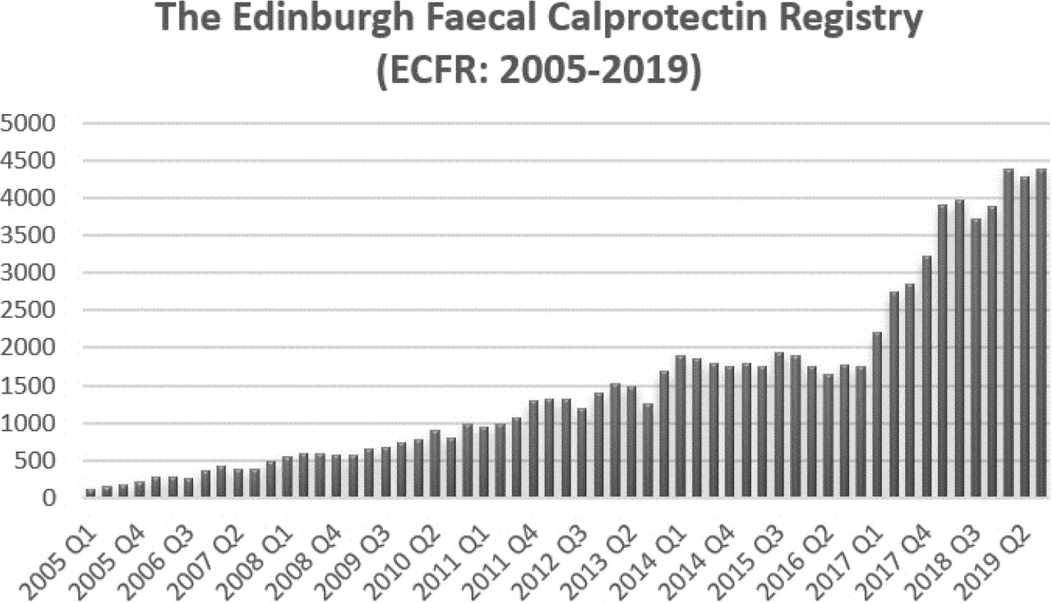
Figure A1: The number of FC tests performed per quarter based on the Edinburgh FC Registry. The increased demand for FC after opening the testing directly to General Practitioners is clearly demonstrated from Q1 2017 onwards (54)

References
1. PWC. Improving Inflammatory Bowel Disease care across Australia [Internet]. 2013 Mar [cited 2023 Jul 10]. Available from: https://crohnsandcolitis.org.au/wp-content/uploads/2022/02/PwC-report-2013.pdf
2. Flanagan A, Allsopp SM, O’Connor SA, Tobin J, Pretorius C, Brown IS, et al. High incidence of inflammatory bowel disease in Northern Australia: a prospective community population-based Australian incidence study in the Mackay-Isaac-Whitsunday region. Intern Med J. 2022;
3. Johnston RD, Logan RFA. What is the peak age for onset of IBD? Inflamm Bowel Dis. 2008;14 Suppl 2.
4. De Souza HSP, Fiocchi C. Immunopathogenesis of IBD: Current state of the art. Vol. 13, Nature Reviews Gastroenterology and Hepatology. 2016.
5. Card T, Hubbard R, Logan RFA. Mortality in Inflammatory Bowel Disease: A Population-Based Cohort Study. Gastroenterology. 2003;125(6).
6. Follin-Arbelet B, Cvancarova Småstuen M, Hovde Ø, Jelsness-Jørgensen LP, Moum B. Mortality in Patients with Inflammatory Bowel Disease: Results from 30 Years of Follow-up in a Norwegian Inception Cohort (the IBSEN study). J Crohns Colitis [Internet]. 2023 Apr 1;17(4):497–503. Available from: https://doi.org/10.1093/ecco-jcc/jjac156
7. Burisch J, Lophaven S, Langholz E, Munkholm P. The clinical course of Crohn’s disease in a Danish population-based inception cohort with more than 50 years of follow-up, 1962-2017. Aliment Pharmacol Ther. 2022;55(1).
8. Olén O, Askling J, Sachs MC, Neovius M, Smedby KE, Ekbom A, et al. Mortality in adult-onset and elderly-onset IBD: a nationwide register-based cohort study 1964-2014. Gut. 2020;69(3).
9. Ludvigsson JF, Holmgren J, Grip O, Halfvarson J, Askling J, Sachs MC, et al. Adult-onset inflammatory bowel disease and rate of serious infections compared to the general population: a nationwide register-based cohort study 2002–2017. Scand J Gastroenterol. 2021;56(10).
10. Moradkhani A, Beckman LJ, Tabibian JH. Health-related quality of life in inflammatory bowel disease: Psychosocial, clinical, socioeconomic, and demographic predictors. J Crohns Colitis. 2013;7(6).
11. McDermott E, Mullen G, Moloney J, Keegan D, Byrne K, Doherty GA, et al. Body image dissatisfaction: Clinical features, and psychosocial disability in inflammatory bowel disease. Inflamm Bowel Dis. 2015;21(2).
12. Australian Government Department of Health. Inflammatory Bowel Disease National Action Plan 2019 [Internet]. 2019 Mar [cited 2023 Jul 10]. Available from: https://www.health.gov.au/sites/default/files/documents/2019/09/national-strategic-action-plan-for-inflammatory-bowel-disease-inflammatory-bowel-disease-national-action-plan-2019_0.pdf
13. Magro F, Gionchetti P, Eliakim R, Ardizzone S, Armuzzi A, Barreiro-de Acosta M, et al. Third European evidence-based consensus on diagnosis and management of ulcerative colitis. Part 1: Definitions, diagnosis, extra-intestinal manifestations, pregnancy, cancer surveillance, surgery, and ileo-anal pouch disorders. J Crohns Colitis. 2017;11(6).
14. Dignass A, Van Assche G, Lindsay JO, Lémann M, Söderholm J, Colombel JF, et al. The second European evidence-based consensus on the diagnosis and management of Crohn’s disease: Current management. Vol. 4, Journal of Crohn’s and Colitis. 2010.
15. Magro F, Langner C, Driessen A, Ensari A, Geboes K, Mantzaris GJ, et al. European consensus on the histopathology of inflammatory bowel disease. J Crohns Colitis. 2013;7(10).
16. Elnawsra O, Fok I, Sparrow M, Gibson P, Andrews J, Connor S. Faecal calprotectin: Current usage and perceived beneficial effects of third-party funding on rates of colonoscopy by Australian gastroenterologists. Intern Med J. 2016;46(5).
17. Turner D, Ricciuto A, Lewis A, D’Amico F, Dhaliwal J, Griffiths AM, et al. STRIDE-II: An Update on the Selecting Therapeutic Targets in Inflammatory Bowel Disease (STRIDE) Initiative of the International Organization for the Study of IBD (IOIBD): Determining Therapeutic Goals for Treat-to-Target strategies in IBD. Gastroenterology. 2021;160(5).
18. Neurath MF, Travis SPL. Mucosal healing in inflammatory bowel diseases: A systematic review. Vol. 61, Gut. 2012.
19. Ungaro RC, Yzet C, Bossuyt P, Baert FJ, Vanasek T, D’Haens GR, et al. Deep Remission at 1 Year Prevents Progression of Early Crohn’s Disease. Gastroenterology. 2020;159(1).
20. Shah SC, Colombel JF, Sands BE, Narula N. Systematic review with meta-analysis: Mucosal healing is associated with improved long-term outcomes in Crohn’s disease. Vol. 43, Alimentary Pharmacology and Therapeutics. 2016.
21. Shah SC, Colombel JF, Sands BE, Narula N. Mucosal Healing Is Associated With Improved Long-term Outcomes of Patients With Ulcerative Colitis: A Systematic Review and Meta-analysis. Vol. 14, Clinical Gastroenterology and Hepatology. 2016.
22. Williamson KD, Steveling K, Holtmann G, Schoeman M, Andrews JM. Clinical triage for colonoscopy is useful in young women. Intern Med J. 2015;45(5).
23. Walsh AJ, Bryant R V., Travis SPL. Current best practice for disease activity assessment in IBD. Nat Rev Gastroenterol Hepatol [Internet]. 2016;13(10):567–79. Available from: http://www.nature.com/doifinder/10.1038/nrgastro.2016.128
24. Cellier C, Sahmoud T, Froguel E, Adenis A, Belaiche J, Bretagne JF, et al. Correlations between clinical activity, endoscopic severity, and biological parameters in colonic or ileocolonic Crohn’s disease. A prospective multicentre study of 121 cases. The Groupe d’Etudes Therapeutiques des Affections Inflammatoires Digestives. Gut. 1994;35(2).
25. Halpin SJ, Ford AC. Prevalence of symptoms meeting criteria for irritable bowel syndrome in inflammatory bowel disease: Systematic review and meta-analysis. Vol. 107, American Journal of Gastroenterology. 2012.
26. Abdalla MI, Sandler RS, Kappelman MD, Martin CF, Chen W, Anton K, et al. Prevalence and Impact of Inflammatory Bowel Disease-Irritable Bowel Syndrome on Patient-reported Outcomes in CCFA Partners. Inflamm Bowel Dis. 2017;23(2).
27. Baars JE, Nuij VJAA, Oldenburg B, Kuipers EJ, Van Der Woude CJ. Majority of patients with inflammatory bowel disease in clinical remission have mucosal inflammation. Inflamm Bowel Dis. 2012;18(9).
28. Colombel JF, Panaccione R, Bossuyt P, Lukas M, Baert F, Vanasek T, et al. Effect of tight control management on Crohn’s disease (CALM): a multicentre, randomised, controlled phase 3 trial. Lancet. 2018 Dec;390(10114):2779–89.
29. D’Haens G, Ferrante M, Vermeire S, Baert F, Noman M, Moortgat L, et al. Fecal calprotectin is a surrogate marker for endoscopic lesions in inflammatory bowel disease. Inflamm Bowel Dis. 2012;18(12).
30. Berni Canani R, Terrin G, Rapacciuolo L, Miele E, Siani MC, Puzone C, et al. Faecal calprotectin as reliable non-invasive marker to assess the severity of mucosal inflammation in children with inflammatory bowel disease. Digestive and Liver Disease. 2008;40(7).
31. Schoepfer AM, Beglinger C, Straumann A, Trummler M, Renzulli P, Seibold F. Ulcerative colitis: Correlation of the Rachmilewitz Endoscopic Activity Index with fecal calprotectin, clinical activity, C-reactive protein, and blood leukocytes. Inflamm Bowel Dis. 2009;15(12).
32. Noiseux I, Veilleux S, Bitton A, Kohen R, Vachon L, White Guay B, et al. Inflammatory bowel disease patient perceptions of diagnostic and monitoring tests and procedures. BMC Gastroenterol. 2019;19(1).
33. Ye X, Wang Y, Wang HHX, Feng R, Ye Z, Han J, et al. Can fecal calprotectin accurately identify histological activity of ulcerative colitis? A meta-analysis. Therap Adv Gastroenterol. 2021;14.
34. Mosli MH, Zou G, Garg SK, Feagan SG, MacDonald JK, Chande N, et al. C-reactive protein, fecal calprotectin, and stool lactoferrin for detection of endoscopic activity in symptomatic inflammatory bowel disease patients: A systematic review and meta-analysis. Vol. 110, American Journal of Gastroenterology. 2015. p. 802–19.
35. Bromke MA, Neubauer K, Kempiński R, Krzystek‐korpacka M. Faecal calprotectin in assessment of mucosal healing in adults with inflammatory bowel disease: A meta‐analysis. Vol. 10, Journal of Clinical Medicine. 2021.
36. Rokkas T, Portincasa P, Koutroubakis IE. Fecal calprotectin in assessing inflammatory bowel disease endoscopic activity: A diagnostic accuracy meta-analysis. Vol. 27, Journal of Gastrointestinal and Liver Diseases. 2018.
37. Bohra A, Mohamed G, Vasudevan A, Lewis D, Van Langenberg DR, Segal JP. The Utility of Faecal Calprotectin, Lactoferrin and Other Faecal Biomarkers in Discriminating Endoscopic Activity in Crohn&rsquo;s Disease: A Systematic Review and Meta-Analysis. Biomedicines [Internet]. 2023;11(5). Available from: https://www.mdpi.com/2227-9059/11/5/1408
38. Plevris N, Fulforth J, Lyons M, Siakavellas SI, Jenkinson PW, Chuah CS, et al. Normalization of Fecal Calprotectin Within 12 Months of Diagnosis Is Associated With Reduced Risk of Disease Progression in Patients With Crohn’s Disease. Clinical Gastroenterology and Hepatology. 2021;19(9).
39. Li J, Zhao X, Li X, Lu M, Zhang H. Systematic review with meta-analysis: Fecal calprotectin as a surrogate marker for predicting relapse in adults with ulcerative colitis. Vol. 2019, Mediators of Inflammation. 2019.
40. Heida A, Park KT, Van Rheenen PF. Clinical Utility of Fecal Calprotectin Monitoring in Asymptomatic Patients with Inflammatory Bowel Disease: A Systematic Review and Practical Guide. Inflamm Bowel Dis. 2017;23(6).
41. Louis E, Resche-Rigon M, Laharie D, Satsangi J, Ding N, Siegmund B, et al. Withdrawal of infliximab or concomitant immunosuppressant therapy in patients with Crohn’s disease on combination therapy (SPARE): a multicentre, open-label, randomised controlled trial. Lancet Gastroenterol Hepatol. 2023;8(3).
42. Buisson A, Mak WY, Andersen MJ, Lei D, Kahn SA, Pekow J, et al. Faecal Calprotectin Is a Very Reliable Tool to Predict and Monitor the Risk of Relapse after Therapeutic De-escalation in Patients with Inflammatory Bowel Diseases. J Crohns Colitis. 2019;13(8).
43. De Suray N, Salleron J, Vernier-Massouille G, Grimaud JC, Bouhnik Y, Laharie D, et al. Close monitoring of CRP and fecal calprotectin is able to predict clinical relapse in patients with crohn’s disease in remission after infliximab withdrawal. A sub-analysis of the stori study. Gastroenterology [Internet]. 2012;1):S149. Available from: http://ovidsp.ovid.com/ovidweb.cgi?T=JS&CSC=Y&NEWS=N&PAGE=fulltext&D=emed14&AN=71105786
44. Tham YS, Yung DE, Fay S, Yamamoto T, Ben-Horin S, Eliakim R, et al. Fecal calprotectin for detection of postoperative endoscopic recurrence in Crohn’s disease: systematic review and meta-analysis. Therap Adv Gastroenterol [Internet]. 2018 Jan 1;11:1756284818785571. Available from: https://doi.org/10.1177/1756284818785571
45. NPS MedicineWise. Faecal Calprotectin in Inflammatory Bowel Disease (IBD) [Internet]. 2021 [cited 2023 Jul 10]. Available from: https://www.nps.org.au/assets/NPS/pdf/NPSMW2394_Faecal_Calprotectin_Algorithm.pdf
46. Boirivant M, Leoni M, Tariciotti D, Fais S, Squarcia O, Pallone F. The clinical significance of serum C reactive protein levels in crohn’s disease: Results of a prospective longitudinal study. J Clin Gastroenterol. 1988;10(4).
47. Saverymuttu SH, Hodgson HJF, Chadwick VS, Pepys MB. Differing acute phase responses in Crohn’s disease and ulcerative colitis. Gut. 1986;27(7).
48. Motaganahalli S, Beswick L, Con D, van Langenberg DR. Faecal calprotectin delivers on convenience, cost reduction and clinical decision-making in inflammatory bowel disease: a real-world cohort study. Intern Med J. 2019;49(1).
49. Australian Commission on Safety and Quality in Health Care. The Fourth Australian Atlas of Healthcare Variation. Sydney; 2021.
50. Plevris N, Lees CW. Disease Monitoring in Inflammatory Bowel Disease: Evolving Principles and Possibilities. Gastroenterology. 2022;162(5).
51. Wright EK, Kamm MA, De Cruz P, Hamilton AL, Ritchie KJ, Krejany EO, et al. Measurement of fecal calprotectin improves monitoring and detection of recurrence of Crohn’s disease after surgery. Gastroenterology. 2015;148(5).
52. Wright EK, Kamm MA, Cruz PD, Hamilton AL, Ritchie KJ, Bell SJ, et al. Cost-effectiveness of Crohn’s disease post-operative care. World J Gastroenterol. 2016;22(14).
53. Badgery-Parker T, Pearson SA, Chalmers K, Brett J, Scott IA, Dunn S, et al. Low-value care in Australian public hospitals: Prevalence and trends over time. BMJ Qual Saf. 2019;28(3).
54. Siakavellas S, Lyons M, Plevris N, Lucaciu L, McCall S, Bandel-Kuchorew T, et al. P155 88000 faecal calprotectin measurements over 15 years: insights gained from the edinburgh faecal calprotectin register. In 2021.

FC was the subject of a GESA successful separate MSAC application for use in the primary care setting to distinguish between functional gastrointestinal disorders and IBD.

