Medical Services Advisory Committee (MSAC)
Public Summary Document
Application No. 1549 – PD-L1 immunohistochemistry testing for access to pembrolizumab in combination with chemotherapy for first line treatment of triple negative breast cancer
Applicant: Merck Sharp & Dohme (Australia) Pty Limited
Date of MSAC consideration: 30-31 March 2023
Context for decision: MSAC makes its advice in accordance with its Terms of Reference, visit the MSAC website.

1. Purpose of application
The streamlined codependent submission requested:
- An amendment of Medicare Benefits Schedule (MBS) item 72814 for programmed death ligand-1 (PD-L1) immunohistochemical (IHC) testing to include locally recurrent unresectable or metastatic triple negative breast cancer (TNBC); and
- Pharmaceutical Benefits Schedule (PBS) listing of pembrolizumab for the treatment of people with locally recurrent unresectable or metastatic TNBC whose tumours express PD-L1 Combined Positive Score (CPS) ≥10 who have not received prior chemotherapy for metastatic disease.
For brevity, locally recurrent unresectable or metastatic TNBC is referred to as advanced TNBC.

2. MSAC’S advice to the Minister
After considering the strength of the available evidence in relation to comparative safety, clinical effectiveness, cost-effectiveness and total cost, MSAC supported an amendment to Medicare Benefits Schedule (MBS) item 72814 for programmed death ligand 1 (PD-L1) immunohistochemistry (IHC) testing to also include testing of tumour material from patients with inoperable locally recurrent or metastatic triple-negative breast cancer (TNBC). MSAC recalled its concerns regarding the poor analytical performance and inconsistent clinical utility of PD-L1 IHC testing it had outlined in its position statement on PD-L1 testing. However, MSAC considered that in this specific case, PD-L1 IHC testing with a combined positive score (CPS) threshold of ≥10 has sufficient clinical value in identifying which patients may derive greater benefit from pembrolizumab in combination with chemotherapy, as there is no evidence that adding pembrolizumab to chemotherapy improves outcomes in the broader population with inoperable locally recurrent or metastatic triple-negative breast cancer. MSAC advised that the item should not be pathologist determinable for consistency with the existing item. MSAC did not the specify testing using a core biopsy or excisional tissue as a requirement because compliance could not be ensured. MSAC advised the testing was cost-effective, and that the financial cost to the MBS was modest and acceptable. MSAC considered that testing should be accompanied by relevant pathologist training and quality assurance requirements.
Category 6 – Pathology Services
Item 72814
Immunohistochemical examination by immunoperoxidase or other labelled antibody techniques using the programmed cell death ligand 1 (PD-L1) antibody of tumour material from a patient diagnosed with non-small cell lung cancer; recurrent or metastatic squamous cell carcinoma of the oral cavity, pharynx or larynx; or inoperable locally recurrent or metastatic triple-negative breast cancer.
Fee: $74.50 Benefit: 75% = $55.90 85% = $63.35

Consumer summary
This is an application from MSD Australia requesting expanding current Medicare Benefits Schedule (MBS) item 72814 to include people with inoperable locally recurrent or metastatic triple-negative breast cancer (TNBC). MBS item 72814 currently funds testing for PD-L1 status in people with non-small cell lung cancer and recurrent or metastatic squamous cell carcinoma of the oral cavity, pharynx or larynx, for access to a drug called pembrolizumab on the Pharmaceutical Benefits Scheme (PBS).
PD-L1 testing is a special test that measures how much of a protein called programmed death ligand 1 – or PD-L1 – is on the surface of cancer cells and the cells surrounding the cancer. If there is enough of this protein present – measured by something called the combined positive score (CPS) – patients will be eligible for medications such as pembrolizumab that can target the cells and help fight the cancer.
MSAC has said in the past that it did not consider PD-L1 testing to be a reliable test to identify patients whose cancers will benefit from treatment with pembrolizumab or other similar medicines called PD-(L)1 immune checkpoint inhibitors. MSAC has said this is because while PD-(L)1 immune checkpoint inhibitors can sometimes be an effective treatment for cancers with low levels of PD-L1 protein, PD-L1 testing is also complex and can lead to variable results from laboratories.
However, in this case MSAC considered PD-L1 testing is needed to decide which patients with advanced TNBC should receive pembrolizumab treatment. MSAC considered the clinical evidence showed that pembrolizumab helps improve survival for people with advanced TNBC whose CPS score of 10 or greater but does not for other patients. MSAC recognised that this patient group often has poor health outcomes and few treatment options, and considered it important that the patients gain access to a drug that can benefit them. MSAC supported expanding the existing MBS item to include testing of advanced TNBC.
MSAC also recommended that laboratories performing the PD-L1 test ensure that their staff have additional training, and that the tests are regularly monitored to make sure they are of high quality.

MSAC’s advice to the Commonwealth Minister for Health and Aged Care
MSAC supported expanding the listing for MBS item 72814 (for PD-L1 testing) to include people with inoperable locally recurrent or metastatic TNBC so that they can access pembrolizumab on the PBS. MSAC considered the test to be safe, effective and good value for money in this group of patients.

3. Summary of consideration and rationale for MSAC’s advice
MSAC noted that this streamlined, co-dependent application from MSD requested amendment of MBS item 72814 for PD-L1 IHC testing to include locally recurrent unresectable or metastatic TNBC for Pharmaceutical Benefits Schedule (PBS) access to pembrolizumab for patients whose tumours express PD-L1 CPS ≥10 and who have not received prior chemotherapy for metastatic disease.
MSAC noted that, at its March 2023 meeting, the Pharmaceutical Benefits Advisory Committee (PBAC) recommended the PBS listing of pembrolizumab for the treatment of patients with locally recurrent unresectable or metastatic TNBC whose tumours express PD-L1 (CPS ≥10). MSAC noted that the PBAC:
- noted there is a high clinical need for effective treatment in this patient population, who are typically young and have a poor prognosis
- considered that pembrolizumab in combination with chemotherapy provides a meaningful improvement in overall survival (OS) compared with standard chemotherapy alone.
MSAC recalled it was previously inclined to support PD-L1 testing for some patients with advanced TNBC to determine eligibility for treatment with atezolizumab (p1, MSAC Application 1570 Public Summary Document [PSD]).
MSAC considered there were no safety issues associated with the testing process.
Regarding the analytical performance of PD-L1 testing, MSAC recalled its position statement on PD-L1 IHC testing for determining patient eligibility for treatment with PD-(L)1 checkpoint inhibitors: “MSAC will not, in the future, support the use of PD-L1 IHC testing as being essential for the purpose of helping to make decisions affecting the eligibility of patients for treatment involving PD-L1 or PD-1 checkpoint inhibitors”. However, MSAC also noted that its Position Statement enables applicants to lodge streamlined codependent submissions requesting subsidy for PD-L1 IHC testing on a case-by-case basis.
MSAC agreed with PBAC that there is unmet clinical need for these patients, and also noted this was stated in the pre-MSAC response.
MSAC noted that as a streamlined codependent submission, an assessment of analytical performance was not included. MSAC noted that one of the main issues with PD-L1 testing is that the platforms and antibodies used can differ between laboratories. This can lead to variable results being obtained on the same sample. In addition, MSAC noted that the Royal College of Pathologists Australasia (RCPA) and the Australasian Society for Breast Disease consider the several IHC antibodies available for PD-L1 testing to be non-interchangeable, as they vary considerably in sensitivity. For each PD-L1 indication, these organisations recommend that the assay and scoring method that was supported by the relevant trials be used. MSAC recalled it had previously considered the analytical performance of the 22C3 antibody using the Ventana platform in its consideration of application 1522.1 (p4, MSAC Application 1522.1 Public Summary Document) and not specified a particular platform for testing.
MSAC considered that another issue with PD-L1 assays is inter-observer and intra-observer variability when assessing PD-L1 scores. MSAC considered that this variability could be addressed through more intensive user training and certification, and through the RCPA external Quality Assurance Program (QAP). MSAC considered the CPS scoring to be more difficult than tumour proportion scoring (TPS).
MSAC noted the clinical evidence from the KN-355 trial supporting the use of pembrolizumab in the TNBC patient group who had CPS≥10. MSAC noted improvements in OS between the treatment and placebo arms were not found in the CPS≥1 or intention to treat (ITT) patient groups.
MSAC considered several aspects of the KN-355 trial reduced its confidence the trial results and the claim that the trial supported the codependency. This included:
- The change in primary endpoint between the first interim analysis and final analysis.
- The trial being originally stratified by the proportion of CPS ≥1 as opposed to CPS ≥10. Therefore the CPS ≥10 subgroup could potentially be inadequately randomised and may carry a higher risk of bias.
- Overlapping confidence intervals for OS across the subgroups by CPS status.
MSAC considered pembrolizumab’s PD-L1 agnostic Therapeutic Goods Administration indication for early TNBC but not advanced TNBC weakened suggestions based on biological plausibility that PD-L1 expression (as measured by CPS score) predicts response to pembrolizumab in advanced TNBC.
MSAC noted that the application presented a cost-utility analysis. MSAC noted that, although eligible patients require their condition to express PD-L1 with a CPS ≥10 as determined by a validated test, a test-treat model structure (where false positives and false negatives are explicitly modelled) was not adopted for this economic evaluation. MSAC considered the submission’s modelling approach to be consistent with the streamlined co-dependent pathway, and with advice provided by the Department. MSAC noted that the ICER increased from $55,000 to < $75,000 to $55,000 to < $75,000 per quality-adjusted life year (QALY) in a multivariate analysis addressing several issues identified in the commentary and by the PBAC’s Economics Sub-Committee.
MSAC noted that the application stated that expanding this testing to patients with TNBC would result in an additional 500 to < 5,000 services each year. MSAC noted the relatively minor impact to the MBS of $0 to < $10 million in year 1 to $0 to < $10 million in year 6.
On balance, MSAC supported expanding the listing of MBS item 72814 to include inoperable locally recurrent or metastatic TNBC. MSAC considered that the issues it outlined in its Position Statement on PD-L1 immunohistochemistry testing to determine eligibility for treatment with PD-(L)1 checkpoint inhibitors remain. However, MSAC considered that in this specific application, PD-L1 IHC testing with a CPS threshold of ≥10 has sufficient value in identifying which patients may derive greater benefit from pembrolizumab in combination with chemotherapy. Of note, the addition of pembrolizumab did not demonstrate a clinical benefit for the broader population (ITT population) with advanced TNBC.
MSAC advised that the item descriptor should state “inoperable locally recurrent or metastatic triple negative breast cancer” for consistency with standard clinical nomenclature.
MSAC advised that it is appropriate to include the wording “inoperable” rather than “unresectable” in the MBS item descriptor. MSAC advised the explanatory notes specify that the 22C3 antibody should be used for testing TNBC samples to determine eligibility for pembrolizumab.
MSAC advised that the test should not be pathologist determinable for consistency with the existing MBS item.

4. Background
At its July 2022 meeting, MSAC ratified its Position Statement PD-L1 IHC testing for determining patient eligibility for treatment with PD-(L)1 checkpoint inhibitors. MSAC considered that the Position Statement appropriately retains the option of streamlined codependent submissions on a case-by-case basis. This will enable each application to provide a rationale for PD-L1 IHC testing by addressing the MSAC Position Statement in order to access PD-(L)1 checkpoint inhibitors, whilst still leaving the option of having a PD-L1 agnostic PBS listing. MSAC considered that this would facilitate its proportionate appraisal of each application.
At its April 2022 meeting, MSAC considered a codependent submission for testing of PD-L1 expression on tumour-infiltrating immune cells (IC) to determine eligibility for treatment with atezolizumab plus a taxane in patients with unresectable locally advanced or metastatic triple negative breast cancer (TNBC). MSAC deferred its advice on the creation of an MBS item for this purpose. Although inclined to support, MSAC will expeditiously reconsider this application at such time as the Pharmaceutical Benefits Advisory Committee (PBAC) were to recommend the codependent PBS listing of atezolizumab.

5. Prerequisites to implementation of any funding advice
The submission stated that a Quality Assurance Program will be developed with Royal College of Pathologists of Australasia Quality Assurance Programs (RCPAQAP).
The National Pathology Accreditation Advisory Council (NPAAC) advised that an External Quality Assurance program is available from RCPAQAP for other PD-L1 antibodies and it is expected that this will now include this particular antibody.
The application stated that an application has been submitted to the TGA on 29th April 2022 to update the Instructions for Use for the 22C3 PharmDx kit to include triple negative breast cancer. Approval is expected within 6 months.
The TGA has approved pembrolizumab for the following indications:
- in combination with chemotherapy, is indicated for the treatment of patients with locally recurrent unresectable or metastatic TNBC whose tumours express PD-L1 (CPS ≥10) as determined by a validated test and who have not received prior chemotherapy for metastatic disease; and
- the treatment of patients with high-risk early-stage TNBC in combination with chemotherapy as neoadjuvant treatment, and then continued as monotherapy as adjuvant treatment after surgery (to be considered as a separate submission at the March 2023 PBAC meeting).

6. Proposal for public funding
Table 1 Proposed amendment to MBS item 72814
Category 6 - PATHOLOGY SERVICES
MBS item 72814
Immunohistochemical examination by immunoperoxidase or other labelled antibody techniques using the programmed cell death ligand 1 (PD-L1) antibody of tumour material from a patient diagnosed with non-small cell lung cancer, recurrent or metastatic squamous cell carcinoma of the oral cavity, pharynx or larynx or locally recurrent unresectable or metastatic triple negative breast cancer.
Fee: $74.50 Benefit: 75% = $55.90 85% = $63.35
The submission considered PD-L1 testing was necessary to determine eligibility for pembrolizumab based on the results of the KN355 trial which demonstrated a clinical benefit for patients with a PD-L1 CPS ≥10.
At its March 2023 meeting, the PBAC will consider a separate submission for pembrolizumab in early TNBC for a PD-L1 agnostic population. The PBAC submission noted this difference but did not provide a clear biological rationale for the difference between early and advanced disease. However, the submission considered that this was consistent with trials for atezolizumab – another PD-1/PD-L1 checkpoint inhibitor where a benefit was demonstrated for PD-L1 positive metastatic disease. The PBAC submission concluded that this suggested that baseline tumour PD-L1 expression plays a differential role in the efficacy of PD-1/PD-L1 inhibition in early, as compared with advanced TNBC.
There was insufficient evidence to show whether findings from PD-L1 expression from atezolizumab using the SP142 antibody would be applicable to pembrolizumab and the 22C3 antibody. PD-L1 expression to determine eligibility for atezolizumab was based on PD-L1 expression on immune cells covering ≥1% of tumour area. In contrast, CPS measures the number of PD-L1 expressing cells, including tumour cells, lymphocytes, and macrophages, divided by the total number of viable tumour cells, multiplied by 100.
The submission considered that a newly obtained sample (core or excisional biopsy) should be used (as per KN355). The submission considered fine needle aspirates should not be used and that this aligned with previous MSAC advice for PD-L1 testing using the CPS scoring system.
The submission considered testing should only be performed using the 22C3 antibody due to a lack of concordance data.

7. Population
The proposed population for testing is patients newly diagnosed with locally recurrent unresectable or metastatic triple negative breast cancer.
The requested PBS listing for advanced TNBC allows patients who have completed treatment with pembrolizumab for early TNBC to use pembrolizumab for advanced disease. The PBAC submission considered that this group of patients should still be eligible for pembrolizumab treatment in the metastatic setting if they had not progressed on pembrolizumab treatment in the early setting. However, KN355 excluded patients who had received prior therapy with an anti–PD-1, anti–PD-L1, or anti–PD-L2 agent (p62, KN355 CSR).

8. Comparator
The proposed comparator in the Application Form was no PD-L1 testing. This was appropriate.

9. Summary of public consultation input
Consultation feedback was received from two medical organisations and one individual consumer:
- The Royal College of Pathologists of Australasia (RCPA)
- The Australian Society for Breast Disease (ASBD)
Both organisations noted that these patients have poorer prognosis and limited access to publicly funded treatment options compared to other patients with breast cancer. Both organisations considered that even small incremental improvements on survival for these patients are worthy of consideration and that funding this test will improve patient access to more treatment options, which may improve prognosis, quality of life and life expectancy.
The organisations did not agree with the clinical claim and that all associated interventions had been adequately captured. They noted the variability in assay choice in PD-L1 testing significantly influences the results translated to the patient (and therefore their outcomes) in addition to the variability in IHC antibodies for PDL1 which are not interchangeable. They noted that correlative studies comparing the test assays are not available and considered that the funded tests should be specific to the assays used in the studies to support the clinical outcomes achieved for the relevant patient group.
The individual consumer supported the public funding of the application and shared their experience of funding their own treatment with pembrolizumab to treat their diagnosis of TNBC which has created a large burden of cost to them.

10. Characteristics of the evidence base
The key evidence presented in the submission was from the Keynote-355 (KN355) trial. KN355 was a phase III randomised controlled trial (RCT) that compared pembrolizumab + chemotherapy (nab-paclitaxel, paclitaxel, or gemcitabine carboplatin) with chemotherapy for previously untreated locally recurrent unresectable or metastatic triple negative breast cancer.
KN355 assessed PD-L1 expression status using a new or recent sample from a core or excisional biopsy obtained from a locally advanced inoperable or metastatic TNBC tumour lesion. PD-L1 expression was determined centrally using the investigational PD-L1 IHC 22C3 pharmDx kit. The assay is labelled for investigational use only and is otherwise identical to the FDA-approved PD-L1 IHC 22C3 pharmDx kit (p66, KN355 CSR).
Table 2 Key features of KN-355
Trial | N | Design/ duration | Risk of bias | Patient population | Outcome(s) | Use in modelled evaluation
Pembrolizumab plus chemo versus placebo plus chemo
KN-355 | 847 | R, DB/  17.0 monthsª | Low^{b} | Advanced, metastatic TNBC, first line | OS, PFS | used
Source: pp19-40 of the submission.
DB = double blind; MC = multi-centre; OL = open label; OS = overall survival; PFS = progression-free survival; R = randomised, TNBC = triple negative breast cancer.
ª Median follow-up for all patients defined as the time from randomization to the date of death or the database cut-off date if the subject is still alive. In the economic evaluation follow-up of 44.0-44.4 months defined as, the median time since randomisation at the data cut-off date
^{b} Low for CPS ≥ 1 and all patient population. Possibly higher in CPS ≥ 10 subgroup due to amendment which prioritised CPS ≥ 10 subgroup occurring after first interim analysis and randomisation was not stratified by CPS ≥ 10.
Participants were stratified by chemotherapy (taxane vs gemcitabine/carboplatin), tumour PD-L1 status (CPS ≥1 vs CPS <1), and prior treatment with the same class of chemotherapy in the (neo)adjuvant setting (yes vs no).
The KN-355 trial was originally designed with PFS and OS in all patients as well as in those expressing PD-L1 positive tumours at CPS ≥1 as co-primary endpoints. The submission noted that, based on emerging data external to the trial, the protocol underwent its final amendment (Amendment 5) on the 4th of October 2019 to add PFS and OS in subjects with PD-L1 positive tumours (CPS ≥10) as two additional primary endpoints. This amendment also changed the multiplicity strategy such that CPS ≥10 was the subgroup which would be first tested in stepwise fashion, essentially giving priority to this subgroup. This last amendment was completed prior to the final analysis (which was completed on 15th June 2021) but was after the first interim analysis (IA1). The PBAC PSCR noted that revisions to the statistical analysis plan are statistically justified by eliminating the alpha spent in IA1. The PBAC ESC considered that the multiplicity strategy presented in the submission was difficult to interpret, but that error spending appeared to have been applied appropriately. The PBAC ESC considered that the protocol change, although it occurred almost 2 years prior to the final analysis, may have introduced bias in terms of the statistical analysis.
The PBAC commentary considered that given that KN-355 was originally stratified by the proportion of CPS ≥1 as opposed to CPS ≥10, the CPS ≥10 subgroup could be considered potentially inadequately randomised and may carry a higher risk of bias. The PBAC PSCR noted that a similar strategy was implemented in KN119-05 (also in patients with mTNBC) with regards to the addition of CPS ≥10, and the sponsor conducted an evaluation of the potential for imbalance in the CPS ≥10 population. This evaluation concluded that the impact of not having CPS ≥10 would be minimal and it is unlikely that there would be large imbalances in baseline factors between the treatment groups. The PBAC ESC considered that this is unlikely to be a substantial source of bias.
The statistical analysis plan included consideration of efficacy bars (expressed as a one-sided p-value which must be met, along with an estimated hazard ratio denoting the boundary). If an efficacy bar was crossed for OS, in all patients or patients with CPS ≥1 or CPS ≥10, the study would be declared to have met its primary objective. The PBAC ESC considered that the use of approximate values for the efficacy bars (i.e., ‘CPS ≥ 10 OS HR = ~0.72’) increased uncertainty regarding their application in the statistical analysis plan.

11. Comparative safety
The submission did not make a clinical claim with respect to comparative safety of PD-L1 testing. The test procedure is unlikely to have any safety implications.
The submission considered that targeting pembrolizumab to the approximately 38% advanced TNBC with CPS ≥10 would minimise harms from pembrolizumab for patients with CPS <10 who would not experience a survival benefit.
However, there may be safety considerations due to the poor analytical performance of PD-L1 testing and the resulting changes in clinical management. MSAC has previously raised concerns regarding the poor analytical performance of PD-L1 testing which are summarised in the MSAC Position Statement on programmed death-ligand 1 (PD-L1) immunohistochemistry testing to determine eligibility for treatment with PD-(L)1 checkpoint inhibitors.
Patients with a false negative result may forego potential treatment benefits from pembrolizumab treatment in combination with chemotherapy. Patients with a false positive result would be exposed to additional adverse events associated with pembrolizumab with no corresponding benefit in effectiveness.
In clinical practice, there may be more false positives rather than false negatives. In its consideration of Application 1522.1, MSAC noted the possibility that pathologists may be inclined to overestimate CPS scores close to the threshold for treatment eligibility so that patients can access more treatment options (p5, Application 1522.1 MSAC PSD).

12. Comparative effectiveness
A summary of primary efficacy endpoints in KN-355 is presented in Table 3.
Table 3: Summary of Primary efficacy endpoints in KN-355
 | CPS ≥ 10 |  | CPS ≥ 1 |  | ITT
 | Pembro + chemo  N = 220 | Placebo + chemo  N = 103 | Pembro + chemo  N = 425 | Placebo + chemo  N = 211 | Pembro + chemo  N = 566 | Placebo + chemo  N = 281
PFS (IA2)
Median, months (95% CI) | 9.7  (7.6, 11.3) | 5.6  (5.3, 7.5) | 7.6  (6.6, 8.0) | 5.6  (5.4, 7.4) | 7.5  (6.3, 7.7) | 5.6  (5.4, 7.2)
HR (95% CI)  p-value | 0.65 (0.49, 0.86)  0.0012 |  | 0.74 (0.61, 0.90)  0.0014 |  | 0.82 (0.69, 0.97)  0.0112 (nominal)
Rate (%) at 12 months (95% CI) | 39 (32, 46) | 23 (15, 32) | 32 (27, 37) | 19 (14, 26) | 29.3 (25, 34) | 21 (16, 26)
PFS (FA) (nominal)ª
Events (%) | 144 (65.5) | 81 (78.6) | 299 (70.4) | 166 (78.7) | 406 (71.7) | 217 (77.2)
Median, months (95% CI) | 9.7 (7.6, 11.3) | 5.6 (5.3, 7.5) | 7.6 (6.6, 8.0) | 5.6 (5.4, 7.4) | 7.5 (6.3, 7.7) | 5.6 (5.4, 7.2)
HR (95% CI)  p-value | 0.66 (0.50, 0.88)  0.0018 |  | 0.75 (0.62, 0.91)  0.0016 |  | 0.82 (0.70, 0.98)  0.0120
Rate (%) at 12 months (95% CI) | 39.1  (32.0, 46.1) | 23.0  (14.7, 32.3) | 31.7  (26.8, 36.6) | 19.4  (13.8, 25.9) | 29.3  (25.2, 33.5) | 20.8  (15.6, 26.4)
OS (Final Analysis)
Events (%) | 155 (70.5) | 84 (81.6) | 336 (79.1) | 177 (83.9) | 460 (81.3) | 238 (84.7)
Median, months (95% CI) | 23.0  (19.0, 26.3) | 16.1  (12.6, 18.8) | 17.6  (15.5, 19.5) | 16.0  (12.8, 17.4) | 17.2  (15.3, 19.0) | 15.5  (13.9, 17.2)
HR (95% CI) p-value | 0.73 (0.55, 0.95)  0.0093 |  | 0.86 (0.72, 1.04)  0.0563 |  | 0.89 (0.76, 1.05)  0.0797 (nominal)
Rate (%) at 6 months (95% CI) | 89 (84, 92) | 88 (80, 93) | 87 (83, 90) | 89 (84, 93) | 86 (83, 89) | 88 (93, 91)
Rate (%) at 12 months (95% CI) | 71 (64, 76) | 64 (54, 73) | 64 (60, 69) | 63 (56, 70) | 65 (60, 68) | 62 (56, 68)
Rate (%) at 18 months (95% CI) | 58 (51, 65) | 45 (35, 54) | 48 (44, 53) | 41 (35, 48) | 48 (44, 52) | 42 (36, 48)
Rate (%) at 24 months (95% CI) | 48 (41, 55) | 34 (25, 43) | 38 (33, 42) | 30 (24, 36) | 36 (32, 40) | 30 (25, 36)
Source: Table 2.5-3, pp43-44 and Table 2.5-4, p48 of the submission.
CI = confidence interval; CPS = combined positive score; FA = final analysis HR = hazard ratio; IA2 = interim analysis 2; ITT = intention to treat; OS = overall survival; PFS = progression free survival
ª At IA2, KEYNOTE-355 met the success criterion for the primary hypothesis of PFS in participants with PD-L1 positive tumours (CPS ≥10). As per the Statistical Analysis Plan, the analyses performed at IA2 were the final pre-specified analyses for PFS and the PFS results at the final analysis were only provided with nominal p-values
Text in bold indicate statistically significant differences
The PBAC submission stated that KN-355 met its primary endpoint of OS in the CPS ≥10 subgroup since the prespecified p-value boundary of 0.01311 was met. The OS p-value (0.0093) was close to the pre-specified p-value boundary of 0.01311 and the point estimate of OS HR for CPS ≥10 in KN-355 (OS HR = 0.73) was close to the approximated minimally clinically important difference (MCID) (MCID OS HR ~ 0.72). Based purely on these statistical considerations, the trial met its primary endpoint of OS at CPS ≥10. However, given that this was contingent on an important protocol change after the first interim results were completed, the PBAC ESC advice considered that there was still a risk of bias despite the change in the multiplicity strategy.
The PBAC submission also considered that the median OS in the patients with CPS ≥10 who were randomised to pembrolizumab + chemotherapy was almost seven months longer than for those patients randomised to placebo + chemotherapy (median OS pembrolizumab + chemotherapy: 23.0 months; placebo + chemotherapy: 16.1 months).
In the CPS ≥1 subgroup and the ITT population, the upper 95% CI of the OS HR exceeded 1, and the (nominal) p-values for both groups exceeded 0.05. Therefore, it was likely that, without the protocol amendment to change the ordering of statistical testing of primary outcome such that the CPS ≥10 subgroup was first tested, the OS results from KN-355 would not have been statistically significant.
Figure 1 presents the Kaplan Meier curves for OS in patients with CPS ≥10 in KN-355.
Figure 1: Kaplan Meier curves for OS in patients with CPS ≥ 10, final analysisKN-355
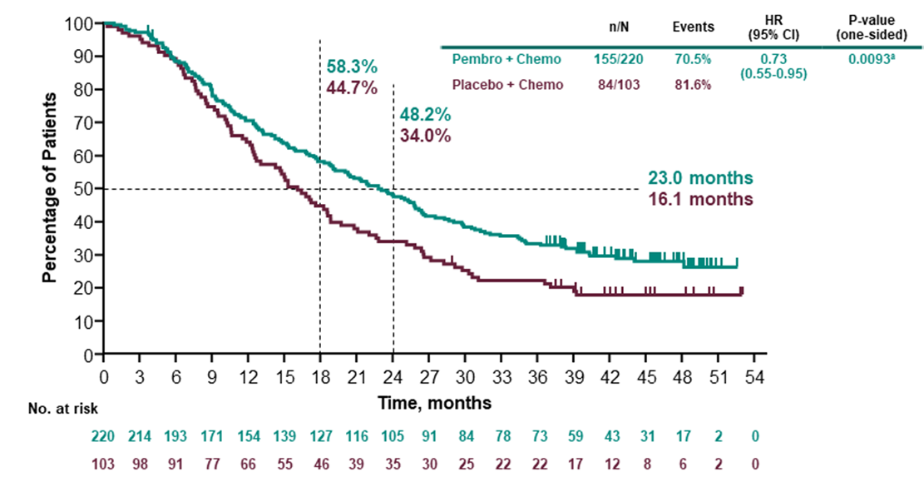
Source: Figure 2.5.1, 45 of the PBAC submission
Figure 2 presents the Kaplan Meier curves for OS in the ITT population in KN-355.
Figure 2: KM Curve of overall survival for pembrolizumab + chemotherapy vs placebo + chemotherapy (all comers) (KN355)
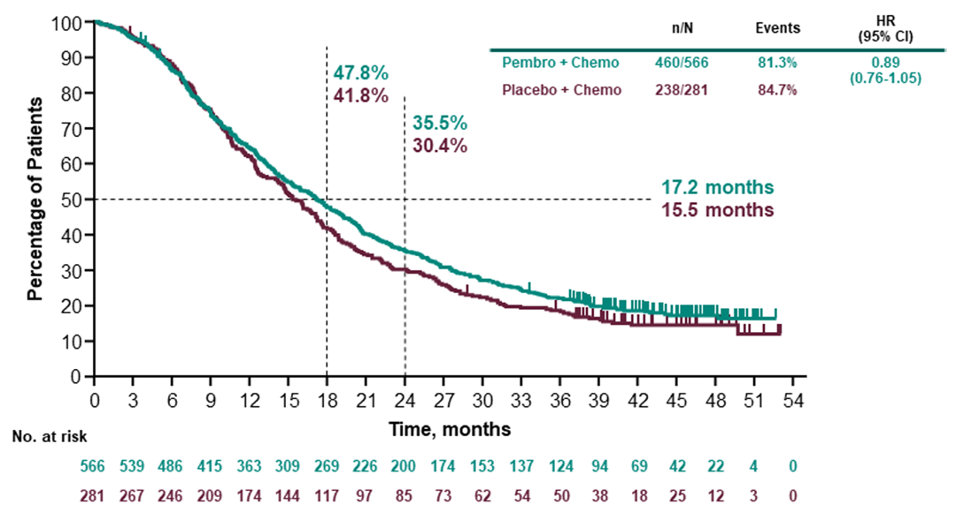
Source: Figure 2.5-3, p46 of the PBAC submission.
The Kaplan Meier curves for PFS in patients with CPS ≥10 from the final analysis are presented in Figure 3.
Figure 3: KM Curve for PFS in patients with CPS ≥ 10, final analysis KN-355
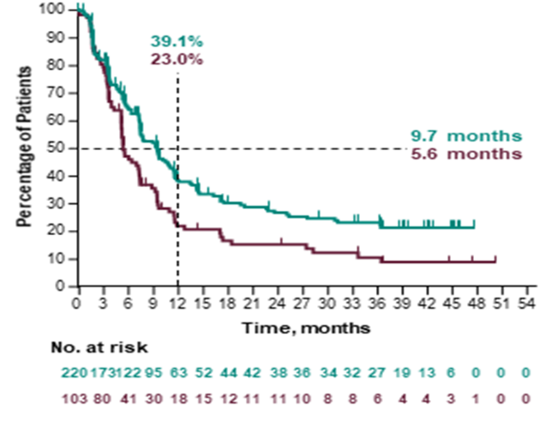
Source: Figure 2.5-5, p49 of the submission
Figure 4 presents the Kaplan Meier estimates of PFS in the ITT population at Final Analysis of KN 355.
Figure 4: Kaplan-Meier estimates of PFS in the ITT population at Final Analysis of KN 355
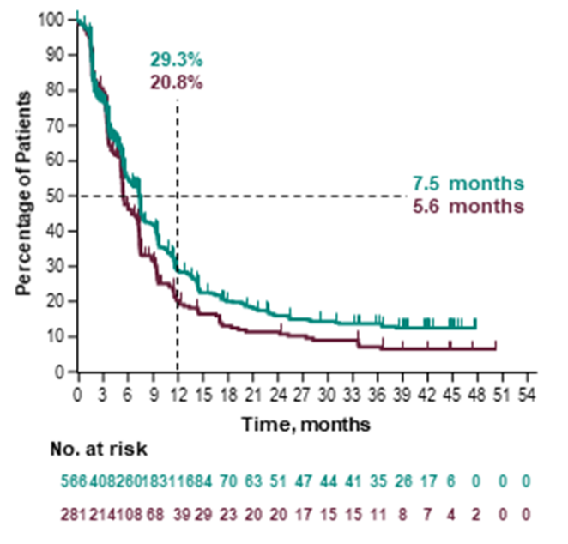
Source: Figure 2.5-6, p50 of the submission.
Table 4 presents the overall survival by subgroups in KN-355.
Table 4: Analysis of Overall survival subgroups (intention to treat population)
 | Pembrolizumab + Chemotherapy |  |  | Placebo + Chemotherapy |  |  | Pembrolizumab + Chemotherapy vs. Placebo + Chemotherapy
Overall Survival | N^{b} | Participants  with Event n (%) | Median  Time^{c} in Months  [95 %-CI] | N^{b} | Participants  with Event n (%) | Median  Time^{c} in Months [95 %-CI] | Hazard Ratio  [95 %-CI]^{d} | p-Value for  Interaction Test^{e}
PD-L1 CPS 1 Cut-off
CPS ≥ 1 | 425 | 336 (79.1) | 17.6 [15.5; 19.5] | 211 | 177 (83.9) | 16.0 [12.8; 17.4] | 0.86 [0.72; 1.04] | 0.523
CPS <1 | 141 | 124 (87.9) | 16.2 [13.8; 20.1] | 70 | 61 (87.1) | 14.7 [9.8; 19.8] | 0.97 [0.72; 1.32]
PD-L1 CPS 10 Cut-off
CPS ≥ 10 | 220 | 155 (70.5) | 23.0 [19.0; 26.3] | 103 | 84 (81.6) | 16.1 [12.6; 18.8] | 0.71 [0.54; 0.93] | 0.022
CPS < 10 | 346 | 305 (88.2) | 14.7 [13.3; 17.0] | 178 | 154 (86.5) | 15.2 [12.6; 17.4] | 1.04 [0.85; 1.26]
PD-L1 CPS 20 cut-off
CPS ≥ 20 | 140 | 99 (70.7) | 24.0 [19.0; 28.3] | 64 | 51 (79.7) | 15.6 [12.3; 20.8] | 0.72 [0.51; 1.01] | 0.133
CPS < 20 | 426 | 361 (84.7) | 15.9 [13.9; 17.7] | 217 | 187 (86.2) | 15.5 [12.6; 17.6] | 0.96 [0.80; 1.14]
Source: Table 2.6.1, p75 of the submission.
CI = confidence interval; CPS = combined positive score
ª Database Cut-off Date: 15JUN2021
^{b} Number of participants: intention-to-treat population
^{c} From product-limit (Kaplan-Meier) method for censored data
^{d} Based on Cox regression model with treatment as a covariate using Wald confidence interval
^{e} Based on Cox model with treatment and subgroup as covariates, and treatment-by-subgroup interaction (p-value of likelihood ratio test for interaction term)
The subgroup analysis reported CPS ≥20 as not statistically significant (OS HR 0.72, 95%CI 0.51, 1.01). The submission considered that there is a treatment effect modification for CPS ≥10 compared to CPS <10, but there was no significant interaction for CPS ≥1 compared to CPS <1, or for CPS ≥20 compared to CPS <20.
The submission concluded that this was strong evidence that the PD-L1 test is required to obtain a statistically significant overall survival benefit with pembrolizumab in TNBC, and that the most appropriate threshold is CPS ≥10. The submission considered the appropriateness of the CPS ≥10 cut point was further supported by subgroup analysis that showed a similar magnitude of survival benefit was apparent in the CPS 10-19 population and the CPS ≥20 group, but there was no evidence of a survival benefit in the CPS <1 and CPS 1-9 groups, despite the latter two subgroups being of sufficient size (CPS <1 n=141; CPS 1-9 n=205). The submission considered that this indicated that the CPS ≥10 survival benefit is driven by both the CPS 10-19 group, as well as the CPS >20 group, not by CPS >20 alone.
The Kaplan Meier curves for the CPS <10 subgroup were provided in the PBAC PSCR and are show in Figure 5.
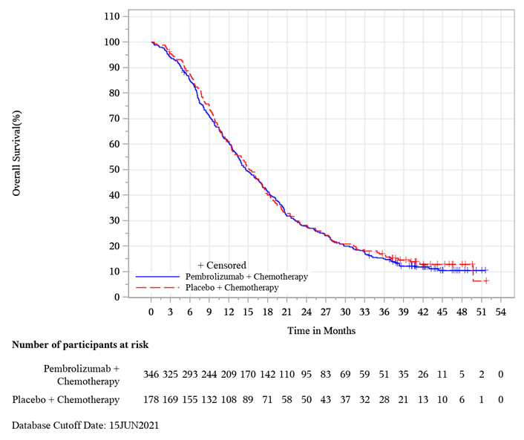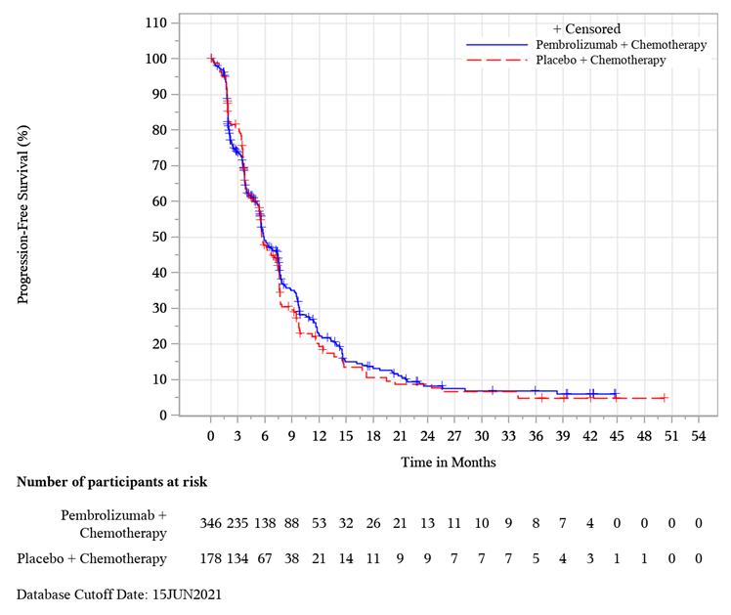
Figure 5: Kaplan-Meier Estimates of OS (left) and PFS (right) in the CPS<10 population
Source: PBAC PSCR Attachment 2
Given the statistically significant test for treatment effect modification between the CPS ≥10 and CPS <10 subgroups and the lack of a statistically significant difference in treatment effect for pembrolizumab in the CPS <10 subgroup, the PBAC ESC agreed with the commentary that the submission’s request for treatment in the CPS ≥10 subgroup may be reasonable, noting there remained a potential for bias in terms of the statistical analysis.
Clinical claim
The PBAC submission claimed that pembrolizumab + chemotherapy has superior efficacy and an inferior, but manageable safety profile compared with chemotherapy alone in metastatic TNBC patients whose tumours express PD-L1 at a threshold of CPS ≥10.
The submission considered the codependency between PD-L1 expression at the CPS ≥10 threshold and treatment benefit from pembrolizumab was demonstrated as the KN355 trial did not demonstrate a benefit of adding pembrolizumab to chemotherapy in the PD-L1 CPS <10 population or the ITT population.
The submission considered the codependency between PD-L1 expression and treatment benefit from pembrolizumab in TNBC was consistent with MSAC’s previous acceptance of the codependency between PD-L1 expression and atezolizumab in TNBC (Application 1570).
The clinical claim that pembrolizumab has superior effectiveness in the CPS ≥10 subgroup appeared to be supported. Given the lack of benefit in the ITT and CPS <10 population, MSAC is asked to consider whether PD-L1 IHC is essential for determining eligibility to pembrolizumab therapy for advanced TNBC.

13. Economic evaluation
The submission presented a cost utility analysis. Table 5 presents key components of the economic evaluation.
Table 5: Key components of the economic evaluation
Component | Summary
Treatments | Pembrolizumab + chemotherapy vs. chemotherapy
Time horizon | 15 years in the model base-case  Sensitivity analysis considers a time horizon of 12 and 17 years
Outcomes | QALY and LY
Methods used to generate results | Partitioned survival analysis
Health states | Progression free (PF), Progressive disease (PD) and death
Cycle length | 1 week, with half-cycle correction
Allocation to health states | Determined by PF and Overall Survival (OS) curves from KN355
Extrapolation method | PFS and OS beyond the trial period was extrapolated using Log normal extrapolation for the pembrolizumab OS arm and log-logistic extrapolations for chemotherapy PFS and OS curves. The submission claimed that proportional hazard assumption was not supported due to the overlapping log-cumulative Hazard and Schoenfeld residual plots and therefore extrapolation of OS was conducted independently for pembrolizumab and chemotherapy. The selection of OS and PFS extrapolation method was based on goodness of fit and clinical plausibility
Health related quality of life | EQ-5D scores from KN355 were used to derive utility estimates based on an Australian scoring algorithm  PF health state utility: 0.790 for both arms  PD health state utility: 0.703 for both arms  AE disutility: -0.023
Discount rate | 5% per annum for cost and effectiveness. Inappropriately applied from cycle 1 onwards.
Software | Microsoft Excel
Source: Table 3.1-1, p82 of the PBAC submission.
AE = adverse event; LYG = life-year gained; PF = progression free; PD = progressive disease; QALY = Quality-adjusted life year
Although eligible patients require their condition to express PD-L1 with a CPS ≥10 as determined by a validated test, a test-treat model structure (where false positives and false negatives are explicitly modelled) was not adopted for this economic evaluation. The submission’s modelling approach was consistent with the streamlined co-dependent pathway and consistent with advice provided by the Department.
Acknowledging the complexities of a test-treat model, the commentary considered such a model would be more informative in assessing the uncertainties regarding PD-L1 testing in the Australian context, and how they might affect modelled long-term treatment effect of pembrolizumab. The lack of consideration for false (positive and negative) results likely favoured treatment with pembrolizumab + chemotherapy.
Table 6 presents the results of the economic evaluation. The PBAC ESC advice considered that the incremental cost-effectiveness ratio (ICER) presented in the submission was likely underestimated. The PBAC ESC noted that multivariate analysis addressing these issues increased the ICER from $55,000 to < $75,000 to $55,000 to < $75,000 per QALY gained (22.7%).
Table 6: Results of the economic evaluation (discounted)
Component | Pembrolizumab + chemo | Chemo | Increment
Costs | $| | $55,139 | $|
LYs | 2.75 | 2.04 | 0.71
Cost/LYG |  |  | $ | /LYG ¹
QALYs | 2.10 | 1.52 | 0.57
Incremental cost/extra QALY gained |  |  | | ¹
Source: Table 3.8-4, p123 and Table 3.8-5, p124 of the PBAC submission.
LY= Life year; LYG = Life years gained; QALYs = Quality-adjusted life year.
The redacted values correspond to the following ranges:
¹ $55,000 to < $75,000

14. Financial/budgetary impacts
The financial implications to the MBS resulting from the proposed listing PD-L1 IHC for TNBC are summarised in Table 7. The MSAC submission estimated a small financial impact to the MBS. However, these figures could not be verified in the financial estimates spreadsheet. Correcting the calculations did not meaningfully change the financial implications to the MBS.
Table 7 Net financial implications of PD-L1 testing to the MBS
Parameter | 2023 | 2024 | 2025 | 2026 | 2027 | 2028
MSAC submission
Total MBS services – PD-L1 testing | || ¹ | || ¹ | || ¹ | || ¹ | || ¹ | ||| ¹
Cost to MBS (80% benefit) | || ² | || ² | || ² | || ² | || ² | ||| ²
Financial estimates spreadsheet (advanced TNBC)
Incident de-novo mTNBC | || ¹ | || ¹ | || ¹ | || ¹ | || ¹ | ||| ¹
Incident recurrent unresectable TNBC | || ¹ | || ¹ | || ¹ | || ¹ | || ¹ | ||| ¹
Prevalent mTNBC | || ¹ | || ³ | || ³ | || ³ | || ³ | ||| ³
Total eligible for testing | || ¹ | || ¹ | || ¹ | || ¹ | || ¹ | ||| ¹
PD-L1 testing uptake (95%) | || ¹ | || ¹ | || ¹ | || ¹ | || ¹ | ||| ¹
MBS services (PD-L1 testing only) | ||¹ | || ¹ | ||¹ | || ¹ | || ¹ | ||| ¹
Cost to MBS | || ² | || ² | || ² | || ² | || ² | ||| ²
Cost to MBS (corrected) | || ² | || ² | || ² | || ² | || ² | ||| ²
Source: Table 2, p5 of the submission, and the financial estimates spreadsheet (KN355 mTNBC UCM)
MBS = Medicare Benefits Schedule; TNBC = triple negative breast cancer
The redacted values correspond to the following ranges:
¹ 500 to < 5,000
² $0 to < $10 million
³ < 500

15. Other relevant information
Nil.

16. Applicant comments on MSAC’s Public Summary Document
MSD is pleased that the MSAC reviewed this application via the streamlined pathway and have agreed that PD-L1 testing has a role in mTNBC in identifying which patients are appropriate for pembrolizumab.

17. Further information on MSAC
MSAC Terms of Reference and other information are available on the MSAC Website: visit the MSAC website

