MSAC Application 1725
Transanal total mesorectal excision (taTME) for the treatment of rectal cancer and benign disease

PICO Confirmation

Summary of PICO criteria to define question(s) to be addressed in an Assessment Report to the Medical Services Advisory Committee (MSAC).
Table 1 PICO for transanal total mesorectal excision (taTME) in rectal cancer and benign disease
Component | Description
Population | Patients with low rectal cancer and benign rectal lesions. This population comprises the following subpopulations:  - patients with low rectal cancer and difficult pelvic anatomy undergoing surgery  - selected cases of patients with benign rectal lesions or non-oncological indications undergoing surgery.
Intervention | Transanal total mesorectal excision (taTME)
Comparator/s | Standard rectal cancer surgery (i.e. abdominal approach alone), including:  - open total mesorectal excision (TME)  - laparoscopic TME  with or without robotic assistance.
Outcomes | Outcomes applicable to subpopulation a only:  Oncological outcomes:  - progression-free and overall survival  - cancer recurrence (local or distant)  - resection margins (i.e. completeness of TME)  Outcomes applicable to subpopulations a and b:  Effectiveness outcomes  Operative outcomes:  - reconstruction rates  - conversion (to open surgery) rates  Function/quality of life outcomes:  - physical function  Safety outcomes  Operative outcomes:  - anastomotic leak  - perioperative survival  - surgical site infection  - stoma rates and complications  - other adverse events  Function/quality of life outcomes:  - sexual function  - bladder function  - faecal incontinence  - faecal urgency  Healthcare system outcomes:  - costs associated with intervention and comparator procedures  - costs associated with adverse events for intervention and comparator
Assessment question | What is the safety, effectiveness and cost-effectiveness of taTME versus standard rectal cancer surgery in patients with low rectal cancer and difficult pelvic anatomy undergoing surgery and selected cases of patients with benign rectal lesions undergoing surgery?
Abbreviations: taTME = transanal total mesorectal excision, TME = total mesorectal excision

Purpose of application
An application requesting Medicare Benefits Schedule (MBS) listing of transanal total mesorectal excision (taTME) for the treatment of rectal cancer and benign disease was received from the Colorectal Surgical Society of Australia and New Zealand (CSSANZ) by the Department of Health.
The Colorectal Surgery Clinical Committee (the Committee) of the MBS Review Taskforce recommended the creation of 4 new items for the abdominal component of taTME and 3 new items for the perineal component of taTME (Medicare Benefits Schedule Review Taskforce 2019). The applicant noted that the creation of these new MBS items is necessary to acknowledge the technical complexity and dual-surgeon approach to this procedure (Applicant 2022a).
The applicant claims that taTME can facilitate improved precision in total mesorectal excision (TME) surgery in patients with difficult to access tumours and facilitate reconstruction in selected patients where it would otherwise be impossible (Applicant 2022b). Based on further clarification by the applicant, the clinical claim can be summarised as follows:
Patients with low rectal cancer and difficult pelvic anatomy undergoing surgery:

Safety
- Compared to standard rectal cancer surgery the proposed intervention (taTME) has superior operative outcomes.
- Compared to standard rectal cancer surgery the proposed intervention (taTME) has noninferior functional outcomes.

Effectiveness
- Compared to standard rectal cancer surgery the proposed intervention (taTME) has superior operative outcomes.
- Compared to standard rectal cancer surgery the proposed intervention (taTME) has noninferior or equivalent oncological outcomes.
- Compared to standard rectal cancer surgery the proposed intervention (taTME) has noninferior functional outcomes.

Selected cases of patients with benign rectal lesions or non-oncological indications undergoing surgery:
Safety
- Compared to standard rectal cancer surgery the proposed intervention (taTME) has superior operative outcomes.
- Compared to standard rectal cancer surgery the proposed intervention (taTME) has noninferior functional outcomes.

Effectiveness
- Compared to standard rectal cancer surgery the proposed intervention (taTME) has superior operative outcomes.
- Compared to standard rectal cancer surgery the proposed intervention (taTME) has noninferior functional outcomes.

PICO criteria

Population
The applicant proposes that the population for this application is patients with low rectal cancer and benign rectal lesions. This population comprises the following subpopulations:
- patients with low rectal cancer and difficult pelvic anatomy undergoing surgery
- selected cases of patients with benign rectal lesions undergoing surgery

Subpopulation a: patients with low rectal cancer and difficult pelvic anatomy undergoing surgery
Colorectal cancer (CRC) is a serious and fatal disease. Globally, CRC is the third most commonly diagnosed cancer, with an estimated number of cases exceeding 1.9 million in 2020 (Rawla, Sunkara & Barsouk 2019; World Health Organisation 2020). In Australia, CRC was the third most commonly diagnosed cancer in 2018 and was the second most common cause of cancer death in 2020 (Cancer Australia 2022). Furthermore, approximately 15,610 new cases of CRC were diagnosed in Australia in 2018, with 7,120 of cases being female and 8,490 of cases being male (Cancer Australia 2022). Between 2014 and 2018, the five-year survival rate of CRC was 71% across the Australian population (Cancer Australia 2022).
Multiple risk factors have been identified that are believed to play a role in the development of CRC. Factors that may increase the risk of CRC include (i) personal and family medical history, that is, previous personal or familial cancer diagnoses, inflammatory bowel disease, a history of colon polyps, diabetes mellitus or cholecystectomy; (ii) lifestyle factors, that is, increased body weight, sedentary lifestyle and lack of physical activity, smoking, excessive alcohol consumption and dietary patterns (i.e. diet high in processed and red meat; low in fibre, vegetables, fruit, calcium and dairy products, and vitamin D); (iii) other risk factors, that is, age, race, gender, gut microbiota and socioeconomic factors (Sawicki et al. 2021).
CRC is diagnosed after the onset of symptoms or via the use of various screening modalities in non-symptomatic patients. Symptoms of CRC may include (Macrae, Parikh & Ricciardi 2022):
- change in bowel habits and appearance of stool (e.g. diarrhoea, constipation)
- blood in the stool or urine
- persistent abdominal/anal/rectal pain
- rectal or abdominal mass
- weight loss
- fatigue.
Various screening tools exist to detect and diagnose CRC and other precancerous or benign rectal lesions. Polyps are the precancerous stage of CRC. If left untreated, polyps may mutate and become cancerous via 3 molecular pathways (Parkin, Bell & Mirbagheri 2018): (i) the adenoma-carcinoma pathway (APC gene mutation); (ii) the serrated pathway (KRAS mutation, BRAF mutation); (iii) the familial pathway (e.g. Lynch syndrome, familial adenomatous polyposis) (Parkin, Bell & Mirbagheri 2018). Currently, screening is undertaken using non-invasive stool-based testing, which may include the faecal occult blood test, faecal immunochemical test or guaiac faecal occult test (Macrae, Parikh & Ricciardi 2022). These stool-based tests seek to determine whether microscopic amounts of blood exist in the stool (Parkin, Bell & Mirbagheri 2018). These are first-line tests, with most guidelines suggesting initiation of screening at age 50 unless the individual has a familial history of CRC, inflammatory bowel disease or other risk factors predisposing them to an increased risk of CRC (Macrae, Parikh & Ricciardi 2022). Where symptoms are experienced or blood is detected in a patient’s stool, the patient is advised to visit a general practitioner (GP) who will collect the medical and familial history, conduct a physical examination and provide a referral to a gastroenterologist or colorectal surgeon.
Diagnosis of CRC is most commonly made from a histologic specimen obtained via biopsy through endoscopy of the lower gastrointestinal (GI) tract (Macrae, Parikh & Ricciardi 2022). Once CRC is suspected, patients will undergo additional testing including endoscopy (i.e. colonoscopy, flexible sigmoidoscopy) to visualise, biopsy and remove lesions (Macrae, Parikh & Ricciardi 2022). If colonoscopy is incomplete or not indicated, patients may undergo a computed tomography (CT) colonoscopy for primary or further inspection (Macrae, Parikh & Ricciardi 2022). Where appropriate, a doctor may order additional laboratory tests to investigate tumour markers (e.g. carcinoembryonic antigen, cancer antigen 19-9) or complete blood count (Macrae, Parikh & Ricciardi 2022).
Upon completion of histological examination, a diagnosis of CRC will be confirmed or denied. Differential diagnoses other than CRC may also be possible due to the broad variety of signs and symptoms that may be experienced (Macrae, Parikh & Ricciardi 2022). For example, other forms of benign or malignant disorders may be uncovered. If CRC is confirmed, the local and distant extent of disease spread is established in a process commonly known as ‘staging’ (Macrae, Parikh & Ricciardi 2022). Staging allows for the most appropriate treatment to be determined and provides patients with an accurate prognosis (Macrae, Parikh & Ricciardi 2022). The tumour, node, metastasis (TNM) staging system is the most commonly used staging system for CRC (see Table 2). Additional clinical staging will occur prior to surgery to develop an in-depth surgical plan and plans for any additional treatments as necessary (Macrae, Parikh & Ricciardi 2022). These tests may include physical examination, positron emission tomography (PET) and/or CT scan of the chest/abdomen/pelvis, and magnetic resonance imaging (MRI) of the pelvis (Expert Colorectal Surgeon 2022; Macrae, Parikh & Ricciardi 2022).
Table 2 Colorectal cancer (CRC) staging
TNM | Tumour Extent | 5-year Survival
Stage I | Invasion submucosa T1 | 85–95%
 | Invasion muscularis propria T2
 | No nodal involvement, no distant metastasis
Stage II | Invasion outside muscularis propria T3 | 60–80%
 | Invasion visceral peritoneum T4a
 | Invasion other organs T4b
 | No nodal involvement, no distant metastasis
Stage III | 1–3 lymph nodes involved N1 | 30–60%
 | >3 N2
Stage IVa | Distant metastasis in 1 organ M1a | <10%
Stage IVb | Distant metastasis in >1 organ M1b | <10%
Stage IVc | Metastasis to the peritoneum with or without distant organ involvement | <10%
Abbreviations: TNM = tumour, node, metastasis
Notes: TNM 8th edition
Source: Content sourced and reproduced from Boone, Plumb and Taylor (2021)
Clinical staging, particularly involving the use of MRI, is crucial in the development of a treatment plan for CRC. MRI allows for assessment of the extent of circumferential resection margin (CRM) involvement, with much involvement likely if a tumour lies within 1 mm of the mesorectal fascia (Boone, Plumb & Taylor 2021). MRI will typically stratify rectal tumours into 3 groups: (i) high-risk tumours that will likely have CRM involvement after surgery; (ii) moderate-risk tumours that are unlikely to threaten the CRM; (iii) low-risk tumours (Boone, Plumb & Taylor 2021). High-risk tumours typically require preoperative downstaging with chemoradiotherapy before surgery can be undertaken (Boone, Plumb & Taylor 2021). Patients with moderate-risk tumours will usually undergo surgery, supplemented by neoadjuvant chemoradiotherapy (Boone, Plumb & Taylor 2021). Those with low-risk tumours will typically undergo surgery without the need for chemoradiotherapy (Boone, Plumb & Taylor 2021).
Surgery is the only curative treatment for CRC; most patients undergo surgery. Depending on the stage, size and location of the tumour, CRC can be removed via local or radical excision (Bleday, Ronald; & Shibata, David. 2022). Local excision is typically performed via a transanal approach. Radical excision is performed via a transabdominal approach by implementing a low anterior resection (LAR, also sphincter sparing) or an abdominoperineal resection (APR) (Bleday, Ronald; & Shibata, David. 2022). The aim of these surgical procedures is to remove the portion of the rectum (or whole rectum) where the tumour lies, a margin of healthy tissue around it and the mesorectum (Bleday, Ronald; & Shibata, David. 2022). To facilitate reconstruction in those with low rectal cancer, LAR can be executed with or without TME or taTME.
Neoadjuvant chemoradiotherapy may be used to shrink the tumour and reduce spread of disease prior to surgery depending on its stage, location and size. To prevent the spread of disease, adjuvant chemoradiotherapy may also be implemented after surgery.
It is important to note that certain early-stage tumours (i.e. T1 or T2) can be treated via local resection alone (Ryan & Rodriguez-Bigas 2022). This is performed using transanal endoscopic microsurgery (TEM) to remove the cancerous tumour (Ryan & Rodriguez-Bigas 2022). According to Ryan and Rodriguez-Bigas (2022), tumours with the following features are suitable for local excision:
- superficial T1 cancer, limited to the submucosa
- no radiographic evidence of metastatic disease to regional nodes
- tumour <3 cm in diameter
- low risk of developing positive regional nodes (well-differentiated, no lymphovascular or neural invasion)
- involves <30% of the circumference of the lumen
- mobile, nonfixed
- margins clear (>3 mm)
- compliance with appropriate postoperative surveillance.
Although meeting the features listed above, a decision must still be made by the multidisciplinary management team (e.g. surgeons, radiation oncologists, medical oncologists) as to whether local excision is the best treatment option. A transabdominal excision may be a more suitable approach in those who are young and fit for surgery (Ryan & Rodriguez-Bigas 2022). T1 and T2 tumours not meeting the above criteria are unsuitable for local excision and are therefore candidates for radical excision (Ryan & Rodriguez-Bigas 2022).
More advanced tumours, including those staged as T3–4 or node positive, will also require the implementation of radical excision using APR alone, or LAR with or without TME or taTME to facilitate reconstruction in those with low rectal cancer (Ryan & Rodriguez-Bigas 2022). TME or taTME should be considered for all eligible patients and those who agree to radical resection via a transabdominal resection (TME) or transabdominal plus transanal resection (taTME).
Currently, TME is the gold standard procedure used in CRC. In a subset of patients, however, achieving favourable surgical outcomes with TME (particularly when conducted laparoscopically) may be more difficult due to access and angle of the anal canal and visibility of the distal margins of the tumour (De Rosa et al. 2020; Ma et al. 2016). This includes those with a narrow pelvis, obese patients, male patients and female patients with tumours that abut the vagina (Applicant 2022b; Expert Colorectal Surgeon 2022). In these patients the plane of dissection may be difficult to identify, ultimately resulting in incomplete excision and inadequate resection margins (De Rosa et al. 2020). To overcome these limitations taTME may be utilised to facilitate standard TME in cases where standard surgical techniques are too difficult due to significant technical or anatomical challenges (Cassinotti et al. 2017). Per Motson et al. (2016), taTME is thus favoured in any of the following circumstances:
- male gender
- rectal cancer <12 cm from the anal verge, including very low cancers
- narrow and/or deep pelvis
- visceral obesity and/or obesity with body mass index (BMI) >30 kg/m²
- prostatic hypertrophy
- tumour diameter >4 cm
- distorted tissue planes due to neoadjuvant radiotherapy
- impalpable, low primary tumour requiring accurate placement of the distal resection margin.

taTME is contraindicated in patients with obstructive rectal tumours and emergency presentations (Motson et al. 2016).

Subpopulation b: selected cases of patients with benign rectal lesions or non-oncological indications undergoing surgery
Selected cases of patients with benign rectal lesions, other than low rectal cancer, that require surgery will also be included in this application.
Rectal cancer can start as, or coexist with, benign lesions or tumours that can be asymptomatic, congenital and benign (Pfenninger & Zainea 2001; Sawicki et al. 2021; Shussman & Wexner 2014). These non-cancerous tumours will not metastasise to other parts of the body and thus are not life-threatening in most cases. In rare circumstances, they can turn into cancer very quickly (e.g. villous adenomas), therefore prompt surgery to remove them is usually required.
Symptoms of benign rectal lesions may include rectal bleeding, abdominal pain or change in bowel habits, such as frequency/urgency of bowel movements, constipation and faecal incontinence (Purysko et al. 2014). Diagnosis or differentiation between benign and malignant rectal tumours requires medical history review, physical examination, imaging studies and endoscopy. MRI, CT and PET scans are frequently used (Expert Colorectal Surgeon 2022); however, relatively low diagnostic accuracy has been reported when differentiating between early-stage malignant and benign tumours (Al-Najami, Mahmoud Sheta & Baatrup 2019).
Benign rectal lesions can include non-neoplastic polyps, neoplastic epithelial polyps and mesenchymal lesions (Zuber & Harder 2001). Based on the stage and location of the benign tumour, a polypectomy, local excision or TME could be performed. TME is indicated for selected cases only, particularly those not suitable for intraluminal resection (Table 3) (Expert Colorectal Surgeon 2022). Patients with other benign rectal lesions treatable or manageable by local excisions, such as hyperplastic polyps, inflammatory polyps, tubular adenomas and lipomas, are not considered in this application. Of note, TME can act as a radical surgery performed after some transanal endoscopic operation (TEO) or TEM procedures (D'Hondt et al. 2017). Thus, patients eligible for TME should also be considered within the scope of subpopulation b.
Table 3 Selected benign lesions of the rectum indicated for TME
Non-neoplastic polyps | Hamartomas (Nicoll et al. 2019; Willis et al. 2021)
Neoplastic epithelial polyps | Villous adenomas (Farag et al. 2010; Koning et al. 2008)
 | Tubulovillous adenomas (Michalik et al. 2012)
Mesenchymal lesions | Rectal hemangiomas (Wu et al. 2017)

Considering the benign nature of these tumours, traditional TME is not the optimal therapy (Dapri 2020). Instead, taTME may allow for better operative outcomes (Araujo et al. 2015; Koedam et al. 2017). While taTME has been extended to indications/pathologies other than rectal cancer, the use of taTME for benign rectal lesions is still not common. Patients with rectal cancer are the most commonly studied population for the use of taTME. In an initial study using data from the international taTME registry (Low Rectal Cancer Development Programme (LOREC): Pelican Cancer Foundation 2022), only 12% of cases (n = 86/720) were reported as benign pathology (Penna et al. 2017). In a 3-year retrospective study examining oncological outcomes of 50 patients who underwent taTME, 1 of 50 patients (2%) had benign disease (i.e. endoscopically nonresectable tubulovillous adenoma with high-grade dysplasia), which was localised mainly in the mid-low rectum (Ourô et al. 2021).
Benign conditions that may benefit from taTME include (Motson et al. 2016):
- inflammatory bowel disease requiring proctectomy
- rectal strictures
- complex fistulae
- faecal incontinence
- familial adenomatous polyposis
- radiation proctitis
- removal of orphaned rectum following colectomy or permanent colonic diversion.

PASC noted that subpopulation b is a heterogenous group, which includes a number of diseases and therefore possible comparators from an assessment perspective. The applicant confirmed that there is limited evidence available regarding subpopulation b and there is a lack of patient reported outcome measures (PROM) associated with subpopulation b.

Intervention
First described in 2010, taTME is a minimally invasive surgical (MIS) procedure used to excise CRC and benign rectal lesions (Atallah, Albert & Larach 2010; de Lacy et al. 2013). taTME is proposed as a replacement to standard rectal surgery and is performed as an in-hospital procedure under general anaesthetic, typically by 2 colorectal surgeons trained in the technique.

Description of the procedure
The taTME procedure includes both an abdominal phase and a transanal phase. These are typically conducted by separate surgeons, but can also be conducted in a 2-step approach by a single surgeon (Applicant 2022a). The procedural steps involved in the abdominal and transanal phases are summarised in Table 4. The abdominal phase is typically performed laparoscopically, but can also be performed with a laparotomy or robotic system (Trépanier, Lacy & Lacy 2020). The transanal phase is also performed laparoscopically or robotically with the aid of a transanal minimally invasive surgery (TAMIS) access platform. Robotic dissection is becoming the preferred method of resection if the infrastructure is available (Expert Colorectal Surgeon 2022). A contributing factor in the complexity of taTME compared to standard rectal surgery, is that it creates a new plane for the abdominal anatomy not typically seen by the treating surgeon.
It is noted that the greatest benefit of having the dual-surgeon approach is to allow better cooperation during the procedure. This is due to the ability for one surgeon to provide a guide from atop (i.e. transabdominally) as the pelvic anatomy can be difficult, particularly noting the distance from the location of resection and restoration. Prior chemoradiation may also result in scarring which can also make access more difficult. The volume of dual-surgeon operations which will be performed per year will not be particularly high. The applicant also noted that a single surgeon approach may also be performed.
PASC noted that the comparative utility of one surgeon versus two surgeons performing taTME in terms of outcomes and ease of performing the procedure. The dual-surgeon approach better facilitated cooperation during the procedure. The rationale of having the dual-surgeons approach was incorporated into the intervention section.
Table 4 Steps involved in the abdominal and transanal phases of taTME procedures
Abdominal phase | Transanal phase
- Insufflation of the pneumoperitoneum and abdominal inspection  - Division of the inferior mesenteric vessels  - Left colon mobilisation and splenic flexure takedown  - Colon clamping during transanal rectal purse-string  - Upper rectum dissection  - Specimen extraction: transabdominally or transanally  - Colorectal anastomosis  - Diverting loop ileostomy when needed | - Transanal platform insertion and pneumorectum to 12–15 mm Hg  - Purse-string distal to the rectal tumour  - Rectotomy (perpendicular rectal wall transection)  - Cephalad total mesorectal excision dissection  - Specimen extraction  - Anastomosis (either stapled or hand-sewn)
Source: Content sourced and reproduced from Trépanier, Lacy and Lacy (2020)

Depending on the size and location of the tumour, taTME incorporating an LAR, restorative proctocolectomy, an APR or pan-proctocolectomy may be performed. These techniques are briefly outlined below.
LAR – LAR involves the total or partial resection of the rectum, followed by a colorectal or coloanal anastomosis to ensure continuity of the intestine (Bleday, Ronald & Shibata, David 2022).
Restorative proctocolectomy – Restorative proctocolectomy involves the total resection of the colon and rectum, followed by a colorectal or coloanal anastomosis to ensure continuity of the intestine (Fichera 2022).
APR – APR involves the total resection of the sigmoid colon, rectum and anus, followed by construction of a permanent colostomy (Bleday, Ronald & Shibata, David 2022).
Pan-proctocolectomy – Pan-proctocolectomy involves the total resection of the colon, rectum and anus. A permanent ileostomy is also established (Wirral Surgeon NR).

Hardware requirements
Conducting a taTME procedure requires single- and multi-use consumables currently used in MIS for rectal cancer using standard approaches. With multiple surgeons involved, duplicate MIS equipment may be required. In addition to standard surgical equipment, a TAMIS access platform is necessary for the transanal component of the operation (Hong et al. 2015). This is a consumable device that inserts into the anus and is used to stabilise and secure laparoscopic equipment. The list of consumables and equipment for taTME has been reported in various publications (usage of specific equipment may be subject to change as the technologies are being updated frequently). A recent published study reported a full list of consumables and equipment involved in taTME (Trépanier, Lacy & Lacy 2020); specific usage can be sourced for conducting health economic modelling during the evaluation phase.

Training and accreditation requirements
taTME is a complex procedure with a significant learning curve, which carries a risk of urethral, pelvic side wall and nerve injury (Lacy et al. 2015; Veltcamp Helbach et al. 2016). As such, colorectal surgeons conducting taTME require a high degree of training and competency to perform the procedure safely (Costedio 2021). The applicant recommends that conducting taTME procedures is limited to surgeons and centres with a relatively high volume of rectal cancer surgery and sufficient taTME surgery, noting that what constitutes “a relatively high volume” has not been defined (Applicant 2022a).
Current consensus statements suggest that colorectal surgeons should have performed a minimum of 10 laparoscopic TME procedures and have experience with transanal surgery before beginning training to conduct taTME (Costedio 2021). While not specific to taTME, in 2009 the CSSANZ recommended surgeons intending to conduct TEM complete a training certificate, assist in 5 procedures, perform 5 procedures under the supervision of a TEM-accredited surgeon and conduct at least 5 cases per year with prospective auditing of outcomes in order to maintain skills (Slack, Wong & Muhlmann 2014). More recent recommendations from CSSANZ are unavailable. Currently, there are no standardised requirements or governing bodies overseeing credentials related to performing taTME procedures in Australia, although training workshops have been available since 2015 (Abbott et al. 2018) and are typically run twice a year (Bell & Stevenson 2020). The workshops are offered to surgeons who have conducted specialised Post Fellowship training in colorectal surgery, have independently conducted 200 laparoscopic colonic resections, 50 laparoscopic rectal resections and 10–20 transanal MIS cases, and have sufficient ongoing case volume (Abbott et al. 2018). Each participant is offered the opportunity to undertake 2 formative, proctored cases after the workshop. The workshop and proctored cases are supported by industry (Abbott et al. 2018).
PASC noted that taTME was a technically challenging form of surgery and was associated with a potentially high risk of complications.
PASC noted that there are currently no standardised training requirements or credentialing in place for surgeons to become qualified in performing taTME, although surgeons were typically required to be experienced in conducting transanal surgery before beginning training to perform taTME. PASC noted that proctorship is an important component in achieving competency in performing taTME. A fellowship model is an alternative training model that involves a surgeon visiting a centre that performs taTME frequently to receive training. In both training models, there is also a need for ‘observership’ in the learning pathway. PASC suggested that training and proctoring programmes should be supervised by the relevant specialist college.
PASC noted the volume of procedures that will need to be undertaken to achieve competency and to maintain competency. PASC noted that consensus statements recommend that in general, a surgeon should be required to perform a minimum of 10 taTME cases to achieve competency. It is recommended that a surgeon should undertake 5 taTME cases each year to maintain competency annually, on the proviso that the surgeon is also performing other anal surgeries on a regular basis. PASC noted that the relative infrequency of taTME procedures has created challenges in ensuring that surgeons are able to undertake the minimum volume of procedures to achieve and maintain competency.
PASC noted that it may be useful to create a taTME database where cases and outcomes must be submitted upon performing the procedure. The applicant agreed that a database which registered basic outcomes, including interoperative success, complications and pathological data, would be of particular interest.
PASC noted a credentialing committee should be established and it may be useful to include this as a condition of the MBS listing. Surgeons should be required to present taTME cases and outcomes to the committee on an annual basis. The committee may need to be organised and supported by a relevant specialist college. The applicant agreed with this point.

Reimbursement status
taTME could be claimed through existing MBS items for rectal surgery (items 32026, 32028) that involve ultra-low anterior resection, or ultra-low anterior resection with coloanal or handsewn anastomosis. The current application proposes seven new taTME-specific MBS items to cover the increased complexity and dual-surgeon requirements compared to standard surgery.

Estimated usage
The applicant suggests that taTME is a niche procedure used only for cases where standard surgical techniques are too difficult due to significant technical or anatomical challenges. The applicant estimates that taTME would be used for 5–10 cases per centre with the expertise to deliver this service in the first full year after MBS listing (Applicant 2022b). This is an uncertain estimate. A small case series of 8 surgeons from 12 institutions between 2015 and 2017 reported 133 cases had been undertaken, or an average of 44 cases per year (range 1–15 cases per surgeon per year) (Abbott et al. 2018). As of 2020, more than 130 surgeons had completed taTME training in Australia (Bell & Stevenson 2020). The current number of trained surgeons is unknown but likely to be higher. Given the recommended requirement for surgeons to maintain minimum caseloads for maintaining taTME accreditation, it is likely that the estimated uptake of the procedure is higher than that estimated by the applicant.

Comparator(s)
For patients with rectal cancer, the applicant has stated that standard rectal cancer surgery is the comparator to taTME (Applicant 2022a).
Standard rectal cancer surgery may include (Bleday, Ronald & Shibata, David 2022):
- local excision
- radical transabdominal resection (i.e. LAR or APR)
- multivisceral resection.
These are mutually exclusive procedures. Each of these surgical techniques is briefly outlined below (Bleday, Ronald & Shibata, David 2022).
Local excision – Local excision aims to remove the tumour and surrounding rectal tissue as a single specimen via a transanal approach. Local excision is typically only performed for early stages of rectal cancer (T0 or T1) where lymph node metastasis is of low risk.
Radical transabdominal resection – Patients with invasive rectal cancer are candidates for radical transabdominal surgery. If negative distal margins are achievable, LAR should be performed to spare the sphincter. As aforementioned, LAR involves the total or partial resection of the rectum, followed by a colorectal or coloanal anastomosis to ensure continuity of the intestine. In contrast, an APR is necessary if adequate distal margins cannot be achieved. APR involves the total resection of the sigmoid colon, rectum and anus, followed by construction of a permanent colostomy. For LAR, it is also critical to perform a TME and lymph node resection.
Multivisceral resection – Multivisceral resection is necessary for the curative resection of T4 rectal cancer. It entails the total resection of the rectum and one or more additional pelvic organs or bony structures. The magnitude of resection will depend on the extent of disease. Where a large portion of the colon, rectum or anus is required to be removed and continuity of the intestines cannot be re-established, a permanent colostomy may be considered.
Of importance to this PICO, upon further discussion with the applicant, TME has been selected as the most appropriate comparator for taTME, which is a component of radical transabdominal resection (i.e. abdominal approach alone) (Applicant 2022b). Relevant TME techniques include:
- open TME
- laparoscopic TME
- with or without robotic assistance
TME was first introduced by Heald in 1979 and is considered to be an important milestone in the progression of rectal cancer surgery (Havenga et al. 2007). TME, characterised by the complete removal (en bloc) of the rectum and surrounding fatty tissue (mesorectum), is the gold standard procedure used in CRC (Cassinotti et al. 2017; Delibegovic 2017). The objective of TME is to remove the invading rectal tumour along with pararectal lymph nodes involved in tumour drainage (Delibegovic 2017). Another primary aim of TME is to preserve the surrounding structures, vasculature and nerves to the prostate, vagina and urinary bladder (Delibegovic 2017).
TME has been shown to result in favourable oncological outcomes, including a reduced local recurrence rate and greater 5-year survival rates (Li et al. 2018). However, as with any surgical procedure this treatment also comes with risks, most commonly anastomotic leakage, anastomotic haemorrhage, LAR syndrome and sexual dysfunction (Tang et al. 2022).
TME has become a standard component of radical surgery to treat rectal cancer. TME may be performed laparoscopically, robotically or via open surgery. The standard technique for performing TME has been the open approach (Ma et al. 2016); however, recently, TME has shifted to an MIS laparoscopic approach (Ma et al. 2016). The advantages of switching from an open approach to a laparoscopic approach include decreased wound complications and reduced need for postoperative care (Agha & Muir 2003). Furthermore, robotic dissection is increasingly becoming the preferred method of resection if the infrastructure is available (Expert Colorectal Surgeon 2022).
TME is a complex surgical procedure due to the multiple dissection planes and narrow pelvic anatomy (Expert Colorectal Surgeon 2022; Havenga et al. 2007). The utility of laparoscopic TME is limited to patients with low rectal cancer. It also requires a surgeon with extensive training and experience in the technique to ensure that positive CRMs are avoided (Ma et al. 2016). Patients with a narrow pelvis, those who are obese or overweight, and those of male sex are unfavourable for a laparoscopic approach (Ma et al. 2016). Due to limited visibility of the distal margins of the tumour, laparoscopic TME is often converted to open TME, leading to higher operative risk and less favourable patient outcomes (Ma et al. 2016).

Operative procedure
According to Weaver, Grimm and Fleshman (2015), the following steps are undertaken when performing restorative resection using TME for mid-to-low rectal tumours:
- ligation of inferior mesenteric artery at its origin
- complete mobilisation of splenic flexure
- transection of proximal left colon
- sharp dissection in avascular plane into the pelvis (anterior to presacral fascia), parietal fascia and outside the fascia propria or enveloping visceral fascia
- division of lymphatics and middle haemorrhoidal vessels anterolaterally at level of the pelvic floor
- inclusion of all pelvic fat and lymphatic material to level of the anorectal ring, or all fat and lymphatic material ≥2 cm below level of the distal margin.
As per the surgical steps listed above, the following MBS items are claimable for such a procedure and have been suggested by the applicant to be appropriate comparators for taTME:
Ultra-low restorative resection (MBS item 32026)
Rectum, ultra-low restorative resection, with or without covering stoma and with or without colonic reservoir, if the anastomosis is sited in the anorectal region and is ≤6 cm from the anal verge.
Low or ultra-low restorative resection (MBS item 32028)
Rectum, low or ultra-low restorative resection, with per anal sutured coloanal anastomosis, with or without covering stoma and with or without colonic reservoir.
It is important to note that these MBS items only encompass the restorative resection and anastomosis portion of the TME procedure.
PASC noted that for subpopulation a the appropriate comparator was TME which can be delivered through open or laparoscopic surgery and with or without robotic assistance. This can involve a low or ultra-low anterior resection using MBS items 32026 or 32028.
PASC noted for subpopulation b that because it comprises a heterogenous group undergoing treatment for a range of diseases, it may have more than one comparator from an assessment perspective.

Outcomes
As outlined by the applicant and relevant literature, the following list presents the core outcomes to assess when evaluating CRC surgery, including taTME (Applicant 2022a; McNair et al. 2016):
Outcomes applicable to subpopulation a only:

Oncological outcomes:
- progression-free and overall survival
- cancer recurrence (local or distant)
- resection margins (i.e. completeness of TME)

Outcomes applicable to subpopulations a and b:

Effectiveness outcomes

Operative outcomes:
- reconstruction rates
- conversion (to open surgery) rates

Function/quality of life outcomes:
- physical function

Safety outcomes

Operative outcomes:
- anastomotic leak
- perioperative survival
- surgical site infection
- stoma rates and complications
- other adverse events

Function/quality of life outcomes:
- sexual function
- bladder function
- faecal incontinence
- faecal urgency

Additional outcomes provided by the applicant include healthcare system costs such as those associated with the intervention and comparator procedures, including costs of appointments, preoperative assessment, surgical procedure, consumables (e.g. anaesthesia, harmonic, TAMIS platform, surgical scope), hospital stay, follow-up, monitoring and any subsequent interventions required (Applicant 2022a, 2022b). Additionally, there may be further costs associated with adverse events for the intervention and comparator (Applicant 2022a, 2022b).
It is noted that an ongoing randomised controlled trial (RCT; COLOR III, NCT02736942) comparing laparoscopic TME and TaTME will be completed in 2025. Various PICO elements of the trial are in line with this document. Upon the study completion, the result of the RCT will be able to provide sufficient data to answer the research question for this assessment.

Rationale
The applicant provided the following outcomes for the development of this PICO: completeness of TME, recurrence, survival, reconstruction rates and functional outcome (Applicant 2022a). For this PICO it was considered necessary to supplement the applicant’s outcomes with additional outcomes relevant to CRC surgery to ensure that appropriate outcomes assessed across clinical trials are captured (McNair et al. 2016).
It should be noted that oncological outcomes are only considered relevant for cancer patients. Patients with benign tumours will not be considered for oncological outcomes such as survival time and recurrence in the context of malignancy.
PASC noted that current evidence in support of taTME is restricted to observational studies from data collected from registries and there is an absence of RCT evidence. Consequently, the outcome observed from the currently available evidence may not be sufficiently robust to demonstrate superiority of the proposed technology in terms of effectiveness and safety.
PASC noted that while the scarcity of robust evidence on outcomes applies to both defined subpopulations, it is especially lacking for subpopulation b given its heterogenous cohort and the consequently very low sample sizes associated with outcome measures for groups in this subpopulation.
PASC noted that concerns associated with both effectiveness (high local recurrence rates) and safety (high incidence of urethral injuries and other morbidities during the learning curve) of taTME based on European evidence have led to a national moratorium on taTME for rectal cancer in Norway and the recommendation by the Association of Coloproctology of Great Britain and Ireland (ACPGBI) for a pause for re-evaluation and consolidation of evidence on taTME. PASC noted the applicant’s response that the European data may not be applicable to Australia due to its more rigorous proctoring and training arrangements.
PASC noted that there is an ongoing international multicentre RCT (COLOR III) and it is anticipated that the results from this trial will be highly informative to assist in assessing the effectiveness, safety and cost-effectiveness of taTME. PASC noted that the primary outcome of this trial was circumferential resection margin (CRM) while secondary outcomes included completeness of mesorectum, residual mesorectum, morbidity and mortality, local recurrence, disease-free and overall survival, percentage of sphincter-saving procedures, functional outcome and quality of life.
PASC considered that in light of the lack of robust evidence on safety and effectiveness, it may be appropriate to pause the application process until the COLOR III trial results are available. PASC noted that the Department will present this proposal to the MSAC Executive Committee for discussion and approval, and the applicant will be informed of this decision. The applicant agreed that this may be a suitable option. However PASC noted that subpopulation b will likely not be covered in the COLOR III trial.

Clinical management algorithms
Current and proposed clinical management algorithms for subpopulation a (patients with low rectal cancer and difficult pelvic anatomy undergoing surgery) and subpopulation b (selected cases of patients with benign rectal lesions undergoing surgery) are provided in Figure 1 to Figure 4.
Figure 1 Current clinical management algorithm for subpopulation a (patients with low rectal cancer and difficult pelvic anatomy undergoing surgery)
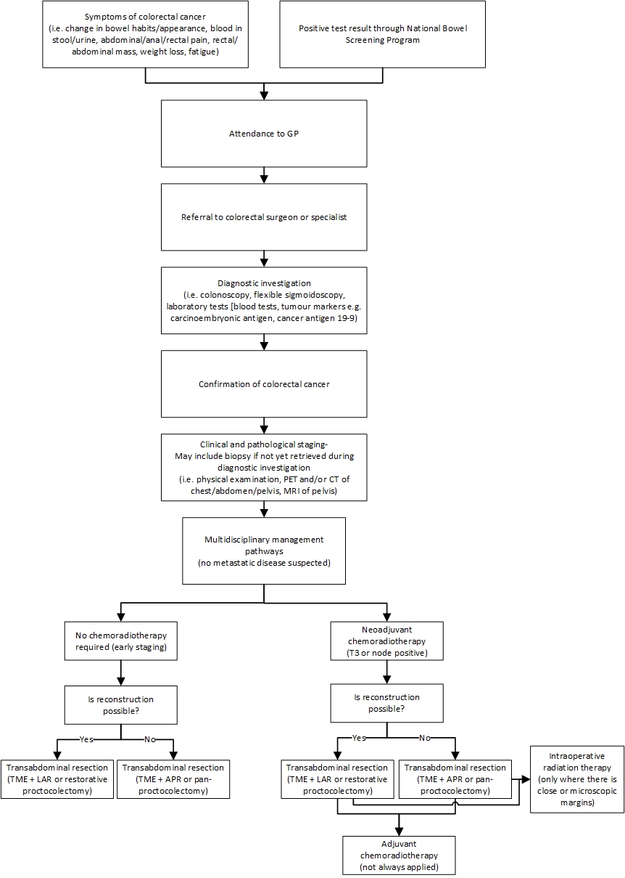
Abbreviations: APR = abdominoperineal resection, CT = computed tomography, GP = general practitioner, LAR = low anterior resection, PET = positron emission tomography, TME = total mesorectal excision
Figure 2 Proposed clinical management algorithm for subpopulation a (patients with low rectal cancer and difficult pelvic anatomy undergoing surgery)
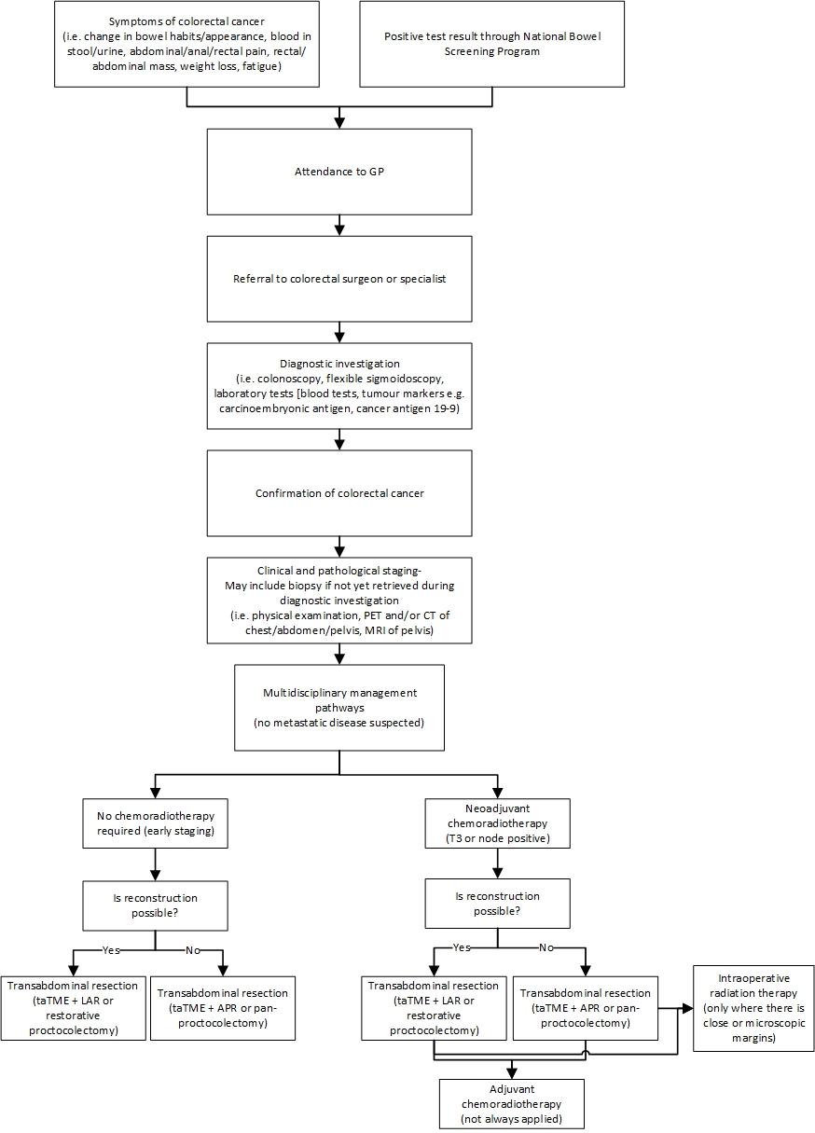
Abbreviations: APR = abdominoperineal resection, CT = computed tomography, GP = general practitioner, LAR = low anterior resection, PET = positron emission tomography, taTME = transanal total mesorectal excision
Figure 3 Current clinical management algorithm for subpopulation b (selected cases of patients with benign rectal lesions undergoing surgery)
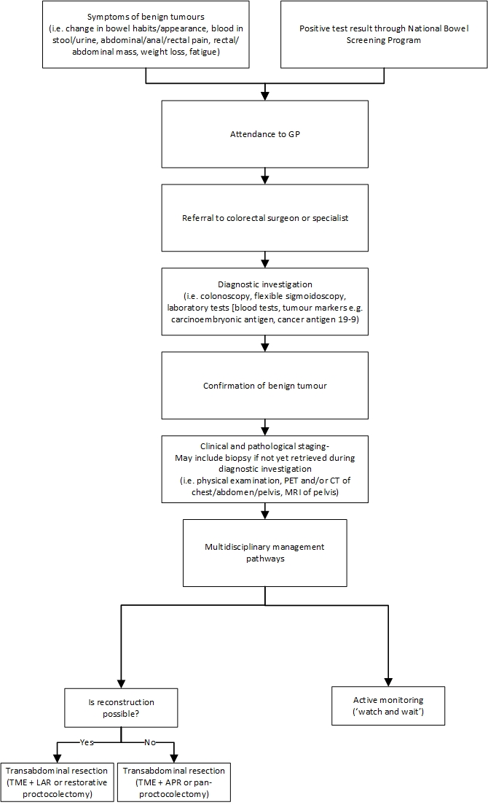
Abbreviations: APR = abdominoperineal resection, GP = general practitioner, LAR = low anterior resection, TME = total mesorectal excision
Figure 4 Proposed clinical management algorithm for subpopulation b (selected cases of patients with benign rectal lesions undergoing surgery)
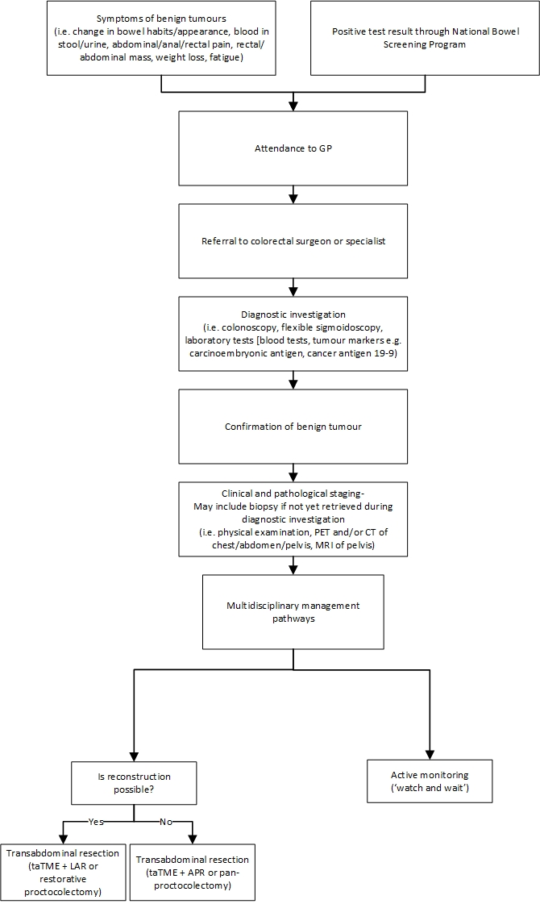
Abbreviations: APR = abdominoperineal resection, GP = general practitioner, LAR = low anterior resection, taTME = transanal total mesorectal excision

PASC agreed with the current and the proposed clinical management algorithms. No further changes were made to the clinical management algorithm in the current PICO.

Proposed economic evaluation
Based on the clinical claims provided by the applicant and considering the matrix in Table 5, the proposed economic evaluation is presented below per subpopulation:
- Patients with low rectal cancer and difficult pelvic anatomy undergoing surgery:
Safety outcomes
    - compared to standard rectal cancer surgery, TaTME has superior operative outcomes (higher reconstruction rates)
    - compared to standard rectal cancer surgery, TaTME has noninferior functional outcomes
Effectiveness outcomes
    - compared to standard rectal cancer surgery, TaTME has noninferior or equivalent oncological outcomes
    - compared to standard rectal cancer surgery, TaTME has superior operative outcomes (higher reconstruction rates)
    - compared to standard rectal cancer surgery, TaTME has noninferior functional outcomes.
Overall, the cost-effectiveness analysis (CEA) or cost-utility analysis (CUA) are required for this subpopulation.
- Selected cases of patients with benign rectal lesions undergoing surgery:
Safety outcomes
    - compared to standard rectal cancer surgery, TaTME has superior operative outcomes (higher reconstruction rates)
    - compared to standard rectal cancer surgery, TaTME has noninferior functional outcomes
Effectiveness outcomes
    - comparing to standard rectal cancer surgery, TaTME has superior operative outcomes (higher reconstruction rates)
    - comparing to standard rectal cancer surgery, TaTME has noninferior functional outcomes.
Overall, CEA and CUA are required for this subpopulation.
For subpopulation b, oncological outcomes are not considered due to the benign nature of the tumour.
Table 5 Classification of comparative effectiveness and safety of the proposed intervention, compared with its main comparator, and guide to the suitable type of economic evaluation
Comparative safety- |  | Comparative effectiveness
 | Inferior | Uncertainª | Noninferior^{b} | Superior
Inferior | Health forgone: need other supportive factors | Health forgone possible: need other supportive factors | Health forgone: need other supportive factors | ? Likely CUA
Uncertainª | Health forgone possible: need other supportive factors | ? | ? | ? Likely CEA/CUA
Noninferior^{b} | Health forgone: need other supportive factors | ? | CMA | CEA/CUA
Superior | ? Likely CUA | ? Likely CEA/CUA | CEA/CUA | CEA/CUA
Abbreviations: CEA = cost-effectiveness analysis, CMA = cost-minimisation analysis, CUA = cost-utility analysis
Notes: ? = reflects uncertainties and any identified health trade-offs in the economic evaluation, as a minimum in a cost-consequences analysis.
ª ‘Uncertainty’ covers concepts such as inadequate minimisation of important sources of bias, lack of statistical significance in an underpowered trial detecting clinically unimportant therapeutic differences, inconsistent results across trials, and trade-offs within the comparative effectiveness and/or the comparative safety considerations
^{b} An adequate assessment of ‘noninferiority’ is the preferred basis for demonstrating equivalence

PASC acknowledged that the proposed economic evaluation (cost effectiveness analysis and cost utility analysis) is reasonable in the PICO. However, PASC also noted that given the absence of high-level evidence, it may not be currently feasible to perform the proposed economic evaluation.

Proposal for public funding
The Colorectal Surgery Clinical Committee (the Committee) of the MBS Review Taskforce recommended the creation of 4 new items for the abdominal component of taTME (Table 7 to Table 10) and 3 new items for the perineal component of taTME (Table 11 to Table 13) (Medicare Benefits Schedule Review Taskforce 2019).
The applicant also noted that the creation of these new MBS items is needed to acknowledge the technical complexity and dual-surgeon approach to this procedure (Applicant 2022a). The Committee noted that a single surgeon performing a taTME procedure should claim one abdominal number and one perineal number (Medicare Benefits Schedule Review Taskforce 2019). The lesser of the 2 fees will, as per the 100:50:25 rule, be 50% of the quoted fee. Two surgeons performing synchronous taTME surgery would each claim one item number and each claim 100% of the fee (Medicare Benefits Schedule Review Taskforce 2019).
Certain claiming requirements as outlined by the Committee will also apply to the taTME items proposed (Medicare Benefits Schedule Review Taskforce 2019). The listed claiming requirements include (Medicare Benefits Schedule Review Taskforce 2019):
- for any given taTME procedure there will be 2 items claimed (1 abdominal, 1 perineal)
- 320HP and 320PC are always claimed with 320EA
- 320AR and 320TC can be claimed with either 320ST or 320HS.

This provides for six item combinations as outlined in Table 6.
Table 6 Proposed item combinations for taTME procedures
Proposed item combinations | Description of taTME procedure
320AR + 320ST | Ultra-low anterior resection with stapled anastomosis where the rectal dissection is performed by a technique involving the use of a digital viewing platform and pneumopelvis
320AR + 320HS | Ultra-low anterior resection with hand-sewn colo-anal anastomosis where the rectal dissection is performed by a technique involving the use of a digital viewing platform and pneumopelvis
320TC + 320ST | Restorative proctocolectomy with stapled anastomosis where the rectal dissection is performed by a technique involving the use of a digital viewing platform and pneumopelvis
320TC + 320HS | Restorative proctocolectomy with hand-sewn colo-anal anastomosis where the rectal dissection is performed by a technique involving the use of a digital viewing platform and pneumopelvis
320HP + 320EA | Abdomino-perineal resection of rectum and anus where the rectal dissection is performed by a technique involving the use of a digital viewing platform and pneumopelvis
320PC + 320EA | Pan-proctocolectomy where the rectal dissection is performed by a technique involving the use of a digital viewing platform and pneumopelvis via the perineal incision

The Committee derived a set of proposed taTME fees in 2016–2017, based on fees for other colorectal surgery MBS items at that time (fees available to view at Colorectal Surgery Clinical Committee Report). It has been noted that the underlying fees have increased since then (predominantly due to the application of indexation) and thus the proposed fees for taTME items require revision. Accordingly, the Department of Health has calculated a set of revised taTME fees. These revised fees are based on the same methodology used by the Committee, plus current fees for the relevant colorectal surgery MBS items (as of 1 July 2022). The revised fees, along with the proposed explanatory notes, are available in Table 7to Table 13.
The Committee further noted that, in cases where one surgeon is responsible for all aftercare of the patient, surgeons can negotiate between themselves whether the remuneration split is fair. Surgeons can reach their own financial arrangement such that one surgeon agrees to pay the other an agreed portion of the fee to reflect the share of aftercare provided (Medicare Benefits Schedule Review Taskforce 2019).
The authors propose an addition/improvement to the proposed MBS items for PICO Advisory Sub-Committee (PASC) approval. In the following MBS item boxes, the authors propose ‘transanal total mesorectal excision (taTME)’ be used as the intervention name, replacing ‘rectal resection’ as currently utilised in MBS items (e.g. item 32026 and item 32028).
Table 7 taTME abdominal component – Item 1
Category 3 – T8 Subgroup 2 (Colorectal)
MBS item 320AR
Transanal total mesorectal excision (taTME)
Trans-abdominal component of an ultra-low anterior resection where the rectal dissection is performed by a technique involving the use of a digital viewing platform and pneumopelvis (trans-anal total mesorectal excision) (H)
Multiple Operation Rule (Anaes.) (Assist)
Notes: These rectal resection procedures should be performed with the following requirements:
• in an appropriate setting with High Dependency Unit or Intensive Care Unit availability
• include multidisciplinary team discussion of patient with rectal cancer
• have patient managed using Enhanced Recovery after Surgery (ERAS) principles
• in a setting with adequate access to stomal therapy nurse services.
Additional note: Can be claimed with 320ST or 320HS
Fee: $1,442.60 Benefit: 75% = $1,081.95
Table 8 taTME abdominal component – Item 2
Category 3 – T8 Subgroup 2 (Colorectal)
MBS item 320TC
Transanal total mesorectal excision (taTME)
Trans-abdominal component of a restorative proctocolectomy where the rectal dissection is performed by a technique involving the use of a digital viewing platform and pneumopelvis (trans-anal total mesorectal excision) (H)
Multiple Operation Rule (Anaes.) (Assist)
Notes: These rectal resection procedures should be performed with the following requirements:
• in an appropriate setting with High Dependency Unit or Intensive Care Unit availability
• include multidisciplinary team discussion of patient with rectal cancer
• have patient managed using Enhanced Recovery after Surgery (ERAS) principles
• in a setting with adequate access to stomal therapy nurse services.
Additional note: Can be claimed with 320ST or 320HS
Fee: $1,593.55 Benefit: 75% = $1,195.16
Table 9 taTME abdominal component – Item 3
Category 3 – T8 Subgroup 2 (Colorectal)
MBS item 320HP
Transanal total mesorectal excision (taTME)
Trans-abdominal component of an abdomino-perineal resection of rectum and anus where the rectal dissection is performed by a technique involving the use of a digital viewing platform and pneumopelvis (trans-anal total mesorectal excision) (H)
Multiple Operation Rule (Anaes.) (Assist)
Notes: These rectal resection procedures should be performed with the following requirements:
• in an appropriate setting with High Dependency Unit or Intensive Care Unit availability
• include multidisciplinary team discussion of patient with rectal cancer
• have patient managed using Enhanced Recovery after Surgery (ERAS) principles
• in a setting with adequate access to stomal therapy nurse services.
Additional note: Always claimed with 320EA
Fee: $1,090.25 Benefit: 75% = $817.69
Table 10 taTME abdominal component – Item 4
Category 3 – T8 Subgroup 2 (Colorectal)
MBS item 320PC
Transanal total mesorectal excision (taTME)
Trans-abdominal component of a pan-proctocolectomy where the rectal dissection is performed by a technique involving the use of a digital viewing platform and pneumopelvis via the perineal incision (H)
Multiple Operation Rule (Anaes.) (Assist)
Notes: These rectal resection procedures should be performed with the following requirements:
• in an appropriate setting with High Dependency Unit or Intensive Care Unit availability
• include multidisciplinary team discussion of patient with rectal cancer
• have patient managed using Enhanced Recovery after Surgery (ERAS) principles
• in a setting with adequate access to stomal therapy nurse services.
Additional note: Always claimed with 320EA
Fee: $1,216.15 Benefit 75% = $912.11
Table 11 taTME perineal component – Item 1
Category 3 – T8 Subgroup 2 (Colorectal)
MBS item 320ST
Transanal total mesorectal excision (taTME)
Perineal component of an ultra-low anterior resection or restorative proctocolectomy with stapled anastomosis where the rectal dissection is performed by a technique involving the use of a digital viewing platform and pneumopelvis (trans-anal total mesorectal excision) (H)
Multiple Operation Rule (Anaes.) (Assist)
Notes: These rectal resection procedures should be performed with the following requirements:
• in an appropriate setting with High Dependency Unit or Intensive Care Unit availability
• include multidisciplinary team discussion of patient with rectal cancer
• have patient managed using Enhanced Recovery after Surgery (ERAS) principles
• in a setting with adequate access to stomal therapy nurse services.
Additional note: Can be claimed with 320AR or 320TC
Fee: $1,436.10 Benefit: 75% = $1,077.08
Table 12 taTME perineal component – Item 2
Category 3 – T8 Subgroup 2 (Colorectal)
MBS item 320HS
Transanal total mesorectal excision (taTME)
Perineal component of an ultra-low anterior resection or restorative proctocolectomy with partial inter-sphincteric dissection and hand sewn colo-anal anastomosis where the rectal dissection is performed by a technique involving the use of a digital viewing platform and pneumopelvis (trans-anal total mesorectal excision) (H)
Multiple Operation Rule (Anaes.) (Assist)
Notes: These rectal resection procedures should be performed with the following requirements:
• in an appropriate setting with High Dependency Unit or Intensive Care Unit availability
• include multidisciplinary team discussion of patient with rectal cancer
• have patient managed using Enhanced Recovery after Surgery (ERAS) principles
• in a setting with adequate access to stomal therapy nurse services.
Additional note: Can be claimed with 320AR or 320TC
Fee: $1,705.10 Benefit: 75% = $1,278.83
Table 13 taTME perineal component – Item 3
Category 3 – T8 Subgroup 2 (Colorectal)
MBS item 320EA
Transanal total mesorectal excision (taTME)
Perineal component of an abomino-perineal resection or rectum and anus or panproctocolectomy where the rectal dissection is performed by a technique involving the use of a digital viewing platform and pneumopelvis (trans-anal total mesorectal excision) (H)
Multiple Operation Rule (Anaes.) (Assist)
Notes: These rectal resection procedures should be performed with the following requirements:
• in an appropriate setting with High Dependency Unit or Intensive Care Unit availability
• include multidisciplinary team discussion of patient with rectal cancer
• have patient managed using Enhanced Recovery after Surgery (ERAS) principles
• in a setting with adequate access to stomal therapy nurse services.
Additional note: Always claimed with 320HP or 320PC
Fee: $1,065.10 Benefit: 75% = $798.83

PASC acknowledged the newly proposed MBS items for taTME comprising 4 new items for the abdominal component and 3 new items for the perineal component of taTME, including the revised claiming requirements and revised fees. No further changes were made to the proposal for public funding in the current PICO.
Due to the limited availability of this highly specialised service, PASC raised the issue of equity of access and the associated costs that would need to be borne by patients in outer metropolitan and rural areas to access this service if it were to become available. PASC also noted that taTME is only intended for a very limited number of selected patients.

Summary of public consultation input
Input was received from The Royal Australian and New Zealand College of Radiologists (RANZCR). RANZCR is broadly supportive of the application.
PASC noted the supportive consultation feedback from the RANZCR. No other public consultation was presented.

Next steps
PASC noted that the absence of reliable and robust clinical evidence may present challenges in the assessment phase. Therefore, PASC suggested that this application should be revisited pending the finalisation and publication of the key randomised control trial (COLOR III). This suggestion will be presented to the MSAC Executive Committee for discussion and approval. The applicant understands and supports this decision. PASC also considered that the MSAC Executive Committee should note that some components of taTME could be claimed through existing MBS items for rectal surgery (items 32026, 32028) and advise whether there are any concerns related to this.

References

Abbott, SC, Stevenson, ARL, Bell, SW, Clark, D, Merrie, A, Hayes, J, Ganesh, S, Heriot, AG & Warrier, SK 2018, 'An assessment of an Australasian pathway for the introduction of transanal total mesorectal excision (taTME)', Colorectal Disease, vol. 20, no. 1, pp. O1-O6.
Agha, R & Muir, G 2003, 'Does laparoscopic surgery spell the end of the open surgeon?', J R Soc Med, vol. 96, no. 11, pp. 544-6.
Al-Najami, I, Mahmoud Sheta, H & Baatrup, G 2019, 'Differentiation between malignant and benign rectal tumors by dual-energy computed tomography - a feasibility study', Acta Oncol, vol. 58, no. sup1, pp. S55-s9.
2022a, Application form for Application 1725, by Applicant, viewed October 2022.
—— 2022b, Teleconference with Assessment Group, Department of Health and Applicants for 1725 on 10 October 2022.
Araujo, SE, Crawshaw, B, Mendes, CR & Delaney, CP 2015, 'Transanal total mesorectal excision: a systematic review of the experimental and clinical evidence', Techniques in Coloproctology, vol. 19, no. 2, pp. 69-82.
Atallah, S, Albert, M & Larach, S 2010, 'Transanal minimally invasive surgery: a giant leap forward', Surg Endosc, vol. 24, no. 9, pp. 2200-5.
Bell, SW & Stevenson, A 2020, 'Training and accreditation in transanal total mesorectal excision (taTME) (Australasia)', Annals of Laparoscopic and Endoscopic Surgery, vol. 5.
Bleday, R & Shibata, D 2022, Radical resection of rectal cancer, viewed October 2022, <https://www.uptodate.com/contents/radical-resection-of-rectal-cancer?search=tatme&source=search_result&selectedTitle=1~4&usage_type=default&display_rank=1>.
Bleday, R & Shibata, D 2022, Surgical treatment of rectal cancerOctober 2022, <https://www.uptodate.com/contents/surgical-treatment-of-rectal-cancer?search=rectal%20surgery&source=search_result&selectedTitle=1~86&usage_type=default&display_rank=1>.
Boone, D, Plumb, A & Taylor, SA 2021, The Large Bowel, 7th edn, 22.
Cancer Australia 2022, Bowel cancer (Colorectal cancer) in Australia statistics, Australian Government, viewed October 2022, <https://www.canceraustralia.gov.au/cancer-types/bowel-cancer/statistics#:~:text=and%202%2C487%20females).-,In%202022%2C%20it%20is%20estimated%20that%20a%20person%20has%20a,or%201.3%25%20for%20females).>.
Cassinotti, E, Palazzini, G, Della Porta, M, Grosso, I & Boni, L 2017, 'Transanal total mesorectal excision (TaTME): tips and tricks of a new surgical technique', Annals of Laparoscopic and Endoscopic Surgery, vol. 2, no. 7.
Costedio, M 2021, 'Current Challenges for Education and Training in Transanal Surgery', Clin Colon Rectal Surg, vol. 34, no. 3, pp. 151-4.
D'Hondt, M, Yoshihara, E, Dedrye, L, Vindevoghel, K, Nuytens, F & Pottel, H 2017, 'Transanal Endoscopic Operation for Benign Rectal Lesions and T1 Carcinoma', Jsls, vol. 21, no. 1.
Dapri, G 2020, 'Transanal Minimally Invasive Surgery: A Multi-Purpose Operation', Surg Technol Int, vol. 36, pp. 51-61.
de Lacy, AM, Rattner, DW, Adelsdorfer, C, Tasende, MM, Fernández, M, Delgado, S, Sylla, P & Martínez-Palli, G 2013, 'Transanal natural orifice transluminal endoscopic surgery (NOTES) rectal resection: "down-to-up" total mesorectal excision (TME)--short-term outcomes in the first 20 cases', Surg Endosc, vol. 27, no. 9, pp. 3165-72.
De Rosa, M, Wynn, G, Rondelli, F & Ceccarelli, G 2020, 'Transanal total mesorectal excision for rectal cancer: state of the art', Mini-invasive Surgery, vol. 4, p. 34.
Delibegovic, S 2017, 'Introduction to Total Mesorectal Excision', Med Arch, vol. 71, no. 6, pp. 434-8.
Expert Colorectal Surgeon 2022, Response to emailed questions by colorectal surgeon to Assessment Group on 1 November.
Farag, M, Saklani, A, N, NN & Masoud, A 2010, 'The Red Rectum (Carpet villous adenoma of the rectum)', J Surg Case Rep, vol. 2010, no. 10, p. 10.
Fichera, A 2022, Restorative proctocolectomy with ileal pouch-anal anastomosis: Laparoscopic approach, viewed November 2022, <https://www.uptodate.com/contents/restorative-proctocolectomy-with-ileal-pouch-anal-anastomosis-laparoscopic-approach>.
Havenga, K, Grossmann, I, DeRuiter, M & Wiggers, T 2007, 'Definition of Total Mesorectal Excision, Including the Perineal Phase: Technical Considerations', Digestive Diseases, vol. 25, no. 1, pp. 44-50.
Hong, KD, Kang, S, Urn, JW & Lee, SI 2015, 'Transanal Minimally Invasive Surgery (TAMIS) for Rectal Lesions: A Systematic Review', Hepatogastroenterology, vol. 62, no. 140, pp. 863-7.
Koedam, TW, van Ramshorst, GH, Deijen, CL, Elfrink, AK, Meijerink, WJ, Bonjer, HJ, Sietses, C & Tuynman, JB 2017, 'Transanal total mesorectal excision (TaTME) for rectal cancer: effects on patient-reported quality of life and functional outcome', Tech Coloproctol, vol. 21, no. 1, pp. 25-33.
Koning, GG, Rensma, PL, van Milligen de Wit, AW & van Laarhoven, CJ 2008, 'In-one-continuity rectal excision and anal mucosectomy of a giant villous adenoma: an alternative surgical approach', Case Rep Gastroenterol, vol. 2, no. 2, pp. 175-80.
Lacy, AM, Tasende, MM, Delgado, S, Fernandez-Hevia, M, Jimenez, M, De Lacy, B, Castells, A, Bravo, R, Wexner, SD & Heald, RJ 2015, 'Transanal Total Mesorectal Excision for Rectal Cancer: Outcomes after 140 Patients', J Am Coll Surg, vol. 221, no. 2, pp. 415-23.
Li, X, Liang, L, Shi, D, Ma, Y & Li, Q 2018, 'Vessel-centered laparoscopic total mesorectal excision via medial approach', Translational Cancer Research, vol. 7, no. 3, pp. 744-57.
Low Rectal Cancer Development Programme (LOREC): Pelican Cancer Foundation 2022, taTME Registry, <https://tatme.medicaldata.eu/>.
Ma, B, Gao, P, Song, Y, Zhang, C, Zhang, C, Wang, L, Liu, H & Wang, Z 2016, 'Transanal total mesorectal excision (taTME) for rectal cancer: a systematic review and meta-analysis of oncological and perioperative outcomes compared with laparoscopic total mesorectal excision', BMC Cancer, vol. 16, p. 380.
Macrae, FA, Parikh, AR & Ricciardi, R 2022, Clinical presentation, diagnosis, and staging of colorectal cancer, viewed October 2022, <https://www.uptodate.com/contents/clinical-presentation-diagnosis-and-staging-of-colorectal-cancer?search=rectal%20cancer&source=search_result&selectedTitle=3~150&usage_type=default&display_rank=3>.
McNair, AG, Whistance, RN, Forsythe, RO, Macefield, R, Rees, J, Pullyblank, AM, Avery, KN, Brookes, ST, Thomas, MG, Sylvester, PA, Russell, A, Oliver, A, Morton, D, Kennedy, R, Jayne, DG, Huxtable, R, Hackett, R, Dutton, SJ, Coleman, MG, Card, M, Brown, J & Blazeby, JM 2016, 'Core Outcomes for Colorectal Cancer Surgery: A Consensus Study', PLoS Med, vol. 13, no. 8, p. e1002071.
Medicare Benefits Schedule Review Taskforce 2019, Final Report on the review of Colorectal Surgery MBS items, viewed October 2022, <https://www.health.gov.au/sites/default/files/documents/2021/01/taskforce-final-report-colorectal-surgery-mbs-items-final-report-on-the-review-of-colorectal-surgery-mbs-items.pdf>.
Michalik, M, Bobowicz, M, Frask, A & Orlowski, M 2012, 'Transumbilical laparoendoscopic single-site total mesorectal excision for rectal carcinoma', Wideochir Inne Tech Maloinwazyjne, vol. 7, no. 2, pp. 118-21.
Motson, RW, Whiteford, MH, Hompes, R, Albert, M & Miles, WF 2016, 'Current status of trans-anal total mesorectal excision (TaTME) following the Second International Consensus Conference', Colorectal Dis, vol. 18, no. 1, pp. 13-8.
Nicoll, K, Bartrop, C, Walsh, S, Foster, R, Duncan, G, Payne, C & Carden, C 2019, 'Malignant transformation of tailgut cysts is significantly higher than previously reported: systematic review of cases in the literature', Colorectal Dis, vol. 21, no. 8, pp. 869-78.
Ourô, S, Albergaria, D, Ferreira, MP, Costeira, B, Roquete, P, Ferreira, D & Maio, R 2021, 'Transanal total mesorectal excision: 3-year oncological outcomes', Tech Coloproctol, vol. 25, no. 2, pp. 205-13.
Parkin, C, Bell, S & Mirbagheri, N 2018, 'Colorectal cancer screening in Australia: An update', Australian Journal for General Practitioners, vol. 47, pp. 859-63.
Penna, M, Hompes, R, Arnold, S, Wynn, G, Austin, R, Warusavitarne, J, Moran, B, Hanna, GB, Mortensen, NJ & Tekkis, PP 2017, 'Transanal Total Mesorectal Excision: International Registry Results of the First 720 Cases', Ann Surg, vol. 266, no. 1, pp. 111-7.
Pfenninger, JL & Zainea, GG 2001, 'Common anorectal conditions: Part II. Lesions', Am Fam Physician, vol. 64, no. 1, pp. 77-88.
Purysko, AS, Coppa, CP, Kalady, MF, Pai, RK, Leão Filho, HM, Thupili, CR & Remer, EM 2014, 'Benign and malignant tumors of the rectum and perirectal region', Abdom Imaging, vol. 39, no. 4, pp. 824-52.
Rawla, P, Sunkara, T & Barsouk, A 2019, 'Epidemiology of colorectal cancer: incidence, mortality, survival, and risk factors', Prz Gastroenterol, vol. 14, no. 2, pp. 89-103.
Ryan, DP & Rodriguez-Bigas, MA 2022, Overview of the management of rectal adenocarcinomaOctober 2022, <https://www.uptodate.com/contents/overview-of-the-management-of-rectal-adenocarcinoma?sectionName=Clinical%20T2N0%20and%20cT1N0%20not%20amenable%20to%20local%20excision&topicRef=15311&anchor=H922308174&source=see_link#H922308174>.
Sawicki, T, Ruszkowska, M, Danielewicz, A, Niedźwiedzka, E, Arłukowicz, T & Przybyłowicz, KE 2021, 'A Review of Colorectal Cancer in Terms of Epidemiology, Risk Factors, Development, Symptoms and Diagnosis', Cancers, vol. 13, no. 9, DOI 10.3390/cancers13092025.
Shussman, N & Wexner, SD 2014, 'Colorectal polyps and polyposis syndromes', Gastroenterol Rep (Oxf), vol. 2, no. 1, pp. 1-15.
Slack, T, Wong, S & Muhlmann, M 2014, 'Transanal minimally invasive surgery: an initial experience', ANZ Journal of Surgery, vol. 84, no. 3, pp. 177-80.
Tang, J, Zhang, Y, Zhang, D, Zhang, C, Jin, K, Ji, D, Peng, W, Feng, Y & Sun, Y 2022, 'Total Mesorectal Excision vs. Transanal Endoscopic Microsurgery Followed by Radiotherapy for T2N0M0 Distal Rectal Cancer: A Multicenter Randomized Trial', Frontiers in Surgery, vol. 9.
Trépanier, JS, Lacy, FB & Lacy, AM 2020, 'Transanal Total Mesorectal Excision: Description of the Technique', Clin Colon Rectal Surg, vol. 33, no. 3, pp. 144-9.
Veltcamp Helbach, M, Deijen, CL, Velthuis, S, Bonjer, HJ, Tuynman, JB & Sietses, C 2016, 'Transanal total mesorectal excision for rectal carcinoma: short-term outcomes and experience after 80 cases', Surg Endosc, vol. 30, no. 2, pp. 464-70.
Weaver, KL, Grimm, LM, Jr. & Fleshman, JW 2015, 'Changing the Way We Manage Rectal Cancer-Standardizing TME from Open to Robotic (Including Laparoscopic)', Clin Colon Rectal Surg, vol. 28, no. 1, pp. 28-37.
Willis, MA, Enderes, J, Exner, D, Stoffels, B, Tischler, V, Luetkens, J, Gonzalez-Carmona, M, Egger, EK, Kalff, JC & Vilz, TO 2021, '[Incidental finding of an intestinally differentiated adenocarcinoma in a tailgut cyst after robotic-assisted resection]', Z Gastroenterol, vol. 59, no. 7, pp. 677-82.
Wirral Surgeon NR, Information on Laparoscopic Panproctocolectomy, viewed November 2022, <https://www.wirralsurgeon.co.uk/Patient-information/Information-laparoscopic-panproctocolectomy.pdf>.
World Health Organisation 2020, GLOBOCAN database, October 2022, <https://gco.iarc.fr/about-us>.
Wu, XR, Liang, WW, Zhang, XW, Kang, L & Lan, P 2017, 'Transanal total mesorectal excision as a surgical procedure for diffuse cavernous hemangioma of the rectum: A case report', Int J Surg Case Rep, vol. 39, pp. 164-7.
Zuber, M & Harder, F 2001, 'Benign tumors of the colon and rectum', in Surgical Treatment: Evidence-Based and Problem-Oriented, Munich: Zuckschwerdt.

