Public Summary Document

Report to the Medical Services Advisory Committee on real world outcomes of Application 1223: Insertion, replacement or removal of a cardiac resynchronisation therapy device capable of defibrillation (CRT-D) for mild, moderate or severe chronic heart failure (NYHA II, III or IV)
Medicare Benefits Schedule (MBS) items considered: 38368, 38371, 38387 and 38654
Date of MSAC consideration: 24-25 November 2016
Context for decision: MSAC makes its advice in accordance with its Terms of Reference, see the MSAC Website

Purpose
The purpose of the report presented to the Medical Services Advisory Committee (MSAC) was to inform MSAC of the real world impacts on the outcomes of Application 1223. The MSAC then uses this information to ensure that the new item/s resulting from this application/s is being used as intended.
The report is not intended to be a review of the clinical information covered during the application process.

MSAC’s advice
After considering the real world impacts of the outcomes of application 1223 to amend the items for insertion, replacement or removal of a cardiac resynchronisation therapy device capable of defibrillation (CRT-D) to include patients with mild chronic heart failure (MBS items 38368, 38371 and 38654), MSAC concluded that there was no unusual utilisation post implementation and recommended no further action.

Summary of consideration and rationale for MSAC’s advice
MSAC considered the real world impacts of the outcome of application 1223 to amend the items for insertion, replacement or removal of a cardiac resynchronisation therapy device capable of defibrillation (CRT-D) to include patients with mild chronic heart failure by examining the available data for the relevant item numbers. MBS items 38371, 38368 and 38654 were amended on 1 July 2014 to include patients with mild chronic heart failure.
MSAC recalled that it was anticipated that there would be an increase in service volume for item 38371 and a corresponding decrease in service volume for item 38387 (for implantable cardioverter-defibrillator, the comparator). MSAC noted that the utilisation of the four item numbers does not appear to have been affected as a result of the changes. MSAC considered that this may reflect that the changes to these items were catching up with existing clinical practice and that patients with mild chronic heart failure were already treated under these items.
In considering the data on the fee charged MSAC noted that although the MBS fees for items 38368 and 38654 are the same the average fee charged for item 38368 was substantially higher.
In considering the provider breakdown, MSAC noted that provision of services is not concentrated, except for item 38387 where 20% of practitioners provide approximately 70% of services.
MSAC noted the range of co-claiming data provided and concluded that the range of items co-claimed appeared reasonable.
MSAC concluded that there was no unusual utilisation post implementation and recommended no further action.

Methodology
An application is selected for consideration if the resulting new item(s) or item amendment(s) have been on the MBS for approximately 24 months or longer or if there were particular concerns about utilisation such that MSAC requested to consider it earlier. The specific applications for each MSAC meeting are selected by the MSAC Executive which is composed of the Chairs of MSAC and its sub-committees.
A report on the utilisation is developed by the Department of Health (the department) with information on a number of metrics including state variation, patient demographics, services per patient, practitioner’s providing the service, data on fees and co-claiming of services. The number of metrics included in a report is dependent on the annual service volume for the MBS item(s) under consideration i.e. an item with very low utilisation will have less data to analyse. Where service volumes are too low, information is suppressed to protect patient privacy.
Where possible the report compares data on real world utilisation to the assumptions made during the MSAC assessment. Most of these assumptions are drawn from the assessment report.
Relevant stakeholders are provided an opportunity to comment on the findings in the report before it is presented to the MSAC. It is intended that stakeholders are given at least three weeks to consider the reports.
The stakeholder version of the report does not contain information on assumptions from the MSAC consideration if this information is not already publicly available. This is to protect the commercial in confidence of the original applicants. The same principle is applied to this document.
Once MSAC has considered the report its advice is made available online at the MSAC Website.

Results

Utilisation
At the time of the MSAC consideration it was expected that as a result of the item amendments, item 38371 would increase in service volume and that there would be a corresponding decrease in item 38387. The utilisation of the four items considered in this report does not appear to have been affected by the amendments that occurred on 1 July 2014.

Table 1: Services per state for MBS items 38368, 38371, 38654 and 38387 from 2013-14 to 2015-16 by date of service
 |  | Services
 |  | NSW | VIC | QLD | SA | WA | TAS | NT | ACT | Australia
38368 | 2013-14 | 327 | 363 | 191 | 95 | 82 | np | np | np | 1,080
 | 2014-15 | 331 | 406 | 213 | 110 | 102 | np | np | np | 1,189
 | 2015-16 | 318 | 427 | 172 | 82 | 107 | np | np | np | 1,135
38371 | 2013-14 | 333 | 292 | 240 | 106 | 67 | np | np | np | 1,053
 | 2014-15 | 330 | 316 | 242 | 110 | 78 | np | np | np | 1,096
 | 2015-16 | 346 | 303 | 254 | 99 | 81 | np | np | np | 1,106
38387 | 2013-14 | 235 | 206 | 227 | 92 | 97 | np | np | np | 874
 | 2014-15 | 253 | 202 | 260 | 94 | 98 | np | np | np | 930
 | 2015-16 | 234 | 223 | 184 | 78 | 90 | np | np | np | 836
38654 | 2013-14 | 11 | 22 | 12 | np | np | np | np | np | 53
 | 2014-15 | 15 | 16 | np | np | np | np | np | np | 48
 | 2015-16 | 15 | 15 | np | np | np | np | np | np | 42
NP = not published due to low volumes
Source: Department of Health
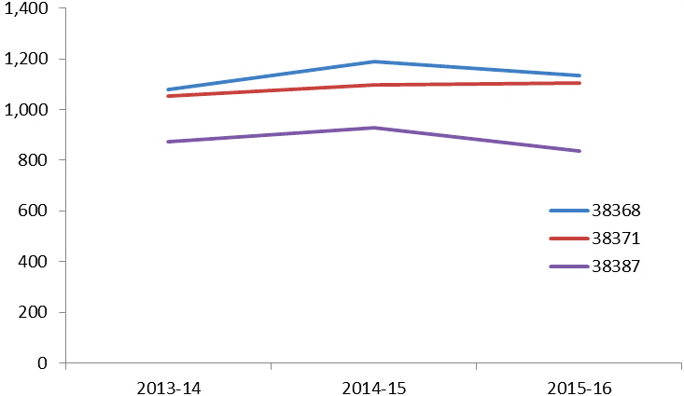

Figure 1: Services of MBS items 38368, 38371 and 38387 from 2013-14 to 2015-16
Source: Department of Health
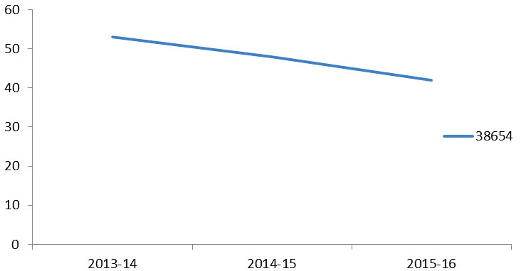

Figure 2: Services of MBS item 38654 from 2013-14 to 2015-16
Source: Department of Health

Patient breakdown
The number of patients claiming each item does not appear to have been affected by the item amendment occurring on 1 July 2014 with patient numbers remaining similar across the three financial years considered. This is consistent with the utilisation data.
There was also no change in the age or gender ratio of patients utilising these items after 1 July 2014. The items are predominantly used by males in the 65-84 age groups.

Table 2: Number of patients who received items 38368, 38371, 38387 and 38654 in 2013-14
MBS Item | NSW | VIC | QLD | SA | WA | TAS | NT | ACT | Australia
38368 | 313 | 350 | 185 | 91 | 77 | np | np | np | 1,038
38371 | 327 | 287 | 229 | 105 | 64 | np | np | np | 1,027
38387 | 233 | 203 | 223 | 92 | 96 | np | np | np | 864
38654 | np | np | np | np | np | np | np | np | 53

Table 3: Number of patients who received items 38368, 38371, 38387 and 38654 in 2014-15
MBS Item | NSW | VIC | QLD | SA | WA | TAS | NT | ACT | Australia
38368 | 324 | 399 | 204 | 109 | 99 | np | np | np | 1,162
38371 | 323 | 310 | 232 | 109 | 75 | np | np | np | 1,069
38387 | 248 | 199 | 251 | 92 | 94 | np | np | np | 906
38654 | np | np | np | np | np | np | np | np | 47

Table 4: Number of patients who received items 38368, 38371, 38387 and 38654 in 2015-16
MBS Item | NSW | VIC | QLD | SA | WA | TAS | NT | ACT | Australia
38368 | 311 | 421 | 170 | 80 | 107 | np | np | np | 1,115
38371 | 338 | 298 | 245 | 94 | 80 | np | np | np | 1,076
38387 | 230 | 220 | 179 | 78 | 87 | np | np | np | 819
38654 | np | np | np | np | np | np | np | np | 39
NP = not published due to low volumes
Source for tables 2-4: Department of Health

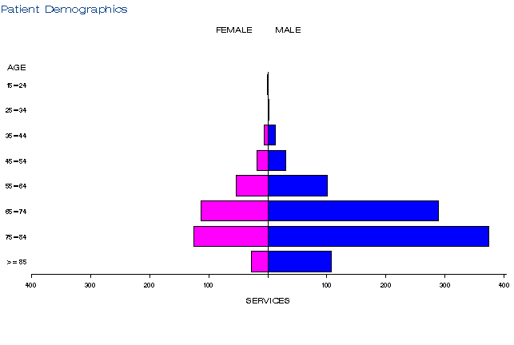
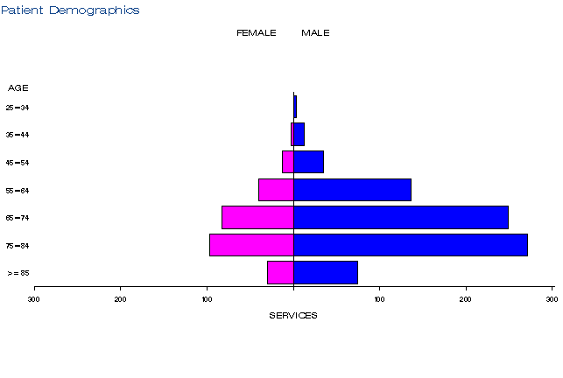
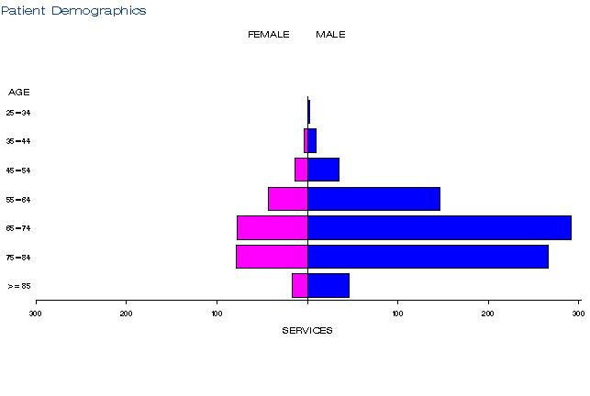
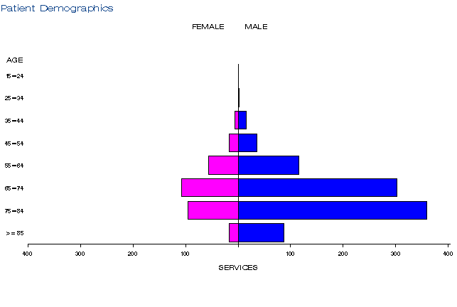
Figure 3: Demographic profile for MBS item 38368 for 2013-14 (left), before the item amendment and 2015-16 (right).

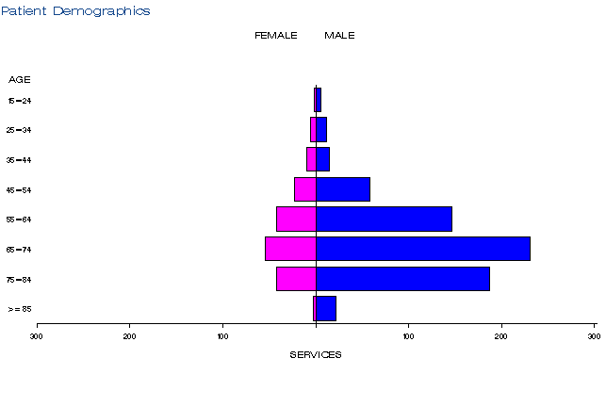
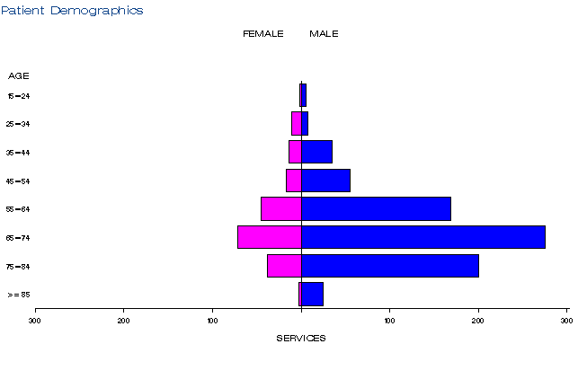
Figure 4: Demographic profile for MBS item 38371 for 2013-14 (left), before the item amendment and 2015-16 (right).

Figure 5: Demographic profile for MBS item 38387 for 2013-14 (left), before the item amendment and 2015-16 (right).
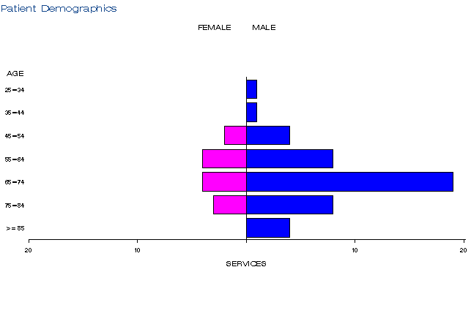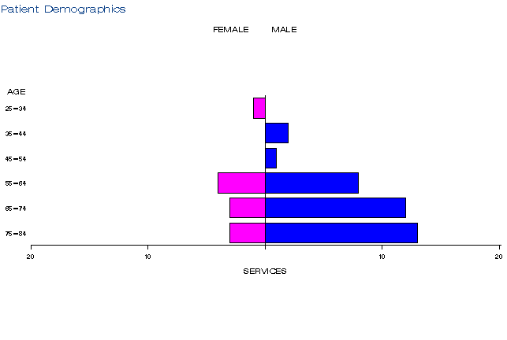

Figure 6: Demographic profile for MBS item 38654 2013-14 (left), before the item amendment and 2015-16 (right).
Source for figures 3-6: Medicare Statistics Online

Practitioner breakdown
The number of medical practitioners providing this service remained steady from 2013-14 to 2015-16.
In 2015-16, cardiologists provided the majority of services, with a small proportion of services provided by internal medicine specialists, cardiothoracic surgeons and other specialties.
The provision of these services is not very concentrated with 20% of medical practitioners providing 60% or less of services under items 38368, 38371 and 38654 in 2015-16. Service provision under item 38387 is more concentrated with 20% of medical practitioners providing 78% of services in 2015-16.

Table 5: Number of practitioners providing items 38368, 38371, 38387 and 38654 in 2013-14 to 2015-16
MBS item number | 2013-14 | 2014-15 | 2015-16
38368 | 139 | 156 | 143
38371 | 140 | 156 | 151
38387 | 146 | 155 | 167
38654 | 28 | 22 | 24

Table 6: Practitioner specialties providing items 38368, 38371, 38387 and 38654 in 2015-16
MBS item number | Specialty | Services in 2015-16 | % of total services
38368 | Cardiology | 1,003 | 88%
 | Internal Medicine | 79 | 7%
 | Cardio-Thoracic Surgery | 44 | 4%
 | Other | 9 | 1%
 | Total | 1,135 | 100%
38371 | Cardiology | 934 | 84%
 | Internal Medicine | 100 | 9%
 | Cardio-Thoracic Surgery | 63 | 6%
 | Other | 9 | 1%
 | Total | 1,106 | 100%
38387 | Cardiology | 727 | 87%
 | Cardio-Thoracic Surgery | 54 | 6%
 | Internal medicine | 37 | 4%
 | Other | 18 | 2%
 | Total | 836 | 100%
38654 | Cardio-Thoracic Surgery | 35 | 83%
 | Other | 7 | 17%
 | Total | 42 | 100%

Table 7: Cumulative percentage of medical practitioners providing items 38368, 38371, 38387 and 38654 and how many services each percentile accounts for in 2015-16
 | 38368 | 38371 | 38387 | 38654
10% | 43% | 45% | 64% | 31%
20% | 59% | 60% | 78% | 45%
30% | 70% | 72% | 88% | 62%
40% | 80% | 82% | 93% | 67%
50% | 86% | 88% | 96% | 74%
60% | 92% | 93% | 98% | 79%
70% | 96% | 96% | 99% | 83%
80% | 98% | 98% | 99% | 90%
90% | 99% | 99% | 100% | 95%
100% | 100% | 100% | 100% | 100%
Source for tables 5-7: Department of Health

Co-claiming
Items 38368, 38371, 38387 and 38654 are commonly co-claimed with each other, item 61109 (fluoroscopy), item 116 (consultant physician attendance) and a range of other Subgroup 6 Cardio-Thoracic items.

Table 8: Top 10 instances of co-claiming with MBS item 38368 in 2015-16
# | Items | Episodes | Number of Services | Schedule Fee for Combination | % of total episodes | Cumulative %
1 | 38368, 00116, 11721, 38356, 38365, 61109. | 43 | 264 | $89,521 | 4% | 4%
2 | 38368, 38356, 38365, 61109. | 31 | 124 | $60,794 | 3% | 7%
3 | 38368, 00116, 11727, 38350, 38371, 38384, 61109. | 30 | 210 | $71,074 | 2% | 9%
4 | 38368, 00116, 38371, 38384, 61109. | 28 | 149 | $59,965 | 2% | 11%
5 | 38368, 00116, 11700, 38212, 38350, 38371, 38384, 61109. | 27 | 231 | $76,368 | 2% | 13%
6 | 38368, 00116, 38356, 38365, 61109. | 27 | 136 | $54,119 | 2% | 15%
7 | 38368, 00116, 38365, 61109. | 27 | 109 | $44,538 | 2% | 17%
8 | 38368, 00116, 38212, 38371, 38384, 61109. | 23 | 138 | $60,130 | 2% | 19%
9 | 38368, 00116, 11700, 38350, 38371, 38384, 61109. | 22 | 166 | $51,290 | 2% | 21%
10 | 38368, 00116, 11727, 38371, 38384, 61109. | 22 | 134 | $48,817 | 2% | 23%

Table 9: Top 10 instances of co-claiming with MBS item 38371 in 2015-16
# | Items | Episodes | Number of Services | Schedule Fee for Combination | % of total episodes | Cumulative %
1 | 38371. | 38 | 38 | $10,938 | 3% | 3%
2 | 38371, 00116, 11727, 38212, 61109. | 30 | 156 | $57,677 | 3% | 6%
3 | 38371, 00116, 11727, 38350, 38368, 38384, 61109. | 30 | 210 | $71,074 | 3% | 9%
4 | 38371, 00116. | 29 | 59 | $10,613 | 2% | 11%
5 | 38371, 00116, 38368, 38384, 61109. | 28 | 149 | $59,965 | 2% | 13%
6 | 38371, 00116, 11700, 38212, 38350, 38368, 38384, 61109. | 27 | 231 | $76,368 | 2% | 15%
7 | 38371, 00116, 38212, 38368, 38384, 61109. | 23 | 138 | $60,130 | 2% | 17%
8 | 38371, 00116, 11700, 38350, 38368, 38384, 61109. | 22 | 166 | $51,290 | 2% | 19%
9 | 38371, 00116, 11727, 38368, 38384, 61109. | 22 | 134 | $48,817 | 2% | 21%
10 | 38371, 38368, 38384, 61109. | 22 | 88 | $45,691 | 2% | 23%

Table 10: Top 10 instances of co-claiming with MBS item 38387 in 2015-16
# | Items | Episodes | Number of Services | Schedule Fee for Combination | % of total episodes | Cumulative %
1 | 38387, 00116, 38212, 38384, 61109. | 56 | 282 | $127,002 | 6% | 6%
2 | 38387, 00116, 38212, 38350, 38384, 61109. | 32 | 192 | $77,597 | 4% | 10%
3 | 38387, 00116, 38384, 61109. | 31 | 124 | $46,221 | 3% | 13%
4 | 38387, 38384, 61109. | 26 | 78 | $37,713 | 3% | 16%
5 | 38387, 38212, 38384, 61109. | 24 | 96 | $53,393 | 3% | 19%
6 | 38387, 00116, 38350, 38384, 61109. | 23 | 115 | $39,983 | 3% | 22%
7 | 38387, 00116, 11700, 38212, 38350, 38384, 61109. | 18 | 138 | $44,851 | 2% | 24%
8 | 38387. | 17 | 17 | $4,893 | 2% | 26%
9 | 38387, 00116, 11727, 38384, 61109. | 17 | 87 | $27,109 | 2% | 28%
10 | 38387, 38212, 38350, 38384, 61109. | 17 | 85 | $40,535 | 2% | 30%

Table 11: Top instances of co-claiming with MBS item 38654 in 2015-16
# | Items | Episodes | Number of Services | Schedule Fee for Combination | % of total episodes | Cumulative %
1 | 38654. | np | np | np | np | np
2 | 38654, 38365. | np | np | np | np | np
Note: due to low service volumes for item 38654, only the top two co-claiming patterns could be included.
NP = not published due to low volumes
Source for tables 8-11: Department of Health

Data on fee charged
The average fee charged for items 38371 and 38387 is lower than the benefit paid for the service, indicating that the multiple operations rule is regularly applied with these items.
In 2015-16, the average fee charged for item 38368 at $1507, was higher than the average fee charged for item 38654 at $1245. However, the fee charged at the 75th and 95th percentiles was very similar for both items.

Table 12: Data on fees charged for MBS items 38368, 38371, 38387 and 38654 for 2015-16
 |  | Provider State/Territory
 |  | NSW | VIC | QLD | SA | WA | TAS | NT | ACT | Australia
38368 | Average Fee Charged | $1,335 | $1,634 | $1,255 | $1,573 | $1,785 | np | np | np | $1,507
 | Std Deviation | $508 | $371 | $451 | $445 | $392 | np | np | np | $467
 | Median Fee Charged | $1,225 | $1,785 | $1,007 | $1,785 | $1,910 | np | np | np | $1,706
 | 75th Percentile | $1,785 | $1,785 | $1,785 | $1,885 | $2,081 | np | np | np | $1,834
 | 95th Percentile | $2,022 | $2,021 | $1,984 | $2,042 | $2,081 | np | np | np | $2,081
 | Bulk-billing Rate | 1% | 0% | 0% | 0% | 1% | np | np | np | 0%
38371 | Average Fee Charged | $198 | $169 | $179 | $191 | $193 | np | np | np | $184
 | Std Deviation | $177 | $112 | $109 | $121 | $121 | np | np | np | $136
 | Median Fee Charged | $112 | $112 | $118 | $111 | $122 | np | np | np | $291
 | 75th Percentile | $238 | $210 | $213 | $221 | $245 | np | np | np | $300
 | 95th Percentile | $693 | $372 | $358 | np | $349 | np | np | np | $358
 | Bulk-billing Rate | 1% | 0% | 0% | 0% | 0% | np | np | np | 0%
38387 | Average Fee Charged | $181 | $210 | $166 | $165 | $192 | np | np | np | $187
 | Std Deviation | $141 | $119 | $94 | $89 | $107 | np | np | np | $119
 | Median Fee Charged | $118 | $198 | $118 | $120 | $122 | np | np | np | $122
 | 75th Percentile | $211 | $238 | $213 | $221 | $226 | np | np | np | $221
 | 95th Percentile | $422 | $420 | $370 | $420 | $489 | np | np | np | $422
 | Bulk-billing Rate | 5% | 0% | 1% | 0% | 1% | np | np | np | 2%
38654 | Average Fee Charged | $1,289 | $1,181 | $715 | $1,832 | np | np | np | np | $1,245
 | Std Deviation | $664 | $736 | $395 | $96 | np | np | np | np | $670
 | Median Fee Charged | np | np | np | np | np | np | np | np | $1,225
 | 75th Percentile | np | np | np | np | np | np | np | np | $1,849
 | 95th Percentile | np | np | np | np | np | np | np | np | $2,022
 | Bulk-billing Rate | 0% | 0% | 0% | 0% | np | np | np | np | 0%
NP = not published due to low volumes
Source: Department of Health

Background
An application requesting amendments to existing MBS items for the insertion, replacement, or removal of a cardiac resynchronisation therapy device capable of defibrillation (CRT-D) and associated leads, to include patients with mild chronic heart failure, was received from Optum (working with Biotronik, Boston Scientific, Medtronic and St. Jude Medical) by the Department of Health in May 2012.
The proposed intervention was an extension of the services then used for the insertion, removal, or replacement of a CRT-D device in patients with moderate to severe chronic heart failure (NYHA class III or IV) (MBS items 38371, 38368, 38654 and 38350).
After considering the strength of the available evidence in relation to safety, clinical effectiveness and cost-effectiveness, MSAC supported public funding for cardiac resynchronisation therapy with a cardioverter defibrillator by amending the current MBS items 38371, 38368 and 38654 to also include patients who have mild chronic heart failure symptoms (NYHA Class II) despite optimal medical therapy and who meet the following criteria:
- sinus rhythm
- left ventricular ejection fraction of ≤ 35%
- QRS duration ≥ 150 ms.

Item descriptor
38368 | Permanent transvenous left ventricular electrode, insertion, removal or replacement of through the coronary sinus, for the purpose of cardiac resynchronisation therapy, including right heart catheterisation and any associated venogram of left ventricular veins, other than a service associated with a service to which item 35200 or 38200 applies, for a patient who:  (a) has:  (i) moderate to severe chronic heart failure (New York Heart Association (NYHA) class III or IV) despite optimised medical therapy; and  (ii) sinus rhythm; and  (iii) a left ventricular ejection fraction of less than or equal to 35%; and  (iv) a QRS duration greater than or equal to 120 ms; or  (b) has:  (i) mild chronic heart failure (New York Heart Association (NYHA) class II) despite optimised medical therapy; and  (ii) sinus rhythm; and  (iii) a left ventricular ejection fraction of less than or equal to 35%; and  (iv) a QRS duration greater than or equal to 150 ms; or  (c) satisfied the requirements mentioned in paragraph (a) or (b) immediately before the insertion of a cardiac resynchronisation therapy device and transvenous left ventricle electrode  (Anaes.)  (See para T8.64 of explanatory notes to this Category)  Fee: $1,224.60 Benefit: 75% = $918.45
38371 | Permanent cardiac synchronisation device capable of defibrillation, insertion, removal or replacement of, for a patient who:  (a) has:  (i) moderate to severe chronic heart failure (New York Heart Association ((NYHA) class III or IV) despite optimised medical therapy; and  (ii) sinus rhythm; and  (iii) a left ventricular ejection fraction of less than or equal to 35%; and  (iv) a QRS duration greater than or equal to 120 ms; or  (b) has:  (i) mild chronic heart failure (New York Heart Association (NYHA) class II) despite optimised medical therapy; and  (ii) sinus rhythm; and  (iii) a left ventricular ejection fraction of less than or equal to 35%; and  (iv) a QRS duration greater than or equal to 150 ms  (Anaes.)  (See para T8.66 of explanatory notes to this Category)  Fee: $287.85 Benefit: 75% = $215.90
38387 | AUTOMATIC DEFIBRILLATOR GENERATOR, insertion or replacement of for, primary prevention of sudden cardiac death in:  - patients with a left ventricular ejection fraction of less than or equal to 30% at least one month after a myocardial infarct when the patient has received optimised medical therapy; or  - patients with chronic heart failure associated with mild to moderate symptoms (NYHA II and III) and a left ventricular ejection fraction less than or equal to 35% when the patient has received optimised medical therapy.  Not being a service associated with a service to which item 38213 applies, not for defibrillators capable of cardiac resynchronisation therapy (Anaes.) (Assist.)  Fee: $287.85 Benefit: 75% = $215.90 85% = $244.70
38654 | Permanent left ventricular electrode, insertion, removal or replacement of via open thoracotomy, for the purpose of cardiac resynchronisation therapy, for a patient who:  (a) has:  (i) moderate to severe chronic heart failure (New York Heart Association (NYHA) class III or IV) despite optimised medical therapy; and  (ii) sinus rhythm; and  (iii) a left ventricular ejection fraction of less than or equal to 35%; and  (iv) a QRS duration greater than or equal to 120 ms; or  (b) has:  (i) mild chronic heart failure (New York Heart Association (NYHA) class II) despite optimised medical therapy; and  (ii) sinus rhythm; and  (iii) a left ventricular ejection fraction of less than or equal to 35%; and  (iv) a QRS duration greater than or equal to 150 ms; or  (c) satisfied the requirements mentioned in paragraph (a) or (b) immediately before the insertion of a cardiac resynchronisation therapy device and transvenous left ventricle electrode  (Anaes.) (Assist.)  (See para T8.64 and T8.68 of explanatory notes to this Category)  Fee: $1,224.60 Benefit: 75% = $918.45

Applicant’s comments on MSAC’s public summary document
Nil response.

Further information on MSAC
MSAC Terms of Reference and other information are available on the MSAC Website.

The 95th percentile fee charged represents that 95% of the time the fee is below this amount but in 5% of cases, the fee is higher than this.

