Public Summary Document

Report to the Medical Services Advisory Committee on utilisation of MBS item 73338 following Applications 1362 and 1363: RAS mutation testing for eligibility for panitumumab and cetuximab in previously untreated metastatic colorectal cancer patients
Medicare Benefits Schedule (MBS) item considered: 73338
Date of MSAC consideration: 27 July 2018
Context for decision: MSAC makes its advice in accordance with its Terms of Reference, see the MSAC Website.

Purpose
The purpose of the report presented to the Medical Services Advisory Committee (MSAC) was to allow MSAC to consider the real world data on utilisation of Medicare Benefits Schedule (MBS) item 73338, following Applications 1362 and 1363: RAS mutation testing for eligibility for cetuximab and panitumumab in previously untreated metastatic colorectal cancer patients.
MSAC uses the information to ensure that the new item resulting from these applications is being used as intended.
The report is not intended to be a review of the clinical information covered during the application process.

MSAC’s advice
After consideration of the real world data for RAS mutation testing for eligibility for cetuximab and panitumumab in previously untreated metastatic colorectal cancer patients (MBS item 73338) – MSAC Applications 1362 and 1363, MSAC recommended no further action. MSAC considered that the actual utilisation data tracked reasonably closely with the utilisation predicted before this MBS listing was implemented, and that the other review variables presented did not raise any substantive concerns.
MSAC also recommended that consideration will need to be given to the ongoing need for this item if panel-based testing for predictive biomarkers is introduced (MSAC Application 1495).

Summary of consideration and rationale for MSAC’s advice
MSAC considered the impacts of the outcome of MSAC Applications 1362 and 1363 for RAS mutation testing for eligibility for cetuximab and panitumumab in previously untreated metastatic colorectal cancer (mCRC) patients (MBS item 73338) by examining real world data up to January 2018. The item was MBS listed in April 2014.
MSAC recalled that the item descriptor was amended urgently in October 2014 to refer to RAS (KRAS and NRAS) and the change was implemented in January 2015 with an increased fee. There was also a concurrent resubmission to the PBAC in July 2014 to modify second line panitumumab PBS listing to require KRAS and NRAS wild-type, and to list panitumumab for first line treatment of RAS wild-type mCRC.
Item 73338 provides for testing of RAS mutations to limit subsidy of anti-EGFR (epidermal growth factor receptor) antibodies to only those patients demonstrated to have no RAS mutations. For a Medicare benefit to be payable, the test must be conducted for all clinically relevant mutations on KRAS exons 2, 3 and 4 and NRAS exons 2, 3 and 4, or until a RAS mutation is found. This means that, once the test indicates that the patient is not RAS wild-type and therefore not suitable for access to cetuximab and panitumumab under the PBS, a pathologist is not required to continue testing for other clinically relevant mutations.
MSAC recalled that it was predicted that item 73338 would be utilised by 2208 patients in the first year, increasing to 2465 patients by year 5. These predictions were based on the number of incidents of mCRC and assumed that about 37% or eligible patients would access RAS mutation testing.
MSAC noted that utilisation of item 73338 was fairly consistent with that predicted by the MBS costing model (noting that, before January 2015, only KRAS was tested; both KRAS and NRAS were tested after that). In 2014–15, there were 1325 services (57% of predicted volume), increasing to 2654 services in 2015–16 (110% of predicted volume) and 2287 services in 2016–17 (95% of predicted volume). MSAC noted feedback from the Royal College of Pathologists of Australasia suggesting that the peak in the rate of testing most likely represents referrals to a highly specialised cancer service.
MSAC noted that the service is predominantly claimed by patients aged 55 to 84, which is as expected given the age incidence of colorectal carcinoma. MSAC also noted that, in 2016–17, only 3% of patients received two or more services under item 73338. The need for repeat testing likely reflects a nondiagnostic initial result due to problems with either the tissue (degraded DNA) or the assay.
MSAC noted that a large amount of testing is being referred between laboratories. MSAC also noted that a disproportionate level of testing is done in Victoria and Tasmania – 3821 services between April 2014 and January 2018, which is approximately half of the total services for item 73338. MSAC suggested that this interstate variation is due to cross-border referrals for testing (particularly to the Peter MacCallum Cancer Centre in Victoria) following implementation of the additional NRAS requirement for this item.
MSAC recalled that the MBS fee for item 73338 is $362.60 (75% = $271.95, which increased in January 2015 with the additional NRAS requirement). MSAC noted that the average fee has increased from $396.88 in 2014–15 to $408 in 2015–16 and $434.99 in 2016–17 and is similar between states. The majority of services (86%) are bulk billed. However, bulk billing rates in South Australia dropped from 88.2% in 2014–15 to 36.3% in 2016–17.
MSAC noted that co-claiming is generally restricted to Patient Episode Initiation (PEI) items (73938, 73939, 73940), which implies that testing is performed on archival material when metastases are diagnosed. A much smaller number of tests is performed on current metastatic samples. Occasional co-claims with item 72846 probably represent requests for ancillary BRAF immunohistochemistry by an oncologist. MSAC noted that, if an item for tissue retrieval is approved (MSAC Application 1331), that item is also likely to be co-claimed in most instances.
MSAC recommended no further action. MSAC considered that the actual utilisation data tracked reasonably closely with the utilisation predicted before this MBS listing was implemented, and that the other review variables presented did not raise any substantive concerns. However, if panel based-testing for predictive biomarkers is introduced (MSAC Application 1495), the ongoing need for item 73338 will need to be considered.

Methodology
An application is selected for consideration if the resulting new item(s) and/or item amendment(s) have been on the MBS for approximately 24 months or longer or if there were particular concerns about utilisation such that MSAC requested to consider it earlier. The specific applications for each MSAC meeting are selected by the MSAC Executive which is composed of the chairs of MSAC and its sub-committees.
A report on the utilisation is developed by the department with information on a number of metrics including; state variation, patient demographics, services per patient, practitioner’s providing the service, data on fees and co-claiming of services. The number of metrics included in a report is dependent on the annual service volume for the MBS item(s) under consideration i.e. an item with very low utilisation will have less data to analyse. Where service volumes are too low, information is suppressed to protect patient privacy.
Where possible the report compares data on real world utilisation to the assumptions made during the MSAC assessment. Most of these assumptions are drawn from the assessment report.
Relevant stakeholders are provided an opportunity to comment on the findings in the report before it is presented to the MSAC. It is intended that stakeholders are given at least three weeks to consider the reports.
The stakeholder version of the report does not contain information on assumptions from the MSAC consideration if this information is not already publicly available. This is to protect the commercial in confidence information of the original applicants. The same principle is applied to this document.
Once MSAC has considered the report, its advice is made available online at the MSAC Website.

Results

Utilisation
Predictions
At the time of MSAC consideration, a sensitivity analysis conducted for RAS mutation testing for eligibility to access cetuximab or panitumumab was estimated to be utilised in 2208 patients in year 1, increasing to 2465 patients by year 5. This estimate was based on the number of incidents of mCRC, and an assumption that approximately 37% of eligible patients would access RAS mutation testing.
Table 1: Predicted costs of RAS mutation testing for eligibility to access cetuximab or panitumumab
 | Year 1 | Year 2 | Year 3 | Year 4 | Year 5
Testing Costs Costings assumed uptake of testing- 37% (base case 100%)
Incident mCRC cases | 6046 | 6218 | 6391 | 6567 | 6747
Uptake of KRAS mutation testing | 37% | 37% | 37% | 37% | 37%
Number of KRAS mutation tests offset | 2208 | 2271 | 2335 | 2399 | 2465
Cost of KRAS mutation testing off set | $510,001 | $524,515 | $539,181 | $553,952 | $569,204
Cost of RAS mutation testing | $3,695,705 | $3,538,623 | $3,367,975 | $3,460,244 | $3,555,516
Net cost of RAS mutation testing | $3,185,704 | $3,014,108 | $2,828,794 | $2,906,291 | $2,986,312
Actual
The utilisation of item 73338 is on par with the MBS costing model predictions.
There were 1,325 services in 2014-15 (57% of predicted volume), increasing to 2,654 services in 2015-16 (110% of predicted volume) and 2,287 services in 2016-17 (95% of predicted volume), (Figure 1).
Figure 1: Predicted versus actual services of MBS item 73338 from 1 April 2014 to
30 June 2017 by date of service.

From 1 April 2014 to 31 January, 2018, Victoria/Tasmania had the highest utilisation with 3,821 services (approximately half of the total services billed to the item) (Table 2).
Table 2: Service volume of MBS item 73338 between 2014-15 and 2017-18 (to Jan 2018) (date of service)
 | State/Territory |  |  |  |  | Total
 | NSW & ACT | VIC & TAS | QLD | SA & NT | WA
2014-15 | 372 | 661 | 157 | 68 | 67 | 1325
2015-16 | 552 | 1419 | 375 | 136 | 172 | 2654
2016-17 | 461 | 1207 | 343 | 158 | 118 | 2287
2017-18* | 175 | 534 | 159 | 53 | 39 | 960
All years | 1560 | 3821 | 1034 | 415 | 396 | 7226
Source: MBS Analytics Section – Q21109B: Standard Post Implementation Review of Item 73338
*2017-18 includes data from 1 July 2017 to 31 January 2018

Data on fee charged
The information provided on fees below is a snapshot of how the item is being claimed in practice. Data has not been included for states and territories with low service volumes.
The 75% benefit for item 73338 is $271.95. The average fee charged for item 73338 has increased from $396.88 in 2014-15 to $434.99 in 2016-17 (Table 3).
Services are generally bulk billed, however SA showed a significant drop in bulk billing, from 88.2% in 2014-15 down to 36.3% in 2016-17, which is inconsistent with all other states and territories, whose rates remained consistent.
Table 3: Statistics on fees charged for MBS item 73338 for 2014-15 to 2016-17 by date of service
 |  | Provider State/Territory
 |  | NSW | Vic | Qld | SA | WA | ACT | AUS
2014-15 | Average Fee Charged | $436.69 | $397.40 | $429.50 | $260.55 | $390.01 | $468.58 | $396.88
 | Standard  Deviation | $81.59 | $78.63 | $64.23 | $83.72 | $103.15 | $209.06 | $97.41
 | 95th Percentile | n/a | $550.95 | n/a | n/a | $550.95 | n/a | $550.95
 | Bulk Billed Rate | 95.6% | 95.9% | 87.3% | 88.2% | 31.3% | 93.3% | 91.1%
2015-16 | Average Fee Charged | $394.23 | $388.12 | $481.35 | $386.62 | $410.89 | $297.90 | $408.00
 | Standard Deviation | $94.01 | $91.53 | $132.66 | $73.69 | $95.01 | $121.63 | $105.83
 | 95th Percentile | 593.20 | $550.00 | $692.80 | $528.66 | $558.45 | n/a | $561.70
 | Bulk Billed Rate | 90.3% | 95.0% | 87.2% | 74.3% | 58.7% | 84.8% | 89.4%
2016-17 | Average Fee Charged | $437.57 | $389.98 | $484.75 | $448.63 | $431.24 | $357.05 | $434.99
 | Standard Deviation | $129.86 | $57.47 | $80.14 | $59.18 | $156.12 | $55.66 | $96.21
 | 95th Percentile | $652.70 | $494.95 | $561.70 | $530.11 | $548.59 | n/a | $561.70
 | Bulk Billed Rate | 91.1% | 94.1% | 82.8% | 36.3% | 65.3% | 68.9% | 86.0%
Source: Department of Health, File: Q21109B: Standard Post Implementation Review of Item 33338. Services rendered between 1 January 2015 and 31 December 2017 processed to 31 January 2018
n/a = not available
Figure 2: Average fee charged and variation in fee charged by state for MBS item 93338 between 2014-15 and 2016-17

Patient breakdown
There were 2213 patients who claimed item 73338 in 2016-17. Of these, 2,161 were new patients and 52 were continuing from the previous financial year. (Table 4)

Table 4: Number of new and continuing patients who received MBS item 73338 by financial year
Financial | Total |  | New |  | Continuing
Year | Patients | Services | Patients | Services | Patients | Services
2014-15 | 1,260 | 1,325 | 1,260 | 1,325 | - | -
2015-16 | 2,518 | 2,654 | 2,499 | 2,630 | 19 | 24
2016-17 | 2,213 | 2,287 | 2,161 | 2,234 | 52 | 53
2017-18 | 946 | 960 | 907 | 919 | 39 | 41
Total | 6,827 | 7,226 | - | - | - | -

In 2016-17, 3% of patients received two or more services under item 73338 (Table 5).
since the listing of the item.

Table 5: Number of services per patient in 2015-16, 2016-17 and 2017-18*
Financial | Services | Count | Percentage
2015-16 | 1 | 2389 | 95.0%
 | 2 | 123 | 5.0%
2016-17 | 1 | 2141 | 97.0%
 | 2 | 71 | 3.0%
2017-18* | 1 | 933 | 99.0%
 | 2 | 12 | 1.0%
*Note: figures for 2017-18 include services processed to 31 January 2018.
The service has predominantly been claimed by patients aged 55-84. (Figures 3-5).
Figure 3: Demographic profile for MBS item 73338 for July 2014-June 2015
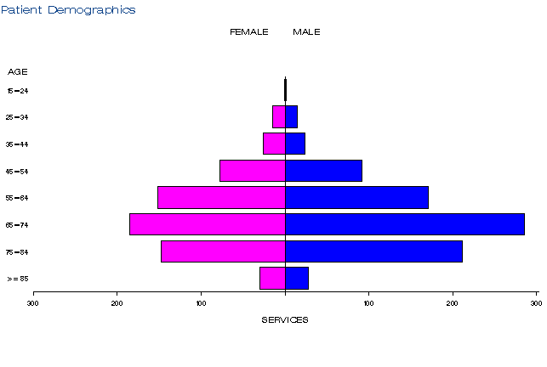
Figure 4: Demographic profile for MBS item 73338 for July 2015-June 2016
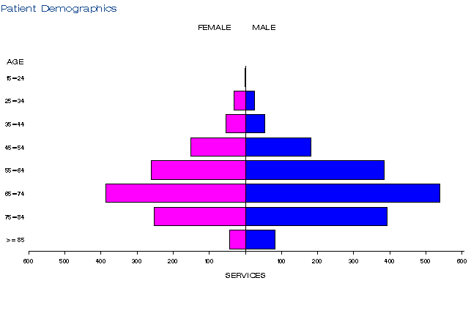
Figure 5: Demographic profile for MBS item 73338 for July 2016-December 2017
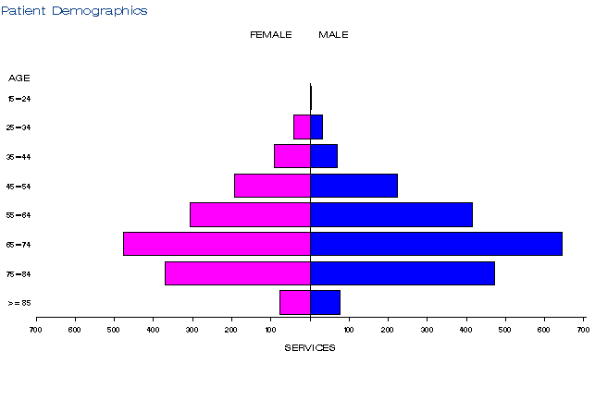
Figure 3-5: Demographic profile for MBS item 73338 for 2014-15, 2015-16, 2016-December 2017
Source: Medicare Statistics online, Department of Human Services
Co-claiming
The service is most commonly claimed with item 73940 (Receipt of a specimen by an approved pathology practitioner), 73939, 73938 (PEI items) or on its own.
Departmental medical advice noted there was no concern from a clinical perspective in relation to the other MBS items that were co-claimed in this dataset.

Table 6: Top 5 instances of co-claiming with MBS item 73338 in 2014-15
# | Items | Episodes | Services | Schedule Fee for combination | Number of patients | % of episodes
1 | 73338 and 73940 | 441 | 917 | $177,113 | 435 | 34.2%
2 | 73338 only | 305 | 305 | $110,590 | 301 | 23.6%
3 | 73338 and 73939 | 198 | 396 | $72,268 | 195 | 15.4%
4 | 73338 and 73938 | 169 | 338 | $62,621 | 168 | 13.1%
5 | 73338 and 72846 | 57 | 116 | $24,065 | 56 | 4.4%

Table 7: Top 5 instances of co-claiming with MBS item 73338 in 2015-16
# | Items | Episodes | Services | Schedule Fee for combination | Number of patients | % of episodes
1 | 73338 and 73940 | 887 | 1826 | $349,211 | 870 | 34.2%
2 | 73338 and 73938 | 518 | 1036 | $191,940 | 511 | 19.9%
3 | 73338 only | 455 | 461 | $167,154 | 451 | 17.5%
4 | 73338 and 73939 | 329 | 658 | $120,082 | 327 | 12.7%
5 | 73338 and 72846 | 73 | 146 | $30,820 | 69 | 2.8%

Table 8: Top 5 instances of co-claiming with MBS item 73338 in 2016-17
# | Items | Episodes | Services | Schedule Fee for combination | Number of patients | % of episodes
1 | 73338 and 73940 | 879 | 1,774 | $333,536 | 869 | 38.8%
2 | 73338 and 73938 | 474 | 948 | $175,640 | 473 | 20.9%
3 | 73338 and 3939 | 234 | 468 | $85,410 | 230 | 10.3%
4 | 73338 only | 174 | 175 | $63,455 | 172 | 7.7%
5 | 73338 and 72846 | 89 | 178 | $37,576 | 88 | 3.9%

Source for Tables 6-8: Department of Health, File: Q21109B Item 73338 Item combination Top 10.xlsx

Descriptor of each co-claimed service
MBS Item # | Descriptor
72846 | Group P5 - Tissue Pathology  Immunohistochemical examination of biopsy material by immunofluorescence, immunoperoxidase or other labelled antibody techniques with multiple antigenic specificities per specimen - 1 to 3 antibodies except those listed in 72848  (Item is subject to rule 13)  Fee: $59.60 Benefit: 75% = $44.70 85% = $50.70
73938 | Group P10 - Patient Episode Initiation  Initiation of a patient episode by collection of a specimen for 1 or more services (other than those services described in items 73922, 73924 or 73926) if the specimen is collected by or on behalf of the treating practitioner. Unless item 73939 applies  Fee: $7.95 Benefit: 75% = $6.00 85% = $6.80
73939 | Group P10 - Patient Episode Initiation  Initiation of a patient episode by collection of a specimen for 1 or more services (other than those services described in items 73922, 73924 or 73926), if the specimen is collected by or on behalf of the treating practitioner and if:  (a) the service is performed in a prescribed laboratory or  (b) the person is a private patient in a recognised hospital  Fee: $2.40 Benefit: 75% = $1.80 85% = $2.05
73940 | Group P11 - Specimen Referred  Receipt of a specimen by an approved pathology practitioner of an approved pathology authority from another approved pathology practitioner of a different approved pathology authority or another approved pathology authority  (Item is subject to rules 14, 15 and 16)  Fee: $10.25 Benefit: 75% = $7.70 85% = $8.75
Source: MBSOnline (www.mbsonline.gov.au)

Applicant’s comments on MSAC’s public summary document
The applicant had minor comments which were incorporated into the document.

Further information on MSAC
MSAC Terms of Reference and other information are available on the MSAC Website at: www.msac.gov.au.

