Protocol to guide the assessment of a faecal calprotectin test to help differentiate between functional and inflammatory bowel disorders, and for monitoring disease activity in people with known inflammatory bowel disease (IBD)
Ratified in May 2017

Table of Contents
MSAC and PASC 3
Purpose of this document 3
Summary of matters for which PASC seeks input 4
Purpose of application 6
Intervention 7
Description 7
Administration, dose, frequency of administration, duration of treatment 8
Co-administered interventions 9
Background 10
Current arrangements for public reimbursement 10
Regulatory status 11
Patient population 13
Proposed MBS listing 13
Clinical place for proposed intervention 14
Comparator 21
Clinical claim 21
Reference Standard 22
Outcomes and health care resources affected by introduction of proposed intervention 22
Outcomes 22
Summary of PICO criteria for the assessment 24
References 26
Appendix 1: Issues to consider in the Assessment Report 27

MSAC and PASC
The Medical Services Advisory Committee (MSAC) is an independent expert committee, appointed by the Minister for Health (the Minister) to strengthen the role of evidence in health financing decisions in Australia. MSAC advises the Minister on evidence relating to the safety, effectiveness and cost-effectiveness of new and existing medical technologies and procedures and under what circumstances public funding should be supported.
The PICO Advisory Sub-Committee (PASC), formerly called the Protocol Advisory Sub-Committee, is a standing sub-committee of MSAC. Its primary objective is the determination of PICO Confirmations (formerly called Protocols) to guide clinical and economic assessments of medical interventions proposed for public funding. (PICO stands for ‘Population’, ‘Intervention’, ‘Comparator’ and ‘Outcome’.)

Purpose of this document
This document is intended to provide confirmation of the PICO that will be used to guide assessment of this intervention for a particular population of patients. It is called a Protocol in this application, because the application was lodged prior to MSAC reforms. ‘Protocols’ are now called ‘PICO Confirmations’. The Protocol/PICO Confirmation has been finalised after relevant stakeholders have provided input. The final PICO provides the basis for assessment of the intervention.
The Protocol/PICO Confirmation guiding the assessment of this health intervention has been developed using the widely accepted ‘PICO’ approach. The PICO approach involves clear articulation of the following aspects of the research question the assessment is intended to answer:
Patients – specification of characteristics of patients in whom the intervention will be considered for use;
Intervention – specification of the proposed intervention
Comparator – specification of the therapy most likely to be replaced by the proposed intervention
Outcomes – specification of health outcomes and healthcare resources likely to be affected by introduction of the proposed intervention

Summary of matters for which PASC seeks input
PASC requested that the applicant note the following issues and consider addressing these issues in its application:
PASC advised the applicants to:
- Clarify that infection is excluded from the patient population and there are no ‘alert’ signs or symptoms raising suspicion of cancer.
- Consider specifically adopting patient populations that have been found to be most efficacious for economic modelling by the United Kingdom’s National Institute for Health and Care Excellence (NICE) (e.g. inflammatory bowel disease (IBD) vs irritable bowel syndrome (IBS) in adults, IBD vs ‘other’ in children).
- Include data relating to predictive value of the assay at different ages, in view of the varying incidences of IBD and likely impact of confounding diseases.
- Include MBS items 72823 or 72824 (pathology biopsy costs) under current MBS items for colonoscopy and endoscopy.
- Justify the cut-off points used by different assays (point of care test and enzyme-linked immunosorbent assay; ELISA). PASC advised there is limited data on concordance between the different assays and comparison between different assays of each class.
- Define and justify the thresholds for ‘indeterminate results’ (e.g. between 50 and 100) and justify the algorithm for re-testing patients with indeterminate results.
- Justify the proposed IBD monitoring algorithm (four calprotectin tests per year, with more tests if the disease flares) and quote any available guidelines for IBD monitoring.
PASC advised the comparator used in the submission should be colonoscopy/endoscopy and biopsy. The current proposed comparator is colonoscopy alone. Determining the comparator for the second patient group (monitoring patients with known IBD) is more problematic and should include a combination of colonoscopy (and biopsy), Erythrocyte sedimentation rate/C-reactive protein (ESR/CPR) testing and imaging (Computed Tomography/Magnetic Resonance Imaging; CT/MRI). These tests would not be all done quarterly as routine monitoring, and some would only be done in the context of a disease flare or complications.
PASC advised that, with respect to general practitioner (GP) monitoring of IBD patients, the comparator for quarterly monitoring by faecal calprotectin suggested by Figures 4 and 5 would be routine blood tests (full blood count/Multi Biochemical Analysis-20; FBC/MBA-20, CRP/ESR +/- iron/B12 studies) performed 3-12 monthly depending on clinical circumstance.
PASC advised that, with respect to specialist monitoring of IBD patients (presumed to be the less stable patients), the comparator would be endoscopy/colonoscopy (and biopsy) +/- CT/MRI. Data on the current utilization of radiology in this cohort of patients would be of assistance in defining the most likely to be replaced comparator and should be sought from specialist bodies.
PASC noted that the outcomes have been updated in light of previous PASC and GESA recommendations.
PASC acknowledged the following amendments (in bold) to the outcomes:
- Faecal calprotectin test for differentiating between functional and inflammatory bowel disorders:
- Effectiveness
  - Diagnostic accuracy: sensitivity, specificity, NPV, PPV, AROC, additional true positives, additional true negatives, test reproducibility (within and between assays) and repeatability
  - Time to diagnosis and time to commencement of therapy
  - Change in patient management: colonoscopies avoided, delay in diagnosis due to false negatives
  - Other: disease-specific morbidity, disease progression, quality of life, impact on colonoscopy demand
  - Reduction in referrals to specialists
- Safety
  - Adverse events: perforations avoided, bleeding
- Economic
  - Cost-utility or a cost-effectiveness analysis
  - Time lost from work’
- Faecal calprotectin test for monitoring those patients with IBD:
  - Effectiveness
    - Test reproducibility (within and between assays) and repeatability (coefficient of variance)
    - Diagnostic accuracy: sensitivity, specificity, NPV, PPV, AROC, additional true positives, additional true negatives, assay cut-offs for severity of acute inflammation, longitudinal correlation of faecal calprotectin levels and disease activity
    - Change in patient management: colonoscopies and hospitalisations avoided; reduced use of imaging, reduced use of serum inflammatory markers, reduced specialist referrals for monitoring patient on immunotherapy, reduced need for biological therapies and surgery, how changes in calprotectin levels will influence patient management,
    - Other: disease-specific morbidity, disease progression, quality of life, impact on colonoscopy demand, confounding effect of other inflammatory GE disorders, longitudinal changes in calprotectin levels and correlation with symptoms and histological evidence of active inflammation, utilization of the assays between gastroenterologist and GP.
  - Safety
    - Adverse events: perforations avoided, bleeding
  - Economic
    - Cost-utility or a cost-effectiveness analysis
    - Time lost from work
PASC advised that the MBS item descriptor should be revised to make it clear the assay is to distinguish between IBD and IBS.
PASC advised that the reference standard for both indications should be colonoscopy and biopsy. PASC expressed doubts about the nomination of MRI as a reference standard for IBD.

Purpose of application
In May 2014, a draft Protocol (for an MSAC application) requesting MBS listing of faecal calprotectin test for: (1) differential diagnosis of functional bowel disorders from inflammatory bowel disorders; and
(2) monitoring disease activity in patients with known inflammatory bowel disease, was received by the Department of Health from Taylor Bio-Medical Pty Ltd. The Protocol was not ratified by PASC, although it was released for public consultation in October 2014. An amended Protocol was submitted by the applicant in October 2014, and considered at PASC’s December 2014 meeting. The amended Protocol was not ratified by PASC at that time. The NHMRC Clinical Trials Centre was commissioned by the Department of Health to prepare the current Protocol/PICO Confirmation. The final Protocol/PICO Confirmation was ratified by PASC on 30 May 2017.
PASC also noted there are no domestic guidelines for faecal calprotectin testing. Consequently, public funding for this test would benefit from being accompanied by clinical practice guidelines. International guidelines and de facto guidelines exist, in particular a Canadian guidance, Clinicians’ guide to the use of fecal Calprotectin to identify and monitor disease activity in inflammatory bowel disease 2015, and two guidelines in Europe, The second European evidence-based consensus on the diagnosis and management of Crohn’s disease: Definition and Diagnosis 2012 and Second European evidence-based Consensus on the diagnosis and management of ulcerative colitis: Definitions and diagnosis 2012. Further, the Gastroenterological Society of Australia (GESA) has advised that there are de facto guidelines in New Zealand The New Zealand Laboratory Schedule and Test Guidelines 2013, and that NICE has endorsed use of the calprotectin test in the United Kingdom for differential diagnosis between IBD and IBS in adults, and between IBD and non-IBD in children (NICE, 2013), with the proviso that signs or symptoms raising suspicion of malignancy must be absent, and local quality assurance processes and agreed care pathways are in place. NICE did not consider the issue of the use of faecal calprotectin for disease monitoring in known IBD patients.

Intervention

Description
The aim of faecal calprotectin testing for people with GI symptoms is to distinguish between patients with functional bowel disorders without current inflammation and patients with current inflammation in the lower gut who require further investigation by colonoscopy.
Functional bowel disorders are a collection of bowel disorders in which patients experience chronic gastrointestinal symptoms in the absence of an identifiable biological cause. The most common functional bowel disorder is Irritable bowel syndrome (IBS). IBS is characterised by symptoms such as: abdominal pain and discomfort, urgency, bloating, diarrhoea, constipation, alternating bouts of diarrhoea and constipation, and changes in bowel habits. These symptoms are not accompanied by inflammation of the bowel; the aetiology of IBS is unknown. The Australian prevalence of IBS is estimated at between 10-15% (AIHW 2012); this similar to the estimate of UK prevalence at between 10-20% of general population (NICE 2013). As noted by both NICE and AIHW, these prevalence values may be underestimated, since many IBS patients do not seek medical help but rather elect to self-care. IBS is more common in women than men (approximately twice as common) and is thought to most commonly affect individuals in their 20s and 30s (NICE 2013).
A number of gastrointestinal conditions may involve inflammation in the lower bowel. These conditions include inflammatory bowel disease (IBD), colorectal cancer, active diverticulitis, polyps, NSAID enteropathy, intestinal TB, and many other disorders. In all of these conditions, the patient’s symptoms may be similar to those of the functional bowel disorders. However, unlike the functional bowel disorders, these conditions are associated with visible inflammation of, and damage to, the gastrointestinal tract. The most common of these conditions is IBD, which includes Ulcerative Colitis (locus of inflammation is the colon) and Crohn’s disease (inflammation may involve any part of the GI tract). Both Ulcerative Colitis and Crohn’s are chronic and relapsing diseases, requiring lifetime care, medication and treatment (Andrews 2010). The prevalence estimates of IBD (CD and UC) in Australia range from 0.20% to 0.36% (Access Economics 2007) and crude annual overall incidence of IBD in Australia is estimated at 23.67-29.3 per 100,000 individuals (Siew 2013, Wilson 2010). For comparison, NICE reports in the United Kingdom the prevalence of Ulcerative Colitis at 0.1-0.2%, and the prevalence of Crohn’s at 0.05-0.1% (NICE 2013). Treatment for IBD aims at controlling the inflammation; it includes: aminosalicylates (5-ASA), corticosteroids, immunomodulators (e.g. azathioprine, 6-mercaptopurine and methotrexate), biological agents (infliximab and adalimumab), and antibiotics (metronidazole, ampicillin, ciprofloxin) (GESA, 2013).
Because many symptoms of inflammatory gut disorders and functional gut disorders are similar to each other, they often cannot initially be reliably differentiated on the basis of clinical presentation alone (Lasson 2008; Chey 2010). Since inflammation is the key characteristic that differentiates these disorders, biomarkers of inflammation can be used for distinguishing the two groups of patients. This protocol concerns the use of faecal calprotectin as a marker for intestinal inflammation that can be used to differential between inflammatory and functional gut disorders.
Two MBS listings for the faecal calprotectin test are proposed:
- Faecal calprotectin test for differentiating between people with and without current inflammation in the lower gut needing further evaluation (mainly distinguishing between people with IBS and IBD); and
- Faecal calprotectin test for monitoring those patients who are diagnosed with IBD (to determine whether there is current disease activity, and whether it is improving or worsening compared to last measurement).
Two types of faecal calprotectin test exist: point of care test (by benchtop, quantitative lateral flow analyser), and laboratory-based testing (e.g. enzyme-linked immunosorbent assay (ELISA)). The former is performed at the point of care and has a turnaround time of 20 minutes. Laboratory-based testing is performed in a pathology laboratory. The ELISA method is commonly used to assay faecal calprotectin, but other methods may also be employed. The Applicant proposes that both tests (point of care and laboratory-based) are suitable for differentiating between patients with functional and inflammatory gut disorders (proposed listing 1), and for monitoring disease activity in patients with known IBD (proposed listing 2). The choice between which testing method is used is therefore contingent on: the clinical setting, the laboratory environment, the number of tests requested, and the desired time-frame for receipt of test results. There is limited data on concordance between the different assays (ELISA vs POC and comparison between different assays of each class), and this requires further analysis.
Outside of NATA accredited laboratories, GESA supports the availability of both tests for specialist gastroenterologists; however, it does not support availability of MBS funding for the benchtop test in GP or other non-gastroenterology clinicians. This on the grounds that non-gastroenterologists are unable to reliably differentiate between people who do and do not need colonoscopy.

Administration, dose, frequency of administration, duration of treatment
Two listings for the test are proposed:
- Faecal Calprotectin test for differentiating between people with and without current inflammation in the lower gut needing further evaluation (mainly distinguishing between people with IBS and IBD); and
- Faecal Calprotectin test for monitoring those patients who are diagnosed with IBD (to determine whether there is current disease activity, and whether it is improving or worsening compared to last measurement).

Faecal calprotectin test for differentiating functional and inflammatory bowel disorders:
The population eligible for faecal calprotectin testing would be patients presenting with chronic (more than 6 weeks’ duration) gastrointestinal symptoms which are suggestive of either functional or inflammatory bowel disorders, and where infectious causes have been excluded and where there are no signs or symptoms raising suspicion of malignancy. Faecal calprotectin testing would be performed if the patient has experienced the following symptoms for greater than 6 weeks: chronic abdominal pain and discomfort, urgency and bloating, diarrhoea, constipation, alternating bouts of diarrhoea and constipation, and absence of alarm symptoms such as rectal bleeding or abnormal blood tests. The Applicant proposes that the test is suitable for use in both adults and children, and that testing be made available to individuals >3 years old. The Applicant proposes that patients be tested once. If the test results are indeterminate, a repeat test should be conducted within 1-2 weeks.
PASC questioned the evidence relating to the testing of indeterminate patients and requested any justification, including any available clinical guidelines, for this treatment algorithm.

Faecal calprotectin test for monitoring patients with known IBD:
The population eligible for monitoring with faecal calprotectin test are patients with an established diagnosis of IBD, such as Ulcerative Colitis (UC) or Crohn’s disease (CD). The measurement of faecal calprotectin would be used to monitor these patients to evaluate disease activity, since an incipient relapse can be recognised earlier by monitoring calprotectin level, thus avoiding or ameliorating a recurrent attack through timely therapy adjustment. The Applicant proposes that testing be available to individuals >3 years old.
The Applicant proposes that patients identified as having IBD may require up to 4 tests per year (every 3 months) for monitoring for the lifetime of the patient, and an additional test may be performed if a flare up occurs. For IBD patients who are well-managed, the Applicant proposes that annual testing is sufficient. GESA agrees with this testing frequency.
PASC questioned the evidence for the proposed monitoring regimen, and requests clarification on whether this implies the use of serum markers of inflammation are not required.

Co-administered interventions
(1) Point of Care Test
Not applicable

(2) Laboratory-based test
Not applicable
PASC advised that:
- MBS Items 72823 or 72824 (pathology biopsy costs) should be included under Current MBS item descriptors for colonoscopy and endoscopy.
- There is limited data on concordance between different assays (ELISA vs POC and comparison between different assays of each class).
The paucity of data was also noted by NICE.
- Justification for the cut-off points used of the different assays (POCT and ELISA) needs to be provided.
- ‘Indeterminate result’ needs to be defined (eg a level between 50 and 100) and the thresholds justified; and the algorithm for re-testing of patients with indeterminate results also needs justification.
- Justification for the proposed IBD monitoring algorithm (4x per annum plus if the disease flares) is not provided; any guidelines available should be quoted.

Background

Current arrangements for public reimbursement

Faecal calprotectin test for differentiating between functional and inflammatory bowel disorders:
Currently, patients are diagnosed with inflammatory bowel disorders on the basis of a combination of: endoscopic tests, history, histology and radiology (high-radiation dose computed tomography scan or magnetic resonance imaging; unfunded and variously available.)
Current MBS item for colonoscopy and endoscopy include:
Table 1: Current MBS item descriptors for colonoscopy and endoscopy
Group T8: Surgical Operations
Subgroup 2: Colorectal
MBS item 32084
FLEXIBLE FIBREOPTIC SIGMOIDOSCOPY or FIBREOPTIC COLONOSCOPY up to the hepatic flexure, WITH or
WITHOUT BIOPSY (Anaes.)
(See para T8.17 of explanatory notes to this Category)
Fee: $111.35 Benefit: 75% = $83.55 85% = $94.65
MBS item 32090
FIBREOPTIC COLONOSCOPY examination of colon beyond the hepatic flexure WITH or WITHOUT BIOPSY (Anaes.)
(See para T8.17 of explanatory notes to this Category)
Fee: $334.35 Benefit: 75% = $250.80 85% = $284.20
MBS item 32095
ENDOSCOPIC EXAMINATION of SMALL BOWEL with flexible endoscope passed by stoma, with or without biopsies
(Anaes.)
(See para T8.17 of explanatory notes to this Category)
Fee: $127.80 Benefit: 75% = $95.85 85% = $108.65

PASC advised costs involved with pathology biopsy should be included in the assessment of differentiating between functional and inflammatory bowel disorders. These costs are shown in Table 2.

Table 2: Current MBS item descriptors for pathology biopsy
Category 6 - PATHOLOGY SERVICES
MBS item 72823
Examination of complexity level 4 biopsy material with 1 or more tissue blocks, including specimen dissection, all tissue processing, staining, light microscopy and professional opinion or opinions - 1 separately identified specimen
(Item is subject to rule 13)
Fee: $97.15 Benefit: 75% = $72.90 85% = $82.60
MBS item 72824
Examination of complexity level 4 biopsy material with 1 or more tissue blocks, including specimen dissection, all tissue processing, staining, light microscopy and professional opinion or opinions - 2 to 4 separately identified specimens
Fee: $141.35 Benefit: 75% = $106.05 85% = $120.15

Faecal Calprotectin test for monitoring patients with known IBD:
The Applicant notes that for monitoring purposes, colonoscopy, endoscopy and radiology, may be used. However, colonoscopy is invasive, and due to associated risks of perforation, healthcare professionals are hesitant to frequently utilise it as a monitoring tool. The radiation associated with CT, and access and costs around the use of MRI makes these procedures likewise unsuitable for regular monitoring. Non-specific serum markers of inflammation (CRP/ESR) are variably used in monitoring, but may be discordant with the degree of inflammation in the colon.
Current MBS item for colonoscopy and endoscopy include:
Table 3: Current MBS item descriptors for colonoscopy and endoscopy
Group T8: Surgical Operations
Subgroup 2: Colorectal
MBS item 32084
FLEXIBLE FIBREOPTIC SIGMOIDOSCOPY or FIBREOPTIC COLONOSCOPY up to the hepatic flexure, WITH or
WITHOUT BIOPSY (Anaes.)
(See para T8.17 of explanatory notes to this Category)
Fee: $111.35 Benefit: 75% = $83.55 85% = $94.65
MBS item 32090
FIBREOPTIC COLONOSCOPY examination of colon beyond the hepatic flexure WITH or WITHOUT BIOPSY (Anaes.)
(See para T8.17 of explanatory notes to this Category)
Fee: $334.35 Benefit: 75% = $250.80 85% = $284.20
MBS item 32095
ENDOSCOPIC EXAMINATION of SMALL BOWEL with flexible endoscope passed by stoma, with or without biopsies
(Anaes.)
(See para T8.17 of explanatory notes to this Category)
Fee: $127.80 Benefit: 75% = $95.85 85% = $108.65
PASC advised costs involved with pathology biopsy should be included in the assessment of monitoring patients with known IBD. These costs are shown in Table 2.

Regulatory status
The Applicant and GESA propose that if used in primary care, the test should be sent to NATA accredited lab for laboratory-based testing; if the test is conducted in a gastroenterological setting, both benchtop and laboratory-based testing are acceptable.
Laboratory-based testing will be carried out in National Association of Testing Authorities (NATA)-accredited pathology laboratories. Point of care tests will only be performed and analysed by gastroenterologists. Testing requires operator training and compliance with the National Pathology Accreditation Advisory Council (NPAAC) guidelines for Point of Care testing.
The Applicant notes that Taylor Bio-Medical Pty Ltd – Clinical chemistry-specific protein IVDs (ARTG entry 223904) is the relevant medical device, although PASC expressed preference for a generic listing on the MBS. GESA agrees with generic listing.

Patient population

Proposed MBS listing

Faecal calprotectin test for differentiating between functional and inflammatory bowel disorders
Table 4: Proposed MBS item descriptor for Faecal Calprotectin test for differentiating functional and inflammatory bowel disorders
Category 2 – Diagnostic
MBS [item number]
Faecal Calprotectin point of care testing of patients aged 3 years or older presenting with chronic (more than 6 weeks’ duration) gastrointestinal symptoms which are suggestive of either inflammatory or functional bowel disease, where infectious causes have been excluded.
A maximum of 3 tests may be performed in any 2-year period.
Fee: [Applicant proposes a fee of $80 per test]
[Relevant explanatory notes]
Category 6 – Pathology
MBS [item number]
Faecal Calprotectin testing of patients aged 3 years or older presenting with chronic (more than 6 weeks’ duration) gastrointestinal symptoms which are suggestive of either inflammatory or functional bowel disease, where infectious causes have been excluded.
A maximum of 3 tests may be performed in any 2-year period.
Fee: [Applicant proposes a fee of $80 per test]
[Relevant explanatory notes]

PASC advised the proposed MBS descriptor needs to indicate that the assay is intended to distinguish between patients who have IBD and IBS. PASC also advised the proposed fee of $80 per test requires justification as the cost of the same test in the UK (2013) is only £23. Input from the manufacturer notes there is no official price for the test in the UK and the applicant comments that, in comparison with the £23 figure cited in the 2013 NICE report, Kings College Hospital was charging £55 per test in 2013, though Kings has since lowered its price to £35 per test, likely due to competition. Other prices charged by UK laboratories for this test (reported by the applicant) were £26, £22 and £19.56.

Faecal calprotectin test for monitoring patients with known IBD:
Table 5: Proposed MBS item descriptor for Faecal Calprotectin test for monitoring patients with IBD
Category 2 – Diagnostic
MBS [item number]
Faecal Calprotectin point of care testing of patients aged 3 years or older with an established Inflammatory Bowel Disease diagnosis such as ulcerative colitis or Crohn’s disease, to monitor patients and evaluate disease activity.
A maximum of 5 tests per year may be performed.
Fee: [Applicant proposes a fee of $80 per test]
[Relevant explanatory notes]
Category 6 – Pathology
MBS [item number]
Faecal Calprotectin testing of patients aged 3 years or older with an established Inflammatory Bowel Disease diagnosis such as ulcerative colitis or Crohn’s disease, to monitor patients and evaluate disease activity.
A maximum of 5 tests per year may be performed.
Fee: [Applicant proposes a fee of $80 per test]
[Relevant explanatory notes]

Clinical place for proposed intervention

Faecal calprotectin test for differentiating between functional and inflammatory bowel disorders

Current clinical pathway
The current clinical pathway for the management of a patient with abdominal symptoms suggestive of either functional or inflammatory bowel disorders is presented in Figure 1. Under the current pathway, a patient with abdominal symptoms and bowel habit disturbance lasting longer than 6 weeks will present to their GP. The GP will take a medical history for alarm features and may order blood tests and stool tests. If the patient has no alarm features, no abnormal tests, and they and the GP are not worried, the symptoms will be managed by the GP. If the symptoms are ongoing, the GP may reassess the patient at a later date. If the patient does have alarm features, has abnormal tests, or they and the GP are worried, the patient will be referred to a specialist gastroenterologist. The specialist will perform a further clinical assessment, which may include assessment of risk factors and tests to date, endoscopy, colonoscopy, and radiology depending on age. GESA advises that once a patient has been referred to a specialist, it is very common that they will undergo gastroscopy and colonoscopy
Figure 1: Current clinical pathway for a clinical presentation of a patient with abdominal symptoms and bowel habit disturbance >6 weeks*
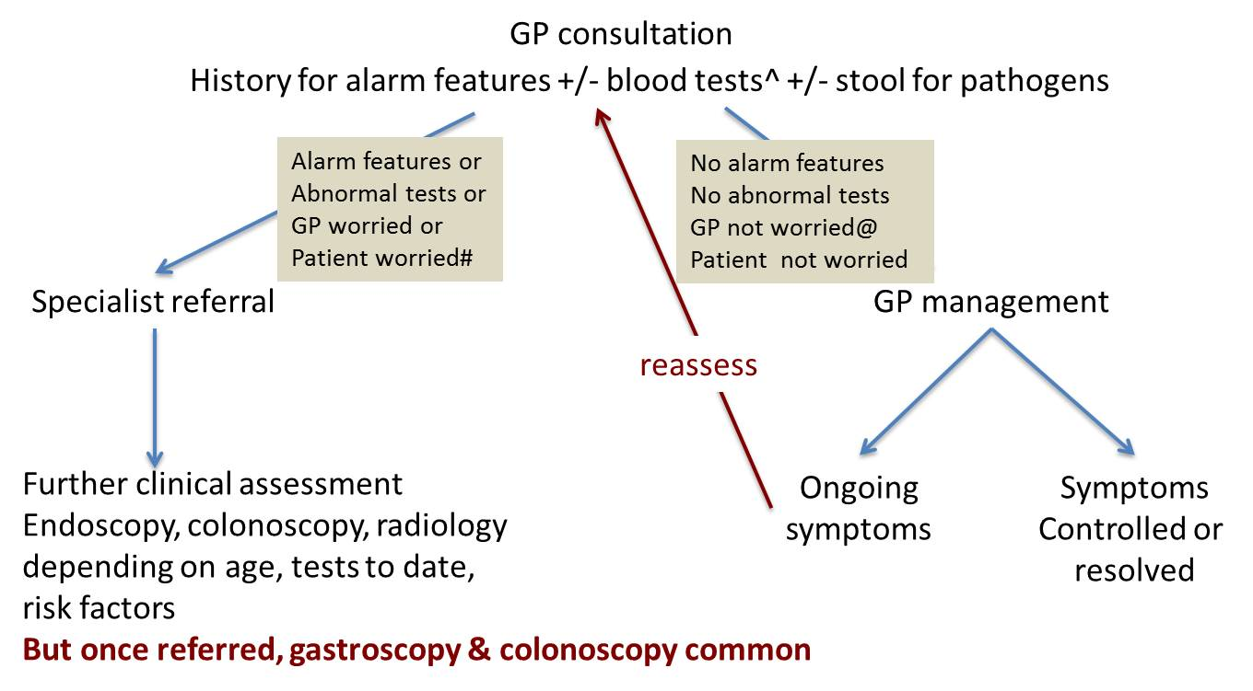
Algorithm supplied by GESA.
*Note that GESA advises that this algorithm represents an ideal management pathway, and that there is some variation in real world practice.
^ common tests FBC, CRP, ESR. GESA advises that GPs should also do Coeliac serology and iron studies if FBC results are suggestive.
# GESA advises that many people are referred because of their level of concern about their symptoms, even in the absence of alarm features or to abnormal bloods. In this situation, the faecal calprotectin test may allay non-specific worry of “missing” something.
@ GESA advises that many people who should be referred are not, as the tests weren’t ordered, or they and/or the GP did not perceive the severity. In this situation, calprotectin may aid in picking up those needing referral.
Abbreviations: FBC=full blood count; CRP=C-reactive protein; ESR=Erythrocyte sedimentation rate (with or without a stool specimen).

Proposed clinical pathway
The proposed pathways for patients with abdominal symptoms suggestive of either functional or inflammatory bowel disorders, where testing is ordered by a general practitioner or by a specialist are presented in Figure 2 and Figure 3, respectively.
Where testing is used by a GP, the faecal calprotectin test will be ordered together with other initial testing in presenting patients. Patients with an abnormal faecal calprotectin level will be referred to a specialist gastroenterologist, where they will be managed in the same way as under the current clinical pathway. Patients who do not have an abnormal faecal calprotectin level may be managed by their GP, as per the current clinical pathway; however, these patients may still be referred to a specialist if they have alarm features, have other abnormal tests, or if they or their GP are worried.
GESA advises that:
- Many people are referred to specialists because of their level of concern about their symptoms, even in the absence of alarm features or to abnormal bloods. In this situation, the faecal calprotectin test may allay non-specific worry of “missing” something.
- Many people who should be referred to specialists are not, as the tests weren’t ordered, or they and/or the GP did not perceive the severity. In this situation, calprotectin may aid in picking up those needing referral.
- GPs need to be mindful that faecal calprotectin testing will not replace community screening recommendations for colorectal cancer with FHH testing in people aged over 50 years.

Figure 2: Proposed clinical pathway for a patient with abdominal symptoms and bowel habit disturbance >6 weeks – where a General Practitioner orders the Faecal Calprotectin test (lab test)
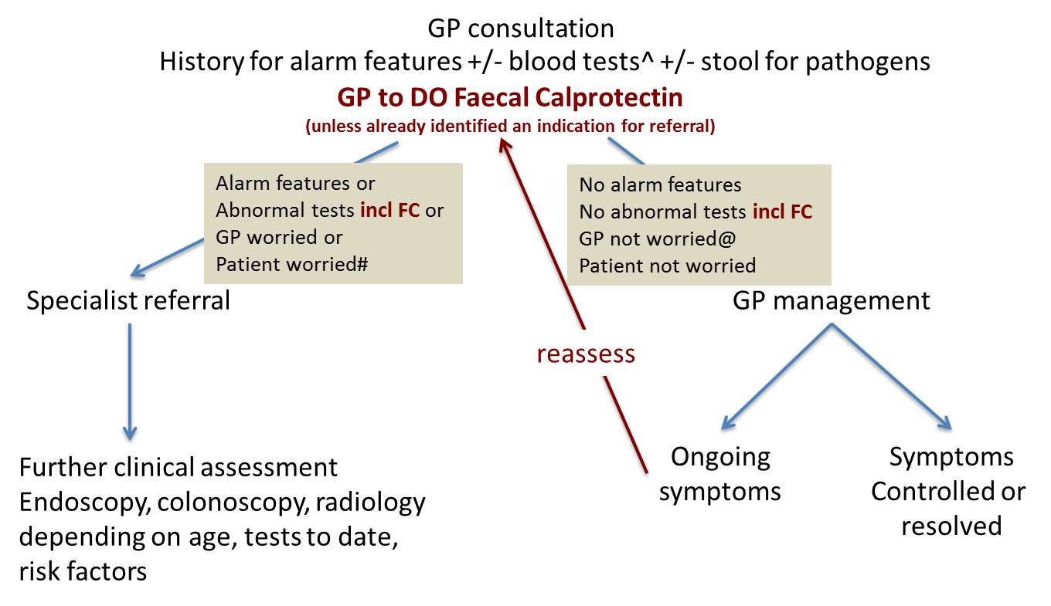
Algorithm supplied by GESA.
^ common tests FBC, CRP, ESR. GESA advises that GPs should also do Coeliac serology and iron studies if FBC results are suggestive.
# GESA advises that many people are referred because of their level of concern about their symptoms, even in the absence of alarm features or to abnormal bloods. In this situation, the faecal calprotectin test may allay non-specific worry of “missing” something.
@ GESA advises that many people who should be referred are not, as the tests weren’t ordered, or they and/or the GP did not perceive the severity. In this situation, calprotectin may aid in picking up those needing referral.
Abbreviations: FBC=full blood count; FC = faecal calprotectin; CRP=C-reactive protein; ESR=Erythrocyte sedimentation rate (with or without a stool specimen).

If the GP has not performed calprotectin testing prior referring a patient, then this testing will be performed by the specialist gastroenterologist. If the patient has a faecal calprotectin level of <50, then no action will be taken. The specialist will provide reassurance and return the patient to their GP for management. If the patient has a faecal calprotectin level between 50 and 100, the specialist will re-test the patient in two weeks and reassess the clinical scenario at that time. Evidence supporting these thresholds would be required in the assessment. If the patient has a faecal calprotectin level of >100, the specialist will undertake further investigations, as per the current clinical pathway. The applicant has indicated that the cut-off values follow the findings of the Pavlidis 2013 study, and that values in the range >50µg/g <100 µg/g require further investigation depending on the clinical treatment setting.
In ideal clinical practice, this pathway should be used less frequently than the previous pathway where the GP orders faecal calprotectin testing prior to referral, unless the GP has already identified a need to refer based on alarm features.
GESA advises that many of the people referred will not need faecal calprotectin testing, as they will clearly need endoscopic or radiologic investigations. However, in patients aged under 50 without alarm features, faecal calprotectin testing will allow the gastroenterologist to provide reassurance and send the patient back to the GP without invasive and expensive tests.
Figure 3: Proposed clinical pathway for a patient with abdominal symptoms and bowel habit disturbance >6 weeks – where a GP has not done FC testing and the specialist performs Point of Care Testing
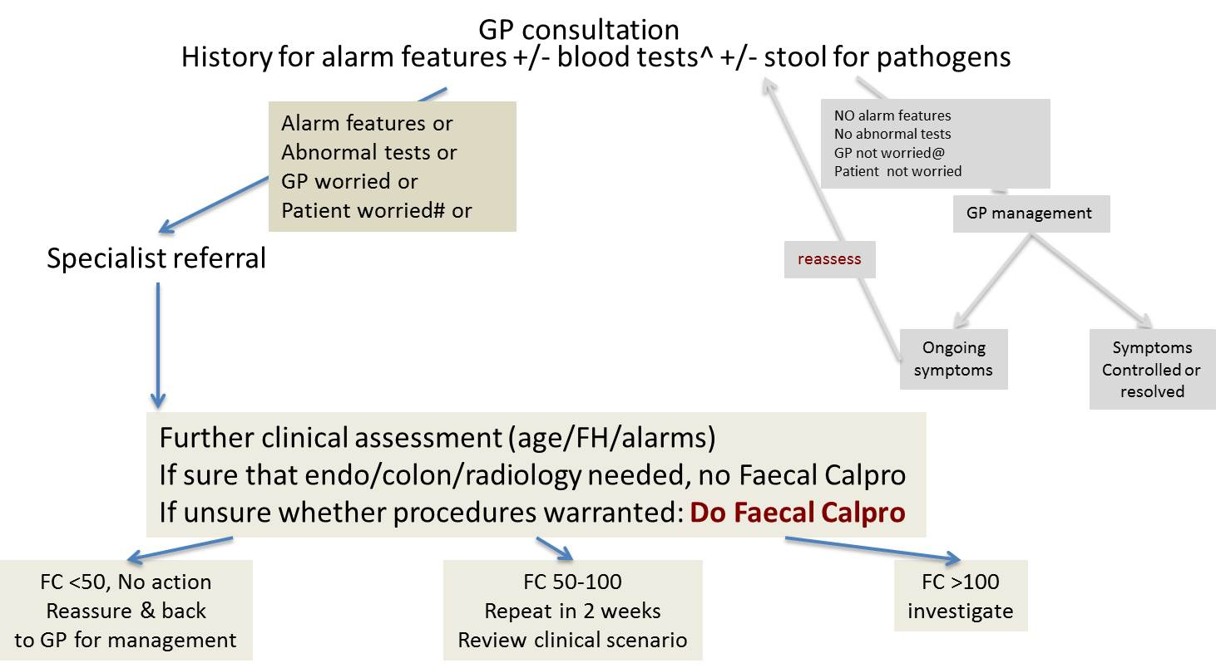
Algorithm supplied by GESA.
^ common tests FBC, CRP, ESR. GESA advises that GPs should also do Coeliac serology and iron studies if FBC results are suggestive.
# GESA advises that many people are referred because of their level of concern about their symptoms, even in the absence of alarm features or to abnormal bloods. In this situation, the faecal calprotectin test may allay non-specific worry of “missing” something.
@ GESA advises that many people who should be referred are not, as the tests weren’t ordered, or they and/or the GP did not perceive the severity. In this situation, calprotectin may aid in picking up those needing referral.
Abbreviations: FBC=full blood count; FC = faecal calprotectin; CRP=C-reactive protein; ESR=Erythrocyte sedimentation rate (with or without a stool specimen).

GESA advises that where a test result is indeterminate, and a subsequent re-test is also indeterminate, the patient will be referred to a gastroenterologist who will determine the subsequent course of action. The definition of an indeterminate result would need to be clarified in the assessment.
GESA suggests using the threshold of either <30 or <50 for the best negative predictive value. These values will need to be substantiated with evidence from the literature during the systematic review of evidence. Data relating to the predictive value of the assay at different ages is required in view of the varying incidences of IBD and likely impact of confounding diseases.

Faecal calprotectin test for monitoring patients with known IBD

Current clinical pathway
The current clinical pathway for GP monitoring of a patient diagnosed with IBD is presented in Figure 4. This pathway is based on the current Australian guidelines for GPs and physicians for the management of Inflammatory Bowel Disease which were developed by GESA (2013) and direct advice from GESA. IBD patients who are not on immunosuppressive therapies will be assessed annually by their GP, including a clinical history and blood and biochemistry testing. IBD patients on immunosuppressive therapies will undergo blood and biochemistry tests every 3 months and have a formal evaluation with their GP every 6 months. For either group, if the patient has had symptomatic periods in the prior year or their test results are concerning, the GP will refer the patient to a specialist for immediate review.
GESA advises that IBD patients on Immunosuppression are recommended to be under specialist care and to have a review 3-6 monthly with the specialist, although this can be shared with the GP by agreement.
Figure 4: Current clinical pathway for GP monitoring of IBD patients
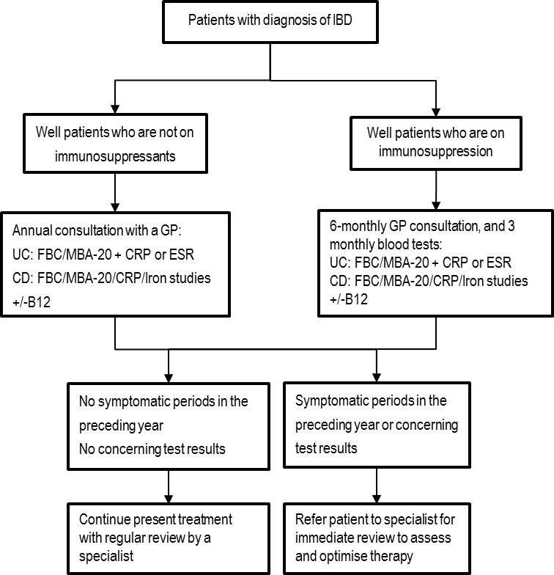
Abbreviations: FBC=full blood count; FC = faecal calprotectin; CD = Crohn's disease; CRP=C-reactive protein; ESR=Erythrocyte sedimentation rate (with or without a stool specimen); GP = general practitioner; IBD = inflammatory bowel disease; LFT = liver function tests; MBA-20 = Multi Biochemical Analysis 20; UC = ulcerative colitis.

Proposed clinical pathway
The proposed clinical pathway for faecal calprotectin testing for GP monitoring of patients with IBD is presented in Figure 5. Under the proposed pathway, patients diagnosed with IBD would have quarterly faecal calprotectin testing ordered by their GP, regardless of whether the patient is on immunosuppression. If the test result is lower than or equal to previous results, the current management strategy will be continued. If the test result is higher than previous results, the patient will be referred to a specialist for review.
Figure 5: Proposed clinical pathway for GP monitoring of patients with IBD
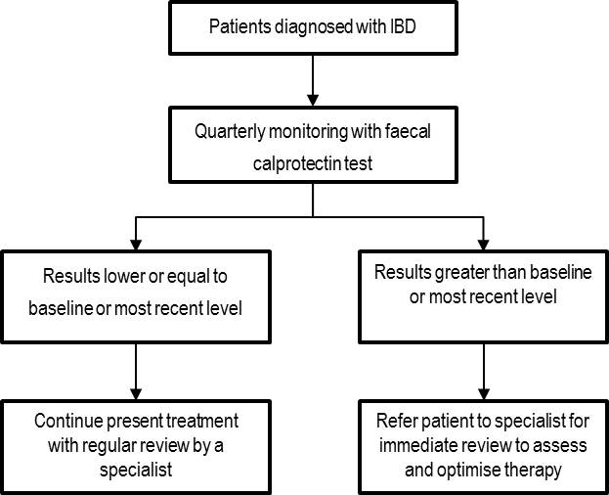

A variety of values for predicting relapse are used in the literature (e.g. D’Haens 2012; Naismith 2014), with different values used for POCT and the lab-based test (see, e.g. Ortega 2013). GESA advises that there is currently no data suggesting a specific cut-off value but note that a normal value (<30 or <50) indicates remission. They suggest that because rising value suggests relapse, while a falling value shows a decrease in inflammation, trend over time may be more informative.
The Applicant advises that in therapy monitoring, they suggest the following values: <100 as healthy, 100-300 as normal and >300 as high with an elevated risk of relapse. These discrepancies will need to be reconciled based on the evidence reviewed during the development of the assessment.
The proposed clinical pathway for faecal calprotectin testing for specialist monitoring of patients with IBD is presented in Figure 6. Under the proposed clinical pathway, patients will undergo regular faecal calprotectin testing, with the frequency of testing based on the patient’s current disease status. Patients with a faecal calprotectin level below 200 and stable disease would have no change to their treatment. Patients with a faecal calprotectin level below 200, but where the level is rising would be re-tested in two weeks or may undergo other investigative procedures, including endoscopy, colonoscopy, or radiology. Patients with a faecal calprotectin level above 200 will undergo other investigative procedures, including endoscopy, colonoscopy, or radiology.
GESA notes that faecal calprotectin testing may also be used to check compliance with increased therapy, as the most common cause of increased disease activity is non-adherence to prescribed medications.
Figure 6: Proposed clinical pathway for specialist monitoring of patients with IBD
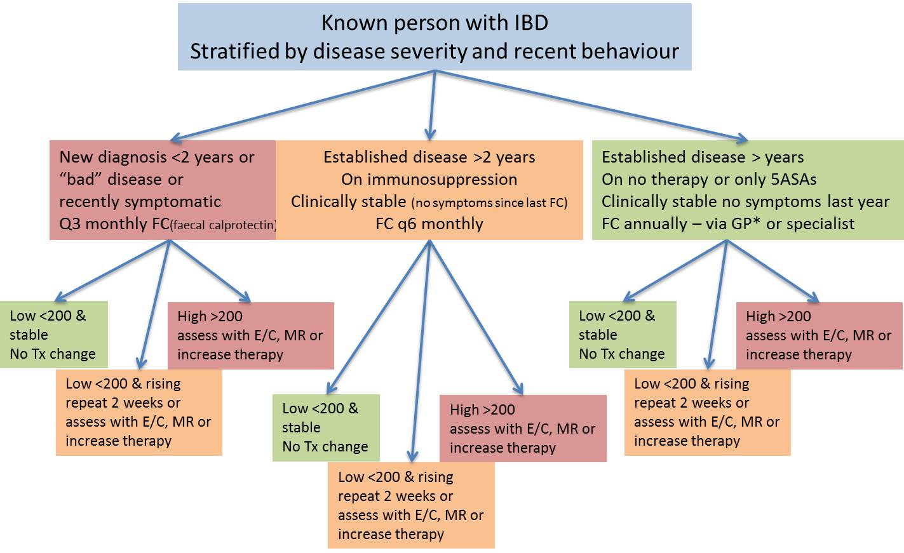
Algorithm supplied by GESA.
Note: If patients have substantial colonic disease >8 years, they will be having regular colonoscopy as per surveillance guidelines (NHMRC Dec 2011)
* if annual FC done by GP in stable low risk IBD patient, the result must be sent to a specialist and if in orange or red categories, the patient should be reassessed by a gastroenterologist.
Abbreviations: 5ASA = 5-aminosalicylic acid; C = colonoscopy; E = endoscopy; FC = faecal calprotectin; GP = general practitioner; Tx = treatment.
PASC advised that:
- The patient population needs to have clarified that infection must be excluded and there be no “alert” signs/symptoms raising suspicion of cancer.
- Patient populations found to be the most efficacious for economic modelling by NICE (IBD vs IBS in adults, IBD vs “other” in children) have not been specifically adopted.
- Data relating to the predictive value of the assay at different ages is required in view of the varying incidences of IBD and likely impact of confounding diseases.

Comparator
(1) Faecal calprotectin test for differentiating between functional and inflammatory bowel disorders:
The comparator for patients presenting with symptoms suggestive of either functional or inflammatory bowel disorders is colonoscopy/endoscopy and biopsy, which would be performed only once.
(2) Faecal calprotectin test for monitoring those patients with known IBD:
The comparator for monitoring patients with known IBD is a combination of colonoscopy, ESR and/or CRP, and radiology (CT +/- MRI). The frequency of these tests need to be clarified as each test would not occur on a quarterly basis.
PASC noted that the comparator for faecal calprotectin testing in the diagnostic algorithm (IBD vs IBS) was given as colonoscopy. PASC advised that the comparator should be colonoscopy/endoscopy and biopsy.
Determining the comparator for the second patient group (monitoring patients with known IBD) is more problematic. PASC agreed that the comparator would include some combination of colonoscopy (and biopsy), ESR/CPR and imaging (CT/MRI), but these tests would not all be done quarterly as routine monitoring, and some would only be done in the context of a disease flare or complications.
PASC advised that with respect to GP monitoring of IBD patients, the comparator for quarterly monitoring by faecal calprotectin suggested by Figures 4 and 5 would be routine blood tests (FBC/MBA-20, CRP/ESR +/- iron/B12 studies) performed 3-12 monthly depending on clinical circumstance. The Applicant notes that regular pathology monitoring of IBD patients is required.
PASC advised that with respect to specialist monitoring of IBD patients (presumed to be the less stable patients), the comparator would be endoscopy/colonoscopy (and biopsy) +/- CT/MRI. Data on the current utilization of radiology in this cohort of patients would be of assistance in defining the most likely to be replaced comparator and should be sought from specialist bodies.

Clinical claim
(1) Faecal calprotectin test for differentiating between functional and inflammatory bowel disorders:
The claim is that testing with faecal calprotectin is cheaper, safer and more effective than the present alternative (performing colonoscopy). In the event that claims of superior efficacy and safety are supported by the literature, either a cost-utility or a cost-effectiveness analysis would be appropriate, as per Table 6, below.

(2) Faecal calprotectin test for monitoring those patients with IBD:
The claim is that testing with faecal calprotectin is safer and more effective than the present alternative. In the event that claims of superior efficacy and safety are supported by the literature, either a cost-utility or a cost-effectiveness analysis would be appropriate, as per Table 6, below.
Table 6: Classification of an intervention for determination of economic evaluation to be presented
 |  | Comparative effectiveness versus comparator
 |  | Superior |  | Non-inferior | Inferior
Comparative safety versus comparator | Superior | CEA/CUA |  | CEA/CUA | Net clinical benefit | CEA/CUA
 |  |  |  |  | Neutral benefit | CEA/CUA*
 |  |  |  |  | Net harms | None^
 | Non-inferior | CEA/CUA |  | CEA/CUA* | None^
 | Inferior | Net clinical benefit | CEA/CUA | None^ | None^
 |  | Neutral benefit | CEA/CUA*
 |  | Net harms | None^
Abbreviations: CEA = cost-effectiveness analysis; CUA = cost-utility analysis
* May be reduced to cost-minimisation analysis. Cost-minimisation analysis should only be presented when the proposed service has been indisputably demonstrated to be no worse than its main comparator(s) in terms of both effectiveness and safety, so the difference between the service and the appropriate comparator can be reduced to a comparison of costs. In most cases, there will be some uncertainty around such a conclusion (i.e., the conclusion is often not indisputable). Therefore, when an assessment concludes that an intervention was no worse than a comparator, an assessment of the uncertainty around this conclusion should be provided by presentation of cost-effectiveness and/or cost-utility analyses.
^ No economic evaluation needs to be presented; MSAC is unlikely to recommend government subsidy of this intervention

Reference Standard
The reference standard for both proposed indications is colonoscopy/endoscopy and biopsy.
The other reference standard for IBD (especially Crohn’s Disease) is MRI.

Outcomes and health care resources affected by introduction of proposed intervention

Outcomes
(1) Faecal Calprotectin test for differentiating between functional and inflammatory bowel disorders:
- Effectiveness
  - Diagnostic accuracy: sensitivity, specificity, NPV, PPV, AROC, additional true positives, additional true negatives, test reproducibility (with and between assays) and repeatability
  - Time to diagnosis and time to commencement of therapy
  - Change in patient management: colonoscopies avoided, delay in diagnosis due to false negatives
  - Other: disease-specific morbidity, disease progression, quality of life, impact on colonoscopy demand
  - Reduction in referrals to specialists
- Safety
  - Adverse events: perforations avoided, bleeding
- Economic
  - Cost-utility or a cost-effectiveness analysis
  - Time lost from work
(2) Faecal Calprotectin test for monitoring those patients with IBD:
- Effectiveness
  - Test reproducibility and repeatability (coefficient of variance)
  - Diagnostic accuracy: sensitivity, specificity, NPV, PPV, AROC, additional true positives, additional true negatives, assay cut-offs for severity of acute inflammation, longitudinal correlation of faecal calprotectin levels and disease activity
  - Change in patient management: colonoscopies and hospitalisations avoided; reduced use of imaging, reduced use of serum inflammatory markers, reduced specialist referrals for monitoring patient on immunotherapy, reduced need for biological therapies and surgery, how changes in calprotectin levels will influence patient management,
  - Other: disease-specific morbidity, disease progression, quality of life, impact on colonoscopy demand, confounding effect of other inflammatory GE disorders, longitudinal changes in calprotectin levels and correlation with symptoms and histological evidence of active inflammation, utilization of the assays between gastroenterologist and GP
- Safety
  - Adverse events: perforations avoided, bleeding
- Economic
  - Cost-utility or a cost-effectiveness analysis
  - Time lost from work
The PASC has provided guidance on the information that should be presented in the assessment report to establish the validity of calprotectin testing in each of the requested populations. This information is presented in Appendix 1, below.
The PASC noted that the predictive value of the assay (PPV, NPV) will be affected by: confounding non-infectious conditions (e.g. diverticular disease, microscopic colitis, coeliac disease, and non-steroidal anti-inflammatory drugs), the age of the patient, and the prevalence of IBD, IBS and other conditions that vary with age.

Summary of the PICO criteria for the assessment
Once the discrepancies identified above are resolved, the PPICO table, below, will be revised.

Table 3: Summary of extended PICO to define research question that assessment will investigate
Patients | Prior test | Intervention | Comparator | Outcomes to be assessed
Patients presenting with chronic (more than 6 weeks’ duration) gastrointestinal symptoms which are suggestive of either functional and inflammatory bowel disorders, and where infectious causes have been excluded and there are no signs suggestive of malignancy | N/A | Faecal calprotectin test (POCT or laboratory-based) | Colonoscopy and biopsy | Effectiveness  - Test reproducibility and repeatability  - Diagnostic accuracy: sensitivity, specificity, NPV, PPV, AROC, additional true positives, additional true negatives  - Time to diagnosis and time to commencement of therapy  - Change in patient management: colonoscopies avoided, delay in diagnosis due to false negatives  - Other: disease-specific morbidity, disease progression, quality of life, impact on colonoscopy demand  - Reduction in referrals to specialists  Safety  - Adverse events: perforations avoided, bleeding  Economic  - Cost-utility or a cost-effectiveness analysis  - Time lost from work
Patients with an established diagnosis of IBD such as ulcerative colitis (UC) or Crohn’s disease (CD). | Established diagnosis of IBD (endoscopy) | Faecal calprotectin test (POCT or laboratory based) | Combination of colonoscopy, ESR and/or CRP, and radiology (CT +/- MRI) | Effectiveness  - Test reproducibility and repeatability (coefficient of variance)  - Diagnostic accuracy: sensitivity, specificity, NPV, PPV, AROC, additional true positives, additional true negatives, assay cut-offs for severity of acute inflammation  - Change in patient management: colonoscopies avoided; reduced need for biological therapies and surgery, how changes in calprotectin levels will influence patient management  - Other: disease-specific morbidity, disease progression, quality of life, impact on colonoscopy demand, confounding effect of other inflammatory GE disorders, longitudinal changes in calprotectin levels and correlation with symptoms and histological evidence of active inflammation  Safety  - Adverse events: perforations avoided, bleeding  Economic  - Cost-utility or a cost-effectiveness  - Time lost from work

PASC noted that the outcomes have been updated in light of previous PASC and GESA recommendations.
PASC advised the following amendments (in bold) to the outcomes:
- Faecal calprotectin test for differentiating between functional and inflammatory bowel disorders:
- Effectiveness
  - Diagnostic accuracy: sensitivity, specificity, NPV, PPV, AROC, additional true positives, additional true negatives, test reproducibility (within and between assays) and repeatability
  - Time to diagnosis and time to commencement of therapy
  - Change in patient management: colonoscopies avoided, delay in diagnosis due to false negatives
  - Other: disease-specific morbidity, disease progression, quality of life, impact on colonoscopy demand
  - Reduction in referrals to specialists
- Safety
  - Adverse events: perforations avoided, bleeding
- Economic
  - Cost-utility or a cost-effectiveness analysis
  - Time lost from work’
- Faecal calprotectin test for monitoring those patients with IBD:
  - Effectiveness
    - Test reproducibility (within and between assays) and repeatability (coefficient of variance)
    - Diagnostic accuracy: sensitivity, specificity, NPV, PPV, AROC, additional true positives, additional true negatives, assay cut-offs for severity of acute inflammation, longitudinal correlation of faecal calprotectin levels and disease activity
    - Change in patient management: colonoscopies and hospitalisations avoided; reduced use of imaging, reduced use of serum inflammatory markers, reduced specialist referrals for monitoring patient on immunotherapy, reduced need for biological therapies and surgery, how changes in calprotectin levels will influence patient management,
    - Other: disease-specific morbidity, disease progression, quality of life, impact on colonoscopy demand, confounding effect of other inflammatory GE disorders, longitudinal changes in calprotectin levels and correlation with symptoms and histological evidence of active inflammation, utilization of the assays between gastroenterologist and GP.
  - Safety
    - Adverse events: perforations avoided, bleeding

  - Economic
    - Cost-utility or a cost-effectiveness analysis
    - Time lost from work

References
Access Economics (2007) The Economic Costs of Crohn's Disease and Ulcerative Colitis. Available at: https://www.crohnsandcolitis.com.au/site/wp-content/uploads/Deloitte-Access-Economics-Report.pdf
AIHW (2012) Australia’s Health 2012.
Andrews JM et al (2010). Un-promoted issues in inflammatory bowel disease: opportunities to optimise care. Intern Med J 40(3): 173-82.
Chey WD et al (2010) The yield of colonoscopy in patients with non-constipated irritable bowel syndrome: results from a prospective, controlled US trial. Am J Gastroenterol 105(4): 859-65
D’Haens et al (2012). Faecal calprotectin is a surrogate marker for endoscopic lesions in inflammatory bowel disease. Inflammatory Bowel Diseases 18(12): 2218-2224
Gastroenterologocial Society of Australia (GESA) (2013) Australian Guidelines for General Practitioners and Physicians: Inflammatory Bowel Disease (IBD).
Lasson A et al (2008) Diagnostic yield of colonoscopy based on symptoms. Scand J Gastroenterol 43(3): 356-62
Naismith et al (2014). A prospective evaluation of the predictive value of faecal calprotectin in quiescent Crohn's disease. J Crohns Colitis 8(9):1022-29.
National Institute for Health and Care Excellence - NICE (2013). Faecal Calprotectin diagnostic tests for inflammatory diseases of the bowel. NICE diagnostics guidance 11. Available at: https://www.nice.org.uk/guidance/dg11
Ortega et al (2013). A new rapid test for FC predicts mucosal healing in Ulcerative Colitis.
Pavlidis P1, Chedgy FJ, Tibble JA (2013). Diagnostic accuracy and clinical application of faecal calprotectin in adult patients presenting with gastrointestinal symptoms in primary care. Scand J Gastroenterol. 2013 Sep;48(9):1048-54.
Siew CN et al (2013) Incidence and Phenotype of Inflammatory Bowel Disease Based on Results From the Asia-Pacific Crohn’s and Colitis Epidemiology Study. Gastroenterology 145:158-65.
Wilson J et al (2010) High incidence of inflammatory bowel disease in Australia: a prospective population-based Australian incidence study. Inflamm Bowel Dis 16(9):1550-56.

Appendix 1: Issues to consider in the Assessment Report
At its December 2014 meeting, PASC noted that the following issues need to be addressed in the assessment report.
(1) Calprotectin test as a means of differentiating between IBS and IBD patients:
  - Applicant needs to indicate whether the intended population is IBD vs IBS or inflammatory vs non-inflammatory or organic vs functional disease. (NB: the present protocol assumes that the intended population is IBD vs. IBS)
  - Provide evidence for the proposed 50 and 150 μg/g thresholds for the assays, and the basis for resolving an intermediate score between these thresholds.
  - Analyse the impact of confounding (e.g. diverticular disease, microscopic colitis, coeliac disease, reflux esophagitis, gastritis and non-steroidal anti-inflammatory drugs) on the assay’s accuracy in ruling in or out gastrointestinal inflammation in the proposed population.
  - Discuss how the prevalence of inflammatory/organic disease (IBD) vs non-inflammatory/functional disease (IBS), and other confounding diseases in different age groups, affects the assay’s predictive value and clinical and economic consequences.
  - Provide data regarding the assay’s performance (e.g. sensitivity, specificity, PPV, NPV) in the intended population and use this information in the economic evaluation.
  - Provide sufficient data for the economic evaluation, accounting for management and health outcomes of true positives, false positives (over-investigation and over-treatment), true negatives, false negatives (delayed diagnosis and under-treatment) and confounding diseases.
PASC also noted a number of additional research questions that should be addressed in the assessment report.
  - Calculate PPV and NPV and colonoscopy costs for each scenario taking into account disease prevalence at different ages (IBD>IBS in children, IBS>IBD in middle age, colorectal cancer and diverticular disease more common in elderly).
  - Provide evidence for the claim that a test returning <50 μg/g where no colonoscopy is performed results in cost savings.
  - Provide additional clinical management guidelines.

(2) Calprotectin test for monitoring those patients who are identified as having IBD:
  - No clinical guidelines are available for use of Faecal Calprotectin testing.
  - Provide data regarding biovariability and the assay’s reproducibility and repeatability.
  - Provide data to show longitudinal correlation of Faecal Calprotectin levels with disease activity.
  - Provide data to indicate what a significant increase is in Faecal Calprotectin above patient baseline or last measurement.
  - Provide data to justify testing intervals.
  - Provide data to estimate the proportion of patients with a significant increase in Faecal Calprotectin who will proceed to colonoscopy.
  - Provide evidence to show the split of the assay use between GP and gastroenterologist.
  - Provide data to show improvement in quality of life.
  - Provide sufficient data for the economic evaluation.

PASC also noted a number of additional research questions that should be addressed in the assessment report.
  - Need coefficient of variance data for assay reproducibility and repeatability for serial Faecal Calprotectin measurements.
  - Need biovariability data for Faecal Calprotectin measurements in longitudinal studies of healthy and IBD subjects.
  - Need clear Faecal Calprotectin values that indicate mucosal healing, deep remission, relapse and flare in patients with CD and UC.
  - Need data correlating Faecal Calprotectin concentrations with disease activity (symptoms), degree of inflammation (histology), markers of inflammation (ESR, CRP) and therapeutic responses over time in individual patients with CD and UC.
  - Need data showing correlation between measurement intervals and ability to predict relapse and/or flare.
  - Need data showing that regular monitoring improves quality of life, reduces number of colonoscopies and hospitalisations, reduces need for biological therapies and surgery.
  - Need clinical guidelines for use of Faecal Calprotectin in IBD.

The PASC noted The Royal College of Pathologists of Australasia advice that data in children is not as compelling as in adults, and requires clarification.
As above, the data in children requires clarification.

