A MESSAGE FROM THE DEPARTMENT OF HEALTH ON BEHALF OF THE PROTOCOL ADVISORY SUB COMMITTEE REGARDING THIS PROTOCOL

PLEASE NOTE: This is an applicant-prepared Consultation Protocol, which will be considered by PASC at its 15-16 August meeting. This version of the Protocol has not been assessed by the Protocol Advisory Sub Committee (PASC).

When PASC considered an earlier version of the Protocol at its April 2014 meeting, it recommended that the following be considered by the applicant prior to public consultation:
- The impact of MammaPrint® on node negative patients versus node positive patients should be evaluated, PASC noted that nodal status is a critical determinant of breast cancer prognosis;
- PASC noted that establishment of HER2/neu status is not an entry criterion for testing, which could lead to some HER2 positive patients not receiving chemotherapy. PASC noted that this occurred in the RASTER trial but was highly unlikely to occur in Australian practice;
- The definition of the patient population does not include primary tumour size and tumour grade, which are currently common prognostic factors in cancer management; and
- PASC sought clarity as to whether patients who have a primary tumour less than 1cm in diameter will be tested. Patients with tumours less than 1cm are generally those for whom the benefits of chemotherapy are queried.

PASC’s role
PASC does not assess evidence in relation to a technology or service, but proposes the framework for evidence collection during the assessment phase of the MSAC process once a Protocol has been finalised. This is done by establishing a 'PICO', which is described below.

- Population – the specific patient group/s for whom the proposed medical service is to be considered;
- Intervention – the proposed medical service, where it fits in the clinical management of the patient, and who administers it;
- Comparator – current clinical practice and the existing service/s most likely to be replaced by the proposed service; and
- Outcomes – all potentially impacted healthcare resources, health outcomes, or clinical management changes likely to be achieved if the proposed service is funded.

Whilst evidence may be presented in the applicant’s consultation protocol, and comment may be made on the entire protocol, PASC's primary function is to focus on the PICO.

------------------- START OF APPLICANT’S PROTOCOL -------------------

MEDICAL SERVICES ADVISORY COMMITTEE

Consultation Protocol to guide the assessment of gene expression profiling of 70 genes in breast cancer assay to quantify the risk of disease recurrence and predict adjuvant chemotherapy benefit.

MSAC Application Number 1376

Submitted February 2014
Revised and re-submitted April 2014
Revised again and re-submitted June 2014
Revised again and re-submitted July 2014

Prepared by Applicant - Genome Investigation Pty Ltd.

TABLE OF CONTENTS
1. Title & Summary 2
Contents 3
Abbreviations 4
2. Purpose of Application 6
3. Population and medical condition eligible for the proposed medical service 8
4. Intervention –proposed medical service 24
5. Co-dependent Information 38
6. Comparator – clinical claim for the proposed medical service 39
7. Expected health outcomes relating to the medical service 44
8. Fee for the proposed medical service 45
9. Clinical Management Algorithm – clinical place for the proposed intervention 50
10. Regulatory Information 56
11. Decision Analytic 57
12. Healthcare Resources 59
13. Questions for Public Funding 67
14. Conclusions 70 References 71

Abbreviations

AAB American Association of Bioanalysts
AACR American Association of Cancer Registries
AC doxorubicin and cyclophosphamide
AC-Taxol doxorubicin and cyclophosphamide followed by paclitaxel
AIHW Australian Institute of Health and Welfare
AJCC American Joint Committee on Cancer Staging
AOL Adjuvant online
ARTG Australian Register of Therapeutic Goods
ASBD Australasian Society of Breast Disease
BAG-1 BCL2-associated athanogene 1
BCL-2 B-cell lymphoma 2
BCRT Breast Cancer Research & Treatment
BreastSurgANZ Breast Surgeons of Australia and New Zealand Inc.
BCSS Breast Cancer Specific Survival
CAP College of American Pathologists
CD-68 Cluster of differentiation 68
CEA Cost-effectiveness analysis
CI confidence interval
CLIA United States Clinical Laboratory Improvement Amendment
CMF cyclophosphamide, methotrexate, 5-fluourouracil
CMS Centers for Medicare and Medical Service
CUA Cost-utility analysis
DAP Decision Analytical Protocol
DDFS Distant Disease Free Survival
DMFS Distant Metastasis Free Survival
DNA deoxyribonucleic acid
DRFI Distant Recurrence Free Interval
ECOG Eastern Cooperative Oncology Group
EGFR epidermal growth factor receptor
ER oestrogen receptor
ER- oestrogen receptor-negative
ER+ oestrogen receptor-positive
ESMO European Society for Medical Oncology
FDA United States Food & Drug Administration
FECD 5-fluourouracil, epirubicin, cyclophosphamide followed by docetaxel
FFPE formalin fixed paraffin embedded
FFPET formalin fixed paraffin embedded tissue
FiSH fluorescence in situ hybridization
FPE paraffin-embedded tumour tissue
GAPDH Glyceraldehyde 3-phosphate dehydrogenase
GEP gene expression profiling
GRB-7 Growth factor receptor-bound protein 7
GSTM-1 Glutathione S-transferase mu 1
GUS Beta-glucuronidase
HER2 human epidermal growth factor receptor 2
HER2- human epidermal growth factor receptor 2-negative
HER2+ human epidermal growth factor receptor 2-positive
ID Identification
IHC Immunohistochemistry
IJC International Journal of Cancer
IVDs In Vitro diagnostic medical devices
KRAS GTPase KRas or V-Ki-ras2 Kirsten rat sarcoma viral oncogene homolog
LN lymph node
MOGA Medical Oncology Group of Australia
MBS Medicare Benefits Scheme
MDM Multidisciplinary Meeting
MINDACT Microarray In Node negative and 1-3 positive lymph node Disease may Avoid ChemoTherapy trial
mRNA messenger ribonucleic acid
MSAC Medical Services Advisory Committee
MYBL-2 Myb-related protein B
N- node-negative
N+ node-positive
NATA National Association of Testing Authorities
NBOCC National Breast and Ovarian Cancer Centre
NCCN National Comprehensive Cancer Network
NEJM New England Journal of Medicine
NHMRC National Health and Medical Research Council
NPAAC National Pathology Accreditation Advisory Committee
NSABP National Surgical Adjuvant Breast and Bowel Project
PASC Protocol Advisory Sub-Committee
PICO Patients, Intervention, Comparator, Outcomes
PR progesterone receptor
PR- progesterone receptor-negative
PR+ progesterone receptor-positive
PROMIS – PRospective study Of MammaPrint in breast cancer patients with an Intermediate recurrence Score
RASTER microarRAy-prognoSTics-in-breast-cancER study Drukker et al 2013 IJC
RNA ribonucleic acid
RPLPO Large ribosomal protein
RT-PCR reverse-transcriptase polymerase chain reaction
SCUBE-2 Signal peptide, CUB domain, epidermal growth factor-like 2
SD standard deviation
STK-15 Serine/threonine kinase
TAC docetaxel, doxorubicin, cyclophosphamide
TC docetaxel, cyclophosphamide
TFRC Transferrin receptor
TGA Therapeutic Goods Administration
TNM Classification of Malignant Tumours
USA United States of America
USD United States Dollar

MSAC and PASC

The Medical Services Advisory Committee (MSAC) is an independent expert committee appointed by the Australian Government Health Minister to strengthen the role of evidence in health financing decisions in Australia. MSAC advises the Health Minister on the evidence relating to the safety, effectiveness, and cost effectiveness of new and existing medical technologies and procedures and under what circumstances public funding should be supported. The Protocol Advisory Sub-Committee (PASC) is a standing sub-committee of MSAC. Its primary objective is the determination of protocols to guide clinical and economic assessments of medical interventions proposed for public funding.

Purpose of Application

A. Please indicate the rationale for the application and provide one abstract or systematic review that will provide background.

This application from Genome Investigation is provided to the Department of Health and Ageing, requesting a Medicare Benefits Schedule (MBS) listing for gene expression profiling (GEP) using the 70 gene MammaPrint® test in a subset of early breast cancer patients.

This document is a Decision Analytical Protocol (DAP) that should be used to guide the assessment of GEP testing by microarray messenger ribonucleic acid (mRNA) analysis of the scientifically selected, prospectively validated and FDA approved breast cancer 70 gene set that predicts the risk of recurrence and the likelihood of benefit of adjuvant chemotherapy in a subset of breast cancer patients.

It is the intent of this DAP to develop a protocol for the assessment and MBS listing for any GEP in breast cancer using a scientifically selected 70 gene set measured by microarray mRNA GEP technique. The rationale behind performing such a test is to characterise and identify patients with low or high risk profiles for recurrence, thus allowing clinicians to better individualise their treatment recommendations.

GEP is an emerging technology used for identifying breast cancer genes whose activity may be helpful in assessing disease prognosis and guiding therapy. In recent years, GEP has been successfully used in breast cancer research. For instance, distinct subtypes of breast tumours (such as tumours expressing HER-2) have been identified as having distinctive gene expression profiles, representing diverse biologic entities associated with differences in clinical outcome (Knauer et al. British Journal of Cancer 2010). Further, the important I SPY 2 and I SPY 3 trials are now using the 70 gene MammaPrint assay as part of their trial protocol to help select appropriate patients for to assess their response to new oncology drugs.

There is currently only one such test that uses 70-genes and the microarray mRNA technique in existence, the 70 gene MammaPrint® breast cancer test which is distributed in Australia by Genome Investigation Pty Ltd, and produced and operated by Agendia Inc, California, USA. Agendia hold the patent for the GEP algorithm for the 70 gene microarray mRNA assay.

MammaPrint® testing has now been validated by many retrospective studies, prospectively
by the RASTER study, and the large randomised prospective MINDACT study has now
reported the risk stratification data. As a result, MammaPrint® testing has now been acknowledged by the 2013 St Gallen International Expert Consensus Statement Recommendations (St Gallen), the 2013 European Society of Medical Oncology (ESMO) Guidelines, the 2013 National Comprehensive Cancer Network (NCCN) Clinical Practice Guidelines in Breast Cancer and the 2013 Japanese Society of Medical Oncology (JSMO) international breast cancer guidelines.

Throughout the remainder of this DAP the GEP in breast cancer using 70-genes and the microarray mRNA analysis technique will be referred to as MammaPrint. Although reference is made to the MammaPrint brand name in this DAP for simplicity, it should be noted that Genome Investigation is not seeking to include a brand name in an MBS item descriptor. If implemented, this MBS item would therefore apply to other GEP’s assaying 70 genes using microarray mRNA analysis and an algorithm in competition with MammaPrint.

This DAP has been prepared by Genome Investigation Pty Ltd, with assistance from Agendia Inc. It is expected that this version should be reviewed and released to the public for comment. Following a period of consultation the final DAP ratified by PASC should provide the basis for the assessment of the intervention.

This application relates to the MammaPrint test for Australian patients that is conducted in asingle laboratory in the United States (Agendia Laboratory, Irvine, California, USA), and so isnot subject to regulation by the Australian Therapeutic Goods Administration. Europeanpatients have their MammaPrint testing performed in Amsterdam. The Californian laboratoryis however subject to regulation by the United States’ Centers for Medicare and MedicalService (CMS). Further, it has received five separate FDA approvals for utilisation in breastcancer, which is a major difference to the 21 gene assay, which after 12 years of utilisation inthe USA, has yet to gain any FDA approvals.
This DAP has been put together by Genome Investigation using a template supplied byMSAC, as well as the final DAP for the 21 gene assay (MSAC ID 1342) as a guide. It isproposed that this DAP guide the assessment of the safety, effectiveness and costeffectiveness of MammaPrint testing in early breast cancer in order to inform MSAC’sdecision-making regarding public funding of the test.

Finally, in view of the current national Australian budget limitations in healthcare, theinclusion of MammaPrint testing has also been shown to be significantly cost effective inseveral international studies (Retel et al 2011 Breast Cancer Res Treat, Yang et al 2012Cancer, Retel et al 2013 European Journal of Cancer), resulting in significant financialsavings for health care funders.

In essence, MammaPrint testing results in an approximate 30% net reduction in theadministration of adjuvant chemotherapy in the early breast cancer setting. When all costsare taken into consideration, the financial cost of adjuvant therapy in breast cancer isestimated to be around $AUD20,000 per patient (including all associated costs of inpatientadmissions needed for managing medical complications, modern pharmaceuticals, nursingand medical staffing costs, etc.). With the price of a MammaPrint test currently setinternationally at $USD4,200, it can be quickly seen that a 30% reduction in adjuvant therapygives a major significant overall price saving for the health care funder (the AustralianDepartment of Health).

It is a rare modern occurrence to have a significant medical innovation result in an overallcost savings. However, this is what makes MammaPrint testing particularly worthwhile, andis why so many international guidelines are now incorporating this new validated test into their fight against breast cancer.

Population and medical condition eligible for the proposed medical services

Provide a description of the medical condition (or disease) relevant to the service

Eligible Population Summary - Definition of Patient Population:-

Patients with stage I-II early breast cancer who are either node negative or node positive with up to three lymph nodes involved and who are oestrogen or progesterone receptor positive. Further, as approved by the FDA, tumour size can be any size up to 50mm in diameter. Tumours can be any histological grade, and either HER2+ or HER2-.

Eligible Population Background:-

Breast cancer is a malignant neoplasm of the breast, resulting in a highly significant annual mortality and morbidity. In Australia, there were 12,567 new cases of breast cancer in 2007, and it is estimated that this will increase to approximately 14,818 cases in 2011 and 15,409 cases by 2015 (Cancer Australia 2011). Based on data from the NSW Central Cancer Registry between 2004 and 2008, 51.2% of patients have localised disease at the time of diagnosis, while 36.5% have advanced disease with regional lymph node involvement, 5.4% have distant metastases, and the extent of disease in 6.9% is unknown (New South Wales Central Cancer Registry 2010). It is estimated that half of the women with regional lymph node involvement will have involvement in less than 3 nodes. Thus, approximately 70% of patients have breast cancer with either no lymph node involvement or 1-3 lymph nodes involved. This equates to approximately 10,372 patients per annum (14,818×0.70).

The rationale for developing the MammaPrint 70 gene microarray mRNA assay was to provide clinicians with a tool that would allow them to better select patients with early breast cancer who may benefit from adjuvant chemotherapy. Breast cancer is a disease in which abnormal cells, most commonly originating from the terminal duct lobular unit of the breast, transform and develop into an invasive tumour. These tumours can invade and damage the tissue around them, and spread to other parts of the body, such as the bones, liver, lung and brain, through the lymphatic or vascular systems (AIHW & NBOCC 2009).

Breast cancer is the most common cancer among Australian women, accounting for 27% of all cancer diagnoses and with an average age of first diagnosis of 60 years in 2007 (AIHW & AACR 2010; AIHW & NBOCC 2009). Thus, one in nine women will be diagnosed with breast cancer before the age of 85. The BreastScreen Australia program screened 1,641,316 women (77.6% aged 50-69 years) for breast cancer in 2007-2008 (AIHW 2010). There was an increase in the rate of detection of invasive breast cancer between 1996 and 2008, from 56.5 to 71.7 per 10,000 women screened for the first screening round, and from 35.3 to 47.5 per 10,000 women screened for subsequent screening rounds. However, nearly two-thirds of all invasive breast cancers detected by BreastScreen Australia were small, improving the chances of survival for these patients.

The relative five-year survival rates for Australians has been increasing steadily in the last few decades; 72.6% of women diagnosed with breast cancer in 1982-1987 survived, compared to 88.3% of women in 2000-2006. The 2006 five-year relative survival rate can be further divided into 96.5% for women with negative nodal status and 80.2% for women with positive nodal status in 2006 (AIHW & NBOCC 2009).

Despite the high survival rates, breast cancer was the leading cancer cause of burden of disease for women, accounting for 40,600 years of life lost due to premature death and 20,500 years of healthy life lost due to disease, disability or injury in 2010 (AIHW & AACR 2010). In the current care paradigm a diagnosis of breast cancer is made by multiple assessments (clinical assessment, mammography or magnetic resonance imaging and/or ultrasound imaging with core biopsy and/or fine needle aspiration) and upon pathological confirmation of cancer diagnosis and staging a treatment plan is suggested.

Systemic therapy options for breast cancer management include endocrine treatments, targeted biological agents and chemotherapy. Surgery is usually considered as the first treatment option for primary breast cancer. For patients who present with tumours that are considered too large for breast conservation surgery, guidelines recommend that primary systemic therapy (neoadjuvant therapy) may be used in an attempt to shrink the size of the primary tumour to enable breast conserving treatment and surgery. In addition some patients are considered unfit for surgery, these patients are usually elderly.

During surgery the tumour and axillary lymph nodes are dissected. The aim of surgery is to eradicate the primary tumour and any local extension in the hope of achieving total disease control (NHRMC Clinical practice guidelines for the management of early breast cancer, 2001).

Histological information obtained following surgery provides information relating to a number of prognostic factors including histological grade, nodal status, tumour size, hormone (ER and PR) receptor, HER-2 status and proliferation index (Ki67). Subsequent planning of treatment is then undertaken on the basis of these prognostic and predictive factors (in combination with information on patient characteristics). The strongest prognostic factors for predicting future recurrence or death from breast cancer are patient age, co-morbidity, tumour size, tumour grade, number of involved axillary lymph nodes, MammaPrint low or high risk stratification and HER2 status.

Algorithms, such as Adjuvant online (AOL), have been published estimating the rates of recurrence, but it has not been updated for some time and does not include HER2 tumour status (Segelov and Yeo 2010). Based on expert opinion gathered to assist the development of this DAP, it is for these reasons, along with the availability of the prospectively validated 70 gene MammaPrint assay, that Australian clinicians are tending to use AOL less frequently.

Information on risk of recurrence is used by clinicians and patients to make decisions regarding toxicities, costs and benefits of systemic adjuvant therapy (NCCN 2011). Systemic adjuvant therapy may comprise hormone therapy and or chemotherapy. The intent is to include all “hormone receptor (HR)-positive” patients, defined as being ER+ and/or PR+ determined by immunohistochemistry (IHC), as eligible for the assay, as these are patients for whom adjuvant hormonal therapy with or without chemotherapy is usually recommended.

The level of ER assessed immunohistochemically provides useful predictive information regarding efficacy of endocrine therapy. ER status therefore forms part of the Australian minimum dataset for histopathology reporting of invasive breast cancer. ER status is routinely determined on all invasive breast cancers and reported using a standardised technique (such as the Allred scoring system). However, the prediction of likelihood of response of a breast cancer to endocrine therapies using ER assessment is not precise; some patients with ER-positive disease will not respond to endocrine therapies. Therefore, additional markers for response to endocrine therapy have been sought.

Since progesterone receptor (PR) expression is induced by ER, it has been studied as a surrogate marker for ER activity and immunohistochemical assessment of PR has been used as an additional predictive factor for hormonal therapy in breast cancer. The results of overview analyses of randomised clinical trials in early breast cancer have shown that PR

may add to the power of ER for predicting response to endocrine therapy. PR also predicts response to endocrine therapy in metastatic breast cancer (Mohsin et al. 2004). Divergent ER and PR status is uncommon (for example, less than 5% of cases are ER negative but PR-positive). Nevertheless, PR examination is routinely performed on all invasive tumours by some laboratories.

Immunohistochemical assessment of the ER and PR status of a breast cancer tumour is currently used to predict the efficacy of hormone therapy (NHMRC 2001). HER2 status is also assessed and forms a key component of the decision to offer trastuzumab.

Immunohistochemistry (IHC) for the detection of oestrogen, progesterone and HER2, among other antibodies, is currently listed on the MBS (item number 72848, 72849 or 72850). These item numbers allow for examination of biopsy with 1 to 3, 7 to 10 and 11 or more antibodies, respectively and are currently not restricted by patient or clinical indication. Any of these tests are sufficient to determine patients’ ER status to establish eligibility for the MammaPrint test.

The utilisation of these items (as reported on https://www.medicareaustralia.gov.au/) indicates that between January 2010 and December 2011 there were approximately 28,874 services claimed for women for MBS item numbers 72848, 72849 or 72850. Based on the estimated 14,818 new breast cancer cases in 2011, current usage of IHC testing suggests that all women with breast cancer are being tested for ER, PR and HER2.

Ki-67 is a genetic marker in development however there still remain substantial challenges in its utility as inter-laboratory concordance and reliable Ki-67 index assessments are not yet available (Goldhirsch et al. 2011, Luporsi et al. 2012). Furthermore Ki-67 has not been found to be predictive for long term follow-up after chemotherapy (Luporsi et al. 2012).

Until MammaPrint was introduced, there has been no validated tumour specific chemotherapy tool available to determine the likelihood of benefiting from adjuvant chemotherapy. It is well recognised that there is a significant over treatment (and under treatment) with chemotherapy in the adjuvant setting in patients with ER+ early stage breast cancer based on conventional care paradigm.

The selection of patients with ER+ (or PR+) early stage breast cancer for adjuvant chemotherapy remains an important clinical issue since the additional benefit of adjuvant chemotherapy in node negative breast cancer is modest (estimated absolute benefit of 4%; 92% with versus 88% without, in terms of 10-year distant recurrence in the NSABP-20 trial) but the toxicity is significant.

There is great interest in developing, testing, and validating strong predictive markers that can be used in daily clinical practice to accurately identify those patients most likely to benefit from specific therapy options such as chemotherapy.

For node positive patients, who are HR+ (N=3383), there is also a relatively modest risk of relapse and modest treatment effect observed with taxane containing chemotherapy regimens (annual recurrence rate less than 0.1 and 7.0% absolute survival benefit due to chemotherapy for patients who survived to 5 years disease-free) (Berry et al. 2006). Additionally, patients with node positive disease are more likely to be initiated on chemotherapy than node-negative patients.

Table 1 provides definitions for the TNM staging categories used by the American Joint Committee on Cancer Staging (AJCC) and Table 2 describes the TNM categories that define breast cancer stages 0-IV. Patients with breast cancer stage I-II would be eligible for MammaPrint testing.
Table 1. TNM staging of breast cancer
Primary Tumour (T) | Regional lymph node (N) | Distant metastasis (M)
TX Primary tumour cannot be assessed.  T0 No evidence of primary tumour  Tis Carcinoma in situ  (DCIS) Ductal carcinoma in situ  (LCIS) Lobular carcinoma in situ  (Paget’s) Paget’s disease of the nipple NOT associated with invasive carcinoma and/or carcinoma in situ.  T1 Tumour ≤20mm in greatest dimension  T2 Tumour > 20mm but ≤50mm in greatest dimension  T3 Tumour > 50mm in greatest dimension  T4 Tumour of any size with direct extension to the chest wall and/or to the skin (ulceration or skin nodules)  T4a Tumour of any size with direct extension to the chest wall, not only pectoralis muscle adherence/invasion  T4b Tumour of any size with ulceration and/or ipsilateral satellite nodules and/or edema (including peau d’orange) of the skin, which do not meet the criteria for inflammatory carcinoma  T4c Both T4a and T4b  T4d Inflammatory carcinoma | NX Regional lymph nodes cannot be assessed (for example, previously removed).  N0 No regional lymph node metastasis  N1 Metastases to movable ipsilateral level I, II axillary lymph nodes(s)  N2a Metastases in ipsilateral level I, II axillary lymph nodes that are clinically fixed or matted  N2b Metastases in clinically detected ipsilateral internal mammary nodes in the absence of clinically evident axillary lymph node metastases  N3a Metastases in ipsilateral infraclavicular (level III axillary) lymph node(s) with or without level I, II axillary lymph node involvement;  N3b Metastases in clinically detected ipsilateral internal mammary lymph node(s) with clinically evident level I, II axillary lymph node metastases;  N3c Metastases in clinically detected ipsilateral supraclavicular lymph node(s) with or without axillary or internal mammary lymph node involvement | M0 No clinical or radiographic evidence of distant metastases.  M0(i+) Deposits of tumour cells in circulating blood, bone, marrow, or other non-regional nodal tissue that are no larger than 0.2mm  M1 Distant detectable metastases larger than 0.2mm
Source:- American Joint Committee on Cancer Staging resources [accessed September 2011].
(As presented in Decision Analytic Protocol for HER2 testing in breast cancer, application 1175, January 2012)
Table 2. American Joint Committee on Breast Cancer TNM stage grouping

Stage grouping | T stage | N stage | M stage
Stage 0  Stage IA  Stage IB  Stage IIA  Stage IIB  Stage IIIA  Stage IIIB  Stage IIIC  Stage IV | T1  T0  T0  T1  T0  T1  T2  T2  T3  T0  T1  T2  T3  T3  T4  T4  T4  Any T  Any T | N0  N0  N1mi  N1mi  N1  N1  N0  N1  N0  N2  N2  N2  N1  N2  N0  N1  N2  N3  Any N | M0/M0(i+)  M0/M0(i+)  M0/M0(i+)  M0/M0(i+)  M0/M0(i+)  M0/M0(i+)  M0/M0(i+)  M0/M0(i+)  M0/M0(i+)  M0/M0(i+)  M0/M0(i+)  M0/M0(i+)  M0/M0(i+)  M0/M0(i+)  M0/M0(i+)  M0/M0(i+)  M0/M0(i+)  M0/M0(i+)  M1

Source:- American Joint Committee on Cancer Staging resources [accessed September 2011].
(As presented in Decision Analytic Protocol for HER2 testing in breast cancer, application 1175, January 2012).

MammaPrint has now been validated prospectively to prevent unnecessary exposure to chemotherapy regimens that are offering the patient no clinical effect (microarRAy-prognoSTics-in-breast-cancER - RASTER trial, Drukker et al IJC 2013).

Of the many hundreds of GEP research papers now published, the RASTER study is arguably the most significant to be fully reported in the peer reviewed literature to date, as it has confirmed prospectively that adjuvant chemotherapy can now be safely withheld in low risk patients with no impairment in cancer recurrence or longevity. This is another major difference to any other tests in this arena which have no prospective data to support significant outcome data.

The largest GEP trial is the very significant Microarray In Node negative and 1-3 positive lymph node Disease may Avoid ChemoTherapy (MINDACT) trial. Recruitment of 6,694 patients in this prospective randomised trial closed back in 2011 and the trial is now nearing completion. However, Professor Emiel Rutgers et al have already released two initial reports (Rutgers et al European Journal of Cancer 2011 and Rutgers et al EORTC Conference Abstract September 2013).

The initial risk stratification MINDACT trial results are now in the public domain, are included in Section 2 and these will be referred to in Section 3 (B) of this DAP.

B. Define the proposed patient population that would benefit from the use of this service. This could include issues such as patient characteristics and /or specific circumstances that patients would have to satisfy in order to access the service.

Definition of Patient Population:-
MammaPrint testing is approved in patients with stage I to II early breast cancer who are either node negative or node positive with up to three lymph nodes involved and who are oestrogen or progesterone receptor positive (ER+ or PR+). Further (as approved by the FDA) tumour size can be any size up to 50mm in diameter. Tumours may be any histological grade, and either HER2+ or HER2-.
(i) Tumour size up to 50mm.

The FDA has approved the MammaPrint 70 gene assay for any invasive tumour size up to 50mm in diameter. With regards to tumours larger than 50mm in diameter, these are classified in Table 1 above as being T3 tumours. There is little debate regarding T3 tumours, as it is generally agreed that these patients should not be offered gene expression profiling risk stratification testing, due to the advanced size of their tumour indicating their high risk pathology.

Mook et al (Ann Surg Oncol 2010) demonstrated that the 70 gene MammaPrint assay was prognostically more accurate than standard clinical-pathologic factors in small tumours. Traditional practice standards suggest that small primary tumours (<2cm) carry a lower metastatic risk than tumours > 2cm. In a retrospective meta-analysis of 964 patients with T1 primary cancers from previously published series, MammaPrint proved to be independently prognostic for both distant metastasis free survival (DMFS) and breast cancer specific survival (BCSS) in both ‘Low risk’ and ‘High Risk’ in uni-variant analysis. Further, MammaPrint was the most prognostically significant variable for both DMFS and BCSS in both ‘Low and ‘High Risk’ in multivariate analysis. Therefore, Mook et al concluded that the 70 gene MammaPrint assay was superior to clinical-pathologic factors in accurately prognostically stratifying ‘High vs. Low Risk’ in small primary tumours (<2 cm).

The initial risk stratification of 6,694 patients in MINDACT was presented late in 2013 (Rutgers et al EORTC Abstract). Table 3 below presents the tumour size breakdown in relation to clinical risk (C - as determined by Adjuvant! Online) and genomic risk (G – as determined by the 70 gene MammaPrint assay), in the low (l) and high (h) risk subgroups:-

Table 3. MINDACT Patients Categorised by Tumour Size & Corrected Risk
Size | Cl/Gl | Cl/Gh | Ch/Gl | Ch/Gh | Total
< 1 cm | 654 | 193 | 39 | 34 | 921
1-2 cm | 1959 | 383 | 605 | 913 | 3861
2-5 cm | 129 | 16 | 844 | 839 | 1828
>5 cm | 1 | 0 | 62 | 21 | 84
Total | 2743 | 592 | 1550 | 1807 | 6694

Source:- Baseline results of the EORTC 10041/MINDACT TRIAL (Microarray In Node 0-3 positive Disease may Avoid ChemoTherapy) E. Rutgers et al on behalf of the MINDACT TRANSBIG study group. (Abstract presented to EORTC September 2013 Conference). Key – C Clinical Risk G Genomic Risk l Low Risk h High Risk.

This data confirms that there is a significant shift in risk stratification for tumours <10mm in size. In this subgroup, 23% (193 / 847) of clinically low risk patients had their risk stratification increased to the genomic high risk category. Also in this <10mm group, 53% (39 / 73) of clinically high risk patients had their risk stratification downgraded. This confirms the considerable utility of adding MammaPrint testing for those whom the benefits of chemotherapy are debatable.

(ii) Node negative or node-positive (up to 3 nodes)

There is mounting data that the 70 gene MammaPrint test may well reflect underlying tumour pathology and risk stratification better than an understanding of the patient’s nodal status (when less than 4 nodes are involved). The RASTER trial has already provided strong 5 year prospective data in node negative patients that adjuvant medical therapy can be safely withheld in those patients who return a low risk 70 gene MammaPrint result.

Mook et al (Breast Cancer Res Treat 2009) have further confirmed this low risk versus high risk finding retrospectively in their review of 241 node positive (1-3 nodes), confirming a 98% 5 year DMFS in low risk patients, and an 80% 5 year DMFS in high risk patients. Further, they demonstrated that this trend continued out to 10 years.

Unexpectedly, Saghatchian et al (The Breast 2013) analysed 173 patient tumour samples from women with between 4 –9 nodes involved. They demonstrated an overall survival at 5 years of 97% in the low risk category and 76% in the high risk category.

As stated above with respect to tumour size, the initial risk stratification of 6,694 patients in MINDACT was presented late in 2013 (Rutgers et al EORTC Abstract). Table 4 presents the node status in relation to clinical risk (C) and genomic risk (G), in the low (l) and high (h) risk subgroups:-

Table 4. MINDACT Patients Categorised by Node Status & Corrected Risk
Node Status | Cl/Gl | Cl/Gh | Ch/Gl | Ch/Gh | Total
Negative | 2571 | 576 | 830 | 1338 | 5317
1 Pos LN | 131 | 10 | 499 | 302 | 942
2 Pos LN | 25 | 3 | 154 | 109 | 291
3 Pos LN | 16 | 2 | 65 | 57 | 140
Total | 2743 | 592 | 1550 | 1807 | 6694

Source:- Baseline results of the EORTC 10041/MINDACT TRIAL (Microarray In Node 0-3 positive Disease may Avoid ChemoTherapy) E. Rutgers et al on behalf of the MINDACT TRANSBIG study group. (Abstract presented to EORTC September 2013 Conference). Key – C Clinical Risk G Genomic Risk l Low Risk h High Risk.

Even though most of the MINDACT patients were node negative (5,317), this data again confirms that there is a significant shift in risk stratification by the 70 gene MammaPrint test for node positive tumours. This was most notable in the clinically high risk node positive patients, where 61% (718 /1186) of these patients were downgraded to low genomic risk.

The Applicant accepts that nodal status has been traditionally viewed as being a critical clinical determinant of breast cancer prognosis. However, the evidence has now reached the point whereby genomic risk stratification profiling with the 70 gene MammaPrint assay can now be shown to be a more accurate determinant than traditionally accepted risk determination methodology with respect to 1–3 nodes being involved.

(iii) HER2

The current standard of care for all IHC+/FISH amplified Her2 tumours is to treat with chemotherapy. In most tumours, particularly those over 1 cm in size, Trastuzumab adjuvant immunotherapy is added in combination with adjuvant medical chemotherapy.

However, in a retrospective analysis of 168 patients with HER2 positive tumours, 89 of whom had not received any adjuvant systemic therapy, Knauer et al (British Journal of Cancer 2010) demonstrated that Mammaprint accurately stratified Low Risk patients who had a 10 year distant disease free survival (DDFS) of 89% versus High Risk patients who had 10 year DDFS of 64%. MammaPrint was shown to be an independent prognostic indicator that identified a subgroup of HER2 positive patients with excellent survival without receiving any adjuvant systemic therapy.

This finding was the basis of withholding chemotherapy for MammaPrint Low Risk HER2 positive patients in the MINDACT trial. Table 5 presents this patient data in relation to clinical risk (C) and genomic risk (G), in the low (l) and high (h) risk subgroups:-

Table 5. MINDACT Patients Categorised by HER2 Receptor Status & Corrected Risk Group
HER2 Status | Cl/Gl | Cl/Gh | Ch/Gl | Ch/Gh | Total
Negative | 2643 | 521 | 1423 | 1465 | 6054
Positive | 91 | 70 | 121 | 340 | 622
Total | 2743 | 592 | 1550 | 1807 | 6694

Source:- Baseline results of the EORTC 10041/MINDACT TRIAL (Microarray In Node 0-3 positive Disease may Avoid ChemoTherapy) E. Rutgers et al on behalf of the MINDACT TRANSBIG study group. (Abstract presented to EORTC September 2013 Conference). Key – C Clinical Risk G Genomic Risk l Low Risk h High Risk.

MINDACT demonstrates that 26% (121/461) of HER2 positive patients returned a low risk 70 gene MammaPrint result. These findings speak to the previously identified subgroup (Knauer et al BJC 2010) of weak to moderate negative prognostic factor of HER2. This supports the previously well understood biology of HER2 as a weak to moderate negative prognostic factor, and that not all patients benefit equally from the toxicity of combined chemotherapy and antibody therapy.

During the years of accrual to the RASTER study (2004-2007) adjuvant trastuzumab was not a standard of care particularly according the prevailing guidelines in the Netherlands. In the RASTER study 48/427 patients (11%) were HER2 positive with 39/48 classified as genomic ‘high risk’and 9/48 classified as genomic ‘low risk’. Seven of the nine genomic low risk patients did not receive any adjuvant systemic therapy and of those one developed metastatic disease at 7 years, but was alive at the time of publication. All but one of the genomic ‘high risk’HER2 positive patients received chemotherapy. Of 9 breast cancer specific deaths in the entire study, 4 were in genomic ‘high risk’HER2 positive patients (3 of which had received chemotherapy), and no deaths occurred in genomic ‘low risk’ HER2 positive patients.

MammaPrint testing will not differentiate HER2 positive patients from HER2 negative patients, as some other form of testing is required (IHC, FISH, genomic molecular sub typing or genomic receptor analysis). However, it has become Australian standard practice that all early breast cancer tumours are tested for HER2. Therefore, in the small subset of patients who are both HER2 positive and MammaPrint Low Risk (around one third of HER2 positive patients in MINDACT (212/622)), this situation currently provides the treating medical oncologist with helpful guiding information, but also a conundrum.
(iv) Tumour Grade
The Applicant is not aware of specific research solely assessing grade with respect to gene expression profiling, although nearly all of the above mentioned papers include tumour grade as part of the assessment and reporting requirements. No direct relationship has been retrospectively documented between tumour histological grade and the 70 gene MammaPrint test, confirming that the underlying nuclear molecular pathology assessed by the 70 gene microarray may be a much more sensitive indicator of prognosis than grade.

Prospectively, MINDACT has recorded this information, and as above, has recently released the following patient data (Table 6):-

Table 6. MINDACT Patients Categorised by Tumour Grade & Corrected Risk Group
Tumour Grade | Cl/Gl | Cl/Gh | Ch/Gl | Ch/Gh | Total
Well differentiated | 1239 | 93 | 98 | 15 | 1447
Moderately differentiated | 1458 | 413 | 995 | 421 | 3287
Poorly or un-differentiated | 36 | 83 | 443 | 1366 | 1928
Total | 2743 | 592 | 1550 | 1807 | 6694

Source:- Baseline results of the EORTC 10041/MINDACT TRIAL (Microarray In Node 0-3 positive Disease may Avoid ChemoTherapy) E. Rutgers et al on behalf of the MINDACT TRANSBIG study group. (Abstract presented to EORTC September 2013 Conference). Key – C Clinical Risk G Genomic Risk l Low Risk h High Risk.

Again, this demonstrates the significant change in risk stratification according to the genomic profile. The St Gallen Consensus does not make a recommendation on using genomic profiling dependent on the grade of the breast cancer (similar to their stance on HER2). Likewise, the Applicant holds the same position, and recommends that the 70 gene MammaPrint testing be applied to patients with tumours sized up to 50mm, with less than four involved nodes, with oestrogen positivity, and being irrespective of tumour grade.

(v) Summary of Patient Population

Both RASTER & MINDACT have defined the shift of patients using genomic testing from the conventional clinical assessments illustrated in the figures below, to the new genomic high risk and low risk categories, as now proven prospectively by RASTER.
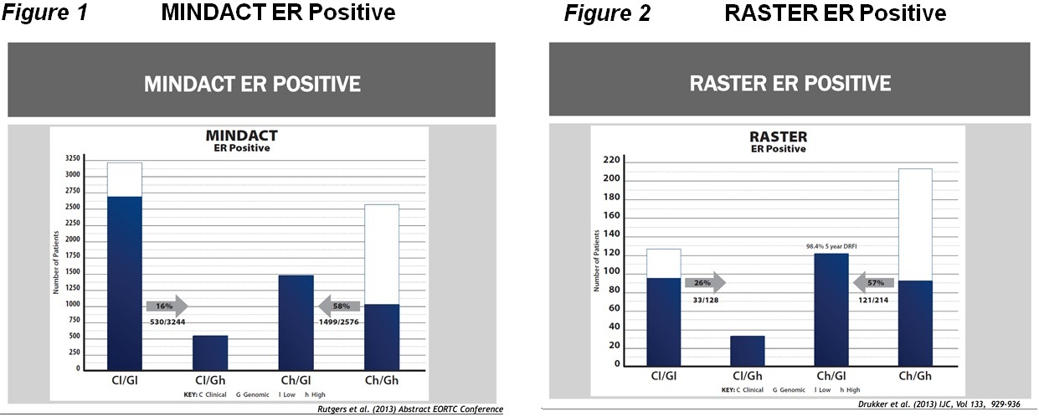

C. Indicate if there is evidence for the population who would benefit from this service i.e. international evidence including inclusion / exclusion criteria. If appropriate, provide a table summarising the population considered in the evidence.

(i) MammaPrint Validation Studies

The original validation of the MammaPrint signature was performed with 295 unselected consecutive patients from a single institution with stage I and II breast cancer in which the predictive power of the signature was evaluated by uni-variant and multi-variant analysis. Critics of that study have identified the heterogeneous nature of the patients (49% lymph-node positive; 24% with >4 nodes positive), and their treatment (44% of patients received some form of adjuvant systemic therapy) as reasons to dismiss the study. Conclusion: The gene expression signature was a more statistically powerful predictor of outcome in young patients (less than 55 years old) than standard systems of clinical and histological criteria.

These 295 consecutively diagnosed study patients were without “convenient sample bias”. Moreover, the study conclusion did not change when 61 lymph-node negative patients used to develop the gene expression were removed from the analysis. Nonetheless, further independent validation was felt to be important.

In 2006, an independent multi-national collaborative initiative under the aegis of the TRANSBIG consortium validated the 70-gene MammaPrint signature. This validation trial led to the FDA clearance in 2007 and 4 subsequent clearances. The validation study stratified untreated, lymph-node negative patients (n=307), with a median follow-up of 13.6 years, into high and low risk, based on either the MammaPrint gene signature classification or a traditional clinical risk assessment tool. The results showed that the MammaPrint signature outperformed the clinical-pathological risk assessment tool for all endpoints: time to distant metastasis and overall survival. Conclusion: MammaPrint adds independent prognostic information to clinical-pathologic risk assessment (Adjuvant! Online) of patients with early stage breast cancer.

It is important to highlight that the decisions to work in fresh/frozen tissue samples and with patients who had received no adjuvant systemic therapy in both the training and validation cohorts was done to minimize unwanted sources of assay bias induced by variations in tissue preservation procedures and/or confounded by treatment effects. Furthermore, there was a disproportionate percentage of large (2-5 cm) (63%) and high-grade tumours (40%) and ER- tumours (29%) in the independent validation cohort which are not representative of the early-stage breast cancer patients of more contemporary times. Despite these factors, MammaPrint remained a statistically significant prognostic factor for time to distant metastasis and survival even after adjustment for various clinical risk classifications that take into account all clinical pathological factors known to have prognostic value in breast cancer. Incorporation of MammaPrint into contemporary prospective trials that were tied to outcomes was recommended by the authors.

The recognition of the need for this level of clinical validation had already been acknowledged in 2004 with the initiation of the RASTER Trial.

Since 2008, 17 clinical studies (see Table 7) have been published that demonstrate the analytic and clinical validity of MammaPrint:-
- 1 MammaPrint analytic validity analysis in Fresh tissue
- 1 MammaPrint analytic validity analysis in FFPE
- 13 MammaPrint Retrospective Studies,
- 1 MammaPrint Neo-adjuvant Study
- 1 MammaPrint Prospective Observational Study with 5 year outcome analysis

These studies directly address the EGAPP Working Group 2009 analysis that stated: “Clinical validation of gene expression tests must include examination of the tests as actually available in typical populations of patients, and assessment of test characteristics across relevant ethnic groups. The risk estimates that result must be calibrated against actual observed risk”.

(ii) MammaPrint Retrospective Studies:

MammaPrint has been validated in all age groups. Mook et al 2009 demonstrated the clinical utility of MammaPrint in lymph-node negative patients over the age of 55 years that facilitated the FDA clearance in 2009 to expand the labeled ‘intended use’ to all lymph-node negative patients’ ages over 18 years of age.

Additional patient cohorts that demonstrated the clinical validity of MammaPrint are captured in the synopsis of studies listed below. A consistent theme of the MammaPrint signature more accurately stratifying ‘Low’ vs. ‘High’ Risk across multiple different patient cohorts than standard clinical-pathologic factors is demonstrated. MammaPrint identifies ‘Low Risk’ patients with a 10- year Distant Metastasis Free Survival (DMFS) of >90% who can safely forego chemotherapy, and ‘High Risk’ patients whose 10-yr DMFS of 71% accurately predicts the patient group that can derive benefit from chemotherapy.

(iii) MammaPrint predictive of benefit from adjuvant chemotherapy:

Knauer et al 2010 demonstrated that MammaPrint predicts the benefit of chemotherapy. Patients classified by MammaPrint as ‘High Risk’ demonstrated a statistically significant breast cancer specific survival (BCSS) benefit from adjuvant chemotherapy in addition to hormonal therapy. Conversely, patients classified by MammaPrint as ‘Low Risk’ for recurrence did not benefit from the addition of chemotherapy to hormonal treatment alone. ‘Low risk’ patients without chemotherapy had a BCSS of 97% and ‘Low Risk’ patients with chemotherapy had a BCSS of 99% (P=0.62). Patients classified by MammaPrint as ‘High Risk’ had a BCSS of 81% without chemotherapy in contrast to a BCSS of 94% with chemotherapy. (P=<0.01).

(iv) MammaPrint prognostically accurate in small primary tumours (T1):

Mook et al demonstrated that MammaPrint was prognostically more accurate than standard clinical-pathologic factors in small tumours. Traditional practice standards suggest that small primary tumours (<2cm) carry a lower metastatic risk than tumours > 2cm. In a retrospective meta-analysis of 964 patients with T1 primary cancers from previously published series, MammaPrint proved to be independently prognostic for DMFS and BCSS in both ‘Low risk’ and ‘High Risk’ in uni-variant analysis. MammaPrint was the most prognostically significant variable for both DMFS and BCSS in both ‘Low and ‘High Risk’ in multivariate analysis. MammaPrint is superior to clinical-pathologic factors in accurately prognostically stratifying ‘high vs. Low Risk’ in small primary tumours (<2 cm) and predicting superior DMFS and BCSS benefit from chemotherapy in the ‘High risk’ cohort.
Table 7. 17 Published clinical studies that demonstrate the analytic and clinical validity of MammaPrint.

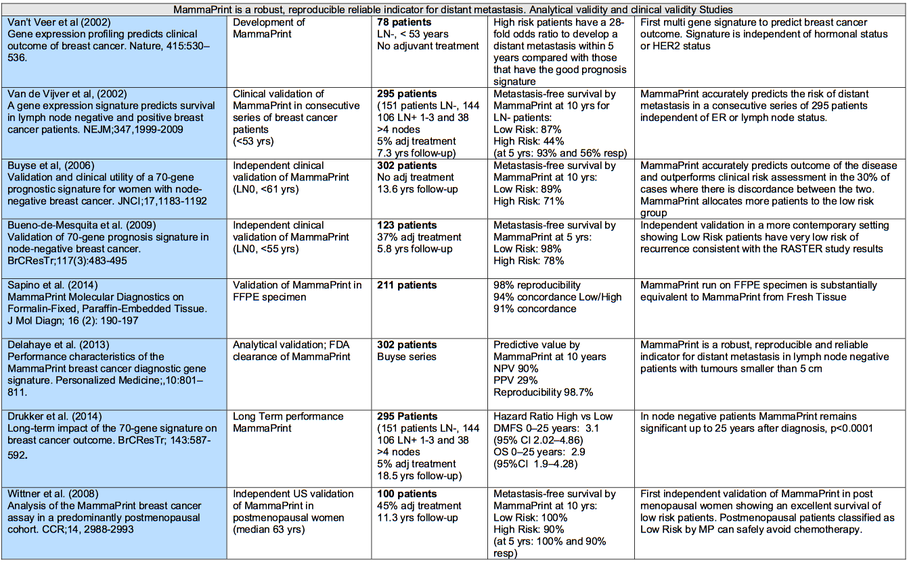
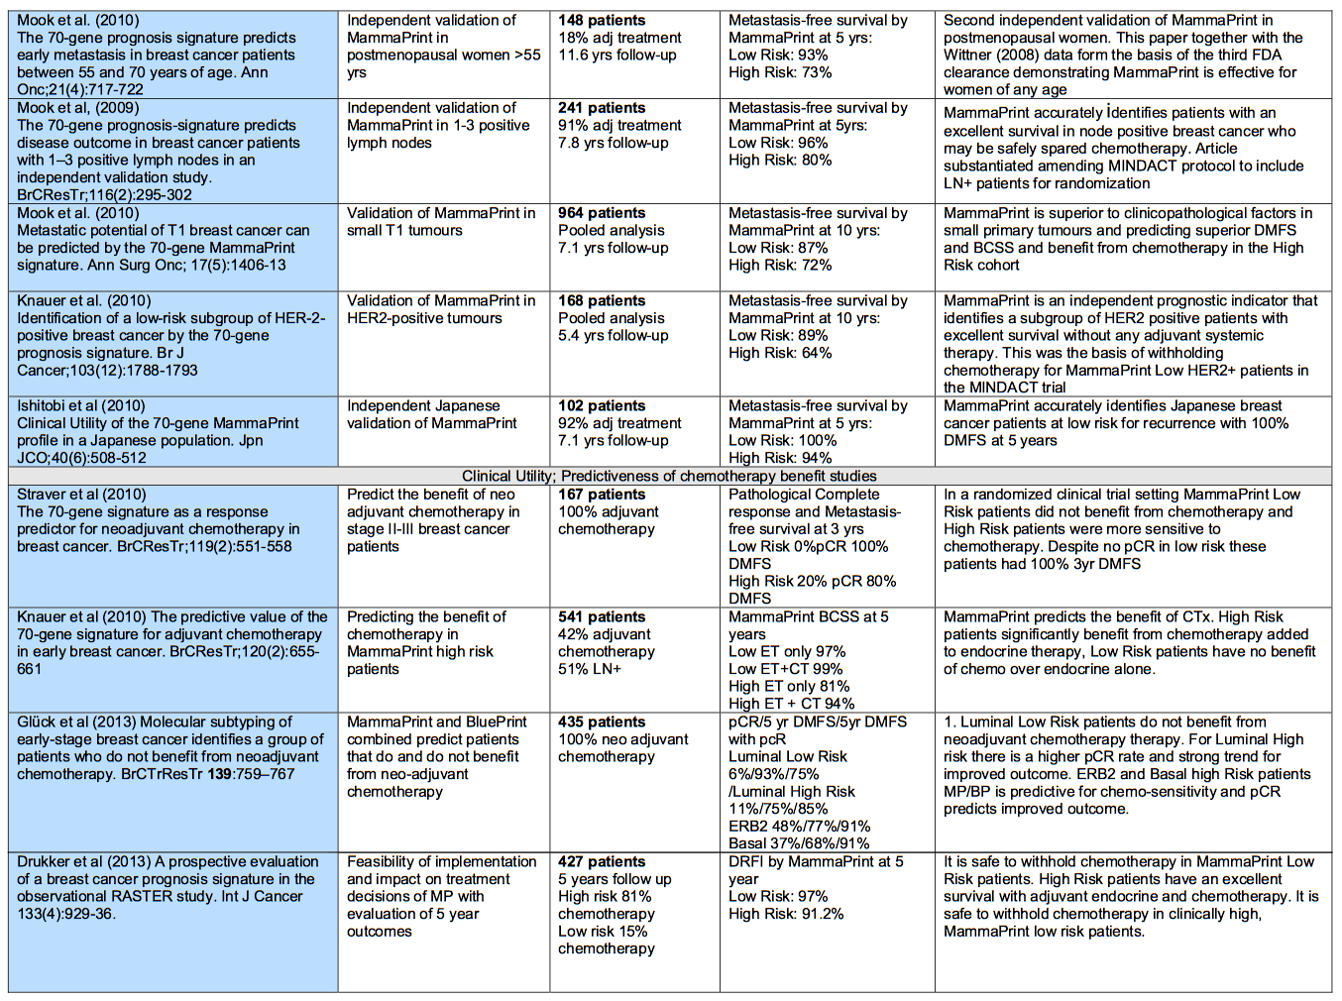
(v) MammaPrint prognostically accurate in stratifying HER2 positive tumours:

The current standard of care for all IHC+/FISH amplified HER2 tumours is to treat with chemotherapy. In most tumours over 1 cm, Trastuzumab adjuvant therapy is now added in combination with chemotherapy. However, In a 10 year retrospective analysis (Knauer et al BJC 2010) of 168 patients (T1-3; N0-1 HER2 positive), 89 patients (53%) did not receive any adjuvant systemic chemotherapy. In that series, MammaPrint accurately identified 20 pts (22% of the untreated patients) as ‘Low Risk’ who had a 10 year distant disease free survival (DDFS) of 84% versus ‘High Risk’ patients who had 10 year DDFS of 55%.

MammaPrint was shown to be an independent prognostic indicator that identifies a subgroup of HER2 positive patients with excellent survival without any adjuvant systemic therapy. This was the basis of withholding chemotherapy for MammaPrint Low Risk HER2 positive patients in the MINDACT trial. However the findings speaks to the previously identified weak to moderate negative prognostic factor of HER2 positive results. Not all patients in the future may need to be exposed to the toxicity and risk of combined chemotherapy and antibody therapy if prospective trials validated this finding.

(vi) MammaPrint Prospective Studies:

The most pivotal data in support of the independent validation study of Buyse, is the industry-first prospective outcome RASTER trial wherein MammaPrint was prospectively incorporated into the treatment decisions of 427 community treated early stage breast cancer patients (T1-2;LN-) enrolled between 2004-2007. In this study, MammaPrint classified 29% fewer ‘High-Risk’ than Adjuvant Online! At 5 years the MammaPrint defined ‘Low Risk’ group had a 5 yr. DRFI of 97%. The MammaPrint defined ‘High Risk’ group had a 91% 5yr. DRFI. In this real-life prospective observational trial, MammaPrint significantly outperformed conventional clinical-pathological classification schemes in accurately identifying sufficiently Low Risk patients who could forego chemotherapy without compromising outcomes and ‘High Risk’ patients who benefited from receiving chemotherapy.

(vii) MammaPrint Neo-Adjuvant Studies:

In a clinically different setting of pre-operative neoadjuvant chemotherapy, Straver et al demonstrated the clinical validity of MammaPrint to accurately stratify regionally advanced stage II and III patients into ‘Low ‘ and ‘High’ Risk. MammaPrint was performed prior to the administration of neoadjuvant chemotherapy. Pathologic complete remission (pCR) was used as a determinant of chemotherapy sensitivity. There was a 0% pCR rate in the MammaPrint ‘Low Risk’ group versus a 20% pCR rate in the MammaPrint ‘High Risk’ group (P=0.015).

(viii) Conclusion:

MammaPrint accurately and consistently outperforms all published clinical-pathological risk stratification tools for identifying ‘Low Risk’ versus ‘High Risk’ for patients with newly diagnosed early stage breast cancer. This capability is demonstrated conclusively across all patients > 18 years old, tumours <5cm, ER positive and negative; HER2 positive and negative, Lymph-node negative and positive (1-3 nodes). The ‘Low Risk’ designation with a 10 year DMFS of 90% allows patients to avoid unnecessary chemotherapy, and the ‘High Risk’ designation with a 10-year DMFS of 71% identifies patients who can benefit from chemotherapy.

Table 8 is a more extensive list of relevant research of the recent utilization of MammaPrint in many different countries.

Table 8. Details the above studies and many more listing the populations considered in their evidence.
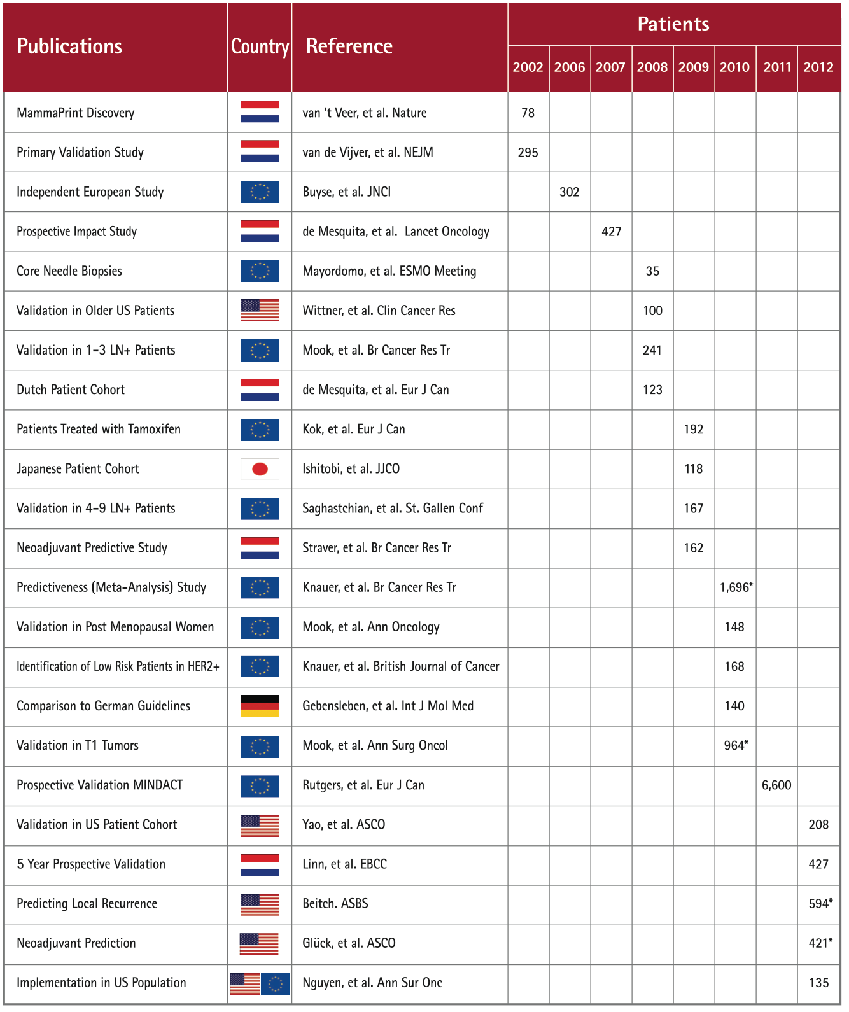

Provide details on the expected utilisation, if the service is to be publicly funded.
As previously stated, in Australia there were 12,567 new cases of breast cancer in 2007, and it is estimated that this will increase to approximately 14,818 cases in 2011 and 15,409 cases by 2015 (Cancer Australia 2011). Based on data from the NSW Central Cancer Registry between 2004 and 2008, 51.2% of patients have localised disease at the time of diagnosis, while 36.5% have advanced disease with regional lymph node involvement, 5.4% have distant metastases, and the extent of disease in 6.9% is unknown (New South Wales Central Cancer Registry 2010). It is estimated that 60% of the women with regional lymph node involvement will have involvement in 0 to 3 nodes (Albain et al. 2010). Thus, approximately 70% of patients have breast cancer with either no lymph node involvement (50%) or 1-3 lymph nodes involved (60% of 36.5%). Based on the predicted incidence of breast cancer in 2011 this equates to approximately 10,372 per annum (14,818×0.70).

It is estimated, based on expert opinion, that approximately half of these patients would be potentially eligible for MammaPrint testing based on St Gallen International Consensus criteria - ER+, Nodes (<4) and Tumour size (up to 50mm in diameter). This equates to approximately 5,366 patients per annum (10,372×0.50). It is expected that around 5,000 patients would be eligible for MammaPrint each year, although only a proportion of these patients would necessarily receive the test. Patients would need to be considered candidates for treatment with systemic chemotherapy in addition to hormone therapy. For example, a frail elderly patient would not usually be considered a candidate for chemotherapy. Patients who have an ECOG performance status 3 or 4 (being bed ridden for >50% of the times with limited ability to self care) would not be considered candidates for chemotherapy. Other reasons patients may not receive the test include patient/physician preference and contraindications or intolerance to chemotherapy. Patients are only tested if oncologists were in doubt regarding the value of chemotherapy in their specific situation. The MammaPrint test will only be required once per new primary breast cancer diagnosis for patients who are eligible.

In Australia, a Multidisciplinary Meeting (MDM) has become the standard forum for determining treatment recommendations. A national goal is for all patients to have their treatment decisions discussed in an MDM, which includes medical oncologists, surgical oncologists, radiation oncologists, pathologists and radiologists, supported by breast care nurses, social workers, genetic counselors, etc. A discussion is held at the MDM prior to instituting definitive treatment recommendations.The binary high risk or low risk information provided by the MammaPrint test will assist in the treatment decision being made by both the oncologist and the patient. There have been a number of studies examining the impact of the MammaPrint test on clinical decision-making (i.e. real life effectiveness of the test) for patients with hormone receptor-positive breast cancer. The results of these studies have been fairly consistent, showing changed treatment recommendations (for adjuvant chemotherapy) in approximately one third of cases compared with conventional assessment.

This targeted therapy has also been shown to be significantly cost effective in several international studies (Retel et al 2011 Breast Cancer Res Treat, Yang et al 2012 Cancer, Retel et al 2013 European Journal of Cancer). In essence, MammaPrint testing results in an approximate 30% net reduction in the administration of adjuvant chemotherapy in the early breast cancer setting. When all costs are taken into consideration, the financial cost of adjuvant therapy in breast cancer is estimated to be around $AUD20,000 per patient (including all associated costs of inpatient admissions needed for managing medical complications, modern pharmaceuticals, nursing and medical staffing costs, etc.). With the price of a MammaPrint test currently set internationally at $US4,200, it can be quickly seen that a 30% reduction in adjuvant therapy gives major significant overall price saving for the health care funder (the Australian Department of Health).

4. Intervention –proposed medical service
A. Provide a description of the proposed medical service.

The 70 gene MammaPrint test is a unique multi-gene microarray mRNA assay signature using 70 scientifically selected genes and offers information on individual tumour biology that is not currently available from any other source. Currently MammaPrint testing is not eligible for reimbursement under Medicare. However the MammaPrint test is available on the private market but only for those with the ability to pay for it.

The single laboratory performing the test for Australian patients is located in Irvine, California, USA. There have been over 40,000 tests delivered to breast cancer patients from many, many countries in Europe, North & South America, Asia, Australia and New Zealand. Genome Investigation now works with Australian medical and surgical oncologists along with Australian pathology laboratories to coordinate the delivery of the breast cancer patient sample to the USA for 70 gene MammaPrint testing. Table 9 below lists the 70 genes used in the 70 gene MammaPrint assay, and is preceded by low risk & high risk 70 gene MammaPrint sample reports.

Gene expression levels are measured by a modern mRNA microarray analysis technique, as reported in Glas et al (BMC Genomics 2006). Fluorescent-dye labeled RNA to microarrays containing 15,000 60-mer oligonucleotide probes are hybridized to perform this test. To increase measurement precision, each of the signature genes are spotted 9 times and an error-weighted average of the intensity ratios is calculated. Since different measurement quantities are used (Xdev versus Log Ratio), the 'good prognosis template' is constructed using the data of the 44 good outcome patients generated on the original mini-array based on log ratios. Disease outcome classification of individual samples is then determined by the cosine correlation to this recreated template in a leave-one-out cross validation procedure.

The expression intensities of the 70 signature genes for the 78 original samples are hybridized to the customized array. The tumours are rank-ordered according to their correlation coefficients with the reestablished 'good prognosis template'. Genes are ordered according to their correlation coefficient with the two prognostic groups as described in the original 2002 Nature article by Van’t Veer et al. Tumours with correlation values above or below this original Van’t Veer et al determined threshold are assigned to the good or poor prognosis profile group, respectively.

The 70 gene MammaPrint analysis is designed to determine the gene activity of specific genes in a tissue sample compared to a reference standard. The result is an expression profile, or fingerprint, of the sample. The correlation of the sample expression profile to a template (the mean expression profile of 44 tumours with a known good clinical outcome) is calculated and the molecular profile of the sample is determined (Low Risk, High Risk, Low Risk Borderline, High Risk Borderline).

The algorithm used to calculate the risk of relapse is as follows. Data analysis is performed according to a specific 70 gene MammaPrint algorithm (the 70 gene MammaPrint Index). The algorithm calculates the similarity (“cosine correlation”) of the patient sample expression profile against two templates; a Low Risk template containing patient samples with a known good clinical outcome, and a High Risk Template containing patient samples with a known poor clinical outcome. This determines the correlation of the molecular profile of the patient sample to either Low Risk or High Risk.

This algorithm is designed and programmed by Agendia and compiled into a stand alone software program called “X-Print Analysis Software”. The “X-Print Analysis Software” loads a data file (CSV) which is created by the laboratory technician by extracting specific information from the laboratory database. The CSV data file contains: external sample ID, internal sample ID, Technician name, Bio-analyzer ratio, RNA integrity number, location of straight and dye-swap data file (TXT), Microarray chip Layout (8-pack) and additional comments by the technician. The “X-Print Analysis Software” reads the CSV file, opens the Feature Extraction Software data files (TXT), performs quality control checks, determines the sample expression profile, calculates the correlation of sample profile to the “Low Risk” template profile on a scale of – 1 (High Risk) to + 1 (Low Risk). This is termed the MammaPrint Index, and it compares the calculated correlation to a pre-defined cut-off value and determines the samples prognostic profile (Low Risk or High Risk). The analysis software output is an internal report (PDF) for every sample. In this report quality control values and analysis results are reported.

To determine the cutoff point used to categorize patients as low or high risk, the abovementioned 70 gene MammaPrint Index is used. This index ranges from -1.0 to +1.0. Tumour samples with the 70 gene MammaPrint Index above the threshold of 0 (zero), are classified as low risk, and tumour samples with the 70 gene MammaPrint Index equal to or lower than the threshold are classified as high risk.

De Snoo et al (Surg Oncol 2009) determined that a 10% risk of recurrence in untreated patients was used to determine the low risk category, as this would translate into a 5-6% recurrence risk if hormonal therapy was given. This was deemed sufficiently low so that patients would not be considered candidates for adjuvant chemotherapy. Conversely, the high risk threshold was set at a 30% risk of recurrence for untreated patients. All such patients would be appropriate candidates for adjuvant chemotherapy based on their risk of developing metastases at the accepted 30% benefit of adjuvant treatment.

The clinical threshold was chosen to permit the creation of the largest group of ‘Low Risk’ intended use patients who could safely forego adjuvant chemotherapy without compromising their outcome. This equates to an untreated patient with lymph-node negative breast cancer having an average of a 10% risk (95% CI 4-15) of developing distant metastasis over the subsequent 10 years.

The separation of MammaPrint results into the binary Low Risk or High Risk result was an astute decision by the MammaPrint development team, as the decision whether or not a patient should receive adjuvant chemotherapy is also a binary decision.

In practical terms, a binary assay result considerably improves the ease of making a binary adjuvant chemotherapy decision, for both clinician and patient. Further, the extensive retrospective and prospective studies confirm beyond reasonably doubt the validity of this binary low risk:high risk result.

However, for clinicians and/or patients wanting further stratification, indication or result of where on the spectrum that an individual patient’s tumour assay falls, then a visualisation of the MammaPrint heat map may communicate the level of the MammaPrint index (from Lowest Risk (+1.0) down to Highest Risk (-1.0), as per the above mentioned MammaPrint index range. However, if clinicians and/or patients want to utilise the heat map in this way, it is important to note that any further information obtained from the heat map above and beyond the low risk:high risk binary result has not yet been validated.
To ensure that a common sense application of the originally intended binary result, the official MammaPrint test result is issued with multiple components as mandated by the original February 2007 FDA 510K clearance:-

- The clinical categorical designation of ‘LOW RISK’ or ‘HIGH RISK’.

- An explanation of the statistical significance of the clinical categorical result that appears immediately under the result such as in the case of LOW RISK the explanation would read:
In the reference group as published, “Low Risk“ means that a lymph node negative breast cancer patient has a 10% chance (95% CI 4-15) that their cancer will recur within 10 years without any additional adjuvant treatment, either hormonal therapy or chemotherapy.”

- A photomicrograph of the tissue section from which the RNA isolation occurred demonstrating compliance with the threshold of 30% Invasive tumour.

- Assay Description.

- The MammaPrint Heat Map with a corresponding ‘result arrow the position of which corresponds to the numerical value of the MammaPrint Index (MPI) that is the output of the FDA cleared proprietary algorithm with input from the 70 reporter genes comprising the signature.

- The independent validation data from the TRANSBIG consortium with associated Kaplan-Meier curve.

The key to providing actionable results to physicians, is to provide clear and un-ambiguous answers to the questions they have. Agendia has conducted multiple meeting with customers worldwide and there is a clear preference for binary a “yes / no” result. In case of MammaPrint this is Low Risk (10% risk of recurrence) or High Risk (30% risk of recurrence).
Some other services provide an invalidated virtual continuum score where “7” is claimed to be different than “12” however, due to the large analytical inaccuracy of these tests the actual risk of recurrence range overlaps largely between the individual numbers, not providing the physician and patient with any actionable result. In addition other products have introduced an “intermediate” risk score group which, in over 60% of the cases, do not provide useful information which, nevertheless is paid for by insurance companies.
Binary results reporting is proven to be the best way to direct decisions for physicians.Pregnancy tests, Hormone receptor tests, HIV tests, BRCA mutation testing, MammaPrint testing are clear examples where binary results is the best way to act.

The MammaPrint Index is a numerical representation of the correlation of the individual patient’s 70-gene profile, compared to a group of patients with known clinical outcome. TheMammaPrint index therefore does not represent an individual risk of recurrence percentage.
As with every qualitative diagnostic tests, the analytical accuracy impacts the accuracy of classifying patients correctly for those patients close to a cut-off. The analytical accuracy and classification accuracy is clearly indicated on the MammaPrint report. For the limited amount of patients where classifying the sample in the right category is less accurate, this is clearly indicated on the report as “borderline”.

The following low risk and high risk sample reports are included to illustrate the above, and Table 9 lists the 70 genes used in the 70 gene MammaPrint assay.
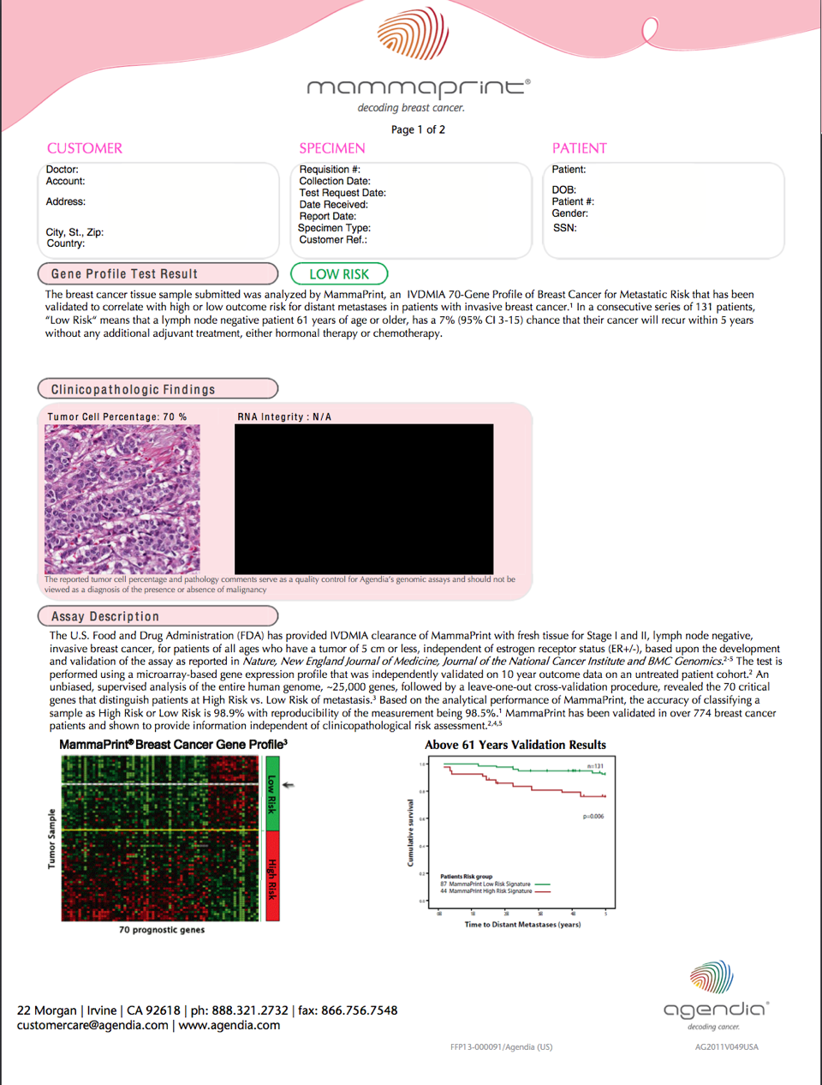

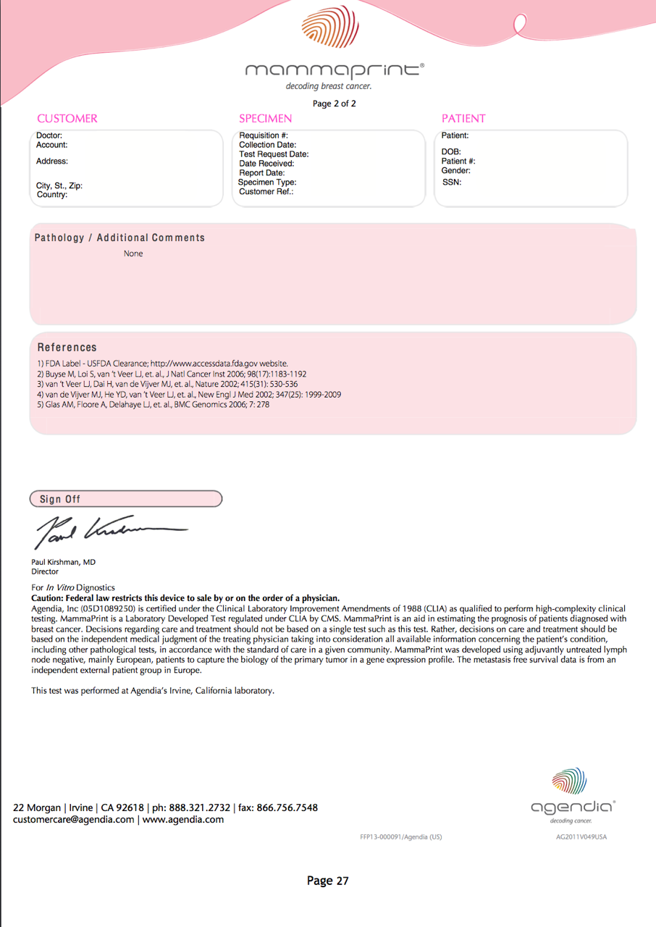

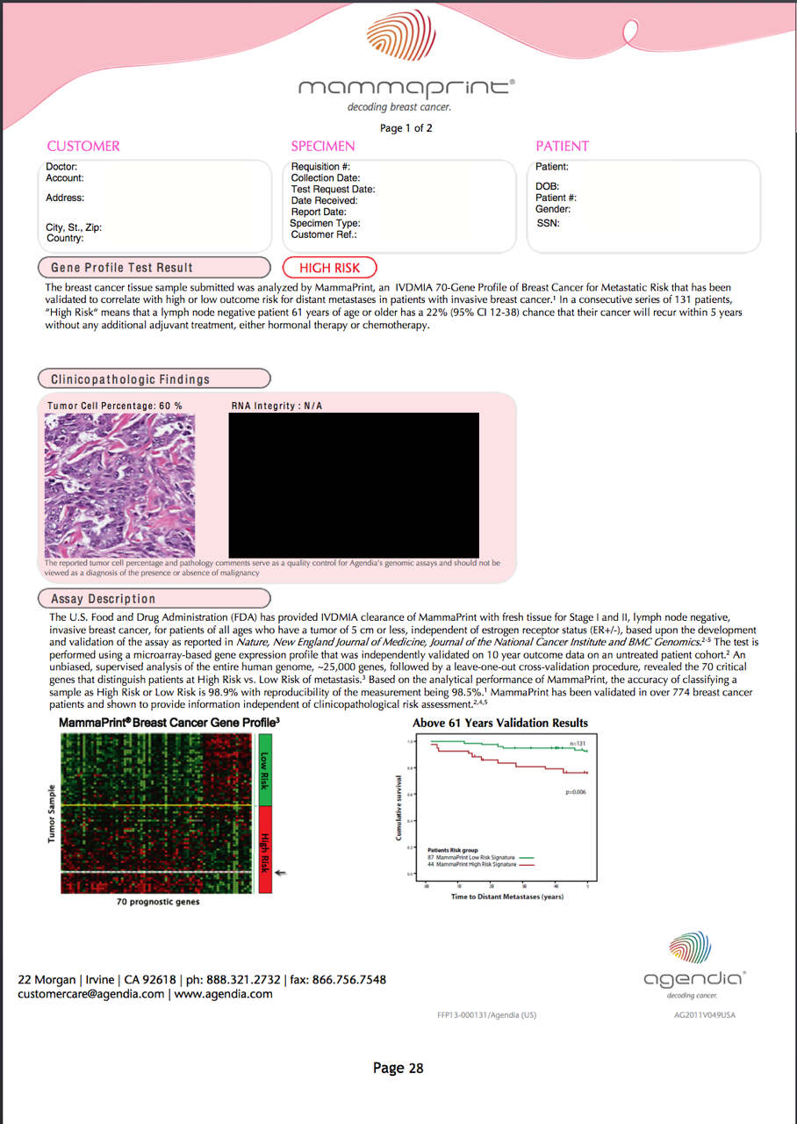

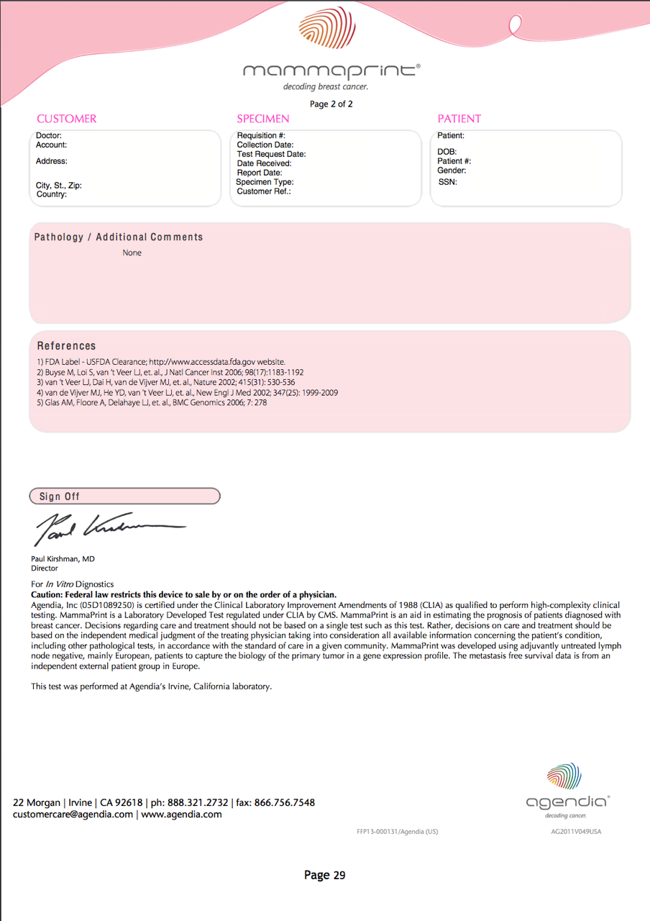

Table 9 List of genes tested by the 70 gene MammaPrint mRNA assay:-
70 MammaPrint Genes
BBC3 | GPR180
TGFB3 | MMP9
ESM1 | GPR126
IGFBP5 | RTN4RL1
FGF18 | DIAPH3
SCUBE2 | CDC42BPA
DIAPH3 | PALM2
WISP1 | ALDH4A1
FLT1 | AYTL2
HRASLS | OXCT1
STK32B | PECI
RASSF7 | GMPS
DCK | GSTM3
MELK | SLC2A3
EXT1 | RAB6B
GNAZ | IGFBP5
EBF4 | COL4A2
MTDH | PECI
PITRM1 | EGLN1
QSCN6L1 | DIAPH3
CCNE2 | LOC100288906
ECT2 | C9orf30
CENPA | ZNF533
LIN9 | C16orf61
KNTC2 | SERF1A
MCM6 | C20ORF46
NUSAP1 | LOC730018
ORC6L | LOC100131053
TSPYL5 | AA555029_RC
RUNDC1 | LGP2
PRC1 | NMU
RFC4 | UCHL5
RECQL5 | JHDM1D
CDCA7 | AP2B1
DTL | MS4 A7
Source:- Van’t Ver et a; Matire 2002

B. If the service is for investigative purposes, describe the technical specification of the health technology and any reference or “evidentiary”standard that has been established.

The MammaPrint 70-gene breast cancer signature was the first (2007) In Vitro Diagnostic Multivariate Index Assay (IVDMIA) to be cleared by the FDA in a De Novo Classification Process (Evaluation of Automatic Class 3 Designation). The submission included a rigorous assessment of the analytical and clinical validity of the assay. Issuance of the clearance indicates that the submitted evidence substantially validated the safety and efficacy of the assay for its intended use by an independent and impartial third party (FDA Label - USFDA Clearance; www.accessdata.fda.gov website).

The FDA label indicates that as a prognostic stratification tool, MammaPrint has a 98.9% degree of accuracy in classifying patients as Low Risk or High Risk and technical reproducibility of 98.5%. Inter-laboratory agreement of a series of 100 specimens tested independently in Agendia’s two CLIA certified laboratories, Irvine, California and Amsterdam, Netherlands, is 96 - 100%. Positive predictive value (PPV) at 5 years is 0.22 (0.16-0.28) and the negative predictive value (NPV) at 5 years is 0.95 (0.91-0.99) and at 10 years PPV is 0.29 (0.22-0.35) and NPV is 0.90 (0.85-0.96).

Diagnostic validation was performed according to FDA and NCCLS guidelines. Similarly, MammaPrint has acquired CE marking in Europe and has been granted the International Organisation for Standardisation (ISO) 13485 certification for all activities at facilities in not only Amsterdam, but Irvine, California as well. MammaPrint (Fresh and FFPE) is in conformity with Directive 98/79/EEC, along with Annex I and III of the In Vitro Diagnostic Directive (IVDD). The ISO 13485 quality standard specifies requirements for a quality management system to demonstrate its ability to consistently meet customer and regulatory requirements.

No external proficiency testing exists for molecular breast cancer recurrence. Opposed to some other products, Agendia is in the unique position to have two independently operating mirror laboratories. Both laboratories are accredited by the U.S. CLIA, U.S. College of American Pathologists (CAP), ISO13485 for Medical Device Manufacturers and inspected by the FDA.
Due to the lack of externally organized programs, twice a year Agendia executes an internal blinded proficiency testing scheme between its two laboratories, exchanging 20 samples for blinded re-analysis. This schedule has been accepted by all inspecting governmental and external professional regulating bodies as being an acceptable alternative for the non-existing external proficiency testing schemes.

The MammaPrint test evaluates the expression of a panel of 70 genes from a tumour specimen (surgical resections or core biopsy) using a high-throughput microarray mRNA analysis GEP method to measure levels of gene expression. Standardised pathology guidelines instruct pathologists to select the most representative formalin fixed, paraffin-embedded (FFPE) tumour block (i.e., that which contains the greatest amount of invasive carcinoma that is morphologically consistent with the submitting diagnosis) when preparing unstained slides for the assay.

The MammaPrint test was initially developed using fresh tissue. However, FFPE tissue is now tested due to its greater clinical utility and ease of use. The issue of FFPE versus fresh tissue repeatability and reproducibility was recently reviewed by Sapino A et al in the December 2013 issue of the Journal of Molecular Diagnostics. This peer reviewed-paper establishes the substantially equivalent performance of FFPE to fresh tissue. This article describes method optimization, validations and performance of MammaPrint using analyte from FFPE tissue.
The conclusions from the paper demonstrate that:
- 580 unique tumour samples were used to successfully demonstrate the substantial equivalence of MammaPrint analytic performance utilizing the analyte from FFPE tissue.
  - 157 samples were utilized to develop the laboratory procedures to run MammaPrint on FFPE tissue.
  - 125 paired samples, fresh and FFPE, were utilized to establish the assay
  - 211 paired samples, fresh and FFPE from 5 hospitals were utilized to perform an independent validation
  - 87 samples were utilized to perform the reproducibility, repeatability and precision analysis for the FFPE assay.

- The FFPE sample processing demonstrated a 97% overall success rate.
- The MammaPrint FFPE assay had a very high categorical concordance between ‘low risk’ and ‘high risk classification’ derived from the 211 paired fresh and FFPE samples with a ‘ĸ score’ of 0.82 indicating “an almost perfect agreement”. Importantly, and particularly with relevance to practicing oncologists, of the 211 paired samples, 18 were discordant (91.5%). However, 14 of these 18 lay within 5% of the low risk:hish risk heat map threshold, revealing over 98% concordance (207 / 211) when MammaPrint results are seen outside of the 5% low risk:high risk threshold. Further, Delahaye et al in the Personalised Medicine journal (October 2013) have demonstrated an intrinsic 5% difference in matched tumour samples when samples are taken from the same tumour. This tumour cellular heterogeneity is a further, but significant reason, for this minor discordance.

- Precision was 97.3%
- Repeatability was 98.7%
- Reproducibility was 96% for replicate samples of the same tumour, processed by Agendia’s two separate laboratories in Irvine, California and Amsterdam, Holland.

MammaPrint was successfully translated to FFPE tissue with high precision, reproducibility and FFPE results that are substantially equivalent to results derived from fresh tissue. The laboratory processes, and the analytic and clinical performance data that were reported in this paper, have formed the basis of Agendia’s clearance for FFPE submission to the FDA. This FDA review is due for imminent publication.

Core biopsies containing greater than 30% of representative invasive cancer tissue are preferred to surgical resections due to the increased timeliness of reporting times, enabling results to be presented at the first postoperative MDM. This early reporting enables the multidisciplinary team to provide an informed team recommendation, but more importantly, provides the patient adequate time for her to come to her own decision about the evidence for and against adjuvant chemotherapy in her own individual circumstance. There has not been shown to be any disadvantage to using core biopsy tissue when compared to surgical resection tissue.

All tissue samples are assessed by a pathologist at Agendia to verify the diagnosis and to perform manual microdissection as needed in accordance with pathology guidelines. The assay generally requires at least 1.1mm of invasive tumour tissue for successful analysis. GEP examines the composition of cellular messenger ribonucleic acid (mRNA) populations. The identity of the mRNA transcripts that make up these populations and the number of these transcripts in the cell provide information about the global activity of the genes that give rise to them. The number of mRNA transcripts derived from a given gene is a measure of the “expression” of that gene. Given that mRNA molecules are translated into proteins, changes in mRNA levels are ultimately related to changes in the protein composition of the cells, and consequently to changes in the properties and functions of tissues and cells in the body.

C. Indicate whether the service includes a registered trademark with characteristics that distinguish it from any other similar health technology.

MammaPrint is registered with Australian trademark number 1234096 was lodged on 27/11/2007 and has a status of Registered/Protected. The applicant/owner of the trademark is registered as AGENDIA BV.

D. Indicate the proposed setting in which the proposed medical service will be delivered and include detail for each of the following as relevant: inpatient private hospital, inpatient public hospital, outpatient clinic, emergency department, consulting rooms, day surgery centre, residential aged care facility, patient’s home, laboratory. Where the proposed medical service will be provided in more than one setting, describe the rationale related to each.

Currently, the 70 gene MammaPrint test is discussed with patients and ordered in the specialist medical or surgical oncologist outpatient setting. However, specimens are then sent from the Australian pathology laboratory to one of the three Genome Investigation Australian metropolitan offices (Brisbane, Sydney or Melbourne) for processing prior to forwarding on to the Agendia laboratory located in Irvine, California, USA. Importantly, the MammaPrint test identifies patients who would not be recommended adjuvant chemotherapy based on current assessment of clinical and pathological information but are at high risk of recurrence. This offers the potential to prolong disease free survival and ultimately save lives. It also identifies many patients that will not benefit from chemotherapy, thus sparing them adverse effects and risks associated with chemotherapy.

An oncological surgeon is responsible for removing the breast cancer and axillary lymph nodes. The tumour and all excised lymph nodes are sent to a pathologist for examination. Biopsy and surgical samples are stored in Australia for a period of at least ten years for subsequent testing according to the National Guidelines for Tissues Storage; many centres and institutions would keep samples indefinitely.

The current process for obtaining the 70 gene binary low risk:high risk result is as follows. Medical or Surgical Oncologists requesting the 70 gene MammaPrint test first fax or email the Agendia Test Request Form along with the pathology result to Genome Investigation. Genome Investigation then immediately contacts the Australian pathology laboratory who initially reported the presence of invasive breast cancer on either the invasive tumour core biopsy or invasive tumour resection specimen. The pathology laboratory is then requested to send the designated sample (with a minimum of 30% of representative invasive cancer) via conventional priority courier methods the FFPE tissue to the closest Genome Investigation office (either Brisbane, Sydney or Melbourne; either inside the MammaPrint Specimen Kit or in conventional FFPE packaging material) for export processing prior to sending on to the Agendia laboratory in California.

The Australian pathology laboratory then prepares the specimen, using the appropriate instructions provided with either the MammaPrint Specimen Kit, consisting of 10 unstained slides each with (5 microns) section of tissue. Each slide must be numbered labeled with the Agendia specific patient code label. Charged (coated) slides are preferred. All specimens are labeled with barcode labels which are also placed on the patient’s MammaPrint Test Request Form. An arrangement currently exists whereby Agendia pays a commercial-in-confidence administrative fee to Genome Investigation who then reimburses the Australian pathology company for any costs of sample preparation.

The main factor that influences the preparation of the specimen is the correct selection of invasive tumour sampling (not in-situ or non malignant tissue). However, even though the Australian pathology laboratory sends the exact portion of invasive tumour tissue, all tissue samples received by Agendia are assessed independently by a pathologist from Agendia to verify the diagnosis, review for adequate tumour content (>30%) and to perform manual microdissection as needed in accordance with American pathology guidelines.

Very rarely, the sending Australian pathologist is required to repeat the FFPE slide preparation and send these further slides to Genome Investigation and then on to Agendia in California for analysis. Genome Investigation will meet the separate cost of this repeated exercise in Australia. To date, this occurrence has only happened once - where in situ tumour was sent across rather than invasive tumour.

The results of the MammaPrint test should be available in 7-10 days from the date the tumour sample is sent to Genome Investigation. The results of the test will be returned immediately upon reporting by email securely online to the ordering medical or surgical oncologist as well as the submitting pathologist, and any additional specified physician, involved in the care of the patient as noted on the Agendia Test Request Form. The remaining tumour sample is then returned to the originating Australian pathology laboratory with costs covered by Agendia.

Previous sample reports sent for a low risk patient who has undergone MammaPrint testing, along with a sample report of a patient with a high risk result, are included earlier in this DAP.

Immunohistochemical (IHC) examination of biopsy material is routinely performed as a prior test to examine the ER, PR and HER2 status of all patients with breast cancer. Nodal status is also routinely assessed to inform the breast cancer staging of each patient. The information from these tests will be used to define the population eligible for the MammaPrint test. Ordering of the MammaPrint test should be restricted to medical, radiation or surgical oncologists, once patients are diagnosed with node-negative or 1–3 positive nodes, ER+ tumours in early stage breast cancer, with tumour size less than 50mm in diameter. Data pertaining to the ability of MammaPrint test to predict patients likely to benefit from chemotherapy has only been ascertained in these patient groups.

The chemotherapy regimen(s) that MammaPrint is used to triage patients towards (or away from) are all PBS listed and reimbursed. Hormone therapy remains the mainstay for treatment of hormone receptor-positive (ER+ or PR+) breast cancer. Hormone therapy for breast cancer such as tamoxifen, anastrozole and letrozole are all available on the PBS for patients with breast cancer.

Adjuvant chemotherapy is also administered to patients with early breast cancer with and without nodal involvement based on improved recurrence free survival and overall survival. Although subsequent post hoc analysis of the pivotal trials demonstrating the benefits of chemotherapy in early breast cancer have shown that some patients benefit more than others. All chemotherapy agents used to treat early breast cancer are all available on the PBS under the General Schedule or Streamlined authority. The chemotherapy regimens currently used in this patient population – and therefore the regimens that will be initiated (or not) on the basis of the MammaPrint low risk:high risk result include:
·AC-Taxol (doxorubicin and cyclophosphamide followed by paclitaxel)
·AC (doxorubicin and cyclophosphamide)
·TC (docetaxel, cyclophosphamide)
·CMF (cyclophosphamide, methotrexate, 5-fluourouracil)
·TAC (docetaxel, doxorubicin, cyclophosphamide)
·FECD (5-fluourouracil, epirubicin, cyclophosphamide followed by docetaxel)

The recommendation to prescribe adjuvant chemotherapy in combination with hormone therapy is based on a balance of the risk of recurrence against the potential for adverseeffects of therapy. The patients that should be administered combination chemotherapy andhormone therapy are difficult to define because the ER+ early stage breastcancer group includes patients with a spectrum of recurrence risks.

The advent of GEP now provides the ability to segment heterogeneous subsets of patients based on their degree of gene activity, whose response to a therapeutic intervention within each low risk or high risk subset is homogeneous. This molecular profiling of tumour cells has a prognostic and predictive value in women with early stage breast cancer. Prognostic value provides the risk of distant recurrence if one receives standard treatment (i.e. adjuvant hormone therapy alone) and predictive value provides the likely benefit from the addition of a specific treatment (e.g., adjuvant chemotherapy) to this standard treatment. A prognostic marker is clinically validated by demonstrating in a relevant patient population that the marker identifies subsets of patients at clinically meaningfully higher and lower risks of recurrence. The RASTER study (Drukker et al 2013) has prospectively validated MammaPrint as the only GEP test yet to prove this point in a randomized prospective manner.

Clinical validation of a predictive marker requires a randomised trial in a relevant patient population that compares standard treatment with standard treatment plus the addition of the specific treatment. Clinical validation of MammaPrint high risk versus MammaPrint low risk requires demonstration that relative treatment benefit depends upon the binary result of the marker; this involves demonstration of a statistically significant interaction between treatment (i.e. chemotherapy) and the marker in predicting the risk of recurrence (i.e. binary low risk:high risk 70 gene MammaPrint signature result). For example, prospective clinical trial data from Drukker et al (IJC 2013) shows that chemotherapy is ineffective in patients identified as low risk by MammaPrint.

In the case of MammaPrint, it poses an opportunity to select the most optimal and personalised treatment strategy on the basis of the individual predicted probability of relapse and sensitivity to chemotherapy. Although MammaPrint was first introduced to the Australian TGA in 2005, and then reviewed by MSAC for the first time in 2007, GEP is still a fairly new paradigm in Australian healthcare - although in recent years the molecular profiling of tumours for HER2, KRAS, and EGFR has become widely accepted and implemented.

E. Describe how the service is delivered in the clinical setting. This could include details such as frequency of use (per year), duration of use, limitations or restrictions on the medical service or provider, referral arrangements, professional experience required (e.g.: qualifications, training, accreditation etc.), healthcare resources, access issues (e.g.: demographics, facilities, equipment, location etc.).

The 70 gene MammaPrint signature specialist recommendation and referral is discussed and results delivered to the patient in the outpatient medical and surgical oncology clinics. No further directed biopsy is required above and beyond the normal provision of breast investigation and treatment, as a sample of breast cancer tissue is forwarded on to Genome Investigation from the routine core biopsy or surgical resection specimen, as per the statement in the preceding section.

Although the 70 gene MammaPrint signature test is a complicated microarray mRNA analysis (performing tests for Australian patients in Irvine, California, USA), the report, by design, returns a straight forward binary low risk result or a high risk result. This is a simple result for both patients and specialist medical and surgical oncologists to understand, therefore professional training and accreditation in the area of GEP has not yet been recommended by either MOGA or BreastSurgANZ. The simple binary low risk:high risk 70 gene result has not lead to either MOGA or BreastSurgANZ recommending any particular accreditation for medical or surgical oncologists ordering the 70 gene assay. Further, as the pathological analysis is being conducted in California, there are no specific training or accreditation requirements for pathologists or Australian laboratories sending cancer specimens abroad over and above their current standards.

The above outlined arrangement also means that there are no healthcare access issues for Australian patients over and above their normal access to Australian pathology laboratory analysing and reporting facilities.

Co-dependent information

Please provide detail of the co-dependent nature of this service as applicable.
This not a co-dependent application.

Comparator –clinical claim for the proposed medical service
A. Please provide details of how the proposed service is expected to be used, for example is it to replace or substitute a current practice; in addition to, or to augment current practice.
The current Australian comparator for the MammaPrint test plus usual care is usual care (without testing the tumour using the 70 gene signature). However, the 21 gene assay (Oncotype DX), the 4 immunohistochemical assay (IHC4 consisting of ER, PR, HER2 & Ki67) and the 7 gene assay (BCI) have been suggested by PASC to also be a significant comparators, although there is not yet any prospective evidence confirming their ability.
Comparator - Current Standard Practice

First, with respect to the current Australian comparator (usual care), patients in the comparator arm would receive endocrine therapy with or without the addition of adjuvant chemotherapy based on traditional clinical and pathological measures, none of which have individually been shown to be predictive of adjuvant chemotherapy benefit. There is no change in the treatment algorithm between the current and proposed pathways, rather the binary high risk or low risk test determination results in a change in the recommendation to treat with adjuvant chemotherapy in addition to endocrine therapy.

The clinical validity and the clinical utility of the MammaPrint test should be included in the assessment submitted to MSAC. MammaPrint changes treatment decisions on average in 30% of the cases. It has prospectively proven to reduce chemotherapy utilization without compromising outcome. This has been discussed extensively already in Section 3 (C) of this DAP.

Bueno-de-Mesquita et al (Lancet Oncol 2007) demonstrated an impact of MammaPrint on treatment decision in 16 community hospitals. MP resulted in a 19% change in adjuvant treatment decisions, confirming that implementation of MammaPrint outside the academic setting is feasible.

Knauer et al have further demonstrated the clinical utility of MammaPrint in their trial:-

“The 70-gene signature could also predict chemotherapy benefit in the high risk group, versus no apparent benefit in the low risk group…clinical utility studies showed use of the assay results in a change in treatment decision in 25-30% of cases, most commonly from chemoendocrine therapy to endocrine therapy alone.” ( Knauer, et al., The predictive value of the 70-gene signature for adjuvant chemotherapy in early breast cancer, Breast Cancer Research Treatment; 120 (2): 655-661, 2010).

Drukker et al (IJC 2013) subsequently demonstrated that it is safe to withhold chemotherapy in MammaPrint Low Risk patients. High Risk patients have an excellent survival with adjuvant endocrine and chemotherapy. It is safe to withhold chemotherapy in clinically high, MammaPrint low risk patients.

Investigators of the RASTER trial concluded that withholding chemotherapy in Clinically High risk patients that are MammaPrint Low risk did not compromise outcome. Depending on what chemotherapy guideline is used, there will be up to 25% reduction in chemotherapy after utilising the MammaPrint result:-

“The 70-gene signature correctly identified not only the patients who needed adjuvant chemotherapy but also those who did not need adjuvant chemotherapy, leading to a 20%-30%reduction in the number of women who would otherwise receive chemotherapy without compromising long-term clinical outcome.” (Drukker, et al., RASTER, International Journal of Cancer: 133, 929–936 (2013) © 2013 UICC).

Kunz et al (Arch Gynaecol Obstet 2011) demonstrated that MammaPrint was discordant with Adjuvant! Online in 45% of the cases in this prospective study. In the 522 St. Gallen intermediate cases, 40% were genomic Low Risk, with a 10 year distant metastasis free survival (DMFS) of 91.4%, again demonstrating the significant clinical utility of MammaPrint.

Rutgers et al in the EORTC 10041/BIG 03-04 MINDACT trial pilot phase (Eur J Cancer 2011) of this international prospective, randomized, phase III trial using MP together with commonly used clinico-pathological criteria (Adjuvant! Online) for selecting patients for adjuvant chemotherapy. Analysis of the first 800 patients of the 6,694 patients enrolled confirmed that 66% of patients were genomic low risk and 34% were genomic high risk cases. A 27% discordancy between MammaPrint and clinical risk assessment was demonstrated, noting that 71% were ER positive and 29% ER negative and that 86% were HER2 negative and 11% were HER2 positive. MINDACT already demonstrates with large numbers the clinical ability of MammaPrint to successfully differentiate more accurate genomic risk from clinical risk.

Further, MINDACT defines in terms of clinical utility what extent the 70 gene MammaPrint test will change the management of patients, and particularly to what extent chemotherapy should be offered to patients classified as having a good or poor prognosis:-

“MammaPrint resulted in 29% of patients being reassigned to a different risk group, and spared 10% of patients from receiving adjuvant chemotherapy.” (Rutgers, et al., The EORTC 10041/BIG 03-04 MINDACT trial is feasible: Results for the pilot phase, European Journal Cancer 47, 2742-2749).

There is no reference or gold standard for determining the binary low risk:high risk MammaPrint result. As described earlier, centralisation, using a standardised assay, reagents, procedures, and scoring is a significant strength of MammaPrint with regard to reproducibility. MammaPrint does not suffer from the same problems as other assays based on technologies that are difficult to standardize across different laboratories.

Evidence that the Agendia laboratory and the analytical and clinical validity of the
test meet the standards required by the National Association of Testing Authorities and the Royal College of Pathologists of Australasia / Quality Assurance Program Pty Ltd, for medical testing will be provided.

The cost of the test option and test strategy should be assessed from the full healthcare system perspective (i.e., the provision of each relevant healthcare resource with a material increment fully costed irrespective of the source of the payment(s) and also disaggregated across these sources as appropriate).

There is no change in the diagnostic practice or treatment options available to patients between the current and proposed pathway. Rather, it is a tool which provides new and additional information for the patient/physician decision as to whether or not to initiate chemotherapy. It is still the same decision to be made, however the outcome of the MammaPrint test will result in triage of different patients through to different treatments (than is current practice).

The test will improve health outcomes in one of two possible ways:

i) by identifying patients likely to benefit from chemotherapy that would not have
been identified through standard clinical practice. This will result in improved
disease free survival and reduction in breast cancer recurrence by the addition of
chemotherapy to a patient who would have otherwise been treated with hormone
therapy alone.

ii) by identifying patients that will not benefit from chemotherapy, thus sparing them
adverse effects and other risks associated with chemotherapy.

The clinical claim depends on a linked approach which:

(i) shows the impact of MammaPrint on the decision to initiate chemotherapy; and

(ii) shows that the change in allocation by MammaPrint binary low risk:high risk score of chemotherapy improves disease free survival and reduces unnecessary adverse effects.

Prospective clinical trial data from Drukker et al (IJC 2013) shows that chemotherapy is ineffective in patients identified as low risk by MammaPrint. A similar relationship between MammaPrint binary low risk:high risk stratification andresponse to chemotherapy was observed in node positive patients (Mook Breast Cancer Res Treat 2010 & Saghatchian et al The Breast 2013). It isimportant to note that the predictive benefit of the binary low risk:high risk MammaPrint test result isderived from retrospective analysis of trial data but that theassociation has now been successfully tested prospectively (RASTER Drukker et al IJC 2013).

These data are presented in this DAP by way of illustration only and should be fully evaluated in the assessment itself. Relative to the comparator, MammaPrint testing and consequent treatment may be considered superior in terms of safety (less chemotherapy adverse effects) and to be non-inferior to superior in terms of effectiveness (better disease free survival in patients using chemotherapy when they otherwise would not have). As such, the type of economic evaluation required is a cost-effectiveness analysis or cost-utility analysis.

The applicant does not intend to make any claims about the comparative effectiveness of the various chemotherapy options (with or without hormone therapy) available for patients with breast cancer.

Comparator - 21 Gene Assay

The principle differences between the 70 gene assay and the 21 gene assay are summarised in Table 10 below.

The first major difference revolves around the absence of any prospective data available for the 21 gene assay. The 70 gene assay now has very significant prospective data support with the prospective RASTER study which has been fully reported. Further, the randomised prospective MINDACT study has now reported it’s risk stratification data as per the abstract at the start of this DAP.

The second major difference is the helpful and cost effective binary high risk:low risk 70 gene assay versus the unhelpful and cost ineffective large intermediate risk group revealed by the 21 gene assay (towards a binary decision of chemotherapy versus no chemotherapy).

The third major difference is the lack of any FDA approvals for the 21 gene assay as compared to the 5 FDA approvals for the 70 gene assay.

Table 10 Comparison of the 70 gene assay versus 21 gene assay:-
Feature | 70 gene assay | 21 gene assay
Year First Published | 2002 | 2002
Number of genes tested | 70 | 16 (5 reference genes)
Gene pool selected from | 25,000 | 250
Nature of gene selection | Scientific analysis to derive 70 key genes from whole genome | Committee selection process of chosen genes
Test type | mRNA microarray | RT PCR
FDA approvals | Five (plus one under consideration) | Nil
Results | Binary – Low or High Risk | Tertiary – Low, Intermediate & High
Clinical utility | Helpful binary test result for binary choice regarding chemotherapy | Unhelpful intermediate risk category for binary choice regarding chemotherapy
Validation | Binary result validated  by FDA | Recurrence score not validated by FDA
Cost effectiveness | More cost effective  (no intermediate result) | Less cost effective – (primarily due to intermediate result)
Patient specimen data | Untreated patients | 5 years of Tamoxifen
Reliance on hormone therapy | Not required – can reliably use Tamoxifen, Anastrozole, Letrozole or other hormonal agents & retain risk prediction | Tamoxifen only otherwise can’t utilise risk prediction
Prospective studies completed | One - RASTER | Nil
Sample type | FFPE or Fresh | FFPE
Country of origin | Holland | USA
Location of laboratories | 2 – USA & Holland. | 1 - USA
Utility in I SPY 2 & I SPY 3 drug selection trials | Yes | No
T size | Any | Any
N status | N- / N+ (1-3) | N- / N+ (1-3)
ER status | Positive or Negative | Positive
Grade | Any | Any
Proven utility with HER2 | Yes (Knauer 2010) | No
Predictive Data | 1696 patients  (Straver 2009, Knauer 2010) | 651 patients  (Gianni 2005, Paik 2006)

Expected health outcomes relating to the medical service
A. Identify the expected patient-relevant health outcomes if the service is recommended for public funding, including primary effectiveness (improvement in function, relief of pain) and secondary effectiveness (length of hospital stays, time to return to daily activities).
MammaPrint is expected to influence outcomes in two ways:
1. By reducing exposure to adverse event causing chemotherapies in those patient
populations in whom chemotherapy is less likely to offer a survival benefit; and,
2. By increasing chemotherapy use in those patient populations in which chemotherapy is more likely confer a survival benefit.

The health outcomes, upon which the comparative clinical performance of MammaPrint testing versus usual care (according to funding scenario) will be measured, are based on the impact of a change in treatment decisions and treatment effectiveness.

These outcomes are listed below:-
·Primary outcomes: Disease free survival, overall survival, quality adjusted survival
·Secondary outcomes: Change in treatment decisions, uptake of chemotherapy,
quality of life.

B. Describe any potential risks to the patient.
As with any pathology test, there are the potential psychological and physical harms from testing. In clinical practice, these are deemed to be very rare. Any adverse events related to a change in treatment including toxicity is also possible, but is much less likely due to the significant decrease in adjuvant chemotherapy administration as a result of the utilisation of the 70 gene MammaPrint assay. The 70 gene assay has been shown prospectively (RASTER Drukker et al IJC 2013) to safely allow the reduction of chemotherapy administration in a significant number of 70 gene low risk early breast cancer patients, thus utilisation of the 70 gene assay markedly reduces the overall treatment risks to many patients with early breast cancer.

C. Specify the type of economic evaluation.
The 70 gene MammaPrint signature has undergone extensive European and American cost effective analyses (Retel 2010; 2012; 2013 & Yang et al 2012). This research has confirmed the 70 gene assay to be cost effective as a risk stratification and predictive tool.

There is no reason to suppose that cost effectiveness of MammaPrint testing under Australian conditions should be any different to the positive findings that have been found in both Europe and North America. The binary result obtained is particularly relevant here, with no intermediate results being reported with this 70 gene assay.

Fee for the proposed medical service
A. Explain the type of funding proposed for this service.
It is proposed that the 70 gene assay attract routine MBS funding as the type of funding proposed for this service. It is anticipated that the listing would appear as a Pathology service (Category 6) in Group P7- Genetics. The text describing the eligibility criteria are separated into those aspects determined by an Australian pathology laboratory and those determined by the referring clinician. It is proposed that MammaPrint should be used in patients with the following disease characteristics for whom physicians are in doubt of the value of chemotherapy:
·Early breast cancer (stages I-II)suitable for adjuvant chemotherapy and, as determined by an Australian pathology laboratory:
·Invasive tumour size up to 50mm
·Node negative or 1-3 positive nodes
·Oestrogen positive (ER+) as determined by IHC.
The proposed MBS item descriptors and fees for patients with early breast cancer according to IHC (and or ISH) results are provided below:-

Proposed MBS item descriptor
MBS [item number] (proposed MBS item) Pathology Group P7 Genetics
Gene expression profiling of tumour samples (core biopsy preferably or surgical resection) by
microarray messenger RNA technique for 70 genes in breast cancer tissue.

May only be used to test samples from patients with the following characteristics as determined by the referring clinician:
·early breast cancer (stages I-II) suitable for adjuvant chemotherapy and, as determined by an Australian pathology laboratory:-
·invasive tumour size up to 50mm in size
·node negative or 1-3 positive nodes
·oestrogen positive as determined by immunohistochemistry
May only be used once per new primary breast cancer diagnosis
Fee: TO BE DETERMINED

B. Please indicate the direct cost of any equipment or resources that are used with the service relevant to this application, as appropriate.
For Australian patients, the 70 gene MammaPrint signature test is performed in Irvine, California. As such, there are no direct costs of any equipment or resources that are used in Australia, over and above those required to send FFPE tissue from the Australian reporting pathology laboratory via Genome Investigation to the Agendia laboratory in Irvine California. These dispatch and return costs are included in the Agendia fee outlined below.
C Provide details of the proposed fee.
The proposed MBS fee is yet to be determined by MSAC, although the current international fee for MammaPrint is $USD4,200.00. The MBS fee itself will cover administrative costs of collecting and preparing the sample performed in Australia, cost of shipping the sample overseas, the cost of performing the microarray mRNA 70 gene analysis and all subsequent reporting of results. A commercial in-confidence arrangement currently exists whereby Agendia pays an administrative fee to Genome Investigation in Australia who then reimburses the pathology company for the costs of sample preparation. The costs of shipping the sample to the Agendia laboratory are covered by Agendia within the proposed MBS fee. The remaining tumour sample is returned to the Australian pathology laboratory with costs covered by Agendia.

The MBS fee to be proposed in the application will be justified using cost effectiveness analysis (Yang et al 2012, Retel et al EJC 2013 RASTER cost effectiveness data, Retel et al EJC 2010, Chen AJMC 2010). As stated earliet, MammaPrint testing results in an approximate 30% net reduction in the administration of adjuvant chemotherapy in the early breast cancer setting. When all costs are taken into consideration, the financial cost of adjuvant therapy in breast cancer is estimated to be around $AUD20,000 per patient (including all associated costs of inpatient admissions needed for managing medical complications, modern pharmaceuticals, nursing and medical staffing costs, etc.). With the price of a MammaPrint test currently set internationally at $US4,200, it can be quickly seen that a 30% reduction in adjuvant therapy gives a major significant overall price saving for the health care funder (the Australian Department of Health).

MammaPrint development started back in the mid-1990’s, as a high end expensive large university research project, which culminated with the publication of the highly researched and well thought out 70 gene MammaPrint assay. A patent was applied for to attempt to recover some of these multi-million euro research expenses and development costs.

Following the initial publication in early 2002, and founded in 2003, Agendia research teams have now been involved in several hundred research projects, further analyzing and validating this great new tool in early breast cancer. These research projects involve many salaried staff, and continue to require a large financial injection to achieve the quality scientific results that have been produced. It is estimated that close to 100 million euros was spent in the pre-development and post development testing phases, up until 2009.

Further, these very expensive projects are ongoing, particularly with funding MINDACT, with nearly 7,000 patients recruited in the world’s largest prospective gene expression profiling randomised prospective trial. Agendia currently spend in excess of 5 million euros per annum directly on research expenditure.

All of the aforementioned research projects since 2002 have involved using the 70 gene MammaPrint assay. This assay itself is a very expensive test to perform per se, involving specialist pathologists, specialist molecular biochemists and two large supportive administrative laboratory teams, one in Holland and the other in California. The modern equipment platform that was needed to purchase and maintain, the ongoing molecular biology testing processes as well as the need to fulfill international ISO quality standards to satisfy the many countries’ where MammaPrint is now used across the globe also require a high cash injection.

The Medical affairs team consisting of medical oncologists, specialist pathologists, qualified medical research and administrative staff all contribute to the substantial ongoing and knowledge base that Agendia now has, and these staff all require funding. Many important questions are placed at Agendia’s feet each week from medical and surgical oncologists, large insurance corporations and government health departments from around the world. Maintaining an Agendia medical team with high expertise and efficient response times again is an expensive exercise.

Agendia also needs to employ a team of people whose sole role is to liaise directly with patients who are being tested, providing support and education. This caring aspect of Agendia again requires cash funding from MammaPrint testing to secure the services of this department.

There is the need to have a large commercial arm committed to market awareness and education. Many employees are based in Europe, America and around the world to drive the promotion, education and competitive aspects of MammaPrint testing. Agendia currently spend around 15 million euros annually on this task alone. Again, this team of people require funding to be sourced solely from the expensive assay test price.

There are now over 100 Agendia employees, who perform all of the above roles and many more, working hard to provide a high quality mRNA microarray testing platform that is now second to none around the world. The 70 gene MammaPrint assay can now be viewed as a sound, internationally respected European workhorse in early breast cancer testing. However, like other highly respected European brands (Porsche, BMW, etc.), the Agendia research and development, manufacturing and quality processes do not come at bargain basement prices. $USD4,200 is the current international price for the 70 gene MammaPrint testing. It should be noted that this price has not risen with inflation for several years, and so is essentially becoming cheaper each year.

Genome Investigation Pty Ltd was specifically incorporated to provide Australian women with the benefits of MammaPrint testing. However, Genome Investigation in Australia also requires a small part of the 70 gene MammaPrint fee to conduct its own activities. Genome Investigation staff time, resources, availability and company office and administration promotion and processing structures all require funding from the MammaPrint fee. The Australian pathology laboratory tumour tissue processing, courier fees for shipping from Australian Pathology laboratory to Genome Investigation Melbourne, Sydney or Brisbane offices then onwards via international air courier fees to Californian Agendia laboratory also need to be covered. Further, the costs of return of tumour tissue to the originating Australian pathology laboratory as well as the reporting requirements back to the originating referring oncologist also need to be met. Finally, the maintenance of quality and audit checks in Australia is also an important part of ensuring accurate result reporting, given the travel of tumour tissue between countries.

In the twelve years that MammaPrint has been available commercially, there has been a progressive shift away from the use of systemic chemotherapy in clinically low risk patients to a much greater adoption of systemic endocrine therapy. Recognition of the short and long term toxicities versus benefit of chemotherapy, patient advocacy for less use of chemotherapy and incremental benefit seen with 2nd generation hormonal therapy strategies have all contributed to this frame shift. The critical need for accurate genomic profiling has therefore become more critical than ever before as the cost of a misappropriated low risk patient who relapses is very significant.

MammaPrint is the most cost effective breast cancer molecular diagnostic assay available on the market today. MammaPrint provides 100% definitive results with no patients classified as “Intermediates,” which eliminates the over treatment issue of the “Intermediate Risk” patient population. Numerous clinical trials have proven that “Low Risk” patients, identified by MammaPrint, have little to no benefit of chemotherapy and, therefore, can safely forgo chemotherapy. Several independent peer-reviewed, published cost-effective studies quantify the economic advantage of MammaPrint (Retel et al 2011 Breast Cancer Res Treat, Yang et al 2012 Cancer(Retel et al 2013 European Journal of Cancer).

Citing Yang et al (Cost Effectiveness of Gene Expression Profiling for Early Stage Breast Cancer: A Decision-Analytic Model. Cancer 2012):-

“Therefore, the use of MammaPrint as a prognostic assessment tool is not only cost effective: it also appears to circumvent the ambiguity in the 21-gene test results.”

“In summary, we modeled 2 commercially available GEP tests, the 21-gene test and MammaPrint, both of which are aimed at providing information based on genetic characteristics of breast cancer tumours to aid in guiding treatment decisions about adjuvant therapy. Our analysis suggests that MammaPrint is the more cost-effective (dominant) testing strategy for guiding treatment decisions.”

In this model, patients who received the 21-gene test to guide treatment spent $27,882 (US dollars) and gained 7.364 QALYs, whereas patients who received the MammaPrint test to guide treatment spent $21,598 and gained 7.461 QALYs. Cost of the 21-gene test and MammaPrint are statistically different with P values <.01; the mean cost of the 21-gene test is $27,882 with a standard error of $1,455, and the mean cost of MammaPrint is $21,598 with a standard error of $1,246.

Therefore use of the 70 gene MammaPrint breast cancer recurrence signature provides significant value and cost-savings to the physicians, patients and healthcare systems treating breast cancer patients. The proper clinical use of MammaPrint:

- Actionable results – with MammaPrint there are no indeterminate results;

- Provides both prognostic and predictive genomic information for determining the correct risk group and who will benefit from chemotherapy;

- Provides the information needed by physicians to withhold ineffective drugs in patients that will not benefit from them, thereby saving funders the cost of an expensive yet ineffective course of therapy or therapies;

- Avoids exposure to unnecessary drug toxicities, reducing the number of patients experiencing adverse effects of unnecessary and ineffective treatments;

- Provides the information needed by physicians to administer hormonal therapies when they will benefit the patient, expediting the use of the best available alternative therapy, thereby eliminating the trial and error of several sequential treatments;

- Limits the use of expensive biologic oncologic therapies to only the patients who will benefit, thereby saving payers the cost of an expensive unnecessary and ineffective course of treatment; and

- Increases the quality of life for cancer patients – by sparing some patients treatment and ensuring other patients receive necessary, effective and beneficial treatment.

Clinical Management Algorithm - clinical place for the proposed intervention
A. Provide a clinical management algorithm (e.g.: flowchart) explaining the current approach (see (6) Comparator section) to management and any downstream services (aftercare) of the eligible population/s in the absence of public funding for the service proposed preferably with reference to existing clinical practice guidelines.
As stated in (6) Comparator section, the comparator for MammaPrint test plus usual care is usual care (without testing the tumour using the 70 gene signature). Consequently patients in the comparator arm would receive endocrine therapy with or without the addition of adjuvant chemotherapy based on traditional clinical and pathological measures, none of which have individually been shown to be predictive of adjuvant chemotherapy benefit.
There is no change in the treatment algorithm between the current and proposed pathways, rather the binary high risk or low risk test determination results in a change in the recommendation to treat with adjuvant chemotherapy in addition to endocrine therapy.
Patients in Australia diagnosed with breast cancer currently follow the diagnosis/treatment pathway described in Figure 3. Normal Australian NH&MRC breast cancer treatment guidelines are followed with this algorithm. The pathway reflects the assessment of all patients diagnosed with breast cancer up to the point of administration of adjuvant therapy. The biopsies from all patients are tested using IHC to determine hormone and HER2 status. The post operative assessment of tumour size and degree of lymph node involvement is used to define the patient’s stage of illness.
After surgery, patient’s breast cancer results are presented to the local multidisciplinary meeting (MDM) team for discussion. The team should normally consist of a surgical oncologist, medical oncologist, radiation oncologist, pathologist, radiologist, breast care nurse, social worker, genetics counselor and other staff as appropriate. Decisions are then made as to whether further surgery is required, and if not, then what adjuvant therapy (chemotherapy, hormonal therapy, immunotherapy or radiation therapy) should be administered and in what order these adjuvant treatments should be delivered.

Figure 3
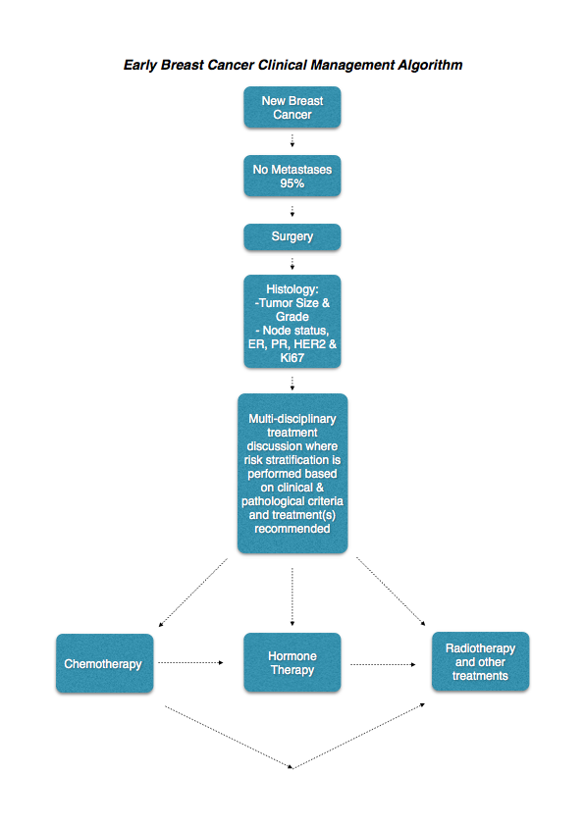
B. Provide a clinical management algorithm (e.g.: flowchart) explaining the expected management and any downstream services (aftercare) of the eligible population/s if public funding is recommended for the service proposed.
It is proposed that the MammaPrint test be positioned as an adjunctive test around the time of surgery for a subgroup of breast cancer patients who are classified as having a tumour size up to 50mm, ER+ with 0-3 positive lymph nodes, in patients who are eligible to receive adjuvant chemotherapy. The MammaPrint test will be used to guide the use of adjuvant chemotherapy in addition to existing prognostic approaches based on tumour staging, histological features and lymph node involvement. Any patients deemed not suitable for chemotherapy or unable to tolerate chemotherapy would not be eligible for the MammaPrint test.
Expert opinion sought on the time to commence adjuvant chemotherapy after surgery indicates that treatment usually commenced within 3-6 weeks after surgery. The results of the MammaPrint test are available within 7-10 days of the sample being sent to Genome Investigation in Australia (including delivery to the Agendia laboratory in Irvine, California, USA) therefore imposing no delay for treatment to commence.
There is now a need for repeat testing in around 3% of cases. Sapino et al (Journal of Molecular Diagnostics 2013) state in their recent review entitled “MammaPrint Molecular Diagnostics on Formalin-Fixed Paraffin-Embedded Tissue” that “FFPE sample processing had a success rate of 97%.” This is a significant improvement over the earlier fresh tissue processing where higher failure rates were reported. Causes of failures are derived from insufficient invasive tumour, insufficient RNA or unevaluable slides. In such cases it is necessary to resubmit a sample for MammaPrint testing or repeat the MammaPrint test, in both circumstances the costs are borne by Agendia.
The algorithm shown in Figure 4 below reveals the position of the 70 gene MammaPrint test in the standard pathway. Positioning of the 70 gene test on this pathway shows the test occurring after the MDM team discussion of the patient’s test results. However, at the discretion of the treating team, the 70 gene assay testing can also be performed after surgery and before the MDM meeting so that the results are available at the time of the discussion at the MDM. As the 70 gene test can be safely performed on core biopsy tissue (with invasive cancer accounting for more than 30% of the core biopsy), then MammaPrint testing is preferred to be performed by some oncologists prior to the patient undergoing surgery (if the patient is clinically node negative and IHC performed on the core biopsy confirms an ER+ tumour). This enables timely reporting of the 70 gene assay, bearing in mind the international journey of the breast cancer specimen which is required for testing.
MammaPrint is included as a test predictive of chemotherapy in the latest international St Gallen guidelines. Australian clinical experts contacted considered that MammaPrint risk stratification (low risk or high risk) would be used in the clinical setting as an adjunct to current clinical practice rather than replacing any part of it. In different markets with varying therapeutic approaches, using the test has consistently resulted in a significant reduction of patients who are prescribed chemotherapy (and identifies a smaller subset of patients who would benefit from chemotherapy among patients who would otherwise be treated with endocrine therapy alone) (RASTER trial Drukker et al IJC2013).
Furthermore in a population in whom it is difficult to select patients that would benefit most from chemotherapy, the introduction of MammaPrint would standardise treatment decisions and improve the quality, equity and consistency of care across Australia.
Figure 4
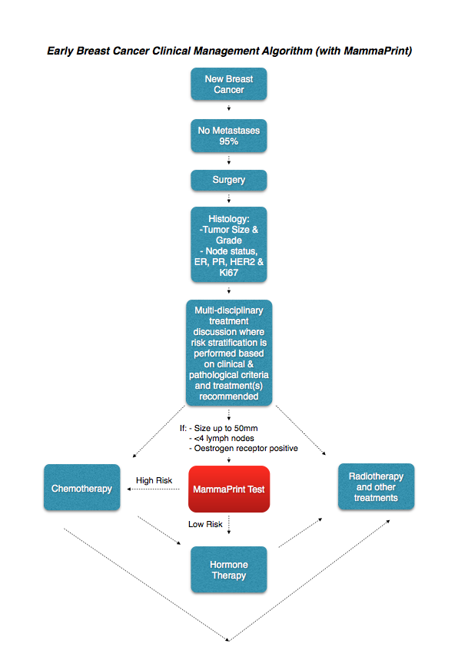
There is no change in the diagnostic practice or treatment options available to patients between the current and proposed pathway. Rather, it is a tool which provides new and additional information for the patient/physician decision as to whether or not to initiate chemotherapy. It is still the same decision to be made, however the outcome of the MammaPrint test will result in triage of different patients through to different treatments (than is current practice).

The test will improve health outcomes in one of two possible ways:

(i) by identifying patients likely to benefit from chemotherapy that would not have been identified through standard clinical practice. This will result in improved disease free survival and reduction in breast cancer recurrence by the addition of chemotherapy to a patient who would have otherwise been treated with hormone therapy alone
(ii) by identifying patients that will not benefit from chemotherapy, thus sparing them adverse effects and other risks associated with chemotherapy.

The clinical claim depends on a linked approach which:
(i) shows the impact of MammaPrint on the decision to initiate chemotherapy, and
(ii) shows that the change in allocation by MammaPrint binary low risk:high risk score of chemotherapy improves disease free survival and reduces unnecessary adverse effects.

Prospective clinical trial data (Drukker et al IJC2013) shows that chemotherapy is ineffective in patients identified as low risk by MammaPrint. In this prospective community based observational study, the 5-year DRFI probabilities confirmed the additional prognostic value of the 70-gene signature to clinicopathological risk estimations such as AOL. Omission of adjuvant chemotherapy as judged appropriate by doctors and patients and instigated by a low-risk 70-gene signature result, appeared not to compromise outcome. A similar relationship between MammaPrint binary low risk:high risk stratification andresponse to chemotherapy was observed in node positive patients (Saghatchian et al The Breast Journal 2013 and Mook et al Breast Cancer Res Treat 2009). It isimportant to note that the predictive value of the binary low risk:high risk MammaPrint test result isderived from retrospective analysis but that theassociation has now been tested prospectively in the RASTER trial (Drukker et al IJC 2013).

These data are presented in this DAP by way of illustration only and will be fully evaluated in the MSAC assessment itself. Relative to the comparator, MammaPrint testing and consequent treatment may be considered superior in terms of safety (less chemotherapy adverse effects) and to be non-inferior to superior in terms of effectiveness (better disease free survival in patients using chemotherapy when they otherwise would not have). As such, the type of economic evaluation required is a cost-effectiveness analysis or cost-utility analysis (green shading in Table 11 below). The applicant does not intend to make any claims about the comparative effectiveness of the various chemotherapy options (with or without hormone therapy) available for patients with breast cancer.

Table 11. Classification of an intervention for determination of economic evaluation to be presented.
 |  | Comparative effectiveness versus comparator
 |  | Superior |  | Non-inferior | Inferior
 | Superior | CEA/CUA |  | CEA/CUA | Net clincal benefit | CEA/CUA
 |  |  |  |  | Neutral benefit | CEA/CUA*
 |  |  |  |  | Net harms | None^
 | Non-inferior | CEA/CUA |  | CEA/CUA* | None^
 | Inferior | Net clinical benefit | CEA/CUA | None^ | None^
 |  | Neutral benefit | CEA/CUA*
 |  | Net harms | None^

Abbreviations: CEA = cost-effectiveness analysis; CUA = cost-utility analysis
* May be reduced to cost-minimisation analysis. Cost-minimisation analysis should only be presented when the
proposed service has been indisputably demonstrated to be no worse than its main comparator(s) in terms of both
effectiveness and safety, so the difference between the service and the appropriate comparator can be reduced to a
comparison of costs. In most cases, there will be some uncertainty around such a conclusion (i.e., the conclusion is often
not indisputable). Therefore, when an assessment concludes that an intervention was no worse than a comparator, an
assessment of the uncertainty around this conclusion should be provided by presentation of cost-effectiveness and/or cost utility
analyses.
^ No economic evaluation needs to be presented; MSAC is unlikely to recommend government subsidy of this intervention.

Regulatory Information
A. Please provide details of the regulatory status, noting that regulatory listing must be finalised before MSAC consideration.
The 70 gene MammaPrint assay is registered as a Class III in vitro diagnostic medical device (IVD) by the FDA. It is registered in many countries as it is a test service that is performed either in Irvine, California for American, Asian and Australasian patients, or in Amsterdam for European patients. Both Agendia Inc laboratories are certified to perform such testing with the United States’ Centers for Medicare and Medical Service (CMS) and accredited by the College of American Pathologists (CAP) under the United States Clinical Laboratory Improvement Amendment (CLIA) of 1988 and operates in accordance with federal and state laws.

Worldwide, the 70 gene MammaPrint test was the first the first diagnostic microarray test to receive ISO17025 accreditation. In March 2014, Agendia was granted the new Global Medical Device Nomenclature (GMDN) code number 60943 for the 70 gene MammaPrint assay.

Further, Agendia Inc has obtained five separate FDA certifications for the use of MammaPrint in early breast cancer. Centralisation of the testing process is a significant strength of MammaPrint with regard to reproducibility. It does not suffer from the same problems as other assays based on technologies that are difficult to standardise across different laboratories. Hence there is no need for an Australian laboratory to implement new testing strategies. Importantly, there are no issues with laboratory workforce limitations such as the need for additional expertise in performing or interpreting the test that could be a barrier to access and indeed has been with the implementation of other tests. For example, the review of tests for HER2 gene amplification found that some techniques would be restricted to central laboratories because of requirements for investment in specialised equipment and training. Furthermore widespread introduction of some techniques were not thought to be tenable due to the workload pressures facing Australian pathologists (MSAC assessment report 38, June 2008 p. 64).

The Australian TGA first reviewed the 70 gene MammaPrint assay back in October 2005, when it was deemed to be “exempt device under Section 18 of the Therapeutic Goods Act 1989 and Schedule 5, Item 7(b) of the Therapeutic Goods Regulation 1990” (Personal Communication between TGA & Agendia Australia). However, the new in vitro diagnostic medical device (IVD) framework commenced on 1July 2010. IVDs that were supplied in Australia prior to 1 July 2010 are considered to be transitional, and transitional devices are required to be included on the Australian Register of Therapeutic Goods (ARTG) prior to 1 July 2014. Further, a recommendation has been made to the Australian Government that this transitional period should be extended for another year such that all transitional IVDs must transition to the new IVD framework by 1 July 2015. This recommendation has not received government approval as yet. Therefore, at the time of submission of this MSAC DAP application, the 70 gene MammaPrint assay remains an exempt transitional Class 3 IVD. However, the TGA continues to process IVD Application DV-2014-IVA-02071-1, Sponsor Reference: MammaPrint Application 1.

Decision analytic
A. Provide a summary of the PICO as well as the health care resource of the comparison/s that will be assessed, define the research questions and inform the analysis of evidence for consideration by MSAC (as outlined in Table 1 [converted into Table 12 below]).
The protocol guiding the assessment of the health intervention has been developed using the widely accepted “PICO approach”. This approach involves a clear articulation of the following aspects of the research question that the assessment is intended to answer:
Patients - specification of the characteristics of the population or patients in whom the intervention is intended to be used;
Intervention - specification of the proposed intervention;
Comparator - specification of the therapy most likely to be replaced, or added to, by the proposed intervention; and
Outcomes - specification of the health outcomes and the healthcare resources likely to be affected by the introduction of the proposed intervention.

Table 12 below provides a summary of the PICO used to:
(1) define the questions for public funding,
(2) select the evidence to assess the safety and effectiveness of MammaPrint testing, and
(3) provide the evidence-based inputs for any decision analysis modeling to determine the cost-effectiveness of MammaPrint testing, for the proposed and current clinical pathways.

Table 12. Summary of PICO to define research question in 70 Gene testing
PICO | Comments
Patients | Women diagnosed with early (stage I or II) breast cancer who have ER+ tumours, node negative or with a maximum of 3 positive nodes. Patients must have an invasive primary tumour size up to 50mm, and be a suitable candidate for chemotherapy.  Subgroup analyses may be presented to define populations in which the degree of clinical benefit and cost effectiveness can be assessed to determine which patient subgroups would and would not be eligible for public funding.
Intervention | 70 gene MammaPrint test with low risk:high risk guided usual care.
Comparator | No 70 gene MammaPrint test and current usual care (without low risk:high risk guidance).
Outcomes | Safety  Psychological and physical harms from testing. Any adverse events related to a change in treatment including tolerability and toxicity.  Effectiveness  Primary outcomes: Disease free survival, Overall survival, Quality adjusted survival.  Secondary outcomes: Change in management, Uptake of chemotherapy, Quality of life.  Analytic Validity  Description of the genetic test. Rationale for sample selection.  Development and validation of prognostic low risk:high risk binary result.  Clinical validity and utility.  Cost-effectiveness  Cost, cost per relevant health outcome (e.g. LYG, QALY). Assessment of the evidence will be made separately for patients who are node negative and those who are node positive (1-3) nodes. This is because differences in nodal status are known to be prognostic for disease recurrence and thus is already taken into consideration in clinical decisions about whether to recommend adjuvant chemotherapy.
For investigative services
Prior tests | Nil
Reference standard | Not applicable

Healthcare resources
A. Using tables 2 and 3 [condensed into Table 13 below], provide a list of the health care resources whose utilisation is likely to be impacted should the proposed intervention be made available as requested whether the utilisation of the resource will be impacted due to differences in outcomes or due to availability of the proposed intervention itself.

Outcomes for economic evaluation
If differences in health outcomes, such as the rate of disease recurrence and incidence of chemotherapy adverse effects can be determined, cost-effectiveness and cost-utility analyses would be relevant, and health outcomes would need to be measured as life-years gained and quality-adjusted life-years gained.

Health care resources
As diagnosis and staging of breast cancer will occur in both comparative arms – that is with or without MammaPrint testing – costs and resource use associated with these will not be needed in the economic evaluation of MammaPrint testing. The proposal includes the costs for the following health care resource items:-

·Costs for MammaPrint testing (these costs will include; block retrieval of stored
sample from tissue archive, preparation of tissue sample; transportation of the tissue
sample; reporting of results including any the cost for retesting of any samples which
were found to be insufficient)
·Costs associated with acquisition and administration of hormone therapy and
chemotherapy used to treat patients with early (stage I-II) breast cancer.

·Costs associated with the management of adverse events associated with
chemotherapy and hormone therapy.
·Costs associated with the management of stable disease and recurrent breast
cancer
A non-exhaustive list of the resources that would need to be considered in the economic analysis is provided in Table 13.

Table 13. List of resources to be considered in the economic analysis

Type of resource | Provider of resource |  | Setting in which resource is provided |  | Proportion  of patients receiving resource |  | Number of units of resource per cycle per patient receiving resource |  | Disaggregated unit cost
 |  |  |  |  |  |  |  |  | MBS |  |  | Safety nets* | Other government budgets  (PBS, hospitals,  etc) |  |  | Private health insurer |  | Patient | Total cost
Resources provided in association with proposed intervention
Block retrieval of stored sample from tissue archive. | Pathologist |  |  |  |  | 100% | 1 |  | 1 |  |  |  |  |  |  |  |  |  | Proposed MBS fee is to be determined
Preparation of tissue sample. | Pathologist
70 gene MammaPrint reporting of results. | Agendia |  | Agendia laboratory
Resources provided to deliver chemotherapy
Chemotherapy treatment cost  (chemotherapy regimen(s) including those regimens above). | Medical Oncologist |  | Outpatient /  Inpatient |  |  | TBD based on uptake  of chemotherapy in the clinical evaluation of 70 gene assay. | Number of infusions per patient. |  |  |  |  |  |  |  |  |  |  |  | To be determined.
Supportive or prophylactic  medication (e.g. G-CSF, anti-emetics). | Medical Oncologist |  | Outpatient /  Inpatient |  |  | As above along with  evidence of  concomitant  medication use.
Monitoring of chemotherapy (test/  lab analyses performed before,  during and after the chemotherapy  treatment to monitor the impact of  treatment on some physiological functions. |  |  | Outpatients |  |  | As above
Full day hospital admission for  chemotherapy in a public hospital  setting (excluding average pharmacy cost component). | Medical Oncologist |  | Day Patient |  |  | As above (along with  split of settings of  chemotherapy  administration in Australia.
Full day hospital admission for  chemotherapy in a private hospital  setting (excluding average pharmacy cost component). | Medical Oncologist |  | Day patient |  |  | As above
Drug administration cost for 1 to 6 hour infusion in outpatient setting. | Medical Oncologist |  | Day patient |  |  | As above
Chemotherapy follow up monitoring. | Medical Oncologist |  | Day patient or Inpatient |  |  | As above
Resources provided to deliver hormone therapy
Hormone therapy treatment cost (hormone therapy to be determined). |  | Medical Oncologist |  | Day patient |  | 100% (all patients will get hormone therapy in both arms of the model)
Hormone therapy administration cost. |  | Medical Oncologist |  | Day patient |  | 100%
Resources provided in association with chemotherapy: costs associated with treating adverse events for patients receiving chemotherapy
Short and long term adverse events. Will depend on adverse  events associated with chemotherapy usage. |  |  |  | Inpatient |  | Patients receiving  chemotherapy  treatment who incur grade 3/4 adverse event.
Resources provided in association with hormone therapy: costs associated with treating adverse events for patients receiving hormone therapy
Will depend on adverse events  associated with hormone therapy usage. |  |  |  | Inpatient |  | Patients receiving  hormone therapy  treatment who incur grade 3/4 adverse event.
Resources provided in association with the management of recurrent breast cancer
Will depend on results of literature review for relevant information. | To be determined |  | To be determined |  |  | Patients in the ‘BC  recurrence’health  state of the model.
Resources provided in association with the management of stable disease breast cancer.
Will depend on results of literature review for relevant information. | To be determined |  | To be determined |  |  | Patients in the ‘disease free’health state of the model.

The MammaPrint test result is used to classify patients as low risk or and high risk. There is NO intermediate risk determination, due to the scientific method used to establish the MammaPrint 70 gene signature which was first reported in Nature over 12 years ago (van’t Veer Nature January 2002). The structure of the economic evaluation will align with the linked evidence approach described earlier. That is, MammaPrint testing impacts the decision to initiate chemotherapy treatment, and the change in allocation of chemotherapy treatment by the binary MammaPrint low risk:high risk result improves disease free survival and reduces unnecessary
adverse events. The decision analysis presented in Figure 3 uses trial based analysis where staging the population suitable for MammaPrint testing is identical to the staging of patients who would not undergo MammaPrint testing. The introduction of MammaPrint testing helps to inform the decision on adjuvant chemotherapy for patients based on their risk status (low risk or high risk). Therefore, the
primary analysis compares current clinical practice with the adjuvant treatment decision based on the addition of MammaPrint to current clinical practice (‘USUAL CARE’).

Patients in the model are either assigned adjuvant chemotherapy based on the conventional approach in the Australia (usual care) or based on the MammaPrint binary result.

There are three states in the model:
·recurrence-free (in which all patients start the simulation),
·recurrence (following a distant recurrence event) and
·dead (following a mortality event).

All patients start the simulation in the recurrence-free state. In each cycle of the simulation, patients are exposed to the risk of competing mortality and recurrence. Patients who have a mortality event transition to the dead state (absorbing state). Patients who experience a distant recurrence event transition to the recurrence state, where they are exposed to the risk of breast cancer mortality in each subsequent cycle of the simulation.

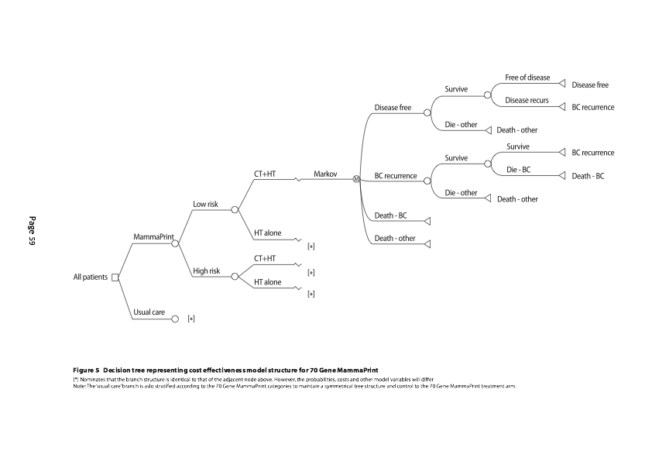

Questions for public funding
A. Please list questions relating to the safety, effectiveness and cost effectiveness of the service / intervention relevant to this application, for example:
- Which health / medical professionals provide the service
Australian medical or surgical oncologists currently request the 70 gene MammaPrint service, and Australian pathologists and laboratories forward the early breast cancer specimens to Genome Investigation for export and international air courier processing prior to forwarding on to the 70 gene processing laboratory located in Irvine, California, USA.
- Are there training and qualification requirements
The 70 gene test does not have any workforce implications in Australia in terms of the need for investment in new technology, additional capacity or training –unlike other genetic tests recently reviewed by PASC and MSAC (for example, HER2 testing using fluorescence in situ hybridization, FiSH - MSAC assessment report 38, June 2008 p.64).
- Are there accreditation requirements
There are currently no accreditation requirements for Australian medical or surgical oncologists ordering the tests, nor are there accreditation requirements for Australian pathologists or laboratories over and above their normal accreditations to send early breast cancer specimens.

It is accepted that it would be informative for the assessment of evidence in response to the final DAP to assess the proposed intervention separately for:
·patients who are node negative
·patients who have 1-3 positive nodes
as these differences in nodal status are known to be prognostic for disease recurrence and this is already taken into consideration in clinical decisions about whether to recommend adjuvant chemotherapy.

It is accepted that the assessment of evidence in response to the final DAP would need to provide additional information to address the following matters:

In relation to the proposed genetic testing intervention:
·a detailed explanation and justification (with a biological basis) for the selection of
each of the 70 genes, including how and why they were identified, and how and why other genes which may or may not have had prognostic value in breast cancer were excluded from the 25,000 genes originally identified in the human genome.
·a detailed explanation and justification for choosing microarray mRNA GEP as the method of analysis.
·details of the analytical validation of the microarray mRNA method for each of the 70 genes profiled.
·a demonstration that the measured expression levels of each of the 70 genes is in
the linear range of measurement of the microarray mRNA 70 gene assay.
·a demonstration of the effect of tumour spatial heterogeneity in mRNA expression on assay reproducibility.

In relation to pre-analytical variables, particularly to establish whether the origin and/or method of specimen preparation is a source of reduced confidence in the outputs of the 70 genes:

·a detailed explanation and justification for relying on formalin-fixed paraffin embedded (FFPE) tissues given the known instability of RNA. There is no extra cost implication for Australia for specific shipping conditions apart from the standard international air courier charges.
·a demonstration of the stability and reproducibility of mRNA detection, using microarray mRNA GEP analysis for each of the 70 genes from FFPE breast cancer samples obtained from different pathology laboratories.

In relation to evidence of the clinical validity and utility of the proposed intervention:
·a detailed explanation and justification of how and why the patient population(s) to be tested was chosen in each of the studies conducted to provide evidence of the clinical validity and utility of the proposed intervention.
·a demonstration of which of these studies were retrospective or prospective (with
respect to when the data were collected and when the analysis was specified). It is
noted that the recent significant prospective trial evidence confirming the prognostic and predictive value of the MammaPrint test was prospective in nature (RASTER trial Drukker et al IJC 2013).
- a demonstration that pre-specified endpoints were met in each study.
- a demonstration of an improved performance of the 70 gene signature over the known IHC-based prognostic markers, ER, PR and HER2, alone.
- a demonstration that women with a low risk of recurrence who forego or decline
- adjuvant chemotherapy have equivalent or better clinical outcomes to women with
- similar risk results who are treated with adjuvant chemotherapy. Such demonstration
- would support the hypothesis that MammaPrint has the propensity to improve
- outcomes by reducing exposure to ineffective, yet adverse event causing,
- chemotherapy (as evidenced by RASTER trial).
- a demonstration that women with a high risk of recurrence who receive adjuvant
- chemotherapy have better clinical outcomes to women with a similar high risk result who were not treated with adjuvant chemotherapy. Such demonstration would support the hypothesis that MammaPrint has the propensity to improve outcomes by extending disease free survival in patients who would not otherwise be treated with effective chemotherapy.
- a demonstration that the pathology laboratory involved in each study participated in an external quality assurance program measuring the same 70 gene signature on the same patient population.

In relation to evidence from studies undertaken to validate the downstream health outcome and cost consequences of adding the recurrence score to current clinical decision-making (noting the variation in Australian practice and the US-based evidence available):
- details of the characteristics of the populations and existing management strategies studied.
- details of which studies were retrospective or prospective (with respect to when the
- data were collected and when the analysis was specified). In this regard, PASC
- should note that the MINDACT prospective trial in early breast cancer patients has completed accrual of over 6,000 participants, and is estimated to begin reporting in late 2014 or early 2015.
- details of the proportions of patients tested who fall within the low and the high risk groups according to their heat map results.
- a demonstration of the cost offsets for the population of patients being tested due to the reduction in cost for adjuvant chemotherapy in those patients with low risk
- results and due to the improvement in health outcomes for those additional patients with high risk results who otherwise would not have received adjuvant chemotherapy.

In relation to sources of data used to predict the risk of breast cancer recurrence across the two arms of the proposed decision analysis, with one arm representing the range of current management strategies and the other arm representing the addition of the proposed intervention (noting that a shift in the spectrum of disease is likely to be a confounding factor):
- an assessment of the comparability of the spectrum of disease of the patients across the two arms and their sources of data. In this regard, PASC should note that this is important to distinguish between the prognostic effect of better risk classification by the proposed intervention and the differential treatment effect as a consequence of the proportion of eligible patients for whom the decision as to whether to offer chemotherapy as well as hormone therapy would be changed.

Conclusions

The 70 gene MammaPrint mRNA microarray assay is a cost effective and highly researched test which now should be funded by the Australian Government Department of Health to benefit a well defined subgroup of patients with early breast cancer, due to MammaPrint’s proven ability to quantify the risk of disease recurrence & predict adjuvant chemotherapy benefit.
The early results of the prospective randomised MINDACT study confirm the proven ability of MammaPrint to quantify the risk of disease recurrence via MammaPrint’s unique risk stratification ability. The imminent release of MINDACT’s 5 year survival figures should give the final validation.
In the interim, the fully published and peer reviewed prospective RASTER study clearly provides firm evidence that high risk patients benefit from chemotherapy, and low risk patients benefit from not having chemotherapy, again illustrating MammaPrint’s claim of adequately predicting the benefit of adjuvant chemotherapy in this large group of early breast cancer patients.
The utilization of this new test will surprisingly result in a net financial savings for the Australian Government Department of Health. MammaPrint testing results in an approximate 30% net reduction in the administration of adjuvant chemotherapy in the early breast cancer setting. When all costs are taken into consideration, the financial cost of adjuvant therapy in breast cancer is estimated to be around $AUD20,000 per patient (including all associated costs of inpatient admissions needed for managing medical complications, modern pharmaceuticals, nursing and medical staffing costs, etc.). With the price of a MammaPrint test currently set internationally at $USD4,200, it can be quickly seen that a 30% reduction in adjuvant therapy gives a major significant overall price saving for the health care funder.

Most importantly, MammaPrint results in improved targeted treatment for the individual woman with a new diagnosis of breast cancer. This is a significant improvement in personalized therapy for those struggling with a new diagnosis of breast cancer.

This document is being released for public consultation, and feedback to MSAC is encouraged.

References

1. Gene expression profiling predicts clinical outcome of breast cancer
Laura J. van’t Veer, Hongyue Dal, Marc J. van de Vljver, Yudong D He, Augustinus A.M. Hart, Mao Mao, Hans L. Peterse, Karin van der Kooy, Matthew J. Marton, Anke T. Witteveen, George J. Schrelber, Ron M. Kerkhoven, Chris Roberts, Peter S. Linsley, Rene Bernards & Stephen H. Friend
Nature, Vol. 415, 31 January 2002, pp. 530 –536
2. A Gene-expression Signature as a Predictor of Survival in Breast Cancer
Marc J. van de Vijver, Yudong D. He, Laura J. van’t Veer, Hongyue Dai, Augustinus A.M. Hart, Dorien W. Voskuil, George J. Schreiber, Johnanes L. Peterse, Chris Roberts, Matthew J. Marton, Mark Parrish, Douwe Atsma, Anke Witteveen, Annuska Glas, Leonie Delahaye, Tony van der Velde, Harry Bartelink, S. Jored Rodenhuis, Emiel T. Rutgers, Stephen H. Friend, and Rene Bernards
The New England Journal of Medicine, 9 December 2002, Vol. 347, No. 25, pp. 1999-2009
3. Validation and Clinical Utility of a 70-Gene Prognostic Signature for Women With Node-Negative Breast Cancer
Marc Buyse, Sherene Loi, Laura van’t Veer, Giuseppe Viale, Mauro Delorenzi, Annuska M. Glas, Mahasti Saghatchian d’Assignies, Jonas Bergh, Rosette Lidereau, Paul Ellis, Adrian Harris, Jan Bogaerts, Patrick Therasse, Arno Floore, Mohamed Amakrane, Fanny Piette, Emiel Rutgers, Christos Sotiriou, Fatima Cardoso, Martine J. Piccart
Journal of the National Cancer Institute, 6 September 2006, Vol. 98, No. 17, pp. 1183 –1192
4. Recommendations from the EGAPP Working Group: can tumour gene expression profiling improve outcomes in patients with breast cancer?
EGAPP Working Group:
Genetics IN Medicine •Volume 11, Number 1, January 2009
5. The 70-gene prognosis-signature predicts disease outcome in breast cancer patients with 1–3 positive lymph nodes in an independent validation study
Stella Mook, Marjanka K. Schmidt, Giuseppe Viale, Giancarlo Pruneri, Inge Eekhout, Arno Floore, Annuska M. Glas, Jan Bogaerts, Fatima Cardoso, Martine J. Piccart-Gebhart, Emiel T. Rutgers, Laura J. van ’t Veer On behalf of the TRANSBIG consortium
Breast Cancer Res Treat, 116 (2) Jul 2009, 295-302
6. Analysis of the MammaPrint Breast Cancer Assay in a Predominantly Postmenopausal Cohort
Ben S. Wittner, Dennis C. Sgroi, Paula D. Ryan, Tako J. Bruinsma, Annuska M. Glas, Anitha Male, Sonika Dahiya, Karleen Habin, Rene Bernards, Daniel A. Haber, Laura J. Van’t Veer, and Sridhar Ramaswamy
Clin Cancer Res, 15 May 2008, 14(10), pp. 2988 –2993
7. The 70-gene prognosis signature predicts early metastasis in breast cancer patients between 55 and 70 years of age
S. Mook, M. K. Schmidt, B. Weigelt, B. Kreike, I. Eekhout, M. J. van de Vijver, A. M. Glas, A. Floore, E. J. T. Rutgers & L. J. van ‘t Veer
Annals of Oncology, 2010; 21 (4):717-722
8. Validation of 70-gene prognosis signature in node-negative breast cancer
J. M. Bueno-de-Mesquita, S. C. Linn, R. Keijzer, J. Wesseling, D. S. A. Nuyten, C. van Krimpen, C. Meijers,P. W. de Graaf,M. M. E. M. Bos, A. A. M. Hart, E. J. T. Rutgers, J. L. Peterse, H. Halfwerk, R. de Groot, A. Pronk,
A. N. Floore, A. M. Glas,L. J. van’t Veer, M. J. van de Vijver
Breast Cancer Res Treat, 8 September 2008
9. Clinical Utility of the 70-gene MammaPrint Profile in a Japanese Population
Ishitobi M, Goranova TE, Komoike Y, Motomura K, Koyama H, Glas AM, van Lienen E, Inaji H, Van't Veer LJ, Kato K.
Jpn J Clin Oncol. 2010 Jan 27
10. Identification of a low-risk subgroup of HER-2-positive breast cancer by the 70-gene prognosis signature
M Knauer, F Cardoso, J Wesseling, PL Bedard, SC Linn, EJT Rutgers and LJ van ’t Veer
Br J Cancer. 2010 Dec 7;103(12):1788-93. doi: 10.1038/sj.bjc.6605916. Epub 2010 Nov 16.
11. Molecular subtyping improves stratification of patients into diagnostically more meaningful risk groups
Massimo Cristofanilli, Karen Kaul, Mary Turk, Jo Ellen Weaver, Jelle Wesseling, Lisette Stork-Sloots, Femke de Snoo, Katharine Yao
SABCS 2012 abstract
12. A prospective evaluation of a breast cancer prognosis signature in the observational RASTER study
Drukker C, Bueno-de-Mesquita J, Retel V, et al., Int J Cancer. 2013 Aug 15;133(4):929-36. doi: 10.1002/ijc.28082. Epub 2013 Mar 4.
13. The 70-gene signature as a response predictor for neoadjuvant chemotherapy in breast cancer
Marieke E Straver, Annuska M. Glas, Juliane Hannemann, Jelle Wesseling, Marc van de Vijver, Emiel J. Th. Rutgers, Marie-Jeanne T.F.D. Vrancken Peeters, Harm van Tinteren, Laura J. van ’t Veer, Sjoerd Rodenhuis
Breast Cancer Research and Treatment, 2009 Jan; 119(3):551-8
14. Chemotherapy response and recurrence-free survival
in neoadjuvant breast cancer depends on biomarker profiles: results from the I-SPY 1 TRIAL (CALGB 150007/150012; ACRIN 6657)
Laura J. Esserman •Donald A. Berry •Maggie C. U. Cheang •Christina Yau •
Charles M. Perou •Lisa Carey •Angela DeMichele •Joe W. Gray •Kathleen Conway-Dorsey •Marc E. Lenburg •Meredith B. Buxton •Sarah E. Davis •Laura J. van’t Veer •
Clifford Hudis •Koei Chin •Denise Wolf •Helen Krontiras •Leslie Montgomery •
Debu Tripathy •Constance Lehman •Minetta C. Liu •Olufunmilayo I. Olopade •
Hope S. Rugo •John T. Carpenter •Chad Livasy •Lynn Dressler •David Chhieng •
Baljit Singh •Carolyn Mies •Joseph Rabban •Yunni-Yi Chen •Dilip Giri •
Alfred Au •Nola Hylton •The I-SPY 1 TRIAL Investigators
Breast Cancer Res Treat. 2012 Apr;132(3):1049-62. doi: 10.1007/s10549-011-1895-2
15. The EORTC 10041/BIG 03-04 MINDACT trial is feasible: Results of the pilot phase
Emiel Rutgers, Martine J. Piccart-Gebhart, Jan Bogaerts, Suzette Delaloge, Laura Van ‘t Veer, Isabel Teresa Rubio, Giuseppe Viale, Alastair M. Thompson, Rodolfo Passalacqua, Ulrike Nitz, Anita Vindevoghel, Jean-Yves Pierga,
Peter M. Ravdin, Gustavo Werutsky, Fatima Cardoso
Eur J Cancer 47 (2011) 2742-2749
16. Cost effectiveness of gene expression profiling for early stage breast cancer: a decision-analytic model.
Mo Yang, Suja Rajan , Amalia M. Issa
Cancer. 2012 Oct 15;118(20):5163-70. doi: 10.1002/cncr.27443. Epub 2012 Feb 22.
17. Use of 70-gene signature to predict prognosis of patients with node-negative breast cancer: a prospective community-based feasibility study (RASTER)
Jolien M Bueno-de-Mesquita, Wim H van Harten, Valesca P Retel, Laura J van ’t Veer, Frits S A M van Dam, Kim Karsenberg, Kirsten F L Douma, Harm van Tinteren, Johannes L Peterse, Jelle Wesseling, Tin S Wu, Douwe Atsma, Emiel J T Rutgers, Guido Brink, Arno N Floore, Annuska M Glas, Rudi M H Roumen, Frank E Bellot, Cees van Krimpen, Sjoerd Rodenhuis, Marc J van de Vijver, Sabine C Linn
The Lancet, 2007 Dec;8(12):1079-1087
18. Head-to-head comparison of the 70-gene signature versus the 21-gene assay: cost-effectiveness and the effect of compliance
Retél VP, Joore MA, van Harten WH. Breast Cancer Res Treat, September 2011; DOI 10.1007/s10549-011-1769-7
19. Cost-Effectiveness of 70-Gene MammaPrint Signature in Node-Negative Breast Cancer
ER Chen, MPP; Kuo Bianchini Tong, MS; and Jennifer L. Malin, MD, PhD
The American Journal of Managed Care, Vol. 16, No. 12, December 2010
20. Cost-effectiveness of the 70-gene signature versus St. Gallen guidelines and Adjuvant Online for early breast cancer
Valesca P. Rete`l a, Manuela A. Joore b,c, Michael Knauer d,e, Sabine C. Linn f, Michael Hauptmann g, Wim H. van Harten. European Journal of Cancer, (2010) 1382-139121.
21. Agendia’s Original FDA Clearance:- http://www.fda.gov/ForConsumers/ConsumerUpdates/ucm048477.htm
22. Use of a genomic test (MammaPrint™) in daily clinical practice to assist in risk stratification of young breast cancer patients
Kunz G, Arch Gynecol Obstet (2011) 283:597–602
23. Expression of the 21 genes in the Recurrence Score assay and tamoxifen clinical benefit in the NSABP study B-14 of node negative, estrogen receptor positive breast cancer
S. Paik, S. Shak, G. Tang, C. Kim, J. Baker, M. Cronin, D. Watson, J. Bryant, J. Costantino, N. Wolmark
Journal of Clinical Oncology, 2005 ASCO Annual Meeting Proceedings. Vol 23, No. 16S, Part I of II (June 1 Supplement), 2005: 510
24. The impact of the Oncotype Dx Beast Cancer Assay in Clinical practice: systematic review and meta-analysis,
Josh John Carlson, Joshua A. Roth;
J Clin Oncol 30, 2012 (suppl; abstr 560)
25. The predictive value of the 70-gene MammaPrint signature for adjuvant chemotherapy in early breast cancer
Michael Knauer, Stella Mook, Emiel JT Rutgers, Richard A Bender, Michael Hauptmann, Marc van de Vijver, Rutger HT Koornstra, Jolien M Bueno-de-Mesquita, Sabine C Linn and Laura J van ’t Veer
Breast Cancer Res Treat, 19 February 2010, DOI 10.1007/s10549-010-0814-2
26. Comparison of MammaPrint and TargetPrint results with clinical parameters in German patients with early stage breast cancer
Heidrun Gevensleben, Uwe-Jochen Gohring, Reinhard Buttner, Lukas C. Heukamp, Georg Kunz, Thomas Dimpfl, Christian Jackisch, Olaf Ortmann, Ute-Susann Albert, Richard Bender, Femke De Snoo, Oscar Krijgsman, Annuska M. Glas, Yavuz H. Ergonenc, Corinna Vogel, August Dykgers, Claus Landwieder, Martin Rees and Tobias Anzeneder
International Journal of Molecular Medicine 26: 837-843, 2010
27. Metastatic Potential of T1 Breast Cancer Can Be Predicted By The 70-gene MammaPrint Signature
Mook S, Knauer M, Bueno-de-Mesquita JM, Retel VP, Wesseling J, Linn SC, Van't Veer LJ, Rutgers EJ.
Ann Surg Oncology 2010 Jan 22
28. Early Discontinuation and Non-adherence to Adjuvant Hormonal Therapy in a Cohort of 8,769 Early-Stage Breast Cancer Patients
Dawn L. Hershman, Lawrence H. Kushi, Theresa Shao, Donna Buono, Aaron Kershenbaum, Wei-Yann Tsai,
Louis Fehrenbacher, Scarlett Lin Gomez, Sunita Miles, and Alfred I. Neugut; J. Clin. Oncol,28:1-10, 2010
29. Adherence to Adjuvant Hormonal Therapy among Breast Cancer Survivors in Clinical Practice: A Systematic Review
Caitlin C. Murphy, MPH*, L. Kay Bartholomew, EdD, Melissa Y. Carpentier, PhD, Shirley M.
Bluethmann, MPH, MA, and Sally W. Vernon, PhD: Breast Cancer Res Treat. 2012 July ; 134(2): 459–478.
30. MammaPrint 70-Gene Assay Predicts Risk of Local-Regional Recurrence. Beitsch P et al. Poster presentation at American Society of Breast Disease. 2012.
31. Use of 70 gene signature to predict prognosis of patients with node-negative breast cancer: a prospective community-based feasibility study (RASTER). Bueno-de-Mesquita J M, et. al. Lancet Oncol 2007.
32. Performance characteristics of the MammaPrint®breast cancer diagnostic gene signature. Delahaye L et al. Personalized Medicine (2013) 10(8), 801–811.
33. Gene expression profiling to predict the risk of locoregional recurrence in early breast cancer. Drukker C et al. Poster presentation at San Antonio Breast Cancer Symposium. December 2012.
34. Thresholds for therapies: highlights of the St Gallen International Expert Consensus on the Primary Therapy of Early Breast Cancer 2009. Goldhirsch A, et. al. Annals of Oncology 2009 June;20:1319-1329.
35. Strategies for subtypes—dealing with the diversity of breast cancer: highlights of the St Gallen International Expert Consensus on the Primary Therapy of Early Breast Cancer 2011 , Goldhirsch A et al. Annals of Oncology 2011.
36. Personalizing the treatment of women with early breast cancer: highlights of the St Gallen International Expert Consensus on the Primary Therapy of Early Breast Cancer 2013. Goldhirsch A et al. Annals of Oncology 24: 2206–2223, 2013.
37. Health Policy Advisory Committee on Technology. Technology Brief. Gene expression profiling of breast cancer. May 2012. Queensland Health.
38. First generation prognostic gene signatures for breast cancer predict both survival and chemotherapy sensitivityy and identify overlapping patient populations. Iwamoto T, Lee JS, et. al. Breast Cancer Res Treat 2011;130:155.
39. The 70 gene MammaPrint signature in breast cancer –prognostic information independent of grade. Knauer M et al. Poster presentation at American Society of Clinical Oncology. June 2010.
40. The predictive value of the 70-gene signature for adjacent chemotherapy in early breast cancer. Knauer M, et. al. Breast Cancer Res Treat 2010. 120:655–661.
41. Metastatic Potential of T1 Breast Cancer can be Predicted by the 70-gene MammmaPrint Signature. Mook S, Knauer M, et al. Ann Surg Oncol.2009. 1-6.
42. The 70-gene prognosis-signature predicts disease outcome in breast cancer patients with 1-3 positive lymph nodes in an independent validation study. Mook S, et. al. Breast Cancer Res Treat 2008.
43. Prospective cost-effectiveness analysis of genomic profiling in breast cancer. Retel V et al. Eur J Cancer. 2013 Dec;49(18):3773-9.
44. Additional prognostic value of the 70-gene signature (MammaPrint) among breast cancer patients with 4-9 positive lymph nodes Saghatchian et al. The Breast 22 (2013) 682-690.
45. MammaPrint Molecular Diagnostics on Formalin-Fixed, Paraffin-Embedded Tissue. Sapino A et al. J Mol Diagn. 2013 Dec 27. 1525-1578.
46. Prospective study Of MammaPrint in breast cancer patients with an Intermediate recurrence Score (PROMIS). Soliman et al. Poster presentation at San Antonio Breast Cancer Symposium –December 10-14, 2013.
47. Cost Effectiveness of Gene Expression Profiling for Early Stage
Breast Cancer - A Decision-Analytic Model. Yang M et al. Cancer October 15, 2012 5163 –5170.
48. AIHW (2010). BreastScreen Australia monitoring report 2006-2007 and 2007-2008. Australian Institute of Health and Welfare, Canberra.
49. AIHW & AACR (2010). Cancer in Australia: an overview, 2010, Australian Institute of Health and Welfare, Canberra.
50. AIHW & NBOCC (2009). Breast cancer in Australia: an overview, 2009., Australian Institute of Health and Welfare, Canberra.
51. Cancer Australia (2011). Breast cancer statistics [Internet]. Australian Government. Available from: http://canceraustralia.nbocc.org.au/breast-cancer/about-breast-cancer/breast-cancer-statistics [Accessed 19 September 2011].
52. Tumor gene expression and prognosis in breast cancer patients with 10 or more positive lymph nodes. Cobleigh MA, Tabesh B, Bitterman P, et al. Clin Cancer Res 2005;11(24 Pt 1):8623-31.
53. Early Breast Cancer Trialists Cooperative Group. Polychemotherapy for early breast cancer: an overview of the randomised trials. . Lancet. 1998;352(9132):930-42.
54. Adoption of gene expression profile testing and association with use of chemotherapy among women with breast cancer. Hassett MJ et al. JCO 2012; 30(18): 2218-26.
55. Ki-67: level of evidence and methodological considerations for its role in the clinical management of breast cancer: analytical and critical review. Luporsi E, AndréF, Spyratos F et al. Breast Cancer Res Treat. 2012 Apr;132(3):895-915. Epub 2011 Nov 3.
56. Medical Services Advisory Committee (MSAC) 1172 Final Decision Analytic Protocol (DAP) to guide the assessment of BRAF genetic testing in patients with melanoma for access to proposed PBSfunded vemurafenib. January 2012.
57. Medical Services Advisory Committee (MSAC) 1173 Final Decision Analytic Protocol (DAP) to guide the assessment of Epidermal Growth Factor Receptor (EGFR) testing for eligibility for erlotinib treatment as a first line therapy in patients with locally advanced or metastatic non-small cell lung cancer (NSCLC). January 2012.
58. Medical Services Advisory Committee (MSAC) 1175 Final Decision Analytic Protocol (DAP) to guide the assessment of HER2 testing for access to lapatanib in metastatic breast cancer. May 2012.
59. Medical Services Advisory Committee (MSAC) 1342 Final Decision Analytical Protocol (DAP) to guide the assessment of gene expression profiling of 21 genes in breast cancer assay to quantify the risk of disease recurrence and predict adjuvant chemotherapy benefit. March 2013.
60. Medical Services Advisory Committee (MSAC) Assessment 38. Tests for HER2 gene amplification in breast cancer. MSAC reference 38. June 2008.
61. Progesterone receptor by immunohistochemistry and clinical outcome in breast cancer: a validation study 2004 Mohsin S., Weiss H., Havighurst T., et al. Modern Pathology (17) 1545-1554.
62. National Health & Medical Research Council (NHMRC) Clinical practice guidelines for the management of early breast cancer 2001.
63. New South Wales Central Cancer Registry (2010). Top 20 cancer sites, Incidence, Persons, NSW,2004-2008 [Internet]. NSW Health Department Available from:
http://www.statistics.cancerinstitute.org.au/prodout/top20_extent/top20_extent_lhnres_incid_2004-2008_NSW_P.htm [Accessed 21 September 2011].
64. Baseline results of the EORTC 10041/MINDACT TRIAL (Microarray In Node 0-3 positive Disease may Avoid ChemoTherapy) E. Rutgers, M.J. Piccart-Gebhart, J. Bogaerts, S. Delaloge, L.J. Van ‘t Veer, I.T. Rubio, G. Viale, U. Nitz, J.Y.Pierga, A. Vindevoghel, E. Brain, P.M. Ravdin, C. Messina, F. Cardoso on behalf of the MINDACT TRANSBIG study group. Abstract presented to EORTC September 2013 Conference.
65. Gene Expression Profiling: Decoding Breast Cancer F. de Snoo, R Bender, A Glas, E. Rutgers. Surgical Oncology (2009) 18, 366 –378.
66. Converting a breast cancer microarray signature into a high-throughput diagnostic test. Annuska M Glas, Arno Floore, Leonie JMJ Delahaye, Anke T Witteveen, Rob CF Pover, Niels Bakx, Jaana ST Lahti-Domenici, Tako J Bruinsma,
Marc O Warmoes, RenéBernards, Lodewyk FA Wessels and Laura J Van 't
Veer. BMC Genomics (2006) 7:278; 1-10.

