MSAC Application 1770
Valve-in-valve transcatheter aortic valve implantation using a balloon-expanding transcatheter heart valve system for patients with severe, symptomatic aortic stenosis
PICO Set 1

Population

Describe the population in which the proposed health technology is intended to be used:
The target population comprises patients whose background problem is severe, symptomatic aortic stenosis. These patients have previously undergone surgical aortic valve replacement (SAVR), but are now experiencing symptomatic structural valve deterioration (SVD), with the bioprosthetic aortic valve failing and resulting in stenosis, insufficiency or both. A repeat aortic valve replacement is indicated. The patients have also been judged by a heart team, including a cardiothoracic surgeon, to be at high risk for open heart surgery; that is, ≥8% predicted risk of surgical mortality at 30 days, based on the Society of Thoracic Surgeons (STS) risk score and other clinical co-morbidities unmeasured by the STS risk calculator. Only patients at high surgical risk are currently eligible as per the current regulatory approval issued by the Australian Therapeutic Goods Administration (TGA).

Specify any characteristics of patients with, or suspected of having, the medical condition, who are proposed to be eligible for the proposed health technology, describing how a patient would be investigated, managed and referred within the Australian health care system in the lead up to being considered eligible for the technology:
As for patients currently undergoing TAVIs in native aortic valves, the proposed target patient group will be assessed for eligibility for a TAVI in a ‘TAVI case conference’ (MBS items 6080 and 6081). A TAVI case conference comprises at least a cardiothoracic surgeon, an interventional cardiologist and a specialist or consultant physician who does not perform TAVIs. The team assesses a patient’s risk and technical suitability to receive TAVIs, taking into account the patient’s risk, cognitive function and frailty.
By necessity, TAVI case conferences are routinely convened in healthcare facilities in which TAVIs are undertaken. Patients are referred by other medical professionals to TAVI services. Other than investigations into structural heart and valve function, patients will undergo investigations to assess fitness for surgery, cognitive status and frailty.

Provide a rationale for the specifics of the eligible population:
Surgical bioprosthetic valves are susceptible to SVD. Although the mechanisms underlying SVD are not completely understood, recent studies suggest that multiple processes are involved in pathogenesis, including long-term immune rejection and atherosclerosis-like tissue remodelling. Ultimately, SVD can lead to surgical bioprosthetic valve failure, which requires a repeat valve replacement procedure.

Are there any prerequisite tests?
There are no specific prerequisite tests, but patients will typically have undergone a range of tests as part of the work up for TAVI eligibility, as discussed above.

Are the prerequisite tests MBS funded?
Not applicable.

Please provide details to fund the prerequisite tests:
Not applicable.

Intervention

Name of the proposed health technology:
Valve-in-valve (ViV) TAVI BEV (Balloon Expanding Valve) using the Edwards SAPIEN 3 Ultra Transcatheter Heart Valve (THV) system.

Describe the key components and clinical steps involved in delivering the proposed health technology:
The Edwards SAPIEN 3 Ultra THV system consists of the Edwards SAPIEN 3 Ultra Valve and the Commander Delivery system delivery. The Edwards SAPIEN 3 Ultra Valve comprises a balloon-expandable, radiopaque, cobalt-chromium frame, trileaflet bovine pericardial tissue valve, and polyethylene terephthalate inner and outer fabric skirts. The Commander Delivery system allows for either transfemoral or subclavian/axillary access implantation of the Edwards SAPIEN 3 Ultra Valve.
There are also a number of consumables involved. Single use consumables comprise: angioplasty kit which includes drapes, manifolds and extensions tubing; small and large bore vascular access sheaths; lock syringes; 2 x 3-way taps; 3 x bowls; 2 x galley pots; temporary pacing wire; pre-shaped catheters; and standard or speciality wires. Multi-use consumables comprise: temporary pacing cable; temporary pacing box; and transthoracic or transoesophageal probe.
In Australia, TAVI is performed in a cardiac catheterisation or an operating room. TAVI is performed under general anaesthesia or local anaesthesia with sedation. For transfemoral delivery, the latter is often sufficient. The procedure is performed without cardio-pulmonary bypass.
TAVI is usually performed under the guidance of fluoroscopy and transoesophageal echocardiography (TOE). Aortography may also be used. A percutaneous sheath is inserted into the access artery with a guide wire that is pushed passed the aortic valve. The aortic valve is predilated via balloon valvuloplasty while the heart is rapidly paced. The SAPIEN 3 balloon-expanded valve (BEV) is mounted on a balloon catheter and is inserted percutaneously over the guidewire until it crosses the aortic valve. Optimum positioning is confirmed by fluoroscopy. Once the correct position is confirmed, the heart is again rapidly paced and the balloon is expanded until the device meets the native annular walls. The balloon is then deflated and the catheter and guidewire are removed. Immediately following the procedure, aortography and TOE are again performed to assess the location and the degree of any aortic regurgitation, and the functioning of the coronary arteries. Patients are then transferred for monitoring to either a coronary care, high dependency or intensive care unit.

Identify how the proposed technology achieves the intended patient outcomes:
ViV TAVI is a minimally-invasive procedure. Compared to redo SAVR, an open procedure that involves cardio-pulmonary bypass, there is a lesser risk of mortality and other peri-operative complications, shorter length of hospital stay and faster recovery.

Does the proposed health technology include a registered trademark component with characteristics that distinguishes it from other similar health components?
Yes.

Explain whether it is essential to have this trademark component or whether there would be other components that would be suitable:
The Edwards SAPIEN 3 Ultra THV system is the only technology with regulatory approval for ViV TAVI among patients at high surgical risk.

Are there any proposed limitations on the provision of the proposed health technology delivered to the patient (For example: accessibility, dosage, quantity, duration or frequency):
Yes.

Provide details and explain:
Patients will need to have been judged by a heart team, including a cardiothoracic surgeon, to be at high risk for open heart surgery; that is, ≥8% predicted risk of surgical mortality at 30 days, based on the STS risk score and other clinical co-morbidities unmeasured by the STS risk calculator. Only patients at high surgical risk are currently eligible as per the current regulatory approval issued by the TGA.

If applicable, advise which health professionals will be needed to provide the proposed health technology:
TAVIs are only performed by accredited TAVI practitioners in accredited TAVI health facilities. TAVI practitioners comprised appropriately-qualified interventional cardiologists or cardiothoracic surgeons.

If applicable, advise whether delivery of the proposed health technology can be delegated to another health professional:
Not applicable. The service cannot be delegated.

If applicable, advise if there are any limitations on which health professionals might provide a referral for the proposed health technology:
As discussed above, referrals for ViV TAVI have to be all considered in TAVI case conferences.

Is there specific training or qualifications required to provide or deliver the proposed service, and/or any accreditation requirements to support delivery of the health technology?
Yes.

Provide details and explain:
Cardiothoracic surgeons must have completed the Cardiothoracic Surgery Program and be eligible to be a Fellow of the Royal Australasian College of Surgeons, or otherwise qualified to practice cardiothoracic surgery in Australia. Interventional cardiologists must have completed the Advanced Training Curriculum in Cardiology and be eligible to be a Fellow of the Royal Australasian College of Physicians or otherwise qualified to practice interventional cardiology in Australia.
Additionally, the interventional cardiologist or cardiothoracic surgeon must be an accredited TAVI practitioner. Accreditation is conducted by the Accreditation Committee appointed by Cardiac Accreditation Services Limited.

Indicate the proposed setting(s) in which the proposed health technology will be delivered:
Consulting rooms
Day surgery centre
Emergency Department
Inpatient private hospital
Inpatient public hospital
Laboratory
Outpatient clinic
Patient’s home
Point of care testing
Residential aged care facility
Other (please specify)
The procedure can only be performed in an accredited health facility.

Is the proposed health technology intended to be entirely rendered inside Australia?
Yes.

Please provide additional details on the proposed health technology to be rendered outside of Australia:
Not applicable.

Comparator

Nominate the appropriate comparator(s) for the proposed medical service (i.e. how is the proposed population currently managed in the absence of the proposed medical service being available in the Australian health care system). This includes identifying health care resources that are needed to be delivered at the same time as the comparator service:
The nominated comparator is redo SAVR using a surgical bioprosthetic valve.

List any existing MBS item numbers that are relevant for the nominated comparators:
MBS item 38484.

Please provide a rationale for why this is a comparator:
SAVR is the current standard of care for treatment of SVD post initial SAVR.

Pattern of substitution – Will the proposed health technology wholly replace the proposed comparator, partially replace the proposed comparator, displace the proposed comparator or be used in combination with the proposed comparator? (please select your response)
None (used with the comparator)
Displaced (comparator will likely be used following the proposed technology in some patients)
Partial (in some cases, the proposed technology will replace the use of the comparator, but not all)
Full (subjects who receive the proposed intervention will not receive the comparator)

Please outline and explain the extent to which the current comparator is expected to be substituted:
As with aortic valve replacement in native valves, it is expected that ViV TAVIs will displace SAVRs in patients at high surgical risk needing repeat aortic valve replacement who meet eligibility criteria. This is because of the advantage of TAVI over SAVR in terms of peri-procedural risks and outcomes (detailed below). However, for various reasons, including practitioner preference, patient preference and circumstantial factors, it is not expected that SAVRs will be completely displaced.

Outcomes

List the key health outcomes (major and minor – prioritising major key health outcomes first) that will need to be measured in assessing the clinical claim for the proposed medical service/technology (versus the comparator): (please select your response)
Health benefits
Health harms
Resources
Value of knowing
Major outcome: mortality

Outcome description – please include information about whether a change in patient management, or prognosis, occurs as a result of the test information:
Health benefits
Health harms
Resources
Value of knowing
Death at: i) 30 days post procedure and ii) beyond 30 days.
Results in change in management and prognosis.
Major outcome: stroke

Outcome description – please include information about whether a change in patient management, or prognosis, occurs as a result of the test information:
Health benefits
Health harms
Resources
Value of knowing
Stroke at: i) 30 days post procedure and ii) beyond 30 days.
Results in change in management and prognosis.
Major outcome: length of hospital stay for the index procedure

Outcome description – please include information about whether a change in patient management, or prognosis, occurs as a result of the test information:
Health benefits
Health harms
Resources
Value of knowing
Major driver of healthcare costs.
Other outcomes: major bleeding, acute kidney injury, permanent pacemaker insertion, atrial fibrillation, major vascular complications, paravalvular leak.

Outcome description – please include information about whether a change in patient management, or prognosis, occurs as a result of the test information:
Health benefits
Health harms
Resources
Value of knowing
Procedure-related outcomes, defined according to Valve Academic Research Consortium 2 (VARC-2) criteria.
Results in change in management and prognosis.
Other outcome: associated healthcare costs

Outcome description – please include information about whether a change in patient management, or prognosis, occurs as a result of the test information:
Healthcare costs related to the index procedures, their complications and other relevant consequences over a specified time horizon.

Proposed MBS items

How is the technology/service funded at present? (for example: research funding; State-based funding; self-funded by patients; no funding or payments):
There is State-based funding in Public Hospitals.
In Private Hospitals patients can apply for ex-gratia funding through their Private Health Fund and these are assessed on a case-by-case basis.

Please provide at least one proposed item with their descriptor and associated costs, for each population/Intervention: (please copy the below questions and complete for each proposed item)
MBS item number | Modelled on MBS item 38495.
Category number | 3
Category description | Therapeutic procedures
Proposed item descriptor | Valve-in-valve TAVI, for the treatment of structural valve deterioration following surgical aortic valve replacement, performed via transfemoral delivery, unless transfemoral delivery is contraindicated or not feasible, if:  a) the TAVI patient is at high risk for surgery; and  b) the service:  (i) is performed by a TAVI Practitioner in a TAVI Hospital ; and  (ii) includes all intraoperative diagnostic imaging that the TAVI Practitioner performs upon the TAVI Patient;
Proposed MBS fee | $1576.45
Indicate the overall cost per patient of providing the proposed health technology | Total MBS costs: approximately $3500, including for the TAVI case conference and other services.  Total hospital costs: approximately $50,000, including $29,000 for the Edwards SAPIEN 3 Ultra THV system.  Details are provided below.
Please specify any anticipated out of pocket expenses | None.
Provide any further details and explain | Cost estimates based on previous MSAC application 1635, October 2020: ‘Transcatheter aortic valve implantation (TAVI) via transfemoral delivery using a balloon-expandable valve (BEV) system for patients at low risk for surgery.’

Algorithms

Preparation for using the health technology

Define and summarise the clinical management algorithm, including any required tests or healthcare resources, before patients would be eligible for the proposed health technology:
The current clinical management algorithm is outlined in Figure 1.

Figure 1 Current clinical management algorithm.
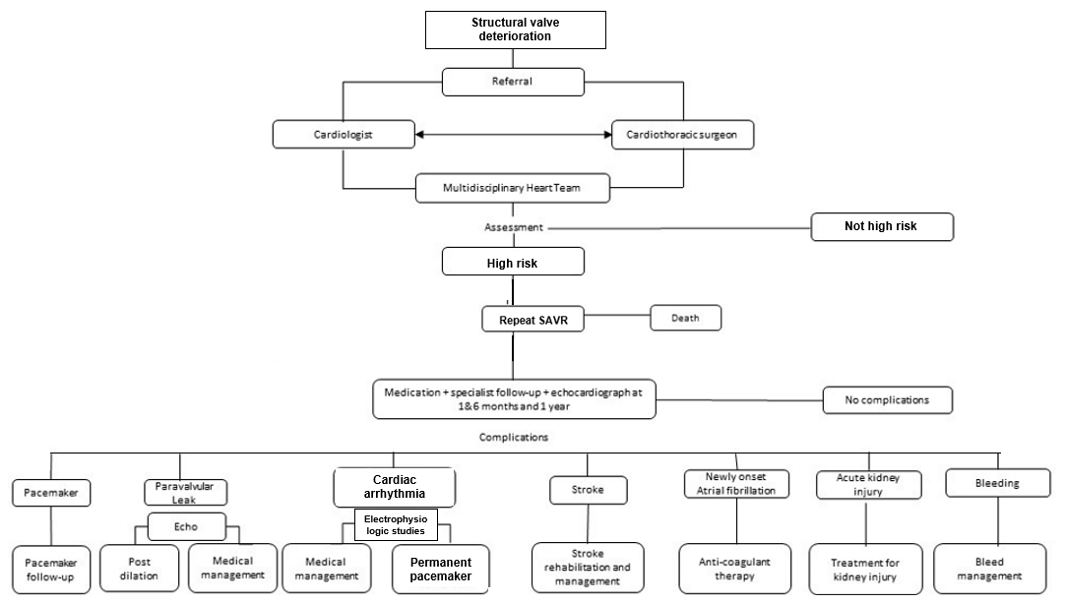
Is there any expectation that the clinical management algorithm before the health technology is used will change due to the introduction of the proposed health technology?
Yes. ViV TAVI will alter the clinical management, as outlined in Figure 2.

Figure 2 New clinical management algorithm.
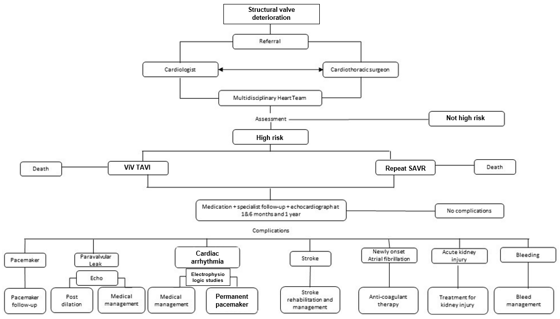

Describe and explain any differences in the clinical management algorithm prior to the use of the proposed health technology vs. the comparator health technology:
With the availability of ViV TAVI, the clinical management algorithm differs only in this being an option for patient management. Secondary outcomes and their management are unchanged.

Use of the health technology

Explain what other healthcare resources are used in conjunction with delivering the proposed health technology:
Other than the Edwards SAPIEN 3 Ultra THV system and the TAVI case conference, other healthcare resources required for ViV TAVI comprise:
Procedure:
- CT scan
- Echocardiography
- Anaesthetist and anaesthesia
Post-procedure:
- Care in intensive care unit, if required
- Care in hospital ward
- Management of complications, if required

Explain what other healthcare resources are used in conjunction with the comparator health technology:
Other than the surgical aortic valve and the TAVI case conference, other healthcare resources required for redo SAVR comprise:
Procedure:
- Open cardiac surgery
- Cardio-pulmonary bypass
- Surgical assistance
- Anaesthetist and anaesthesia
Post-procedure:
- Care in intensive care unit
- Care in hospital ward
- Management of complications, if required

Describe and explain any differences in the healthcare resources used in conjunction with the proposed health technology vs. the comparator health technology:
Differences in the healthcare resources required between ViV TAVI and redo SAVR are outlined above. The key difference stems from ViV TAVI being minimally invasive, while redo SAVR requires major open heart surgery with cardio-pulmonary bypass. As a consequence, peri-operative complications are more significant for redo SAVR, and length of hospital stay is longer.

Clinical management after the use of health technology

Define and summarise the clinical management algorithm, including any required tests or healthcare resources, after the use of the proposed health technology:
The clinical management of patients post ViV TAVI, and associated healthcare resources, is outlined in Figure 2.

Define and summarise the clinical management algorithm, including any required tests or healthcare resources, after the use of the comparator health technology:
The clinical management of patients post redo SAVR, and associated healthcare resources, is outlined in Figure 1.

Describe and explain any differences in the healthcare resources used after the proposed health technology vs. the comparator health technology:
There are no differences in the types of outcomes post ViV TAVI compared to post redo SAVR. However, the likelihoods of their occurrences differ significantly, as described in the next two sections of this application.

Insert diagrams demonstrating the clinical management algorithm with and without the proposed health technology:
See Figures 1 and 2.

Claims

In terms of health outcomes (comparative benefits and harms), is the proposed technology claimed to be superior, non-inferior or inferior to the comparator(s)? (please select your response)
Superior
Non-inferior
Inferior

Please state what the overall claim is, and provide a rationale:
ViV TAVI is superior to redo SAVR as it provides significant improvements in short-term mortality, bleeding and length of hospital stay according to an umbrella meta-analysis of published meta-analyses by Aedma et al (2022). This umbrella analysis synthesised the results from nine meta-analyses, and found that ViV TAVI compared to redo SAVR was associated with a significantly lower risk of procedural mortality (odds ratio [OR] 0.52, 95% CI: 0.27-0.98; p=0.04) and 30-day mortality (OR 0.60, 95% CI: 0.53-0.68; p<0.00001). The risk of long-term mortality was comparable between ViV TAVI and redo SAVR (p=0.42). The likelihood of stroke (OR 0.71, 95% CI: 0.59-0.84; p<0.0001), major bleeding (OR 0.44, 95% CI:0.35-0.57; p<0.000001), acute kidney injury (OR 0.57, 95% CI: 0.43-0.75; p<0.0001), and new permanent pacemaker insertion (PPI) (OR 0.67, 95% CI: 0.52-0.86; p<0.002) were significantly lower with ViV TAVI than with redo SAVR. However, ViV TAVI was associated with a higher likelihood of vascular complications (OR 2.70, 95% CI: 1.58-4.62; p<0.0003). Rates of hospital readmission (p=0.18) and acute myocardial infarction (MI) (p=0.38) were comparable between ViV TAVI and redo SAVR. ViV TAVI was associated with a significantly shorter hospital length of stay (mean difference -2.44 days, 95% CI: -4.10 to -0.77; p<0.004).

Why would the requestor seek to use the proposed investigative technology rather than the comparator(s)?
As discussed above, ViV TAVI is associated with better outcomes than redo SAVR. Redo SAVR in patients with SVD is also associated with considerably higher morbidity and mortality (ranging from 5.8% to 12.8%) compared to the initial SAVR.

Identify how the proposed technology achieves the intended patient outcomes:
ViV TAVI, which involves percutaneous access, is a far less invasive procedure than SAVR, an open procedure than requires sternotomy, cardiotomy, valve excision and cardiopulmonary bypass. In the target patient population with high surgical risk, the risk of mortality is inherently high (≥ 8%), as is the risk of peri-operative morbidity.

For some people, compared with the comparator(s), does the test information result in:
A change in clinical management? Yes
A change in health outcome? Yes
Other benefits? Yes

Please provide a rationale, and information on other benefits if relevant:
Cost benefits are also anticipated with ViV TAVI compared to redo SAVR, as discussed below.

In terms of the immediate costs of the proposed technology (and immediate cost consequences, such as procedural costs, testing costs etc.), is the proposed technology claimed to be more costly, the same cost or less costly than the comparator?
More costly
Same cost
Less costly

Provide a brief rationale for the claim:
It is anticipated that the improvement in clinical outcomes, as well as the reduced length of hospital stay, will result in ViV TAVI being associated with overall lesser costs to the Australian healthcare system compared to redo SAVR. This has been observed in previous health economic evaluations of TAVI versus SAVR in native aortic valves submitted for MSAC consideration. Two such evaluations have been published . A cost-effectiveness analysis will be undertaken in the MSAC submission as part of this proposal.

Summary of Evidence

Provide one or more recent (published) high quality clinical studies that support use of the proposed health service/technology. At ‘Application Form lodgement’,
 | Type of study design | Title of journal article or research project | Short description of research | Website link to journal article or research | Date of publication
1. | Meta analysis of meta-analyses | Aedma SK, et al. Umbrella meta‑analysis evaluating the effectiveness of ViV‑TAVI vs redo SAVR. SN Comprehensive Clinical Medicine 4:63 (2022). | Umbrella meta-analysis to evaluate the safety and efficacy of ViV-TAVI compared to redo SAVR. Following PRISMA guidelines, the authors searched for meta-analyses comparing the safety and efficacy of ViV-TAVR vs redo SAVR from PubMed and included nine analyses which compared the two modalities head-to-head in terms of outcomes and complications. | https://link.springer.com/article/10.1007/s42399-022-01136-x | 26 February 2022

Identify yet-to-be-published research that may have results available in the near future (that could be relevant to your application).
-

Australian Government, ARTG Entry: 343715 Edwards Lifesciences Pty Ltd - Edwards SAPIEN 3 Ultra Transcatheter Heart Valve System - Valve-non-specific transcatheter heart valve bioprosthesis. https://www.tga.gov.au/resources/artg/343715.
Côté, N., Pibarot, P. & Clavel, M.A. Incidence, risk factors, clinical impact, and management of bioprosthesis structural valve degeneration. Curr Opin Cardiol 32, 123-129 (2017).
Kostyunin, A.E., et al. Degeneration of Bioprosthetic Heart Valves: Update 2020. Journal of the American Heart Association 9, e018506 (2020).
Sa et al. Valve-in-Valve Transcatheter Aortic Valve Replacement Versus Redo Surgical Aortic Valve Replacement: An Updated Meta-Analysis. JACC Cardiovasc Interv. 2021 Jan 25;14(2):211-220. doi: 10.1016/j.jcin.2020.10.020.
Australian Government, ARTG Entry: 343715 Edwards Lifesciences Pty Ltd - Edwards SAPIEN 3 Ultra Transcatheter Heart Valve System - Valve-non-specific transcatheter heart valve bioprosthesis. https://www.tga.gov.au/resources/artg/343715.
http://tavi.org.au/
Kappetein AP, Head SJ, Généreux P, et al. Updated standardized endpoint definitions for transcatheter aortic valve implantation: the Valve Academic Research Consortium-2 consensus document (VARC-2). Eur J Cardiothorac Surg 2012;42:S45-60.
Aedma et al. Umbrella Meta‑analysis Evaluating the Effectiveness of ViV‑TAVI vs Redo SAVR. Comprehensive Clinical Medicine (2022) 4:63. https://doi.org/10.1007/s42399-022-01136-x.
Balsam LB, Grossi EA, Greenhouse DG, et al. Reoperative valve surgery in the elderly: predictors of risk and long-term survival. Ann Thorac Surg. 2010;90(4):1195-1200.
Webb JG. Transcatheter Valve in Valve Implants for Failed Prosthetic Valves. Catheterization and Cardiovascular Interventions 2007; 70:765–766.
Zhou JY, Liew D, Duffy SJ, Walton A, Htun N, Stub D. Cost-Effectiveness of Transcatheter Versus Surgical Aortic Valve Replacement in Low-Risk Patients With Severe Aortic Stenosis. Heart Lung Circ. 2021 Apr;30(4):547-554.
Zhou J, Liew D, Duffy SJ, Walton A, Htun N, Stub D. Cost-effectiveness of transcatheter aortic valve implantation compared to surgical aortic valve replacement in the intermediate surgical risk population. Int J Cardiol. 2019 Nov 1;294:17-22.

