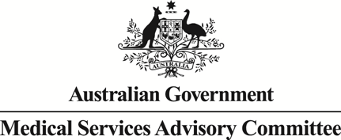
Public Summary Document

Report to the Medical Services Advisory Committee on real world outcomes of Application 1168: Injection of Botulinum Toxin (Botox®) for Prophylaxis of Headaches in Adults with Chronic Migraine
Medicare Benefits Schedule (MBS) item considered: 18377
Date of MSAC consideration: 24-25 November 2016
Context for decision: MSAC makes its advice in accordance with its Terms of Reference, see the MSAC Website.

Purpose
The purpose of the report presented to the Medical Services Advisory Committee (MSAC) was to inform MSAC of the real world impacts on the outcomes of Application 1168. The MSAC uses this information to ensure that the new item/s resulting from this application/s is being used as intended.
The report is not intended to be a review of the clinical information covered during the application process.

MSAC’s advice
After considering the real world impacts of the outcomes of application 1168 for the injection of botulinum toxin for prophylaxis of headaches in adults with chronic migraine (MBS item 18377), MSAC advised that the data suggests that use in some states and territories is disproportionate to their populations. MSAC recommended the department to investigate further the variation in utilisation between states and territories and to consider providing education on the service particularly regarding continued use and use without benefit.

Summary of consideration and rationale for MSAC’s advice
MSAC considered the real world impacts of the outcome of application 1168 for the injection of botulinum toxin (Botox®) for the treatment of chronic migraine (MBS item 18377) by examining the available data for this item number.
MSAC noted that utilisation of the service is growing faster than predicted with utilisation being significantly above predicted use in 2014–15 and in 2015–16. MSAC was concerned that actual utilisation is much higher than predicted and suggested that this may be due to both increased patient and GP awareness that patients can be referred to neurologists for this treatment. MSAC highlighted that there was significant variation in utilisation rates across states. Utilisation rates were substantially higher in the ACT with 188 services of item 18377 claimed per 100,000 population compared with 48–50 services claimed per 100,000 population in NSW and VIC.
MSAC noted that there was marked variation in the fees charged for the service. Fees charged for the item varied more in SA and WA than they did in NSW and VIC.
In considering the patient breakdown MSAC noted that the uptake rate was higher than expected with more new patients than expected initiating treatment each year. MSAC was concerned that data relating to the number of injections per patient suggests that patients were continuing to receive treatment at a higher rate than estimated. The item descriptor requires at least a 50% reduction in symptoms after two cycles of treatment to continue therapy, with the expectation that a number of patients will cease treatment after this point. The MBS data indicates that at least 55% of patients have had more than two treatments since the item was listed in March 2014. This figure may be much higher as the data does not identify the number of patients who would have commenced treatment in the last six months to June 2016 and thus still be on their first or second treatment. MSAC questioned whether the evaluation of the usefulness of ongoing treatment was occurring as the continuation rate was higher than expected.
MSAC considered that the co-claiming with subsequent or initial specialist consult items was appropriate as it is reasonable that neurologists would perform this service during the first consultation with a patient referred by a GP.
MSAC recommended the department to investigate the variation in utilisation between states. MSAC also noted that there may be a need for information to providers regarding appropriate continued use of Botox® for the treatment of chronic migraine and the need to assess treatment response. MSAC noted that the Drug Utilisation Sub Committee of the Pharmaceutical Benefits Advisory Committee will review the use of Botox® on the PBS in 2017. MSAC suggested that it may be appropriate to reassess utilisation of item number 18377 at that time.

Methodology
An application is selected for consideration if the resulting new item(s) and/or item amendment(s) have been on the MBS for approximately 24 months or longer or if there were particular concerns about utilisation such that MSAC requested to consider it earlier. The specific applications for each MSAC meeting are selected by the MSAC Executive which is composed of the chairs of MSAC and its sub-committees.
A report on the utilisation is developed by the department with information on a number of metrics including; state variation, patient demographics, services per patient, practitioner’s providing the service, data on fees and co-claiming of services. The number of metrics included in a report is dependent on the annual service volume for the MBS item(s) under consideration i.e. an item with very low utilisation will have less data to analyse. Where service volumes are too low, information is suppressed to protect patient privacy.
Where possible the report compares data on real world utilisation to the assumptions made during the MSAC assessment. Most of these assumptions are drawn from the assessment report.
Relevant stakeholders are provided an opportunity to comment on the findings in the report before it is presented to the MSAC. It is intended that stakeholders are given at least three weeks to consider the reports.
The stakeholder version of the report does not contain information on assumptions from the MSAC consideration if this information is not already publicly available. This is to protect the commercial in confidence of the original applicants. The same principle is applied to this document.
Once MSAC has considered the report, its advice is made available online at the MSAC Website.

Results

Utilisation
Item 18377 was claimed 15,407 times in 2015-16. Month to month growth in use of this item suggests this service will continue to grow at least in the near future.
The ACT has relatively high utilisation for its population with service volumes greater than SA and on par with utilisation in WA (Table 1). Broken down by services per capita in 2015-16, in NSW and VIC, 48-50 services of item 18377 were claimed per 100,000 population. In the ACT there were 188 services of item 18377 claimed per 100,000 population.

Table 1: Services and benefits paid per state for MBS item 18377 from 2013-14 to 2015-16
 |  | NSW | VIC | QLD | SA | WA | TAS | NT | ACT | Australia
2013-14 | Services | 609 | 450 | 194 | 102 | 114 | np | np | 328 | 1,810
 | Benefits | $69,748 | $49,659 | $22,675 | $13,269 | $13,840 | np | np | $35,893 | $206,658
2014-15 | Services | 3,243 | 2,518 | 1,412 | 595 | 960 | np | np | 1,125 | 9,981
 | Benefits | $393,439 | $288,557 | $184,163 | $80,377 | $147,839 | np | np | $131,428 | $1,240,168
2015-16 | Services | 4,885 | 3,845 | 2,800 | 902 | 1,447 | np | np | 1,328 | 15,407
 | Benefits | $574,428 | $438,846 | $360,705 | $113,570 | $217,773 | np | np | $166,142 | $1,894,460
NP = not published due to low volumes NOTE: Item was listed 1 March 2014, which is why services volumes are low for 2013-14 financial year.
Source: Department of Health
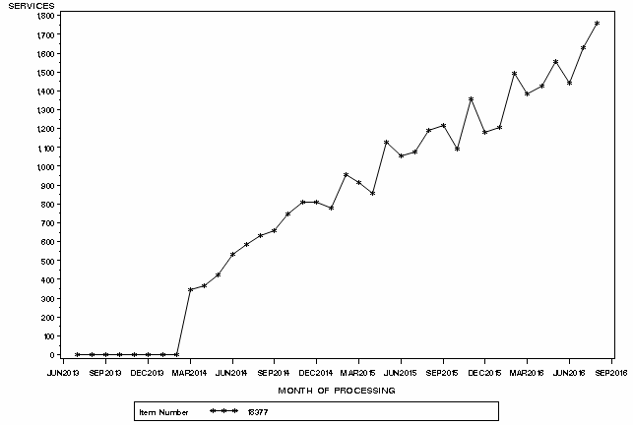

Figure 1: Month by month comparison of service volume for MBS item 18377 from March 2014 to August 2016
Source: Medicare Statistics online

Patient breakdown
It was anticipated that each patient would receive about four injections per year, reflecting that each treatment cycle is 12 weeks duration (MSAC PSD, app 1168, August 2013). In 2015-16 about a third of patients receiving treatment claimed item 18377 four times (Table 4). Given the number of new patients commencing treatment in 2015-16 (2,964) it is not unexpected that a number of patients are still receiving 1-3 treatments in the financial year (Table 3).
The PBS restrictions for botulinum toxin specify that the patient must have received a 50% or greater reduction from baseline in the number of headache days per month after two treatment cycles (24 weeks) in order to be eligible for continuing PBS-subsidised treatment. At least 55% of patients have continued on treatment past the first 24 weeks (Table 5). The actual figure may be higher as the data does not account for patients who commenced their first treatment in the last 24 weeks of 2015-16.
Patients receiving this service are predominantly female and aged 35-64 (Figure 2).

Table 2: Actual number of patients who received item 18377 at least once in 2013-14, 2014-15 or 2015-16
Number of Patients | NSW | VIC | QLD | SA | WA | ACT | Australia
2013-14 | 507 | 385 | 159 | 88 | 100 | 261 | 1,513
2014-15 | 1,400 | 1,110 | 635 | 252 | 375 | 416 | 4,224
2015-16 | 1,992 | 1,494 | 1,098 | 355 | 529 | 485 | 6,021

Table 3: Number of new patients commencing treatment each financial year
Financial year | New patients | Continuing patients | % continuing treatment | Total
2013-14 | 1,513 |  |  | 1,513
2014-15 | 2,935 | 1,289 | 85.2% | 4,224
2015-16 | 2,964 | 3,057 | 72.4% | 6,021
Total | 7,412 | 4,346 |  | 11,758

Table 4: Number of services per patient in 2013-14, 2014-15 and 2015-16
 | Services | # of patients | % of patients
2013-14 | 1 | 1,216 | 80%
 | 2 | 297 | 20%
 | Total | 1,513 | 100%
2014-15 | 1 | 1,294 | 31%
 | 2 | 1,043 | 25%
 | 3 | 966 | 23%
 | 4 | 902 | 21%
 | 5 | 19 | 0%
 | Total | 4,224 | 100%
2015-16 | 1 | 1,639 | 27%
 | 2 | 1,258 | 21%
 | 3 | 1,353 | 22%
 | 4 | 1,662 | 28%
 | 5 | 109 | 2%
 | Total | 6,021 | 100%

Table 5: Number of services per patient since the service was listed on 1 March 2014 to June 2016
Number of Services | Number of Patients | Percentage of Patients
1 | 1,826 | 25%
2 | 1,556 | 21%
3 | 886 | 12%
4 | 735 | 10%
5 | 547 | 7%
6 | 507 | 7%
7 | 486 | 7%
8 | 417 | 6%
9 | 374 | 5%
10+ | 78 | 1%
Total | 7,412 | 100%
Source for tables 2-5: Department of Health

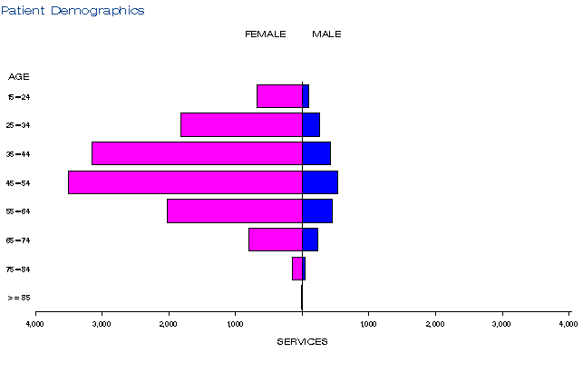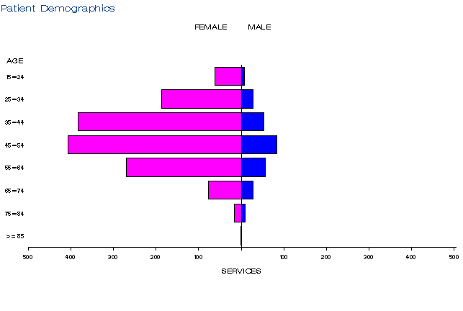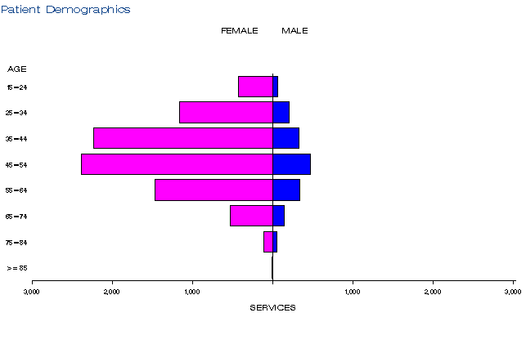
a)
b))
c)

Figure 2: Demographic profile for MBS item 18377 for 2013-14 (a), 2014-15 (b) and 2015-16 (c)
Source: Medicare Statistics Online

Practitioner breakdown
There were 151 medical practitioners providing this service in 2015-16 (Table 6). The PBS restrictions require that the service be provided by a neurologist. It is assumed that the other specialties shown in Table 7 reflect medical practitioners with co-specialties.
About 30% of medical practitioners are providing 80% of services (Table 8). This proportion appears to be relatively stable across financial years.

Table 6: Number of practitioners providing this service from 2013-14 to 2015-16
Financial year | Australia
2013-14 | 92
2014-15 | 124
2015-16 | 151

Table 7: Practitioner specialties providing item 18377 from 2013-14 to 2015-16.
Practitioner specialty | 2013-14 | 2014-15 | 2015-16
Neurology | 1,723 | 9,446 | 14,668
Internal Medicine | 37 | 298 | 465
Nuclear Medicine and Ophthalmology | 50 | 237 | 261
Total | 1,810 | 9,981 | 15,407

Table 8: Cumulative percentage of medical practitioners providing item 18377 and how many services each percentile accounts for in 2013-14 to 2015-16
 | 2013-14 | 2014-15 | 2015-16
10% | 54% | 51% | 51%
20% | 70% | 67% | 68%
30% | 80% | 79% | 80%
40% | 86% | 86% | 87%
50% | 92% | 92% | 93%
60% | 95% | 96% | 97%
70% | 98% | 98% | 99%
80% | 99% | 100% | 100%
90% | 100% | 100% | 100%
100% | 100% | 100% | 100%
Source for tables 6-8: Department of Health

Co-claiming
MBS item 18377 is predominantly claimed with the subsequent or initial specialist consult items 110, 116, 132 and 133 (Tables 9-11). There are a small number of instances where item 18377 is being claimed in the same episode as other botulinum toxin items (18350, 18352 and 18372).

Table 9: Top 10 instances of co-claiming with MBS item 18377 in 2013-14
# | Items | Episodes | Number of Services | Schedule Fee for Combination | % of total episodes | Cumulative %
1 | 18377,00116. | 1,267 | 2,534 | $253,843 | 70% | 70%
2 | 18377,00110. | 231 | 462 | $63,698 | 13% | 83%
3 | 18377,00132. | 108 | 216 | $41,985 | 6% | 89%
4 | 18377,00133. | 92 | 184 | $23,639 | 5% | 94%
5 | 18377. | 51 | 51 | $6,367 | 3% | 97%
6 | 18377,00116,11012. | 13 | 39 | $4,061 | 1% | 98%
7 | 18377,00116,11012,18352*. | 9 | 37 | $5,134 | 1% | 99%
8 | 18377,00119. | np | np | np | np
9 | 18377,00116,18362. | np | np | np | np
10 | 18377,00116,18372. | np | np | np | np
NP = not published due to low volumes
*item no longer exists

Table 10: Top 10 instances of co-claiming with MBS item 18377 in 2014-15
# | Items | Episodes | Number of Services | Schedule Fee for Combination | % of total episodes | Cumulative %
1 | 18377,00116. | 7,406 | 14,815 | $1,484,068 | 74% | 74%
2 | 18377,00110. | 762 | 1,524 | $210,122 | 8% | 82%
3 | 18377,00133. | 693 | 1,386 | $178,066 | 7% | 89%
4 | 18377. | 455 | 455 | $56,807 | 5% | 94%
5 | 18377,00132. | 366 | 732 | $142,283 | 4% | 98%
6 | 18377,00116,11012. | 67 | 201 | $20,927 | 1% | 99%
7 | 18377,00116,11012,18352*. | 20 | 81 | $11,318 | <1%
8 | 18377,00119. | 19 | 38 | $3,189 | <1%
9 | 18377,00116,18350. | 16 | 48 | $5,203 | <1%
10 | 18377,00116,11018,11021,11027. | 15 | 75 | $11,147 | <1%
*item no longer exists

Table 11: Top 10 instances of co-claiming with MBS item 18377 in 2015-16
# | Items | Episodes | Number of Services | Schedule Fee for Combination | % of total episodes | Cumulative %
1 | 18377,00116. | 12,400 | 24,803 | $2,484,567 | 79% | 79%
2 | 18377,00110. | 904 | 1,808 | $249,278 | 6% | 85%
3 | 18377,00133. | 777 | 1,554 | $199,650 | 5% | 90%
4 | 18377. | 623 | 623 | $77,782 | 4% | 94%
5 | 18377,00132. | 498 | 996 | $193,598 | 3% | 97%
6 | 18377,00116,11012. | 130 | 390 | $40,606 | 1% | 98%
7 | 18377,00116,18350. | 20 | 61 | $6,580 | <1%
8 | 18377,00116,18362. | 20 | 60 | $8,941 | <1%
9 | 18377,00116,11018,11021,  11027,11300. | 18 | 108 | $16,840 | <1%
10 | 18377,00116,11012,18353. | 17 | 68 | $9,556 | <1%
Source for Tables 9-11: Department of Health

Data on fee charged
In 2015-16, the average fee charged ranged from $198 in VIC to $342 in WA (Table 12). The distribution of fees in NSW and VIC was much smaller than the distribution in SA and WA (Table 12). The 95th percentile fee changed is $606 in SA and $590 in WA compared to $260 in VIC.

Table 12: Statistics on fees charged for MBS item 18377 for 2013-14 to 2015-16 by date of service
 |  | Provider State/Territory
 |  | NSW | VIC | QLD | SA | WA | TAS | NT | ACT | Australia
2013-14 | Average Fee Charged | $292 | $182 | $275 | $333 | $249 | np | np | $185 | $242
 | Std Deviation | $63 | $45 | $109 | $200 | $41 | np | np | $29 | $94
 | Median Fee Charged | $300 | $150 | $235 | $256 | $250 | np | np | $200 | $220
 | 75th Percentile | $355 | $200 | $400 | $606 | $280 | np | np | $200 | $300
 | 95th Percentile | $355 | $250 | $400 | $606 | $280 | np | np | $200 | $400
 | Bulk-billing Rate | 39% | 42% | 27% | 21% | 17% | np | np | 15% | 32.0%
2014-15 | Average Fee Charged | $281 | $194 | $289 | $321 | $349 | np | np | $241 | $268
 | Std Deviation | $69 | $43 | $104 | $195 | $146 | np | np | $90 | $110
 | Median Fee Charged | $300 | $195 | $280 | $256 | $285 | np | np | $200 | $240
 | 75th Percentile | $355 | $210 | $400 | $606 | $450 | np | np | $350 | $350
 | 95th Percentile | $355 | $260 | $400 | $606 | $590 | np | np | $350 | $500
 | Bulk-billing Rate | 43% | 40% | 31% | 34% | 10% | np | np | 19% | 34%
2015-16 | Average Fee Charged | $269 | $198 | $288 | $244 | $342 | np | np | $293 | $266
 | Std Deviation | $73 | $50 | $112 | $189 | $142 | np | np | $96 | $112
 | Median Fee Charged | $250 | $200 | $235 | $150 | $295 | np | np | $350 | $240
 | 75th Percentile | $320 | $239 | $400 | $256 | $370 | np | np | $350 | $350
 | 95th Percentile | $355 | $260 | $440 | $606 | $590 | np | np | $350 | $440
 | Bulk-billing Rate | 43% | 39% | 29% | 18% | 8% | np | np | 26% | 34%
NP = not published due to low volumes
Source: Department of Health

Background
MBS item 18377 for the injection of Botox® for chronic migraines was listed onto the MBS on 1 March 2014.
In February 2011, an application to the MSAC was received from Allergan Australia Pty Ltd for injection of botulinum toxin type A (Botox®) for the prevention (prophylaxis) of chronic migraine. The MSAC application was co-dependent on an application to the Pharmaceutical Benefits Advisory Committee (PBAC) for the drug component of the service (i.e. extension of the current Botulinum Toxin Program (Section 100 arrangements) so the drug is listed for prophylaxis of headaches in adults with chronic migraine who meet certain criteria).
The application specifically related to botulinum toxin type A (Botox®), lyophilised powder 100 units, for prophylaxis of headaches in adults with chronic migraine. The recommended dose is 155 units to 195 units, with injections divided across seven specific head and neck areas, and including fixed-site, fixed-dose injections at 31 sites, totalling 155 units and up to an additional 40 units to eight ‘follow the pain’ sites. The drug is administered using a 30-gauge, 0.5 inch needle as 0.1 mL (5 units) injections per site.
Botox® is used for prophylaxis of headaches in adults with chronic migraine (defined as headaches on at least 15 days per month, with at least 8 days with migraine). Chronic migraine is a sub-type of chronic daily headache.
At its July 2013 meeting, PBAC recommended extending the current Section 100 Botulinum Toxin Program listing for botulinum toxin type A to include prophylaxis of headaches in adult patients with chronic migraine who meet certain criteria, on the basis of acceptable cost-effectiveness compared to best supportive care.
The MSAC supported the listing of the service onto the MBS at its November 2012 meeting.

Item descriptor
18377 | Botulinum Toxin Type A Purified Neurotoxin Complex (Botox®), injection of, for the treatment of chronic migraine, including all injections in 1 day, if:  (a) the patient is at least 18 years of age; and  (b) the patient has experienced an inadequate response, intolerance or contraindication to at least 3 prophylactic migraine medications before commencement of treatment with botulinum toxin, as manifested by an average of 15 or more headache days per month, with at least 8 days of migraine, over a period of at least 6 months, before commencement of treatment with botulinum toxin; and  (c) the requirements relating to botulinum toxin type A under the Pharmaceutical Benefits Scheme are complied with  For each patient—applicable not more than twice except if the patient achieves and maintains at least a 50% reduction in the number of headache days per month from baseline after 2 treatment cycles (each of 12 weeks duration)  (See para T11.1 of explanatory notes to this Category)  Fee: $124.85 Benefit: 75% = $93.65 85% = $106.15

Applicant’s comments on MSAC’s public summary document
Nil response

Further information on MSAC
MSAC Terms of Reference and other information are available on the MSAC Website at: www.msac.gov.au.

The 95th percentile fee charged represents that 95% of the time the fee is below this amount but in 5% of cases, the fee is higher than this.

