Application 1147:

Consultation Decision Analytical Protocol (DAP) to guide the assessment of

Fiducial seeds in image-guided radiotherapy of the

prostate

July 2011

Table of Contents
MSAC and PASC 3
Purpose of this document 3
Purpose of application 4
Intervention 4
Description 4
Administration, dose, frequency of administration, duration of treatment 5
Subsequent interventions 6
Background 9
Current arrangements for public reimbursement 9
Patient population 11
Proposed MBS listing 11
Clinical place for proposed intervention 12
Comparator 18
Clinical claim 18
Outcomes and health care resources affected by introduction of proposed intervention 20
Outcomes 20
Health care resources 20
Proposed structure of economic evaluation (decision analysis) 22
References 25

MSAC and PASC

The Medical Services Advisory Committee (MSAC) is an independent expert committee appointed by the Minister for Health and Ageing (the Minister) to strengthen the role of evidence in health financing decisions in Australia. MSAC advises the Minister on the evidence relating to the safety, effectiveness, and cost-effectiveness of new and existing medical technologies and procedures and under what circumstances public funding should be supported.

The Protocol Advisory Sub-Committee (PASC) is a standing sub-committee of MSAC. Its primary objective is the determination of protocols to guide clinical and economic assessments of medical interventions proposed for public funding.

Purpose of this document

This document is intended to provide a draft decision analytic protocol that will be used to guide the assessment of an intervention for a particular population of patients. The draft protocol will be finalised after inviting relevant stakeholders to provide input to the protocol. The final protocol will provide the basis for the assessment of the intervention.

The protocol guiding the assessment of the health intervention has been developed using the widely accepted “PICO” approach. The PICO approach involves a clear articulation of the following aspects of the research question that the assessment is intended to answer:

Patients – specification of the characteristics of the patients in whom the intervention is to be considered for use;
Intervention – specification of the proposed intervention
Comparator – specification of the therapy most likely to be replaced by the proposed intervention
Outcomes – specification of the health outcomes and the healthcare resources likely to be
affected by the introduction of the proposed intervention.

Purpose of application

An application requesting MBS listing of fiducial markers to guide radiotherapy of the prostate for patients with prostate cancer was received from the Royal Australian and New Zealand College of Radiologists (RANZCR) by the Department of Health and Ageing in April 2010.

Intervention

Description

Prostate cancer is the most commonly diagnosed cancer in Australia (excluding basal and squamous cell skin cancers) and the second most common cause of cancer death in men after lung cancer. In
2007, 19,403 cases of prostate cancer were diagnosed in Australian men and there were 2,938
deaths attributed to the disease. The incidence of prostate cancer has fluctuated since the introduction of prostate specific antigen (PSA) testing with a rapid peak in the early 1990s following its introduction, a levelling out in the late 1990s and a further increase from 2002. The age standardised incidence rate in 2007 was 182.9 per 100,000 males. Cancer specific mortality has fallen steadily over the past decade to 31.0 per 100,000 males. The mean age at diagnosis was 68.4 in
2007 and the lifetime risk of developing prostate cancer before the age of 75 was 1 in 7 men
(Australian Institute of Health and Welfare (AIHW) 2010).

External-beam radiotherapy (EBRT) is a treatment option for men with localised or locally advanced prostate cancer, however the prostate gland is difficult to image using standard x-rays and is mobile: its position in relation to external markers on the skin or to bony pelvic anatomy can vary from day to day and also during treatment. The movement is due in part to the filling of adjacent hollow organs (the bladder and rectum) and these are at risk of radiotherapy induced toxicity. These uncertainties about prostate position mean that treatment planning target volumes (PTV) are typically larger than the clinical target volumes (CTV) to allow for the variable position of the prostate. Therefore the accurate delivery of radiotherapy to the prostate and avoidance of the adjacent organs allows greater certainty of daily targeting of the radiotherapy treatment which in turn allows margins to be reduced and dose to adjacent normal critical structures such as the rectum and bladder to be reduced. It may also allow a higher dose to be given to the target organ.

The implantation of radio-opaque, sterile markers (usually 3 or 4) into the prostate is designed to provide fiducial or fixed reference points during a course of radiotherapy with the aim of delivering radiotherapy more accurately and efficiently. The markers are usually small gold seeds (typically
~5mm  ~1mm) that can be easily visualised using X-ray imaging. These seeds are preloaded into
needles that are used to deliver these markers into the prostate before radiotherapy treatment. During the delivery of radiotherapy, the position of the markers is visually checked against reference images derived at the planning process to ensure treatment is accurately delivered.

Image-guided radiotherapy (IGRT) utilising daily on-line verification of prostate position or surrogate has been shown to reduce systematic and random treatment errors, decrease the risk of geographic miss (for a given margin), and may allow for some reduction in PTV margins (Chung et al 2004; O'Daniel et al 2006; Schallenkamp et al 2005). Planar kilovoltage (kV) or megavoltage (MV) imaging of implanted prostate fiducial markers (Litzenberg et al 2002) is the most frequently utilised IGRT technique in Australia. Volumetric verification techniques such as kV cone-beam CT, MV CT, and CT- on-rails allow visualisation of soft tissue structures (Kupelian et al 2008), however investigation is ongoing as to their optimal utilisation and integration into clinical practice.

Administration, dose, frequency of administration, duration of treatment

After consultation with a radiation oncologist and having been assessed as suitable for radiotherapy, patients will be instructed to cease any anti-coagulant or anti-platelet therapy for the recommended period of time prior to fiducial marker implantation. If necessary, appropriate consultations with the patient’s treating physician(s) are undertaken. Prophylactic antibiotics are prescribed according to current guidelines. Patients are also instructed to use a local rectal laxative before the implantation.

Sterilised fiducial markers are pre-loaded into needles that are used to deliver the markers into the prostate. Three or 4 fiducial markers (usually gold) are placed as a one-off procedure prior to the course of radiotherapy. Fiducial markers can be implanted in either the ambulatory care setting or in a day surgery facility depending on factors such as patient preference and insurance status and access to facilities. The procedure is performed under ultrasound control (most commonly trans-rectal ultrasound, MBS Item 55603), using a trans-rectal or trans-perineal needle insertion approach. In the ambulatory care setting this will be performed by a radiologist. The radiologist would be skilled in similar interventional radiological procedures and familiar with ultrasound guided equipment and the sterilised pre-loaded needles used in the implantation. The radiology facility would have a radiology nurse skilled in management of patients who have had a minimally invasive procedure (similar to image-guided biopsy). In a day surgery facility the implantation will be performed by a urologist or radiation oncologist skilled in the use of trans-rectal ultrasound. Urology nurse specialists are usually involved in pre-implant and follow-up of the patient. Rarely the seeds are not optimally placed and the procedure may need to be repeated (expert advice).

An anaesthetic procedure is generally required when performing the implantation of the fiducial markers. This may be a local or general anaesthetic or conscious sedation depending on the assessment and preferences of each individual patient. Patients with a higher risk of infection will undergo a perineal approach which requires a general anaesthetic (expert advice). After the procedure, the patient is observed for a period to ensure adequate recovery from the anaesthetic and that there are no immediate adverse side-effects such as excessive bleeding.

Table 1 MBS item descriptors for interventions co-administered with the procedure to deliver the markers

Category 5 - DIAGNOSTIC IMAGING SERVICES
MBS 55603

PROSTATE, bladder base and urethra, transrectal ultrasound scan of, where performed:

- personally by a medical practitioner who undertook the assessment referred to in (c) using a transducer probe or probes that:

(i) have a nominal frequency of 7 to 7.5 megahertz or a nominal frequency range which includes frequencies of 7 to 7.5 megahertz; and

(ii) can obtain both axial and sagittal scans in 2 planes at right angles; and

- following a digital rectal examination of the prostate by that medical practitioner; and

- on a patient who has been assessed by a specialist in urology, radiation oncology or medical oncology or a consultant physician in medical oncology who has:

(i)examined the patient in the 60 days prior to the scan; and

(ii)recommended the scan for the management of the patient's current prostatic disease (R)

Fee: $109.10 Benefit: 75% = $81.85 85% = $92.75
Category 1 - PROFESSIONAL ATTENDANCES
MBS 104

SPECIALIST, REFERRED CONSULTATION - SURGERY OR HOSPITAL

(Professional attendance at consulting rooms or hospital by a specialist in the practice of his or her specialty where the patient is referred to him or her)

- INITIAL attendance in a single course of treatment, not being a service to which ophthalmology items 106, 109 or obstetric item 16401 apply.

Fee: $82.30 Benefit: 75% = $61.75 85% = $70.00

Subsequent interventions

Fiducial markers are used to guide radiotherapy. EBRT is the irradiation of the prostate from an external source. The planning and treatment associated with EBRT continues to evolve to enable more accurate treatment allowing higher radiation doses. The current standard of care is three- dimensional conformal radiotherapy (3DCRT) (MBS items 15248 and 15263) which uses three dimensional planning systems to maximise dose to the prostate and attempt to spare surrounding tissues. Intensity Modulated Radiation Therapy (IMRT) is a technological advancement of 3DCRT and is currently claimed under the same item number. It uses beams that deliver more than two intensity levels for a single beam direction and a single source position in space allowing the delivery of complex dose distributions and potentially increased target doses.

The radiation treatment technique should be selected to achieve the goal of delivering the prescribed dose to the target volume and minimising dose to organs at risk, while taking into consideration the prescribed dose, departmental resources and the complexity of individual patient anatomy. 3DCRT has been shown to reduce the risk of rectal toxicity when compared with conventional field based radiation therapy (Dearnaley et al 1999; Michalski et al 2004; Michalski et al 2005). IMRT has the potential to deliver a more sculpted dose distribution than 3DCRT resulting in reduced dose to the rectum and bladder, optimised coverage of the PTV by the prescribed dose, and improved

conformality of the high dose region (Cahlon et al 2008; Zelefsky et al 2000). Retrospective evidence demonstrates that IMRT can reduce the incidence of late intestinal toxicity (Jani et al 2007; Zelefsky et al 2008) and may allow dose escalation to be employed without corresponding increases in toxicity (Zelefsky et al 2006).

In Australia, IGRT using daily pre-treatment verification of prostate position is recommended when delivering definitive EBRT for prostate cancer. 3DCRT is regarded as the minimum standard of care when delivering external beam radiotherapy. IMRT is preferred where organ at risk dose constraints are not achievable with 3DCRT (Hayden et al 2010). Australian guidelines also recommend a minimum acceptable dose of 70 Gy for low-risk patients and 74 Gy for intermediate and high-risk patients and state that the benefit of dose-escalation (78-80 Gy) is seen across all risk groups; however major clinical disagreement is noted for this recommendation (Hayden et al 2010).

Patients may undergo EBRT alone or in combination with low dose rate brachytherapy (LDRBT, MBS items 15338, 37220) or high-dose rate brachytherapy (HDRBT, MBS items 37227, 15332) as a boost. LDRBT, or permanent seed BT, is the implantation of radioisotopes (iodine-125 or palladium-103, although only iodine-125 seeds are available in Australia) directly into the prostate gland for the treatment of localised prostate cancer. The seeds remain permanently in the prostate gland. LDRBT has been interim funded on the MBS since 2000. Following a MSAC assessment in 2010 (Tamblyn et al 2011), LDRBT has become permanently funded since December 2010. HDRBT is the temporary implantation of a radiation source (iridium-192) within the prostate. Thin plastic hollow tubes are inserted through the perineal skin and into the prostate gland. A radioactive source is then inserted into each tube. Following treatment, the tubes are pulled out, leaving no radioactive material in the prostate gland. NICE issued guidance on HDRBT in combination with EBRT in 2006 supporting the use of this procedure in combination with EBRT, but noted that the use of HDRBT as monotherapy was the subject of research studies (National Institute for Health and Clinical Excellence (NICE)
2006).

Radical prostatectomy (MBS items 37210, 37211) is an option for the management of localised and locally advanced prostate cancer and involves the surgical removal of the prostate gland and reconnection of the urethra to the bladder neck. EBRT can be provided post-prostatectomy as either adjuvant treatment for high risk patients or salvage treatment following biochemical relapse and
sometimes implanted fiducial markers are used to guide this treatment.

Table 2 Current MBS item descriptors for subsequent interventions

MBS 15248

Category 3 – THERAPUTIC PROCEDURES

RADIATION ONCOLOGY TREATMENT, using a dual photon energy linear accelerator with a minimum higher energy of at least 10MV photons, with electron facilities - each attendance at which treatment is given - 1 field - treatment delivered to primary site (prostate)

Fee: $57.40 Benefit: 75% = $43.05 85% = $48.80

Category 3 – THERAPUTIC PROCEDURES
MBS 15263

RADIATION ONCOLOGY TREATMENT, using a dual photon energy linear accelerator with a minimum higher energy of at least 10MV photons, with electron facilities - each attendance at which treatment is given - 2 or more fields up to a maximum of 5 additional fields (rotational therapy being 3 fields) - treatment delivered to primary site (prostate)

The fee for item 15248 plus for each field in excess of 1, an amount of $36.50
Category 3 – THERAPUTIC PROCEDURES
MBS 15338

PROSTATE, radioactive seed implantation of, radiation oncology component, using transrectal ultrasound guidance, for localised prostatic malignancy at clinical stages T1 (clinically inapparent tumour not palpable or visible by imaging) or T2 (tumour confined within prostate), with a Gleason score of less than or equal to 7 and a prostate specific antigen (PSA) of less than or equal to 10ng/ml at the time of diagnosis. The procedure must be performed at an approved site in association with a urologist.

Fee: $900.15 Benefit: 75% = $675.15 85% = $828.95 (See para T2.2 of explanatory notes to this Category)
Category 3 – THERAPUTIC PROCEDURES
MBS 37220

PROSTATE, radioactive seed implantation of, urological component, using transrectal ultrasound guidance, for localised prostatic malignancy at clinical stages T1 (clinically inapparent tumour not palpable or visible by imaging) or T2 (tumour confined within prostate), with a Gleason score of less than or equal to 7 and a prostate specific antigen (PSA) of less than or equal to 10ng/ml at the time of diagnosis. The procedure must be performed by a urologist at an approved site in association with a radiation oncologist, and be associated with a service to which item 55603 applies.

Multiple Services Rule

(Anaes.)

Fee: $1,004.65 Benefit: 75% = $753.50

(See para T8.58 of explanatory notes to this Category)
Category 3 – THERAPUTIC PROCEDURES
MBS 37210

PROSTATECTOMY, radical, involving total excision of the prostate, sparing of nerves around the bladder and bladder neck reconstruction, not being a service associated with a service to which item 35551, 36502 or 37375 applies

Multiple Services Rule

(Anaes.) (Assist.)

Fee: $1,533.05 Benefit: 75% = $1,149.80
Category 3 – THERAPUTIC PROCEDURES
MBS 37211

PROSTATECTOMY, radical, involving total excision of the prostate, sparing of nerves around the bladder and bladder neck reconstruction, with pelvic lymphadenectomy, not being a service associated with a service to which item 35551,
36502 or 37375 applies

Multiple Services Rule

(Anaes.) (Assist.)

Fee: $1,861.85 Benefit: 75% = $1,396.40

Category 3 – THERAPUTIC PROCEDURES
MBS 37227

PROSTATE, transperineal insertion of catheters into, for high dose rate brachytherapy using ultrasound guidance including any associated cystoscopy. The procedure must be performed at an approved site in association with a radiation oncologist, and be associated with a service to which item 15331 or 15332 applies.

Multiple Services Rule

(Anaes.)

Fee: $544.40 Benefit: 75% = $408.30 85% = $473.20 (See para T8.59 of explanatory notes to this Category)
Category 3 – THERAPUTIC PROCEDURES
MBS 15332

IMPLANTATION OF A SEALED RADIOACTIVE SOURCE (having a half-life of less than 115 days including iodine, gold, iridium or tantalum) to a site (including the tongue, mouth, salivary gland, axilla, subcutaneous sites), where the volume treated involves multiple planes but does not require surgical exposure and using automatic afterloading techniques

(Anaes.)

Fee: $717.55 Benefit: 75% = $538.20 85% = $646.35

Background

Current arrangements for public reimbursement

Until June 30 2011, the proposed service was being claimed under existing MBS item number 37218. As of 1 July 2011, an interim MBS item number 37217 was introduced to cover the proposed service and item number 37218 was modified to exclude this use (Table 3).

Table 3: Current MBS item descriptor for proposed service

Category 3 – THERAPEUTIC PROCEDURES
MBS 37218 (to June 30 2011)

PROSTATE, needle biopsy of, or injection into (Anaes.)

Fee: $133.05 Benefit: 75% = $99.80 85% = $113.10
Category 3 – THERAPEUTIC PROCEDURES
MBS 37217 (From 1 July 2011)

Prostate, implantation of gold fiducial markers into the prostate gland or prostate surgical bed

Multiple Services Rule (Anaes.)

Fee: $133.05 Benefit: 75% = $99.80 85% = $113.10 (See para T8.56 of explanatory notes to this Category)
T 8.56

Item 37217 is for the insertion of gold fiducial seeds into the prostate as markers for radiotherapy. The service can not be claimed under item 37218 or any other surgical item.

This item is introduced into the Schedule on an interim basis pending the outcome of an evaluation being undertaken by the Medical Services Advisory Committee (MSAC).

Further information on the review of this service is available from the MSAC Secretariat.
Category 3 – THERAPEUTIC PROCEDURES
MBS 37218 (From 1 July 2011)

PROSTATE, needle biopsy of, or injection into, excluding for insertion of radiopaque markers (Anaes.)

Fee: $133.05 Benefit: 75% = $99.80 85% = $113.10

Regulatory status

The Best Medical International, Inc. (Best) Radiopaque Strands and Markers have received TGA listing (registration number 143069). They are indicated for use in soft tissue or organ tissue radiation therapy procedures. Other manufacturers are likely to make similar markers for implantation into the target area available in due course. Fiducial markers may also be manufactured in house which may be more cost-effective; however, the quality assurance processes and regulatory status will need to be considered.

The MBS item covers the costs of the procedure. The cost of the seeds is covered by either the patient (private patients) or the hospital (public patients). Fiducial seeds are not eligible for listing on the prosthesis list and were declined for listing as recently as February 2010.

Patient population

Proposed MBS listing

The proposed MBS descriptor has been modified from the interim descriptor. The specification of the type of marker (gold) has been removed as other radio-opaque materials are also considered suitable. Furthermore, technologies currently in development such as markers containing transducers, such as the Calypso™ 4D Localization System, are not excluded by this descriptor although the higher costs of the markers and systems to track them would need to be borne by the hospital and patient. No cap on the number of seeds implanted (3 to 4) has been included in the descriptor; this was not considered necessary given the descriptor is for the implantation procedure and cannot be claimed for each fiducial marker implanted. The proposed item descriptor has been modified to narrow the purpose of the markers from “assist in the delivery of radiotherapy” to “assist in the delivery of external-beam radiotherapy” more specifically; without this, the descriptor would enable the markers
to be implanted for purposes such as HDRBT as monotherapy.

Table 3: Proposed MBS item descriptor for proposed service

Category 3 – THERAPEUTIC PROCEDURES

MBS [item number]

Prostate, implantation of radio-opaque fiducial markers into the prostate gland or prostate surgical bed to assist in the delivery of external-beam radiotherapy

Multiple Operation Rule (Anaes) Fee: $133.05

Clinical place for proposed intervention

Initial cancer diagnosis and clinical assessment includes prostate specific antigen (PSA) blood testing, digital rectal examination (DRE) and needle biopsy. A history and examination performed by a radiation oncologist is also mandatory. Optional investigations include whole body bone scan, CT of the abdomen and pelvis, and prostate MRI.

To identify patients eligible for EBRT, the patient’s life expectancy, overall health status and tumour characteristics need to be assessed. The combination of pathological grade (Gleason score), biochemical information (PSA level) and stage of the tumour (tumor, node, metastasis (TNM) classification system) can effectively stratify patients into categories associated with different probabilities of achieving a cure. The choice of initial treatment is influenced greatly by estimated life expectancy, co-morbidities, potential therapy side effects, and patient preference.

Australian guidelines on the management of patients with localised prostate cancer were published in
2002 (Australian Cancer Network Working Party on Management of Localised Prostate Cancer 2002) and are no longer current. Guidelines have since been published on the management of locally advanced and metastatic prostate cancer (Australian Cancer Network Management of Metastatic Prostate Cancer Working Party 2010); however, this is not the population most relevant to the implantation of fiducial markers. Two recent international guidelines provide the best understanding of current clinical practice: the NCCN Clinical Practice Guidelines for Prostate Cancer (2011) and the NICE Guideline on Prostate Cancer: diagnosis and treatment (2008). In both guidelines, a number of treatment options are available to men diagnosed with low, intermediate or high-risk prostate cancer and the choice of treatment will depend on individual factors. These treatment options are
summarised in Figure 1.

 | Low Risk  PSA ≤10ng/ml and Gleason score ≤6 and T1-T2a | Intermediate Risk PSA 10-20ng/ml or Gleason score 7 or T2b-T2c | High Risk  PSA ≥20ng/ml or Gleason score ≥8 or T3-T4
Active surveillance |  |  | 
LDRBT |  monotherapy |  boost | 
HDRBT (boost or monotherapy) |  |  | 
Radical prostatectomy |  |  | 
External beam radiotherapy1 |  |  | 
1. May include neoadjuvant, concomitant or adjuvant androgen deprivation therapy (ADT) for high risk and some intermediate risk
men

Figure 1 Treatment options for low, intermediate and high risk prostate cancer (based on Australian Cancer Network Management of Metastatic Prostate Cancer Working Party 2010; Australian Cancer Network Working Party on Management of Localised Prostate Cancer 2002; National Comprehensive Cancer Network 2011; NICE 2008)

Patients with low, intermediate or high risk of recurrence are all potentially eligible for a course of EBRT alone or in combination with brachytherapy as a boost. Nevertheless, low risk patients are most commonly treated with only one treatment modality; either EBRT or brachytherapy.

The recent Australian Guidelines on the management of locally advanced prostate cancer make the following recommendations regarding EBRT.

• When radiation therapy alone is used, limited field radiotherapy has similar efficacy and has less toxicity than whole pelvis and therefore is recommended. The role of whole pelvis radiation is yet to be defined. Consideration should be given to dose escalation (74Gy or higher) if it can be delivered safely. Patients with locally advanced prostate cancer should receive 3D conformal radiation to minimise toxicity. Grade C (Body of evidence provides some support for recommendation(s) but care should be taken in its application)
• Radiation in addition to hormone therapy improves survival and is recommended. Grade B (Body of evidence can be trusted to guide practice in most situations) (Australian Cancer Network Management of Metastatic Prostate Cancer Working Party 2010).

The primary eligible patient population therefore is men with prostate cancer who are eligible for a course of radical EBRT as the definitive treatment; these men may have localised or locally advanced disease and may have low, intermediate or high risk of recurrence. They may have EBRT alone or with low or high dose brachytherapy as a boost.

There are also some patients within this patient population who may be expected to derive greater benefit from the accurate delivery of radiotherapy, including those with:
‐ Previous irradiation of the pelvis such that it is necessary to avoid irradiated normal tissues (ie
very tight margins are to be used in treating the prostate).
‐ Men who have inflammatory bowel disease such that very accurate radiotherapy is required to minimise normal tissue toxicity.

Although patients may be stratified into low, intermediate, and high risk, reflecting their risk of recurrence and treatment options vary for these different patient groups, the decision option to be considered, that is, whether IGRT using fiducial markers should be used in place of conventional IGRT using intermittent imaging of the bony pelvis will be the same across different risk groups. The relative differences of IGRT with fiducial markers and conventional IGRT in terms of extent of any improvement in effectiveness may differ across these risk subgroups.

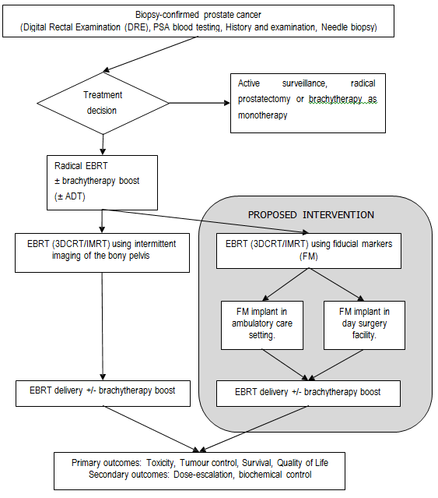Figure 2 Proposed clinical algorithm for radical EBRT

Fiducial markers are proposed as a replacement for imaging using bony landmarks; it is expected that utilisation of fiducial markers would increase such that they become standard practice meanwhile imaging using bony landmarks would decrease. However, a small percentage of patients (<1% estimated by the applicant) will be considered inappropriate to undergo implantation of fiducial markers because of either a previous or concurrent infection or the need to be on continuous anti- coagulant therapy.

The number of MBS claims for item 37218 under which the proposed service is currently being claimed increased from 2037 in 2007/08 to 5030 in 2009/10 (Figure 3) which may reflect the trend toward greater use of fiducial markers since 2007. However, these data do not reflect the size of the

eligible population as this item may be used with internal rather than external radiotherapy and the eligible population is likely to be much larger than the actual number of services currently claimed.

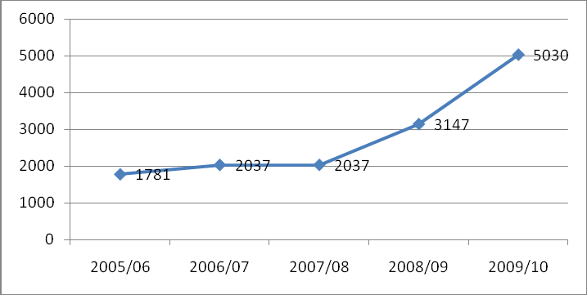

Figure 3 Medicare Australia Items process by financial year - MBS item number 37218

The applicant estimates, based on unpublished data from NSW showing that 1710 courses of EBRT were delivered per year, that the number of prostate cancer patients across Australia who are suitable for EBRT where implantation of fiducial markers is deemed appropriate is approximately 5000 for 2009/10 or approximately 30.5% of all newly diagnosed prostate cancers.

There are other patient populations in which fiducial markers may be used:

‐ Implantation of fiducial markers into the pelvic soft tissue (ie “prostate bed”) after radical prostatectomy in adjuvant and in salvage post-radical prostatectomy radiotherapy.
‐ Implantation of fiducial markers into the prostate to guide high dose rate brachytherapy as monotherapy.
‐ Men with advanced or metastatic disease (ie not suitable for definitive radiotherapy) who have had bowel surgery such that risk of normal tissue toxicity is increased.

With respect to EBRT post-prostatectomy, the Australian Guidelines state:

• It is recommended that patients with extracapsular extension, seminal vesicle involvement or positive surgical margins receive postoperative EBRT within four months of surgery. The role of active surveillance and early salvage radiotherapy has not been defined. (Grade B)

The number of men who undergo radical prostatectomy is estimated from the AIHW (includes public as well as private patients) and Medicare Australia (Table 4). The applicant estimates that approximately 20% of patients who undergo this treatment would be suitable for post-prostatectomy EBRT and that <5% would benefit from fiducial markers. Using a figure of 6000 men undergoing radical prostatectomy per year, an estimated 1,200 would be suitable for post-prostatectomy EBRT and approximately 300 may utilise fiducial markers. However, it is noted that this figure is likely to be

an underestimate and is expected to rise as the field is rapidly changing; the number of patients receiving post-prostatectomy EBRT is increasing and the use of fiducial markers to guide this is likely to become more widespread (expert opinion). The decision to use fiducial markers in this indication is driven by the experience and practice of the provider more than by patient factors with some centres using fiducial markers routinely.

Table 4 Number of radical prostatectomies

Source | Item numbers | Year
 |  | 2005/06 | 2006/07 | 2007/08 | 2008/09 | 2009/10
AIHW | Radical prostatectomy subset of 1167 |  | 6,179 | 6,671 | 6,178 | 5,913
MBS | 37210/37211 | 4,011 | 4,599 | 5,017 | 6,115 | 6,479
(Australian Government Department of Human Services 2011; Australian Institute of Health and Welfare (AIHW) 2011)

Therefore, a secondary patient population is men who have had a radical prostatectomy for primary treatment of prostate cancer and who are undergoing either adjuvant or salvage EBRT due to either high risk pathological factors (extracapsular extension, seminal vesicle invasion and/or involved surgical margins) or a rising PSA level. In each person treated, fiducial markers are proposed as a replacement for imaging using bony landmarks. However, a smaller proportion of the overall population receiving post-prostatectomy EBRT is expected to have EBRT with fiducial markers than the overall population receiving radical EBRT in the primary treatment of prostate cancer. In addition, few patients receiving post-prostatectomy EBRT are expected to also receive low or high dose brachytherapy as a boost.

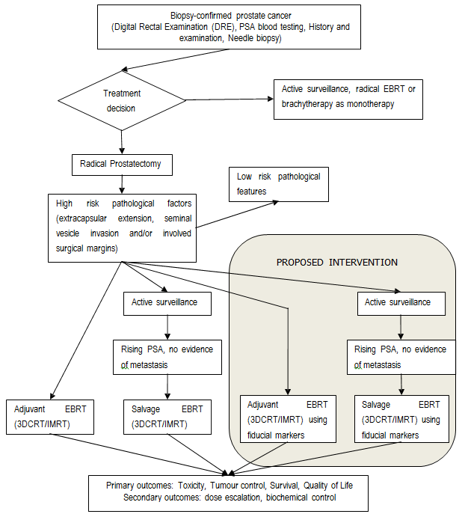Figure 4 Proposed clinical algorithm for post-prostatectomy EBRT

HDRBT is likely to be given in conjunction with EBRT; fiducial seeds used to guide the EBRT component are included in the primary indication. However, HDRBT can also be given as monotherapy and may also benefit from fiducial seeds to guide the implantation of the brachytherapy. The number of patients who undergo HDRBT in Australia currently is likely to be small. The AIHW National Hospital Morbidity Database includes a code for ‘brachytherapy with implantation of removable multiple planes or volume implant, high dose rate’ (15327-07), the number of procedures under this code in 2007/08 was 264 of whom 243 were male. This may include procedures for conditions other than prostate cancer. The number of Medicare items processed for

item number 37227 in the 2009/10 financial year was 361. Additional analyses provided by the Department of Health and Ageing show that 343 of these were unique services of which 272 were patients who also claimed either item 15248 or 15263 (EBRT) within either the preceding or following
31 days. It can therefore be estimated, that 71 of the 343 unique claims for item 37227 in 2009/10 may have been for HDRBT as monotherapy. These data reflect patients undergoing this procedure in private hospitals, the majority of patients may be treated at public hospitals and therefore, these are likely to be underestimates.

Table 5 Estimated utilisation of HDRBT

Source | Item numbers | Year
 |  | 2006/07 | 2007/08 | 2008/09 | 2009/10
AIHW | 15327-07 (male) | 216 | 243
MBS | 37227 | 183 | 399 | 389 | 361
(Australian Government Department of Human Services 2011; Australian Institute of Health and Welfare (AIHW) 2011)

HDRBT as monotherapy is not yet considered standard clinical practice (Expert advice and National Institute for Health and Clinical Excellence (NICE) 2006) and its utilisation in Australia appears to be low, therefore it is not considered suitable as a sole purpose of fiducial marker implantation at this time, despite its proposal by the applicant.

Comparator

Radiotherapy for prostate cancer has always been undertaken with “image-guidance”. During a course of radiotherapy, verification of the placement of the radiotherapy beam(s) is performed visually by taking an x-ray image of the relevant part of the body. The accuracy depends on the matching of bony landmarks obtained at the time of treatment planning (that is, prior to the course of treatment) and comparing the daily images.

Other imaging techniques, including ultrasound, electromagnetic targeting and tracking, or endorectal balloon, can also be used, but are less common in Australia and not considered comparators. The comparator is therefore intermittent imaging using bony landmarks.

Clinical claim

Compared with intermittent imaging of the bony pelvis, possible immediate complications of the implantation of fiducial markers are:

• Risk of infection due to surgical implantation
• Risk of haematuria
• Risk of haemotospermia
• Risk of dysuria
• Risk of rectal bleeding
• Risk of pain
• Risk of fever
• Risk of urinary incontinence

Compared with IGRT following intermittent imaging of the bony pelvis, IGRT with fiducial markers has the following potential benefits:

• Ability to dose-escalate and more accurately deliver EBRT which may lead to:
o Reduced toxicity
▪ Reduction of radiation proctitis
▪ Reduction of medical treatment
▪ Reduction of radiation cystitis
o Improved tumour control

Compared with IGRT following intermittent imaging of the bony pelvis, IGRT with fiducial markers has the potential to reduce PTV margins with the following potential harm:

• Possible reduced rates of local/regional control in high risk subgroups (due to a lower radiation dose to unknown microscopic disease)

On the basis of these clinical claims, which are primarily the superior effectiveness of (dose- escalated) IGRT using fiducial markers, it is expected that either a cost-effectiveness analysis or a cost-utility analysis would be undertaken (subject to the availability of appropriate clinical evidence).

Table 6: Classification of an intervention for determination of economic evaluation to be presented

 |  | Comparative effectiveness versus comparator
 |  | Superior |  | Non-inferior | Inferior
Comparative safety versus comparator | Superior | CEA/CUA |  | CEA/CUA | Net clinical benefit | CEA/CUA
 |  |  |  |  | Neutral benefit | CEA/CUA*
 |  |  |  |  | Net harms | None^
 | Non-inferior | CEA/CUA |  | CEA/CUA* | None^
 | Inferior | Net clinical benefit | CEA/CUA | None^ | None^
 |  | Neutral benefit | CEA/CUA*
 |  | Net harms | None^
Abbreviations: CEA = cost-effectiveness analysis; CUA = cost-utility analysis

* May be reduced to cost-minimisation analysis. Cost-minimisation analysis should only be presented when the proposed service has been indisputably demonstrated to be no worse than its main comparator(s) in terms of both effectiveness and safety, so the difference between the service and the appropriate comparator can be reduced to a comparison of costs. In most cases, there will be some uncertainty around such a conclusion (i.e., the conclusion is often not indisputable). Therefore, when an assessment concludes that an intervention was no worse than a comparator, an assessment of the uncertainty around this conclusion should be provided by presentation of cost-effectiveness and/or cost-utility analyses.
^ No economic evaluation needs to be presented; MSAC is unlikely to recommend government subsidy of this intervention

Outcomes and health care resources affected by introduction of proposed intervention

Outcomes

Safety

• Risk of complications post implantation of fiducial seeds:
o Infection
o Haematuria
o Haemotospermia
o Dysuria
o Rectal bleeding
o Pain
o Fever
o Urinary incontinence
• Toxicity of radiotherapy

Effectiveness

• Local/regional tumour control
• Progression-free survival
• Overall survival
• Quality of life

Health care resources

The key differences in resource usage are expected to be the fiduciary markers themselves (cost not borne by the MBS), and resources associated with the procedure of implanting fiducial markers into the prostate (which may vary by setting, ambulatory vs day surgery), treatment of complications of the procedure, and the equipment and training requirements of implanting fiducial markers.

As the use of fiducial markers enables dose escalation, the total number of radiotherapy treatments may also vary. Standard radiotherapy for definitive EBRT consists of 74Gy delivered over 37 treatments (2Gy per treatment), whereas dose-escalation consists of 78-80Gy delivered over 39-40 treatments (2Gy per treatment).

When IGRT with fiducial markers leads to reduced toxicity and/or changes in tumour control from higher target doses without increased local toxicity, differences in resource usage for their downstream treatment should be considered.

Table 7: List of resources to be considered in the economic analysis

 | Provider of resource | Setting in which resource is provided | Proportion of patients receiving resource | Number of  units of resource  per relevant time  horizon per patient receiving resource | Disaggregated unit cost
 |  |  |  |  | MBS | Safety nets* | Other govt budget | Private health insurer | Patient | Total cost
Resources provided to deliver proposed intervention
Pack of needles  preloaded with fiducial markers | Manufacturer | Outpatient | All | 1
Seed implantation in day  surgery | Urologist or  Radiation oncologist | Outpatient/  Inpatient |  | 1
Seed implantation in  ambulatory care | Radiologist | Outpatient |  | 1
Trans-rectal ultrasound  procedure | Specialist | Outpatient |  | 1 | 55603
Specialist procedure |  |  |  | 1
Resources provided in association with proposed intervention
Antibiotics (often  ciprofloxacin 500 mg for  3 days ± gentamicin 160 mg perioperatively) | PBS | Outpatient |  |  |  |  | PBS  items  1209P  2824P
Enema (e.g. Microlax  enema) | PBS | Outpatient |  |  |  |  | PBS item  2091C
Anaesthetic  - local | Anaesthetist | Inpatient
Anaesthetic  - sedation | Anaesthetist | Outpatient/  Inpatient
Post-implant nursing  care | Nurse | Outpatient/  Inpatient
Costs of treating  complications  - infection  - bleeding  - pain | Specialist | Outpatient/  Inpatient
Radiotherapy treatments | Radiation  oncologist | Outpatient | All | 37 standard  39-40 dose escalation | 15248  15263
Resources used for treatment of downstream conditions
Costs of treating cancer  recurrence | Specialist | Outpatient  Inpatient
Cost of treating toxicity | Specialist | Outpatient

Proposed structure of economic evaluation (decision analysis)

Table 8: PICO criteria and decision options for implantation of fiducial markers into prostate gland for radiotherapy

Patients | Intervention | Comparator | Outcomes | Healthcare resources to  be considered
Men with prostate cancer, who are medically eligible  for and agree to undergo a course of radical radiotherapy with external beam radiotherapy for the  primary treatment of prostate cancer with or without radiotherapy dose escalation and alone or in  combination with high or low dose rate brachytherapy as a boost.  A small percentage (<1%) of patients prescribed radiotherapy may be considered inappropriate to undergo implantation of fiducial markers due to:  (1) Previous and/or concurrent infection  (2) The need to be on a continuous anti-coagulant therapy (ie the  cessation of those medications is contra-  indicated) | Implantation of a number of radio-  opaque, sterile markers (3 or 4) into the prostate to serve as fiducial reference  points during a course of radiotherapy. | Intermittent imaging of the bony pelvis (eg x-  ray images taken with the linear accelerator with the patient in treatment position) to  verify that the field placements are accurate. | Safety  Immediate complications:  - Infection  - Haematuria  - Haemotospermia  - Dysuria  - Rectal bleeding  - Pain  - Fever  - Urinary voiding  Toxicity of radiotherapy  - Urinary and bowel toxicities  - Sexual dysfunction  - Pain  - Secondary  malignancies  - Other treatment related events  Effectiveness  Primary outcomes  - Cancer-specific survival  - All-cause survival  - Clinical local and  distant  recurrence-free survival  - Progression-free survival  - Quality of life  Secondary outcome  - Dose-escalation  - Biochemical control  (PSA) | Fiducial markers  & needle pack  Prophylactic antibiotics  Day surgery facilities  Ambulatory care facilities  Trans-rectal ultrasound  Specialist procedure  Post-implant nursing care  Resources for treating complications  Resources for treating recurrence  Radiotherapy treatments
Decision option(s) (ie question(s) for public funding)
Primary question:
What is the safety, effectiveness, and cost-effectiveness of IGRT with fiducial markers to verify that the field placements are accurate compared with IGRT using intermittent imaging of the bony pelvis in the primary treatment of prostate cancer using radical EBRT alone without dose escalation?

Secondary questions:
Do the safety, effectiveness, and cost-effectiveness of IGRT with fiducial markers compared with IGRT using intermittent imaging of the bony pelvis vary in this patient population with radiotherapy dose escalation and/or or in combination with high or low dose rate brachytherapy as a boost?
Do the safety, effectiveness, and cost-effectiveness of IGRT with fiducial markers compared with IGRT using intermittent imaging of the bony pelvis vary across subgroups of this patient population defined according to risk of recurrence?

Table 9: PICO criteria and decision options for implantation of fiducial markers into prostatic surgical bed for radiotherapy

Patients | Intervention | Comparator | Outcomes | Healthcare  resources to be considered
Men who have had a radical prostatectomy for primary treatment of  prostate cancer and who are undergoing either adjuvant or salvage EBRT (with or without  radiotherapy dose escalation) due to either high risk pathological factors (extracapsular  extension, seminal vesicle invasion and/or involved surgical margins) or a rising PSA level. | Implantation of a number of radio- opaque, sterile  markers (3 or 4) into prostatic surgical bed to serve as fiducial reference points  during a course of radiotherapy. | Intermittent imaging of the bony pelvis (eg x- ray images taken with the linear accelerator with the patient in treatment position) to verify that the field placements are accurate. | Safety  Immediate complications:  - Infection  - Haematuria  - Haemotospermia  - Dysuria  - Rectal bleeding  - Pain  - Fever  - Urinary voiding  Toxicity of radiotherapy  - Urinary and bowel toxicities  - Sexual dysfunction  - Pain  - Secondary  malignancies  - Other treatment related events  Effectiveness  Primary outcomes  - Cancer-specific survival  - All-cause survival  - Clinical local and  distant  recurrence-free survival  - Progression-free survival  - Quality of life  Secondary outcome  - Dose-escalation  - Biochemical control  (PSA) | Fiducial markers  & needle pack  Prophylactic antibiotics  Day surgery facilities  Ambulatory care facilities  Trans-rectal ultrasound  Specialist procedure  Post-implant nursing care  Resources for treating complications  Resources for treating recurrence  Radiotherapy treatments
Decision option(s) (ie question(s) for public funding)
Primary question:
What is the safety, effectiveness, and cost-effectiveness of IGRT with fiducial markers to verify that the field placements are accurate compared with IGRT using intermittent imaging of the bony pelvis in the treatment of post-prostatectomy men
undergoing adjuvant or salvage EBRT without dose escalation?

Secondary questions:
Do the safety, effectiveness, and cost-effectiveness of IGRT with fiducial markers compared with IGRT using intermittent imaging of the bony pelvis vary in this patient population with radiotherapy dose escalation?
Do the safety, effectiveness, and cost-effectiveness of IGRT with fiducial markers compared with IGRT using intermittent imaging of the bony pelvis vary across subgroups of this patient population defined according to risk of recurrence?

In the proposed decision analyses (Figures 5 and 6), toxicity is defined according to the Common

Terminology Criteria for Adverse Events (CTCAE) Version 4.0 (available from:

http://evs.nci.nih.gov/ftp1/CTCAE/About.html). Mild toxicity is grade 1, moderate toxicity grades 2 or

3 and severe toxicity grades 4 or 5. Acute toxicity is defined as toxicity occurring during or within 3 months of treatment and likely to be reversible, late toxicity as occurring three months or more months post-treatment and likely to be permanent. Well patients include those with mild late toxicity.

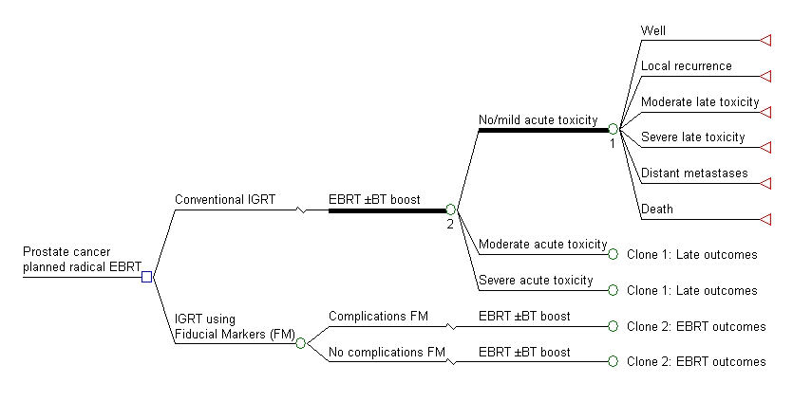

Figure 5: Decision analysis for fiducial markers for radical EBRT of the prostate
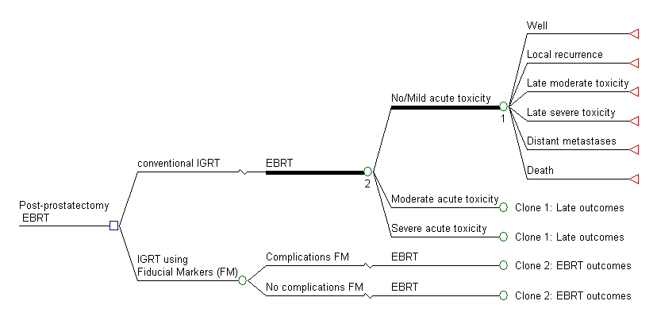

Figure 6 Decision analysis for fiducial markers for post-prostatectomy EBRT

References

Australian Cancer Network Management of Metastatic Prostate Cancer Working Party 2010, Clinical practice guidelines for the management of locally advanced and metastatic prostate cancer. Sydney: Cancer Council of Australia and Australian Cancer Network.

Australian Cancer Network Working Party on Management of Localised Prostate Cancer 2002, Clinical Practice Guidelines: Evidence-based information and recommendations orf the management of olcalised prostate cancer. Canberra: Commonwealth of Australia.

Australian Government Department of Human Services 2011, Medicare Item Reports [Internet]. Available from: http://www.medicareaustralia.gov.au/statistics/mbs_item.shtml [Accessed 6 June
2011].

Australian Institute of Health and Welfare (AIHW) 2010, ACIM (Australian Cancer Incidence and Mortality) Books [Internet]. AIHW, Canberra. Available from: http://www.aihw.gov.au/acim-books/ [Accessed 6 June 2011].

Australian Institute of Health and Welfare (AIHW) 2011, National Hospital Morbidity Data Cubes
[Internet]. AIHW, Canberra. Available from: http://www.aihw.gov.au/hospitals-data-cubes/ [Accessed
6 June 2011].

Cahlon, O, Hunt, M et al 2008.Intensity-modulated radiation therapy: supportive data for prostate cancer, Semin Radiat Oncol,18 (1),

Chung, PW, Haycocks, T et al 2004.On-line aSi portal imaging of implanted fiducial markers for the reduction of interfraction error during conformal radiotherapy of prostate carcinoma, Int J Radiat Oncol Biol Phys,60 (1),

Dearnaley, DP, Khoo, VS et al 1999.Comparison of radiation side-effects of conformal and conventional radiotherapy in prostate cancer: a randomised trial, Lancet,353 (9149),

Hayden, AJ, Martin, JM et al 2010.Australian & New Zealand Faculty of Radiation Oncology Genito- Urinary Group: 2010 consensus guidelines for definitive external beam radiotherapy for prostate carcinoma, J.Med.Imaging Radiat.Oncol.,54 (6),513-525.

Jani, AB, Su, A et al 2007.Comparison of late gastrointestinal and genitourinary toxicity of prostate cancer patients undergoing intensity-modulated versus conventional radiotherapy using localized fields, Prostate Cancer Prostatic Dis,10 (1),

Kupelian, PA, Langen, KM et al 2008.Image-guided radiotherapy for localized prostate cancer:
treating a moving target, Semin Radiat Oncol,18 (1),

Litzenberg, D, Dawson, LA et al 2002.Daily prostate targeting using implanted radiopaque markers,
Int J Radiat Oncol Biol Phys,52 (3),

Michalski, JM, Winter, K et al 2005.Toxicity after three-dimensional radiotherapy for prostate cancer on RTOG 9406 dose Level V, Int J Radiat Oncol Biol Phys,62 (3),

Michalski, JM, Winter, K et al 2004.Toxicity after three-dimensional radiotherapy for prostate cancer with RTOG 9406 dose level IV, Int J Radiat Oncol Biol Phys,58 (3),

National Comprehensive Cancer Network 2011, NCCN Clinical Practice Guidelines in Oncology: Prostate Cancer. Version 1.2011.National Comprehensive Cancer Network.

National Institute for Health and Clinical Excellence (NICE) 2006, High dose rate brachytherapy in combination with external-beam radiotherapy for localised prostate cancer. Interventional Procedure Guidance 174.London: NICE.
NICE 2008, Prostate cancer: diagnosis and treatment. National Collaborating Centre for Cancer. O'Daniel, JC, Dong, L et al 2006.Dosimetric comparison of four target alignment methods for prostate
cancer radiotherapy, Int J Radiat Oncol Biol Phys,66 (3),

Schallenkamp, JM, Herman, MG et al 2005.Prostate position relative to pelvic bony anatomy based on intraprostatic gold markers and electronic portal imaging, Int J Radiat Oncol Biol Phys,63 (3),

Tamblyn, D, Ellery, B et al 2011, Brachytherapy for the treatment of prostate cancer. MSAC Application 1089.1, Review of interim funded service.Canberra: Commonwealth of Australia.

Zelefsky, MJ, Chan, H et al 2006.Long-term outcome of high dose intensity modulated radiation therapy for patients with clinically localized prostate cancer, J Urol,176 (4 Pt 1),

Zelefsky, MJ, Fuks, Z et al 2000.Clinical experience with intensity modulated radiation therapy (IMRT)
in prostate cancer, Radiother Oncol,55 (3),

Zelefsky, MJ, Levin, EJ et al 2008.Incidence of late rectal and urinary toxicities after three- dimensional conformal radiotherapy and intensity-modulated radiotherapy for localized prostate cancer, Int J Radiat Oncol Biol Phys,70 (4),

