|  |
| --- |
| **1370**  **Final Protocol to guide the assessment of optical coherence tomography for the determination of eligibility and efficacy assessment of treatment with ocriplasmin (JETREA®)** |
| May 2014 |

Table of Contents

MSAC and PASC 5

Purpose of this document 5

Purpose of application 6

Background 6

Vitreoretinal interface disorders 6

Ocriplasmin 10

OCT 10

Regulatory status 11

OCT 12

Ocriplasmin 12

Current arrangements for public reimbursement 12

OCT 12

Ocriplasmin 14

Intervention 14

Description of the interventions 14

OCT 14

Ocriplasmin 17

Delivery of the interventions 19

OCT 19

Ocriplasmin 20

Prerequisites 22

OCT 22

Ocriplasmin 22

Co-administered and associated interventions 23

OCT 23

Ocriplasmin 23

Listing proposed and options for MSAC consideration 23

Proposed MBS listing 23

Clinical place for proposed intervention 25

Comparator 29

OCT 29

Ocriplasmin 30

Clinical claims 31

Ocriplasmin 31

OCT 32

Outcomes for safety and effectiveness evaluation 34

Effectiveness 34

OCT 34

Ocriplasmin 36

Vitrectomy 36

Safety 37

OCT 37

Ocriplasmin 37

Vitrectomy 37

Summary of PICO to be used for assessment of evidence 37

OCT 38

Ocriplasmin 38

Outcomes and health care resources affected by introduction of proposed

intervention 40

Outcomes for economic evaluation 40

Health care resources 40

Proposed structure of economic evaluation (decision-analytic) 42

Cost-effectiveness analysis of ocriplasmin versus watchful waiting

in patients with sVMA 43

Cost-effectiveness analysis of ocriplasmin versus vitrectomy in patients with full thickness

macular hole 43

References 48

# MSAC and PASC

The Medical Services Advisory Committee (MSAC) is an independent expert committee appointed by the Australian Government Health Minister to strengthen the role of evidence in health financing decisions in Australia. MSAC advises the Commonwealth Minister for Health and Ageing on the evidence relating to the safety, effectiveness, and cost-effectiveness of new and existing medical technologies and procedures and under what circumstances public funding should be supported.

The Protocol Advisory Sub-Committee (PASC) is a standing sub-committee of MSAC. Its primary objective is the determination of protocols to guide clinical and economic assessments of medical interventions proposed for public funding.

## Purpose of this document

This document is a protocol that will be used to guide the co-dependent assessment of optical coherence tomography (OCT) together with ocriplasmin as follows:

1. OCT as an additional investigative procedure in patients with vitreomacular traction (VMT)
   1. *as an investigative procedure to confirm diagnosis of VMT, including those associated with full thickness macular hole (FTMH)*
   2. *to determine whether patients with VMT, including those associated with FTMH meet the eligibility criteria for treatment with ocriplasmin on the* Pharmaceutical Benefits Scheme (*PBS).*
2. OCT for assessment of treatment outcome with ocriplasmin and determining eligibility for subsequent vitrectomy.

The protocol guiding the assessment of the health intervention has been developed using the widely accepted “PICO” approach. The PICO approach involves a clear articulation of the following aspects of the research question that the assessment is intended to answer:

**P**atients – specification of the characteristics of the patients or population in whom the intervention is to be considered for use;

**I**ntervention – specification of the proposed intervention;

**C**omparator – specification of the therapy most likely to be replaced by the proposed intervention; and

**O**utcomes – specification of the health outcomes and the healthcare resources likely to be affected by the introduction of the proposed intervention.

# Purpose of application

Alcon Laboratories (Australia) Pty Ltd (applicant), are requesting the Medicare Benefits Schedule (MBS) listing of optical coherence tomography (OCT) for the determination of patient eligibility and for efficacy assessment of a single treatment with ocriplasmin (JETREA®). Patients are not eligible for re-treatment with ocriplasmin and as such, monitoring of patients for subsequent treatment will not be required. Patients who do not respond to treatment with ocriplasmin are to be managed by standard clinical management that includes either watchful waiting or vitrectomy.

The benefit of OCT in the proposed listing is to ensure that only those patients most likely to benefit from treatment will receive ocriplasmin, improving patient health outcomes and ensuring the cost-effective use of ocriplasmin on the PBS.

The applicant has drafted this protocol in order to guide the development of an application for MBS funding that will address MSAC’s decision-making concerns regarding public funding of the intervention. Recently, both MSAC and PBAC considered applications which propose the use of an OCT to influence drug therapy (MSAC applications 1310 and 1350). After the most recent MSAC meeting in August 2013, MSAC agreed to hold a consultation forum to consider the views of stakeholders involved in the provision of OCT services. This stakeholder meeting was held on 10th September 2013, in conjunction with the PBAC to progress OCT-related applications. Attending parties agreed to provide suitable evidence that demonstrates the clinical effectiveness of OCT in the diagnosis of sVMA (to be replaced with VMT to ensure alignment with the proposed TGA indication for ocriplasm) and macular hole and separately in the diagnosis and subsequent monitoring of wet Age-Related Macular Degeneration (AMD), diabetic retinopathy and retinal vascular disease. These actions will occur in parallel with this draft Protocol.

# Background

## Vitreoretinal interface disorders

Vitreomacular interface disorders describe a group of pathologies each with their own distinctive features that distort or blur vision and potentially impair central visual acuity, including; vitreomacular adhesion/traction, macular epiretinal membrane, and macular holes (full thickness, pseudo and lamellar holes). Many of these pathologies result from the liquefaction of the vitreous gel and its incomplete detachment from the macula. The vitreous gel has an outer cortex of dense collagen that is attached to the internal limiting membrane of the retina. Attachment between the vitreous and the retina is typically complete from birth through young adulthood (Stalmans *et al.*, 2013). The natural ageing process of the vitreous results in its liquefaction and separation from the retina (Larsson and Österlin 1985, Sebag 2004, Uchino *et al.*, 2001). This process is referred to as posterior vitreous detachment (PVD) and in most cases will occur without pathologic consequences.

In some eyes (usually in patients older than 50 years), the adhesion between the vitreous and the macula does not weaken sufficiently to allow for the separation of the vitreous, resulting in a condition known as vitreomacular adhesion (VMA). VMA can lead to vitreomacular traction (VMT) if the forces of attachment are great enough to cause anatomical disturbance of the macular architecture. By definition VMT is always pathologic and almost always symptomatic, thus the term symptomatic VMA (sVMA) is interchangeable with VMT (Stalmans *et al.*, 2013). This persistent adhesion and traction can produce symptoms including metamorphopsia (distorted vision), blurred vision, decreased visual acuity, central visual field defect and negatively impacting patient quality of life (Figure 1). VMT is progressive and can lead to the formation of a full thickness macular hole (FTMH) which, if untreated can result in central blindness. It is documented that some cases of VMT and macular hole (MH) will spontaneously resolve without intervention (for example Hikichi *et al.* 1995 and Ezra 2001). The pathway of VMT/FTMH disease progression is illustrated in Figure 2.

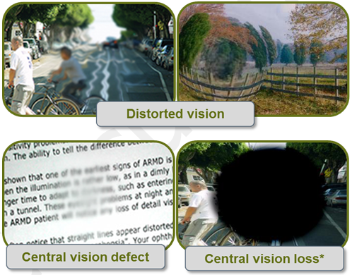

Figure 1 Illustration of how a patient’s field of view may appear with metamorphopsia (distorted vision), central vision disturbances or central vision loss.

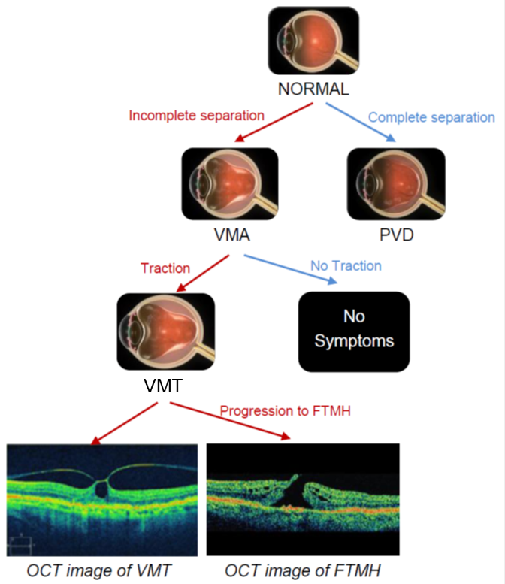

Figure 2 Pathway of VMA/VMT/FTMH disease progression

Abbreviations: VMA, vitreomacular adhesion; PVD, posterior vitreous detachment; VMT, vitreomacular traction ; FTMH, full thickness macular hole; OCT, optical coherence tomography.

Currently, there is no pharmacological treatment approved by the Therapeutic Goods Administration (TGA) for VMT including those associated with FTMH. The goal of therapy for these conditions is to eliminate tractional effects on the macula thereby resolving the underlying condition, resolve any resultant structural abnormality, and provide subsequent functional improvement. The only treatment option currently available to achieve this goal is surgery (vitrectomy), whereby adhesions are dissected from the retinal surface with complete aspiration of the vitreous allowing resolution of any resultant structural abnormality. Vitrectomy is recommended in patients with diagnosis of a FTMH and in those patients with VMT where disturbances in visual function cannot be tolerated. In less severe cases, patients with VMT without FTMH undergo a period of “watchful waiting” when the patients’ symptoms go untreated until they either spontaneously resolve or they become intolerable and warrant surgical intervention. In some cases, clinical management with “watchful waiting” can lead to irreversible damage to the retina, leading to a poor prognosis.

## Ocriplasmin

Ocriplasmin is the first pharmacological treatment option for VMT including those associated with FTMH and addresses an unmet medical need, representing an advance in the standard of care of this progressive and potentially sight-threatening condition. In those patients unable to undergo vitrectomy, ocriplasmin provides an important treatment option.

## OCT

The applicant proposes that OCT be listed as a reimbursed service to determine patient eligibility for treatment with ocriplasmin, for which PBS listing will be concurrently sought, and for assessment of treatment outcome.

The proposed use of OCT is as an additional investigative procedure specifically to identify those patients who have VMT (including those associated with FTMH) where traction is present, and identify patients eligible for treatment with ocriplasmin on the PBS. Accordingly, the proposed use of OCT will be complementary to other diagnostic tests for VMT and FTMH.

OCT is an established technology in Australia[1] and globally where it forms part of standard clinical practice across a wide range of macular and retinal diseases. Currently, OCT is performed as an out-of-pocket expense to patients. Based on the applicant’s own internal research and advice from Advisory Boards, the cost of the service is claimed to be $80-$100 with no subsidies from private health insurance currently available. OCT is reimbursed for veterans ($91.75) by the Department of Veteran’s Affairs (DVA).

## Regulatory status

### OCT

There are several OCT systems currently listed on the Australian Register of Therapeutic Goods (ARTG) for retinal and macular imaging. The ARTG numbers and sponsors of these systems are documented in Table 1.

Table 1 Optical coherence tomography systems currently registered on the ARTG. This is not intended to represent a comprehensive list as other OCT units become available from time to time.

| **ARTG Number** | **Sponsor** | **Device** |
| --- | --- | --- |
| 194817 | Optos Australia Pty Ltd | Retinal optical coherence tomography system |
| 202863 | Carl Zeiss Pty Ltd | Spectral-domain optical coherence tomography system |
| 197023 | Brien Holden Vision Pty Ltd | Spectral-domain optical coherence tomography system |
| 200072 | Canon Australia Pty Ltd | Retinal optical coherence tomography system |
| 139794 | Optech Diagnostic & Surgical Pty Ltd | Retinal optical coherence tomography system |

Source: http://www.tga.gov.au/industry/artg.htm

### Ocriplasmin

The proposed co-dependent drug, ocriplasmin, is not currently on the ARTG. TGA approval of the treatment will be required prior to, or parallel to, determination of eligibility for listing on the PBS. An application for TGA approval of this product is currently undergoing evaluation.

## Current arrangements for public reimbursement

### OCT

OCT is not reimbursed for the vast majority of patients.

The Department of Veteran’s Affairs (DVA) states that OCT is a non-invasive, safe and effective procedure and will fund clinically required OCT for eligible patients for the assessment and management of retinal diseases, excluding glaucoma[2]. However, no clinical indications for OCT are currently included for reimbursement under the MBS.

A previous assessment of OCT for the diagnosis and monitoring of macular disease and glaucoma was considered by MSAC in November 2008 (application 1116); however, the application for funding of OCT with respect to these indications was rejected on the grounds of insufficient evidence to support the proposed clinical claims.

Recently, both MSAC and PBAC considered applications which propose the use of OCT to influence drug therapy.These drugs are:

EYLEA® (aflibercept) - OCT is used for the assessment of central retinal thickness in the presence of macular oedema secondary to central retinal vein occlusion (MSAC application 1310)

LUCENTIS® (ranibizumab) - OCT is used for the assessment of visual impairment due to macular oedema secondary to retinal vein occlusion (MSAC application 1350)

While the current application is also for the co-dependency of OCT with a drug therapy, the applicant would like to highlight that the nature of co-dependency between ocriplasmin and OCT differs significantly from that of MSAC applications 1310 and 1350. The intended indication for treatment with ocriplasmin involves a single intravitreal injection. Re-treatment with ocriplasmin will not be reimbursed by the PBS. As such, OCT as it relates to ocriplasmin is not required for ongoing monitoring, optimisation or management of multiple injections per patient. Rather, it is intended that OCT will be used to directly establish eligibility for treatment with ocriplasmin (consistent with the proposed PBS Authority Required restriction), and for assessment of treatment efficacy. In this sense, the co-dependency in this application is more analogous to gene mutation testing to determine PBS access, or otherwise, to an anti-cancer treatment. However it is noted thatin practice, OCT may be offered serially for suspected VMT (and/or other eye pathology). Therefore there would be multiple tests prior to a definitive diagnosis of VMT, to ascertain the severity of VMT/FTMH or to monitor traction believed to be self-limiting and ensure resolution. Post-ocriplasmin treatment, there would only need to be one test.

### Ocriplasmin

Ocriplasmin is not yet PBS reimbursed.

It is envisaged a PBS Authority Required (streamlined or otherwise) listing will be necessary for ocriplasmin, which may require the use of OCT to establish patient eligibility and treatment efficacy depending on the outcome of this co-dependent application. If the MSAC and PBAC conclude that OCT is required to determine eligibility for PBS treatment with ocriplasmin then OCT will require listing on the MBS.

# Intervention

## Description of the interventions

### OCT

OCT has been proposed as a technology to improve the management of patients with VMT including those associated with FTMH.

Prior to OCT, contact slit-lamp biomicroscopy was principally used as the diagnostic tool to identify clinical signs associated with a number of vitreoretinal interface disorders (encompassing full thickness, pseudo and lamellar holes, macular epiretinal membranes and vitreomacular adhesion and traction). However, interpretation of what is seen using this method is subjective, dependent on the clinician’s experience, limited by the optical resolution and cannot be documented, which is problematic given the progressive nature of these diseases (Azzolini *et al.*, 2001, Huang *et al.*, 2011). The inconsistencies and incorrect interpretation of biomicroscopy have been widely acknowledged in the literature (Gass *et al.* 1990, Coker *et al.* 1996, Barack *et al.,* 2012, Gallemore *et al.,* 2000, Stalmans *et al.*, 2013). Biomicroscopic errors include the inaccurate staging of macular holes, the inability to visualise early stages of VMT, as well as difficulty in differentiating full thickness macular holes from other macular pathologies including pseudo-holes, lamellar macular holes, and detached pseudo-operculum (Gass *et al*., 1990 and Coker *et al.*, 1996).

The clinical value of OCT is seen in the ability to reduce many of the errors and uncertainties associated with biomicroscopy. OCT facilitates the non-invasive capture of detailed, high resolution, transverse images of the vitreoretinal anatomy and provides objective parameters (Stalmans *et al.*, 2013, Yun *et al.*, 2012). Accurate and objective assessment of the vitreomacular interface using OCT allows confirmation of the presence of traction, assessment of the severity of structural abnormalities in the macula and allows for the exclusion of other pathologies. It is proposed that the co-dependent use of OCT as an additional investigative procedure will enable accurate identification of patients eligible for, and most likely to benefit from, treatment with ocriplasmin.

Examination with OCT has diffused into clinical practice and is widely used in the detection and management of macular and retinal disease (Jonas *et al.*, 2010). In the 2008 MSAC Assessment of OCT it was reported that the detection and management of “macular problems without OCT is now obsolete and unacceptable” (MSAC Assessment 1116, 2008 p.17).

OCT can be considered the optical analogue of ultrasound. In OCT, cross-sectional image acquisition is based on mapping the depth-wise reflection of light from the subject tissue. The use of light instead of sound permits the acquisition of images at higher resolution than ultrasound without the need for contact with the patient’s eye. However, reflected light cannot be measured directly by the echo time delay principle as in ultrasound, and therefore OCT relies on the optical technique known as low coherence interferometry. During a retinal scan, an OCT machine generates an imaging beam which is split into two. One beam is projected at the retina and the other onto a mirror, which reflects the incident light to produce a reference beam. This technique allows the light returning from the retina to interfere with the reference light beam that has travelled a known path length. The signals generated by this interference are detected by an interferometer and correspond to optical interfaces within the retina. Scans of the retina at a single point known as A-scans, are repeated at different points to generate two dimensional B-scans, which may in turn be combined to produce three dimensional images. The images are displayed on a computer monitor either in grey scale or false colour in order to differentiate intra-retinal microstructures as can be seen from Figure 3 (Drexler & Fujimoto 2008, Marschall *et al.*, 2011, MSAC 2009, Sakata *et al.*, 2009, van Velthoven *et al.*, 2007).

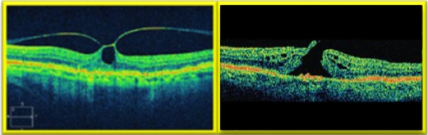

Figure 3 OCT image of VMT (left) and FTMH (right)

In clinical practice, two types of OCT systems have been used. First generation OCT systems, now largely superseded, are based on A-scans which are acquired in the time domain, whereas second generation systems acquire A-scans in the spectral frequency domain. Time domain technology (e.g. Zeiss Stratus OCT™) uses light at wavelength of 820nm to achieve a maximum of 512 A-scans per B-scan at a rate of 400 A-scans per second. Axial and transverse retinal image resolutions of 10 and 20µm, respectively, are achieved. The more recent spectral domain systems can acquire 4,000 to 8,000 A-scans per B-scan at a rate of 18,000 to 40,000 A-scans per second with superior resolution in the axial (5-7µm) and transverse (10-20µm) planes, when compared to time domain OCT. Second generation OCT also permits imaging in three dimensions via reconstruction of the two-dimensional A-scan and B-scan data (Marschall *et al.*, 2011; MSAC 2009).

This application does not specify any trademarked technology for the provision of OCT procedures for the management of VMT including those associated with FTMH. The Royal College of Ophthalmologists (UK) have recommended OCT equipment with specifications corresponding to the Zeiss Stratus OCT™ system as a minimum (RCO 2010). However, it is understood that other OCT equipment made by a number of manufacturers is available in Australia, and the proposal is for a generic intervention to determine eligibility for treatment with ocriplasmin and assessment of treatment outcome. Clinical trials of ocriplasmin employed the mandatory use of Zeiss Stratus OCT™ imaging software. Spectral domain OCT (SD-OCT) machines (Cirrus™ or Spectralis®) were used at selected investigative sites, in addition to the Stratus OCT, which were obtained at all sites (Folgar *et al.* 2012).

### Ocriplasmin

Ocriplasmin is a recombinant truncated form of human plasmin obtained from microplasminogen produced in a Pichia pastoris expression system by recombinant DNA technology.

Ocriplasmin exerts *in vivo* proteolytic effects on fibrinogen, fibronectin and, to a lesser extent, laminin and collagen, each of which is a component of the adhesion that exists between the vitreous and the macula. Following intravitreal injection ocriplasmin may completely dissolve this protein matrix causing posterior vitreous detachment (PVD). Numerous pharmacology studies have demonstrated consistent and rapid induction of PVD shortly after ocriplasmin intravitreal injection.

The drug product is a sterile, clear and colourless solution with no preservatives in a single use glass vial containing 0.5mg of ocriplasmin in 0.4 ml (1.25 mg/mL) solution for intravitreal injection after dilution with 0.9% (w/v) sodium chloride solution. The intended dose is 0.1 ml of the diluted ocriplasmin.

The goal of therapy in patients with VMT including those associated with FTMH is to relieve the tractional effects on the macula and resolution of any structural abnormality with subsequent functional improvement in patients. The mechanism of action of ocriplasmin is illustrated in Figure 4.

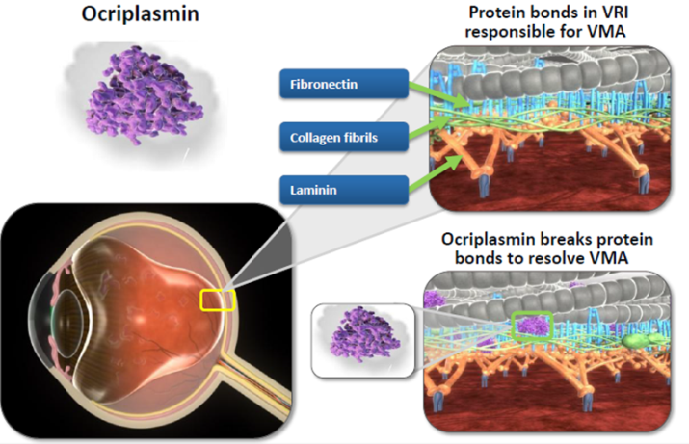

Figure 4 Ocriplasmin mechanism of action

The exact wording of the proposed ocriplasmin PBS Authority Required listing is yet to be determined. OCT was used to define the inclusion of participants in both pivotal clinical trials of ocriplasmin and was also performed at each study visit for outcome assessment. However, this does not automatically imply that OCT be referenced in a PBS Authority Required listing for ocriplasmin.

Certain pre-specified subgroups, as identified by OCT, of the clinical trial population can impact the relative and absolute treatment effect of ocriplasmin. For example, Figure 5 shows the results of the pivotal ocriplasmin trials in patients with or without epiretinal membrane at baseline. Figure 5 is provided for illustrative purposes only. Other baseline characteristics identifiable on OCT which could influence the effectiveness and cost-effectiveness of ocriplasmin include size of the macular hole and area of vitreomacular adhesion.

For these reasons it is anticipated OCT will be required for the PBS listing of ocriplasmin to ensure treatment is administered to the population in which the evidence base exists. Even so, the issue of whether or not OCT is actually required for the PBS listing of ocriplasmin will be a research question for this application.

Figure 5 Nonsurgical resolution of vitreomacular adhesion (VMA) with ocriplasmin versus placebo to day 180 in the pivotal ocriplasmin trials by presence of epiretinal membrane (ERM) at baseline

Figure 5 Nonsurgical resolution of vitreomacular adhesion (VMA) with ocriplasmin versus placebo to day 180 in the pivotal ocriplasmin trials by presence of epiretinal membrane (ERM) at baseline

Reproduced from Figure 1B of Stalmans *et al.* (2012)

## Delivery of the interventions

### OCT

OCT of the posterior eye takes approximately three to five minutes to perform per eye by a trained operator. In many practices the technical component of the scan is performed by a trained orthoptist although the ophthalmologist may perform the scan themselves in smaller practices. Evaluation and reporting on an OCT scan of the macula is predominantly performed by the ophthalmologist, and is expected to take 5-10 minutes. Ophthalmologists receive a minimum of 5 years supervised training in the interpretation of OCT scans as part of RANZCO accredited training (RANZCO 2013).

Dilation of the pupil is undertaken prior to OCT scanning to optimise image quality. The patient is positioned in front of the OCT machine, and height adjustments are made to maximise the comfort of the patient. The scan is then performed, with the possibility of repeat scans if the initial scan is of suboptimal quality (for example, if ocular motion artefacts are present or if the image is not appropriately centred) (MSAC Assessment 1116, pg. 4).

In the context of VMT and FTMH, the clinician in charge of care would be a specialist ophthalmologist, typically a vitro-retinal (VR) surgeon or medical retinal specialist. It is not expected that introduction of publicly reimbursed OCT for the requested uses will have implications for staffing numbers, training or skill set, as OCT has already diffused widely in the current practice of ophthalmology. As the proposed restriction of the service is to ophthalmologists, the vast majority of who practice in major urban centres, there is likely to be only limited access to specialist care of VMT including MH (OCT use and any intravitreal treatment) in outer regional, remote and very remote areas (AIHW 2009).  
The limitation to ophthalmologists (mostly retinal specialists), not optometrists, is emphasised as optometrists would not be able to prescribe or administer ocriplasmin.

The majority of patients treated with ocriplasmin will receive two OCTs, one for eligibility and one for treatment assessment. Some patients not initially meeting the PBS Authority Required listing for ocriplasmin may be eligible at a later date given the progressive nature of this disease. If appropriate, a patient may be eligible for a repeat OCT scan at a point in the future to determine if the condition has changed enabling access to PBS subsidised ocriplasmin.

### Ocriplasmin

Clinical trials of ocriplasmin followed a protocol in which a single intravitreal injection of ocriplasmin was administered. The recommended dose is 125μg. OCT was performed at baseline and conducted at each subsequent study visit up to month 6. Resolution of VMA was assessed in the trials using OCT at Day 28. In practice it is proposed that OCT will be used once at baseline to determine eligibility and those patients who go on to receive ocriplasmin will receive a second OCT scan to assess the efficacy of treatment.

As ocriplasmin is administered as an intravitreal injection, an MBS item will be required for the delivery of treatment. This procedure can be appropriately billed in the majority of cases under the existing item number 42738, and in some instances using items 42739 or 42740, as shown in Table 2. Also a consultation service may be charged at the same time. The wording of these MBS items does not need to change to accommodate the administration of ocriplasmin. No new MBS item number is required.

OCT services in the management of VMT including MH would be most appropriately provided by the treating ophthalmologists in a consultation room setting. Although optometrists use OCT for a variety of indications, the subsequent medical management in the context of VMT and FTMH would require the expertise of an ophthalmologist. Therefore, the listing proposed in the application seeks to restrict the service to ophthalmologists.

Please note: the scope of this application is limited to the use of OCT by ophthalmologists. It is limited to this scope because only ophthalmologists can use the co-dependent treatment, ocriplasmin. Assessment of the use of OCT in optometry is beyond the scope of the application.

Table 2 Current MBS item descriptors under which it is proposed intravitreal injections with ocriplasmin will be provided.

|  |
| --- |
| Category 3 – THERAPEUTIC PROCEDURES |
| 42738  PARACENTESIS OF ANTERIOR CHAMBER OR VITREOUS CAVITY, or both, for the injection of therapeutic substances, or the removal of aqueous or vitreous humours for diagnostic purposes or therapeutic purposes, 1 or more of, as an independent procedure.  Fee: $300.75 Benefit: 75% = $225.60 85% = $255.65 |
| 42739  PARACENTESIS OF ANTERIOR CHAMBER OR VITREOUS CAVITY, or both, for the injection of therapeutic substances, or the removal of aqueous or vitreous humours for diagnostic purposes or therapeutic purposes, 1 or more of, as an independent procedure, for a patient requiring anaesthetic services.  Fee: $300.75 Benefit: 75% = $225.60 85% = $255.65 |
| 42740  INTRAVITREAL INJECTION OF THERAPEUTIC SUBSTANCES, or the removal of vitreous humour for diagnostic purposes, 1 or more of, as a procedure associated with other intraocular surgery.  Fee: $295.15 Benefit: 75% = $221.40 85% = $250.90 |
| Associated Notes  Items 42738 and 42739 provide for paracentesis for the injection of therapeutic substances and/or the removal of aqueous or vitreous, when undertaken as an independent procedure. That is, not in conjunction with other intraocular surgery.  Item 42739 should be claimed for patients requiring anaesthetic services for the procedure.  Advice from the Royal Australian and New Zealand College of Ophthalmologists is that independent injections require only topical anaesthesia, with or without subconjunctival anaesthesia, except in specific circumstances as outlined below where additional anaesthetic services may be indicated:  nystagmus or eye movement disorder;  cognitive impairment precluding safe intravitreal injection without sedation;  a patient under the age of 18 years;  a patient unable to tolerate intravitreal injection under local anaesthetic without sedation; or  endophthalmitis or other inflammation requiring more extensive anaesthesia (eg peribulbar).  Practitioners billing item 42739 must keep clinical notes outlining the basis for the use of anaesthetic.  Item 42740 provides for intravitreal injection of therapeutic substances and/or the removal of vitreous for diagnostic purposes when performed in conjunction with other intraocular surgery including with a service to which Item 42809 (retinal photocoagulation) applies. |

## Prerequisites

### OCT

There are no specific requirements in terms of geography, facilities or location for delivery of OCT. In fact, OCT is already widely used in Australian ophthalmology practices. For the purpose of this co-dependent application it is recommended that the provision of OCT on the MBS be limited to those ophthalmologists who will have authority to administer ocriplasmin on the PBS.

### Ocriplasmin

Ocriplasmin needs to be stored in a deep freeze at or below -20°C, protected from light by storing in the original package until time of use.

## Co-administered and associated interventions

### OCT

OCT systems are stand-alone mobile equipment with no specific complementary services required. However, as described above a number of standard tests such as slit lamp biomicroscopy examination, visual acuity testing and intraocular pressure testing may also be performed as part of the diagnostic work up prior to a patient receiving OCT. These prior tests are already included in the MBS fee structure for professional attendance (comprehensive consultation) by an ophthalmologist.

### Ocriplasmin

As detailed above, an MBS item is required for the delivery of ocriplasmin and can be appropriately billed in the majority of cases under the existing item number 42738, and in some instances under 42739 or 42740. The wording of these MBS items does not need to change to accommodate the administration of ocriplasmin. Incorporating the delivery of ocriplasmin under these MBS items will have a budget impact which can and will be quantified in the submission based assessment.

There are no specific co-administered medications for treatment with ocriplasmin however antimicrobial drops and topical anaesthesia are used and occasionally an anti-inflammatory medication could be administered.

Surgical intervention (vitrectomy) may be required in those patients in whom ocriplasmin has not successfully resulted in PVD (including release of vitreomacular traction) or macular hole closure. This is covered in greater detail in the ‘Comparator’ section. Anaesthesia, via peribulbar or sub-tenons, is administered prior to vitrectomy. Antimicrobial, anti-inflammatory and dilating eye drops are generally used after vitrectomy surgery. A consultation service may also be billed.

# Listing proposed and options for MSAC consideration

## Proposed MBS listing

The proposed wording of the MBS item descriptor is shown in Table 3. It is intended that the use of OCT would be limited to patients who have undergone clinical ophthalmic assessment and in whom the treating ophthalmologist suspects will have a condition consistent with the PBS Authority Required listing for ocriplasmin.

The specific wording of the proposed listing is analogous to the descriptor of MBS item 73328 for EGFR gene mutation testing for access to gefitinib, erlotinib or afatinib:

“…requested by, or on behalf of, a specialist or consultant physician to determine if the requirements relating to epidermal growth factor receptor (EGFR) gene status for access to gefitinib under the Pharmaceutical Benefits Scheme (PBS) are fulfilled.”

Based on this descriptor, the proposed wording for the MBS item requested is as follows (differences from MBS item 73328 are emphasised in bold):

“…requested by an **opthalmologist** to determine if the requirements relating to **vitreomacular traction including those associated with full thickness macular hole** for access to **ocriplasmin** under the Pharmaceutical Benefits Scheme (PBS) are fulfilled.”

Table 3 presents the proposed item descriptors for OCT. For simplicity, it is proposed at this stage that the DVA fee of $91.75 is appropriate for MBS listing. The fee structure will be ultimately determined at the discretion of the Department of Health and Ageing in the event that the application for OCT services is successful.

Table 3 Proposed MBS item descriptors for OCT for the determination of eligibility and efficacy assessment of treatment with ocriplasmin *Item number to be assigned by department if MBS listed*

|  |
| --- |
| Category 2 – DIAGNOSTIC PROCEDURES AND INVESTIGATIONS |
| MBS [xxxx]  Optical coherence tomography by an ophthalmologist to determine if the requirements relating to vitreomacular traction including those associated with full thickness macular hole for access to ocriplasmin under the Pharmaceutical Benefits Scheme (PBS) are fulfilled.  Fee: $91.75 |
| Explanatory notes  Suspected diagnosis of VMT and/or FTMH using baseline standard ophthalmic assessment (including biomicroscopy) by professional attendance of an ophthalmologist is required. |
| MBS [xxxx]  Optical coherence tomography requested by an ophthalmologist for the assessment of patient response to PBS-subsidised ocriplasmin, claimable only once per eye per lifetime.  Fee: $91.75 |
| Explanatory notes  Single OCT assessment after one time injection of ocriplasmin |

As described in the proposed MBS listing, it is apparent that the listing completely depends on ocriplasmin becoming available on the PBS. The exact wording of the proposed ocriplasmin PBS Authority Required listing is yet to be finalised. However, it is envisaged that any such wording will specify the requirement of OCT for determination of patient eligibility and treatment outcome. For example, based on the trial eligibility criteria, access to ocriplasmin through the PBS could be restricted to patients with VMT with (or without) a FTMH of width ≤400µm as determined by OCT. The submission based assessment will include subgroup analyses from the clinical trials to determine the patient population that should be most appropriately targeted for the effective treatment with ocriplasmin. As treatment with ocriplasmin involves a single intravitreal injection, treatment continuation criteria are not necessary.

The applicant indicates that the proposed MBS listing of OCT is specific to determining 1) a patient’s eligibility to receive PBS-funded treatment with ocriplasmin and 2) the effectiveness of treatment. Only patients with suspected diagnosis that aligns with the PBS Authority Requirement will be eligible to receive OCT to determine whether treatment with ocriplasmin is appropriate, and only those patients who receive ocriplasmin will be eligible for assessment of treatment efficacy using OCT.

## Clinical place for proposed intervention

Clinical assessment and prior ophthalmic investigations (including slit lamp biomicroscopy examination, visual acuity testing and intraocular pressure testing) is routinely performed and required as part of patient work-up prior to a patient receiving OCT. To briefly summarise, a patient presenting with visual disturbances with suspected macular involvement will first require a medical history check to identify any contributing key risk factors or comorbidities. A range of baseline ophthalmic assessments would follow including slit lamp biomicroscopy. OCT would then be performed to confirm the diagnosis, including confirmation that a clinically mimicking lesion, like macular pseudohole, is absent and determine the severity of the disease and clinical management pathway.

The reimbursement of OCT would be limited to patients who have undergone clinical and baseline ophthalmic assessment and in whom the treating ophthalmologist suspects will have a condition consistent with the PBS Authority Required listing for ocriplasmin.

Listing of the proposed intervention will represent a complementary publicly funded service to the current diagnosis and clinical management of VMT including those associated with FTMH, as shown in the current and proposed management algorithms depicted by Figure 6 and Figure 7. The applicant proposes that OCT enables the confirmation of VMT diagnosis and objective measurement of FTMH width, which is not accurate using other current diagnostic methods, and therefore provides additional information whereby patients who are most likely to benefit from ocriplasmin treatment are targeted. The PBS Authority Required listing for ocriplasmin is yet to be finalised. In both the pivotal clinical trials of ocriplasmin, OCT was used to define the inclusion of participants and was subsequently performed at each study visit for outcome assessment. If based on the trial eligibility criteria, access to treatment through the PBS could be restricted to patients with VMT with (or without) a FTMH of width ≤400µm as determined by OCT. Patients with a FTMH >400µm or asymptomatic VMA would not be eligible for subsidised treatment with ocriplasmin even if traction was present on OCT. For these reasons it is envisaged OCT is required for the PBS listing of ocriplasmin to ensure that treatment is administered to the population in which the evidence base exists.

Currently, there is no pharmacological treatment approved by the Therapeutic Goods Administration (TGA) for symptomatic VMA including those associated with FTMH. At the present time, publicly funded treatment for patients with a FTMH (or those patients with intolerable VMT) is limited to vitrectomy. Vitrectomy is an invasive procedure and carries the risk of complications, both intra-operative and post-operative as well as imposing a significant burden for the patient and carers. Whilst not frequently used, there is the additional risk associated with general anaesthesia in this age group. Additionally, cataract is a very common post-operative complication of vitrectomy, occurring in the majority of phakic patients, thereby requiring an additional surgical procedure (cataract extraction) (Cheng 2001) and its consequent risks. In a retrospective study of Australian patients with macular hole and undergoing vitrectomy, Livingstone *et al.* (1999) found that progression or development of cataracts occurred as a postoperative complication in 96% of phakic eyes. Thompson *et al.* (1995) refers to an incidence of cataracts post vitrectomy of 75% within two years of macular hole surgery, with another study by Leonard *et al.* (1997) reporting 95% of eyes at two years follow-up had developed cataracts. The post-vitrectomy patient may also have to undergo a period of 4-6 weeks without being able to work, out of which 7-14 days may be in a “head-down” position to enhance the success rate of the surgical procedure. Noting that at present the details are for treatment on a ‘per eye’ not a ‘per patient’ basis. And the condition can affect the second eye.

Vitrectomy is only recommended in patients with diagnosis of a FTMH or in those patients with VMT where visual disturbances cannot be tolerated. For those patients unable to undergo vitrectomy, there are currently no other treatment options. Patients with VMT without FTMH undergo a period of “watchful waiting” when the patient symptoms go untreated until these become intolerable and warrant a major surgical procedure. In a limited number of cases where surgery is delayed, this period of “watchful waiting” without surgical intervention, can lead to irreversible damage to the macula, with a poor prognosis. As demonstrated in Figure 6 and Figure 7, if reimbursed, ocriplasmin provides a new treatment option for patients with VMT (other than “watchful waiting”) as well as those patients with a FTMH ≤400µm (invasive surgery [vitrectomy] is the only treatment option currently available).

In the absence of OCT use, the diagnosis and assessment of severity to determine eligibility for treatment of patients with VMT including FTMH (≤400µm) relies on standard clinical observation (including biomicroscopy) which does not provide clear objective evidence. The proposed use of OCT is specifically for a patient population who have a suspected diagnosis of VMT including those associated with FTMH. Accordingly, the proposed OCT services will be complementary to other diagnostic tests for VMT and MH. Slit-lamp biomicroscopy is often used to evaluate and diagnose large macular holes but provides limited structural information of macular damage that may be present. It is a subjective diagnostic tool and cannot be reliably used to identify VMT in patients without FTMH. Further, biomicroscopy does not enable accurate measurement of FTMH widths and there is difficulty in differentiating other macular abnormalities (e.g. pseudo-holes, lamellar macular holes, detached pseudo-operculum and other vitreo-retinal surface pathologies) (Cocker 1996, Azzolini 2001, Do 2007, Stalmans 2013). OCT however, allows for the measurement of objective parameters that can be used to reduce the uncertainty involved in diagnosing VMT including those associated with FTMH and provide accurate assessment of FTMH width. It is claimed that the co-dependent use of OCT will enable the optimal selection of patients that are most likely to benefit from treatment with ocriplasmin. Reimbursement of OCT may also identify patients who are not eligible for ocriplasmin due to pathologies not identifiable using clinical assessment without OCT (eg: pseudo-holes or lamellar macular holes without traction; detached pseudo-operculum and other vitreo-retinal surface pathologies or FTMH >400µm). The value of OCT in this context is that it provides the certainty to MSAC and to the PBAC that the use of ocriplasmin in clinical practice is consistent with the underlying clinical trial evidence base.

Figure 6 Current Clinical Management Algorithm for VMT and FTMH

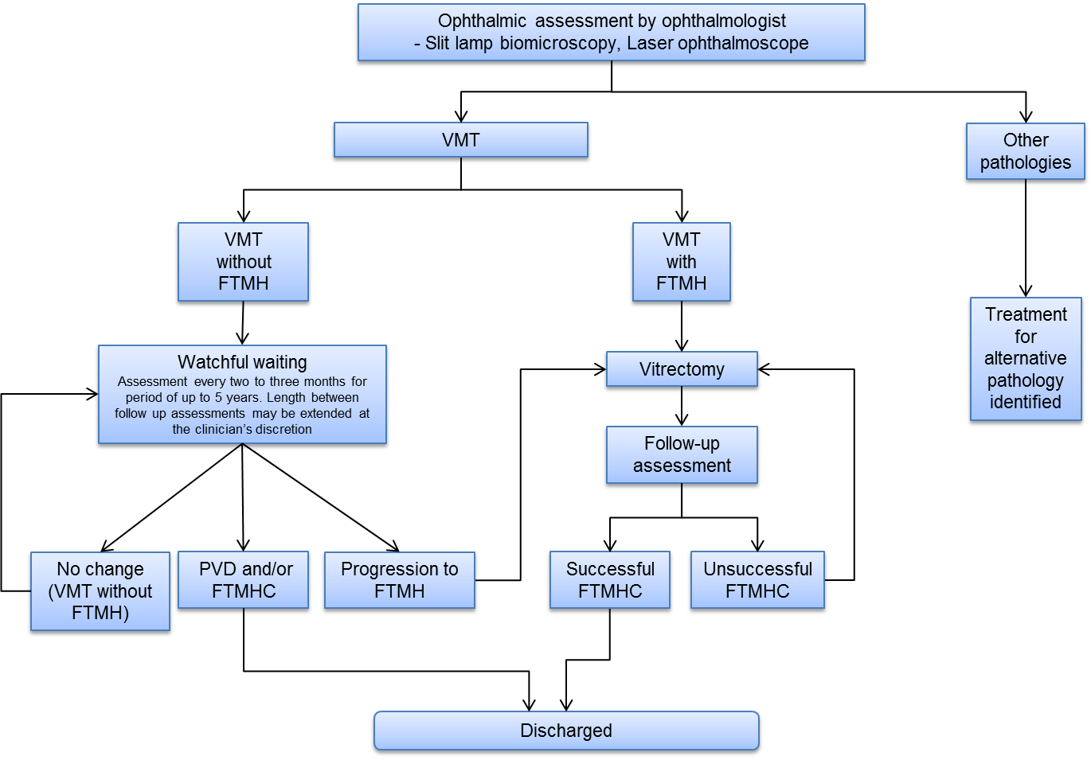

Abbreviations: VMT, vitreomacular traction; FTMH, full thickness macular hole; PVD, posterior vitreous detachment; FTMHC, full thickness macular hole closure

Figure 7 Proposed Clinical Management Algorithm for VMT and FTMH with OCT and ocriplasmin 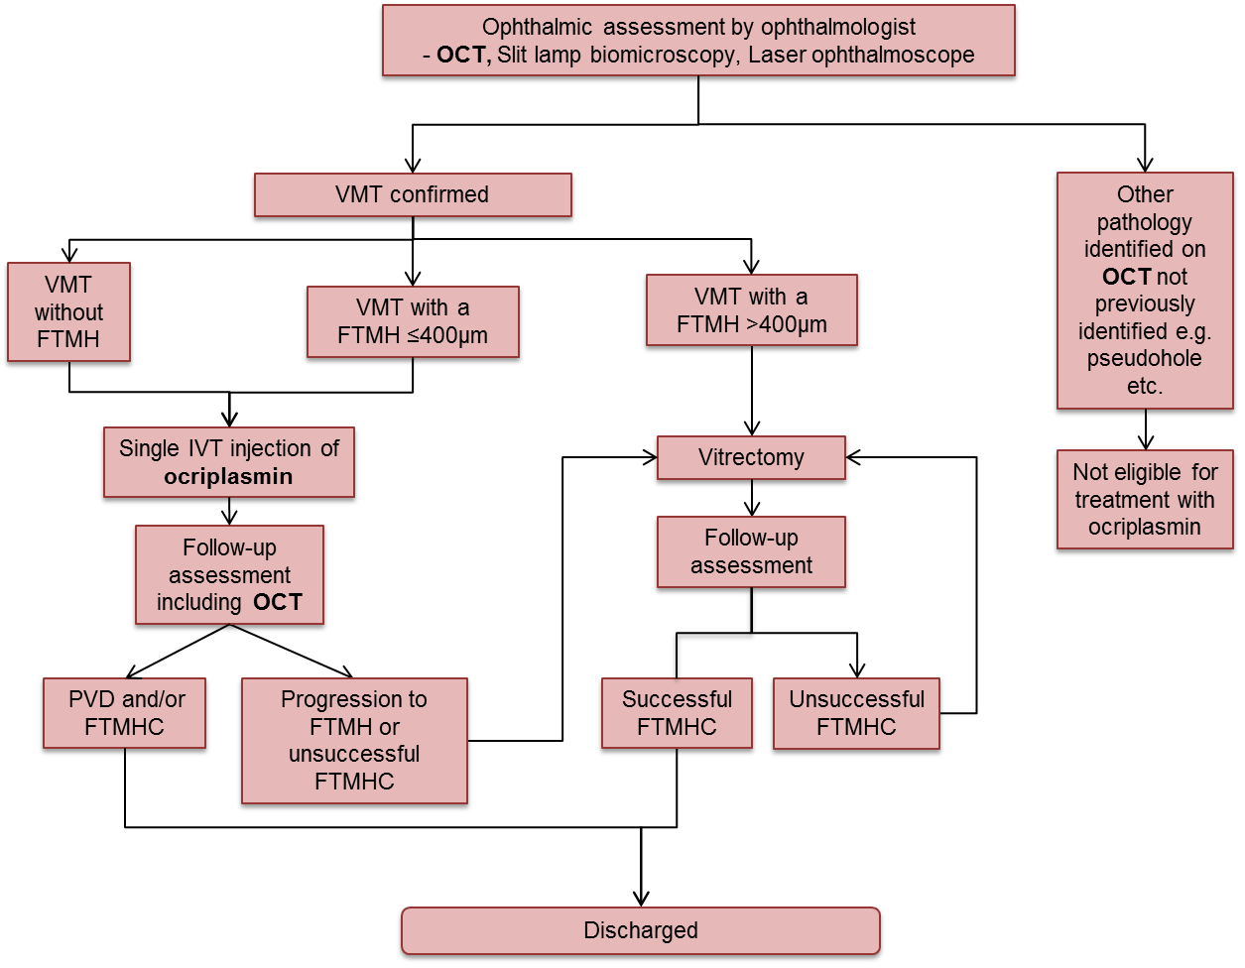

Abbreviations: OCT, optical coherence tomography; VMT, vitreomacular traction; FTMH, full thickness macular hole; PVD, posterior vitreous detachment; FTMHC, full thickness macular hole closure

# 

# Comparator

OCT

As shown by the current and proposed management algorithms in Figure 6 and Figure 7, the most appropriate comparator involves standard ophthalmic assessment without the additional quantitative information provided by OCT. Standard ophthalmic assessment, includes but is not limited to, slit lamp biomicroscopy and clinical observations. These would be included in the MBS fee structure for professional attendance (comprehensive consultation) by an ophthalmologist. If reimbursed, the proposed medical service OCT, is intended to be used in addition to these other investigative procedures.

The intended MBS listing of OCT is for co-dependent use with ocriplasmin to determine PBS eligibility and treatment effect. As such, the clinical effectiveness, safety and cost-effectiveness of ocriplasmin with and without the use of OCT will need to be examined in addition to establishing the clinical validity and utility of OCT compared to standard ophthalmic assessment. A submission based assessment will assess if OCT, as an additional investigative procedure, is effective and cost-effective to determine eligibility for treatment with ocriplasmin on the PBS. That is, the question of whether or not OCT is actually required for the PBS listing of ocriplasmin will be a research question for this application.

It was noted that, for both scenarios, the alternative treatment to ocriplasmin is surgery (e.g. vitrectomy) or watchful waiting, noting (a) the issue of the specific subset is for the treatment of those patients in whom there is an expectation that they will respond to ocriplasmin and (b) surgery still remains an option if ocriplasmin is not sufficiently effective.

Given that the comparator for OCT is more complex because VMT can only be diagnosed with reference to OCT. The comparator for OCT is therefore the costs and consequences of inadequate diagnosis for patients before OCT became available, especially as it could be difficult to show natural history if the condition cannot be monitored except with the use of the intervention. Prior to OCT coming into existence, it was more challenging to distinguish a diagnosis of VMT, with a macular hole from a range of other ocular pathologies with standard ophthalmic examination techniques.

Ocriplasmin

As demonstrated in Figure 7, the comparator for ocriplasmin depends upon the macula abnormality of the individual patient. For patients with FTMH (≤400 µm) the nominated comparator is vitrectomy. For patients with VMT (without FTMH) the nominated comparator is watchful waiting which will ultimately lead to vitrectomy in a proportion of patients. These comparators align with current clinical practice as identified in the 2008 MSAC assessment report and from the applicant’s advisory board meeting of Australian vitreoretinal specialists held in May 2013 (see Prevalence andincidence ratesTable 4).

Noting that prevalence and incidence rates of VMT will likely underestimate the number of patients who are examined, as these figures will not include persons examined who are not found to have VMT.

Table 4 Current treatment recommendations by staging as described by applicant advisory board and by MSAC

|  |  |  |  |  |
| --- | --- | --- | --- | --- |
| **Stagea** | **Description of stage** | **Proposed treatment** | **Current treatment (comparator)** | |
| **Advisory board a** | **MSAC 1116b** |
| Stage 1a  Stage 1b | VMT/ | Ocriplasmin | Watchful waiting, typically involving regular OCT assessments. Patients with intolerable symptoms or progressive symptoms would be considered for vitrectomy | Clinical observation  “The comparator for OCT in initial diagnosis of tractional diseases is standard clinical examination plus observation. OCT is considered an additional test to standard clinical examination.” [MSAC 1116 page 25] |
| Stage 2 | FTMH <400µm | Ocriplasmin | Vitrectomyd | Vitrectomy  “Vitrectomy may be offered to patients with stage 2 holes or above” [MSAC 1116 page 11] |
| Stage 3 | FTMH >400µm | No change  (ocriplasmin not indicated) |
| Stage 4 | FTMH with complete PVD | No change  (ocriplasmin not indicated) | Vitrectomy – however in some cases where a patient has a large chronic FTMH, it may not be worth operating and would depend on the individual patients need and the benefits of surgery would be at the clinician’s discretion |

a Reference: Gass *et al.* 1988 (same staging used in MSAC assessment 1116 of OCT)

bAlcon advisory board of Australian Vitreo-retinal specialists, 31 May 2013

c MSAC assessment 1116 of OCT

d Assuming that the patient is willing and fit enough to undergo surgery

# 

# Clinical claims

Ocriplasmin

It is expected that the clinical claim for treatment with ocriplasmin will be superior efficacy and non-inferior safety versus watchful waiting as demonstrated in Phase III clinical trials in the overall population and subgroups of VMT and FTMH (≤400um). Indirect comparisons will then be made against the relevant comparators in each subgroup for this analysis.

This claim is based on clinical evidence conducted in a clinical trial setting guided by OCT.

The appropriate form of economic evaluation for assessing the cost-effectiveness of ocriplasmin versus “watchful waiting” in patients with VMT will be cost-utility analysis (green highlighted cell in Table 5).

The appropriate form of economic evaluation for assessing ocriplasmin versus vitrectomy in patients with FTMH (≤400µm) or VMT where symptoms are intolerable will also be a cost-utility analysis. The significant safety benefits of ocriplasmin versus vitrectomy need to be considered because a net clinical benefit with ocriplasmin is expected because patients who achieve hole closure with ocriplasmin will avoid the associated risks and burden of vitrectomy. Those who do not achieve hole closure with ocriplasmin will still have the opportunity to receive vitrectomy (see Figure 7 above). Therefore, with an expected net clinical benefit, a cost-utility analysis is the appropriate form of economic evaluation.

Table 5 Classification of an intervention for determination of the economic evaluation to be presented

|  |  |  |  |  |  |  |
| --- | --- | --- | --- | --- | --- | --- |
|  | | **Comparative effectiveness versus comparator** | | | | |
| Superior | | Non-inferior | Inferior | |
| **Comparative safety versus comparator** | Superior | CEA/CUA | | CEA/CUA | Net clinical benefit | CEA/CUA |
| Neutral benefit | CEA/CUA* |
| Net harms | None^ |
| Non-inferior | CEA/CUA | | CEA/CUA* | None^ | |
| Inferior | Net clinical benefit | CEA/CUA | None^ | None^ | |
| Neutral benefit | CEA/CUA* |
| Net harms | None^ |

Abbreviations: CEA = cost-effectiveness analysis; CUA = cost-utility analysis

*May be reduced to cost-minimisation analysis. Cost-minimisation analysis should only be presented when the proposed service has been indisputably demonstrated to be no worse than its main comparator(s) in terms of both effectiveness and safety, so the difference between the service and the appropriate comparator can be reduced to a comparison of costs. In most cases, there will be some uncertainty around such a conclusion (i.e., the conclusion is often not indisputable). Therefore, when an assessment concludes that an intervention was no worse than a comparator, an assessment of the uncertainty around this conclusion should be provided by presentation of cost-effectiveness and/or cost-utility analyses.

^No economic evaluation needs to be presented; MSAC is unlikely to recommend government subsidy of this intervention

OCT

With respect to the clinical claim of OCT, the submission based assessment will determine if the superiority claims for ocriplasmin are relevant and applicable with or without the use of OCT. That is:

* Is OCT as an additional investigative procedure effective and cost-effective to determine eligibility for treatment with ocriplasmin on the PBS?
* Is OCT as an additional investigative procedure effective and cost-effective to assess treatment outcome?

As illustrated in Figure 8, if OCT is not an effective or cost-effective additional procedure, then ocriplasmin can be considered for a PBS listing with an Authority Requirement that does not specify the use of OCT. A decision by the PBAC can be reached without the need for co-dependent assessment by MSAC because:

* No service would be under consideration for public listing on the MBS, and
* The current Phase III data (which includes the use of OCT) would appropriately inform the decision for ocriplasmin with OCT having no impact on the outcomes.

If OCT is deemed a necessary additional investigative procedure to determine eligibility for treatment with ocriplasmin on the PBS and to assess treatment outcome, the cost-effectiveness of both OCT and ocriplasmin on the MBS and PBS schedules respectively, will need to be assessed compared with a scenario where neither ocriplasmin nor OCT are reimbursed. While OCT is not currently reimbursed in Australia it is used in clinical practice and paid for by patients. Therefore any comparison to a situation in which OCT is not used in clinical practice would be hypothetical.

Figure 8 Potential decision pathways for reimbursement of ocriplasmin with or without OCT based on answers to the primary research questions to be determined in the submission based assessment.

Figure 8 Potential decision pathways for reimbursement of ocriplasmin with or without OCT based on answers to the primary research questions to be determined in the submission based assessment.

# Reference standard

In the VMT population there is no other standard and like any areas where the intervention is a gold standard it has had a rapid uptake. However, as the natural history can provide support for the case of OCT in the absence of any other standard and evidence would need to provide information to address how many Australians are affected by VMT. Including:

* Detail on what is current standard practice in eye check-ups for VMT pre- and post-diagnosis, and post-treatment.
* What the current clinical practice for referring patients to an ophthalmologist for suspected VMT is? How will this change with the addition of OCT testing for reimbursement?
* What is the prevalence and incidence rate of VMA/PVD in the Australian population, and the associated occurrence of VMT/VMT with FTMH of width ≤400µm?
* Are there high-risk groups or specific age-groups it is more common to occur in?
* What proportions of patients tested are anticipated to be eligible for ocriplasmin, vitrectomy and/or watchful waiting?
* Due to the self-limiting nature of VMT, what is the proportion of patients with natural resolution and restoration of vision evidence?
* How fast VMT progresses to needing treatment. This is relevant for identifying the proportion of patients who are currently not eligible but may become eligible for ocriplasmin.

Several eye pathologies can occur concurrently with VMT (Jackson et al. 2013). There is the potential regarding the overuse of OCT for all these pathologies (i.e., neovascular age-related macular oedema, diabetic macular oedema, macular hole, epiretinal membrane) and not only VMT to direct ocriplasmin treatment. However, as not using OCT to identify co-existing pathologies may result in poor case selection and less effective treatment evidence would need to be provided as to the rationale behind current clinical guidelines or criteria for its use.

# Outcomes for safety and effectiveness evaluation

Health outcomes will be measured in order to assess the safety and effectiveness of the proposed interventions and appropriate comparators.

## Effectiveness

Primary effectiveness outcomes for all proposed interventions and comparators include improvement in visual acuity, function/activities of daily living, and quality of life. Specific outcomes that could be included in the submission based assessment are outlined below.

### OCT

OCT is proposed to facilitate the accurate and objective assessment of the vitreomacular interface to determine eligibility for treatment with ocriplasmin on the PBS.

Several investigations support OCT as a more sensitive diagnostic tool in the detection of vitreomacular interface disorders in comparison to clinical examination alone (Do *et al.*, 2007, Gallemore *et al.*, 2000, Smiddy *et al.*, 2006). The inconsistencies and incorrect interpretation of biomicroscopy is also widely acknowledged in the literature (Gass *et al.*, 1990, Coker *et al.*, 1996, Barack *et al.*, 2012, Stalmans *et al.*, 2013). A study by Gallemore *et al.* (2000) noted the presence of VMA in 30% of eyes after review of OCT images in contrast to 8% identified using biomicroscopy. This result is supported by Azzolini *et al.* (2001) for which OCT provided additional information in 22 of 24 (91.7%) of eyes that were initially diagnosed as stage 1A or 1B using biomicroscopy. In those eyes initially classified as stage 2, 3 or 4, OCT provided differential information or diagnoses in 18.9% of eyes. It is claimed that the co-dependent use of OCT will enable the accurate identification of those patients eligible for and most likely to benefit from treatment with ocriplasmin.

The additional information provided by OCT is used in conjunction with symptom presentation, patient tolerance, disease history and co-morbidities to inform treatment decisions. It is proposed that without the use of OCT as an additional investigative procedure, the most effective clinical treatment pathway may not be identified. A study of 84 eyes conducted by Do *et al.* (2007) compared the recommendations of retinal surgeons regarding the management of epiretinal membrane and VMT based on either clinical assessment alone or that supplemented by OCT. Surgical intervention was recommended in 57.6% of cases based on history and clinical examination findings. An additional 14 (42.4%) cases were recommended for surgical intervention when clinical examination was combined with OCT findings.

Therefore, depending on the available evidence, a submission based assessment will attempt to demonstrate:

* Analytical validity – the reproducibility and repeatability of the test i.e., sensitivity and specificity of OCT
* Clinical validity - ability to classify patient risk of progression/non-resolution of VMT/FTMH’ eg. to demonstrate performance of using OCT criteria to distinguish between patients at low versus high risk of progressing when managed with watchful waiting (or variations on this and ideally with comparison to diagnosis+ risk classification based on standard tests without OCT)
* Clinical utility – the likelihood that the test will lead to an improved health outcome i.e., linked evidence approach of the ability of OCT to change treatment decisions

A subgroup analysis comparing outcomes of different OCT systems, e.g. time domain versus spectral domain may also be appropriate, depending on the available evidence.

As OCT is proposed to measure VMT to determine treatment eligibility, and to monitor response to treatment as a surrogate outcome for visual acuity, PASC advised that the submission should include evidence to demonstrate:

* baseline macular hole diameter as it predicts a material variation in ocriplasmin’s treatment effect on visual acuity, with reference to the nominated macular hole >400 µm threshold for determining eligibility for ocriplasmin;
* the association between change in macular hole diameter and improvement in visual acuity;
* the reliability of OCT measurement of macular hole diameter;
* the proposed response criteria can detect true inter-individual variation in treatment effects to confirm OCT’s value in assessing response to therapy and determining eligibility for subsequent vitrectomy; and
* As the reference standard OCT instrument is the instrument specified as being used in the randomised trials for ocriplasmin; all other OCT instruments available in Australia should be compared with this instrument, particularly if there is variation in instruments used by ophthalmologists.

Relevant methodology for assessing the value of treatment monitoring has been previously described elsewhere (Bell et al 2009). Establishing the value of OCT lies in effective demonstration that the observed variation in response to therapy (ocriplasmin) between individuals (treatment-related variation) on the surrogate outcome (macular hole diameter) exceeds the variation observed within individuals upon repeated measurement (measurement-related variation). Conversely, a finding that inter-individual variation in treatment effects on macular hole diameter is small in comparison to intra-individual variation would show that the former is not clinically relevant and suggests that assessment of response should be avoided. The example provided by Bell and colleagues (Bell et al 2009) demonstrated this principle using a large RCT which compared the treatment effects of alendronate (for low bone mineral density) and placebo in 6459 post-menopausal women. Their finding that treatment-related variation in bone mineral density was small compared to intra-individual variation led to the conclusion that monitoring of bone mineral density in this population is unnecessary.

Bell and colleagues have provided a checklist for determining whether a treatment response assessment is appropriate within the context of monitoring a surrogate outcome to determine the need for any subsequent therapy (Bell et al 2010)(Table 1).

Table 1 Checklist for deciding when a response rule may be appropriate (Bell et al 2010)

|  |
| --- |
| 1. **Has the surrogate outcome been shown to predict risk of the clinically relevant outcome?**a  * Is there meta-analytic evidence demonstrating a relationship between treatment effect on the surrogate and treatment effect on risk of clinically relevant outcome? |
| 1. **Is the proposed target for the surrogate outcome associated with a clinically important decrease in the risk of adverse clinical outcome?**b |
| 1. **Is systematic measurement error in the surrogate outcome small?**c  * What is the potential for systematic under/over-estimation of the surrogate outcome? |
| 1. **Is the response rule likely to detect true between person variation in treatment effects on the surrogate outcome?**d  * What is the inter-individual variation in treatment effects on the surrogate outcome? * What is the intra-individual variation in the surrogate outcome? * What is the ratio of inter-individual variation in treatment effects to intra-individual variation? |

Note: It is suggested (Bell et al 2010) that decision makers start with the item for which information is most easily available. If the response rule fails any of the checklist items, then it is unlikely to be useful and further appraisal is not required.

aA surrogate outcome should only be considered for treatment monitoring if it is *known* to predict the effect of treatment on risk of the clinical outcome(s). The preferred evidentiary standard is meta-analyses of RCTs where the change in surrogate outcome is related to change in risk of a clinically relevant outcome(s) for patients treated with the intervention relative to those on control. If this level of evidence is lacking because the treatment is recently developed, then meta-analyses of RCTs of other therapies for the *same disease* may be acceptable evidence. Otherwise, observational data demonstrating that the surrogate predicts the clinically relevant outcome may be admissible.

bAs per the criteria for the first item in the checklist, meta-analyses of RCT evidence are preferred.

cSystematic error occurs when true values for the surrogate outcome is under- or over-estimated due to bias. Where possible, choosing a surrogate for which there is less room for interpretation should minimise this type of error. At the very least, especially where only one surrogate can be pragmatically chosen, standardised methods of measurement and reporting should be used.

dIf there are insufficient data to estimate the inter-individual variation in treatment effects, the largest probable variation may still be estimated (see Bell et al 2010). Random intra-individual variation occurs due to biological fluctuations as well as technical error. This can be minimised by standardising how measurements are taken (technique and time) and using the mean of multiple measurements (before and after treatment). The ratio of inter-individual variation in treatment effects to the random intra-individual variation enables quantification of the likelihood of detecting true inter-individual variation in treatment effects. The larger the ratio, the more likely that the true inter-individual variation will be detected by a response rule.

### Ocriplasmin

The primary and secondary efficacy endpoints of the ocriplasmin pivotal clinical trials are outlined below. It is envisaged that a submission based assessment will present the results of these outcomes for the direct comparison between ocriplasmin and placebo (as a proxy for best supportive care). Secondary indirect comparison will also be required against the comparator of vitrectomy pending the available evidence for reported outcomes.

Primary Efficacy Endpoint:

* The proportion of subjects with nonsurgical resolution of focal VMA at Day 28 post-injection, as determined by masked central reading centre (CRC) OCT evaluation.

Secondary Efficacy Endpoints:

* Proportion of subjects with total PVD at Day 28, as determined by masked Investigator assessment of B-scan ultrasound
* Proportion of subjects not requiring vitrectomy
* Proportion of (FTMHs) that closed without vitrectomy as determined by CRC (natural resolution)
* Achievement of ≥2 and ≥3 lines improvement in best corrected visual acuity (BCVA) without need for vitrectomy
* Improvement in BCVA

Quality of Life:

* Improvement in the National Eye Institute (NEI) 25-Item Visual Function Questionnaire (VFQ-25).

### Vitrectomy

As a comparator to treatment with ocriplasmin it is suggested that the following outcomes be considered for vitrectomy pending availability of evidence:

* Surgical resolution of focal VMA
* Macular hole closure
* Improvement in BCVA
* Quality of life changes

Primary effectiveness outcomes include improvement in visual acuity, function/activities of daily living, and quality of life.

## Safety

### OCT

OCT has previously been considered a safe procedure by MSAC. It is a non-invasive and non-contact scan. The safety of OCT will not be explicitly investigated in the submission based assessment.

### Ocriplasmin

Safety outcomes include any adverse events related to testing and any subsequently indicated treatment(s). The assessment of safety for ocriplasmin could include:

* intraocular inflammation;
* post-operative cataract;
* raised intra-ocular pressure (IOP)
* vitreous haemorrhage
* endophthalmitis, and;
* retinal tear or detachment

### Vitrectomy

In addition to the safety endpoints being investigated for ocriplasmin it is proposed the following safety outcomes be considered for vitrectomy pending available evidence:

* Intra-operative complications
* Post-operative complications (e.g. cataracts)

# Summary of PICO to be used for assessment of evidence

Table 6 and Table 7 provide a summary of the PICO for OCT and ocriplasmin respectively.

OCT

Table 6 Summary of PPICO to define research questions to investigate the effectiveness and cost-effectiveness of OCT as a means of identifying patients eligible for treatment with ocriplasmin on the PBS

|  |  |  |  |  |  |
| --- | --- | --- | --- | --- | --- |
| **Population** | **Prior tests** | **Intervention** | **Direct evidence comparator** | **Reference standard/ evidentiary standard** | **Outcomes to be assessed** |
| Patients who have undergone clinical and baseline ophthalmic assessment and in whom the treating ophthalmologists suspects will have a condition consistent with the PBS Authority Required listing for ocriplasmin | Biomicroscopy  Clinical examination | OCT | Standard ophthalmic assessment without OCT  Surgery  Or watchful waiting | The reference standard for determining the “accuracy” of OCT is the ocriplasmin clinical trial evidence base.  Current practice without OCT would need to be as accurate and effective as this method for identifying patients to ensure OCT adds no value.  Natural history to provide support for the case of OCT in the absence of any other standard.including the rationale behind current clinical guidelines or criteria | Efficacy outcomes:  Clinical utility  Clinical validity  Analytical validity  Safety/Adverse events  Not assessed  Modelled endpoints:  Likelihood the test will lead to an improved health outcome i.e., linked evidence approach of the ability of OCT to change treatment decisions |
| Primary OCT Research Questions   1. Is OCT as an additional investigative procedure necessary, effective and cost-effective to determine eligibility for treatment with ocriplasmin on the PBS? 2. Is OCT as an additional investigative procedure necessary, effective and cost-effective to determine response to treatment with ocriplasmin on the PBS? | | | | | |

Abbreviations: OCT, optical coherence tomography

Ocriplasmin

Table 7 Summary of PICO to define research questions to investigate the safety, effectiveness and cost-effectiveness of ocriplasmin for reimbursement on the PBS

|  |  |  |  |
| --- | --- | --- | --- |
| **Population** | **Intervention** | **Comparators** | **Outcomes to be assessed** |
| Patients eligible for ocriplasmin on the basis of the PBS Authority required listing.  Exact wording to be determined however patients can be broadly classified as patients with :   * VMT (without FTMH) * VMT (with FTMH) | ocriplasmin | Without FTMH  Watchful waiting  With FTMH  Vitrectomy | Primary Outcome:  Non-surgical resolution of VMA  Secondary Outcomes:  Total PVD  Non-surgical FTMH closure  Improvement in BC visual acuity  Proportion of subjects not requiring vitrectomy  Improvement in 25-item NEI-VFQ  Safety/adverse events  Intraocular inflammation  Cataract  Raised intra-ocular pressure (IOP)  Vitreous haemorrhage  Exacerbation of pre-existing glaucoma  Endophthalmitis  Retinal tear or detachment  Intra-operative complications  Post-operative complications (e.g. cataracts)  Modelled endpoints:  QOL  QALYs  Mortality  Resource utilisation |
| Research Questions  The research questions are separated based on whether or not OCT is considered necessary for the PBS listing of ocriplasmin  Without OCT on the MBS   1. Is OCT 2. Is ocriplasmin safe, effective and cost-effective for the treatment of VMT comparative to placebo as a proxy for ‘watchful waiting’ or best supportive care? 3. Is ocriplasmin safe, effective and cost-effective for the treatment of MH comparative to vitrectomy?   With OCT on the MBS   1. Is the co-dependent listing of both OCT and ocriplasmin on the MBS and PBS schedules respectively, cost-effective comparative to current management where neither are reimbursed? | | | |

Abbreviations: VMT, vitreomacular traction; FTMH, full thickness macular hole; OCT, optical coherence tomography; QoL, quality of life; QALY, quality adjusted life year; BC, best corrected.

# Outcomes and health care resources affected by introduction of proposed intervention

## Outcomes for economic evaluation

The main goal for ocriplasmin treatment guided by OCT is to save sight and improve visual function and associated *quality of life* (QoL)*.* Gain in quality-adjusted life-years (QALYs) would therefore be an appropriate health outcome for the economic evaluation. Adverse events would also be modelled if they differ to those associated with standard medical management (i.e., watchful waiting or vitrectomy).

Modelled outcomes for the economic evaluation:

* Visual acuity
* Visual acuity transformed to:
  + Quality adjusted life years (QALYs)
  + Risk of death
  + Resource utilisation and costs
* Adverse events including intra- and post-operative events

## Health care resources

The list of resources to be considered in the economic analyses is outlined in Table 8. The sources of information used to determine the number of units for use in the economic analysis will be provided in the submission of evidence.

Table 8 List of resources to be considered in the economic analysis

|  | **Provider of resource** | **Setting in which resource is provided** | **Number of units of resource per relevant time horizon per patient receiving resource** | **Source of information of number of units\*** |
| --- | --- | --- | --- | --- |
| Resources provided to identify the eligible population that would vary from current clinical practice (from Step 2, e.g., diagnostic and other investigative medical services, prior therapeutic interventions). *Identify variations where these may vary across different decision options.* | | | | |
| No additional resources over current practice are necessary to determine patients eligible for OCT as proposed | | | | |
| Resources provided in association with the proposed medical service to deliver the proposed intervention (from Step 1, e.g., pre-treatments, co-administered interventions). *Identify variations where these may vary across different decision options.* | | | | |
| OCT | Ophthalmologist | Consultation room | 1 | Expected clinical practice |
| Ocriplasmin | Ophthalmologist | Consultation room | 1 | Expected clinical practice  Maximum number of injections allowed by TGA registration |
| Intravitreal injection (MBS item 42740) | Ophthalmologist | Consultation room | 1 | Expected clinical practice |
| Resources provided to deliver the comparator to deliver the current intervention (from Step 4, e.g., pre-treatments, co-administered interventions). *Identify variations where there may be more than one comparator or where these may vary across different decision options.*  *Comparator: Watchful waiting* | | | | |
| Consultations | Ophthalmologist | Consultation room | Periodical/as needed | Expected clinical practice |
| OCT | Ophthalmologist | Consultation room | Periodical/as needed (not currently reimbursed) | Expected clinical practice |
| Vitrectomy (if and when it becomes necessary) | Ophthalmologist | Theatre (see Table 9 for more information) | 1 (or repeat if necessary) | Clinical practice |
| Resources provided to deliver the comparator to deliver the current intervention (from Step 4, e.g., pre-treatments, co-administered interventions). *Identify variations where there may be more than one comparator or where these may vary across different decision options.*  *Comparator: Vitrectomy* | | | | |
| Vitrectomy (if and when it becomes necessary) | Ophthalmologist | Theatre (see Table 9 for more information) | 1 (or repeat if necessary) | Clinical practice |
| Resources provided following the proposed intervention with the proposed medical service (from Step 8, e.g., resources used to monitor or in follow-up, resources used in management of adverse events, resources used for treatment of down-stream conditions conditioned on the results of the proposed intervention). *Identify variations where these may vary across different decision options.* | | | | |
| OCT | Ophthalmologist | Consultation room | 1 | Expected clinical practice. A single OCT to assess outcome of treatment |
| Vitrectomy (if necessary) | Vitreoretinal surgeon | Theatre (see Table 9 for more information) | 1 (or repeat if necessary) | Expected clinical practice |

Abbreviations: OCT, optical coherence tomography; TBD, to be disclosed

* Possible sources include experimental or trial data, observational data such as epidemiological data or utilisation data from Medicare Australia, survey data, expert opinion

The main resource item included in the list of resources to be considered in the economic analysis (Table 8) is that of vitrectomy. The resources associated with vitrectomy are summarised in Table 9.

Table 9 Healthcare resources utilised by patients receiving vitrectomy

| **Procedure** | **Item number** |
| --- | --- |
| Consultation | 104* |
| OCT | Not reimbursed* |
| Surgeon (vitrectomy)  Vitrectomy ± lens replacement | 42725  42702 |
| Assistant surgeon | 51315 |
| Anaesthesia | 20145 |
| Operating theatre (and hospital stay) | Completely variable depending on where the procedure is performed (in some circumstances patients will stay overnight in hospital) |
| Use of retinal tamponade | 42740 |
| Disposable (light pipe, infusion port, vitrectomy piece) | not reimbursed |
| Medications – antibiotics, steroids, homatropine | not reimbursed |
| Laser for repair retinal tear during vitrectomy (3-5% surgeries) | 42809 |
| Allied health such as nursing care during recovery | In some circumstances |

*component of watchful waiting

## Proposed structure of economic evaluation (decision-analytic)

It is proposed there will be two economic evaluations, one for each indication and comparator:

* Cost-utility analysis of OCT informed ocriplasmin versus watchful waiting in patients with VMT
* Cost-utility analysis of ocriplasmin versus vitrectomy in patients with FTMH

The approach for each economic evaluation described below is preliminary and will likely be modified according to data availability.

### Cost-effectiveness analysis of ocriplasmin versus watchful waiting in patients with VMT

A cost-effectiveness evaluation is performed comparing ocriplasmin (assisted by OCT) versus watchful waiting followed by vitrectomy. No cost-effectiveness evaluation for OCT itself will be undertaken given that this is a co-dependency submission for ocriplasmin and OCT.

The health benefits offered by ocriplasmin over watchful waiting reflect VA improvement achieved by resolution of the VMT as well as a reduction in the need for surgical intervention should the VMT progress to FTMH which requires intervention.

The protocol model will be structured as follows:

* OCT will allocate patients to treatment with ocriplasmin (who would otherwise remain without treatment on watchful waiting)
* Ocriplasmin will resolve the traction and/or macular hole causing the symptoms (in a proportion of patients)
* Resolution of symptoms will improve visual acuity
* Improved visual acuity will result in improved quality of life and additional QALYs

This approach is illustrated in a protocol structure in Figure 9.

### Cost-effectiveness analysis of ocriplasmin versus vitrectomy in patients with full thickness macular hole

As described earlier, it is expected rates of FTMH closure will be lower with ocriplasmin than with vitrectomy. However, the costs of ocriplasmin will also be lower and safety will be superior. Non-inferior efficacy (in terms of hole closure) can be assumed because patients who do not achieve FTMH closure with ocriplasmin will be expected to go on to receive vitrectomy. As such, ocriplasmin will be less costly and have better safety outcomes than vitrectomy in some patients (those achieving FTMH closure with ocriplasmin) but more costly than vitrectomy in others (those that do not achieve FTMH closure with ocriplasmin will need vitrectomy in addition to ocriplasmin). Ocriplasmin will be cost-effective if the savings and QALY gains in the former group outweigh the additional costs in the latter group. This approach is illustrated in a protocol structure in Figure 10.

Figure 9 Protocol model structure for the economic evaluation comparing OCT plus ocriplasmin versus current practice without OCT in patients with VMT

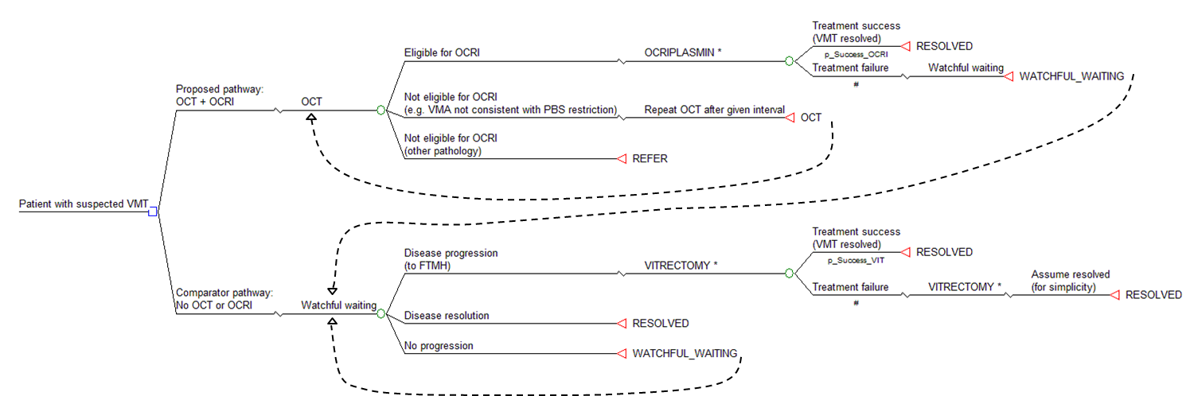

REFER – denotes that the patients will be referred to the appropriate specialist and managed as per the current treatment pathway for the alternative pathology  
RESOLVE – condition no longer requires treatment due to resolution of tractional effects (i.e. posterior vitreous detachment)

Figure 10 Protocol model structure for the economic evaluation comparing OCT plus ocriplasmin with vitrectomy if necessary versus vitrectomy alone in patients with FTMH

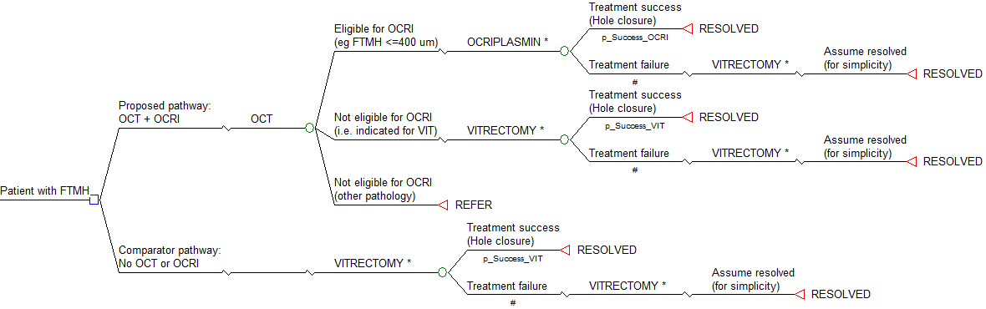

* The cost and quality of life impact of a given intervention in this protocol structure will include all costs associated with the identification of the patient group (eg OCT) and the expected costs and quality of life decrement associated with any adverse events

**Alternative tree**

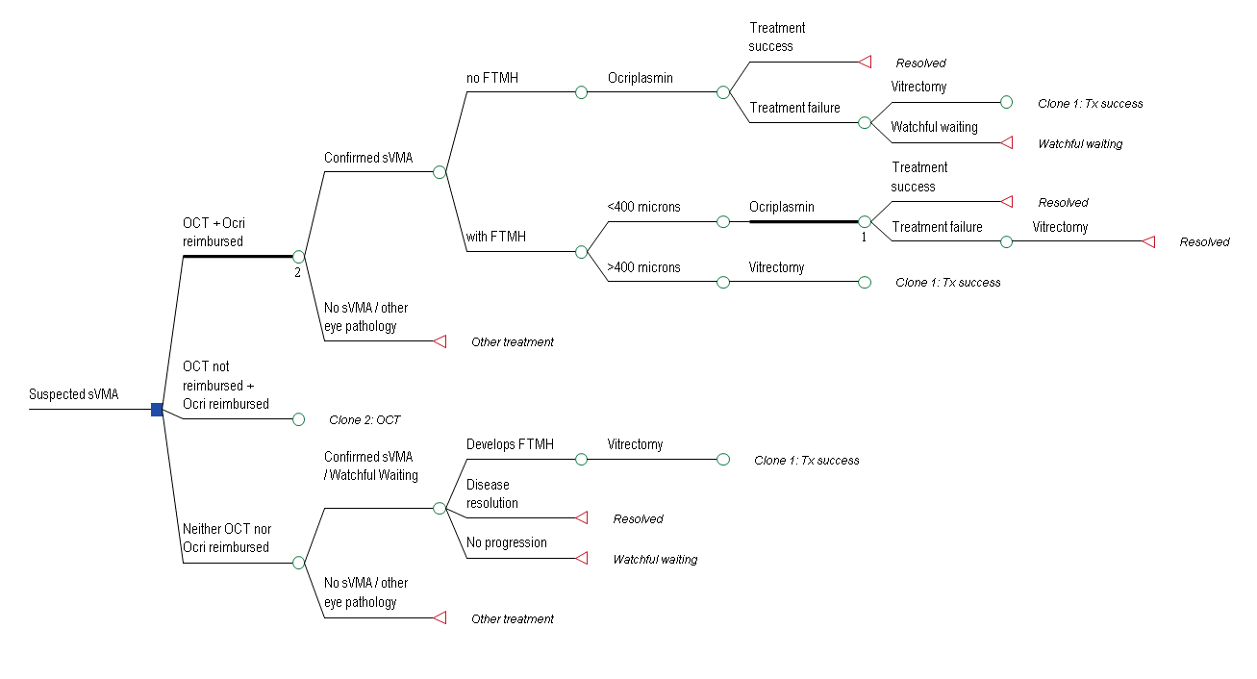

# References

AIHW (2009). Eye health labour force in Australia. Cat. No PHE 116 [Internet]. Australian Institute of Health and Welfare. Available from: http://www.aihw.gov.au/WorkArea/DownloadAsset.aspx?id=6442459946 [Accessed 21 June 2012].

Azzolini C, Patelli F and Brancato R. Correlation Between Optical Coherence Tomography Data and Biomicroscopic Interpretation of Idiopathic Macular Hole. Am J Ophthalmol 2001;132:348–355.

Barack Y, Ihnen M, and Schaal S. Spectral Domain Optical Coherence Tomography in the Diagnosis and Management of Vitreoretinal Interface Pathologies. Journal of Ophthalmology 2012. Article ID 876472, 7 pages doi:10.1155/2012/876472

Cheng L, Azen SP, El-Brady MH, Scholz BM, Chaidhawangul S, Toyoguchi M and Freeman WR. Duration of Vitrectomy and Postoperative Cataract in the Vitrectomy for Macular Hole Study. Am J Ophthalmol. 2001;132(6): 881-87.

Coker JG, Duker JS. Macular disease and optical coherence tomography. Curr Opin Ophthalmol. 1996 Jun;7(3):33-8.

Do D, Cho M, Nguyen Q, Shah S et al. Impact of optical coherence tomography on surgical decision making for epiretinal membranes and vitreomacular traction. Retina 2007; 27:552–556.

DoHA (2012). Medicare item reports [Internet]. Department of Health and Ageing. Available from: https://www.medicareaustralia.gov.au/statistics/mbs_item.shtml [Accessed 21 June 2012].

Drexler, W. & Fujimoto, J. G. (2008). 'State-of-the-art retinal optical coherence tomography', Prog Retin Eye Res, 27 (1), 45-88.

Ezra E. Idiopathic Full Thickness Macular Hole: Natural History and Pathogenesis. Br J Ophthalmol. 2001;85: 102–108.

Folgar F, Toth C, DeCroos F, Girach A, Pakola S, Jaffe G. Assessment of Retinal Morphology with Spectral and Time Domain OCT in the Phase III Trials of Enzymatic Vitreolysis. Invest Ophthalmol Vis Sci. 2012;53:7395–7401

Gallemore RP, Jumper JM, McCuen BW, 2nd, Jaffe GJ, Postel EA, Toth CA (2000) Diagnosis of vitreoretinal adhesions in macular disease with optical coherence tomography. Retina 20 (2):115-120

Gass D, Joondeph B. Observations concerning patients with suspected impending macular holes. American Journal of Ophthalmology 1990, 109:638-646.

Hikichi T, Yoshida A and Trempe CL. Course of Vitreomacular Traction Syndrome. Am J Ophthalmol. 1995;119 (1): 55-61.

Huang L, Levinson D, Levine J, Mian U, Tsui I. Optical Coherence Tomography Findings in Idiopathic Macular Holes. Journal of Ophthalmology 2011. Article ID 928205, 4 pages doi:10.1155/2011/928205

Jonas, J., Paques, M. et al (2010). 'Retinal vein occlusions', Dev Ophthalmol, 47, 111-135.

Larsson L and Österlin S. Posterior Vitreous Detachment. A Combined Clinical and Physiochemical Study. Graefes Arch Clin Exp Ophthalmol. 1985;223:92-95.

Leonard RE, Smiddy WE, Flynn HN, Fewer W (1997) Long-term visual outcomes in patients with successful macular hole surgery. Ophthalmology 104:1684-1752.

Livingstone BI, Bourke RD Retrospective study of macular holes treated with pars plana vitrectomy Australian and New Zealand Journal of Ophthalmology 1999; 27: 331–341

Marschall, S., Sander, B. et al (2011). 'Optical coherence tomography-current technology and applications in clinical and biomedical research', Anal Bioanal Chem, 400 (9), 2699-2720.

MSAC (2009). Optical Coherence Tomography: MSAC Application 1116, Commonwealth of Australia, Canberra.

OBA (2010). Endorsement for scheduled medicines registration standard [Internet]. Optometry Board of Australia. Available from: www.optometryboard.gov.au/documents/default.aspx?record=WD10%2f158&dbid=AP&chksum=uA2c3Oie3cwpQqUMXLHfKg%3d%3d [Accessed 23 May 2012].

RANZCO 2013. Letter to the Medical Services Branch. Response to the request for advice regarding Optical Coherence Tomography for macular conditions.

RCO (2010). Interim guidelines for management of retinal vein occlusion [Internet]. The Royal College of Ophthalmologists. Available from: http://www.rcophth.ac.uk/news.asp?section=24&itemid=374&search= [Accessed 21 June 2012].

Sakata, L. M., Deleon-Ortega, J. et al (2009). 'Optical coherence tomography of the retina and optic nerve - a review', Clin Experiment Ophthalmol, 37 (1), 90-99.

Sebag J. Anomalous Posterior Vitreous Detachment: A Unifying Concept in Vitreo-Retinal Disease. Graefes Arch Clin Exp Ophthalmol. 2004;242(8):690-98.

Smiddy WE. Macular hole update: 2006. Retinal Physician, Issue July 2006. http://www.retinalphysician.com/printarticle.aspx?articleID=100221

Stalmans P, Benz MS, Gandorfer A, Kampik A, Girach A, Pakola S, Haller JA, Enzymatic vitreolysis with ocriplasmin for vitreomacular traction and macular holes. New England Journal of Medicine. 2012. 367;7 606-615

Stalmans P, Duker JS, Kaiser PK, Heier JS, Dugel PU, Gandorfer A, Sebag J, Haller JA. OCT-based interpretation of the vitreomacular interface and indications for pharmacologic vitreolysis. Retina. 2013 Jul 22. [Epub ahead of print]

Thompson JT, Glaser BM, Sjaarda RN, Murphy RP (1995) Progression of nuclear sclerosis and long-term visual results of vitrectomy with transforming growth factor beta-2 for macular holes. Am J Ophthalmol 119:48-54

Uchino E, Uemura A and Ohba N. Initial Stages of Posterior Vitreous Detachment in Healthy Eyes of Older Persons Evaluated by Optical Coherence Tomography. Arch Ophthalmol. 2001;119(10):1475-79.

van Velthoven, M. E., Faber, D. J. et al (2007). 'Recent developments in optical coherence tomography for imaging the retina', Prog Retin Eye Res, 26 (1), 57-77.

Yun C, Oh J, Hwang SY, Togloom A, Kim SW, Huh K.Morphologic characteristics of chronic macular hole on optical coherence tomography. Retina. 2012 Nov-Dec;32(10):2077-84. doi: 10.1097/IAE.0b013e31825620ba.

1. The applicant quotes page 26 of MSAC application 1116 to further substantiate this claim. The passage referred to reads: “It is the expert opinion of the Advisory Panel that OCT machines are located in every Australian state capital city and in the Australian Capital Territory. Machines are also located in some major population centres outside capital cities. Wide dissemination of the technology has occurred across Australia, and as such it is not possible to accurately describe the number of machines around the country.”
2. OCT can only be provided to entitled persons by an ophthalmologist. Further information describing the circumstances in which DVA will accept financial responsibility for the provision of OCT can be located in the link below: http://factsheets.dva.gov.au/factsheets/documents/HIP90%20Optical%20Coherence%20Tomography.htm

   The fee at which DVA will reimburse OCT is $91.75 (Item MT12; http://www.dva.gov.au/service_providers/doctors/Pages/fee%20schedule.aspx)