Application Form

F-18 Fluorodeoxyglucose positron emission tomography (FDG PET) for the diagnosis of Alzheimer’s disease
This application form is to be completed for new and amended requests for public funding (including but not limited to the Medicare Benefits Schedule (MBS)). It describes the detailed information that the Australian Government Department of Health requires to determine whether a proposed medical service is suitable.
Please use this template, along with the associated Application Form Guidelines to prepare your application. Please complete all questions that are applicable to the proposed service, providing relevant information only. Applications not completed in full will not be accepted.
Should you require any further assistance, departmental staff are available through the Health Technology Assessment Team (HTA Team) on the contact numbers and email below to discuss the application form, or any other component of the Medical Services Advisory Committee process.

Email: hta@health.gov.au
Website: www.msac.gov.au

PART 1 – APPLICANT DETAILS

Applicant details (primary and alternative contacts)
Corporation / partnership details (where relevant): N/A
Corporation name: Department of Molecular Imaging and Therapy, Austin Health
ABN: 96237388063
Business trading name: Austin Health

Primary contact name: REDACTED
Primary contact numbers
Business: REDACTED
Mobile: REDACTED
Email: REDACTED

Alternative contact name: REDACTED
Alternative contact numbers
Business: REDACTED
Mobile: REDACTED
Email: REDACTED

(a) Are you a lobbyist acting on behalf of an Applicant?
Yes
No

If yes, are you listed on the Register of Lobbyists?
Yes
No

PART 2 – INFORMATION ABOUT THE PROPOSED MEDICAL SERVICE

Application title
F-18 Fluorodeoxyglucose positron emission tomography (FDG PET) for the diagnosis of Alzheimer’s disease

Provide a succinct description of the medical condition relevant to the proposed service (no more than 150 words – further information will be requested at Part F of the Application Form)
Alzheimer’s disease (AD) is the most common cause of dementia. It is relentlessly progressive and leads to severe disability and then death on average 7 years from diagnosis. Symptoms of AD are present for several years before diagnosis and the pathological process that leads to the dementia of AD begins a decade or more before diagnosis.
The prevalence of this disease is increasing as Australia’s population ages. It afflicts 1% of the community aged 60 years and this prevalence rises to 20% by the age of 85 years. It is estimated that there are currently 400,000 persons in Australia with AD (see Access Economics report for Alzheimer’s Australia 2009).

Provide a succinct description of the proposed medical service (no more than 150 words – further information will be requested at Part 6 of the Application Form)
It is proposed that FDG PET brain imaging be used in patients with evidence of decline in memory or other areas of cognition when current diagnostic methods are inconclusive. The decline may be based on history from a patient if verified by a reliable informant (usually a spouse) or on a cognitive test score that is below those expected for age and level of education. Current diagnostic methods consist of clinical evaluation by a medical specialist, an MRI brain scan and blood tests for routine biochemistry and haematology plus blood tests for thyroid function and vitamins B12 and folate. FDG PET should be used after this initial evaluation if diagnosis remains in doubt.

(a) Is this a request for MBS funding?
Yes
No

If yes, is the medical service(s) proposed to be covered under an existing MBS item number(s) or is a new MBS item(s) being sought altogether?
Amendment to existing MBS item(s)
New MBS item(s)

If an amendment to an existing item(s) is being sought, please list the relevant MBS item number(s) that are to be amended to include the proposed medical service:
N/A

If an amendment to an existing item(s) is being sought, what is the nature of the amendment(s)?
N/A

If a new item(s) is being requested, what is the nature of the change to the MBS being sought?
- A new item which also seeks to allow access to the MBS for a specific health practitioner group
- A new item that is proposing a way of clinically delivering a service that is new to the MBS (in terms of new technology and / or population)
- A new item for a specific single consultation item
- A new item for a global consultation item(s)

Is the proposed service seeking public funding other than the MBS?
Yes
No

If yes, please advise:
N/A

What is the type of service:
Therapeutic medical service
Investigative medical service
Single consultation medical service
Global consultation medical service
Allied health service
Co-dependent technology
Hybrid health technology

For investigative services, advise the specific purpose of performing the service (which could be one or more of the following):
- To be used as a screening tool in asymptomatic populations
- Assists in establishing a diagnosis in symptomatic patients
- Provides information about prognosis
- Identifies a patient as suitable for therapy by predicting a variation in the effect of the therapy
- Monitors a patient over time to assess treatment response and guide subsequent treatment decisions

Does your service rely on another medical product to achieve or to enhance its intended effect?
Pharmaceutical / Biological
Prosthesis or device
No

(a) If the proposed service has a pharmaceutical component to it, is it already covered under an existing Pharmaceutical Benefits Scheme (PBS) listing?
N/A

If yes, please list the relevant PBS item code(s):
N/A

If no, is an application (submission) in the process of being considered by the Pharmaceutical Benefits Advisory Committee (PBAC)?
N/A

If you are seeking both MBS and PBS listing, what is the trade name and generic name of the pharmaceutical?
N/A

If the proposed service is dependent on the use of a prosthesis, is it already included on the Prostheses List?
N/A

Please identify any single and / or multi-use consumables delivered as part of the service?
Single use consumables: An intravenous dose of F-18 Fluorodeoxyglucose.
Multi-use consumables: N/A

PART 3 – INFORMATION ABOUT REGULATORY
REQUIREMENTS

(a) If the proposed medical service involves the use of a medical device, in-vitro diagnostic test, pharmaceutical product, radioactive tracer or any other type of therapeutic good, please provide the following details:
2-deoxy-2-[18F]fluoro-D-glucose (¹⁸F-FDG)
ARTG Entry 54521:
Type of therapeutic good: Single Medicine Product
Manufacturer’s name:
Sponsor’s name: Austin Health
ARTG Entry 78935:
Type of therapeutic good: Single Medicine Product
Manufacturer’s name:
Sponsor’s name: PETTECH Solutions Australia Pty Ltd

Is the medical device classified by the TGA as either a Class III or Active Implantable Medical Device (AIMD) against the TGA regulatory scheme for devices?
Class III
AIMD
N/A

(a) Is the therapeutic good to be used in the service exempt from the regulatory requirements of the Therapeutic Goods Act 1989?
Yes
No

If no, has it been listed or registered or included in the Australian Register of Therapeutic Goods (ARTG) by the Therapeutic Goods Administration (TGA)?
Yes (if yes, please provide details below)
No

ARTG listing, registration or inclusion number: 54251
TGA approved indication(s): Diagnostic agent in PET scanning for tumour detection, focal epilepsy, cardiac disorders, neurological disorders, stroke.

ARTG listing, registration or inclusion number: 78935
TGA approved indication(s): Fludeoxyglucose[¹⁸F] injection is indicated in positron emission tomography (PET) imaging for assessment of abnormal glucose metabolism to assist in the evaluation of malignancy in patients with known or suspected abnormalities found by other testing modalities, or in patients with an existing diagnosis of cancer. Fludeoxyglucose[¹⁸F] injection is indicated in positron emission tomography (PET) imaging in patients with coronary artery disease and left ventricular dysfunction, when used together with myocardial perfusion imaging, for the identification of left ventricular myocardium with residual glucose metabolism and reversible loss of systolic function. Fludeoxyglucose [¹⁸F] injection is indicated in positron emission tomography (PET) imaging in patients for the identification of regions of abnormal glucose metabolism associated with the focal epileptic seizures.

If the therapeutic good has not been listed, registered or included in the ARTG, is the therapeutic good in the process of being considered for inclusion by the TGA?
N/A

If the therapeutic good is not in the process of being considered for listing, registration or inclusion by the TGA, is an application to the TGA being prepared?
N/A

PART 4 – SUMMARY OF EVIDENCE

Provide an overview of all key journal articles or research published in the public domain related to the proposed service that is for your application (limiting these to the English language only). Please do not attach full text articles, this is just intended to be a summary.
 | Type of study design* | Title of journal article or research project (including any trial identifier or study lead if relevant) | Short description of research (max 50 words)** | Website link to journal article or research (if available) | Date of publication***
1. | Study of diagnostic accuracy | A head-to-head comparison of cerebral blood flow SPECT and ¹⁸F-FDG PET in the diagnosis of Alzheimer’s Disease.  Christopher Rowe | CBF SPECT and FDG PET in 126 patients referred for diagnostic testing were read by 5 readers. Diagnostic confidence and accuracy compared to amyloid PET supported final diagnosis was compared. PET was superior in confidence and sensitivity. | Internal Medicine Journal  2020 May 10.  doi: 10.1111/imj.14890. | 2020
2. | Study of diagnostic accuracy | What does fluorodeoxyglucose PET imaging add to a clinical diagnosis of dementia?  William Jagust | FDG PET shown to be more accurate than clinical assessment when compared to post mortem neuropathology. | Neurology 2007 Aug 28;69(9):871-7.  doi: 10.1212/01.wnl.0000269790.05105.16. | 2007
3. | Study of management impact | Management impact of FDG-PET in dementia: results from a tertiary center memory clinic  Christopher Rowe | Prospective study demonstrated moderate or high impact of FDG PET in 30% of 200 patients referred from a specialist memory clinic in Melbourne | Journal of Alzheimer’s disease 2014;42(3):885-92.  doi: 10.3233/JAD-132729 | 2014
4 | Study of diagnostic accuracy | Accuracy of the clinical diagnosis of Alzheimer disease at National Institute on Aging Alzheimer Disease Centers, 2005-2010  Thomas Beach | Comparison of clinical diagnosis to neuropathological findings in 1198 subjects showed average sensitivity and specificity was only 70% | J Neuropathol Exp Neurol. 2012 Apr;71(4):266-73.  doi: 10.1097/NEN.0b013e31824b211b. | 2012
* Categorise study design, for example meta-analysis, randomised trials, non-randomised trial or observational study, study of diagnostic accuracy, etc.
**Provide high level information including population numbers and whether patients are being recruited or in post-recruitment, including providing the trial registration number to allow for tracking purposes.
*** If the publication is a follow-up to an initial publication, please advise.

Identify yet to be published research that may have results available in the near future that could be relevant in the consideration of your application by MSAC (limiting these to the English language only). Please do not attach full text articles, this is just intended to be a summary.
Not applicable

PART 5 – CLINICAL ENDORSEMENT AND CONSUMER INFORMATION

List all appropriate professional bodies / organisations representing the group(s) of health professionals who provide the service (please attach a statement of clinical relevance from each group nominated):

Service Providers: Fellows of the RACP or the RANZCR who are Nuclear Medicine specialists with accreditation for PET. These are represented by the Australasian Association of Nuclear Medicine Specialists.

Service Users: Medical specialists who are Fellows of the RACP (neurologists and geriatricians) or the RANZCP (psychiatrists). These are represented by the Australian Society of Geriatric Medicine, ANZ Association of Neurologists, and the Royal ANZ College of Psychiatrists (Old Age Psychiatry subgroup).

Support letters have been previously provided by Department of Old Age Psychiatry at the University of Melbourne and from the ANZ Association of Neurologists.

List any professional bodies / organisations that may be impacted by this medical service (i.e. those who provide the comparator service):

Nuclear Medicine Specialists also provide brain SPECT. The Australasian Association of Nuclear Medicine Specialists strongly supports this application.

List the consumer organisations relevant to the proposed medical service (please attach a letter of support for each consumer organisation nominated):

Dementia Australia

List the relevant sponsor(s) and / or manufacturer(s) who produce similar products relevant to the proposed medical service:

Not applicable

Nominate two experts who could be approached about the proposed medical service and the current clinical management of the service(s):
Name of expert 1: REDACTED
Telephone number(s): REDACTED
Email address: REDACTED
Justification of expertise: REDACTED
Name of expert 2: REDACTED
Telephone number(s): REDACTED
Email address: REDACTED
Justification of expertise: REDACTED

Please note that the Department may also consult with other referrers, proceduralists and disease specialists to obtain their insight.

PART 6 – POPULATION (AND PRIOR TESTS), INTERVENTION, COMPARATOR, OUTCOME (PICO)

PART 6a – INFORMATION ABOUT THE PROPOSED POPULATION

Define the medical condition, including providing information on the natural history of the condition and a high level summary of associated burden of disease in terms of both morbidity and mortality:
Alzheimer’s disease (AD) is the most common cause of dementia. It is relentlessly progressive and leads to severe disability and then death on average 7 years from diagnosis. Symptoms of AD are present for several years before diagnosis and the pathological process that leads to the dementia of AD begins a decade or more before diagnosis.
The prevalence of this disease is increasing as Australia’s population ages. It afflicts 1% of the community aged 60 years and this prevalence rises to 20% by the age of 85 years. It is estimated that there are currently 240,000 persons in Australia with AD (see Access Economics report for Alzheimer’s Australia 2009).
The burden of Alzheimer’s disease and other neurodegenerative dementias on the individual, their family and Australian society is huge and growing. Dementia is the single most common reason for nursing home care and amongst the top 3 causes of morbidity and mortality in Australia. Health expenditure on dementia is rising rapidly and will overwhelm the national health budget unless steps are taken to improve management and reduce the prevalence of the disease and its related costs.

Specify any characteristics of patients with the medical condition, or suspected of, who are proposed to be eligible for the proposed medical service, including any details of how a patient would be investigated, managed and referred within the Australian health care system in the lead up to being considered eligible for the service:
It is proposed that FDG PET brain imaging be used in patients with evidence of decline in memory or other areas of cognition when current diagnostic methods are inconclusive. The decline may be based on history from a patient if verified by a reliable informant (usually a spouse) or on a cognitive test score that is below those expected for age and level of education. Current diagnostic methods consist of clinical evaluation by a medical specialist, with or without a separate neuropsychology report, a CT or MRI brain scan and blood tests for routine biochemistry and haematology plus blood tests for thyroid function and B12 and folate. FDG PET should be used after this initial evaluation if diagnosis remains in doubt and will substitute for cerebral perfusion imaging with SPECT (MBS fee $605-705) and in many cases for the neuropsychology report (DVA and private fee $840). FDG PET has proven superior diagnostic accuracy to standard assessment when using post mortem histopathology as the standard of truth.

Define and summarise the current clinical management pathway before patients would be eligible for the proposed medical service (supplement this summary with an easy to follow flowchart [as an attachment to the Application Form] depicting the current clinical management pathway up to this point):

A patient will be referred by a medical specialist after initial evaluation of cognitive decline if the diagnosis remains uncertain. The referral will be made to a nuclear specialist who is credentialed for PET. A written report including the results of quantitative analysis by comparison to a normal age matched database will be provided to the referring specialist who will then review the diagnosis and management plan of the patient.

PART 6b – INFORMATION ABOUT THE INTERVENTION

Describe the key components and clinical steps involved in delivering the proposed medical service:

AD affects particular areas of the brain more than others. Loss of brain cell activity in these areas causes reduction in glucose use in these areas. This produces a characteristic pattern of reduced glucose use that can be seen with an FDG PET brain scan. FDG is a slightly radioactive form of glucose that can be safely injected into a patient. After 30 minutes a scan can then be performed with a PET camera. This scan takes about 15 minutes. By showing areas of brain malfunction, the scan can assist doctors in making a diagnosis. FDG PET brain scans are already used to help surgeons identify the area of the brain causing focal seizures. The technique is the same as for MBS Item Number 61559 (FDG PET study of the brain, performed for the evaluation of refractory epilepsy which is being evaluated for surgery). The service will be provided by nuclear medicine specialists upon receipt of a written referral from a medical specialist. The professional groups most likely to order this test are neurologists, geriatricians and psychiatrists. A report would then be sent to the referring specialist who would use the information to assist in formulating a diagnosis and treatment plan for the patient.

The requirement for semi-quantitative analysis by comparison to a normal database differs from MBS Item Number 61559. Programs for this analysis are available that run on a standard PC on the PET scanners processing workstation.

Does the proposed medical service include a registered trademark component with characteristics that distinguishes it from other similar health components?
N/A

If the proposed medical service has a prosthesis or device component to it, does it involve a new approach towards managing a particular sub-group of the population with the specific medical condition?
N/A

If applicable, are there any limitations on the provision of the proposed medical service delivered to the patient (i.e. accessibility, dosage, quantity, duration or frequency):
The service will be limited to one scan per patient per year and not applicable if a cerebral perfusion SPECT study has been performed within the same year.

If applicable, identify any healthcare resources or other medical services that would need to be delivered at the same time as the proposed medical service:
N/A

If applicable, advise which health professionals will primarily deliver the proposed service:
Nuclear medicine specialists credentialed for PET.

If applicable, advise whether the proposed medical service could be delegated or referred to another professional for delivery:
N/A

If applicable, specify any proposed limitations on who might deliver the proposed medical service, or who might provide a referral for it:

The service will be provided by nuclear medicine specialists credentialed for PET upon receipt of a written referral from a medical specialist.

If applicable, advise what type of training or qualifications would be required to perform the proposed service, as well as any accreditation requirements to support service delivery:
Medicare PET services can be provided by a specialist or consultant physician credentialed under the Joint Nuclear Medicine Specialist Credentialling Program for the Recognition of the Credentials of Nuclear Medicine Specialists for Positron Emission Tomography overseen by the Joint Nuclear Medicine Credentialling and Accreditation Committee of the RACP and RANZCR.

(a) Indicate the proposed setting(s) in which the proposed medical service will be delivered (select ALL relevant settings):
Inpatient private hospital (admitted patient)
Inpatient public hospital (admitted patient)
Private outpatient clinic
Public outpatient clinic
Emergency Department
Private consulting rooms - GP
Private consulting rooms – specialist
Private consulting rooms – other health practitioner (nurse or allied health)
Private day surgery clinic (admitted patient)
Private day surgery clinic (non-admitted patient)
Public day surgery clinic (admitted patient)
Public day surgery clinic (non-admitted patient)
Residential aged care facility
Patient’s home
Laboratory
Other – please specify below
As with all other PET services, the proposed service should only be provided in facilities which meet legislative requirements for provision of PET services.
- Where the proposed medical service is provided in more than one setting, please describe the rationale related to each:
The service will be provided in nuclear medicine facilities, private and public, that are accreditated for PET imaging. There are over 60 such sites in Australia.

Is the proposed medical service intended to be entirely rendered in Australia?
Yes
No – please specify below

PART 6c – INFORMATION ABOUT THE COMPARATOR(S)

Nominate the appropriate comparator(s) for the proposed medical service, i.e. how is the proposed population currently managed in the absence of the proposed medical service being available in the Australian health care system (including identifying health care resources that are needed to be delivered at the same time as the comparator service):

The proposed diagnostic test would be used instead of cerebral perfusion study with SPECT (MBS Item Number 61402) in cases where there is diagnostic uncertainty after standard work up (clinical assessment, CT or MRI scan and routine blood tests).
The standard diagnostic approach for AD is expert clinical evaluation. CT or MRI and blood tests are always done to assist in excluding rare, treatable causes for dementia such as subdural haematoma, severe hypothyroidism or severe vitamin B12 deficiency. Formal testing by a neuropsychologist is sometimes used but this is not funded by Medicare. Cerebral perfusion study with SPECT is sometimes used and is funded by Medicare.

Does the medical service (that has been nominated as the comparator) have an existing MBS item number(s)?
Yes (please list all relevant MBS item numbers below)
No
61402 (Cerebral perfusion study with SPECT) plus 61505 (CT for attenuation correction of SPECT)

Define and summarise the current clinical management pathway/s that patients may follow after they receive the medical service that has been nominated as the comparator (supplement this summary with an easy to follow flowchart [as an attachment to the Application Form] depicting the current clinical management pathway that patients may follow from the point of receiving the comparator onwards, including health care resources):
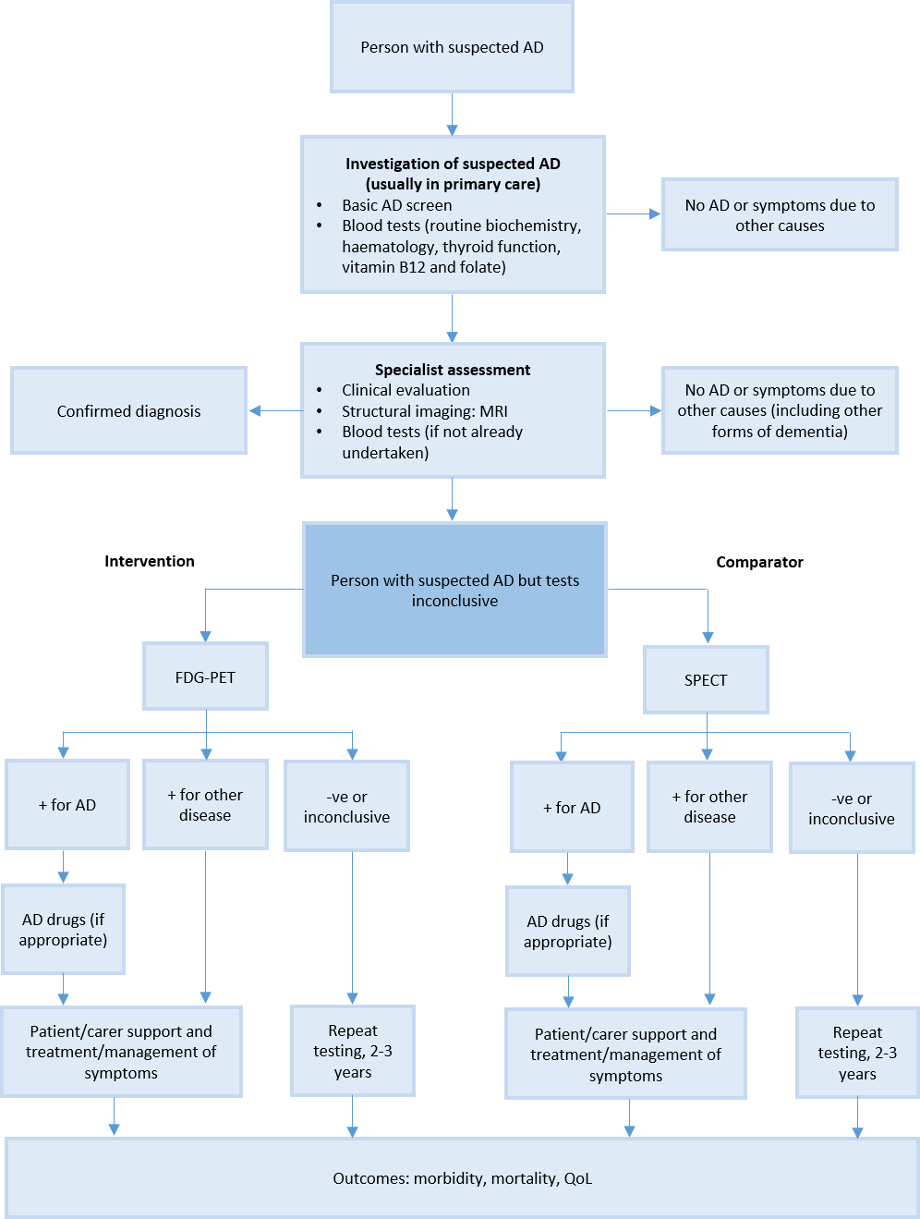
Compared to cerebral perfusion (also described as cerebral blood flow (CBF)) SPECT, brain FDG PET will provide more accurate and confident diagnosis reducing the need for repeat testing and permitting earlier use of AD drugs (acetylcholinesterase inhibitor, Souvenaid nutritional supplement, anti-amyloid antibodies if approved), earlier care planning and more referrals to clinical trials (presently diagnosis is often delayed until dementia is clearly present and the patient is then not suitable for the majority of drug trials which are aimed at early intervention).

(a) Will the proposed medical service be used in addition to, or instead of, the nominated comparator(s)?
In addition to (i.e. it is an add-on service)
Instead of (i.e. it is a replacement or alternative)

If instead of (i.e. alternative service), please outline the extent to which the current service/comparator is expected to be substituted:
If available, brain FDG PET will replace use of CBF SPECT in all instances where CBF SPECT has been used after standard diagnostic work-up for suspected AD by specialist consultation with CT or MRI brain structural imaging and routine blood tests has proven inconclusive. When brain FDG PET is not available, CBF SPECT may still be used. However, there is no clinical justification for doing both tests.

Define and summarise how current clinical management pathways (from the point of service delivery onwards) are expected to change as a consequence of introducing the proposed medical service, including variation in health care resources (Refer to Question 39 as baseline):
A written report including the results of semi-quantitative analysis by comparison to a normal age matched database will be provided to the referring specialist who will then review the diagnosis and management plan of the patient. Also see answer to Q40 above.

PART 6d – INFORMATION ABOUT THE CLINICAL OUTCOME

Summarise the clinical claims for the proposed medical service against the appropriate comparator(s), in terms of consequences for health outcomes (comparative benefits and harms):

FDG PET has greater diagnostic accuracy for AD than the current clinical approach and CBF SPECT. Compared to post-mortem diagnosis, the gold standard and only definitive test for AD and other dementias, the standard clinical approach, even when neuropsychology testing is employed, is 80% sensitive and 70% specific for AD. Compared to post-mortem diagnosis, brain FDG PET has sensitivity of 90% and specificity of 75%.

FDG PET is more accurate than cerebral perfusion SPECT. There are no restrictions on Medicare payment for cerebral perfusion SPECT other than the need for a referral from a medical practitioner. Cerebral perfusion reflects brain metabolism and may assist diagnosis of AD. However, the image quality provided by SPECT, both in terms of spatial resolution (12mm for SPECT versus 4mm for PET) and contrast between normal and abnormal brain, is much less than that obtained with PET and this translates to a 15-20% reduction in accuracy compared to FDG PET in clinical studies.

Formal neuropsychological assessment is used in some patients but FDG PET has greater accuracy when compared to eventual post mortem diagnosis in head to head comparison of patients at first presentation.

In response to the MSAC review of 2015 the following study was undertaken to compare FDG PET to cerebral perfusion SPECT and recently published. Internal Medicine Journal 2020 May 10. doi: 10.1111/imj.14890.

Abstract from “A head-to-head comparison of cerebral blood flow SPECT and ¹⁸F-FDG PET in the diagnosis of Alzheimer’s Disease.”
Background: Clinical diagnosis of Alzheimer’s disease (AD) is only 70% accurate. Reduced cerebral blood flow (CBF) and metabolism in parieto-temporal and posterior cingulate cortex may assist diagnosis. Whilst widely accepted that ¹⁸F-FDG PET has superior accuracy to CBF SPECT for AD, there is very limited head-to-head data from clinically relevant populations and these studies relied on clinical diagnosis as the reference standard.
Aim: To directly compare the accuracy of CBF-SPECT and ¹⁸F-FDG PET in patients referred for diagnostic studies in detecting β-amyloid PET confirmed AD.
Methods: 126 patients, 56% with mild cognitive impairment and 44% with dementia, completed both CBF-SPECT and ¹⁸F-FDG PET as part of their diagnostic assessment, and subsequently underwent β-amyloid PET for research purposes. Transaxial slices and Neurostat 3D-SSP analyses of ¹⁸F-FDG PET and CBF-SPECT scans were independently reviewed by five nuclear medicine clinicians blinded to all other data. Operators selected the most likely diagnosis and their diagnostic confidence. Accuracy analysis used final diagnosis incorporating β-amyloid PET as the reference standard.
Results: Clinicians reported high diagnostic confidence in 83% of ¹⁸F-FDG PET compared to 67% for CBF-SPECT (p=0.001). All reviewers showed individually higher accuracy using ¹⁸F-FDG PET. Based on majority read, the combined AUROC in diagnosing AD was 0.71 for ¹⁸F-FDG PET and 0.61 for CBF-SPECT (p=0.02). The sensitivity of ¹⁸F-FDG PET and CBF-SPECT was 76% vs 43% (p<0.001), whilst specificity was 74% vs 83% (p=0.45).
Conclusion: ¹⁸F-FDG PET is superior to CBF-SPECT in detecting Alzheimer’s disease amongst patients referred for the assessment of cognitive impairment.

The availability of funding for FDG PET would markedly reduce the use of cerebral perfusion SPECT in the diagnostic work up for suspected Alzheimer’s disease.

Please advise if the overall clinical claim is for:
Superiority
Non-inferiority

Below, list the key health outcomes (major and minor – prioritising major key health outcomes first) that will need to be specifically measured in assessing the clinical claim of the proposed medical service versus the comparator:
Safety Outcomes: Both CBF SPECT and brain FDG PET are very safe with no proven drug related adverse effects and both give similar radiation exposure.

Clinical Effectiveness Outcomes:
New tests are required that provide earlier and more accurate diagnosis so that appropriate treatment and prognosis can be given to patients.
Access Economics Report 2009 for AD in Australia stated ‘early diagnosis may reduce overall costs and burden associated with dementia care. Improved diagnosis is now possible through new neuroimaging technologies. Early diagnosis means the person and the family benefit from drug treatments, support and planning strategies. This helps those involved have more control over the disease and their lives and can slow progression due to early access to pharmacotherapies. Financial and legal plans can be made, with the full agreement of the person with dementia. The individual and family can adjust better to the diagnosis, understand the illness and earn how to cope better through adequate counselling and education, remaining productive longer and improving quality of life. This can reduce carer stress and enhance informal care supply, which would help alleviate the shortfalls identified in the modelling.’
Earlier diagnosis of AD will assist in earlier treatment and financial planning including appointment of enduring power of attorney, education of the patient and family that will allow them to better prepare and cope with subsequent decline, earlier trial of symptomatic therapy (eg. Aricept), linkage to community support (AD Association, Age Care Assessment Services, etc), and possibly greater participation in therapy drug trials.

PART 7 – INFORMATION ABOUT ESTIMATED UTILISATION

Estimate the prevalence and/or incidence of the proposed population:
Dementia Australia claims there are 90,000 new cases of dementia diagnosed per year in Australia based on data in The National Centre for Social and Economic Modelling NATSEM (2016) Economic Cost of Dementia in Australia 2016–2056 report. However, there are only approximately 6,000 Medicare claims for brain SPECT per year and not all these are for Alzheimer’s diagnosis.

Estimate the number of times the proposed medical service(s) would be delivered to a patient per year:
One scan once only for diagnosis. In rare instances the scan may be repeated after 1-2 years to increase diagnostic certainty. Imaging changes in Alzheimer’s disease evolve slowly so there is no justification for repeating the scan earlier than one year.

How many years would the proposed medical service(s) be required for the patient?
Once only in 90% of referred patients. 10% may require a repeat scan 1-2 years after the first scan to increase diagnostic certainty.

Estimate the projected number of patients who will utilise the proposed medical service(s) for the first full year:
Best estimate is 4,000 and these would be in place of brain SPECT ordered for suspected Alzheimer’s disease.

Estimate the anticipated uptake of the proposed medical service over the next three years factoring in any constraints in the health system in meeting the needs of the proposed population (such as supply and demand factors) as well as provide commentary on risk of ‘leakage’ to populations not targeted by the service:
Year one: 4,0000
Year two: 8,000 due to more sites developing the required expertize and wider take up by memory specialists – estimate only
Year three: 8,000 – estimate only
Restricting the rebate to those referred by a specialist and only then if standard work-up does not give a diagnosis should contain numbers.

PART 8 – COST INFORMATION

Indicate the likely cost of providing the proposed medical service. Where possible, please provide overall cost and breakdown:
Year one – For fee of $705.05 at 85% ($600) for 4,000 services it would cost $2,400,000 but this would be little additional cost to Medicare as brain FDG PET is substituting for an inferior service at the existing rebate for the inferior test.
Subsequent years – an additional $2,400,000/year if there is a 100% increase in usage

Specify how long the proposed medical service typically takes to perform:

90 minutes – arrival checks, blood glucose check, cannulation then injection of FDG, 30 minute brain uptake time in a quiet room, position on scanner and acquire CT for attenuation correction, acquire 15 minute brain PET scan, then reconstruction of images, analysis compared to normal database, report generation and distribution.

If public funding is sought through the MBS, please draft a proposed MBS item descriptor to define the population and medical service usage characteristics that would define eligibility for MBS funding.
Category I4 – Nuclear Medicine Imaging
FDG PET study of the brain that includes quantitative comparison to a normal database, performed for the diagnosis of Alzheimer’s disease where clinical evaluation by a specialist, or in consultation with a specialist, and structural brain imaging are equivocal. Limitation of one scan per patient per year and not applicable if a cerebral perfusion SPECT study has been performed within the same calendar year.
Fee: $705.05
Attachment: Clinical management algorithms

The approach to current management of the eligible population/s in the absence of public funding for the service proposed
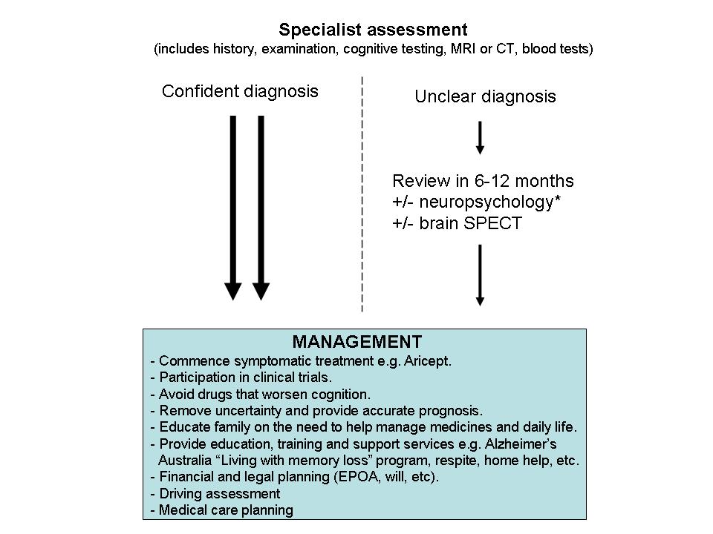

The approach to current management of the eligible population/s if public funding is recommended for the service proposed
