Public Summary Document
Application No. 1431 – HbA1c point of care testing for the diagnosis and management of diabetes mellitus
Applicant: Optum for IVD Australia
Date of MSAC consideration: MSAC 70th Meeting, 27 July 2017
Context for decision: MSAC makes its advice in accordance with its Terms of Reference, visit the MSAC website

Purpose of application
An application requesting three new Medicare Benefit Schedule (MBS) items of HbA1c point-of-care (PoC) testing for the diagnosis and management of diabetes mellitus was received from by the Department of Health from Optum. After receipt of the application, the applicant changed to In-Vitro Diagnostics (IVD) Australia.

MSAC’s advice to the Minister
MSAC considered the available evidence presented in relation to safety, clinical effectiveness and cost-effectiveness of HbA1c PoC testing as an alternative to HbA1c testing in an accredited pathology laboratory for:
- the diagnosis of diabetes in asymptomatic patients; and
- the monitoring of glycaemic management in established diabetes, including in pregnancy.
MSAC did not support public funding for HbA1c PoC tests for diagnosis as it does not appear to be sufficiently accurate in terms of analytical validity or clinical validity for diagnostic purposes.
MSAC deferred its advice on public funding for HbA1c PoC tests for monitoring of glycaemic management pending further advice on accreditation of these tests, a reduction in or further justification of the proposed test fee over the laboratory test fee, and also to request further economic analysis.

Summary of consideration and rationale for MSAC’s advice
MSAC noted that the application sought to add three new MBS items for HbA1c PoC testing for the diagnosis and management of diabetes. MSAC noted that the proposed populations overlap with those currently funded for HbA1c laboratory testing for diabetes diagnosis and management (MBS items 66841, 66551 and 66554), and that the application proposed substituting some or all HbA1c laboratory tests with PoC tests. MSAC noted that the MBS currently subsidises HbA1c testing via laboratory testing once per year for diagnosis and four times per year for established diabetes.
MSAC noted that the application originally proposed the use of this service in three distinct circumstances:
- asymptomatic patients referred to testing for the diagnosis of diabetes;
- management of diabetes in symptomatic patients with established diabetes; and
- management of diabetes in pregnant patients with pre-existing diabetes.
MSAC noted that the application presented limited information on the use of HbA1c PoC testing for the diagnosis of diabetes, and no evidence for the use of HbA1c PoC testing in pregnant women with established diabetes. As such, MSAC agreed that separate consideration of symptomatic and pregnant patients was unjustified and should be presented in combination with each other.
MSAC considered that there are no significant acute differences in the safety of the HbA1c PoC testing technique over standard laboratory testing. MSAC noted that there are a number of different HbA1c PoC testing devices available in Australia. MSAC considered that most HbA1c PoC testing devices have acceptable precision (that is, coefficients of variation that are less than 3%), but that laboratory testing was more precise in most cases. MSAC noted that HbA1c PoC tests have greater variation than laboratory tests, and may report HbA1c levels that are up to 1% higher or lower than laboratory tests.
MSAC considered that the greater variation in HbA1c levels detected in PoC tests creates considerable uncertainty regarding the ability of these tests to accurately differentiate between asymptomatic high-risk patients with and without diabetes. MSAC was particularly concerned that there may be evidence of a negative assay bias suggesting that the PoC test result is more likely to be less than the laboratory result, which would underdiagnose diabetes (Hirst et al, Clin Chem Lab Med 2017; 55(2): 167–180 and Laurence et al, 2009). MSAC advised that a diabetes misdiagnosis can have serious consequences, and as such, the diagnosis of diabetes should be based on the most accurate assay methodology, which is standard laboratory testing. In addition, no analytical validity results were presented with laboratory testing as the reference standard, and formal estimates of sensitivity or specificity against the diagnosis of diabetes.
MSAC considered that the aforementioned assay imprecision associated with HbA1c PoC testing is less critical in established diabetes, as diabetes management is guided by a range of measures alongside HbA1c levels. In addition, MSAC noted that when monitoring established diabetes, clinicians are interested in trends in HbA1c levels across time. Therefore, if the same device is used for PoC testing every time HbA1c is measured, any changes in the results can be relied upon as a measure of change in the patient’s condition.
MSAC considered evidence from an Australian randomised clinical trial (n = 5,234; Laurence G et al 2009), which formed the basis of the evidence for the effectiveness of HbA1c PoC testing compared to laboratory testing for the management of established diabetes. In this trial, the percentage of HbA1c tests within the target range was higher in the PoC testing group compared with the laboratory testing group (64.11% vs 54.74%), with a difference of 9.36% (90% confidence interval [CI] 4.04–14.69). However MSAC noted the following applicability and validity concerns for this study:
- 85% of dropouts were patients in the PoC testing arm (who received both laboratory and PoC tests);
- the study involved a suite of PoC tests (including the urinary albumin/creatinine ratio, lipid tests, and the international normalised ratio), that did not reflect the proposed management algorithms; and
- the study included rural GPs, but excluded populations of interest (e.g. patients with culturally and linguistically diverse backgrounds or those who had difficulty complying with testing requirements).
MSAC also considered evidence from a systematic review (Al-Ansary L et al 2011), which supported non-inferiority of HbA1c PoC testing compared with laboratory testing in overall reduction in HbA1c levels. MSAC considered that there was a non-significant trend toward greater overall reduction in HbA1c for the PoC testing groups, but that this finding was likely influenced by high levels of heterogeneity in the included studies.
MSAC noted that HbA1c PoC testing was dominant (less costly and more effective) in the economic models for both diagnosis and management, but that this was based on uncertain assumptions in both models. MSAC noted that the economic model for diagnosis relied upon the assumption that HbA1c PoC testing would reduce the number of GP visits, but considered that this was very uncertain. MSAC noted that confirmatory HbA1c laboratory tests are recommended by the National Health and Medical Research Council and the Royal Australian College of General Practitioners for the diagnosis of diabetes (although the confirmatory test is not eligible for MBS funding). In addition to confirmatory tests, many patients would also require additional blood tests to manage other risk factors, irrespective of whether they have PoC or laboratory HbA1c testing. MSAC noted that the economic model for management also assumed that PoC testing would lead to a reduction in GP visits, but as with diagnosis, considered that there was uncertainty around this assumption.
MSAC noted that the proposed fee for HbA1c PoC tests was $redacted, which is approximately redacted% higher than the pathology laboratory test fee of $22.80. MSAC noted that the justification provided for the greater cost by the applicant was the cost of meeting quality assurance, training and accreditation requirements. MSAC noted that the price per test for the various HbA1c PoC test devices ranged from $10-$24, and questioned what would be required for quality assurance, training and accreditation in this context (which could reduce cost further). Given this, MSAC queried whether the proposed fee was set too high.
MSAC considered that the cost of implementing an accreditation framework for quality control and quality assurance was uncertain due to the wide variation in the number of GPs and patients across practices, and that the cost of the chosen framework would have a direct impact on service costs and MBS item fees. MSAC indicated that the current Category M accreditation framework may not be suitable for HbA1c PoC testing, but a viable PoC testing accreditation framework would be an important component of any implementation of the requested listing, and should be completed prior to resubmission. MSAC suggested that the possibility of developing an accreditation framework in partnership with primary health networks (PHNs) would be a worthwhile option to investigate further. MSAC also recommended the government-funded Queensland Aboriginal Health Services PoC testing program that is currently in place for Aboriginal Health Services as a starting point for this investigation.
MSAC considered the issue of data integration and emphasised the value of ensuring that GPs could access all HbA1c PoC test results for services administered to a patient. MSAC suggested incorporating a requirement that HbA1c test results be recorded in the clinical record (ideally in the electronic clinical My Health Record) in any eventual MBS item descriptor.
MSAC did not support funding for HbA1c PoC testing for the diagnosis of diabetes, because the Committee did not consider that the analytical accuracy of the test was sufficient for diagnosis, and also because of the likely need for confirmatory laboratory tests and blood testing for the management of other risk factors in addition to HbA1c PoC tests. As HbA1c PoC tests may improve in accuracy with time, MSAC noted that new assay performance data to support a conclusion of improved accuracy would assist with any resubmission. Any resubmission for diagnosis would need to be considered via ESC.
MSAC deferred its advice on funding for the management of diabetes with HbA1c PoC testing to seek further advice on an accreditation framework, a reduction in or further justification of the proposed test fee over the laboratory test fee and provide improvements in the economic analyses. MSAC requested the base case of the revised economic analyses for management should:
- be for management alone (ie omit the use of HbA1c PoC for diagnostic testing);
- include a reduction in HbA1c PoC test fee to at or below the laboratory test cost;
- account for accreditation costs;
- factor in a frequency of 3-monthly HbA1c PoC tests, as these are routinely conducted for long-term management of diabetes; and
- factor in alignment with standard laboratory tests conducted for patients on an annual basis (ie by avoiding duplication with a fourth HbA1c PoC test at this time point).
This further information for management would need to be considered via ESC.

Background
MSAC has not previously reviewed this application.

Prerequisites to implementation of any funding advice
The tests currently funded under the Pathology Services Table (PST) must be performed in a NATA accredited pathology laboratory. In addition, under the current PST legislation, only Approved Pathology Authorities (APAs), as registered with the Department of Human Services, can provide pathology services.

Proposal for public funding
The proposed MBS item descriptors are summarised in Table 1.
Table 1 Proposed MBS item descriptors
Category 6 – PATHOLOGY SERVICES Group PXX – Point of Care Tests
MBS [item number]
Quantitation of HbA1c (glycated haemoglobin) via point of care testing performed for the diagnosis of diabetes in asymptomatic patients at high risk. (Item is subject to rule 25)
Fee: $redacted
Category 6 – PATHOLOGY SERVICES Group PXX – Point of Care Tests
MBS [item number]
Quantitation of glycated haemoglobin via point of care testing performed in the management of established diabetes. (Item is subject to rule 25)
Fee: $redacted
Category 6 – PATHOLOGY SERVICES Group PXX – Point of Care Tests
MBS [item number]
Quantitation of glycated haemoglobin via point of care testing performed in the management of pre-existing diabetes where the patient is pregnant – including a service in item 66551 (if performed). (Item is subject to rule 25)
Fee: $redacted
It was proposed that the MBS items would be placed in a new “Point of Care Tests” Group in the pathology services table. It was considered that a safe, practical level of accreditation, with corresponding quality assurance (QA) would be required for HbA1c PoC testing.
The proposed MBS item fee for HbA1c PoC testing was $redacted, which was greater than fee for the HbA1c pathology laboratory test of $22.80 that includes an MBS fee of $16.80 and a patient episode fee of $6. This did not take into account the additional GP visits associated with the laboratory test – as patients require an initial and review consultation versus the single consultation required with the HbA1c PoC test.

Summary of Public Consultation Feedback/Consumer Issues
Public consultation feedback was received from 1 GP practice manager, 1 specialist, 1 QAAMS program manager, 1 organisation from the IVD industry, 3 peak bodies and 1 medical student.
Some of the positive feedback included the following:
- greater accessibility (particularly in regional/rural areas);
- decreased GP visits;
- decreased loss of patients to follow-up;
- increased patient convenience;
- education and management;
- increased health outcomes; and
- improved quality of life.
Some of the negative feedback from the public consultation included the following:
- increase in practice time;
- increase in practice costs;
- changed model of care;
- requirement for other pathology tests; and
- potential duplicate testing.

Proposed intervention’s place in clinical management
Diabetes mellitus is a group of metabolic disorders characterised by hyperglycaemia resulting from defects in insulin secretion, action or both. Early detection and effective therapy providing good metabolic control, can delay the onset and progression of diabetes late complications, resulting in better outcomes for patients.
The proposed medical service was for the use of in vitro diagnostic test instrument that meets defined acceptable performance criteria comparable to laboratory based testing being performed at or near the site of patient care (e.g. within GP consulting rooms) for the quantification of HbA1c (glycated haemoglobin) in human whole blood.
There were two populations relevant to the MBS items proposed for this application:
- Asymptomatic patients with a high risk of developing diabetes mellitus.
- Patients with established diabetes who require ongoing management (including monitoring of pregnant patients with existing diabetes).
The two proposed patient populations were the same as those currently funded for HbA1c testing for the diagnosis and management of diabetes (MBS items 66841, 66551 and 66554).
Practitioners would perform the proposed medical service under the same circumstances as they would order the existing HbA1c tests and hence the clinical management algorithm would remain the same as current practice.

Comparator
The nominated comparator for HbA1c PoC testing was HbA1c testing performed in an accredited laboratory with blood samples drawn at a pathology collection centre (MBS items 66841, 66551 and 66554).
Currently, HbA1c tests are predominantly performed in accredited laboratories and patients attend a pathology collection centre to have a blood sample drawn and sent to a laboratory for measurement.
The three new proposed MBS items would be similar to the currently listed diagnostic tests for HbA1c currently used to diagnose diabetes in asymptomatic patients at high risk (see MBS item 66841), and to monitor the effectiveness of diabetes treatment and long term blood glucose in people with established diabetes (see MBS items 66551 and 66554 in pregnant patients).

Comparative safety
Laboratory HbA1c testing was previously evaluated by the MSAC in 2014, at which time no serious safety concerns were identified (Parsons et al 2014). Point-of-care tests are comparatively safer in terms of risk of infection, as most can be conducted with a finger prick rather than venous puncture. No studies were identified that directly compared the safety of PoC and laboratory HbA1c tests.
HbA1c PoC testing is a simple procedure that has limited safety concerns. HbA1c PoC testing is non-inferior for safety when compared with pathology laboratory testing.

Comparative effectiveness
The application stated that the effectiveness of HbA1c PoC testing has been demonstrated in several publications. Specifically the most applicable trial in terms of the managed diabetes patient population was an Australian cluster randomised trial of PoC testing in rural, remote and urban populations reported by Laurence et al (2009).
All patients enrolled in the trial were >18 years of age with most patients using dietary control, insulin and prescription tablets to control their diabetes. Over 34% of patients had been diagnosed with diabetes between one and five years. The trial found no difference in results between those in rural, remote or urban areas.
The key result of this trial found that patients who received the HbA1c PoC test were more likely to have controlled diabetes compared with the pathology laboratory test over the 18 month trial period (65.5% vs 56.2%, [p<0.001]). Patients who received the HbA1c PoC test had lower hospital costs.
The critique noted that evidence of the effectiveness of HBA1c PoC testing, related to the proportion of patients achieving good glycaemic control, was presented from two randomised controlled trials (RCT) (Khunti et al 2006; Laurence et al 2009). The Khunti et al (2006) trial had significant applicability issues to the Australian context. As a result, the pivotal clinical trial reported by Laurence et al (2009) formed the basis of the evidence for effectiveness.
The trial met the criteria to demonstrate the non-inferiority of HbA1c PoC testing on glycaemic control compared to laboratory testing (relative difference = 9.36% [90% CI 4.04, 14.69] of patients achieved good glycaemic control), albeit this was calculated with 90% confidence; however, there are important applicability and internal validity concerns, regarding:
- dropouts in the PoC arm,
- a suite of PoC tests were used that does not reflect the proposed management algorithms, and
- exclusion of populations of interest (e.g. culturally and linguistically diverse background, difficulty complying with testing requirements).

Diagnostic accuracy and mean bias
The application included two studies that reported the mean absolute difference between PoC and laboratory testing (Hirst et al 2017; Laurence et al 2009).
As stated in the application, and indicated by the data presented in Figure 1, the assessment of limits of agreement suggest that the 95% of DCA 2000 PoC test results will be within -1.07% HbB1c below, and +0.97% HbA1c higher than a laboratory test result.
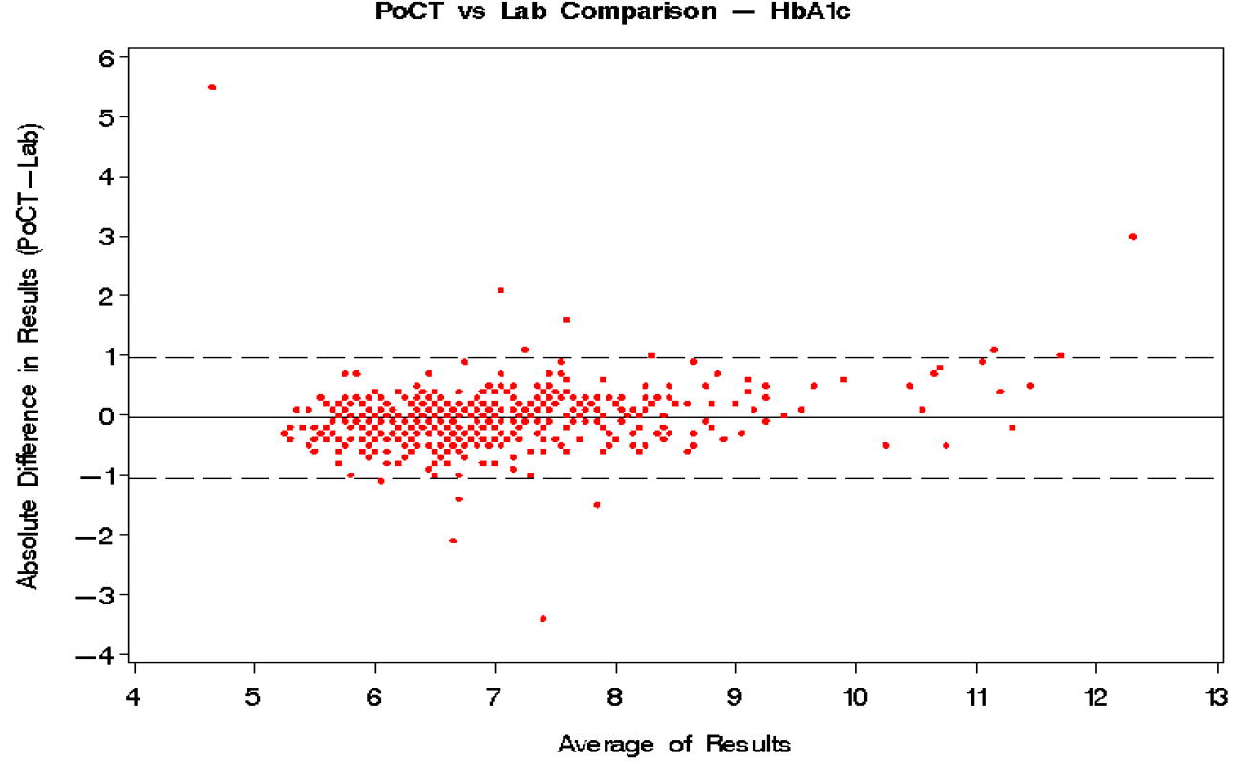
Figure 1: Absolute difference in results vs average of results for HbA1c over all geographic regions
Source: Laurence et al (2009)
The systematic review by Hirst et al (2017) also reported the mean difference as shown in Figure 2.
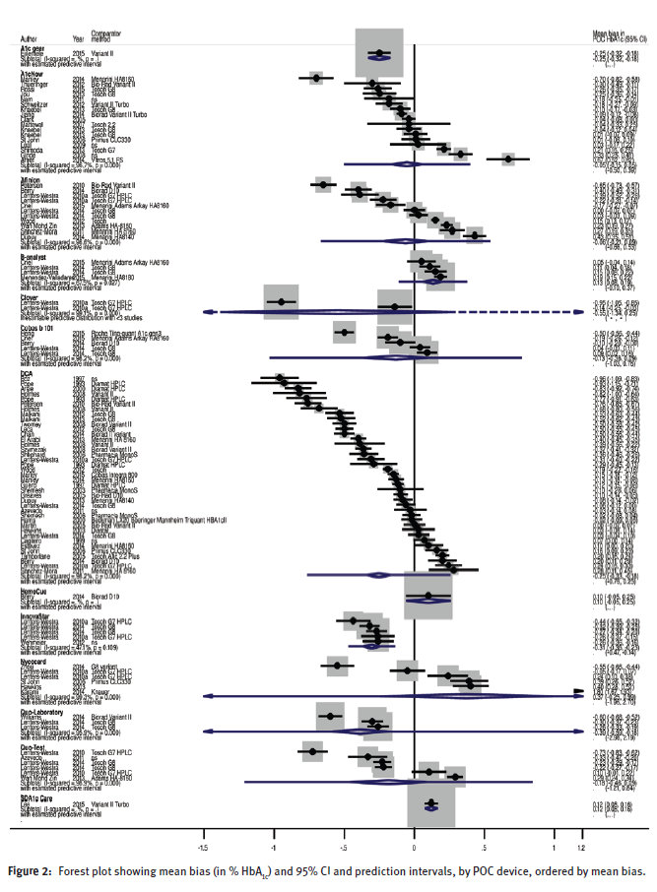
Source: Hirst et al (2017)
For patients with established diabetes, the Hirst et al (2017) review reported the mean bias between PoC analysers available in Australia and laboratory HbA1c test results ranged between -0.96% (95% CI -1.09% to -0.83%) to +0.43 (95% CI +0.35% to +0.51%).

Clinical claim
On the basis of the benefits and harms reported in the evidence base, it was suggested that, relative to laboratory HbA1c testing, HbA1c PoC testing has non-inferior safety and effectiveness for the management of established diabetes. This claim is reasonably justified by the evidence presented in the application.

Economic evaluation
The application presented a cost-utility analysis for the diagnosis of diabetes and one for the management of diabetes, in line with the proposed MBS item descriptors.
Model 1: Diagnosis of diabetes
A cost-utility analysis was undertaken to determine the value of HbA1c PoC testing compared to pathology laboratory testing in the diagnosis of diabetes in patients at high risk. A summary of the key parameters of the model are presented in Table 2.
Table 2 Summary of the economic evaluation for the diagnosis of diabetes
Perspective | Australian Government
Comparator | HbA1c pathology laboratory testing
Type of economic evaluation | Cost-utility analysis
Sources of evidence | Randomised controlled trial of PoC testing in Australia; systematic review of economic evaluations
Time horizon | 12 months
Outcomes | Incremental cost per QALY
Methods used to generate results | Simple cost-effectiveness model
Health states | Patients adherent to HbA1c test request; Patients non-adherent to HbA1c test request; Patient has diagnosed diabetes; Patient has undiagnosed diabetes; Patient does not have diabetes; Controlled diabetes; Uncontrolled diabetes
Cycle length | 3 months
Discount rate | Not applicable
Software packages used | Microsoft Excel 2010
Abbreviations: HbA1c, glycated haemoglobin; MBS, Medicare Benefits Schedule; PoC, point of care; QALY, quality adjusted life year
The overall costs and outcomes, and incremental costs and outcomes as calculated for the test and comparator in the model, with the base case assumptions for the diagnosis of diabetes, are shown in Table 3.
Table 3 Incremental cost-effectiveness ratio – HbA1c-based diagnosis of diabetes
Resource item description | PoC testing | Pathology laboratory testing | Incremental
12 months
Cost | $redacted | $redacted | redacted
Effect (QALYs) | 0.8840 | 0.8836 | 0.0004
 |  | Incremental cost per QALY gained | DOMINANT
Abbreviations: PoC, point of care; QALY, quality adjusted life year
The critique noted that the base case result for the diagnosis of diabetes model showed that HbA1c PoC testing is dominant for diabetes diagnosis over 12 months (ie more effective and less costly than HbA1c laboratory testing). The diagnosis of diabetes model results are driven by the cost saving from PoC testing involving less GP visits than laboratory testing.
Model 2: Management of diabetes
A stepped evaluation leading to a cost-utility analysis was undertaken:
- Step 1 – trial-based cost-effectiveness model (ie derived from the PoC test GP trial results over 18 months) yielding an incremental cost per responder.
- Step 2 – a cost-utility model (ie derived from the PoC test GP trial results over 18 months, and associated utility values) yielding an incremental cost per QALY.
- Step 3 – a cost-utility model (ie derived from the PoC test GP trial results over 18 months with extrapolation to 3 years, and associated utility values) yielding an incremental cost per QALY.
A summary of the key characteristics of the economic evaluation are presented in Table 4.
Table 4 Summary of the economic evaluation for the management of diabetes
 | Step 1 | Step 2 | Step 3
Perspective | Australian Government | Australian Government | Australian Government
Comparator | HbA1c pathology laboratory testing | HbA1c pathology laboratory testing | HbA1c pathology laboratory testing
Type of economic evaluation | Cost-effectiveness analysis | Cost-utility analysis | Cost-utility analysis
Sources of evidence | Randomised controlled trial of PoC testing in Australia; systematic review of economic evaluations | Randomised controlled trial of PoC testing in Australia; systematic review of economic evaluations | Randomised controlled trial of PoC testing in Australia; systematic review of economic evaluations
Time horizon | 18 months | 18 months | 3 years
Outcomes | Incremental cost per responder (where a responder is defined as someone having ‘controlled diabetes’) | Incremental cost per QALY | Incremental cost per QALY
Methods used to generate results | Markov model | Markov model | Markov model
Health states | Controlled diabetes, Uncontrolled diabetes | Controlled diabetes, Uncontrolled diabetes | Controlled diabetes, Uncontrolled diabetes
Cycle length | 3 months | 3 months | 3 months
Discount rate | 5% per annum | 5% per annum | 5% per annum
Software packages used | Microsoft Excel 2010 | Microsoft Excel 2010 | Microsoft Excel 2010
Abbreviations: HbA1c, glycated haemoglobin; MBS, Medicare Benefits Schedule; PoC, point of care; QALY, quality adjusted life year
The overall costs and outcomes, and incremental costs and outcomes as calculated for the test and comparator in the model, with the base case assumptions for the management of diabetes are shown in Table 5. The base case result shows HbA1c PoC testing is dominant (ie more effective and less costly) than HbA1c pathology laboratory testing (ICER -$31,747 per QALY gained).
The critique noted that, over the PoC GP trial period of 18 months, the intervention is still dominant when the assumed cost differences were included. An additional analysis of 18 months with no differences in hospital and medicines costs was presented in the critique and resulted in an ICER of $redacted. This analysis corresponded with the non-significant cost difference results from the PoC GP trial and 18-month period of follow-up.
Table 5 Incremental cost-effectiveness ratio for HbA1c-based diabetes management by model time horizon (discounted)
Resource item description | PoC testing | Pathology laboratory testing | Incremental
18 months
Cost | $redacted | $3,298.14 | redacted
 |  | Incremental cost per responder | -$810.19
18 months
Cost | $redacted | $3,710.67 | redacted
Effect (per responder) | 1.309 | 1.307 | 0.002
 |  | Incremental cost per QALY gained | DOMINANT
3 years (base case)
Cost | $redacted | $6,648.58 | redacted
Effect (QALYs) | 2.346 | 2.342 | 0.005
 |  | Incremental cost per QALY gained | DOMINANT
Abbreviations: PoC, point of care; QALY, quality adjusted life year

Financial/budgetary impacts
The application estimated the budgetary impact for both the diagnosis and management of diabetes using data from the MBS for items 66551 (management of diabetes) and 66841 (diagnosis of diabetes). As noted by PASC, the MBS data are coned, and therefore underestimate the actual number of HbA1c pathology laboratory tests performed.
The number of services was adjusted by the coning rate of 34% to estimate the real number of HbA1c tests. The costs associated with both the diagnosis and management of diabetes included costs associated with the MBS, PBS and the hospital setting. The costs used in the budget impact model sourced data from the MBS, the DoH PoC testing GP trial and the Australian Government Department of Human Services.
The estimated number of HbA1c PoC test services was redacted in 2017, increasing to redacted in 2021. The majority of these tests (approximately redacted) were expected to be in patients already diagnosed with diabetes.
The net impact to the MBS was estimated to be $redacted in 2017, increasing to $redacted in 2021. This difference was due to the increase in the number of HbA1c PoC tests being used. If there would be no additional growth in the number of tests used the net impact to the health sector was estimated to be cost saving.
Table 6 Net costs to the MBS associated with HbA1c PoC testing
Year | 2017 | 2018 | 2019 | 2020 | 2021
Net change in test costs ($) | redacted | redacted | redacted | redacted | redacted
Net change in GP visit costs ($) | 23,675 | 48,571 | 74,734 | 102,214 | 131,063
Total net change to the MBS ($) | redacted | redacted | redacted | redacted | redacted
Abbreviations: GP, general practitioner; HbA1c, glycated haemoglobin; PoC, point of care; MBS, Medicare Benefits Schedule
The critique noted that there was uncertainty around the analysis of MBS net financial impact, which was governed by the uptake assumptions, that PoC testing would substitute for laboratory testing on a 1:1 basis, that there would be fewer GP visits associated with PoC testing, and that coning currently accounts for 34% of HbA1c diagnostic tests. Coning results in fewer tests being reimbursed and created uncertainty as to the exact number of HbA1c diagnostic tests provided in Australia. The assumption of fewer GP visits for PoC testing was uncertain given patients may have multiple comorbidities. No evidence was provided in the application to support uptake estimates.

Key issues from ESC for MSAC
ESC noted that laboratory HbA1c testing is already subsidised for the diagnosis and management of diabetes and that the application requested MBS listing of HbA1c PoC testing for the diagnosis of diabetes and for the management of patients with established diabetes.
ESC noted that there were no significant safety concerns with HbA1c PoC testing.
ESC noted that there was little information in the application on the use of HbA1c PoC testing in people without diagnosed disease. The applicant’s arguments that the clinical validity of using HbA1c testing for diagnosis had been established in MSAC Application 1267 — HBA1c Test for the Diagnosis of Diabetes Mellitus and that the analytical validity of HbA1c PoC testing was non-inferior to laboratory testing regardless of whether or not a person had been diagnosed with diabetes. However, ESC noted that the Hirst JA et al 2017 review of the performance of HbA1c PoC test devices indicated that the mean bias between PoC testing and laboratory testing ranged between -0.96% and +0.43%. This in turn meant that patients with HbA1c values between 6.07% and 7.46% are more likely to be incorrectly diagnosed due to random error than a patient with an HbA1c value above this range.
ESC considered that clinicians may still continue to order laboratory confirmatory tests if an HbA1c PoC test indicates that a person may have diabetes, particularly if the person is asymptomatic. The Royal Australian College of General Practitioners (RACGP) guidelines require a second confirmatory test to be undertaken before an asymptomatic individual is diagnosed as having diabetes.
ESC noted that implementing an accreditation framework for quality control and quality assurance of HbA1c PoC testing was estimated to cost each practice $redacted per year. Assuming that a practice undertook 260 tests per year, the costs associated with quality assurance and quality control were calculated to be $redacted per test. ESC noted that this cost was uncertain because there is wide variation as to the number of GPs and patients between different practices.
ESC queried the difference between the requested fee ($redacted) for undertaking HbA1c PoC testing and the cost per laboratory test used in the economic model ($redacted). The difference in fees between HbA1c PoC testing and laboratory testing was $redacted. ESC noted that the application had factored in a cost for quality assurance of $redacted per HbA1c PoC test, but considered that the justification for the additional $6.33 was unclear.
ESC noted that many patients would still need to have formal blood tests to manage other risk factors, irrespective of whether they have an HbA1c PoC or laboratory test and that the economic model for the diagnosis of patients relied upon an assumption that HbA1c PoC testing would reduce the number of GP visits. ESC considered that this assumption remained uncertain, particularly if other blood tests are performed as part of diagnosis and monitoring.
ESC noted that the utility values used in the economic model were based upon UK data from 2002 and queried whether more recent utility values were available.
ESC advised that there was uncertainty around the estimates of the number and costs of HbA1c PoC tests conducted each year because of:
- uncertainty around the number of current HbA1c tests conducted each year. ESC noted that current MBS statistics on laboratory HbA1c testing would underestimate test numbers due to coning rules. ESC also noted that HbA1c PoC testing may not be subject to coning and as such the number of tests paid for under the MBS overall could increase;
- a potential for overuse and over-testing, particularly in asymptomatic patients at risk of diabetes;
- uncertainty around how frequently HbA1c PoC testing would replace laboratory testing;
- uncertainty about the extent to which clinicians would order a confirmatory laboratory HbA1c test as well as undertaking a HbA1c PoC test, particularly in previously undiagnosed patients; and
- an uncertain assumption that uptake of HbA1c PoC testing would increase from 1% to 5% over five years.
ESC noted that currently the MBS only subsidises HbA1c testing once per year for diagnosis and four times a year for established diabetes. ESC queried how HbA1c PoC testing should best interact with these counts
ESC noted that there were three proposed MBS item descriptors included in the application - one for diagnosis, one for management of established diabetes, and one for management of pre-existing diabetes when the patient is pregnant. ESC noted that no evidence on the use of HbA1c PoC testing in pregnant women with pre-existing diabetes had been presented in the application. ESC noted that this may have been because these patients were included in the evidence presented for established diabetes, and suggested that the third item descriptor could be deleted. ESC noted that HbA1c testing is inappropriate for the diagnosis of gestational diabetes.
ESC noted that consumers are likely to want access to an HbA1c PoC test if it helps them manage their condition better.
ESC KEY ISSUES | ESC ADVICE
Coning | Coning means that 34% of HbA1c tests are not reimbursed, but ESC was uncertain as to whether the correct multiplier was used to calculate the estimated total number of HbA1c tests – which may bias the results in favour of the comparator
Translation issues | The cost of the test remains uncertain, with approximately $6 of the $redacted unaccounted for, compared to the $15.05 for laboratory testing
Duplication | As person-centred care is a driver for PoC tests, ESC was uncertain whether HbA1c PoC testing would substitute or complement current rates of laboratory testing
Need for pregnancy item listing | ESC was uncertain as to why the pregnancy item is required but noting that intention may be to align with 66841 (established diabetes) and 66551 (pre-existing diabetes where the patient is pregnant)

Other significant factors
Nil

Applicant’s comments on MSAC’s Public Summary Document
IVD Australia looks forward to working with the Department of Health and other stakeholders to provide the additional advice that MSAC has requested so that a recommendation can be made and health outcomes of Australians living with diabetes can be improved. The decision not to recommend funding of point of care HbA1c testing for the diagnosis of diabetes is disappointing. IVD Australia will continue to work on opportunities to improve outcomes for the up to 500,000 Australians living with silent undiagnosed type 2 diabetes.

Further information on MSAC
MSAC Terms of Reference and other information are available on the MSAC Website:
visit the MSAC website

https://www.diabetesaustralia.com.au/diabetes-in-australia

