MSAC Application 1769
Human leukocyte antigen testing for sensitivity to carbamazepine in patients with epilepsy
PICO Set Document

Population

Describe the population in which the proposed health technology is intended to be used:
Carbamazepine is an anticonvulsant medication used in the first-line treatment of epilepsy, neuropathic pain stemming from trigeminal neuralgia, and acute manic and mixed episodes in bipolar I disorder. Carbamazepine’s mode of action is through the inhibition of action potentials and decreased synaptic transmission (Maan et al 2023). Carbamazepine is marketed under several brand names; however, only Tegretol® (Novartis Pharmaceuticals Australia Pty Ltd) and Carbamazepine Sandoz (Sandoz Pty Ltd) are listed on the PBS.
Although associated with milder side effects such as dizziness, drowsiness, ataxia, nausea, and vomiting, carbamazepine comes with a black box warning for severe dermatologic hypersensitivity reactions, specifically Stevens–Johnson syndrome (SJS) and toxic epidermal necrolysis (TEN, also known as also known as Lyell’s syndrome), as well as drug reaction with eosinophilia and systemic symptoms (DRESS), and maculopapular exanthema (MPE), involving the skin and mucous membranes (Phillips et al 2017). These potentially lethal adverse drug reactions typically occur within the first 3-months of commencing treatment with carbamazepine (Ahmed et al 2021; Maan et al 2023). SJS/TEN are examples of idiosyncratic or Type B adverse drug reaction, in that they are not dose-dependent and require the immediate cessation of the drug to ameliorate symptoms. Hypersensitivity to carbamazepine is an example of an immune-mediated adverse event that is associated with variants in the human leukocyte antigen genes (HLA-A and HLA-B) (Duong et al 2017; Pirmohamed 2023).
Epilepsy
The most common indication for the prescription of carbamazepine is epilepsy, a chronic neurological condition characterised by recurrent seizures that are caused by a disruption of the electrical activity in the brain. Carbamazepine is prescribed specifically for partial seizures with complex symptomatology (psychomotor, temporal lobe), generalised tonic seizures (grand mal), and mixed seizure patterns. Seizures do not always involve convulsions but can include changes to sensation, awareness, behaviour or movement. The underlying cause of epilepsy is only known for approximately 50% of patients, with known causes including injury and stroke, prolonged oxygen deprivation, brain infections and tumours, neurodegenerative conditions (such as dementia) and congenital abnormalities (AIHW 2022). Commonly available anti-epileptic drugs such as carbamazepine (Tegretol), lamotrigine (Lamictal), vigabatrin (Sabril) and gabapentin (Neurontin) among others (The Epilepsy Centre 2023), are capable of controlling seizures in up to 70% of people with epilepsy (WHO 2019). Carbamazepine is the 5th most commonly prescribed, accounting for 9.4% (292,216) of anti-epileptic drug prescriptions in Australia in the year 2019-20 (AIHW 2022) (Figure 1).
Based on self-reported data, it was estimated that 150,838, or 0.6% of Australians had epilepsy, with the same overall prevalence reported in both males and females (Figure 2). Rates of self-reported diagnosis increased with age, with epilepsy most prevalent in the 65+ age group (0.9%). However, rates of epilepsy are significantly higher in Indigenous Australians, who are twice as likely to report having epilepsy as non-Indigenous Australians (1.2% vs 0.6%, respectively), with male Indigenous Australians reporting slightly higher rates than females (1.3% and 1.0% respectively) (AIHW 2022).
For the purposes of HLA genotyping prior to patients commencing treatment with carbamazepine, it is important to estimate the incidence of epilepsy. As there is a lack of Australian data on the incidence of epilepsy, international estimates must be relied on. The systematic review and meta-analysis of international studies by Fiest et al (2017) estimates the incidence of epilepsy as 61.44 per 100,000 person-years (95% CI 50.75–74.38) (Fiest et al 2017). With Australia’s current population of approximately 26.5 million people, this would translate to 16,282 incident epilepsy cases per year; however, it should be noted that not all incident cases will be prescribed carbamazepine.
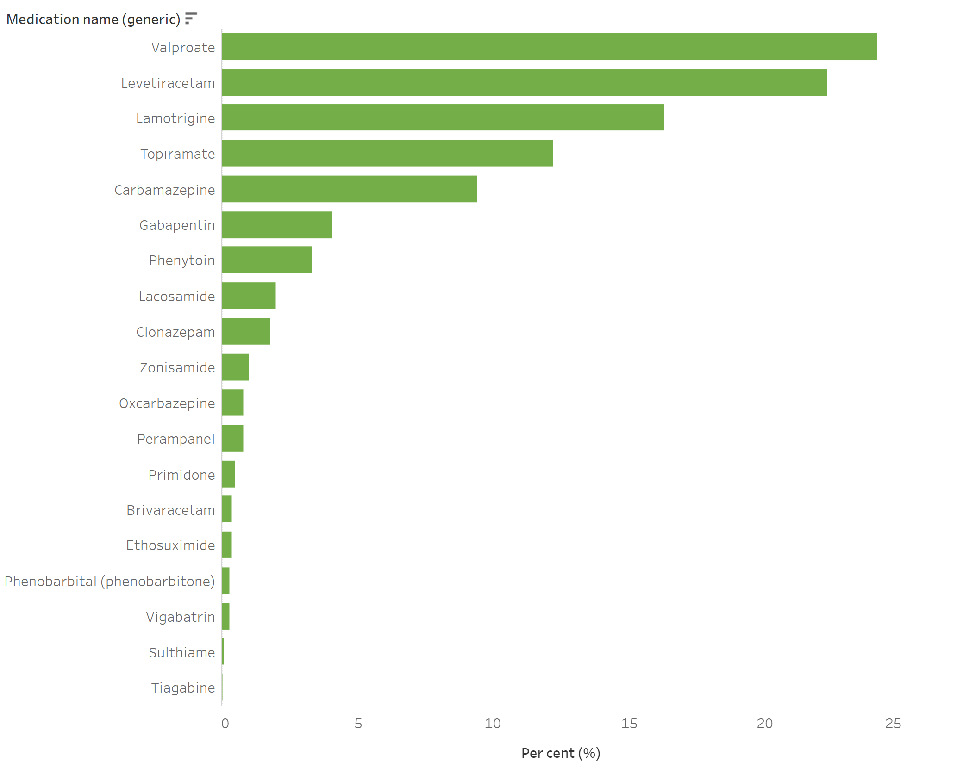

Figure 1 Antiepileptic prescriptions dispensed in Australia in 2019–20 (AIHW 2022)
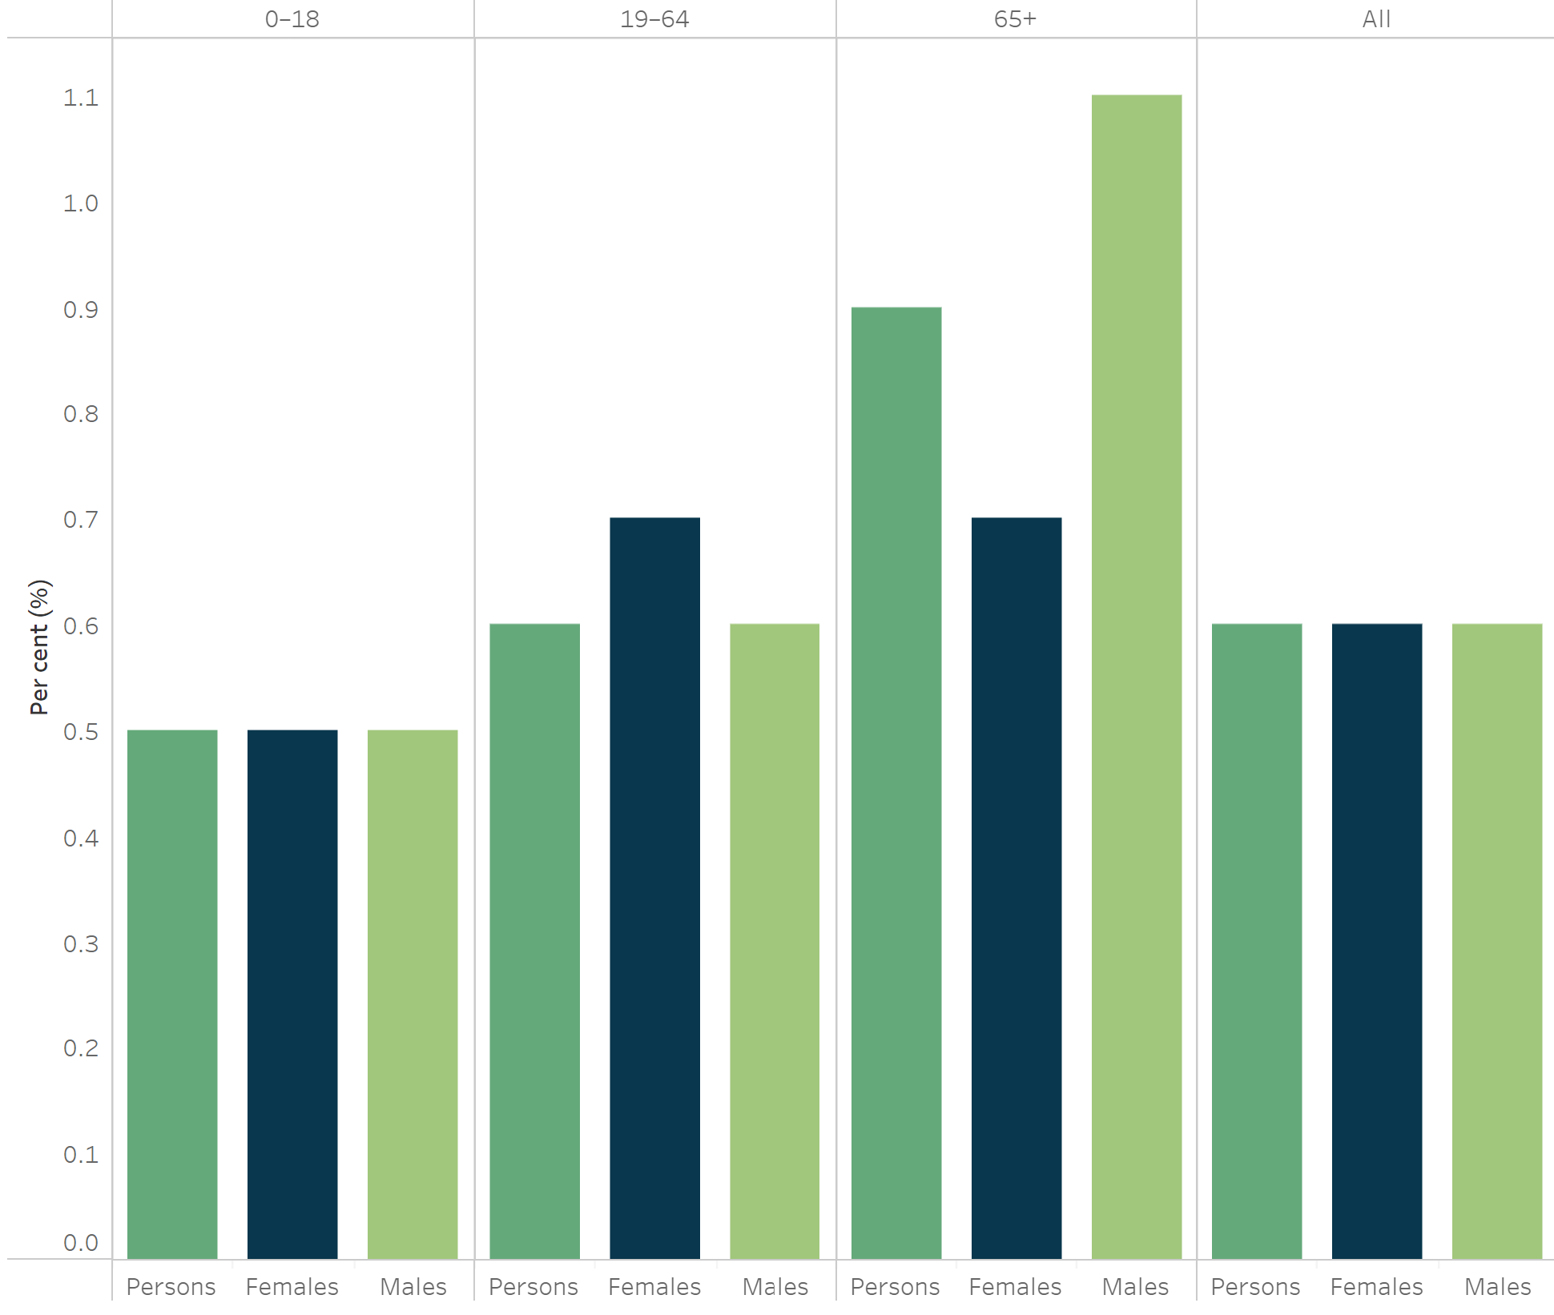

Figure 2 Prevalence of self-reported epilepsy in Australia, by age and sex, 2017–18 (AIHW 2022)

Trigeminal neuralgia
Trigeminal neuralgia is a debilitating neuropathic pain disorder characterised by recurrent, short-lasting but severe episodes of intense, electric shock-like pain along the three divisions of the trigeminal nerve, affecting the lips, eyes, nose, scalp, forehead, upper jaw, and lower jaw. Carbamazepine is the first-line treatment of choice. There is a paucity of data describing the prevalence and incidence of trigeminal neuralgia in Australia, and again international estimates must be relied upon. Trigeminal neuralgia is a rare condition, with a systematic review reporting an annual incidence ranging from 4.3 to 8 per 100,000, with incidence increasing with age. The average age of onset is estimated to be 53 to 57 years; however, incidence increases to 17.5 and 25.9 per 100,000 in 60-69-year-old and >80 years respectively (Khawaja & Scrivani 2023; Trigeminal Neuralgia Association Australia 2021). Based on the current Australian population this would translate to incident trigeminal neuralgia cases per year ranging from 1,140 to 2,120. As noted above with epilepsy, not all incident trigeminal neuralgia cases would be prescribed carbamazepine.
Stevens–Johnson syndrome (SJS), toxic epidermal necrolysis (TEN), drug reaction with eosinophilia and systemic symptoms (DRESS) syndrome and maculopapular exanthema (MPE)
SJS and TEN are examples of severe and potentially life-threatening type IV delayed allergic reactions that result from the inappropriate activation of T-cells in response to carbamazepine (Böhm et al 2018). SJS and TEN are thought to be variants of the same condition with similar clinical features but differentiated by the extent of the body surface area affected: 1–10% for SJS, 10–30% for SJS/TEN overlap and >30% for TEN (Copaescu & Trublano 2022; Frantz et al 2021; Owen & Jones 2021). SJS and TEN are associated with significant morbidity with clinical manifestations including dark-purple skin infiltration, facial swelling, blisters and erosions occupying large areas of the skin, mainly on the trunk and face, mucosal involvement, adenopathy, fever above 38.5 °C as well as haematological and biochemical laboratory abnormalities including eosinophilia and elevated liver enzymes (Böhm et al 2018; Copaescu & Trublano 2022). DRESS is a severe hypersensitivity reaction characterised by potentially life-threatening generalised cutaneous eruptions with systemic manifestations including maculopapular rash, erythroderma, facial or extremity oedema, purpura, pustules, focal monopolar, mucous-membrane involvement as well as fever above 38.5 °C. DRESS may also affect the liver, kidneys and lungs leading to hepatic or renal failure in some cases. MPE; however, is a milder reaction with only the presence of rash without mucosal or organ involvement, or systemic features (Phillips et al 2017; Duong et al 2017).
The presence of any of these symptoms warrants immediate cessation of treatment with carbamazepine (as well as drugs in the same family) and urgent hospital referral (Böhm et al 2018).
Hypersensitivity reactions to carbamazepine are associated with specific HLA alleles: HLA-A*31:01 and HLA-B*15:02. A meta-analysis reported that the HLA-A*31:01 and HLA-B*15:02 alleles are significantly associated with the risk of developing carbamazepine-induced SJS or TEN (OR: 2.88 and OR: 24.51, respectively) (Rashid et al 2022). The prevalence of these alleles is dependent on the patient’s ethnic origin: 10–15% in Han Chinese, Thais and South-East Asians, <1% in Koreans and Japanese and <0.1% in those with European ancestry (Böhm et al 2018; Copaescu & Trublano 2022). However, as either heterozygous carriers or individuals homozygous for either the HLA-A*31:01 or HLA-B*15:02 alleles are at risk of a severe cutaneous reaction to carbamazepine, genotyping is recommended for all individuals about to commence treatment with carbamazepine (Pirmohamed 2023).
The incidence of DRESS syndrome in new users of carbamazepine is estimated to be one per 1,000 to one per 10,000. Although the incidence of SJS and TN is extremely rare in comparison, estimated to be two per one million people, they are all associated with significant mortality, especially as the extent of disease progresses (Duong et al 2017). SJS has a better prognosis with the rate of mortality in these patients estimated to be 5%. This rate increases sharply to 30% for those patients in the SJS/TEN overlap, then up to 50% for those patients with TEN. The primary cause of mortality is multiorgan failure from sepsis, often from skin or peripheral line infection as well as hypovolemia from fluid loss (Owen & Jones 2021). The rate of mortality from DRESS ranges from 1-10%, usually from multi-organ failure, with surviving patients susceptible to autoimmune diseases such as lupus, thyroiditis, diabetes or scleroderma (Duong et al 2017).
No data are available on the rate of SJS, TEN or DRESS in Australia.

Specify any characteristics of patients with the medical condition, or suspected of, who are proposed to be eligible for the proposed health technology, describing how a patient would be investigated, managed and referred within the Australian health care system in the lead up to being considered eligible for the technology:
The target population for HLA-A*31:01 and HLA-B*15:02 genotyping is patients with epilepsy or neuropathic pain resulting from trigeminal neuralgia who are about to commence treatment with carbamazepine. As discussed above, although there are strong correlations between the development of hypersensitivity syndrome and cutaneous adverse drug reactions with the presence of HLA-A*31:01 and HLA-B*15:02 in certain ethnic groups, especially in Asian populations(TGA 2019), testing for the presence of these alleles is recommended in all new patients prior to the commencement of therapy, not just those populations considered to be genetically at-risk, in order to guide prescription of the most appropriate antiepileptic drug (Rashid et al 2022; Biswas et al 2022).

Provide a rationale for the specifics of the eligible population:
Targeted genotyping of HLA-A and HLA-B alleles (HLA-A*31:01 and HLA-B*15:02) using real-time PCR of all individuals about to commence treatment with carbamazepine would identify people at risk of developing severe morbidity and possibly mortality associated with SJS, TEN, DRESS or MPE.

Are there any prerequisite tests?
No

Are the prerequisite tests MBS funded? (please highlight your response – only if you answered ‘Yes’ to the question above)
N/A

Please provide details to fund the prerequisite tests:
N/A

Intervention

Name of the proposed health technology:
Targeted genotyping using real-time PCR of all individuals about to commence treatment with carbamazepine to identify HLA-A and HLA-B alleles (HLA-A*31:01 and HLA-B*15:02), that would place them at risk of developing SJS, TEN, DRESS or MPE. Genotyping results are considered “positive” if one or two copies of the variant allele are present, that is, being heterozygous or homozygous for either the HLA-A*31:01 or HLA-B*15:02 alleles (Pirmohamed 2023).

Describe the key components and clinical steps involved in delivering the proposed health technology:
HLA-A*31:01 and HLA-B*15:02 genotyping is typically conducted using polymerase chain reaction (PCR) on DNA extracted from peripheral blood cells (4 ml EDTA sample). The turnaround time for HLA genotyping is approximately 5-7 days, with testing conducted in a NATA accredited diagnostic laboratory in accordance with NPAAC guidelines.

Identify how the proposed technology achieves the intended patient outcomes:
As described in Figure 4, all patients who are about to commence treatment with carbamazepine should undergo HLA-A*31:01 and HLA-B*15:02 genotyping prior to commencing therapy. Individuals who have no variant detected are assumed to have two copies of the normal HLA alleles and can commence carbamazepine therapy as planned. However, as stated above, individuals are considered to be at risk of a severe HLA sensitivity reaction “positive” if one or two copies of the variant allele are present, that is, being heterozygous or homozygous for either the HLA-A*31:01 or HLA-B*15:02 alleles (Pirmohamed 2023). These patients should not commence carbamazepine therapy and treatment should be commenced with an alternative drug.

Does the proposed health technology include a registered trademark component with characteristics that distinguishes it from other similar health components?
No

Explain whether it is essential to have this trademark component or whether there would be other components that would be suitable:
N/A

Are there any proposed limitations on the provision of the proposed health technology delivered to the patient (For example: accessibility, dosage, quantity, duration or frequency):
No

Provide details and explain:
Patients only require this test to be carried out once prior to commencing treatment with carbamazepine. There is no benefit in cascade testing of relatives.

If applicable, advise which health professionals will be needed to provide the proposed health technology:
Testing would be requested by the treating clinician and provided by Approved Practising Pathologists in line with other tests on the MBS Pathology Table.

If applicable, advise whether delivery of the proposed health technology can be delegated to another health professional:
N/A

If applicable, advise if there are any limitations on which health professionals might provide a referral for the proposed health technology:
Patients should be referred by a neurologist, psychiatrist or consultant physician.

Is there specific training or qualifications required to provide or deliver the proposed service, and/or any accreditation requirements to support delivery of the health technology? (please highlight your response)
Yes

Provide details and explain:
Testing would be delivered only by Approved Practising Pathologists with appropriate scope of practice in NATA Accredited Pathology Laboratories (as defined in MBS Pathology table) by referral only by registered Medical Practitioners (non-pathologists) in line with other tests in the MBS Pathology Table.

Indicate the proposed setting(s) in which the proposed health technology will be delivered:
Consulting rooms
Day surgery centre
Emergency Department
Inpatient private hospital
Inpatient public hospital
Laboratory
Outpatient clinic
Patient’s home
Point of care testing
Residential aged care facility
Other (please specify)

Is the proposed health technology intended to be entirely rendered inside Australia?
Yes

Please provide additional details on the proposed health technology to be rendered outside of Australia:
N/A

Comparator

Nominate the appropriate comparator(s) for the proposed medical service (i.e. how is the proposed population currently managed in the absence of the proposed medical service being available in the Australian health care system). This includes identifying health care resources that are needed to be delivered at the same time as the comparator service:
As there is no other means of identifying patients carrying either the HLA-B*15:02 or HLA-A*31:01 allele, the nominated comparator is therefore no genotyping.

List any existing MBS item numbers that are relevant for the nominated comparators:
N/A

Please provide a rationale for why this is a comparator:
The nominated comparator is no HLA genotyping.
Pattern of substitution – Will the proposed health technology wholly replace the proposed comparator, partially replace the proposed comparator, displace the proposed comparator or be used in combination with the proposed comparator? (please select your response)
None – used with the comparator
Displaced – comparator will likely be used following the proposed technology in some patients
Partial – in some cases, the proposed technology will replace the use of the comparator, but not all
Full – subjects who receive the proposed intervention will not receive the comparator

Please outline and explain the extent to which the current comparator is expected to be substituted:
Patients currently have no other option – there is no comparator. The nominated comparator is no HLA genotyping.

Outcomes

List the key health outcomes (major and minor – prioritising major key health outcomes first) that will need to be measured in assessing the clinical claim for the proposed medical service/technology (versus the comparator):

Health benefits
Health harms
Resources
Value of knowing

Outcome description – please include information about whether a change in patient management, or prognosis, occurs as a result of the test information:

Safety Outcomes:
Test adverse events
Adverse events (or avoidance of AE) from treatment i.e. avoidance of Stevens–Johnson syndrome, toxic epidermal necrolysis and drug reaction with eosinophilia and systemic symptoms (DRESS) syndrome
Adverse events (or avoidance of AE) from change in patient management (treatment modifications)

Clinical Effectiveness Outcomes:
Direct evidence:
Change in patient health outcomes: mortality, morbidity, quality of life - comparing patients who receive genotype-guided therapy to those who receive carbamazepine.
Indirect evidence
Clinical utility: change in patient management/treatment resulting in change in patient outcomes: mortality, morbidity, quality of life

Health system resources:
Cost of HLA-B*15:02 and HLA-A*31:01 genotyping
Cost of toxicity-related hospitalisation, morbidity, mortality
Cost per quality-adjusted life years
Total Australian Government healthcare costs

Proposed MBS items

How is the technology/service funded at present? (for example: research funding; State-based funding; self-funded by patients; no funding or payments):
Self-funded, state-based funding (minimal) – no funding

Please provide at least one proposed item with their descriptor and associated costs, for each population/Intervention:

Proposed item details
MBS item number | AAAA
Category number | Category 6
Category description | Pathology services Group P7 - Genetics
Proposed item descriptor | Genotyping of a patient for HLA-B*15:02 and HLA-A*31:01 variants prior to the initiation of treatment with the anticonvulsant drug and analgesic drug, carbamazepine, requested by a specialist or consultant physician.  Once per lifetime
Proposed MBS fee | $188
Indicate the overall cost per patient of providing the proposed health technology | $188
Please specify any anticipated out of pocket expenses | Nil
Provide any further details and explain

Algorithms

Preparation for using the health technology

Define and summarise the clinical management algorithm, including any required tests or healthcare resources, before patients would be eligible for the proposed health technology:

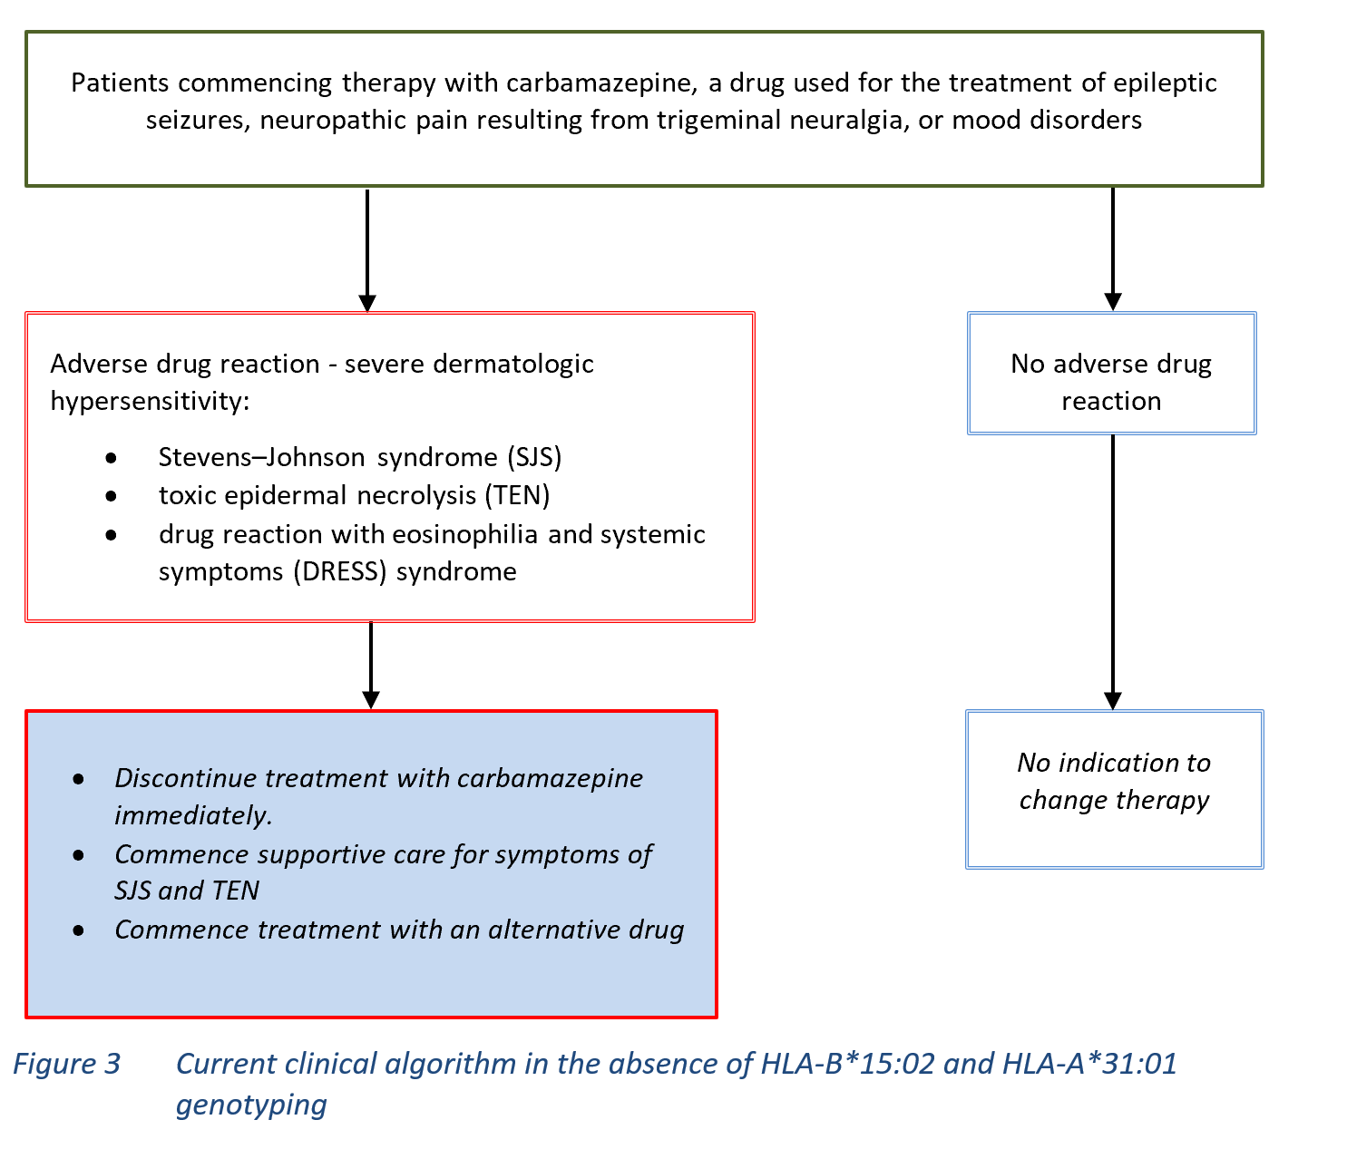

Is there any expectation that the clinical management algorithm before the health technology is used will change due to the introduction of the proposed health technology? (please highlight your response)
Yes

Describe and explain any differences in the clinical management algorithm prior to the use of the proposed health technology vs. the comparator health technology:
There is no difference in the clinical management of patients prior to testing with the proposed intervention as there is no comparator (the comparator is no genetic testing).

Use of the health technology

Explain what other healthcare resources are used in conjunction with delivering the proposed health technology:
Nil – the intervention is a genetic test. No other resources are required other than the test itself.

Explain what other healthcare resources are used in conjunction with the comparator health technology:
Nil – there is no comparator.

Describe and explain any differences in the healthcare resources used in conjunction with the proposed health technology vs. the comparator health technology:
No healthcare resources are used in conjunction with the proposed health technology vs. the comparator health technology.

Clinical management after the use of health technology

Define and summarise the clinical management algorithm, including any required tests or healthcare resources, after the use of the proposed health technology:

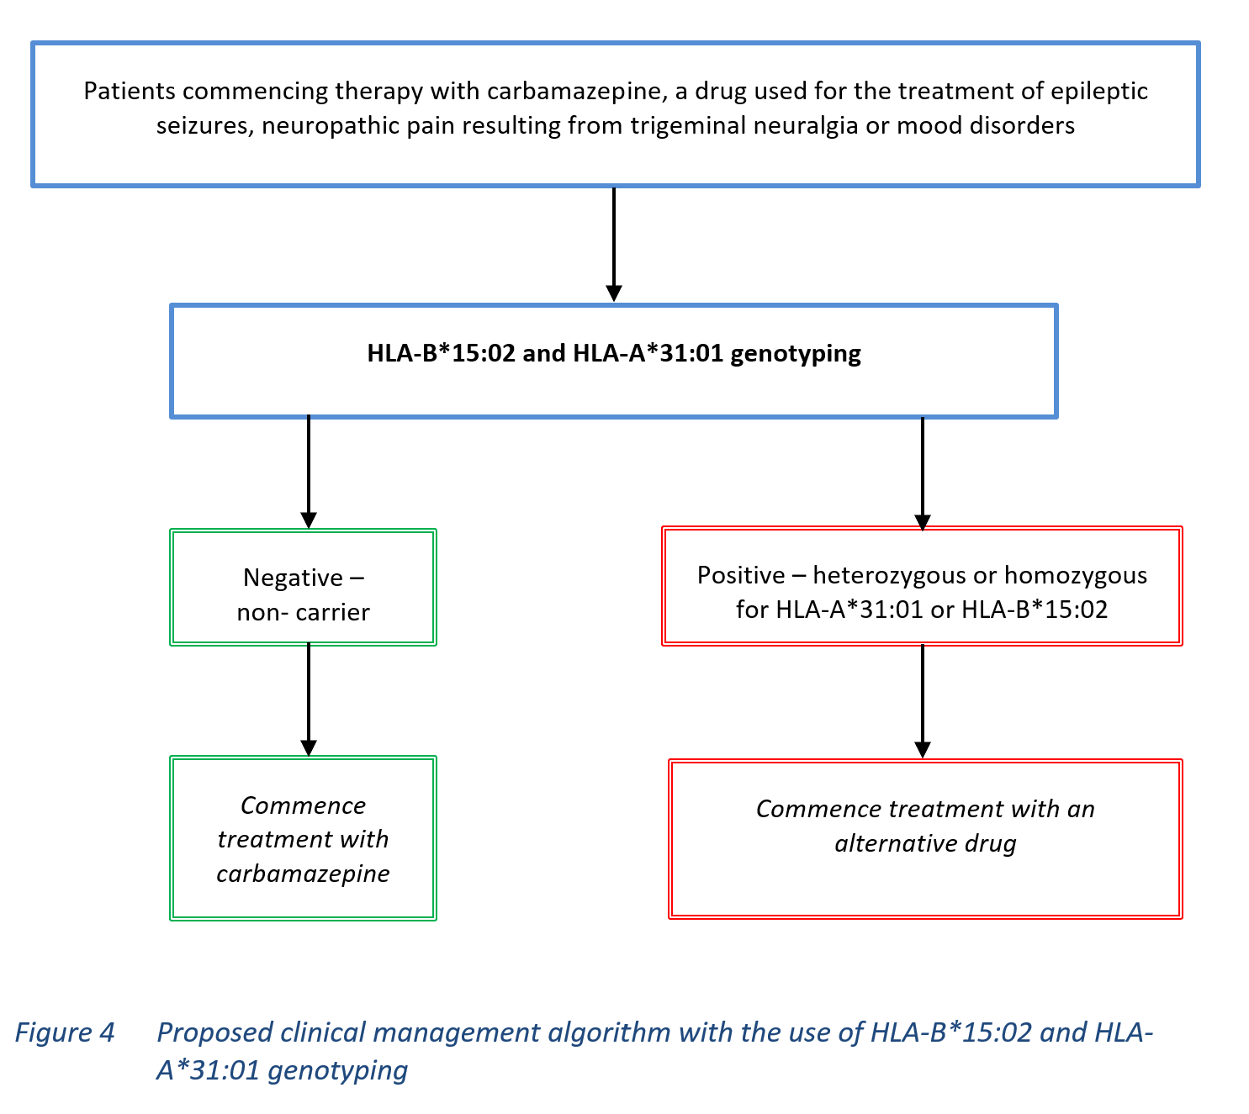

Define and summarise the clinical management algorithm, including any required tests or healthcare resources, after the use of the comparator health technology:
The comparator technology is no genetic testing

Describe and explain any differences in the healthcare resources used after the proposed health technology vs. the comparator health technology:
As described in Figure 4, all patients prescribed carbamazepine for the control of neurological symptoms associated with epilepsy or trigeminal neuralgia or for neuropathic pain or mood disorders should undergo HLA-B*15:02 and HLA-A*31:01 genotyping prior to the commencement of therapy. Patients found to be heterozygous or homozygous for either allele should not commence treatment with carbamazepine but should be treated with an alternative anti-epileptic drug such as gabapentin.

Insert diagrams demonstrating the clinical management algorithm with and without the proposed health technology:
Refer to Figure 3 and Figure 4 above

Claims

In terms of health outcomes (comparative benefits and harms), is the proposed technology claimed to be superior, non-inferior or inferior to the comparator(s)?
Superior
Non-inferior
Inferior

Please state what the overall claim is, and provide a rationale:
Anticonvulsant medication is used as a first-line treatment option for the neurological symptoms of epilepsy and neuropathic pain. One of the more common and effective anti-epileptic drugs is carbamazepine. Although extremely rare, hypersensitivity reactions to carbamazepine can result in Stevens–Johnson syndrome, toxic epidermal necrolysis or drug reaction with eosinophilia and systemic symptoms (DRESS) syndrome, all of which are associated with significant morbidity or mortality in individuals who are heterozygous or homozygous for HLA-A*31:01 or HLA-B*15:02 alleles. Genotyping before commencing therapy with carbamazepine can identify patients who are at high risk of toxicity, allowing treatment with an alternative drug for the indication. Pre-treatment genotyping is safe, has been demonstrated to reduce patient morbidity, mortality and hospitalisations.

Why would the requestor seek to use the proposed investigative technology rather than the comparator(s)?
Comparator is no HLA sensitivity genotyping, which would leave individuals who may be carrying the HLA-A*31:01 and HLA-B*15:02 alleles and about to commence therapy with carbamazepine at risk of developing the severe morbidity and possibly mortality associated with SJS, TEN, DRESS or MPE.

Identify how the proposed technology achieves the intended patient outcomes:
As above

For some people, compared with the comparator(s), does the test information result in:

A change in clinical management?
Yes

A change in health outcome?
Yes

Other benefits?
Yes

Please provide a rationale, and information on other benefits if relevant:
Pre-treatment genotyping is safe, has been demonstrated to reduce patient morbidity and mortality and hospitalisations.

In terms of the immediate costs of the proposed technology (and immediate cost consequences, such as procedural costs, testing costs etc.), is the proposed technology claimed to be more costly, the same cost or less costly than the comparator?
More costly
Same cost
Less costly

Provide a brief rationale for the claim:
As there is currently no comparative test, then the addition of testing will increase costs. However, the associated reductions in patient morbidity and mortality, and hospitalisations should ensure that HLA testing is cost-effective

Summary of Evidence

Provide one or more recent (published) high quality clinical studies that support use of the proposed health service/technology.
Type of study design | Title of journal article or research project | Short description of research | Website link to journal article or research
Guideline  (Phillips et al 2017) | Clinical Pharmacogenetics Implementation Consortium Guideline for HLA Genotype and Use of Carbamazepine and Oxcarbazepine: 2017 Update | The variant allele HLA-B*15:02 is strongly associated with greater risk of Stevens–Johnson syndrome (SJS) and toxic epidermal necrolysis (TEN) in patients treated with carbamazepine or oxcarbazepine. The variant allele HLA-A*31:01 is associated with greater risk of maculopapular exanthema, drug reaction with eosinophilia and systemic symptoms, and SJS/TEN in patients treated with carbamazepine. This guideline summarises evidence from the published literature supporting these associations and provides recommendations for carbamazepine and oxcarbazepine use based on HLA genotypes. | https://files.cpicpgx.org/data/guideline/publication/carbamazepine/2017/CPIC_HLA_CBZ_OXC.pdf
Meta-analysis  (Biswas et al 2022) | Associations of HLA genetic variants with carbamazepine-induced cutaneous adverse drug reactions: An updated meta-analysis | 46 case-control studies were included consisting of 1,817 cases and 6,614 controls. Case-patients who carried the HLA-B*15:02 allele were associated with a significantly increased risk of CBZ-induced Stevens-Johnson syndrome/toxic epidermal necrolysis (SJS/TEN) compared to controls (OR 26.01, p < 0.00001). The aggregated risk of cADRs was slightly higher in Asian compared to Caucasian patients (Asians: OR 14.84, p < 0.00001; Caucasians: OR 11.65, p = 0.01). HLA-B*15:11, HLA-B*15:21, or HLA-A*31:01 allele was also associated with significantly increased risk of CBZ-induced cADRs but other HLA variants were not found to have any significant associations with CBZ-induced cADRs. Pharmacogenetic testing of specific HLA alleles before initiation of CBZ therapy may be beneficial to patients and may help to eradicate cADRs substantially. | https://pubmed.ncbi.nlm.nih.gov/35599240/
Systematic review and meta-analysis  (Rashid et al 2022) | Role of human leukocyte antigen in anti-epileptic drugs-induced Stevens-Johnson Syndrome/toxic epidermal necrolysis: A meta-analysis | A systematic review and meta-analysis of evidence on HLA-associated AED-induced Stevens-Johnson Syndrome/Toxic Epidermal Necrolysis (SJS/TEN). 37 studies (7,027 cases and 44,395 controls). There was a significantly higher risk of Carbamazepine-induced SJS/TEN with HLA-A (OR: 1.50), HLA-B (OR: 1.94), HLA-C (OR: 7.83), and HLA-DRB1 (OR: 2.82). | https://pubmed.ncbi.nlm.nih.gov/36183454/
Systematic review of cost-effectiveness  (Turongkaravee et al 2021) | Pharmacogenetic testing for adverse drug reaction prevention: systematic review of economic evaluations and the appraisal of quality matters for clinical practice and implementation | 5 economic evaluation studies of HLA-B*15:02 genotyping to prevent the risk of SJS/TEN in patients with epilepsy prescribed carbamazepine (CBZ) were carried out in Malaysia, Hong Kong, Thailand and Singapore from 2012 to 2017. 3 studies showed that testing would be cost-effective and cost-saving to prevent SJS/TEN in CBZ, as compared with no testing. The Malaysian study indicated that testing would not be cost-effective as a result of ethnicity and an effective alternative drug for those who tested positive. The study in Thailand showed that HLA-B*15:02 screening would be cost-effective in CBZ-treated patients with neuropathic pain but not for epilepsy because the cost of alternative drugs for epilepsy was approximately two times higher than the cost for neuropathic pain.  CBZ associated with HLA-A*31:01: A study in UK was performed using CUA with model-based economic evaluation in 2015. The results showed that testing would be cost-effective as the efficacy (e.g., remission rate) of anti-epileptic drugs was the main driver of cost-effectiveness results. In addition, this study used lamotrigine as an alternative drug for patients who tested positive rather than valproate, which might be different from other clinical settings. | https://pubmed.ncbi.nlm.nih.gov/34600523/
Systematic review and meta-analysis  (Chouchi et al 2018) | The HLA-B*15:02 polymorphism and Tegretol(®)-induced serious cutaneous reactions in epilepsy: An updated systematic review and meta-analysis | Nine studies were included to assess the association between HLA-B*15:02 polymorphisms and CBZ-induced serious cutaneous reactions (SCRs), such as Stevens-Johnson syndrome (SJS) and toxic epidermal necrolysis (TEN), in epilepsy. HLA-B*15:02 polymorphisms were significantly associated with CBZ SCR risk (OR: 27.325), while subgroup analyses by ethnicity showed that the association was significant in Han Chinese (OR: 42.059). The HLA-B*15:02 polymorphism was also strongly associated with the CBZ-SJS subgroup (OR: 152.089) and significantly associated with the CBZ-SJS/TEN subgroup (OR: 13.993). The allele was overrepresented in the Han Chinese population (OR: 17.886) within the CBZ-SJS/TEN subgroup. | https://pubmed.ncbi.nlm.nih.gov/29685430/
Meta-analysis  (Wang et al 2017) | Association between the HLA-B alleles and carbamazepine-induced SJS/TEN: A meta-analysis | A total of 11 studies investigating the association of HLA-B alleles and CBZ-induced SJS/TEN were retrieved, totalling 343 CBZ-induced SJS/TEN cases, 838 CBZ tolerant controls, and 978 population controls. We observed HLA-B*1511 as a risk marker, and HLA-B*4001 and HLA-B*4601 as protective markers for the development of SJS/TEN in patients taking CBZ. SJS/TEN cases were found to be significantly associated with HLA-B*1511 in both the tolerant group (OR=17.43;95%CI=3.12-97.41;P=0.001) and the population-control group (OR=11.11; 95%CI=2.62-47.09; P=0.001). The sensitivity analysis found that HLA-B*5801 was a protective marker in the Southeast Asian population (OR=0.23; 95%CI=0.09-0.58; P=0.002). | https://pubmed.ncbi.nlm.nih.gov/28618376/
Systematic review of cost-effectiveness  (Plumpton et al 2016) | A Systematic Review of Economic Evaluations of Pharmacogenetic Testing for Prevention of Adverse Drug Reactions | Systematic review of economic evaluations of pharmacogenetic tests aimed to reduce the incidence of adverse drug reactions. 47 articles met the inclusion criteria. There was evidence supporting the cost effectiveness of genotyping prior to treatment for HLA-B*15:02 and HLA-A*31:01 (prior to carbamazepine). | https://pubmed.ncbi.nlm.nih.gov/26984520/
Systematic review and clinical practice guidelines  (Amstutz et al 2014) | Recommendations for HLA-B*15:02 and HLA-A*31:01 genetic testing to reduce the risk of carbamazepine-induced hypersensitivity reactions | Systematic review of the evidence on genetic risk factors for carbamazepine (CBZ)-induced hypersensitivity reactions (HSRs) to address key questions: (1) Should genetic testing for HLA-B*15:02 and HLA-A*31:01 be performed in patients with an indication for CBZ therapy to reduce the occurrence of CBZ-induced HSRs? (2) Are there subgroups of patients who may benefit more from genetic testing for HLA-B*15:02 or HLA-A*31:01 compared to others? (3) How should patients with an indication for CBZ therapy be managed based on their genetic test results? Evidence was critically appraised and clinical practice recommendations were developed based on expert group consensus. | https://pubmed.ncbi.nlm.nih.gov/24597466/
Systematic review and meta-analysis  (Grover & Kukreti 2014) | HLA alleles and hypersensitivity to carbamazepine: an updated systematic review with meta-analysis | 20 eligible studies were identified that included 720 CBZ-intolerant [Stevens-Johnson syndrome and toxic epidermal necrolysis (bullous lesions): n=277; hypersensitivity syndrome/maculopapular exanthema (nonbullous lesions): n=359; others: n=84], 1,512 CBZ-tolerant, and 1,113 normal controls. HLA-A*3101 and HLA-B*1502 were identified as risk markers and HLA-B*4001 as a protective marker for susceptibility to cADRs when comparing intolerant with tolerant patients. Stratification by clinical outcome showed HLA-B*1502 and HLA-B*1511 as risk and HLA-A*2402 as protective markers for bullous lesions in Asians [HLA-B*1502: OR=80.70, HLA-B*1511: OR=17.43; HLA-A*2402: OR=0.27]. HLA-A*3101 was observed to be a universal risk marker. | https://pubmed.ncbi.nlm.nih.gov/24336023/
Systematic review  (Yip et al 2012) | HLA genotype and carbamazepine-induced cutaneous adverse drug reactions: a systematic review | The carriage of HLA-B*1502 in Asian patients was associated with a pooled OR of 113.4 for CBZ-induced Stevens-Johnson syndrome (SJS) and toxic epidermal necrolysis (TEN). A total of 461 patients would need to be screened for HLA-B*1502 to prevent one episode of SJS/TEN. HLA-A*3101 is significantly associated with all phenotypes of CBZ hypersensitivity in multiple ethnicities with a pooled OR of 9.5. Between 47 and 67 patients would need to be tested for HLA-A*3101 to prevent one episode of hypersensitivity. HLA testing before carbamazepine therapy would be effective at identifying individuals at risk of hypersensitivity and applicable to multiple populations. | https://pubmed.ncbi.nlm.nih.gov/23132554/
Retrospective cohort  (Tiwattanon et al 2022) | Implementation of HLA-B*15:02 Genotyping as Standard-of-Care for Reducing Carbamazepine/Oxcarbazepine Induced Cutaneous Adverse Drug Reactions in Thailand | HLA-B*15:02 PGx-testing and clinical data from electronic medical records during 2011-2020 were obtained. 384 patient data were included in this study to investigate the clinical decision on CBZ/OXC usage before and after the HLA-B*15:02 PGx testing, and 1,539 patient data were included in this study to demonstrate the incidence of CBZ/OXC-induced SCARs and SJS between HLA-B*15:02 tested and non-tested patients. 70 patients carried HLA-B*15:02, of which 63 and 65 patients were not prescribed with CBZ/OXC before and after the availability of genotyping results, respectively. In the remaining HLA-B*15:02 non-carriers, 48, and 189 patients were prescribed CBZ/OXC before and after genotyping results were available, respectively. The findings of this study showed that the incidence of SCARs of CBZ/OXC was significantly lower (p < 0.001) in the HLA-B*15:02 screening arm than in the non-screening arm. HLA-B pharmacogenetics testing influenced the selection of appropriate AEDs. | https://pubmed.ncbi.nlm.nih.gov/35865943/
Retrospective cohort  (Fang et al 2019) | A Screening Test for HLA-B(∗)15:02 in a Large United States Patient Cohort Identifies Broader Risk of Carbamazepine-Induced Adverse Events | FDA-approved labelling recommends HLA-B(∗)15:02 screening before CBZ therapy in patients of Asian ancestry. The aim of this study was to evaluate prevalence in a large cohort of United States patients. Retrospective analysis of de-identified SNP and ethnicity data from 130,460 individuals was performed to evaluate the ethnic distribution of HLA-B(∗)15:02 in the USA. Retrospective analysis of 160 positive individuals (66 with physician-reported ethnicity) notably included 28 Asians (42%), 15 African Americans (22%), 11 Caucasians (17%), 2 Hispanics (3%), and 10 "Other" (15%). Screening for HLA-B(∗)15:02 without ethnicity-based preselection identifies more than twice the number of carriers at risk of CBZ-related adverse events than screening patients of Asian ancestry alone. Risk assessment based on ethnicity assumptions may not identify a large portion of at-risk patients in ethnically diverse populations. | https://pubmed.ncbi.nlm.nih.gov/30971914/
Case series  (Nakkam et al 2018) | HLA Pharmacogenetic Markers of Drug Hypersensitivity in a Thai Population | Determination of distribution of HLA alleles in 183 unrelated individuals of a Thai population compared with other ethnicities. A high prevalence of pharmacogenetic markers of drug-induced SCARs e.g. B(*)15:02 for carbamazepine and oxcarbazepine. The allele frequencies of B(*)13:01, B(*)15:02, and B(*)58:01 observed in a Thai population were significantly higher than those reported in Japanese and Caucasian populations. Similar to those observed in other Southeast Asian populations, low frequencies of A(*)31:01 and B(*)57:01 alleles were noted in the study population. Thai and other Southeast Asian populations may at higher risk of drug-induced SCARs compared with Caucasian population. | https://pubmed.ncbi.nlm.nih.gov/30127801/

Identify yet-to-be-published research that may have results available in the near future (that could be relevant to your application).
-

References
Ahmed, A. F., Sukasem, C. et al (2021). 'Genetic Determinants in HLA and Cytochrome P450 Genes in the Risk of Aromatic Antiepileptic-Induced Severe Cutaneous Adverse Reactions', J Pers Med, 11 (5).
AIHW (2022). Epilepsy in Australia, Australian Institute of Health and Welfare, Canberra.
Amstutz, U., Shear, N. H. et al (2014). 'Recommendations for HLA-B*15:02 and HLA-A*31:01 genetic testing to reduce the risk of carbamazepine-induced hypersensitivity reactions', Epilepsia, 55 (4), 496-506.
Biswas, M., Ershadian, M. et al (2022). 'Associations of HLA genetic variants with carbamazepine-induced cutaneous adverse drug reactions: An updated meta-analysis', Clin Transl Sci, 15 (8), 1887-1905.
Böhm, R., Proksch, E. et al (2018). 'Drug Hypersensitivity', Dtsch Arztebl Int, 115 (29-30), 501-512.
Chouchi, M., Kaabachi, W. et al (2018). 'The HLA-B*15:02 polymorphism and Tegretol(®)-induced serious cutaneous reactions in epilepsy: An updated systematic review and meta-analysis', Rev Neurol (Paris), 174 (5), 278-291.
Copaescu, A. M. & Trublano, J. A. (2022). 'The assessment of severe cutaneous adverse drug reactions', Aust Prescr, 45 (2), 43-48.
Duong, T. A., Valeyrie-Allanore, L. et al (2017). 'Severe cutaneous adverse reactions to drugs', Lancet, 390 (10106), 1996-2011.
Fang, H., Xu, X. et al (2019). 'A Screening Test for HLA-B(∗)15:02 in a Large United States Patient Cohort Identifies Broader Risk of Carbamazepine-Induced Adverse Events', Front Pharmacol, 10, 149.
Fiest, K. M., Sauro, K. M. et al (2017). 'Prevalence and incidence of epilepsy: A systematic review and meta-analysis of international studies', Neurology, 88 (3), 296-303.
Frantz, R., Huang, S. et al (2021). 'Stevens-Johnson Syndrome and Toxic Epidermal Necrolysis: A Review of Diagnosis and Management', Medicina (Kaunas), 57 (9).
Grover, S. & Kukreti, R. (2014). 'HLA alleles and hypersensitivity to carbamazepine: an updated systematic review with meta-analysis', Pharmacogenet Genomics, 24 (2), 94-112.
Khawaja, S. N. & Scrivani, S. J. (2023). 'Trigeminal Neuralgia', Dent Clin North Am, 67 (1), 99-115.
Maan, J. S., Duong, T. H. & Saadabadi, A. (2023). Carbamazepine [Internet]. StatPearls Publishing. Available from: https://www.ncbi.nlm.nih.gov/books/NBK482455/ [Accessed 18th September].
Nakkam, N., Konyoung, P. et al (2018). 'HLA Pharmacogenetic Markers of Drug Hypersensitivity in a Thai Population', Front Genet, 9, 277.
Owen, C. E. & Jones, J. M. (2021). 'Recognition and Management of Severe Cutaneous Adverse Drug Reactions (Including Drug Reaction with Eosinophilia and Systemic Symptoms, Stevens-Johnson Syndrome, and Toxic Epidermal Necrolysis)', Med Clin North Am, 105 (4), 577-597.
Phillips, E. J., Sukasem, C. et al (2017). Clinical Pharmacogenetics Implementation Consortium Guideline for HLA Genotype and Use of Carbamazepine and Oxcarbazepine: 2017 Update [Internet]. Clinical Pharmacogenetics Implementation Consortium (CPIC®). Available from: https://cpicpgx.org/guidelines/guideline-for-carbamazepine-and-hla-b/ [Accessed 19th September].
Pirmohamed, M. (2023). 'Pharmacogenomics: current status and future perspectives', Nat Rev Genet, 24 (6), 350-362.
Plumpton, C. O., Roberts, D. et al (2016). 'A Systematic Review of Economic Evaluations of Pharmacogenetic Testing for Prevention of Adverse Drug Reactions', Pharmacoeconomics, 34 (8), 771-793.
Rashid, M., Rajan, A. K. et al (2022). 'Role of human leukocyte antigen in anti-epileptic drugs-induced Stevens-Johnson Syndrome/toxic epidermal necrolysis: A meta-analysis', Seizure, 102, 36-50.
TGA (2019). CARBAMAZEPINE SANDOZ carbamazepine 100mg tablet blister pack (78217) [Internet]. Therapeutic Goods Administration, Department of Health and Aged Care, Australian Government. Available from: https://www.tga.gov.au/resources/artg/78217 [Accessed 26th September].
The Epilepsy Centre (2023). Epilepsy Medication [Internet]. Available from: https://epilepsycentre.org.au/anti-epilepsy-drugs/ [Accessed 26th September].
Tiwattanon, K., John, S. et al (2022). 'Implementation of HLA-B*15:02 Genotyping as Standard-of-Care for Reducing Carbamazepine/Oxcarbazepine Induced Cutaneous Adverse Drug Reactions in Thailand', Front Pharmacol, 13, 867490.
Trigeminal Neuralgia Association Australia (2021). What is Trigeminal Neuralgia? [Internet]. Available from: https://tnaaustralia.org.au/what-is-trigeminal-neuralgia/ [Accessed 27th September].
Turongkaravee, S., Jittikoon, J. et al (2021). 'Pharmacogenetic testing for adverse drug reaction prevention: systematic review of economic evaluations and the appraisal of quality matters for clinical practice and implementation', BMC Health Serv Res, 21 (1), 1042.
Wang, Q., Sun, S. et al (2017). 'Association between the HLA-B alleles and carbamazepine-induced SJS/TEN: A meta-analysis', Epilepsy Res, 135, 19-28.
WHO (2019). Epilepsy: a public health imperative, World Health Organization, Geneva.
Yip, V. L., Marson, A. G. et al (2012). 'HLA genotype and carbamazepine-induced cutaneous adverse drug reactions: a systematic review', Clin Pharmacol Ther, 92 (6), 757-765.

