Public Summary Document
Application No. 1534 – (CUC) Heritable Mutations associated with Familial Hypercholesterolaemia
Applicant: The Royal College of Pathologists of Australasia (RCPA)
Date of MSAC consideration: MSAC 75th Meeting, 28-29 March 2019
Context for decision: MSAC makes its advice in accordance with its Terms of Reference, visit the MSAC website

Purpose of application
An application for diagnostic genetic testing for heritable mutations predisposing to familial hypercholesterolaemia (FH) in clinically affected individuals, and for predictive genetic testing (or “cascade testing”) of the family members of those affected individuals who are shown to have such a mutation was received from the Royal College of Pathologists of Australasia (RCPA) by the Department of Health in February 2018. The evidence for assessment of this application was submitted in the form of a clinical utility card (CUC).

MSAC’s advice to the Minister
After considering the strength of the available evidence in relation to comparative safety, clinical effectiveness and cost-effectiveness, MSAC supported MBS listing of genetic testing for heritable mutations associated with familial hypercholesterolaemia in affected individuals meeting defined eligibility criteria, and targeted cascade testing in first and second-degree relatives of those affected individuals with a confirmed genetic diagnosis.
MSAC advised in each case that testing should be once in a lifetime and that the item descriptor for the first population should allow testing for germline gene variants in all genes associated with familial hypercholesterolaemia.
MSAC noted that all of the benefits are associated with cascade testing in first-degree and second-degree relatives, as a positive result could result in early uptake of lipid-lowering treatments, and thus reduce the risk of cardiovascular events in this group of patients.
MSAC recommended that this MBS listing be reviewed in 2 years, particularly in relation to the extent of cascade testing compared to the extent of testing of affected individuals, and whether cascade testing contributes to earlier onset of appropriate therapy.

Summary of consideration and rationale for MSAC’s advice
MSAC noted that three “star performer” genes (LDLR, PCSK9 and APOB) were associated with >90% of affected individuals with FH testing positive for a pathogenic germline gene variant (index cases or probands). FH is autosomal dominant, with 1:353 people heterozygous for the condition and 1:300,000 homozygous. MSAC therefore advised that the MBS item descriptor should at least identify these three genes, but should also allow testing for germline gene variants of other genes causing FH. MSAC further advised that this suggested change in item descriptor should not result in an increase to the proposed fee.
MSAC noted that people with FH are at increased risk of cardiovascular (CV) events leading to death, myocardial infarction, unstable angina requiring hospitalisation, coronary revascularisation, stroke, transient ischaemic attack and hospitalisation for heart failure.
MSAC accepted that the proposed genetic testing is highly sensitive and specific, and clinically valid in that an identified mutation predicted adverse CV events. MSAC noted that all of the clinical utility benefits of genetic testing for FH would be realised in the cascade testing group. MSAC noted that there was no incremental benefit of genetic testing compared with lipid testing for affected individuals, but identification of a germline variant allows family members with a predisposition for FH to be identified. Earlier identification of at-risk individuals should enable intervention using earlier and/or higher dose lipid-lowering treatments to reduce subsequent CV events.
Currently, confirmation of FH by genetic testing is an alternative to assessment by the Dutch Lipid Clinic Network Score as one of the requirements for access to PCSK9 inhibitors (evolocumab) on the Pharmaceutical Benefits Scheme (PBS). Evolocumab was listed on the PBS in March 2016 for homozygous FH patients and in March 2018 for heterozygous FH patients. MSAC considered that likely earlier subsidised access to this therapy for family members testing positive to cascade testing was the main source of expected clinical utility, but noted that this was not included in the assessment.
MSAC queried whether the PBS criteria would lead to leakage for an MBS listing, but noted that the Dutch Lipid Clinic Network Score for identifying affected individuals in the proposed MBS item descriptor (at least 6) is similar to the Score used in the alternative option for confirming FH in the PBS restriction for evolocumab (at least 6 for heterozygous FH, and at least 7 for homozygous FH). In addition, the PBS listing for homozygous FH patients does not appear to have resulted in large increases in genetic testing, although the listing for heterozygous FH patients is too recent for any data to yet be available. MSAC noted that the pool of heterozygous FH patients is much larger than for homozygous FH patients.
MSAC queried the criteria for testing in the proposed MBS item descriptor, noting that it differed in some respects from the PBS listing for access to evolocumab. However, MSAC accepted that these criteria do not have to match. Therefore, MSAC accepted the following criteria for testing of affected individuals who do not have a previously identified FH mutation, but have one or more of the following:
- a Dutch Lipid Clinic Network Score of at least 6
- a low-density lipoprotein (LDL) cholesterol level of at least 6.5 mmol/L in the absence of secondary causes
- an LDL cholesterol level between 5.0 and 6.5 mmol/L with signs of premature/accelerated atherogenesis.
MSAC noted the estimated incremental cost-effectiveness ratios (ICERs) from the economic evaluation were $26,174 per quality-adjusted life year (QALY) for testing of affected individuals and first-degree relatives; $24,907 per QALY for testing of affected individuals and first- and second-degree relatives; and $25,147 per QALY for testing of affected individuals and first-, second- and third-degree relatives.
MSAC noted the marginal ICERs from the economic evaluation were $2,649 per QALY for testing of first-degree relatives as well as affected individuals; $14,397 per QALY for testing of second-degree relatives as well as affected individuals and first-degree relatives; and $37,446 per QALY for testing of third-degree relatives as well as affected individuals and first-, and second-degree relatives.
MSAC considered the economic evaluation to have some flaws. One was that the estimates were derived from lipid clinic data and these data may not translate to the general practice setting. Local experience in Western Australia revealed that, when general practitioners (GPs) are involved with requesting testing of affected individuals, the diagnostic yield decreases. MSAC also considered the involvement of genetic counselling in these cases to be important, as this could address potential issues such as disclosure of results to relatives, who would benefit the most from the overall proposed genetic testing. Further, MSAC noted that initiation of evolocumab therapy via the PBS is restricted to specialist physicians. Thus, MSAC recommended that testing of affected individuals should be requested by a specialist or consultant physician only, but that cascade testing could be ordered by a GP, specialist or consultant physician.
MSAC also considered these ICERs to be unreliable, as the economic evaluation excluded PCSK9 inhibitor therapy and so underestimated both their effectiveness and costs. As this therapy has been listed on the PBS as being acceptably cost-effective, MSAC had confidence that including this therapy into the current economic evaluation would tend to make the ICERs more favourable. In addition, the ICERs depended on cascade testing uptake numbers, which were based on lipid clinic data. It was thus uncertain if these data would translate to the financial model. This model estimated a cost to the MBS of $540,955 in Year 1 rising to $622,098 in Year 5.
Since MSAC considered the cascade testing uptake numbers to be unreliable, and noting the plausibly large increase in the marginal ICER for adding third-degree relatives to the testing proposal, MSAC supported cascade testing for first- and second-degree relatives only. MSAC also noted there might be confusion in defining third-degree relatives by those requesting the tests.
MSAC considered once in a lifetime testing to be appropriate for both affected individual and cascade family member populations, anticipating that next-generation sequencing (NGS) would be used to test affected individuals. The ‘once in a lifetime’ limit could be reviewed in 5–10 years if the field advances substantially during this time, especially to reduce false negative test results.
MSAC considered the proposed fee of $1200 to be appropriate for affected individuals, as NGS is required for the proposed panel. MSAC also considered the proposed fee of $400 for cascade testing to be appropriate, as MSAC accepted the applicant’s explanation that the currently charged fees of $120–200 underestimate the true cost of the targeted pathogenic germline gene variant test.
MSAC considered that the financial analyses may underestimate the extent of uptake of the requested genetic testing because the market share approach adopted for these analyses is based on an assumption that the current levels of under-diagnosis will remain. MSAC considered that this assumption may not hold if the new model of FH care proposed by Atherosclerosis Australia is implemented widely, noting that genetic testing of the large prevalence pool of existing affected individuals has not been a standard part of routine management to date.
MSAC recommended that the MBS item be reviewed in 2 years to capture predicted and actual uptake.

Background
The MSAC has piloted arrangements through its CUC to assess the utility of germline genetic testing for broad disease areas, such as cancer, cardiovascular or mental illness. This approach is to be used to inform consideration of the circumstances under which germline genetic testing for these diseases should be publicly funded.
The purpose of genetic testing for heritable mutations associated with FH is to investigate:
- clinically affected individuals, to make a genetic diagnosis and thus estimate the future risk of further disease – for these individuals, this is diagnostic testing; and, when also appropriate
- cascade testing of family members of those individuals who test positive for one or more relevant mutations, to make a genetic diagnosis and thus estimate each family member’s variation in (predisposition for) the future risk of developing the clinical disease (and, less commonly, future risk of further disease if hypercholesterolaemia has already been diagnosed) – for these individuals, this is predictive testing.
For FH, “star performer” gene(s) for testing were selected on the basis of having the strongest case for clinical utility, and the evidence provided in the CUC focussed on these genes. Other genes may be added to the panel of genes to be tested for the disease area on the basis of also having clinical utility, of not detracting from the clinical utility of the “star performer” genes, and of incurring negligible consequences for the incremental cost-effectiveness of the proposed genetic testing.
For FH, the characteristics of the clinically affected individuals who should be selected as eligible for this genetic testing are defined. This reflects an MSAC preference for a low probability of an actionable result over a high probability of an uninterpretable or unactionable result. Cascade testing is then only contemplated for family members of those individuals who test positive for a relevant mutation, and only when this mutation is also associated with having clinical utility for the family members.
Currently, fees for genetic testing of genes associated with FH vary widely across Australia; between $800.00 for exon-by-exon sequencing of the LDLR gene plus select regions in PCSK9 and APOB (by SA Pathology) and $1,664.00 for a panel that includes APOB, CETP, LDLR, LDLRAP1, LIPA, PCSK9, STAP1 and also includes genetic counselling (by Sonic Genetics). Current fees for cascade testing (of a known mutation) were reported as $132 by SA Pathology and $200 by Master Pathology in Queensland.

Prerequisites to implementation of any funding advice
Genetic testing for FH should be undertaken in a National Association of Testing Authorities (NATA)/ RCPA accredited laboratory.

Proposal for public funding
The proposed MBS item descriptor for diagnostic testing is provided in Table 1. Specifically, the proposed item descriptor for genetic testing of affected individuals allows the test panel to be ordered by specialists, consultant physicians or general practitioners in consultation with specialists.
Table 1 Proposed item descriptor for diagnostic testing
Category 6 – PATHOLOGY SERVICES
Characterisation of germline gene variants in the LDLR, PCSK9 and APOB genes causing familial hypercholesterolaemia, requested by a specialist or consultant physician or a general practitioner in consultation with a specialist, in patients where:
- No familial mutation has been identified, and
- The patient has a Dutch Lipid Clinic Network score of at least 6; or
- The patient has an LDL-cholesterol level of at least 6.5 mmol/L in the absence of secondary causes; or
- The patient has an LDL-cholesterol level between 5.0 and 6.5 mmol/L with signs of premature/accelerated atherogenesis.
Fee: $ 1,200.00 Benefit: 75% = 900.00 85% = 1020.00
The proposed item descriptor for predictive testing of family members is provided in Table 2. The proposal agreed to by PASC is that general practitioners or other specialists may order cascade testing for FH.
Table 2 Proposed item descriptor for predictive testing of family members
Category 6 – PATHOLOGY SERVICES
Detection of a familial mutation in the LDLR, PCSK9 or APOB gene in a first- or second-degree relative of a patient with a documented pathogenic germline gene variant for familial hypercholesterolaemia, requested by a general practitioner, specialist or consultant physician who manages the treatment of the patient.
Fee: $ 400.00 Benefit: 75% = $300.00 85% = 340.00

Summary of Public Consultation Feedback/Consumer Issues
No consultation feedback was received for this application.

Proposed intervention’s place in clinical management
The current and proposed clinical management algorithm for affected individuals strongly suspected of or diagnosed with FH is provided in Figure 1. The proposed test is an addition to current practice.
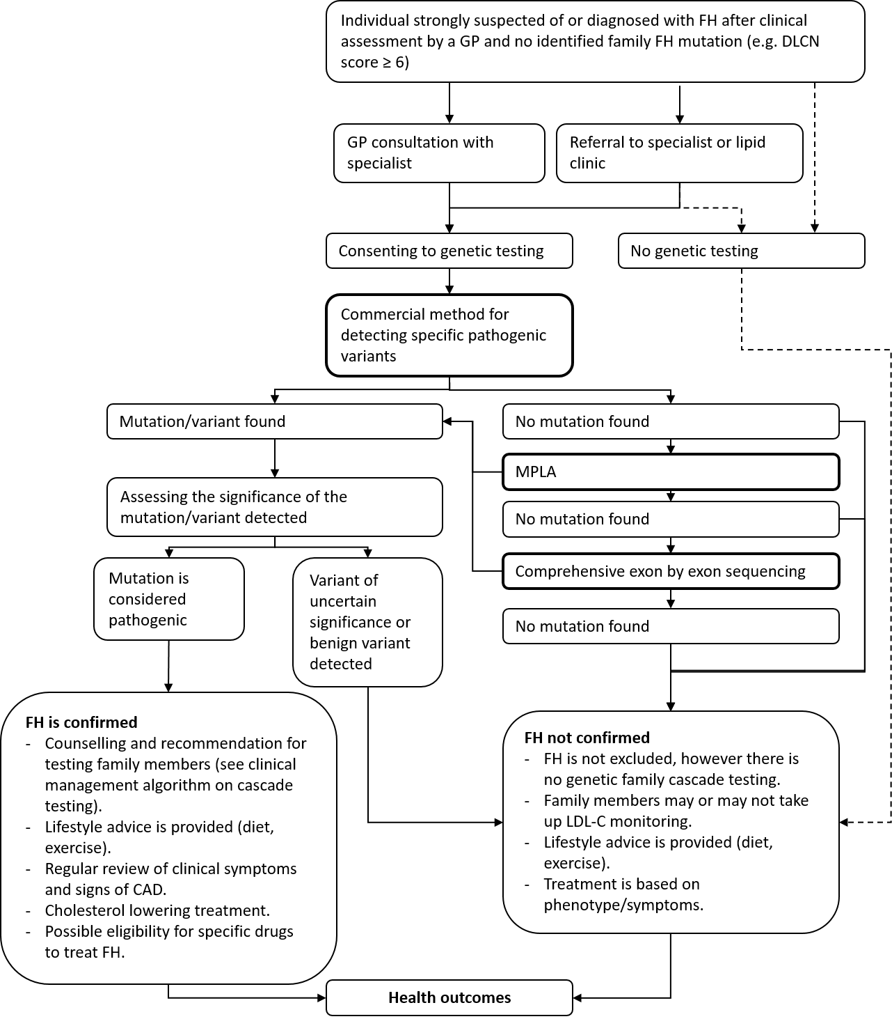
Figure 1 Current & proposed clinical management algorithm for affected individuals strongly suspected of or diagnosed with FH
The clinical management algorithm for first or second degree family members of an FH patient with an identified mutation is provided in Figure 2.
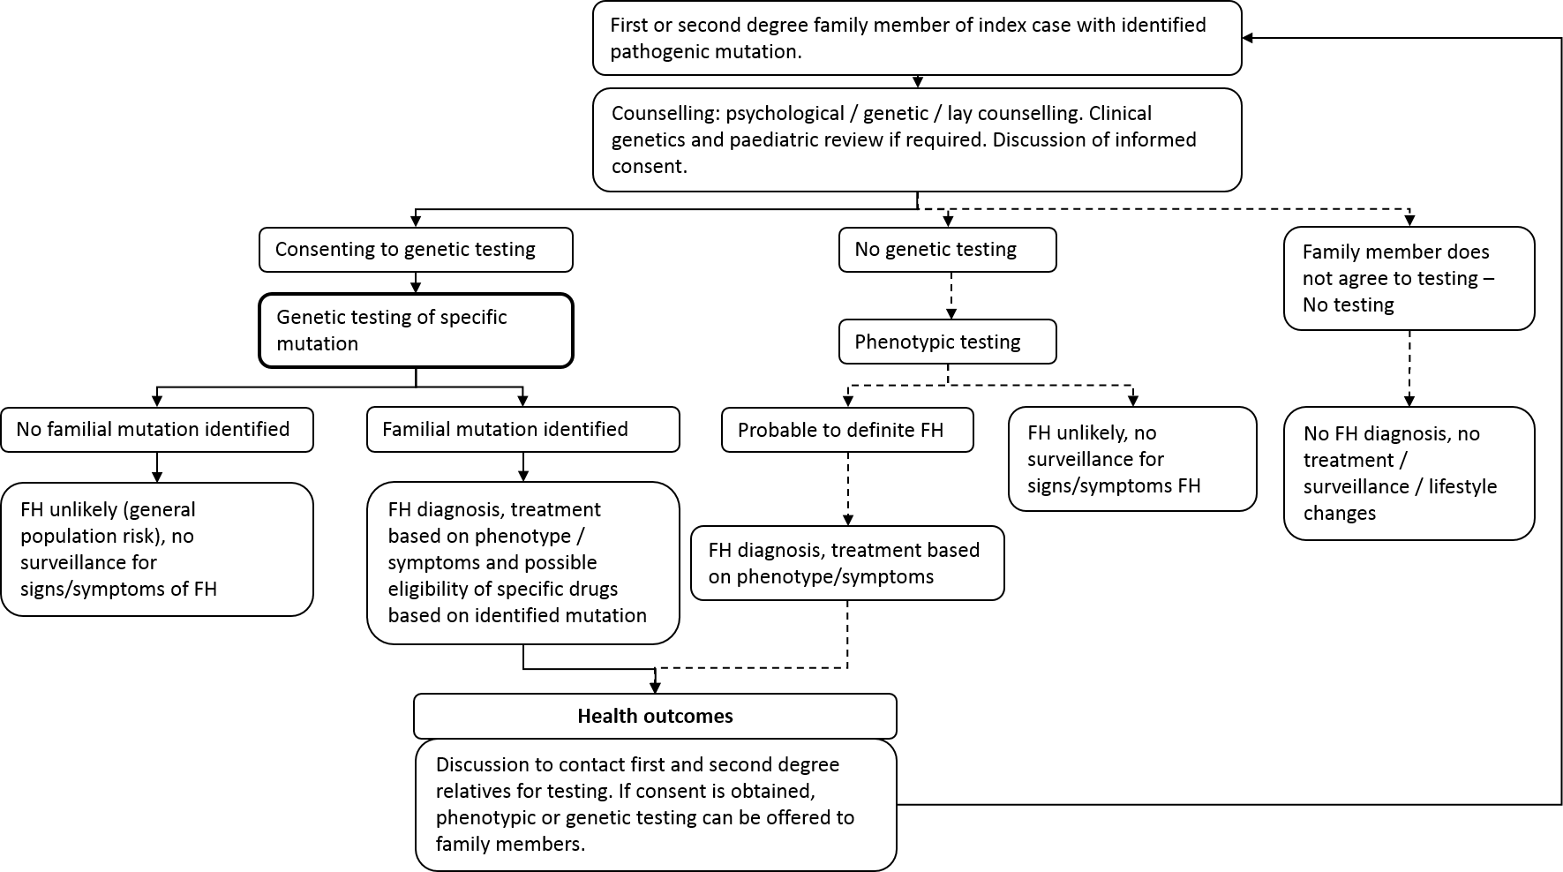
Figure 2 Current & proposed clinical management algorithm for first or second degree family members of an FH patient with an identified mutation
The current and proposed clinical management algorithm for children with at least one parent diagnosed with FH is presented in Figure 3. The Australian model of care proposes that children and adolescents should not be tested for FH unless the diagnosis has been confirmed in a first-degree relative.
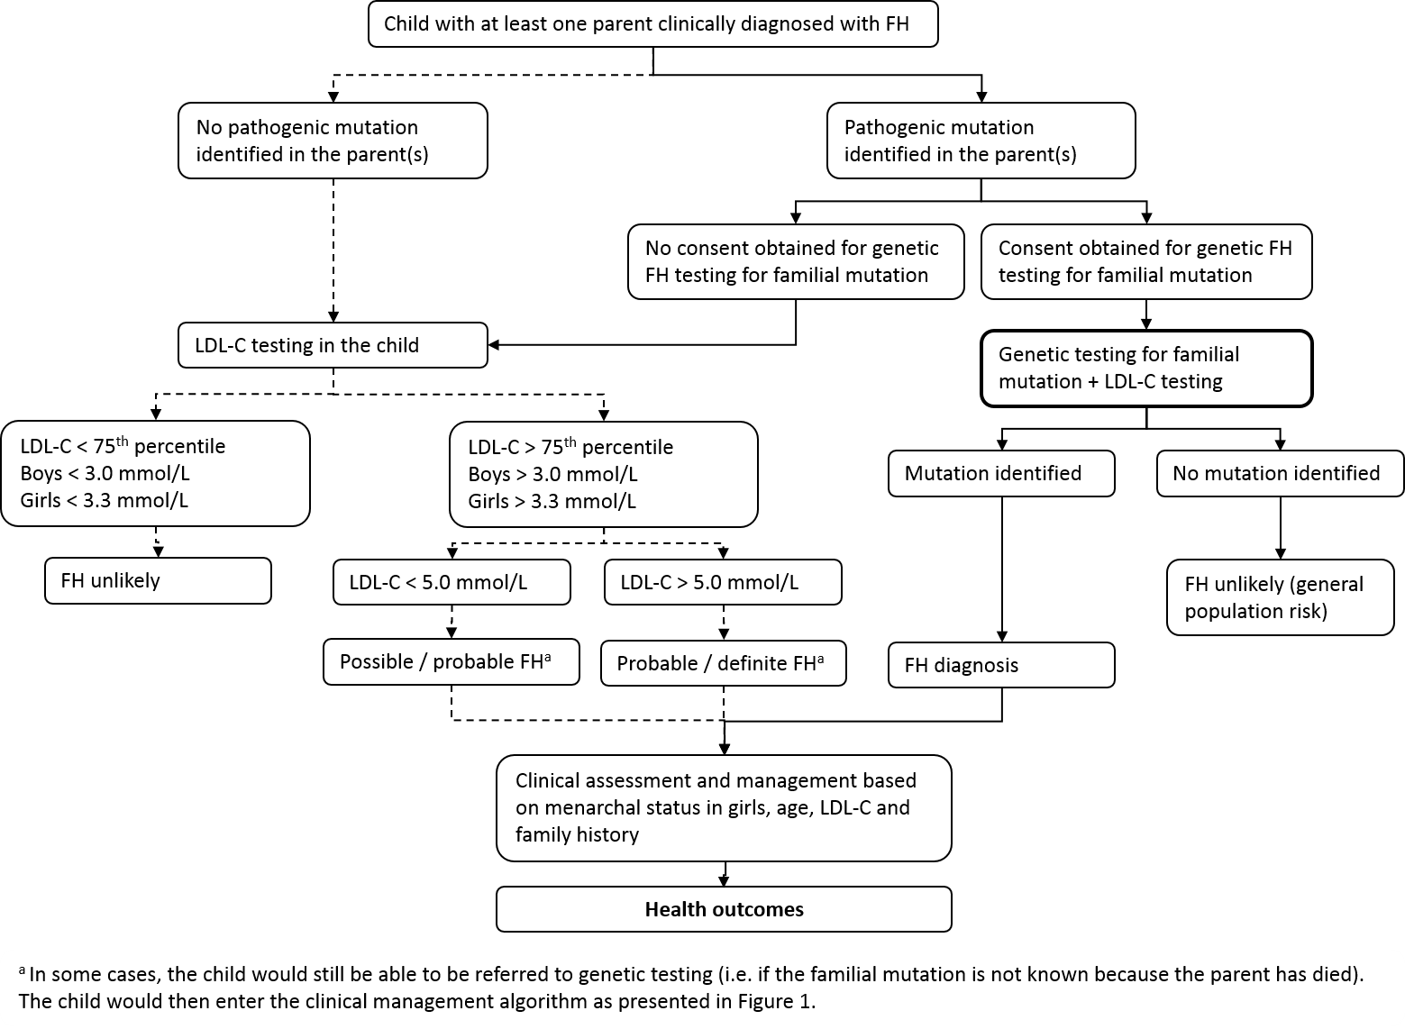
Figure 3 Current & proposed clinical management algorithm for children with at least one parent diagnosed with FH

Comparator
The comparator is usual standard of care, without genetic testing. Prior tests include clinical assessment and LDL cholesterol (LDL-C) in patients suspected with FH.
Treatment decisions with current standard of care is based on the phenotype / symptoms, and there would be no genetic family cascade testing. Family members or children of a diagnosed patient may have phenotypic testing (e.g. by Dutch Lipid Clinic Network (DLCN) score, LDL-C measurement), and will also be treated based on symptoms and LDL-C levels. If no familial mutation is found through genetic testing (but there is a clinical diagnosis), family members of a FH patient can still undergo LDL-C testing.

Comparative safety
Very few studies reported on the impact of genetic testing of affected individuals for FH. One qualitative study reported that genetic testing provided very little new insight or personal benefit to affected individuals, but the authors believed there may be a benefit for family members (Jenkins et al. 2013). No studies were identified on the safety and/or physical harms from genetic testing for FH.

Comparative effectiveness

Key analytical performance results
The genetic tests currently used to identify FH are sensitive and specific in the populations in which they were tested, and detected almost all mutations they were designed to detect (k=5 GRADE ⊕⊝⊝⊝). No studies were identified that assessed the analytical sensitivity and specificity of cascade testing, however the accuracy would be close to 100% (see Table 3), as methods used for testing for a known mutation are able to be tailored to ensure the mutation is found (if it exists).
Table 3 Results of key accuracy trials comparing intervention and comparator against reference standard
Study ID | Intervention | Sensitivity | Specificity
Stef et al. (2013) | LIPOchip version 7 (point mutations)  - all chips  - quality control passed | 100 ± 1.53  100 ± 1.81 | 100 ± 0.08  100 ± 0.09
 | LIPOchip version 7 (copy number variations)  - all chips  - quality control passed | 85.6 ± 1.13  94.7 ± 0.73 | 99.9 ± 0.11  99.9 ± 0.11
 | LIPOchip version 9 (point mutations)  - all chips  - quality control passed | 100 ± 0.08  100 ± 0.08 | 100 ± 0.004  100 ± 0.004
 | LIPOchip version 9 (copy number variations)  - all chips  - quality control passed | 98.85 ± 0.59  98.85 ± 0.48 | 99.96 ± 0.06  99.96 ± 0.07
Vandrovcova et al. (2013) | Custom SureSelect Target Enrichment System | 100% | 100%
 | PCR-based Access Array System  - Short variant detection  - Overallª | 98%  82% | 100%  NR
Wright et al. (2008) | iPLEX MassARRAY Spectrometry mutation test^{b} | 100% [95%CI 97.57% - 100.00%] | 98.96 % [95%CI 94.33% - 99.97%]
ª large insertions/deletions could not be detected by the PCR-based Access Array System.
^{b} 150 patients had a known causative mutation determined by sequencing, and 96 samples which had been shown by previous various methods not to carry any of the 56 tested mutations. This was used as the reference standard. The sensitivity and specificity therefore only shows how accurate the test is in detecting mutations the test is designed to detect (not in detecting any mutation).

Key clinical validity results
The risk of premature cardiovascular disease (CVD) and/or CVD events was higher in patients with an identified mutation, compared with the risk in patients without an identified mutation (Table 4). Some studies reported higher odds ratios (ORs) when patients were diagnosed with a specific mutation (e.g. D374Y in the PCSK9 gene), relative to other mutations.
Table 4 Type of mutation and risk of (premature) coronary heart disease/events
Study | Mutation | N | CHD+ve/  CHD-ve | % CHD+ve | OR [95%CI] | P-value
Alonso et al. (2008) | Defective mutation | 451 | NR | NR | 1 (reference) | -
 | Null mutation | 248 | NR | NR | 1.68 [1.10, 2.40] | <0.01
Humphries et al. (2006) | None | 156 | 55/101 | 35.2 | 1 (reference) | -
 | LDLR (any) | 236 | 91/145 | 38.6 | 1.84 [1.10, 3.06]ª  1.81 [1.08, 3.01]^{b}  2.23 [1.30, 3.83]^{c}  1.70 [1.01, 2.86]^{d} | 0.02  0.02  0.004  0.05
 | APOB (R3500Q) | 10 | 6/4 | 60 | 3.40 [0.71, 16.36]ª  3.44 [0.71, 16.8]^{b}  4.06 [0.84,19.68]^{c}  3.76 [0.76, 18.76]^{d} | 0.13  0.13  0.08  0.11
 | PCSK9 (D374Y) | 7 | 6/1 | 85.7 | 19.96 [1.88, 211.55]ª  16.22 [1.56, 168.3]^{b}  47.73 [3.79, 601]^{c}  14.74 [1.35, 161]^{d} | 0.01  0.02  0.003  0.03
Khera et al. (2016) ^{e} | No mutation | - | NR | NR | 1 (reference) | -
 | Any FH mutation | 164 | NR | NR | 3.8 [2.6, 5.4] | NR
 | Loss of function | 31 | NR | NR | 9.5 [3.6, 33] | NR
 | Predicted Damaging Missense | 100 | NR | NR | 3.5 [2.3, 5.7] | NR
 | ClinVar Pathogenic | 45 | NR | NR | 3.4 [1.8, 6.9] | NR
 | Any rare missense | 2289 | NR | NR | 1.19 [1.08, 1.32] | NR
 | Any rare synonymous | 1965 | NR | NR | 0.93 [0.84, 1.03] | NR
Seguro et al. (2018)^{f} | No pathogenic mutation identified (Mutation negative FH) | 147 | NR | NR | 1 (reference) | -
 | Pathogenic mutation | 179 | NR | NR | 3.00 [1.38, 6.55] | <0.01
Silva et al. (2016)^{g} | No mutation | 132 | 4/128^{h} | 3.0 | 1 (reference) | -
 | Mutation found | 167 | 20/147^{h} | 12.0 | 4.35 [1.45, 13.07] | 0.01
Tada et al. (2017)^{i} | No clinical signs^{j}, no mutation found | 76 | NR | NR | 1 (reference) | -
 | Clinical signs^{j}, no mutation found | 58 | NR | NR | 4.6 [1.5, 14.5] | NR
 | No clinical signs^{j}, mutation found | 78 | NR | NR | 3.4 [1.0, 10.9] | NR
 | Clinical signs^{j} and mutation found | 424 | NR | NR | 11.6 [1.1, 30.2] | NR
CHD = coronary heart disease, NR = not reported, OR = odds ratio
ª = Model 1 adjusted for age, sex, smoking (never vs ex and current) and systolic blood pressure at recruitment
^{b} = Model 2 plus HDL at recruitment
^{c} = Model 3 plus LDL at recruitment
^{d} = Model 1 plus recorded pretreatment. Total cholesterol or group average value if data not recorded.
^{e} = calculated via logistic regression with adjustment for sex, cohort, and principal components of ancestry
^{f} = calculated via logistic regression with included in the model: age, sex, smoker status, diabetes mellitus, hypertension, previous history of premature CHD, first-degree relative with premature CHD, LDL-C level, HDL-C level, lipoprotein a level, and modification of diet in renal disease.
^{g} = Univariate logistic regression analysis
^{h} = presented are number of patients with cardiac events / patients with no cardiac events after 1 year follow-up (% cardiac events)
^{i} = calculated via logistic regression with adjustment for age, sex, hypertension, diabetes, smoking, and LDL-C levels.
^{j} = clinical signs were defined as xantoma and/or family history of FH

Key clinical utility consequences
A single before and after case series in affected individuals reported that patients who received a genetic diagnosis of FH were more likely to take lipid lowering treatment (LLT) after diagnosis.
In family members, a larger volume of evidence of before and after case series was consistent that having a FH mutation will:
- result in most patients seeing a physician regarding their FH,
- increase the intensity or rate of LLT (i.e. increase the proportion of patients receiving LLT and, for 30% of those already on LLT, it will increase the dose), and
- marginally reduce the smoking rate and lead to a change in diet in around a third of patients.
Single arm evidence in people with FH, and a large meta-analysis of randomised trials in a broader population (participants in large trials of statins) supported the effectiveness of LLT for reducing LDL cholesterol. Lower LDL cholesterol results in fewer coronary or vascular events, and reduced mortality.
These results indicate that if FH mutation testing is performed then there will be changes in patient management and potential benefits in terms of the prevention of cardiovascular events. However, what is not clear is whether these changes occur anyway as a consequence of standard clinical practice where patients (and their family members) with hypercholesterolaemia are identified on the basis of clinical criteria.
Two randomised trials compared the uptake of cascade screening using standard practice (in the absence of genetic testing) versus genetic testing. The results of these trials were contradictory regarding which genetic screening or lipid screening resulted in more family members being screened. Other studies which directly compared genetic testing with standard practice reported no differences in the psychological consequences of the two testing methods.
The critical clinical utility uncertainty for FH genetic testing in Australia is the added value of genetic testing over the standard practice management of patients with FH.

Clinical claim
The CA made clinical claims for each population:
- for affected individuals: on the basis of the evidence, it is suggested that, relative to lipid testing alone, genetic testing for FH and associated interventions has non-inferior safety and uncertain incremental effectiveness; and
- for family members: on the basis of the evidence, it is suggested that, relative to cascade lipid testing alone, cascade genetic testing for FH associated interventions has non-inferior safety and uncertain incremental effectiveness.

Economic evaluation
The summary of the CAs exploratory economic evaluation is presented in Table 5.
Table 5 Summary of the economic evaluation
Perspective | Australian health care system
Population | People with ‘probable’ or ‘definite’ FH and first- and second-degree relatives of cases identified with mutations
Prior testing | Lipid testing (including total cholesterol, HDL-C and triglycerides (which are used to calculate LDL-C))
Comparator | No genetic testing available for affected individuals, followed by lipid family cascade screening
Type of economic evaluation | Exploratory cost-utility analysis and cost-effectiveness analysis
Outcomes | Quality-adjusted life years gained  Life-years gained
Sources of evidence | Systematic review of the literature (which had inconclusive findings).  Additional AIHW data, published literature, unpublished data and expert opinion where required.
Methods used to generate results | Decision tree and Markov model.
Cohorts modelled | FH affected individuals  Adult relatives of FH affected individuals  Child/adolescent relatives of FH affected individuals
Age at model entry | FH testing of affected individuals: 47 years  Adult relatives of FH testing of affected individuals: 36 years  Child/adolescent relatives of FH testing of affected individuals: 13 years
Time horizon | Lifetime (age = 100 years)
Health states | CV event-free  Unstable angina (and post-Unstable angina)  MI (and post-MI)  Stroke (and post-Stroke)  Heart failure  CV death  Non-CV death
Cycle length | 1 year
Transition probabilities | Primary transitions based on AIHW hospital separations data, and where applicable, applying increased risk of events due to FH and decreased risk of events due to treatment.  Secondary transitions were derived from the literature.
Software packages used | Microsoft Excel
CV = cardiovascular; FH = familial hypercholesterolemia; HDL-C = high density lipoprotein cholesterol; LDL-C = low-density lipoprotein cholesterol; MI = myocardial infarction.
The CA stated, given the uncertainties presented in the clinical evidence regarding the relative uptake of cascade screening and treatment by testing type, the results are initially presented in a stepped manner, to observe the effect of the differing assumptions on the resulting exploratory incremental cost-effectiveness ratio (ICER) (Table 6).
The CA advised that the best estimate of the ICER aggregated across testing of affected individuals and their first- and second-degree relatives as appropriate, subject to acceptance of the assumptions of the model, was $24,907 per additional quality-adjusted life year (QALY) gained (see Step 5 in Table 6 below). The CA noted the key assumptions included in this estimate were that:
- there is no change in management with a genetic diagnosis of FH in affected individuals, as similar proportional reductions in LDL-C were observed in mutation positive (M+) and mutation negative (M–) affected individuals in Silva et al. (2016);
- uptake of cascade screening is improved with genetic testing relative to lipid testing (as per Ajufo et al. (2017); and
- more M+ relatives uptake treatment following genetic cascade screening than after lipid cascade screening, based on uptake of treatment after genetic testing reported in Bell et al. (2015) and an estimate of the proportion of relatives tested who had LDL-C levels ≥4.0mmol/L to approximate those that would have received treatment after lipid cascade screening only.
The CA stated that the key areas of uncertainty were that:
- these assumptions were based on studies that were undertaken in lipid clinics. The generalisability of these results to general practice is uncertain; and
- the results of two randomised trials were contradictory regarding which genetic screening or lipid screening resulted in more family members being screened. If the benefits in the cascade group are lower (for example due to lower testing uptake resulting in lower rates of management change), the predicted the ICER will be larger. This is demonstrated in Table 6 scenario analyses, which model conflicting evidence from two international RCTs (Ajufo et al. 2017, (Marteau et al. 2004).
Table 6 Stepped analysis (base case scenario assuming no change in management in M+ affected individuals)
Stepped analyses | Inc. cost | Inc. QALYs | ICER
- 100% uptake of cascade genetic + lipid testing and 100% use of LLT, compared to no cascade lipid testing and no LLT  This analysis assumes no treatment prior to testing in either arm, 100% uptake of genetic + lipid cascade screening and 100% uptake of LLT in M+ in the intervention arm of the model, and no uptake of lipid cascade screening nor LLT in the comparator arm. | –$611 | 0.46 | Dominant
- Including pre-existing LLT in some relatives prior to testing  The only change made in this step is the inclusion of pre-existing LLT (as per Bell et al. (2015) for adults and Pang et al. (2018), for children) | $1,034 | 0.25 | $4,085
- Incorporating lipid testing uptake (and increase in LLT due to lipid screening) in the comparator arm of the model.  The rate of lipid screening uptake is assumed to be 100% and after lipid screening use of LLT is assumed to be 54.8% in children/adolescents and 56.9% in adults | $1,352 | 0.20 | $6,758
- Reducing uptake of cascade screening  Uptake of genetic cascade screening is reduced to 48.7%, and uptake of lipid screening is reduced to 18.9% (approximately 8.8%/22.7% = 39% of genetic screening. | $1,602 | 0.12 | $13,926
- Reduced uptake of LLT in M+ after genetic testing  Uptake of LLT in M+ after genetic cascade screening is reduced from 100% to 54.8% in children and 82.9% in adults.  Results at this step of the exploratory analysis are assumed to be the best available estimate of the ICER (i.e. base case). | $1,741 | 0.07 | $24,907
- Assuming uptake of LLT after lipid cascade screening is the same as after genetic cascade screening | $2,000 | 0.05 | $40,278
Scenario analyses with different assumptions regarding uptake of cascade screening
Assuming uptake of lipid screening is equivalent to uptake of genetic screening (i.e. both 48.7%) but uptake of LLT in adults following cascade screening is unchanged. | $1,551 | 0.05 | $29,676
[Assuming uptake of LLT after lipid screening same as after genetic screening | $2,218 | 0.00 | Dominated]
Assuming uptake of lipid screening is greater than uptake of genetic screening assuming the relative difference observed in Marteau et al. (2004) (i.e. genetic + lipid: 48.7%; lipid: 63.4%, 52.3%/40.) but uptake of LLT in adults following cascade screening is unchanged. | $1,457 | 0.04 | $33,463
[Assuming uptake of LLT after lipid screening same as after genetic screening | $2,326 | –0.02 | Dominated]
ICER = incremental cost-effectiveness ratio; LLT = lipid lowering therapy; M+ = mutation positive; QALY = quality-adjusted life year.
Importantly, there is no benefit for testing of affected individuals only (as demonstrated in Table 7 below, whereby the ICER is dominated). The benefits are entirely accrued in the cascade groups (FDR, SDR, TDR). Table 8 shows the marginal ICERs of adding testing of these groups in the model, including 3rd degree relatives (ICER $37,446/QALY).
Table 7 Incremental cost-effectiveness of genetic testing across various cohorts
 | Genetic testing available | Genetic testing not available | Increment | ICER
Affected individuals only
Costs | $31,018 | $29,550 | $1,468
QALYs | 11.72 | 11.72 | 0.00 | Dominated
LYs | 16.37 | 16.37 | 0.00 | Dominated
Mutations identified | 0.41 | 0.00 | 0.41 | $3,578/mutation identified
Mutation status known | 1.00 | 0.00 | 1.00 | $1,468/mutation status known
Affected individuals + FDR
Costs | $66,372 | $64,739 | $1,633
QALYs | 29.46 | 29.40 | 0.06 | $26,174/QALY gained
LYs | 40.17 | 40.11 | 0.06 | $29,062/LY gained
Mutations identified | 0.98 | 0.00 | 0.98 | $1,672/mutation identified
Mutation status known | 2.13 | 0.00 | 2.13 | $766/mutation status known
Affected individuals + FDR & SDR
Costs | $103,365 | $101,623 | $1,741
QALYs | 50.91 | 50.84 | 0.07 | $24,907/QALY gained
LYs | 68.87 | 68.81 | 0.06 | $27,631/LY gained
Mutations identified | 1.04 | 0.00 | 1.04 | $1,667/mutation identified
Mutation status known | 2.40 | 0.00 | 2.40 | $724/mutation status known
Affected individuals + FDR, SDR & TDR
Costs | $156,916 | $155,124 | $1,792
QALYs | 82.42 | 82.35 | 0.07 | $25,147/QALY gained
LYs | 111.04 | 110.97 | 0.06 | $27,885/LY gained
Mutations identified | 1.06 | 0.00 | 1.06 | $1,696/mutation identified
Mutation status known | 2.50 | 0.00 | 2.50 | $716/mutation status known
FDR = first-degree relative; ICER = incremental cost-effectiveness ratio; LY = life year; QALY = quality-adjusted life year; SDR = second-degree relative; TDR = third-degree relative.
Table 8 Marginal incremental cost-effectiveness of increasing eligibility of cascade screening to additional cohorts
 | Incremental cost | Incremental QALYs | Marginal costs | Marginal QALYs | Marginal ICER of additional cohort
Affected individuals only | $1,468 | 0.00 | - | - | -
Affected individuals + FDR | $1,633 | 0.06 | $165 | 0.06 | $2,649
Affected individuals + FDR + SDR | $1,741 | 0.07 | $108 | 0.01 | $14,397
Affected individuals + FDR, SDR +TDR | $1,792 | 0.07 | $51 | 0.00 | $37,446
FDR = first-degree relative; ICER = incremental cost-effectiveness ratio; QALY = quality-adjusted life year; SDR = second-degree relative; TDR = third-degree relative.

Financial/budgetary impacts
The CA stated that, in the absence of any relevant estimate for annual incidence of FH in Australia or elsewhere, a market-based approach was used to estimate the financial implications of testing FH affected individuals who meet the eligibility criteria specified in the proposed listing (see proposed listing; Table 1) and for family members of those who are positive for mutations in the LDLR, PCSK9 or APOB genes. Diagnostic yields in affected individuals and family members were informed by the data from the FH program in Western Australia (WA).
The results of the costs to the MBS of testing affected individuals and family members over the first five years of listing is presented in Table 9. The additional financial cost of including these patients is small (Table 10). The CA conducts sensitivity analysis (SA) to demonstrate the impact of uncertainties in the model estimates (Table 11). Notably, the diagnostic yield and genetic testing uptake rates are key sources of uncertainty. The CA included additional costs associated with genetic counselling.
Table 9 Estimated cost to MBS of FH genetic testing in affected individuals and family members
Row | Description | 2019 | 2020 | 2021 | 2022 | 2023
 | Affected individuals
B | Number of diagnostic tests | 339 | 356 | 363 | 373 | 390
G | Cost to MBS ( = B × $1,117) | $378,974 | $397,923 | $405,502 | $416,871 | $435,820
 | Cascade testing
F | Number of predictive tests | 476 | 500 | 510 | 524 | 548
H | Cost to MBS ( = F × $340) | $161,981 | $170,080 | $173,320 | $178,179 | $186,278
I | Total cost to MBS (diagnostic and predictive) ( = G + H) | $540,955 | $568,003 | $578,822 | $595,051 | $622,098
FH = familial hypercholesterolemia; MBS = Medicare Benefits Schedule
Table 10 Costs to MBS if cascade testing includes third degree relatives in addition to first and second degree relatives
Row | Description | 2019 | 2020 | 2021 | 2022 | 2023
M | Number of predictive tests in TDRs (= C × 5.6 × 4.2%) | 33 | 35 | 35 | 36 | 38
N | Cost to MBS for predictive tests in TDRs | $11,182 | $11,741 | $11,965 | $12,300 | $12,859
O | Total cost to MBS (Diagnostic + predictive in FDRs + SDRs + TDRs) ( = I + N) | $552,137 | $579,744 | $590,787 | $607,351 | $634,958
FDRs = first degree relatives; FH = familial hypercholesterolemia; MBS = Medicare Benefits Schedule; SDRs = second degree relatives; TDRs = third degree relatives.
Table 11 Sensitivity analyses
Sensitivity analyses | 2019 | 2020 | 2021 | 2022 | 2023
Base-case | $540,955 | $568,003 | $578,822 | $595,051 | $622,098
Cost of diagnostic test - $800 (base-case: $1,200) | $405,195 | $425,455 | $433,559 | $445,715 | $465,974
Cost of diagnostic test - $1,495 (base-case: $1,200) | $641,078 | $673,132 | $685,954 | $705,186 | $737,240
Cost of predictive test - $132 (base-case: $400) | $432,428 | $454,049 | $462,698 | $475,671 | $497,292
Diagnostic yield in affected individuals -53% (base-case: 41%) | $588,364 | $617,782 | $629,550 | $647,201 | $676,619
No change in genetic testing uptake (base-case: 0%-15% increase) | $540,955 | $540,955 | $540,955 | $540,955 | $540,955
Genetic testing uptake increased by 5-25% (base-case: 0%-15% increase) | $568,003 | $595,051 | $622,098 | $649,146 | $676,194
2 predictive tests per proband (base-case: 3.4 relatives tested per proband) | $473,599 | $497,279 | $506,751 | $520,959 | $544,639
6 predictive tests per proband (base-case: 3.4 relatives tested per proband) | $662,848 | $695,991 | $709,248 | $729,133 | $762,275
Inclusion of cost of genetic counselling | $656,928 | $689,775 | $702,913 | $722,621 | $755,467

Key issues from ESC for MSAC
ESC key issue | ESC advice to MSAC
Frequency of testing | PASC advised once in a lifetime. Consider expanding this, as once per lifetime does not cover additional genes and pathogenic variants yet to be identified. Genetic sequences can also be reanalysed at later dates.
Generalisability of evidence to general practice – will proposal for GP requests replicate the outcomes primarily obtained from lipid clinics | Given potential numbers of cases and specialist constraint, professional education and RACGP collaboration is advised, including provision of genetic counselling.  To note, for other genetic tests, a specialist or consultant physician is required for both affected individuals and for cascade testing of family members (e.g. BRCA1/BRCA2 mutation testing – MBS items 73295 and 73297). Cascade testing of family members for the VHL gene (MBS Item 73334) is not restricted to ordering by a specialist.  Consider whether assumptions in the model are applicable to general practice. Notably the diagnostic yield rate could be lower than predicted (due to lower-risk group); testing and lipid-lowering treatment uptake rates in the cascade group may be higher.
Limited comparative effectiveness data (before-and-after case series) | Consider the uncertain incremental cost-utility benefit of genetic testing with more specialist visits, starting (or increasing) lipid-lowering medication and reducing smoking levels is not comparative.  The issue with the model is the evidence base for the change in management. The Contracted Assessment (CA) suggested that, relative to lipid testing alone, genetic testing for FH has non-inferior safety and uncertain incremental effectiveness for both affected individuals and family members/cascade testing.
Fee | The proposed fee for identifying the familial mutation in relatives ($400) is higher than fees currently charged ($132–200).
Inclusion of third-degree relatives | Shown to be cost-effective in other studies (e.g. as per NICE advice). PASC requested that third-degree relatives be included in sensitivity analyses. Including this additional cohort results in a marginal ICER of $37,446; the additional financial implications are small.
Leakage | Consider the speculative use of the test to access anti-PCSK9 therapy on the PBS, for statin-intolerant patients. The PBS restriction for access to these therapies includes confirmation by genetic testing.
ICER | The benefits of this testing is entirely in the cascade group. It is assumed that, if MBS listed, uptake of cascade testing will increase. But if it does not, the ICER becomes high.  Several economic evaluations in the literature show cost-effectiveness. The CA results are consistent with these other studies. However, there is significant uncertainty in the incremental effectiveness estimates.
Type of testing method for affected individuals | The item descriptor does not specify the type of genetic test to be used for affected individuals. The fee of $1200 suggests that the tests are likely next-generation sequencing and copy number variation analysis. Lower-cost methods are available.
Uncertainty around uptake of cascade testing | MSAC Secretariat advised to seek more data from Western Australia to guide the estimated uptake numbers before MSAC considers this application.

ESC discussion
ESC noted that the proposed MBS item descriptors allow for general practitioners (GPs) to request genetic testing of affected individuals, in consultation with a specialist for the affected individual, or independently for cascade testing. This is a change from current practice in which genetic testing for FH occurs through state-based lipid clinics, which specialise in complex lipid disorders and inherited disorders.
ESC noted that cascade testing would include children with at least one parent diagnosed with FH, and that there is potentially more clinical benefit to be derived for children than for other older relatives.
ESC noted the benefits of FH cascade testing and considered that GPs being able to request testing would increase access for patients, and potentially therefore increase uptake of cascade testing. ESC noted that, as cascade testing increased, so would demand for genetic counselling services. ESC agreed with the CA’s concerns regarding patient access and the financial implications of increased use of genetic counselling. Given the potential numbers of cases and constraints in accessing specialists, professional education of GPs and Royal Australian College of General Practitioners (RACGP) collaboration is advised, including GP provision of genetic counselling.
ESC noted that, currently, the available data come from lipid treatment centres, which have their own genetic counsellors and laboratories. This is important for requesting tests and maintaining a level of consistency in interpreting results. Replicating these results will be an issue if the care model switches to include primary care. GPs will need to be educated about FH genetic testing and the Dutch Lipid Clinic Network tool. ESC noted, however, that cascade testing could be done by GPs in collaboration with a specialist.
ESC noted that the proposed item descriptor does not specify the type of genetic testing to be used. The current fee of $1200 suggests next-generation sequencing (NGS) and copy number variation (CNV) analysis, but lower-cost methods are available. In addition, laboratories have the option of stepwise testing (which would result in lower fees) and simultaneous sequencing of all three genes.
The Australian Atherosclerosis Society proposed that probable FH should first be tested with a commercial method that targets specific mutations, followed by multiplex ligation-dependent probe amplification (MLPA) and LDLR exon-by-exon sequence analysis if no mutations are found. ESC noted that stepwise testing is a logical approach from a laboratory sense, but perhaps not to the broader public.
ESC considered that the proposed cascade testing fee of $400 was too high, as the variant is already known. Fees currently charged range from $132 to $200.
ESC considered that the testing frequency of once per lifetime was not reasonable. If the testing method is targeted, repeat testing would be justified because more genes or variants may become identified in the future. In addition, clinicians may not share testing results, especially state to state. ESC noted that another consideration would be that genetic sequences can be reinterpreted as more information about genes and variants becomes available. ESC noted that these issues were similar to those raised for MSAC Application 1476 – Genetic testing for childhood syndromes.
ESC noted the potential for leakage as a result of speculative use for patients wanting to access anti-PCSK9 therapy on the Pharmaceutical Benefits Scheme, for statin-intolerant patients. The PBS restriction for access to these therapies includes confirmation by genetic testing.
ESC noted that incremental effectiveness relative to lipid testing alone is uncertain for both affected individuals and family members/cascade testing.
ESC noted that very few studies reported on clinical utility and those that did were qualitative. One qualitative study reported that genetic testing provided very little new insight or personal benefit to affected individuals, but may be a benefit for family members (Jenkins et al. 2013). Marteau et al. (2004) found that the impact of diagnosis on illness perceptions, perceived accuracy of diagnosis and perceived risk were all greatest for those patients who had a mutation identified (compared with those with no mutation identified or those who underwent non-genetic diagnosis).
ESC noted an apparent increase in use of lipid-lowering treatments (LLT) in those who were found to have FH mutations. A single Brazilian case series showed some increased uptake of medication in those who were mutation positive but a small decrease in those who were mutation negative; however, the study showed very little change in smoking behaviour.
ESC noted that no studies were identified that assessed the analytical sensitivity and specificity of genetic cascade testing for FH compared with the comparator (lipid testing only) or Sanger sequencing as a reference standard.
ESC noted that two studies examined the prognostic value of cascade testing. Relatives with a diagnosed familial mutation are at an increased risk of adverse coronary and cardiovascular events. However, mutation-negative relatives still seem to have a slightly higher risk when compared with the general population.
ESC noted that the greatest benefits of genetic testing for FH come from the clinical utility gained from cascade testing, not testing of affected individuals. Diagnosing non-symptomatic family members can lead to a change in management through, for example, lifestyle and behavioural changes, and uptake of LLT. Five before-and-after case series (two of them Australian with overlapping populations) reported reductions in LDL cholesterol in family members (adults and children) after cascade screening.
ESC noted that three qualitative publications were identified that examined the psychological impact of genetic testing in family members. The studies found no discernible difference in impact for those whose diagnostic assessment included a genetic test compared with those without genetic testing. The psychological impact of being approached for the screening program was minimal. The studies showed a small significant change in quality of life after genetic testing for FH, but this was not considered to be clinically relevant. However, ESC noted uncertainties around the potential uptake rate of cascade testing. Current data suggest that at least 65,000 people in Australia have the condition, but only about 400 people undergo cascade testing each year.
ESC noted data from Western Australia, where the process of cascade testing is centralised, showing that about 9% of people took up testing if it was possible that a relative had a mutation, but more than 90% took up testing if a relative probably or definitely had a mutation. ESC considered that this is probably an overestimate and the likely rate of uptake in Australia is uncertain.
ESC noted that two randomised trials reviewed the benefits of cascade testing for FH and showed conflicting results:
- in a United States study (conference poster), index cases were asked to contact their relatives to encourage screening; cascade screening was low, but significantly higher in those in the genetic testing arm than in the lipid arm; and
- in a United Kingdom study, index cases provided details of relatives for a nurse to contact; overall uptake was higher than in the US, but those in the lipid screening arm had higher uptake than the genetic testing arm.
ESC noted that, as for most genetic testing applications, the ‘value of knowing’ was not addressed in any studies.
ESC noted that the economic evaluation was a clinical-utility analysis using a decision tree and Markov cohort model, with assumptions based on inconclusive findings from a systematic review. The comparator was lipid testing only (vs lipid testing plus genetic testing, followed by family cascade screening). The main difference in the two scenarios was the benefits and costs associated with identification of a mutation (when present), resulting from reduced incidence in cardiovascular events.
ESC noted that the sensitivity and specificity of mutation testing was assumed to be 100%. Evidence on effectiveness (change in management) was based on before-and-after case series which ESC considered to be an issue with the model. The model included a 1-year cycle length and a lifetime time horizon.
Because some assumptions for the cohort of affected individuals were based on data from lipid clinics, ESC queried the applicability of these assumptions if GPs request tests. If the diagnostic yield is lower (because the risk of patients is lower in general practice than in lipid clinics), the ICER would be higher.
ESC noted that the results of the evaluation will be affected by the uncertain uptake of cascade testing. There is no evidence in the Australian setting, so the evaluation assumed a weighted average of 48.7% of first- and second-degree relatives. A higher or lower uptake will affect the ICER. ESC also queried whether the clinical benefit in children was fully captured.
ESC noted that, given the uncertainties in the clinical evidence, the CA used a stepped approach (rather than two models as suggested by PASC). ESC considered this to be appropriate. Based on the best available evidence, the CA estimated an ICER of $24,907 per quality-adjusted life year (QALY).
ESC noted the assumptions applied in the model:
- for affected individuals, there is no change in management
- cascade testing assumes first- and second-degree relatives only. If third-degree relatives are included, the ICER is marginal ($37,446) and the additional financial implications are small; this has been shown to be cost-effective in other economic evaluations (e.g. NICE).
- uptake of cascade testing is higher for genetic testing than for lipid testing
- more mutation positive relatives take up treatment after genetic cascade screening than after lipid cascade screening.
ESC noted that, if the benefits in the cascade group are lower (e.g. due to lower testing uptake resulting in lower rates of management change), then the predicted ICER will be higher. ESC also noted that the cost of statins is likely to reduce over time, which would improve the ICER.
ESC noted that cascade screening has been found to be highly cost-effective to dominant in other studies. However, due to the uncertainty about applicability of the lipid clinic evidence to the GP setting and considerable uncertainty in incremental effectiveness, ESC expressed reservations about any conclusion of acceptable cost-effectiveness, or otherwise.
ESC noted that estimates of financial and budgetary impacts assumed a 5% increase in the number of diagnostic and predictive tests each year due to increased access and affordability if testing was available through GPs. ESC considered this to be reasonable.
ESC suggested that more data be collected to determine the likely uptake rate of cascade testing. Western Australia may be able to provide more information about uptake rates; the MSAC Secretariat agreed to approach Western Australia about obtaining more information. ESC suggested that a wider range of cascade testing uptake (for example, 5–95%) would provide more information about how sensitive cost-effectiveness is to this variable. ESC also suggested reviewing the proposed MBS item descriptors to determine if these can be worded in such a way to encourage uptake of cascade testing. People having access to genetic testing is also crucial for increasing uptake.

Other significant factors
Nil.

Applicant’s comments on MSAC’s Public Summary Document
The Royal College of Pathologists of Australasia is pleased with the recommendation by the MSAC to support MBS listing of genetic testing for heritable mutations predisposing to familial hypercholesterolaemia in clinically affected individuals, and targeted cascade testing in first and second-degree relatives of those affected individuals with a confirmed genetic diagnosis.
The RCPA notes that the clinical algorithm (Figure 1) allows for a “Commercial method for detecting specific pathogenic variants”, which then allows for MLPA and comprehensive sequencing to be conducted if no mutation is forthcoming. It may be helpful to stipulate that the Medicare Schedule fee should only be payable if a pathology provider undertakes this, or an equivalent process, to completion. It would be inappropriate if a laboratory was paid for partial testing and the negative samples were referred on to another (public) laboratory for testing that may not be eligible for full remuneration.
In addition, the background states that “Currently, fees for genetic testing of genes associated with FH vary widely across Australia; between $800.00 for exon-by-exon sequencing of the LDLR gene plus select regions in PCSK9 and APOB (by SA Pathology) and $1,664.00 for a panel that includes APOB, CETP, LDLR, LDLRAP1, LIPA, PCSK9, STAP1 and also includes genetic counselling (by Sonic Genetics). Current fees for cascade testing (of a known mutation) were reported as $132 by SA Pathology and $200 by Master Pathology in Queensland.” The exon-by-exon sequencing attributed to SA Pathology in this statement was actually conducted by WA Health and is no longer routinely performed. Similarly, cascade testing attributed to SA Pathology is also conducted by WA Health (samples are referred from SA Pathology to WA Health). The panel test currently used by WA Health for a fee of $1,100 includes the genes LDLR, APOB, PCSK9, APOE, LDLRAP1, LIPA, ABCG5, ABCG8 and STAP1.

Further information on MSAC
MSAC Terms of Reference and other information are available on the MSAC Website:
visit the MSAC website

