Application 1534:
Heritable mutations associated with familial hypercholesterolaemia

PICO Confirmation
(To guide a new application to MSAC)
(Version 1.1)

Summary of PICO/PPICO criteria to define the question(s) to be addressed in an Assessment Report to the Medical Services Advisory Committee (MSAC)
Table 1 Summary of the PICO criteria
Component | Description
Patients | - Individuals strongly suspected of or clinically diagnosed with familial hypercholesterolaemia (FH) after clinical assessment (and/or a family history of FH) and no identified familial FH mutation  - First, second and/or third degree family member of an index case with an identified pathogenic FH mutation
Prior tests | Clinical assessment and LDL cholesterol (LDL-C) measurement in suspected FH patients.
Intervention | - Characterisation of germline gene variants associated with FH (at least the LDLR, PCSK9 and APOB genes) (in population 1)  - Testing for a specific (known) familial mutation for FH (in population 2)
Comparator | Usual standard of care, without genetic testing.
Reference standard (for analytical validity) | Sanger sequencing
Outcomes | Patient relevant outcomes  Direct safety and effectiveness:  - Safety: physical and/or psychological harms from testing or no testing, adverse events from testing  - Effectiveness (primary outcomes): quality of life, mortality  Indirect evidence:  - Analytical validity: test failure rate, sensitivity, specificity, concordance, unsatisfactory or uninterpretable results, diagnostic yield  - Clinical validity: predictive or prognostic value  - Therapeutic efficacy: change in patient management, change in detection and treatment of family members  - Therapeutic effectiveness: effect of change in management (e.g. reduction in Coronary Heart Disease (CHD) and mortality, increased quality of life, reduced LDL-C levels in family, improved quality of life, improved psychological health)  Healthcare system outcomes  - Cost, cost-effectiveness  - Financial implications (financial impact, overall healthcare costs, etc.)

PICO rationale for therapeutic and investigative medical services only

1.1 Research questions
- What is the safety, effectiveness and cost-effectiveness of testing for heritable mutations in the LDLR, PCSK9 and APOB genes in individuals strongly suspected of or clinically diagnosed with familial hypercholesterolaemia (FH), compared with usual standard of care without genetic testing?

- What is the safety, effectiveness and cost-effectiveness of cascade testing for a known familial FH mutation in first, second and/or third degree family members of an index case with an identified pathogenic FH mutation in the LDLR, PCSK9 or APOB gene, compared with no genetic cascade testing?

In case of a linked analysis:
(See section 1.6 for brief explanation of ‘linked evidence approach’)
Table 2 Research questions for linked analysis
Linked evidence step | Research question(s)
Analytical validity | - What is the analytical validity of testing for heritable mutations in the LDLR, PCSK9 and APOB genes in individuals strongly suspected of or clinically diagnosed with FH, compared with the reference standard?  - What is the analytical validity of testing for a known familial FH mutation in first-, second-, and/or third-degree family members of an index case with an identified pathogenic FH mutation, compared with Sanger sequencing?
Clinical validity | - Will the extra information generated as a result of the genetic test be of additional prognostic value in individuals strongly suspected of or clinically diagnosed with FH, compared to clinical assessment alone?
Therapeutic efficacy | - Does the addition of genetic testing lead to a change in disease management in individuals strongly suspected of or clinically diagnosed with FH?  - Does the addition of genetic cascade testing of first-, second- or third-degree family members of an index case with an identified pathogenic FH mutation lead to a change in detection and management of FH in family members?
Therapeutic effectiveness | - Does the change in disease management due to genetic testing in individuals strongly suspected of or clinically diagnosed with FH lead to better health outcomes?  - Does the change in detection and management due to genetic cascade testing in first-, second-, or third-degree family members of an index case with an identified pathogenic FH mutation lead to better health outcomes?

1.2 Population
Familial hypercholesterolaemia (FH) is an inherited condition which leads to high level of low-density lipoprotein cholesterol (LDL-C) and an increased risk of premature cardiovascular disease¹. FH is commonly underdiagnosed and undertreated. The most common form of FH is an autosomal dominant disorder, caused by defects in the LDL receptor (LDLR) pathway. The majority of the mutations (in 85-90% of FH cases) occur in the LDLR gene, whereas 5-10% of FH cases are caused by mutations in the APOB gene. FH-causing mutations in other genes (e.g. PCSK9, LDLRAP1) are rare¹. Untreated heterozygous FH results in fatal coronary heart disease (CHD) in around 50% of men and 20% of women by 60 years of age². Individuals with homozygous FH usually have severe atherosclerosis. They typically develop CHD before they enter their third decade, and often do not survive beyond age 30³.
In Australia, it is estimated that at least 65,000 people have FH, with the vast majority of these people having undiagnosed and/or inadequate treatment⁴. The estimated prevalence of FH is 1:256 in unselected participants in the US⁵. The article by Watts et al. (2015) showed the prevalence of definite/probable FH to be 1 per 353 people (0.28%, 95% CI 0.16%–0.41%) in the Australian Diabetes, Obesity and Lifestyle study (AusDiab), and this was 1 per 229 people in the Baker IDI Heart and Diabetes Institute samples (0.44%, 95% CI 0.26%–0.62%). A possible FH diagnosis was recorded in 1 in 10 individuals in AusDiab and 1 in 15 in the Baker IDI population⁶. Due to the gene founder effect, certain ethnic groups in the community (e.g. Christian Lebanese, Afrikaner and Lithuanian Jews) have a particularly high prevalence of FH⁷.
The majority of patients in Australia have not had their respective mutation(s) identified, and in clinical practice many remain undiagnosed^{8,9}. Furthermore, of individuals with a high LDL cholesterol (≥ 6.5 mmol/L), only 11.5% (3/26 individuals) were referred to a specialist in a Western Australian historical control study⁹.
There are three well known tools for diagnosing FH. These include the US MedPed (Make Early Diagnosis to Prevent Early Death) program, the Simon Broome Register Group criteria in the UK, and the Dutch Lipid Clinic Network (DLCN) tool.
In Australia, the DLCN tool is most commonly used (Table 3). A ‘definite’ FH diagnosis can be made if the patient scores more than eight points. A ‘probable’ FH diagnosis can be made if the patient scores 6-8 points. If the subject scores 3 to 5 points, a ‘possible’ FH diagnosis can be made. A patient is ‘unlikely’ to have FH if he/she scores 0-2 points¹⁰.
Table 3 Dutch Lipid Clinic Network (DLCN) criteria for diagnosis of heterozygous familial hypercholesterolaemia (FH) in adults ¹¹
Group | Criteria | Score
- Family history | First degree relative with known premature coronary and/or vascular disease (men aged <55 years, women aged <60 years)  OR  First degree relative with known LDL-cholesterol above the 95th percentile for age and gender | 1
 | First degree relative with tendinous xanthomata and/or arcus cornealis  OR  Children aged <18 years with LDL-cholesterol above the 95th percentile for age and gender | 2
- Clinical history | Patients with premature coronary artery disease (men aged <55 years, women aged <60 years) | 2
 | Patients with premature cerebral or peripheral vascular disease (men aged <55 years, women aged <60 years) | 1
- Physical examination | Tendinous xanthomata | 6
 | Arcus cornealis before 45 years of age | 4
- Biochemical results (LDL cholesterol) | LDL-C ≥8.5 | 8
 | LDL-C 6.5–8.4 | 5
 | LDL-C 5.0–6.4 | 3
 | LDL-C 4.0–4.9 | 1
- Molecular genetic testing (DNA analysis) | Causative mutation shown in the LDLR, APOB, or PCSK9  genes | 8

In cases of probable or definite FH, cascade screening using LDL cholesterol measurement in the family should be conducted and the patient can be referred for genetic testing¹¹. In this group, and particularly those with an obvious clinical diagnosis with xanthoma and/or high cholesterol plus a family history of premature coronary heart disease (CHD), molecular genetic testing is strongly recommended. The recommendation by the European Atherosclerosis Society is that when a causative mutation is found in the index case, mutation testing should be offered to all first degree relatives¹¹.
The Australasian consensus model of care⁷ developed by FH Australasia (formerly a subcommittee of the Australian Atherosclerosis Society), suggests cases with a DLCN score of ≥ 3 would be eligible for genetic testing. In Individuals with ‘possible’ FH, a commercial method for detecting specific pathogenic variants would be used, with Multiplex Ligation Probe Amplification (MLPA) if no variant is found. In individuals with definite and probable FH (based on DLCN score), comprehensive exon by exon sequencing is recommended if variants are absent after the MLPA test (this is not recommended for ‘possible’ FH). However, several clinical experts indicated that in Australian clinical practice patients would usually have a score of at least 6 to be considered for genetic testing. In the study by Hooper et al. (2012), 64% of genetic testing requests in Western Australia were done for patients with a score of 6 or higher (probable or definite FH), whereas 33% had ‘possible’ FH (score of 3-5) and 3% had ‘unlikely’ FH. The study suggested that genetic testing should be prioritised to those with high DLCN scores¹⁰. The applicant suggested patients with ‘probable’ FH (DLCN score ≥ 6) should be eligible for testing. Of the patients tested, 70% of ‘definite’ FH patients were found to have a mutation, compared to 29% of patients with a score representing ‘probable’ FH.
The below eligibility criteria for genetic testing for FH were proposed by the RCPA’s working party:
- Probable FH (DLCN score ≥ 6), OR;
- An LDL-C level of ≥ 6.5 mmol/L in the absence of secondary causes (which would enable inclusion of younger individuals who have not yet developed heart disease or physical features of FH, and those where family history is not available)¹², OR;
- An LDL-C level between 5.0 and 6.5 mmol/L with signs of premature/accelerated atherogenesis.
Children:
While the DLCN criteria are not always valid in children², the Simon Broome criteria have specific cut-offs for LDL cholesterol (LDL-C) in this group. The Simon Broome criteria¹³ are presented in the Appendix. In children aged < 10 years with FH, the LDL-C threshold is 4 mmol/L (160 mg/dL). Children and adolescents should not be tested for FH unless the diagnosis has been confirmed in a first-degree relative². When children undergo genetic testing (as part of a cascade screening), a slightly lower threshold may be used (around 3.5 mmol/L or 130 mg/dL), and should be measured at least twice over three months¹⁴. Due to the differences in diagnostic criteria between children and adults, children should be assessed separately as a subgroup.

1.3 Prior tests
Before patients are referred to genetic testing, they will undergo a clinical assessment and an LDL-C measurement. Patients are diagnosed with a clinical tool (e.g. US MedPed, Simon Broome criteria or DLCN), and those with a score above the threshold would undergo genetic testing.

1.4 Intervention

Method of testing
Genetic testing for FH should occur in a National Association of Testing Authorities (NATA)/ Royal College of Pathologists of Australasia (RCPA) accredited laboratory. The samples analysed are most commonly blood samples for diagnostic testing of affected individuals and cascade testing of their family members. Once a familial mutation is identified, a test would be done for family members to detect that specific mutation only.
Most diagnostic laboratories that will undertake genetic testing for FH will use a number of different mutation detection methods. These include (1) nucleotide sequence analysis of each of the exons and flanking splice regions of the eligible genes (LDLR, APOB and PCSK9) either by exon-by-exon Sanger sequence analysis or massively parallel sequencing, (2) methods that detect large duplications and deletions in the LDLR gene including MLPA, and (3) methods that screen for specific mutations in the eligible genes.
The different methods used for genetic testing and the order in which the different methods are used are shown in (Figure 1). However, depending on available resources of the laboratory, the approach to testing may vary. In patients with probable FH (DLCNS score of at least 6), it was proposed to test with a commercial method which targets specific mutations first, followed by MLPA and exon by exon sequence analysis of at least the LDLR gene if no mutations are found⁷. When a gene variant is found, the laboratory should conduct an assessment of its significance, and the report should include whether the variant is expected to be a pathogenic mutation, or whether it is of uncertain significance or benign.
Genetic testing for FH is currently funded through the State or Territory health budget, or is paid for by patients out-of-pocket. Only a small percentage of patients suspected of FH was referred to a specialist in Western Australia (3/26; 11.5%), according to a study by Bell et al. (2013)⁹. However, of the individuals referred to a specialist clinic, it is expected that over 80% would accept genetic testing (23/25 patients)¹². The applicant indicates that differences in practice may currently exist based on the availability of genetic testing and perceptions around accessibility to therapeutic agents such as PCSK9 inhibitors.

Who should order the test?
It is claimed that through MBS listing the accessibility of the test will improve and that this will augment adherence to the current FH model of care. It was proposed that patients suspected of having FH will be seen by general practitioners (GPs), who should be able to diagnose FH¹⁵. There can be a long waiting period before a patient is able to see a genetic counsellor, which will create an extra hurdle and may lead to patients not being referred for genetic testing after clinical diagnosis. Referral rates are currently low: in an Australian study by Bell et al. (2014)¹², only 33 out of 196 patients (16.8%) with a LDL-C of ≥6.5mmol/L were referred to a specialist and, subsequently, genetic testing. Twenty-seven of these patients (27/33; 81.8%) were only referred after receiving a telephone call from a chemical pathologist to highlight the patient’s risk of FH and in which a specialist referral was suggested. Yet, this study suggested that GPs have a limited awareness of FH which may, in part, explain the low referral rates for individuals at high risk of FH (in Western Australia, genetic counsellors are not used for FH). It was also reported that the majority of GPs considered they were the most effective health practitioners for managing FH¹⁵, however knowledge deficits in prevalence, inheritance, and clinical features of FH were identified.
Therefore, if GPs would order the intervention this would eliminate waiting lists, referrals and extra hurdles to testing. However, given the current deficits in GP knowledge, it is unclear whether appropriate interpretation of genetic test results and counselling of patients would follow (such as the understanding of the negative predictive value of the test results).
While GPs have a role in cascade testing, it is recognised that a centralised service coordinated via a lipid clinic is probably best placed to undertake extended cascade testing of relatives, and a lipid clinic can determine appropriate investigations to detect existing CHD, determine the best pharmacological regimen to manage abnormal lipid profile, and enforce the importance of a healthy lifestyle^{c}.
Irrespective of who orders the test, to maximise the utility of the intervention, there seems to be a need for more extensive GP education combined with interventions to highlight at risk individuals.
PASC considered that a shared model involving GPs and specialists would be a feasible approach to improve access to testing and genetic counselling. PASC stated that cascade testing could be requested by a GP, and proband testing could be requested by either a specialist, or a GP in consultation with a specialist. Due to the large potential population eligible for genetic testing, genetic counselling is likely to require delivery in a shared care model.
Prior to ordering the genetic test, the practitioner should ensure the patient (or appropriate proxy) has provided informed consent. Furthermore, appropriate genetic counselling should be provided to the patient by the treating practitioner, a genetic counselling service or a clinical geneticist on referral.
This means that if the intervention is listed on the MBS, the number of specialist consultations is expected to increase, however the magnitude of this increase is difficult to estimate. Having the condition managed by a specialist would reflect improved adherence to the recommended standard of care in the Australasian FH model of care⁷. The ongoing requirement for specialist review would still be determined by individual patient’s vascular risk and performed according to the FH model of care.

Frequency of testing
The test would be done once per patient lifetime. However, it is recommended that results from a commercial kit that identify a mutation being present should be confirmed using a second validated testing method⁷. The proposed fee covers the entire testing process. If a laboratory performs confirmatory testing, this would be an individual decision based on the methods and procedures at that specific laboratory. This would not involve a second sample for repeat testing; the initial tests and confirmatory tests are performed on the same DNA sample.
Rationale
The applicant reported publications investigating the analytical sensitivity and specificity of targeted massively parallel sequencing panels for FH, with Sanger sequencing as the reference standard^{8,16}. Reported sensitivity and specificity was close to 100% in these studies.
If the evidence shows that the cascade test is (only) done through Sanger sequencing (the reference standard), the analytical validity section for family members would only consist of diagnostic yield and technical efficacy (data on test failures, etc).

1.5 Comparator
The proposed test is an addition to current practice. In the absence of genetic testing for FH, there would be usual standard of care (without the proposed test). This means that without genetic testing, treatment is based on the phenotype / symptoms, and there would be no genetic family cascade testing. Family members or children of a diagnosed patient may have phenotypic testing (e.g. by DLCN score, LDL-C measurement), and will also be treated based on symptoms and LDL-C levels. If no familial mutation is found through genetic testing (but there is a clinical diagnosis), family members of a FH patient can still undergo LDL-C testing.

1.6 Outcomes
The applicant stated that identification of FH mutations in affected individuals and family members would lead to:
- Confirming the FH diagnosis
- Enabling cascade testing of family members
- Early detection of FH in relatives (early commencement of lifestyle changes and drug therapy)
- Reassuring family members who have not inherited the condition
The assessment aims to determine the safety, effectiveness and cost-effectiveness of the test. Direct evidence would include evidence on whether genetic testing leads to better quality of life / survival (in both the index case and family members), compared to no genetic testing. In the absence of sufficient direct evidence, a linked evidence approach should be conducted, including evidence on analytical validity, therapeutic efficacy and therapeutic effectiveness. Outcomes related to these linked evidence steps are shown below in ‘patient relevant outcomes’.
To show clinical utility, evidence on change in management should be provided. Changes in management due to genetic cascade testing could be earlier detection of FH and earlier management/treatment of relatives due to genetic testing, and possible lifestyle changes (in case of a positive result, such as rate of uptake of cigarette smoking).
In patients suspected of FH, it is suggested that some patients may be eligible for specific medications if a mutation is identified. People eligible for evolocumab need to have a genetic mutation or have a DLCN score of at least 7. This means patients with a score of 6 would only be eligible for the drug after genetic testing identifies a mutation. However, this is expected to be a very small population. The applicant indicates that in homozygous FH and compound heterozygous FH, the treatment can change if the mutations are known.
The applicant also provided some evidence that patients with high LDL-C levels and an identified mutation have a higher risk of CHD, compared to patients with high LDL-C levels and no identified mutation¹⁷ (i.e. mutation positive, phenotype positive FH is more severe and more closely associated with premature CHD, compared with mutation negative, phenotype positive FH). If the evidence identified in the systematic literature search confirms this, this means having a mutation would be a prognostic factor. The applicants indicate that this information is used in clinical practice to determine the intensity of lipid-lowering therapy and for planning a strategy for investigating subclinical accelerated atherogenesis (i.e. there may be a change in patient management if a mutation is found). Furthermore, it is claimed that finding a mutation is associated with improved medication compliance.

Patient relevant outcomes

Safety:
- Physical and/or psychological harms from genetic testing or no testing
- Adverse events from testing

Effectiveness:
- Quality of life
- Mortality

Secondary effectiveness:
- Length of hospital stays
- Time to return to daily activities (after an event, e.g. myocardial infarction)

For a linked evidence approach:

Analytical validity
- Test failure rate (and re-testing rate)
- Analytical performance (sensitivity, specificity)
- Concordance (per cent positive agreement)
- Unsatisfactory or uninterpretable test results
- Diagnostic yield

Clinical validity
- Predictive and prognostic value

Clinical utility – therapeutic efficacy
- Change in patient management (management after genetic testing vs no genetic testing, e.g. access to specific drugs, increased intensity of lipid-lowering therapy, increased compliance in surveillance recommendations or lifestyle changes, such as avoidance of smoking)
- Change in detection and treatment of family members (earlier detection of and management of relatives due to genetic testing, lifestyle changes due to genetic cascade testing, impact on family planning)

Clinical utility – therapeutic effectiveness
- Effect of change in management (e.g. reduction in CHD and mortality, increased quality of life)
- Effect of change in management due to cascade testing (Reduced LDL-C levels in family, improved quality of life, improved psychological health, reduction of CHD, mortality, etc)

Healthcare system outcomes

Cost-effectiveness
- Cost
- Cost per life year gained (LYG)
- Cost per quality adjusted life year (QALY) or disability adjusted life year (DALY)
- Incremental cost-effectiveness ratio (ICER)

Financial implications / healthcare resources
- Estimated number of patients / family members undergoing genetic testing
- Test turn-around time
- Net overall healthcare costs
- Net cost to the MBS
- Estimated cost of subsequent treatment, monitoring and counselling after genetic testing
- Estimated cost of subsequent treatment, monitoring and counselling after no genetic testing

Current and proposed clinical management algorithm for identified population
The applicant did not provide a clinical management algorithm. The clinical management algorithms presented below are based on literature about Australian clinical practice^{2,6,7}, a teleconference with clinical experts and the PASC outcomes.
The dotted lines represent the historic (current) pathway, which represents what would happen in the absence of genetic testing. This is the comparator. The solid lines represent the additional pathways which would be created with the addition of genetic testing. We aimed to explain the current and proposed approaches for management and any downstream services and outcomes for the proposed populations in three different algorithms on: (1) individuals suspected of or diagnosed with FH after clinical assessment, (2) first, second and/or third degree family members of an index case with an identified pathogenic mutation, and (3) children with at least one parent clinically diagnosed with FH.
Figure 1: Patients strongly suspected of FH would be referred to genetic testing through their GP (in consultation with a specialist), or after referral to a lipid clinic or, if lipid clinics are not available, a specialist (cardiologist or endocrinologist).
Figure 2: While cascade testing of family members may be done through the GP when family members are under the care of the same GP, however this is probably best placed at a centralised service located via a lipid clinic.
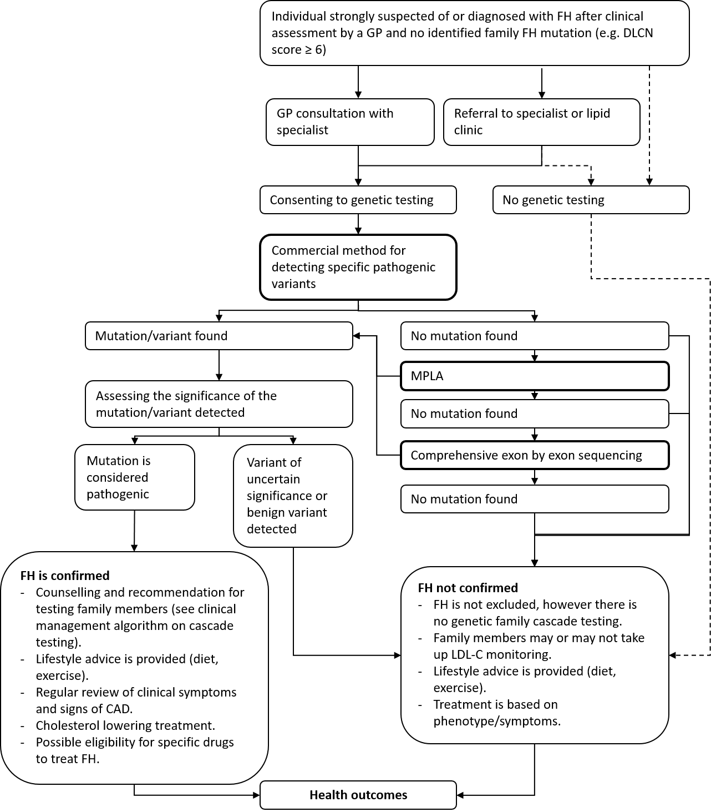
Figure 1 Current and proposed clinical management algorithm for individuals strongly suspected of or diagnosed with FH

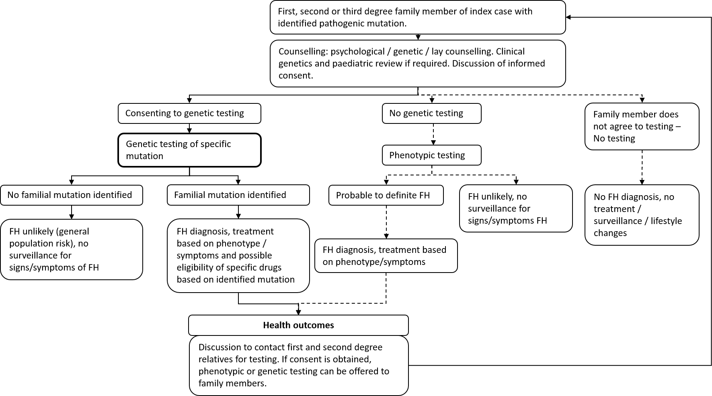
Figure 2 Current and proposed clinical management algorithm for first, second or third degree family members of an FH patient with an identified mutation

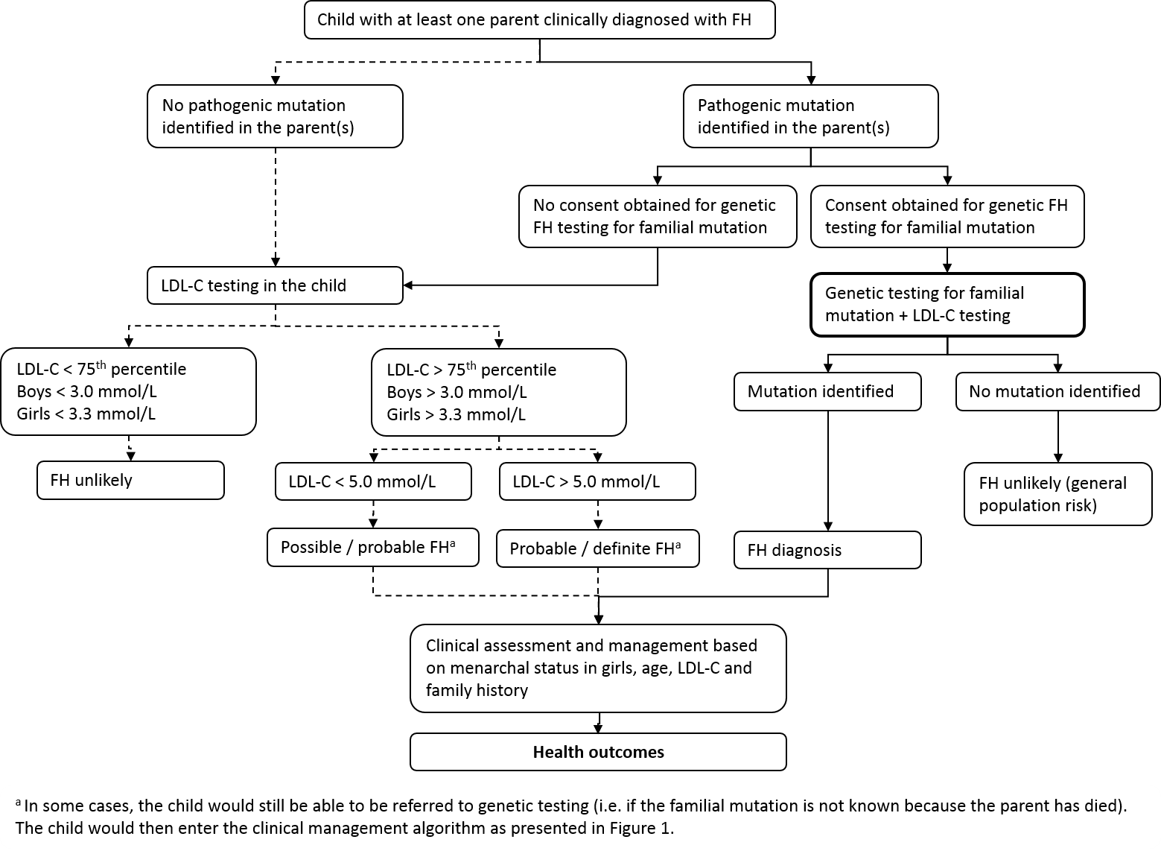
Figure 3 Current and proposed clinical management algorithm for children with at least one patient diagnosed with FH

Proposed economic evaluation
The applicant did not provide a clinical claim in the application document. However, based on the information presented in the application is it assumed the claim would be that the intervention is superior to the comparator, improving health outcomes through better targeting of surveillance and improved adherence to lifestyle changes.
If this is supported by the clinical evidence presented in the assessment report, a cost-utility analysis would be the most appropriate type of economic evaluation to present.
The model should aim to investigate the incremental value of cascade testing. Cascade testing would include 1st and 2nd degree family members as a base case, and should also explore the option of testing 3rd degree family members (in a sensitivity analysis).

Proposed item descriptor
Item descriptors were proposed by the applicant and are presented in Table 4 and Table 5.
Table 4 Item descriptor diagnostic testing, proposed by the applicant
Category 6 – PATHOLOGY SERVICES
Characterisation of germline gene variants in at least LDLR, PCSK9 and APOB in a patient with hypercholesterolaemia for whom clinical and family history criteria, as assessed by a treating medical practitioner using a quantitative algorithm, place the patient at >10% risk of having a clinically actionable pathogenic mutation identified.

Fee: $ 1,200

Table 5 Item descriptor predictive testing of family members, proposed by the applicant
Category 6 – PATHOLOGY SERVICES
Request by a medical service able to provide genetic counselling, for the detection of a clinically actionable pathogenic mutation previously identified in a gene listed in item XXXX in a near relative.

Fee: $ 400

One of the criteria for testing proposed above in Table 4 states that the patient needs to have a “>10% risk of having a clinically actionable pathogenic mutation identified”. The applicant indicated that this was based on other applications for less common conditions, and is not necessarily an appropriate criterion for FH. Therefore, the assessment group proposes some slight changes in the item descriptors and is proposing the item descriptors below in Table 6 and Table 7.
It should be noted that if the sensitivity analysis identifies the testing of third degree relatives as cost-effective and MSAC decides to list the intervention for third degree relatives, the item descriptor (Table 7) should be amended to allow for this.
The proposed items would fall under MBS Category 6 ‘Pathology services’. Within this category, the items would be under subgroup P7 (Genetics).
The fees were proposed by the applicant. They are consistent the MBS fees for testing BRCA1 and BRCA2 mutations, but significantly more than the MBS fees for detection of germline mutations in the RET gene ($400 for the index patients and $200 in family members) and VHL gene ($600 for index patients and $340 in family members).

Table 6 Proposed changed item descriptor for diagnostic testing
Category 6 – PATHOLOGY SERVICES
Characterisation of germline gene variants in the LDLR, PCSK9 and APOB genes causing familial hypercholesterolaemia, requested by a specialist or consultant physician or a general practitioner in consultation with a specialist, in patients where:

- No familial mutation has been identified, and
- The patient has a Dutch Lipid Clinic Network score of at least 6; or
- The patient has an LDL-cholesterol level of at least 6.5 mmol/L in the absence of secondary causes; or
- The patient has an LDL-cholesterol level between 5.0 and 6.5 mmol/L with signs of premature/accelerated atherogenesis.

Fee: $ 1,200.00 Benefit: 75% = 900.00 85% = 1020.00

Table 7 Proposed changed item descriptor for predictive testing of family members
Category 6 – PATHOLOGY SERVICES
Detection of a familial mutation in the LDLR, PCSK9 or APOB gene in a first- or second-degree relative of a patient with a documented pathogenic germline gene variant for familial hypercholesterolaemia, requested by a general practitioner, specialist or consultant physician who manages the treatment of the patient.

Fee: $ 400.00 Benefit: 75% = $300.00 85% = 340.00

References
1. Bouhairie VE, Goldberg AC. Familial hypercholesterolemia. Cardiol Clin. 2015;33(2):169-179.
2. Martin AC, Coakley J, Forbes DA, Sullivan DR, Watts GF. Familial hypercholesterolaemia in children and adolescents: a new paediatric model of care. J Paediatr Child Health. 2013;49(4):E263-272.
3. Migliara G, Baccolini V, Rosso A, et al. Familial Hypercholesterolemia: A Systematic Review of Guidelines on Genetic Testing and Patient Management. Front Public Health. 2017;5:252.
4. Bellgard MI, Walker CE, Napier KR, et al. Design of the Familial Hypercholesterolaemia Australasia Network Registry: Creating Opportunities for Greater International Collaboration. J Atheroscler Thromb. 2017;24(10):1075-1084.
5. Abul-Husn NS, Manickam K, Jones LK, et al. Genetic identification of familial hypercholesterolemia within a single U.S. health care system. Science. 2016;354(6319).
6. Watts GF, Shaw JE, Pang J, Magliano DJ, Jennings GL, Carrington MJ. Prevalence and treatment of familial hypercholesterolaemia in Australian communities. Int J Cardiol. 2015;185:69-71.
7. Watts GF, Sullivan DR, Poplawski N, et al. Familial hypercholesterolaemia: a model of care for Australasia. Atheroscler Suppl. 2011;12(2):221-263.
8. Hinchcliffe M, Le H, Fimmel A, et al. Diagnostic validation of a familial hypercholesterolaemia cohort provides a model for using targeted next generation DNA sequencing in the clinical setting. Pathology. 2014;46(1):60-68.
9. Bell DA, Bender R, Hooper AJ, et al. Impact of interpretative commenting on lipid profiles in people at high risk of familial hypercholesterolaemia. Clin Chim Acta. 2013;422:21-25.
10. Hooper AJ, Nguyen LT, Burnett JR, et al. Genetic analysis of familial hypercholesterolaemia in Western Australia. Atherosclerosis. 2012;224(2):430-434.
11. Nordestgaard BG, Chapman MJ, Humphries SE, et al. Familial hypercholesterolaemia is underdiagnosed and undertreated in the general population: guidance for clinicians to prevent coronary heart disease: consensus statement of the European Atherosclerosis Society. Eur Heart J. 2013;34(45):3478-3490a.
12. Bell DA, Hooper AJ, Edwards G, et al. Detecting familial hypercholesterolaemia in the community: impact of a telephone call from a chemical pathologist to the requesting general practitioner. Atherosclerosis. 2014;234(2):469-472.
13. National Collaborating Centre for Primary Care. Identification and Management of Familial Hypercholesterolaemia (FH) [Internet]. Appendix F, Simon Broome Diagnostic criteria for index individuals and relatives. Vol 71. London: Royal College of General Practitioners (UK)2008.
14. Wiegman A, Gidding SS, Watts GF, et al. Familial hypercholesterolaemia in children and adolescents: gaining decades of life by optimizing detection and treatment. Eur Heart J. 2015;36(36):2425-2437.
15. Bell DA, Garton-Smith J, Vickery A, et al. Familial hypercholesterolaemia in primary care: knowledge and practices among general practitioners in Western Australia. Heart Lung Circ. 2014;23(4):309-313.
16. Vandrovcova J, Thomas ER, Atanur SS, et al. The use of next-generation sequencing in clinical diagnosis of familial hypercholesterolemia. Genet Med. 2013;15(12):948-957.
17. Khera AV, Won HH, Peloso GM, et al. Diagnostic Yield and Clinical Utility of Sequencing Familial Hypercholesterolemia Genes in Patients With Severe Hypercholesterolemia. J Am Coll Cardiol. 2016;67(22):2578-2589.

Appendix: Simon Broome Criteria
Simon Broome diagnostic criteria for index individuals (probands)
Diagnose a person with definite familial hypercholesterolaemia (FH) if they have:
- cholesterol concentrations as defined in Table 8 and tendon xanthomas, or evidence of these signs in first- or second-degree relative
or
- DNA-based evidence of an LDL-receptor mutation, familial defective apo B-100, or a PCSK9 mutation.
Table 8 Cholesterol levels to be used as diagnostic criteria for the index individual¹
 | Total cholesterol | LDL-C
Child/young person | > 6.7 mmol/l | > 4.0 mmol/l
Adults | > 7.5 mmol/l | > 4.9 mmol/l
¹ levels either pre-treatment or highest on treatment.

Diagnose a person with possible FH if they have cholesterol concentrations as defined in Table 8 and at least one of the following.
- Family history of myocardial infarction: aged younger than 50 years in second-degree relative or aged younger than 60 years in first-degree relative.
- Family history of raised total cholesterol: greater than 7.5 mmol/l in adult first- or second-degree relative or greater than 6.7 mmol/l in child, brother or sister aged younger than 16 years.
Gender- and age-specific LDL-C criteria for the diagnosis of FH in relatives of a person with FH
These gender- and age-specific LDL-C criteria are to be used for the diagnosis of FH in the relatives of an index case with FH where the family mutation has not been identified (Table 9 and Table 10). These are intended for use by healthcare professionals with expertise in FH.
Relatives with LDL-C levels in the green zone are unlikely to have FH. In these instances, tables manage the person’s coronary heart disease risk as in the general population (see ‘Lipid modification: cardiovascular risk assessment and the modification of blood lipids for the primary and secondary prevention of cardiovascular disease’, NICE clinical guideline 67).
Relatives with LDL-C levels in the red zone are likely to have a clinical diagnosis of FH.
The diagnosis of FH for relatives in the grey zone is uncertain. A further measurement of LDL-C concentration should be carried out, and if the level is still in the grey zone this should be repeated annually. If the person’s LDL-C concentration remains in the grey zone then coronary heart disease risk should be assessed and managed as in the general population (see ‘Lipid modification: cardiovascular risk assessment and the modification of blood lipids for the primary and secondary prevention of cardiovascular disease’, NICE clinical guideline 67).
Table 9 Simon Broome Criteria table for females
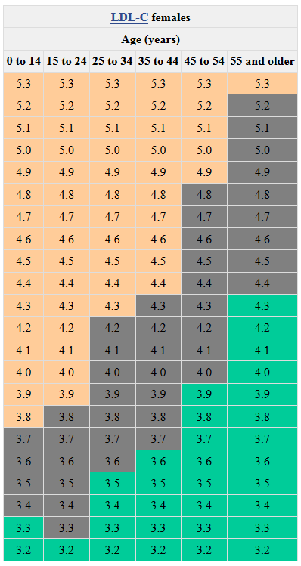

Table 10 Simon Broome Criteria table for males
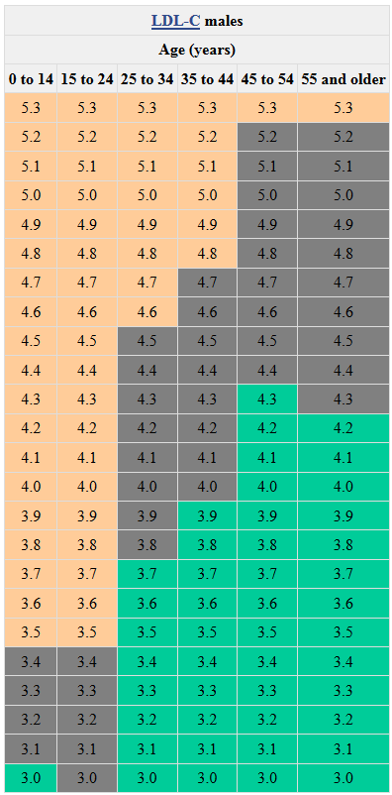

The base case should include first and second degree relatives, however evidence on third degree relatives should also be considered.
The base case should include first and second degree relatives, however evidence on third degree relatives should also be considered.
Discussed during a teleconference with the Department of Health, the applicant and several clinical experts on 25 May 2018
https://www.racgp.org.au/afp/2012/december/familial-hypercholesterolaemia
http://www.pbs.gov.au/medicine/item/10958R-11193D

