1369

Final protocol to guide the assessment of insertion of synthetic sling for the treatment of male stress urinary incontinence
December 2014

Table of Contents
MSAC and PASC 3
Purpose of this document 3
Purpose of application 4
Background 4
Current arrangements for public reimbursement 4
Regulatory status 6
Intervention 7
Description 7
Delivery of the intervention 8
Prerequisites 8
Co-administered and associated interventions 8
Listing proposed and options for MSAC consideration 9
Proposed MBS listing 9
Clinical place for proposed intervention 11
Comparator 13
Clinical claim 17
Outcomes and health care resources affected by introduction of proposed intervention 18
Outcomes 18
Health care resources 18
Proposed structure of economic evaluation (decision-analytic) 20

MSAC and PASC
The Medical Services Advisory Committee (MSAC) is an independent expert committee appointed by the Australian Government Health Minister to strengthen the role of evidence in health financing decisions in Australia. MSAC advises the Commonwealth Minister for Health on the evidence relating to the safety, effectiveness, and cost-effectiveness of new and existing medical technologies and procedures and under what circumstances public funding should be supported.
The Protocol Advisory Sub-Committee (PASC) is a standing sub-committee of MSAC. Its primary objective is the determination of protocols to guide clinical and economic assessments of medical interventions proposed for public funding.

Purpose of this document
This document is intended to provide a draft decision analytic protocol that will be used to guide the assessment of an intervention for a particular population of patients. The draft protocol will be finalised after inviting relevant stakeholders to provide input to the protocol. The final protocol will provide the basis for the assessment of the intervention.
The protocol guiding the assessment of the health intervention has been developed using the widely accepted “PICO” approach. The PICO approach involves a clear articulation of the following aspects of the research question that the assessment is intended to answer:
Patients – specification of the characteristics of the patients in whom the intervention is to be considered for use;
Intervention – specification of the proposed intervention
Comparator – specification of the therapy most likely to be replaced by the proposed intervention
Outcomes – specification of the health outcomes and the healthcare resources likely to be affected by the introduction of the proposed intervention

Purpose of application
A request for MBS listing of insertion of synthetic sling for the treatment of male stress urinary incontinence was received from American Medical Systems Australia Pty Ltd by the Department of Health in September 2013. The application states that “[t]he Department of Health has requested either a new code or a modification of an existing code to better reflect the service with regard to implantation of a synthetic sling”. The application also states that the service of sling insertion is currently being claimed under MBS item 37042. The application does not state which MBS item
(if any) is currently claimed for adjustment or removal of the synthetic sling, to which MBS item 37341 may apply.
The application proposes three new MBS items for:
(1) synthetic sling insertion;
(2) synthetic sling adjustment; and
(3) synthetic sling removal.

Background

Current arrangements for public reimbursement
Surgery to insert autologous or synthetic slings requires patient admission into a private or public hospital (depending on the level of health insurance cover) and is undertaken by a urologist on a patient under anaesthetic, with each operation taking between 90 to 120 minutes. Insertion and removal of autologous and synthetic slings are currently claimed for males and females under MBS item 37042 (insertion) and item 37341 (division or removal) (see Tables 1 and 2). There is currently no relevant MBS item for synthetic sling adjustment, but item 37341 covers division of a sling where there is urethral obstruction or erosion. Descriptor wording of item 37042 is inappropriate for synthetic slings (because it refers to ‘autologous’ sling, which is made from the patient’s own cells or tissues). However, pending the assessment of evidence by MSAC, and the fact that a range of synthetic slings are approved on the Prostheses List, the Department has permitted continued claiming of item 37042 for synthetic slings. Lower-rebated MBS item 35599 (sling insertion, without being limited to autologous slings) is not being billed for male stress incontinence because it is located in the gynaecological section of the MBS (Subgroup 4 of Group T8).
Table 1: Current MBS item descriptor for insertion of urinary autologous slings
Category 3 – Therapeutic procedures
MBS item 37042
BLADDER STRESS INCONTINENCE, sling procedure for, using autologous fascial sling, including harvesting of sling, with or without mesh, not being a service associated with a service to which item 30405 or 35599 applies
MBS Fee: $911.30 Benefit: 75% = $683.50

Table 2: Current MBS item descriptor for removal of urinary slings
Category 3 – Therapeutic procedures
MBS item 37341
URETHRAL SLING, division or removal of, for urethral obstruction or erosion, following previous surgery for urinary incontinence, suprapubic or combined suprapubic/vaginal approach, not being a service associated with a service to which item number 37340 applies
MBS Fee: $911.30 Benefit: 75% = $683.50

Between July 2012 and June 2013, there were 383 claims for MBS item 37042 (273 for males) and 51 claims for MBS item 37341 (8 for males).
At its first consideration of the Draft Protocol, the PASC considered that the current MBS items for autologous sling insertion (MBS item 37042) and removal (MBS item 37341) could be amended to specifically include synthetic slings and acknowledged that a new MBS item would be required for adjustment. The PASC also considered that should the proposed fees for the insertion and removal of synthetic slings be greater than those that currently apply (which is the case, see Tables 4-6), that the applicant provide sufficient justification for the increased fee.
Funding to cover the cost of male urinary synthetic sling devices (inserted as part of a private,
in-hospital admission) is primarily provided through private health insurance (PHI). Four types of male stress urinary incontinence synthetic sling (bone anchored, retrourethral transobturator, quadratic and adjustable retropubic) are approved on the Prostheses List (six products; see Table 3 below). In private hospital/day surgery settings, PHI benefits contribute towards the cost of the sling device, medical service to insert the sling, and associated hospital accommodation, while MBS benefits contribute towards the cost of the medical service. Each synthetic sling is inserted by the same type of surgery and functions in the same way, but differs in the way the sling is anchored (Trost & Elliot 2012).
Bone anchored sling (BAS)
The synthetic or organic mesh is secured (and tightened to an appropriate tension) using six titanium screws on the inferior pubic ramus, as well as sutures. Synthetic slings are most commonly used as degradation of organic mesh was reported. The sling results in compression to the bulbar urethra.
Retrourethral transobturator sling (RTS)
The retrourethral transobturator sling is self-anchoring with bilateral polypropylene mesh arms placed in a transobturator fashion. The sling portion is secured at the proximal bulbar urethra with continence achieved through subsequent elevation of the urethra.
Quadratic sling (QS)
Similar to the bone-anchored sling, the quadratic sling is placed over the bulbar urethra. Like the retrourethral transobturator, it is self-secured with two arms placed in a transobturator and two other arms placed in a prepubic manner, and the arms can be further secured to create additional points of fixation.

Adjustable retropubic sling (ARS)
Similar to the retrourethral transobturator sling, the adjustable retropubic sling is secured at the proximal bulbar urethra, with traction sutures placed retropubicly. It acts by exerting urethral compression.
Figure 1 provides a graphical representation of the placement of each type of sling.
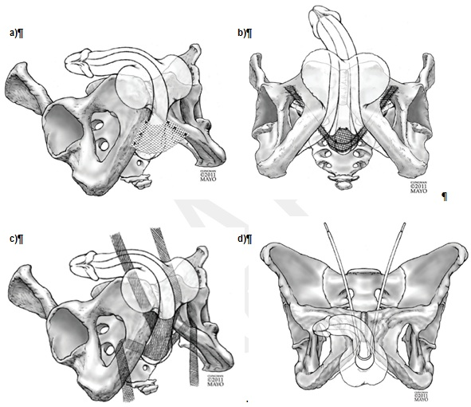
Figure 1: Diagrammatical representations of a) bone anchored sling (BAS), b) retrourethral transobturator sling (RTS), c) quadratic sling (QS) and d) adjustable retropubic sling (ARS) placement
Source: Figures 1-4, pp3-4 of Trost & Elliot 2012

Regulatory status
A summary of male urinary slings available on the prostheses list is provided in Table 3. The proposed MBS items for insertion, adjustment or removal of male urinary synthetic slings may be used in combination with any of the ARTG listed male urinary slings (and implicitly, any synthetic slings listed in the future).

Table 3: List of male urinary synthetic slings available on prostheses list
ARTG number | Name (Manufacturer) | Billing code | Description | Size | Type | Benefit
122095 | InVance Male Sling System (American Medical Systems Pty Ltd) | AM017 | Kit includes inserter with shaft, 6 bone screws with suture and silicone-coated sling surgical mesh | One Size | BAS | $5,718
126765 | AdVance XP male Sling System (American Medical Systems Pty Ltd) | AM048 | Sub-urethral sling implant for treatment of male stress urinary incontinence. Made from polypropylene monofilament mesh | Arm width: 1.2cm, Centre  width: 3.55cm, Total Length:  35.5cm, 43.5cm | RTS | $5,718
187095 | Virtue Male Sling System (Coloplast Pty Ltd) | CT015 | Male sling system with quadratic fixation | One Size | QS | $5,718
118082 | ARGUS (Endotherapeutics Pty Ltd) | ET050 | Adjustable Male Sling made of silicone adjustable self-fixating columns and urethral cushion | One Size | ARS | $5,718
180393 | Contrasure Remeex Male (Gytech Pty Ltd) | GP006 | Adjustable male SUI sling | Varitnesor is 1 x 1 x 2.5cm,  the sling is 22mm x 33mm. | ARS | $5,718
97288 | TiLOOP male (Medical Specialties Australia Pty Ltd) | MS055 | Tension-free mesh made out of titanized polypropylene for restoration of male urinary continence | 65 g/m² (strong) | ARS | $5,718
BAS = Bone Anchored Sling, RTS = Retrourethral transobturator sling, QS = Quadratic Sling, ARS = Adjustable retropubic sling, SUI = stress urinary incontinence
Source: Prostheses List – Part A; http://www.health.gov.au/internet/main/publishing.nsf/Content/prostheses-list-pdf.htm [accessed 12 June 2014]
The PASC considered that an assessment of the comparative safety and effectiveness of the different types of synthetic slings would be informative.

Intervention

Description
Stress urinary incontinence is the involuntary loss of urine prompted by a physical movement. In stress incontinence, the sphincter muscle and/or the pelvic diaphragm, which support the bladder and urethra, are weakened or non-functioning. Suboptimal function may be caused by injury to the urethral area, surgery to the prostate or pelvic area etc. The sphincter is not able to prevent urine from flowing when intra-abdominal pressure is raised (such as when the patient coughs, laughs, or lifts heavy objects). Stress incontinence is more common in women than men and is unrelated to physiological stress. Leakage can lead to embarrassment for the patient and impact on quality of life as it may limit ability to work, exercise or restrict social contact.
Perineal slings are used to treat mild to moderate stress incontinence. Synthetic mesh (sling) is inserted surgically around the urethral bulb, slightly compressing the urethra and with the aim of improving urinary stress incontinence.

Delivery of the intervention
Urinary slings (autologous or synthetic) must be inserted surgically by a urologist, on a patient under anaesthetic, with each operation taking between 90 to 120 minutes. In males, incisions are made through the perineum and the synthetic sling is wrapped around the bulbar urethra, and anchored to surrounding structures such as bone for support, to change the position of the urethra. The applicant estimates around 400 synthetic slings are inserted each year, which is more than the 273 claims for MBS item 37042 in males between July 2012 and June 2013.
As the function of synthetic urinary slings relies on tension to alter the position of the urethra, it may be necessary to adjust the position of the synthetic sling at a later point in time. Removal of the synthetic sling may also be necessary if complications such as infection occur.
The six types of synthetic sling (i.e. specific products) listed on the prostheses list differ in how the sling is anchored, but the function of each sling is identical.

Prerequisites
Currently, only urologists are able to insert male urinary slings. Patients are referred by their general practitioner to a specialist, who will conduct a range of history/physical examinations including urinalysis, urodynamics assessment and cystoscopy, and also pad weight measurements to determine the severity of stress urinary incontinence before the appropriate therapy is chosen. Urinary slings are mainly indicated for mild to moderate stress urinary incontinence.
The insertion of male urinary slings must be conducted under anaesthetic and can be conducted in the hospital setting as either day surgery or more commonly as an overnight stay; therefore an anaesthetist must be involved as well as surgical assistants to the urologist. Further, given that the synthetic urinary sling itself is not covered by the MBS, the synthetic sling must be purchased by the patient, hospital or private health insurer.

Co-administered and associated interventions
Whilst the aim of insertion of a sling would be to cure incontinence, the result may only be an improvement in incontinence, thus pad therapy or use of condom catheters may be a continuing co-administered intervention.
There are currently no listed restrictions on the types of patients covered by MBS item 37042, and no restrictions are included in the proposed MBS items requested by the applicant for changes/new listings to the MBS for insertion, removal and adjustment of male urinary synthetic slings. The applicant has not requested any changes to urinary synthetic slings already approved on the Prostheses List, but the proposed MBS fees for the amended/new MBS items for insertion and removal of synthetic slings are higher than existing MBS fees for insertion of autologous slings and removal of non-specified slings. The assessment group considers it unlikely that having new MBS items for insertion, removal and adjustment of male synthetic urinary slings will have any overall impact on the number of patients receiving male urinary slings.

Listing proposed and options for MSAC consideration

Proposed MBS listing
The application does not provide suggested wording for the proposed MBS items for male stress urinary incontinence synthetic sling insertion, adjustment or removal, but does propose an MBS fee for each item as summarised in Tables 4-6.
Table 4: Proposed MBS item descriptor and MBS fee for insertion of male synthetic sling
Category 3 – Therapeutic procedures
MBS item xxxxx
[Item descriptor - to be determined]
MBS Fee: $1,235 Benefit 75% = $926.25
[Relevant explanatory notes – to be determined, if necessary]

Table 5: Proposed MBS item descriptor and MBS fee for adjustment of male synthetic sling
Category 3 – Therapeutic procedures
MBS item xxxxx
[Item descriptor - to be determined] – including wording ‘with or without replacement of sling’
MBS Fee: $545 Benefit 75% = $408.75
[Relevant explanatory notes – to be determined, if necessary]

Table 6: Proposed MBS item descriptor and MBS fee for removal of male synthetic sling
Category 3 – Therapeutic procedures
MBS item xxxxx
[Item descriptor - to be determined] – including wording ‘with or without replacement of sling’
MBS Fee: $1,235 Benefit 75% = $926.25
[Relevant explanatory notes – to be determined, if necessary]

No proposed criteria for patient eligibility have been included by the applicant. However, only men who experience stress urinary incontinence would benefit from insertion of a urinary sling.
Select evidence from the literature and the proposed clinical algorithm in the application suggest that the use of urinary synthetic slings may be best restricted to men with mild or moderate (not severe) stress urinary incontinence. However, a full assessment of the safety and effectiveness of the use of the sling in all levels of severity (mild, moderate and severe; see below for definitions) would be required to ascertain whether restricting use to mild and moderate patients is reasonable, and how these should be defined.
There is also some evidence that the urinary synthetic sling may have reduced efficacy amongst men who have undergone radiotherapy treatment for prostate cancer (Stern et al 2005), however this requires a full assessment before exclusion of this patient group from the MBS item descriptor is warranted.
Additionally, regarding wording for the proposed adjustment and removal MBS items, wording that includes “with or without replacement” should be given consideration to maintain consistency with existing MBS item 37390 (descriptor on page 16, Table 13), which is for revision or removal of an artificial urinary sphincter.
The Australian Government requires that gender-neutral language be used to make the language of legislation (in this case, the Health Insurance (General Medical Services Table) Regulation) more inclusive. However, consideration needs to be given to whether MBS item 37042 has a higher MBS fee than item 35599 because item 37042 is intended for male procedures, which may be more complicated. Item 37042 is currently being billed for males (70%) and females (30%).
The proposed MBS fee for insertion of the male synthetic sling ($1,235) is 36% higher than the MBS fee for existing MBS item 37042 ($911.30), and 16% higher than the current MBS fee for insertion of an artificial urinary sphincter by the comparable perineal approach under MBS item 37381 (cuff; $741.50) and 37387 (balloon and pump; $323.20), totalling $1,064.70. Similarly, the proposed MBS fee for removal of synthetic sling ($1,235) is 36% higher than the MBS fee for existing sling division or removal item 37341 ($911.30) and 34% higher than the current MBS fee for removal of an artificial urinary sphincter under MBS item 37390 ($924.70). The proposed MBS fee for adjustment of the synthetic sling ($545) is 41% lower than the current MBS fee for revision of an artificial urinary sphincter under MBS item 37390 ($924.70), and 40% lower than the current MBS fee for division of urethral sling under item 37341 ($911.30). No rationale is provided in the application for differences in fees across the MBS items; however the application does note some important differences in surgical approach between males and females (indicating a more complicated procedure in males). This may explain fee differences between items 35599 and 37042, but not between the proposed items and those currently billed for males.
Insertion
Surgical approach
- Perineal incision for males versus vaginal approach for females.
- Anatomical differences in surgical approaches between female and male sling insertion cannot be compared. The female urethra itself is not dissected and mobilised; indeed very little dissection is required. The body tissues divided to place a female sling are more superficial and easy to access than those dissected in placing a male sling, and the potential for complications is much less in the surgical approach to insert a female sling.
- With insertion of a male sling, the potential exists for damage to the urethra itself, to posterior scrotal nerves leading to chronic pain issues, or to the erectile bodies leading to erectile dysfunction. The sling must be sutured to the urethra and adjusted under endoscopic control, or supporting washers must be positioned under the correctly measured urethral closing pressures.
Stronger Muscular structures
- Greater force and depth of passage is required for the male sling obturator needle pass.
Post radical prostatectomy anatomy
- Prolapsed urethra in the male versus healthy urethra in females.
- Often compromised tissue in men (i.e. from radiation).

Relocation and supportive requirements of sling
- Female incontinence slings neither relocate nor continuously support (under tension) the female urethra. The male sling is required to do both and is constructed to provide a mechanism of action that relocates the bulbar urethra, in an action parallel to the urethral lumen. Some sling designs may require adjustment post primary surgery, requiring a second but simpler procedure.
Removal of the male sling
- Removal of the sling requires a procedure similar in technical difficulty to the primary placement of the device, with similar dissection differences as described above in “Surgical approach” and also described below.
Adjustment
Adjustment requires perineal and, potentially, transabdominal/retropubic surgery to locate, mobilise and adjust the sling.
Removal of sling
Removal of the male sling is a technically challenging procedure with, potentially, a combined
perineal / abdominal / retropubic surgical procedure. Mesh material often erodes or becomes adherent, due to scarring, to surrounding structures. This dramatically increases the extent and need for dissection and mesh resection / removal. Patients will require a period of bladder drainage and post-operative inpatient care to ensure the urinary tract is stably managed and infective risk averted.

Clinical place for proposed intervention
The clinical algorithm with and without male urinary sling in the management of stress urinary incontinence is shown in Figure 2. The main difference between the two algorithms is that, after stress incontinence has been diagnosed and the severity defined (based on pad weight measurement), urinary synthetic slings may be used as an alternative to autologous slings and Macroplastique injections in mild incontinence, as well as an alternative to autologous slings, condom catheters and artificial urinary sphincters in moderate to severe incontinence. However, it is unclear whether urinary synthetic slings are an appropriate therapy for severe urinary incontinence, as there is evidence that the success rate of urinary slings in severe urinary incontinence (>6 pads per day) is poor (Castle et al 2005).
Currently, funding for Macroplastique injections is available under MBS item 37339 and the agent itself is covered by private health insurance and listed on the prostheses list. For the artificial urinary sphincter (AUS), funding is similar to the urinary sling where the procedure to implant the AUS is covered under the MBS (MBS items 37381, 37384, 37387 and 37390), but the actual sphincter is covered by private health insurance and listed on the prostheses list. Limited funding by the Australian Government under the Continence Aids Payment Scheme (CAPS) is provided for purchases of pads for pad therapy or condom catheter accessories, and there are also state government initiatives which may provide further funding or support for incontinence services.
However, it should be noted that the proposed changes to the MBS items will not alter the clinical algorithm in any way, as urinary synthetic slings are currently funded through private or public means.
The proportion of men assumed to undertake treatment for stress urinary incontinence via use of the male sling, Macroplastique and artificial urinary sphincters can be elucidated from current MBS item claims. However, with respect to male slings, it will be difficult to identify the use of autologous versus synthetic slings. The proportion opting to cope with symptoms of urinary incontinence via the use of pads or condom catheters may be difficult to estimate.
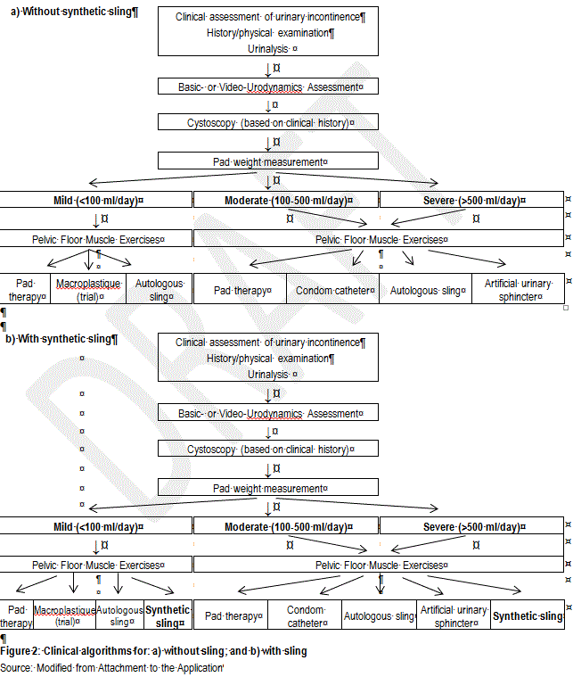

Comparator
The relevant comparators for slings to treat male stress urinary incontinence are dependent on the level of urinary incontinence severity, as summarised in Table 7.
Table 7: Relevant comparators for synthetic slings to treat male stress urinary incontinence
 | Mild incontinence  <100mL/day | Moderate incontinence  100-500mL/day | Severe incontinence  >500mL/day
Autologous sling | √ | √ | √
Pad therapy | √ | √ | √
Condom catheter | × | √ | √
Macroplastique | √ | × | ×
Artificial urinary sphincter | × | √ | √
Autologous sling
Autologous slings function in the same way as synthetic slings. Autologous slings are made from the patient’s own cells or tissues. This operation is typically performed using a free graft of rectus fascia placed around the bladder neck or urethra (Athanasopolous & McGuire 2010).
Pad therapy
Whilst not offering the potential to cure men of stress urinary incontinence, the use of pads provides a mechanism by which the symptoms of incontinence can be dealt with.
Condom catheter
Like pad therapy, the use of a condom catheter does not represent the potential for a cure of incontinence, but provides a mechanism by which the symptoms of incontinence can be dealt with.
Macroplastique
Macroplastique is a material consisting of textured silicone particles suspended in a liquid gel (polyvinylpyrrolidone). It is a bulking agent; when injected it stabilises and “bulks” the tissue, providing the surrounding muscles with increased capability to control the flow of urine. In a publication reporting on the use of Macroplastique in the treatment of mild to moderate male stress urinary incontinence, 2.5 to 5mL of Macroplastique was injected to the external sphincter at 5 or 7 o’clock, or both, under local anaesthesia (Kylmala et al 2003). Macroplastique is on the prostheses list under billing code ET011 (ARTG 146732) and is priced at $690.00 per 1.3mL. At up to 5mL of Macroplastique per injection, the cost of Macroplastique per injection may be up to $2,760 (4 vials). The relevant MBS item for injection of Macroplastique (MBS item 37339) is presented in Table 8.
The item is billed once per service (MBS fee $239.85), regardless of how many vials or individual injections are required during a single service. From July 2012 and June 2013 (inclusive), a total of 104 claims were made under MBS item 37339 for males (with a total of 586 claims for males and females).
Table 8: MBS item descriptor for item 37339 – suitable to claim for injection of Macroplastique
Category 3 – Therapeutic procedures
MBS item 37339
PERIURETHRAL OR TRANSURETHRAL INJECTION of materials for the treatment of urinary incontinence, including cystoscopy and urethroscopy, other than a service associated with a service to which item 18375 applies
MBS Fee: $239.85 Benefit: 75% = $179.90 85% = $203.90
(See para T8.2 of explanatory notes to this Category)

The study reported by Kylmala et al (2003) also allowed for further injections in men whose initial treatment was not curative, at an interval of 3 months, with up to four injections. The total volume of Macroplastique ranged from 2.5 to 13.5mL, with a mean of 7.1mL (Kylmala et al 2003).
Artificial urinary sphincter (AUS)
Insertion of an artificial urinary sphincter (AUS) is considered the gold standard treatment for male stress urinary incontinence (Trost & Elliot 2012). An AUS can be inserted via one or two small incisions and typically involves an overnight stay in hospital. The device has 3 main components attached to each other: the cuff (surrounding the urethra), the pump (placed in the scrotum next to one of the testes) and the reservoir (placed in the pelvis). In normal resting mode, the cuff is full of water, compressing the urethra. When the patient feels his bladder is full, he goes to the toilet and squeezes the pump, which forces the water out of the cuff and into the reservoir, so that the urethra is opened and urine is free to drain out. Over the next 2-3 minutes, the water passively returns to the cuff, closing the urethra again (http://www.aua.com.au/content_common/pg-artificial-urethral-sphincter.seo [accessed 25 June 2014]).
Figure 3 provides a graphical representation of one-cuff or tandem-cuff artificial urinary sphincters.
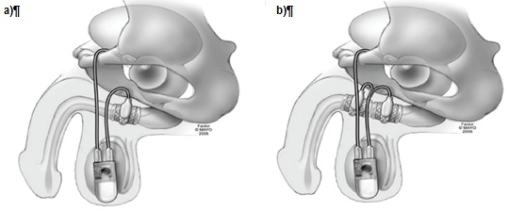
Figure 3: Diagrammatical representations of: a) single-cuff; and b) tandem cuff artificial urinary sphincters
Source: Figures 5-6, p4 of Trost & Elliot 2012
Table 9 summarises the AUS components listed on the Prostheses List, and Tables 9-13 summarise the MBS items relevant to insertion of the cuff and balloon and pump, revision and removal of the AUS.

Table 9: List of artificial urinary sphincters available on prostheses list
ARTG number | Name (Manufacturer) | Billing code | Description | Size | Benefit
Pump
131706 | AMS 800 Artificial Urinary Sphincter Pump (American Medical Systems Pty Ltd) | AM029 | Control pump | One size | $4,947
165326 | Urinary Control System Pump (American Medical Systems Pty Ltd) | AM050 | Pump with InhibiZone Antibiotic Surface Treatment | One size only | $5,343
Occlusive cuff
131706 | AMS 800 Artificial Urinary Sphincter Cuff (American Medical Systems Pty Ltd) | AM001 | Occlusive Cuff | 13 Cuff sizes from 3.5 to 11.0cm: Size 3.5, 4, 4.5, 5, 5.5, 6, 6.5, 7, 7.5, 8, 9, 10, 11cm | $2,614
131706 | AMS 800 Artificial Urinary Sphincter Cuff (American Medical Systems Pty Ltd) | AM021 | Silicone cuff for artificial urinary sphincter. For the implantation of the second cuff for the AMS 800 | 13 Cuff sizes from 3.5 to 11.0cm: Size 3.5, 4, 4.5, 5, 5.5, 6, 6.5, 7, 7.5, 8, 9, 10, 11cm | $2,614
165326 | AMS 800 Artificial Control System with InhibiZone - cuff (American Medical Systems Pty Ltd) | AM051 | Occlusive Cuff with InhibiZone Antibiotic Surface Treatment | 13 Cuff sizes from 3.5 to 11.0cm | $2,850
Regulating balloon
131706 | AMS 800 Artificial Urinary Sphincter Pressure Regulating Balloon (American Medical Systems Pty Ltd) | AM028 | Pressure Regulating Balloon | 51-60cm, 61-70cm,  71-80cm | $2,057
Constrictor
14276 | Inflatable Periurethral Constrictor (Device Technologies Australia Pty Ltd) | DE313 | Consists of membrane, filler product and silicone tube | One size only | $1,225
Accessory kit
131706 | AMS 800 Artificial Urinary Sphincter Accessory Kit (American Medical Systems Pty Ltd) | AM030 | Accessory kit | One size | $689
System
153266 | Flow Secure Artificial Urinary Sphincter (Endotherapeutics Pty Ltd) | ET057 | Artificial Urinary Sphincter with conditional occlusion, inflatable hydraulic device | One size | $10,000
Source: Prostheses List – Part A; http://www.health.gov.au/internet/main/publishing.nsf/Content/prostheses-list-pdf.htm [accessed 12 June 2014]

Table 10: MBS item descriptor for AUS cuff insertion
Category 3 – Therapeutic procedures
MBS item 37381
ARTIFICAL URINARY SPHINCTER, insertion of cuff, perineal approach
(Anaes.) (Assist.)
MBS Fee: $741.50 Benefit: 75% = $556.15

Table 11: MBS item descriptor for AUS cuff insertion
Category 3 – Therapeutic procedures
MBS item 37384
ARTIFICAL URINARY SPHINCTER, insertion of cuff, abdominal approach
(Anaes.) (Assist.)
MBS Fee: $1,157.85 Benefit: 75% = $868.40

Table 12: MBS item descriptor for AUS regulatory balloon and pump insertion
Category 3 – Therapeutic procedures
MBS item 37387
ARTIFICAL URINARY SPHINCTER, insertion of pressure regulating balloon and pump
(Anaes.) (Assist.)
MBS Fee: $323.20 Benefit: 75% = $242.40

Table 13: MBS item descriptor for AUS revision or removal
Category 3 – Therapeutic procedures
MBS item 37390
ARTIFICAL URINARY SPHINCTER, revision or removal of, with or without replacement
(Anaes.) (Assist.)
MBS Fee: $924.70 Benefit: 75% = $693.55
The number of claims for each MBS item number relevant to insertion, revision or removal of an AUS is presented in Table 14.
Table 14: Claims for MBS items 37381, 37384, 37387 and 37390 between June 2012 and July 2013
MBS item | Total | Males
37381 | 166 | 166
37384 | 24 | 21
37387 | 174 | 173
37390 | 74 | 71
Source:
http://www.medicareaustralia.gov.au/cgi-bin/broker.exe?_PROGRAM=sas.mbs_item_standard_report.sas&_SERVICE=default&DRILL=ag&_DEBUG=0&group=37381%2C37384%2C37387%2C37390&VAR=services&STAT=count&RPT_FMT=by+state&PTYPE=finyear&START_DT=201207&END_DT=201306 [accessed 25 June 2014]
Whilst PASC agreed these were the appropriate comparators, as stated previously, the PASC also considered that the current MBS items for autologous sling insertion (MBS item 37042) and removal (MBS item 37341) could be amended to specifically include synthetic slings and acknowledged that a new MBS item would be required for adjustment. The PASC also considered that should the proposed fees for the insertion and removal of synthetic slings be greater than those that currently apply (which is the case, see Tables 4-6), that the Applicant provide sufficient justification for the increased fee.

Clinical claim
The application makes the following claim:
Male slings provide a highly successful and permanent form of urinary incontinence therapy in this group of men. The slings allow patients to become pad-free without the need for additional aids such as condom sheath catheters.
Furthermore, male slings produce a much higher degree of success (85%) compared to Macroplastique injection (15%). Durability of treatment is also far greater.
Male slings allow men to achieve complete continence without the need to resort to an Artificial Urinary Sphincter (AUS). These latter devices are more complicated to implant and have a higher degree of risk and complication. Furthermore, the AUS requires a greater degree of dexterity for a patient to use.
In summary, for the comparison of the male sling and
- pad therapy, condom catheters and Macroplastique - a claim of superior comparative effectiveness, and equivalent comparative safety is made;
- artificial urinary sphincter - no claim regarding comparative effectiveness, but a claim of superior comparative safety is made; and
- no claims regarding the comparative safety and effectiveness of autologous versus synthetic slings are made.
On the basis of the claims above, a cost-effectiveness/cost-utility approach would be the relevant type of economic evaluation to be provided when considering pad therapy, condom catheter, Macroplastique or artificial urinary sphincter as the comparators. However, as stated previously, the PASC has considered that the MBS item numbers relevant to autologous slings could be amended to specifically include synthetic slings and that any increase in the fee would require justification. Should the Applicant make a claim that synthetic slings have benefits in terms of safety or effectiveness over autologous slings that would justify a higher fee for MBS items associated with synthetic sling, a cost-effectiveness/cost utility approach would be the relevant type of economic evaluation to be presented.

Table 12: Classification of an intervention for determination of economic evaluation to be presented
 |  | Comparative effectiveness versus comparator
 |  | Superior |  | Non-inferior | Inferior
Comparative safety versus comparator | Superior | CEA/CUA |  | CEA/CUA | Net clinical benefit | CEA/CUA
 |  |  |  |  | Neutral benefit | CEA/CUA*
 |  |  |  |  | Net harms | None^
 | Non-inferior | CEA/CUA |  | CEA/CUA* | None^
 | Inferior | Net clinical benefit | CEA/CUA | None^ | None^
 |  | Neutral benefit | CEA/CUA*
 |  | Net harms | None^
Abbreviations: CEA = cost-effectiveness analysis; CUA = cost-utility analysis
* May be reduced to cost-minimisation analysis. Cost-minimisation analysis should only be presented when the proposed service has been indisputably demonstrated to be no worse than its main comparator(s) in terms of both effectiveness and safety, so the difference between the service and the appropriate comparator can be reduced to a comparison of costs. In most cases, there will be some uncertainty around such a conclusion (i.e., the conclusion is often not indisputable). Therefore, when an assessment concludes that an intervention was no worse than a comparator, an assessment of the uncertainty around this conclusion should be provided by presentation of cost-effectiveness and/or cost-utility analyses.
^ No economic evaluation needs to be presented; MSAC is unlikely to recommend government subsidy of this intervention

Outcomes and health care resources affected by introduction of proposed intervention

Outcomes
Although the application is requesting MBS items for insertion, adjustment and removal of male urinary synthetic slings, assessment of the surgery alone cannot be done in isolation. That is, assessment of the safety and effectiveness of the synthetic sling (and the nominated comparator, autologous sling) must also be undertaken. The outcomes of relevance to this evaluation are summarised in Table 16.

Table 16: Outcomes upon which it is proposed the comparative clinical performance of the proposed intervention versus the comparator(s) should be based
Safety | Effectiveness
Complications from surgery (including, but not limited to wound infection and perineal pain) | Cure rate for incontinence
Complications from the sling (including, but not limited to urinary retention, urinary tract infections) | Improved incontinence
 | Reduction in pad/condom catheter use
 | Adjustment (synthetic sling) / division (autologous sling)
 | Life-time of the sling (when a replacement of the sling would be required)
 | Quality of life

Health care resources
Given that the diagnosis of stress urinary incontinence (as well as determination of severity) does not vary between different interventions, resources provided to identify eligible populations have not been considered in the economic analysis. Table 17 summarises the costs that could be considered in the economic evaluation. With regard to costs associated with pad or condom catheter use, these may change should other reasonable data sources be available.
Table 17: List of resources to be considered in the economic analysis
 | Provider of resource | Setting in which resource is provided | Proportion of patients receiving resource | Number of units of resource per relevant time horizon per patient receiving resource | Disaggregated unit cost
 |  |  |  |  | MBS | Safety nets* | Other govt budget | Private health insurer | Patient | Total cost
Resources provided for synthetic urinary slings
- Cost of device | PHI | N/A | 100 | 1 |  |  |  | 5718 |  | 5718
- Insertion of sling | MBS | Hospital | 100 | 1 | 926.25 |  |  |  | 308.75 | 1235
- Adjustment of sling | MBS | Hospital | ? | 1 | 408.75 |  |  |  | 136.25 | 545
- Removal of sling | MBS | Hospital | ? | 1 | 926.25 |  |  |  | 308.75 | 1235
- Hospitalisation for surgeryª | Private and State Gov’t | Hospital | ? | 1 |  |  | 8007 | ? |  | 8007
- Hospitalisation for surgery^{b} | Private and State Gov’t | Hospital | ? | 1 |  |  | 3808 | ? |  | 3808
Resources provided in association with synthetic urinary slings
- Complications^{c} | MBS | Hospital or outpatient | ? | ?
- Pads/Condom catheters/other aids^{d} | Gov’t and patient | N/A | ? | ? |  |  | 533.50e |  | ?
Resources provided for autologous urinary slings
- Cost of creating / harvesting graft | ? | Hospital? | 100 | 1
- Insertion of sling | MBS | Hospital | 100 | 1 | 683.50 |  |  |  | 227.80 | 911.30
- Removal of sling | MBS | Hospital | ? | ? | 683.50 |  |  |  | 227.80 | 911.30
- Hospitalisation for surgeryª | Private and State Gov’t | Hospital |  |  |  |  | 8007 | ? |  | 8007
- Hospitalisation for surgery^{b} | Private and State Gov’t | Hospital |  |  |  |  | 3808 | ? |  | 3808
Resources provided in association with autologous urinary slings
- Complications^{c} | MBS | Hospital or outpatient | ? | ?
- Pads/Condom catheters/other aids^{d} | Gov’t and patient | N/A | ? | ? |  |  | 533.50e |  | ?
* Include costs relating to both the standard and extended safety net.
ª AR-DRG L08A – Urethral procedures with complication or comorbidity
^{b} AR-DRG L08B – Urethral procedures without complication or comorbidity
^{c} No formal meta-analysis conducted to identify relevant complications to include in economic analysis during preparation of protocol. Decision on which complications to include and cost of treatment or sequelae of complication depends on the meta-analysis
^{d} Cost of incontinence products may be derived from Pharmacy Direct (www.pharmacydirect.com.au) based on Manual of resource items and their associated costs for PBAC December 2009 (http://www.pbs.gov.au/industry/useful-resources/manual/Manual%20of%20Resource%20Items%202009.pdf) accessed 26/6/2014. Condom catheter costs may be derived from independence Australia (http://store.independenceaustralia.com/continence-aids-1.html) - approved supplier of QLD and WA government schemes and also listed for SA programs. Victorian program supplies through Bright Sky Australia
^{e} From annual payment under Continence Aids Payment Scheme. State government schemes are not included as they vary depending on state.

Proposed structure of economic evaluation (decision-analytic)
A summary of the extended PICO to define research question that assessment will investigate is provided in Table 18.

Table 18: Summary of extended PICO to define research question that assessment will investigate
Patients | Intervention | Comparator | Outcomes to be assessed | Healthcare resources to be considered
Males with stress urinary incontinence (may be limited to those with mild or moderate symptoms) | Male synthetic sling of any type | Autologous sling | Complications and adverse events from surgery and sling  Cure rate to continence  Improvement in incontinence  Adjustment/revision rates  Sling failure rates  Quality of life | Costs associated with:  Complications (related to surgery and sling)  Pad and catheter use  AND  MBS item numbers for insertion/adjustment/removal of slings  Cost of slings (taken from prostheses list)

A model structure for a comparison of autologous and synthetic slings for the treatment of male stress urinary incontinence has been proposed (Figure 4). This would only need to be conducted should any proposed increase in fee be not well justified by differences in the procedure in terms of the surgical approach or time required to undertake the procedure.
Patients would start off in the model in an incontinent health state (which would be mild, moderate or severe). Patients would then undergo treatment with an autologous or synthetic male urinary sling.

The model assumes that insertion of the sling would occur only once. This assumption has been included as there may be no evidence of differential safety or effectiveness with multiple replacements of slings (which may not be applicable to autologous slings) and to not unnecessarily complicate the structure of the model. With this is mind, the relevant time horizon should perhaps be based on the expected life-time of the synthetic sling (if one exists).
Following insertion of the sling, patients either experience a complication or no complications. These refer to adverse events relating to surgery or the sling itself, which would be expected to occur fairly soon after implantation (eg, <90 days). Costing these adverse events may be approached in two ways: (i) use of the AR-DRG AR-DRG L08B – Urethral procedures without complication or comorbidity for those with no complications, and AR-DRG L08A – Urethral procedures with complication or comorbidity for those with complications, where this approach would also account for costs associated with hospital stay; or (ii) the number of separations for these two AR-DRG codes could be used to provide a weighted average cost for hospitalisation, and the individual complications would be costed, where relevant.
Following any complications, patients would then: (i) achieve continence; (ii) have an improvement in incontinence; or (iii) remain incontinent. Over the course of the model, patients would then have the opportunity to have the synthetic sling adjusted (in response not achieving continence in the first instance or due to reduced efficacy over time or long-term complications (i.e. >90 days)). It is not clear from the available literature whether autologous slings can be adjusted and is assumed to not be the case as there is no MBS item associated with this procedure. Thus, for autologous slings, the sling is assumed to be removed and the patient becomes incontinent. When the synthetic sling is adjusted, a patient has the opportunity to (i) achieve continence; (ii) have an improvement in incontinence; or (iii) remain incontinent. The synthetic sling may also be removed, but once removed, it is assumed that it will not be re-inserted, with all patients who have slings removed returning to/remaining incontinent.
Key uncertainties:
- A quick search of the literature has not identified any randomised controlled trials directly comparing the male autologous and synthetic slings. Therefore, the transition probabilities required for the model may need to be derived from a variety of single arm studies, where comparability of patients groups, background therapies etc may limit the exchangeability of the data;
- Derivation of transition probabilities for movement between health states given there are a number of synthetic sling devices available, which may have differential safety and effectiveness profiles (however, this should become evident in the assessment of the comparative safety and effectiveness of the different synthetic sling types);
- Appropriateness of not accounting for potential progression in worsening of incontinence symptoms (for example, from mild to moderate);
- The cost of synthetic sling devices is assumed to be as reported in the prostheses list. It is acknowledged that public hospitals may not be purchasing the sling at these costs, however the ability to gather such information may be difficult and is likely to vary from hospital to hospital;
- Appropriateness of the assumption that the model only follows patients through a single sling insertion and does not allow for repeat insertions; and
- Whether utilities which accurately reflect the quality of life of individuals who are continent and those with mild, moderate and severe incontinence (with or without complications) can be sourced in the literature.

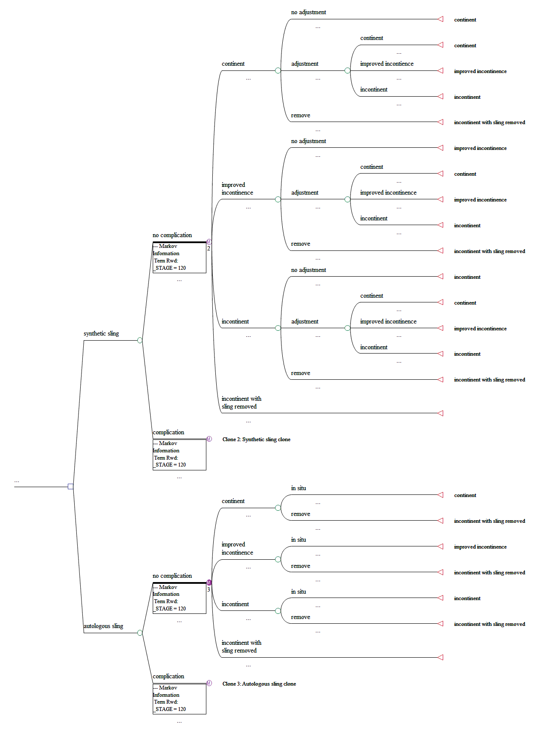
Figure 4: Decision analytic model for use of autologous versus synthetic slings in males with stress urinary incontinence

References
Athanasopoulos A & McGuire EJ. 2010. Efficacy of the bulbourethral autologous sling in treating male stress urinary incontinence: a three-year experience from a single center. International Urology & NeEphrology, 42: 921-927.
Castle EP et al. 2005. The male sling for post-prostatectomy incontinence: mean follow-up of 18 months. The Journal of Urology, 173: 1657-1660.
Kylmala T et al. 2003. Treatment of postoperative male urinary incontinence using transurethral Macroplastique injections. Journal of Endourology, 17(2): 113-115.
Trost L & Elliott DS. 2012. Male Stress Urinary Incontinence: A Review of Surgical Treatment Options and Outcomes. Advances in Urology, Vol. 2012, Article ID 287489, 13 pages. doi:10.1155/2012/287489
Stern JA et al. 2005. Long-term results of the bulbourethral sling procedure. The Journal of Urology, 173: 1654-1656.

