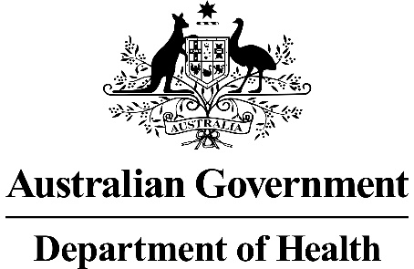

Application 1552:
Transcatheter Aortic Valve Implantation (TAVI) via transfemoral delivery, for patients at intermediate risk for surgery
Ratified PICO Confirmation

Summary of PICO/PPICO criteria to define the question(s) to be addressed in an Assessment Report to the Medical Services Advisory Committee (MSAC)
Component | Description
Patients | Persons with symptomatic severe aortic stenosis at intermediate risk for surgical aortic valve replacement, with no more than mild frailty and defined as fulfilling any one of the following criteria:  - Society of Thoracic Surgeons’ Predicted Risk Of Mortality (STS-PROM) 4%-8% OR  - One major organ system compromise not to be improved postoperatively OR  - Possible procedure-specific impediment
Intervention | Transcatheter aortic valve implantation (TAVI) via transfemoral delivery
Comparator | Surgical aortic valve replacement (SAVR) with a bioprosthesis or mechanical aortic valve
Outcomes | - Safety including any potential risk of harm to patient:  - Major stroke  - Major bleeding events  - Major vascular complications  - Renal failure  - Myocardial infarction  - New onset atrial fibrillation  - New permanent pacemaker  - Paravalvular leak rate  - Aortic valve reintervention  - Efficacy / effectiveness including, but not limited to, patient-relevant outcomes:  - Overall survival  - Hospitalisation for aortic stenosis/chronic heart failure  - Symptoms of heart failure  - Valve performance  - Health-related quality of life  - Recovery time  - Pain  - Healthcare resources  - Cost of valvular prosthesis  - Cost associated with changes in clinical management (testing required before the procedure, length of stay, post-discharge rehabilitation)  - Cost-effectiveness:  - Cost per life-year gained  - Cost per QALY gained  - Total Australian Government healthcare costs:  - Total cost to the Medical Benefits Schedule (MBS)
PICO or PPICO rationale for therapeutic and investigative medical services only
Population
Aortic stenosis (AS) is one of the most common and most serious cardiac valve disease problems. AS is a narrowing of the aortic valve opening. AS restricts the blood flow from the left ventricle to the aorta and may affect the pressure in the left atrium. Although some people have AS due to a congenital heart defect (bicuspid aortic valve), this condition more commonly develops during aging as calcium and/or scarring damages the valve and restricts the flow rate of blood through the valve. AS is not merely a result of aging but also a process of inflammation, lipid accumulation and calcification characterised by subendothelial thickening (Thaden, Nkomo et al. 2014).
AS results in structural changes to the heart from increased load on the left ventricle (LV) and hypertrophy (or enlargement of the heart). Stenotic valves may not close fully resulting in regurgitation back into the left ventricle. AS is a progressive disease that is asymptomatic until the latest, most severe stages of the disease. Symptoms include exertional dyspnoea, decreased exercise tolerance, exertional angina, and exertional syncope or presyncope.
Symptomatic severe AS is classified as Stage D AS and can be confirmed by the presence of symptoms (e.g., dyspnoea, angina, syncope, heart failure), severely calcified valve leaflets with reduced opening, jet velocity (V_{max}) ≥4 m/s, or mean aortic valve gradient ≥40 mm Hg. Variations in valve haemodynamics and the presence of symptoms are used to further subclassify symptomatic severe AS (Nishimura, Otto et al. 2014).
Left untreated patients will experience heart failure and angina (Nishimura, Otto et al. 2014). Patients are then at high risk for sudden death. Prognosis is poor once there is a mean aortic valve gradient greater than 40 mm Hg. Severe AS is associated with high death rates of 38%, 68% and 82% at 1 year, 5 years and 10 years respectively in non-surgically managed patients (Varadarajan, Kapoor et al. 2006).
The prevalence of AS is age-dependent. A large population-based study from the National Health, Lung, and Blood Institute in the United States estimated the prevalence of moderate or severe AS to range from a low of 0.02% in those aged 18-44 years to a high of 2.8% in persons aged over 75 years. Similar trends are present in other economically developed nations (Thaden, Nkomo et al. 2014). Osnabrugge, Mylotte et al. (2013) estimated that 3.4% of the population over 75 years would have severe AS. Of those, 75.6% would be symptomatic. It is estimated that 15.8% of patients with severe symptomatic AS are at intermediate risk for surgery (Osnabrugge, Mylotte et al. 2013). Thourani, Suri et al. (2015) estimated from the Society of Thoracic Surgeons (STS) data set that 13.9% of patients who underwent surgical aortic valve replacement (SAVR) were of intermediate risk.
Rationale
Patients with severe AS are typically elderly although younger adults may present with a congenital malformation of the valve. Patients may present to a general practitioner (GP) or alternatively an unexplained episode of shortness of breath, angina or syncope may trigger a presentation to an emergency room. Regardless of presentation an echocardiograph is the investigation to confirm a diagnosis of AS, and Doppler echocardiography is the preferred technique for assessing severity. Echocardiographic criteria for the definition of severe AS are as follows (Vahanian, Alfieri et al. 2012):
- Valve area <1.0 cm²
- Indexed valve area <0.6 cm²/m² body surface area (BSA)
- Mean gradient >40 mm Hg (in patients with normal cardiac output/transvalvular flow)
- Maximum jet velocity >4.0 m/s
- Velocity ratio <0.25.
Transoesophageal echocardiography may also be considered. Other tests that may be conducted include cardiac MRI, exercise echocardiography, multi-slice computed tomography, coronary angiography and peripheral vascular assessment. Valvular regurgitation is also assessed. Functional status is assessed by the New York Heart Association (NYHA) functional class system.
Three treatment options are available: SAVR, transcatheter aortic valve replacement (TAVR), and medical management. Medical management consists of pharmacologic treatment to alleviate symptoms and, in certain cases, balloon aortic valvuloplasty to enlarge the aortic valve opening. However, these treatments have not been found to provide sustained symptom relief, alter the disease course, or improve survival in patients with severe symptomatic AS. Medical management is not usually first line therapy for an operable patient so a referral is made to either a cardiologist or to a cardiothoracic surgeon. Referral is then made to a multi-disciplinary heart valve team to determine the patient’s potential suitability for the either the SAVR or the transcatheter aortic valve implantation (TAVI) procedure. This assessment should take into account clinical information (major cardiovascular and non-cardiovascular comorbidities, risk score assessment), functional assessment (frailty, physical and cognitive function), surgical risk assessment, and shared goals of care (benefit-risk discussion with the patient and family, patient goals and expectations, likelihood of symptom relief and improved survival, possible complications, expected recovery process) (Otto, Kumbhani et al. 2017).
This Application pertains to patients who are determined to be at intermediate risk for surgery by a heart team (Kodali, Thourani et al. 2016). Patients at an intermediate risk for surgery have been defined in the literature as those fulfilling any one of the following criteria (Nishimura, Otto et al. 2014, Otto, Kumbhani et al. 2017): Society of Thoracic Surgeons’ Predicted Risk Of Mortality (STS-PROM) 4%-8%, no more than mild frailty, one major organ system compromise not to be improved postoperatively, or having a possible procedure-specific impediment.
PASC confirmed the population relevant to this Application would be defined as:
Persons with symptomatic severe aortic stenosis at intermediate risk for surgical aortic valve replacement, with no more than mild frailty and fulfilling any one of the following criteria:
- STS PROM 4-8% OR
- One major organ system compromise not to be improved postoperatively OR
- Possible procedure-specific impediment.
The STS-PROM risk score is an accepted tool to predict the 30-day risk of SAVR and serves as a starting point for risk assessment in TAVR candidates (Otto, Kumbhani et al. 2017).
Mild frailty is defined as the presence of one of the seven frailty indices of Katz Activities of Daily Living (independence in feeding, bathing, dressing, transferring, toileting, urinary continence, and independence in ambulation i.e. no walking aid required or 5-meter walk in <6 s). Other frailty scoring systems may be applied as well (Nishimura, Otto et al. 2014).

Examples of major organ system compromise include:
  - Cardiac – severe left ventricular systolic or diastolic dysfunction or right ventricular dysfunction, fixed pulmonary hypertension;
  - Chronic kidney disease stage 3 or worse;
  - Pulmonary dysfunction with FEV1 (forced expiratory volume in 1 s) <50% or DLCO₂ (diffusion capacity for carbon dioxide) <50% of predicted;
  - Central nervous system dysfunction (dementia, Alzheimer’s disease, Parkinson’s disease, stroke with persistent physical limitation);
  - Gastrointestinal dysfunction – Crohn’s disease, ulcerative colitis, nutritional impairment, or serum albumin <3.0 g/dl;
  - Cancer – active malignancy; and
  - Liver – any history of cirrhosis, variceal bleeding, or elevated international normalised ratio (INR) in the absence of vitamin K antagonist therapy.
Examples of procedure-specific impediments include present tracheostomy, heavily calcified ascending aorta, chest malformation, arterial coronary graft adherent to posterior chest wall, or radiation damage.
As noted in the 2017 ACC Expert Consensus Decision Pathway for TAVR (Otto, Kumbhani et al. 2017), algorithms for TAVR assessment assume that patients are adults with calcific valvular AS, as TAVR for congenital AS, rheumatic valve disease, or isolated aortic regurgitation has not been studied in clinical trials.
Intervention
In Australia TAVI is performed in a cardiac catheterisation suite or an operating room. TAVI is generally performed under general or local anaesthesia and sedation, but for transfemoral delivery, which this Application is concerned with, sedation and analgesia may be sufficient. The procedure is performed without cardio-pulmonary bypass.
The procedure is performed under the guidance of fluoroscopy and transoesophageal echocardiography, however this may not always be necessary in an intermediate-risk patient. Aortography may also be used. A percutaneous sheath is inserted into the femoral artery with a guide wire that crosses the aortic valve. The aortic valve is predilated via balloon valvuloplasty.
Two different types of devices can be used to perform the TAVI procedure, self-expanding and balloon-expandable. Both types of devices are listed on the Australian Register for Therapeutic Goods (ARTG) and on the Prostheses List.
- If the device used is balloon-expandable, the valve is mounted on a balloon catheter and inserted percutaneously over the guide wire until it crosses the aortic valve. Optimum positioning is confirmed by fluoroscopy. Once the correct position is confirmed, the heart is again rapidly paced, the balloon is expanded until the device meets native annular walls. The balloon is deflated, the guide wire and catheter are then removed.
- If the device is self-expanding, the device is mounted on the guide wire until it crosses the aortic valve. Optimum positioning is confirmed by fluoroscopy. Once the correct position is confirmed, the heart is again rapidly paced, and the valve self-expands until it meets native annular walls. The guide wire and catheter are then removed.
Immediately following the procedure, aortography and transthoracic echocardiography are performed to assess the location and the degree of any aortic regurgitation, and the functioning of the coronary arteries. Patients are then transferred for monitoring to either a coronary care, high dependency or intensive care unit (ICU).
The Applicant claims that it is anticipated that in nearly all cases that TAVI would be delivered only once in a lifetime. However, as pointed out by Siemieniuk, Agoritsas et al. (2016) and Vandvik, Otto et al. (2016), the durability of TAVI valves is highly uncertain, as is the estimated long-term re-intervention rate after TAVI.
TAVI is currently included on the MBS for patients with symptomatic severe AS who are at high risk for SAVR or who would otherwise be inoperable (item 38495). TAVI is a new approach in Australia for treating patients who have symptomatic severe AS and are at intermediate risk for SAVR, and the purpose of the Application is to amend the patient population for MBS item 38495 to include patients at intermediate risk.
In order to attract a Medicare benefit under MBS item 38495, the patient’s eligibility for the TAVI service has to be approved through a TAVI Case Conference, and the service has to be performed by a TAVI practitioner in a hospital that is considered clinically accepted as being a suitable hospital for the provision of TAVI services.
A TAVI practitioner is an interventional cardiologist or a cardiothoracic surgeon with Fellowship of the Royal Australasian College of Physicians with specialty training in cardiology or Fellowship of the Royal Australasian College of Surgeons with specialty training in cardiothoracic surgery, who has been accredited through Cardiac Accreditation Services Limited (CASL; http://tavi.org.au). CASL is a national body comprising representatives from the Australian & New Zealand Society of Cardiac & Thoracic Surgeons (ANZSCTS) and the Cardiac Society of Australia & New Zealand (CSANZ).
When gaining accreditation, a TAVI practitioner must seek accreditation for a specific hospital/s. The hospital must be able to demonstrate to CASL that they meet the relevant requirements to be considered “clinically acceptable” (Department of Health 2017; Cardiac Accreditation Services Limited 2017).
Prior to receiving a Medicare-eligible TAVI procedure, a TAVI patient must have been assessed by a TAVI Case Conference (sometimes referred to as a TAVI Heart Team) as having an unacceptably high risk for surgical aortic valve replacement and suitable to receive the TAVI procedure. There is an MBS item for both co-ordination (item 6080) and participation in the conference (6081).
As mentioned, there are two main categories of transcatheter aortic valve prostheses: balloon-expandable (Sapien 3, Edwards Lifesciences i.e. the Applicant) and self-expanding (various manufacturers e.g. Medtronic CoreValve Evolut R; Portico, Abbott). Data directly comparing self-expanding and balloon-expandable valves are limited, especially for long-term outcomes (Noorani and Bapat 2014, Jose, Richardt et al. 2015, Wijeysundera, Qiu et al. 2017). The Application is for TAVI procedures using either a balloon-expandable or self-expanding transcatheteral aortic valve prostheses. PASC noted that the Prostheses List currently includes three TAVI devices that may not be equivalent. At the moment, only the balloon-expandable Sapien 3 prosthesis is registered for use in intermediate risk patients by the ARTG.Comparator
The comparator is SAVR, the gold standard for treating symptomatic severe AS. SAVR is an open-heart surgical procedure to repair or remove the narrowed aortic valve and replace it with a bioprosthesis or mechanical aortic valve. A SAVR procedure requires general anaesthetic and extracorporeal circulation, and may require sternotomy or be performed through a lesser invasive approach.
The intervention (TAVI) may replace or substitute current practice (SAVR). According to the Applicant, it is estimated that as many as 80% of intermediate-risk patients may access TAVI, should the service be included on the MBS.
Rationale
Medical management is usually not first-line therapy for an operable (low- or intermediate-risk) patient as aortic valve replacement is the only effective therapy (Varadarajan, Kapoor et al. 2006).
The comparator (SAVR) can be provided by cardiothoracic surgeons who must have completed the Cardiothoracic Surgery Program and be eligible to be a Fellow of the Royal Australasian College of Surgeons or otherwise qualified to practice cardiothoracic surgery in Australia.
Outcomes
Patient relevant
The Applicant claims that TAVI is superior to SAVR in patients with symptomatic severe ASat intermediate risk for surgery in terms of overall survival at one year.
TAVI is also claimed to result in significantly lower incidence of disabling stroke and lower rates for new onset atrial fibrillation (AF), major bleeding events, and renal failure than SAVR.
TAVI would involve a shorter hospital stay, including shorter ICU/high-dependency unit time, and shorter recovery time than SAVR as an open-chest procedure. Patients participating in a clinical guideline panel for TAVI uniquely identified recovery time and pain as critical to decision making (Siemieniuk, Agoritsas et al. 2016).
One of the major uncertainties, of particular relevance to younger patients, is the long-term durability of TAVI valves (Vandvik, Otto et al. 2016) and possible need for future revision procedures.
Safety outcomes:
- Major stroke
- Major bleeding events
- Major vascular complications
- Renal failure
- Myocardial infarction
- New onset atrial fibrillation
- New permanent pacemaker
- Paravalvular leak rate
- Aortic valve reintervention
Efficacy/ effectiveness outcomes including, but not limited to, patient-relevant outcomes:
- Overall survival
- Hospitalisation for AS/chronic heart failure
- Symptoms of heart failure
- Valve performance
- Health-related quality of life
- Recovery time
- Pain
Healthcare system
Cost-effectiveness:
- Cost per life-year gained
- Cost per QALY gained
Healthcare resources:
- Cost of valvular prosthesis
- Cost associated with changes in clinical management (testing required before the procedure, length of stay, post-discharge rehabilitation)
Total Australian Government Healthcare costs:
- Total cost to the Medical Benefits Schedule (MBS).

According to the Applicant, it is estimated that as many as 80% of intermediate-risk patients may access TAVI, should the service be included on the MBS. The Applicant claims that the clinical pathway will be essentially the same after TAVI as it is for SAVR.
It is possible that there will be capacity restraints if there are not enough available facilities and trained medical staff to meet demand. The Applicant claims that it is likely that capacity will increase in coming years.

Current clinical management algorithm for identified population
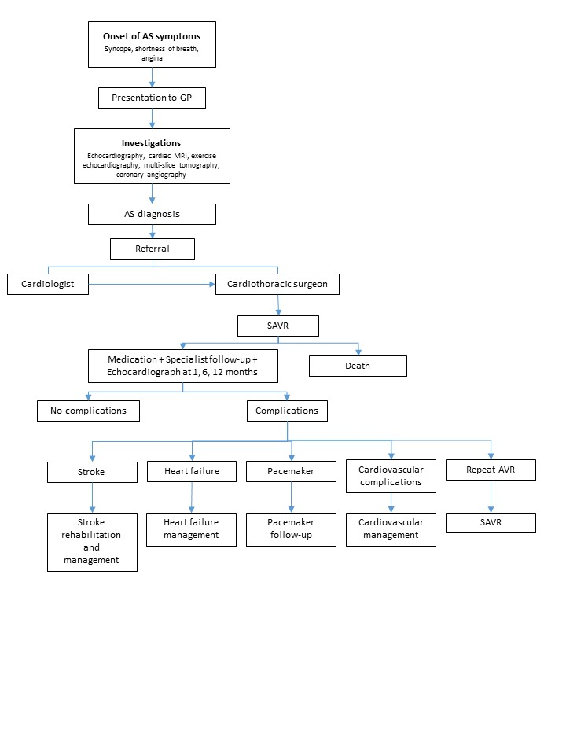

Proposed clinical management algorithm for identified population
TAVI is a new approach in Australia for treating patients who have symptomatic aortic stenosis and are at intermediate risk for SAVR. The clinical pathway after TAVI is the same as after SAVR.
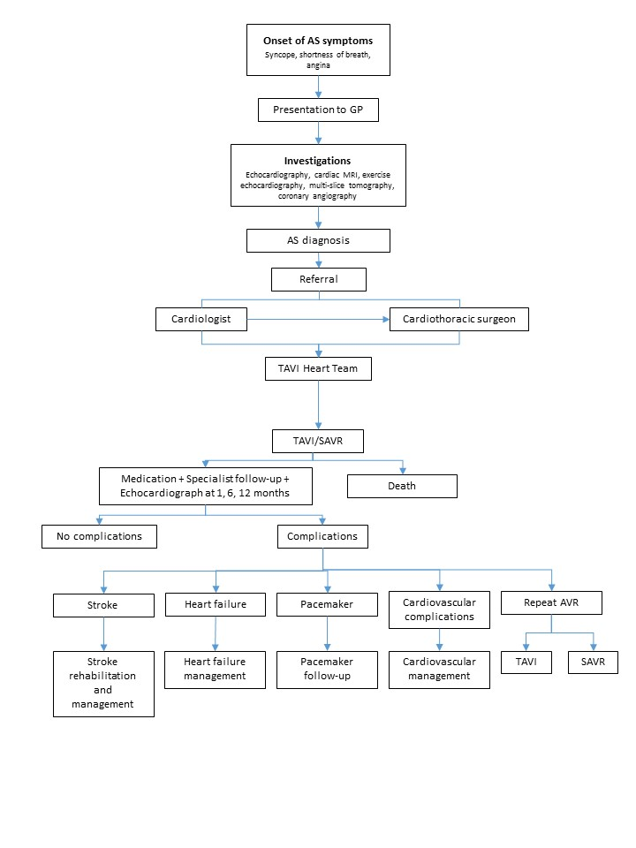

Proposed economic evaluation
The clinical claim is that TAVI is superior to SAVR. The appropriate economic evaluation is a cost-effectiveness or cost-utility analysis.

Proposed item descriptor
PASC confirmed that the MBS item descriptor below did not require modification. However, the definition of a TAVI patient will require amendment.
38495
TAVI, for the treatment of symptomatic severe aortic stenosis, performed via transfemoral delivery, unless transfemoral delivery is contraindicated or not feasible, in a TAVI Hospital on a TAVI Patient by a TAVI Practitioner – includes all intraoperative diagnostic imaging that the TAVI Practitioner performs upon the TAVI Patient
(Not payable more than once per patient in a five year period.)
MBS Fee: $1,432.20 Benefit: 75% = $1,074.15 85% = $1,348.80

The Health Insurance (Section 3C General Medical Services - Transcatheter Aortic Valve Implantation) Determination 2017(Cth) (Department of Health 2017) outlines the definitions of a TAVI Patient, TAVI Hospital and TAVI Practitioner.
TAVI Patient is a patient who, as a result of a TAVI Case Conference, has been assessed as having an unacceptably high risk for surgical aortic valve replacement and is recommended as being suitable to receive the service described in item 38495.
TAVI Hospital means a hospital, as defined by subsection 121-5(5) of the Private Health Insurance Act 2007, that is clinically accepted as being a suitable hospital in which the service described in Item 38495 may be performed.
TAVI Practitioner is either a cardiothoracic surgeon or interventional cardiologist who is accredited by the Cardiac Accreditation Services Limited.
It is anticipated that only the TAVI patient definition will require amendment to allow for the expanded population. PASC noted a distinction between the definition of the population to inform the evaluation (as defined in the PICO), and the population eligible for TAVI following assessment by a TAVI Heart Team.

TAVI Case Conference Items
There are currently two items for co-ordination and participation in a TAVI Case Conference.
6080 | Coordination of a TAVI Case Conference by a TAVI Practitioner where the TAVI Case Conference has a duration of 10 minutes or more.  (Not payable more than once per patient in a five year period.)  Fee: $50.15

6081 | Attendance at a TAVI Case Conference by a specialist or consultant physician who does not also perform the service described in item 6080 for the same case conference where the TAVI Case Conference has a duration of 10 minutes or more.  (Not payable more than twice per patient in a five year period.)  Fee: $37.40

It is not anticipated that this definition of a TAVI Case Conference will require amendment.
TAVI Case Conference means a process by which:
(a) there is a team of 3 or more participants, where:
(i) the first participant is a cardiothoracic surgeon; and
(ii) the second participant is an interventional cardiologist; and
(iii) the third participant is a specialist or consultant physician who does not perform a service described in Item 38495 for the patient being assessed; and
(iv) either the first or the second participant is also a TAVI Practitioner; and
(b) the team assesses a patient’s risk and technical suitability to receive the service described in Item 38495, taking into account matters such as:
(i) the patient’s risk and technical suitability for a surgical aortic valve replacement; and
(ii) the patient’s cognitive function and frailty; and
(c) the result of the assessment is that the team makes a recommendation about whether or not the patient is suitable to receive the service described in Item 38495; and
(d) the particulars of the assessment and recommendation are recorded in writing.

References
Cardiac Accreditation Services Limited (2017). Transcatheter Aortic Valve Implantation. Rules for the accreditation of TAVI practitioners. Version 1. Available at: https://tavi.org.au/wp-content/uploads/Rules-for-the-Accreditation-of-TAVI-Practitioners-1-Nov-2017.pdf. Accessed Nov 7, 2018.
Department of Health (2017). Health Insurance (Section 3C General Medical Services – Transcatheter
Aortic Valve Implantation) Determination 2017. Canberra; Department of Health. Available at: https://www.legislation.gov.au/Details/F2017L01380/Explanatory%20Statement/Text. Accessed Nov 7, 2018.
Jose, J., G. Richardt and M. Abdel-Wahab (2015). "Balloon- or Self-Expandable TAVI: Clinical Equipoise?" Interv Cardiol 10(2): 103-108.
Kodali, S., V. H. Thourani, J. White, S. C. Malaisrie, S. Lim, K. L. Greason, M. Williams, M. Guerrero, A. C. Eisenhauer, S. Kapadia, D. J. Kereiakes, H. C. Herrmann, V. Babaliaros, W. Y. Szeto, R. T. Hahn, P. Pibarot, N. J. Weissman, J. Leipsic, P. Blanke, B. K. Whisenant, R. M. Suri, R. R. Makkar, G. M. Ayele, L. G. Svensson, J. G. Webb, M. J. Mack, C. R. Smith and M. B. Leon (2016). "Early clinical and echocardiographic outcomes after SAPIEN 3 transcatheter aortic valve replacement in inoperable, high-risk and intermediate-risk patients with aortic stenosis." Eur Heart J 37(28): 2252-2262.
Nishimura, R. A., C. M. Otto, R. O. Bonow, B. A. Carabello, J. P. Erwin, 3rd, R. A. Guyton, P. T. O'Gara, C. E. Ruiz, N. J. Skubas, P. Sorajja, T. M. Sundt, 3rd and J. D. Thomas (2014). "2014 AHA/ACC guideline for the management of patients with valvular heart disease: executive summary: a report of the American College of Cardiology/American Heart Association Task Force on Practice Guidelines." J Am Coll Cardiol 63(22): 2438-2488.
Noorani, A. and V. Bapat (2014). "Differences in Outcomes and Indications between Sapien and CoreValve Transcatheter Aortic Valve Implantation Prostheses." Interv Cardiol 9(2): 121-125.
Osnabrugge, R. L., D. Mylotte, S. J. Head, N. M. Van Mieghem, V. T. Nkomo, C. M. LeReun, A. J. Bogers, N. Piazza and A. P. Kappetein (2013). "Aortic stenosis in the elderly: disease prevalence and number of candidates for transcatheter aortic valve replacement: a meta-analysis and modeling study." J Am Coll Cardiol 62(11): 1002-1012.
Otto, C. M., D. J. Kumbhani, K. P. Alexander, J. H. Calhoon, M. Y. Desai, S. Kaul, J. C. Lee, C. E. Ruiz and C. M. Vassileva (2017). "2017 ACC Expert Consensus Decision Pathway for Transcatheter Aortic Valve Replacement in the Management of Adults With Aortic Stenosis: A Report of the American College of Cardiology Task Force on Clinical Expert Consensus Documents." J Am Coll Cardiol 69(10): 1313-1346.

Siemieniuk, R. A., T. Agoritsas, V. Manja, T. Devji, Y. Chang, M. M. Bala, L. Thabane and G. H. Guyatt (2016). "Transcatheter versus surgical aortic valve replacement in patients with severe aortic stenosis at low and intermediate risk: systematic review and meta-analysis." Bmj 354: i5130.
Thaden, J. J., V. T. Nkomo and M. Enriquez-Sarano (2014). "The global burden of aortic stenosis." Prog Cardiovasc Dis 56(6): 565-571.
Thourani, V. H., R. M. Suri, R. L. Gunter, S. Sheng, S. M. O'Brien, G. Ailawadi, W. Y. Szeto, T. M. Dewey, R. A. Guyton, J. E. Bavaria, V. Babaliaros, J. S. Gammie, L. Svensson, M. Williams, V. Badhwar and M. J. Mack (2015). "Contemporary real-world outcomes of surgical aortic valve replacement in 141,905 low-risk, intermediate-risk, and high-risk patients." Ann Thorac Surg 99(1): 55-61.
Vahanian, A., O. Alfieri, F. Andreotti, M. J. Antunes, G. Baron-Esquivias, H. Baumgartner, M. A. Borger, T. P. Carrel, M. De Bonis, A. Evangelista, V. Falk, B. Iung, P. Lancellotti, L. Pierard, S. Price, H. J. Schafers, G. Schuler, J. Stepinska, K. Swedberg, J. Takkenberg, U. O. Von Oppell, S. Windecker, J. L. Zamorano and M. Zembala (2012). "Guidelines on the management of valvular heart disease (version 2012)." Eur Heart J 33(19): 2451-2496.
Vandvik, P. O., C. M. Otto, R. A. Siemieniuk, R. Bagur, G. H. Guyatt, L. Lytvyn, R. Whitlock, T. Vartdal, D. Brieger, B. Aertgeerts, S. Price, F. Foroutan, M. Shapiro, R. Mertz and F. A. Spencer (2016). "Transcatheter or surgical aortic valve replacement for patients with severe, symptomatic, aortic stenosis at low to intermediate surgical risk: a clinical practice guideline." Bmj 354: i5085.
Varadarajan, P., N. Kapoor, R. C. Bansal and R. G. Pai (2006). "Clinical profile and natural history of 453 nonsurgically managed patients with severe aortic stenosis." Ann Thorac Surg 82(6): 2111-2115.
Wijeysundera, H. C., F. Qiu, M. Koh, T. J. Prasad, W. J. Cantor, A. Cheema, M. W. Chu, A. Czarnecki, C. Feindel, S. E. Fremes, K. J. Kingsbury, M. K. Natarajan, M. Peterson, M. Ruel, B. Strauss and D. T. Ko (2017). "Comparison of Outcomes of Balloon-Expandable Versus Self-Expandable Transcatheter Heart Valves for Severe Aortic Stenosis." Am J Cardiol 119(7): 1094-1099.

