Application 1590:
Multifocal motor neuropathy (MMN)

PICO Confirmation
(to guide a new application to MSAC)
(Version 1.0)

  - Summary of PICO/PPICO criteria to define the question(s) to be addressed in an Assessment Report to the Medical Services Advisory Committee (MSAC)
Component | Description
Population | Patients diagnosed with multifocal motor neuropathy (MMN) who are currently eligible for the use of intravenous immunoglobulin (IVIg) treatment in Australia according to Version 3 of ‘The Criteria for the clinical use of immunoglobulin in Australia’.
Intervention | The intervention is IVIg.
Comparator | The comparator is no IVIg with active disease surveillance.
Outcomes | The outcomes listed below are those identified as relevant in the development of the PICO Confirmation. Additional relevant outcomes may be identified during the evaluation process. The outcomes identified are:  Safety outcomes:  - Adverse events (AEs) including hypersensitivity reactions, fall in blood pressure with anaphylactic reaction; thromboembolic reactions such as myocardial infarction, stroke, pulmonary embolism, deep vein thromboses; acute renal failure; anaphylaxis, veno-occlusive events.  Clinical effectiveness outcomes:  - Disease remission;  - Change in motor muscle weakness;  - Change in disability (e.g. measured by the ONLS);  - Change in quality of life (QoL);  - Quality adjusted life year.  Healthcare system resources utilisation as identified in the Referral:  - Changes in health system resource utilisation associated with the intervention compared to the comparator for the following:  - IVIg products;  - Other therapies used in patients with progressive MMN;  - Infusion equipment;  - Administrative and clinician time (e.g. resources associated with requesting, and authorising, access to Ig);  - Nursing time (for treatment initiation and monitoring of IVIg);  - Hospitalisation (including use of hospital resources);  - Additional treatments used for the occurrence of adverse events (e.g. analgesia or antihistamines);  - Product dispensing and disposal of any unused product;  - Follow-up and/or monitoring visits, including regular neurology visits;  - Disability support services;  - Home nursing and support needs.
Abbreviations: AE= adverse events; IVIg= intravenous immunoglobulins; ONLS= Overall Neuropathy Limitations Scale; QoL= quality of life.
  - PICO rationale for therapeutic medical services
Public funding for immunoglobulin (Ig) is available in Australia through the National Blood Authority (NBA), a statutory agency within the Australian Government that manages and coordinates arrangements for the supply of blood and blood products. The National Blood Agreement within the National Policy, ‘Access to Government Funded Immunoglobulin Products in Australia’ ensures that delivery of the highest quality products occurs at the effectively and efficiently (1).
The NBA, through the Criteria for the clinical use of immunoglobulins in Australia, Version 3 (2) (from hereon referred to as The Criteria), identifies medical conditions and other circumstances for which the use of Ig is clinically appropriate and for which patients can access publicly funded Ig, under the National Blood Agreement. The medical conditions for which Ig is available under this agreement have been grouped into three categories according to the therapeutic role that Ig plays: ‘established therapeutic role’; ‘emerging therapeutic role’; or ‘exceptional circumstances only’. The use of Ig in multifocal motor neuropathy (MMN) has been categorised as having an ‘established therapeutic role’. More specifically, The Criteria establishes access for the treatment of patients diagnosed with MMN with or without persistent conduction block (CB).
Because Ig for patients with MMN is listed under The Criteria, patients in Australia currently receive Ig as a standard of care. The initial funding via the NBA was supported by evidence on clinical effectiveness; evidence on cost-effectiveness was not presented. This PICO Confirmation was commissioned as part of the process to establish the effectiveness and cost-effectiveness of intravenous immunoglobulin (IVIg) for the treatment of MMN with or without persistent CB.
Disease background
MMN is a rare motor neuropathy characterised by motor deficits that present as slowly progressive, predominantly distal, asymmetrical limb weakness without associated sensory loss (2-4). The most commonly affected muscles are in the upper limbs, particularly the hands, and to a lesser extent, the lower limbs. The cranial nerves and proximal limbs are often not affected (3). The prognosis for MMN is usually good given that around 70-80% of patients respond to treatment with Ig. For patients who do not respond, disease progression generally occurs slowly and the majority of patients are able to maintain usual activities, including employment (5).
At the onset of MMN, weakness usually begins in the arms in combination with cramps, wasting and fasciculations. These symptoms are also often observed in patients with a diagnosis of motor neuron disease (MND). However, MMN differs from its principal differential diagnosis – MND – in that motor deficits in MMN occur in the distribution of a single nerve whilst in MND they occur in the distribution of spinal segments. In contrast to MMN, the upper motor neuron component of MND is also characterised by muscle rigidity, inability to move muscles and loss of the ability to control muscles over time (6). In addition, CB is indicative of the diagnosis of MMN; however, there may be cases where a patient will exhibit the clinical symptoms of MMN without CB (4). Another condition in the differential diagnosis of MMN is a rare variant of chronic inflammatory demyelinating neuropathy (CIDP) known as multifocal acquired demyelinating sensory and motor neuropathy (MADSAM) which can also affect single nerves. MMN can be distinguished from MADSAM through clinical examination and electro-diagnostic studies that will show absence of sensory involvement in MMN (4).
There is incomplete understanding of the pathophysiology of MMN and there is variation in the pathology observed in case series. For example, whilst some patients may exhibit persistent CB, some do not. Furthermore, MMN is reported to be most likely an immune-mediated disorder as some studies have reported the presence of IgM anti-GM1 antibodies in about 30-80% of MMN patients (3, 7).
IVIg has been the standard of treatment for MMN since the early 1990s. Before Ig was the standard of treatment, patients were trialled with corticosteroids (mainly prednisone and methylprednisolone) and plasma exchange; however, no improvement was observed and in some cases their condition worsened (3). Cyclophosphamide is the only immunosuppressant therapy with which improvement has been observed, but there are no randomised controlled trials (RCTs) to establish its effectiveness and its unfavourable safety profile has limited its use (3). Other treatments have been tested, but have not proven to be effective, including: interferon beta, mycophenolate mofetil, cyclosporine, azathioprine, rituximab and infliximab. Some of these treatments, with the exception of mycophenolate mofetil, have been tested as adjunctive treatments to IVIg; however, the limited evidence available comes from case reports (3). MMN is a non-life-threatening illness that progresses very slowly, hence the use of treatments with an unfavourable safety profile should only be considered in those cases where the risks (sometimes serious or life-threatening) are outweighed by the potential benefits.

Population

1.1 Immunoglobulin use for MMN
Version 3 of The Criteria considers the use of IVIg in the treatment of MMN with or without persistent CB for the following indications:
- First-line and subsequent maintenance therapy and;
- Further and subsequent maintenance therapy for patients who relapse within six months of commencement of trial off Ig therapy.
The criteria for commencing and continuing IVIg therapy for MMN patients with or without persistent CB under the two indications approved in Australia are summarised in Table 1. For both indications, diagnosis of MMN has to be made by a neurologist. In addition, IVIg should be used for a maximum of four months in the initial treatment phase. This requirement was introduced in the Version 3 Criteria. After this initial induction treatment phase, the patient is assessed by a neurologist who will determine whether the patient has responded to treatment. If the patient benefits from IVIg (see Table 6), a subsequent maintenance therapy is commenced for up to 12 months. IVIg therapy should be discontinued in cases where the patient does not benefit from therapy during the initial treatment phase. A patient is said to benefit from IVIg therapy when there is improvement in (or disease remains stable) muscle weakness and improvement in the level of disability as measured by the adjusted Overall Neuropathy Limitations Scale (ONLS) (see Table 6 for further details). For patients in remission (reduction or stabilisation of the intensity of the symptoms) while on maintenance therapy, a trial of weaning leading to treatment discontinuation should be considered if not otherwise contraindicated. This requirement was introduced in the Version 3 Criteria. If the patient relapses within six months, they may be eligible for further IVIg therapy under the indication ‘Further and subsequent maintenance therapy for MMN patients who relapse within six months of commencement of a trial off Ig therapy’. This indication was introduced in the Version 3 Criteria.

Table 1: Current qualifying criteria for the use of IVIg therapy in MMN in Australia
Indication | Qualifying criteria for IVIg therapy
First-line and subsequent maintenance therapy for MMN | Criteria:  Newly diagnosed MMN patient, with a typical clinical phenotype, usually with persistent motor CB;  AND  Demonstrates progressive motor weakness in the distribution of individual peripheral nerves;  AND  Demonstrates disability as measured by the Overall Neuropathy Limitations Scaleª (ONLS) score of at least two points.
Further and subsequent maintenance therapy for MMN patients who relapse within six months of commencement of a trial off Ig therapy | Criteria:  MMN patients who are responding to Ig therapy, but have relapsed within six months of commencement of a trial off Ig therapy;  AND  Following a trial off Ig therapy, deterioration in motor weakness  compared to the level of weakness at the last review in a patient who  was previously stable while on Ig therapy;  AND  An increased level of disability as measured by the adjusted ONLS with an increase of at least one point compared to the score at last review.
Abbreviations: IVIg = intravenous immunoglobulin; MMN = multifocal motor neuropathy; ONLS = overall neuropathy limitations scale.
Note: The ONLS is a modified version of the overall disability sum score which was the first scale designed to assess the limitations of patients with immune-mediated peripheral neuropathies. The ONLS consists of two parts: arm scale and leg scale. The ONLS is scored by adding the total of the arm scale score (0-5) and leg scale score (0-7), making a total score up to 12. To evaluate a change in disability on patient review an adjusted ONLS is recorded. The adjusted score is identical to the ONLS disability score except for the exclusion of changes in upper limb function from 0 to 1 or from 1 to 0, because these changes have not been judged to be clinically significant in all patients. All other 1-point steps in either the arm or leg scale represent clinically meaningful changes in disability.
Source: BloodSTAR (2018). The Criteria for clinical use of immunoglobulin in Australia (the Criteria); multifocal motor neuropathy, Version 3.

1.2 Diagnosis of MMN
The Criteria requires that a diagnosis of MMN be made by a neurologist. As indicated in Table 1, the clinical criteria for assessing IVIg therapy for MMN in Australia include progressive motor weakness and a disability of ≥2 as measured by the ONLS (2). The incomplete understanding of the pathophysiology of MMN and the similarities of some of the clinical symptoms of MMN to MND and CIDP makes it difficult to diagnose MMN. In particular, there is difficulty in distinguishing between MMN and MND clinically because both are characterised by weakness in the arms in combination with cramps, wasting and fasciculation. However, as noted earlier, a principal differential diagnosis of MMN to MND is that motor deficits in MMN occur in the distribution of a single nerve whilst in MND they occur in the distribution of spinal segments. In addition, in contrast to MMN, MND is characterised by muscle rigidity, inability to move muscles and loss of the ability to control muscles over time (6). Due to the difficulty in diagnosing MMN, the Ig Review Reference Group noted that MMN should preferably be diagnosed by two clinicians (neurologists), but that this may have an impact on access and equity. The draft Referral for MMN 1590 noted that referral pathways to a neurologist are varied including general practitioners (GP) or other specialists, such as rheumatologists or orthopaedic surgeons. The draft Referral further stated that to rule out the main differential diagnosis, MND, genetic testing may be conducted; however, this diagnostic test is not currently funded under the Medical Benefits Scheme (MBS).
The European Federation of Neurological Societies/Peripheral Nerve Society (EFNS/PNS) guideline (7) suggests that the diagnosis of MMN should be based on clinical and electrophysiological criteria, and supplemented with other supportive criteria. The criteria for these diagnostics and recommendations for good practice as included in the 2010 EFNS/PNS guideline are presented in Table 2. The main clinical characteristics of MMN are slowly progressive or stepwise progressive course of weakness, weakness without objective sensory loss, asymmetric involvement of two or more nerves, and the absence of upper motor neuron signs. The criteria used for IVIg therapy for MMN in Australia are consistent with the clinical diagnostic criteria of EFNS/PNS. In addition, the electrophysiological criteria include definite or probable motor CB and normal sensory nerve conduction.
Other tests that could support the diagnosis of MMN are: elevated IgM anti-ganglioside GM1 antibodies; normal or mildly increased cerebrospinal fluid protein (<1 g/l); and increased signal intensity on T2-weighted magnetic resonance imaging (MRI) scans of the brachial plexus associated with a diffuse nerve swelling. An objective clinical improvement following IVIg treatment could also support the diagnosis of MMN. However, IVIg therapy can also have a placebo effect on MND patients for a short term. Therefore, it should be noted that, objective clinical response to IVIg therapy and all of these other tests (for supportive criteria) are not required for patients who satisfy the clinical and electro-diagnostic criteria of MMN: that is when a definitive diagnosis of MMN can be made (see Table 2).
Table 2: Diagnostic criteria and diagnostic tests for MMN as presented in the 2010 EFNS/PNS guideline (7)
Clinical criteria | Electrophysiological criteria | Supportive criteria
Core (required)  - Slowly progressive or stepwise progressive, focal, asymmetric limb weakness; that is, motor involvement in the motor nerve distribution of at least two nerves for more than 1 month. If symptoms and signs are present only in the distribution of one nerve, only a possible diagnosis can be made.  - No objective sensory abnormalities except for minor vibration sense abnormalities in the lower limbs.  Supportive  - Predominant upper limb involvement.  - Decreased or absent tendon reflexes in the affected limb.  - Absence of cranial nerve involvement.  - Cramps and fasciculations in the affected limb.  - Response in terms of disability or muscle strength to immunomodulatory therapy.  Exclusion criteria  - Upper motor neuron signs.  - Marked bulbar involvement.  - Sensory impairment more marked than minor vibration loss in the lower limbs.  - Diffuse symmetric weakness during initial weeks. | - Definite motor CBª  - Negative peak CMAP area reduction on proximal versus distal stimulation of at least 50% regardless of nerve segment length (median, ulnar, and peroneal).  - Negative peak CMAP amplitude on stimulation of the distal nerve segment >20% of the lower limit of normal and >1 mV.  - Increase of proximal to distal negative peak CMAP duration of ≤30%.  - Probable motor CBª  - Negative peak CMAP area reduction of at least 30% over a long segment (eg, wrist to elbow or elbow to axilla) of an upper limb nerve with increase of proximal to distal negative peak CMAP duration of ≤30%.  - OR  - Negative peak CMAP area reduction of at least 50% with an increase of proximal to distal negative peak CMAP duration of >30%.  - Normal sensory nerve conduction in upper limb segments with CB (see exclusion criteria under clinical criteria). | - Elevated IgM anti-ganglioside GM1 antibodies.  - Increased CSF protein (<1 g/l).  - Magnetic resonance imaging showing increased signal intensity on T2-weighted imaging associated with a diffuse nerve swelling of the brachial plexus.  - Objective clinical improvement following IVIg treatment.
Diagnostic categories
Definite MMN:
- clinical criteria 1,2, AND 8-11 AND electrophysiological criteria 1 and 3 in one nerve.
Probable MMN:
- clinical criteria 1,2, AND 8-11 AND electrophysiological criteria 2 and 3 in two nerves;
- clinical criteria 1,2, and 8-11 AND electrophysiological criteria 2 and 3 in two nerves AND at least two supportive criteria 1-4.
Possible MMN:
- clinical criteria 1, 2, AND 8-11 AND normal sensory nerve conduction studies AND supportive criteria 4;
- clinical criteria 1 with clinical signs present in only one nerve, clinical criteria 2 AND 8-11 AND electrophysiological criteria 1 or 2 and 3 in one nerve.
Good practice points for diagnostic criteria
- Clinical: the two core criteria and all exclusion criteria should be met.
- Electro-diagnostic: definite or probable CB in at least one nerve.
- Supportive: anti-GM1 antibodies, MRI, CSF, and treatment response
- Categories: definite and probable MMN
Good practice points for diagnostic tests
- Clinical examination and electro-diagnostic tests should be done in all patients.
- Anti-GM1 antibody testing, MRI of the brachial plexus, and CSF examination should be considered in selected patients.
- Investigations to discover concomitant disease or exclude other possible causes should be considered, but the choice of tests will depend on the individual circumstances
Abbreviations: CB = conduction block; CMAP = compound muscle action potential; CSF = cerebrospinal fluid; MMN = multifocal motor neuropathy; MRI = magnetic resonance imaging
Note: ª Evidence of CB must be found at sites distinct from common entrapment or compression syndromes.
Source: van Schaik et al, 2010 (Table 1, p.298; Table 2, p.297; Table 3, p.298; Table 4, p.299; and text p298).

1.3 Epidemiology of MMN and patient characteristics
MMN is a rare inflammatory neuropathy with a reported prevalence that ranges from 0.3 to 2 cases per 100,000 depending on jurisdiction and on how the estimates were derived (8-10) (see Table 3). The age at disease onset is variable ranging from 15-74 years; however this is a disease most commonly diagnosed in adults, with a mean age of onset of 41 (Table 3). MMN is very rare in paediatric populations with very few cases being reported as case reports in the literature (11). The available epidemiological studies consistently show that this is a disease more commonly observed in males compared to females, with a reported ratio of 2.5-2.7 : 1 (8-10).
Given the rarity of the disease and lack of complete understanding of the underlying pathophysiological mechanism of MMN, there is a risk of misdiagnosis and/or under diagnosis and hence estimates of the prevalence of the condition should be interpreted with caution.
Table 3: Overview of MMN prevalence estimates in the literature
Study (author, year) | Country | Study design/method | Estimated prevalence per 100,000 | Male: female ratio | Mean age of onset (range)
Miyashiro et al, 2014 | Japan | Retrospective analysis using a nationwide survey. Diagnosis of MMN was based on 2006 EFNS/PNS criteria. | 0.29 | 2.5 : 1 | 42.5 (16-74)
Nobile-Orazio, 2001 | Italy | Approximate estimate using proportion of MMN in patients initially diagnosed of MND (i.e. 10%). | Approximately 1 to 2 | 2.6 : 1 | 41 (15-72)
Cats et al, 2010 | Netherlands | Nationwide survey. MMN was diagnosed using the proposed diagnostic criteria recommended by Berg-Vos et al. 2000. | 0.6 | 2.7 : 1 | 40 (22-66)
Abbreviations: EFNS/PNS = European Federation of Neurological Societies/Peripheral Nerve Society; MMN = multifocal motor neuropathy.
There are currently no epidemiological data available for MMN in Australia. This PICO Confirmation used the population-based prevalence rate estimates for MMN reported by Cats et al. 2010 (10) as a proxy to project the number of Australians likely to be living with MMN. This prevalence estimate was recommended by the Ig Review Reference Group, because the study was conducted in a systematic way and the findings are widely used. The clinical criteria used for IVIg therapy for MMN in the Cat et al. 2010 study (12) were consistent with the quality criteria (The Criteria Version 3) for IVIg therapy for MMN used in Australia.
In order to estimate MMN prevalence, we applied the estimated prevalence rate from Cats et al. 2010 to an estimate of the Australian population as at the end of December 2018 of 25,180,234 individuals (13). By assuming a prevalence rate of 0.6 per 100,000 population, this would equate to 151 patients with a definite MMN diagnosis. However, this estimate is lower than the number of patients who received IVIg treatment for MMN in Australia under The Criteria Version 2 (see Table 4). The differences observed could be due to patients treated according to The Criteria Version 2 having been categorised in all the diagnostic categories of MMN: definite, probable and possible. In addition, it was also noted in the Referral that the higher number of patients in Australia being treated with IVIg for MMN compared to the estimated prevalence could be a result of misdiagnosing MND as MMN and thus commencing and maintaining treatment with IVIg therapy as long as patients demonstrate objective clinical improvement. The Reference Group agreed with this explanation. It should also be noted that The Criteria Version 3 is more sensitive in differentiating between MMN and MND than The Criteria Version 2 due to new requirements for diagnosing and continuing treatment with IVIg for MMN. For example, the addition of the qualifying criteria for IVIg therapy for MMN of ‘progressive motor weakness that is demonstrated in the distribution of individual peripheral nerves’. Also, The Criteria Version 3 requires that newly diagnosed MMN patients on IVIg therapy be reviewed at 4 months to eliminate non-responders and also a trial off treatment for MMN patients in remission on maintenance therapy. The use of The Criteria Version 3 and/or EFNS/PNS guideline for diagnosing MMN may reduce misdiagnosis of MND as MMN.
By using the NBA utilisation data on IVIg for MMN, the estimated prevalence of MMN was 2.2 per 100,000 population for 2017-2018. Similarly, the corresponding incidence of MMN in Australia was also estimated as 0.5 per 100,000 persons (Table 4). It should be noted that as stated above, these estimates may not truly represent the prevalence of MMN in Australia. In addition, according to The Criteria, only MMN patients who demonstrate progressive muscle weakness and disability according to the adjusted ONLS (see Table 1) are eligible to receive IVIg, hence those with MMN who do not exhibit these symptoms are not being captured in the NBA IVIg for MMN utilisation data. The prevalence as calculated using the NBA data resulted in a higher estimate compared to other estimates reported in the literature, potentially representing use in a non-MMN population.
Table 4: Incidence and prevalence of MMN in Australia using data on the use of IVIg therapy from the National Blood Authority based on The Criteria Version 2.
 | 2013-14 | 2014-15 | 2015-16 | 2016-17 | 2017-18
Australian population | 23,640,331 | 23,984,581 | 24,389,684 | 24,775,451 | 25,180,234
New patients diagnosed | 127 | 105 | 137 | 126 | 125
Total patients | 438 | 444 | 496 | 527 | 560
Estimated incidence per 100, 000 | 0.5 | 0.4 | 0.6 | 0.5 | 0.5
Estimated prevalence per 100,000 | 1.9 | 1.9 | 2.0 | 2.1 | 2.2
Abbreviations: Ig = immunoglobulin; MMN = multifocal motor neuropathy
Note: the total population of Australia used in estimating the prevalence rate of MMN was the estimate for the end of December quarter for the end of the year, e.g. at the end of 2014 December quarter the total population of Australia was 23,640,331.
These data reflect usage under The Criteria V2, prior to the introduction of key changes in The Criteria V3 which aimed to address leakage. This number is likely to be less using the qualifying criteria for IVIg therapy for MMN under of the current Version 3 of The Criteria due to the differences in the qualifying criteria between The Criteria Version 2 and Version 3, with the latter being more sensitive in diagnosing true MMN patients eligible for IVIg therapy.
Source: Australian Bureau of Statistics, Quarterly Population Estimates (ERP), by State/Territory, Sex and Age; Table 30, p. 25 of the 1590 MMN draft Referral form.

Intervention
The intervention under review is IVIg for the treatment of MMN with or without persistent CB as described in The Criteria Version 3. In the Australian setting, Ig for the treatment of MMN is administered intravenously. The subcutaneous (SC) form of Ig is not funded by the NBA for the treatment of MMN mainly because there is no available Phase III clinical trial evidence or planned RCTs to support its use in MMN.
The Therapeutic Goods Administration (TGA) registers and regulates the use of Ig products in Australia which are regulated as prescription medicines under the Therapeutic Goods Act 1989 and associated statutory instruments. Available IVIg products in Australia are registered for two treatment modalities under the TGA: ‘replacement therapy’ and ‘immunomodulatory effect’. The NBA ensures sufficient supply of TGA approved IVIg products to meet Australian demand. Due to TGA alignment of Ig evaluation processes with US Food and Drug Administration (FDA) and European Medicines Agency assessment processes for Ig products which allow for safety and efficacy to be demonstrated against a limited number of replacement and immunomodulatory indications, not all indications listed in The Criteria are listed in the product information sheets of products listed on the Australian Register of Therapeutic Goods.
The available alternative presentations of IVIg registered by the TGA for the potential treatment of MMN in Australia are summarised in Table 5. The NBA price per gram is also provided for current NBA funded alternatives.
Table 5: IVIg products registered in the TGA potentially relevant for the treatment of MMN
Product/strength | Route of administration | Presentations | TGA indication for MMN (Yes/No) | NBA price per gram  @ 10/10/19
Flebogamma 5% | IV | 0.5 g/10 mL  2.5 g/50 mL  5 g/100 mL  10 g/200 mL  20 g/400 mL | No | $45
Flebogamma 10% | IV | 5 g/50 mL  10 g/100 mL  20 g/200 mL | No | $45
Intragam P (6%) | IV | 0.6 g/10 mL  60 g/L | No | Not NBA funded
Intragam 10 (10%) | IV | 5 /50 mL  2.5 /25 mL  10 g/100 mL  20 g/200 mL | Yes | $58.23
Privigen 10% | IV | 5 g/50 mL  10 g/100 mL  20 g/200 mL  40 g/400 mL | Yes | $45
Octagam 5% | IV | 1 g/20 mL  2.5 g/50 mL  5 g/100 mL  10 g/200 mL | No | Not NBA funded
Octagam 10% | IV | 20 g/200 mL  10 g/100 mL  2 g/20 mL  5 g/50 mL | No | Not NBA funded
Gammanorm 16.5% | IV | 3300 mg/20 mL  1650 mg/10 mL | No | Not NBA funded
Kiovig* (10%) | IV | 30 g/300 mL  20 g/200 mL  10 g/100 mL  5 g/50 mL  2.5 g/25 mL  1 g/10 mL | Yes | Not NBA funded
Panzyga 10% | IV | 1 g/10 mL  5 g/50 mL  20 g/200 mL  2.5 g/25 mL  30 g/300 mL | No | Not NBA funded
Intratect 10% | IV | 20 g/200 mL  10 g/100 mL  5 g/50 mL  1 g/10 mL | No | Not NBA funded
Intratect 5% | IV | 5 g/100 mL  1 g/20 mL  10 g/200 mL  2.5 g/50 mL | No | Not NBA funded
TBSF human immunoglobulin | IV | NA | No | Not NBA funded
Gamunex 10% | IV | 20 g/200 mL  10 g/100 mL  5 g/50 mL  2.5 g/25 mL  1 g/10 mL | No | TBA by NBA
Abbreviations: IVIg = intravenous immunoglobulin; MMN = multifocal motor neuropathy; NA= not available; NBA = National Blood Authority; TBA = to be announced; TGA = Therapeutic Goods Association.
Note: *The Referral noted Kiovig was not funded by the NBA.
Source: Table 1, p.6 and Table 11, p.28 of the draft Referral form 1590-MMN.
The draft Referral mentioned there is a potential for maintenance therapy provided to patients who do not have a confirmed diagnosis of MMN or who have not shown a response, which may result in leakage. In the context of this PICO Confirmation, leakage refers to the use of IVIg outside of the specified criteria which may have implications in terms of product availability and is likely to have financial implications for the NBA. To control this leakage and ensure the appropriate use of IVIg in MMN, The Criteria specifies review criteria to be met before authorising maintenance use for the two indications outlined in Table 2 above. The review criteria outlines steps to assessing the effectiveness of IVIg in the management of MMN. For each indication, clinical effectiveness of IVIg therapy should be assessed. There should be:
- An initial review (by a neurologist) within four months after treatment commences (referred to as ‘on review of the initial authorisation period’ by The Criteria)
- Ongoing reviews to justify the continuous use of IVIg (referred to as ‘on review of the continuing authorisation period’ by The Criteria).
Details of the review criteria for the use of IVIg for the treatment of MMN are provided in Table 6. The Criteria establish the use of IVIg as initial and subsequent maintenance in two different patient populations, previously untreated patients (first indication) and relapsed patients (second indication). Funding for both subgroups would include an initial treatment phase where patients are trialled for four months before they are assessed by a neurologist as a responder or non-responder. Only responders are eligible to access maintenance treatment for up to 12 months. The Criteria encourages a trial of a weaning phase leading to cessation of IVIg therapy to be considered at least after 12 months of treatment for all patients who have initiated maintenance therapy (either as first line or relapsed) unless otherwise contraindicated. Trial off Ig therapy is considered to test whether ‘remission’ has been achieved. Stable patients may achieve long term remission which will only be evident if trialled off Ig therapy. Gradual dose reductions may occur over a period of up to a year prior to a trial cessation. Despite The Criteria’s approach to control leakage, the draft Referral noted dosing as another factor with a potential risk of leakage for consideration.
Table 6: Review criteria for assessing the effectiveness of IVIg therapy use in MMN as established in Version 3 of the ‘Criteria for Clinical Use of Immunoglobulin in Australia’
Indication | Review criteria
First-line and subsequent maintenance therapy for MMN | Initial treatment  Upon establishing diagnosis, IVIg should be used for a maximum of four months (induction plus three maintenance cycles) before determining whether the patient has responded. If there is no benefit after this treatment, IVIg therapy should be discontinued.  Review by a neurologist is required within four months of treatment and annually thereafter. Documentation of clinical efficacy is necessary for continuation of IVIg therapy.  On review of an initial authorisation period  Clinical effectiveness of IVIg therapy will be demonstrated by:  - Improvement in focal weakness in previously weak (but not end-stage) muscles;  AND  - Improvement in the level of disability as measured by the adjusted ONLS of at least one point less than the qualifying score.  On review of a continuing authorisation period  After a period of IVIg treatment of no more than 12 months, all patients need to be assessed for clinical effectiveness and may be eligible for continuing maintenance if they demonstrated clinical improvement measured as:  - Improvement in or stabilisation of weakness after previous evidence of deterioration in motor strength. It is acknowledged that very slow deterioration may occur over several years in stable patients  AND  - Improvement in or stabilisation of disability as measured by the adjusted ONLS score compared to the previous review score (gradual deterioration of one point over several years is acceptable);  AND  - A trial of weaning/cessation of IVIg therapy is planned for patients who are clinically stable to identify those in remission or a reason provided as to why a trial is not being planned.  For patients in remission on maintenance therapy, a trial of weaning leading to cessation should be considered. If the patient relapses within six months, they may be eligible for further Ig therapy under the indication ‘Relapse of MMN patients within six months of commencement of a trial off Ig therapy’. A subsequent trial of weaning leading to cessation might be considered after a further two years of Ig therapy.
Further and subsequent maintenance therapy for MMN patients who relapse within six months of commencement of a trial off Ig therapy | Initial treatment  IVIg should be used for a maximum of four months (induction plus three maintenance cycles) before determining whether the patient has responded. If there is no benefit after this treatment, IVIg therapy should be abandoned.  Review by a neurologist is required within four months of treatment and annually thereafter. Documentation of clinical efficacy is necessary for continuation of IVIg therapy.  Patient qualifies for continuing/maintenance treatment with IVIg once its clinical benefit/ effectiveness has been confirmed within four months of treatment initiation by a neurologist.  On review of the initial authorisation period (e.g. initial treatment)  Clinical effectiveness of IVIg therapy will be demonstrated by:  - Improvement in focal motor weakness in response to four months of Ig therapy compared to muscle strength at the qualifying assessment following relapse  AND  - Improvement in disability as measured by the Adjusted ONLS compared to the qualifying assessment at relapse.  On review of a continuing authorisation period  Clinical effectiveness of IVIg therapy will be demonstrated by:  - Improvement in or stabilisation of focal motor weakness as compared to the focal muscle strength at the previous review assessment;  AND  - Improvement in or stabilisation of disability as measured by the adjusted ONLS compared to the previous review score (gradual deterioration of one point over several years is acceptable);  AND  - A trial of weaning/cessation of IVIg therapy is considered annually for patients who are clinically stable to identify those in remission or a valid reason provided as to why a trial is not being planned or is contraindicated at this time.  For patients in remission on maintenance therapy, a trial of weaning leading to cessation should be considered. If the patient relapses, again within six months of commencement of a trial off Ig therapy, they may be eligible for further IVIg therapy under this indication. A subsequent trial of weaning leading to cessation might be considered after a further two years of IVIg therapy.
Abbreviations: IVIg = intravenous immunoglobulin; MMN = multifocal motor neuropathy; ONSL = overall neuropathy limitations scale.
Source: BloodSTAR (2018). The Criteria for clinical use of immunoglobulin in Australia (the Criteria); multifocal motor neuropathy, Version 3.

2.1 Dosage and frequency
The permissible dose of IVIg for each indication according to The Criteria (2) is presented in Table 7.

Table 7: Current effective dose of IVIg for MMN in Australia as established in Version 3 of The Criteria
Indication | Dose
First-line and maintenance therapy for MMN | Induction Dose  2 g/kg divided in 2 to 5 doses.  Maintenance Dose  0.4–1 g/kg, 2–6 weekly. The amount per dose should be titrated to the individual’s response, up to a maximum dose of 2 g/kg in any 4 week period. This might be administered in divided doses. The aim should be to use the lowest dose possible that achieves the appropriate clinical outcome for each patient.
Relapse of MMN patients within six months of commencement of a trial off Ig therapy | Induction Dose  1-2 g/kg in 2 to 5 divided doses.  Maintenance Dose  0.4–1 g/kg, 2–6 weekly. The amount per dose should be titrated to the individual’s response, up to a maximum dose of 2 g/kg in any 4 week period. This might be by smaller doses more frequently than fortnightly. The aim should be to use the lowest dose possible that achieves the appropriate clinical outcome for each patient.
Abbreviations: g = gram; IVIg = intravenous immunoglobulin; kg = kilogram; MMN = multifocal motor neuropathy.
Note: For both indications the aim should be to use the lowest dose possible that achieves the appropriate clinical outcome for each patient. Refer to the current product information sheet for further information on dose, administration and contraindications.
Source: BloodSTAR (2018). The Criteria for clinical use of immunoglobulin in Australia (the Criteria); multifocal motor neuropathy, Version 3.

2.2 Service delivery
IVIg can be delivered in different settings depending on various factors. In Australia, IVIg therapy can be delivered in one of the following settings:
- Inpatient private hospital
- Inpatient public hospital (as private patient)
- Inpatient public hospital (as public patient)
- Outpatient clinic
- Patient’s home
- Private same day infusion facility unattached to a hospital.
The timeframe taken to administer IVIg varies between patients and depends on:
- Dose required
- Weight of the patient
- Specifications of product information and hospital protocol on infusion rate
- Patient’s response during infusion.
Patients requiring smaller does are likely to attend the hospital/clinic for a day procedure. Larger doses may be split over several days and patients may (or may not) be required to attend a ‘day procedure’ on a number of days (usually consecutive) each month. Some patients may require admission to hospital due to comorbidities, advanced age, doses required over multiple days or patient preference.
The required dose of IVIg must be established by the treating doctor while its administration can be undertaken by a junior doctor or by nursing staff. During the course of the infusion, a registered or enrolled nurse monitors the vital signs (temperature, pulse and blood pressure) of the patient. Some IVIg products, such as Flebogamma®, require that the patient is hydrated before infusion and that urine output and serum creatinine levels be monitored. Concomitant medications such as analgesia and/or antihistamines may be required to manage infusion reactions (e.g. headaches, rash and flushes).

2.3 Current usage of IVIg therapy for MMN in Australia
The use of IVIg therapy for MMN over recent years as derived from the NBA internal data is provided in Table 8. An average of 633 grams per patient was used during 2017-18.
Table 8: Usage of IVIg therapy over recent years for MMN based on The Criteria Version 2.
 | 2013-14 | 2014-15 | 2015-16 | 2016-17 | 2017-18
New patients | 127 | 105 | 137 | 126 | 125
Total patients | 438 | 444 | 496 | 527 | 560
Total grams issued/administered | 239,791 | 256,041 | 293,458 | 331,147 | 354,434
Average grams per patient | 547ª | 577 | 592 | 628 | 633
Abbreviations: Ig = immunoglobulin; MMN = multifocal motor neuropathy
Note: ª This was reported as 546. This calculation was verified as 547 during development of the PICO Confirmation.
These data reflect usage under The Criteria V2, prior to the introduction of key changes in The Criteria V3 which aimed to address leakage. Useage is likely to be less using the qualifying criteria for IVIg therapy for MMN under of the current Version 3 of The Criteria due to the differences in the qualifying criteria between The Criteria Version 2 and Version 3, with the latter being more sensitive in diagnosing true MMN patients eligible for IVIg therapy.
Source: Table 7, p.25 of the draft Referral form 1590-MMN. Estimates were collated from the National Blood Authority.

Comparator
There are no other NBA funded or Pharmaceutical Benefits Scheme (PBS) treatments subsidised for the treatment of MMN. The current practice for the treatment of MMN is IVIg available through the NBA.

3.1 No IVIg with active disease surveillance
Immunoglobulins have been the gold standard of treatment for MMN since the early 1990s and are the standard treatment recommended in the 2010 EFNS/PNS MMN guideline (7). Cyclophosphamide was not considered a relevant comparator because its use is limited by its toxicity in a non-life-threatening illness like MMN. For this reason, ‘No IVIg with active disease surveillance’ is considered the relevant comparator to IVIg in MMN. Additional reasoning as to why cyclophosphamide was not considered a relevant comparator are presented below.

Cyclophosphamide as an immunosuppressive agent
Cyclophosphamide is not specifically approved by the TGA for the treatment of MMN; however, the Product Information (PI) states that it can be ‘recommended for use in treatment of non-malignancies only when in the opinion of the physician the benefits to the patient outweigh the risk of treatment with cyclophosphamide’.
Cyclophosphamide was the first immunosuppressive agent assessed for the treatment of MMN. The evidence available to support the use of cyclophosphamide comes from several case reports available since 1988, where two patients achieved an improvement in limb strength after receiving intravenous cyclophosphamide 3g/m² followed by 100 mg oral cyclophosphamide (14). Several series of case reports have been published thereafter with differences identified in terms of previous line of treatment (e.g. failed to corticosteroid and/or plasma exchange) and adjuvant treatments (e.g. plasma exchange, azathioprine, among others). Overall, high dose intravenous cyclophosphamide has been shown to be effective in up to 50% of patients, with lower doses being ineffective (14-17), with all reports showing a non-favourable safety profile. Patients treated with cyclophosphamide often suffer adverse events, some of which are serious including death. Of the 56 patients receiving cyclophosphamide from 14 published articles, all reported having suffered AEs; mainly events like bone marrow suppression, alopecia, haemorrhagic cystitis, delayed bladder cancer, teratogenicity, azoospermia, and infections (4). These case reports reported the death of two patients, one due to listeria meningitis and the other a bone myelogenous leukaemia.
A systematic literature review that assessed the use of immunosuppressant and immunomodulatory therapies suggested there might be a possible therapeutic role for cyclophosphamide in the treatment of patients who do not respond to IVIg and have progressed in their disease to a level where the benefits outweigh the safety risks associated (3). Cyclophosphamide is used in patients who have not responded to IVIg or have failed IVIg; however, it is used later in the disease course and as observed in case series, in a minority of patients (18). It should be noted that this is not the patient population targeted in this PICO Confirmation and that all the available evidence comes from non-randomised studies.

Outcomes
The outcomes have been categorised according to: safety, efficacy, and use of healthcare resources. The outcomes identified during the PICO Confirmation are:

4.1 Safety outcomes identified in the Referral:
- Adverse events (AEs):
  - Hypersensitivity reactions, fall in blood pressure with anaphylactic reaction;
  - Thromboembolic reactions such as myocardial infarction, stroke, pulmonary embolism, deep vein thromboses;
  - Acute renal failure;
  - Anaphylaxis, veno-occlusive events.
- AEs not covered in the MMN Referral but addressed in IVIg PI (Flebogamma TGA PI, Intragam TGA PI):
  - Haemolytic anaemia;
  - Transfusion-related acute lung injury;
  - Reversible aseptic meningitis;
  - Transient cutaneous reactions and exfoliative dermatitis;
  - Acid load;
  - Pathogen safety.

4.2 Clinical effectiveness outcomes identified in the Referral:
- Disease remission;
- Change in motor muscle weakness;
- Change in disability (e.g. measured by the ONLS);
- Change in quality of life (QoL);
- Quality adjusted life year (QALY).

4.3 Other clinical effectiveness outcomes identified in systematic literature review and clinical trials (clinicaltrials.gov).
- Reverse or improvement of the motor conduction block (3);
- Grip strength (3) ;
- Change in axonal degeneration (19);
- Nerve conduction parameters (NCT00268788);
- Changes in isometric muscle strength (NCT02556437);
- Changes in isokinetic muscle strength (NCT02121678);
- Changes in maximal oxygen consumption (NCT02121678);
- Variation in blood haemoglobin (NCT02111590);
- Morphology of the nerves (NCT03008733);
- Changes in gait performance (NCT02556437);
- Changes in Fatigue Severity Score (NCT02121678).

4.4 Healthcare system resources utilisation as identified in the Referral
- Changes in health system resource utilisation associated with the intervention compared to the comparator:
  - IVIg products;
  - Other therapies used in patients with progressive MMN;
  - Infusion equipment;
  - Administrative and clinician time (e.g. resources associated with requesting, and authorising, access to Ig);
  - Nursing time (for treatment initiation and monitoring if IVIg);
  - Hospitalisation (including use of hospital resources);
  - Treatment of adverse events (e.g. analgesia or antihistamines);
  - Product dispensing and disposal of any unused product;
  - Follow-up and/or monitoring visits, including regular neurology visits;
  - Disability support services;
  - Home nursing and support needs.

Clinical management algorithm

5.1 Current clinical management algorithm
The current clinical management algorithm for the initial and maintenance access of IVIg is as in the Referral, is presented in Figure 1 and Figure 2 in Attachment 1.
The proposed clinical management algorithm is presented in Figure 3 in Attachment 1.
Patient eligibility
Patients may be eligible to initiate treatment with IVIg if they have a confirmed diagnosis of MMN by a neurologist. However, the following criteria must be met in order for a patient to qualify for first line treatment:
- Progressive motor weakness demonstrated in the distribution of individual peripheral nerves AND;
- Disability score ≥ 2 measured by ONLS.
Initial treatment
At the treatment initiation stage, IVIg should be used for a maximum of four months (induction plus three maintenance cycles as described in the intervention section) before being reviewed by a neurologist who will determine if the patient has responded or not. If there is no measurable benefit after this period of treatment, IVIg therapy should be discontinued. The following criteria need to be met to establish whether a patient has responded after the initial 4-month period:
- Improvement in focal motor weakness in previously weak (but not end-stage) muscles;
- Improvement in the level of disability as measured by the ONLS of at least one point less than the quantifying score.
Maintenance treatment (continuing authorisation period)
If response to treatment is established by the neurologist, the doctor may request maintenance therapy with IVIg for up to 12 months. After this period, patients are reviewed by the neurologist who will classify patients as improved/remained stable or has mildly worsened. If the patient has significantly worsened, IVIg treatment should be discontinued. On the other hand, if the patient improved or remained stable, the neurologist must decide whether to initiate a weaning off trial phase or to stay on maintenance therapy. The following criteria need to be met to establish whether a patient has improved or remained stable after maintenance therapy:
- Improvement in or stabilisation of weakness after previous evidence of deterioration in motor strength, assuming small deterioration may occur over several years in stable patients.
- Improvement in or stabilisation of disability as measured by the ONLS score compared to the previous review score, assuming gradual deterioration of one point over several years may occur.
A trial of weaning /cessation of Ig therapy is considered annually for patients who are clinically stable to identify those in remission. A valid justification should be provided as to why a trial is not being planned or is contraindicated at this time. If the patient relapses within six months, they may be eligible for further IVIg therapy under the indication ‘Relapse of MMN patients within six months of commencement of a trial off IVIg therapy’.
If a MMN patient relapses within six months of commencement of a trial off from IVIg therapy, The Criteria identify the following qualifying criteria regarding treatment initiation in this patient population:
- Following a trial off IVIg therapy, deterioration in motor weakness compared to the level of weakness at the last review in a patient who was previously stable while on IVIg therapy;
- An increased level of disability as measured by the adjusted ONLS with an increase of at least one point compared to the score at the last review;
- Relapse occurred following trial off therapy.
IVIg treatment re-initiation should follow the same flow as defined for first line and maintenance therapy. The following criteria need to be met to establish a patient has improved after initial therapy and having had relapsed:
- Improvement in focal motor weakness in response to four months of IVIg therapy compared to muscle strength at the qualifying assessment following relapse;
- Improvement in disability as measured by the ONLS score compared to the qualifying assessment at relapse.
Similarly, if improvement was established by the neurologist after a period of up to 12 months of maintenance therapy, the following criteria need to be met to establish a patient has improved or remained stable:
- Improvement in or stabilisation of focal motor weakness as compared to the focal muscle strength at the previous assessment;
- Improvement in or stabilisation of disability as measured by the ONLS compared to the previous review score (gradual deterioration of one point over several years is acceptable).
A trial of weaning /cessation of IVIg therapy is considered annually for patients who are clinically stable to identify those in remission or a valid reason provided as to why a trial is not being planned or is contraindicated at this time. If the patient relapses for a second time within six months of commencement of a trial off IVIg therapy, they may be eligible for further IVIg therapy under this indication. A subsequent trial of weaning leading to cessation might be considered after a further two-years of IVIg therapy.
Currently, the indication approved in The Criteria does not consider patients who may relapse after 6 months of initiating the trial of cessation phase. These patients are assumed to restart IVIg as a new patient following reassessment by a neurologist, refer to Figure 4.

5.2 Proposed clinical management algorithm for identified population when IVIg is not available
IVIg for this indication is already funded by the NBA. The purpose of this application is to consider the clinical and cost-effectiveness of these products as currently funded.
The proposed treatment algorithm (see Figure 4, Attachment 1) may be applicable for any patient who is not eligible or no longer eligible for IVIg therapy under Version 3 of The Criteria or for patients for whom IVIg is contraindicated. These patients are assumed to maintain active disease surveillance with a neurologist.

Proposed economic evaluation
IVIg is claimed to have superior effectiveness and inferior safety compared to ‘No IVIg’ based on limited RCT evidence, but large experience of use since IVIg has been used as the standard of care of MMN treatment since the early 1990s. By assuming superior effectiveness and inferior safety, a cost- effectiveness (CEA) and cost-utility analysis (CUA) will be required. The RCTs summarised in Table 9, which will be supplemented with any potential additional sources identified from a systematic literature review, will serve as the basis to inform the treatment effect in the economic evaluation.

Table 9. Current available RCT evidence to inform the economic evaluation.
Reference | Trial description
Leger JM, Chassande B, Musset L, Meininger V, Bouche P, Baumann N. Intravenous immunoglobulin therapy in multifocal motor neuropathy: a double-blind, placebo-controlled study. Brain: a journal of neurology, 124(Pt 1), 145-153 (2001). | 19 patients diagnosed with MMN with persistent CB were enrolled into a double blind, placebo-controlled trial. Patients were divided into two groups: naïve patients (N=10) (no IVIg) and those previously treated and presenting with recurrent symptoms (N=9). Patients were randomised prospectively to receive IVIg (500 mg/kg/d) for 5 consecutive days, once a month for 3 months. At month 4 responders remained on treatment for 3 additional months and non-responders where switched to the alternative arm.
Van den Berg LH, Franssen H, Wokke JH. Improvement of multifocal motor neuropathy during long-term weekly treatment with human immunoglobulin. Neurology, 45(5), 987-988 (1995). | The IVIg treatment protocol included an open and a single patient double blind placebo controlled trial. Patients classified as responders were entered into the double blind placebo controlled trial. Four patients (1-4) received two IVIg treatments (0 4 g/kg for five consecutive days) and two placebo treatments (pasteurised plasma solution for five consecutive days) in a randomised order.
Federico P, Zochodne DW, Hahn AF, Brown WF, Feasby TE. Multifocal motor neuropathy improved by IVIg: randomised, double-blind, placebo-controlled study. Neurology, 55(9), 1256-1262 (2000). | A total of 16 MMN patients were enrolled and randomised to either IVIg (0.4 g/kg/d for 5 consecutive days) or placebo. The study was a double-blind crossover study. Patients were evaluated before and about 28 days after trial treatment.
Azulay JP, Blin O, Pouget J, Boucraut J, Billé-Turc F, Carles G, et al. Intravenous immunoglobulin treatment in patients with motor neuron syndromes associated with anti-GM1 antibodies: a double-blind, placebo-controlled study. Neurology, 1994; 44(3 Pt 1):429–32. | The effect of IVIg was studied in 12 patients with motor neuron syndromes associated with high titres of anti-GM1 antibodies (5 patients had CB). The study design was a double-blind, placebo-controlled, crossover trial with IVIg (0.4 g/kg body weight per day injected for 5 consecutive days).
Abbreviations: CB= conduction block; d= days; IVIg= intravenous immunoglobulins; kg= kilograms; MMN= multifocal motor neuropathy.
Based on the current knowledge and understanding of MMN, this PICO Confirmation suggests that the most likely adequate modelling method will be a Markov cohort model with a four-monthly cycle length. The economic evaluation would be conducted from the health care system perspective and should apply a lifetime horizon. The identified outcomes suggest that patients derive a gain in terms of quality of life, hence the gain in health would be measured as a quality adjusted life year (QALY). The main outcome of the economic evaluation, the incremental cost-effectiveness ratio (ICER) should be reported as the additional cost per QALY gained. In addition, the ICER would also be reported as additional cost per relevant disease specific outcomes.
Resources for inclusion in the analysis are to be confirmed by the Department of Health. Resources that could be considered for inclusion in the analysis would be:
- Acquisition costs, IV infusion administration (outpatient/inpatient setting), health resource use (number of specialist visits, other health care professional visits, hospital days, ICU admission) and cost of managing adverse events such as severe infusion reactions.
- Drug costs should include dispensing fees and wastage where applicable.
For the contracted assessment, the applicant should provide the following information, where available:
- Average monthly dose and/or dose range per patient;
- Average treatment duration and/or range per patient.
This should permit a calculation of cost per month and cost per course. In a previous PICO it was noted that ‘The Department of Health advises that the NBA price structure is not within scope for this review, though the economic evaluation may need to consider local versus imported pricing. Pricing of IgG products may be amended by the NBA in future.’ (p. 12 of the 1565 PICO Confirmation).

Attachment 1: current and proposed clinical management algorithms
Figure 1: Current clinical management algorithm: initial access to Ig under NBA as per MMN Referral
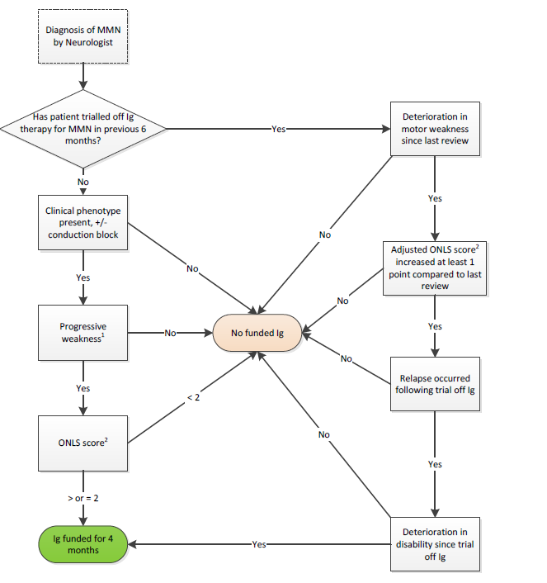
Abbreviations: Ig= immunoglobulins; MMN= multifocal motor neuropathy; NBA= National Blood Authority; ONLS= Overall Neuropathy Limitations Scale.
Note: 1Progressive weakness as demonstrated in the distribution of individual peripheral nerves; 2Overall Neuropathy Limitations Scale.
Source: Figure 2, p. 14 of the 1590 MMN draft Referral Form.

Figure 2: Current clinical management algorithm: initial access to Ig under NBA as per MMN Referral
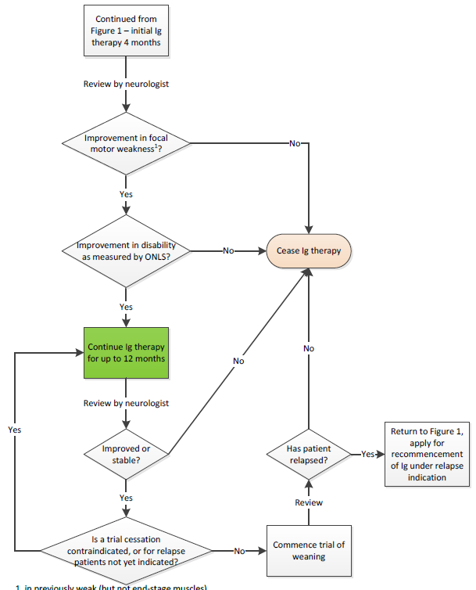
Abbreviations: Ig= immunoglobulins; MMN= multifocal motor neuropathy; NBA= National Blood Authority; ONLS= Overall Neuropathy Limitations Scale.
Sources: Figure 2, p. 19 of the 1590 MMN draft Referral Form.

Figure 3: Proposed clinical management algorithm: initial and maintenance treatment (continuing authorisation) to Ig under NBA for first indication (first-line and subsequent maintenance therapy for MMN) as per MMN Referral
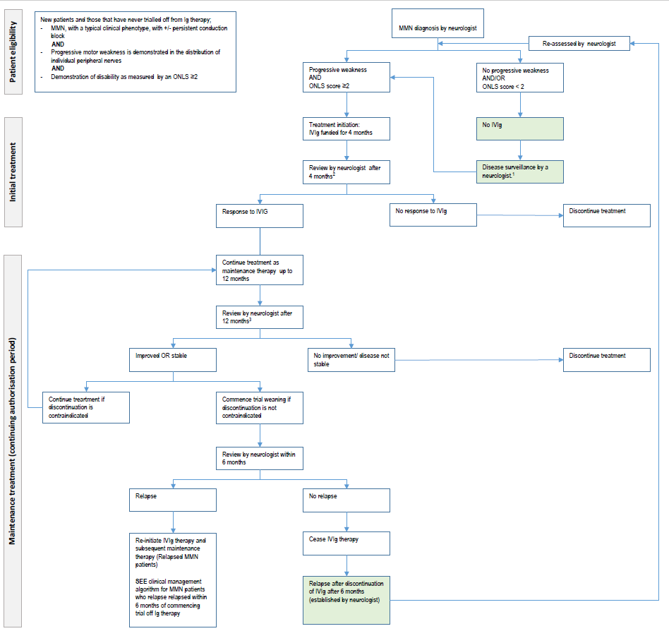

Abbreviations: IVIg= intravenous immunoglobulin; MMN= multifocal motor neuropathy; NBA= National Blood Authority; ONLS = Overall Neuropathy Limitations Scale. Note: ¹Refers to no changes in the patient’s disease status; blocks highlighted in green were added during the PICO Confirmation.
² Clinical effectiveness (response) of Ig therapy can be assessed by: Improvement in focal motor weakness in previously weak (but not end stage) muscles AND Improvement in the level of disability as measured by the Adjusted ONLS of at least one point less than the qualifying score.
³ Clinical effectiveness (response) of Ig therapy can be assessed by: Improvement in, or stabilisation of, weakness after previous evidence of deterioration in motor strength. It is acknowledged that very slow deterioration may occur over several years in stable patients AND Improvement in or stabilisation of disability as measured by the Adjusted ONLS score compared to the previous review score. (Note: Gradual deterioration of one point over several years may occur) AND A trial of Ig weaning/cessation of Ig therapy is planned for patients who are clinically stable to identify those in remission or a reason provided as to why a trial is not planned
Sources: Prepared during PICO Confirmation based on Figure 1 and Figure 2 of the MMN Referral and the reviewed content.

Figure 4: Proposed clinical management algorithm: initial and maintenance treatment (continuing authorisation) to Ig under NBA for second indication (Further and subsequent maintenance therapy for MMN patients who relapse within six months of commencement of a trial off Ig therapy) as per MMN Referral
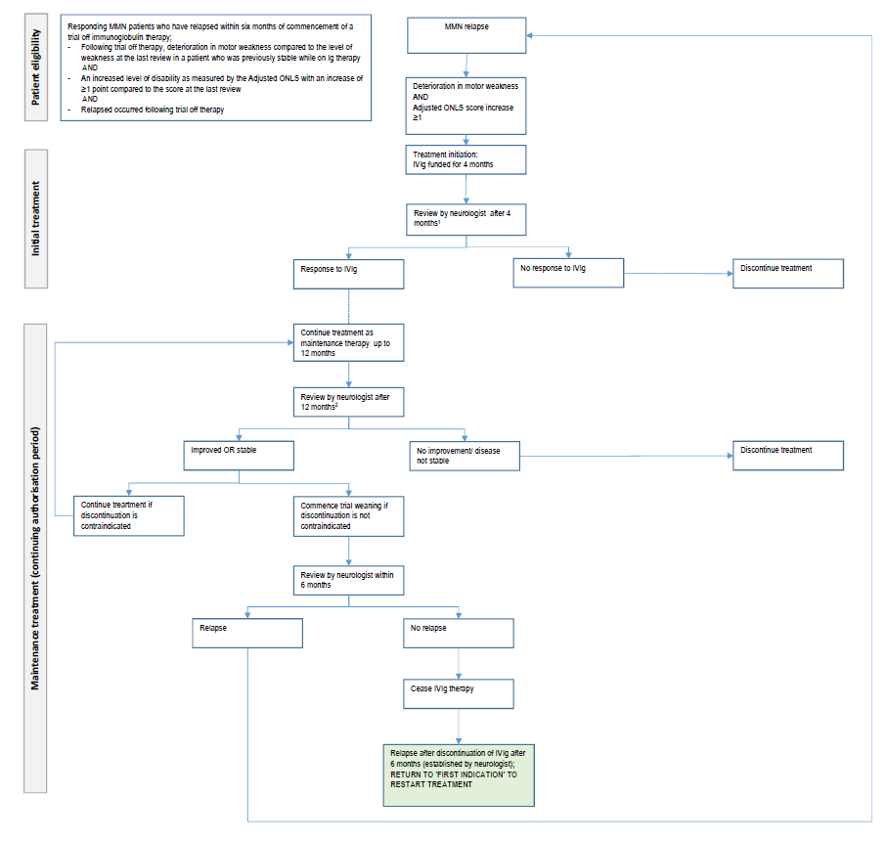
Abbreviations: IVIg= intravenous immunoglobulin; MMN= multifocal motor neuropathy; NBA= National Blood Authority; ONLS = Overall Neuropathy Limitations Scale.
Note: ¹ Clinical effectiveness (response) of Ig therapy can be assessed by: Improvement in focal motor weakness in response to four months of Ig therapy compared to muscle strength at the qualifying assessment following relapse AND Improvement in disability as measured by the Adjusted ONLS compared to the qualifying assessment at relapse.
² Clinical effectiveness (response) of Ig therapy can be assessed by: Improvement in, or stabilisation of, focal motor weakness as compared to the focal muscle strength at the previous review assessment AND Improvement in or stabilisation of disability as measured by the Adjusted ONLS compared to the previous review score (gradual deterioration of one point over several years is acceptable) AND A trial of weaning/cessation of Ig therapy are considered annually for patients who are clinically stable to identify those in remission or a valid reason provided as to why a trial is not being planned or is contraindicated at this time.
Block highlighted in green was added during the PICO Confirmation.
Sources: Prepared during PICO Confirmation based on Figure 1 and Figure 2 of the MMN Referral and the reviewed content.
Figure 5: Clinical treatment algorithm when IVIg is not funded by the NBA
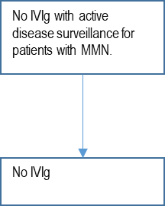
Abbreviations: IVIg= intravenous immunoglobulin; MMN= multifocal motor neuropathy; NBA= National Blood Authority. Sources: Figure 3, p. 20 of the 1590 MMN draft Referral Form.

References
1. National blood agreement, (2002).
2. BloodSTAR. Current ig use in australia: Multifocal motor neuropathy. 2018:7.
3. Umapathi T, Hughes RA, Nobile-Orazio E, et al. Immunosuppressant and immunomodulatory treatments for multifocal motor neuropathy. The Cochrane database of systematic reviews. 2015 Mar 4(3):CD003217.
4. Lawson VH, Arnold WD. Multifocal motor neuropathy: A review of pathogenesis, diagnosis, and treatment. Neuropsychiatric disease and treatment. 2014;10:567-76.
5. Taylor BV, Wright RA, Harper CM, et al. Natural history of 46 patients with multifocal motor neuropathy with conduction block. Muscle & nerve. 2000 2000/06/01;23(6):900-8.
6. Norris F, Shepherd R, Denys E, et al. Onset, natural history and outcome in idiopathic adult motor neuron disease. Journal of the Neurological Sciences. 1993 1993/08/01/;118(1):48-55.
7. Joint Task Force of the EFNS and PNS. European federation of neurological societies/peripheral nerve society guideline on management of multifocal motor neuropathy. Report of a joint task force of the european federation of neurological societies and the peripheral nerve society – first revision. Journal of the Peripheral Nervous System. 2010 2010/12/01;15(4):295-301.
8. Miyashiro A, Matsui N, Shimatani Y, et al. Are multifocal motor neuropathy patients underdiagnosed? An epidemiological survey in japan. Muscle & nerve. 2014 2014/03/01;49(3):357-61.
9. Nobile-Orazio E. Multifocal motor neuropathy. Journal of Neuroimmunology. 2001 2001/04/02/;115(1):4-18.
10. Cats EA, van der Pol WL, Piepers S, et al. Correlates of outcome and response to ivig in 88 patients with multifocal motor neuropathy. Neurology. 2010;75(9):818.
11. Ishigaki H, Hiraide T, Miyagi Y, et al. Childhood-onset multifocal motor neuropathy with immunoglobulin m antibodies to gangliosides gm1 and gm2: A case report and review of the literature. Pediatric neurology. 2016 Sep;62:51-7.
12. Van Den Berg-Vos RM, Franssen H, Wokke JHJ, et al. Multifocal motor neuropathy: Diagnostic criteria that predict the response to immunoglobulin treatment. Annals of neurology. 2000;48(6):919-26.
13. ABS. Quarterly population estimates (erp), by state/territory, sex and age. In: Statistics ABo, editor. Canberra2018.
14. Pestronk A, Cornblath DR, Ilyas AA, et al. A treatable multifocal motor neuropathy with antibodies to gm1 ganglioside. Annals of neurology. 1988 Jul;24(1):73-8.
15. Feldman EL, Bromberg MB, Albers JW, et al. Immunosuppressive treatment in multifocal motor neuropathy. Annals of neurology. 1991 1991/09/01;30(3):397-401.
16. Chaudhry V, Corse AM, Cornblath DR, et al. Multifocal motor neuropathy: Response to human immune globulin. Annals of neurology. 1993 Mar;33(3):237-42.
17. Krarup C, Stewart JD, Sumner AJ, et al. A syndrome of asymmetric limb weakness with motor conduction block. Neurology. 1990;40(1):118.
18. Leger JM, Viala K, Cancalon F, et al. Intravenous immunoglobulin as short- and long-term therapy of multifocal motor neuropathy: A retrospective study of response to ivig and of its predictive criteria in 40 patients. Journal of neurology, neurosurgery, and psychiatry. 2008 Jan;79(1):93-6.
19. Leger JM. Immunoglobulin (ig) in multifocal motor neuropathy (mmn): Update on evidence for ig treatment in mmn. Clinical and experimental immunology. 2014 Dec;178 Suppl 1:42-4.

One stakeholder referred to these other treatments in their response to the Department of Health Targeted Consultation Survey on MSAC Ig Referral 1590 MMN. They also noted that cyclophosphamide for the treatment of MMN is currently limited to subsequent lines of therapy or in refractory cases due to toxicity.
Search was conducted in clinicaltrials.gov, International Clinical Trials Registry Platform (ICRPT) from the WHO.
Relapsed patients are MMN patients who relapse within six months of commencement of a trial off Ig therapy. These patients access IVIg therapy under the second indication. It should also be noted that MMN patients who relapse after six months of commencement of a trial off Ig therapy are also able to access IVIg therapy after reassessment by a neurologist but under the first indication (Reference Group).
A sponsor, in their response to the Department of Health Targeted Consultation Survey on MSAC Ig Referral 1590 MMN, noted that cyclophosphamide for the treatment of MMN is currently limited to subsequent lines of therapy or in refractory cases due to its toxicity.

