Application 1490:
Breast magnetic resonance imaging (MRI) for breast implant-associated anaplastic large cell lymphoma

PICO Confirmation
(To guide a new application to MSAC)
(Version 0.2)

This PICO Confirmation Template is to be completed to guide a new request for public funding for new or amended medical service(s) (including, but not limited to the Medicare Benefits Schedule (MBS)). It is relevant to proposals for both therapeutic and investigative medical services.
Please complete all questions that are applicable to the proposed service, providing relevant information only.
Should you require any further assistance, departmental staff are available through the Health Technology Assessment (HTA Team) on the contact number and email below to discuss the application form, or any other component of the Medical Services Advisory Committee process.
Phone: +61 2 6289 7550
Email: hta@health.gov.au
Website: http://www.msac.gov.au

Version Control

Document History
Version Number | Date Changed | Author | Reason for Change
0.1 | 21 June 2017 | Jacqueline Parsons | First draft
0.2 | 12 Sept 2017 | Jacqueline Parsons | Incorporating PASC feedback

Document Approval
Version Number | Date Changed | Author | Reason for Change
1.0 |  |  | Document released for publication

Summary of PICO/PPICO criteria to define the question(s) to be addressed in an Assessment Report to the Medical Services Advisory Committee (MSAC)
Table 1: Summary of PICO criteria for an assessment of breast magnetic resonance imaging to improve staging and work-up in patients with breast-implant-associated anaplastic large cell lymphoma (assuming DIRECT EVIDENCE is available)
Component | Description
Patients | Patients with breast implant-associated anaplastic large cell lymphoma (BIA-ALCL), diagnosed by ultrasound and biopsy
Intervention | Standard lymphoma work-up including PET/CT scan plus breast MRI to inform lymphoma surgery
Comparator | Standard lymphoma work-up including PET/CT scan to inform lymphoma surgery
Outcomes | MRI-associated safety:  Reaction to contrast medium  Claustrophobia  Unknown contra-indications to MRI resulting in injury  Any other safety outcome associated with MRI  Direct surgical effectiveness outcomes:  Survival  Recurrence-free survival (consider loco-regional recurrence vs lymphoma-free survival)  Completeness of capsulectomy or excision of any mass  Need for further surgery (i.e. if margins are not clear)  Length of hospital stay  Cosmesis (appearance of surgical site)  Other surgery-related safety outcomes/complications  Patient satisfaction and quality of life
MRI = magnetic resonance imaging; PET/CT = positron emission tomography / computed tomography
Research questions for direct evidence:
What is the safety of using breast MRI in the staging and surgical work-up of patients with BIA-ALCL?
What is the clinical effectiveness of breast MRI in the staging and surgical work-up of patients with BIA-ALCL?

Table 2: Summary of PICO criteria for an assessment of breast magnetic resonance imaging to improve staging and work-up in patients with breast-implant-associated anaplastic large cell lymphoma (assuming no direct evidence is available and a LINKED-EVIDENCE APPROACH is applied)
Component | Description
Patients | Patients with breast implant-associated anaplastic large cell lymphoma (BIA-ALCL), diagnosed by ultrasound and biopsy
Intervention | Standard lymphoma work-up including PET/CT scan plus breast MRI to inform lymphoma surgery
Comparator | Standard lymphoma work-up including PET/CT scan to inform lymphoma surgery
Reference standard | Histopathology (of the surgically-excised specimen)
Outcomes | Diagnostic accuracy of MRI for staging:  Sensitivity and specificity  Positive and negative likelihood ratios  Positive and negative predictive values  Receiver operator characteristic curves; area under the curve  Impact on change in management (versus standard tests):  Any change in surgical technique or treatment decision made by clinicians in response to information provided by the MRI  Effectiveness of change in management:  Mortality  Survival /recurrence-free survival (consider loco-regional recurrence vs lymphoma-free survival)  Rate of recurrence  Length of hospital stay  Patient quality of life  Patient satisfaction  Cosmesis (appearance of surgical site)
MRI = magnetic resonance imaging; PET/CT = positron emission tomography / computed tomography
Research questions for linked evidence:
What is the accuracy of breast MRI in the staging and surgical work-up of patients with BIA-ALCL?
What is the impact on change in management as a result of using breast MRI in the staging and surgical work-up of patients with BIA-ALCL?
What impact does the change in management have on health outcomes? (The intervention and comparator to be assessed for this research question will depend on what changes are identified in the prior linked evidence step).

PICO or PPICO rationale for therapeutic and investigative medical services only

Population
The population is patients with diagnosed breast implant-associated anaplastic large cell lymphoma (BIA-ALCL). BIA-ALCL is a rare but serious complication of breast implants. It is a form of rare T-cell non-Hodgkin’s lymphoma, and presents in two ways: the seroma type, and the mass type. The seroma type consists of a malignant effusion with or without the inner lining of the capsule involved. In this type, cure is usually achieved by removing the implant and capsule. The mass type, or infiltrative disease, is less common but has a worse prognosis and is treated with surgery, as well as other oncological treatments. Worldwide recognition of BIA-ALCL has resulted in statements about the risk of BIA-ALCL from the World Health Organization (WHO), the United States (US) Food and Drug Administration (FDA) and the Therapeutic Goods Administration (TGA) in Australia (Swerdlow, Campo et al. 2016, FDA 2017, TGA 2017).
In order to diagnose BIA-ALCL, patients will have undergone ultrasound and biopsy, with cytology of the biopsied fluid confirming the ALCL diagnosis. It should be noted that BIA-ALCL is a rare disease and thus identifying current clinical practice is difficult. There have been 56 cases of BIA-ALCL in Australia to date, all of which have occurred since 2007 (TGA 2017). The applicant estimates 10 newly diagnosed patients per year. It is suspected the disease is under-diagnosed, and the TGA is working with research groups to obtain better estimates of the incidence (TGA 2017). Worldwide, 350 cases are estimated.
PASC noted Australia has been at the forefront of publishing epidemiological data, working collaboratively to develop treatment guidelines and research opportunities internationally. PASC noted the disease is not related to integrity of the implant.
A statement for members of the Australian Society of Plastic Surgeons, the Australasian Society of Aesthetic Plastic Surgeons and the New Zealand Association of Plastic Surgeons (included with the application) notes that all Australian cases of the disease have been in women with textured implants, and evidence from the US suggests more cases associated with textured implants compared to smooth. Other than the surface of the implant, there appear to be no other consistent risk factors for BIA-ALCL.
Rationale
Patients with diagnosed BIA-ALCL undergo lymphoma work-up and staging, with multiple tests and imaging to inform treatment. Surgery is the mainstay of treatment and often cures the BIA-ALCL.
Prior test (investigative services only - if prior tests are to be included)
Not applicable.

Intervention
Breast magnetic resonance imaging (MRI) is an established technique for imaging of the breast tissue, usually for the purposes of detecting new breast cancers or the extent of breast cancer diagnosed by other methods. It is currently listed on the Medicare Benefits Schedule (MBS) for:
- identification of primary cancers in cases of metastatic cancer in the regional lymph nodes, where the primary cancer is unknown (items 63487-8);
- early detection of breast cancer in patients at high risk of the disease (items 63457 and 63464), and follow-up of these scans (items 63458 and 63467); and
- evaluation of implant integrity in patients with an implant manufactured by Poly Implant Prothese (items 63501-2 and 63504-5).
The intervention is intended to provide additional information to the clinical team caring for the person with BIA-ALCL, with the intention of making initial surgery more effective and reducing the need for repeat surgery if tumour margins are not clear. It is also intended to help identify the need for any other necessary treatments, such as chemotherapy.
Breast MRI would be undertaken by qualified radiologists in private (MBS) or public (non-MBS or as a private patient) hospital settings (admitted or non-admitted patient), or in private radiology clinics. It requires a dedicated breast coil to perform. The breast MRI would be ordered by a specialist physician or surgeon, as the patient would be under the care of a specialist team once BIA-ALCL is diagnosed. This item would not be available to general practitioners (GPs).
Rationale
The breast MRI is intended to help clinicians stage the disease and provide the best possible guidance (the work-up) for surgery, to ensure complete excision of lymphoma, implants and surrounding fibrous capsule is achieved, as well as any mass or lymph nodes that require excision. Positron emission tomography – computed tomography (PET/CT) scanning is also used at this stage in the treatment of the BIA-ALCL, and breast MRI is intended to add further information to the clinical picture, to improve the surgical outcomes.

Comparator
The comparator is standard lymphoma work-up of PET/CT imaging to stage the lymphoma and prepare for surgery, but without MRI.
PASC noted that ultrasound is used as a pre-diagnostic and surveillance tool and has no role in the diagnostic pathway.
Rationale
Staging and work-up under the existing clinical management algorithm would include PET/CT imaging, alongside a range of clinical tests required by the physician and surgeon team. A relevant MBS item is available for PET/CT imaging in patients with newly diagnosed non-Hodgkin’s lymphoma (MBS item 61620). However, it should be noted that this item is not available for patients with indolent non-Hodgkin’s lymphoma, and BIA-ALCL can take an indolent form, so it is not clear if this item would be applicable in all cases (Brody, Deapen et al. 2015).

Outcomes
Patient relevant
Relevant outcomes relate to success of the surgery in ensuring the entirety of malignant tissue is excised, and need for further surgery if surgical margins are not clear. Later outcomes relating to this include survival and recurrence-free survival.
MRI is generally considered safe, especially when patients are adequately screened beforehand (for example, to exclude patients with implanted medical devices). However, relevant safety outcomes for the intervention include reaction to any contrast medium used, claustrophobia, and other reactions to the MRI resulting in injury, such as unknown contra-indications.
Healthcare system
MRI is relatively widely available in Australia across metropolitan and some rural areas. However, the MBS website is not up-to-date with regard to MRI providers who are MBS eligible and have the breast coil. Access to breast MRI could be an issue. The suggested MBS item descriptor specifies that only a specialist can order the MRI scan, and this is appropriate given the patient already has a diagnosis of ALCL and would be under the care of a team of specialists. Oncology care is likely to be delivered predominantly in Australian cities, as opposed to smaller rural centres.
Other healthcare system implications include costs associated with having to repeat surgery if margins are not clear, or for cosmetic reasons.
Rationale
As the premise of using MRI in addition to other tests in the clinical pathway is to better inform surgery, it is relevant that the direct and indirect results of surgery are the outcomes.
Linked-evidence approach
Effectiveness of a test for staging depends on whether it improves patient outcomes, and this is assessed in studies that directly investigate the impact of the test on those outcomes. Should no direct evidence be available, a linked-evidence approach can be used (Medical Services Advisory Committee 2016). The linked-evidence approach uses test performance, impact on change in management of the patient (based on results of the test), and impact of change in management on patient outcomes (to ascertain if the test is effective). If there is evidence the incremental information provided by breast MRI allows more accurate staging of BIA-ALCL, then the further two steps of linked evidence should be undertaken. This may require extra literature searches. The reference standard is histopathology. Outcomes for a linked-evidence approach are:
- Accuracy of MRI for staging (e.g. classification of localised vs advanced disease, detection of effusion or mass, assessment of resection margin, stage I to IV or relevant staging system):
Sensitivity and specificity, positive and negative likelihood ratios, positive and negative predictive values, receiver operator characteristic curves, area under the curve.
- Impact on change in management:
Any change in surgical technique or treatment decision made by clinicians in response to information provided by the MRI.
- Effectiveness of change in management:
Mortality, survival, recurrence-free survival, rate of recurrence, length of hospital stay, patient quality of life, patient satisfaction, cosmesis (appearance of surgical site).

Current clinical management algorithm for identified population
A clinical management algorithm for Australian clinical practice was not included in the application. Thus the clinical management algorithm presented was developed by the evaluator and informed by both discussion with the applicant and using guidelines produced for Australia and New Zealand plastic surgeons (and included with the application). It should be noted that National Health and Medical Research Council (NHMRC)-approved clinical practice guidelines for lymphoma have not been updated since 2005, and these guidelines look at ALCL in general, not BIA-ALCL (Australian Cancer Network Diagnosis and Management of Lymphoma Guidelines Working Party 2005). ALCL which originates in the breast is usually a B-cell lymphoma, whereas BIA-ALCL is a T-cell lymphoma. Information about standard care for patients with ALCL, including surgical work-up, is not presented in these guidelines. The current clinical management algorithm is shown in Figure 1 (left hand side).

Proposed clinical management algorithm for identified population
PASC requested amendment to the original algorithm so it is clear that all patients must have their history taken, a physical examination, pathology and imaging (as updated in the second line boxes below). The proposed clinical management algorithm (also shown in Figure 1, right hand side) is simply the current algorithm with the addition of breast MRI at the staging and work-up stage.
Figure 1: Current and proposed clinical management algorithm for patients with diagnosed BIA-ALCL
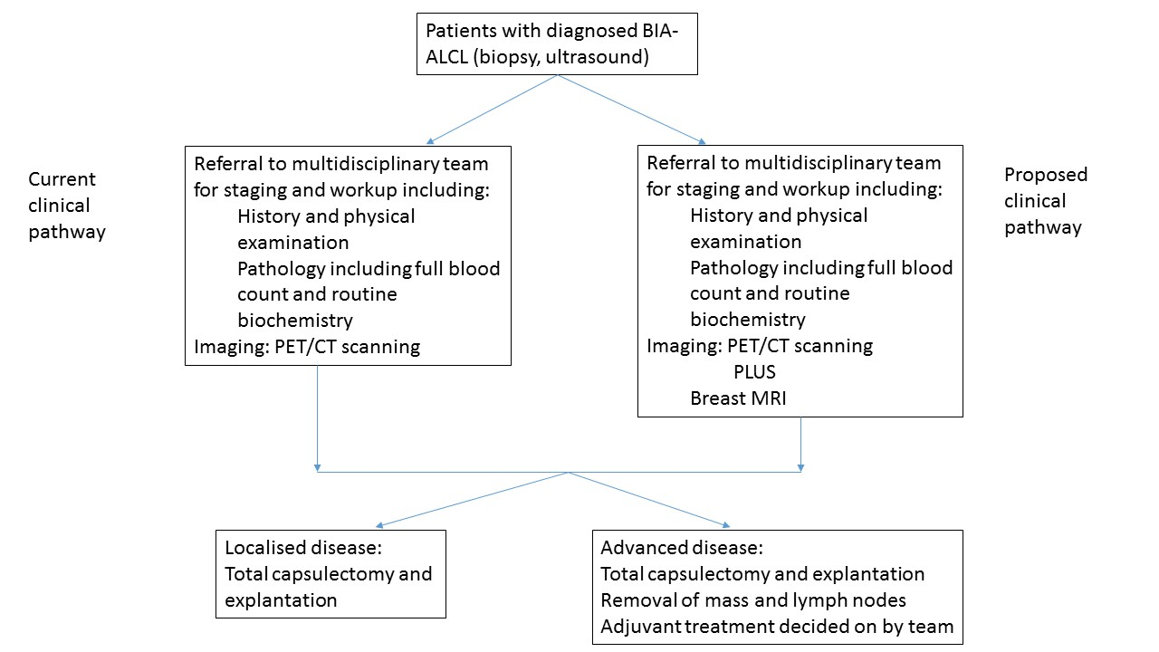

Proposed economic evaluation
None of the studies included with the application provide evidence that breast MRI results in better surgical results. The only study that compares imaging in BIA-ALCL considered a case series of patients with the disease who had one or more of ultrasound, CT, MRI, PET-CT or mammography. Each of these imaging modalities was then judged on its ability to identify a mass or effusion adjacent to the implant. The impact of imaging on the surgical outcome was not reported.
As the clinical claim is likely to be for non-inferior safety and superior effectiveness, a cost-effectiveness analysis or cost-utility analysis is the likely suitable economic evaluation. However, given the likelihood of a lack of evidence to support the clinical claim, it is likely that only a financial analysis will be possible. PASC noted that, with such small patient numbers, it may be difficult to demonstrate value of the addition of MRI.

Proposed item descriptor
In the application form, the applicant suggested an amendment to existing breast MRI items be accommodated for the proposed population. However, after pre-PASC discussion between the applicant and Department of Health, it was agreed a new item number would be required. Wording of the proposed new MBS item is outlined below:
Category: Category 5 – Diagnostic imaging services
Proposed item descriptor: MBS [item number]
MAGNETIC RESONANCE IMAGING for staging of proven breast-implant-associated anaplastic large cell lymphoma, performed under the professional supervision of an eligible provider at an eligible location, where the patient is referred by a specialist or a consultant physician and where:
(a) a dedicated breast coil is used; and
(b) the request for scan identifies that the patient has a breast implant in situ, and ALCL has been diagnosed.
Limited to once per breast per lifetime.
Fee: $500 Benefit: 75% = $375 85% = $425

MBS fee
PASC noted the applicant will need to provide supporting documentation to justify a higher fee than the existing fee for screening for implant integrity (MBS items 63501-2 and 63504-5). At this stage, PASC recommended the same fee of $500. PASC noted that arguments to increase the fee might include additional training and expertise required for specialists who identify cancer, as opposed to the more straightforward task of implant integrity screening.

References
Australian Cancer Network Diagnosis and Management of Lymphoma Guidelines Working Party (2005). Guidelines for the Diagnosis and Management of Lymphoma. Sydney, Aus, The Cancer Council Australia and Australian Cancer Network.
Brody, G. S., D. Deapen, C. R. Taylor, L. Pinter-Brown, S. R. House-Lightner, J. S. Andersen, G. Carlson, M. G. Lechner and A. L. Epstein (2015). "Anaplastic large cell lymphoma occurring in women with breast implants: analysis of 173 cases." Plast Reconstr Surg 135(3): 695-705.
FDA. (2017). "Breast Implant-Associated Anaplastic Large Cell Lymphoma." Retrieved 6 July, 2017, from https://www.fda.gov/medicaldevices/productsandmedicalprocedures/implantsandprosthetics/breastimplants/ucm239995.htm.
Medical Services Advisory Committee (2016). Technical Guidelines for preparing assessment reports for the Medical Services Advisory Committee – Service Type: Investigative (Version 3.0). Canberra, Australia, Department of Health.
Swerdlow, S. H., E. Campo, S. A. Pileri, N. L. Harris, H. Stein, R. Siebert, R. Advani, M. Ghielmini, G. A. Salles, A. D. Zelenetz and E. S. Jaffe (2016). "The 2016 revision of the World Health Organization classification of lymphoid neoplasms." Blood 127(20): 2375-2390.
TGA. (2017). "Alerts: Breast implants and anaplastic large cell lymphoma. Update- additional confirmed cases of anaplastic large cell lymphoma." Retrieved 19 Sept, 2017, from http://www.tga.gov.au/alert/breast-implants-and-anaplastic-large-cell-lymphoma.
TGA. (2017). "Safety Information- Alerts: Breast implants." Retrieved 6 July, 2017, from https://www.tga.gov.au/alert/breast-implants.

