Applicant submitted protocol for
Fluorescence guided resection of high grade (grade IV) glioma that are glioblastoma multiforme (GBM) using oral aminolevulinic acid hydrochloride (ALA)

Medical Services Advisory Committee
Application 1395
February 2016

Title of Application
Fluorescence guided resection of high grade (grade IV) glioma that are glioblastoma multiforme (GBM) using oral aminolevulinic acid hydrochloride (ALA).

Purpose of application
Please indicate the rationale for the application and provide one abstract or systematic review that will provide background.
This application is for a new MBS item for craniotomy for removal of glioma that are GBM, with the use of oral ALA based on MBS item 39709, but with a higher fee which reflects the cost of oral ALA and the use of the “blue light” fluorescence functionality on the neurosurgical operating microscope.
The use of oral ALA enables more complete resections of contrast enhancing tumour, leading to improved rates of Complete Resection (confirmed by post-operative MRI), and improved progression free survival in patients with malignant glioma (Stummer et al., 2006).
A copy Stummer et al. (2006) is provided.

Population and medical condition eligible for the proposed medical services
Provide a description of the medical condition (or disease) relevant to the service.
Brain tumours are responsible for 85–90% of all primary tumours in the central nervous system (NCI 2010). High grade gliomas (WHO stage III/IV) are infiltrating malignant tumours derived from glia cells and are the most frequent brain tumours in adults, corresponding to more than 75% of diagnosed cases (CBTRUS 2011). The most common histological sub-types are glioblastoma multiforme (stage IV), anaplastic astrocytoma (stage III) and anaplastic oligodendroglioma (stage III), which correspond, respectively, to 40–45%, 30–35% and 5–15% of the high grade gliomas diagnosed in adults (Garside et al., 2007). Astrocytomas and glioblastomas represent 76% of all gliomas (CBTRUS 2011).
Table 1 Proportion of cases presenting with specific symptoms
Presenting symptom | Low-grade glioma (%) | Glioblastoma multiforme (%)
Headache/signs of increased intracranial pressure | 5–53 | 19–34
Hemiparesis | 20–26 | 14–41
Seizure | 78–89 | 17–31
Cognitive deficits | 11–39 | 15–22
Speech deficit aphasia | * | 6–32
Visual disturbance | * | 3–15
Ataxia | * | 9
Cranial nerve dysfunction | * | 9
Dizziness | * | 9
Loss of consciousness | * | 4
Focal neurological deficits | 31 | *
Transient events | 5 | *
*prevalence unknown
Source: Australian Cancer Network Adult Brain Tumour Guidelines Working Party 2009

Oral ALA has Therapeutic Goods Administration (TGA) approval and is indicated in adult patients for visualisation of malignant tissue during surgery for malignant gliomas that are glioblastoma multiforme (GBM) on preoperative imaging, and who are intended for resection of the tumour.
In a population-based sample of all patients with glioma diagnosed in Victoria from 1998 to 2000, the median survival was 9.2 months (range, 0–84+ months) overall and 7.4 months (range, 0–84+ months) in patients with GBM (Rosenthal et al., 2006). The 5-year survival rate was 19% for the entire cohort and 3% for patients with GBM.
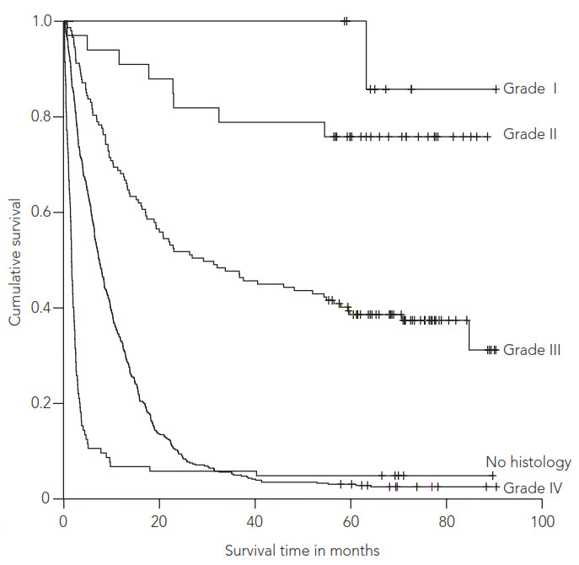
Figure 1 Survival according to tumour grade in a population-based sample of all patients with glioma diagnosed in Victoria during 1998, 1999 and 2000
Source: Rosenthal et al. (2006)

Define the proposed patient population that would benefit from the use of this service. This could include issues such as patient characteristics and /or specific circumstances that patients would have to satisfy in order to access the service.
Oral ALA is indicated in adult patients for visualisation of malignant tissue during surgery for malignant gliomas that are GBM on preoperative imaging, and who are intended for resection of the tumour. Oral ALA is contraindicated in patients with hypersensitivity to ALA or porphyrins, acute or chronic types of porphyria, and in pregnant women.
- Oral ALA can be used for the resection of both newly diagnosed and recurrent tumours.
- GBM are poorly differentiated, have increased cellularity, variable mitotic activity, and prominent vascular proliferation or necrosis.
- GBM are usually diagnosed pre-operatively with the aid of an MRI on which they appear as a large, heterogeneous mass in supratentorial white matter. The defining features are haemorrhage and necrosis, with surrounding “fingers of oedema” (extensive). There is usually considerable mass effect. While MRI is the preferred imaging modality, if the patient is unsuitable for MRI, CT may be utilised.
- Eligibility for surgery is determined based on whether the lesion is amenable to resection (not deeply situated, or diffuse and non-focal) and on the patient’s clinical condition/ability to tolerate surgery.
- Pre- and post-surgical treatments are not changed by the use of oral ALA. Adjuvant whole brain radiotherapy and chemotherapy post surgery has been shown to improve survival.

Indicate if there is evidence for the population who would benefit from this service i.e. international evidence including inclusion / exclusion criteria. If appropriate provide a table summarising the population considered in the evidence.
The key clinical evidence for the use of oral ALA is a randomised controlled trial by Stummer et al. (2006). The trial assessed the eﬀect of ﬂuorescence-guided resection with ALA compared with conventional microsurgery with white light, on surgical radicality, progression-free survival, overall survival, and morbidity.
The study included patients aged 18–72 years with suspected newly diagnosed, untreated malignant glioma and who were eligible for surgery according to the study surgeon. The protocol stipulated that patients had tumours with a distinct ring-like pattern of contrast-enhancement with thick irregular walls preoperative MRI, and a core area of reduced signal which is suggestive of tumour necrosis.
Exclusion criteria were: tumours of the midline, basal ganglia, cerebellum, or brain stem as assessed by MRI; more than one contrast-enhancing lesion; substantial, non-contrast enhancing tumour areas suggesting low-grade glioma with malignant transformation; medical reasons precluding MRI (eg, pacemaker); inability to give consent because of dysphasia or language barrier; tumour location did not enable complete resection of contrast-enhancing tumour as decided by individual study surgeon; Karnofsky performance scale 60 or less; renal insuﬃciency (ie, creatinine >177 µmol/L); hepatic insuﬃciency (ie, gamma glutamyl transpeptidase >100 U/L, proton-beam time <60%, and bilirubin >51 µmol/L); and history of malignant tumours at any body site.
The eligible patient population proposed in the protocol is consistent with the TGA-approved indication for oral ALA which is limited to patients with GBM. The study by Stummer et al. (2006) included a slightly broader patient population with the inclusion of patients with grade III or IV gliomas. However the protocol stipulated that patients had tumours with a distinct ring-like pattern of contrast enhancement with thick irregular walls on MRI, and a core area of reduced signal suggestive of tumour necrosis. These symptoms are consistent with a diagnosis of GBM (Table 2).
Table 2 Classification of astrocytomas (WHO criteria 1993)
WHO Grade | Name | Characteristics
I | Circumscribed astrocytoma | Generally benign, well-circumscribed; most common example is juvenile pilocytic astrocytoma
II | Astrocytoma | Diffusely infiltrating, well differentiated; minimal pleomorphism or nuclear atypia; no vascular proliferation or necrosis
III | Anaplastic astrocytoma | Pleomorphism and nuclear atypia; increased cellularity and mitotic activity; no vascular proliferation or necrosis
IV | Glioblastoma Multiforme | Poorly-differentiated, increased cellularity; variable mitotic activity; prominent vascular proliferation or necrosis

While the key clinical trial for the use of oral ALA in the resection of GBMs was carried out prior to radiotherapy with concurrent temozolomide becoming the standard of care, the benefit of complete resection over sub-total or partial resection has been demonstrated in numerous trials and is independent of subsequent therapies received (van den Bent et al., 2005; Stummer et al. 2012).

Provide details on the expected utilisation, if the service is to be publicly funded.
In 2010 there were 1,680 incident cases of brain tumour in Australia (Australian-specific age-standardised incidence rate 7.2 per 100,000 persons). 42% of brain tumours are glioblastomas (Tracey et al., 2007), suggesting that approximately 700 patients per year are diagnosed with GBM. Only a proportion of these patients would be eligible for surgery, and therefore eligible for fluorescence guided resection using oral ALA. In 2011-2012, the AIHW recorded 2,230 “Removal of lesion of cerebrum” procedures (AIHW 2012; Procedure code 39703-02 ACHI Seventh Edition). However this code is not specific to patients with GBM, and includes the excision of other types of brain tumours.
A retrospective cohort study of patients with glioma (71% of which were GBM) newly diagnosed over the period 1998–2000 in Victoria found that 55% underwent surgical resection. This suggests that approximately 385 patients per year would undergo surgical resection for newly diagnosed GBM. The total patient population would be slightly higher than this with the inclusion of patients with recurrent tumours.
Of the total surgery-eligible GBM population, only a small proportion of these patients would be eligible for Medicare-funded treatment. Currently, only 20% of the use of oral ALA is in the private hospital setting, suggesting that approximately 77 newly diagonesd GBM patients per year would be eligible for Medicare-funded GBM resection with oral ALA, at current private hospital usage levels.

Intervention – proposed medical service
Provide a description of the proposed medical service.
The proposed medical service is fluorescence guided resection of high grade (grade IV) glioma that are GBM using oral ALA.
Oral ALA is a new surgical tool for the visualisation of malignant tissues during surgery for malignant glioma that are GBM on preoperative imaging (Figure 2). This medicine is administered orally, at least three hours before the induction of anaesthesia (recommended dose of 20 mg/kg of body weight) (Gliolan® Product Information).

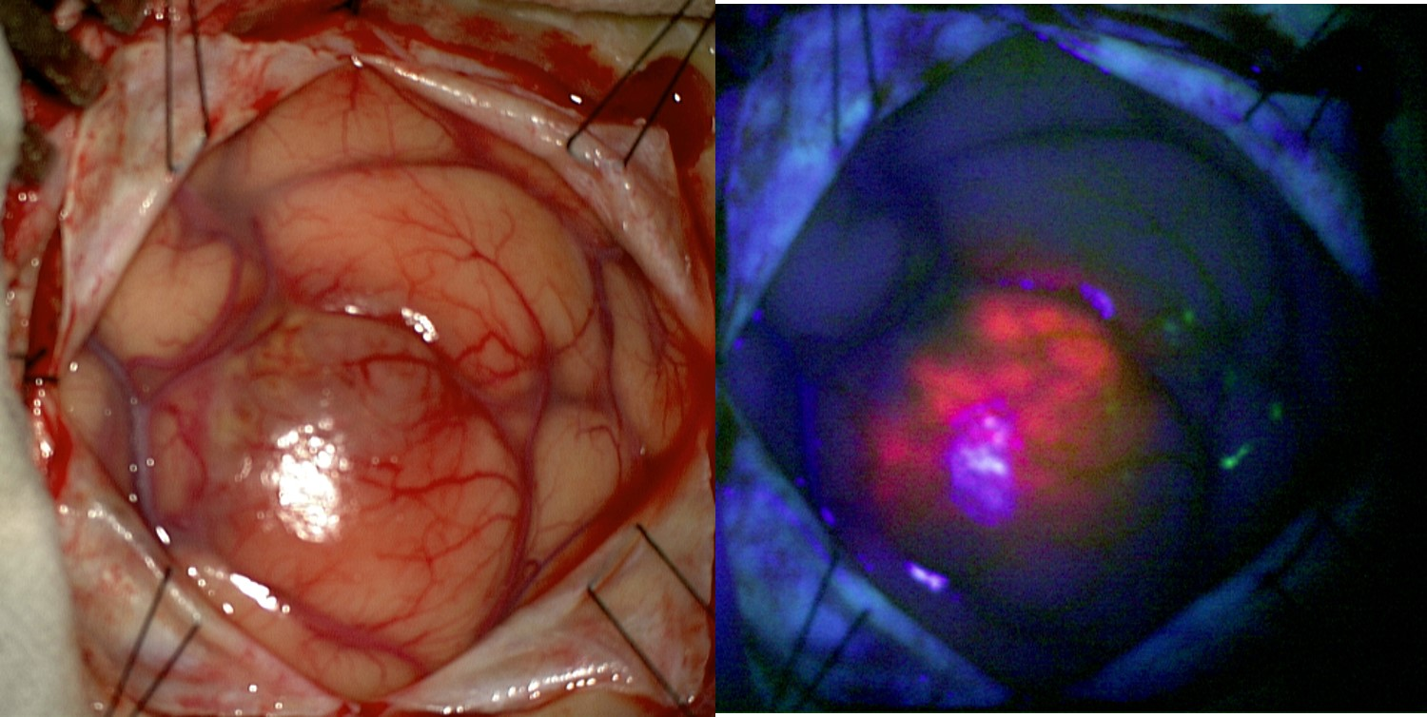
Figure 2 An intra-operative image of a glioblastoma under white light (left panel) and blue light (right panel) after administration of ALA. With blue light the tumour can be seen as pink fluorescence in an area that looked relatively normal with white light.

ALA is absorbed by cells in the body where it is converted by enzymes into fluorescent chemicals, particularly protoporphyrin IX (PPIX), in the normal heme biosynthesis pathway. There is a deficiency of the ferrochelatase enzyme in glioma cells which take up ALA and convert it more rapidly into PPIX, meaning that higher levels of PPIX accumulate in the cancer cells than in normal tissue. When illuminated under blue light of a specific wavelength, the PPIX in the tumour glows an intense red, while the normal brain tissue appears blue. This enables the surgeon to see the tumour more clearly during brain surgery and to remove it more accurately, sparing healthy brain tissue.
Gliolan® is the only formulation of ALA indicated for the use in fluorescence guided resection of high grade glioma. Other brands of ALA have topical formulations.

If the service is for investigative purposes, describe the technical specification of the health technology and any reference or “evidentiary” standard that has been established.
ALA is a natural biochemical heme precursor that is enzymatically metabolised into fluorescent porphyrins, predominately protopophyrin IX (PPIX). Exogenous administration of ALA results in an overload in the metabolism of cellular porphyrin and an accumulation of PPIX in epithelial and carcinogenic tissues such as the high grade malignant glioma. After stimulation with blue light (λ = 400-410nm), PPIX emits fluorescence (peak at λ = 635 nm) which can be visualised through a neurosurgical microscope. The viable malignant glioma tumoural tissue is visualised as an intense red fluorescence. Areas of tumoural cell infiltration have a light pink colour, while normal brain tissue, which does not accumulate PPIX, reflects the blue-violet colour and appears blue (Gliolan® Product Information).
A phase II clinical trial with a recommended dose of 20 mg/kg revealed a predictive positive value of fluorescence induced by oral ALA of 84.8% (IC_{90%}: 70.7–93.8%). This value was defined as the percentage of patients with positive identification of tumoural cells in all biopsies conducted in areas of strong and weak fluorescence. Strong fluorescence presented a higher predictive positive value (100%; IC_{90%}: 91.1–100%) than weak fluorescence (83.3%, IC_{90%}: 68.1–93.2%) (Gliolan® Product Information). Based on these results, subsequent studies were conducted, in which fluorescence induced by oral ALA was used as an intra-surgery marker for high grade malignant glioma tissues, with the purpose of improving the surgical resection of these tumours.
The Gliolan® product information provides details of interactions, use in specific patients, contra-indications, precautions, and adverse events.

Indicate whether the service includes a registered trademark with characteristics that distinguish it from any other similar health technology.
Gliolan® (oral ALA) has a registered trademark.
There are no other products registered for the use in fluorescence guided resection of high grade glioma.
Other formulations of ALA are available, however these products have topical indications.

Indicate the proposed setting in which the proposed medical service will be delivered and include detail for each of the following as relevant: inpatient private hospital, inpatient public hospital, outpatient clinic, emergency department, consulting rooms, day surgery centre, residential aged care facility, patient’s home, laboratory. Where the proposed medical service will be provided in more than one setting, describe the rationale related to each.
Fluorescence guided resection of high grade (grade IV) glioma that are GBM using oral ALA will be performed in the inpatient setting of public and private hospitals. The requested MBS item will be related to inpatient treatment in a private hospital.

Describe how the service is delivered in the clinical setting. This could include details such as frequency of use (per year), duration of use, limitations or restrictions on the medical service or provider, referral arrangements, professional experience required (e.g.: qualifications, training, accreditation etc.), healthcare resources, access issues (e.g.: demographics, facilities, equipment, location etc.).
ALA is administered orally, at least three hours before the induction of anaesthesia (recommended dose of 20mg/kg of body weight) (Gliolan® Product Information). There are no repeat administrations (unless a second surgery is required).
Gliolan® vials should be kept in the outer carton in order to protect from light. The vials should be stored below 25ºC. The reconstituted solution is physically-chemically stable for 24 hours at 25ºC, however the product information states that Gliolan® should be used within four hours of reconstitution.
After administration of oral ALA, exposure of eyes and skin to strong light sources (eg. operating illumination, direct sunlight or brightly focused indoor light) should be avoided for 24 hours.
Co-administration with other potentially phototoxic substances (e.g. tetracyclines, sulfonamides, fluoroquinolones, hypericin extracts) should be avoided.
Within 24 hours after administration, other potentially hepatotoxic medicinal products should be avoided.
In patients with pre-existing cardiovascular disease, oral ALA should be used with caution since literature reports have shown decreased systolic and diastolic blood pressures, pulmonary artery systolic and diastolic pressure as well as pulmonary vascular resistance.
Fluorescence guided resection of GBM using oral ALA can only be performed by neurosurgeons who have undergone a training course in this method, and who have received subsequent accreditation. Specialised Therapeutics Australia provides neurosurgeons with a distance learning based training program. Neurosurgeon training and accreditation forms part of the Risk Management Plan (RMP) agreed with the TGA for the registration of Gliolan®.

Co-dependent information (if not a co-dependent application go to Section 6)
Not applicable

Comparator – clinical claim for the proposed medical service
Please provide details of how the proposed service is expected to be used, for example is it to replace or substitute a current practice; in addition to, or to augment current practice.
The usual therapy for patients recently diagnosed with high grade glioma (including GBM) comprises an initial surgery followed by adjuvant treatment with radiotherapy and chemotherapy with temozolomide (TMZ). The purposes of the surgery are diagnosis confirmation, relief of symptoms related to the increase in intracranial pressure and decrease in the need to use corticosteroids (NCCN 2011). In addition to these benefits, it is widely accepted that there is a relation between the extent of resection, and survival, in order to provide the best starting platform for adjuvant therapy (Australian Cancer Network 2009).
The retrospective study of Lacroix and colleagues (2001), which involved 416 patients with glioblastoma multiforme, identified age, Karnofsky functional status, the degree of necrosis in pre-surgery magnetic resonance imaging, and extent of resection as predictive factors of survival. This study demonstrated a significant increase in survival related to a degree of resection equal to or above 98% of tumour volume (average survival rate of 13 months; IC_{95%}: 11.4–14.6) in comparison with a resection degree less than 98% (average survival rate of 8.8 months; IC_{95%}:7.4–10.2). The prospective study from Albert and colleagues (1994), which included 60 patients with high grade glioma, concluded that patients with a residual tumour had a death risk factor that was six times higher in comparison to patients without residual tumour after surgery.

More recently, the influence of the degree of resection in the survival of patients with glioblastoma multiforme was evaluated through a retrospective re-analysis of the data from the randomised study conducted by Stummer and colleagues (2006). Patients with a complete resection were compared with patients with an incomplete resection, whilst controlling for factors such as age, tumour location and Karnofsky functional status. This re-analysis confirmed the association between the resection degree and survival (Stummer 2008).
Currently, the most common adjuvant treatment for these patients is an initial concomitant radiotherapy plus chemotherapy treatment with temozolomide (fractionated external radiotherapy: 2 Gy per fraction, once a day, 5 days/week, 6 weeks; temozolomide: 75 mg/m²/day, 7 days/week, from the beginning until the end of radiotherapy) followed by 6 cycles of adjuvant temozolomide (150 to 200 mg/m²/day for 5 days, every 28 days; NCCN 2011, Stupp et al, 2011).
High grade gliomas have a very high relapse rate. The treatment of relapses depends on the extension of disease and the patient’s clinical condition. In case of a local relapse, a new surgery is recommended, if possible, either with or without placement of chemotherapy implants. After surgery, patients with a poor functional status only receive supportive treatment, whilst patients with a better clinical condition undergo chemotherapy and/or re-radiation. For recurrence of diffuse pattern or multiple lesions, the therapeutic options are supportive treatment in patients with poor functional status, and systemic chemotherapy and/or surgery for symptomatic relief. In this context, there is no established chemotherapy plan. Some of the recommended plans comprise the use of temozolomide, irinotecan in association with bevacizumab, or plans comprising the use of procarbazine, lomustine and vincristine (NCCN 2011, Stupp et al., 2011). These protocols are consistent with the earlier Australian guidleines which recommend concurrent radiotherapy and chemotherapy followed by adjuvant chemotherapy, finding that it provides a significant improvement in median and two-year survival in patients with (Australian Cancer Network 2009).
Patients with high grade malignant glioma show symptoms that require appropriate management, namely peritumoural brain oedema, venous thromboembolism and convulsions. The brain oedema causes neurological symptoms that significantly contribute to morbidity associated with the tumour and it is usually treated with corticosteroids (Pace 2010, Stupp et al., 2011).
Some patients with high grade malignant glioma present a higher risk of venous thromboembolism, and it is estimated that in the first year after diagnosis, 16% to 28% of patients are affected. Treatment with low molecular weight heparin is recommended for patients with symptomatic thromboembolism. The use of antiepileptics is only recommended in symptomatic cases (Pace 2010, NCCN 2011).
Despite the aggressiveness of treatment administered to patients with high grade malignant glioma, the disease remains incurable and patients end up going through a terminal phase with accentuated decline in their clinical condition. The most frequent problems in terminal patients are changes in the state of consciousness, drowsiness, dysphagia, progressive neurological deficits, convulsions, headaches, nausea and vomiting (Oberndorfer 2008, Sizoo 2010, Pace 2009, Pace 2010).
Fluorescence guided resection of GBM using oral ALA will replace resection under white light. The only difference in the procedures will be the administration of oral ALA and the use of blue light on the neurosurgical microscope to induce tumour fluorescence. Oral ALA will improve surgeons’ visualisation of the tumour and subsequent decision making regarding identification of tumour margins and extent of resection to be employed. It will not affect patients’ eligibility for surgery which is dependent on the lesion not being deeply situated, or diffuse and non-focal, and on the patient’s clinical condition.

Expected health outcomes relating to the medical service
Identify the expected patient-relevant health outcomes if the service is recommended for public funding, including primary effectiveness (improvement in function, relief of pain) and secondary effectiveness (length of hospital stays, time to return to daily activities).

The expected outcomes for the assessment are:
- complete resection rate;
- surgical morbidity;
- progression-free survival;
- overall survival;
- quality of life;
- reduction in symptoms from mass effect in the brain (headache, neurological deficit);
- reduced need for corticosteroid, reduction in side effects (used for treatment of brain oedema); and
- photosensitivity.

Background information
One of the main clinical trials that provides evidence of the efficacy and safety of oral ALA is the study by Stummer and colleagues (2006). It is a phase III randomised clinical trial, un-blinded, in two parallel groups, comparing surgery guided by fluorescence with oral ALA and conventional neurosurgery with white light. This study included individuals between 18 and 72 years of age, with evidence of high grade malignant glioma (WHO stage III or IV) through pre-operative magnetic resonance imaging, eligible for surgery and with a single tumoural lesion in a location amenable to complete resection.
Evaluation of the efficacy of oral ALA was conducted according to two main evaluation criteria:
- Percentage of patients with complete resection (without evidence of a residual tumour in the first magnetic resonance conducted 72 hours after surgery);
- Six month progression-free survival assessed by MRI
In this study, disease progression was defined on the basis of imagiological criteria (appearance of a new lesion with volume > 0.175 cm³ or an increase in residual volume above 25%). All magnetic resonances conducted in relation to this study were subjected to revision and centralised evaluation. In terms of secondary evaluation criteria, global survival, neurological deficit after surgery and oral ALA toxicity were tested.
The evaluation of quality of life in patients with high grade glioma is particularly important due to the impact of the tumour and its treatment on a physical, cognitive and emotional level, and also due to the low life expectancy of these patients. The prospective study by Brown and colleagues (2005) evaluated quality of life in adult patients with recently diagnosed high grade glioma, with the use of questionnaires directed toward general evaluation of quality of life, depression, fatigue and daytime drowsiness. One of the interesting aspects revealed by this study was the existence of statistically significant association between complete resection and improvement in quality of life (p = 0.003) and between complete resection and decrease in the probability of depression (p = 0.0008).

Describe any potential risks to the patient.
After administration of oral ALA, exposure of eyes and skin to strong light sources (eg, direct sunlight or brightly focused indoor light) should be avoided for 24 hours. Co-administration with other potentially phototoxic substances (eg. tetracyclines, sulfonamides, fluoroquinolones, hypericin extracts) should also be avoided. Within 24 hours after administration, other potentially hepatotoxic medicinal products should be avoided.

Specify the type of economic evaluation.
The clinical claim is that the proposed intervention is superior in efficacy (rate of complete resection and rate of 6-month progression-free survival) and non-inferior in safety compared with standard white-light resection of GBM.
- The study by Stummer et al. (2006) shows that neurosurgery guided by fluorescence with oral ALA significantly increases the proportion of patients with complete resection, which translates into the increase in progression-free survival.
- Extent of resection is associated with longer survival, independent of factors such as age, tumour location, adjuvant therapy and Karnofsky functional status (Stummer et al., 2006; van den Bent et al., 2005; Stummer et al. 2012) and improvement in quality of life (Brown et al., 2005).
The proposed economic evaluation is a cost-effectiveness assessment, using a Markov model adapted from that described by Rogers and colleagues (2008) and Garside and colleagues (2007). This model allows calculation of the cost per life year gained, cost per life year gained and adjusted according to quality of life and cost per year gained free of progression.
The Markov model describes the natural evolution of the disease, namely its progression and respective deterioration of health status in patients over time. The Australian model will be adapted from a European model published by Slof et al. (2015). The European model includes five health statuses: surgery, stable disease with complete resection, stable disease with partial resection, progressive disease and death. Figure 3 illustrates the model, exhibiting five health statuses (boxes) and the possibilities of transition between statuses (arrows).
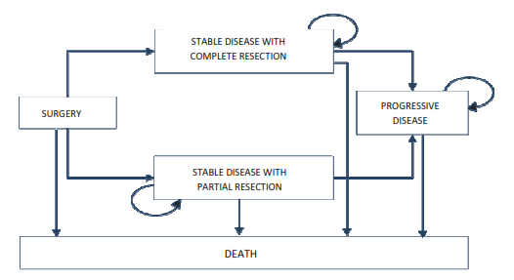
Figure 3 Structure of the European Markov model published by Slof et al. (2015)

The Australian model will be adapted to include recurrence of lesions.
Utility values will be obtained from the literature.

Fee for the proposed medical service
Explain the type of funding proposed for this service.
The proposed funding is for a Medicare Item number for craniotomy for surgical resection of GBM with the use of oral ALA based on MBS item 39709, but with a higher fee which reflects the cost of oral ALA and the use of the blue light microscope, and the expected improvement in health outcomes.
ALA is a biochemical pre-cursor to fluorescent PPIX, and once converted intracellularly, its properties can be exploited and used as a marker to aid visualisation and surgical excision of tumours. It is not an active therapeutic agent. The cost of oral ALA will therefore be included in the cost of the requested item number. This is consistent with the incorporation of the costs of radiopharmaceuticals in the Schedule fees for nuclear medicine imaging services.

Please indicate the direct cost of any equipment or resources that are used with the service relevant to this application, as appropriate.
The direct costs of hospitalisation, surgery, and post-surgical rehabilitation are identical to those incurred by the main comparator (excision under white light). These are provided in Table 5.
The blue light required for fluorescent guided resection with oral ALA is available as standard equipment on new neurosurgical microscopes, and also as an upgrade for Carl Zeiss Pentero and Leica Microsystems OH4/OH5 microscopes. The cost of the upgrade varies from $40,000 to $70,000. It is unclear at this time, how many neurosurgery departments would require an upgrade. The standard inclusion of blue light fluorescence capability on the Zeiss and Leica microscopes is indicative of the use of blue light as the standard of care globally. Currently at least 22 Australian hosptials that provide a neurosurgery service have neurosurgical microscopes with fluorescence capabilities; 12 private hosptials and 10 public hospitals. This is known through registration and certificaction of neurosurgeons who have undertaken Gliolan training (provided by Specialised Therapeutics Australia), and through information provided by the companies that manufacture and distribute the neurosurgical microscopes with fluorescence capability.

Provide details of the proposed fee.
The proposed fee for oral ALA is $3,990 per vial. This fee includes the cost of the pharmaceutical product only. The cost of the surgical resection will be based on the costs of existing item numbers.
There is some evidence that patients administered a single vial of oral ALA may achieve sufficient fluourecence for complete visualisation of the tumour, regardless of body mass. However, the recommended dose is 20 mg ALA per kilogram body weight (TGA-approved product information for Gliolan®).
One vial of Gliolan® contains 1.5g of aminolevulinic acid hydrochloride (ALA HCl), equivalent to 1.17g of aminolevulinic acid. Therefore, the sponsor proposes a second item number on the MBS for patients weighing more than 75kg who would require an additional vial of oral ALA eg.
- Visualisation of malignant tissue using oral ALA during surgery for malignant gliomas that are GBM on preoperative imaging. Oral ALA is contraindicated in patients with hypersensitivity to ALA or porphyrins, acute or chronic types of porphyria, and in pregnant women. Oral ALA can be used for the resection of both newly diagnosed and recurrent tumours.
- Visualisation of malignant tissue using oral ALA during surgery for malignant gliomas that are GBM on preoperative imaging in patients weighing more than 75kg who require a second vial of oral ALA. Oral ALA is contraindicated in patients with hypersensitivity to ALA or porphyrins, acute or chronic types of porphyria, and in pregnant women. Oral ALA can be used for the resection of both newly diagnosed and recurrent tumours. The median weight of patients included in the RCT reported by Stummer et al. (2006) was 78.5kg, suggesting that slightly more than half of the patients required two vials of oral ALA.
Consultations with members of the Medicare Services Section will be ongoing in parallel with the MSAC evaluation to establish an appropriate payment mechanism for oral ALA.

Clinical Management Algorithm - clinical place for the proposed intervention
Provide a clinical management algorithm (e.g.: flowchart) explaining the current approach (see (6) Comparator section) to management and any downstream services (aftercare) of the eligible population/s in the absence of public funding for the service proposed preferably with reference to existing clinical practice guidelines.
The only difference to the clinical management algorithm with the introduction of the intervention is the administration of oral ALA and the use of ‘blue light’ fluorescence functionality on the neurosurgical microscope. There is no change to downstream therapy.
The NCCN (2014) treatment algorithm for GBM is presented in Figure 4. This pathway includes the classification of mixed anaplastic oligoastracytoma (AOA), anaplastic astrocytoma (AA), anaplastic oligodendroglioma (AO) and other rare anaplastic gliomas. Oral ALA is used when the aim of surgical intervention is complete resection.
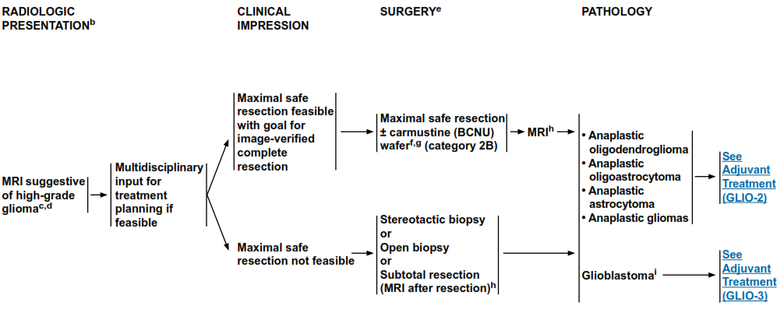
Figure 4 Treatment algorithm for surgical intervention for anaplastic gliomas/glioblastoma
Source: NCCN guidelines Version 2.2014

Following surgical excision, patients receive adjuvant treatment with chemotherapy and/or radiotherapy (Figure 5). The administration of oral ALA does not affect the treatment pathway subsequent to surgery, but rather aims to improve the outcome of surgery by facilitating complete resection.
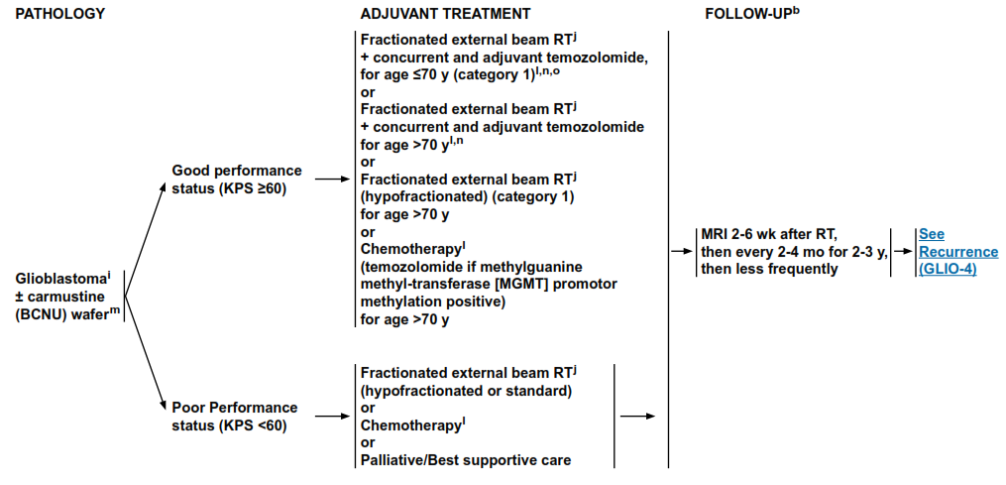
Figure 5 Treatment algorithm for adjuvant therapy of anaplastic gliomas/glioblastoma
Source: NCCN guidelines Version 2.2014

Patients with recurrent disease, may require further surgical intervention (Figure 6). Oral ALA may be utlised in the excision of recurrent tumours.
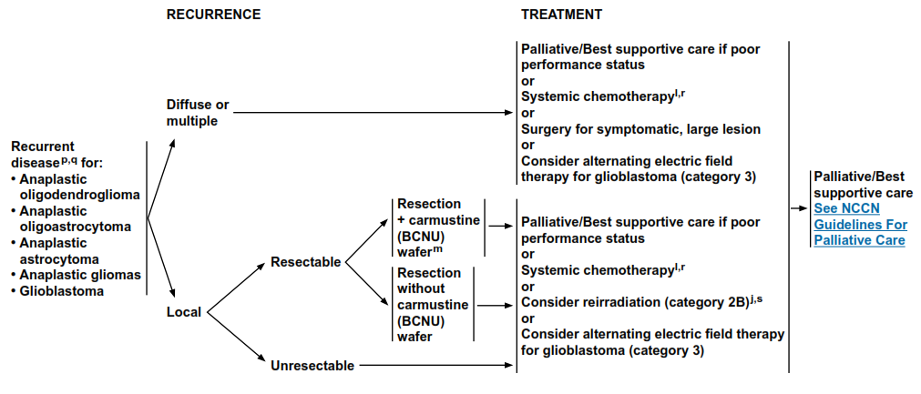
Figure 6 Treatment algorithm for recurrent anaplastic gliomas/glioblastoma
Source: NCCN guidelines Version 2.2014

These management guidelines were published in the US and Europe, and are generally consistent with the Australian management guidelines (Australian Cancer Network, 2009). Further, two studies of current treatment practices in Australia and the US reported similar “patterns of care” (Rosenthal et al., 2006 and Chang et al. 2005 respectively; Table 3).
Table 3 Comparison of GBM management in Australian and US studies
 | US study  (Chang et al., 2005) | Australian study  (Rosenthal et al., 2006)
Number of patients with GBM | 418 | 473
Age > 60 years | 49% | 57%
Male | 60% | 58%
Macroscopic resection | 46% | 31%
Biopsy only | 19% | 21%
Radiotherapy | 89% | 68%
Chemotherapy | 54% | 56%

Provide a clinical management algorithm (e.g.: flowchart) explaining the expected management and any downstream services (aftercare) of the eligible population/s if public funding is recommended for the service proposed.
The clinical management pathway for fluorescence guided resection of high grade (grade IV) glioma that are GBM using oral ALA is consistent with the current clinical management pathway (Figure 6). The only difference is in the actual surgical resection, with the administration of oral ALA and use of the fluorescence capability on the neurosurgical microscope.

Regulatory Information
Please provide details of the regulatory status. Noting that regulatory listing must be finalised before MSAC consideration.
Gliolan® (oral ALA) is registered by the TGA and was first listed on the Australian Register of Therapeutic Goods (ARTG) in November 2013.
The TGA-approved indication is:
Gliolan® is indicated in adult patients for visualisation of malignant tissue during surgery for malignant gliomas that are glioblastoma multiforme (GBM) on preoperative imaging, and who are intended for resection of the tumour.
Oral ALA is contraindicated in patients with hypersensitivity to ALA or porphyrins, acute or chronic types of porphyria, and in pregnant women.

Decision analytic
Provide a summary of the PICO as well as the health care resource of the comparison/s that will be assessed, define the research questions and inform the analysis of evidence for consideration by MSAC (as outlined in Table 4).

Table 4 Summary of PICO to define research question
PICO | Comments
Patients | Adult patients undergoing resection of high grade (grade IV) glioma that are glioblastoma multiforme (GBM).  Oral ALA is contraindicated in patients with hypersensitivity to ALA or porphyrins, acute or chronic types of porphyria, and in pregnant women.Oral ALA can be used for the resection of both newly diagnosed and recurrent tumours.  GBM are poorly differentiated, have increased cellularity, variable mitotic activity, and prominent vascular proliferation or necrosis.  GBM are usually diagnosed pre-operatively with the aid of an MRI on which they appear as a large, heterogeneous mass in supratentorial white matter. The defining features are haemorrhage and necrosis, with surrounding “fingers of oedema” (extensive). There is usually considerable mass effect.  Eligibility for surgery is determined based on whether the lesion is amenable to resection (not deeply situated, or diffuse and non-focal) and on the patient’s clinical condition/ability to tolerate surgery
Intervention | Fluorescence guided resection of high grade (grade IV) glioma that are GBM using oral ALA (aminolevulinic acid).
Comparator | Resection of high grade (grade IV) glioma that are GBM using standard white light.
Outcomes | Clinical trial data:  - Complete resection  - Progression Free Survival  - Survival  - Treatment-emergent adverse events  Other benefits not measured directly in the trial  - Improvements in quality of life/utility gain (utility values will be sourced from literature)  - Freedom from symptoms of disease  - Sparing of steroid-related side effects

Healthcare resources
Using Table 5, provide a list of the health care resources whose utilisation is likely to be impacted should the proposed intervention be made available as requested whether the utilisation of the resource will be impacted due to differences in outcomes or due to availability of the proposed intervention itself.

Table 5 List of resources to be considered in the economic analysis
 | Provider of resource | Setting in which resource is provided | Proportion of patients receiving resource | Number of units of resource per relevant time horizon per patient receiving resource | Disaggregated unit cost
 |  |  |  |  | MBS | Safety nets* | Other government budget | Private health insurer | Patient | Total cost
Resources provided to identify eligible population |  |  | (None over and above current standard practice)
GP Consultation (MBS23) | GP | Consulting Room | 50% | TBD | $37.05
Medical Practitioner (Emergency Physician) Attendances (MBS501) | Medical Practitioner | Emergency Department | 50% | 1 | $34.20
MAGNETIC RESONANCE IMAGING - scan of head for tumour of the brain or meninges (MBS63001) |  | Hospital & outpatient | TBD | 1 | $403.20
MAGNETIC RESONANCE IMAGING - scan of head for: stereotactic scan of brain, with Fiducials in place, for the sole purpose to allow planning for stereotactic neurosurgery (MBS63010) |  | Hospital & outpatient | 100% | 1 | $336.00
Neurosurgery specialist, referred consultation (MBS6007) | Neurosurgeon | Surgery or hospital | 100% | 1 | $129.60
Neurosurgery specialist, subsequent consultation (MBS6009) | Neurosurgeon | Surgery or hospital | 100% | TBD | $43.00
Neurosurgery specialist, subsequent consultation (MBS6011) | Neurosurgeon | Surgery or hospital | 100% | TBD | $85.55
Neurosurgery specialist, subsequent consultation (MBS6013) | Neurosurgeon | Surgery or hospital | 100% | TBD | $118.50
Neurosurgery specialist, subsequent consultation (MBS6015) | Neurosurgeon | Surgery or hospital | 100% | TBD | $150.90
Resources provided to deliver proposed intervention
Gliolan (oral ALA) |  | Hospital | ~45%  ~55% | 1  2
Carl Zeiss Pentero or Leica Microsystems OH4/OH5 microscope upgrades |  | Hospital | Required for all patients but 22 Australian hospitals already have neurosurgical microscopes with fluorescence capabilities. | TBD |  |  | $40,000 to $70,000
Resources provided to deliver proposed intervention & comparator
Craniotomy for removal of glioma, metastatic carcinoma or any other tumour in cerebrum, cerebellum or brain stem (MBS39709) | Neurosurgeon | Hospital | 100%1 | 1 | $1,586.75
Anti-seizure medications | PBS | Hospital & outpatient | TBD | TBD
Steroids | PBS | Hospital & outpatient | TBD | TBD
Anti-ulcer medication | PBS | Hospital & outpatient | TBD | TBD
Analgesics | PBS | Hospital & outpatient | TBD | TBD
Resources used to manage patients treated with the proposed intervention & comparator
Pathology tests | Pathology laboratory | Pathology laboratory | 100% | TBD
Chemotherapy | PBS | Hospital & outpatient | TBD | TBD
Radiotherapy | PBS | Hospital & outpatient | TBD | TBD
* Include costs relating to both the standard and extended safety net.

Questions for public funding
Please list questions relating to the safety, effectiveness and cost-effectiveness of the service / intervention relevant to this application, for example:
• Which health / medical professionals provide the service
• Are there training and qualification requirements
• Are there accreditation requirements
Currently, neurosurgery for high-grade glioma in Australia is performed in tertiary referral public hospitals and selected private hospital facilities with established neurosurgical staff and expertise. In most instances, minimum safe requirements for neurosurgery in a particular centre are based on consensus and statutory regulations rather than evidence, which is rarely available. According to the Australian Cancer Network Adult Brain Tumour Guidelines Working Party (2009), general considerations for the operating room include:
  - Neurosurgery should be performed in a facility accredited through assessment by the Australian Council on Healthcare Standards (ACHS) (Australian Council on Healthcare Standards ).
  - Basic standards for operating rooms encompass numerous policy documents and regulations from Standards Australia (Standards Australia), State and Federal government, specialist medical colleges and the Australian College of Operating Room Nurses (ACORN).
  - Provision of sterile equipment is an essential standard of neurosurgical care and is governed by Australian Standard AS/NZS 4187:2003 (Standards Australia). The maintenance of sterility of personnel and materials during surgical procedures is covered by ACORN Standards 2006 as are other standards of nursing roles, competency and continuing education (The Australian College of Operating Room Nurses).
  - NSW Department of Health Policy Directive TS10 ‘Standard Procedures for the Handling of Accountable Items in the Operating Suite and other Procedural Areas’ (and other applicable State Government regulations) governs surgical counts during procedures (NSW Department of Health Policy Directive ).
  - The Australian and New Zealand College of Anaesthetists (ANZCA) recommends minimum standards with regards to provision of a safe anaesthetic in Technical Professional Document T1 ‘Recommendations on Minimum Facilities for Safe Administration of Anaesthesia in Operating Suites and Other Anaesthetising Locations – 2006’. This, and more than 50 other Professional Documents and recommendations, are available on the ANZCA website (ANZCA Professional Documents).
In addition to a standard safe operating room, it would be generally agreed that centres conducting surgery for high-grade glioma should have:
  - On-site, 24-hour neuroradiology including CT, MRI and angiography, with experienced neuroradiology staff. Facilities should not be so physically removed from the main location of patient care so as to present an unreasonable danger to patients during transportation.
  - An on-site intensive care unit (ICU) able to provide complex, comprehensive pre- and post-operative care. The Joint Faculty of Intensive Care Medicine of ANZCA gives recommendations for minimum standards for ICU and other policies (Joint Faculty of Intensive Care Medicine of ANZCA recommendations for minimum standards for ICU and other policies ). ICU staff with neuro-intensive care experience is recommended.
  - A multidisciplinary team including, in particular, neurologists, radiation and medical oncologists, neuropathologists, neuroscience nurse specialist and allied health professionals and also general physicians for expertise and assistance in the peri-operative period. Specialty surgical services, including plastic and reconstructive surgery or otorhinolaryngology are also occasionally essential for high-grade glioma surgery and should be available.
Specialist neurosurgical operating room equipment, the availability of which would generally be considered mandatory for surgery for high-grade glioma, although not necessarily used in every operation, would include:
  - facilities to view imaging studies
  - adjustable operating table with adaptation for rigid skull fixation
  - operating microscope
  - stereotactic equipment
  - ultrasonic surgical aspiration device
  - equipment for cortical mapping, including a cortical stimulator and somatosensory evoked potential equipment
Specialised Therapeutics Australia (STA) provides neurosurgeons with a distance learning based training program. Neurosurgeon training and accreditation forms part of the Risk Management Plan (RMP) agreed with the TGA for the registration of Gliolan® (oral ALA) and all neurosurgeons must complete a training course in the safe and effective use of oral ALA for fluorescence guided resection of GBM.
Prof Stummer (who developed the drug and method) was in Australia in 2011 and conducted two training workshops. One was filmed and recorded, including all his slides and discussion. Prof Stummer then oversaw a GBM resection in theatre with a local neurosurgeon, and the attendees on the day watched. This was also recorded by the camera on the microscope. These recordings were put together to form a DVD series of his lectures and the procedure. These DVDs are provided to Australian neurosurgeons as part of the Gliolan® training kit. A written training manual, which is the same as the one used for EU training requirements, is also provided.
Neurosurgeons must watch the DVDs, read the manual, and sign a declaration form stating they have done so, and send this to STA. Once received, they receive certification from STA and are permitted to request and order Gliolan®. The sponsor maintains a database of all certified neurosurgeons.

References
Albert FK, Forsting M, Sartor K, et al. Early post-operative magnetic resonance imaging after resection of malignant glioma: objective evaluation of residual tumour and its influence on regrowth and prognosis. Neurosurgery. 1994; 34:45-60.
Australian Institute of Health and Welfare (AIHW) 2014. Australian Cancer Incidence and Mortality (ACIM) books: Canberra: AIHW. Australian Cancer Incidence and Mortality (ACIM) books Accessed September 9, 2014
Australian Institute of Health and Welfare (AIHW) 2012. AiHW Procedures data cubes 2011-12, classified using ACHI Seventh Edition. Procedures > I. Procedures on nervous system. Available online at Australian Institute of Health and Welfare Accessed October 31, 2014
Australian Cancer Network Adult Brain Tumour Guidelines Working Party. Clinical Practice Guidelines for the Management of Adult Gliomas: Astrocytomas and Oligodendrogliomas. Cancer Council Australia, Australian Cancer Network and Clinical Oncological Society of Australia Inc., Sydney 2009. Available online at Cancer Council Australia, Australian Cancer Network and Clinical Oncological Society of Australia Inc., Sydney 2009. Accessed February 5, 2015.
Brown PD, Maurer MJ, Rummans TA, et al. A prospective study of quality of life in adults with newly diagnosed high-grade gliomas: the impact of the extent of resection on quality of life and survival. Neurosurgery. 2005; 57(3):495-504.
Central Brain Tumor Registry of the United States. CBTRUS Statistical Report: Primary Brain and Central Nervous System Tumors Diagnosed in the United Sates in 2004-2007. CBTRUS Statistical Report: Primary Brain and Central Nervous System Tumors Diagnosed in the United Sates in 2004-2007. Accessed September 9, 2014.
Garside R, Pitt M, Anderson R, Rogers G, Dyer M, Mealing S, Somerville M, Price A, Stein K. The effectiveness and cost-effectiveness of carmustine implants and temozolomide for the treatment of newly diagnosed high-grade glioma: a systematic review and economic evaluation. Health Technol Assess. 2007 Nov;11(45):iii-iv, ix-221.
Lacroix M, Abi-Said D, Fourney DR, et al. A multivariate analysis of 416 patients with glioblastoma multiforme: prognosis, extent of resection, and survival. J Neurosurg. 2001;95(2):190-8.
McGirt MJ, Chaichana KL, Gathinji M. Independent association of extent of resection with survival in patients with malignant brain astrocytoma. J Neurosurg 2009Jan; 110(1):156-62.
Narayanan V, Patel K, Price S. High Grade Gliomas: Pathogenesis, Management and Prognosis. ACNR 2012: 12(4): 24-29
NCCN Clinical Practice Guidelines in Oncology. Central Nervous System Cancers. Version 2.2014 NCCN Clinical Practice Guidelines in Oncology Accessed on March 11, 2014
National Cancer Institute (NCI). US National Institutes of Health. Cancer Topics: Adult Brain Tumors Treatment. Last modified 28th February 2014. Available online at National Cancer Institute. Accessed on 9 September 2014.
Oberndorfer S, Lindeck-Pozza E, Lahrmann H, et al. The end-of-life hospital setting in patients with glioblastoma. J Palliat Med. 2008; 11(1):26-30.
Pace A, Di Lorenzo C, Guariglia L, et al. End of life issues in brain tumor patients. J Neurooncol. 2009; 91(1):39-43.
Pace A, Metro G, Fabi A. Supportive care in neurooncology. Curr Opin Oncol. 2010; 22(6):621-6.
Pichlmeier U, Bink A, Schackert G et al. Resection and survival in glioblastoma multiforme: An RTOG recursive partitioning analysis of ALA study patients. Neuro-Oncology 2008;10:1025–34.
Rosenthal MA, Drummond KJ, Dally M, Murphy M, Cher L, Ashley D, Thursfield V. and Giles GG. Management of glioma in Victoria (1998–2000): retrospective cohort study. MJA 184: 270-273
Sizoo EM, Braam L, Postma TJ, et al. Symptoms and problems in the end-of-life phase of highgrade glioma patients. Neuro Oncol. 2010; 12(11):1162-6.
Slof J, Díez Valle R, Galván J. Cost-effectiveness of 5-aminolevulinic acid-induced fluorescence in malignant glioma surgery. Neurología 2015; 30 (3) 163-168 Available online at http://apps.elsevier.es/watermark/ctl_servlet?_f=10&pident_articulo=90398290&pident_usuario=0&pcontactid=&pident_revista=495&ty=166&accion=L&origen=zonadelectura&web=www.elsevier.es&lan=en&fichero=495v30n03a90398290pdf001.pdf
Specialised Therapeutics Australia. Product information for Gliolan®.
Stummer W, Pichlmeier, Meinel T. Fluorescence- guided surgery with 5-aminolevulinic acid for resection of malignant glioma: a randomised controlled multicentrer phase III trial. Lancet Oncol 2006;7:392-401.
Stummer W, Ewelt C, Felsberg J, Meinel T, Martus P. Reifenberger G, Jakobs O. Prospective cohort study of radiotherapy with concomitant and adjuvant temozolomide chemotherapy for glioblastoma patients with no or minimal residual enhancing tumor load after surgery. J Neurooncol (2012) 108:89–97
Stupp R, Tonn JC, Brada M, Pentheroudakis G; ESMO Guidelines Working Group. High-grade malignant glioma: ESMO Clinical Practice Guidelines for diagnosis, treatment and follow-up. Ann Oncol. 2010; 21 Suppl 5:v190-3.
Stupp R, Brada M, van den Bent MJ, Tonn J.-C, Pentheroudakis G.High-grade glioma: ESMO Clinical Practice Guidelines for diagnosis, treatment and follow-up. Ann Oncol (2014) 25 (suppl 3): iii93-iii101
Tracey E, Barton M, Glass P, Rodriguez M, Bishop J. Brain cancer in NSW – variation in diagnosis and survival by histological subtype. Cancer Institute NSW, November 2007. Cancer Institute
Van den Bent MJ, Stupp R, Mason W, Mirimanoff RO, Lacombe D, Gorlia T. Impact of extent of resection on overall survival in newly diagnosed glioblastoma after chemo-irradioation with temozolomide: further analysis of EORTC study 26981. Eur J Cancer 2005 (Suppl 2):134

