Medical Services Advisory Committee (MSAC)

Public Summary Document
Application 1647 – Brexucabtagene autoleucel for relapsed or refractory mantle cell lymphoma
Applicant: Gilead Sciences Pty Ltd
Date of MSAC consideration: MSAC out-of-session, 29 July 2023
82nd MSAC Meeting, 29-30 July 2021
Context for decision: MSAC makes its advice in accordance with its Terms of Reference, visit the MSAC website

Purpose of application
An application requesting joint public funding by the Commonwealth and the States and Territories under the National Health Reform Agreement (NHRA) of brexucabtagene autoleucel (Tecartus®) for the treatment of patients with relapsed or refractory mantle cell lymphoma (R/R MCL) was received from Gilead Sciences by the Department of Health.
Brexucabtagene autoleucel and the broader health technology (CAR T-cell therapy) are not eligible for funding through the MBS or PBS.

MSAC’s advice to the Minister

July 2023 MSAC consideration
Following the MSAC’s July 2021 advice to support the public funding of brexucabtagene autoleucel (brexu-cel) for certain patients with relapsed or refractory mantle cell lymphoma (R/R MCL), Gilead Sciences submitted a pricing proposal to progress the public funding of the CAR-T cell therapy in July 2023.
Given the details of the pricing proposal varied from the MSAC’s July 2021 advice, the MSAC considered the pricing proposal out-of-session on 29 July 2023. After considering the pricing proposal, MSAC confirmed its support for the public funding of brexu-cel for certain patients with R/R MCL. No changes were made to other parts of its advice to the Minister from July 2021.

July 2021 MSAC consideration
After considering the strength of the available evidence in relation to comparative safety, clinical effectiveness and cost-effectiveness, MSAC supported public funding of brexu-cel for certain patients with R/R MCL. MSAC considered there was significant unmet clinical need in this group of patients. MSAC considered that the level of clinical evidence in support of brexu-cel to be acceptable given the rarity of mantle cell lymphoma and the proposal for its use as a later line of therapy.
MSAC support for public funding was contingent on a price reduction to achieve an average price per patient corresponding to the same incremental cost-effectiveness ratio (ICER) as that accepted for axicabtagene ciloleucel ($redacted/QALY) and if the following measures were implemented to contain the risks associated with public funding:
- treatment must be delivered by a haematologist working in a multi-disciplinary team specialising in the provision of CAR-T cell therapy;
- treatment must be delivered in a tertiary public hospital with appropriate credentials;
- governance and prescribing rules to ensure treatment is directed to patients most likely to benefit;
- Redacted;
- Redacted;
- Redacted;
- Redacted;
- no payment for brexu-cel for an unsuccessful infusion (i.e. an infusion of product that does not meet the TGA agreed specification for minimum cell numbers);
- no payment for brexu-cel if a patient is apheresed but does not receive the infusion of engineered lymphocytes;
- Redacted;
- a limit to one successful CAR-T infusion per lifetime for r/r MCL;
- Redacted;
- data on the use of brexu-cel for mantle cell lymphomas in Australia to be recorded by the Australasian Bone Marrow Transplant Recipient Registry (ABMTRR), with the cost of data collection met by the applicant, with visibility of this data collection, analysis and reporting extending to Commonwealth, State, and Territory governments; and
- A full review of clinical effectiveness, cost-effectiveness and budget impact to be conducted by the MSAC no later than 3 years post the commencement of public subsidy of CAR-T cell therapy for mantle cell lymphoma (note: Gilead will provide a submission to initiate this review). Redacted will be renegotiated as part of this review.
Without agreement to implement all these measures, MSAC advised that the application would have to be reconsidered at a future meeting.
Consumer summary
In July 2021, MSAC considered an application from Gilead Sciences Pty Ltd for public funding of brexucabtagene autoleucel (brexu-cel; Tecartus®) – a type of CAR-T cell therapy (chimeric antigen receptor T-cell therapy). The application requested public funding of brexu-cel for adult patients with relapsed or refractory mantle cell lymphoma (R/R MCL).
CAR-T cell therapies such as brexu-cel are used when patients with some types of cancer, such as lymphoma, don’t respond to, or relapse after, other types of treatment, such as chemotherapy. CAR-T cell therapy involves taking some of the patient’s own blood, which is then sent to a laboratory where the T cells are extracted and altered so that they can attack the cancer cells when re-introduced into the patient’s body. The patient’s changed T cells are infused back into them (by flowing the cells back into the body through a cannula (tube) inserted into a large vein) to target and kill the cancer cells in the patient’s body.
MCL is a rare subtype of non-Hodgkin lymphoma, seen mostly in older adults. The prognosis (outlook for the disease) is often very poor. For R/R MCL, there are few treatment options. MSAC acknowledged that brexu-cel is important to give people with R/R MCL another treatment option after other therapies have not worked, to give them a chance of remission.
MSAC’s advice to the Commonwealth Minister for Health
MSAC recommended that brexu-cel be publicly funded for people with R/R MCL, as there are no other effective treatment options for these patients.
MSAC advised that brexu-cel is a very expensive therapy. MSAC considered several measures need to be put in place to manage the use of public funds for brexu-cel. Many of these measures need to be agreed to between the applicant and the Commonwealth and/or the State and Territory governments.

Summary of consideration and rationale for MSAC’s advice

July 2023

The MSAC noted the public funding of brexu-cel for the treatment of certain patients with R/R MCL had not progressed following its support for funding at its July 2021 meeting. The MSAC noted this was the first time since receiving its July 2021 advice Gilead Sciences had submitted a pricing proposal to progress the public funding of brexu-cel for the treatment of certain patients with R/R MCL. MSAC noted that it was considering the pricing proposal despite its July 2021 support of public funding for brexu-cel given the proposal varied from its July 2021 advice.

The MSAC considered the following pricing proposal submitted by Gilead Sciences in July 2023:
- Redacted
- Redacted
- Redacted
- Redacted
- Redacted
- Redacted
- Redacted
After considering the pricing proposal, MSAC confirmed its support for the public funding of brexu-cel for certain patients with R/R MCL. MSAC noted the Department will be required to confirm the response criteria and 12-month complete metabolic response rate proposed by the applicant were appropriate. MSAC reaffirmed the importance of data being collected through a registry that can be accessed by all relevant stakeholders, and that a full review of clinical effectiveness, cost-effectiveness and budget impact is to be conducted by the MSAC no later than 3 years post the commencement of public subsidy of CAR-T cell therapy for R/R MCL. No changes were made to other parts of its advice to the Minister from July 2021.

July 2021
MSAC noted that this was an application for funding for brexucabtagene autoleucel (brexu-cel) (Tecartus®) for treatment of patients with relapsed or refractory mantle cell lymphoma (R/R MCL). These are patients who have failed immunochemotherapy (first line) and Bruton's tyrosine kinase (BTK) inhibitor therapy (second line). The application also proposed eligibility for patients who have received immunochemotherapy and who are considered unsuitable for BTK inhibitor therapy due to predicted intolerance. MSAC noted that brexu-cel was approved by the Therapeutic Goods Administration (TGA) for registration on the Australian Register of Therapeutic Goods (ARTG) in July 2021, and that this application aligned with the proposed ARTG restrictions.
MSAC noted that this application was expedited (bypassing PASC). The PICO was based on application 1587 for axicabtagene ciloleucel, which MSAC recommended for funding to treat certain refractory or relapsed CD19-positive lymphomas in January 2020 after axicabtagene ciloleucel received TGA approval.
MSAC noted that R/R MCL is a rare subtype of non-Hodgkin lymphoma with poor prognosis. Salvage therapy is currently the only option for those who have failed first- and second-line therapy. Thus, MSAC acknowledged the clinical need for brexu-cel.
MSAC noted the detailed eligibility criteria for treatment with brexu-cel, with a proposed population of redacted per year. However, MSAC considered this to be an overestimation and suggested that the caps are progressively escalated to a maximum of redacted patients per year.
MSAC noted that all the clinical trial data in the application was from the ZUMA-2 trial, a prospective single-arm study. No randomised controlled trial (RCT) comparing brexu-cel with the comparator (salvage therapy) was available; thus, a naïve indirect comparison was offered. MSAC noted the difficulties outlined by the commentary in identifying a similar patient cohort between the ZUMA-2 trial and comparator trials, in particular the high level of heterogeneity with comparator data (study design, population, salvage therapies), with concerns that any comparisons are subject to confounding and significant selection bias. MSAC agreed with the applicant in its pre-MSAC response, that there are limitations in naïve comparisons, but that an RCT would never be feasible due to the low incidence of R/R MCL and the fact that the disease is rapidly fatal.
ZUMA-2 was a phase 2 study with two dose cohorts: a standard dose and a “lower” dose. MSAC noted that the lower dose was not effective, and that the data presented are from the standard dose cohort. MSAC noted that 81% of the patients in the ZUMA-2 study had at least three previous therapies, that 43% had had an autologous stem cell transplant, and that all patients were refractory to treatment with a BTK inhibitor.
MSAC noted that, of the 74 participants given the standard dose in the trial, 71/74 patients underwent successful leukapheresis and 68/74 patients underwent successful administration of brexu-cel. Unsuccessful cases were due to deep vein thrombosis, death, withdrawal from the study, cardiac issues and manufacturing failure.
MSAC noted that the:
- overall response rate for brexu-cel patients in ZUMA-2 was 83.8% compared with 40.4% averaged across patients on salvage therapies in comparator studies
- complete response rate for brexu-cel patients in ZUMA-2 was 59.5% compared with 24.7% averaged across patients on salvage therapies in comparator studies
- median progression-free survival for brexu-cel patients in ZUMA-2 was 16.2 months compared with 9.3 months for patients on salvage therapies in two comparator studies
- median overall survival for brexu-cel patients in ZUMA-2 was not reached compared with 10 months for patients on salvage therapies in five comparator studies.
MSAC noted that the poorer outcomes may be due in part to the worse prognosis of patients in two of the salvage therapy studies. MSAC also noted that the median follow-up in ZUMA-2 was 16.5 months.
MSAC noted that the ZUMA-2 (brexu-cel) efficacy outcomes were broadly comparable to JULIET (tisagenlecleucel) and ZUMA-1 (axicabtagene ciloleucel) outcomes; JULIET and ZUMA-1 were both single-arm trials for CAR-T therapy for relapsed or refractory diffuse large B-cell lymphoma (DLBCL). MSAC recommended both tisagenlecleucel and axicabtagene ciloleucel for funding to treat DLBCL in 2019 and 2020, respectively.
MSAC agreed with the applicant and the commentary that comparative safety was difficult to draw conclusions on, as the salvage therapy trials did not adequately report toxicity. MSAC considered the toxicity profile of CAR-T therapies to be different than those of salvage therapies.
MSAC queried the price of brexu-cel, noting that the proposed cost was redacted than that of axicabtagene ciloleucel. In its pre-MSAC response, the applicant claimed that the additional CD4⁺ and CD8⁺ T cell enrichment step redacted justified the extra cost; however, MSAC did not consider this a strong justification for the additional cost.
MSAC noted that the incremental cost per life-year gained over a 30 year time horizon was $redacted, and that the quality-adjusted life year (QALY) gained over the same time horizon was $redacted using the applicant’s economic model. However, MSAC agreed with the ESC that the incremental cost per life year and QALY were closer to $redacted and $redacted, respectively, when some costs were corrected and lognormal extrapolation for overall survival was used.
MSAC noted that the overall financial impact ranged from $redacted in year 1 to $redacted in year 6, but considered that the uptake predicted by the applicant was too high in the later years (2024–2027). MSAC considered that the overall financial impact should be lower than what was proposed by the applicant.
MSAC noted the applicant’s economic model assumed a price of $redacted. The model then factored in a redacted, resulting in an average price paid of $redacted on which the ICER was based (noting, the applicant does not seek payment for unsuccessful infusions, i.e.patients who undergo leukapheresis and manufacturing of brexu-cel but do not receive infusion). MSAC considered that the ICER accepted should be based on a redacted, consistent with the axicabtagene ciloleucel for DLBCL approach.
If applying the maximum payable price agreed to for axicabtagene ciloleucel – $redacted incremental cost per life-year gained is lowered from an ICER of $redacted/QALY to an ICER of $redacted/QALY using the revised economic model accepted by ESC, with a redacted applied. MSAC noted that, to achieve the same cost per QALY as accepted for DLBCL ($redacted), brexu-cel would need to have an average payable price of $redacted.
MSAC noted that the applicant did not propose a redacted. MSAC considered such an arrangement to be essential in order to achieve cost-effectiveness and to mitigate the financial risk from potential leakage. In addition, MSAC considered that the Department should negotiate the following if brexu-cel is to be listed, which is an approach similar to that has been implemented for currently-funded CAR-T therapies:
- reduction in price per treatment;
- implementation of a redacted;
- a patient cap to manage utilisation beyond the estimates, redacted;
- review continued funding after 3 years.
MSAC noted the redacted agreement implemented for axicabtagene ciloleucel:
- Redacted
- Redacted
- Redacted
- Redacted.
MSAC considered that a similar agreement be negotiated for brexu-cel. MSAC noted that responder status is yet to be clearly defined for R/R MCL. MSAC considered it appropriate for the Department to engage with clinical experts to define an acceptable responder status for MCL patients who undergo brexu-cel therapy, redacted.
MSAC noted that if all the above conditions for support were not agreed to by the Department and the applicant, MSAC would need to reconsider the application at a future meeting.
MSAC noted that other CAR-T therapies required initial review at 1 year; however, MSAC noted that from past experience with other CAR-T therapies to date a 1 year review was not sufficient time to collect meaningful data given lower utilisation than expected. The States and Territories noted no obvious reasons for the slower-than-expected uptake; they reported that capacity was not an issue, but that COVID-19 may have slowed uptake. Therefore, MSAC recommended conducting a full review at 3 years, to allow enough time for meaningful data to be collected and analysed.
Redacted. State and Territory representatives noted that the evidence presented did not fulfil their normal benchmark for funding a therapy. However, MSAC noted that, due to the rarity of R/R MCL, it was not likely that better data would be obtained in the future for this population, and considered the approach taken here to be in line with that considered reasonable for rare conditions and consistent with the level of data previously accepted for DLBCL.
MSAC considered that data on the use of brexu-cel for mantle cell lymphoma in Australia should be recorded by the Australasian Bone Marrow Transplant Recipient Registry, with the cost of data collection met by the applicant. This would ensure a single Australian source of data for all CAR-T therapies in all indications and from all treatment centres. The data collected in the registry should align with international data collections to ensure comparability and access and thus contribute to global knowledge. The registry should include the following minimum data:
- the date of first referral, postcode of patient and referring physician;
- date of apheresis and infusion for treated patients;
- number of patients referred but not accepted, for treatment with CAR-T cell therapy, including the reason;
- patient-reported outcomes;
- lymphoma-free survival (complete and partial response);
- complications, use of high cost medicines, late-onset adverse events and adverse events requiring hospitalisation and adverse events including those requiring ICU admission;
- use and duration of immunoglobulin;
- rate of reinfusion with any CAR-T therapy (noting the cost of reinfusion of such therapy will not be funded under the proposed arrangement);
- indication for use of CAR-T – for example bridge to stem cell transplant, following transplant; and
- results for patients infused with non-optimal cell numbers (noting that for the purposes of subsidy, this is considered an unsuccessful infusion).
MSAC noted that previous data-sharing agreements for other CAR-T therapies did not explicitly include data sharing with the States and Territories; MSAC considered it crucial that future data collection be shared with States and Territories.
MSAC considered details of patient eligibility as proposed in the pre-MSAC response to be acceptable. These criteria are as follows:
Eligibility criteria for brexucabtagene autoleucel in R/R mantle cell lymphoma:
Indication: | Patients with relapsed or refractory CD19-positive mantle cell lymphoma (MCL) who have received at least two lines of therapy, including:  - an anthracycline- or bendamustine- or cytarabine-based chemoimmunotherapy regimen that includes an anti-CD20 monoclonal antibody therapy; AND  - a BTK inhibitor, unless the patient is considered unsuitable for treatment with a BTK inhibitor based on predicted intolerance.
Treatment criteria: | Patient must be treated in a tertiary public hospital with appropriate credentials  AND  Patient must be treated by a haematologist working in a multi-disciplinary team specialising in the provision of CAR-T cell therapy  AND  Patient must not have uncontrolled infection, including uncontrolled HIV or active hepatitis B or C infection  AND  Patient must not have primary CNS lymphoma  AND  Patient must not have uncontrolled secondary CNS disease, or secondary CNS disease anticipated to be uncontrolled at the time of infusion of brexucabtagene autoleucel
Clinical criteria: | Patient must have a WHO performance status of 0 or 1  AND  Patient must have sufficient organ function, including:  • Renal and hepatic function: Creatinine clearance >40 mL/min; serum ALT/AST <5 x ULN; and total bilirubin < 2 x ULN  • Cardiac function: absence of symptomatic heart failure (i.e. NYHA grade <2), cardiac left ventricular ejection fraction ≥50%, or supplementary functional tests and cardiology assessment demonstrating adequate cardiopulmonary reserve  • Pulmonary function: baseline peripheral oxygen saturation >91% on room air, no clinically significant pleural effusion  AND  The treatment team must consider the patient’s condition can be effectively managed during lymphocyte collection and manufacturing, to allow for the absence of rapidly progressive disease at the time of lymphocyte infusion.

Background
This is the first submission for brexucabtagene autoleucel for the treatment of patients with R/R MCL. MSAC has not previously considered this application.
MSAC has previously considered other CAR-T therapies in different patient populations.

Prerequisites to implementation of any funding advice
Brexucabtagene autoleucel was listed on the Australian Register of Therapeutic Goods (ARTG) on 21 July 2021.
On 7 June 2021, the applicant received a positive Therapeutic Goods Administration (TGA) Delegate’s overview. The proposed indication was amended to include the requirement for patients to have previously received two lines of treatment, including a Bruton's tyrosine kinase (BTK) inhibitor. The agreed indication is:
TECARTUS is a genetically modified autologous immunocellular therapy for the treatment of patients with relapsed or refractory mantle cell lymphoma (MCL), who have received two or more lines of therapy, including a BTK inhibitor, unless ineligible or intolerant to treatment with a BTK inhibitor.
Registered by the TGA with the indication above, brexucabtagene autoleucel (under the trade name of Tecartus®) is supplied as a trademarked class 4 biological product.

Proposal for public funding
Funding of brexucabtagene autoleucel is sought through a block funding mechanism, as has been agreed by the Commonwealth and the States for funding of other CAR T-cell therapies.
Public funding of brexucabtagene autoleucel is specifically requested for patients with R/R MCL who have received at least two lines of therapy including:
- an anthracycline- or bendamustine-based or cytarabine-based immunochemotherapy regimen that includes an anti-CD20 monoclonal antibody therapy; AND
- a BTK inhibitor, unless the patient is considered unsuitable for treatment with a BTK inhibitor on the basis of predicted intolerance.
The proposed price for treatment with brexucabtagene autoleucel is $redacted, paid upon infusion of the manufactured product (i.e., no payment is sought for patients who undergo leukapheresis and manufacturing of brexucabtagene autoleucel but do not receive infusion of the final product).

Summary of public consultation feedback/consumer Issues
Nil

Proposed intervention’s place in clinical management

Description of Proposed Intervention
Brexucabtagene autoleucel is a chimeric antigen receptor (CAR) T-cell therapeutic product that is personalised to each individual patient. It has been specifically developed for the treatment of MCL.
Each individual patient’s T-cells are collected via leukapheresis and genetically modified in a laboratory to recognise cancer cells that express CD19 on their surface. The modified T-cells are then expanded to several million and infused back into the patient.
Description of Medical Condition(s)
Mantle cell lymphoma is a rare, aggressive subtype of B-cell non-Hodgkin lymphoma (NHL) that has distinctive clinical, biological, and molecular characteristics.
Figure 1 shows the clinical management pathway for patients with MCL through to the point where it is proposed that brexucabtagene autoleucel would become a treatment option. It is anticipated that brexucabtagene autoleucel will primarily replace or displace the use of salvage therapy.

Figure 1: Management algorithm for MCL in Australia, showing proposed positioning of brexucabtagene autoleucel
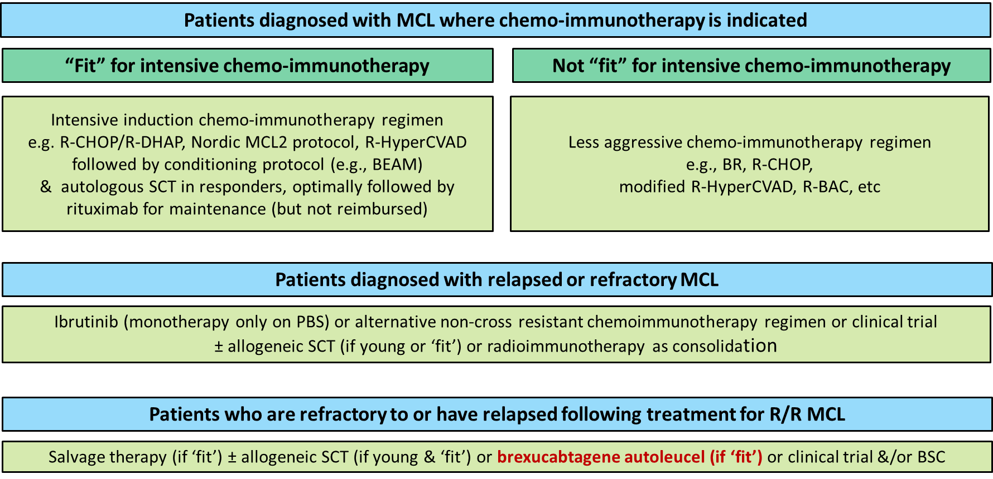
Abbreviations: BEAM = carmustine etoposide cytarabine melphalan; BSC = best supportive care; MCL = mantle cell lymphoma; Nordic MCL2 protocol involves administration of alternating courses of maxi-CHOP (cyclophosphamide, doxorubicin, vincristine and prednisolone) and high-dose cytarabine (rituximab is co-administered on Day 1 of Cycles 2-5); PBS = Pharmaceutical Benefits Scheme; R-BAC = rituximab, bendamustine, cytarabine; R-CHOP = rituximab, cyclophosphamide, doxorubicin, vincristine, and prednisolone; R-DHAP = rituximab, dexamethasone, cytarabine, and cisplatin; R-Hyper-CVAD = rituximab plus fractionated cyclophosphamide, vincristine, doxorubicin, and dexamethasone plus methotrexate and cytarabine; SCT = stem cell transplant.

Comparator
The application nominated salvage therapy as the main comparator, given it is the subsidised therapy most likely to be replaced or displaced by brexucabtagene autoleucel. In Australia, salvage therapy typically comprises of a variety of immunochemotherapy regimens.

Comparative safety
The clinical evidence presented in the application to compare outcomes with brexucabtagene autoleucel to those with salvage therapy consists of one prospective study of brexucabtagene autoleucel (ZUMA-2) and 14 studies reporting outcomes with various salvage therapy regimens in patients with R/R MCL in the post-BTK inhibitor setting.
The key features of each of the studies is summarised in Table 1.

Table 1: Key features of the studies to inform a comparison of brexucabtagene autoleucel versus salvage therapy
Publication | N (post-BTK inhibitor) | Study location  Dates of recruitment | Outcomes assessed (in post-BTK inhibitor population) | Study design | Post BTK inhibitor patient population | Intervention(s) post-BTK inhibitor
Brexucabtagene autoleucel studies
ZUMA-2 | 74 (FAS), 68 (mITT) | 33 sites across the USA, France, Germany and the Netherlands  16 May 2016 – 31 Dec 2019 | CR, ORR, PFS (KM), OS (KM) | Prospective Phase 2, MC, single arm in patients with R/R MCL with progression after or intolerance to a BTK inhibitor | Patients with progression after receiving an anthracycline- or bendamustine- containing chemotherapy, anti-CD20 antibody and a BTK inhibitor | KTE-X19
Salvage therapy prospective studies
Srour 2018 | 5 | MD Anderson Cancer Center  Apr 2015 – May 2016 | CR, ORR | Prospective pilot study of the DR2IVE protocol in patients with R/R MCL in patients previously treated with ibrutinib | Patients with resistance to ibrutinib | DR2IVE
Salvage therapy retrospective studies
McCulloch 2020a | 36 | 23 sites across the UK and Italy  Oct 2015 – Mar 2019 | CR, ORR, PFS (KM), OS (KM) | Retrospective review of outcomes with R-BAC in patients with R/R MCL in the post-BTK inhibitor setting | Patients with progression after a BTK inhibitor | R-BAC
Eyre 2019 | 20 | UK  Mar 2016 - May 2018 | CR, ORR, PFS (KM), OS (KM) | Retrospective review of hospital records to investigate outcomes to venetoclax in patients with R/R MCL in the post-BTK inhibitor setting | Patients with R/R MCL treated via a compassionate use program (AbbVie) | Venetoclax monotherapy
Jain 2018b | 35 | MD Anderson Cancer Center  Feb 2011 – Mar 2017 | CR, ORR, OS (IPD*)  **CR and ORR not reported in this study | Retrospective chart review of patients with R/R MCL treated with ibrutinib | Patients with R/R MCL after discontinuing ibrutinib | Not all patients received salvage therapy. However, some outcomes are reported for those treated with salvage therapy (rituximab, cyclophosphamide, radiation, bendamustine, lenalidomide or bortezomib)
Wang 2017 | 58 | 11 sites across the USA and England  1 Mar 2009 – 12 Apr 2016 | CR, ORR | Retrospective, observational, MC study in patients with R/R MCL who had progression or were refractory to ibrutinib | Patients with relapse post-, progression post-, refractory to or intolerance to ibrutinib | Lenalidomide-based therapy
Martin 2016 | 73 | 15 sites across the USA, UK, Germany and Poland  No recruitment date specified | CR, ORR, PFS, OS (KM) | Retrospective cohort study with R/R MCL with progression after ibrutinib | Patients with progression after ibrutinib | Rituximab, lenalidomide, cytarabine or bendamustine
Cheah 2015 | 31 | MD Anderson Cancer Center  Jan 2011 – Jan 2014 | CR, ORR,  OS (KM by response) | Retrospective review of outcomes in patients with R/R MCL in the post-ibrutinib setting who were treated with salvage therapy | Patients discontinuing ibrutinib for any reason | Salvage therapy (cyclophosphamide, bendamustine, lenalidomide, bortezomib, clinical trial or radiation)
Other studies reporting outcomes of salvage therapy in the post-BTK inhibitor setting
Tucker 2020a | 22  (reported by McCulloch 2020b) | 37 hospitals across the UK and Ireland  Janssen-Cilag Name Patient Programme; Nov 2014 – Dec 2015 | OS (KM by subsequent treatment) | Retrospective, 5-year real world observational study of patients receiving ibrutinib | Patients with progression while receiving ibrutinib | R-BAC, low-dose chemotherapy, radiation, lenalidomide or venetoclax
Jeon 2019 | 6 | Catholic Hematology Hospital, South Korea  Jan 2013 – Aug 2018 | ORR | Retrospective, observational cohort study of patients with R/R MCL receiving salvage therapy with ibrutinib | Patients receiving salvage chemotherapy after resistance to ibrutinib | BR or ESHAP
Regny 2019 | 12 | 19 sites  Jun 2016 – Jan 2019 | CR, ORR | Retrospective review of RiBVD regimen in patients with R/R MCL | Patients failing treatment with ibrutinib | RiBVD
Jain 2018a | 13 | MD Anderson Cancer Center  15 Jul 2013 – Jan 2018 | CR, ORR, OS (IPD*)  **CR and ORR not reported in this study | Prospective, single arm, Phase 2 study of outcomes in patients with R/R MCL treated with IR | Patients with disease progression or transformation while receiving IR treatment | Salvage therapy (bortezomib, rituximab, lenalidomide, cyclophosphamide or bendamustine)
Rule 2018 | 63 | 21 countries  10 Dec 2012 – 26 Nov 2013 | CR, ORR | Long-term follow-up of ibrutinib arm of the RAY RCT comparing ibrutinib and temsirolimus in patients with R/R MCL | Patients receiving subsequent anticancer therapy in the ibrutinib arm | Rituximab-based therapy
Seviar 2018 | 3 | Cancer Drugs Fund  2015 – 2017 | OS | Retrospective review of patients with R/R MCL treated with ibrutinib | Patients with progression after receiving ibrutinib | NR
Epperla 2017 | 29 | 8 academic tertiary care centres in the USA identified through clinical databases  Nov 2013 – Dec 2015 | ORR, OS | Retrospective cohort MC study in patients with R/R MCL treated with ibrutinib | Patients receiving subsequent therapy after failing treatment with ibrutinib | Bortezomib-, lenalidomide-, or bendamustine-based
* The presentation of patient-level data permitted construction of KM plots
**blue italics represents amendments made by the assessment group during the evaluation
Abbreviations: BR = bendamustine and rituximab; BTK = Bruton’s tyrosine kinase; CR = complete response; DR2IVE = dexamethasone, rituximab, lenalidomide and bortezomib;
ESHAP = etoposide, methylprednisolone, high-dose Ara-C and Platinol; FAS = full analysis set (corresponds to the intent-to-treat population); IPD = individual patient data;
IR = ibrutinib and rituximab; KM = Kaplan-Meier; MC = multicentre; MCL = mantle cell lymphoma; mITT = modified intent-to-treat (corresponds to the population infused with brexucabtagene autoleucel); N = number (of patients); NR = not reported; ORR = objective response rate; OS = overall survival; PFS = progression-free survival; R-BAC = rituximab, bendamustine and cytarabine; RCT = randomised controlled trial; RiBVD = rituximab, bendamustine, bortezomib and dexamethasone; R/R = relapsed or refractory; TTP = time to progression; UK = United Kingdom; USA = United States of America
During evaluation, the Commentary noted that the study by Seviar et al (2018) was excluded from further evaluation, as the only publication for this study was a conference abstract.
The Commentary stated that there are transitivity issues when comparing the outcomes from the ZUMA-2 study with those in the salvage therapy studies. The main reasons for this are summarised in Table 2. Three of the included studies could not be included in the table (Regny et al. 2019; Srour et al. 2018; Tucker et al. 2020a).
Table 2: Differences in patient characteristics in the salvage studies compared with ZUMA-2 that could have a prognostic impact on the study outcomes.
Study | Treatment | N | Patient characteristics
 |  |  | % blastoid | ECOG 2-4 | MIPI score: High risk | Ki-67 index | % SCT after salvage
ZUMA-2 | CAR-T | 74 | 25% | 0% | 13% | 50% ≥65% | 2/74 (3%)
Wang et al. 2017 | Lenalidomide-based therapy | 58 |  | 14%
Jain et al. (2018b) | Multiple lines of salvage therapies | 36 | 36% |  | 63% | 50%≥45% | 2/36 (6%)
McCulloch et al. 2020a | R-BAC | 36 | 19% | 20% | 39% |  | 12/36 (33%)
Cheah et al. 2015 | Rituximab-based salvage therapy | 78 | 29% | 2% |  | 52% ≥50% | 7/31 (23%)
Epperla et al. 2017 | Post-ibrutinib treatments | 97 | 15% | 14% | 27% | 38% ≥30% | 2/49 (7%)
Rule et al. 2018 | Rituximab-based chemotherapy | 139 | 12% | 1% | 22%
Eyre et al. 2019 | Venetoclax monotherapy | 20 | 20% | 45% | 55% | 50% ≥45% | 1/20 (5%)
Jain et al. (2018a) | Multiple lines of salvage therapies | 13 | 23% |  | 46% | 54%≥30% | 1/13 (8%)
Martin et al. 2016 | Post-ibrutinib treatments | 114 |  |  | 40% | 72% ≥30% | 5/73 (7%)
Jeon et al. 2019 | Salvage chemotherapies | 33 |  | 12% | 21% | 33% ≥30% | 2/6 (33%)
Values in red indicate characteristics where patients undergoing salvage therapies have a worse prognosis compared to patients in the ZUMA-2 study.
Values in green indicate characteristics where patients undergoing salvage therapies have a better prognosis compared to patients in the ZUMA-2 study.
The application presented a comparison of the types and rates of adverse events (AEs) observed with brexucabtagene autoleucel with the types and rates of AEs observed in patients treated with immunochemotherapy which indicated that there are differences and trade-offs across the toxicity profiles associated with brexucabtagene autoleucel versus salvage therapy. The AE profile associated with immunochemotherapy (the most likely salvage therapy to be used in Australia) that has been presented in the application is for patients in the frontline setting. When considering the same evidence at the time it considered submissions seeking PBS listing of ibrutinib for R/R MCL, the Pharmaceutical Benefits Advisory Committee (PBAC) accepted that the reported rates from the frontline setting are likely to understate the extent of AEs that would be observed in a pre-treated population. The application considered that these facts, along with issues related to the comparison being based on single arm studies, preclude the drawing of any definitive conclusion in regard to the comparative toxicity of brexucabtagene autoleucel and salvage therapy.
Adverse events associated with brexucabtagene autoleucel and other anti-CD19 CAR T-cell therapies are becoming better characterised over time and clinician experience in managing the AEs observed with these therapies continues to build.
The Commentary agreed with the application that due to the limited evidence from single arm studies, no definitive conclusions in regard to the comparative toxicity of brexucabtagene autoleucel and salvage therapy can be made. Also as noted in the application, the safety profile of CAR-T therapies are very dependent on adequate provisions for the immediate treatment of specific AEs associated with CAR-T cell therapies, such as cytokine release syndrome (CRS).
An overview of treatment-emergent AEs observed in the ZUMA-2 study is presented in Table 3. The majority of CRS and neurological events were Grade 1 or 2, occurred within one week of infusion of brexucabtagene autoleucel, and were resolved within two weeks. CRS and neurologic events were resolved in all patients and no CRS or neurologic events that occurred in the ZUMA-2 study were fatal.

Table 3 Summary of AEs in ZUMA-2
 | Any event | Worst ≥ Grade 3
TEAEs | 68 (100%) | 67 (99%)
Serious TEAEs | 46 (68%) | 37 (54%)
CRS | 62 (91%) | 10 (15%)
Neurologic event | 43 (63%) | 22 (32%)
Thrombocytopenia | 50 (74%) | 35 (51%)
Neutropenia | 59 (87%) | 58 (85%)
Anaemia | 46 (68%) | 34 (50%)
Serious infection | 17 (25%) | 16 (24%)
Hypogammaglobulinaemia | 13 (19%) | 1 (1%)
Source: Table 2.8 in Section 2.5.1 of the ADAR and Table 40 ZUMA-2 CSR
The Commentary noted that a comparison between the ZUMA-2 study and the safety profile of R-CHOP (as reported by Robak et al. 2015) found that patients treated with brexucabtagene autoleucel had more grade ≥3 events (99% had grade ≥3 treatment emergent AEs) compared with patients treated with R-CHOP (85% had grade ≥3 AEs). Additionally, grade ≥3 AEs of special interest when treated with brexucabtagene autoleucel occurred at higher rates than in patients who were treated with R-CHOP:
- Neurologic event 32% vs 6%
- Thrombocytopenia 51% vs 6%
- Neutropenia 85% vs 67%
- Anaemia 50% vs 14%
- Serious infection 24% vs 14%

Comparative effectiveness
The application stated that as there were several studies reporting response rates, progression free survival (PFS) and overall survival (OS) in patients treated with salvage therapy, results from the salvage therapy studies were, where appropriate, pooled to facilitate a comparison against results for brexucabtagene autoleucel as observed in the ZUMA-2 study.
Ten studies of salvage therapy reported complete response (CR) rates and eight studies reported objective response rate (ORR) and were included in the pooled analyses to derive a weighted average CR rate and ORR, respectively. Only two studies presented Kaplan-Meier plots for PFS – McCulloch 2020a and Eyre 2019. Patient-level data was reconstructed for PFS from the Kaplan-Meier plots provided for each study using the approach described by Guyot 2012. The reconstructed patient-level data were then pooled to generate a weighted average Kaplan-Meier function for PFS. Five studies either provided patient-level data to permit the derivation of, or presented Kaplan-Meier curves for OS in patients treated with salvage therapy after discontinuation of a BTK inhibitor – McCulloch 2020a, Eyre 2019, Jain 2018b, Martin 2016, and Jain 2018a. Reconstructed patient-level data from these studies was then pooled to generate a weighted average Kaplan-Meier function for OS.
Key outcomes reported for the studies are summarised in Table 4.

Table 4: Overview of the key characteristics of patients and key results from the studies available to compare outcomes brexucabtagene autoleucel to salvage therapy in patients with R/R MCL in the post-BTK inhibitor setting
Study | N  (post-BTK inhibitor setting) | Mean number of prior regimens (range) | Median duration of BTK inhibitor  (in months, range) | CR  n/N (%) | ORR  n/N (%) | Median PFS  (in months) | Median OS  (in months)
ZUMA-2 | 74 | 3.3ª  (1 - 5) | 10.8  (0.03 – 49.7) | 44/74 (59%) | 62/74 (84%) | 16.2 | Not reached
Srour 2018 | 5 | 3 (median)  (3-11) | NR | 3/5 (60%) | 5/5 (100%) | NR  (3/5 patients had progressed after ≤ 11 months follow-up) | NR  (but 2/5 patients had died after ≤ 11 months follow-up)
McCulloch 2020a | 36 | 3 (median) | NR | 60%  (incl. unconfirmed CR) | 83% | 10.1 | 12.5
Eyre 2019 | 20 | 3.1 (2-5) | 14 (0.7 – 34.8) | 3/20  (15%) | 10/20  (50%) | 3.2 | 9.4
Jain 2018b | 35 | NR for subgroup of interest | 8 (0.3-59) | NR | NR for subgroup of interest | NR | 10.5
Wang 2017 | 58 | 4 (median)  (1-13) | 4.3 (0.5 - 47.6) | 8/58  (14%) | 17/58  (29%) | NR | NR
Martin 2016 | 73 | 3 (median)  (0-10)^{b} | 4.7 (0.7 - 43.6) | 5/73  (7%) | 18/73  (25%) | 1.9 | 5.8
Cheah 2015 | 31 | 2 (median)  (1-8)^{c} | 6.5 cycles (1.2 - 43.3) | 6/31  (19%) | 10/31  (32%) | NR | 8.4
Tucker 2020a | 22  (reported by McCulloch 2020b) | NR for subgroup of interest | NR for subgroup in post-ibrutinib setting | NR | NR | NR for subgroup of interest | 9.3 months  (reported by  McCulloch 2020b)
Jeon 2019 | 6 | NR for subgroup of interest | NR for subgroup of interest | NR | 2/6  (33%) | NR for subgroup of interest | NR for subgroup of interest
Regny 2019 | 12 | NR | NR | 3/12  (25%) | 8/12  (67%) | NR for subgroup of interest | NR for subgroup of interest
Jain 2018a | 13 | NR for subgroup of interest | 13 (2-45) | NR (only response to ibrutinib+rituximab is provided) | NR (only response to ibrutinib+rituximab is provided) | NR for subgroup of interest | 20
Rule 2018 | 63 | NR for subgroup of interest | NR for subgroup of interest | 7/29^{d}  (24%) | 12/29 ^{d}  (41%) | NR for subgroup of interest | NR for subgroup of interest
Seviar 2018 | 3 | NR for subgroup of interest | NR for subgroup of interest | NR | NR | NR | 4.7
Epperla 2017 | 29 | NR for subgroup of interest | NR for subgroup of interest | NR | 14/29  (48%) | NR | 7 for bortezomib-based salvage regimens  6 for lenalidomide-based salvage regimens  4.5 for bendamustine-based salvage regimens
Italicised font indicates derived by the sponsor from information in the publications.
ª Reported in the ZUMA-2 CSR only for the mITT population
^{b} Reported for 114 patients examined by Martin 2016 (i.e., including patients who did not receive salvage therapy)
^{c} Reported for 42 patients discontinuing ibrutinib (i.e., including patients who did not receive salvage therapy)
^{d} Response rates are reported only for a subset (29/63; 46%) of patients with R/R MCL receiving subsequent treatments after discontinuation of ibrutinib
Abbreviations: BTK = Bruton’s tyrosine kinase; CR = complete response, CSR = clinical study report; NR = not reported; ORR = objective response rate (CR + PR); OS = overall survival; PFS = progression-free survival; PR = partial response; tx = treatment

Comparison of response rates
The application stated that based on a comparison of the results from ZUMA-2 with the meta-analysis of proportions of patients treated with salvage therapy, the likelihood of achieving an objective response, including a CR, is more than twice as high in patients treated with brexucabtagene autoleucel than in patients treated with salvage therapy:
- The ORR observed in the intent-to-treat (ITT) population of ZUMA-2 was 83.8% compared to a weighted average ORR in patients treated with salvage therapy of 40.4% (Figure 2).
- The CR rate observed in the ITT population recruited to the ZUMA-2 was 59.5% compared to a weighted average CR rate in patients treated with salvage therapy of 24.7% (Figure 3).
The Commentary noted that the forest plot from the single study for brexucabtagene autoleucel (ZUMA-2) overlaps the wide range of CR and ORR forest plots seen for the salvage studies (Figures 2 and 3). In particular, there is no significant difference in CR and ORR when ZUMA-2 is compared to the Srour et al. (2018), McCulloch et al (2020) and Regny et al. (2019; for ORR) studies. These studies all used rituximab-based salvage therapies. Given the degree of overlap between the ZUMA-2 study and these three studies, the Commentary considered it has not been conclusively shown that the response rate to brexucabtagene autoleucel therapy is superior to all rituximab-based salvage therapies.

Figure 2: Comparison of ORR for brexucabtagene autoleucel and salvage therapy
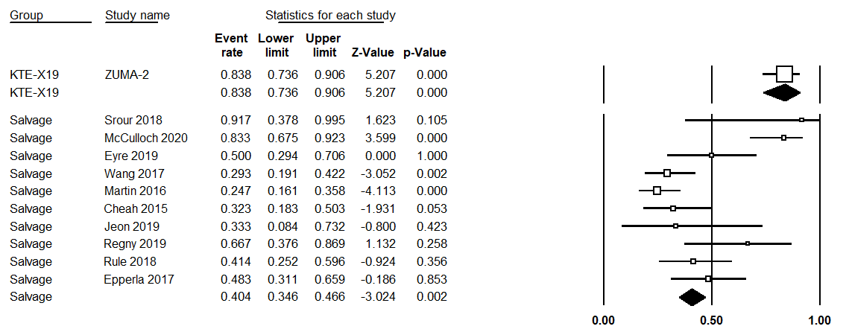

Figure 3: Comparison of CR rates for brexucabtagene autoleucel and salvage therapy
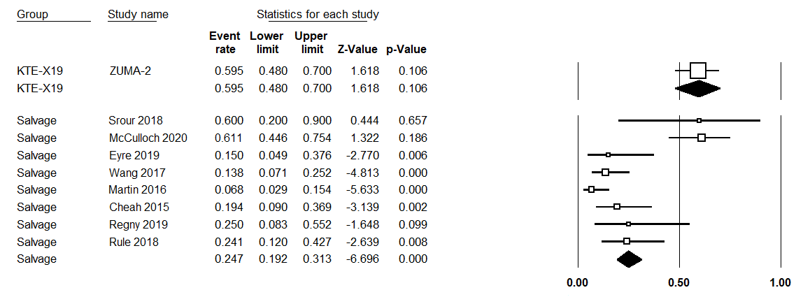
The application stated that, “it is important to recognise that the nature of response is not necessarily consistent across studies. Responses may be deeper and more durable with one treatment compared with another.” The Commentary noted that the ADAR reports on CR and ORR but not on duration of response (DOR). A naïve comparison of DOR conducted during evaluation suggests that in patients who respond to treatment, brexucabtagene autoleucel may induce a more enduring response than salvage therapies. However, the limited size of the evidence base, as well as the short follow-up of the data from ZUMA-2, indicate that the results are not sufficiently robust to draw any definitive conclusions about the size of the effect.

Comparison of PFS outcomes
The Kaplan-Meier PFS plot for brexucabtagene autoleucel as reported in the ZUMA-2 study is compared to the pooled Kaplan-Meier PFS plot for salvage therapy in Figure 4.
The median PFS in patients in the ZUMA-2 study was 16.2 months, in contrast, the median PFS in the pooled analysis of patients treated with salvage therapy was 9.3 months (McCulloch et al. 2020a and Eyre et al. 2019), signifying a PFS gain of 6.9 months for patients treated with brexucabtagene autoleucel.
The application stated that although there are limitations associated with a comparison based on single arm studies, the substantial magnitude of the difference means that the difference is highly unlikely to be due to confounding. It is therefore clear that brexucabtagene autoleucel is superior to salvage therapy in terms of PFS outcomes.
The Commentary considered that although the results are suggestive of a longer PFS with brexucabtagene autoleucel compared with salvage therapy, no definitive conclusions about the size of the effect can be made due to limited evidence base for both brexucabtagene autoleucel and salvage therapies. These results are also likely to be confounded due to the worse prognosis of patients in the two salvage therapy studies reporting PFS Kaplan-Meier curves with respect to the proportion of patients with ECOG 2-4 scores (20% and 45% vs 0% for ZUMA-2) and high risk MIPI scores (39% and 55% vs 13% for ZUMA-2).

Figure 4: Comparison of pooled Kaplan-Meier PFS function for salvage therapy with the Kaplan-Meier PFS function for brexucabtagene autoleucel as observed in the ZUMA-2 study
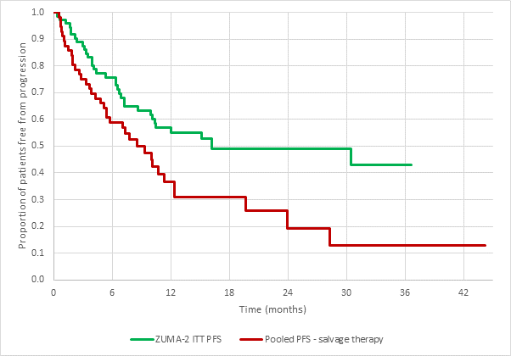
The pooled PFS curve was estimated from the data provided in McCulloch et al. (2020a) and Eyre et al. (2019).

Comparison of OS outcomes
The Kaplan-Meier OS function for brexucabtagene autoleucel as reported in ZUMA-2 is compared with the pooled Kaplan-Meier OS function for salvage therapy in Figure 5. Median OS in patients treated with salvage therapy from 5 studies in the pooled analysis is approximately 10 months whereas for patients treated with brexucabtagene autoleucel in the ZUMA-2 study, the median OS has not been reached despite a median follow-up of 16.5 months, noting that the first 28 (47%) patients treated had at least 24 months follow-up with a median follow-up of 27.0 months.
The application stated that as the median OS has not been reached for patients treated with brexucabtagene autoleucel in the ZUMA-2 study, it is not possible to ascertain the exact magnitude of difference in the median OS for brexucabtagene autoleucel versus salvage therapy however, the evidence indicating a large survival advantage for brexucabtagene autoleucel is compelling.
The application claimed that brexucabtagene autoleucel is superior to salvage therapy in terms of OS outcomes and that treatment with brexucabtagene autoleucel results in survival outcomes that are unprecedented in this population.

Figure 5: Comparison of pooled Kaplan-Meier OS function for salvage therapy with the Kaplan-Meier OS function for brexucabtagene autoleucel as observed in the ZUMA-2 study
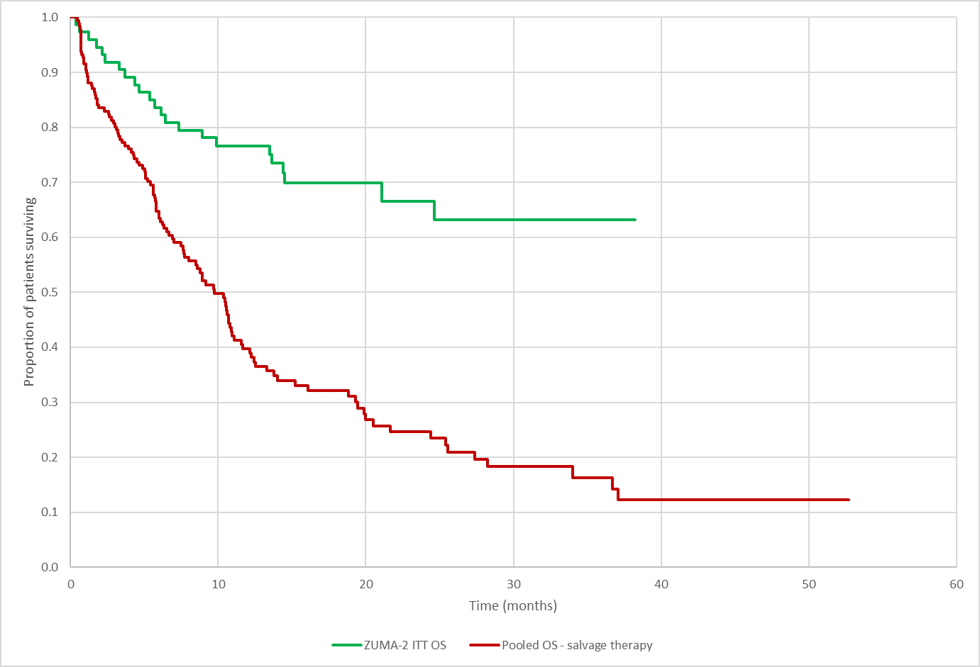
The pooled OS curve was estimated from the data provided in McCulloch et al. (2020a), Eyre et al. (2019), Jain et al (2018a), Jain et al. (2018b) and Martin et al. (2016)
The Commentary considered that although the naïve comparison of the Kaplan-Meier curves for salvage therapies compared with brexucabtagene autoleucel (Figure 6) indicate that patients treated with brexucabtagene autoleucel are likely to survive longer than patients treated with salvage therapies, no definitive conclusions about the size of the effect can be made as the evidence for brexucabtagene autoleucel relies on a small single-arm study.
Additionally, there is a lack of transitivity between the population enrolled in the ZUMA-2 study and those enrolled in the salvage therapy studies, plus the unknown applicability of the salvage therapies to the Australian setting, indicate that the results are likely subject to confounding and/or bias.
Figure 6 Kaplan-Meier curve comparing the OS for the ZUMA-2 and five salvage therapy studies
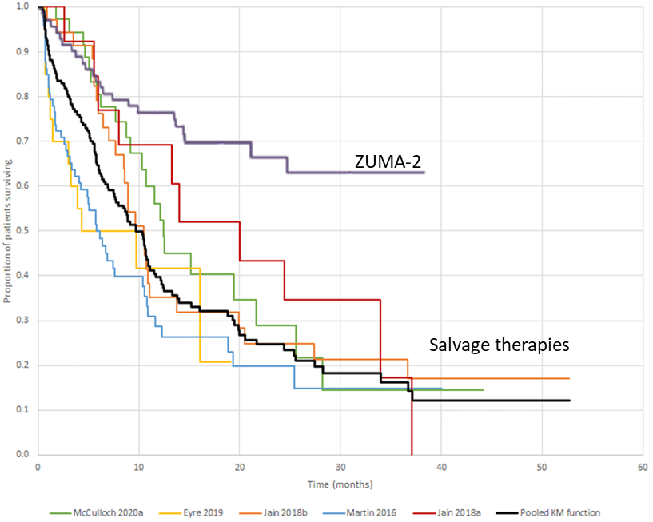

Comparison of OS by response – brexucabtagene autoleucel vs salvage therapy
The application stated that the comparison of response rates presented earlier is incomplete without a parallel consideration of the depth and duration of response. To provide insight into the depth and duration of response with brexucabtagene autoleucel compared with salvage therapy the application presented a comparison of OS by response.
Figure 7 shows OS by response as observed for patients treated with brexucabtagene autoleucel in the ZUMA-2 study. The application stated that the pattern of survival is dramatically different in patients achieving an objective response to brexucabtagene autoleucel versus non-response, particularly for those that achieve a CR.
The application stated that a key assumption underpinning the Kaplan-Meier approach is that patients who are censored from analysis have the same survival prospects as those who have been followed to the equivalent time point. In the case of ZUMA-2, there is potential violation of this assumption because the majority of patients censored from analysis are patients achieving CR and, as shown in Figure 7, OS in patients achieving CR is systematically different than in those not achieving CR. The Kaplan-Meier estimates for all patients treated (as shown above in Figure 6) are thus primarily driven by patients who did not achieve a CR. Extrapolation of the OS plot based on the full population of patients treated with brexucabtagene autoleucel (as done for the economic model) is therefore likely to be biased against brexucabtagene autoleucel.
The Commentary noted the application statement that, “OS in patients achieving CR is systematically different than in those not achieving CR.” However, considered that this is inherent in this particular comparison as patients who respond to an effective treatment are expected to live longer than patients who did not respond. Thus, there is an accepted systematic difference between responders and non-responders.
In Figure 7, the Commentary noted that patients who are still alive are censored at the time of their last clinical follow-up. This introduces a bias that is due to the relatively short follow-up of 8 to 18 months after study entry in a large group of responders. Only a longer follow-up for these censored patients will resolve this bias. The salvage studies did not show the same pattern of censoring.

Figure 7: Kaplan-Meier plot of OS by response as reported for brexucabtagene autoleucel in ZUMA-2
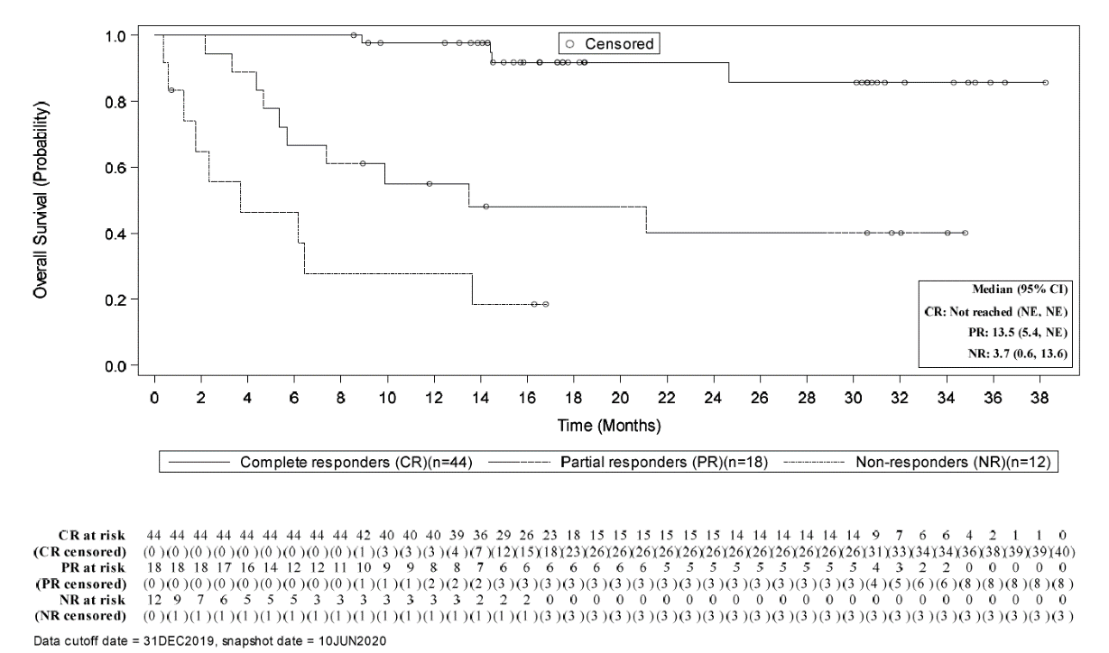
Figure 8 compares OS by response (responder vs non-responder) as observed for patients treated with brexucabtagene autoleucel in ZUMA-2 to those treated with salvage therapy in the study reported by Cheah 2015. The application stated the comparison indicates that the nature of response is different for patients treated with brexucabtagene autoleucel compared with those treated with salvage therapy. Response to brexucabtagene autoleucel appears to be deeper and more durable than response to salvage therapy, with consequent observation of improved survival. In Figure 8, survival in patients achieving response with brexucabtagene autoleucel is shown by the solid green line which is noticeably different to that currently experienced by patients achieving response to salvage therapy shown by the dashed green line.
The Commentary noted that duration of response (DOR) was not discussed in the ADAR. A naïve comparison of median DOR during evaluation found that in patients who respond to treatment, brexucabtagene autoleucel may induce a more enduring response than salvage therapies. However, the limited size of the evidence base, as well as the short follow-up of the data from ZUMA-2, indicate that the results are not sufficiently robust to draw any definitive conclusions about the size of the effect.
The Commentary considered that the naïve comparison of OS by response does suggest improved survival in responders compared to non-responders. However, as this comparison relies on data from two small single arm studies, no definitive conclusion about the size of the effect can be made.

Figure 8: Comparison of OS by response (response vs no response) for patients treated with brexucabtagene autoleucel in ZUMA-2 versus those treated with salvage therapy as reported by Cheah 2015
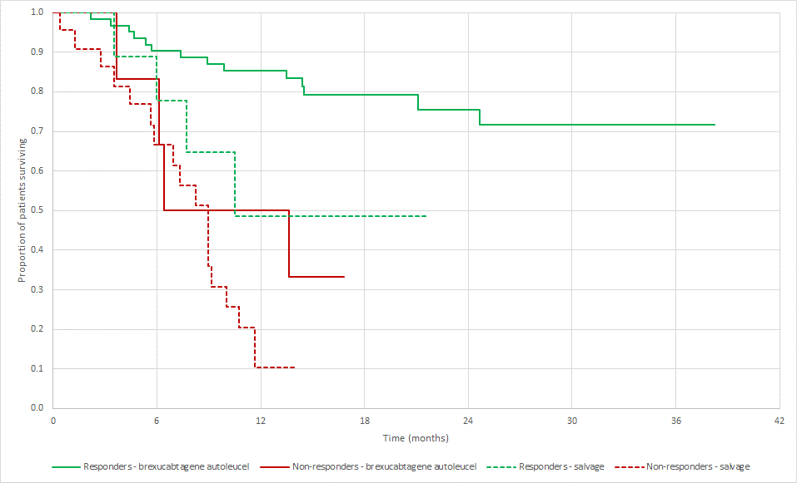
Clinical claim
The application claimed that use of brexucabtagene autoleucel results in markedly improved response rates, PFS and OS compared with the outcomes achieved with salvage therapy. The magnitude of therapeutic benefit associated with brexucabtagene autoleucel is unprecedented for this heavily pre-treated population and is expected to be extremely meaningful to patients.
The drawing of any definitive conclusions in regard to the comparative safety of brexucabtagene autoleucel and salvage therapy is precluded by the fact that there are differences and trade-offs across the types and rates of AEs associated with each therapy.
Adverse events associated with brexucabtagene autoleucel and other anti-CD19 CAR T-cell therapies are becoming better characterised over time and clinician experience in managing the AEs observed with these therapies continues to build. As such, the benefit to risk trade-off for brexucabtagene autoleucel is considered to be substantially superior than the benefit to risk trade-off for salvage therapy.
The application acknowledged that, according to the Grading of Recommendations Assessment, Development, and Evaluation (GRADE) approach, the results of the comparison of brexucabtagene autoleucel to salvage therapy would be rated down due to limitations of a comparison based on results from single arms. However, it is also important to recognise that the GRADE approach would also rate the evidence up because the magnitude of treatment effect is large and because the outcome of survival is not a subjective outcome.
The Commentary considered that this statement is incorrect, as the GRADE approach would only allow rating the evidence up if there is a large effect size (RR >2 or <0.5) and no plausible confounding. Patients included in the salvage therapy have worse prognosis on average than those in the ZUMA-2 trial, which could be confounding the results.
Overall, the application stated that the evidence supporting a claim of therapeutic superiority of brexucabtagene autoleucel over salvage therapy is compelling.
The Commentary considered that it has not been conclusively shown that there is a statistically significant improvement in CR and OR rates for brexucabtagene autoleucel compared with all salvage therapies, especially those with a rituximab-based regimen. However, the response appeared to be of longer duration in those treated with brexucabtagene autoleucel compared with those receiving salvage therapies.
The magnitude of the benefit for DOR, PFS and OS cannot be determined due to the naïve comparison and the limited evidence base for brexucabtagene autoleucel, therefore, the level to which it is ‘meaningful’ to patients cannot be predicted.
Overall, the Commentary stated that chemotherapies are likely to have a better safety profile than CAR-T therapies, due to the specific AEs associated with brexucabtagene autoleucel and other anti-CD19 CAR T-cell therapies, such as CRS and neurologic events. If the management of treatment-emergent AEs were handled according to monitoring guidelines at qualified treatment centres, the benefit to risk ratio would likely be acceptable.
As the evidence base is very limited, the longer PFS and OS in patients treated with brexucabtagene autoleucel compared with salvage therapy is suggestive of therapeutic superiority rather than compelling.

Economic evaluation
A partitioned survival analysis model was used to conduct the economic analysis. Both a cost-effectiveness analysis (based on life-years gained) and a cost-utility analysis, conducted over a lifetime, were presented. The analyses were conducted from a health care system perspective, where only health benefits accruing to the patient and where costs to the health care system. are considered.
The structure of the model is shown in Figure 9.

Figure 9: Structure of the model used to conduct the economic evaluation of brexucabtagene autoleucel for R/R MCL

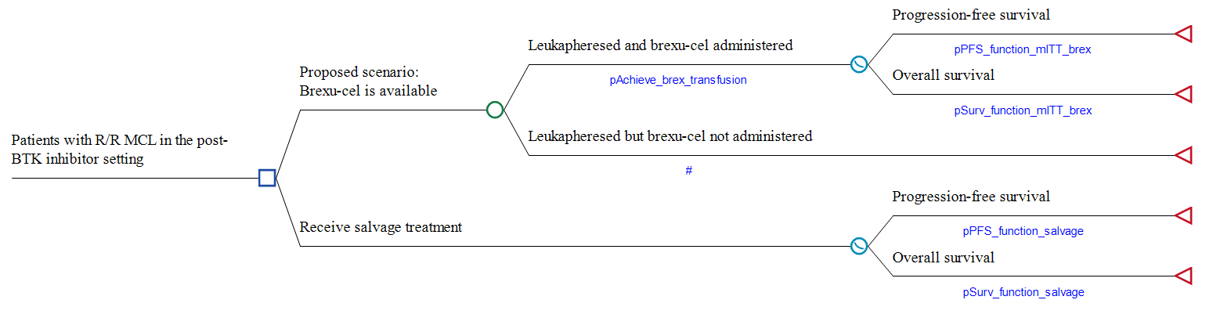
Costs and outcomes were examined over a 30-year lifetime time horizon. Discounting of future costs and benefits was applied at a rate of 5% per annum (p.a.), as required according to the MSAC Guidelines.
Outcomes in the model are primarily driven by PFS and OS Kaplan-Meier data. As patients, particularly those in the ZUMA-2 study were not followed up through to a time where they had all died (due to the extended survival outcomes associated with brexucabtagene autoleucel and the limited follow-up to date of ZUMA-2), extrapolation of the Kaplan-Meier functions was required to model benefits of brexucabtagene autoleucel over a patient lifetime.
Utilities applied to time in the progression-free and post-progression states were 0.78 and 0.68, respectively. The utilities were derived from data captured by the administration of the EQ-5D-5L instrument that was administered in the ZUMA-2 trial. Utilities were calculated applying the Australian value set. The National Institute for Health and Care Excellence (NICE) technology appraisal report for ibrutinib in R/R MCL reported pre-progression and post-progression utility weights of 0.78 and 0.68, respectively, based on data from the RAY trial data. These weights are the same as those estimated by application of the Australian value set to EQ-5D data from ZUMA-2.
The cost of a brexucabtagene autoleucel, a single infusion product, is $redacted. The analysis also included costs associated with use of other health care resources affected by availability of brexucabtagene autoleucel, including costs of leukapheresis, bridging therapy, lymphodepleting therapy, hospitalisation for administration and monitoring, extension of hospitalisation (including in an intensive care unit) and tocilizumab and intravenous immunoglobulin replacement therapy used in the management of AEs.
The results of the cost-effectiveness and cost-utility analysis over a 30-year time horizon are summarised in Table 5. The key driver of incremental costs are the costs of brexucabtagene autoleucel.
Table 5: Results of the base case modelled economic evaluation
 | Brexucabtagene autoleucel arm | Salvage therapy arm | Increment
Brexucabtagene autoleucel | $redacted | $redacted | $redacted
Cost of leukapheresis | $redacted | $redacted | $redacted
Cost of bridging therapy | $redacted | $redacted | $redacted
Cost of lymphodepleting therapy | $redacted | $redacted | $redacted
Costs for hospitalisation for administration of brexucabtagene autoleucel, monitoring and management of AEs | $redacted | $redacted | $redacted
Salvage therapy (including costs of administration) | $redacted | $redacted | $redacted
Costs associated with stem cell transplant | $redacted | $redacted | $redacted
Costs to monitor and manage patients in the community | $redacted | $redacted | $redacted
Palliation costs | $redacted | $redacted | $redacted
AE costs | $redacted | $redacted | $redacted
Costs over a 30-year time horizon (discounted) | $redacted | $redacted | $redacted
Life-years over a 30-year time horizon (discounted) | 6.866 | 1.540 | 5.327
QALYs over a 30-year time horizon (discounted) | 5.090 | 1.191 | 3.899
Incremental cost per life-year gained over a lifetime time horizon |  |  | $redacted
Incremental cost per QALY gained over a lifetime time horizon |  |  | $redacted
Figure 10 presents a trace of modelled outcomes in the brexucabtagene autoleucel and salvage therapy arms. Mean survival (undiscounted) in patients treated with brexucabtagene autoleucel is 10.78 years compared with 1.77 years in patients managed with salvage therapy.

Figure 10: Comparison of survival in patients treated with brexucabtagene autoleucel and salvage therapy as generated by the modelled economic evaluation
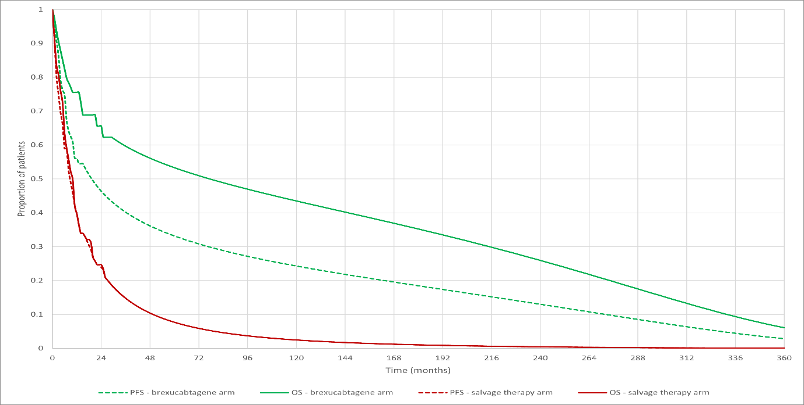

Financial/budgetary impacts
The application estimated that in Year 1, redacted patients will be treated by brexucabtagene autoleucel, increasing to redacted in Year 6. This corresponds to a net budget impact of $redacted in Year 1 increasing to $redacted in Year 6 and a total net impact of $redacted over the forward estimates period.

Key Issues from ESC for MSAC
ESC key issue | ESC advice to MSAC
Limited evidence base | There is a high level of uncertainty around the magnitude and the duration of the survival benefits compared to the comparator (salvage therapies). The ZUMA-2 data (and any extrapolations based on these data) are highly uncertain given that:  - it is a single-arm study  - the follow-up is short  - there are some applicability issues.
Economic evaluation and budget impact are uncertain | The clinical effectiveness evidence used in the economic evaluation (which informs the model inputs) is weak and subject to bias. There are uncertain extrapolations of survival data (time horizon = 30 years). The ZUMA-2 observed data may not be mature enough to robustly inform appropriate long-term projections. There appears to be a high risk of long-term relapse and death due to severe adverse events. The budget impact is likely to be underestimated.
Eligibility criteria | MSAC may wish to:  - consider the TGA indication (if the product is included on the ARTG by the MSAC meeting date) to help inform eligibility criteria  - consider re-instating the exclusion criterion “prior allogenic SCT” as per ZUMA-2  - consider reinstating the exclusion criterion “patient must not have primary CNS lymphoma”, as per the Yescarta® eligibility criteria  - consider reinstating “patient must not have uncontrolled secondary CNS disease, or secondary CNS disease anticipated to be uncontrolled at the time of lymphocyte infusion”, as per the Yescarta® eligibility  - note the ZUMA-2 exclusion “subjects with detectable cerebrospinal fluid malignant cells or brain metastases or with a history of cerebrospinal fluid malignant cells or brain metastases”
Base case might not be clinically plausible | The choice of survival function for the base case (with impact on the ICER) may result in survival curves that are not clinically plausible. ESC recommended using a more flexible extrapolation approach (e.g. piecewise spline models). Grey et al. (Medical Decision Making 2021 41(2):179–193) found that, across 15 cancer datasets, the spline model generated more accurate predictions of survival outcomes than standard parametric models.
Lack of real-world Australian data | If brexucabtagene autoleucel is funded, ESC recommends requiring a review of effectiveness/safety/cost within 1–2 years, like the Yescarta® agreement. ESC noted that a pay-for-performance arrangement would be appropriate if brexucabtagene autoleucel were to be funded.
State and territory feedback | The responses from several states suggested that ancillary costs are higher than estimated in the submission (~20% increase in the base case ICER). The applicant is open to discussing ancillary costs with governments.
ESC Discussion
ESC noted that this application was for public funding of brexucabtagene autoleucel (Tecartus®) for treatment of patients with relapsed or refractory mantle cell lymphoma (R/R MCL). R/R refers to patients who have failed immunochemotherapy (first-line) and Bruton's tyrosine kinase (BTK) inhibitor therapy (second-line). ESC noted that the Therapeutic Goods Administration (TGA) Delegate finalised the TGA Delegate’s Overview for brexucabtagene autoleucel on 7 June 2021.
ESC noted the responses from state governments, redacted.
ESC noted that brexucabtagene autoleucel is a one-time single intravenous infusion CAR-T cell therapy and is a similar product to axicabtagene ciloleucel (Yescarta®). ESC noted that this application by-passed PASC.
ESC queried the very high fee for brexucabtagene autoleucel, which was approximately redacted and has not been justified.
ESC noted that MCL treatment is not considered curative, as most patients relapse. First-line treatment includes anthracycline- or bendamustine-based immunochemotherapy, second-line therapy includes BTK inhibitor ibrutinib therapy and third-line treatment is “post-BTK inhibitor” salvage therapy, which includes:
various chemoimmunotherapy regimens (platinum/lenalidomide/bortezomib; some are not listed on the Pharmaceutical Benefits Scheme [PBS])
allogeneic stem cell transplant (SCT), if fit
clinical trial.
ESC noted that the PBS data suggest that 66% of patients who discontinue ibrutinib receive salvage therapy. The median overall survival (OS) is poor (10 months).
ESC noted the proposed eligibility criteria in the pre-ESC response, in which the applicant included cytarabine based chemotherapy (as an alternative to anthracycline- or bendamustine-based chemoimmunotherapy as a preceding line of therapy); modified the exclusion criterion concerning pre-existing CNS disease; and removed the exclusion concerning history of allogeneic SCT.
ESC noted that the key trial (ZUMA-2) showing clinical effectiveness for brexucabtagene autoleucel excluded (amongst others) patients with MRI evidence of CNS lymphoma, and patients with detectable cerebrospinal fluid (CSF) malignant cells or brain metastases or with a history of CSF malignant cells or brain metastases, and patients with a history of allogeneic SCT.
ESC reviewed the eligibility criteria and funding agreement for Yescarta® due to the treatments’ similarities. ESC considered that, if brexucabtagene autoleucel is funded, the eligibility criteria and funding agreements should align with that of Yescarta®, those used in the ZUMA-2 trial and the TGA decision concerning inclusion on the ARTG.
ESC noted the differing toxicity profiles for brexucabtagene autoleucel and salvage therapy, and considered it difficult to draw definitive conclusions between the two treatments. ESC noted that some serious adverse events of brexucabtagene autoleucel included cytokine release syndrome, neurotoxicity, infection, B-cell aplasia and cytopenias. ESC noted that two patients died (from pneumonia/ bacteraemia). The applicant claimed that the benefit-to-risk trade-off for brexucabtagene autoleucel is substantially superior than the benefit-to-risk trade-off for salvage therapy. However, ESC did not consider there to be enough evidence to make such a claim, and noted that the safety profile for brexucabtagene autoleucel was likely to be similar to other CAR-T therapies.
ESC noted that there were no randomised clinical trials (RCTs) comparing brexucabtagene autoleucel and salvage therapy, and that ZUMA-2 was a prospective single-arm trial. ESC agreed with the Commentary that it was difficult to identify a similar patient cohort between the ZUMA-2 and comparator studies, and that there was a high level of heterogeneity within the comparator data (study design, population, types of salvage therapy used). ESC was concerned that the comparisons are subject to confounding and significant selection bias. For example, ESC noted that 81% of patients received ≥ 3 prior therapies in the ZUMA-2 study, compared with proposed third-line treatment regimens commonly used in clinical practice. In its pre-ESC response, the applicant acknowledged that there are limitations of the naïve comparisons, and that an RCT would never be feasible due to low incidence of R/R MCL and because the disease is rapidly fatal.
ESC noted the applicant’s claim that brexucabtagene autoleucel results in markedly improved response rates, progression-free survival (PFS) and OS compared to salvage therapy, and is unprecedented. ESC noted disagreement from the Commentary, which stated that the magnitude of benefit for duration of response, PFS and OS cannot be determined due to naïve comparisons. ESC noted that the comparative analysis and inputs included in the model representing the size of clinical effects (from the observed data) are subject to bias, resulting in uncertain impact on incremental clinical effectiveness.
ESC agreed with the Commentary’s concerns that more information is needed about the most common salvage therapies administered in Australia, which was addressed by the applicant in the pre-ESC response. The applicant-developed assessment report (ADAR) used R-CHOP/R-DHAP, which ESC queried. The applicant reiterated their position to use R-CHOP/R-DHAP, as these are PBS-listed and the Pharmaceutical Benefits Advisory Committee (PBAC) considered R-CHOP to be an appropriate comparator for the ibrutinib application that was recommended at the March 2018 meeting of PBAC. ESC also noted that some of the salvage therapies included therapies that are not available on the PBS.
ESC noted that the Commentary stated that the salvage-therapy patients had a worse prognosis than those used in the ZUMA-2 study, based on ECOG status, Mantle Cell Lymphoma International Prognostic Index (MIPI) score, Ki-67 index and blastoid histology. The applicant disagreed, stating that these factors are not validated in the R/R setting and prognosis is considered poor regardless of MIPI score and Ki-67 index.
ESC noted that for OS studies, the median OS for brexucabtagene autoleucel was not reached. ESC was concerned about the short follow up for brexucabtagene autoleucel (16.5 months). ESC noted that 24-month data were provided in the pre-ESC response, but noted that the median OS is still not reached with these new data.
ESC considered the choice of model (three-state partitioned survival model: pre-progression, post-progression and death) used for the economic evaluation to be appropriate. ESC noted several uncertainties with the data extrapolation:
Temporal uncertainty: If observed OS and PFS data are short, uncertain and subject to bias, then uncertainty is further magnified by temporal extrapolation (time horizon of 30 years).
Structural uncertainty: Assumptions about the duration of benefits beyond observed data (continuous effect) add more uncertainty.
Structural uncertainty due to the choice of survival functions: The submission extrapolated the observed OS and PFS data fitting six standard parametric models. Using AIC and BIC to assess the goodness of fit, in both PFS and OS, gamma was used for both interventions in the base case.
ESC queried whether the extrapolated OS survival curves were clinically plausible: the brexucabtagene autoleucel mean survival post-progression appeared to be 56 months over the modelled time horizon of 30 years compared with 0.42 months for salvage therapy. ESC noted that, in its pre-ESC response, the applicant maintains that 56 months is plausible. ESC noted that choosing a different function (e.g. log-normal; second-best fit) for the OS curve can reduce the mean post-progression survival in patients receiving brexucabtagene autoleucel to 13.9 months. This reduced the incremental life-years gained (LYG) and quality-adjusted life years (QALYs) in the base case resulting in a redacted% increase in the incremental cost-effectiveness ratio (ICER) – from $redacted/QALY to $redacted/QALY. ESC considered this to highlight how important it is to have evidence to support the post-progression data and how the external validity of the model needs to be tested using other datasets or expert opinion. ESC recommended using a more flexible extrapolation approach (e.g. piecewise spline models) (Grey et al. Medical Decision Making 2021 41(2):179–193).
ESC noted that the costs used for the model inputs were corrected by the Commentary, such as the cost of the salvage therapy and hospital costs for salvage therapy (comparator). ESC noted there was little Australian data about the most appropriate salvage therapies used in Australia, and the salvage therapy used in the ADAR does not match that recommended by Evi-Q. Thus, the applicability of the costing approach used for the comparator to the Australian clinical setting (and impact on the ICER) is unclear.
ESC noted the revised sensitivity analysis (base case $redacted/QALY) after altering the time horizon, the utility weights, and proportion of patients receiving SCT after brexucabtagene autoleucel and after salvage therapy. Altering these variables resulted in ICERs of between $redacted/QALY (using lowered discounting rates) and $redacted/QALY (using a 10-year time horizon).
ESC noted that a market-share approach using multiple data sources was used in the budget impact analysis. ESC noted that, adjusting for cost savings associated with the reduced use of salvage therapy (and including the Commentary’s corrections), the estimated net budget impact could be approximately $redacted in year 1 to $redacted in year 6. ESC considered that these costs could be underestimated, which the applicant agreed with.
ESC considered that, if brexucabtagene autoleucel were to be funded, a review after 1–2 years and a redacted would be appropriate, similar to Yescarta®.

Other significant factors
Nil

Applicant comments on MSAC’s Public Summary Document
Gilead Sciences welcomes the MSAC decision to support public funding of brexucabtagene autoleucel for certain patients with relapsed or refractory mantle cell lymphoma, a rare condition in a small population with high clinical need. Gilead Sciences is looking forward to collaborating with the Commonwealth and State and Territory governments to provide access to this CAR -T- cell therapy to all eligible patients throughout Australia in the timeliest manner.

Further information on MSAC
MSAC Terms of Reference and other information are available on the MSAC Website:
visit the MSAC website

Guyatt, GH, et al. 2011, 'GRADE guidelines: 9. Rating up the quality of evidence', J Clin Epidemiol, vol. 64, no. 12, Dec, pp. 1311-1316.

