Public Summary Document

Application No. 1357 – F-18 Fluorodeoxyglucose (FDG) positron emission tomography (PET) for the evaluation of breast cancer

Applicant: Australian Association of Nuclear Medicine

Date of MSAC consideration: MSAC 62nd Meeting, 26- 28 November 2014

Context for decision: MSAC makes its advice in accordance with its Terms of Reference, see at www.msac.gov.au

Purpose of application and links to other applications

An application requesting Medicare Benefits Schedule (MBS) listing of F-18 fluorodeoxyglucose (¹⁸F-FDG) positron emission tomography (PET) for the evaluation and staging of spread of disease in proven locally advanced breast cancer (LABC), suspected locally and regionally recurrent, or suspected metastatic breast cancer was received from the Australasian Association of Nuclear Medicine Specialists by the Department of Health in May 2013.

The purpose of the application is to assess the role of ¹⁸F-FDG PET in:
(i) staging potentially operable locally advanced breast cancer; and
(ii) in replacing the current practice of confirmatory standard diagnostic imaging study (e.g. follow-up diagnostic X-ray computed tomography [CT]) with confirmatory ¹⁸F-FDG PET imaging to more accurately stage proven locally advanced, suspected locally or regionally recurrent, and suspected metastatic breast cancers.

MSAC’s advice to the Minister

After considering the available evidence in relation to safety, clinical effectiveness and cost-effectiveness, MSAC did not support public funding of PET for the evaluation of breast cancer because of uncertain clinical effectiveness, cost-effectiveness and financial impact due to weak comparative data and no translation of imaging performance to improved health outcomes.

MSAC considered that any reapplication should include:
- amendments to the descriptor, better definitions of what constitutes standard prior imaging and equivocal prior diagnostic work-up; and to specify specialist referral;
- an amended decision tree to consider earlier use of PET/CT (noting that PET/CT, not stand-alone PET, is the current standard);
- any evidence for a consequential change in clinical management and patient outcomes;
- a cost consequence analysis; and
- a longer time horizon in the economic evaluation.

Summary of consideration and rationale for MSAC’s advice

MSAC noted that the proposed service is for the use of PET/CT to evaluate patients with known LABC, who are suspected to have local or regional disease recurrence, or are suspected to have metastatic breast cancer, where other (“conventional”) imaging does not provide sufficient information to determine appropriate treatment. For patients with proven LABC and suspected locally or regionally recurrent or metastatic breast cancer the use of PET/CT may detect additional sites of disease that could either be suitable for more aggressive active treatment, or that would preclude curative treatment.

MSAC noted that the nominated comparator for PET/CT was "confirmatory standard diagnostic imaging", which would include any combination of the imaging techniques currently available for staging and restaging breast cancer (for example, radiography, ultrasound, bone scintigraphy, CT, and magnetic resonance imaging [MRI]) depending on individual clinical factors. MSAC noted that the options of proceeding directly to image-guided or surgical biopsy if standard imaging was equivocal, or to use FDG PET/CT to replace standard imaging for suspected locoregionally recurrent or metastatic disease, had not been considered in the evaluation.

MSAC noted that there was no direct evidence comparing the health outcomes of patients with breast cancer assessed with and without PET. It was also noted that the current data could not be translated to clinical outcomes. The linked evidence studies presented in support of clinical effectiveness had a high or unclear risk of bias with limited applicability to the proposed population. Overall, these studies demonstrated that PET was at least as accurate as standard imaging in terms of diagnostic yield with some evidence of incremental accuracy.
It is unclear whether increased diagnostic accuracy translates to improved clinical outcomes. In the studies included, a small proportion of patients had a change in management based on the results of PET imaging. In patients with LABC, treatment intent changed from curative to palliative in 5 - 8% of patients in three studies and from palliative to curative in 3% of patients in one study. In patients with suspected recurrent or metastatic disease, up to 25% of patients had a change in management (initiation or change in medical therapy). Whether this change in management translated to improvements in clinical outcome was not addressed in any of the included studies. MSAC noted that an intent to change patient management could not be assumed to translate into an actual change in management, or a change in clinical outcomes.

MSAC considered the cost effectiveness analysis comparing PET with standard diagnostic imaging. For the population of patients with proven LABC, PET/CT is associated with increased total costs and fewer diagnostic errors. The incremental cost effectiveness ratio (ICER) for proven LABC was presented per diagnostic errors prevented and was calculated at $2,058. However MSAC noted that the model was sensitive to the sensitivities of confirmatory standard imaging and to both the sensitivity and specificity of PET.
Compared with the proven LABC population, total costs for the population of patients with suspected recurrent or metastatic disease are significantly lower, as the default position (no cancer detected) is for regular follow-up only. However, the incremental cost is significantly greater and is not offset by the improvement in diagnostic errors avoided. Therefore, the ICER in this population was $3,993 per diagnostic error avoided. MSAC considered there was considerable uncertainty in the economic modelling presented. MSAC noted that the data for the models were taken from studies that were generally small, retrospective, with poorly reported patient selection criteria, resulting in a high risk of bias and overestimated the sensitivity and specificity of PET. MSAC noted that the sensitivity and specificity were high in studies, but that there was a range of sensitivities.

MSAC questioned the validity of the time horizon of 12 months used in the model given the long disease course of breast cancer. MSAC also noted that the measure used (diagnostic errors avoided) could not be translated to patient-relevant outcomes,

The financial and budgetary implications of publicly funding PET/CT for this indication were based on the following key assumptions:
- That PET/CT would replace confirmatory standard imaging in all patients
- Patients who have a positive PET/CT would receive a follow-up biopsy
- False-positive tests would be detected via biopsy (assumed to be 100% accurate)
- False-negative tests would be identified at 6 months’ follow-up (assumed 100% accuracy)

Based on these assumptions, the estimated total cost to the government for the proposed listings is $648,075 in 2015 rising to $701,666 in 2019. MSAC noted that the overall cost was relatively low. However, MSAC also noted there was considerable uncertainty in these estimates particularly in the estimated number of eligible patients in each population. The proportion of patients who would have equivocal prior imaging is based on an unsupported assumption.

MSAC noted that the applicant had introduced two new papers for consideration in the pre-MSAC response. MSAC advised that introducing evidence at this late stage was not generally considered appropriate, but the results of these papers were nevertheless considered and did not change the position of the Committee.

MSAC noted that the term ‘equivocal imaging’ in the proposed descriptor is highly interpretable and considered there was a high risk of leakage as the term could be treated as inclusive rather than exclusive. In addition, MSAC noted that standard diagnostic imaging had not been defined in the descriptor and it was unclear whether one, some or all imaging modalities would be required to satisfy the requirement. MSAC considered this could also lead to leakage and increased usage outside the intended indication.

MSAC also suggested that PET/CT may be a more appropriate follow-up for patients with equivocal imaging results as most PET scanners in Australia are PET/CT. MSAC noted that PET/CT scans are likely to be more effective that PET alone and may remove the need for CT in the prior imaging algorithm.

Background

PET has been reviewed previously by MSAC on multiple occasions. MSAC has supported ongoing funding through the MBS for a wide range of PET services through various Medicare items that can be provided by all eligible PET facilities in Australia.

Prerequisites to implementation of any funding advice

It is envisioned that the MBS descriptor for the proposed services will be consistent with the regulations on the MBS for delivering PET services for other diseases (i.e. ‘Note DIN Group I4 - Nuclear Medicine Imaging’ for MBS items 61523 to 61646).

Proposal for public funding

The proposed MBS item descriptors as determined by the Protocol Advisory Sub-Committee (PASC) for the proposed medical service are presented below.

The applicant did not originally specify a proposed MBS fee for PET and stated that the level of funding for PET remains contentious. Consequently, no fee for the requested listing was specified in the final protocol. The current assessment has used the Schedule fee for the comparable MBS item 61541 (whole-body PET for suspected residual, metastatic or recurrent colorectal cancer) as a proxy for the fee for the requested listing.

Proposed MBS item descriptor for ¹⁸F-FDG PET for proven locally advanced breast cancer
Category 5—DIAGNOSTIC IMAGING SERVICES
MBS [item number]
Whole-body ¹⁸F-FDG PET study, performed for the staging of spread of disease in patients with proven locally advanced breast cancer who are considered potentially suitable for active therapy, where previous standard diagnostic imaging is equivocal or suspicious for spread of disease.
Fee: $?

Proposed MBS item descriptor for ¹⁸F-FDG PET for suspected locally or regionally recurrent or suspected metastatic breast cancer
Category 5—DIAGNOSTIC IMAGING SERVICES
MBS [item number]
Whole-body ¹⁸F-FDG PET study, performed for the confirmation and evaluation of suspected metastatic or suspected locally or regionally recurrent breast carcinoma in patients considered suitable for active therapy, where previous standard diagnostic imaging is equivocal or suspicious for spread of disease.
Fee: $?

Summary of Public Consultation Feedback/Consumer Issues

It was noted that this imaging service, if funded, will inform more relevant treatment plans and peace of mind for, often vulnerable, patients. It was further noted that, if funded, this imaging service would lead to a community advantage in that it will potentially provide better information and decision making. This would in turn lead to reduced personal and financial cost. Consumers report that currently this service is provided at an unreasonable patient cost.

Proposed intervention’s place in clinical management

Breast cancer is the most common cancer in women. In determining the best treatment for each patient, it is important to know when there is locally advanced disease, recurrent breast cancer or metastatic spread. The clinical claim made in this Application is that current diagnostic methods are inferior to PET in the evaluation of locally advanced disease, recurrence of disease and identification of metastatic spread, and that PET consequently provides information to guide more appropriate management.

The proposed service is ¹⁸F-FDG PET scanning for the evaluation of breast cancer in patients with locally advanced disease where other imaging does not provide sufficient information to determine appropriate treatment and in patients with breast cancer in whom recurrent or metastatic disease is suspected and for whom active therapy is likely to be pursued.

PET is a minimally invasive nuclear medicine imaging technique that uses short-lived radiopharmaceuticals to detect and assess perfusion and metabolic activity in various organ systems. It provides information about function and metabolism that is complementary to the structural information provided by anatomical imaging techniques such as x-ray computed tomography (CT).

Clinical management algorithm for proven locally advanced breast cancer. Confirmatory standard diagnostic imaging vs confirmatory ¹⁸F-FDG PET.

Patients with proven locally advanced breast cancer undergo standard diagnostic imaging to assess if there is spread of disease. If this result is equivocal, under the current pathway, the patient will undergo confirmatory standard imaging. Under the proposed pathway, if the result is equivocal, the physician would have the option of choosing either confirmatory imaging with ¹⁸F-FDG PET or standard imaging.

Under the current pathway, if the result of confirmatory standard imaging is negative the patient will be offered local treatment resulting in a range of potential health outcomes based on the impact of treatment on cancer progress, morbidity and mortality related to treatment, overall survival and quality of life. If the result of confirmatory standard imaging is positive or equivocal, the patient will undergo a biopsy. If the biopsy result is negative the patient will be offered local treatment with the same range of potential health outcomes stated above. If the biopsy result is positive, the stage of the cancer will be upstaged. For treatable disease the patient will be offered altered local treatment with or without systemic therapy resulting in a range of potential health outcomes based on the impact of treatment on cancer progress, morbidity and mortality related to treatment, overall survival and quality of life. For incurable disseminated disease the patient will be offered palliation resulting in a range of potential health outcome results stated above.

Under the proposed pathway, if the physician chooses confirmatory imaging with ¹⁸F-FDG PET and the result is negative the patient will be offered local treatment resulting in a range of potential health outcomes based on the impact of treatment on cancer progress, morbidity and mortality related to treatment, overall survival and quality of life. If the result of confirmatory imaging with ¹⁸F-FDG PET is positive, the patient will undergo a biopsy and follow the same clinical management pathways as stated above.

Clinical management algorithm for suspected locally and regionally recurrent breast cancer. Confirmatory standard diagnostic imaging vs confirmatory ¹⁸F-FDG PET.

Patients with suspected locally and regionally recurrent breast cancer undergo standard diagnostic imaging to assess if there is recurrence of disease. If this result is equivocal, under the current pathway, the patient will undergo confirmatory standard imaging. Under the proposed pathway, if the result is equivocal, the physician would have the option of choosing either confirmatory imaging with ¹⁸F-FDG PET or standard imaging.

Under the current pathway, if the result of confirmatory standard imaging is negative the patient will be observed resulting in a range of potential health outcomes based on the impact of treatment on cancer progress, morbidity and mortality related to treatment, overall survival and quality of life. If the result of confirmatory standard imaging is positive or equivocal, the patient will undergo a biopsy. If the biopsy result is negative the patient will be observed with the same range of potential health outcomes stated above. If the biopsy result is positive the patient has recurrence. For treatable disease the patient will be offered further therapy resulting in a range of potential health outcomes based on the impact of treatment on cancer progress, morbidity and mortality related to treatment, overall survival and quality of life. For incurable disseminated disease the patient will be offered palliation resulting in the range of potential health outcome results stated above.

Under the proposed pathway, if the physician chooses confirmatory imaging with ¹⁸F-FDG PET and the result is negative the patient will be observed resulting in a range of potential health outcomes based on the impact of treatment on cancer progress, morbidity and mortality related to treatment, overall survival and quality of life. If the result of confirmatory imaging with ¹⁸F-FDG PET is positive or equivocal the patient will undergo a biopsy and follow the same clinical management pathways as stated above depending on the outcome of the biopsy.

Clinical management algorithm for suspected metastatic breast cancer. Confirmatory standard diagnostic imaging vs confirmatory ¹⁸F-FDG PET.

Patients with suspected metastatic breast cancer undergo standard diagnostic imaging to assess if there is spread of disease. If this result is equivocal, under the current pathway, the patient will undergo confirmatory standard imaging. Under the proposed pathway, if the result is equivocal, the physician would have the option of choosing either confirmatory imaging with ¹⁸F-FDG PET or standard imaging.

Under the current pathway, if the result of confirmatory standard imaging is negative the patient will be observed resulting in a range of potential health outcomes based on the impact of treatment on cancer progress, morbidity and mortality related to treatment, overall survival and quality of life. If the result of confirmatory standard imaging is positive or equivocal, the patient will undergo a biopsy. If the biopsy result is negative the patient will be observed with the same range of potential health outcomes stated above. If the biopsy result is positive the patient has metastases. For treatable disease the patient will be offered further therapy resulting in a range of potential health outcomes based on the impact of treatment on cancer progress, morbidity and mortality related to treatment, overall survival and quality of life. For incurable disseminated disease the patient will be offered palliation resulting in the range of potential health outcome results stated above.

Under the proposed pathway, if the physician chooses confirmatory imaging with ¹⁸F-FDG PET and the result is negative or equivocal the patient will be observed resulting in a range of potential health outcomes based on the impact of treatment on cancer progress, morbidity and mortality related to treatment, overall survival and quality of life. If the result of confirmatory imaging with ¹⁸F-FDG PET is positive the patient will undergo a biopsy and follow the same clinical management pathways as stated above depending on the biopsy result.

Comparator

The nominated comparator was ‘confirmatory standard diagnostic imaging’, which would include any combination of techniques, depending on individual clinical factors. All patients eligible for PET for these clinical indications would have had equivocal prior standard diagnostic imaging.
A variety of imaging techniques are available for staging and restaging breast cancer: plain radiography, ultrasound, bone scintigraphy, CT and magnetic resonance imaging (MRI). The imaging technique most commonly used for staging breast cancer is CT. MRI may be used to confirm spread to the brain and spine. Radiography (diagnostic mammography and/or CT) can be used to evaluate the primary lesion and search for spread to the lungs and other chest tissues. Ultrasound can be used to characterise breast lesions and abdominal spread. Bone scintigraphy is specific for bone metastases.

Comparative safety

PET has been reviewed previously by MSAC on multiple occasions and found to be a safe procedure. The studies included in this assessment did not raise any new safety concerns.

Comparative effectiveness

The main potential impact of PET in patients with proven LABC and suspected locally or regionally recurrent breast cancer, is in the detection of additional sites of disease that would either be suitable for more aggressive active treatment or that would preclude curative treatment.

The main potential impact of PET on patients with suspected metastatic disease is in the detection of distant metastases that would preclude curative treatment.

No direct evidence was found comparing the health outcomes of patients with breast cancer assessed with and without PET. In the absence of direct evidence for the effectiveness of PET, the Assessment Report presented evidence for accuracy, change in management and the expected benefit of changes in management on health outcomes to evaluate the effectiveness of PET using a linked evidence approach.

Locally advanced breast cancer

Risk of bias and applicability
Five studies provided data that were of limited applicability due to the inclusion of patients who did not have equivocal prior conventional imaging and/or the inclusion of patients with less advanced disease. Differences in the spectrum of disease are associated with differences in the prevalence of distant metastasis and can affect estimates of sensitivity and specificity.

The inclusion of CT as a conventional imaging modality is central to the clinical algorithm; however, it was not used in all of the included studies. For all studies, the risk of bias across multiple domains was unclear or high.

Comparative accuracy
Based on two studies, PET/CT is more accurate than combined conventional imaging for the detection of distant metastases. In one study of 134 patients, sensitivity for combined conventional imaging was 0.83 (95% CI: 0.69-0.93) versus 0.98 (0.87-1.00) for PET/CT, while specificity was 0.85 for combined conventional imaging versus 0.90 for PET/CT. This study was retrospective and these results are for the subgroup with LABC. In the second study, sensitivity for combined conventional imaging was 0.60 versus 1.00 (0.63-1.00) for PET/CT, and specificity was 0.83 for combined conventional imaging versus 0.98 (0.90-1.00) for PET/CT. This study included women with lower risk of distant metastases and did not provide raw data (to enable reconstruction of a 2-by-2 table and calculation of the 95% CIs) for the comparator.

Data on site-specific detection of metastasis were reported in two studies. Based on these studies, PET/CT is more accurate than bone scintigraphy for the detection of bone metastases (two studies) and has similar accuracy to CT for the detection of both liver (one study) and lung metastases (two studies). PET/CT may have higher sensitivity than CT for the detection of thoracic lymph node metastases with similar specificity (one study).

Incremental accuracy
Two studies reported that the addition of PET to conventional imaging lead to the detection of additional distant metastases. In one study PET/CT was positive in 11 (25%) patients, with 10 true-positive (positive predictive value [PPV] of 0.91, 95% CI: 0.62-0.98). That study was conducted in India and did not include CT in the conventional imaging tests. In the second study, PET/CT was positive in 21 (16%) patients, with 16 true-positive (PPV of 0.76, 0.53-0.99). This study included women with less advanced disease and did not include CT in the conventional imaging tests.

Does the addition of PET change patient management?
Based on three studies, the addition of PET led to a change in treatment intent from curative to palliative in 5–8% of patients based on sample sizes of 154, 142 and 48. In addition, the management for 4/142 (3%) changed from palliative to curative. The impact of these changes on patient outcomes is uncertain.

Suspected recurrent or metastatic breast cancer

Risk of bias and applicability
Five studies from the systematic review and 11 studies from an existing health technology assessment (HTA) provided data that were of limited applicability due to the inclusion of patients who did not have equivocal prior conventional imaging.

All studies identified in the systematic review were retrospective and the inclusion criteria were not well reported; therefore, selection bias may elevate the prevalence of distant metastasis and the sensitivity of the test.

The inclusion of CT as a conventional imaging modality is central to the clinical algorithm; however, it was not used in all of the included studies. Many studies used PET rather than PET/CT as the index test. For all studies, the risk of bias across multiple domains was unclear or high.

Comparative accuracy
Based on four studies, PET has higher sensitivity (range 0.81 to 0.97) than combined conventional imaging (range 0.33 to 0.82) for the detection of recurrence. PET may have higher sensitivity over combined conventional imaging, but the findings were mixed. Only one study used PET/CT as the index test but did not include CT in the combined conventional imaging. Based on five studies, PET/CT has a higher accuracy (sensitivity range 0.85 to 1.00, specificity range 0.73 to 1.00) than CT (sensitivity range 0.67 to 0.92, specificity range 0.47 to 1.00) for the detection of recurrence. CT was not undertaken as a separate investigation in some of these studies. Based on four studies, PET has a similar accuracy to bone scintigraphy for the detection of bone metastasis.

Incremental accuracy
Two studies reported on incremental accuracy, one for the detection of additional recurrence and one for the detection of additional lung lesions only. In the first study, PET/CT detected additional recurrence in 34 patients (74%); 33 were true-positive (PPV of 0.97, 95% CI: 0.85-0.99). In the second study, PET/CT detected additional lung lesions in 12 patients (41%); 11 were true-positive (PPV of 0.92, 0.65-0.99).

Does the addition of PET change patient management?
No new data on patient management were identified. Based on data from three studies with sample sizes of 20, 44 and 61, reported by Pennant et al. (2010), the addition of PET led to a change in management in 11–25% of patients; predominantly a start and/or change in medical therapy. The impact of these changes on patient outcomes is uncertain.

Economic evaluation

A cost-effectiveness analysis comparing PET imaging with confirmatory standard imaging was conducted. Two models were constructed: the first considered patients with proven LABC and the second considered patients with suspected recurrent or metastatic breast cancer. The models’ clinical outcome was diagnostic errors avoided. Patients were stratified by cancer site in order to capture the potential significant cost savings associated with avoiding futile, expensive surgery for patients correctly diagnosed with disseminated disease.

In the model for proven LABC, if spread is not detected patients receive surgery and radiotherapy as part of curative-intent treatment for the localised cancer. Accurately detecting disseminated disease leads to relatively less expensive systemic therapy.

In the model for suspected recurrent or metastatic breast cancer, if cancer is not detected patients do not receive direct treatment but relatively inexpensive regular follow-up. Accurately detecting cancer leads to more expensive treatments for local or regional recurrence or disseminated disease.

The key parameters in both models were:
- the sensitivities and specificities of PET and confirmatory standard imaging
- the probability of cancer being spread for LABC or present for suspected recurrent or metastatic disease
- the probability of cancer being disseminated
- the cost of diagnostic procedures: PET, confirmatory standard imaging, distant biopsy and local biopsy
- the first 12 months’ direct treatment costs associated with each possible cancer outcome

Results - proven locally advanced breast cancer

The results of the base-case analysis for total costs, diagnostic errors and incremental cost-effectiveness ratio for the proven LABC population are presented below. As expected, PET is associated with increased total costs and fewer diagnostic errors.

Base-case analysis results for proven locally advanced breast cancer
Description | PET | CSI | Incremental
Total costs | $27,785 | $27,616 | $169
Diagnostic errors | 0.07 | 0.16 | 0.08
ICER | NA | NA | $2,058/error avoided
Abbreviations: CSI = confirmatory standard imaging; ICER = incremental cost-effectiveness ratio; NA = not applicable; PET = positron emission tomography

Deterministic sensitivity analyses were performed that varied the prevalence of disease spread and the sensitivity and specificity of PET and its comparator (see tornado diagram below). All parameters were varied between the lower and upper bounds of their 95% confidence intervals. The model was most sensitive to the sensitivity of confirmatory standard imaging and the sensitivity and specificity of PET.
Tornado diagram for proven locally advanced breast cancer
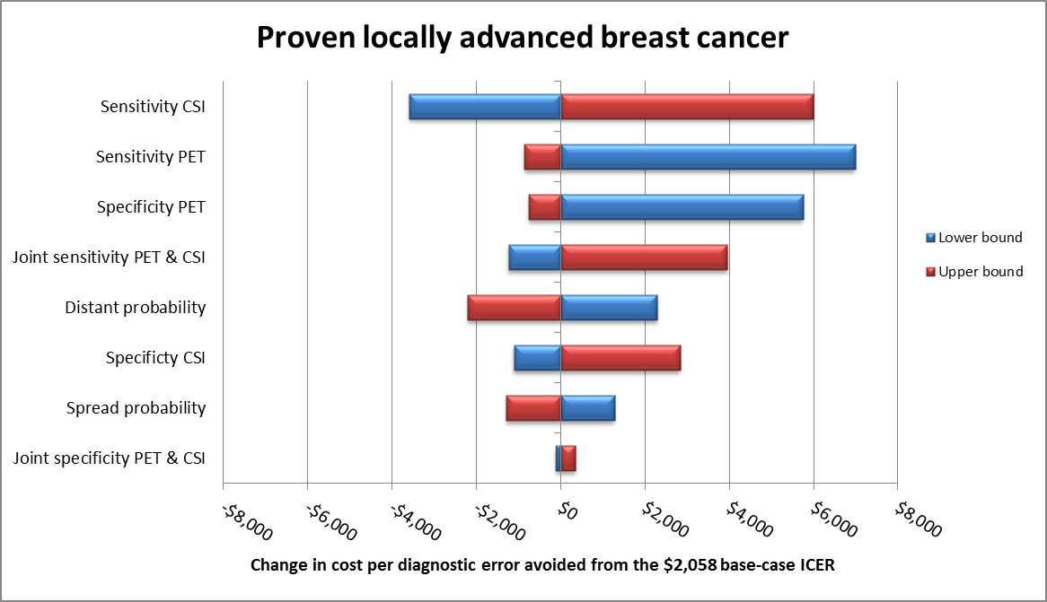
Abbreviations: CSI = confirmatory standard imaging; ICER = incremental cost-effectiveness ratio; PET = positron emission tomography
Probabilistic sensitivity analysis was performed by characterising the diagnostic sensitivities and specificities, and the probabilities of cancer and of disseminated disease using a beta distribution. The results of 5,000 probabilistic samples for the proven LABC population are presented below as data points on the cost-effectiveness plane.

Cost-effectiveness plane for proven locally advanced breast cancer
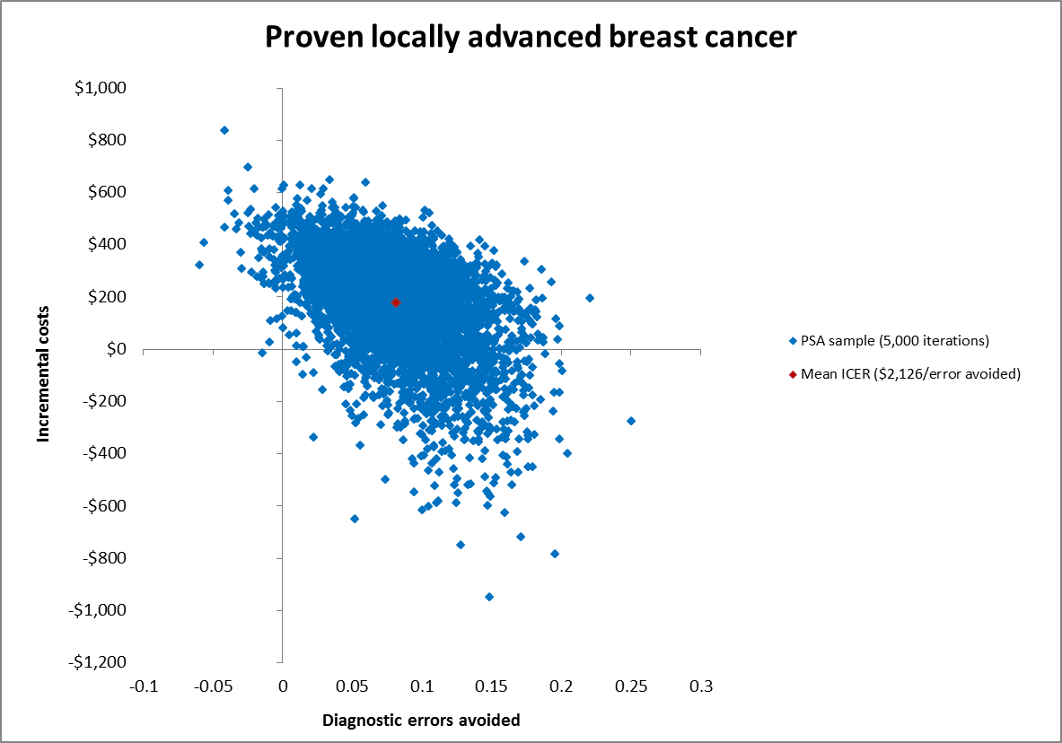
Abbreviations: ICER = incremental cost-effectiveness ratio; PSA = probabilistic sensitivity analysis
The spread of samples across the cost-effectiveness plane highlights how the uncertainty in the sampled parameters affects the model results. The spread of points across the plane is 81%, 17% and 2% in the north-east, south-east and north-west quadrants, respectively.

Results - suspected recurrent or metastatic breast cancer
The results of the base-case analysis for total costs, diagnostic errors and incremental cost-effectiveness ratio for the suspected recurrent or metastatic breast cancer population are presented below.

Base-case analysis results for suspected recurrent or metastatic breast cancer
Description | PET | CSI | Incremental
Total costs | $10,335 | $9,497 | $837
Diagnostic errors | 0.10 | 0.31 | 0.21
ICER | NA | NA | $3,993/error avoided
Abbreviations: CSI = confirmatory standard imaging; ICER = incremental cost-effectiveness ratio; NA = not applicable; PET = positron emission tomography

Compared with the proven LABC population, total costs are significantly reduced, as the default position - if no cancer is detected - is for regular follow-up only. However, the incremental cost is significantly greater and is not offset by the improvement in diagnostic errors avoided. Therefore, PET imaging has a higher ICER in this population of $3,993 per diagnostic error avoided.

A tornado diagram of the results of the deterministic sensitivity analysis for the suspected recurrent or metastatic breast cancer population is presented below. All parameters were varied between the lower and upper bounds of their 95% confidence intervals.

Tornado diagram for suspected recurrent or metastatic breast cancer
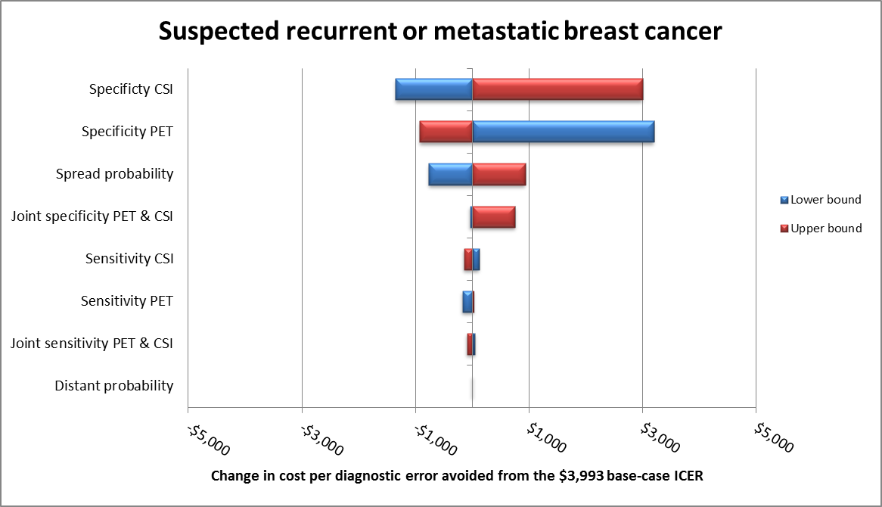
Abbreviations: CSI = confirmatory standard imaging; ICER = incremental cost-effectiveness ratio; PET = positron emission tomography
The model was most sensitive to the specificity of PET and confirmatory standard imaging, and the proportion of patients with cancer spread. A reduction in the specificity of PET leads to an inferior cost-effectiveness profile for PET due to the increase in diagnostic errors (and subsequent decrease in diagnostic errors avoided), as well as the increase in total costs from performing additional biopsies.

For the probabilistic sensitivity analysis, beta distributions were assigned to the same parameters as for the proven LABC population. The results of the probabilistic sensitivity analysis for the suspected recurrent or metastatic breast cancer population are presented below as data points on the cost-effectiveness plane.

Cost-effectiveness plane for suspected recurrent or metastatic breast cancer
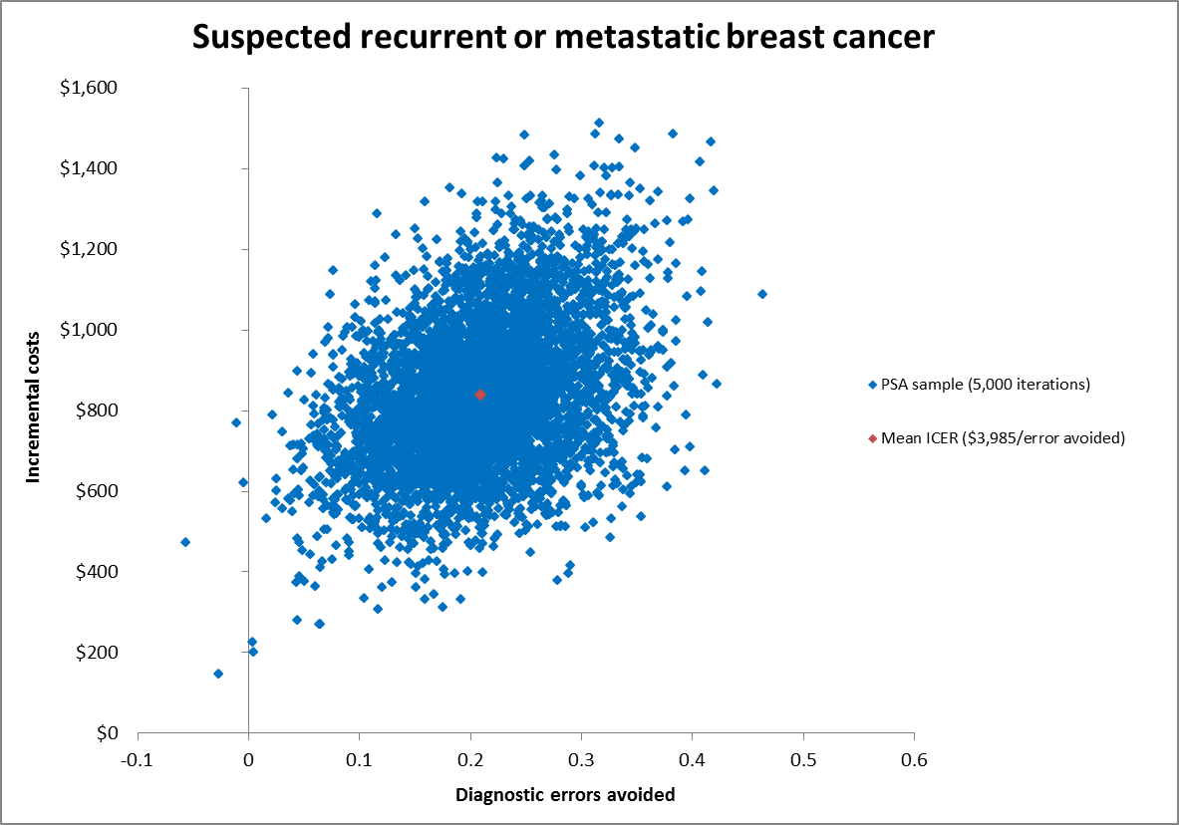
Abbreviations: ICER = incremental cost-effectiveness ratio; PSA = probabilistic sensitivity analysis
In this model, 99.9% of the samples lie in the north-east quadrant of the cost-effectiveness plane.

In the first and second populations, PET imaging was associated with ICERs of $2,058 and $3,993 per diagnostic error avoided, respectively. While PET imaging itself is an expensive diagnostic procedure, its ability to correctly detect disseminated disease and consequently avoid futile, expensive surgery or radiotherapy resulted in favourable deterministic cost-effectiveness results.

The deterministic sensitivity analyses revealed that the results of the first and second models are highly sensitive to the sensitivity and to the specificity of the imaging techniques, respectively. Unfortunately, there is considerable uncertainty around the inputs for diagnostic accuracy, as the data used were not fully representative of the requested MBS population. The probabilistic sensitivity analyses confirmed the uncertain nature of the results, with a wide spread of data points on the cost-effectiveness planes. This economic evaluation highlights how PET imaging may indeed be cost-effective in these patients; however, the results of the models are subject to considerable uncertainty that could not be resolved without conducting extensive primary research.

Key uncertainties in the economic evaluation
There is considerable uncertainty surrounding the data for diagnostic accuracy incorporated into the decision-analytic models. These data were abstracted from studies with small sample sizes that generally enrolled patients without equivocal prior imaging results and, as such, the sensitivity and specificity of the tests may be overestimated and imprecise.

Additionally, the proportion of patients with disseminated versus locoregional spread was not well reported in any of the identified studies for the proven LABC population. This variable has a significant impact on the results of the model, as highlighted by the deterministic sensitivity analysis for that population.

Financial/budgetary impacts

For the proposed populations, future use of PET/CT imaging was estimated using an epidemiological approach where possible, and using assumptions where data were lacking.

The financial impact analyses focus on the cost of imaging with PET/CT and cost offsets from the replacement of confirmatory standard imaging and the avoidance of unnecessary biopsies, breast surgeries and radiotherapy.

The financial impact analyses are based on the following key assumptions:
- PET/CT replaces confirmatory standard imaging in all patients.
- Patients who are positive with PET/CT receive a follow-up biopsy.
- False-positive results are detected at biopsy (which is assumed to be 100% accurate).
- False-negative results are identified at 6 months follow-up (with assumed 100% accuracy) and these patients incur costs for additional standard imaging.

The rate of avoidance of unnecessary biopsies, breast surgeries and radiotherapy is based on the rate of reduction in false-positive and false-negative findings, with PET/CT compared to confirmatory standard imaging as estimated by the economic model.

The estimated number of patients in each population who will be eligible for PET/CT imaging is shown below. In total, 1,961 patients are estimated to be eligible for PET/CT in 2015, increasing to 2,123 patients in 2019.

Estimated number of patients who will be eligible for PET imaging
Description | 2015 | 2016 | 2017 | 2018 | 2019
Number patients with locally advanced breast cancer who are eligible for PET | 702 | 717 | 731 | 746 | 760
Number of patients with recurrent and metastatic breast cancer who are eligible for PET | 1,259 | 1,286 | 1,311 | 1,337 | 1,363
Abbreviations: PET = positron emission tomography
The total cost to the MBS for the requested listing includes the costs for PET/CT and consultant physician attendance with PET/CT. Cost savings to the MBS come from the replacement of confirmatory standard imaging, and the avoidance of additional standard imaging, unnecessary biopsies and inappropriate radiotherapy. The total cost of the proposed listing for each of the populations, incorporating cost savings, is presented below. The estimated total cost for all populations is $804,245 in the first year of listing, increasing to $870,750 in the fifth year.

Estimated total cost to the MBS of the requested listing
Population | 2015 | 2016 | 2017 | 2018 | 2019
Proven locally advanced breast cancer | $260,342 | $265,849 | $271,190 | $276,530 | $281,871
Suspected recurrent or metastatic breast cancer | $543,903 | $555,409 | $566,566 | $577,723 | $588,880
All eligible patients | $804,245 | $821,258 | $837,755 | $854,253 | $870,750
Abbreviations: MBS = Medicare Benefits Schedule
The total cost of the proposed listing to government health budgets is presented below. This includes the estimated costs and cost savings to the MBS and the cost savings to state and territory governments from the avoidance of inappropriate surgery. The estimated total cost to government of the proposed listings is $648,075 in 2015, rising to $701,666 in 2019.

Estimated total cost of the requested listing to government health budgets
Costs | 2015 | 2016 | 2017 | 2018 | 2019
Cost to the MBS | $804,245 | $821,258 | $837,755 | $854,253 | $870,750
Cost to state and territory governments | –$156,170 | –$159,473 | –$162,677 | –$165,880 | –$169,084
Total cost | $648,075 | $661,785 | $675,078 | $688,372 | $701,666
Abbreviations: MBS = Medicare Benefits Schedule
Sensitivity analyses were conducted to explore the effect of varying the eligible patient numbers and varying the cost offsets from the replacement of confirmatory standard imaging. The financial impact analyses were sensitive to changes in patient numbers, with the cost changes being proportionate to the change in patient numbers. As the data supporting the estimates of the numbers of patients include significant uncertainty, the results of the financial impact analyses should be interpreted with caution.

The estimates of the financial impact for the proposed listing are most sensitive to changes in the proportion of patients in whom PET/CT replaces confirmatory standard imaging. If PET/CT is used as an additional test in all patients, the total cost to government is more than doubled, to $1.51 million in 2015.

The key uncertainties that may affect the results of the financial impact analysis are:
- The estimated number of eligible patients in each population is uncertain. In particular, the proportion of patients with equivocal prior imaging is based on an unsupported assumption.
- The cost offsets from the replacement of confirmatory standard imaging may be overestimated if PET/CT is used as an additional test in some patients.

Key issues from ESC for MSAC

ESC considered that the provision that standard imaging is equivocal for spread of disease was a key issue.

ESC suggested the intervention should be restricted to those who have previously had breast- conserving surgery, and were now suspected of having recurrent disease and have had prior combined conventional imaging. The clinical utility of PET/CT is likely to be greater for patients with suspected recurrent disease, which is more likely (and better supported by evidence) to lead to change in management.

ESC noted that the assessment used an existing systematic review (HTA) on detection of recurrence to 2009 plus systematic review of new studies published in 2009-14, as well as individual studies on comparative accuracy, incremental accuracy and change in management. ESC questioned the applicability of these studies as they included patients without equivocal prior confirmatory imaging and/or with less advanced disease.

ESC further noted that there were very scant data on whether PET/CT would make a difference to the way patients are treated, for example, a change in management from curative to palliative care. But more importantly there was no evidence that changes in management would have a real impact on patient outcomes.

ESC noted that PET/CT was assessed as a replacement test for confirmatory standard imaging (CSI), but also commented that it may also be used as an additional test for some patients and this would have financial consequences.

ESC noted that PET/CT is associated with increased total costs and fewer diagnostic errors, but was concerned about how this translates into quality adjusted life years for patients.

ESC was concerned about the short time horizon of 12 months used in the economic modelling.

ESC was also concerned that the linked evidence approach was very uncertain and the data on diagnostic accuracy and change in management were sparse. Furthermore there were no data on the impact of any changes on the patient outcomes listed in the protocol including morbidity, mortality, overall/cancer-specific survival, cancer progression etc.

ESC noted that there was considerable uncertainty surrounding the data on diagnostic accuracy incorporated into the decision-analytic models. Data were abstracted from studies that generally enrolled patients without equivocal prior imaging results and, as such, the sensitivity and specificity of the imaging techniques may be overestimated.

ESC questioned the assumptions that all false-positive PET/CT results will be identified with follow-up biopsy and that all false-negative PET/CT results will be identified at follow-up six months later.

ESC discussed the appropriateness of diagnostic errors avoided as a measure of effectiveness in the economic evaluation. ESC concluded that the numbers of errors avoided is very hard to translate into the number of quality adjusted life years for patients and therefore difficult for the committee to interpret.

ESC was concerned that the costs of confirmatory standard imaging were estimated as a simple average of the unit costs of CT, MRI, bone scintigraphy and ultrasound and that the average cost of biopsies was the simple average of liver and lung biopsies despite the mix of possible biopsy sites and techniques (e.g., image-guided, surgical) in clinical practice.

ESC questioned whether the distributions of the receptor (HER2, ER and PR) status of tumours are the same for locally advanced and suspected recurrent or metastatic breast cancer.

ESC noted that the costs of treatment in the first 12 months were based on the expert opinion of HESP and estimated as the weighted average of treatments using the proportions with HER2, ER and PR positive and negative tumours. ESC noted that these simplifications do not take into account what happens in practice. ESC was disappointed that no real modelling of different patient scenarios and pathways was presented with the corresponding costs included.

ESC was primarily concerned that the estimated number of eligible patients in each population is uncertain. In particular, the proportion of patients with equivocal prior imaging is based on an unsupported assumption.

ESC was concerned that the assessment had simplified the costs of the different imaging strategies and treatments by taking simple averages of all relevant items. For example, ESC commented that confirmatory standard imaging costs had been calculated using a simple average of CT, MRI, bone scintigraphy, and ultrasound.

ESC was concerned that the assessment had not accounted for the considerable amount of breast cancer surgery that occurs in the private sector and incurs cost to the MBS rather than the State/Territory health budgets.

ESC noted that the recurrence rate had been taken from three different studies and was highly uncertain due to the wide range of possible values (10-42.6%). ESC also noted that the listed assumptions were highly uncertain and that the numbers of unnecessary biopsies, surgery, radiotherapy, additional standard imaging due to PET/CT was also highly uncertain (primarily because they came directly from the economic models).

ESC noted that older machines provided PET only but now generally provide combined PET and CT. ESC was concerned that some of the evidence is based on the older machines and some is based on the combined PET/CT machines. ESC noted that the combined PET/CT machines are in universal use in Australia and so the data from studies using PET/CT are more applicable to the Australian setting. ESC also noted that there is some evidence to suggest that combined PET/CT has higher specificity than PET alone.

ESC noted that the assessment has used the Schedule fee for the comparable MBS item 61523 (whole-body PET for suspected residual, metastatic or recurrent colorectal cancer) as a proxy for the fee for the requested listing because a fee was not suggest by the Applicant. ESC questioned whether there is enough evidence to support the same fee as MBS item number 61523, but concluded that the discussion should centre on whether PET/CT should be funded at all for the new indications relating to breast cancer and not on the fee itself.

Other significant factors

Nil.

Applicant’s comments on MSAC’s Public Summary Document

AANMS is disappointed with the final MSAC recommendations, as we believe that the methodological approach used by the external review was flawed, given it omitted key evidence in the literature, and also utilised a cost analysis approach that was based on inaccurate assumptions. The ESC report, on which the PSD is based, commented on the lack of evidence in the literature for the outcomes of breast cancer patients with "equivocal imaging" although this was not the scenario proposed by AANMS, nor was it included in the proposed descriptors. The AANMS proposed that PET should be considered in patients with locally advanced breast cancer, or suspected metastatic or suspected locally or regionally recurrent breast carcinoma "where previous standard diagnostic imaging is equivocal or suspicious for metastatic disease". It is the latter definition (included in the proposed descriptors) that should have been included, as it encompasses the range of clinically relevant situations where clinical decisions are required, and where PET has an important and evidence-based utility. The AANMS also notes that the prior external review of this application did not include studies where patients had imaging "equivocal or suspicious for metastatic disease", only those equivocal for disease; hence the review omitted key publications which confirmed the evidence for PET in this clinical scenario. As such, the evidence presented does not fully encompass all the relevant data for the proposed clinical indications. Furthermore, the detailed caveats for bias, comparative accuracy, and incremental accuracy in the ESC report, as quoted in the PSD, are overstated, and are clearly influenced by the omission of published studies where suspicious metastatic disease was part of the inclusion criteria, and where treatment choices are significantly affected by the extent and site of metastatic disease. The AANMS accepts that the economic modelling submitted does assume similar outcomes in all patients, but that has been on the basis that it is not possible to factor every possible clinical scenario (including tumour phenotype / gene mutation, and treatment option) into any one economic model. Many factors will influence the choice, and therefore cost, of treatment. In fact, prior MSAC reviews of PET have adopted a similar approach to that provided in the AANMS submission. It is also of note that this report is at odds with a series of overseas Health technology Assessments, which came to different conclusions regarding the utility of PET in breast cancer. However, we note the invitation to resubmit an application on PET in breast cancer to MSAC. The improvement in outcomes for breast cancer patients, guided by the most appropriate medical imaging, is a goal we all share, and AANMS aims to work with MSAC in this regard.

Further information on MSAC

MSAC Terms of Reference and other information are available on the MSAC Website at: www.msac.gov.au.

