MSAC Application 1718
PD-L1 (Programmed Death 1 Ligand) immunohistochemistry testing for access to pembrolizumab for first-line treatment of adults with persistent, recurrent, or metastatic cervical cancer
This application form is to be completed for new and amended requests for public funding (including but not limited to the Medicare Benefits Schedule (MBS)). It describes the detailed information that the Australian Government Department of Health requires to determine whether a proposed medical service is suitable.
Please use this template, along with the associated Application Form Instructions to prepare your application. Please complete all questions that are applicable to the proposed service, providing relevant information only. Applications not completed in full will not be accepted. The separate MSAC Guidelines should be used to guide health technology assessment (HTA) content of the Application Form
Should you require any further assistance, departmental staff are available through the Health Technology Assessment Team (HTA Team) on the email below to discuss the application form, or any other component of the Medical Services Advisory Committee process.

Email: hta@health.gov.au
Website: www.msac.gov.au

PART 1 – APPLICANT DETAILS

Applicant details (primary and alternative contacts)
Corporation / partnership details (where relevant): N/A
Corporation name: MSD (Australia) Pty Limited
ABN: 14 000 173 508
Business trading name: N/A

Primary contact name: REDACTED
Primary contact numbers
Mobile: REDACTED
Email: REDACTED

Alternative contact name: REDACTED
Alternative contact numbers
Mobile: REDACTED
Email: REDACTED

(a) Are you a consultant acting on behalf on an applicant?
Yes
No
(b) If yes what is the Applicant(s) name that you are acting on behalf of?
N/A

(a) Are you a lobbyist acting on behalf of an Applicant?
Yes
No

If yes, are you listed on the Register of Lobbyists?
N/A

Have you engaged a consultant on your behalf?
N/A

PART 2 – INFORMATION ABOUT THE PROPOSED MEDICAL SERVICE
Cervical cancer is one of the most preventable and treatable forms of cancer if diagnosed early. In 2020, the World Health Assembly adopted the Global strategy for cervical cancer elimination. With the current National Cervical Screening Program and HPV Vaccination program in place in Australia, we are on track to become the first country in the world to eliminate cervical cancer as a public health problem. However, there is still an unmet clinical need in the treatment for patients who are diagnosed with this disease.
The pivotal phase III clinical trial (Keynote 826) of which this application is based on is currently progressing through the regulatory process via Project Orbis, REDACTED. The biomarker driven population would be determined by a Combined Positive Score (CPS) of ≥1, which account for approximately 90% of cervical cancer patients. In order to ensure that patients are able to access pembrolizumab as soon as possible following regulatory approval we are submitting this application to determine the appropriate PICO for a CPS driven population.
MSD has previously submitted two co-dependent applications for MBS funding of PD-L1 testing in non-small cell lung cancer (NSCLC) [Applications 1414, 1440, 1440.1]; and head and neck squamous cell carcinoma (HNSCC) [Applications 1522, 1522.1]. Application 1440.1 was supported by MSAC and a PD-L1 test in patients with NSCLC is now included on the MBS (Item 72184). Furthermore, HNSCC was also recently considered at the November 2021 meeting where MSAC supported amending MBS item 72814 for PD-L1 immunohistochemistry (IHC) testing to include patients with recurrent or metastatic HNSCC to identify those with a CPS>20 who may be eligible for pembrolizumab monotherapy.
We understand that PASC and MSAC have extensive experience reviewing PD-L1 tests to determine eligibility for treatment with various PD-L1 inhibitors across a range of tumours. Furthermore, the specific scoring system (Combined Positive Score, CPS) used in this application is identical to the scoring system used in HNSCC, which was recently reviewed by both committees. We hope to incorporate some learnings from that previous submission into the co-dependent submission for PD-L1 testing and pembrolizumab for cervical cancer, to ensure that the significant unmet clinical need can be addresses as soon as possible.

Application title
PD-L1 (Programmed Death Ligand 1) immunohistochemistry testing for access to pembrolizumab for first-line treatment of adult patients with persistent, recurrent, or metastatic cervical cancer.

Provide a succinct description of the medical condition relevant to the proposed service (no more than 150 words – further information will be requested at Part F of the Application Form)
Patients included within this application will be adult patients with a histologically confirmed diagnosis of persistent, recurrent, or metastatic squamous cell carcinoma, adenosquamous carcinoma or adenocarcinoma of the cervix who are not eligible for treatment with curative intent and who are PD-L1 positive (as determined by the Combined Positive Score (CPS) of ≥1).

Provide a succinct description of the proposed medical service (no more than 150 words – further information will be requested at Part 6 of the Application Form)
As mentioned above, PD-L1 testing has already been listed for NSCLC (MBS item 72184) and an amendment to the existing item number to include HNSCC has been supported by MSAC (1522.1 Final MSAC PSD). It is suggested that this item number will also be amended to include cervical cancer patients.
It is proposed that an immunohistochemistry (IHC) test be used for the evaluation of Programmed Cell Death-Ligand 1 (PD-L1) expression to determine eligibility for treatment with pembrolizumab in patients with persistent, recurrent, or metastatic carcinoma of the cervix. The core needle or excisional biopsy sample taken as part of a standard diagnostic process in cervical cancer will be used for immunohistochemical testing with PD-L1. The testing would be done by a pathologist alongside other immunohistochemical tests which are done routinely, and it is proposed that the test is a pathologist determinable test.
If newly obtained tissue is unavailable, then archival tissue can be used. Based on the Information for Use (IFU) for PD-L1 IHC 22C3 pharmDx assay, the archival tissue should be <5 years old.
If the TGA were to restrict the use of pembrolizumab for patients with a histologically confirmed diagnosis of persistent, recurrent, or metastatic squamous cell carcinoma, adenosquamous carcinoma or adenocarcinoma of the cervix who are not eligible for treatment with curative intent the cutpoint would be determined a CPS of >1. CPS is the number of PD-L1 staining cells divided by the total number of viable tumour cells, multiplied by 100. Distinction of viable tumour cells, lymphocytes, and macrophages is essential for accurate denominator estimation. CPS is defined as follows:

(a) Is this a request for MBS funding?
Yes
No

If yes, is the medical service(s) proposed to be covered under an existing MBS item number(s) or is a new MBS item(s) being sought altogether?
Amendment to existing MBS item(s)
New MBS item(s)

If an amendment to an existing item(s) is being sought, please list the relevant MBS item number(s) that are to be amended to include the proposed medical service/technology:
-

If an amendment to an existing item(s) is being sought, what is the nature of the amendment(s)?
-

If a new item(s) is being requested, what is the nature of the change to the MBS being sought?
A new item which also seeks to allow access to the MBS for a specific health practitioner group
A new item that is proposing a way of clinically delivering a service that is new to the MBS (in terms of new technology and / or population)
A new item for a specific single consultation item
A new item for a global consultation item(s)

Is the proposed service seeking public funding other than the MBS?
Yes
No

If yes, please advise:
N/A

What is the type of medical service/technology?
Therapeutic medical service
Investigative medical service
Single consultation medical service
Global consultation medical service
Allied health service
Co-dependent technology
Hybrid health technology

For investigative services, advise the specific purpose of performing the service (which could be one or more of the following):
To be used as a screening tool in asymptomatic populations
Assists in establishing a diagnosis in symptomatic patients
Provides information about prognosis
Identifies a patient as suitable for therapy by predicting a variation in the effect of the therapy
Monitors a patient over time to assess treatment response and guide subsequent treatment decisions

Does your service rely on another medical product to achieve or to enhance its intended effect?
Pharmaceutical / Biological
Prosthesis or device
No

(a) If the proposed service has a pharmaceutical component to it, is it already covered under an existing Pharmaceutical Benefits Scheme (PBS) listing?
Yes
No

If yes, please list the relevant PBS item code(s):
N/A

If no, is an application (submission) in the process of being considered by the Pharmaceutical Benefits Advisory Committee (PBAC)?
Yes (please provide PBAC submission item number below)
No
This application is being lodged to support a co-dependent technology submission for access to pembrolizumab in combination with chemotherapy, with or without bevacizumab, for the treatment of persistent, recurrent, or metastatic carcinoma of the cervix in patient who are PD-L1 positive (as determined by CPS ≥1). REDACTED
Pembrolizumab (Keytruda) is currently PBS listed for use in advanced malignant melanoma, adjuvant melanoma, relapsed/refractory Hodgkin’s Lymphoma, 1L non-small cell lung cancer, 1L metastatic urothelial cancer, primary mediastinal B-cell lymphoma and 1L metastatic mismatch repair deficient colorectal cancer. At the time of this application, pembrolizumab is under consideration for head and neck squamous cell carcinoma, oesophageal carcinoma, renal cell carcinoma and endometrial cancer.

If you are seeking both MBS and PBS listing, what is the trade name and generic name of the pharmaceutical?
Trade name: KEYTRUDA
Generic name: pembrolizumab

If the proposed service is dependent on the use of a prosthesis, is it already included on the Prostheses List?
N/A

Please identify any single and/or multi-use consumables delivered as part of the service?
The PD-L1 test comes as part of a kit (PD-L1 22C3 PharmDx kit). The kit is designed for 50 single use tests on the Dako ASL 48 platform. The 22C3 antibody concentrate is also available for use on alternate platforms (e.g. Ventana)

PART 3 – INFORMATION ABOUT REGULATORY REQUIREMENTS

(a) If the proposed medical service involves use of a medical device, in-vitro diagnostic test, pharmaceutical product, radioactive tracer, or any other type of therapeutic good, please provide details
Type of therapeutic good: The PD-L1 test is a class III in vitro diagnostic test which uses IHC (CT1056
Immunohistology cell marker IVDs)
Manufacturer’s name: Dako Pty Ltd/Agilent
Sponsor’s name: Agilent Technologies Australia Pty Ltd

Has it been listed on the Australian Register of Therapeutic Goods (ARTG) by the Therapeutic Goods Administration (TGA)? If the therapeutic good has been listed on the ARTG, please state the ARTG identification numbers, TGA-approved indication(s), and TGA-approved purpose(s).
-

If a medical device is involved, has the medical device been classified by TGA as a Class III OR Active Implantable Medical Device (AIMD) under the TGA regulatory scheme for devices?
Class III
AIMD
N/A

Is the therapeutic good classified by TGA for Research Use Only (RUO)?
-

(a) If not listed on the ARTG, is the therapeutic good to be used in the service exempt from the regulatory requirements of the Therapeutic Goods Act 1989?
Yes (If yes, please provide supporting documentation as an attachment to this application form)
No

If the therapeutic good is not ARTG listed, is the therapeutic good in the process of being considered by TGA?

Yes (if yes, please provide details below)
No

- If the therapeutic good is NOT in the process of being considered by TGA, is an application to TGA being prepared?
Yes (please provide details below)
No

The ARTG entry 282596 includes the following indications:
• Companion Diagnostic (CDx) claims for NSCLC, Urothelial Carcinoma
• Analytical claim for Melanoma

On October 29, 2020, Agilent submitted application DV-2020-IVA-30161-1/Submission ID DA-2020-0930-1 to the TGA for inclusion of PD-L1 IHC 22C3 pharmDx into the ARTG as a Class 3 in vitro diagnostic (IVD) CDx as per the new TGA CDx IVD regulations (effective Feb 2020).

The proposed instructions for use (IFU) of the PD-L1 IHC 22C3 pharmDx under review include NSCLC, melanoma, and the addition of an intended use for PD-L1 testing as an aid in identifying HNSCC patients for treatment with pembrolizumab. That submission remains under review with the TGA.

Upon approval of the IFU currently under review, and when a new ARTG number is issued for this PD-L1 IHC 22C3 pharmDx submission under the new CDx regulations, Agilent will submit an application for the addition of an intended use for PD-L1 testing for patients with cervical cancer.

Proposed purpose(s), if applicable: For in vitro diagnostic use.

PD-L1 IHC 22C3 pharmDx is a qualitative immunohistochemical assay using monoclonal mouse anti-PD-L1, Clone 22C3 intended for use in the detection of PD-L1 protein in formalin-fixed, paraffin-embedded (FFPE) non-small cell lung cancer (NSCLC), head and neck squamous cell carcinoma (HNSCC), and melanoma tissues using EnVision FLEX visualization system on Autostainer Link 48.

PART 4 – SUMMARY OF EVIDENCE

Provide one or more recent (published) high quality clinical studies that support use of the proposed health service/technology. At ‘Application Form lodgement’, please do not attach full text articles; just provide a summary.
 | Type of study design | Title of journal article or research project | Short description of research | Website link to journal article or research (if available) | Date of publication
1. | Open Label, Single Arm Clinical Trial | Safety and Efficacy of Pembrolizumab in Advanced, Programmed Death Ligand 1-Positive Cervical Cancer: Results From the Phase Ib KEYNOTE-028 Trial | A phase 1b single arm trial to assess the safety and efficacy of pembrolizumab.  Population: PD-L1 positive patients with advanced cervical cancer.  Intervention: Pembrolizumab monotherapy  Conclusion: Pembrolizumab demonstrated antitumour activity and exhibited a safety profile consistent with that seen in other tumour types. | Clinical safety and activity of pembrolizumab in patients with malignant pleural mesothelioma (KEYNOTE-028): preliminary results from a non-randomised, open-label, phase 1b trial - ScienceDirect | May 2017
2. | Open Label, Non-Randomised Clinical Trial  ClinicalTrials.gov Identifier: NCT02628067 | Efficacy and Safety of Pembrolizumab in Previously Treated Advanced Cervical Cancer: Results From the Phase II KEYNOTE-158 Study | Purpose: A clinical trial of pembrolizumab evaluating predictive biomarkers in subjects with advanced solid tumours.  Population: patients with advanced solid tumours who have progresses on SOC; including patients with cervical cancer  Intervention: Pembrolizumab monotherapy  Conclusion: Among the 98 patients treated who were PD-L1 positive, pembrolizumab demonstrated durable antitumour activity and manageable safety in patients with advanced cervical cancer. | https://pubmed.ncbi.nlm.nih.gov/30943124/ | June 2019
3. | Randomised, Placebo-Controlled Trial  ClinicalTrials.gov Identifier: NCT03635567 | Efficacy and Safety Study of First-line Treatment With Pembrolizumab (MK-3475) Plus Chemotherapy Versus Placebo Plus Chemotherapy in Women With Persistent, Recurrent, or Metastatic Cervical Cancer (MK-3475-826/KEYNOTE-826) | A phase 3 randomised, double-blind, placebo-controlled trial of pembrolizumab plus chemotherapy VS chemotherapy plus placebo for persistent, recurrent or metastatic cervical cancer.  Population: Patients with persistent, recurrent or metastatic cervical cancer  Intervention: Pembrolizumab + chemotherapy +/- bevacizumab  Conclusion: PFS and OS were significantly lower with pembrolizumab than with placebo among patients (regardless of CPS score) with persistent, recurrent, or metastatic cervical cancer who were also receiving chemotherapy with or without bevacizumab. | https://www.nejm.org/doi/10.1056/NEJMoa2112435?url_ver=Z39.88-2003&rfr_id=ori:rid:crossref.org&rfr_dat=cr_pub%20%200pubmed | November 2021

Identify yet-to-be-published research that may have results available in the near future (that could be relevant to your application). Do not attach full text articles; this is just a summary.
 | Type of study design | Title of research | Short description of research | Website link to research | Date
1. | Concordance Study | Analytical Comparison of a PD-L1 22C3 Antibody Laboratory-Developed Test Protocol on the Benchmark XT and PD-L1 IHC 22C3 pharmDx: Pan-Tumor and Triple-Negative Breast Cancer Samples | A study to compare PD-L1 22C3 antibody–based LDT on the BenchMark XT platform with the gold standard PD-L1 IHC 22C3 pharmDx, alone or together in a pan-tumor analysis, in patients with CC, ESCC, HNSCC, TNBC, or UC | Currently available as a poster and can be provided if needed. | Presented at SITC November 2021

PART 5 – CLINICAL ENDORSEMENT AND CONSUMER INFORMATION

List all appropriate professional bodies/organisations representing the health professionals who provide the service. For MBS-related applications ONLY, please attach a brief ‘Statement of Clinical Relevance’ from the most relevant college/society.
Royal College of Pathologists Australasia.
The statement of clinical relevance is not applicable, as MSAC has now recommended PD-L1 testing in relation to pembrolizumab access for NSCLC, the clinical relevance of the test has been determined.

List any professional bodies / organisations that may be impacted by this medical service (i.e. those who provide the comparator service):
See above.

List the consumer organisations relevant to the proposed medical service (noting there is NO NEED to attach a support letter at the ‘Application Lodgement’ stage of the MSAC process):
-

List the relevant sponsor(s) and / or manufacturer(s) who produce similar products relevant to the proposed medical service:
N/A
- Nominate two experts that can be contacted about the proposed medical service, and current clinical management of the condition:
REDACTED

PART 6 – POPULATION (AND PRIOR TESTS), INTERVENTION, COMPARATOR, OUTCOME (PICO)

PART 6a – INFORMATION ABOUT THE PROPOSED POPULATION

Define the medical condition, including providing information on the natural history of the condition and a high level summary of associated burden of disease (in terms of both morbidity and mortality):
Cervical cancer occurs when there is abnormal cell growth in the lining of the cervix. The most common cervical cancer is squamous cell carcinoma (SCC), which accounts for 70% of cases in Australia. This is followed by adenocarcinoma and adenosquamous carcinoma, respectively making up 25% and 3% to 5% of cases^{1,} . It is estimated that in 2021, there will be approximately 913 cases of cervical cancer diagnosed in Australia resulting in 273 deaths. Cervical cancer can occur in women, transgender men, intersex people and non-binary people and most commonly occurs between the ages of 30-49 years.
Nearly all cervical cancers are caused by a human papillomavirus infection (HPV). HPV is a common virus that is spread by genital skin-to-skin contact during sexual activity. This is a major risk factor of cervical cancer, along with smoking, lack of regular cervical screening tests, a weakened immune system, women who have taken the oral contraceptive pill for 5 years of more and unvaccinated women¹. Some common symptoms of cervical cancer include vaginal bleeding, pain during sex, and unusual vaginal discharge¹. Whilst there is a National Cervical Screening Program and a successful national HPV vaccination program, there is still a substantial number of diagnosed cervical cancer cases within the Australian population.
Worldwide, cervical cancer is the fourth most common cancer affecting women and is estimated to affect 6.6 Australian women per 100,000³. However, it should be noted that the incidence of cervical cancer is inequitably distributed across Australia with it being numerically significantly higher in remote and very remote areas, respectively affecting 9.4 and 11.7 Australian women per 100,000. The disparity in health outcomes between Indigenous and non-Indigenous Australians is exemplified by cervical cancer. The most recent national estimate of age-standardised cervical cancer incidence rate was 14.5 and 6.4 per 100,000 in Indigenous and non-Indigenous women respectively. The Indigenous age-standardised mortality rate was 6.8 per 100,000, four times higher than the non-Indigenous rate.
Early-stage cervical cancer is treatable, however due to low rates of HPV screening, between 2018-2020 only 55.7%⁵ of the target population participated in the screening program, women are being diagnosed at later stages. In 2013-2017, individuals diagnosed with cervical cancer had a 5-year relative survival rate of 74%. However, those diagnosed with advanced diseased had a survival rate of just 18%. This highlights not only the importance of screening and early intervention, but also the high unmet clinical need that exists for those women who are diagnosed with advanced disease.

Specify the characteristics of patients with (or suspected of having) the medical condition, who would be eligible for the proposed medical service/technology (including details on how a patient would be investigated, managed and referred within the Australian health care system, in the lead up to being eligible for the service):
In the management of persistent, recurrent or metastatic cervical cancer, the taking of biopsy specimens is currently part of standard practice and diagnostic work-up. It is proposed that PD-L1 expression testing can be carried out on the tissue sample when a patient is diagnosed with recurrent, persistent or metastatic disease. As part of standard practice, patients with advanced disease would have had a biopsy taken as part of initial diagnosis (See Figure 1 below) and use of their archival sample is acceptable for assessing PD-L1 expression, as per the clinical trial. Alternatively, for patients that did not have testing at diagnosis or do not have archival tissue samples available, newly obtained tissue would be used for immunohistochemical testing with the PD-L1 antibody.
Figure 1 Sequence of investigations for cervical cancer
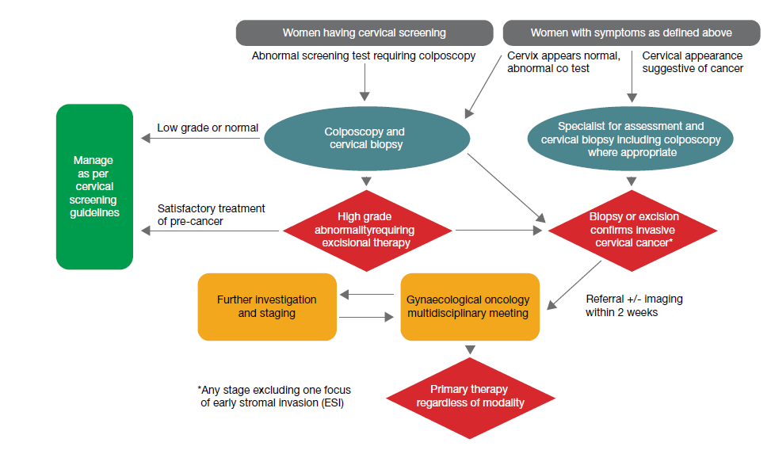
Source: Optimal care pathway for women with cervical cancer, Figure 3, p. 17

PART 6b – INFORMATION ABOUT THE INTERVENTION

Describe the key components and clinical steps involved in delivering the proposed medical service/technology:
As IHC testing is a common procedure, it is proposed that PD-L1 IHC testing be carried out in any pathology laboratory holding the appropriate accreditation to claim pathology services through the MBS. While kits are available, they can only be performed on the Dako/Agilent platform. However, antibodies can be validated on alternate platforms and MSD has previously developed protocols for this validation process.
The testing would be performed by a pathologist, and it is proposed that the test is a pathologist determinable test. The test would enable identification of those patients most likely to benefit from first line treatment with pembrolizumab in combination with chemotherapy +/- bevacizumab.
The PD-L1 assay that will be used during the pembrolizumab cervical cancer clinical development program is known as the PD-L1 IHC 22C3 pharmDx Market Ready Assay (developed by Dako/Agilent). The PD-L1 IHC 22C3 pharmDx Market Ready Assay will be used to determine PD-L1 expression in tumour tissue in order to explore the relationship between tumour PD-L1 expression and response to treatment with pembrolizumab. Furthermore, the CPS method has been validated by MSD for predicting response to pembrolizumab in cervical cancer.
Pembrolizumab is a highly selective humanised monoclonal antibody that targets the PD-L1 receptor to potentiate an immune response. PD-L1 expression in persistent, recurrent, or metastatic, advanced cervical cancer biopsies can be assessed using immunohistochemical (IHC) testing with antibodies that bind specifically to the PD-L1 protein.

Does the proposed medical service include a registered trademark component with characteristics that distinguishes it from other similar health components?
At the time of lodging this application, PD-L1 testing is listed on the MBS for use in NSCLC, and MSAC has supported an amendment to this MBS item to include patients with HNSCC. The PD-L1 22C3 pharmDx assay Market Ready Assay will be made commercially available in Australia. The PD-L1 22C3 pharmDx assay Market Ready Assay, including any applicable registered trademark, is TGA registered. The 22C3 antibody is also available for use on other platforms.

If the proposed medical service has a prosthesis or device component to it, does it involve a new approach towards managing a particular sub-group of the population with the specific medical condition?
N/A

If applicable, are there any limitations on the provision of the proposed medical service delivered to the patient (i.e. accessibility, dosage, quantity, duration or frequency)?
Accessibility
In the management of persistent, recurrent or metastatic cervical cancer, taking biopsy specimens is currently part of standard practice and diagnostic work-up. It is proposed that PD-L1 expression testing can be carried out on the tissue sample when a patient is found to have persistent, recurrent or metastatic disease. As part of standard practice, patients with advanced disease would have had a biopsy taken as part of initial diagnosis and use of their archival sample could be acceptable for assessing PD-L1 expression.
As IHC staining is a common procedure, PD-L1 IHC testing can be carried out in any pathology laboratory holding the appropriate accreditation. As IHC testing does not require a large volume of tissue, tissue availability shouldn’t limit access. PD-L1 expression testing can be carried out on archival tissue samples taken as part of standard diagnostic procedures.
Frequency
It is proposed that one PD-L1 test be performed once for each patient as part of the diagnostic biopsy, which is already part of standard management. There is no known role for PD-L1 testing in monitoring a patient’s response to pembrolizumab treatment.
Sample consideration
As per the KN 826 clinical trial inclusion criteria, participants had to have provided archival tissue or newly obtained core or excisional biopsy of a tumour lesion not previously irradiated. For those with an initial early-stage diagnosis, archival tissue will likely be used due to the current treatment paradigm involving chemoradiotherapy.
There was a preference for newly obtained tissue samples, however, archival tissue samples were also obtained for each patient (where available) and we plan to present the concordance of using new vs. archival tissue samples as part of the co-dependent submission for MSAC’s consideration.
In addition, the application will explore information on other relevant sample considerations as needed (pending available data).
There is no known role for PD-L1 testing in monitoring a patient’s response to pembrolizumab treatment.
Testing considerations
IHC testing is a well-established technique in all major pathology labs. Laboratories already have the platform infrastructure and reagents to perform PD-L1 IHC testing.
It is acknowledged that there are differences between PD-L1 antibody assays for immune cell staining. Consequently, it is important that the antibody being used to assess PD-L1 status is aligned to the drug being considered. In this instance, the 22C3 antibody and CPS≥1 cut point should be used to determine eligibility for pembrolizumab.

If applicable, identify any healthcare resources or other medical services that would need to be delivered at the same time as the proposed medical service:
Some patients may not have had an initial test at diagnosis and do not have archival tissue samples available. Given the existence of a National Cervical Screening Program, it is presumed that this will be a small number of patients. These patients may require a biopsy at diagnosis of metastatic disease to obtain new tissue for PD-L1 expression testing. A comparison of outcomes in patients with PD-L1 test results based on archival and fresh tissue samples from the KN 826 trial will be presented for MSAC’s consideration once the results are available. The additional health resources associated with this procedure, including any potential adverse events, will be included in the economic and budget impact models submitted for MSAC and PBAC’s consideration.

If applicable, advise which health professionals will primarily deliver the proposed service:
A certified pathologist would be responsible for conducting the test and reporting the results. Consistent with the introduction of diagnostic tests associated with access to other targeted therapies, pathologist training and quality assurance programs would be expected to be developed with respect to delivery of diagnostic tests for access to treatments targeting the PD-1 pathway on the PBS.

If applicable, advise whether the proposed medical service could be delegated or referred to another professional for delivery:
A certified pathologist would be responsible for conducting the test and reporting the results. Specialists including (e.g., oncologists) will provide a referral for PD-L1 testing.

If applicable, specify any proposed limitations on who might deliver the proposed medical service, or who might provide a referral for it:
As IHC testing is a common procedure, it is proposed that PD-L1 IHC testing be carried out in any pathology laboratory holding the appropriate accreditation to claim pathology services through the MBS.

If applicable, advise what type of training or qualifications would be required to perform the proposed service, as well as any accreditation requirements to support service delivery:
A certified pathologist would be responsible for conducting the test and reporting the results. Consistent with introduction of diagnostic tests associated with access to other targeted therapies, pathologist training and quality assurance programs would be developed with respect to delivery of diagnostic tests for access to treatments targeting the PD-L1 pathway on the PBS.
The RCPA QAP are providing Technical modules for PD-L1 IHC for NSCLC, HNSCC, and TNBC in 2022. It is expected that this will be expanded to cover additional indications as required. In addition, MSD facilitates one day peer-to-peer workshops for Australian pathologists, with a training effectiveness performed with those who participate. This results in pathologists having greater experience in performing the test and applying the scoring methods.

(a) Indicate the proposed setting(s) in which the proposed medical service will be delivered (select ALL relevant settings):
Inpatient private hospital (admitted patient)
Inpatient public hospital (admitted patient)
Private outpatient clinic
Public outpatient clinic
Emergency Department
Private consulting rooms - GP
Private consulting rooms – specialist
Private consulting rooms – other health practitioner (nurse or allied health)
Private day surgery clinic (admitted patient)
Private day surgery clinic (non-admitted patient)
Public day surgery clinic (admitted patient)
Public day surgery clinic (non-admitted patient)
Residential aged care facility
Patient’s home
Laboratory
Other – please specify below
Specify further details here
- Where the proposed medical service is provided in more than one setting, please describe the rationale related to each:
Describe rationale here

Is the proposed medical service intended to be entirely rendered in Australia?
Yes
No – please specify below

PART 6c – INFORMATION ABOUT THE COMPARATOR(S)

Nominate the appropriate comparator(s) for the proposed medical service (i.e. how is the proposed population currently managed in the absence of the proposed medical service being available in the Australian health care system). This includes identifying health care resources that are needed to be delivered at the same time as the comparator service):
The comparator is no PD-L1 testing and current standard of care, which is a platinum compound plus paclitaxel, with or without bevacizumab.

Does the medical service (that has been nominated as the comparator) have an existing MBS item number(s)?
Yes (please list all relevant MBS item numbers below)
No

(a) Will the proposed medical service/technology be used in addition to, or instead of, the nominated comparator(s)?
In addition to (i.e. it is an add-on service)
Instead of (i.e. it is a replacement or alternative)

If yes, please outline the extent to which the current service/comparator is expected to be substituted

PART 6c CONTINUED – INFORMATION ABOUT ALGORITHMS (CLINICAL MANAGEMENT PATHWAYS)s

Define and summarise the CURRENT clinical management pathway (algorithm) that patients follow when they receive the COMPARATOR service (i.e. the landscape before the proposed service is introduced). An easy-to-follow flowchart is preferred, depicting the current clinical management pathway), but dot-points would be acceptable. Please include health care resources used in the current landscape (e.g. pharmaceuticals, diagnostics and investigative services, etc.).
Patients who present to their healthcare provider with symptoms of cervical cancer will undergo further investigation. These symptoms include vaginal bleeding between periods, longer or heavier than usual menstrual bleeding, pain or bleeding during intercourse, pelvic pain, change in vaginal discharge or bleeding after menopause. Following a screening test that may indicate signs of cancer, a specialist may carry out further tests such as a colposcopy with biopsy, large loop excision or a cone biopsy (see Figure 1). Diagnosis and staging will occur at this stage with biopsies taken from the suspect areas.
Treatment is dependent on the disease stage of the cancer. For early-stage disease and smaller lesions, treatment can be a combination of surgery and/or chemoradiation therapy. For locally advanced disease, chemo-sensitising radiotherapy with chemotherapy drugs such as cisplatin is utilised.
Current guidelines for first-line treatment of patients with persistent, recurrent, or metastatic disease is chemotherapy using a platinum-based combination plus an angiogenesis inhibitor, such as bevacizumab (refer to Figure 2). The combination is a platinum compound with paclitaxel. The choice of the platinum compound depends on the individual patient’s comorbidities, such as pre-existing renal failure and previous history of cisplatin-based chemoradiation.
Figure 2 Current treatment algorithm of patients diagnosed with cervical cancer
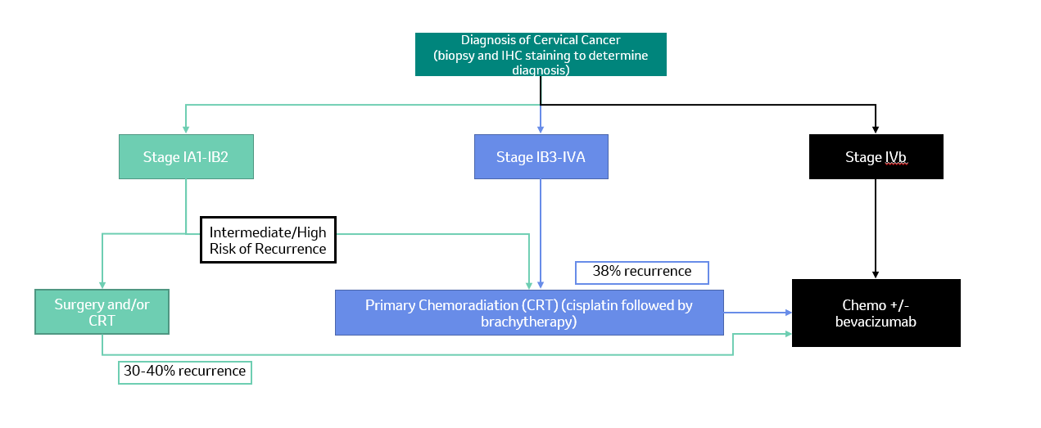

Define and summarise the PROPOSED clinical management pathway (algorithm) that patients would follow after the proposed service/technology is introduced, including variation in health care resources.
Using the proposed service, patients with persistent, recurrent, or metastatic cervical cancer would be treated with a combination chemotherapy regimen of a platinum-based compound plus paclitaxel plus pembrolizumab, with or without bevacizumab (refer to Figure 3). Patients presenting with persistent or recurrent disease would have archival tissue available from initial diagnostic workup, and the same tissue sample can then be used for PD-L1 IHC testing. In the instance where archival tissue is not available, or a patient is newly diagnosed with metastatic disease, then the PD-L1 IHC testing will be performed on newly obtained tissue samples that had not been previously irradiated.
Figure 3 Proposed treatment algorithm of patients diagnosed with cervical cancer
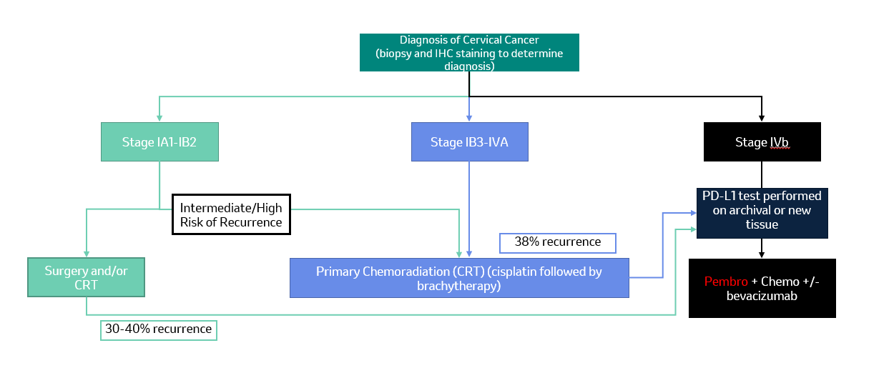

PART 6d – INFORMATION ABOUT CLINICAL OUTCOMES

Summarise the clinical claims for the proposed medical service against the appropriate comparator(s), in terms of consequences for health outcomes (comparative benefits and harms):
PD-L1 testing followed by treatment with pembrolizumab is associated with superior outcomes compared to the current standard of care for patients with persistent, recurrent, or metastatic cervical cancer.
Hence, the clinical claim is driven by three factors:
1. Acceptable safety and analytical performance of PD-L1 test. (To be assessed by MSAC.)
2. Superior effectiveness with acceptable safety of treating PD-L1 positive patients with
pembrolizumab relative to standard of care. (To be assessed by PBAC).
3. Clinical utility of the test + drug combination (To be assessed by MSAC/PBAC).
Clinical efficacy and the clinical utility claims will be based on KN826. KN180 and KN028 data will be used as supportive data to inform safety outcomes.
The co-dependent submission will present efficacy and safety data for patients with PD-L1 expression CPS≥1 and the complement (CPS <1). It is expected that PD-L1 testing will help to determine the most appropriate clinical pathway for individual patients

Please state what the overall clinical claim is:
The clinical evidence in the key clinical trial, KN 826, demonstrated that pembrolizumab in combination with chemotherapy +/- bevacizumab is superior in terms of efficacy and safety, compared to standard of care (SOC) in the Australian setting, for patients with a PD-L1 expression of CPS ≥1. The clinical trial also demonstrated that pembrolizumab in combination with chemotherapy +/- bevacizumab was superior in terms of efficacy and safety in all patients compared to SOC.
It should be noted that in the KN 826 pivotal trial approximately 10% of patients were CPS <1. It is anticipated that the proportion of patients CPS<1 in Australia within would be consistent within clinical practice. For this small number of patients (~30) SOC would be the available treatment option.
It should be noted that at the November 2021 MSAC meeting, the committee supported PD-L1 testing in patients with HNSCC. MSAC considered that PD-L1 testing with a CPS threshold of ≥20 had sufficient value in identifying which patients may derive greater benefit from pembrolizumab monotherapy. The co-dependent submission also proposed a CPS threshold ≥1 for patients to be eligible for pembrolizumab combination therapy, in line the approved TGA indication. However, the PBAC considered that, based on the data provided, pembrolizumab plus chemotherapy was superior to standard of care (SOC) in the CPS ≥1 population and also in the all-comers population (that is, regardless of CPS). On the basis of this, the PBAC is currently of the mind to recommend the listing of pembrolizumab combination therapy in an allcomers population and to not exclude CPS <1 patients, which formed approximately 15% of the population.

List the key health outcomes (major and minor – prioritising major key health outcomes first) that will need to be measured in assessing the clinical claim for the proposed medical service/technology (versus the comparator):
Clinical Effectiveness Outcomes
KN826:
- Primary outcomes: Overall survival (OS), and Progression Free Survival (PFS) (per RECIST V1.1 by investigator)
- Secondary outcomes: Overall Response Rate (ORR), duration of response (DOR), and 12-month PFS rate per RECIST 1.1 by investigator. PFS per RECIST 1.1 by BICR. HRQOL assessment using the EORTC QLQ-C30
- Exploratory endpoints: ORR, DOR and 12-month PFS rate per RECIST 1.1 by BICR, utilities using EQ-5D-5L, PFS per irRECIST by investigator, identify HRQoL using EORTC QLQ-C30, EORTC QLQ-CX24, and EQ-5D-5L, identify molecular biomarkers that may be indicative of clinical response, safety, pharmacodynamic activity and/or the MOA of pembrolizumab and other treatments
Safety Outcomes
KN826:
- Any adverse events (adverse events, serious adverse events and fatal serious adverse events), causality and outcome of adverse events/serious adverse events (according to NCI CTCAE, Version 4.0)
- Rate of treatment discontinuations and reasons
- Changes in vital signs, laboratory values etc.

PART 7 – INFORMATION ABOUT ESTIMATED UTILISATION

Estimate the prevalence and/or incidence of the condition in the proposed population:
A | Estimate no. of persons diagnosed with cervical cancer in 2021 | 913 | AIHW
B | Proportion of Early-Stage cervical cancer (Stage IA1 – IB2) (44% * A) | 402 | SEER Data
C | Proportion of locally advanced cervical cancer (Stage IB3 – IVA) (36% * A) | 329 | SEER Data
D | Proportion of metastatic cervical cancer (Stage IVB) (19% * A) | 174 | SEER Data
E | Recurrence rate of early disease – midpoint used (35% * B) | 141 | Management of early-stage cervical cancer - UpToDate
F | Recurrence rate of locally advanced disease (38% * C) | 125 | Management of locally advanced cervical cancer - UpToDate
G | Total incident metastatic and recurrent disease (D + E +F) | 440

Estimate the number of times the proposed medical service/technology would be delivered to a patient per year:
It is anticipated that one PD-L1 test would be performed on patients at diagnosis with persistent, recurrent or metastatic cervical cancer. The test would be undertaken prior to commencement of pembrolizumab in combination with chemotherapy to enable identification of those patients most likely to benefit from treatment. There is currently no known role for PD-L1 testing in monitoring a patient’s response to pembrolizumab treatment.

How many years would the proposed medical service/technology be required for the patient?

N/A

Estimate the projected number of patients who will utilise the proposed medical service(s) for the first full year:
As presented in Item 44, the estimated number of new patients who will utilise the PD-L1 test is approximately 440 patients in the first year. Since the PD-L1 test is a one-off test, which will only be performed at diagnosis, the estimated number of patients who will be tested in the forthcoming years will include incident patients only.

Estimate the anticipated uptake of the proposed medical service/technology over the next three years, factoring in any constraints in the health system in meeting the needs of the proposed population (such as supply and demand factors), as well as provide commentary on risk of ‘leakage’ to populations not targeted by the service.
Currently, the majority of patients who are diagnosed with metastatic cervical cancer will receive combination chemotherapy with or without bevacizumab. The KN 826 results indicate that PD-L1 positive patients benefit from pembrolizumab therapy therefore pembrolizumab could be added to the previously mentioned first line therapy in cervical cancer patients. Consequently, the uptake of the PD-L1 test is anticipated to be 100% for all patients diagnosed with persistent, recurrent or metastatic cervical cancer.
If restricted by the TGA only those patients with expression of PD-L1 (CPS >1) would be eligible for pembrolizumab. Therefore, uptake of pembrolizumab would be restricted to those who have PD-L1 expression of CPS >1 in tumour tissues. The risk of leakage for PD-L1 testing is minimal, as testing would be restricted to only those patients who would eventually be eligible for pembrolizumab.

PART 8 – COST INFORMATION

Indicate the likely cost of providing the proposed medical service. Where possible, please provide overall cost and breakdown:
The final fee request will be contingent on decisions made by Dako/Agilent and aligned with other MSAC applications currently under consideration. The expected fee for the proposed service is likely to be consistent with other immunohistochemical tests currently available on the MBS.

Specify how long the proposed medical service/technology typically takes to perform:
The IHC service testing for PD-L1 expression can take between 2.5-4 hours depending on instrumentation and protocol used.

If public funding is sought through the MBS, please draft a proposed MBS item descriptor to define the population and usage characteristics that defines eligibility for the medical service/technology.
As this is an amendment to an existing item number, the changes made to the current MBS item descriptor for item 72814 are below.
Category 6 – Pathology Services
Item 72184:
Immunohistochemical examination by immunoperoxidase or other labelled antibody techniques using the programmed cell death ligand 1 (PD-L1) antibody of tumour material from a patient diagnosed with non-small cell lung cancer, recurrent or metastatic squamous cell carcinoma of the oral cavity, pharynx or larynx or locally recurrent unresectable or persistent, recurrent or metastatic cervical cancer.
Fee: To be determined Benefit: To be determined

If public funding is sought through an alternative (non-MBS) funding arrangement, please draft a service description to define the population and usage characteristics that defines eligibility for the service/technology.
N/A

Cancer.org.au. 2022. Cervical cancer | Causes, Symptoms & Treatments. [online] Available at: <https://www.cancer.org.au/cancer-information/types-of-cancer/cervical-cancer> [Accessed 25 February 2022].
Wright, J., 2022. Management of recurrent or metastatic cervical cancer. [online] Www-uptodate-com.ezproxy-so.library.sydney.edu.au. Available at: <https://www-uptodate-com [Accessed 25 February 2022].
https://www.aihw.gov.au/reports/cancer/cancer-data-in-australia/contents/cancer-summary-data-visualisation
https://www.aihw.gov.au/reports/cancer/cancer-in-australia-2021/data; tables 10.2 and 10.5
Australian Institute of Health and Welfare 2021. National Cervical Screening Program monitoring report 2021. Cancer series 134. Cat. no. CAN 141. Canberra: AIHW.
https://www.cancer.org/cancer/cervical-cancer/detection-diagnosis-staging/survival.html
Cancer data in Australia, Cancer summary data visualisation - Australian Institute of Health and Welfare (aihw.gov.au)

