MSAC Application 1719

Insertion of bioabsorbable implant for nasal airway obstruction due to lateral wall insufficiency

# Ratified

# PICO Confirmation

Summary of PICO/PPICO criteria to define question(s) to be addressed in an Assessment Report to the Medical Services Advisory Committee (MSAC).

Table 1 PICO for Insertion of a bioabsorbable implant for nasal airway obstruction due to lateral wall insufficiency: PICO Set 1

| **Component** | **Description** |
| --- | --- |
| Population | Patients with nasal airway obstruction (NAO) due to lateral wall insufficiency and with a Nasal Obstruction Symptom Evaluation (NOSE) score of greater than 45 |
| Intervention | Bioabsorbable nasal implant for the treatment of lateral wall insufficiency |
| Comparator | Primary: Functional rhinoplasty  Secondary: Conservative management including medical management (nasal steroids, antihistamines) and temporary external supports (e.g. Breathe Right strips) |
| Outcomes | **Safety outcomes:**  Serious adverse events  Procedure-related adverse events  AE/complications (e.g. dislodgment of implant; implant retrieval; infection; bleeding)  **Clinical Effectiveness Outcomes:**  Responder rates  Rate of revision  Change from baseline in NOSE score  Change in Lateral Wall Insufficiency (LWI) score  Change in visual analogue scale (patient’s perception of their ability to breathe)  Change in satisfaction measures  **Healthcare resources:**  Costs to deliver the intervention  Cost of hospitalisation  Costs of post-surgical follow-ups and care  Costs of adverse event management |
| Assessment questions | What is the safety, effectiveness and cost-effectiveness of a bioabsorbable implant versus functional rhinoplasty or conservative management in patients with nasal airway obstruction with a NOSE score of greater than 45? |

AE=adverse events

## Purpose of application

An application requesting Medicare Benefits Schedule (MBS) listing of a bioabsorbable implant for nasal airway obstruction due to lateral wall insufficiency was received from Stryker Australia by the Department of Health.

The clinical claim is that the use of the bioabsorbable implant results in

* non-inferior safety and non-inferior health outcomes, compared to functional rhinoplasty. In terms of health care resource utilisation, the insertion of bioabsorbable implant may be associated with reduced length of hospital stay relative to functional rhinoplasty.
* superior health outcomes compared to conservative management. The insertion of bioabsorbable implants is expected to have a tolerable safety profile, with procedural adverse events observed in clinical trials resolving with no clinical sequelae. While a tolerable safety profile is claimed by the applicant, this claim may be required to be changed to a non-inferior safety profile compared with medical management.

## PICO criteria

### Population

The target population for the proposed service is patients with nasal airway obstruction (NAO) due to lateral wall insufficiency confirmed by positive modified Cottle manoeuvre and having a self-reported Nasal Obstruction Symptom Evaluation (NOSE) scale score of greater than 45.

*PASC noted that the proposed population are patients with nasal airway obstruction (NAO) due to lateral wall insufficiency and with a Nasal Obstruction Symptom Evaluation (NOSE) score of greater than 45.*

#### Nasal airway obstruction

Nasal airway obstruction leads to insufficient airflow and difficult breathing through the nose and is a common presenting symptom in otolaryngology practices (1, 2). The limited airflow through the nose can be associated with significant quality of life consequences. Symptoms of NAO may include nasal congestion or stuffiness, nasal blockage or obstruction, trouble breathing through the nose, trouble sleeping, and inability to get enough air through the nose during exercise or exertion.

The nasal cavity commences at the external nasal valve, which is defined by the lower lateral cartilages, inferior septum, nostril sill and alae. Superiorly, the septum and nasal bones provide the structural support of the nose. The septum is the midline structure separating the two nostrils and is composed of cartilage anteriorly and bone posteriorly. The internal nasal valve is the narrowest aspect of the nasal cavity and is formed by the septum, inferior turbinate and upper lateral cartilage on either side. There are three turbinates (superior, middle and inferior) that arise from the lateral nasal wall; their function is to humidify, warm and filter air. Inferolateral to each turbinate is a corresponding meatus into which the paranasal sinuses and nasolacrimal duct open.

The internal nasal valve represents the narrowest segment of the nasal airway. It has a cross-sectional area of approximately 40 to 60 mm2 and accounts for approximately two thirds of total nasal airway resistance. As such, collapse or stenosis of this area can significantly contribute to nasal airway obstruction and is thought to be one of the most common causes of nasal obstruction (3).

Aetiologies of nasal obstruction consist of inflammatory and anatomic (including inferior turbinate hypertrophy, septal deviation, and nasal valve dysfunction) contributors (1). Nasal valve dysfunction can have static and dynamic components, where dynamic nasal valve dysfunction (hereby defined as nasal valve collapse [NVC]) is caused by lateral wall insufficiency (1). NVC is recognised as a distinct and primary cause for symptomatic nasal airway obstruction by the American Academy of Otolaryngology – Head and Neck Surgery clinical consensus statement for the diagnosis and management of nasal valve compromise (4). Many patients have more than one anatomic cause for their nasal obstruction (1).

The proposed population specifically refers to patients with NAO where nasal valve collapse is caused by lateral wall insufficiency.

#### Nasal Obstruction Symptom Evaluation (NOSE) scale and modified Cottle manoeuvre

The NOSE score is a patient completed instrument used to assess nasal obstruction. It is a brief questionnaire consisting of 5 self-rated items (Nasal congestion or stuffiness; nasal blockage or obstruction; trouble breathing through the nose; trouble sleeping; unable to get enough air through the nose during exercise or exertion). Each item is scored from 0 to 4, with 0 representing not a problem and 4 representing severe problem. The NOSE score represents the sum of the responses to the 5 individual items and ranges from 0 to 20, with the sum converted to a 100-point scale by multiplying the total score by 5. Based on the NOSE score, patients can be classified as having mild (5-25), moderate (30-50), severe (55-75) and extreme (80-100) severity.

The modified Cottle manoeuvre is used to assess the internal nasal valve integrity by providing intranasal stabilisation of the lateral nasal wall using an instrument to gently support the lateral nasal wall cartilage on each side of the nose while the patient is asked to inspire. A modified Cottle manoeuvre is considered positive if the patient reports improvement in breathing (1).

#### Eligibility

The proposed eligibility criteria for the insertion of a bioabsorbable nasal implant are a NOSE score of greater than 45, and a positive modified Cottle manoeuvre. The NOSE score threshold of 45 is aligned with the requirement as per the rhinoplasty MBS listings (the primary comparator).

#### Assessment and patient management

The applicant notes that no published Australian or well recognised international treatment guidelines exist for the management of patients with lateral wall insufficiency. Hence, Australian expert advice was sought to inform the current management of patients with NAO due to lateral wall insufficiency.

The Royal Australian College of General Practitioners (RACGP) provides guidance on the clinical assessment and diagnosis of nasal airway obstruction as published in the Australian Family Physician (5). As NAO may have inflammatory causes or anatomical abnormalities (fixed or dynamic) with management dependent on aetiology, the first objective of the physician is therefore to establish the cause.

The physician will obtain the history of clinical presentation, including the NOSE score, and perform a physical examination taking into consideration airflow dynamics and areas where increased resistance can occur. Typically, an external examination of the nose focusing on deformities of the bony and cartilaginous structures of the nose and adjacent tissues will be performed followed by examination of the internal anatomy. The internal nasal valve provides the greatest resistance to airflow, therefore even minor narrowing can cause nasal obstruction. The modified Cottle manoeuvre can help diagnosis nasal valve collapse (5).

Further assessments may include an anterior rhinoscopy of the nose (5). If the diagnosis remains unclear, fibre optic nasal endoscopy may be needed, which is performed by a specialist.

Computed tomography (CT) is the preferred imaging modality for the nose and paranasal sinuses (5).

Conservative management generally consists of medical therapy, such as nasal steroids and antihistamines. Temporary supports are also used, including nasal strips (e.g. Breathe Right strips). Patients with anatomic aetiology and symptomatic despite medical therapy warrant referral to a specialist for consideration of functional rhinoplasty surgery.

#### Prevalence of nasal airway obstruction due to lateral wall insufficiency

A pragmatic search of the literature conducted by the applicant failed to identify any epidemiological studies to inform the prevalence or incidence of nasal airway obstruction in Australia or elsewhere.

The search did identify a recent study that was conducted to estimate the distribution of NOSE Scale in the Australian population (6). The study used a market research agency to randomly survey 502 participants with no history of rhinoplasty, septoplasty or turbinectomy. The results of the study showed that 9.6% of the study participants had a NOSE score of > 45 and would therefore meet the criterion for MBS funded rhinoplasty. However, while participants recruited to the study were intended to represent the general population, a greater proportion of participants had major risk factors such as obstructive sleep apnoea (OSA), CPAP usage, cleft palate and nose trauma than would be expected. Hence, selection bias may be responsible for the high prevalence of NOSE scores > 45. On the other hand, this may also indicate that many patients with a self-reported NOSE score of > 45 may not consider themselves to be severe enough to want to pursue surgical treatment.

#### Utilisation estimates

The size of the patient population eligible for the proposed service was derived, as a proxy, from available MBS statistics for services related to functional rhinoplasty, the only intervention currently available to treat NAO due to lateral wall insufficiency in Australia.

There are currently three MBS item numbers for the provision of functional rhinoplasty for the treatment of NAO (Table 2). Eligibility requirements for each MBS item are identical and only apply where:

(a) the indication for surgery is:

(i) airway obstruction and the patient has a self-reported NOSE Scale score of greater than 45; or

(ii) significant acquired, congenital or developmental deformity; and

(b) photographic and/or NOSE Scale evidence demonstrating the clinical need for this service is documented in the patient notes.

An analysis of utilisation of the MBS items showed that 5,657 patients elected to undergo rhinoplasty in 2021 (Table 2). However, the item numbers listed are not specific to nasal airway obstruction due to lateral wall insufficiency alone. While no specific data to Australia is readily available to inform the proportion of patients with NAO that is due to lateral wall insufficiency, a survey conducted in the US among patients complaining of nasal obstruction and a NOSE score >50, estimate the prevalence of NVC to be 73% (1). Applying this to the estimates derived from the MBS data, it is estimated that 4,130 (5,657*73%) rhinoplasties were performed for the treatment of lateral wall insufficiencies in 2021. Given the MBS items are also relevant to patients with acquired, congenital or developmental deformity, this number is likely to be over-estimated. Note that items 45641 and 45644 involve correction of both bony and cartilaginous elements.

Table 2 Utilisation of MBS items for rhinoplasty

|  |  |  |
| --- | --- | --- |
| **MBS item** | **Descriptor** | **2021 utilisation** |
| 45632 | Rhinoplasty, partial, involving correction of one or both lateral cartilages, one or both alar cartilages or one or both lateral cartilages and alar cartilages | 522 |
| 45641 | Rhinoplasty, total, including correction of all bony and cartilaginous elements of the external nose, with or without autogenous cartilage or bone graft from a local site (nasal) | 4,286 |
| 45644 | Rhinoplasty, total, including correction of all bony and cartilaginous elements of the external nose involving autogenous bone or cartilage graft obtained from distant donor site, including obtaining of graft | 849 |
| Total |  | 5,657 |

Figure 1 Historical and projected utilisation of MBS items 45632, 45641 and 45644

Figure 1 Historical and projected utilisation of MBS items 45632, 45641 and 45644

Projected uptake of current MBS item numbers relevant to rhinoplasty for the treatment of NVC (45632, 45641 and 45644) is projected based on historical use over the last 10-years (see Figure 1). Assuming continued linear growth it is estimated 4,572 patients will utilise these MBS items in the first full year of listing (assumed to be 2024). The uptake of the proposed medical service is projected to increase from 667 in the first full year of listing to between **||||||||||||** and **||||||||||||** over the next three years (Table 3). When considering projected and historical use for MBS item 45632 alone (Figure 2), the uptake is projected to increase from 71 in the first full year of listing to between **||||||||||||** and **||||||||||||** over the next three years (Table 3). Increased uptake over these years reflects the expected impact of increased market awareness and wider adoption among ENT and rhinology specialists.

It is acknowledged that a patient pool exists with severe NVC who are unwilling to undergo a rhinoplasty due to concerns relating to the general anaesthetic, invasive nature of the procedure and/or extensive recovery time or that are contraindicated to the procedure. As a less invasive alternative to rhinoplasty, it is expected that some patients who would otherwise not have undergone rhinoplasty will also utilise the service, meaning total expected utilisation may exceed this.

*PASC considered the proposed population includes a subset of patients who would be averse to surgery or not be eligible for rhinoplasty and may prefer a bioabsorbable implant.*

Note, these projected numbers are indicative only and will be finalised in the applicant developed assessment report (ADAR).

PASC may wish to consider whether inclusion of items 45632, 45641 and 45644 may lead to an over-estimation of the utilisation estimates and if utilisation estimates should be derived from MBS item 45632 alone.

Table 3 Projected utilisation of proposed MBS service in first 4 years of funding

|  |  |  |  |  |
| --- | --- | --- | --- | --- |
| **Population** | **Year 1**  **(2024)** | **Year 2**  **(2025)** | **Year 3**  **(2026)** | **Year 4**  **(2027)** |
| Based on MBS items 45632, 45641 and 45644 |  |  |  |  |
| Estimated population who would have undergone rhinoplasty in the absence of the proposed service | 4,572 | 4,673 | 4,774 | 4,875 |
| Proportion of patient with NAO that is due to lateral wall insufficiency | 73% | 73% | 73% | 73% |
| Total patients eligible for insertion of bioabsorbable implant | 3,337 | 3,411 | 3,485 | 3,559 |
| Uptake rate of proposed service in patients who would have undergone rhinoplasty | **||||||||||||** | **||||||||||||** | **||||||||||||** | **||||||||||||** |
| Estimated utilisation in patients who would have undergone rhinoplasty | **||||||||||||** | **||||||||||||** | **||||||||||||** | **||||||||||||** |
| Based on MBS items 45632 alone |  |  |  |  |
| Estimated population who would have undergone rhinoplasty in the absence of the proposed service | 485 | 479 | 473 | 467 |
| Proportion of patient with NAO that is due to lateral wall insufficiency | 73% | 73% | 73% | 73% |
| Total patients eligible for insertion of bioabsorbable implant | 354 | 349 | 345 | 341 |
| Uptake rate of proposed service in patients who would have undergone rhinoplasty | **||||||||||||** | **||||||||||||** | **||||||||||||** | **||||||||||||** |
| Estimated utilisation in patients who would have undergone rhinoplasty | **||||||||||||** | **||||||||||||** | **||||||||||||** | **||||||||||||** |

Figure 2 Historical and projected utilisation of MBS items 45632

Figure 2 Historical and projected utilisation of MBS items 45632

### Intervention

The proposed medical service involves the implantation of a bioabsorbable implant (LATERA®) to support the upper and lower cartilage inside the lateral wall of the nose by anchoring above the maxilla to provide cantilever support. By supporting the cartilage, NAO symptoms may reduce, and the patient’s breathing may improve. The implant is placed inside the nasal wall in a minimally invasive procedure.

The LATERA procedure needs to be undertaken by a qualified ENT surgeon or rhinologist. Further it is recommended that they do Stryker training on a head model to familiarise them with the procedure. The first case a physician performs must be attended by a company representative. It is also recommended for the first three cases that the company representative be present.

Anaesthetics will be required for the delivery of LATERA. Depending on the setting in which LATERA is delivered, anaesthetics can be local (in office) or general. The delivery of LATERA that can be performed as a patient hospital service or as a day surgery clinic, as well as in private consulting rooms. Local expert advice states that the procedure is mostly performed with local anaesthetics in Australia.

*PASC discussed the setting where the intervention would take place, noting that if the procedure were to take place in an office the cost of the device would not be covered under the Prosthesis List. This may lead to significant out-of-pocket-costs for the patient.*

The delivery of the proposed medical service, insertion of a bioabsorbable implant, is a minimally invasive and easily performed procedure that can be performed as in patient hospital service or as a day surgery clinic and is typically performed under local anaesthesia. The procedure can also be performed in private consulting rooms. Based on local expert advice, it is expected the proposed procedure is performed as day surgery, with few patients requiring overnight stay.

*PASC queried the invasiveness of the procedure. The applicant noted that the device is deployed through a large needle underneath the skin. As such, local anaesthesia is used in most cases and would be conducted mostly as day procedures.*

The LATERA Absorbable Nasal Implant System is composed of the implant, delivery device, and implant positioning guide (LATERA Instructions for Use). The implant is predominantly cylindrical in shape with a diameter of 1 mm and is available in two lengths, 20mm and 24mm, with a forked distal end for anchoring and features on the proximal end for increased flexibility (LATERA Instructions for Use). The Implant is composed of Poly (L-lactide-co-D-L-lactide) 70:30 copolymer which is absorbed in the body over a period of approximately 18 months (LATERA Instructions for Use). During this period, the nose builds up a collagen matrix around the site of the implant, so the benefits last beyond the 18 months.

*PASC queried the longevity of the implant and the applicant acknowledged there is currently limited evidence. The applicant’s clinical experts noted that the nose tissue/anatomical structures will sag over time in all patients, providing less support and potentially leading to nasal airway obstruction.*

*PASC requested any further data on implant longevity should be included in the assessment.*

The implant and packaging are depicted in Figure 3. The delivery device and implant positioning guide are intended for single patient use only. The packaged system comes with one delivery system (with an implant positioning guide) and two implants (either 20mm or 24mm long). The delivery device may be used to deliver two implants to a single patient in a single clinical setting.

The delivery device is composed of an inner shaft, an outer handle with a push rod, a deploy button, an open button and a 16-gauge delivery cannula with a protective cover (LATERA Instructions for Use). The inner shaft includes an implant loading port which enables the loading of the implant and include graphics to indicate the open position (LATERA Instructions for Use). The inner shaft transitions between the open position and the cannula to collapse the Implant forks within the cannula inner lumen and prepare the Implant for deployment (LATERA Instructions for Use). The outer handle includes deploy and open buttons that lock and release the handle from these respective positions (LATERA Instructions for Use). The outer handle also includes a push rod that shuttles the implant from the implant loading port to a ready position for deployment (LATERA Instructions for Use).

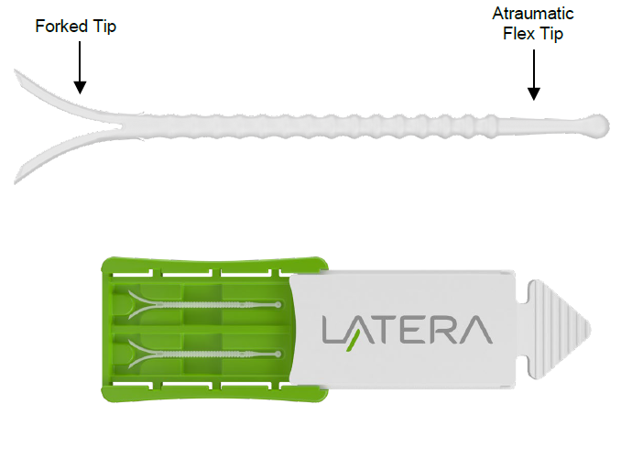

Figure 3 LATERA absorbable nasal implant and packaging

Source: LATERA Instructions for Use

The three main steps in delivering LATERA are implant target location and device preparation, implant delivery, and disposal. Details of the involved steps are provided in Table 4.

Table 4 Steps involved in delivering the LATERA implant

|  |
| --- |
| **Implant target location and device preparation**  1. The implant is available in two lengths, 20mm and 24mm. Nasal anatomy (i.e. nose size, length of maxilla/nasal bone, alar crease position, etc.) should be considered in selecting an appropriate implant length. A ruler may be used to help determine the desired size.  2. Standard surgical procedures should be used to prepare the site for implantation (e.g. cleaning, disinfection, anaesthetic, etc.)  3. Prior to implantation, identify the target implant location and cannula insertion trajectory. The forked distal tip of the Implant should be positioned adjacent and across the maxilla bone and the cylindrical portion of the Implant should be positioned to support the upper and lower lateral cartilage. The proximal tip of the implant should be placed cephalic to the supra-alar crease.  4. Use the implant positioning guide to mark the surgical trajectory using a standard surgical pen. The holes provided on the Implant Positioning Guide allow for marking the base of implant forked tip and the spherical end of the atraumatic proximal tip. The distal mark correlates to the final position of the cannula tip prior to Implant delivery.  5. Retract the outer handle of the delivery device by gripping the distal flange of the inner shaft, holding the open button in the depressed position and gently pulling until the push rod is clear of the implant loading port. On devices with inner shaft graphics, the green ring will be proximal to the solid black line graphic when the push rod is clear of the implant loading port. Continue to retract the outer handle fully until the pushrod is clear of the implant loading port.  6. Using sterile surgical forceps transfer the Implant from the plastic tray to the implant loading port of the delivery device.  7. Slowly advance the outer handle until the outer handle locks into the ready position to advance the implant into the delivery cannula. While advancing, watch the implant load into cannula inner lumen. This positions the implant at the tip of the cannula in the ready position.  **Implant Delivery**  8. Identify the cannula insertion point, Figure 3(a), to provide the maximum distance between the cannula insertion point and the target position of the proximal tip of the Implant to ensure the Implant is fully embedded within the tissue, Figure 3(b).  9. The ala is everted under direct visualization, and the delivery cannula is inserted perpendicular to the septum through the nasal vestibular lining of the lateral wall within the nasal cavity near the margin of the nostril. A small conventional scalpel incision at the target cannula entry location may be optionally created to ease cannula puncture.  10. The cannula should pass along the center of the thickness of the lateral wall to avoid piercing medial through the mucosa or lateral through the skin as it traverses the wall to the target location.  11. When the cannula reaches the bony cartilaginous junction, the cannula is passed over the maxillary bone to the target depth.  12. If the nasal tissue has compressed or bunched-up during cannula insertion, relax the tissue to its native position. Verify that the cannula is inserted deep enough such that the tip of the cannula is positioned over the maxilla bone.  13. The implant forks will expand to their original shape as they exit the cannula tip in the orientation they are loaded. Using the implant fork orientation features on the distal end of the delivery device as a reference for fork orientation, verify that the delivery device rotation about its axis is appropriate to deliver the forks parallel to the underlying bone.  14. When the cannula is in the appropriate location and orientation, the deploy button can be depressed and released and the outer handle can be carefully advanced to the deployed position. Keep fingers proximal to the green ring when deploying the implant. Cannula may be stabilised with off-hand while deploying, if desired. The Implant forks are driven approximately 4 mm into the tissue beyond the distal tip of the cannula when deployed.  15. Following deployment, apply slight compression over deployed forks cephalic to the cannula tip (Figure 4a) and slowly withdraw the cannula from the tissue. Take care to not alter the angle or rotational orientation of the delivery device while withdrawing or the Implant could be dislodged.  16. After complete withdrawal, visually examine the insertion site to ensure the Implant is not exposed and is fully embedded within the tissue. Do not compress or fold the lateral wall to visualize the insertion site. The insertion site may be optionally closed by conventional suture techniques.  17. If multiple implantation attempts are required, a second insertion should utilize a different pierce point within the mucosa and follow a different cannula trajectory.  18. Counsel the patient to avoid manipulation of the nose during the acute healing period (e.g., Week 1: do not pinch or blow nose; Weeks 1-2: avoid strenuous activity; Weeks 1-4: do not place objects inside of nose).  **Disposal**  The delivery device should be disposed of in a biohazard sharps disposal container. The implant positioning guide and implant container may be disposed of along with standard medical waste. |

Source: LATERA Instructions for Use

### Comparators

The appropriate comparator to the insertion of bioabsorbable implant in patients with NAO due to lateral wall insufficiency is functional rhinoplasty, the gold standard treatment in the proposed patient population. The requested listing of the insertion of bioabsorbable implant is aligned with that of the MBS item descriptors for rhinoplasty, in that it targets patients with a NOSE score of greater than 45. The rhinoplasty procedure is generally performed using general anaesthesia and typically as a day procedure. Based on local expert advice, approximately one third of procedures require an overnight stay.

The assessment should identify whether any implantable devices or PL items are used in functional rhinoplasty. The cost of these associated devices or items should be included in the economic analysis when considering the comparators.

The three currently used MBS item numbers for the provision of functional rhinoplasty for the treatment of NAO are listed below.

| Category 3 – THERAPEUTIC PROCEDURES |
| --- |
| MBS item 45632  Rhinoplasty, partial, involving correction of one or both lateral cartilages, one or both alar cartilages or one or both lateral cartilages and alar cartilages, if:  (a) the indication for surgery is:  (i) airway obstruction and the patient has a self reported NOSE Scale score of greater than 45; or  (ii) significant acquired, congenital or developmental deformity; and  (b) photographic and/or NOSE Scale evidence demonstrating the clinical need for this service is documented in the patient notes  Multiple Operation Rule  (Anaes.) |
| Fee: $541.20 Benefit: 75% = $405.90 85% = $460.05 |

| Category 3 – THERAPEUTIC PROCEDURES |
| --- |
| MBS item 45641  Rhinoplasty, total, including correction of all bony and cartilaginous elements of the external nose, with or without autogenous cartilage or bone graft from a local site (nasal), if:  (a) the indication for surgery is:  (i) airway obstruction and the patient has a self‑reported NOSE Scale score of greater than 45; or  (ii) significant acquired, congenital or developmental deformity; and  (b) photographic and/or NOSE Scale evidence demonstrating the clinical need for this service is documented in the patient notes  Multiple Operation Rule  (Anaes.) |
| Fee: $1,126.95 Benefit: 75% = $845.25 |

| Category 3 – THERAPEUTIC PROCEDURES |
| --- |
| MBS item 45644  Rhinoplasty, total, including correction of all bony and cartilaginous elements of the external nose involving autogenous bone or cartilage graft obtained from distant donor site, including obtaining of graft, if:  (a) the indication for surgery is:  (i) airway obstruction and the patient has a self‑reported NOSE Scale score of greater than 45; or  (ii) significant acquired, congenital or developmental deformity; and  (b) photographic and/or NOSE Scale evidence demonstrating the clinical need for this service is documented in the patient notes  Multiple Operation Rule  (Anaes.) (Assist.) |
| Fee: $1,352.55 Benefit: 75% = $1,014.45 |

Additionally, conservative management is the appropriate comparator in the population that meets eligibility for rhinoplasty, but who elect not to have the procedure or have a contraindication to the procedure, and are currently managed on conservative management, such as medical management (nasal steroids, antihistamines) and temporary external supports (e.g. Breathe Right strips).

*PASC noted that the comparator should be functional rhinoplasty. However, PASC noted that the term functional was not used in existing MBS listings for rhinoplasty.*

### Outcomes

**Safety Outcomes:**

* Serious adverse events
* Procedure-related adverse events
* AEs/complications (e.g. dislodgment of implant; implant retrieval; infection; bleeding)

**Clinical Effectiveness Outcomes:**

* Responder rates
* Rate of revision
* Change from baseline in NOSE score
* Change in Lateral wall insufficiency (LWI) scores
* Change in visual analogue scale (patient’s perception of their ability to breathe)
* Change in satisfaction measures

**Healthcare resources:**

* Costs to deliver the intervention
* Cost of hospitalisation
* Costs of post-surgical follow-ups and care
* Costs of adverse event management

*PASC queried the evidence base underpinning patient-reported outcomes in terms of minimum clinically important differences and noted that the key Randomised Controlled Trial (RCT) for the LATERA system included patients with a baseline median The Nasal Obstruction Symptom Evaluation (NOSE) score of 77, far higher than the threshold of 45 included in the proposed MBS restriction. The applicant responded that NOSE threshold of 45 was chosen as it aligns with other MBS restrictions (such as MBS items 45641 and 45644 for total rhinoplasty), however, the applicant’s clinical experts noted that most patients seeking specialist medical treatment for lateral wall insufficiency will have NOSE scores of 70 or higher. The applicant also noted that the NOSE outcome measure is thoroughly validated and used frequently to measure nasal health and disease along with quality of life, and score thresholds were established based on patient focus groups.*

## Clinical management algorithms

The diagram in Figure 4 summarises the current clinical management pathway for patients with nasal airway obstruction.

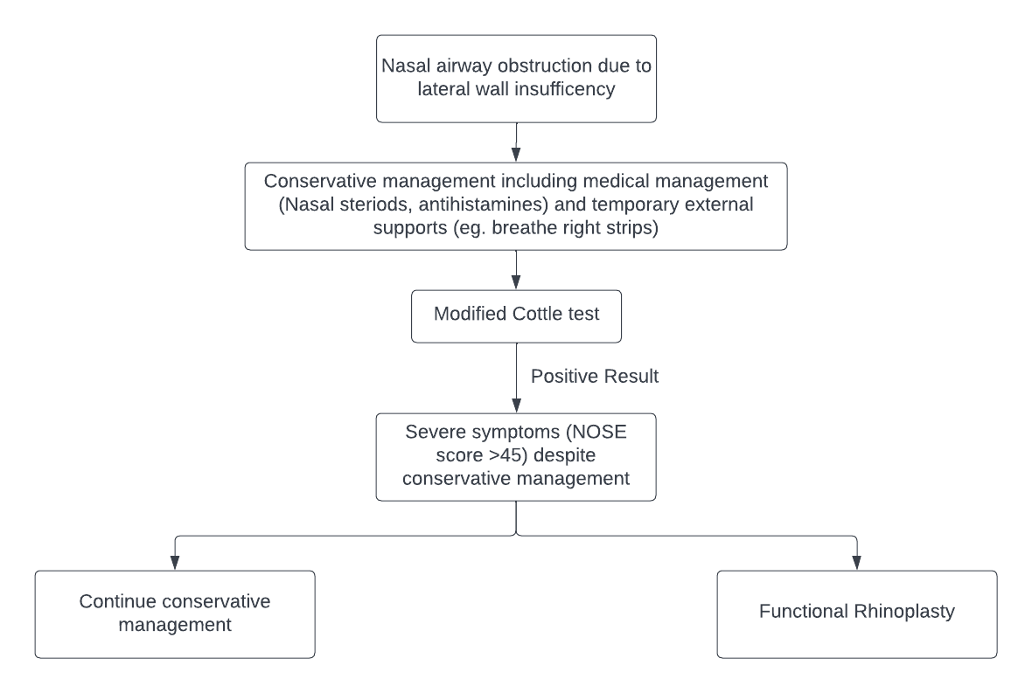

Figure 4 Current clinical management algorithm

NOSE=nasal obstruction symptom evaluation

*PASC noted that lateral wall insufficiency is not necessarily a universally accepted term and is sometimes referred to as nasal valve dysfunction within the literature.*

The diagram in Figure 4 represents the clinical management pathway that patients would follow after the proposed service/technology is introduced.

After the introduction of the bioabsorbable nasal implant, people with NAO would have an additional MBS-approved treatment option, in addition to continued conservative management and functional rhinoplasty. Patients may also use the LATERA implant as a nexus to definitive surgical treatment (if revision surgery is required).

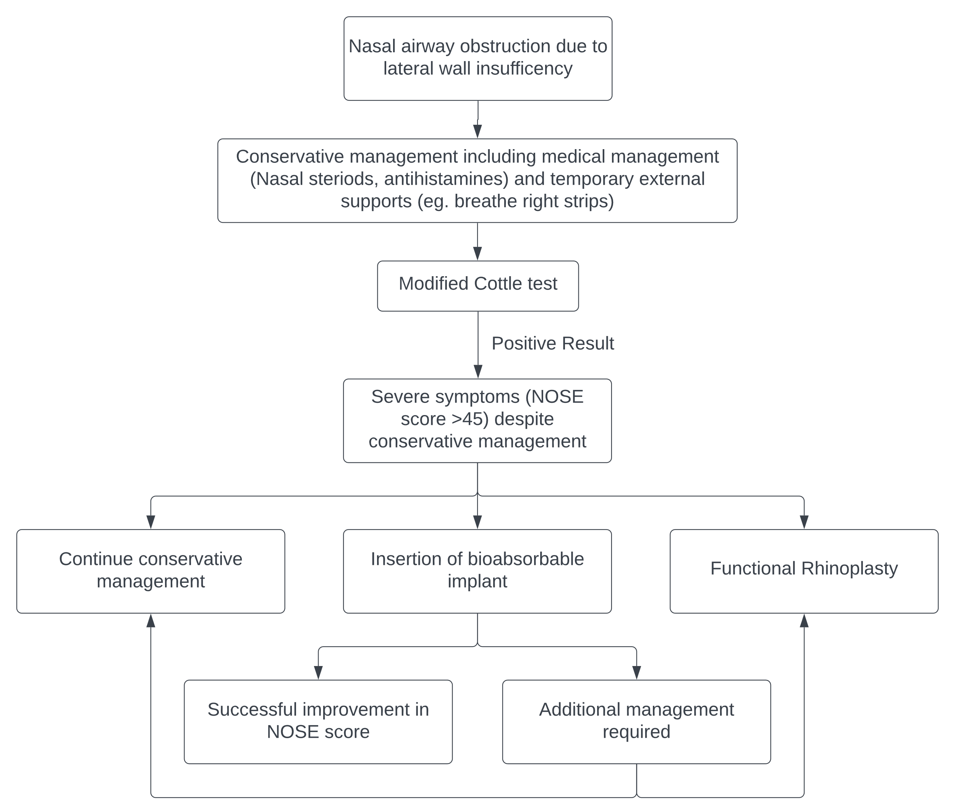

Figure 5 Proposed clinical management algorithm

NOSE=nasal obstruction symptom evaluation

*The applicant noted that the incidence data reported in Table 3 are probably an overestimation as most MBS claims for rhinoplasty are due to malformations and trauma. Lateral wall insufficiency/nasal valve dysfunction patients are only a subset of the population undergoing rhinoplasty.*

*PASC noted that there is insufficient data to determine the longevity of the implant and whether the procedure could be delivered once per lifetime or over multiple occasions. The applicant noted that patients undergoing the comparator, functional rhinoplasty, by the age of 45-50, would be unlikely to require additional surgery after re-tensioning and tightening the cartilage and ligaments of the nose. PASC also discussed whether the bioabsorbable implant procedure would complicate subsequent rhinoplasty procedures due to possible increased fibrosis or other reactions around the device. The applicant acknowledged that while this is unknown for LATERA patients, rhinoplasty surgeons are experienced with procedures involving prior trauma, injectables and other obstacles to surgery.*

*PASC discussed whether the surgery should be restricted to only ENT surgeons. PASC noted that rhinoplasty is currently also performed by plastic surgeons. PASC considered that it was important service provider restricted to surgeons who undergo Australian Medical Council (AMC) accredited training program. PASC also considered that a formal statement may be required to minimise misuse in cosmetic space as rhinoplasty alternative. It was appropriate for the MBS restriction to remain restricted to trained surgeons.*

## Proposed economic evaluation

The overall clinical aim of bioabsorbable nasal implants is to deliver similar improvements in symptoms compared with functional rhinoplasty, while being at least as safe and potentially reducing the length of stay when performed in hospital setting. Superior health outcomes and a non-inferior (referred as tolerable by the applicant) safety profile is expected compared with conservative management.

Based on this clinical claim of non-inferior clinical effectiveness and safety (compared with rhinoplasty) and superior effectiveness (compared with conservative management), the appropriate economic evaluation is cost-effectiveness or cost-utility analysis (Table 5).

Table 5 Classification of comparative effectiveness and safety of the proposed intervention, compared with its main comparator, and guide to the suitable type of economic evaluation

| Comparative safety- |  | Comparative effectiveness |  |  |
| --- | --- | --- | --- | --- |
| Inferior | Uncertaina | Noninferiorb | Superior |
| Inferior | Health forgone: need other supportive factors | Health forgone possible: need other supportive factors | Health forgone: need other supportive factors | ? Likely CUA |
| Uncertaina | Health forgone possible: need other supportive factors | ? | ? | ? Likely CEA/CUA |
| Noninferiorb | Health forgone: need other supportive factors | ? | CMA | CEA/CUA |
| Superior | ? Likely CUA | ? Likely CEA/CUA | CEA/CUA | CEA/CUA |

CEA=cost-effectiveness analysis; CMA=cost-minimisation analysis; CUA=cost-utility analysis

? = reflect uncertainties and any identified health trade-offs in the economic evaluation, as a minimum in a cost-consequences analysis

a ‘Uncertainty’ covers concepts such as inadequate minimisation of important sources of bias, lack of statistical significance in an underpowered trial, detecting clinically unimportant therapeutic differences, inconsistent results across trials, and trade-offs within the comparative effectiveness and/or the comparative safety considerations

b An adequate assessment of ‘noninferiority’ is the preferred basis for demonstrating equivalence

The application provides one comparative study (LATERA RCT) (7) to support the clinical claim. The remaining five studies listed by the applicant in the summary of evidence are non-comparative case series (8-12). No ongoing trials were identified via a search of clinicaltrials.gov.

PASC may wish to consider if the economic evaluation should include both the proposed benefit amount for the Latera implant (noting this will form part of the whole of system cost, regardless of whether or not it is PL-listed) and the cost of consumables, separately calculated. When proposing a PL benefit amount, the sponsor should be advised this should be equal to the reference price – that is, the same as the public sector price (or if this is not available, comparable international prices).

PASC should note that where the procedure is done may have very different costing implications. A successful PLAC listing and subsequent Private Health Insurance (PHI) coverage may not result in coverage of the LATERA device costs when performed in a non-hospital setting. This may also result in significant out-of-pocket costs for the patient in terms of the cost of the device. The assessment should consider the clinical setting and cost implications in the economic evaluation.

*PASC considered the different adverse event profiles of the bioabsorbable implant compared with functional rhinoplasty may result in significant differences in quality of life. A significantly different safety profile may negate the appropriateness of a cost-minimisation analysis. PASC noted that if the patient population included patients who were ineligible for MBS subsidised rhinoplasty, then a cost-effectiveness analysis would be required. However, if the patient criteria were to define a group of patients who would not adopt rhinoplasty due to choice, then a cost-effectiveness and a cost-minimisation analysis would be required. The applicant noted that two economic evaluations (cost-effectiveness analysis for the bioabsorbable implant compared with medical management and cost-minimisation analysis for bioabsorbable implant compared with rhinoplasty) would be conducted, one for each comparator.*

## Proposal for public funding

The applicant proposes new MBS items for public funding of the insertion of bioabsorbable implants for nasal airway obstruction due to lateral wall insufficiency. Drafts of the proposed MBS item descriptors are provided below. It is the intention that the procedure be performed unilaterally and bilaterally, and as such two MBS item have been proposed.

The NOSE Scale cut-off score of greater than 45 is consistent with the MBS item restrictors for rhinoplasty for nasal airway obstruction.

*PASC noted that a moderate NOSE score ends at 50. A severe NOSE score then takes over from 51-80. PASC considered that the difference between thresholds and the item descriptor cut off should be explored in the assessment*

Note that the applicant’s draft of the MBS items contains no details on restrictions on use, limits on frequency of use or provider. Elsewhere in application it is stated that the bioabsorbable nasal implant is proposed to be performed once only per patient and side, and the service is to be provided by ENT specialists.

PASC may want to consider whether restrictions on frequency and service provider be incorporated into the item descriptor.

Additionally, PASC may wish to consider whether a single MBS item covering unilateral and bilateral insertion is preferred. Resource use (ie set up time, time taken for insertion) would be expected to be similar for a unilateral as well as a bilateral insertion. As two implants are included in the LATERA package, this would cover most unilateral and bilateral procedures.

| Category 3 - THERAPEUTIC PROCEDURES |
| --- |
| MBS item XXXX  Unilateral insertion of bioabsorbable implant for nasal airway obstruction due to lateral wall insufficiency confirmed by positive modified Cottle manoeuvre and the patient has a self-reported NOSE Scale score of greater than 45 |
| Fee: TBC |

| Category 3 - THERAPEUTIC PROCEDURES |
| --- |
| MBS item YYYY  Bilateral insertion of bioabsorbable implant for nasal airway obstruction due to lateral wall insufficiency confirmed by positive modified Cottle manoeuvre and the patient has a self-reported NOSE Scale score of greater than 45 |
| Fee: TBC |

LATERA absorbable nasal implant was listed on the Australian Register of Therapeutic Goods on 31/05/2022 (ARTG ID 389271).

An application for inclusion of LATERA in the Prosthesis List was lodged to PLAC in September 2021 however this PL application has been deferred, however the device is eligible for the PL. A successful PL listing and subsequent Private Health Insurance (PHI) coverage may not result in coverage of the LATERA device costs in all the clinical situations included in this application.

*The applicant noted that the application to the PL has been deferred while they seek further advice regarding the use of implantable devices or PL items*

*PASC noted that out-of-pocket costs may be substantial considering the intervention may occur in offices/suites where the cost of the device is not covered under the Prosthesis List. It was discussed whether two different MBS items would be needed for inpatient and outpatient setting, but the Department confirmed that a different MBS item would not be required, as the different MBS benefits (ie 75% benefit, 85% benefit) would cover the different settings. The Department also noted that MBS items can only cover the cost of the service delivery (procedure) and not the cost of the device or components of the device, therefore, a separate item (to address different out-of-pocket expenses) would not be a helpful or practical solution. PASC noted the Department will explore further options to address the issue of additional out-of-pocket expenses for patients.*

## Summary of public consultation input

*PASC noted and welcomed consultation input from 1 health professional.*

**Health** **Professionals**

One submission was received from a health professional. This submission mostly supportive of the public funding for MSAC Application 1719 – *insertion of bioabsorbable implant for nasal airway obstruction due to lateral wall insufficiency*.

The health professional stated that the main benefit of the proposed service is a simple, quick, office procedure. They went on to state that a further benefit to the proposed service is a reduced requirement for surgery. However, they did express that longevity is a concern and that the natural history of absorbable implants is that the effect wears off with time.

The health professional agreed with the population, the intervention, the comparator, and the service descriptor in the application form. However, they stated that a positive Cottle manoeuvre is a fairly non-discriminatory test, because in most people it is positive, and that if it’s negative, the obstruction is likely static and will not be affected by the device.

They disagreed with the clinical claim and stated that there are no comparisons vs well performed rhinoplasty and that rhinoplasty does a lot more than the device can do. They further stated that overall, for select cases, the proposed service may work.

The health professional added that the implant may be very useful in certain circumstances of valve collapse with no other issues. But they went on to state that they think the effect is unlikely to be permanent and that longer term studies are needed for this.

The health professional also stated that Specialist Plastic Surgeons do a large number of rhinoplasties in Australia, and that they disagreed with using rhinologists as the reference group. They further stated that Rhinoplasty surgeons would be the group that carry out the most rhinoplasties and consists of Specialist Otolaryngologist Head and Neck surgeons and Specialist Plastic surgeons.

## Next steps

The MSAC assessment will proceed as an ADAR.

## Applicant comment on the ratified PICO confirmation

### Population

*The Applicant noted PASCs consideration that the population includes a subset of patients who would be averse to surgery or not eligible for rhinoplasty and may prefer a bioabsorbable implant. The applicant considered this to be incorrect as patients ineligible for rhinoplasty would also be ineligible for the bioabsorbable implant. They stated the correct population includes a subset of patients who are contraindicated to rhinoplasty (e.g., due to general anaesthesia requirement) or who would be averse to rhinoplasty surgery due to its invasive nature and therefore may prefer a bioabsorbable implant.*

## References

1. Clark DW, Del Signore AG, Raithatha R, Senior BA. Nasal airway obstruction: Prevalence and anatomic contributors. Ear Nose Throat J. 2018;97(6):173-6.

2. Mohan S, Fuller JC, Ford SF, Lindsay RW. Diagnostic and Therapeutic Management of Nasal Airway Obstruction: Advances in Diagnosis and Treatment. JAMA Facial Plast Surg. 2018;20(5):409-18.

3. Chandra RK, Patadia MO, Raviv J. Diagnosis of nasal airway obstruction. Otolaryngol Clin North Am. 2009;42(2):207-25, vii.

4. Rhee JS, Weaver EM, Park SS, Baker SR, Hilger PA, Kriet JD, et al. Clinical consensus statement: Diagnosis and management of nasal valve compromise. Otolaryngol Head Neck Surg. 2010;143(1):48-59.

5. Esmaili A, Acharya A. Clinical assessment, diagnosis and management of nasal obstruction. Aust Fam Physician. 2017;46(7):499-503.

6. Stefani K, Baxter C, Crittenden T, Dean NR. Normative data for the Nasal Obstruction Symptom Evaluation Scale in the general Australian population. ANZ J Surg. 2020;90(11):2304-9.

7. Stolovitzky P, Senior B, Ow RA, Mehendale N, Bikhazi N, Sidle DM. Assessment of bioabsorbable implant treatment for nasal valve collapse compared to a sham group: a randomized control trial. Int Forum Allergy Rhinol. 2019;9(8):850-6.

8. San Nicolo M, Stelter K, Sadick H, Bas M, Berghaus A. Absorbable Implant to Treat Nasal Valve Collapse. Facial Plast Surg. 2017;33(2):233-40.

9. San Nicolo M, Stelter K, Sadick H, Bas M, Berghaus A. A 2-Year Follow-up Study of an Absorbable Implant to Treat Nasal Valve Collapse. Facial Plast Surg. 2018;34(5):545-50.

10. Sidle DM, Stolovitzky P, O'Malley EM, Ow RA, Nachlas NE, Silvers S. Bioabsorbable Implant for Treatment of Nasal Valve Collapse with or without Concomitant Procedures. Facial Plast Surg. 2021;37(5):673-80.

11. Sidle DM, Stolovitzky P, Ow RA, Silvers S, Matheny K, Bikhazi N, et al. Twelve-month outcomes of a bioabsorbable implant for in-office treatment of dynamic nasal valve collapse. Laryngoscope. 2020;130(5):1132-7.

12. Stolovitzky P, Sidle DM, Ow RA, Nachlas NE, Most SP. A prospective study for treatment of nasal valve collapse due to lateral wall insufficiency: Outcomes using a bioabsorbable implant. Laryngoscope. 2018;128(11):2483-9.