MSAC Application 1736
Lipoprotein(a) testing as an independent predictor of cardiovascular disease

PICO Confirmation

Summary of PICO/PPICO criteria to define question(s) to be addressed in an Assessment Report to the Medical Services Advisory Committee (MSAC)
Table 1 PICO for lipoprotein(a) testing as an independent predictor for cardiovascular disease risk for the index populations
Component | Description
Test population | Population (A) (index population): Adults at moderate CVD risk as assessed by the currently available CVD risk assessment tool recommended by the Australian clinical practice guideline.  Population (B) (index population): Adults at high CVD risk as assessed by the currently available CVD risk assessment tool recommended by the Australian clinical practice guideline, but not optimally managed, Note Population B needs considerable re-framing
Prior tests | Tests required to undertake a risk assessment for CVD using the tool recommended by the current Australia clinical practice guideline.  The timeframe requirement of when these tests must be conducted prior to Lp(a) has not been specified
Intervention | Immunoassay measuring Lp(a) concentration in blood reported as nmol/L
Comparator/s | Current risk assessment, MBS reimbursed lipid profile and management strategies without Lp(a) measurement
Reference standard | While no reference standard was formally defined in the application, the Australian and New Zealand guidelines for the management of absolute cardiovascular disease risk (AIHW 2021a) provide criteria for assessing risk and guiding treatment for different population groups (Table 5)
Outcomes | The following outcomes are relevant to this application:  Safety  - Harms associated with testing  - Harms associated with treatment  Clinical effectiveness  - Test performance outcomes:  - intra-observer or intra-instrument variability/agreement  - analysis of assay test performance, define the lower limit of detection  - concordance between tests  Patient management outcomes  - Diagnostic utility – for each population, confirmation of high Lp(a) concentration  - Change in risk score  - Prognostic utility – for each population, informed change in prognosis without change in treatment  - Need for additional monitoring for CVD risk and/or development of aortic stenosis  - Predictive utility – change in treatment pathway (initiated, ceased, modified, avoided)  - Commencement of treatment  Health outcomes  - Morbidity associated with CVD  - Mortality due to CVD  - Health-related quality of life  - Other patient-relevant outcomes  Non-health outcomes  - The value of knowing, including:  - impact on patient behaviours (e.g. health, diet and exercise)  - impact on first-degree family members (e.g. worry, stress)

Component | Description
Outcomes | Healthcare resource use  - Costs associated with the intervention, including costs of appointments, blood tests; costs of Lp(a) test processing, change in management  - Increased number of individuals treated with a statin  - Cost-effectiveness of Lp(a) testing  - Total Australian Government healthcare costs
Assessment questions | What is the comparative safety, effectiveness, cost-effectiveness and total costs of the use of Lp(a) testing versus current standard of care in the proposed populations A (moderate risk for CVD) and B (high-risk for CVD).
Abbreviations
ASCVD = atherosclerotic cardiovascular disease, CVD = cardiovascular disease, ESC = European Society of Cardiology, HDL = high‑density lipoprotein, HRQoL = health-related quality of life, LDL-C = low-density lipoprotein cholesterol, Lp(a) = lipoprotein(a), PROCAM = Prospective Cardiovascular Münster Study, ROC = receiver operating characteristic
Table 2 PICO for lipoprotein(a) testing as an independent predictor for cardiovascular disease risk for the cascade population
Component | Description
Test population | Adults with a first-degree relative with significantly elevated Lp(a) (>200 nmol/L)
Prior tests | No prior tests are required
Intervention | Immunoassay measuring Lp(a) concentration in blood reported as nmol/L
Comparator/s | No Lp(a) test
Reference standard | While no reference standard was formally defined in the application, the Australian and New Zealand guidelines for the management of absolute cardiovascular disease risk (National Vascular Disease Prevention Alliance 2012) provide criteria for assessing risk and guiding treatment for different population groups (Table 5)
Outcomes | The following outcomes are relevant to this application:  Safety  - Harms associated with testing  - Harms associated with treatment  Clinical effectiveness  - Test performance outcomes:  - intra-observer or intra-instrument variability/agreement  - analysis of assay test performance, define the lower limit of detection  concordance between tests  Patient management outcomes  - Diagnostic utility – for each population, confirmation of high Lp(a)  - Change in risk score  - Prognostic utility – for each population, informed change in prognosis without change in treatment  - Need for monitoring CVD risk and/or development of aortic stenosis  - Predictive utility – change in treatment pathway (initiated, ceased, modified, avoided)  - Commencement of treatment  Health outcomes  - Morbidity associated with CVD  - Mortality due to CVD  - Health-related quality of life  - Other patient-relevant outcomes  Non-health outcomes  - The value of knowing, including:  - impact on patient behaviours (e.g. health, diet and exercise)  - impact on first-degree family members (e.g. worry, stress)  Healthcare resource use  - Costs associated with the intervention, including costs of appointments, blood test; cost of Lp(a) test processing  - Increased number of individuals treated with a statin  - Cost-effectiveness of Lp(a) testing  - Total Australian Government healthcare costs
Assessment questions | What is the comparative safety, effectiveness, cost-effectiveness and total costs of the use of Lp(a) testing versus current standard of care in patients who have a first-degree relative with significantly elevated Lp(a) (>200 nmol/L)?
Abbreviations
ASCVD = atherosclerotic cardiovascular disease, CVD = cardiovascular disease, ESC = European Society of Cardiology, HDL = high‑density lipoprotein, HRQoL = health-related quality of life, LDL-C = low-density lipoprotein cholesterol, Lp(a) = lipoprotein(a), PROCAM = Prospective Cardiovascular Münster Study, ROC = receiver operating characteristic

Purpose of application
An application requesting Medicare Benefits Schedule (MBS) listing of the use of lipoprotein(a) [Lp(a)] testing as an independent predictor of cardiovascular disease was received from the Royal College of Pathologists of Australasia by the Department of Health.
The rationale of this application is that Lp(a) concentration can identify patients at high risk of cardiovascular events (including onset of vascular disease and aortic stenosis) earlier and lead to intensification of lifestyle modification and pharmacotherapy.

PICO criteria

Population
Definition of the condition
- Cardiovascular disease (CVD) refers to conditions due to atherosclerotic changes affecting blood vessels which can lead to stenosis of the affected blood vessels. This application is limited to the following conditions: coronary heart disease – atherosclerotic disease of the blood vessels supplying the heart muscle
- cerebrovascular disease – atherosclerotic disease of the blood vessels supplying the brain
- peripheral arterial disease – atherosclerotic disease of blood vessels supplying the arms and legs
- aortic stenosis- thickening and calcification of the aortic valve
This application includes populations that have been assessed for CVD risk using common risk calculators, however, these are primarily related to managing the risk of coronary heart disease. Please see below for more information on the common risk calculators.
Disease burden
CVD is a significant cause of morbidity and mortality. In 2018–2019, CVD accounted for 5.2% (n = 591,000) of all hospitalisations in Australia, the majority (90%) of which were for acute care (AIHW 2021b). Of these, 27% had a principal diagnosis of coronary heart disease followed by atrial fibrillation (12%), heart failure and cardiomyopathy (12%) and stroke (11%) (AIHW 2021b). Hospitalisation rates for men with CVD are more than twice that of women, with hospitalisation rates and mortality from CVD increasing with age (Figure 1) (AIHW 2021a). Of concern is the rate of hospitalisation among Indigenous Australians, which is 1.7 times higher than that of non-Indigenous Australians (3,300 and 1,900 per 100,000 population, respectively) (National Vascular Disease Prevention Alliance 2012).
Figure 1 Number of hospitalisations (A) and deaths (B) per 100,000 due to cardiovascular disease in Australia (principal diagnosis), by sex, 2018–2019 (AIHW 2021a)
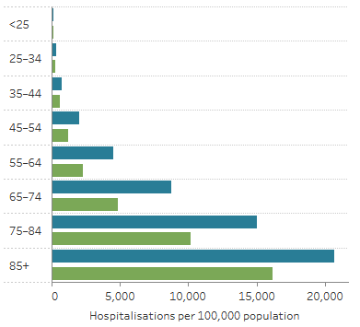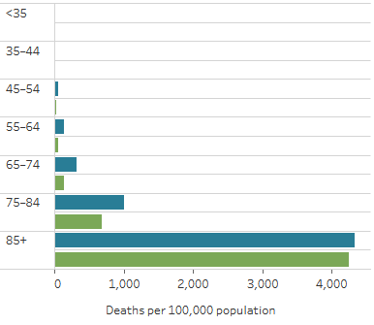
B
A

CVD risk factors
High blood pressure, high concentration of atherogenic cholesterol, overweight and obesity, physical inactivity, excessive alcohol use, poor diet and smoking are all modifiable risk factors for CVD. At least one of these risk factors is present in the majority of Australian individuals, and 25% of Australian adults have three or more risk factors (AIHW 2021a). Because CVD is largely preventable, an emphasis on thorough risk assessment and the modifiable risk factors (lifestyle changes and, when necessary, pharmaceutical treatment) is an essential part of treatment planning.
Lowering a patient’s overall CVD risk is the goal of CVD management and this is accomplished by managing numerous individual risk variables. Individual risk factors such as high blood pressure (BP) and elevated lipid concentration have been shown to continuously increase the risk of CVD events; as a result, moderate reductions in several risk factors may be more effective than a major reduction in one risk factors in lowering overall CVD risk (Tonkin et al. 2005).
Elevated concentration of low-density lipoprotein cholesterol (LDL-C) have been demonstrated to be a major contributor to atherosclerosis leading to CVD events, the cumulative effects of which may begin increasing from adolescence (Zhang et al. 2021). The mainstay of CVD treatment, in combination with lifestyle modifications, are drugs that reduce LDL-C which, if adhered to, significantly lower CVD risk among the majority of patients; however, some patients remain at risk of CVD and/or experience a CVD event despite significant lowering of their LDL-C.

Candidate patients for CVD risk assessment
The following information is from the current version of the Australian CVD guidelines developed by the National Vascular Disease Prevention Alliance in 2021. However we understand that there have been updates to this guideline that are currently out for consultation. The information below should be updated as relevant when the new version is available.
The Australian and New Zealand guidelines (National Vascular Disease Prevention Alliance 2012) for the management of absolute CVD risk recommend the following patients undergo risk assessment:
- In the general population aged 45–74 years who are not known to have CVD, absolute CVD risk assessment should be performed using the Framingham Risk Score to predict their risk of a cardiovascular event over the next 5 years.
- In Aboriginal and Torres Strait Islander adults aged 35–74 years who are not known to have CVD or to be at clinically determined high risk, absolute cardiovascular risk over the next 5 years should be calculated using the Framingham Risk Equation. Although the Framingham Risk Equation might underestimate risk in this population, available evidence suggests that this approach will provide an estimate of minimum cardiovascular risk.
- In adults with diabetes aged 60 years or less who are not known to have CVD or to be at clinically determined high risk, absolute cardiovascular risk over the next 5 years should be assessed using the Framingham Risk Equation. Although the Framingham Risk Equation might underestimate risk in this population, available evidence suggests that this approach will provide an estimate of minimum cardiovascular risk.
- In adults who are overweight or obese who are not known to have CVD or to be at clinically determined high risk, absolute cardiovascular risk over the next 5 years should be assessed using the Framingham Risk Equation. The results should be interpreted with the awareness that its predictive value has not been specifically assessed in this population (AIHW 2021a).
Measuring risk for CVD
Because individual patients are likely to have more than one risk factor, assessment of CVD risk is undertaken on the basis of the combined effect of multiple risk factors; this is more accurate than the use of individual factors alone (National Vascular Disease Prevention Alliance 2012). Table 2 describes the individual risk factors published by the National Vascular Disease Prevention Alliance, which should be measured when assessing risk (National Vascular Disease Prevention Alliance 2012).
The results of the assessment of individual risk factors, together with non-modifiable factors (e.g. age, gender, family history of CVD) are entered into one of several available online calculators (Heart Foundation; The National Vascular Disease Prevention Alliance 2022) based on validated equations (e.g. The Framingham Equation (Wilson et al. 1998)) to calculate an individual patient’s risk score. The CVD risk score refers to the likelihood of a person experiencing a cardiovascular event within the next 5 years.
CVD management
The following information is from the current version of the Australian CVD guidelines, however we understand that there have been updates to this guideline that are currently out for consultation. The information below should be updated as relevant when the new version is available.
The risk of CVD is greatly lowered through lifestyle modifications and pharmacotherapy. Lifestyle modifications include smoking cessation, maintaining a healthy weight, limiting alcohol and increasing physical activity, while the use of medications most often includes those that lower LDL-C and antihypertensives.
Over 107 million Pharmaceutical Benefits Scheme (PBS) prescriptions for cardiovascular medicines were supplied to the Australian community in 2019–2020 (AIHW 2021a). These comprised one-third (35%) of the total number of PBS prescriptions. Rosuvastatin (12.7 million) and atorvastatin (11.0 million)—both lipid-modifying medicines—and perindopril (6.6 million)—a BP lowering medicine—were among the most commonly supplied PBS medicines in Australia in 2019–2020 (AIHW 2021a).
Table 3 Risk factors that may be considered for absolute cardiovascular disease risk assessment
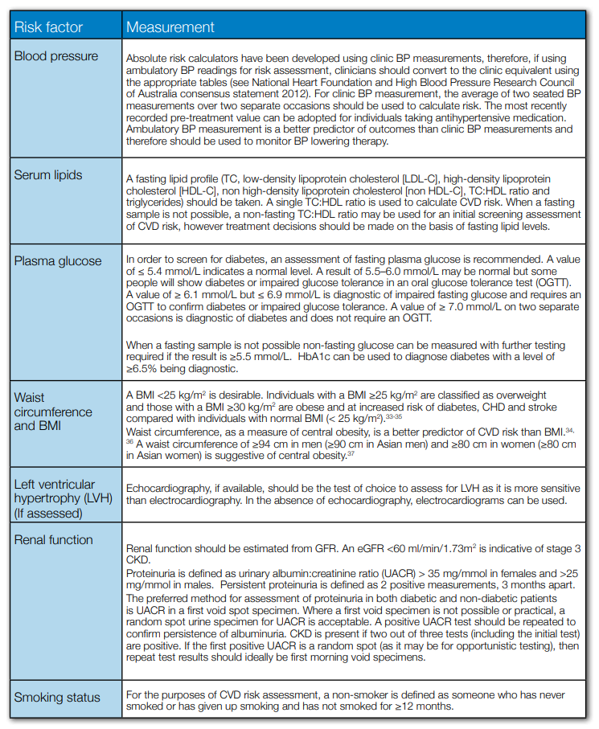
Abbreviations
ASCVD = atherosclerotic cardiovascular disease, BMI = Body mass index, BP = Blood pressure, CHD = Coronary heart disease, CKD = Chronic kidney disease, CVD = cardiovascular disease, eGFR = estimated glomerular filtration rate, ESC = European Society of Cardiology, HBA1C = Haemoglobin A1C, HDL = high‑density lipoprotein, HDL-C = high‑density lipoprotein cholesterol, HRQoL = health-related quality of life, LDL-C = low-density lipoprotein cholesterol, Lp(a) = lipoprotein(a), LVH = Left ventricular hypertrophy, OGTT = Oral glucose tolerance test, PROCAM = Prospective Cardiovascular Münster Study, ROC = receiver operating characteristic, TC = Total cholesterol, UACR = Urinary albumin:creatinine ratio
Notes: There are references listed in the Waist Circumference and BMI risk factor category; these can be found in the guideline text cited below.
Source: National Vascular Disease Prevention Alliance 2012, Guidelines for the management of absolute cardiovascular disease risk, <https://www.heartfoundation.org.au/getmedia/4342a70f-4487-496e-bbb0-dae33a47fcb2/Absolute-CVD-Risk-Full-Guidelines_2.pdf>
Eligible candidates for Lp(a) testing
Lp(a) has been found by a recent systematic review to be an independent risk factor for coronary heart disease death, nonfatal myocardial infarction, and stroke (Forbes et al. 2016). The review reported an independent positive association between Lp(a) and the risk of future CVD events both in the general population and in high-risk populations, including those with diabetes and hypertension or on dialysis (Forbes et al. 2016). Approximately 1 in 5 individuals have Lp(a) concentration >150 nmol/L, which is associated with a 1.5-fold risk for CVD (Forbes et al. 2016). Individuals with very high concentration of Lp(a) may have an increased CVD risk (4- to 8-fold) compared with individuals with normal Lp(a).
Prior to a Lp(a) test, patients from the index population must have had a CVD risk assessment completed, whereas the cascade population will require the associated index cases to have a high Lp(a) concentration, or to meet certain (additional) clinical criteria. The applicant suggested 4 groups of patients for Lp(a) testing. The first population subgroup was proposed for patients with moderate 10-year CVD risk (10-15%) when classical risk algorithms are used, such as the Framingham Risk Score, the PROCAM risk score, the ESC HeartScore or the Australian and New Zealand risk calculator. The second population subgroup was proposed for adults to assess or stratify CVD risk in those with the following clinical features: a personal history of premature CVD (<60 years), family history of premature CVD, family history of high Lp(a) (>200 nmol/L), familial hypercholesterolaemia, significant renal impairment, early onset calcific aortic stenosis (<60 years). The third population subgroups could include patients with recurrent or progressive CVD despite optimally treated plasma LDL-C concentrations. Finally, the fourth subgroup included children and adolescents with familial hypercholesterolaemia, premature CVD, a first-degree relative with significantly elevated Lp(a) (>200 nmol/L), a family history of premature ASCVD.
The 4 population subgroups described above by the applicant were proposed based on clinical features; however, these population descriptors did not clearly delineate the index patients and the cascade patients for testing populations. Population 1 is clear, however populations 2 and 3 are likely to be high risk patients due to their current diagnoses. We have simplified the populations with two index populations and a cascade population. To avoid confusion with the applications numbered population subgroups, we renamed the populations as A, B and C.
The revised populations for Lp(a) testing:
- Population A (index population): adults at moderate CVD risk as assessed by the currently available CVD risk assessment tool recommended by the Australian clinical practice guideline.
- Population B (index population): adults at high CVD risk as assessed by the currently available CVD risk assessment tool recommended by the Australian clinical practice guideline, but not optimally managed
- Population C (cascade population): Patients at any age with a first-degree relative with significantly elevated Lp(a) (>200 nmol/L).
PASC noted several issues around the definition of the proposed three populations:
- PASC considered the definition of adults at moderate CVD risk (population A) as proposed in the PICO was reasonable. PASC noted that the applicant suggested to also include patients with low CVD risk. However, PASC considered that the population should still focus on the moderate risk group where the impact of the test could be reflected via re-classification of the CVD risk.
- PASC advised that adults at high CVD risk (Population B) needs to be more clearly defined and to include:
(i) asymptomatic individuals at high CVD risk
(ii) patients who are symptomatic with premature CVD and/or aortic stenosis
(iii) patients at high CVD risk and with family history of hypercholesterolaemia
(iv) patients with family history of premature CVD.
However, this expansion would result in some overlap with population C and A.
- PASC noted that the rationale for testing children as part of the cascade population (population C) is not clear. The applicant agreed that the clinical utility of Lp(a) in children and adolescents under 18 years is low and that there is no validated risk assessment tool for this population.
- There is a lack of definitions for the pre-test population, including the number of patients that would potentially be eligible for Lp(a) testing.
- There is a discrepancy between risk scores for Lp(a) classification with high risk defined as >200nmol/L while for the cascade population this has been defined as >100nmol/L. PASC noted that the 200nmol/L cut-off would be acceptable for both the index and the cascade populations.
PASC requested that further work is done to clarify the populations for this PICO, in particular population B.
PASC also considered there was high uncertainty around the estimation of the size of the proposed population as the information provided in the application is only a subpopulation of population B, and population A and C are not necessarily captured. It was suggested that the number of patients potentially eligible for the Lp(a) test could be significantly underestimated. However, until the definition of the population is clarified can appropriate estimates of the testing population be better understood.
PASC also noted that professional education would be important for Lp(a) testing to be successfully implemented.

Intervention
Lp(a) is made up of an apolipoprotein(a) molecule that is attached to an LDL-like particle that is encoded by the highly polymorphic LPA gene. Lp(a) concentration, in contrast to most other forms of cholesterol particles, is genetically predetermined. Lp(a) should typically only be tested for once in a person's lifetime because they tend to be stable over the course of a lifetime and are not greatly affected by factors like age, sex, physical activity, dietary changes or the majority of medicines used to treat high cholesterol (The Royal College of Pathologists of Australasia 2022). The applicant suggests that for most patients this would be a one-off diagnostic test; however, in the near future when patients have access to Lp(a)-lowering therapies, follow-up testing of these patients may be required to monitor changes in Lp(a) (The Royal College of Pathologists of Australasia 2022).
Procedure and measurement
Patients may be referred for Lp(a) testing by their treating general practitioner, consultant physician or cardiovascular specialist. The Lp(a) test requires venepuncture to be performed on the patient for the collection of a blood/plasma sample that is referred to a pathology laboratory for analysis.
Lp(a) can be measured using a variety of methods, including enzyme-linked immunosorbent assays (ELISA), latex agglutination, immunoturbidimetry/immunonephelometry, electrophoresis and immunofixation electrophoresis (IFE) (Wyness & Genzen 2021) or by mass spectrometry. Testing would be provided by approved pathology practitioners in line with other tests on the MBS Pathology Services Table.
The applicant suggested that a major challenge to the accurate measurement of Lp(a) is the heterogeneity in apo(a) size between, as well as within, individual patients. Lp(a) has historically been expressed in mass units (mg/dL), which includes the mass of the entire particle, including the content of apo(a), apoB-100, cholesterol, cholesteryl ester, phospholipid, triglyceride and carbohydrate. This should be avoided, as what is measured by preferred methods is the number of Lp(a) particles (molar concentration) and not the lipid and carbohydrate content. The most appropriate unit of measurement of Lp(a) is nmol/L (Cegla et al. 2021).
There is clinical evidence reporting elevated Lp(a) as a significant predictor of an increased risk for CVD events. A systematic review conducted in 2016 reported that among 39 studies carried out in participants from the general population (patients not selected based on their baseline history or risk of CVD events) a statistically significant relationship was identified between increased Lp(a) and an increased risk of future CVD. Fourteen studies that assessed the relationship between Lp(a) and CVD outcomes in patients with previous CVD events reported a modest statistically significant relationship (hazard ratio from 0.75 to 3.7).
Additional studies among patients with no prior CVD diagnosis reported that Lp(a) was a risk factor for CVD outcomes in 126,634 participants in 36 prospective studies (Erqou et al. 2009), 15,152 cases and 14,820 controls from 52 countries in a case control study (Paré et al. 2019), and 1,560 patients with chest pain in Germany (Greif et al. 2013). Further studies among patients with a history of CVD reported that Lp(a) was a risk factor for CVD outcomes among 27,564 participants in a randomised controlled trial (RCT) (O'Donoghue et al. 2019) and among 4,078 patients in a study conducted in China (Liu et al. 2020).
Therapeutic evaluation
Testing would be delivered only by the National Association of Testing Authorities (NATA), Accredited Pathology Laboratories (as defined in MBS Pathology Services Table). in line with other tests in the MBS Pathology Services Table. Interpretation of results would be provided by an approved pathology practitioner.
With respect to different populations described above, the Lp(a) test result is intended to be useful to:
- Population A (index population): Patients who are moderate risk but have a significantly elevated Lp(a) (>200 nmol/L) are re-classified as high risk and will have their CVD management plan reviewed and updated.
- Population B (index population): Patients who are high risk but have a significantly elevated Lp(a) (>200 nmol/L) will have their CVD management strategy reviewed with optimisation where the intervention could be intensified, so that additional CVD risk due to the elevated Lp(a) could be offset accordingly.
- Population C (cascade population): Patients in the cascade population will fall into various risk categories based on their Lp(a) test. Early and appropriate interventions could be considered to reduce and manage the ongoing CVD risks to improve patients’ long-term outcomes.
Future treatments
There is some preliminary evidence of benefit from the PCSK9 inhibitor evolocumab with one RCT reporting that evolocumab significantly reduced Lp(a) concentration where patients with higher baseline Lp(a) concentration experienced greater absolute reductions in Lp(a) and derived greater coronary benefit from PCSK9 inhibition (O'Donoghue et al. 2019). Currently, evolocumab is indicated in the PBS for the treatment of patients with familial hypercholesterolaemia, not for those with elevated Lp(a).
The applicant identified 4 ongoing trials comparing PCSK9 inhibitors to placebo (Table 4) and provided details about their interventions and estimated completion date (The Royal College of Pathologists of Australasia 2022).
Table 4 Ongoing trials of PCSK9 inhibitors
Study design | Trial title | Participants and primary endpoint | Estimated dates and NCT record number
 | Lp(a) inclusion criteria
RCT | Assessing the Impact of Lipoprotein (a) Lowering with TQJ230 on Major Cardiovascular Events in Patients With CVD (Lp(a)HORIZON) | 7,680 participants with elevated Lp(a) (≥70 mg/dL) randomised to receive TQJ230 (pelacarsen) or placebo  Primary endpoint: time to first major adverse cardiovascular event | Start date: Dec 2019  Estimated completion: June 2024  NCT04023552
RCT | Safety, Tolerability, Pharmacokinetics and Pharmacodynamics Study of AMG 890 in Subjects With Elevated Plasma Lipoprotein(a) | 80 participants with elevated Lp(a) randomised to receive AMG 890 (olpasiran) or placebo  Primary endpoint: incidence of adverse events | Start date: July 2018  Estimated completion: Aug 2022  NCT03626662
RCT | Olpasiran Trials of Cardiovascular Events And Lipoprotein(a) Reduction - DOSE Finding Study | 290 participants with elevated Lp(a) (>150 nmol/L) randomised to receive various doses of olpasiran or placebo.  Primary endpoint: per cent change in Lp(a) | Start date: July 2020  Estimated completion: March 2023 NCT04270760
 | No Lp(a) inclusion criteria
RCT | A Randomized Trial Assessing the Effects of Inclisiran on Clinical Outcomes Among People With Cardiovascular Disease (ORION-4) | 15,000 participants aged >55 years with pre-existing atherosclerotic cardiovascular disease will be randomised to receive inclisiran sodium 300 mg or placebo  Primary endpoint: time to first major adverse cardiovascular event | Start date: Oct 2018  Primary completion: July 2026  Estimated completion: Dec 2049 NCT03705234

The applicant claims that the testing of Lp(a) has superior effectiveness; however, in order for a new or additional test that will result in increased costs to claim superiority, an improvement in health is required to be demonstrated. The improvement in health suggested by the applicant is based on the assumption that earlier intervention of aggressive lifestyle modifications and lipid lowering with statins or low-dose aspirin will reduce overall CVD risk by lowering LDL-C. However, the effectiveness of these interventions targeting patients with the elevated Lp(a) remains uncertain. A large RCT (n = 25,000+) suggested that Lp(a) is independently associated with CVD risks and patient outcomes may not be substantially improved by lowering LDL-C alone. The applicant has acknowledged that their suggested interventions will not lower Lp(a) and there are currently no treatments listed on the MBS that are appropriate for doing so.
PASC agreed that the intervention is Lp(a) testing and noted the applicant’s suggestion that Lp(a) should be measured in nmol/L, which would improve standardisation but may mean that some laboratories would have to change their reporting units.
PASC also acknowledged that the national guideline for CVD risk assessment is currently undergoing public consultation and will be finalised for publication in 2023. However, PASC also noted that information around the proposed Lp(a) testing may or may not be captured by the guideline update due to the population on which the guideline is focused (adults without known CVD) is not necessarily in line with the proposed population in the PICO.
PASC noted that Lp(a) testing could be requested by a GP or consultant physician/specialist and thus restricting the service to consultant physicians and specialists (as suggested by the Department) is unrealistic given some patients, and the cascade population, will be asymptomatic.
PASC noted that Lp(a) testing for the secondary prevention of CVD was not considered in the current PICO. PASC also noted that the success of secondary prevention led by Lp(a) testing may not be realised until an effective therapeutic option becomes available; however, the proposed Lp(a) testing may be a better value proposition under the secondary prevention setting.

Comparator(s)
The applicant proposes that there is no true comparator for Lp(a) testing because there are no other existing technologies or methods to assess Lp(a). Also, there is no equivalent or comparable biomarker to directly or indirectly measure the level of Lp(a); therefore, the comparator is defined as CVD risk assessment with lipid profile assessment, but no Lp(a) testing. Lp(a) testing will be considered as an add-on to the standard of care.
Due to the absence of reference standards and comparative diagnostic technologies, any benefit of Lp(a) testing could only be realised through the reduction in CVD risks demonstrated by improvement of treatment strategies and better patient outcomes. Analytical validity and diagnostic accuracy outcomes may not be feasible to compare. In order to demonstrate the clinical benefit of Lp(a) testing, several key linkage points from the finding of elevated Lp(a) to better patient outcomes should be established during the assessment phase. It should also be noted that the currently available clinical guidelines in CVD risk assessment and management have not been updated to consider Lp(a) as a part of the standard care; therefore, the most important pivot point for Lp(a) testing is dependent on CVD risk modification.
One of the risk management strategies published by the National Vascular Disease Prevention Alliance is provided here as a reference. Treatment and management strategies are fully reliant on the 3 risk levels; therefore, the Lp(a) testing will need to use clinical evidence to sufficiently demonstrate the comparative effectiveness of improving the risk classification compared to the current algorithm.
In addition to improvement in CVD risk classification, the assessment will also need to demonstrate that patients who are reclassified to higher CVD risk due to elevated Lp(a) can be effectively managed via current or emerging treatment options. Patients with different treatment options (due to Lp(a)-driven CVD risk reclassification) will be compared for relevant outcomes.
A risk management summary (see Table 5) published by the National Vascular Disease Prevention Alliance (National Vascular Disease Prevention Alliance 2012) describes the recommended assessment pathway, interventions, targets and follow up. Decisions regarding management of risk are made according to the individual patient’s absolute risk level, while response to treatment is monitored by measurement of individual risk factors.
The following information is from the current version of the Australian CVD guidelines, however we understand that there have been updates to this guideline that are currently out for consultation. The information below should be updated as relevant when the new version is available.
Table 5 Risk management summary
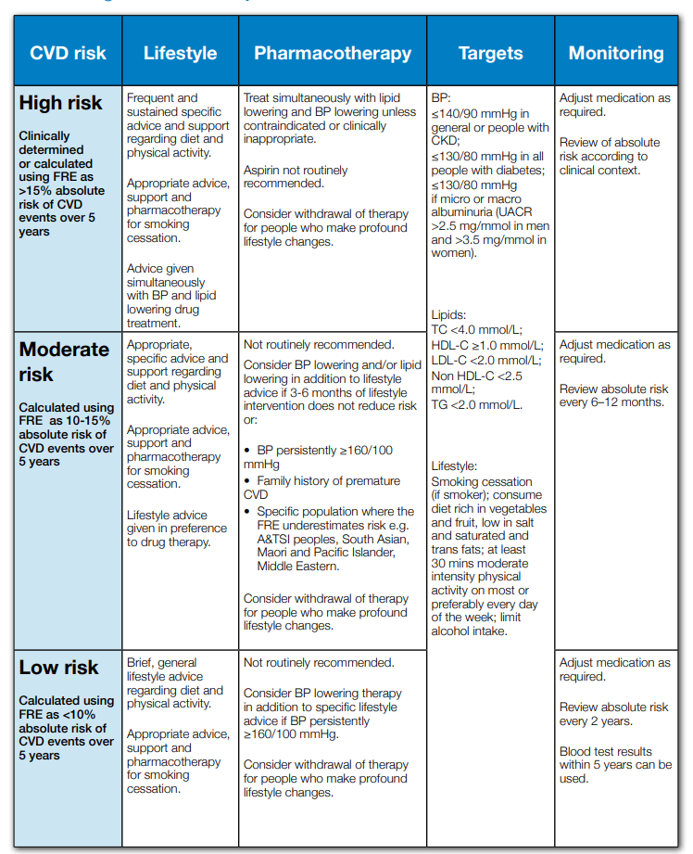
Abbreviations
A&TSI: Aboriginal and Torres Strait Islander peoples; BP = Blood pressure, CKD = Chronic kidney disease, CVD = cardiovascular disease, FRE = Framingham Risk Equation, HDL = high‑density lipoprotein, HDL-C = high‑density lipoprotein cholesterol, LDL-C = low-density lipoprotein cholesterol, Lp(a) = lipoprotein(a), LVH = Left ventricular hypertrophy, OGTT = Oral glucose tolerance test, PROCAM = Prospective Cardiovascular Münster Study, ROC = receiver operating characteristic, SBP = Systolic blood pressure, TC = Total cholesterol, TG = Triglycerides, UACR = Urinary albumin:creatinine ratio
Source: National Vascular Disease Prevention Alliance 2012, Guidelines for the management of absolute cardiovascular disease risk, <https://www.heartfoundation.org.au/getmedia/4342a70f-4487-496e-bbb0-dae33a47fcb2/Absolute-CVD-Risk-Full-Guidelines_2.pdf>

PSAC agreed that there is no true comparator and the comparator for this PICO should therefore be current practice with standard lipid profiling and the use of risk assessment tools (without Lp(a) testing).
PASC noted that coronary artery calcium score is being used in some patients (position statement by Heart Foundation suggests it may be useful in a subset of the population) but is not MBS funded so is not a comparator.

Outcomes
The applicant has provided a list of relevant outcomes to assess the Lp(a) testing for its clinical safety and effectiveness. Expanding upon the list of outcomes provided in the application material, a full list of outcomes is proposed below, and they will be investigated during the assessment phase. These outcomes are all applicable to the population subgroups in this PICO Confirmation; therefore, the proposed list of outcomes is generally presented without specifying any patient cohort.
Due to the proposed treatments indirect effect on CVD risk, the value of knowing was included as a non-health patient-relevant outcome. Instead of directly influencing therapeutic decision-making, the information offered by Lp(a) may indirectly influence patient care. Patient empowerment from the value of knowing and decision making, reassurance or the sense of self-control provided by knowing, increased sense of wellbeing and satisfaction, possibility of positive behaviour change, connection to people with the same condition for peer support and seeking education and social care are possible benefits attributable to the value of knowing. The importance of knowledge may also be advantageous to family, caregivers, medical professionals, and society as a whole.
Test performance outcomes may not be adequately addressed because there is no other currently available technology or method of measuring Lp(a). From an assessment point of view, there is no way to determine these. If Lp(a) testing were to be implemented, it would be assumed that the test performance was accurate.
Safety
- Harms associated with testing
- Harms associated with treatment.
Clinical effectiveness
Test performance outcomes (noting that they may not be feasible to examine due to the lack of adequate reference standards and comparators)
- Test performance outcomes:
  - intra-observer or intra-instrument variability/agreement
  - analysis of assay test performance, define the lower limit of detection
  - concordance between tests
Patient management outcomes
- Diagnostic utility – for each population, confirmation of high Lp(a)
- Change in risk score
- Prognostic utility – for each population, informed change in prognosis without change in treatment
- Need for monitoring CVD risk and/or development of aortic stenosis
- Predictive utility – change in treatment pathway (initiated, ceased, modified, avoided)
- Commencement of treatment
Health outcomes
- Morbidity associated with CVD
- Mortality due to CVD
- Health-related quality of life
- Other patient-relevant outcomes
Non-health outcomes
- The value of knowing, including:
  - impact on patient behaviours (e.g. dietary changes and physical exercise)
  - impact on first-degree family members (e.g. worry, stress)
Healthcare resource use
- Costs associated with the intervention, including costs of appointments, blood tests, costs of Lp(a) test processing, change in management
- Increased number of individuals treated with a statin
- Cost-effectiveness of Lp(a) testing
- Total Australian Government healthcare costs
PASC acknowledged that due the absence of a reference standard, the diagnostic accuracy outcome cannot be adequately assessed. The current (and future updated) guideline may be considered as a reference standard. However, they could not be used to assess the testing performance. PASC advised that the assessment should focus more on patient-related outcomes. However, these outcomes are not directly linked to the testing result, and the indirectness will need to be adequately addressed in the assessment phase.
PASC also raised the that the statin usage may be increased as the result of the proposed testing. This outcome is now added to the healthcare resource use in the PICO.
PASC agreed that any benefit of Lp(a) testing can only be realised through the reduction in CVD risks demonstrated by improvement of treatment strategies (e.g. impact of behavioural changes [primary prevention]) and better patient outcomes. In order to demonstrate the clinical benefit of Lp(a) testing, several key linkage points from the finding of an elevated Lp(a) level to better patient outcomes should be established during the assessment phase. Lp(a) testing will need to use clinical evidence to sufficiently demonstrate the comparative effectiveness of improving the risk classification compared to the current algorithm.
PASC acknowledged that this application may be reconsidered as a codependent application where the Lp(a) is the test, and the emerging therapeutic option would be the matching intervention. However, the current application is not presented as a codependent to support a PBAC application for a PCSK9 inhibitor (e.g. evolocumab) so is outside of the scope of the current PICO.

Assessment framework (for investigative technologies)
Lp(a) testing is an investigative technology and may benefit patients by impacting subsequent management decisions, specifically in that patients who are at moderate level of CVD risk would be reclassified as being at high risk. In addition, receiving a diagnosis of high Lp(a) may add value to the patient journey in other ways (i.e. value of knowing).
Three separate assessment frameworks have been developed to illustrate pathways for the 3 subpopulations. They are illustrated in Figure 2, Figure 3, and Figure 4, respectively.
Figure 2 Assessment framework for population A
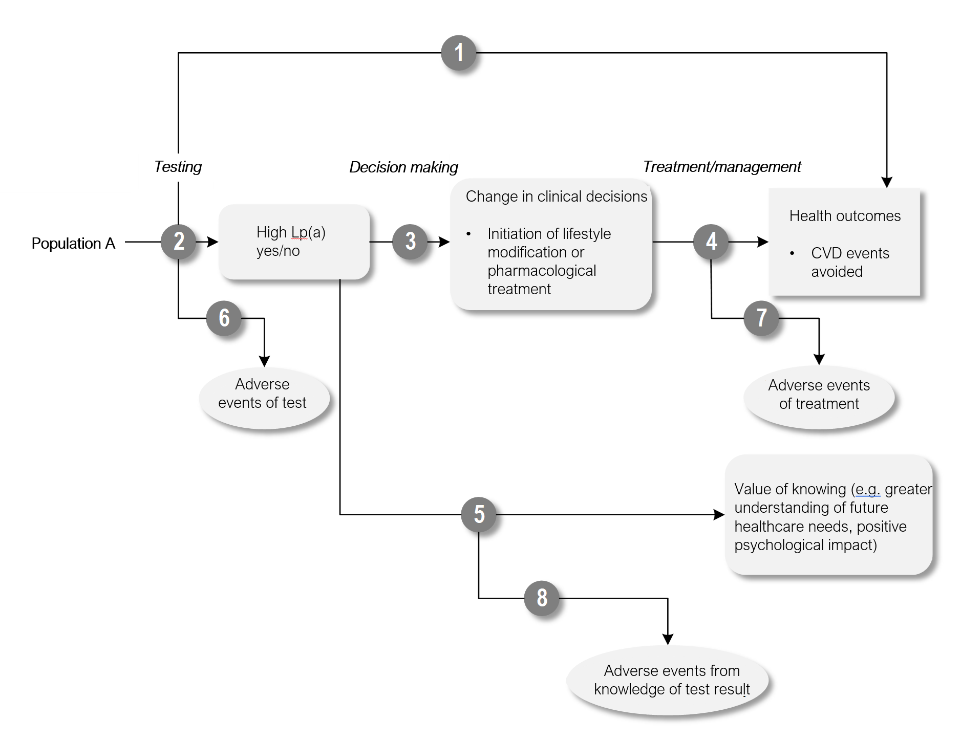
Figure notes: 1: direct from test to health outcomes evidence; 2: test accuracy; 3: change in diagnosis/treatment/management; 4: influence of the change in management on health outcomes; 5: benefits associated with the value of knowing; 6: adverse events due to testing; 7: adverse events due to treatment; 8: harms associated with the value of knowing
Figure 3 Assessment framework for population B
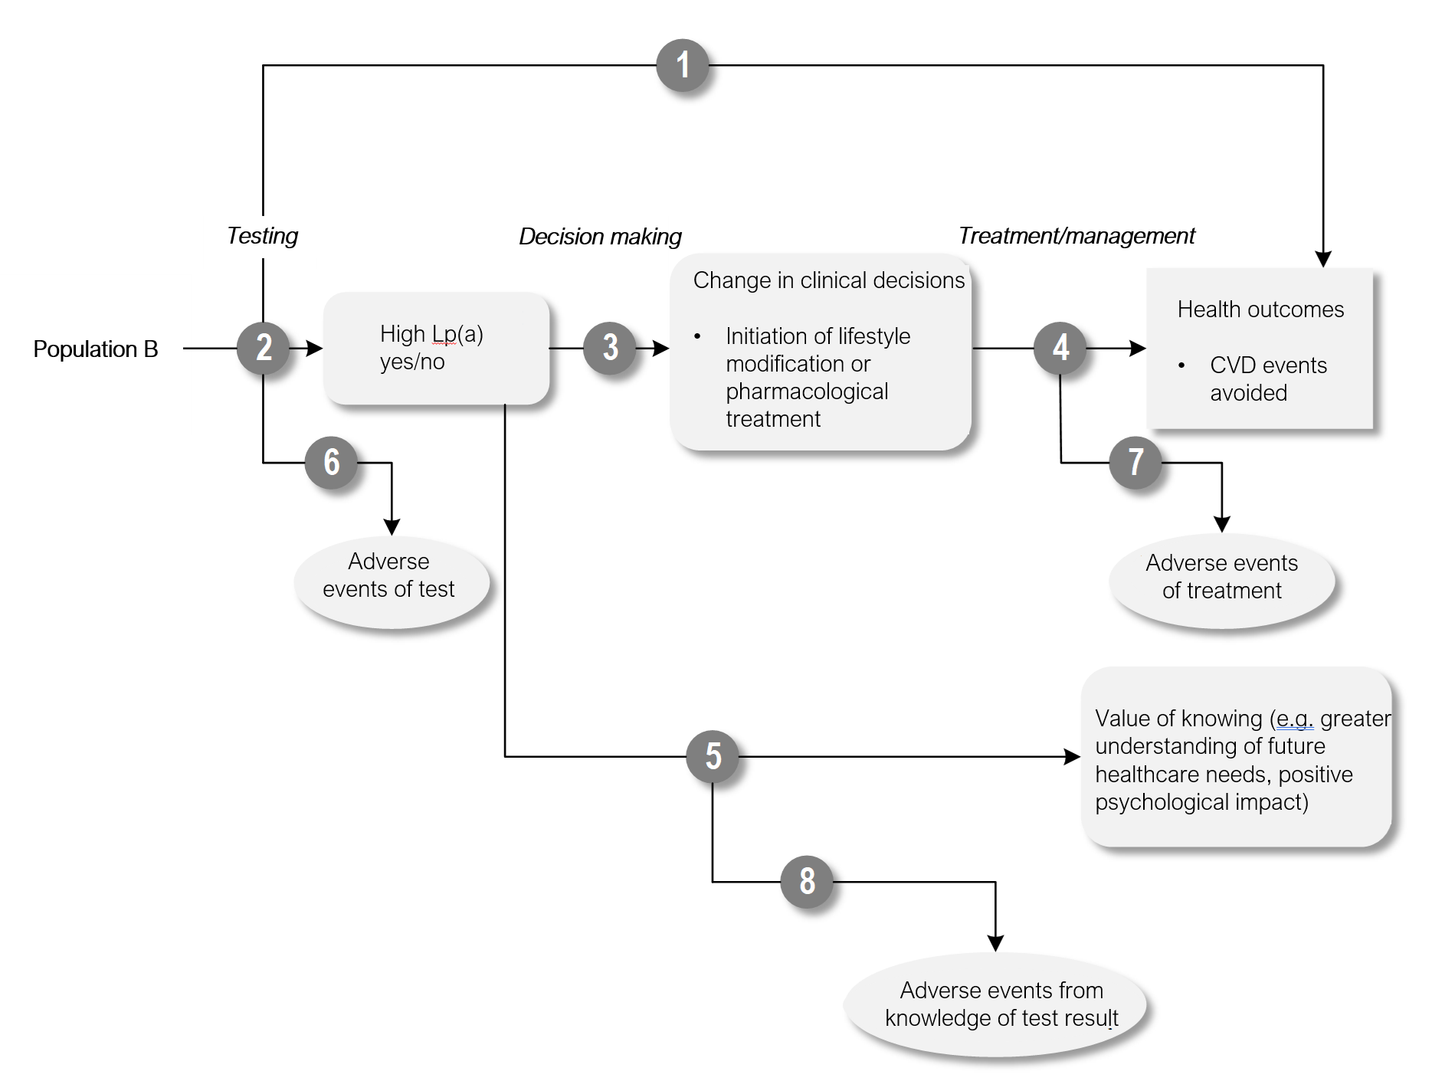
Figure notes: 1: direct from test to health outcomes evidence; 2: test accuracy; 3: change in diagnosis/treatment/management; 4: influence of the change in management on health outcomes; 5: benefits associated with the value of knowing; 6: adverse events due to testing; 7: adverse events due to treatment; 8: harms associated with the value of knowing
Figure 4 Assessment framework for population C
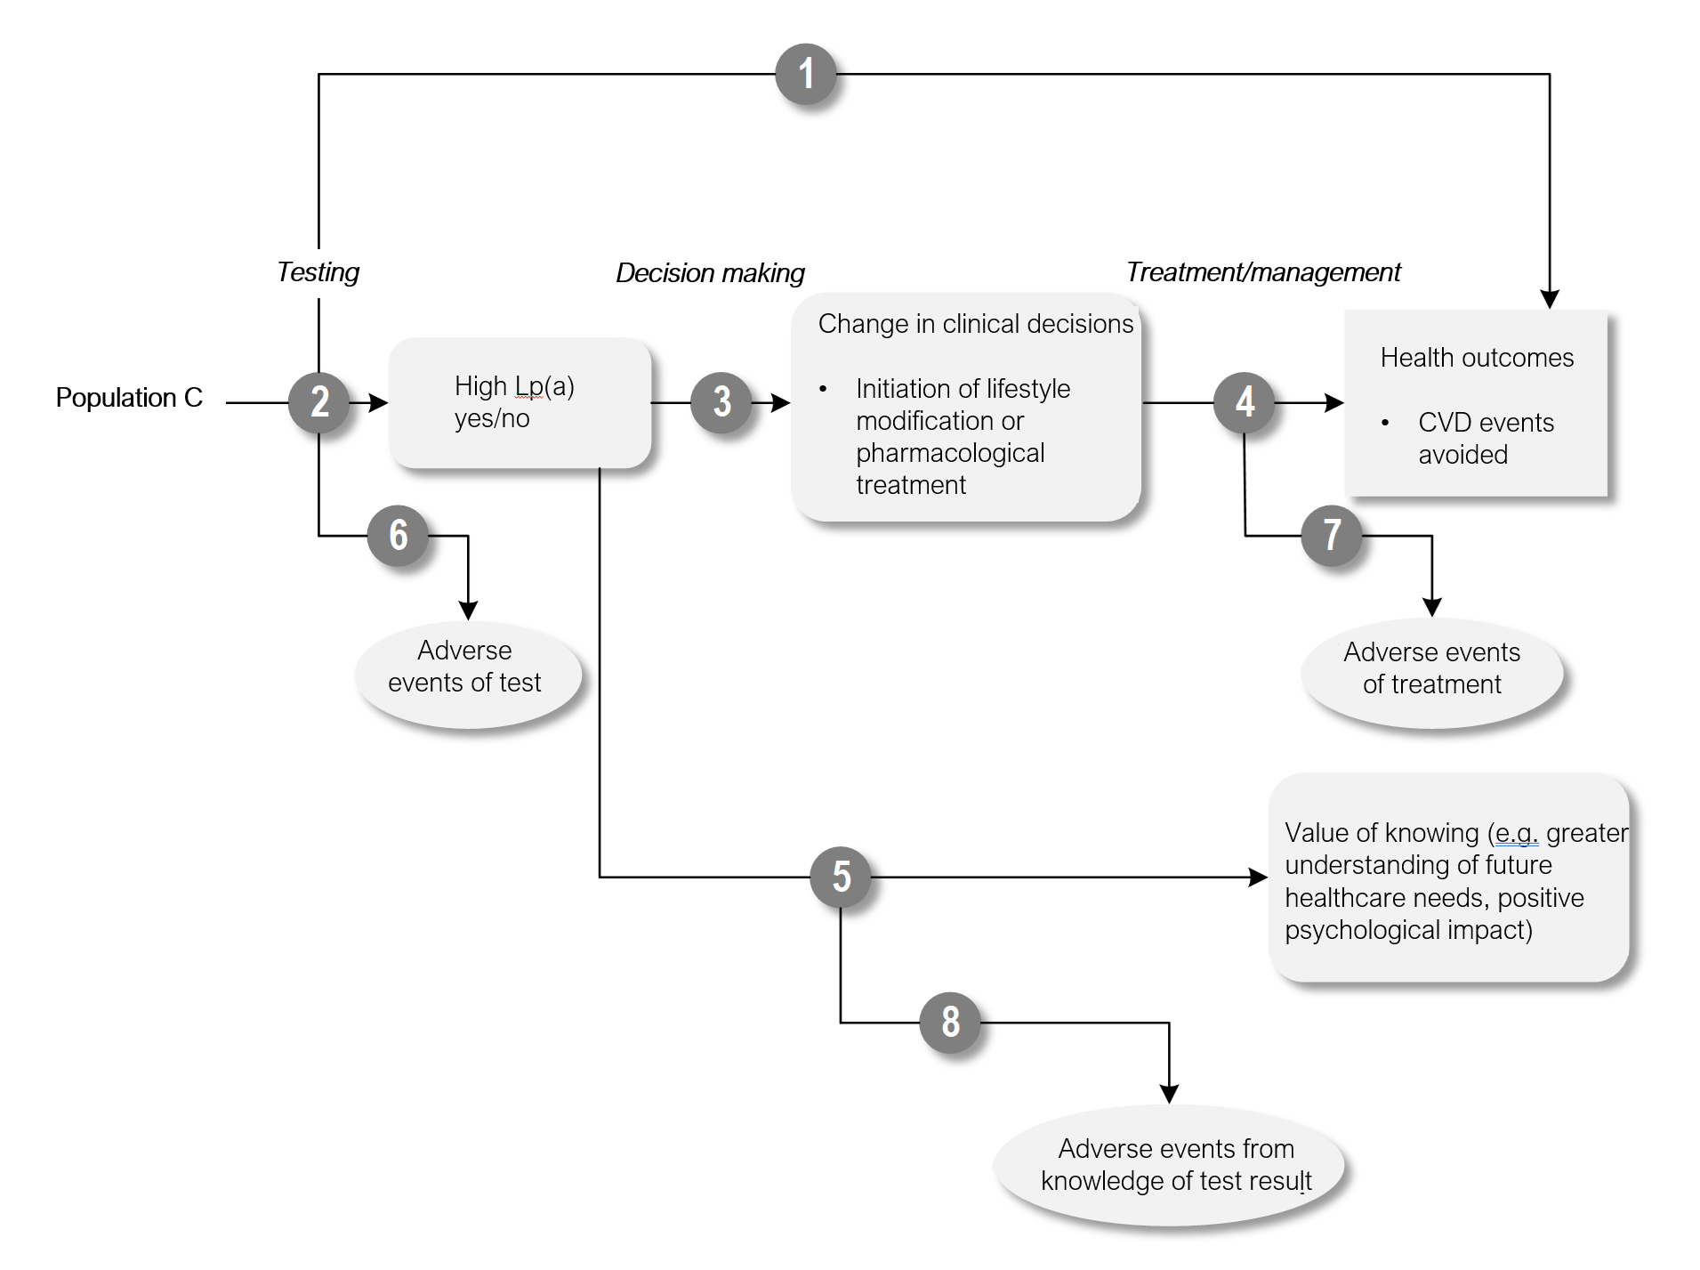
Figure notes: 1: direct from test to health outcomes evidence; 2: test accuracy; 3: change in diagnosis/treatment/management; 4: influence of the change in management on health outcomes; 5: benefits associated with the value of knowing; 6: adverse events due to testing; 7: adverse events due to treatment; 8: harms associated with the value of knowing

PASC acknowledged that there are several problems with defining the populations in this application, particularly population B, however until the populations are more clearly defined the assessment framework cannot be confirmed.

Clinical management algorithms
Three population subgroups were identified in this PICO. These subpopulations are derived from the 4 populations provided in the application material. Separate clinical algorithms have been developed to illustrate how patients are managed under different scenarios.
- Population A (index population): adults at moderate CVD risk as assessed by the currently available CVD risk assessment tool recommended by the Australian clinical practice guideline.
- Population B (index population): adult patients at high CVD risk as assessed by the currently available CVD risk assessment tool recommended by the Australian clinical practice guideline, but not optimally managed.
- Population C (cascade population): Patients of any age with a first-degree relative with significantly elevated Lp(a) (>200 nmol/L).

Population A (index population):
The clinical diagnosis pathway starts with patients for whom risk assessment should be performed (described in the Population section). These patients will undergo standard investigative tests including total cholesterol, high‑density lipoprotein (HDL) cholesterol, non‑HDL cholesterol and triglyceride concentrations. These measures will be applied together with other risk factors (e.g. smoking status, age) to a risk score system (e.g. Framingham Risk Score) to estimate cardiovascular risk for an individual patient. The selection and use of CVD risk assessment tool will be aligned with the most up-to-date Australian clinical practice guideline.
Patients who fall into the moderate risk group will also receive lifestyle modification advice and potentially an intervention, at the discretion of the treating physician. Patients who fall into the low-risk category will not receive any intervention.
In the proposed pathway, patients who fall into a high-risk group will be examined for signs and symptoms for CVD first. Those moderate risk patients with high Lp(a) (defined as over 200 nmol/L) will be reclassified as high risk and will follow the high-risk treatment pathway. Patients with high risk will be revised for their intervention if the optimal treatment and appropriate risk management strategies are not in place. Patients with low Lp(a) (under 200 nmol/L) will be advised to make lifestyle modifications and may receive pharmacological therapy.
Population B (index population):
In the current pathway, patients who fall into a high-risk group will receive lifestyle modification advice and an intervention—usually a statin. The clinical diagnosis pathway starts with patients who are at high risk for CVD. In the current pathway, patients will follow the standard of care described above in Population A.
In the proposed pathway, patients who are not receiving optimal management for their assessed CVD risk will receive the Lp(a) test. Their current CVD management strategy will likely be reviewed where additional pharmacological or non-pharmacological interventions may be applied to offset the additional CVD risk due to high Lp(a). This is dependent on the availability and effectiveness of the interventions at the discretion of the treating clinician. Patients who are receiving optimal management do not require an Lp(a) test.
Population C – cascade population:
The clinical diagnosis pathway starts with patients who are at risk of future CVD due to having a first degree relative with high Lp(a). Prior tests are not required for cascade population.
In the current pathway, the cascade population is not tested for Lp(a) and may therefore not be appropriately managed for their increased hereditary CVD risk. Some patients may be managed for their elevated CVD risk due to known family history of hyperlipidaemia or other conditions. The proportion of patients who are already receiving early interventions due to familial or hereditary conditions will need to be investigated in the evaluation phase.
In the proposed pathway, adults, children and adolescents who have a first-degree relative with high Lp(a) will be eligible to receive testing for their own Lp(a) concentration. Individuals with elevated Lp(a) may be indicated for early intervention to reduce the ongoing risk of cardiovascular event. The intervention may differ depending on the availability and the effectiveness of the CVD risk management strategy.

Figure 5 Current and proposed clinical management algorithms for Population A
Absolute CVD risk assessment using the tool recommended by the Australian clinical practice guideline
High CVD risk
Low CVD risk
Risk management strategies recommended
No action required
Moderate CVD risk
Lifestyle modifications, possible therapy recommended by the guideline
Risk assessment using Lp(a)
Low or intermediate Lp(a) <200 nmol/L
High
Lp(a) >200 nmol/L
Intensified risk factor management and therapy
Proposed clinical management pathway
Lifestyle modifications, possible therapy recommended by the guideline
High CVD risk
Low CVD risk
Moderate CVD risk
(the targeted population)
No action required
Current clinical management pathway
Risk management strategies recommended by the guideline
Figure 6 Current and proposed clinical management algorithms for Population B- Note Population B needs considerable re-framing, including removal of ‘not optimally managed’
Absolute CVD risk assessment using the tool recommended by the Australian clinical practice guideline
High CVD risk
Risk management strategies recommended
Risk assessment using Lp(a)
Low or intermediate Lp(a) <200 nmol/L
High
Lp(a) >200 nmol/L
Intensified risk factor management and therapy
Proposed clinical management pathway
Risk management strategies recommended by guideline
High CVD risk
Current clinical management pathway
Risk management strategies recommended by the guideline, but not optimally managed
Figure 7 Current and proposed clinical management algorithms for Population C
Risk assessment of the first degree relative
With or without
CVD risk assessment on the individual
Risk assessment using Lp(a)
Proposed clinical management pathway
First degree relative with high Lp(a)
First degree relative with low Lp(a)
Managed according to the clinical practice guideline
Not tested based on family history or inherent risk factors
High Lp(a)>200 nmol/L
Low Lp(a)<200 nmol/L
Early intervention to offset the ongoing CVD risk directly or indirectly

PASC suggested that the clinical management algorithm for population A should not be everyone but only the moderate risk group. This change has been reflected in the PICO. High and low risk groups were not removed from the algorithm but greyed out, as they were depicted to reflect the result of CVD risk assessment as an integral part of the testing process.
PASC raised that the clinical management algorithm for population B is not correct. Given the uncertain definition for this population, changes have not been made against the current algorithm illustrated in the PICO. Until the population definition could be clarified, the algorithm could not be finalised.
PASC raised that the clinical management algorithm for population C needs to be rectified for patients with low Lp(a). Patients should be managed according to the clinical practice guidelines instead of “no action required”. This is reflected in the updated algorithm above.
PASC has accepted that 200nmol/L would be acceptable as the cut off for high Lp(a). The figure has been updated accordingly.

Proposed economic evaluation
The applicant claims that Lp(a) testing (versus no comparator) will lead to improved patient care and lower rates of CVD. The applicant notes that by achieving an understanding of Lp(a) concentration, a greater number of moderate-risk patients will be reclassified as high risk and receive lifestyle modification advice and therapeutic intervention to lower LDL-C, leading indirectly to reduced risk of CVD events, noting that this may not reduce Lp(a) using the currently available interventions. The application also states that the benefit of Lp(a) testing lies in the cascade testing of first-degree relatives of the index case where early intervention may be directed to patients with high Lp(a) and associated with elevated CVD risk.
The clinical claim in the application leads to a cost-effectiveness analysis (CEA) or cost-utility analysis (CUA) for the economic evaluation; however, due to uncertainties around the technologies in translating the testing results to patient outcomes, there may not be sufficient information to substantiate this claim, which renders the appropriate economic evaluation to be uncertain. The CEA and CUA cell is highlighted for noting purposes only.
Table 6 Classification of comparative effectiveness and safety of the proposed intervention, compared with its main comparator, and guide to the suitable type of economic evaluation
Comparative safety- |  | Comparative effectiveness
 | Inferior | Uncertainª | Noninferior^{b} | Superior
Inferior | Health forgone: need other supportive factors | Health forgone possible: need other supportive factors | Health forgone: need other supportive factors | ? Likely CUA
Uncertainª | Health forgone possible: need other supportive factors | ? | ? | ? Likely CEA/CUA
Noninferior^{b} | Health forgone: need other supportive factors | ? | CMA | CEA/CUA
Superior | ? Likely CUA | ? Likely CEA/CUA | CEA/CUA | CEA/CUA
Abbreviations
CEA = cost-effectiveness analysis, CMA = cost-minimisation analysis, CUA = cost-utility analysis, ? = reflect uncertainties and any identified health trade-offs in the economic evaluation, as a minimum in a cost-consequences analysis
Notes
a = ‘Uncertainty’ covers concepts such as inadequate minimisation of important sources of bias, lack of statistical significance in an underpowered trial, detecting clinically unimportant therapeutic differences, inconsistent results across trials, and trade-offs within the comparative effectiveness and/or the comparative safety considerations
b = An adequate assessment of ‘noninferiority’ is the preferred basis for demonstrating equivalence
PASC agreed that the CEA/CUA is appropriate for the proposed economic evaluation. However, due to the absence of the direct evidence, a linked approach will be adopted to demonstrate the cost-effectiveness of the test.

Proposal for public funding
The applicant has proposed 3 MBS items for Lp(a) testing in the application material. After the pre-PASC meeting discussion, the last item for patients on Lp(a)-lowering therapy was removed. The applicant advises that because Lp(a) concentration tends to remain relatively constant over a person’s lifetime and is not significantly influenced by age, sex, physical activity, changes in diet nor with most drugs used to treat high cholesterol, Lp(a) should usually only be tested for once per lifetime (Lab Tests Online Australasia 2021); however, the applicant also states that when Lp(a)-lowering therapies are available in Australia, patients who receive these interventions will require annual testing to monitor progress.
Based on the discussion around population subgroups, the MBS item descriptors have been amended to be in line with the appropriate patient characteristics for either the index or the cascade population. The modified descriptors are presented in the tables below.
Category 6 – Pathology Services – Group P2 – Chemical
MBS item AAAA
Quantification of lipoprotein(a) (Lp(a)) concentration for the assessment of CVD risk in a patient with moderate or high CVD risk using the risk assessment tool currently recommended by the Australian clinical practice guideline
Applicable once per lifetime
Fee: $30.00 Benefit: 75% = $22.50 85% = $25.50

Category 6 – Pathology Services – Group P2 – Chemical
MBS item BBBB
Quantification of lipoprotein(a) (Lp(a)) concentration for the assessment of cardiovascular disease (CVD) risk in a patient who has a first-degree relative with lipoprotein(a) (Lp(a)) concentration greater than 200 nmol/L.
Applicable once per lifetime
Fee: $30.00 Benefit: 75% = $22.50 85% = $25.50
While the proposed item descriptor requires that CVD risk results (for the index population, including measurement of total cholesterol, HDL cholesterol, non‑HDL cholesterol and triglyceride concentrations) are available, the application did not state within what timeframe this risk assessment should be conducted. If recently calculated risk scores are not available to clinicians, tests required to ascertain risk will need to be repeated.
There are no tests similar to Lp(a) currently listed on the MBS with which to compare MBS fees.
PASC noted that the proposed MBS fee was based on the applicant’s estimate of the current cost to the patients of Lp(a) testing in Australia ($25-35 per test as per application). PASC considered that fee justification should be provided in the assessment phase.
PASC noted that the wording “asymptomatic” should be removed as a qualifier to ensure all moderate or high-risk patients with the CVD symptoms could be captured. This change has been incorporated into the descriptor above. This would ensure for example that current MBS item AAAA includes patients with premature CVD and aortic stenosis, and thus includes the chance to test their relatives under MBS item BBBB. Additionally, there is a lack of clarity about how the cascade population fits into these MBS descriptors
PASC noted that the item descriptors may need to be amended based on clarification of the patient populations.

Summary of public consultation input
Consultation Feedback
PASC noted and welcomed consultation input from 2 professional organisations, and 1 consumer organisations. The organisations that submitted input were:
- The Royal Australian College of General Practitioners (RACGP)
- Pathology Technology Australia (PTA)
- The Heart Foundation
The consultation feedback received was mixed: PTA and the Heart Foundation supported the application. The RACGP did not support public funding.
Clinical need and public health significance
- The main benefits of public funding received in the consultation feedback included:
  - Prognostic value including critical information about an individual’s risk profile which may have otherwise been missed by traditional risk equations

  - Management of risk factors including targeting of intensive CVD risk modification strategies to individuals that need it most
  - Allows for monitoring of those at risk
- The main disadvantages of public funding received in the consultation feedback included:
  - The new draft Australian CVD risk calculator including several risk modifiers, with considerable overlap with indications for Lipoprotein (A) testing, making the proposed test superfluous.
  - There are currently no treatments indicated for Lp(a) lowering
- Other services identified in the consultation feedback as being needed to be delivered before or after the intervention included:
  - Management of cardiovascular health including comprehensive CVD risk assessment, chronic disease management plans, and consultation with a cardiologist.
  - Genetic counselling for individuals living with FH
Indication(s) for the proposed medical service and clinical claim
- The consultation feedback ranged agreeing to strongly agreeing with the proposed population(s).
  - PTA stated that the proposed population is consistent with evidence and European Atherosclerotic Society guidance.
  - The Heart Foundation stated that they largely agree, however, the criteria should be clearer to aid with implementation, such as distinguishing between features specific to a family history vs current clinical features.
- The consultation feedback generally agreed with the proposed comparator(s).
- The consultation feedback generally agreed with the clinical claim.
Cost information for the proposed medical service
- The consultation feedback generally agreed with the proposed service descriptor.
- The consultation feedback generally agreed with the proposed service fee.
PASC noted that:
- the National Heart Foundation suggested that the new guidelines will consider the place of Lp(a) testing in a primary prevention setting and it would be helpful if there was an MBS subsidy for Lp(a) testing. They suggest that Lp(a) testing may provide additional risk profiling for patients who are missed by traditional risk equations, particularly patients with an individual or family history of premature CVD.
- the Australian Atherosclerosis Society are preparing a position paper on Lp(a) testing and are supportive of the application suggesting that it is a clinically relevant service where the benefit is primarily in cascade testing.
- the Cardiac Society Australia and New Zealand suggested the Lp(a) was generally accepted as having clinical utility.
- the Royal College of General Practitioners claim that the new guidelines include several risk modifiers with considerable overlap with the indications for Lp(a) testing making the test superfluous. PASC noted that this group appear not to have considered cascade testing.
- Pathologists provided the feedback where testing manufacturers were supportive but did not comment on the issues around different testing assays and reference ranges. They also pointed out that the pathologists do not have access to patients’ risk status and individual disease history. They suggest restrictions on the testing should be removed from the MBS item descriptor as ensuring the patient is an appropriate candidate for the test is the responsibility of the requesting clinician, not the pathologist.

Next steps
Following the December PASC meeting, PASC noted that out of session discussions have not sufficiently defined the populations or clinical algorithms. PASC recommend that additional work is required to better define the PICO before it can progress to the assessment phase. Specifically, the following need to be addressed:
- Population B needs considerable re-framing (which may impact the clinical management algorithm)
- The proposed number of tests needs work
- The MBS item descriptors require clarifications to ensure the three proposed populations are reflected and adequately captured.
PASC note that the application relies on the Australian and New Zealand guidelines for the management of absolute cardiovascular disease risk to determine the populations and clinical algorithms. As these guidelines are currently under review, PASC recommend that this application is reconsidered at a second PASC meeting once the updated guidelines are available for consideration.

Applicant comment on the ratified PICO Confirmation
The applicant agrees that there is a great deal of uncertainty around the definition of Population B and that it should be removed from consideration, with only Population A and C considered for assessment.
- Population A (index population): adults at moderate CVD risk as assessed by the currently available CVD risk assessment tool recommended by the Australian clinical practice guideline.
- Population C (cascade population): Patients at any age with a first-degree relative with significantly elevated Lp(a) (>200 nmol/L).
As previously stated, the applicant agrees with PASC that the clinical utility of Lp(a) in children and adolescents under 18 years is low and therefore children should not be tested for Lp(a). The one important exception to this; however, are individuals under 18 years who have familial hypercholesterolaemia, who would also be considered to be at moderate risk of CVD but elevated Lp(a) levels may indicate a risk of premature CVD that would require treatment.
The applicant agrees that Population A should only be those individuals considered to be at moderate risk according to current CVD clinical risk assessment tools. The applicant also agrees with changing the wording in the Population C clinical algorithm from “no action” to “managed according to guidelines”, which was the intent.
The applicant agrees that a CEA/CUA is appropriate.
Although the market has determined the cost of Lp(a) in the private pathology space, the applicant can provide advice to the HTA team regarding the appropriate fee for Lp(a) testing.
Retention of “asymptomatic” in the proposed item number descriptor would be appropriate with the removal of Population B. Population A intends to capture those patients who are otherwise symptom free and are considered to be at moderate risk.
It should be noted that an additional item number should be developed in order to facilitate testing in individuals with familial hypercholesterolaemia <18 years of age. These patients would be considered to be at moderate risk of CVD; however, as previously noted by PASC, individuals under 18 years are excluded from assessment by current clinical CVD risk calculators. FH patients >18 years would be covered under item number AAAA.
It would be appropriate to place a >18 years age restriction on the proposed item numbers AAAA and BBBB; however, the new FH item number should not be age restricted.
MBS item CCCC
Quantification of lipoprotein(a) (Lp(a)) concentration for the assessment of CVD risk in a patient less than 18 years of age diagnosed with familial hypercholesterolaemia
Applicable once per lifetime
It is disappointing that the RACGP did not support this application, as Lp(a) is strongly heritable and testing of Lp(a) has been demonstrated to be an independent causative risk factor for CVD. Testing of Lp(a) would be highly beneficial to patients in the general practice setting who may otherwise remain unaware of their elevated risk of CVD.
The value of Lp(a) testing is supported by peak bodies such as the AAS and HF.
The applicant would like to confirm that to ensure the best chance of the application’s success for Lp(a) testing in Population A, that Population B should be removed from consideration. The applicant may consider an additional MSAC submission for this population in the future once further evidence is collected on the impact of Lp(a) testing in high-risk patients who are not receiving optimal management for their assessed CVD risk.
The applicant looks forward to discussing this amended application further at a future PASC meeting.

References

Cegla, J, France, M, Marcovina, SM & Neely, RDG 2021, 'Lp(a): When and how to measure it', Ann Clin Biochem, vol. 58, no. 1, pp. 16-21.

Erqou, S, Kaptoge, S, Perry, PL, Di Angelantonio, E, Thompson, A, White, IR, Marcovina, SM, Collins, R, Thompson, SG & Danesh, J 2009, 'Lipoprotein(a) concentration and the risk of coronary heart disease, stroke, and nonvascular mortality', Jama, vol. 302, no. 4, pp. 412-23.

Forbes, CA, Quek, RG, Deshpande, S, Worthy, G, Wolff, R, Stirk, L, Kleijnen, J, Gandra, SR, Djedjos, S & Wong, ND 2016, 'The relationship between Lp(a) and CVD outcomes: a systematic review', Lipids Health Dis, vol. 15, p. 95.

Greif, M, Arnoldt, T, von Ziegler, F, Ruemmler, J, Becker, C, Wakili, R, D'Anastasi, M, Schenzle, J, Leber, AW & Becker, A 2013, 'Lipoprotein (a) is independently correlated with coronary artery calcification', Eur J Intern Med, vol. 24, no. 1, pp. 75-9.

Liu, HH, Cao, YX, Jin, JL, Zhang, HW, Hua, Q, Li, YF, Guo, YL, Zhu, CG, Wu, NQ, Xu, RX, Chen, XH & Li, JJ 2020, 'Predicting Cardiovascular Outcomes by Baseline Lipoprotein(a) Concentrations: A Large Cohort and Long-Term Follow-up Study on Real-World Patients Receiving Percutaneous Coronary Intervention', J Am Heart Assoc, vol. 9, no. 3, p. e014581.

O'Donoghue, ML, Fazio, S, Giugliano, RP, Stroes, ESG, Kanevsky, E, Gouni-Berthold, I, Im, K, Lira Pineda, A, Wasserman, SM, Češka, R, Ezhov, MV, Jukema, JW, Jensen, HK, Tokgözoğlu, SL, Mach, F, Huber, K, Sever, PS, Keech, AC, Pedersen, TR & Sabatine, MS 2019, 'Lipoprotein(a), PCSK9 Inhibition, and Cardiovascular Risk', Circulation, vol. 139, no. 12, pp. 1483-92.

Paré, G, Çaku, A, McQueen, M, Anand, SS, Enas, E, Clarke, R, Boffa, MB, Koschinsky, M, Wang, X & Yusuf, S 2019, 'Lipoprotein(a) Levels and the Risk of Myocardial Infarction Among 7 Ethnic Groups', Circulation, vol. 139, no. 12, pp. 1472-82.

The National Vascular Disease Prevention Alliance 2022, Australian absolute cardiovascular disease risk calculator.

The Royal College of Pathologists of Australasia 2022, Application form for Applicaion 1736.

Tonkin, A, Barter, P, Best, J, Boyden, A, Furler, J, Hossack, K, Sullivan, D, Thompson, P, Vale, M, Cooper, C, Robinson, M & Clune, E 2005, 'National Heart Foundation of Australia and the Cardiac Society of Australia and New Zealand: position statement on lipid management--2005', Heart Lung Circ, vol. 14, no. 4, pp. 275-91.

Wilson, PW, D'Agostino, RB, Levy, D, Belanger, AM, Silbershatz, H & Kannel, WB 1998, 'Prediction of coronary heart disease using risk factor categories', Circulation, vol. 97, no. 18, pp. 1837-47.

Wyness, SP & Genzen, JR 2021, 'Performance evaluation of five lipoprotein(a) immunoassays on the Roche cobas c501 chemistry analyzer', Pract Lab Med, vol. 25, p. e00218.

Zhang, Y, Pletcher, MJ, Vittinghoff, E, Clemons, AM, Jacobs, DR, Jr., Allen, NB, Alonso, A, Bellows, BK, Oelsner, EC, Zeki Al Hazzouri, A, Kazi, DS, de Ferranti, SD & Moran, AE 2021, 'Association Between Cumulative Low-Density Lipoprotein Cholesterol Exposure During Young Adulthood and Middle Age and Risk of Cardiovascular Events', JAMA Cardiol, vol. 6, no. 12, pp. 1406-13.

