Public Summary Document

Report to the Medical Services Advisory Committee on real world outcomes of Application 1087: Brain natriuretic peptide assays in the diagnosis and monitoring of heart failure
Medicare Benefits Schedule (MBS) item considered: 66830
Dates of MSAC consideration: 6-7 April 2017
Context for decision: MSAC makes its advice in accordance with its Terms of Reference, see the MSAC Website.

Purpose
The purpose of the report presented to the Medical Services Advisory Committee (MSAC) was to inform MSAC of the real world impacts on the outcomes of Application 1087. The MSAC then uses this information to ensure that the new item/s resulting from this application/s is being used as intended.
The report is not intended to be a review of the clinical information covered during the application process.

MSAC’s advice
After considering the real world impacts of the outcomes of application 1087, MSAC noted that there was significant under-utilisation of item 66830 post-implementation and recommended no further action.

Summary of consideration and rationale for MSAC’s advice
MSAC considered the real world impacts of the outcome of application 1087 for B-type natriuretic peptide (BNP) assays in the diagnosis of heart failure (MBS item 66830) by examining the available data for this item and separations for heart failure from the Australian Institute of Health and Welfare (AIHW) Australian Hospital Morbidity database.
MSAC noted that actual utilisation is between 10-20% of that predicted. MSAC considered that the lower than expected utilisation may be due to an assumption in the initial application that a high proportion of services would be provided in the private setting (36%), whereas the data suggest that the majority of patients presenting with heart failure actually present at public hospital emergency departments. MSAC also noted that utilisation has tended to be highest in the more populous states (NSW, VIC and QLD), with very low use in WA, possibly due to the small number of private emergency departments in this state. MSAC noted that utilisation is concentrated in patients 75 years of age and above, in line with the primary target for the diagnosis and monitoring of heart failure.
MSAC noted that approximately 19% of patients have claimed item 66830 more than once, suggesting these patients have presented to ED and required a BNP test on multiple occasions.
In considering the data related to the fee charged for this MBS item, MSAC noted that the average fee charged has remained relatively stable since listing. MSAC also noted that the rate of bulk-billing appears to have increased from 16% to 43% between 2008-09 and 2015-16, although the rate varies between states.
It was assumed that 87% of pathology would be performed outside of hospital settings. However, since listing, MSAC noted that the majority of services (64-70%) have been provided in hospital. MSAC considered this may reflect use as monitoring which was not recommended.
MSAC noted that co-claiming patterns for MBS item 66830 are highly varied but are consistent with a patient presenting with heart failure. MSAC noted that the item is not as frequently co-claimed with a consult or patient initiation fee as assumed in the assessment report.

Methodology
An application is selected for consideration if the resulting new item(s) or item amendment(s) have been on the MBS for approximately 24 months or longer or if there were particular concerns about utilisation such that MSAC requested to consider it earlier. The specific applications for each MSAC meeting are selected by the MSAC Executive which is composed of the Chairs of MSAC and its sub-committees.
A report on the utilisation is developed by the Department of Health (the department) with information on a number of metrics including state variation, patient demographics, services per patient, practitioner’s providing the service, data on fees and co-claiming of services. The number of metrics included in a report is dependent on the annual service volume for the MBS item(s) under consideration i.e. an item with very low utilisation will have less data to analyse. Where service volumes are too low, information is suppressed to protect patient privacy.
Where possible the report compares data on real world utilisation to the assumptions made during the MSAC assessment. Most of these assumptions are drawn from the assessment report.
Relevant stakeholders are provided an opportunity to comment on the findings in the report before it is presented to the MSAC. It is intended that stakeholders are given at least three weeks to consider the reports.
The stakeholder version of the report does not contain information on assumptions from the MSAC consideration if this information is not already publicly available. This is to protect the commercial in confidence of the original applicants. The same principle is applied to this document.
Once MSAC has considered the report its advice is made available online at the MSAC Website.

Results

Utilisation
To protect commercial in confidence, the final predicted utilisation numbers have been removed. The assumptions from the assessment report have been included and can be accessed in full on the MSAC website on the page for application 1087.
Utilisation estimates were based on the Australian Hospital Morbidity database for heart failure separations and ABS data for growth (3.25% pa).
The Australian National Hospital Morbidity database of the AIHW registered 41,052 separations for heart failure (HF) in 2002-03. The estimate is based on almost all Australian public and private hospitals. For reference the actual separations for the principal diagnosis of heart failure for 2008-09 to 2013-14 have been included in Table 1.
In Mueller et al (2004), of the 80 per cent of admitted patients in their sample with acute dyspnoea, 52.6 per cent were diagnosed with HF. It was assumed in the assessment report that this meant that 42 per cent (0.8*0.525=0.42) of patients with acute dyspnoea arriving at an ED were admitted to hospital with a primary diagnosis of HF. This calculation was then applied to the 2002-03 separation data (n=41,025) to get an estimated rate of 97,742 (41,025/0.42) ED presentations due to acute dyspnoea per annum in Australia.
The assessment report estimated that if the public to private proportions for HF admission are 78 and 22 per cent, then the corresponding public to private patient split is 64 and 36 per cent. As such the estimated services per annum were calculated as 36 per cent of the number of emergency department presentations due to acute dyspnoea, i.e. 97,742*0.36 (Services estimated; Table 1).
Actual utilisation is much lower than that predicted (Table 1).
One of the potential reasons actual utilisation is below that predicted may be because the majority of emergency patients still present at public hospitals. In Australia, in 2014-15, there were 25 private hospitals with an emergency department and 533,414 accident and emergency patients treated. In the same time period there were 290 public hospitals reporting emergency department presentations, totalling 7.4 million presentations.

Table 1: Predicted vs actual utilisation of MBS item 66830
Financial Year/ Year since listing | 2008-09 (Year 1) | 2009-10 (Year 2) | 2010-11 (Year 3) | 2011-12 (Year 4) | 2012-13 (Year 5) | 2013-14 | 2014-15 | 2015-16
Actual number of Services | 2,063 | 3,802 | 5,621 | 6,450 | 7,974 | 9,013 | 9,879 | 11,602
Actual separations for the principal diagnosis of heart failure | 45,197 | 45,004 | 50,089 | 50,983 | 52,041 | 53,643
Source: File: Q20659 Item 73332 66830 utilisation 16JAN17.xlsx, 1083 Assessment report and AIHW Australian Hospital Morbidity database

Figure 1: Number of services for MBS item 66830 for 2008-09 to 2015-16.

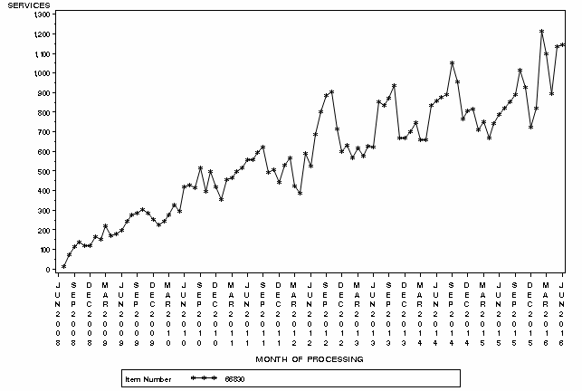

Figure 2: Month by month service volume for MBS item 66830 from July 2008 to June 2016
Source: Medicare Statistics online
Utilisation has tended to be highest in the more populous states (NSW, VIC and QLD)
(Table 2). Notably, there appears to be very little use of this item number in WA, with volumes so low they required suppression and relatively high utilisation in TAS until 2015-16. SA had the highest utilisation in 2015-16 at 3,947 services, a significant jump from previous years of utilisation. In 2014-15, the item was claimed 1,517 times in SA.

Table 2: Services and benefits paid per state for MBS item 66830 from 2008-09 to 2015-16
 |  | NSW | VIC | QLD | SA | WA | TAS | NT | ACT | Australia
2008-09 | Services | 869 | 241 | 795 | 54 | NP | 96 | NP | NP | 2,063
 | Patients | 712 | 229 | 750 | 52 | NP | 83 | NP | NP | 1,834
 | Benefits | $39,444 | $11,100 | $39,101 | $2,497 | NP | $4,568 | NP | NP | $97,068
2009-10 | Services | 1,529 | 555 | 1,191 | 335 | NP | 185 | NP | NP | 3,802
 | Patients | 1,250 | 479 | 1,123 | 314 | NP | 147 | NP | NP | 3,315
 | Benefits | $69,986 | $25,588 | $56,885 | $15,418 | NP | $8,620 | NP | NP | $176,853
2010-11 | Services | 2,359 | 762 | 1,651 | 584 | NP | 224 | NP | NP | 5,621
 | Patients | 1,903 | 684 | 1,545 | 537 | NP | 196 | NP | NP | 4,901
 | Benefits | $110,349 | $36,620 | $79,670 | $26,956 | NP | $10,505 | NP | NP | $266,007
2011-12 | Services | 2,543 | 1,286 | 1,650 | 742 | NP | 206 | NP | NP | 6,450
 | Patients | 2,069 | 1,122 | 1,553 | 693 | NP | 174 | NP | NP | 5,627
 | Benefits | $118,102 | $60,965 | $79,844 | $34,875 | NP | $9,856 | NP | NP | $304,694
2012-13 | Services | 2,792 | 1,856 | 2,012 | 920 | NP | 376 | NP | NP | 7,974
 | Patients | 2,252 | 1,573 | 1,873 | 830 | NP | 313 | NP | NP | 6,845
 | Benefits | $132,383 | $85,734 | $96,434 | $42,596 | NP | $18,108 | NP | NP | $376,089
2013-14 | Services | 2,750 | 2,443 | 2,238 | 1,072 | NP | 499 | NP | NP | 9,013
 | Patients | 2,245 | 2,101 | 2,056 | 965 | NP | 418 | NP | NP | 7,773
 | Benefits | $128,136 | $111,328 | $105,559 | $49,479 | NP | $25,039 | NP | NP | $420,035
2014-15 | Services | 2,841 | 2,693 | 2,451 | 1,517 | NP | 363 | NP | NP | 9,879
 | Patients | 2,306 | 2,303 | 2,239 | 1,368 | NP | 296 | NP | NP | 8,513
 | Benefits | $131,899 | $122,484 | $115,080 | $70,224 | NP | $17,730 | NP | NP | $458,012
2015-16 | Services | 2,038 | 2,642 | 2,824 | 3,947 | NP | 138 | NP | NP | 11,602
 | Patients | 1,720 | 2,280 | 2,543 | 3,396 | NP | 126 | NP | NP | 10,076
 | Benefits | $97,352 | $121,094 | $132,018 | $190,901 | NP | $6,641 | NP | NP | $548,610
NP = not published
Source: Department of Health, File: Q20659 Item 73332 66830 utilisation 16JAN17.xlsx

In and out of hospital
It was assumed that 87% of pathology would be done outside hospital and would attract the 85% rebate with the remaining 13% attracting the 75% rebate.
In actuality, the majority of services have been provided in hospital since the item was listed (64-70% of services in 2008-09 to 2014-15) (Table 5). In 2015-16, it does appear as though the service is shifting to an even split of in and out of hospital provision, with 54% of services provided in hospital.
Since listing, services in SA have slowly shifted from predominantly being provided in-hospital (74% of services in 2008-09) to being provided predominantly out of hospital (34% of services in 2015-16).

Table 3: Percentage of services provided in hospital for item 68830 in 2008-09 to 2015-16
 | NSW | VIC | QLD | SA | WA | TAS | NT | ACT | Australia
2008-09 | 83% | 85% | 50% | 74% | NP | 57% | NP | NP | 69%
2009-10 | 81% | 82% | 52% | 73% | NP | 66% | NP | NP | 70%
2010-11 | 80% | 70% | 41% | 70% | NP | 59% | NP | NP | 65%
2011-12 | 79% | 66% | 43% | 58% | NP | 54% | NP | NP | 64%
2012-13 | 78% | 72% | 45% | 65% | NP | 48% | NP | NP | 65%
2013-14 | 75% | 78% | 49% | 69% | NP | 35% | NP | NP | 67%
2014-15 | 73% | 77% | 54% | 61% | NP | 39% | NP | NP | 66%
2015-16 | 68% | 72% | 55% | 34% | NP | 47% | NP | NP | 54%
NP = not published

Patient breakdown
There did not appear to be any assumptions in the assessment report regarding the number of services a patient is likely to receive over a lifetime. About 19% of patients have claimed item 66830 more than once, with a small percentage claiming it more than 10 times since the item was listed (Table 3). It is possible that these patients have presented to ED on multiple occasions and required a BNP test on each presentation.

Table 4: Number of services per patient since service listed in March 2014 to June 2016
Number of Services | Number of Patients | Percentage of Patients
1 | 35,235 | 81%
2 | 5,314 | 12%
3 | 1,498 | 3%
4 | 602 | 1%
5 | 297 | 1%
6 | 154 | 0%
7 | 58 | 0%
8 | 34 | 0%
9 | 28 | 0%
10 | 8 | 0%
11 | 8 | 0%
12+ | 10 | 0%
Total | 43,246 | 100%
Source for table 4: Department of Health, File: Q20659 Item 73332 66830 utilisation 16JAN17.xlsx
The population aged >75 years is the primary target for the diagnosis, monitoring and prognosis of HF. Utilisation seems to be concentrated in the 75 and above age groups, as expected. The item appears to be claimed evenly by both men and women (5,808 women in 2015-16 compared to 5,727 men) (Figure 3).
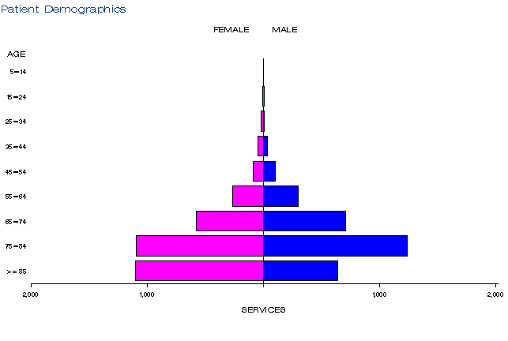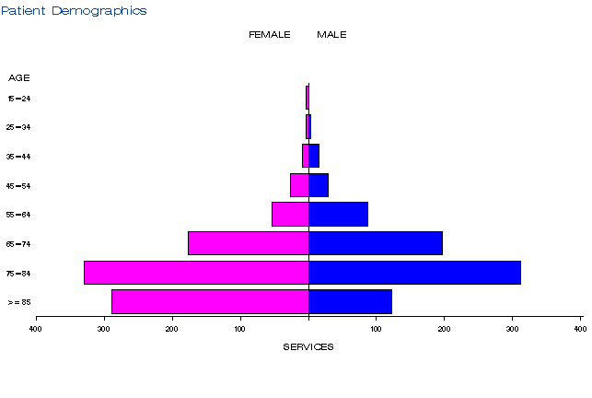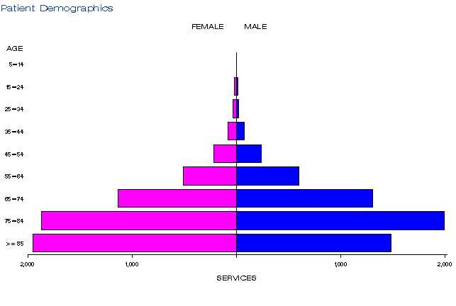
a)
b))
c)

Figure 3: Demographic profile for MBS item 68830 for 2008-09 (a), 2011-12 (b) and 2015-16 (c)
Source: Medicare Statistics Online

Provider breakdown
All practitioners claiming this service are pathologists or haematologists. The number of practitioners claiming this service has fluctuated since listing, ranging from 43 to 56 (Table 5).
Similarly, the concentration of services among providers has varied each year, although the service provision has remained relatively concentrated with about 90% of services provided by just 30% of practitioners (Table 6).

Table 5: Number of practitioners providing this service in 2008-09 to 2015-16
Financial year | Australia
2008-09 | 45
2009-10 | 53
2010-11 | 56
2011-12 | 43
2012-13 | 49
2013-14 | 50
2014-15 | 47
2015-16 | 46

Table 6: Cumulative percentage of medical practitioners providing item 66830 for 2008-09 to 2015-16
 | 2008-09 | 2009-10 | 2010-11 | 2011-12 | 2012-13 | 2013-14 | 2014-15 | 2015-16
10% | 72% | 66% | 66% | 59% | 65% | 62% | 56% | 65%
20% | 85% | 85% | 81% | 75% | 82% | 80% | 72% | 84%
30% | 91% | 91% | 91% | 87% | 92% | 89% | 83% | 93%
40% | 95% | 95% | 95% | 93% | 96% | 94% | 90% | 97%
50% | 97% | 98% | 97% | 96% | 98% | 97% | 95% | 99%
60% | 99% | 99% | 99% | 98% | 99% | 99% | 98% | 100%
70% | 99% | 99% | 100% | 99% | 100% | 100% | 100% | 100%
80% | 100% | 100% | 100% | 100% | 100% | 100% | 100% | 100%
90% | 100% | 100% | 100% | 100% | 100% | 100% | 100% | 100%
100% | 100% | 100% | 100% | 100% | 100% | 100% | 100% | 100%
Source for tables 5 & 6: Department of Health, File: Q20659 Item 73332 66830 utilisation 16JAN17.xlsx

Co-claiming
The MBS items that were assumed to be associated with the diagnosis of heart failure in a private patient are 110 (professional attendance), 116 (subsequent professional attendance), 507 (Level 3 patient initiation fee), 65070 (full blood count), 66509 (electrolytes), 66515 (renal function), 66719 (thyroid function), 73910 (patient episode initiation), 11700 (ECG), 58500 (chest x-ray) and 55113 (echocardiography).
The co-claiming data shown in Tables 7 to 9 is the top 10 claiming combinations per financial year. The top 10 claiming patterns only appear to represent about 20% of all claims for item 66830. This suggests that the claiming patterns for item 66830 are highly varied.
Tables 10 to 12 show the top 5 items claimed with item 66830 in any combination. Item 66830 is typically co-claimed with the same five items each financial year (66512, 65070, 66518, 73930 and 73938) in addition to a range of other items.
Based on this data, item 66830 is not as frequently co-claimed with a consult or patient initiation fee as assumed in the assessment report. The assessment report did identify item 65070 as one that item 66830 would be frequently co-claimed with but failed to identify that it would be claimed with 66512, 66518, 73930 or 73938.

Table 7: Top 10 instances of co-claiming with MBS item 66830 in 2008-09
# | Items | Episodes | Number Services | Schedule Fee for Combination | % of total episodes | Cumulative %
1 | 66830, 66512,66518,73938 | 123 | 492 | $13,229 | 6% | 6%
2 | 66830, 65070,66512,66518,73930 | 61 | 308 | $8,145 | 3% | 9%
3 | 66830, 65070,66512,73930 | 49 | 196 | $5,500 | 2% | 11%
4 | 66830, 65070,66512,66518,73938 | 43 | 216 | $5,374 | 2% | 13%
5 | 66830, 65070, 65120, 66512, 66518, 73930. | 33 | 198 | $4,841 | 2% | 15%
6 | 66830, 65070, 65120, 66512, 66518, 73938 | 27 | 162 | $3,748 | 1% | 16%
7 | 66830, 65070,66512,73938 | 27 | 108 | $2,817 | 1% | 17%
8 | 66830, 65070,66512 | 27 | 81 | $2,553 | 1% | 18%
9 | 66830, 65070,65120,66512,73930 | 25 | 125 | $3,158 | 1% | 19%
10 | 66830, 66512,73930 | 23 | 69 | $2,186 | 1% | 20%

Table 8: Top 10 instances of co-claiming with MBS item 66830 in 2014-15
# | Items | Episodes | Number Services | Schedule Fee for Combination | % of total episodes | Cumulative %
1 | 66830, 65070,66512,73930 | 302 | 1,222 | $30,103 | 3% | 3%
2 | 66830, 66512,66518,73938 | 287 | 1,148 | $29,905 | 3% | 6%
3 | 66830, 65070,66512,66518,73930 | 272 | 1,419 | $32,841 | 3% | 9%
4 | 66830, 65070,66512,66518,73938 | 248 | 1,264 | $30,340 | 3% | 12%
5 | 66830, 65070,66512,73938 | 212 | 851 | $21,476 | 2% | 14%
6 | 66830, 65070,66512 | 180 | 540 | $16,757 | 2% | 16%
7 | 66830, 65070,66512,73931 | 147 | 600 | $14,194 | 1% | 17%
8 | 66830 | 139 | 139 | $8,132 | 1% | 18%
9 | 66830, 65070, 65120, 66512, 66518, 73930 | 130 | 824 | $17,664 | 1% | 19%
10 | 66830, 65070, 65120, 66512, 66518, 73938 | 119 | 719 | $16,087 | 1% | 20%

Table 9: Top 10 instances of co-claiming with MBS item 66830 in 2015-16
# | Items | Episodes | Number Services | Schedule Fee for Combination | % of total episodes | Cumulative %
1 | 66830, 66512,66518,73938 | 361 | 1,445 | $37,624 | 3% | 3%
2 | 66830, 65070,66512,66518,73938 | 319 | 1,619 | $38,961 | 3% | 6%
3 | 66830, 65070,66512,73930 | 301 | 1,216 | $29,970 | 3% | 9%
4 | 66830, 65070,66512,66518,73930 | 273 | 1,430 | $33,064 | 2% | 11%
5 | 66830, 65070,66512 | 269 | 809 | $25,093 | 2% | 13%
6 | 66830, | 246 | 248 | $14,508 | 2% | 15%
7 | 66830, 65070,66512,73939 | 233 | 936 | $22,319 | 2% | 17%
8 | 66830, 65070,66512,73938 | 231 | 932 | $23,465 | 2% | 19%
9 | 66830, 65070, 65120, 66512, 66518, 73938 | 140 | 843 | $18,909 | 1% | 20%
10 | 66830, 65070, 65126, 66512, 66518, 73938 | 111 | 666 | $16,539 | 1% | 21%
Source for Tables 7-9: Department of Health, File: Q20659_TOP05: New Items Evaluation

Table 10: Top 5 items that are co-claimed with 66830 in any combination in 2008-09
Trigger  Combination | CoClaimed Combination | Episodes | Services | Schedule fees | Episodes %
66830 | 66512 | 1,707 | 3,529 | $134,183 | 83%
66830 | 65070 | 1,342 | 2,750 | $104,245 | 65%
66830 | 66518 | 1,039 | 2,079 | $83,128 | 50%
66830 | 73930 | 845 | 1,767 | $66,639 | 41%
66830 | 73938 | 551 | 1,119 | $38,378 | 27%

Table 11: Top 5 items that are co-claimed with 66830 in any combination in 2014-15
Trigger  Combination | CoClaimed Combination | Episodes | Services | Schedule fees | Episodes %
66830 | 66512 | 8,325 | 17,142 | $643,112 | 84%
66830 | 65070 | 6,945 | 14,160 | $528,713 | 70%
66830 | 66518 | 4,544 | 9,089 | $356,990 | 46%
66830 | 73938 | 3,314 | 6,875 | $222,179 | 34%
66830 | 73930 | 3,094 | 6,658 | $202,310 | 31%

Table 12: Top 5 items that are co-claimed with 66830 in any combination in 2015-16
Trigger  Combination | CoClaimed Combination | Episodes | Services | Schedule fees | Episodes %
66830 | 66512 | 9,385 | 19,253 | $723,633 | 81%
66830 | 65070 | 7,632 | 15,534 | $580,445 | 66%
66830 | 66518 | 4,941 | 9,883 | $388,174 | 43%
66830 | 73938 | 3,876 | 8,037 | $259,826 | 33%
66830 | 73930 | 2,876 | 6,191 | $187,970 | 25%
Source for Tables 10-12: Department of Health, File: Q20659_TOP05: New Items Evaluation

Data on fee charged
The information provided on fees below is a snapshot of how the item is being claimed in practice. Data has not been printed for states and territories with relatively low service volumes.
The benefit for MBS item 66830 is $43.90 (75%) or $49.75 (85%).
The average fee charged for item 66830 has remained relatively stable since listing with a range of $69 to $74 (Table 13). In 2015-16, the state with the highest average fee charged was TAS at $80. However, in the same year VIC had the highest fee charged at the 95th percentile at $152.
From 2008-09 to 2015-16, the rate of bulk billing appears to have increased from 16% to 43%. There is marked variation between states with bulk billing in SA at 64% in 2015-16, compared to 24% in Victoria.

Table 13: Fees charged for MBS item 66830 for 2008-09, 2014-15 and 2015-16 by date of service
 |  |  | Provider State/Territory
 |  | NSW | VIC | QLD | SA | WA | TAS | NT | ACT | Australia
2008-09 | Average Fee Charged | $61 | $68 | $81 | $64 | NP | $59 | NP | NP | $69
 | Std Deviation | $12 | $11 | $27 | $4 | NP | $8 | NP | NP | $21
 | Median Fee Charged | $60 | $64 | $73 | $65 | NP | $60 | NP | NP | $60
 | 75th Percentile | $60 | $69 | $115 | $66 | NP | $60 | NP | NP | $74
 | 95th Percentile | $83 | $86 | $128 | $70 | NP | $64 | NP | NP | $128
 | Bulk-billing Rate | 11% | 12% | 22% | 26% | NP | 27% | NP | NP | 16%
2014-15 | Average Fee Charged | $70 | $77 | $76 | $77 | NP | $59 | NP | NP | $74
 | Std Deviation | $17 | $23 | $16 | $16 | NP | $11 | NP | NP | $19
 | Median Fee Charged | $59 | $75 | $76 | $75 | NP | $59 | NP | NP | $75
 | 75th Percentile | $76 | $77 | $80 | $76 | NP | $59 | NP | NP | $78
 | 95th Percentile | $100 | $138 | $97 | $117 | NP | $79 | NP | NP | $104
 | Bulk-billing Rate | 26% | 19% | 38% | 36% | NP | 35% | NP | NP | 29%
2015-16 | Average Fee Charged | $68 | $77 | $77 | $72 | NP | $80 | NP | NP | $74
 | Std Deviation | $13 | $26 | $14 | $16 | NP | $13 | NP | NP | $19
 | Median Fee Charged | $64 | $69 | $76 | $74 | NP | $76 | NP | NP | $76
 | 75th Percentile | $76 | $77 | $80 | $76 | NP | $76 | NP | NP | $76
 | 95th Percentile | $96 | $152 | $91 | $102 | NP | $123 | NP | NP | $116
 | Bulk-billing Rate | 31% | 24% | 42% | 64% | NP | 48% | NP | NP | 43%
NP = not published
Source: Department of Health, File: Q20659 Item 73332 66830 utilisation 16JAN17.xlsx

Background
The item for BNP/NT-proBNP testing was added to the MBS in 2008 following an MSAC assessment in November 2006, which considered the safety, effectiveness and cost-effectiveness of the use of BNP assays in the diagnosis of heart failure in patients presenting with dyspnoea in the hospital emergency department setting, and the use of these assays in monitoring the progress of patients with heart failure. Based on the available evidence for the safety, effectiveness, and cost-effectiveness of the use of BNP assays in the diagnosis of heart failure, MSAC recommended public funding in the hospital emergency setting only. At the time, the evidence for BNP-or NT-proBNP-guided monitoring of patients with heart failure was considered insufficient.
MSAC noted that the yearly cost would be offset by a reduced number of private hospital admissions for heart failure and reduced MBS claims for private inpatient services.

Item descriptor
66830 | Quantitation of BNP or NT-proBNP for the diagnosis of heart failure in patients presenting with dyspnoea to a hospital Emergency Department  (Item is subject to rule 25)  Fee: $58.50 Benefit: 75% = $42.90 85% = $49.75

Applicant’s comments on MSAC’s public summary document
The applicant had no comment

Further information on MSAC
MSAC Terms of Reference and other information are available on the MSAC Website.

The 95th percentile fee charged represents that 95% of the time the fee is below this amount but in 5% of cases, the fee is higher than this.

