MSAC Application 1708
Hepatitis Delta Virus (HDV) RNA PCR testing to determine eligibility for PBS-subsidised bulevirtide (HEPCLUDEX) for treatment of HDV
Ratified
PICO Confirmation

A summary of PICO criteria to define question(s) to be addressed in an Assessment Report to the Medical Services Advisory Committee (MSAC) is shown below in Table 1
Table 1 PICO for hepatitis delta virus RNA PCR testing to determine eligibility for treatment in patients infected with hepatitis delta virus
Component | Description
Population | Test: People diagnosed with chronic hepatitis B who have tested positive for serum anti-hepatitis D virus (anti-HDV) antibodies and are suspected of having chronic hepatitis D virus (HDV) infection.  Drug: Patients with chronic HDV with positive polymerase chain reaction (PCR) results for serum/plasma HDV ribonucleic acid (RNA), REDACTED.
Prior tests | Diagnosis of HBV by hepatitis B surface antigen (HBsAg),  Anti-HDV antibody testing
Intervention | Test: HDV RNA PCR on serum or blood  Drug: bulevirtide
Comparator/s | Test: no HDV RNA testing  Drug: symptomatic chronic HDV management
Clinical utility standard | Robogene® HDV RNA Quantification Kit 2.0 with a lower limit of detection (LLoD) of 6 IU/mL
Outcomes | Test:  - Safety  - Test turnaround time  - Concordance of the test with the clinical utility standard  - Positive percentage agreement  - Negative percentage agreement  - Predictive validity of the test (distinguished from HDV as a prognostic marker)  - Suitability of the test for monitoring (ability to distinguish response to treatment from background random variation, i.e. signal to noise ratio).  - Change in clinical management from initial and ongoing testing  Drug:  - Safety (adverse events, physical examinations, laboratory findings)  - Effectiveness:  - Health-related quality of life (HRQOL)  - Survival  - Quality adjusted life years (QALYs)  - Liver cirrhosis  - Liver transplants  - Response to treatment  Healthcare system:  - Cost of testing and retesting  - Cost of treatment  - Cost-effectiveness of testing and treatment  - Financial implications
Assessment questions | Direct evidence:  What is the safety, effectiveness and cost-effectiveness of HDV RNA PCR testing to determine eligibility for PBS subsidised bulevirtide (HEPCLUDEX) for the treatment of HDV (along with standard HBV treatment) versus standard HBV treatment alone (no HDV treatment) in those diagnosed with HBV and test positive for serum anti-HDV antibodies?  Linked evidence (see Figure 2):  - What is the concordance of the PCR test proposed for use in Australia, compared to the clinical utility standard?  - What is the accuracy of HDV RNA PCR testing for predicting response to bulevirtide treatment in those diagnosed with hepatitis D?  - Does the HDV RNA PCR test result lead to a change in clinical decisions?  - How does bulevirtide treatment impact HDV RNA levels and ALT levels?  - How does a decrease in HDV RNA levels and ALT levels lead to better health outcomes?  - What is the safety of HDV RNA PCR testing?  - What is the safety of bulevirtide treatment?  - What is the safety, effectiveness and cost-effectiveness of HDV RNA PCR testing to determine eligibility for bulevirtide for the treatment of HDV vs no HDV treatment in those diagnosed with HBV, who test positive for serum anti-HDV antibodies?  - How does bulevirtide treatment impact health outcomes?  - How well does HDV RNA PCR distinguish response to treatment compared to background variation?

Purpose of application
The codependent application requested:
- Medicare Benefits Schedule (MBS) listing of hepatitis D virus (HDV) ribonucleic acid (RNA) polymerase chain reaction (PCR) testing for the determination of patient eligibility for treatment with bulevirtide (HEPCLUDEX®);
- MBS listing of HDV RNA PCR testing for efficacy assessment of bulevirtide treatment; and
- Pharmaceutical Benefits Scheme (PBS) Authority Required listing of bulevirtide (HEPCLUDEX®) for the treatment of chronic HDV.
The clinical claim is that the use of HDV RNA PCR testing and access to bulevirtide for the treatment of chronic HDV will result in superior health outcomes compared to no testing and no access to bulevirtide (only symptomatic management of chronic HDV).

PICO criteria

Population
Hepatitis D virus (HDV) is a virus-like particle consisting of a coat of hepatitis B virus (HBV) surface antigen and a unique internal antigen, the delta antigen. HDV is unique in that it can only replicate in the presence of HBV. Therefore, it only occurs among people who have HBV infection. HDV is transmitted percutaneously and through sexual contact via exposure to infected blood or blood products. In high and upper-middle income countries, intravenous drug use (IDU) is a recognised risk factor for HDV co-infection and is thought to represent a significant mode of transmission (Coghill et al. 2018).
HDV infection can be acute (<6 months of duration) or a chronic, long-term infection (>6 months duration) (Schaefer & John 2022). HDV-HBV coinfection occurs when a person becomes infected with HDV and HBV at the same time. Acute HDV-HBV coinfections can resolve. HDV-HBV superinfection occurs when a person with chronic HBV acquires HDV, and results in chronic HDV the majority of cases (CDC 2020). HDV-HBV superinfection is associated with poorer outcomes compared to those with chronic HBV mono-infection (CDC 2020).
Chronic HDV is the focus of the codependent application.
Compared with chronic HBV mono-infection, HDV is associated with increased rates of fulminant hepatitis and faster progression to cirrhosis and end-stage liver disease, resulting in high rates of liver-related morbidity and mortality (Chang et al. 2022). Studies found that HDV co-infection increased the risk of hepatocellular carcinoma (HCC) threefold and mortality twofold compared to HBV mono-infection (Chang et al. 2022). HDV infection was significantly associated with an increased risk of cirrhosis and HDV positive individuals were more likely to have undergone liver transplantation (Coghill et al. 2018).
HDV is estimated to infect 10-20 million people worldwide, which is 5% of those positive for hepatitis B surface antigen (HBsAg) (Coghill et al. 2018; Jackson et al. 2018). Prevalence is higher in the Mediterranean, the Amazon Basin, Sub Saharan Africa, and some parts of Asia, compared with the rest of the world.
HDV is a notifiable disease in Australia. The notification criteria for a confirmed case of HDV requires the detection of anti-HDV serology (immunoglobulin M [IgM] or immunoglobulin G [IgG]) to HDV or HDV detection on liver biopsy, in a person known to be hepatitis B surface antigen (HbsAg) positive (Australian Government Department of Health 2013).
Based on the notification rates in Australia over the last decade (2010 to 2021), the incidence of HDV ranged from 30 to 88 per year (NNDSS Fortnightly summary notes - 2021 2021; NNDSS Annual Report Working Group 2021). A study on the epidemiology of HDV infection in Australia found that the majority of those diagnosed were born overseas (at least 64.6%; n = 58/90, with 15 (16.7%) not stated/unknown), the most common countries of birth being Sudan, Vietnam and Pakistan (Jackson et al. 2018). Around two-thirds of the HDV patients were male (65.5%), and the median age at diagnosis was 40 years (IQR 31-50). None of the cases were reported as Aboriginal or Torres Strait Islander. Around a quarter of patients reported a history of IDU (24.4%), whereas another quarter of patients had an unknown history of IDU (26.7%).
Consultation feedback received by PASC estimated that 222,559 Australians are living with chronic HBV and said that it is estimated that 5% of these patients will also have HDV (Allard & Cowie 2018; MacLachlan, Stewart & Cowie 2020). This suggests that HDV is currently underdiagnosed. It disproportionately affects populations who have barriers to healthcare.
The population proposed for testing for the purposes of access to bulevirtide
The proposed populations for HDV RNA PCR testing as per the original application are:
- people who are anti-HDV positive (revised from hepatitis D surface antigen positive), and
- people undertaking antiviral therapy for chronic HDV hepatitis with bulevirtide.
During the PICO process, the applicant clarified that it is proposed that patients who test negative on HDV RNA PCR and are being managed for HBV but are suspected of having chronic HDV (based on clinical judgement) are monitored for HDV RNA via a PCR test up to a maximum of two times per year. They also indicated that patients suspected of having chronic HDV (but have not necessarily been anti-HDV positive for at least 6 months) would also usually be referred for a HDV RNA PCR test in clinical practice. Therefore it is questioned whether ‘for at least 6 months’ should be removed as an eligibility criterion.
PASC advised that a single positive HDV RNA PCR would be sufficient to confirm chronic active HDV as it is very rare to identify acute HDV infection in clinical practice. PASC advised that the eligible population should be people who are HDV antibody positive and ‘are suspected of having chronic HDV’. PASC considered that the population suspected of having chronic HDV did not need to be strictly defined as patients will be required to have a positive antibody test.
PASC noted that HDV RNA PCR testing would be used to confirm active HDV infection to help determine eligibility for bulevirtide and for monitoring patients on bulevirtide. PASC confirmed that these two purposes were consistent with the intended codependent application, and that any other purposes and a broader population (as per Australian guidelines and public consultation feedback) need not be included in this current MSAC application.
- The population includes people are who are anti-HDV positive (and HbsAg positive) and are suspected to have chronic HDV.
PASC noted that a practice note may need to be included to define chronic HDV infection that clarifies a positive antibody test followed by a positive PCR test is sufficient for a diagnosis of chronic active HDV. This may need to be further considered as part of the MSAC process.
PASC agreed that specific ALT and albumin test results should not be prerequisite tests for the use of the proposed HDV RNA PCR test as ALT concentrations and albumin concentrations are expected to be measured alongside the proposed test. PASC noted that, with increasing use of anti-HDV antibody testing as a screening test in patients with hepatitis B, the consequence of this proposed approach may result in a broader eligible population detected at an earlier and less symptomatic stage of their hepatitis D and in an increase in numbers of patients receiving the proposed test, both of which will need to be considered in the assessment report.
The population proposed for bulevirtide treatment
Patients with chronic HDV with positive PCR results for serum/plasma HDV RNA with REDACTED. The key trial recruited patients who met the following criteria:
- anti-HDV positive or HDV RNA PCR positive for at least 6 months before screening for trial entry
- positive PCR results for serum/plasma HDV RNA at screening for trial entry
- ALT level > 1 x upper limit of normal (ULN), but < 10 x ULN
- serum albumin > 28 g/L
- do not have current or previous history of decompensated liver disease.
The indication for bulevirtide requested of the TGA is adult patients with chronic HDV and compensated liver disease.

Prior tests
The application proposed HDV RNA PCR testing for people who have tested positive for plasma/serum anti-HDV antibodies (IgM or IgE, incorrectly referred to as hepatitis D surface antigen in the application). Testing for anti-HDV antibodies can be performed under MBS item 69481.
Australian Guidelines recommend anti-HDV testing in people with hepatitis B (HBsAg positive). Therefore HBsAg could also be considered a prior test. The 2020 Gastroenterological Society of Australia (GESA) consensus recommendations for the management of hepatitis B infection recommend anti-HDV testing for anyone who is positive for HBsAg (Hepatitis B Consensus Statement Working Group 2022). The Australasian Society for HIV, Viral Hepatitis and Sexual Health Medicine (ASHM) National Testing Policy also considers it important to consider testing for HDV in all patients with HBV due to potential under diagnosis (ASHM 2020). The ASHM consider the following situations should prompt testing for HDV: people presenting with a severe illness (suggesting superinfection), those with a flare of more stable chronic HBV or those from a region where HDV infection has a high prevalence.
Anti-HDV functions as a screening test for HDV infection (Chen 2021). This is illustrated in Figure 1 which presents the serological patterns of HDV infection. Anti-HDV IgM cannot definitively distinguish between acute and chronic HDV infections. Anti-HDV IgM is detectable within 2–3 weeks of symptom onset and disappears two months after acute infection. However, anti-HDV IgM is also elevated in patients with chronic HDV experiencing disease flares. Anti-HDV IgG is positive in patients with acute remission of HDV infection and chronic HDV infection, and persists for a long time after virus clearance, making it difficult to distinguish between present and previous HDV infections (Chen et al. 2021). The RCPA state the diagnosis can be confirmed by detecting HDV RNA (the proposed test) as well as detecting HDV antigen or liver biopsy.
PASC confirmed the requirement of a positive hepatitis D viral antibody test to be eligible for the proposed service.
PASC advised that the detection of HDV on incidental liver biopsy does not need to be specified as an alternative prior test to positive hepatitis D viral antibody test because it is highly unlikely that a diagnosis of chronic hepatitis D would be made on the basis of a liver biopsy without confirmatory serology.
PASC advised HBsAg does not need to be a formal prior test as patients are required to have a positive hepatitis D viral antibody test.

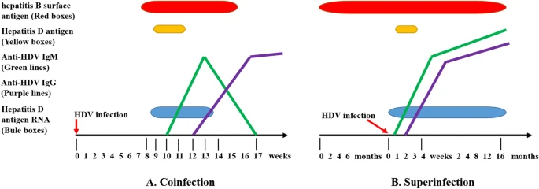
Figure 1 Serological patterns of HDV infection
Source: (Chen et al. 2021), permission provided to use image
Note: Coinfection is the simultaneous acute infection of HBV and HDV in a susceptible individual. Serum HDAg is detectable only transiently in blood specimens collected early at the onset of HDV, before the rising of antibodies. Anti-HDV IgM response is rapid and weak suggesting a resolution of infection. Anti-HDV IgG levels increased rapidly and persisted. B Superinfection is an HDV infection in an individual chronically infected with HBV. This pattern of infection has two components, the acute stage and the chronic stage. The acute phase is characterized by very high levels of HDV viremia and HDAg antigen in serum/liver. In the chronic period, HDV RNA, anti-HDV IgM and anti-HDV IgG persist.
Abbreviations: HDV hepatitis D virus; HBV hepatitis B virus; HDAg hepatitis D antigen; HBsAg hepatitis B surface antigen; Anti-HDV IgM immunoglobulin M antibody to the HDAg; Anti-HDV IgG immunoglobulin G antibody to the HDAg
PASC noted that ALT testing and albumin testing are not necessarily done prior to PCR testing, however these tests will be done (either before, after or alongside PCR testing) as part of standard care.
ALT is an enzyme mostly found in the liver, and serum ALT levels are elevated in cases of liver inflammation. The presence of elevated ALT has been associated with increased liver-related mortality (Kwo, Cohen & Lim 2017). ACG guidelines state that normal ALT levels range from 29 to 33 IU/l for males and 19 to 25 IU/l for females. Elevated ALT levels were a requirement for eligibility in the key trial of bulevirtide.
A serum albumin test is a blood test that measures albumin levels. Albumin is responsible for protein synthesis, which is an important function of the liver. Daily, around 10 grams of albumin is synthesised and secreted by the liver. When a person has progressive liver disease serum albumin levels decrease, which reflects decreased synthesis. Albumin concentration correlates with the prognosis in chronic liver disease. Normal albumin levels range between 40-60 g/l (Limdi & Hyde 2003). The main bulevirtide trial required patients to have an albumin level of at least 28 g/l.
ALT and albumin testing are listed on the MBS under item number 66500.

Intervention
The proposed test
The proposed test is HDV RNA PCR testing, which is an in vitro diagnostic test. In Australia, only the Victorian Infectious Diseases Reference Laboratory (VIDRL) is currently providing the proposed medical service (at a private cost to patients), thus all samples collected nationally will need to be forwarded to VIDRL, Victoria for processing. The HDV RNA PCR test is National Association of Testing Authorities (NATA) accredited.
The applicant states that the HDV RNA PCR test that will be used in Australia by VIDRL is expected to have a lower limit of detection (LLoD) of 10 IU/mL. The testing device in use at VIDRL was developed based on the Abbott m2000 HDV PCR RNA test with a LLoD of 10 IU/mL.
The proposed test would be used in addition to already existing tests (e.g. antibody tests and ALT), not as a replacement. Prior to the proposed HDV RNA PCR testing, all HBsAg positive cases are required to undergo HDV antibody testing. A serological diagnosis is made by detection of total antibody to HDV (anti-HDV) by enzyme-linked immunosorbent assay (ELISA); a positive HDV IgM result indicates ongoing replication.
Purpose of the proposed test for the codependent application
The applicant proposed two new MBS items:
- one to detect the presence of HDV RNA (to be used for the purpose of diagnosing active HDV infection and thus assisting in determining eligibility to bulevirtide), and
- one to quantify levels of HDV RNA, to monitor the effectiveness of this treatment.
PASC noted that HDV RNA PCR is proposed to be a quantitative test (for quantitation of HDV RNA load) to help determine eligibility for and monitor treatment with bulevirtide. PASC accepted that there was no role for a qualitative test for these purposes. For future-proofing purposes, PASC advised that the item descriptor should be re-drafted to allow MSAC the option of supporting use of the proposed test for these purposes with any relevant PBS-listed medication.
Diagnosis of chronic HDV
In the key trial, HDV RNA PCR testing was also used for the purpose of determining the length of time a patient had an active infection, to determine if it could be classified as chronic HDV. The key bulevirtide trial (NCT03852719) recruited participants with chronic HDV who were:
- anti-HDV antibody positive OR HDV RNA PCR positive for at least 6 months before screening AND
- positive HDV RNA PCR at screening.
During the PICO process, the applicant clarified that it is proposed that patients who test negative on HDV RNA PCR and are being managed for HBV but are suspected of having chronic HDV (based on clinical judgement) are monitored for HDV RNA via a PCR test up to a maximum of two times per year.
PASC confirmed that a restriction of two tests per year (consistent with a frequency of a test every 6 months) is appropriate both for establishing a diagnosis of chronic active HDV infection before bulevirtide and for monitoring treatment with bulevirtide.
Monitoring of effectiveness of bulevirtide treatment
The application requested ongoing HDV RNA PCR testing (maximum two tests per year) for patients taking bulevirtide for the purpose of assessing treatment effectiveness. REDACTED.
The proposed treatment
The proposed treatment is bulevirtide, which is an HBV/HDV entry inhibitor. The bile acid transporter NTCP (sodium taurocholate cotransporting polypeptide) is targeted by the drug, which leads to an increase in bile acids during treatment. When NTCP is blocked, HBV and HDV virons are blocked from entering the cell (Yardeni, Heller & Koh 2022). In trials, bulevirtide has been administered as a subcutaneous injection daily (2-10 mg) (Sandmann & Wedemeyer 2021). Bulevirtide therapy is not curative, and ongoing treatment is required (i.e. chronic treatment). The applicant states that chronic treatment would be necessary as viral rebound occurs and the treatment response is lost if treatment is stopped.
Currently, there is no TGA-approved therapy for chronic HDV (Shah et al. 2019) (see the Comparators section below). Bulevirtide has been granted a designation (orphan drug) and determination (priority review) by the TGA with a lapse date of 19/07/2022, for the requested indication for the treatment of chronic HDV infection in adult patients with compensated liver disease. At the time of finalising this PICO Confirmation (May 2022), bulevirtide has not been registered on the ARTG.
The use of HDV RNA PCR testing and subsequent treatment with bulevirtide will not alter the treatment of the underlying HBV.

Comparator(s)
The test
In the current treatment pathway for patients with chronic HDV, there is no HDV RNA PCR testing. The comparator therefore is ‘no HDV RNA PCR testing’. The proposed medical testing is expected to be used in addition to current tests.
PASC confirmed the comparator for the test to be no HDV RNA PCR testing.
The treatment
No medicine is currently TGA-approved for the treatment of HDV in Australia. Antivirals (e.g. ribavirin or famciclovir) have little effect on HDV.
Symptomatic management of HDV infection and long-term follow up by a liver specialist is currently clinical practice in Australia. If the disease has progressed, a liver transplant may be recommended, dependent on the stage of liver fibrosis.
As there currently is no approved pharmacological treatment for HDV infection, ‘no pharmacological intervention’ may be an appropriate comparator.
A weekly subcutaneous dose of pegylated IFN alfa (PEG- IFN- α)- 2a is recommended by professional guidelines to treat HDV, however the drug has not been authorised for use by the regulatory authorities (Yardeni, Heller & Koh 2022). PEG-IFN-α may be used for HDV off-label in Australia as an unrestricted PBS item.
PASC noted advice that PEG-IFN-α is used by in some patients with chronic hepatitis D although careful clinical consideration is required due to side effects/toxicity. PASC considered that PEG-IFN-α may be a potential comparator for bulevirtide, but that the comparator for bulevirtide was a matter for the PBAC to consider.

Clinical utility standard
The key trial demonstrating the clinical utility of HDV RNA quantification and treatment with bulevirtide used the Robogene® HDV RNA Quantification Kit 2.0 with a LLoD of 6 IU/mL. During the pre-PASC meeting, the applicant stated that that the Robogene® HDV RNA Quantification Kit 2.0 is expected to have similar performance to the testing device currently in use at VIDRL, which is developed based on Abbott m2000 HDV PCR RNA test with a LLoD of 10 IU/mL.
The ADAR should include an assessment of the difference in LLoD (6IU/mL vs 10IU/mL) and its impact on the accuracy of the different test options.
PASC accepted the identified clinical utility standard.

Outcomes
Test related outcomes:
- Safety
- Test turnaround time
- Concordance of the test with the clinical utility standard – Performance of test used in Australia compared to clinical utility standard.
  - Positive percentage agreement
  - Negative percentage agreement
- Predictive validity of the test (distinguished from presence of, or quantification of, HDV RNA as a prognostic marker)
- Suitability of the test for monitoring (ability to distinguish response to treatment from background random variation, i.e. signal to noise ratio).
- Change in management (including broader changes in clinical management from testing)
Drug:
- Safety (adverse events, physical examinations, laboratory findings)
- Effectiveness:
  - Health-related quality of life (HRQOL)
  - Survival
  - Quality adjusted life years (QALYs)
  - Liver fibrosis outcomes
  - Liver transplants
  - Response to treatment
PASC noted that the applicant is still working on defining what ‘response to treatment’ entails (REDACTED) and will be included in the assessment report.
Healthcare system:
- Cost of testing and retesting
- Cost of treatment
- Cost-effectiveness of testing and treatment
- Financial implications

Assessment framework (for investigative technologies)
As there has been a claim of superiority, the assessment would need to show an improvement in health outcomes. The information from the HDV RNA PCR test would inform treatment decisions (access to bulevirtide), and the change in treatment would ultimately impact the health of the patient.
If direct evidence is not available (a study directly showing that PCR testing has a positive impact on patient health), evidence should be presented for each separate step. An assessment framework is a graphical representation of each step (Figure 2). Applicable and transitive evidence for each step is required to ensure information or action from the previous step is translated to the next. Each number corresponds to one or more research questions (See ‘assessment questions’ in Table 1 the questions under Figure 2).
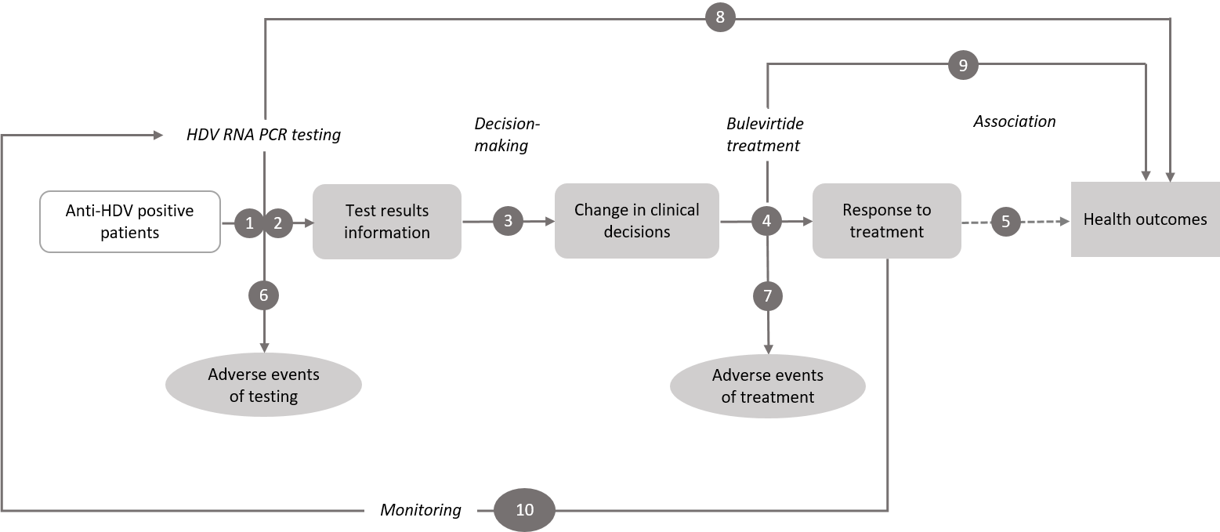
Figure 2 Generic assessment framework showing the links from the test population to health outcomes
HDV = hepatitis D virus; PCR = polymerase chain reaction; RNA = ribonucleic acid
- What is the concordance of the PCR test proposed for use in Australia, compared to the clinical utility standard?
- What is the accuracy of HDV RNA PCR testing for predicting response to bulevirtide treatment in those diagnosed with hepatitis D?
- Does the HDV RNA PCR test result lead to a change in clinical decisions?
- How does bulevirtide treatment impact HDV RNA levels and ALT levels?
- How does a decrease in HDV RNA levels and ALT levels lead to better health outcomes?
- What is the safety of HDV RNA PCR testing?
- What is the safety of bulevirtide treatment?
- What is the safety, effectiveness and cost-effectiveness of HDV RNA PCR testing to determine eligibility for bulevirtide for the treatment of HDV no HDV treatment in those diagnosed with HBV, and testing positive for serum anti-HDV antibodies?
- How does bulevirtide treatment impact health outcomes?
- How well does HDV RNA PCR distinguish response to treatment compared to background variation?
PASC noted the research questions relating to the broader population should be deleted from the PICO Confirmation as it would be very difficult to collect supporting data (with only 80 cases notified per annum in Australia).

Clinical management algorithms
Current clinical management
In the current clinical management algorithm (Figure 3), patients testing positive for HBsAg are tested for anti-HDV antibodies. Based on the presence of anti-HDV antibodies, they are classified as anti-HDV positive and negative. During the acute phase of HDV infection, IgM anti-HDV is detectable in serum. IgG anti-HDV antibodies would be present in chronic HDV infections or would show a past infection with recovery (Shah et al. 2019).
In the absence of HDV RNA PCR testing, testing for anti-HDV antibodies and ALT testing would still be done to determine the presence of HDV and to assess liver damage. While continuing the standard HBV treatment, patients with HDV will be assessed for liver fibrosis using non-invasive techniques preferably irrespective of the ALT levels and continuous monitoring of liver function is required. Currently there is no approved treatment for hepatitis D infection. Long-term follow up by a liver specialist is recommended. If the disease is progressed, liver transplant is recommend based on the liver condition.
The applicant confirmed that ALT is not a direct measure of HDV viraemia and this test alone does not impact patient management. However ALT is a marker for current liver inflammation and forms one part of a liver function test, which is routinely performed in patients with viral hepatitis.
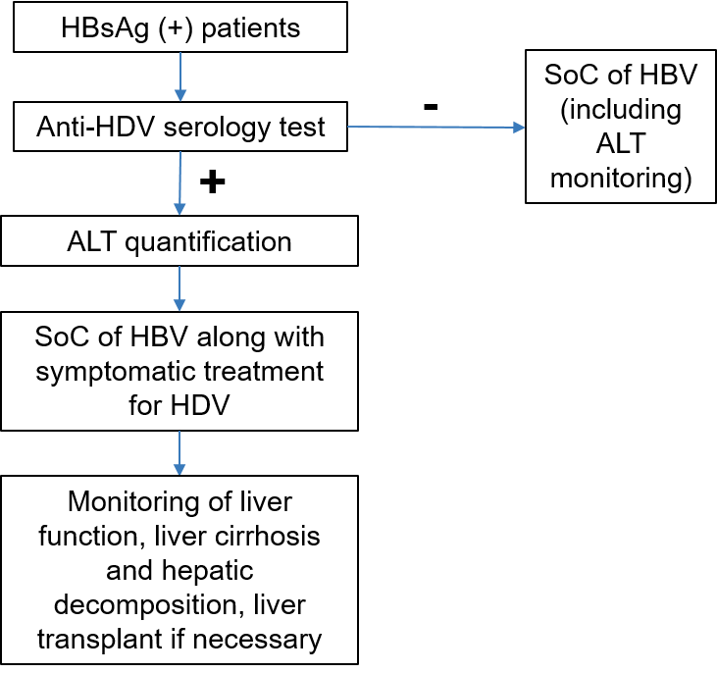
Figure 3 Clinical management of Hepatitis D in the absence of HDV RNA PCR testing and bulevirtide
ALT = alanine aminotransferase; HBsAG = hepatitis B surface antigen; HBV = hepatitis B virus; HDV = hepatitis D virus; SoC = standard of care

Proposed clinical management
PASC noted that the timing of ALT testing is not important in this context and should not be considered a requirement for HDV RNA PCR testing. Therefore ALT quantification has been removed from the proposed clinical management algorithm in the Post-PASC PICO.
The most recent proposed clinical management algorithm (Figure 4,) introduces HDV RNA PCR testing in the population found to be anti-HDV positive and expected to have chronic HDV. Based on the HDV RNA load patients are classified as HDV RNA positive or negative. Patients testing positive on HDV RNA PCR and are found to meet the other requirements (REDACTED) for bulevirtide treatment are directly considered for treatment with bulevirtide. All other patients who tested positive for anti-HDV antibodies would be offered a HDV RNA PCR test twice a year if chronic HDV is suspected, and will commence bulevirtide treatment once the PCR test is positive and other requirements are met.
PASC suggested adding an arrow to the proposed clinical management algorithm from ‘eligible for HDV therapy with bulevirtide’ to ‘HDV RNA PCR test’ to show ongoing HDV RNA testing for monitoring treatment response. The latest (Post-PASC) clinical management algorithm reflecting the intention of this suggestion is presented in the revised Figure 4.
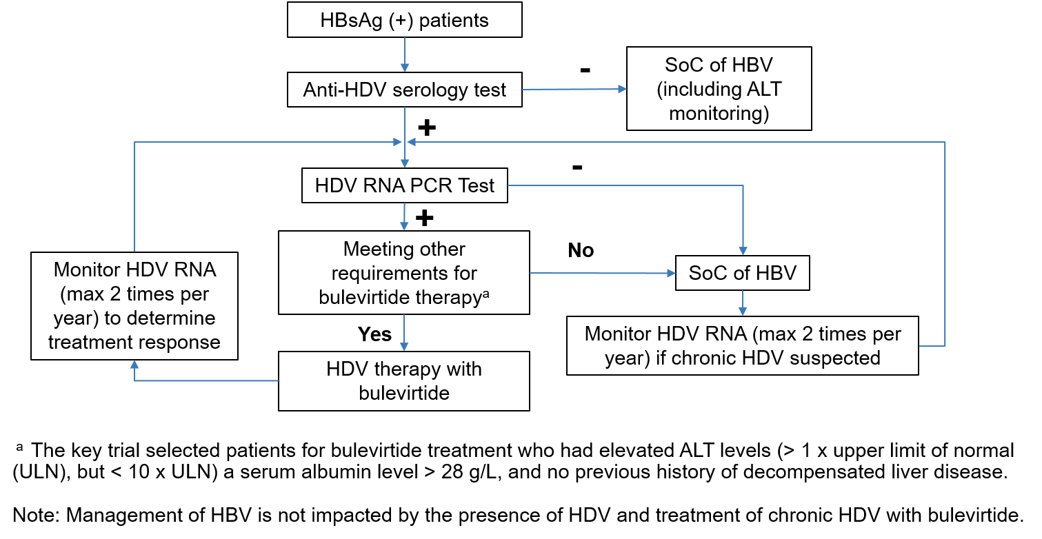 Figure 4 Proposed clinical management of Hepatitis D with HDV RNA PCR testing and bulevirtide
ALT = alanine aminotransferase; HBsAG = hepatitis B surface antigen; HBV = hepatitis B virus; HDV = hepatitis D virus; PCR = polymerase chain reaction; RNA = ribonucleic acid; SoC = standard of care

Proposed economic evaluation
The applicant claims that HDV RNA PCR testing and treatment with bulevirtide for chronic HDV will result in superior safety and effectiveness compared to no testing and symptomatic treatment in patients with chronic HDV.
Responses to public consultation suggested that there is an unmet clinical need for use of the proposed test for broader purposes than associated with bulevirtide. If the proposed MBS items are not highly specific to the population who would otherwise be eligible for bulevirtide, or who are receiving bulevirtide, the risk of “leakage” (usage outside of the codependent purpose) is high.
PASC noted that the applicant re-iterated its intention that the economic evaluation in the ADAR will focus solely on the codependency between HDV RNA testing and bulevirtide.
Based on the clinical claim proposed by the applicant, a cost-effectiveness/cost utility analysis is the most appropriate economic evaluation.
Table 2 provides a guide for determining which type of economic evaluation is appropriate.
Table 2 Classification of comparative effectiveness and safety of the proposed intervention, compared with its main comparator, and guide to the suitable type of economic evaluation
Comparative safety | Comparative effectiveness
 | Inferior | Uncertainª | Noninferior^{b} | Superior
Inferior | Health forgone: need other supportive factors | Health forgone possible: need other supportive factors | Health forgone: need other supportive factors | ? Likely CUA
Uncertainª | Health forgone possible: need other supportive factors | ? | ? | ? Likely CEA/CUA
Noninferior^{b} | Health forgone: need other supportive factors | ? | CMA | CEA/CUA
Superior | ? Likely CUA | ? Likely CEA/CUA | CEA/CUA | CEA/CUA
CEA=cost-effectiveness analysis; CMA=cost-minimisation analysis; CUA=cost-utility analysis
? = reflect uncertainties and any identified health trade-offs in the economic evaluation, as a minimum in a cost-consequences analysis
ª ‘Uncertainty’ covers concepts such as inadequate minimisation of important sources of bias, lack of statistical significance in an underpowered trial, detecting clinically unimportant therapeutic differences, inconsistent results across trials, and trade-offs within the comparative effectiveness and/or the comparative safety considerations.
^{b} An adequate assessment of ‘noninferiority’ is the preferred basis for demonstrating equivalence.

Proposal for public funding
The applicant proposed two new MBS items for HDV RNA testing in patients found to be positive for anti-HDV antibodies to determine the access to PBS-subsidised bulevirtide and also to monitor the treatment effect of bulevirtide for chronic HDV.
The applicant proposed a fee of $152.10 for each item based on HBV DNA testing (MBS Item 69483). During the pre-PASC meeting, it was noted that the current price of the test at VIDRL is $100.
Based on the most recently provided clinical algorithm, it is anticipated that two tests are required per year, for the purposes of both pre-treatment evaluation and treatment monitoring.
Initially, two different items for testing were proposed (Table 3 and Table 4). These were the basis of the consultation feedback.
Table 3 Proposed MBS item for HDV diagnosis (application version)
Category PATHOLOGY SERVICES – P3 - Microbiology
Proposed item descriptor: Quantitation of Hepatitis D viral RNA in patients who are Hepatitis D antibody ª positive - 1 test
Fee: $152.10 Benefit: 75% = $114.10 85% = $129.30
ª Corrected from ‘surface antigen’ in the application
Table 4 MBS item description for continuation of therapy with bulevirtide for HDV treatment (application version)
Category PATHOLOGY SERVICES – P3 - Microbiology
Proposed item descriptor: Quantitation of Hepatitis D viral RNA in patients who are Hepatitis D antibody ª positive and who have chronic hepatitis D and are receiving bulevirtide therapy.
To a maximum of 2 of this item in a 12 month period.
Fee: $152.10 Benefit: 75% = $114.10 85% = $129.30
ª Corrected from ‘surface antigen’ in the application
The applicant proposed that the HDV RNA PCR test would be ordered by the clinician managing the patient. Jackson (2018) reported that VIDRL adopted the policy of reflexing all first time anti-HDV-positive samples into the HDV PCR assay in 2015. This was because less than half of positive results in this study had a clinician-initiated request for PCR testing. However, when PCR was performed without clinician request, half of the samples were positive.
PASC discussed whether the item for the diagnosis of active hepatitis D may need to be restricted to specialists who manage chronic HDV infection, but on balance considered reflex testing (following positive hepatitis D antibody testing) to be preferable to enable diagnosis of chronic HDV. PASC confirmed that HDV RNA PCR testing should be pathologist determinable, and that ‘for at least 6 months’ should be replaced with ‘and are suspected of having chronic HDV’. The MSAC process should consider whether the test should be pathologist determinable and whether it should be restricted to specialists who manage chronic HDV infection and pathologists.
PASC also agreed that the two proposed items could be combined into one item (see Table 5).
For future-proofing purposes, PASC advised that an alternative item descriptor should be drafted to allow MSAC the option of supporting use of the proposed test to help determine eligibility for or monitoring of patients on any relevant PBS-listed medication.
PASC noted that the current fee for HDV RNA PCR testing in Australia, performed only by the Victorian Infectious Disease Reference Laboratory, is $100. However, it was suggested to PASC that this fee may be below or at cost. PASC agreed that a fee of $152.10 was reasonable considering all the steps required to perform the service.
PASC discussed whether re-treatment with bulevirtide should be included in the combined MBS item. PASC concluded that the population described in clause (a) of the combined item descriptor would not necessarily exclude patients who have already been treated with bulevirtide.
The proposed item (revised after PASC) is shown in Table 5.
Table 5 Proposed combined MBS item for HDV diagnosis and continuation of therapy for HDV
Category: Pathology service – P3 - Microbiology
AAABB
Quantitation of Hepatitis D viral RNA load in plasma or serum in:
- the pre-treatment evaluation for access to therapy for chronic HDV hepatitis in patients who are Hepatitis D viral antibody positive and suspected of having chronic hepatitis D; or
- a patient undertaking antiviral therapy for chronic hepatitis with bulevirtide for the purpose of assessing treatment effectiveness.
To a maximum of 2 tests in a 12 month period.
Fee: $152.10 Benefit: 75% = $114.10 85% = $129.30

Summary of public consultation input
Consultation input was received from three (3) professional organisations, two (2) consumer organisations and one (1) individual, a medical professional. The five (5) organisations that submitted input were:
- Australian Pathology (AP)
- Gastroenterological Society of Australia (GESA)
- Hepatitis SA
- Hepatitis Queensland (HQ)
- Public Pathology Australia (PPA)
The consultation feedback received was mostly supportive of public funding for application 1708. The consultation feedback raised a number of concerns, predominately in relation to the population and item descriptor.
Clinical need and public health significance
The main benefits of public funding received in the consultation feedback included:
- Increased accuracy in diagnosing HDV, including quantification of virus levels, and determining active and past infections
- Appropriate treatment, including reduction of treatment delays and under-treatment
- Monitoring treatment, and prompt response to treatment failure and avoidance of unnecessary investigations or interventions
- Public funding of the testing would promote standardisation of HDV testing and monitoring
- Reduced transmission of HDV due to higher rates of diagnosis and increased awareness
- Increased equity of access, including regarding socioeconomic barriers
- Accurate monitoring of infectious diseases, promoting public health goals.
Pre-test counselling and consent were identified in the consultation feedback as being needed to be delivered before the intervention.
Indication(s) for the proposed medical service and clinical claim
The consultation feedback ranged from ‘disagreeing’ to ‘strongly agreeing’ with the proposed population.
While GESA, HQ and PPA agreed with the proposed population, Hepatitis SA and the AP disagreed with the proposed population, as they considered it should be broadened:
- Hepatitis SA considered that all people living with HBV infection should receive a HDV antibody test and that those who begin bulevirtide treatment should receive twice-yearly monitoring via HDV-PCR testing to aid clinical decision making.
- The AP disagreed with the proposed population and considered that the testing should not be restricted to hepatitis-B positive patients due to the possibility of transmission via exposure to bodily fluids. Also, AP considered that the patient’s disease status is clinically relevant across a broader medical context and testing need not be restricted to determining appropriateness of particular pharmaceutical treatments.
The medical scientist was in support of the public funding for the proposed service and considered that the severity of disease caused by HDV co-infection warrants the screening of all HBV infected individuals for HDV antibodies and then anti-HD positive individuals for HDV RNA.
Item Descriptor
The consultation feedback ranged from ‘disagreeing’ to ‘agreeing’ with the proposed item descriptor.
The AP stated that there is no need for a separate item descriptor for patients undergoing therapy with bulevirtide, as long as the base item does not have a time restrictor placed on it.
The PPA considered that a specialist, such as in infectious diseases or a gastroenterologist, should request the initial testing.
Additional comments
The AP considered the existing MBS items to be too restrictive in the number of tests funded and recommended that these items should be revised to increase limit to 6 tests, to allow pathologists to claim for more than 3 hepatitis antigen tests in a patient episode.
The medical scientist considered that:
- the proposed treatment has shown specific response as an anti-HDV treatment with visible decline in HDV RNA and minimal side effects;
- the proposed service will address the finding that currently HDV infection is largely under-diagnosed due to the prohibitive cost of PCR testing, and;
- liver function testing is essential before and during treatment to assess liver damage and response.
The medical scientist agreed with the proposed cost of the service, but considered the wording for the item descriptor (question 51 of the application form) should be “Hepatitis B surface antigen positive”.
Consumer Feedback
- Hepatitis SA noted a large proportion of people who are diagnosed with HDV were born overseas (often low-income countries). Additionally, people who inject drugs and men who have sex with men are have a higher risk of HDV. Hepatitis SA considered these groups experience multiple barriers to accessing health services, including financial costs. Hepatitis SA considered removal of costs for HDV PCR tests encourage correct testing by clinicians and will encourage treatment access by financially and socially vulnerable community members who are managing two or more chronic conditions.
PASC noted supportive consultation feedback from clinicians and consumers.
PASC noted that the consultation feedback proposed broader uses of HDV RNA PCR testing than proposed in the application. PASC noted the applicant was of the view that only testing for its proposed codependent purposes should be considered (narrow population), and the application should not be extended to include testing for other purposes as proposed during the public consultation period.

Next steps
PASC noted the applicant has elected to progress its application as an ADAR (Applicant Developed Assessment Report) in the form of an integrated codependent submission to MSAC and PBAC.

References
Allard, N & Cowie, B 2018, Complex situations Co-infection and Immunosuppression, Australasian Society for HIV, Viral Hepatitis and Sexual Health Medicine (ASHM), viewed 3/5/2022, <https://hepatitisb.org.au/complex-situations-co-infection-and-immunosuppression/>.
ASHM 2020, National Hepatitis B Testing Policy, Australasian Society for HIV, Viral Hepatitis and Sexual Health Medicine (ASHM)
Australian Government Department of Health 2013, Hepatitis D case definition, Commonwealth of Australia, Canberra, <https://www1.health.gov.au/internet/main/publishing.nsf/Content/cda-surveil-nndss-casedefs-cd_hepd.htm>.
CDC 2020, Viral Hepatitis, U.S. Department of Health & Human Services, viewed 23rd March 2022, <https://www.cdc.gov/hepatitis/hdv/hdvfaq.htm>.
Chang, T-E, Su, C-W, Huang, Y-S, Huang, Y-H, Hou, M-C & Wu, J-C 2022, 'Hepatitis D virus dual infection increased the risk of hepatocellular carcinoma compared with hepatitis B virus mono infection: A meta-analysis', Journal of the Chinese Medical Association, vol. 85, no. 1, pp. 30-41.
Chen, LY, Pang, XY, Goyal, H, Yang, RX & Xu, HG 2021, 'Hepatitis D: challenges in the estimation of true prevalence and laboratory diagnosis', Gut Pathog, vol. 13, no. 1, Oct 30, p. 66.
Coghill, S, McNamara, J, Woods, M & Hajkowicz, K 2018, 'Epidemiology and clinical outcomes of hepatitis delta (D) virus infection in Queensland, Australia', Int J Infect Dis, vol. 74, Sep, pp. 123-127.
Hepatitis B Consensus Statement Working Group 2022, Australian consensus recommendations for the management of hepatitis B infection., Gastroenterological Society of Australia, Melbourne.
Jackson, K, MacLachlan, J, Cowie, B, Locarnini, S, Bowden, S, Higgins, N, Karapanagiotidis, T, Nicholson, S & Littlejohn, M 2018, 'Epidemiology and phylogenetic analysis of hepatitis D virus infection in Australia', Internal Medicine Journal, vol. 48, no. 11, pp. 1308-1317.
Kwo, PY, Cohen, SM & Lim, JK 2017, 'ACG Clinical Guideline: Evaluation of Abnormal Liver Chemistries', Am J Gastroenterol, vol. 112, no. 1, Jan, pp. 18-35.
Limdi, JK & Hyde, GM 2003, 'Evaluation of abnormal liver function tests', Postgrad Med J, vol. 79, no. 932, Jun, pp. 307-312.
MacLachlan, J, Stewart, S & Cowie, B 2020, Viral Hepatitis Mapping Project: National Report 2020. , VH Australasian Society for HIV, and Sexual Health Medicine (ASHM). Darlinghurst, NSW, Australia., <https://www.ashm.org.au/programs/Viral-Hepatitis-Mapping-Project/>.
NNDSS Annual Report Working Group 2021, Australia’s notifiable disease status, 2016: Annual report of the National Notifiable Diseases Surveillance System, Communicable Diseases Intelligence, Australian Government Department of Health Commonwealth of Australia, <https://www1.health.gov.au/internet/main/publishing.nsf/Content/8FA6078276359430CA257BF0001A4C42/$File/australia_s_notifiable_disease_status_2016_annual_report_of_the_national_notifiable_diseases_surveillance_system.pdf>.
NNDSS Fortnightly summary notes - 2021 2021, Australian Government Department of Health viewed 2/2/2022, <https://www1.health.gov.au/internet/main/publishing.nsf/Content/nndss-fortnightly-summary-notes-2021>.
Sandmann, L & Wedemeyer, H 2021, 'New Treatments for Chronic Hepatitis B Virus/Hepatitis D Virus Infection', Clin Liver Dis, vol. 25, no. 4, Nov, pp. 831-839.
Schaefer, TJ & John, S 2022, 'Acute Hepatitis', in StatPearls, Treasure Island (FL).
Shah, PA, Choudhry, S, Reyes, KJC & Lau, DTY 2019, 'An update on the management of chronic hepatitis D', Gastroenterol Rep (Oxf), vol. 7, no. 6, Dec, pp. 396-402.
Yardeni, D, Heller, T & Koh, C 2022, 'Chronic hepatitis D-What is changing?', J Viral Hepat, Feb 4.

https://www.tga.gov.au/ws-designation-notices-index
https://www.tga.gov.au/ws-designation-notices-index, accessed 9/3/2022

