RATIFIED PICO
Application 1599:
Genomic testing for the diagnosis of heritable cardiomyopathies

Summary of PICO/PPICO criteria to define the question(s) to be addressed in an Assessment Report to the Medical Services Advisory Committee (MSAC)
Component | Description
Patients | - Broad gene panel testing for:  - Individuals with a suspected heritable cardiomyopathy  - Variant-specific detection for:  - Biological relatives of an individual with a clinically actionable pathogenic variant of a heritable cardiomyopathy
Prior tests | None
Intervention | A gene panel test (either cardiomyopathy panel or cardiac panel) or variant-specific testing, that are in-vitro diagnostic (IVD) tests, which are used to detect genetic variants in a peripheral blood sample to assess whether there is a clinically actionable pathogenic variant of heritable cardiomyopathy.  Only specialist cardiologists or clinical geneticists will offer the proposed intervention.
Comparator | No genetic testing (i.e. clinical diagnosis alone) which involves usual standard of care, without genetic testing.
Outcomes | Safety  - Adverse events from obtaining a sample for testing  - Psychological adverse events from genetic testing or no genetic testing  - Psychological effects of false positives or false negatives  Effectiveness  - Impact on clinical management  - Health-related quality of life  - Reduced morbidity  - Reduced mortality  Analytical validity  - Analytical sensitivity and specificity  - Likelihood ratios  - Rate of repeat testing and/or rate of repeat data analysis (i.e. when new genes are identified and/or added to the panel test)  Clinical validity  - Clinical specificity and sensitivity  - Positive and negative predictor and prognostic values  Healthcare resources  - Cost of gene panel test or variant-specific test  - Number of, and cost associated with obtaining an appropriate sample  - Additional medical practitioner consultations  - Cost of retesting and/or data reanalysis  - Cost of genetic counselling (if undertaken outside consultation with medical practitioner)  - Cost offset by reducing number of cardiac evaluations (including testing) at recommended time intervals  - Cost per quality-adjusted life year  - Total Australian Government healthcare costs

POPULATION
PASC advised that the assessment report should assess each group of inherited cardiomyopathies separately (HCM, DCM, ACM). The PICO currently splits the three conditions by estimates of prevalence and incidence.

The applicant has agreed it would be appropriate to assess the three populations separately, as per its recent application for hereditary colorectal cancer.
PASC noted the prevalence of conditions in population 1 will be extremely hard to determine. PASC acknowledged an estimate of 9,000 was provided, but this was highly uncertain. PASC recommended that data be mined for the people who have been paying for this test privately, in order to estimate the proportion of people who took up the test (out of those who were offered it). This is important to determine the number of people who may take up cascade testing (population 2).
It is understood that this means the applicant should mine existing data to estimate the degree of uptake (the number of people who took up the test out of those who were offered it). It is uncertain if the applicant has access to data which outline the number of times the test was offered. While some of this information may be derived from peer-reviewed literature, the true extent of uptake in the Australian context is not currently known (nor has it been reasonably modelled).
PASC noted the management guidelines are different for people under surveillance, compared to those being treated. PASC advised this needs to be reflected in the economic evaluation. The PICO has been updated with a sentence that reflects differences in the management guidelines across the different disease types (and associated modification made to the clinical algorithm).
PASC also noted a number of germline variants being proposed in this service are for autosomal recessive conditions. As such, an item for cascade testing of the reproductive partners of carriers of recessively inherited variants is also proposed.
Cardiomyopathies comprise a small group of related but clinically distinct primary diseases of the heart muscle and are one of the major causes of sudden cardiac death (SCD) and/or progressive heart failure (HF) (Szabadosova et al., 2018). Cardiomyopathies have a broad range of aetiologies including: genetic, infective, autoimmune, toxicity-related, nutritional deficiencies, drug-induced, endocrine, and inborn errors of metabolism. Cardiomyopathies with a genetic aetiology are usually inherited as autosomal-dominant (Waldmüller et al., 2015) and include:

- Hypertrophic cardiomyopathy (HCM): HCM is a common cardiac genetic disease with an estimated prevalence of 1 in 200 to 1 in 500 (Semsarian, C., Ingles, J. et al 2015). HCM is characterised by the presence of unexplained left ventricular hypertrophy (LVH). The LVH associated with HCM usually develops during adolescence or young adulthood. HCM was initially thought to be associated with high mortality, however, the majority of individuals with HCM will experience a normal life expectancy and manageable symptoms. However, individuals with HCM are at an increased risk for atrial fibrillation (AF), which is associated with significant morbidity due to increased risk of thromboembolism and symptomatic deterioration. Approximately 5%-10% of individuals with HCM progress to end-stage disease with impaired systolic function and, in some cases, left ventricular dilatation and regression of LVH. The annual mortality rate in individuals with end-stage disease is estimated at 11% and cardiac transplantation may be required. A small number of individuals with HCM are at increased risk for SCD related to ventricular tachycardia / ventricular fibrillation. SCD may be the first manifestation of disease, usually occurring in adolescents or young adults (Cirino & Ho, 2008). Patients can be risk-stratified clinically for SCD via Holter, echocardiogram, and family history; however, identification of specific variants may add additional clinical information and assist risk stratification.
- Dilated cardiomyopathy (DCM): DCM is characterised by LV enlargement and systolic dysfunction, a reduction in the myocardial force of contraction. Onset may occur at any time in life but is more common in adults aged 40 to 60 years. Few estimates of the prevalence of DCM exist; however, it has been estimated to be approximately twice that of HCM (1:250) (Hershberger & Morales, 2007). In 80 to 90 percent of cases, familial dilated cardiomyopathy is inherited in an autosomal dominant pattern (Dellefave & McNally, 2010).
- Arrhythmogenic cardiomyopathy (ACM): ACM is characterised by progressive fibro-fatty replacement of the myocardium, predisposing young individuals and athletes to ventricular tachycardia and SCD affecting the right and/or left ventricle. The mean age at diagnosis is 31 ± 13 years (range 4-64 years). The prevalence of ACM is estimated at 1:1,000 to 1:1,250 in the general population (McNally, MacLeod, & Dellefave-Castillo, 2005). Although most non-syndromic ACM is inherited in an autosomal dominant pattern, recessive patterns also exist (Corrado, Basso, & Judge, 2017).
The proposed populations affected by the proposed intervention are:
- Individuals with a suspected heritable cardiomyopathy (i.e. diagnostic testing): Characterisation of germline gene variants for heritable cardiomyopathies in patients where clinical criteria and/or a family history indicate that genetic testing is warranted.
- Biological relatives (predictive genetic testing): Detection of a clinically actionable pathogenic variant previously identified in an at-risk relative.
Table 1 describes the observed demand for the proposed genetic test based on a survey conducted by the RCPA of all Australian laboratories (n=87) known to offer genetic/ genomic tests that yielded results with medical utility during the 2016/17 financial year.
Participation in the survey was 96.6% of all public and private sector laboratories in Australia. The private and public sector delivered 71% and 29% of all genomic tests for heritable conditions, respectively. It should be noted that those tests conducted in the private sector would be on a user-pays basis, and would therefore represent an underestimation of the true number as many patients would be unable to meet the cost of testing.
Table 1 indicates that during the 2016/2017 financial year, 256 genetic tests were ordered via the cardiomyopathy panel. During the same period, 1,108 tests were ordered through the cardiac panel. Using the known proportion of cardiomyopathy specific tests (14.5%) ordered as a proportion of the total number of tests for all cardiovascular conditions and applying it to the total number of genetic tests ordered as part of the cardiac panel (1,108), it was estimated that approximately 160 tests ordered from the cardiac panel were likely to be cardiomyopathy testing. Adding the confirmed (256) and volume of likely cardiomyopathy related genetic tests (160) yields an annual estimate of 416 tests, although the authors indicate that the number of tests is likely an underestimate of the true demand due to long wait lists and limited funding.
While this information is useful in assessing the estimated current testing volume, it does not provide insight into changes in the rate of current uptake of genetic testing which might occur in response to the genetic testing becoming publicly funded or the underlying populations’ need for testing.
Table 1: Reported annual (2016/2017) laboratory genetic testing for cardiomyopathies (unpublished data)
Test Panel | Number of genes tested | Number of tests conducted
Cardiomyopathy | Single (RBM20 & TTN) | 11
 | 11-50 genes | 86
 | 51+ genes | 159
Total-Cardiomyopathy Panel Tests¹ |  | 256
Cardiac | 11-50 genes | 403
 | 51+ genes | 461
 | Overseas Testing | 244
Total-Cardiac Panel Tests |  | 1,108
Cardiac panel tests relating to cardiomyopathy testing (14.5%)² |  | 160
Total number of identified cardiomyopathy tests  (Adding sections 1 and 2 together) |  | 416
HCM incidence estimates
A worked example to identify the likely annual incidence is provided in
Table 2 for HCM. The incidence estimates are based on the assumptions presented in the table and use a method outlined in Brinks (2011) for the estimation of incidence rates in situations where only prevalence rates are available.
In short, the estimates of mortality were incorporated along with established age-specific prevalence estimates derived from recently published estimates in a German population cohort (none were available spanning the life course in Australia) (Husser et al., 2018). Using the approach described and applying the age-related prevalence to the Australian population, it was identified that there could be over 7,000 new HCM cases annually in Australia (incidence). However, only 2,859 (41%) of these would occur before the age of 60.
It should be noted that the prevalence estimate provided in the German population (7.4 per 100,000 individuals) was far higher than the reported estimate in Australia (0.32/100,000), although the estimate identified for the Australian population related to a period between 1987 and 1996 and was confined to specialist cardiac care centres (Nugent et al., 2003). As such, the estimate from the German cohort may represent improvements in diagnosis or diagnostics which may have occurred in the intervening twenty years. However, differences in the genetic profiles of both countries may also be a significant factor. As such, caution in the interpretation of these estimates is warranted.
Table 2: Published prevalence data and estimated incidence data for HCM
Age Range | Age  (Half Point) | HCM prevalence  (per 100,000) | Australian Population  (2018 Estimates) | Number of Individuals  (Prevalence) | Number of New Cases (Incidence)
0-9 Years | 5 | 7.4 | 3,176,700 | 235 | 234
10-19 Years | 15 | 11.2 | 3,006,472 | 337 | 114
20-29 Years | 25 | 12.5 | 3,617,036 | 452 | 153
30-39 Years | 35 | 20.6 | 3,585,218 | 739 | 311
40-49 Years | 45 | 43.1 | 3,265,905 | 1,408 | 752
50-59 Years | 55 | 83.2 | 3,058,381 | 2,545 | 1,295
60-69 Years | 65 | 149.9 | 2,565,919 | 3,846 | 1,587
70-79 Years | 75 | 254.9 | 1,716,836 | 4,376 | 2,030
80+ Years | 85 | 298.7 | 988,859 | 2,954 | 634
Number of potential new cases (Incidence) |  |  |  |  | 7,110
Number of potential new cases (0-59 age brackets) |  |  |  |  | 2,859
DCM incidence estimates
Reports of the incidence and prevalence of DCM have been highly variable, largely due to variation in diagnostic criteria but also due to the populations studied and corresponding differences in the ethnic and genetic composition. A number of different studies conducted internationally have identified various estimates of incidence and prevalence. A summary table of national prevalence estimates is provided in Table 3. Of note, the most recent prevalence estimates are in excess of 20 years old. The estimate provided in the application which quoted a prevalence estimate of 1:250 could not be substantiated from the source.
Table 3: Published prevalence and incidence data for DCM
Location | Year(s) | Prevalence (per 100,000) | Incidence (per 100,000) | Reference
Olmstead County, MN | 1975–1984 | 36.5 | 3.9-7.9 | Codd, Sugrue, Gersh, and Melton (1989)
England | 1983–1984 | 8.3 |  | Williams and Olsen (1985)
Trieste, Italy | 1987–1989 |  | 7.0 | Rakar et al. (1997)
Japan | 1998 | 14.0 | 3.6 | Miura et al. (2002)
Using the highest prevalence and incidence estimate in the established literature (7.9/100,000), the likely number of new DCM cases were estimated in a given year in the Australian population (refer to Table 4). Overall, the modelling indicated that there would be approximately 2,000 new DCM cases identified every year, with approximately 1,500 between the ages of 0-59.
However, it is likely that only a subset of these 2000 cases has a genetic aetiology. Approximately 50 per cent of DCM cases have an acquired (environmental) cause, while the remaining 50 per cent of cases may be termed idiopathic. With careful history-taking and clinical evaluation of first-degree relatives, it is estimated that approximately 1 in 4 people with “idiopathic” DCM will have a family history of DCM i.e. a genetic cause (Fatkin 2012).
Table 4: Estimated incidence data for DCM
Age Range  (Years) | Age  (Half Point) | DCM Incidence  (per 100,000) | DCM Prevalence  (per 100,000) | Australian Population  (2018 Estimates) | Number of Individuals  (Prevalence) | Number of New Cases (Incidence)
0-9 | 5 | 7.9 | 36.5 | 3,176,700 | 1,159 | 251
10-19 | 15 | 7.9 | 36.5 | 3,006,472 | 1,097 | 238
20-29 | 25 | 7.9 | 36.5 | 3,617,036 | 1,320 | 286
30-39 | 35 | 7.9 | 36.5 | 3,585,218 | 1,309 | 283
40-49 | 45 | 7.9 | 36.5 | 3,265,905 | 1,192 | 258
50-59 | 55 | 7.9 | 36.5 | 3,058,381 | 1,116 | 242
60-69 | 65 | 7.9 | 36.5 | 2,565,919 | 937 | 203
70-79 | 75 | 7.9 | 36.5 | 1,716,836 | 627 | 136
80+ | 85 | 7.9 | 36.5 | 988,859 | 361 | 78
Number of potential new cases (Incidence) |  |  |  |  |  | 1,974
Number of potential new cases (0-59 age brackets) |  |  |  |  |  | 1,557
ACM incidence estimates
Determination of the incidence of arrhythmogenic cardiomyopathy (ACM)/ arrhythmogenic right ventricular cardiomyopathy (ARVC) is difficult due to different clinical manifestations of the disease, especially in different ethnic groups, and variations in age-specific penetrance. All of these factors make diagnosis difficult, and in turn, decrease the reported incidence. Given the lack of a single published estimate, no estimate of incidence for this disorder has been estimated.
Summary
Overall, based on the provided prevalence as well as reported incidence measures, there is sufficient evidence to suggest that there could be at least 9,000 new cases of HCM and DCM cardiomyopathies identifiable in Australia each year. This number does not include the number of first order relatives who may be related to an individual with a clinically actionable pathogenic gene variant. As such, there is a potential for significantly more genetic testing to be carried out, although this is heavily reliant on the accurate identification and diagnosis of these cardiomyopathies.
It should be noted that the estimates produced above have assumed an autosomal dominant inheritance pattern. The consequences of testing individuals with a recessive gene as well as tests conducted for couples in which one or more individuals are potential carriers have not been incorporated in the estimates. This is due to the modelled estimates already being in excess of currently reported testing volumes. The current estimates do not account for prenatal testing, as this population was not included by the applicant.

Table 5: Summary of Incidence and prevalence estimates for cardiomyopathy
Incidence by Age Group | HCM | DCM | ARVC/ACM
0-<10 years old (Incidence) | 0.32/100,000 | 0.73/100,000 | 0.17/100,000
Australian Population  (Aged 0-10, June 2018) | Total: 3,494,435
Number of New Cases (Based on Australian 2018 population)¹ | 11 | 26 | 6
Puberty to 64 (Prevalence) | 1:500/1:200² | 1:250³ | 1: 1,000⁴
Australian Population  (Aged 11-75) | Total: 19,953,325
Estimated number of adults with Cardiomyopathies  (Based on Australian 2018 population) | 39,907 | 79,813 | 19,953
Number of new cases annually | 7,110 | 1,974 | -
Table Notes: For ACM/AC, no incidence estimate was provided due to outdated or incomplete prevalence estimates.
Australian population figures identified and access from the following ABS source: 3101.0 - Australian Demographic Statistics, Mar 2019. Accessed on 18/10/2019
1: Incidence estimates: Nugent et al. (2003)
2: HCM prevalence estimate: Burns et al. (2017), Semsarian, Ingles, Maron, and Maron (2015)
3: DCM prevalence estimate: Hershberger and Morales (2007)
4: ACM/AC prevalence estimate: McNally et al. (2005)

Prior test
No prior tests are required for the proposed genetic test.

INTERVENTION

PASC noted that new genes may be added to the panel over time, which might necessitate re-testing or re-analysis.
PASC recommended the panels (cardiomyopathies [Application 1599] versus cardiac rhythm disorders [other current Application 1598]) be clarified before decisions on re-analysis can be made.
The applicant has confirmed the following are the ‘exemplar’ genes for this application:
- Cardiomyopathy and cardiac arrhythmia panels are distinct:
HCM: MYBPC3, MYH7, TNNI3, TNNT2, TPM1, ACTC1, MYL2, MYL3 plus “mimic” genes PRKAG2, LAMP2, GLA
DCM: LMNA, SCN5A, TTN, RBM20, PLN, DSP, MYH7, FLNC
ACM: DSC2, DSG2, DSP, JUP, PKP2, and TMEM43
PASC recommended investigation/clarification be made on what panel clinicians currently request. The applicant advised it was likely to be easier for all laboratories to have the genes on one panel, then run the whole panel, but only analyse/report on the relevant conditions.
PASC queried how variants of unknown significance will be dealt with if any are re-classified as pathogenic or likely pathogenic variants, including how this could be considered in the economic evaluation. The applicant clarified that genetics have remained stable in the past 10–20 years for these conditions, and re-analysis is not likely to have a large impact on modelling.

During the assessment phase, the applicant will need to clarify and confirm the technology they wish to list. In the PICO, specific references are made to NGS and Sanger sequencing. However, in other applications, the applicant has preferred to be technology agnostic (to allow for incorporation of new approaches into the testing, if available and applicable). Regardless, the assessment will need to specify which technology/ies is/are being evaluated.
PASC acknowledged outcomes of the tests are difficult to interpret, due to varying gene penetrance. As gene penetrance is variable, PASC advised that a multidisciplinary team (MDT) approach be used, clarifying that it is uncertain if existing MDT resources will provide sufficient coverage. References to the MDT approach have been added to the clinical algorithm and supporting text.
The proposed intervention includes two types of genetic testing:
- gene panel testing
- variant-specific testing.
The type of genetic test for cardiomyopathy is based on whether there is a known pathogenic gene variant in the person’s biological family members. For those with an identified relative, the type of cardiomyopathy genetic test (i.e. variant-specific testing) is based on the known pathogenic gene variant in the person’s biological family members. For those individuals for whom the gene variant is not known, a full panel test is indicated.
Gene panels are designed to capture all known pathogenic variants of heritable cardiomyopathy that are detectable by next generation sequencing (NGS). After a clinical examination to rule out non-genetic aetiologies of cardiomyopathy, patients will undergo genetic testing by either the cardiomyopathy or cardiac gene panel. In some circumstances, both panels may be used.
The gene panel test is suitable for patients with suspected hereditary cardiomyopathy who do not have a documented family history of a cardiomyopathy gene variant (as compared to single gene tests).
First degree relatives of those with a positive genetic test result would then be screened using a variant-specific genetic test to determine whether the pathogenic variant was inherited or de novo. Patients with a negative genetic test result who still exhibit symptoms may receive increased monitoring of their symptoms (through clinical evaluation) and pharmacological or surgical interventions dependent on the observed disease trajectory. For some individuals, reanalysis of their genetic data at a later date with the inclusion of additional variant types, may be undertaken.
Some cardiomyopathy conditions such as DCM can contribute to sudden death. Current best practice clinical guidelines indicate that if there is a strong clinical suspicion of a family history of premature unexpected sudden death, a patient may undergo panel testing for the relevant genes.
Variant-specific genetic testing utilises Sanger sequencing or other technologies (e.g. multiplex ligation-dependent probe amplification (MLPA)). As stated above, this cascade test will be performed for a first degree relative of a patient with a clinically actionable pathogenic variant of cardiomyopathy.
It would be expected that a gene panel test and/or variant-specific test would be performed and reported on within a 4-8 week period. The gene panel test and variant-specific test is not currently funded by the MBS but is accessed on a user pay basis.
The genetic test proposed for cardiomyopathy is a once off diagnostic test. Retesting and data reanalysis can be requested by the laboratory in consultation with the requesting clinician. This will be applicable for people with a negative test result as new genes are added to the panel.
Due to differences in penetrance of different types of cardiomyopathies across the life span, it can be difficult to characterise the specific cardiac abnormality and identify the cause. The current relevant cardiomyopathy diagnostic tests subsidised under the MBS are:
- Item 57360: Computed tomography of the coronary arteries performed on a minimum of a 64 slice (or equivalent) scanner.
- Item 55116, 55122: Exercise stress echocardiography performed in conjunction with item 11712, with two-dimensional recordings before exercise (baseline) from at least three acoustic windows and matching recordings from the same windows at, or immediately after, peak exercise.
- Item 11700: Twelve lead electrocardiography.
- Item 11709: Continuous ECG recording (Holter) of ambulatory patient for 12 or more hours (including resting ECG and the recording of parameters).
- Item 11712: Multi-channel ECG monitoring and recording during exercise (motorised treadmill or cycle ergometer capable of quantifying external workload in watts) or pharmacological stress, involving the continuous attendance of a medical practitioner for not less than 20 minutes, with resting ECG, and with or without continuous blood pressure monitoring and the recording of other parameters, on premises equipped with mechanical respirator and defibrillator.
- Item 63395, 63396: MRI scans for patients with suspected ACM.
- Item 63397, 63398: MRI scans for asymptomatic patients with a family history of ACM in a first-degree relative.
Genetic testing helps to identify the putative causative gene variant of the clinical phenotype so that treatment and counselling is targeted and can be commenced early. However, the application form states that, while testing had significant diagnostic and prognostic implications, the therapeutic impact of genetic testing is largely negligible for many of the cardiomyopathy variants. However, the advantages of this are that the patients can be advised on family planning, prognosis, and other long-term management plans.
The proposed genetic tests, which would replace the current diagnostic testing processes funded under the MBS described above, would be accessible via a referral from a specialist cardiologist or clinical geneticist. DNA is obtained from a peripheral blood sample, saliva sample or buccal swab for paediatric and adult patients. The samples are delivered to a NATA accredited pathology laboratory for analysis and interpretation is undertaken by accredited pathologists or medical scientists.
The genetic test proposed for cardiomyopathy is a once off diagnostic test. Retesting and data reanalysis can be requested by the laboratory in consultation with the requesting clinician. This will be applicable for people with a negative test result as new genes are added to the panel.

COMPARATOR/S
PASC confirmed the comparator is ‘no genetic testing’ (i.e. clinical diagnosis/surveillance alone of patients and their relatives as standard of care), not ‘user-pays genetic testing’.
PASC acknowledged that standard of care would differ for each of the three groups of inherited cardiomyopathies. Standard of care will need to be incorporated into the economic evaluation. Each algorithm refers to CSANZ Guidelines on the treatment and monitoring of cardiomyopathy/suspected cardiomyopathy patients.
PASC also acknowledged that, with the exception of arrhythmogenic cardiomyopathy (ACM, MBS Item 63395), cardiac MRI is not currently MBS-reimbursed. The cost of cardiac MRI should be included (where relevant) in the cost of the comparator. Cardiac MRI is now represented in PICO text and clinical algorithm.
PASC noted the recommended time intervals for surveillance, which affect the economic evaluation. Further explanation is provided in the PICO to explain the need for standard of care to be incorporated into the economic evaluation, and the timeframe for surveillance has been included in the algorithm.
No gene panel test or variant-specific test is the proposed comparator.
MBS subsidised diagnostic tests are available for patients with suspected cardiomyopathy. These tests are not suitable comparators since they do not provide a definitive diagnosis and are unable to specify the genetic pathogenic variant for the cardiomyopathy.
It should also be noted that the screening requirements, recommended time intervals for surveillance as well as the standard of care can and do differ across the three cardiac conditions. Any economic model developed should account for these differences. One readily identifiable difference in management across the three groups of inherited cardiomyopathies is that cardiac MRI is reimbursed for arrhythmogenic cardiomyopathy (ACM, MBS Item 63395) but not for the other two groups. Therefore, it is recommended that the cost of the comparator must be accurately considered and the economic models developed separately for each of the three groups.

OUTCOMES
PASC confirmed the proposed outcomes.
PASC acknowledged the main benefit is for cascade testing – these are the people whose management may be altered by results of the test (because a negative test would obviate the need for lifelong surveillance or preventive intervention). This should be an important focus of the economic evaluation.
Patient-relevant outcomes
Public funding of genetic testing for the diagnosis of heritable cardiomyopathies would provide equity of access for all Australian patients.

From a patient’s perspective, cardiomyopathy genetic tests offer a definitive diagnosis without the need for multiple tests that can be time consuming, painful, and invasive (in the case of endomyocardial biopsy). Patients can commence pro-active monitoring or commence treatments earlier which can prevent sudden cardiac death, slow disease progression, improve quality of life (QoL), and potentially increase longevity. A definitive diagnosis would also reduce uncertainty and improve the ability to accurately assess prognosis. One example where a definitive diagnosis can reduce the number and degree of unnecessary procedures is in the case of Fabry disease (and related enzyme storage diseases) (Ommen, Nishimura, & Edwards, 2003). Evidence is also emerging that genotype knowledge may expedite treatments such as heart transplantation for some patients with high-risk genotypes, reducing wait times and the need for marked additional testing and risk stratification prior to receiving the intervention needed (Towbin et al., 2019).
From a familial perspective, the applicant claims that by providing equitable access to genetic testing for cardiomyopathy via MBS funding will reduce costs associated with the ongoing monitoring of gene-negative relatives and this is the greatest benefit of the proposed intervention. In the absence of a genetic diagnosis, the frequency of clinical evaluation for asymptomatic HCM family members ranges from annually to once every five years, with a best-practice recommendation that all first-degree relatives of an affected individual be clinically screened for HCM. A number of family members could be safely excluded from screening and ongoing monitoring in the event of a negative genetic result. Genetic testing may also help to discriminate between all causes of LVH, including hypertension and “athlete’s heart” (Semsarian & Group, 2011).
The following outcomes are considered relevant to the assessment of the comparative effectiveness and safety for a person with suspected cardiomyopathy and those with a family history of a clinically actionable pathogenic variant.
Effectiveness:
- Impact on clinical management
- Health-related quality of life
- Reduced morbidity
- Reduced mortality
Safety:
- Adverse events from obtaining a sample for testing
- Psychological adverse events from genetic testing or not genetic testing
- Psychological effects of false positives or false negatives
Analytical validity:
- Analytical sensitivity and specificity
- Likelihood ratios
- Rate of repeat testing and/or rate of repeat data analysis (i.e. when new genes are identified and/or added to the panel test)

Clinical validity:
- Clinical sensitivity and specificity
- Positive and negative predictive and prognostic values
Healthcare system outcomes
It is expected the availability of genetic testing for people with suspected heritable cardiomyopathy and cascade testing of family members will have implications for the Australian healthcare system. From a healthcare service perspective, a key role of genetic testing for many heritable cardiomyopathy conditions is to identify asymptomatic carriers who can be targeted for closer surveillance or gene-negative relatives who are unlikely to develop disease and can be released from future screening (Towbin et al., 2019).
Genetic testing of these asymptomatic carriers would reduce the number of diagnostic tests which would need to be performed as well as providing a definitive diagnosis and reducing the number of unnecessary diagnostic procedures or referrals to other specialists. Equitable access to the requisite genetic testing would ensure that these reductions in cost would be experienced throughout the population, maximising the benefit of providing these tests. It is proposed that the reduction of costly diagnostic tests and routine monitoring would be the primary economic advantage of the gene testing and should be a primary focus of any economic modelling of the impact of the intervention.
The availability of a cardiomyopathy gene panel and variant-specific tests will likely involve additional consultations with clinicians so that people with suspected cardiomyopathy and those with a family history of these disorders understand what the testing provides. Positive results of these genetic tests will result in referrals to other healthcare clinicians and consultation with genetic counselling services (possibly). Since the genetic tests provide a definitive diagnosis, it is expected that there will be fewer specialist appointments, especially for diagnostic purposes, before appropriate treatment and/or monitoring can commence.
In addition, evidence is emerging that genotype knowledge may expedite treatments such as heart transplantation for some patients with high-risk genotypes with truncating variants (Towbin et al., 2019).
Healthcare resources:
- Cost of gene panel test or variant-specific test
- Number of, and cost associated with obtaining an appropriate sample
- Additional medical practitioner consultations
- Cost of retesting and/or data reanalysis
- Cost of genetic counselling (if undertaken outside consultation with medical practitioner)
- Cost offset by reducing number of cardiac evaluations (including testing) at recommended time intervals
- Cost per quality-adjusted life year
- Total Australian Government healthcare costs

CLINICAL MANAGEMENT ALGORITHMS

PASC made recommendations about algorithm improvements, which have been actioned in this PICO:
- Algorithms have been updated to more clearly show demarcation between the affected individual and biological relative.
- User-pay testing has been removed, because the majority of patients do not have access to (or choose to take up) these tests (e.g. rural patients).
- Standard of care may differ between conditions, which should be identified in the algorithm, as this affects the economic evaluation. The clinical algorithm has been amended to align with ‘identified best practice’ clinical guidelines.

PASC agreed ‘biopsy’ should be removed from the algorithms, because biopsy is not indicated for any inherited cardiomyopathy, apart from exceptional circumstances. Biopsy references have been removed from the PICO and clinical algorithms.
Post-PASC, the applicant confirms that:
- In the absence of genetic testing lifelong follow-up clinical assessment by ECG and echocardiography of at-risk relatives of an individual with a confirmed clinical diagnosis of cardiomyopathy is required. Where proband genetic testing fails to identify a causative variant, then at-risk relatives continue clinical surveillance.
- there are no somatic (non-inherited) variants identified that can cause the clinical presentation of any cardiomyopathies
- for each of the three cardiomyopathy subgroups, the management of the affected individual with cardiomyopathy who does not undergo genetic testing is the same as that for those who have an uninformative genetic test result.
Expert cardiology opinion sought post-PASC states that the full cardiomyopathy panel is performed in cases of inherited cardiomyopathy as there is overlap between phenotypes. In a patient over 40-50 years of age with “dilated cardiomyopathy”, one would usually rule out underlying coronary artery disease (either by CT coronary angiography, cardiac MRI, stress imaging or invasive coronary angiography). Other investigations may include thyroid function tests, iron studies, thiamine studies.
Typically, the assessment of family members of patients with HCM and DCM would only involve an ECG and echocardiogram at regular intervals (every 1-5 years) and very occasionally MRI if echocardiography imaging equivocal. Family members of patients with ACM require more comprehensive assessment including ECG, echocardiogram, signal-averaged ECG, Holter, exercise testing and cardiac MRI.

Current and proposed clinical management algorithm for the HCM population
Under the current clinical management pathway, people with suspected hypertrophic cardiomyopathy and those with a family history of these disorders, are referred for clinical testing by their medical practitioner (Figure 1A). In the absence of genetic testing, the risk of heritability of the condition can only be ascertained from the family pedigree.
This will be compared to the proposed clinical algorithm of patient assessment with the addition of genetic testing of symptomatic individuals (Figure 1B).
Figures 2A and 2B show the investigation of the asymptomatic relative of the symptomatic individual, without and with genetic testing, respectively.
Figure 2C shows the investigative pathway for reproductive partners of an individual identified as being a carrier of a recessive pathogenic or likely pathogenic gene causal for HCM.
A multidisciplinary healthcare team treats the disease symptoms through their disease progression.
Expert cardiology opinion sought post-PASC states that for someone with clear hypertrophic cardiomyopathy with asymmetric hypertrophy, a Holter will be done for risk assessment, however no further investigations may be required. However, if the hypertrophy is concentric or there are other red flags such as a pericardial effusion, investigations to rule out an infiltrative cause of increased left ventricular wall thickness may include a cardiac MRI, serum protein electrophoretic profile (EPP) with immunofixation, serum free light chains, urine Bence-Jones proteins with immunofixation, and bone scintigraphy.

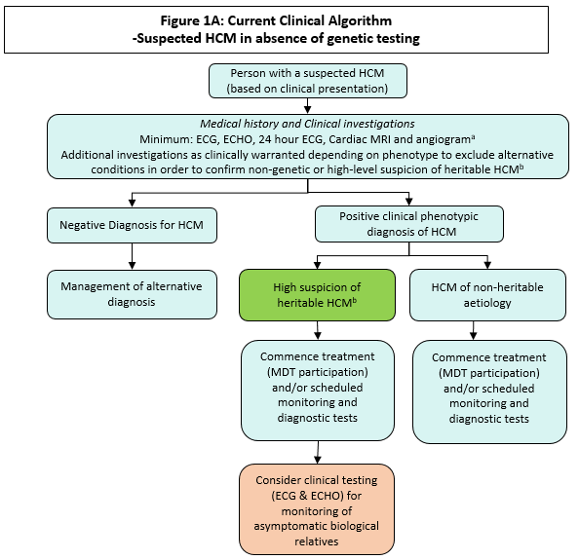

ª MBS items: 55116: Exercise stress echocardiography; 55122: Exercise stress echocardiography; 11700: Twelve lead electrocardiography; 11709: Continuous ECG recording (Holter) of ambulatory patient; 11712: Multi-channel ECG monitoring; 57360: Computed tomography of the coronary arteries
^{b} ‘high suspicion of heritable HCM’ based on personal disease history, patient age, and pedigree

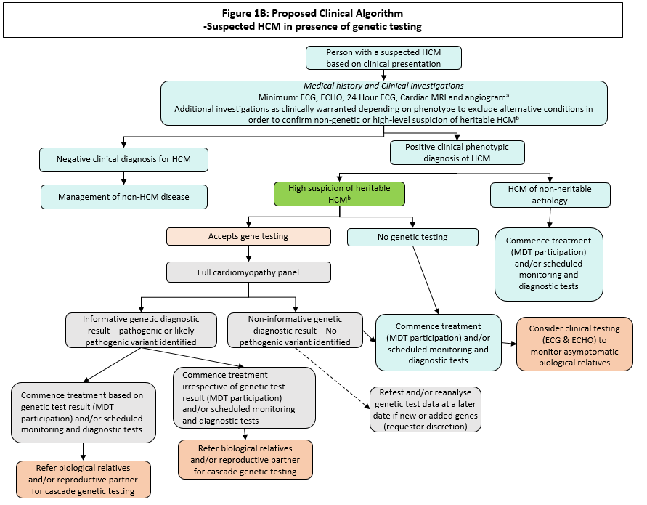
a MBS items: 55116: Exercise stress echocardiography; 55122: Exercise stress echocardiography; 11700: Twelve lead electrocardiography; 11709: Continuous ECG recording (Holter) of ambulatory patient; 11712: Multi-channel ECG monitoring; 57360: Computed tomography of the coronary arteries
b ‘high suspicion of heritable HCM’ based on personal disease history, patient age and family disease pedigree

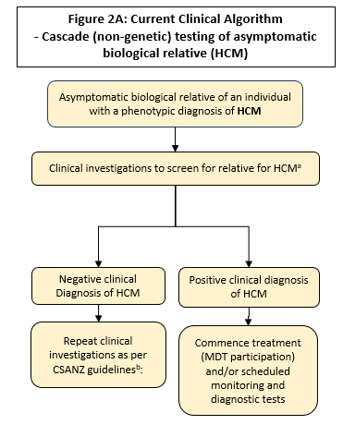

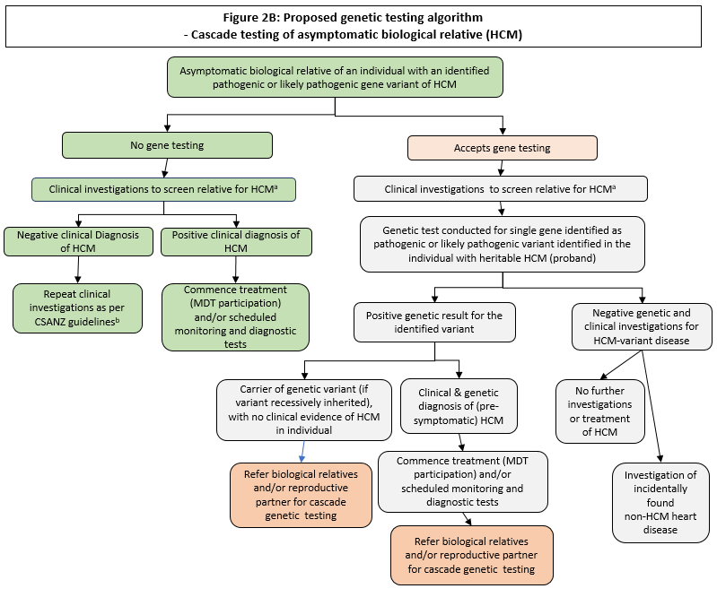
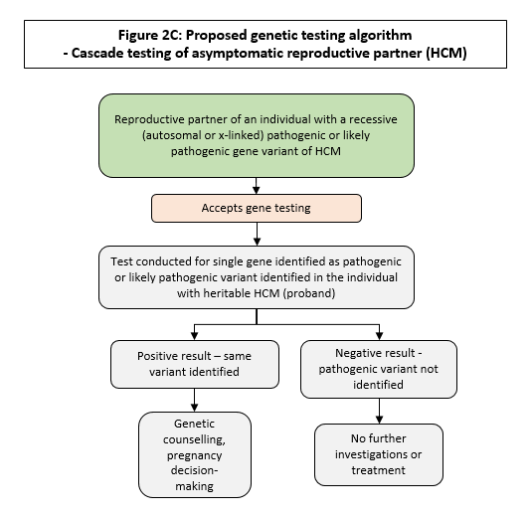

Current and proposed clinical management algorithms for the DCM population
Under the current clinical management pathway, people with suspected dilated cardiomyopathy and those with a family history of these disorders, are referred for clinical testing by their medical practitioner (Figure 3A). In the absence of genetic testing, the risk of heritability of the condition can only be ascertained from the family pedigree.
This will be compared to the proposed clinical algorithm of patient assessment with the addition of genetic testing of symptomatic individuals (Figure 3B).
Figures 4A and 4B show the investigation of the asymptomatic relative of the symptomatic individual, without and with genetic testing, respectively.
Figure 4C shows the investigative pathway for reproductive partners of an individual identified as being a carrier of a recessive pathogenic or likely pathogenic gene causal for DCM.
A multidisciplinary healthcare team treats the disease symptoms through their disease progression.
For dilated cardiomyopathy, the clearest gene with prognostic utility is LMNA. These patients have a higher risk of sudden death due to ventricular arrhythmias, even when the left ventricular function is only mildly reduced. These patients often have associated conduction disease requiring pacing, so one would usually implant an implantable cardioverter/defibirillator (ICD) even if the left ventricular function is only mildly reduced rather than just a pacemaker if a LMNA pathogenic variant is identified.
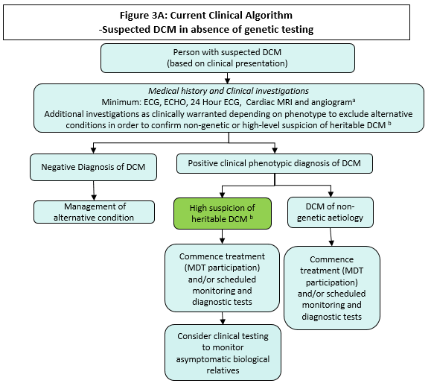
ªMBS items: 57360: Computed tomography of the coronary arteries, 55116: Exercise stress echocardiography, 55122: Exercise stress echocardiography, 11700: Twelve lead electrocardiography, 11709: Continuous ECG recording (Holter) of ambulatory patient, 11712: Multi-channel ECG monitoring
^{b}‘high suspicion of heritable HCM’ based on personal disease history, patient age and family disease pedigree

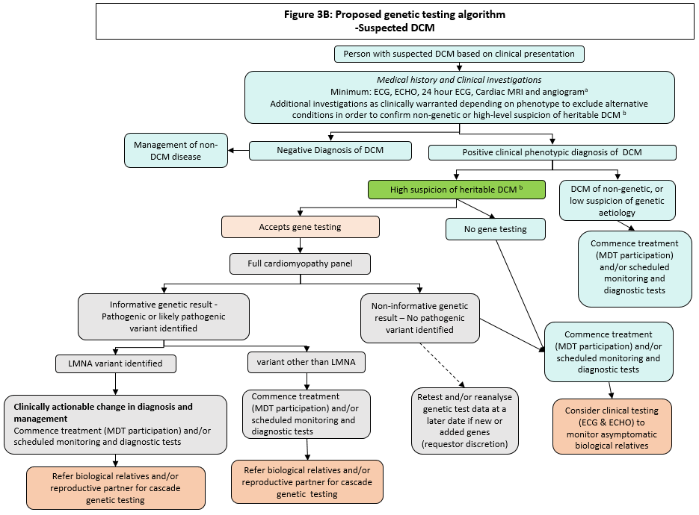
ªMBS items: 57360: Computed tomography of the coronary arteries, 55116: Exercise stress echocardiography, 55122: Exercise stress echocardiography, 11700: Twelve lead electrocardiography, 11709: Continuous ECG recording (Holter) of ambulatory patient, 11712: Multi-channel ECG monitoring
^{b} high suspicion of heritable HCM’ based on personal disease history, patient age and family disease pedigree

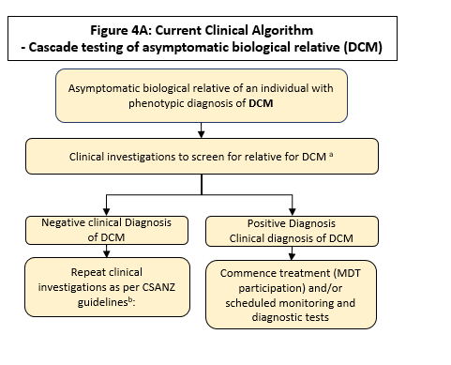
ªMBS items: 57360: Computed tomography of the coronary arteries, 55116: Exercise stress echocardiography, 55122: Exercise stress echocardiography, 11700: Twelve lead electrocardiography, 11709: Continuous ECG recording (Holter) of ambulatory patient, 11712: Multi-channel ECG monitoring
^{b}CSANZ guidelines: 6 months to five years, dependent on family history (age of onset of symptomatic family members)

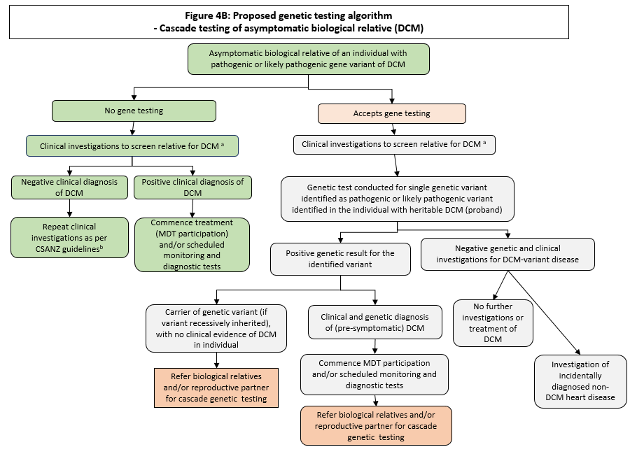
ªMBS items: 57360: Computed tomography of the coronary arteries, 55116: Exercise stress echocardiography, 55122: Exercise stress echocardiography, 11700: Twelve lead electrocardiography, 11709: Continuous ECG recording (Holter) of ambulatory patient, 11712: Multi-channel ECG monitoring
^{b}CSANZ guidelines: 6 months to five years, dependent on family history (age of onset of symptomatic family members)

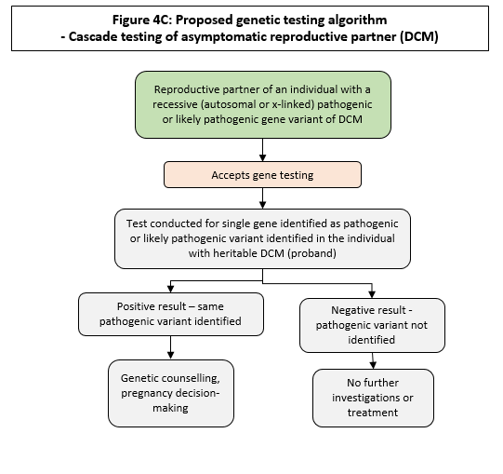

Current and proposed clinical management algorithms for the ARVC/ACM population
Under the current clinical management pathway, people with suspected ARVC/ACM and those with a family history of these disorders, are referred for clinical testing by their medical practitioner (Figure 5A). In the absence of genetic testing, the risk of heritability of the condition can only be ascertained from the family pedigree.
This will be compared to the proposed clinical algorithm of patient assessment with the addition of genetic testing of symptomatic individuals (Figure 5B).
Figures 6A and 6B show the investigation of the asymptomatic relative of the symptomatic individual, without and with genetic testing, respectively.
Figure 6C shows the investigative pathway for reproductive partners of an individual identified as being a carrier of a recessive pathogenic or likely pathogenic gene causal for ACM.
A multidisciplinary healthcare team treats the disease symptoms through their disease progression.
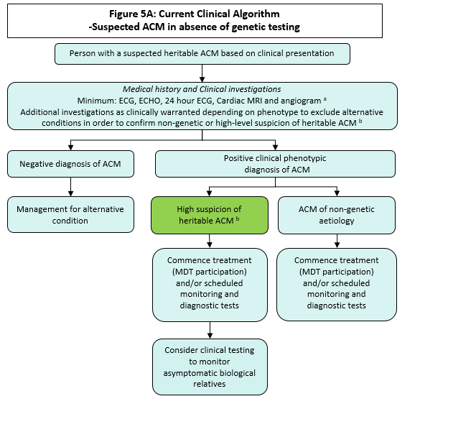
ª MBS items: 57360: Computed tomography of the coronary arteries, 11700: Twelve lead electrocardiography, 11709: Continuous ECG recording (Holter) of ambulatory patient, 11712: Multi-channel ECG monitoring, 63395&63396: MRI scan for ACM
^{b} ’high suspicion of heritable HCM’ based on personal disease history, patient age and family disease pedigree

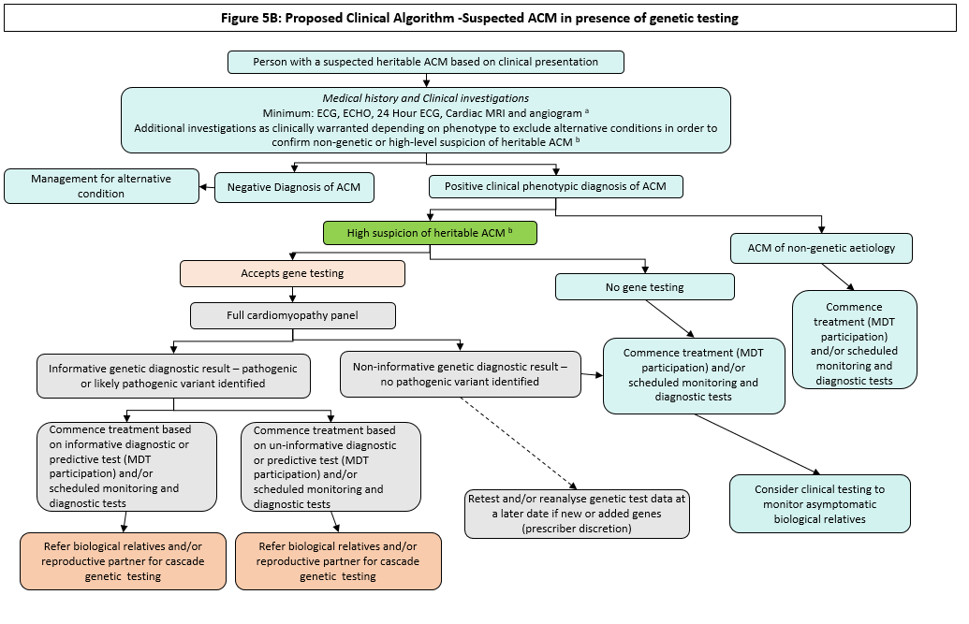
ªMBS items: 57360: Computed tomography of the coronary arteries, 11700: Twelve lead electrocardiography, 11709: Continuous ECG recording (Holter) of ambulatory patient, 11712: Multi-channel ECG monitoring, 63395&63396: MRI scan for ACM
^{b} ’high suspicion of heritable HCM’ based on personal disease history, patient age and family disease pedigree
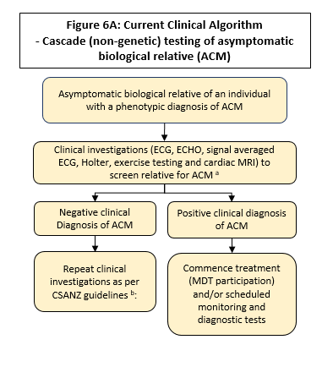
ªMBS items: 57360: Computed tomography of the coronary arteries, 11700: Twelve lead electrocardiography, 11709: Continuous ECG recording (Holter) of ambulatory patient, 11712: Multi-channel ECG monitoring, 63397&63398: MRI scans for ACM
^{b}CSANZ guidelines: Commencing at 10-12 years old (MRI), Repeated every five years until 30, Repeated once more at age 40

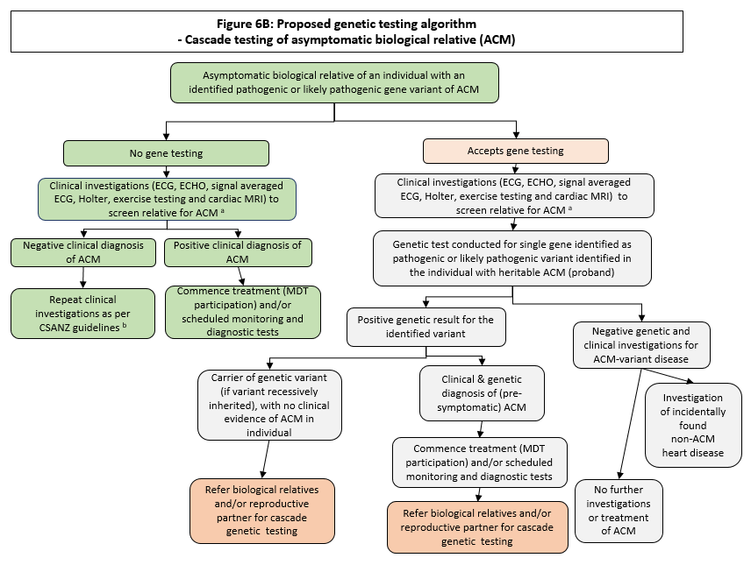

ªMBS items: 57360: Computed tomography of the coronary arteries, 11700: Twelve lead electrocardiography, 11709: Continuous ECG recording (Holter) of ambulatory patient, 11712: Multi-channel ECG monitoring, 63397&63398: MRI scans for ACM
^{b}CSANZ guidelines: Commencing at 10-12 years old (MRI), Repeated every five years until 30, Repeated once more at age 40

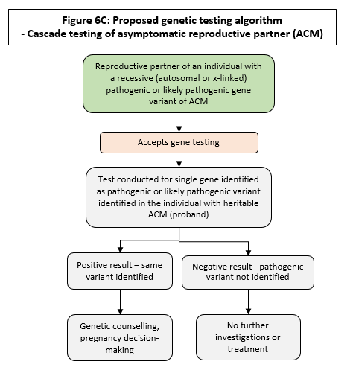

PROPOSED ECONOMIC EVALUATION
PASC confirmed the economic evaluation should be a cost-effectiveness/cost-utility analysis.

PASC acknowledged the upgrading and downgrading of pathogenicity would be key to the economic evaluation.
The clinical claim is that genetic testing for heritable cardiomyopathy, is inferior in terms of safety and superior in terms of clinical effectiveness, compared to no genetic testing for the proposed population.
According to the Technical Guidelines for preparing assessment reports for the Medical Services Advisory Committee: Investigative, the required economic analysis is therefore a cost‐effectiveness and/or cost-utility analysis. This type of analysis will determine the incremental cost per extra unit of health outcome achieved, expressed in quality-adjusted life years (QALYs) because of a reduction in the number of further diagnostic tests and earlier early of adult with cardiomyopathy.
For the economic evaluation, QALYs should be calculated for each of the endpoint outcomes. If QALYs cannot be calculated, then the measure of effectiveness can be expressed in life years or other outcomes. It should be noted that the level of pathogenicity of the genetic variant is an important consideration and should be adequately accounted for in the economic evaluation
An Australian cost-effective analysis study of cascade testing for asymptomatic relatives of patients with DCM compared with periodical surveillance was published in 2019. The results revealed that the incremental cost per additional QALY of cascade genetic testing prior to periodical clinical surveillance alone was estimated at approximately AUD $6,100. At established thresholds of cost-effectiveness, there is a 90% probability that cascade genetic testing is cost-effective. Sensitivity analyses, including the addition of cascade testing to second-degree relatives, did not alter the conclusions drawn from the main analysis.

PROPOSED MBS ITEM DESCRIPTOR AND MBS FEES
PASC requested that proposed MBS item BBBB be worded more explicitly (i.e. re-phrase ‘clinically actionable’, unless it is a broadly understood and accepted phrase [including by referring clinicians]).

The applicant suggested removing ‘clinically actionable’ and re-phrasing the item descriptor as follows:
“….for detection of pathogenic (or likely pathogenic) variants, previously identified by Item xx”
PASC suggested that ‘star performers’ (i.e. the most clinically relevant genes) in the panel be included in the MBS item descriptor, as a minimum gene panel that must be analysed. In relation to ‘star performer genes’ (i.e. genes that would have greatest clinical utility), the applicant has suggested (at a minimum) that MYBPC3, MYH7, LMNA and TTN be included. While others could also be considered, they may not need to be tested for all patients with a heritable cardiomyopathy.
PASC queried why the proposed MBS fee is $1,800, when other similar gene panel testing is $1,200. The applicant stated the main cost relates to bioinformatics (analysis), and the proposed MBS fee reflects the number of genes that need to be analysed for this item. Justification of the proposed fee will need to be included in the assessment.
PASC noted that most cascade testing would be provided as out-of-hospital (non-admitted patient) services.
PASC noted the proposed item descriptor relies on the specialist or consultant physician knowing the three groups of inherited cardiomyopathies (HCM, DCM, ARVC/ACM) that relate to the panel. To address this, three groups of inherited cardiomyopathies have been mentioned in the item descriptor, to ensure the physician requesting the test is aware of the cardiomyopathies required for review.
The assessment phase should consider if wording in the item descriptors (i.e. specifically “specialist or consultant physician”) may be too broad. If the type of specialist needs to be more narrowly focused, it could be defined in an Explanatory Note (e.g. “cardiologist with experience in …”).
PASC advised that co-claiming of cardiac panels (this application and Application 1598) is an implementation issue the Department will need to resolve. PASC noted the panels are largely different, but there is some overlap. PASC acknowledged that most laboratories would process the full panel, then analyse only the required genes. The cost could therefore be 2 x $1,800, or 1 x $1,800, plus another fee to analyse additional genes not included in the panel.
Three MBS items are proposed: One for detection of suspected heritable cardiomyopathy for a paediatric or adult patient, who fulfils diagnostic criteria for cardiomyopathy; one for testing an asymptomatic paediatric or adult patient, with a family history of cardiomyopathy, and one for the testing of partners of individuals who have been diagnosed with a heritable cardiomyopathy.
The applicant did not include MBS items for partner testing of identified carriers, or a specific item for testing in pregnancy. However, an algorithm has been added above, and an additional proposed MBS item (CCCC) added below.
Item number AAAA Category 6 (Pathology Services) – Group P7 Genetics
Characterisation of germline variants, requested by a specialist or consultant physician, for heritable cardiomyopathies (HCM, DCM, ACM), in a patient who fulfils diagnostic criteria for cardiomyopathy (HCM, DCM, ACM)
MBS Fee: $1,800 Benefit: 75% = $1,350 85% = $1,530

Item number BBBB Category 6 (Pathology Services) – Group P7 Genetics
Request by specialist or consultant physician, for detection of a pathogenic, or likely pathogenic, variant, previously identified by Item AAAA in a first or second-degree relative.
MBS Fee: $400 Benefit: 75% = $300 85% = $340.00

Item number CCCC Category 6 (Pathology Services) – Group P7 Genetics
Request by specialist or consultant physician, for detection of an autosomal or X-linked recessive pathogenic, or likely pathogenic variant, previously identified by Item AAAA in a reproductive partner.
MBS Fee: $400 Benefit: 75% = $300 85% = $340.00
Practice note: The laboratory used to undertake gene panel tests for items AAAA, BBBB, and CCCC must use a methodology with sufficient diagnostic range and sensitivity to detect all known pathogenic cardiomyopathy gene variants.
CONSULTATION FEEDBACK
PASC acknowledged the consultation feedback, including support from one professional society and a consumer advocacy group.

NEXT STEPS
Upon ratification of PICO 1599, the application can PROCEED to the pre-Evaluation Sub-Committee (ESC) stage.
The applicant has elected to progress this application through a DCAR (Department-contracted assessment report).
PASC recommended it is appropriate for the assessment to follow the clinical utility card (CUC) approach.

REFERENCES
Brinks, R. (2011). A new method for deriving incidence rates from prevalence data and its application to dementia in Germany. Retrieved from http://arxiv.org/abs/1112.2720.
Burns, C., Bagnall, R. D., Lam, L., Semsarian, C., & Ingles, J. (2017). Multiple Gene Variants in Hypertrophic Cardiomyopathy in the Era of Next-Generation Sequencing. Circ Cardiovasc Genet., 10(4). doi:10.1161/CIRCGENETICS.116.001666.
Cirino, A. L., & Ho, C. (2008). Hypertrophic Cardiomyopathy Overview. In M. P. Adam, H. H. Ardinger, R. A. Pagon, S. E. Wallace, L. J. H. Bean, K. Stephens, & A. Amemiya (Eds.), GeneReviews((R)). Seattle (WA).
Codd, M. B., Sugrue, D. D., Gersh, B. J., & Melton, L. J., 3rd. (1989). Epidemiology of idiopathic dilated and hypertrophic cardiomyopathy. A population-based study in Olmsted County, Minnesota, 1975-1984. Circulation, 80(3), 564-572. doi:10.1161/01.cir.80.3.564
Corrado, D., Basso, C., & Judge, D. P. (2017). Arrhythmogenic Cardiomyopathy. Circ Res, 121(7), 784-802. doi:10.1161/CIRCRESAHA.117.309345
Dellefave, L., & McNally, E. M. (2010). The genetics of dilated cardiomyopathy. Curr Opin Cardiol, 25(3), 198-204. doi:10.1097/HCO.0b013e328337ba52
Fatkin, D. (2012) Familial dilated cardiomyopathy: Current challenges and future directions. Global Cardiology Science and Practice. 2012(1): 8. doi:10.5339/gcsp.2012.8
Hershberger, R. E., & Morales, A. (2007). Dilated Cardiomyopathy Overview. In GeneReviews((R)). Seattle (WA).
Husser, D., Ueberham, L., Jacob, J., Heuer, D., Riedel-Heller, S., Walker, J., . . . Bollmann, A. (2018). Prevalence of clinically apparent hypertrophic cardiomyopathy in Germany-An analysis of over 5 million patients. PLoS One, 13(5), e0196612. doi:10.1371/journal.pone.0196612
McNally, E., MacLeod, H., & Dellefave-Castillo, L. (2005). Arrhythmogenic Right Ventricular Cardiomyopathy. In GeneReviews((R)). Seattle (WA).
Miura, K., Nakagawa, H., Morikawa, Y., Sasayama, S., Matsumori, A., Hasegawa, K., . . . Inaba, Y. (2002). Epidemiology of idiopathic cardiomyopathy in Japan: results from a nationwide survey. Heart, 87(2), 126-130. doi:10.1136/heart.87.2.126
Nugent, A. W., Daubeney, P. E., Chondros, P., Carlin, J. B., Cheung, M., Wilkinson, L. C., . . . National Australian Childhood Cardiomyopathy, S. (2003). The epidemiology of childhood cardiomyopathy in Australia. N Engl J Med, 348(17), 1639-1646. doi:10.1056/NEJMoa021737
Ommen, S. R., Nishimura, R. A., & Edwards, W. D. (2003). Fabry disease: a mimic for obstructive hypertrophic cardiomyopathy? Heart, 89(8), 929-930. doi:10.1136/heart.89.8.929
Rakar, S., Sinagra, G., Di Lenarda, A., Poletti, A., Bussani, R., Silvestri, F., & Camerini, F. (1997). Epidemiology of dilated cardiomyopathy. A prospective post-mortem study of 5252 necropsies. The Heart Muscle Disease Study Group. Eur Heart J, 18(1), 117-123. doi:10.1093/oxfordjournals.eurheartj.a015092
Semsarian, C., & Group, C. C. G. D. C. W. (2011). Guidelines for the diagnosis and management of hypertrophic cardiomyopathy. Heart Lung Circ, 20(11), 688-690. doi:10.1016/j.hlc.2011.07.017
Semsarian, C., Ingles, J., Maron, M. S., & Maron, B. J. (2015). New perspectives on the prevalence of hypertrophic cardiomyopathy. J Am Coll Cardiol, 65(12), 1249-1254. doi:10.1016/j.jacc.2015.01.019
Szabadosova, V., Boronova, I., Ferenc, P., Tothova, I., Bernasovska, J., Zigova, M., . . . Bernasovsky, I. (2018). Analysis of selected genes associated with cardiomyopathy by next-generation sequencing. J Clin Lab Anal, 32(2). doi:10.1002/jcla.22254
Towbin, J. A., McKenna, W. J., Abrams, D. J., Ackerman, M. J., Calkins, H., Darrieux, F. C. C., . . . Zareba, W. (2019). 2019 HRS expert consensus statement on evaluation, risk stratification, and management of arrhythmogenic cardiomyopathy. Heart Rhythm, 16(11), e301-e372. doi:10.1016/j.hrthm.2019.05.007
Waldmüller, S., Schroeder, C., Sturm, M., Scheffold, T., Imbrich, K., Junker, S., . . . Gramlich, M. (2015). Targeted 46-gene and clinical exome sequencing for mutations causing cardiomyopathies. Mol Cell Probes, 29(5), 308-314.
Williams, D. G., & Olsen, E. G. (1985). Prevalence of overt dilated cardiomyopathy in two regions of England. Br Heart J, 54(2), 153-155. doi:10.1136/hrt.54.2.153

Analytical validity: the reproducibility and repeatability of the assay, that is, the ability of the test to measure gene expression accurately and reliably.
Clinical validity: measures the test’s ability to predict the presence or absence of disease, that is, the sensitivity, specificity, and positive and negative predictive values, in this case
Based on the reported incidence estimates in Nugent et al. (2003).
Analytical validity: the reproducibility and repeatability of the assay, that is, the ability of the test to measure gene expression accurately and reliably.
Clinical validity: measures the test’s ability to predict the presence or absence of disease, that is, the sensitivity, specificity, and positive and negative predictive values, in this case.

