Application 1519:
Tisagenlecleucel (CTL019) for treatment of refractory/relapsed CD19-positive leukaemia and lymphoma

PICO Confirmation
(To guide a new application to MSAC)
(Version 2.0)

Summary of PICO criteria to define the question(s) to be addressed in an Assessment Report to the Medical Services Advisory Committee (MSAC)
Table 1 PICO criteria for children and young adult patients with acute lymphoblastic leukaemia (population 1)
Component | Description
Population | Children and young adult patients (3-25 years old) with confirmed relapsed/refractory B-cell acute lymphoblastic leukaemia (ALL). This means patients (listed as sub-populations below) who:  - Have experienced a second or greater bone marrow relapse; OR  - Have experienced any bone marrow relapse following allogenic stem cell transplant; OR  - Are primary refractory (i.e. not achieving a complete response after 2 cycles of a standard chemotherapy regimen); OR  - Are chemo refractory (i.e. not achieving a complete response after 1 cycle of standard chemotherapy for relapsed leukaemia); OR  - Are Philadelphia chromosome positive AND intolerant to (or have failed two lines of) tyrosine kinase inhibitor therapy, OR for whom such therapy is contraindicated; OR  - Are ineligible for allogenic stem cell transplant because of comorbid disease, contraindications to the conditioning regimen, prior SCT, OR lack of a suitable donor.
Intervention | Tisagenlecleucel (also known as CTL019, and brand name Kymriah™)
Comparator | Against the relevant sub-population (see ‘Population’ above)  - Best supportive care (or a clinical trial)  - Salvage chemotherapy with intention to proceed to allogenic SCT, clofarabine with intention to proceed to allogenic SCT, or in some cases: best supportive care or a clinical trial (when refractory after TKI+ chemotherapy and allogenic SCT)  - Salvage chemotherapy with intention to proceed to allogenic SCT, or clofarabine with intention to proceed to allogenic SCT  - Best supportive care (or a clinical trial)  - Best supportive care (or a clinical trial)  - Best supportive care (or a clinical trial)
Outcomes | Clinical effectiveness:  - Overall response rate (ORR) and/or complete response rate  - Relapse-free survival and/or event-free survival  - Overall survival (OS)  - Quality of life (QoL)  - Health-related quality of life (HRQoL)  - Rate of complete/partial remission  - Duration of response  - Time to return to daily activities  Clinical efficacy:  - Tisagenlecleucel failure rate  - Percentage of patients successfully receiving tisagenlecleucel after starting the process  - Time from leukapheresis to receiving tisagenlecleucel  Safety:  - Rate of adverse events (AEs) and serious adverse events (SAEs)  - events of special interest (e.g. cytokine release syndrome, tumour lysis syndrome, febrile neutropenia)  - AEs due to medications, neurotoxicity, infections, secondary cancers  Cost-effectiveness:  - Cost (including cost of additional pre-infusion and post-infusion interventions)  - Cost per life year gained (LYG)  - Cost per quality adjusted life year (QALY) or disability adjusted life year (DALY)  - Incremental cost-effectiveness ratio  Financial implications:  - Number of patients suitable for treatment  - Number of patients who receive treatment
Table 2 PICO criteria for adult patients with diffuse large B-cell lymphoma (population 2)
Component | Description
Population | Adult patients (≥ 18 years old) with confirmed relapsed/refractory diffuse large B-cell lymphoma (DLBCL). This means patients who have relapsed or refractory disease after at least two lines of chemotherapy, and  - have relapsed after autologous stem cell transplant, OR  - are ineligible for subsequent stem cell transplant
Intervention | Tisagenlecleucel (also known as CTL019, and brand name Kymriah™)
Comparator | Salvage chemotherapy (and in some cases a clinical trial)
Outcomes | Clinical effectiveness:  - Overall response rate (ORR) and/or complete response rate  - Relapse-free survival and/or event-free survival  - Overall survival (OS)  - Quality of life (QoL)  - Health-related quality of life (HRQoL)  - Rate of complete/partial remission  - Duration of response  - Time to return to daily activities  Clinical efficacy:  - Tisagenlecleucel failure rate  - Percentage of patients successfully receiving tisagenlecleucel after starting the process  - Time from leukapheresis to receiving tisagenlecleucel  Safety:  - Rate of adverse events (AEs) and serious adverse events (SAEs)  - Events of special interest (e.g. cytokine release syndrome, tumour lysis syndrome, febrile neutropenia)  - AEs due to medications, neurotoxicity, infections, secondary cancers  Cost-effectiveness:  - Cost (including cost of additional pre-infusion and post-infusion interventions)  - Cost per life year gained (LYG)  - Cost per quality adjusted life year (QALY) or disability adjusted life year (DALY)  - Incremental cost-effectiveness ratio  Financial implications:  - Number of patients suitable for treatment  - Number of patients who receive treatment

2. PICO or PPICO rationale for therapeutic and investigative medical services only

2.1 Research questions
Acute lymphoblastic leukaemia (ALL):
- What is the safety, effectiveness and cost-effectiveness of tisagenlecleucel in children and young adult patients (3-25 years old) with confirmed relapsed or refractory B-cell acute lymphoblastic leukaemia (ALL) and a second or greater bone marrow relapse, compared with best supportive care (or a clinical trial)?

- What is the safety, effectiveness and cost-effectiveness of tisagenlecleucel in children and young adult patients (3-25 years old) with confirmed relapsed or refractory B-cell ALL and a bone marrow relapse following allogenic stem cell transplant (SCT), compared with:
  - salvage chemotherapy with the intention to proceed to allogenic SCT, or
  - clofarabine with intention to proceed to allogenic SCT, or
  - best supportive care (in some cases), or
  - a clinical trial (when refractory after TKI+ chemotherapy and allogenic SCT)¹?

- What is the safety, effectiveness and cost-effectiveness of tisagenlecleucel in children and young adult patients (3-25 years old) with confirmed B-cell ALL who are primary refractory, as defined by not achieving a complete response after two cycles of a standard chemotherapy regimen, compared with:
  - salvage chemotherapy with intention to proceed to allogenic SCT, or
  - clofarabine with intention to proceed to allogenic SCT?

- What is the safety, effectiveness and cost-effectiveness of tisagenlecleucel in children and young adult patients (3-25 years old) with confirmed relapsed or refractory B-cell ALL who are chemo refractory, as defined by not achieving a complete response after one cycle of standard chemotherapy for relapsed leukaemia, compared with best supportive care (or a clinical trial)?

- What is the safety, effectiveness and cost-effectiveness of tisagenlecleucel in children and young adult patients (3-25 years old) with confirmed relapsed or refractory B-cell ALL and who are Philadelphia chromosome positive and intolerant to or have failed two lines of tyrosine kinase inhibitor therapy (or for whom such therapy is contraindicated), compared with best supportive care (or a clinical trial²)?

- What is the safety, effectiveness and cost-effectiveness of tisagenlecleucel in children and young adult patients (3-25 years old) with confirmed relapsed or refractory B-cell ALL, who are ineligible for allogenic SCT because of comorbid disease, contraindications to the conditioning regimen, prior SCT, or lack of a suitable donor, compared with best supportive care (or a clinical trial²)?
Diffuse large B-cell lymphoma (DLBCL):
- What is the safety, effectiveness and cost-effectiveness of tisagenlecleucel in adult patients (≥ 18 years old) with confirmed diffuse large B-cell lymphoma (DLBCL), who have relapsed or refractory disease after at least two lines of chemotherapy, and have relapsed after autologous SCT, compared with salvage chemotherapy (or a clinical trial²)?

- What is the safety, effectiveness and cost-effectiveness of tisagenlecleucel in adult patients (≥ 18 years old) with confirmed diffuse large B-cell lymphoma (DLBCL), who have relapsed or refractory disease after at least two lines of chemotherapy, and are ineligible for subsequent stem cell transplant, compared with salvage chemotherapy (or a clinical trial²)?

2.2 Population
Population 1: Relapsed or refractory acute B-cell lymphoblastic leukaemia (ALL)
ALL occurs when lymphoid progenitor cells in the bone marrow proliferate uncontrollably. This leads to an excess of malignant lymphoblasts, which can then be found in the peripheral blood in large numbers. In 2014, 371 people were diagnosed with ALL (156 females and 214 males). The risk of a diagnosis is 1 in 812 before age 75 and 1 in 756 before age 85. (Australian Institute of Health and Welfare (AIHW) 2017)

Figure 1 Incidence rates of ALL by sex and age group at diagnosis (rate per 100,000 population) (Australian Institute of Health and Welfare (AIHW) 2017)
ALL is the most common type of cancer in children, with around 60% of cases diagnosed in children. Most patients are between 2 and 5 years old when they are diagnosed. In 2015, 119 ALL patients in Australia died (51 males and 68 females). This means the risk of death from ALL is 1 in 3193 before age 75 and 1 in 1948 before age 85 (Australian Institute of Health and Welfare (AIHW) 2017). Common treatments include chemotherapy, peripheral blood stem cell and bone marrow transplantation, steroid therapy and radiotherapy to the head.
A large childhood ALL cohort was followed in the US. The 5-year survival rates for ALL patients were 53% for children < 1 year old 94%, 82%, 85% and 75% for patients aged 1-9.9 years, > 10 years, 10-14.9 years, and ≥ 15 years (from 2000-2005) (Hunger et al. 2012). Five-year survival rates increased from 83.7% to 91.4% between 1990-1994 and 2000-2005. The applicant indicated that approximately 20% of patients will experience at least one relapse, and that each relapse makes maintaining remission more challenging. They stated that patients with a second relapse have few effective treatment options and typically a poor prognosis, with a long term survival of 10%.
The applicant proposes that the medical service should be intended for children and young adult patients (3-25 years old), with confirmed relapsed or refractory ALL. This population can be divided into six subpopulations, including patients who:
- Have experienced a second or greater bone marrow relapse; OR
- Have experienced any bone marrow relapse following allogenic stem cell transplant (SCT); OR
- Are primary refractory, as defined by not achieving a complete response after two cycles of a standard chemotherapy regimen; OR
- Are chemo refractory, as defined by not achieving a complete response after one cycle of standard chemotherapy for relapsed leukaemia; OR
- Are Philadelphia chromosome positive AND are intolerant to or have failed two lines of tyrosine kinase inhibitor therapy, OR for whom such therapy is contraindicated; OR
- Are ineligible for allogenic SCT because of comorbid disease, contraindications to the conditioning regimen, prior SCT, OR lack of a suitable donor.
This is the same indication that will be sought from the Therapeutic Goods Administration (TGA). Tisagenlecleucel (the proposed service) was approved by the Food and Drug Administration (FDA) in August 2017 and was the first chimeric antigen receptor T cell therapy approved in the US for the treatment of refractory or relapsed B-cell precursor ALL in patients up to age 25 years. REDACTED
Population 2: relapsed or refractory diffuse large B-cell lymphoma (DLBCL)
The applicant proposes the medical service should also be intended for adult patients (≥18 years) with confirmed relapsed or refractory DLBCL. This means patients who have relapsed or refractory disease after at least two lines of chemotherapy, and (1) have relapsed after autologous SCT, or (2) are ineligible for subsequent SCT. These criteria would create five eligible sub-populations:
DLBCL patients who are refractory or relapsed after:
- Rituximab, cyclophosphamide, doxorubicin, vincristine, prednisolone (RCHOP) and salvage chemotherapy
- RCHOP and high-dose therapy (HDT)
- RCHOP, autologous SCT and salvage chemotherapy
- RCHOP, autologous SCT and HDT (without response/SCT)
- RCHOP, autologous SCT and HDT (with subsequent response and subsequent SCT)
DLBCL is the most common subtype of non-Hodgkin lymphoma (NHL), responsible for around 25% of NHL cases. The average age of DLBCL diagnosis is 60-65 years, with the likelihood of receiving a diagnosis increasing with age, however it can occur at any age. The applicant states the estimated incidence of DLBCL in Australia is around 2,070 patients per year, and reports that approximately 60% of patients with DLBCL achieve and maintain complete remission after first-line therapy. This means around 40% of patients have incomplete response to therapy, with approximately 10% suffering from refractory disease and 30% having a relapse. AIHW figures show relative 1-year and 5-year survival from DLBCL in Australia was 77.3% (95%CI 75.8-78.8%) and 64.4% (95%CI 62.7-66.1%), respectively (AIHW Australian Cancer database, 2006-2010). In 2011, 4,631 people were diagnosed with NHL.

2.1.1 Rationale / evidence base
The applicant referred to three published studies on the proposed service which included ALL patients (Fitzgerald et al. 2017; Maude et al. 2014; Mueller et al. 2017), and one study including DLBCL patients (n=13). A number of studies are still ongoing, on both patients with ALL and DLBCL ('Value in Using CAR T Cells for DLBCL' 2017).
One retrospective cohort study, Fitzgerald et al., investigated the timing, severity and management of cytokine release syndrome (CRS; an adverse event) in relapsed/refractory ALL patients (n=39). Maude et al (2014) included 25 relapsed ALL patients aged between 5 and 22 years old, and five aged > 25 (three of which had primary refractory disease). The study reported complete remission in 27/30 patients, with a sustained remission with a 6-month event-free survival rate of 67%. The institute for Clinical and Economic Review also recently published a report on the effectiveness and value of CAR-T therapies for B-cell cancers, summarising the evidence (Institute for Clinical and Economic Review (ICER) 2017).
The study by Mueller et al (2017) included both children and adult patients with ALL and chronic lymphocytic leukaemia (CLL). There is evidence that CAR-T cells can also be used to treat refractory chronic lymphocytic leukaemia (CLL). One study reported that 8/14 patients had a response (57%), with 4 patients going into complete remission and 4 patients obtaining partial remission. (Porter et al. 2015). Furthermore, another recently published study included both patients with DLBCL (n=23) and follicular lymphoma (n=15). This study reported a complete remission after receiving CTL019 cells (tisagenlecleucel) in 10/14 patients with follicular lymphoma. (Schuster et al. 2017) This suggests CAR-T therapy may potentially be useful for other indications, in addition to ALL and DLBCL.
Around 30 trials are currently ongoing on CAR-T therapies, of which the majority are single-arm. Most are recruiting patients with (refractory or relapsed CD19-positive) ALL or DLBCL, however some are also including patients with CLL, small lymphoblastic lymphoma, multiple myeloma, Hodgkin Lymphoma, mantle cell lymphoma, pancreatic cancer, follicular lymphomas or B-cell malignancies in general. Currently there are around 25 trials on ClinicalTrials.gov which are (or have completed) investigating tisagenlecleucel specifically (studies found for CTL019 and/or CART-19).
On May 1, 2018, the FDA (in the US) approved tisagenlecleucel for the treatment of adult patients with relapsed or refractory DLBCL who have relapsed or are ineligible for autologous SCT. In addition, in January 2018 the European Medicines Agency (EMA) has granted accelerated assessment to the Marketing Authorisation Application (MAA) for tisagenlecleucel for the treatment of children and young adults with relapsed or refractory B-cell ALL and adults with relapsed or refractory DLBCL, who are ineligible for ASCT. This means the decision time would be cut from 201 to 150 days in Europe. This assessment is currently in progress.

2.3 Prior test (investigative services only - if prior tests are to be included)
Patients will be monitored to see whether they have relapsed or refractory disease. A variety of different tests may be done, including blood counts, bone marrow aspiration and biopsy, lumbar puncture, and/or imaging tests (i.e. x-ray, computerised tomography, magnetic resonance imaging, positron emission tomography, ultrasound).

2.4 Intervention
Tisagenlecleucel (also known as CTL019, and brand name Kymriah™) is an immunocellular cancer therapy using autologous peripheral blood T-cells, extracted using leukapheresis, which are then reprogrammed with a chimeric antigen receptor (CAR) that identifies and destroys CD19-expressing (malignant and non-malignant) cells (Novartis 2017). The CD19 antigens are B-cell specific surface antigens expressed in all B-cell lineage malignancies. The CAR consists of a murine single-chain antibody fragment, which recognises CD19. The patient’s own reprogrammed CAR T-cells (CAR-T) are then re-infused into the patient’s body where they target the cancer cells.
According to the Drug Information Portal of the United States National Library of Medicine, tisagenlecleucel is: “Allogeneic T-lymphocytes transduced with a modified lentiviral vector expressing a chimeric antigen receptor (CAR) consisting of an anti-CD19 scFv (single chain variable fragment) and the zeta chain of the TCR/CD3 complex (CD3-zeta), coupled to the signalling domain of 4-1BB (CD137), with potential immunomodulating and antineoplastic activities.” The 4-1BB co-stimulatory molecule signalling domain enhances activation and signalling after recognition of the CD19-expressing tumour cell, and the inclusion of this domain may increase the antitumor activity.
Synonyms used for tisagenlecleucel are: adoptive immunotherapy agent CTL019, Anti-CD19-CAR transduced T cell, CART-19, CTL019, CTL019 CAR T cell, CTL019 CAR T cell therapy agent, Cytotoxic T cell CTL019, Cytotoxic T cell Tisagenlecleucel-T, Kymriah, Tisagenlecleucel-T.
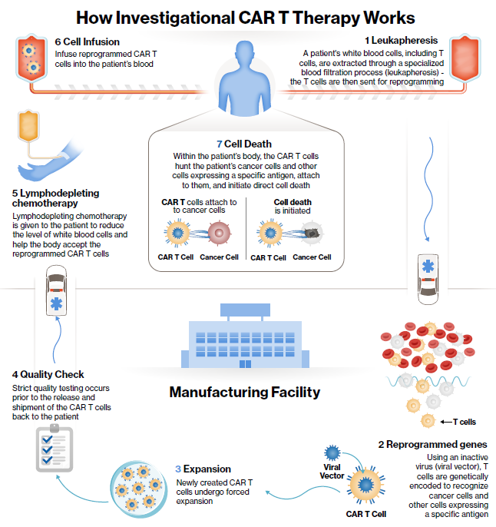
Figure 2 CAR-T cell therapy infographic
Source: application document (image was provided by the applicant)
Novartis indicated that in the US, it would charge $US475,000 ($A598,453) for the treatment, custom-made for each patient. Treatment is intended for single use (with curative intent). However, there has been at least one patient who received two CAR-T cell infusions, after progression of disease (Brudno & Kochenderfer 2018). There is uncertainty related to whether, in future, there would be pressure to provide one or more subsequent infusions of tisagenlecleucel, and PASC advised that the SBA and MSAC should consider prospectively how this risk might best be managed.
A centralised manufacturing facility genetically encodes the T cells to create tisagenlecleucel and is responsible for the modified T cell expansion. The applicant indicated that the centralised facility would most likely be located in the United States of America. The manufacturing process would take around 2 to 3 weeks from leukapheresis to the time the engineered cells are finalised (Institute for Clinical and Economic Review (ICER) 2017). REDACTED A recently published study reported a median time from enrolment to infusion of 45 days (range 30 to 105, n=75) (Maude et al. 2018).
For 3 to 4 weeks after infusion of tisagenlecleucel, it is recommended that patients stay within 2 hours of the hospital where they received the treatment, for monitoring purposes. REDACTED. Interventions which may be required during the post-treatment monitoring period include oxygen, fluids, vasopressor support and antipyretics.
After the first month, the clinical trials reported/recommended standard follow-up visits every month for the first 6 months post-treatment, followed by 3-monthly for the rest of the year and 6-monthly thereafter. Patients should be monitored long-term for potential late onset toxicities, and considered for immunoglobulin therapy in the event of B-cell depletion or hypogammaglobinemia.
REDACTED.
Funding mechanism and current funding of pharmaceutical components
Tisagenlecleucel (brand name Kymriah®) has been classified as a class 4 biological product. It is therefore not eligible to be funded through the Pharmaceutical Benefits Scheme (PBS). REDACTED Tisagenlecleucel is currently provided for certain patients under the Medical Treatment Overseas Program, costing upwards of A$1million per patient.
The remaining components of the process (numbers 1, 5 and 6 in Figure 2) would be performed within the Australian REDACTED hospital setting. Patients would receive lymphodepleting chemotherapy, which is currently covered by the PBS, prior to receiving tisagenlecleucel. This includes fludarabine, cyclophosphamide, cytarabine, etoposide, and bendamustine (listed as Section 100 Chemotherapy items for Public Hospital Use). For pharmaceuticals likely to be used during CAR-T therapy (which are already listed on the PBS or through the National Blood Authority), see Table 3. Siltuximab would be used for the treatment of CRS where tocilizumab is not suitable. If both tocilizumab and siltuximab are ineffective, anti-T cell therapies such as cyclophosphamide, anti-thymocyte globulin or alemtuzumab should also be considered. In patients with low immunoglobulin levels pre-emptive measures such as immunoglobulin replacement should be implemented as per age and standard guidelines.
Table 3 Pharmaceuticals associated with the CAR-T therapy process
Pharmaceutical | Usage | PBS item code / funding
Fludarabine | Chemotherapy for public hospital use, antimetabolite | 4393F
Cyclophosphamide | Chemotherapy for public hospital use, alkylating agent | 4327R
Cytarabine | Chemotherapy for public hospital use, antimetabolite | 4357H
Etoposide | Chemotherapy for public hospital use, plant alkaloids and other natural products | 4428C
Bendamustine | Chemotherapy for public hospital use, alkylating agent (for previously untreated stage II or IV indolent CD20 positive non-Hodgkin lymphoma) | 10760H
Tocilizumab | Treatment of CRS | Funding costs based on PBS codes:1056G, 1058J, 10060L, 10064Q, 10068X, 10071C, 10072D, 10073E, 10077J, 10078K, 10079L, 10081N
Intravenous immunoglobulin | To manage events of B-cell aplasia | (Funded through National Blood Authority for different indications)
Siltuximab | Treatment of CRS, in cases where tocilizumab is not suitable | ATC code: L04AC11
Alemtuzumab | Treatment of CRS, in cases where tocilizumab or siltuximab is not suitable | Funding costs based on PBS codes:10228H, 10232M, 10243D, 10246G
ATC = Anatomical Therapeutic Chemical, CRS = cytokine release syndrome
The leukapheresis requires a specialised apheresis unit, with tubing moving blood through centrifuges and/or filters to separate the different blood products. Single use consumables used during leukapheresis include sets, tubing, bowls, anticoagulant and replacement fluids.
It is unclear if leukapheresis (to retrieve the leukocytes needed to manufacture tisagenlecleucel) is currently covered under the MBS. A broader item (13750), therapeutic haemapheresis, is currently listed for the removal of plasma or cellular (or both) elements of blood, utilising continuous or intermittent flow techniques. This includes morphological tests for cell counts and viability studies, if performed. During the procedure there is continuous monitoring of vital signs, fluid balance, blood volume and other parameters with registered nurse attendance under the supervision of a consultant physician. The fee for this service is $136.65. REDACTED.
The Department of Health should consider which components of the process should be covered under the proposed intervention, and which remaining parts of the process will continue to be funded by the current funding mechanisms/bodies. REDACTED.
Estimated uptake of the intervention
The applicant estimated an incidence of 210 patients with paediatric ALL with B-cell lineage, of which an estimated 28 patients would be eligible for the intervention each year (under the proposed criteria). The estimated incidence and eligibility is 2,070 and 720 for the DLBCL population, respectively. These estimates were proposed when tisagenlecleucel was considered to be only a last- line therapy. The indications have since changed, and PASC considered that this change would likely increase the number of patients eligible for the intervention.
However, not all the patients eligible for the intervention will receive the intervention, due to the relative frailty of the populations or due to the apheresis product not being acceptable for manufacturing. This is supported by the recent study by Maude et al., which reported that of the 107 ALL patients screened, 92 were enrolled, 75 underwent the infusion, and only 48 remained in the follow-up. In the study by Schuster et al., 13 out of 24 enrolled DLBCL patients received tisagenlecleucel infusion (61%). Most patients were excluded due to death, adverse events, and product-related issues, or discontinued the treatment/follow-up due to death, undergoing new therapies, or lack of efficacy of the treatment. REDACTED.

2.3.1 Rationale
See 2.1.1.
This technology will continue to be developed/improved. In the future, CAR-T immunotherapies and CRISPR/Cas9 might be combined to reduce the adverse effects of CAR-T therapy. CRISPR may improve the engineering of T cells and increase specificity, or deliver it to a very specific site. Therefore, it is expected that other CAR-T therapies will follow this same pathway in the coming years. This application is likely to be the first of a series of applications, and the mechanism under which it may be funded may become an example on how to regulate future (autologous) products of gene-editing.
REDACTED.

2.5 Comparator
The applicant states that in most sub-populations in the ALL group, the appropriate comparator is best supportive care (BSC), consisting of further minimally toxic chemotherapy or palliative care (or an experimental treatment through a clinical trial). This is often the last line of therapy. The comparator for the DLBCL sub-groups is salvage chemotherapy, consisting of a mix of predominantly rituximab based chemotherapy regimens. For the comparators per sub-population, see Table 4.
Table 4 Proposed comparators, per population sub-group
ALL
Sub-population | Comparator
- 2nd or greater bone marrow relapse | Best supportive care
- Bone marrow relapse following allogenic SCT | Salvage chemotherapy with intention to proceed to allogenic SCT, clofarabine with intention to proceed to allogenic SCT, or in some cases BSC (or a clinical trial) (when refractory after TKI+ chemotherapy and allogenic SCT)
- Primary refractory, as defined by not achieving a complete response after two cycles of standard chemotherapy | Salvage chemotherapy with intention to proceed to allogenic SCT, or clofarabine with intention to proceed to allogenic SCT
- Chemo refractory, as defined by not achieving complete response after one cycle of standard chemotherapy for relapsed ALL | Best supportive care
- Philadelphia chromosome positive and intolerant, contraindicated or failed two lines of TKI therapy | Best supportive care
- Ineligible for allogenic SCT due to comorbid disease, contraindications to the conditioning regimen, prior SCT, or lack of a suitable donor | Best supportive care
DLBCL
Sub-population | Comparator
- Relapsed/refractory disease after two lines of chemotherapy and relapse after autologous SCT | Salvage chemotherapy
- Relapsed/refractory disease after two lines of chemotherapy and ineligible for subsequent stem cell transplant | Salvage chemotherapy
ALL = acute lymphoblastic leukaemia, BSC = best supportive care DLBCL = diffuse large B-cell lymphoma, SCT = Stem Cell Transplant, TKI = thyrosine kinase inhibitor
The standard of BSC is ill-defined. The applicant reported that BSC most likely comprises a salvage regimen of fludarabine, cytarabine and/or idarubicin, or alternatively clofarabine. Supportive care in cancer should address the following domains: (1) the physical domain, including physical symptoms requiring continuing interventions or rehabilitation; (2) the psychological domain, which addresses issues related to the patient’s mental health and personal relationships; (3) the social domain, which includes social and practical issues impacting the individual and family (e.g. emotional support, maintaining social networks); (4) information domain, addressing access to information about cancer and support services; (5) spiritual domain, focusing on the patient’s changing sense of self and challenges to their beliefs and existential concerns (National Cancer Expert Reference Group 2016).
The Institute for Clinical and Economic Review reported clofarabine-based therapy and blinatumomab-based therapy as comparators in the ALL population, and salvage chemotherapy regimens in the lymphoma population (Institute for Clinical and Economic Review (ICER) 2017). Clofarabine is currently listed as an orphan drug on the TGA for paediatric ALL patients who have relapsed or are refractory, however it is not PBS listed, has not been appraised by the PBAC, and the drug is expensive (up to $100,000 a year). (Kirby 2014) It remains unclear how often clofarabine is used in paediatric ALL in Australia, or its average cost in a specialist public hospital setting.
The proposed medical service is expected to supplement and substitute current clinical practice (e.g. BSC). Even though an experimental treatment through a clinical trial is not considered as a valid comparator to assess the safety and effectiveness of the intervention, it should be noted that it is expected a certain proportion of the patient population is likely to participate in clinical trials, which may impact the estimated population using the service. This will be relevant for the financial section of the assessment report.

2.4.1 Rationale
Comparative trials appear to be lacking. Most of the studies done on CAR-T therapies for B-Cell cancers are single-arm trials.

2.6 Outcomes
The overall clinical claim made by the applicant is for superiority.
REDACTED.

2.5.1 Patient relevant
Clinical effectiveness: Overall response rate (ORR), complete response rate, relapse-free survival, overall survival (OS), event-free survival, quality of life (QoL), health related quality of life (HRQoL), rate of complete remission, rate of partial remission, duration of response, time to return to daily activities
Clinical efficacy: Tisagenlecleucel failure rate, percentage of patients successfully receiving tisagenlecleucel after starting the process, time from leukapheresis to receiving tisagenlecleucel
Safety: Rate of adverse events (AEs) and serious adverse events (SAEs), events of special interest (e.g. cytokine release syndrome, tumour lysis syndrome, febrile neutropenia), AEs due to medications, neurotoxicity, infections, secondary cancers.
Both the safety and effectiveness should be assessed including patients undergoing cell collection (not only patients receiving tisagenlecleucel). Patients who undergo cell collection are exposed to harms, and it should be noted that not everyone who undergoes cell collection will end up receiving tisagenlecleucel. This is most likely due to the time needed to prepare for the intervention. In addition, patients eligible for the intervention are already very sick and while waiting for administration of tisagenlecleucel may have disease progression, chemotherapy side effects, comorbidities, or the patient may have died. Therefore it is important that the trials included in the evidence include the ‘intent to treat’ population). If pre-treatments are required before leukapheresis, the whole ‘pre-treatment’ population should be included in the assessment.

2.5.2 Healthcare system
Cost-effectiveness: Cost (including of additional pre-infusion and post-infusion interventions), cost per life year gained (LYG), cost per quality adjusted life year (QALY) or disability adjusted life year (DALY), incremental cost-effectiveness ratio
Financial implications: Number of patients suitable for treatment, number of patients who receive treatment
PASC recommend that the overall incremental healthcare system costs be identified for the cost-effectiveness assessment, with these to be disaggregated to potentially different funders in the financial implications assessment.
PASC recommended that the costs will need to be considered carefully, including:
- Cost of adverse events, especially cytokine release syndrome in the short-term and its management (PASC noted that some of the proposed management options may involve prolonged admission to an intensive care unit, and some others, including tocilizumab and siltuximab in particular, are not PBS-subsidised and have not been appraised by PBAC for this purpose).
- Cost of ongoing post-infusion therapy with intravenous immunoglobulin (IVIg), and cost of any subsequent stem cell transplants to consolidate a response to tisagenlecleucel (however, PASC acknowledged that horizon scanning of these longer-term costs would be difficult because of the current short-term follow-up within the specific study populations, so suggested that, conservatively, IVIg should be assumed to be lifelong)
- Cost of healthcare resources aligned across the three hospital sites in Australia.

2.5.3 Other secondary outcomes
- Use of ‘rescue medication’ or similar while undergoing tisagenlecleucel therapy, versus use during best supportive care (e.g. filgrastim, epoetin, corticosteroids, etc)
- Rate of hospitalisations, healthcare resource utilisation, length of hospital stay and ICU admissions during and after CAR-T therapy, compared with the comparators.

3. Current and proposed clinical management algorithm for identified population
The applicant provided clinical management algorithms explaining the pathways the different patient populations will follow before he or she is eligible for the intervention (or the comparator).
The solid lines represent the current pathways, the dotted lines the proposed changes with the addition of tisagenlecleucel (the proposed pathway). The light grey lines represent the largely theoretical patients who would technically be eligible for the intervention, but would be very scarce in clinical practice. The circles indicate the proposed sub-populations (numbered sub-populations are explained in section 2.2), and the diamonds show the most likely comparators for the specific sub-populations. Treatment options following the intervention are also shown, noting that patients would not be eligible for a second tisagenlecleucel infusion.
PASC noted the current uncertainty relates to whether, in future, there would be pressure to provide one or more subsequent infusions of tisagenlecleucel, and advised that the submission-based assessment and MSAC consider (prospectively) how this risk might best be managed.
The clinical management algorithms presented in the Appendix aim to explain the current and proposed approaches to management of any downstream services and outcomes for the proposed populations, once they are identified. This means the starting points for the current management algorithm are the target populations. The blue pathways represent the proposed intervention, with the black pathways representing the current management. The dotted lines indicate that patients can drop out at different steps of the treatment process.

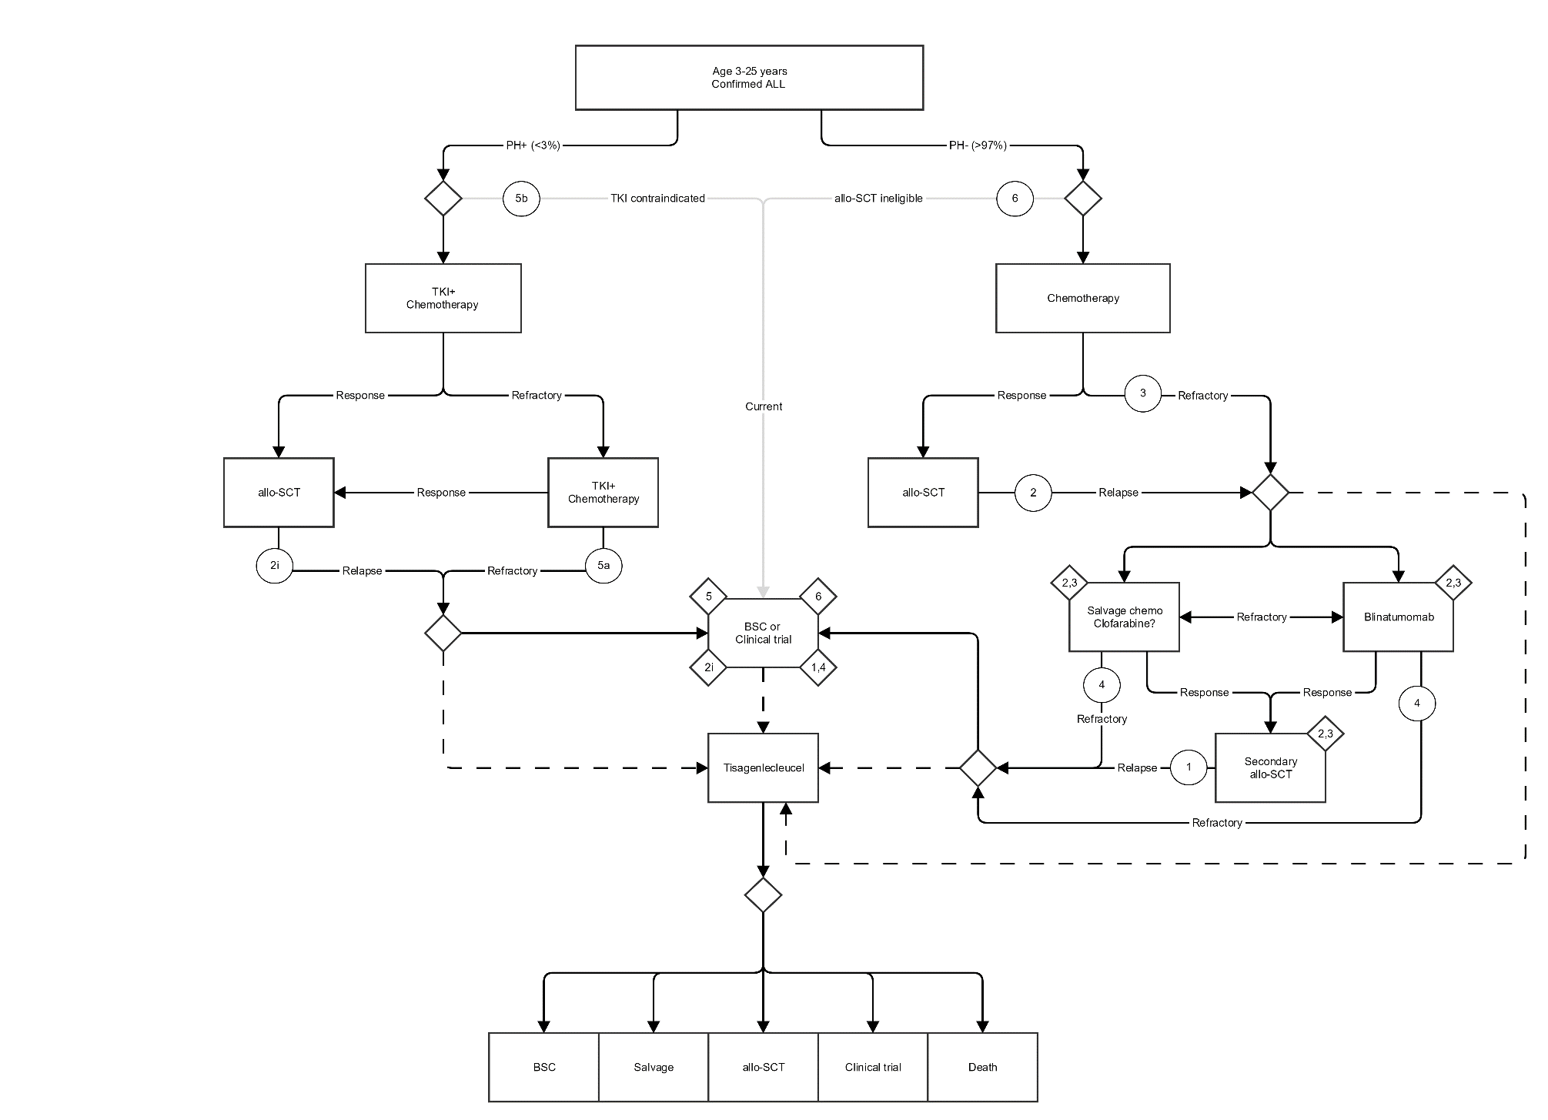
Figure 3 Current and proposed clinical management algorithm for population 1 (ALL)

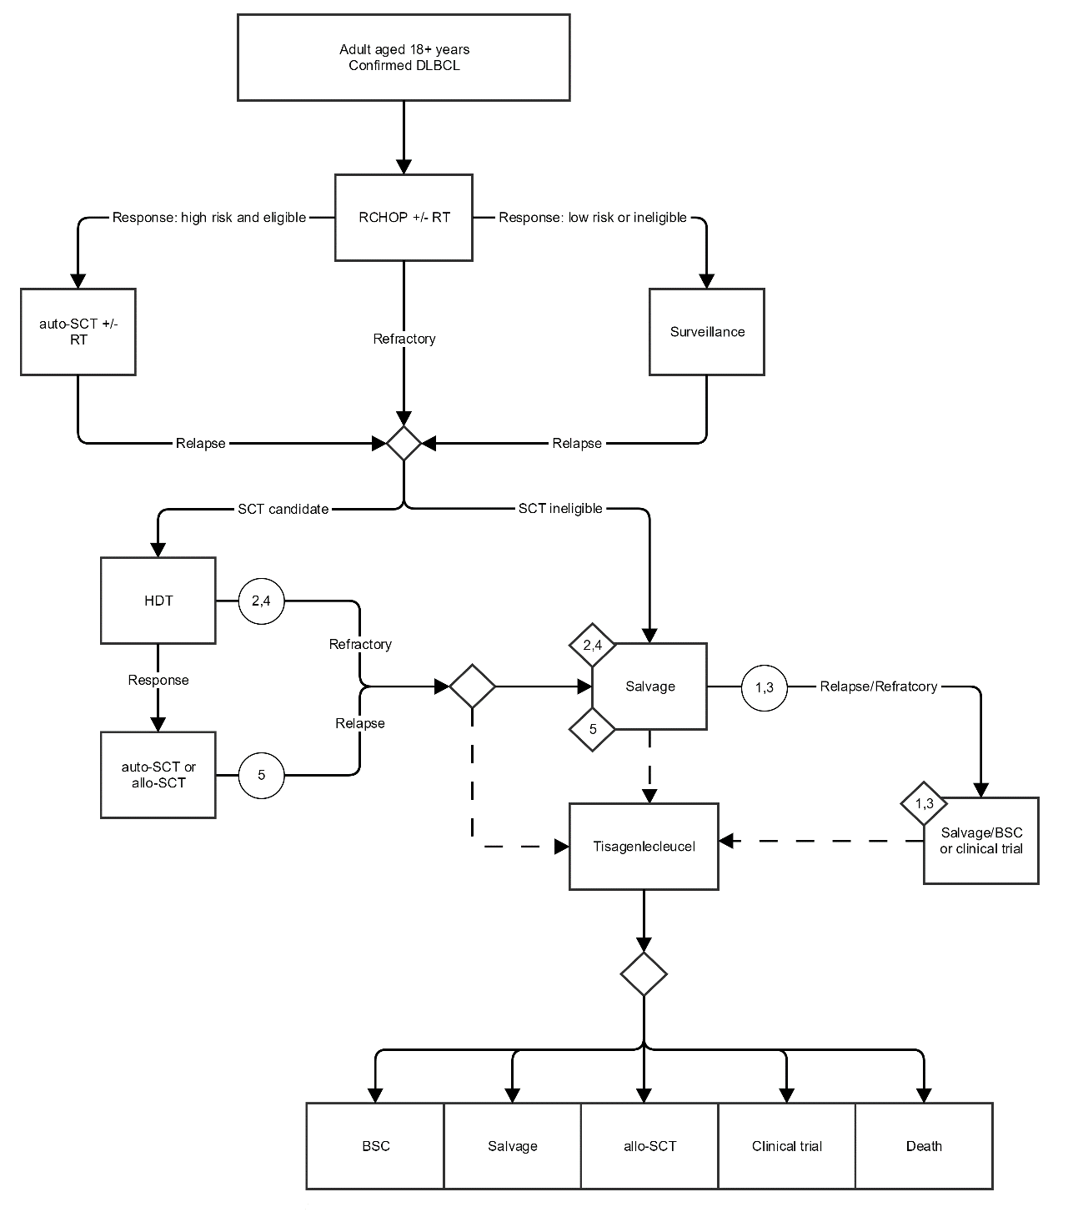
Figure 4 Current and proposed clinical management algorithm for population 2 (DLBCL)

4. Proposed economic evaluation
The applicant proposes that tisagenlecleucel is superior to the comparators in both populations (ALL and DLBCL).
If this claim is supported by the clinical evidence, which will be presented in the clinical section of the assessment, a cost-utility analysis would be the most appropriate type of economic evaluation.

5. Proposed item descriptor
As specified in section 2.4 ‘Intervention’ (under Funding mechanism and coverage of pharmaceutical components), no public funding through the MBS is sought for tisagenlecleucel. There will therefore be no MBS item descriptor.
Fee
REDACTED. A fixed fee should be provided in the assessment report as it is necessary for ESC, and should be a fixed cost in Australian dollars (US dollar will be susceptible to exchange rates), or a fixed range of costs for the purposes of the cost-effectiveness analysis.
REDACTED.

6. References
Australian Institute of Health and Welfare (AIHW) 2017, Australian Cancer Incidence and Mortality (ACIM) books: Acute lymphoblastic leukaemia (ALL), Australian Institute of Health and Welfare (AIHW), Canberra.
Brudno, JN & Kochenderfer, JN 2018, 'Chimeric antigen receptor T-cell therapies for lymphoma', Nat Rev Clin Oncol, vol. 15, no. 1, Jan, pp. 31-46.
Fitzgerald, JC, Weiss, SL, Maude, SL, Barrett, DM, Lacey, SF, Melenhorst, JJ, Shaw, P, Berg, RA, June, CH, Porter, DL, Frey, NV, Grupp, SA & Teachey, DT 2017, 'Cytokine Release Syndrome After Chimeric Antigen Receptor T Cell Therapy for Acute Lymphoblastic Leukemia', Crit Care Med, vol. 45, no. 2, Feb, pp. e124-e131.
Hunger, SP, Lu, X, Devidas, M, Camitta, BM, Gaynon, PS, Winick, NJ, Reaman, GH & Carroll, WL 2012, 'Improved survival for children and adolescents with acute lymphoblastic leukemia between 1990 and 2005: a report from the children's oncology group', J Clin Oncol, vol. 30, no. 14, May 10, pp. 1663-1669.
Institute for Clinical and Economic Review (ICER) 2017, Chimeric Antigen Receptor T-Cell Therapy for B-Cell Cancers: Effectiveness and Value, Draft evidence report, Institute for Clinical and Economic Review.
Kirby, T 2014, 'Children's cancer drugs cut into Australian hospital budgets', Lancet Oncol, vol. 15, no. 9, Aug, p. 923.
Maude, SL, Frey, N, Shaw, PA, Aplenc, R, Barrett, DM, Bunin, NJ, Chew, A, Gonzalez, VE, Zheng, Z, Lacey, SF, Mahnke, YD, Melenhorst, JJ, Rheingold, SR, Shen, A, Teachey, DT, Levine, BL, June, CH, Porter, DL & Grupp, SA 2014, 'Chimeric antigen receptor T cells for sustained remissions in leukemia', N Engl J Med, vol. 371, no. 16, Oct 16, pp. 1507-1517.
Maude, SL, Laetsch, TW, Buechner, J, Rives, S, Boyer, M, Bittencourt, H, Bader, P, Verneris, MR, Stefanski, HE, Myers, GD, Qayed, M, De Moerloose, B, Hiramatsu, H, Schlis, K, Davis, KL, Martin, PL, Nemecek, ER, Yanik, GA, Peters, C, Baruchel, A, Boissel, N, Mechinaud, F, Balduzzi, A, Krueger, J, June, CH, Levine, BL, Wood, P, Taran, T, Leung, M, Mueller, KT, Zhang, Y, Sen, K, Lebwohl, D, Pulsipher, MA & Grupp, SA 2018, 'Tisagenlecleucel in Children and Young Adults with B-Cell Lymphoblastic Leukemia', N Engl J Med, vol. 378, no. 5, Feb 1, pp. 439-448.
Mueller, KT, Maude, SL, Porter, DL, Frey, N, Wood, P, Han, X, Waldron, E, Chakraborty, A, Awasthi, R, Levine, BL, Melenhorst, JJ, Grupp, SA, June, CH & Lacey, SF 2017, 'Cellular kinetics of CTL019 in relapsed/refractory B-cell acute lymphoblastic leukemia and chronic lymphocytic leukemia', Blood, vol. 130, no. 21, Nov 23, pp. 2317-2325.
National Cancer Expert Reference Group 2016, Optimal cancer care pathway for people with Hodgkin and diffuse large B-cell lymphomas, Australian Government Cancer Australia and Cancer Council.
Novartis 2017, Oncologic drugs advisory committee briefing document. Tisagenlecleucel (CTL019) for the treatment of pediatric and young adult patients with relapsed/refractory B-cell acute lymphoblastic leukemia, FDA Advisory Committee Briefing Document.
Porter, DL, Hwang, WT, Frey, NV, Lacey, SF, Shaw, PA, Loren, AW, Bagg, A, Marcucci, KT, Shen, A, Gonzalez, V, Ambrose, D, Grupp, SA, Chew, A, Zheng, Z, Milone, MC, Levine, BL, Melenhorst, JJ & June, CH 2015, 'Chimeric antigen receptor T cells persist and induce sustained remissions in relapsed refractory chronic lymphocytic leukemia', Sci Transl Med, vol. 7, no. 303, Sep 2, p. 303ra139.
Schuster, SJ, Svoboda, J, Chong, EA, Nasta, SD, Mato, AR, Anak, O, Brogdon, JL, Pruteanu-Malinici, I, Bhoj, V, Landsburg, D, Wasik, M, Levine, BL, Lacey, SF, Melenhorst, JJ, Porter, DL & June, CH 2017, 'Chimeric Antigen Receptor T Cells in Refractory B-Cell Lymphomas', N Engl J Med, vol. 377, no. 26, Dec 28, pp. 2545-2554.
'Value in Using CAR T Cells for DLBCL', 2017, Cancer Discov, Dec 15.

Appendix
The clinical management algorithms presented in this Appendix (Figures 5 and 6 below) aim to explain the current and proposed approaches to management of any downstream services and outcomes for the proposed populations, once they are identified. This means the starting points for the current management algorithm are the target populations. The blue pathways represent the proposed intervention, with the black pathways representing current management. The dotted lines indicate that patients can drop out at different steps of the treatment process.
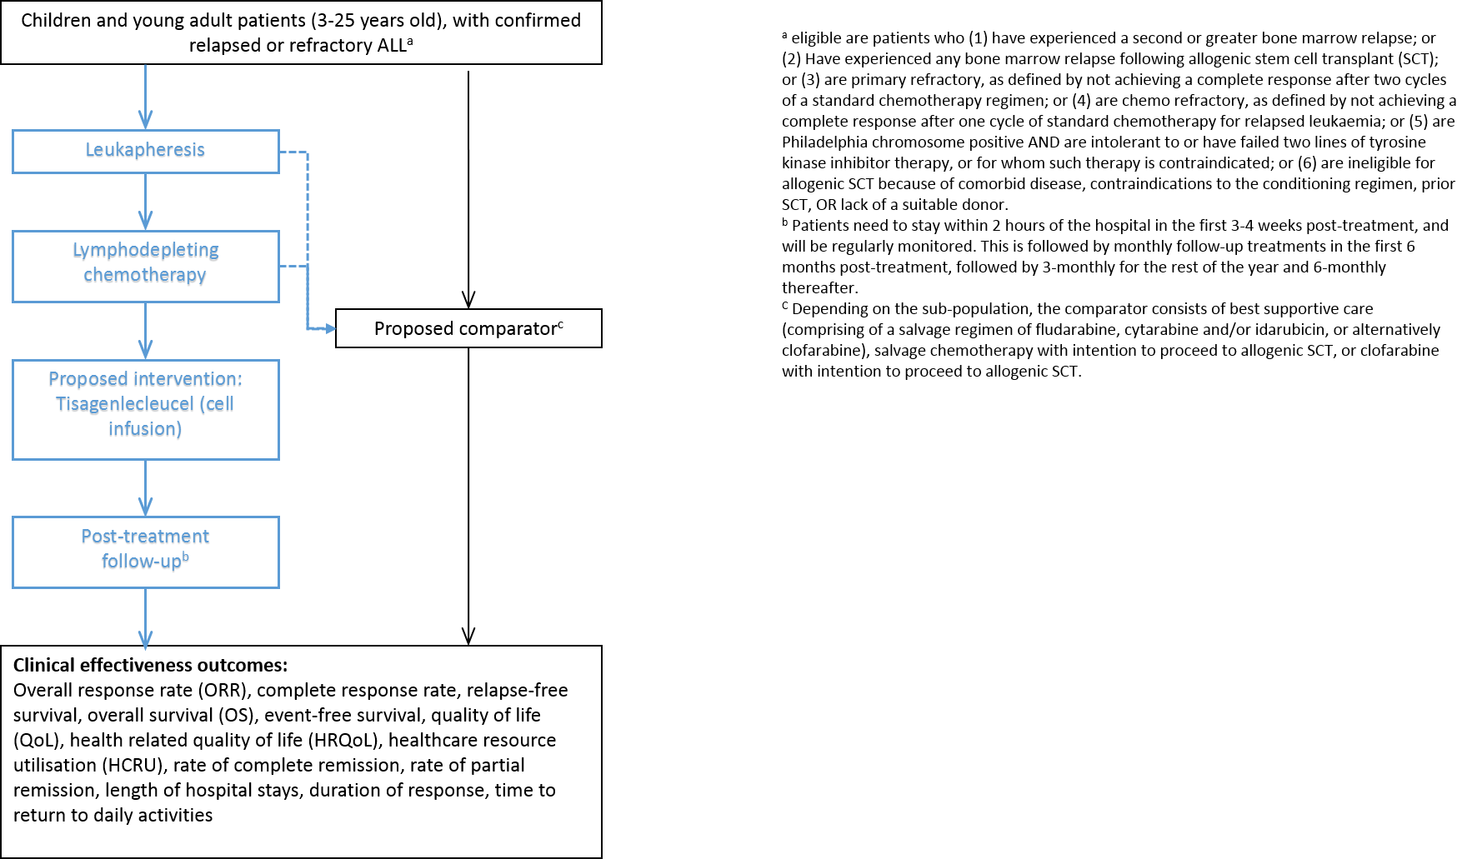
Figure 5 Current and proposed clinical management algorithm for the ALL population (to show downstream effects)
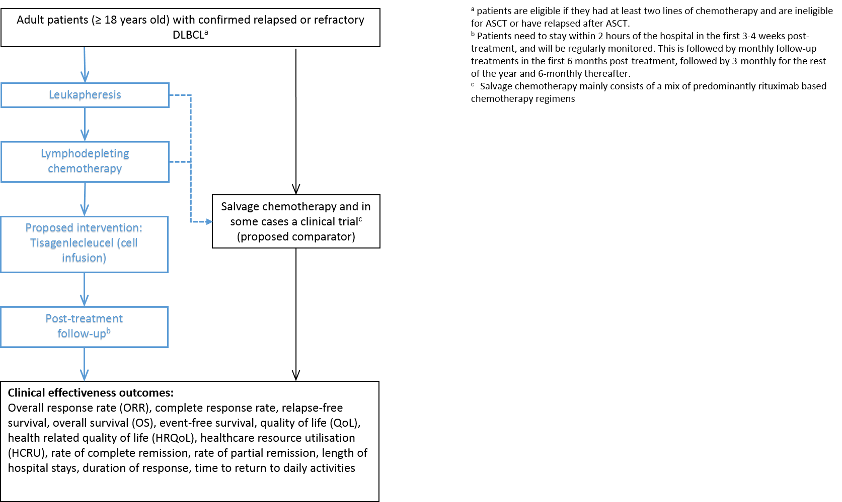
Figure 6 Current and proposed clinical management algorithm for the DLBCL population (to show downstream effects)

Even though an experimental treatment through a clinical trial is not considered as a valid comparator to assess the safety and effectiveness of the intervention, it should be noted that it is expected a certain proportion of the patient population is likely to participate in clinical trials, which may impact the estimated population using the service. This will be relevant for the financial section of the assessment report.
Even though an experimental treatment through a clinical trial is not considered as a valid comparator to assess the safety and effectiveness of the intervention, it should be noted that it is expected a certain proportion of the patient population is likely to participate in clinical trials, which may impact the estimated population using the service. This will be relevant for the financial section of the assessment report.
https://acrf.com.au/on-cancer/acute-lymphoblastic-leukaemia/
http://www.cancer.org.au/about-cancer/types-of-cancer/leukaemia.html
https://www.fda.gov/drugs/informationondrugs/approveddrugs/ucm574154.htm
https://www.uptodate.com/contents/epidemiology-clinical-manifestations-pathologic-features-and-diagnosis-of-diffuse-large-b-cell-lymphoma
http://www.leukaemia.org.au/blood-cancers/lymphomas/non-hodgkin-lymphoma-nhl/diffuse-large-b-cell-lymphoma
https://canceraustralia.gov.au/affected-cancer/cancer-types/lymphoma/non-hodgkin-lymphoma-statistics
https://clinicaltrials.gov/ct2/show/NCT02435849
https://clinicaltrials.gov/ct2/results?cond=&term=CTL019&cntry=&state=&city=&dist=
https://www.fda.gov/Drugs/InformationOnDrugs/ApprovedDrugs/ucm606540.htm
https://endpts.com/kymriah-gets-speed-reviews-in-us-and-eu-as-novartis-looks-to-swiftly-expand-car-t-indications/?utm_content=buffere53dc&utm_medium=social&utm_source=twitter.com&utm_campaign=buffer
https://labtestsonline.org/conditions/leukemia
https://druginfo.nlm.nih.gov/drugportal/name/Tisagenlecleucel-T
https://thenewdaily.com.au/life/wellbeing/2017/08/31/cancer-treatment-car-t-gene/
http://www.isscr.org/professional-resources/news-publicationsss/isscr-news-articles/blog-detail/stem-cells-in-focus/2017/10/27/crispr-car-t-and-cancer .
Complete response: The complete absence of detectable clinical evidence of disease and disease-related symptoms that were present prior to the start of therapy.

