Application Form

Permanent acute coronary syndrome event detector, insertion, removal or replacement of, for the monitoring of the heart's electrical activity

(New Request for Public Funding)

PART 1 – APPLICANT DETAILS

Applicant details (primary and alternative contacts)
Corporation / partnership details (where relevant): N/A
Corporation name: Hydrix
ABN: REDACTED
Business trading name: REDACTED

Primary contact name: REDACTED
Primary contact numbers
Business: REDACTED
Mobile: REDACTED
Email: REDACTED

Alternative contact name: REDACTED
Alternative contact numbers
Business: N/A
Mobile: REDACTED
Email: REDACTED

(a) Are you a lobbyist acting on behalf of an Applicant?
Yes
No

If yes, are you listed on the Register of Lobbyists?
Yes
No

PART 2 – INFORMATION ABOUT THE PROPOSED MEDICAL SERVICE

Application title
Permanent acute coronary syndrome event detector, insertion, removal or replacement of, for the monitoring of the heart's electrical activity

Provide a succinct description of the medical condition relevant to the proposed service (no more than 150 words – further information will be requested at Part F of the Application Form)
Acute coronary syndrome describes a range of conditions associated with sudden, reduced blood flow to the heart. The blockage can be sudden and occur in one instant, or it may come and go over a period of time. The condition occurs due to the build-up of fatty deposits in and on the walls of the coronary arteries. These arteries are responsible for delivering oxygen and nutrients to heart muscles.
Acute coronary syndrome is used to describe three types of coronary artery disease:
- Unstable angina
- Non-ST-segment elevation myocardial infarction or heart attack (NSTEMI)
- ST-segment elevation myocardial infarction or heart attack (STEMI)
The lack of blood supply to any tissue is called ischemia. The death of the cells results in damage to muscle tissue, and this is a heart attack or myocardial infarction.
Unstable angina is the term used to describe the condition when acute coronary syndrome does not lead to cell death.

Provide a succinct description of the proposed medical service (no more than 150 words – further information will be requested at Part 6 of the Application Form)
The proposed medical service involves the implantation of an acute coronary syndrome event detector (ACSED) in patients who have had prior acute coronary syndrome (ACS) events and who remain at high risk for recurrent ACS events.
The ACSED is implanted in a left pectoral subcutaneous pocket, similar to a permanent pacemaker, and connects to a transvenous active-fixation endocardial bipolar pacing lead which is placed in the right ventricular apex. Using a can-tip vector, the ACSED monitors the intracardiac electrograms gathered in real time to assess for ST segment changes including ST depression and elevation. If the device detects an excessive ST shift relative to the baseline ST segment, and if the ST shift exceeds a pre-programmed threshold, the ACSED vibrates to warn the patient and simultaneously signals the patient’s external device to provide redundant audible and visual external warning. The ACSED also stores electrograms for subsequent retrieval by the Programmer via wireless telemetry.

(a) Is this a request for MBS funding?
Yes
No

If yes, is the medical service(s) proposed to be covered under an existing MBS item number(s) or is a new MBS item(s) being sought altogether?
Amendment to existing MBS item(s)
New MBS item(s)

If an amendment to an existing item(s) is being sought, please list the relevant MBS item number(s) that are to be amended to include the proposed medical service:
Insert relevant MBS item numbers here

If an amendment to an existing item(s) is being sought, what is the nature of the amendment(s)?
- An amendment to the way the service is clinically delivered under the existing item(s)
- An amendment to the patient population under the existing item(s)
- An amendment to the schedule fee of the existing item(s)
- An amendment to the time and complexity of an existing item(s)
- Access to an existing item(s) by a different health practitioner group
- Minor amendments to the item descriptor that does not affect how the service is delivered
- An amendment to an existing specific single consultation item
- An amendment to an existing global consultation item(s)
- Other (please describe below):
Insert description of 'other' amendment here

If a new item(s) is being requested, what is the nature of the change to the MBS being sought?
- A new item which also seeks to allow access to the MBS for a specific health practitioner group
- A new item that is proposing a way of clinically delivering a service that is new to the MBS (in terms of new technology and / or population)
- A new item for a specific single consultation item
- A new item for a global consultation item(s)

Is the proposed service seeking public funding other than the MBS?
Yes
No

If yes, please advise:
Prostheses List listing

What is the type of service:
Therapeutic medical service
Investigative medical service
Single consultation medical service
Global consultation medical service
Allied health service
Co-dependent technology
Hybrid health technology

For investigative services, advise the specific purpose of performing the service (which could be one or more of the following):
- To be used as a screening tool in asymptomatic populations
- Assists in establishing a diagnosis in symptomatic patients
- Provides information about prognosis
- Identifies a patient as suitable for therapy by predicting a variation in the effect of the therapy
- Monitors a patient over time to assess treatment response and guide subsequent treatment decisions

Does your service rely on another medical product to achieve or to enhance its intended effect?
Pharmaceutical / Biological
Prosthesis or device
No

(a) If the proposed service has a pharmaceutical component to it, is it already covered under an existing Pharmaceutical Benefits Scheme (PBS) listing?
Yes
No

If yes, please list the relevant PBS item code(s):
Insert PBS item code(s) here

If no, is an application (submission) in the process of being considered by the Pharmaceutical Benefits Advisory Committee (PBAC)?
Yes (please provide PBAC submission item number below)
No
Insert PBAC submission item number here

If you are seeking both MBS and PBS listing, what is the trade name and generic name of the pharmaceutical?
Trade name: Insert trade name here
Generic name: Insert generic name here

(a) If the proposed service is dependent on the use of a prosthesis, is it already included on the Prostheses List?
Yes
No

If yes, please provide the following information (where relevant):
Billing code(s): Insert billing code(s) here
Trade name of prostheses: Insert trade name here
Clinical name of prostheses: Insert clinical name here
Other device components delivered as part of the service: Insert description of device components here

If no, is an application in the process of being considered by a Clinical Advisory Group or the Prostheses List Advisory Committee (PLAC)?
Yes
No

Are there any other sponsor(s) and / or manufacturer(s) that have a similar prosthesis or device component in the Australian market place which this application is relevant to?
Yes
No

If yes, please provide the name(s) of the sponsor(s) and / or manufacturer(s):
N/A

Please identify any single and / or multi-use consumables delivered as part of the service?
Single use consumables: N/A
Multi-use consumables: N/A

PART 3 – INFORMATION ABOUT REGULATORY REQUIREMENTS

(a) If the proposed medical service involves the use of a medical device, in-vitro diagnostic test, pharmaceutical product, radioactive tracer or any other type of therapeutic good, please provide the following details:
Type of therapeutic good: Medical device
Manufacturer’s name: REDACTED.
Sponsor’s name: REDACTED

Is the medical device classified by the TGA as either a Class III or Active Implantable Medical Device (AIMD) against the TGA regulatory scheme for devices?
Class III
AIMD
N/A

(a) Is the therapeutic good to be used in the service exempt from the regulatory requirements of the Therapeutic Goods Act 1989?
Yes (If yes, please provide supporting documentation as an attachment to this application form)
No

If no, has it been listed or registered or included in the Australian Register of Therapeutic Goods (ARTG) by the Therapeutic Goods Administration (TGA)?
Yes (if yes, please provide details below)
No

ARTG listing, registration or inclusion number: Insert ARTG number here
TGA approved indication(s), if applicable: Insert approved indication(s) here
TGA approved purpose(s), if applicable: Insert approved purpose(s) here

If the therapeutic good has not been listed, registered or included in the ARTG, is the therapeutic good in the process of being considered for inclusion by the TGA?
Yes (please provide details below)
No

Date of submission to TGA: 6th November 2019
Estimated date by which TGA approval can be expected: August 2020
TGA Application ID: DV-2019-DA-18301-1
TGA approved indication(s), if applicable:
TGA approved purpose(s), if applicable:

If the therapeutic good is not in the process of being considered for listing, registration or inclusion by the TGA, is an application to the TGA being prepared?
Yes (please provide details below)
No

Estimated date of submission to TGA: Insert date of submission here
Proposed indication(s), if applicable: If applicable, insert description of proposed indication(s)
Proposed purpose(s), if applicable: If applicable, insert description of proposed purpose(s) here

PART 4 – SUMMARY OF EVIDENCE

Provide an overview of all key journal articles or research published in the public domain related to the proposed service that is for your application (limiting these to the English language only). Please do not attach full text articles, this is just intended to be a summary.
 | Type of study design* | Title of journal article or research project (including any trial identifier or study lead if relevant) | Short description of research (max 50 words)** | Website link to journal article or research (if available) | Date of publication***
1. | Multicenter, randomized trial | Implantable Cardiac Alert System for Early Recognition of ST-Segment Elevation Myocardial Infarction | Trial of an implantable cardiac monitor that alerts patients with rapidly progressive ST-segment deviation. High-risk acute coronary syndromes subjects (N = 907) were randomized to a control (alarms deactivated) or treatment group for 6 months, after which alarms were activated in all subjects. | https://www.ncbi.nlm.nih.gov/pubmed/30842028 | April 2019
2. | Multicenter, randomized trial | Implanted Monitor Alerting to Reduce Treatment Delay in Patients With Acute Coronary Syndrome Events. | Trial of an implantable cardiac monitor that alerts patients with rapidly progressive ST-segment deviation. High-risk acute coronary syndromes subjects (N = 907) were randomized to a control (alarms deactivated) or treatment group for 6 months, after which alarms were activated in all subjects. | https://www.ncbi.nlm.nih.gov/pubmed/31623762 | Oct 2019  Note: both papers are reporting on the ALERTS trial
* Categorise study design, for example meta-analysis, randomised trials, non-randomised trial or observational study, study of diagnostic accuracy, etc.
**Provide high level information including population numbers and whether patients are being recruited or in post-recruitment, including providing the trial registration number to allow for tracking purposes.
*** If the publication is a follow-up to an initial publication, please advise.

Identify yet to be published research that may have results available in the near future that could be relevant in the consideration of your application by MSAC (limiting these to the English language only). Please do not attach full text articles, this is just intended to be a summary.
 | Type of study design* | Title of research (including any trial identifier if relevant) | Short description of research (max 50 words)** | Website link to research (if available) | Date***
1. | For yet to be published research that may have results relevant to your application, insert the type of study design in this column and columns below | For yet to be published research that may have results relevant to your application, insert the title of research (including any trial identifier if relevant) in this column and columns below | For yet to be published research that may have results relevant to your application, insert a short description of research (max 50 words) in this column and columns below | For yet to be published research that may have results relevant to your application, insert a website link to this research (if available) in this column and columns below | For yet to be published research that may have results relevant to your application, insert date in this column and columns below
2. | Insert study design | Insert title of research | Insert description | Insert website link | Insert date
* Categorise study design, for example meta-analysis, randomised trials, non-randomised trial or observational study, study of diagnostic accuracy, etc.
**Provide high level information including population numbers and whether patients are being recruited or in post-recruitment.
***Date of when results will be made available (to the best of your knowledge).

PART 5 – CLINICAL ENDORSEMENT AND CONSUMER INFORMATION

List all appropriate professional bodies / organisations representing the group(s) of health professionals who provide the service (please attach a statement of clinical relevance from each group nominated):
Electrophysiologists

List any professional bodies / organisations that may be impacted by this medical service (i.e. those who provide the comparator service):
Cardiac Society of Australia and New Zealand

List the consumer organisations relevant to the proposed medical service (please attach a letter of support for each consumer organisation nominated):
REDACTED

List the relevant sponsor(s) and / or manufacturer(s) who produce similar products relevant to the proposed medical service:
N/A

Nominate two experts who could be approached about the proposed medical service and the current clinical management of the service(s):
REDACTED

Please note that the Department may also consult with other referrers, proceduralists and disease specialists to obtain their insight.

PART 6 – POPULATION (AND PRIOR TESTS), INTERVENTION, COMPARATOR, OUTCOME (PICO)

PART 6a – INFORMATION ABOUT THE PROPOSED POPULATION

Define the medical condition, including providing information on the natural history of the condition and a high level summary of associated burden of disease in terms of both morbidity and mortality:
Acute myocardial infarction (AMI) is a life-threatening event that occurs when a blood vessel supplying the heart itself is suddenly blocked completely, threatening to damage the heart muscle and its functions.
AMI claimed 7,813 lives in 2017, or on average, 21 each day. In 2014–15, there were 32,388 hospitalisations for acute myocardial infarction, representing 252 hospitalisations per 100,000 people aged 35–84 years (the Australian rate).
Early identification of acute myocardial infarctions (AMI), and prompt treatment has been shown to significantly improve clinical outcomes. Experimental and clinical studies have shown that most of the irreversible damage to the myocardium occurs during the first two hours after coronary occlusion. Milavetz et al. demonstrated that successful reperfusion therapy within two hours was associated with the greatest degree of myocardial salvage. According to Boersma, et al., restoration of flow, regardless of the method used, can abort infarction within the first 30 minutes after coronary occlusion, and the benefit of fibrinolytic therapy compared with placebo is considerably higher in patients treated within 2 hours after symptom onset than in those treated later. Further, evidence exists that expeditious restoration of flow in the obstructed infarct artery after the onset of symptoms in patients with the most severe type of MI, ST elevation MI (STEMI) is a key determinant of short and long-term outcomes regardless of whether reperfusion is accomplished by fibrinolysis or percutaneous coronary intervention (PCI).
Therefore, the early arrival at the hospital for a reliable diagnosis and initiation of treatment is paramount to improve the outcomes of myocardial infarction.

Specify any characteristics of patients with the medical condition, or suspected of, who are proposed to be eligible for the proposed medical service, including any details of how a patient would be investigated, managed and referred within the Australian health care system in the lead up to being considered eligible for the service:
The proposed service is indicated for use in patients who have had prior acute coronary syndrome (ACS) events and/or previous by-pass surgery who remain at high risk for recurrent ACS events.
The procedure is contraindicated for patients with implanted pacemaker, implantable cardioverter defibrillator (ICD) or cardiac resynchronization therapy (CRT) devices.

Define and summarise the current clinical management pathway before patients would be eligible for the proposed medical service (supplement this summary with an easy to follow flowchart [as an attachment to the Application Form] depicting the current clinical management pathway up to this point):
The acute coronary syndrome event detector is indicated for implanting in patients who have had prior acute coronary syndrome (ACS) events and who remain at high risk for recurrent ACS events.

PART 6b – INFORMATION ABOUT THE INTERVENTION

Describe the key components and clinical steps involved in delivering the proposed medical service:
The AngelMed Guardian System is an implantable acute coronary syndrome event detector and is implanted in exactly the same way as a cardiac pacemaker and lead are implanted (covered by MBS Item 38350 and MBS Item 38353).

Does the proposed medical service include a registered trademark component with characteristics that distinguishes it from other similar health components?
The AngelMed Guardian System is an implantable acute coronary syndrome event detector with patient alerting capability and an additional external alarm device. The Guardian System is indicated for use in patients who have had prior acute coronary syndrome (ACS) events and who remain at high risk for recurrent ACS events.
The Guardian System is indicated as an adjunct to patient recognized symptoms. The Guardian System detects potential ongoing ACS events, characterized by sustained ST segment changes, and alerts the patient to seek medical attention for those potential ACS events.

If the proposed medical service has a prosthesis or device component to it, does it involve a new approach towards managing a particular sub-group of the population with the specific medical condition?
Yes. The Guardian System is indicated for use in patients who have had prior acute coronary syndrome (ACS) events (heart attack and unstable angina) and who remain at high risk for recurrent ACS events.

If applicable, are there any limitations on the provision of the proposed medical service delivered to the patient (i.e. accessibility, dosage, quantity, duration or frequency):
The Guardian System is intended as a permanent implant or until such time as the patient requires further treatment, for example, implantation of a pacemaker.

If applicable, identify any healthcare resources or other medical services that would need to be delivered at the same time as the proposed medical service:
N/A

If applicable, advise which health professionals will primarily deliver the proposed service:
Electrophysiologists

If applicable, advise whether the proposed medical service could be delegated or referred to another professional for delivery:
N/A

If applicable, specify any proposed limitations on who might deliver the proposed medical service, or who might provide a referral for it:
The patient would be referred by an Interventional Cardiologist. The service would be provided by a Cardiac Electrophysiologist or any accredited pacemaker implanter. The training required to implant the acute coronary syndrome event detector is identical to that required to implant a pacemaker.

If applicable, advise what type of training or qualifications would be required to perform the proposed service, as well as any accreditation requirements to support service delivery:
Same as that required to implant a pacemaker.

(a) Indicate the proposed setting(s) in which the proposed medical service will be delivered (select ALL relevant settings):
Inpatient private hospital (admitted patient)
Inpatient public hospital (admitted patient)
Private outpatient clinic
Public outpatient clinic
Emergency Department
Private consulting rooms - GP
Private consulting rooms – specialist
Private consulting rooms – other health practitioner (nurse or allied health)
Private day surgery clinic (admitted patient)
Private day surgery clinic (non-admitted patient)
Public day surgery clinic (admitted patient)
Public day surgery clinic (non-admitted patient)
Residential aged care facility
Patient’s home
Laboratory
Other – please specify below
N/A
- Where the proposed medical service is provided in more than one setting, please describe the rationale related to each:
Requires overnight stay – either public or private hospital

Is the proposed medical service intended to be entirely rendered in Australia?
Yes
No – please specify below
N/A

PART 6c – INFORMATION ABOUT THE COMPARATOR(S)

Nominate the appropriate comparator(s) for the proposed medical service, i.e. how is the proposed population currently managed in the absence of the proposed medical service being available in the Australian health care system (including identifying health care resources that are needed to be delivered at the same time as the comparator service):
There are no alternatives to the proposed implanting of an acute coronary syndrome event detector (implanted as part of the proposed MBS Item) for near real-time, outpatient monitoring for ACS events. Current patients at risk for ACS must rely only on patient recognized symptoms to prompt them to seek medical attention.

Does the medical service (that has been nominated as the comparator) have an existing MBS item number(s)?
Yes (please list all relevant MBS item numbers below)
No
N/A

Define and summarise the current clinical management pathway/s that patients may follow after they receive the medical service that has been nominated as the comparator (supplement this summary with an easy to follow flowchart [as an attachment to the Application Form] depicting the current clinical management pathway that patients may follow from the point of receiving the comparator onwards, including health care resources):
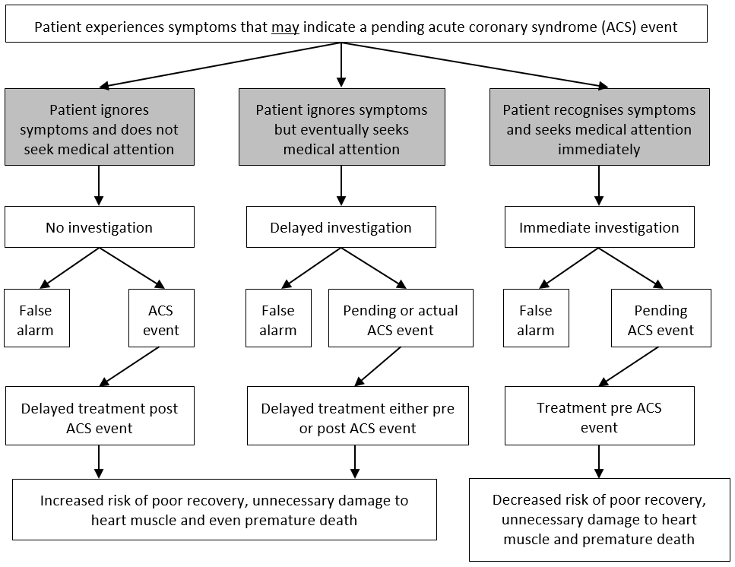

(a) Will the proposed medical service be used in addition to, or instead of, the nominated comparator(s)?
In addition to (i.e. it is an add-on service)
Instead of (i.e. it is a replacement or alternative)
The Guardian System is indicated as an adjunct to patient recognized symptoms.

If instead of (i.e. alternative service), please outline the extent to which the current service/comparator is expected to be substituted:
N/A

Define and summarise how current clinical management pathways (from the point of service delivery onwards) are expected to change as a consequence of introducing the proposed medical service, including variation in health care resources (Refer to Question 39 as baseline):
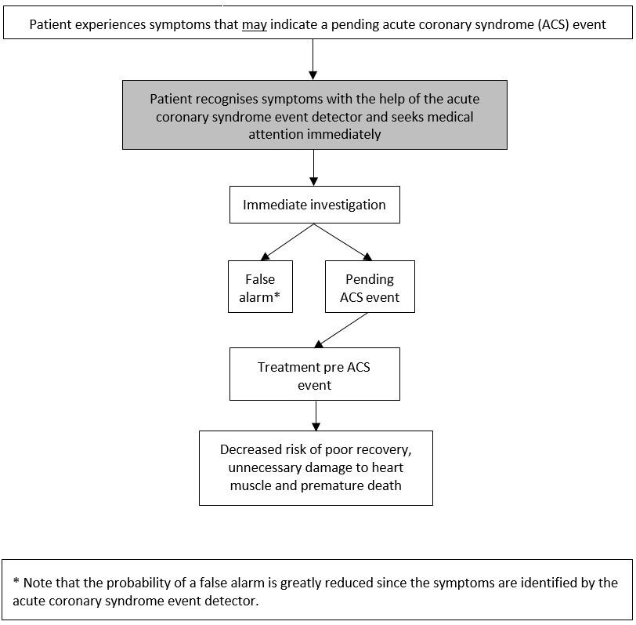

PART 6d – INFORMATION ABOUT THE CLINICAL OUTCOME

Summarise the clinical claims for the proposed medical service against the appropriate comparator(s), in terms of consequences for health outcomes (comparative benefits and harms):
- The Guardian System (an acute coronary syndrome event detector) detects potential ongoing ACS events, characterized by sustained ST segment changes, and alerts the patient to seek medical attention for those potential ACS events.
- A Guardian System alert is a more accurate predictor of ACS events when compared to patient recognized symptoms alone and demonstrates a reduced rate over time of patient presentations without ACS events (false positives) when compared to patient recognized symptoms alone.
- In the absence of symptoms, the Guardian System may identify asymptomatic ACS events and prompt the patient to seek medical attention.

Please advise if the overall clinical claim is for:
Superiority
Non-inferiority

Below, list the key health outcomes (major and minor – prioritising major key health outcomes first) that will need to be specifically measured in assessing the clinical claim of the proposed medical service versus the comparator:
Safety Outcomes:
- Absence of system-related complications
Clinical Effectiveness Outcomes:
- Reduced cardiac/unexplained death,
- Reduced new Q-wave myocardial infarction, or
- Detection to presentation time reduced to <2 hours.

PART 7 – INFORMATION ABOUT ESTIMATED UTILISATION

Estimate the prevalence and/or incidence of the proposed population:
Estimated ACS separations by subtype of ACS, 2017-18 (Source: Heart Foundation calculations)
 | UA | STEMI | NSTEMI | Total ACS
Total (no.) | 23,286 | 14,170 | 41,411 | 78,866
Share (%) | 29.5 | 18.1 | 52.4 | 100
- Unstable angina (UA)
- Non-ST-segment elevation myocardial infarction or heart attack (NSTEMI)
- ST-segment elevation myocardial infarction or heart attack (STEMI)
Despite the advancements made in the treatment for ACS, the incidence of recurrent AMI remains high. Of the approximate 79,000 ACS events in 2017-18, an estimated 30.1 percent have had a previous AMI.
This gives the incidence for the target population, patient who have had a previous ACS, as being approximately 23,700.

Estimate the number of times the proposed medical service(s) would be delivered to a patient per year:
Once only

How many years would the proposed medical service(s) be required for the patient?
Once only per lifetime

Estimate the projected number of patients who will utilise the proposed medical service(s) for the first full year:
500

Estimate the anticipated uptake of the proposed medical service over the next three years factoring in any constraints in the health system in meeting the needs of the proposed population (such as supply and demand factors) as well as provide commentary on risk of ‘leakage’ to populations not targeted by the service:
Year 1 – 500
Year 2 – 1,250
Year 3 – 3,100

PART 8 – COST INFORMATION

Indicate the likely cost of providing the proposed medical service. Where possible, please provide overall cost and breakdown:
According to Medibank Private the total cost of implanting a pacemaker is $14,780 (assumes no patient co-payment).
(2016-17) AR-DRG F12B - Implantation and Replacement of Pacemaker, Total System, Minor Complexity - $10,563 (includes $3,759 for prosthesis)
- Length of procedure: one hour - REDACTED (DVA CMBS Group Accommodation and Theatre Banding Schedule 2019)
- Length of stay: one to two days @ REDACTED per day (NSW State Insurance Regulatory Authority)
- AngelMed Guardian System: REDACTED (includes patient external device)
(Note: Programmer: REDACTED provided at no charge)
- Lead: REDACTED
- MBS Item 38350: $648.85
- MBS Item 38353: $259.55/2 (50% multiple procedure rule)
TOTAL: REDACTED

Specify how long the proposed medical service typically takes to perform:
Approximately one hour

If public funding is sought through the MBS, please draft a proposed MBS item descriptor to define the population and medical service usage characteristics that would define eligibility for MBS funding.
Category 2 - DIAGNOSTIC PROCEDURES AND INVESTIGATIONS
Proposed item descriptor: Permanent acute coronary syndrome event detector, insertion, removal or replacement of for patients who have experienced a previous acute coronary syndrome event
Fee: $259.55 Benefit: 75% = $194.70

Category 2 - DIAGNOSTIC PROCEDURES AND INVESTIGATIONS
Proposed item descriptor: Single chamber permanent transvenous electrode, insertion, removal or replacement of
Fee: $648.85 Benefit: 75% = $486.65

