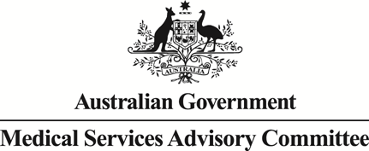

Public Summary Document
Application No. 1610 – Clostridium botulinum type A
toxin-haemagglutinin complex (Dysport®) for the treatment of moderate to severe upper-limb spasticity due to cerebral palsy
Applicant: Ipsen Pty Ltd
Date of MSAC consideration: MSAC 79th Meeting, 28-29 July 2020
Context for decision: MSAC makes its advice in accordance with its Terms of Reference, visit the MSAC website

Purpose of application
An application for a streamlined co-dependent consideration requested:
- extension to the Pharmaceutical Benefits Scheme (PBS) Section 100 Botulinum Toxin Program to include clostridium botulinum type A toxin-haemagglutinin complex (Dysport®), for the treatment of moderate to severe focal spasticity of the upper limb in patients with cerebral palsy
- an amendment of Medicare Benefits Schedule (MBS) item 18361 to include the injection of clostridium botulinum type A toxin-haemagglutinin complex (Dysport®) for the treatment of paediatric patients with upper-limb spasticity due to cerebral palsy.

MSAC’s advice to the Minister
In alignment with the extended Pharmaceutical Benefits Scheme (PBS) listing of clostridium botulinum type A toxin-haemagglutinin complex as recommended by the Pharmaceutical Benefits Advisory Committee (PBAC) in July 2020, MSAC supported the modification of existing MBS item 18361 to include injection of this medicine.
Consumer summary
Ipsen Pty Ltd applied for public funding of clostridium botulinum type A toxin-haemagglutinin complex, Dysport®, to treat moderate to severe upper-limb spasticity due to cerebral palsy.
Cerebral palsy affects a person’s ability to control their muscle movements, which can result in having stiff arms, called spasticity. Dysport® can help relax this stiffness.
MSAC noted that the July 2020 Pharmaceutical Benefits Advisory Committee meeting had advised that this treatment was similar in effectiveness and safety to another botulinum toxin (Botox®), which is already being used for the same moderate to severe paediatric upper-limb spasticity. Botox® administration is already publicly funded under Medicare Benefits Schedule (MBS) item 18361, and MSAC considered that Dysport® administration should therefore be covered under the same item.
MSAC’s advice to the Commonwealth Minister for Health
MSAC supported public funding of the administration of Dysport® for the requested population. MSAC was satisfied that this administration is effective, safe and cost-effective.

Summary of consideration and rationale for MSAC’s advice
MSAC noted that this application was for the addition of clostridium botulinum type A toxin-haemagglutinin complex, Dysport®, to the descriptor of Medicare Benefits Schedule (MBS) item 18361 for the treatment of moderate to severe paediatric upper-limb spasticity due to cerebral palsy.
MSAC noted that, in July 2020, the Pharmaceutical Benefits Advisory Committee (PBAC) recommended that the Pharmaceutical Benefits Scheme (PBS) listing of Dysport® be extended to include the treatment of moderate to severe focal spasticity of the upper limb in patients with cerebral palsy. MSAC also noted that the Therapeutic Goods Administration approved the related new indication “For symptomatic treatment of focal spasticity of upper limbs in children aged 2 years and older” for Dysport® in July 2020.
MSAC noted that the proposed fee remains unchanged at $128.75 as per the existing MBS item number 18361.
MSAC noted the PBAC’s conclusion:
Although the indirect comparison between Dysport® and the nominated comparator, Botox®, had a number of issues including small patient numbers and heterogeneity, the PBAC was satisfied that Dysport® was non-inferior to Botox® in terms of comparative efficacy and safety.
MSAC noted the potential for small cost-savings due to the difference in recommended timing between treatments (Dysport® minimum of 16 weeks, Botox® minimum of 12 weeks), which could lead to a small reduction in MBS costs.
MSAC accepted the applicant’s estimated 50% uptake of Dysport® across the first 6 years of listing compared with Botox®.
MSAC considered that the requested change was likely to be cost-neutral to the MBS.

Background
This is the first application to MSAC seeking amendment of MBS item 18361 to include injection of Dysport® for the treatment of paediatric patients with upper-limb spasticity due to cerebral palsy.

Prerequisites to implementation of any funding advice
Dysport® is included on the Australian Register of Therapeutic Goods (ARTG), as a registered prescription medicine approved for multiple specific indications including the use for symptomatic treatment of upper limb focal spasticity in adults and children aged 2 years and older, as shown in Table 1.
Table 1 Relevant Dysport® indications registered on the ARTG
ARTG no. | Product category | Product description | Specific Indications | Sponsor
74124  Date ARTG last updated: 27/07/2020 | Medicine Registered | DYSPORT clostridium botulinum type A toxin - haemagglutinin complex 500 Ipsen Units powder for injection vial | Dysport is indicated for symptomatic treatment of focal spasticity of:  - Upper limbs in adults  - Lower limbs in adults  - Upper limbs in children aged 2 years and older  - Lower limbs in children aged 2 years and older,  Dysport is indicated in adults for the treatment of:  - Spasmodic torticollis  - Blepharospasm  - Hemifacial spasm  - Moderate to severe glabellar lines and / or lateral canthal lines (crow's feet) | Ipsen Pty Ltd
170651  Date ARTG last updated: 27/07/2020 | Medicine Registered | DYSPORT clostridium botulinum type A toxin - haemagglutinin complex 300 Ipsen Units powder for injection vial | Dysport is indicated for symptomatic treatment of focal spasticity of:  - Upper limbs in adults  - Lower limbs in adults  - Upper limbs in children aged 2 years and older  - Lower limbs in children aged 2 years and older,  Dysport is indicated in adults for the treatment of:  - Spasmodic torticollis  - Blepharospasm  - Hemifacial spasm  Moderate to severe glabellar lines and / or lateral canthal lines (crow's feet) | Ipsen Pty Ltd
Source: ARTG, accessed 30 July 2020.

Proposal for public funding
The applicant proposed addition of Dysport® to MBS item 18361 as shown in Table 2.
The Department also proposed removal of paragraph (b) from item 18361, (irrespective of the outcome of MSAC’s and PBAC’s consideration of the Dysport® submission). This proposed change is to align the MBS with the PBS following a recommendation by the PBAC to remove the requirement for adult cerebral palsy patients to have commenced treatment with botulinum toxin type A as a paediatric patient, which was implemented 1 May 2019.
Table 2 Proposed amendments to MBS item 18361 descriptor
MBS Item 18361
Category 3 – THERAPEUTIC PROCEDURES
Group T11 – Botulinum Toxin Injections
Clostridium Botulinum Type A Toxin-Haemagglutin Complex (Dysport) or Botulinum Toxin Type A Purified Neurotoxin Complex (Botox), injection of, for the treatment of moderate to severe upper limb spasticity due to cerebral palsy if:
(a) the patient is at least 2 years of age, and
(b) for a patient who is at least 18 years of age - before the patient turned 18, the patient had commenced treatment for the spasticity with botulinum toxin supplied under the pharmaceutical benefits scheme; and
(cb) the treatment is for all or any of the muscles sub-serving one functional activity and supplied by one motor nerve, with a maximum of 4 sets of injections for the patient on any one day (with a maximum of 2 sets of injections for each upper limb), including all injections per set
(Anaes.)
Fee: $128.75 Benefit: 75% = $96.60 85% = $109.45

Summary of public consultation feedback/consumer issues
Nil.

Proposed intervention’s place in clinical management

Description of proposed intervention
Dysport® is a neuromuscular blocking agent (neurotoxin) which blocks cholinergic transmission at the neuromuscular junction by a presynaptic action at a site proximal to the release of acetylcholine. The toxin acts within the nerve ending to antagonize those events that are triggered by Ca²⁺ which culminate in transmitter release. This results in a reduction in muscle contraction and a dose-dependent reversible reduction in muscle power. Active neuromuscular junctions take up toxin more avidly than neuromuscular junctions at rest. The onset of drug effect in patients with spasticity usually occurs after 3 to 4 days; the effect peaks at 4 weeks and lasts for 12 to 16 weeks.

Description of medical condition(s)
Spasticity is a chronic manifestation of upper motor neuron syndrome due to lesions of the pyramidal tract (an aggregation of upper motor neurons). The most common cause of the central nervous system (CNS) lesions leading to paediatric upper limb spasticity is cerebral palsy. The ADAR stated that the majority of children with cerebral palsy are affected by spasticity, which can be defined as hypertonia in which one or both of the following signs are present: 1) resistance to externally imposed movement increases with increasing speed of stretch and varies with the direction of joint movement; 2) resistance to externally imposed movement rises rapidly above a threshold speed of joint angle.
The clinical management algorithm for current practice and for the intended use of Dysport® for the treatment of upper limb focal spasticity (ULFS) in patients with cerebral palsy is presented in Figure 1. Dysport® is proposed to substitute for Botox® in the current treatment algorithm where it is used alongside other treatment modalities including physical therapy as well as other drugs.
Figure 1 Proposed clinical management algorithm
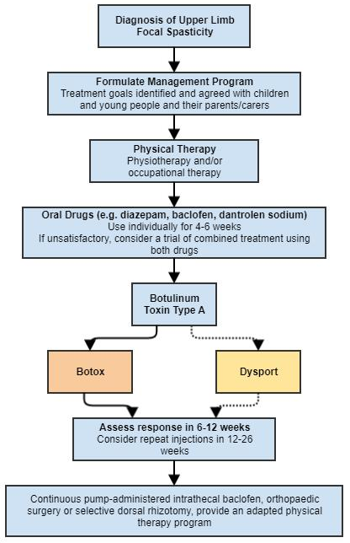
Source : Figure 1-1, p26 of the application.

Comparator
The comparator is Botox®, another botulinum toxin type A.

Financial/budgetary impacts
The application applied a market share approach to estimate the number of Dysport® scripts that will be used for treatment of upper limb spasticity due to cerebral palsy. The application did not propose a change to the estimates of patient numbers and did not include MBS costs for administration of Dysport® or Botox® in the financial impact analysis. The applicant claimed that given the potential differences between treatment durations, it is likely that Dysport® will result in fewer MBS items being processed.

Other significant factors
Nil.

Applicant comments on MSAC’s Public Summary Document
The applicant had no comment.

Further information on MSAC
MSAC Terms of Reference and other information are available on the MSAC Website:
visit the MSAC website

