Public Summary Document

Report to the Medical Services Advisory Committee on utilisation of MBS item 38273 following application 1330: Transcatheter closure of a patent ductus arteriosus
Medicare Benefits Schedule (MBS) item considered: 38273
Date of MSAC consideration: 23 November 2017
Context for decision: MSAC makes its advice in accordance with its Terms of Reference, see the MSAC Website.

Purpose
The purpose of the report presented to the Medical Services Advisory Committee (MSAC) was to inform MSAC of the real world impacts on the outcomes of Application 1330. The MSAC uses this information to ensure that the new item/s resulting from this application/s is being used as intended.
The report is not intended to be a review of the clinical information covered during the application process.

MSAC’s advice
After considering the real world impacts of the outcomes of Application 1330 for the transcatheter closure of a patent ductus arteriosus (MBS item 38273), MSAC considered actual utilisation data and compared it with prior utilisation predictions following MSAC’s support for the transcatheter closure of a patent ductus arteriosus. MSAC noted there was lower than expected utilisation of this item and recommended no further action.

Summary of consideration and rationale for MSAC’s advice
MSAC considered the real world impacts of the outcome of Application 1330 for transcatheter closure of a patent ductus arteriosus (PDA) by examining available data for MBS item 38273.
MSAC recalled that the financial analysis in the assessment report only used data from the private health care system. MSAC recalled that there were a predicted 55 procedures of transcatheter closure of PDA in the private setting for the period 2012–13 increasing to an estimated 58 services for 2015–16.
MSAC noted that the actual uptake of MBS item 38273 was approximately 25% to 35% of the predicted volume of service. MSAC noted the lower than predicted uptake could be due to procedures for transcatheter closure of PDA being largely performed in the public sector rather than the private system.
MSAC noted that MBS item 38273 was being claimed on a small number of occasions with item 60012 for angiography in 2014-15, which may not be appropriate.
MSAC recommended no further action is required for MBS item 38273.

Methodology
An application is selected for consideration if the resulting new item(s) and/or item amendment(s) have been on the MBS for approximately 24 months or longer or if there were particular concerns about utilisation such that MSAC requested to consider it earlier. The specific applications for each MSAC meeting are selected by the MSAC Executive which is composed of the chairs of MSAC and its sub-committees.
A report on the utilisation is developed by the department with information on a number of metrics including; state variation, patient demographics, services per patient, practitioner’s providing the service, data on fees and co-claiming of services. The number of metrics included in a report is dependent on the annual service volume for the MBS item(s) under consideration i.e. an item with very low utilisation will have less data to analyse. Where service volumes are too low, information is suppressed to protect patient privacy.
Where possible the report compares data on real world utilisation to the assumptions made during the MSAC assessment. Most of these assumptions are drawn from the assessment report.
Relevant stakeholders are provided an opportunity to comment on the findings in the report before it is presented to the MSAC. It is intended that stakeholders are given at least three weeks to consider the reports.
The stakeholder version of the report does not contain information on assumptions from the MSAC consideration if this information is not already publicly available. This is to protect the commercial in confidence of the original applicants. The same principle is applied to this document.
Once MSAC has considered the report, its advice is made available online at the MSAC Website.

Results

Utilisation
Uptake of item 38273 has been lower than expected at approximately 25-35% of the anticipated service volume (Table 1). This may be due to the number of procedures performed in the private setting via the transcatheter method being lower than estimated.
Services from 1 July 2014 to 31 March 2017 were predominantly performed in NSW and Victoria.
Table 1: Predicted vs actual utilisation of MBS item 38273 in Australia
 | Financial Year/ Year since listing
 | 2014-15 | 2015-16 | 2016-17*
Actual number of Services | 14 | 20 | 13
Total services projected (private setting, transcatheter method) | 57 | 58 | 59
% of actual services compared to services projected | 25% | 35% | 36%
Source: Department of Health, May 2017
*2016-17 financial year includes data to 31 March 2017
Provider breakdown
The below table shows the number of providers who have performed this service by financial year. The main providers of this service have a derived major specialty of cardiology and paediatric medicine.
Table 2: Number of practitioners providing this service by financial year
Financial year | Australia
2014-15 | 5
2015-16 | 8
2016-17  (to 31 Mar 2017) | 7
Source: Department of Health, File: Q20801a

Data on fees charged
The information provided on fees below is a snapshot of how the item is being claimed in practice.
The benefit for MBS item 38273 is $684.25 (75% benefit only).
The average fee charged for item 38273 decreased from $1,014 in 2014-15 to $948 in
2016-17 (up to 31 Mar 2017). Due to low service volumes, there is no data on median fees charged or percentile distribution of fees.
Table 3: Statistics on fees charged for MBS item 38273 by financial year
 | 2014-15 | 2015-16 | 2016-17*
Average fee charged | $1,014.26 | $998.97 | $948.18
Standard deviation | $145.57 | $159.83 | $198.98

Patient breakdown
Below is a graphical breakdown of number if services and age range of patients receiving this service by financial year since the item’s listing date, 1 July 2014.
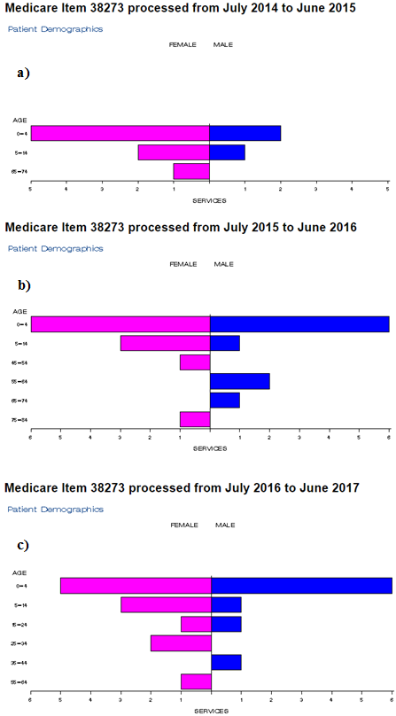
Figure 1: Demographic profile for MBS item 38273 for a) 2014-15 b) 2015-16 c) 2016-17
Source: Medicare Statistics Online

Co-claiming
Below is a snapshot of MBS items commonly claimed with item 38273 on the same day, performed on the same patient, by the same provider.
Table 4: Common MBS items co-claimed with item 38273 by financial year.
2014-15 | 2015-16 | 2016-17*
38273 | 38273 | 38273
38273, 116 | 38273, 110 | 38273, 116
38273, 116, 55115 | 38273, 116 | 38273, 110
38273, 116, 60012 | 38273, 110,55115 | 38273, 110, 116
38273, 116,38206,55115,60015 | 38273, 110,38218,59912,60015 | 38273, 110,119
Source: Department of Health, File: Q20801a
*= 2016-17 year is from 1 Jul 2016 to 31 Mar 2017, processed until 31 May 2017.

Background
MBS item 38273 for the transcatheter closure of a patent ductus arteriosus was listed on the MBS on 1 July 2014.
In September 2012, the Department of Health and Ageing received an application from the Cardiac Society of Australia and New Zealand requesting MBS funding for the transcatheter closure of a patent ductus arteriosus (PDA).
Transcatheter closure of PDA is proposed as a direct substitute for surgical closure of PDA.
MSAC’s role was to assess the safety, effectiveness and efficacy, cost-effectiveness of the transcatheter method for the PDA closure. MSAC would also consider the wording of the MBS item descriptor, the MBS fee and the financial implications of publicly funding this procedure.
The applicant indicated that the technique involved in the procedure and the devices utilised most closely resemble MBS item 38272 transcatheter closure of atrial septal defect (ASD).
At the time of this application’s consideration, transcatheter closure of PDA was already available through the public healthcare system. It was anticipated that there will be no potential advantages (or disadvantages) to consumers should the procedure be explicitly funded under the MBS given it is a procedure that requires the proximity of cardiothoracic surgical backup in the event of complications.
The MSAC supported the listing of the service onto the MBS at its August 2013 meeting.

Item descriptor
38273 | Patent ductus arteriosus, transcatheter closure of, including cardiac catheterisation and any imaging associated with the service (Anaes.) (Assist.)  Fee: $912.30 Benefit: 75% = $684.25

Applicant’s comments on MSAC’s public summary document
The department received no comments from the applicant in the PSD.

Further information on MSAC
MSAC Terms of Reference and other information are available on the MSAC Website at: www.msac.gov.au.

