Economic Evaluation of BRCA mutations Testing of Affected Individuals and Cascade Testing

Background
MSAC considered the application for genetic testing of hereditary mutations predisposing to breast and/or ovarian cancer under the clinical utility card (CUC) approach supported at the July 2015 MSAC meeting. The CUC approach allows for the assessment of the clinical utility of testing of multiple genes known to produce defined clinical outcomes rather than single genes. The application first considered testing of individuals affected by breast and/or ovarian cancer for genes known to predispose to these conditions. The application also included cascade testing of family members of the subset of affected individuals who are shown to test positive for a hereditary mutation. The clinical validity and clinical utility assessment in the current application focussed on the testing of BRCA mutations. Section 6 of the CUC presented an economic evaluation of BRCA mutations testing with two separate Markov models of genetic testing in breast cancer versus usual care in:
- clinically affected individuals who have an early breast cancer diagnosis and also meet the phenome as described in Section 1.5 of the CUC; and
- family members of affected individuals who tested positive for a BRCA1 or BRCA2 mutation.
MSAC considered the results of the cost-utility analyses and noted that they were high with an incremental cost-effectiveness ratio (ICER) per quality-adjusted life-years (QALYs) gained of $151,837 and $85,598 for affected individuals and family members, respectively. MSAC considered that these ICER/QALY estimates may not be representative of the cost utility of publicly funding this test, noting that they do not match others quoted in the literature.
ESC viewed the economic evaluation as preliminary and advised that there were a range of methodological issues that needed to be addressed before the analysis was suitable for MSAC consideration, and before the generalizable approach could be finalised. Key issues included:
- The use of a weighted average approach to modelling the ICER for the entire eligible population (including both affected individuals and family members). ESC requested that additional modelling be undertaken based on an integrated model including both populations to derive an alternative ICER;
- Use of expert opinion as the basis of key inputs to the model (e.g. rate of use of different treatment modalities for breast cancer; number of family members tested per affected individual);
- Potential oversimplification which excluded key benefits and behaviours (e.g., differences in surveillance across arms in the model; the risk/impact of ovarian cancer - in individuals affected with breast cancer, and in the family members of probands identified with ovarian cancer).
- ESC advised that the ICERs derived from the model were highly uncertain and likely overestimated, noting that while the modelled ICERs indicated that testing would not be cost effective in either population, the sensitivity analyses indicated potential for the ICERs and/or the weighted ICER to become cost effective when the modelling was based on age-related relative risk.
Genetics Testing Economics Working Group required a new economic evaluation that addresses above limitations. The new economic analysis will be incorporated into the CUC proforma.

Overview of the new economic evaluation
The presented economic evaluation is intended to assess the cost-effectiveness of BRCA1/BRCA2 mutation testing of affected individuals and the family members of the affected individuals who test positive (cascade testing). An integrated Markov model was structured using TreeAge Pro (2015 v 2.2) to compare the costs and effects of genetic testing versus no genetic testing for the following cohorts:
- Clinically affected individuals (referred to as affected individuals herein). An affected individual is defined in the CUC as “a patient with breast and/or ovarian cancer whose personal or family history of cancer using a mutation prediction score predicts a combined mutation carrier probability of >10%”. Affected individuals who test positive for BRCA1 or BRCA2 mutation (i.e., mutation carrier) is referred to as a proband.
- First degree family members of the proband (i.e., siblings and children).
Only female affected individuals and their female family members will be considered in the model because breast cancer is more common in females. In addition, females have clinical utility from testing; which means they can undertake preventative strategies (e.g., breast and/or ovarian surgery) to reduce their future risk of developing breast and/or ovarian cancer.
Starting age of affected individuals and proband’s female siblings is 40 years, whereas the starting age of proband’s female children is assumed to be 10 years. The model assumes that proband and proband’s siblings will act within one year of learning that they carry a BRCA mutation and undertake a preventative; however, proband’s female children will not be tested until the age of 20 years and they will not undertake a surgical intervention until the age of 30 years.
The model has a cycle length of one year and a lifetime horizon (until the age of 90 years). An annual discount rate of 5% is applied to QALYs, costs and life-years, but not to cancer events. The model estimates the incremental cost per: QALY gained, life-years gained, breast cancer case avoided, and per ovarian cancer case avoided. It also provides Markov traces for key clinical outcomes including survival, cumulative breast cancer risk and cumulative ovarian cancer risk, in each cohort. Sensitivity analyses are performed to test the impact of altering assumptions and input parameters on overall results of the economic evaluation. Table 2.1 summarises key structural assumptions in the new model.
Table 2.1: Summary of the model structure
Model type | Markov cohort
Cohorts | - Female affected individuals  - Proband’s female siblings  - Proband’s female children
Start Age | - Female affected individuals : 40 years  - Proband’s female siblings : 40 years  - Proband’s female children :10 years
Time horizon | Lifetime (Age = 90 years)
Cycle length | 1 year
Discount rate | 5% for costs, QALYs, and life-years gained, but not for cancer events
Outcomes | Total cost, QALYs gained, Life-years gained, breast cancer events, ovarian cancer events
QALY = quality-adjusted life-year

Key differences between the presented model and the previous model
The presented model addresses the concerns around the previous economic evaluation in Section 6 of the CUC document, particularly:

Structural issues
- This model evaluates the costs and consequences of BRCA mutation testing for both affected individuals and proband’s family members simultaneously (i.e., in one model). This integrated modelling is necessary to reflect the cascading in effects and costs when an affected individual is tested positive for the mutation. The estimated ICER is for the whole model and not a weighted average of ICERs. (NB: The previous model incorrectly calculated a weighted average ICER by weighting each ICER rather than weighting the incremental costs, weighting the incremental QALYs and then calculating the ICER).
- For cascade analysis, this model considers first degree female family members (children and siblings) of probands in the base-case and the second degree relatives (female children of positively tested male and female siblings) in a scenario analysis.
- The present model includes the risk of developing ovarian cancer and captures the costs and outcomes of this condition (including disutility). BRCA mutation carriers have increased risk of ovarian cancer compared with the general population.
- In addition to costs and QALYs, the present model reports clinically relevant outcomes that are useful for model validation and clinical practice such as life-years gained, breast cancer events, and ovarian cancer events. Further, the model presents Markov traces of the included cohorts for overall survival, cumulative breast cancer risk over age, and cumulative ovarian cancer risk over age.
- This model considers real-life decision scenarios. For instance, the model assumes that probands and their siblings who test positive will make a decision to undertake preventative measures within one year after they learn the results of their test, whereas, probands’ children will not undertake genetic testing and preventative measures until they are 20 and 30 years old, respectively.

Input parameters
- The model used most of the input parameters advised by the working group in terms of probabilities, costs and utilities (Table 3). However, some inputs were added or modified to improve the model.
- Unlike the previous model, this model does not use a fixed relative risk to the population incidence because a BRCA mutation is likely to increase the risk of breast and ovarian cancers at an earlier age compared to the general population. The present model uses the age-specific incidence of both breast and ovarian cancers reported in Antoniou et al. 2003 (Antoniou, Pharoah et al. 2003). Although these estimates represent incidence from England and Wales and may not be representative of the Australian population, the cumulative incidence in that study was confirmed in a meta-analysis by Chen and Parmigiani (Chen and Parmigiani 2007) and an Australian study by Suthers 2007 (Suthers 2007). Among carriers of BRCA1 or BRCA2 mutations, the cumulative lifetime risk of developing breast cancer is 50–60% and the equivalent risk of ovarian cancer is 20–40%. The impact of using an age-specific incidence versus a fixed relative risk is tested in a sensitivity analysis.
- Instead of adopting the cancer risk from BRCA1 mutation only, the present model considers the lower risk with BRCA2 mutation and uses the weighted average risk based on 54% and 46% prevalence for BRCA1 and BRCA2, respectively (Collins, Milne et al. 2013).
- In its base-case, the present model adopts the utilisation of preventative strategies proposed by the working group, which is 40%, 40%, 20% for mastectomy with salpingo-oophorectomy (BSO), BSO alone, and surveillance, respectively. However, the model tests the possibility of choosing mastectomy alone as well as different uptake rates reported in the Australian study by Collins et al. 2013 (Collins, Milne et al. 2013).

Model structure
The model starts with a decision tree where affected individuals will be either tested for a BRCA mutation (intervention group) or not tested (comparator group). Those tested will incur the cost of the test and the additional cost of confirmatory test and genetic counselling if the test is positive. The model assumes that 15% of affected individuals will test positive for a BRCA1 or BRCA2 mutation. Individuals who test positive (probands) will prompt the cascade of testing whereby their first degree female relatives (siblings and children) will be also tested. For the comparator arm, there will be no testing of BRCA mutation; however, the model considers the consequences of not testing (i.e., not knowing BRCA mutation status) which is manifested in an increased risk of developing breast or ovarian cancer in BRCA mutation carriers. Figure 4.1 illustrates the general structure of the model.
Figure 4.1: General structure of the economic model
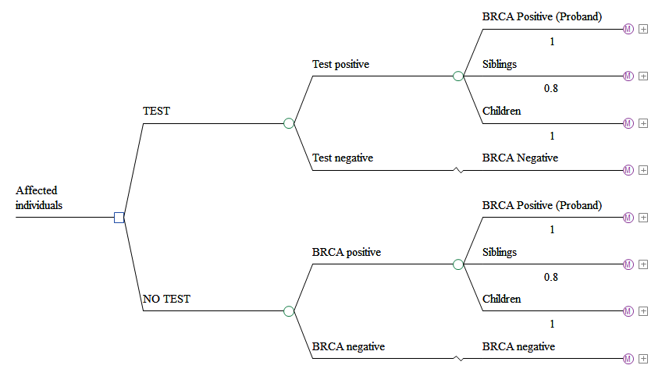The model assumes that first generation household has 2.6 children (proband and siblings), based on the data from Australian Institute of Family Studies (Hayes, Weston et al. 2010). This means that the number of siblings at risk of a BRCA mutation is 1.6 (0.8 female and 0.8 male siblings). Assuming that the modern Australian household has an average of 2 children, the proband will have 2 children at risk (1 male child at and 1 female child). Thus, in the base- case analysis and for each proband, 0.8 female siblings and 1 female child will be tested for BRCA mutation. Of note, the mothers of affected individuals were excluded since at an age of >65 years on average, there is little utility of genetic testing to prevent future cancer. Figure 4.2 shows probands’ family members who are at risk of BRCA mutation.
Figure 4.2: Proband’s family members included in the model 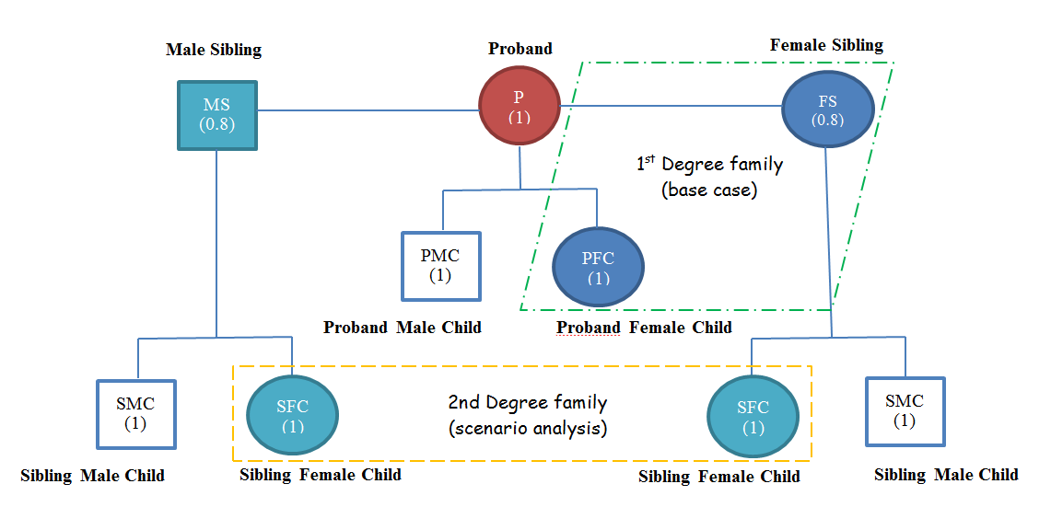Square = male; Circle = female.
*Male siblings will not be included in the model but the cost of testing them will be included in the scenario analysis to inform the need to test their children.
In a scenario analysis the second degree family members (female children of siblings who test positive) are also considered. The chance of a proband’s sibling testing positive for BRCA1 or BRCA2 is 50% which means that 0.8 siblings (of 1.6) will test positive. With an average of 2 children per sibling, the number of second degree females at risk is 0.8 (i.e. 1.6 siblings and 50% will inherit the BRAC mutation = 0.8 siblings; with 2 children each = 1.6 children of which 50% are female = 0.8 children). Table 4.1 describes the number of family members to be tested for each proband.
Table 4.1: Number of family members included in the model
Proband’s first degree family members (base-case) | Number | Number to be tested
Proband’s children | 2 | 1 female
Proband’s siblings | 1.6 | 0.8 Female
Proband’s first and second degree family members (scenario analysis) | Number | Number to be tested
Proband’s children | 2 | 1 female
Proband’s siblings | 1.6 | 1.6ª
Children of BRCA positive siblings | 1.6 | 0.8 female
ª Male siblings will be tested to inform the need to test their children (i.e., children of BRCA positive siblings)
Proband’s first degree family members (base-case)
Each cohort (proband, proband’s female siblings, and proband’s female children) is followed using Markov modelling as described below:

4.1 Affected individuals who test positive (probands)
Probands start the model with an average age of 40 years. The model assumes that probands will make a decision on a strategy to reduce the risk of future cancer (contralateral breast or ovarian cancer) shortly (within one year) after they know that they carry a BRCA mutation. It is unlikely for those individuals to delay their decisions because at the age of 40 they have increased risk of cancer relative to normal population, and they have probably completed their families. Probands will choose one of the mutually exclusive interventions (and the respective costs accumulate in the model) of: contralateral mastectomy (CM) alone (i.e., surgery on the opposite breast to the one previously affected), BSO alone, CM plus BSO, or surveillance. Probands will move to a post-intervention health state (i.e., post-CM, post-CM+BSO, post-BSO, or surveillance) where they may die of any cause, stay alive in that health state (with the same utility of normal population) or develop either contralateral breast cancer or ovarian cancer. The risk of developing cancer depends on the age of the proband and the effect (i.e., cancer risk reduction) of the chosen intervention. The model assumes that individuals may develop one type of cancer (either ovarian or breast). Those who develop cancer may die of that cancer or remain in the relevant cancer health state (breast cancer or ovarian cancer). They will incur the cost of cancer treatment and experience reduced health-related quality-of-life. Probands who remain alive in the cancer health states for five years are considered cured and will move to the Cured health state where they will have mortality rate similar to the normal population. Figure 4.1.1 illustrates the flow of probands through the model.
Figure 4.1.1: Affected individuals who test positive (probands)
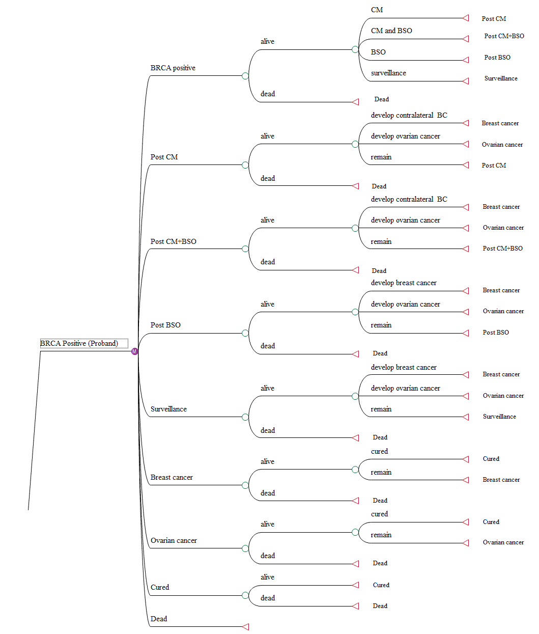 CM = contralateral mastectomy, BSO = salpingo-oophorectomy, BC = breast cancer

4.2 Proband’s female siblings
The female siblings of a proband will be tested. Those who test negative (50% of siblings) will go to BRCA negative health state where they will have similar mortality and risk of cancer to the normal population. Similar to probands, with an average age of 40 years, the model assumes that siblings who test positive will also have an immediate action to prevent future cancer. The preventative strategies for female siblings include bilateral mastectomy (BM) alone, BSO alone, BM plus BSO alone, or surveillance. Siblings will move to the post-intervention health state where they may die of any cause, stay alive or develop breast cancer or ovarian cancer. The risk of developing cancer depends on the intervention selected and the age of the sibling. Individuals who develop cancer will go to either breast cancer or ovarian cancer health state where they may die of cancer or stay alive before they move after five years to the cured health state. Figure 4.2.1 describes the progress of proband’s female siblings in the model.
Figure 4.2.1: Proband’s female siblings
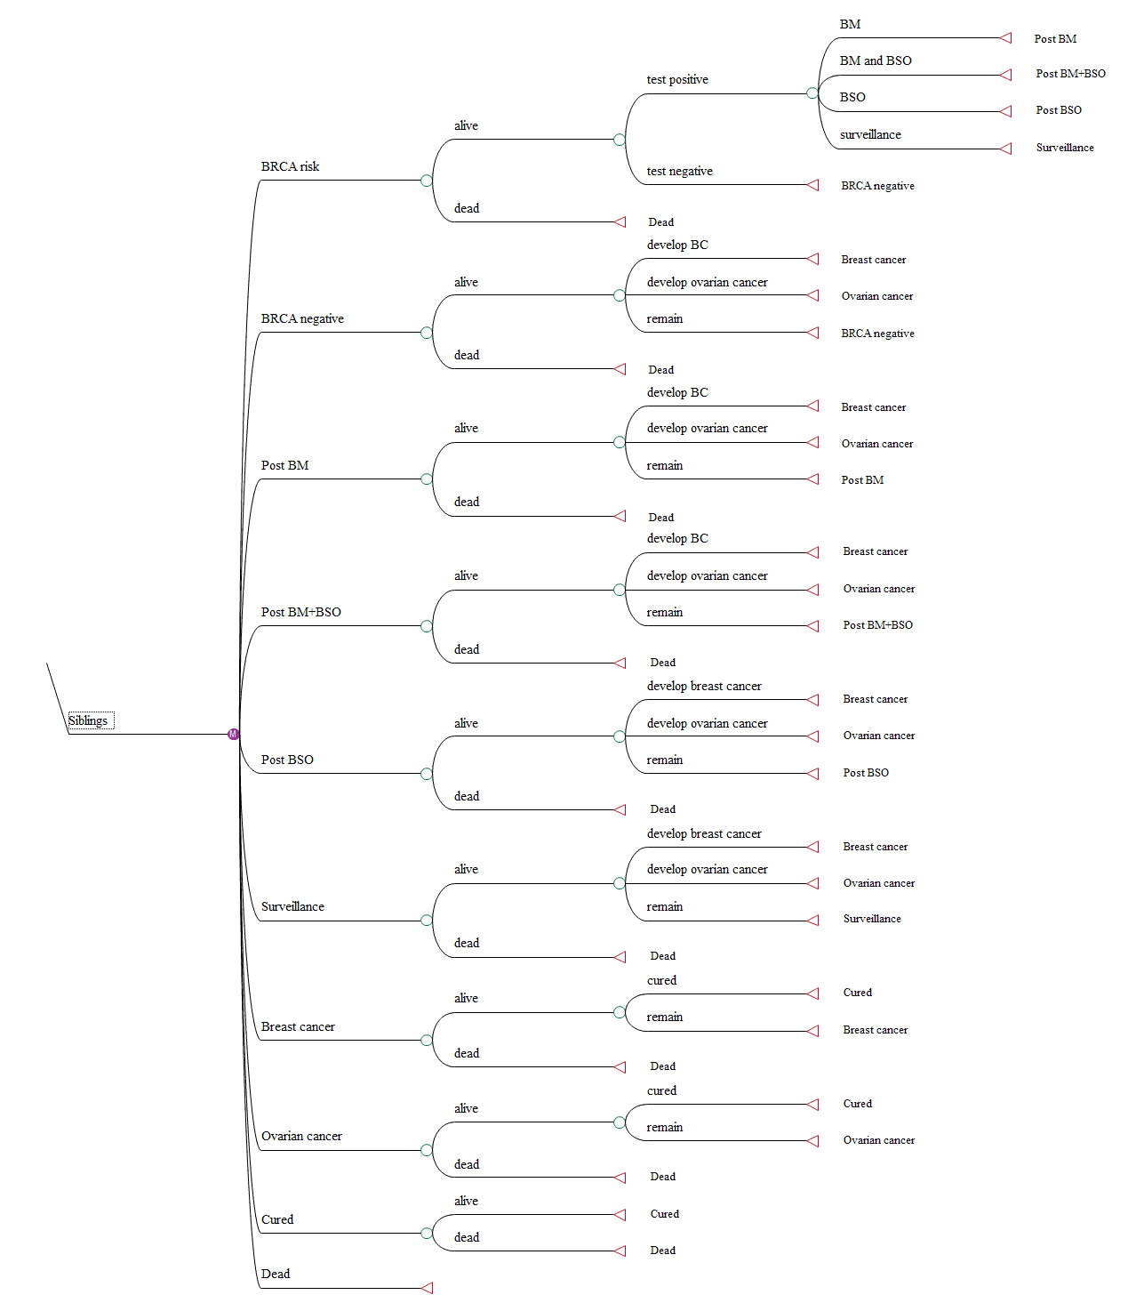
CM = contralateral mastectomy, BSO = salpingo-oophorectomy, BC = breast cancer

4.3 Proband’s female children
The average age of mothers giving birth (i.e., childbearing) in Australia is 30 years, and therefore the model assumes that for 40 years old probands the average age of their children is 10 years (Hayes, Weston et al. 2010). To reflect real-life decisions, female children will remain in the BRCA risk health state until they reach the age of 20 years when they can be tested. Those who test negative (50% of children) will go to the BRCA negative health state where they will have similar mortality and risk of cancer to the normal population. Those who test positive will not take an immediate decision to undertake a preventative strategy because the risk of developing cancer at the age of 20 is small, and they may wish to have their own children before undergoing any risk reducing surgery. Thus, children who carry the mutation will stay in the BRCA positive health state until the age of 30 years when they may act on cancer risk reduction. During this time, the model assumes that those individuals may opt for close follow-up (i.e., surveillance) until they undergo surgery. The preventive strategies include, BM alone, BSO alone, BM with BSO, or surveillance. Modelled children will move to a post-intervention health state where they may die of any cause, stay alive or develop breast or ovarian cancer. The risk of developing cancer is also age and intervention dependent. Figure 4.3.1 illustrates the progress of proband’s female siblings in the model.
Figure 4.3.1: Proband’s female children
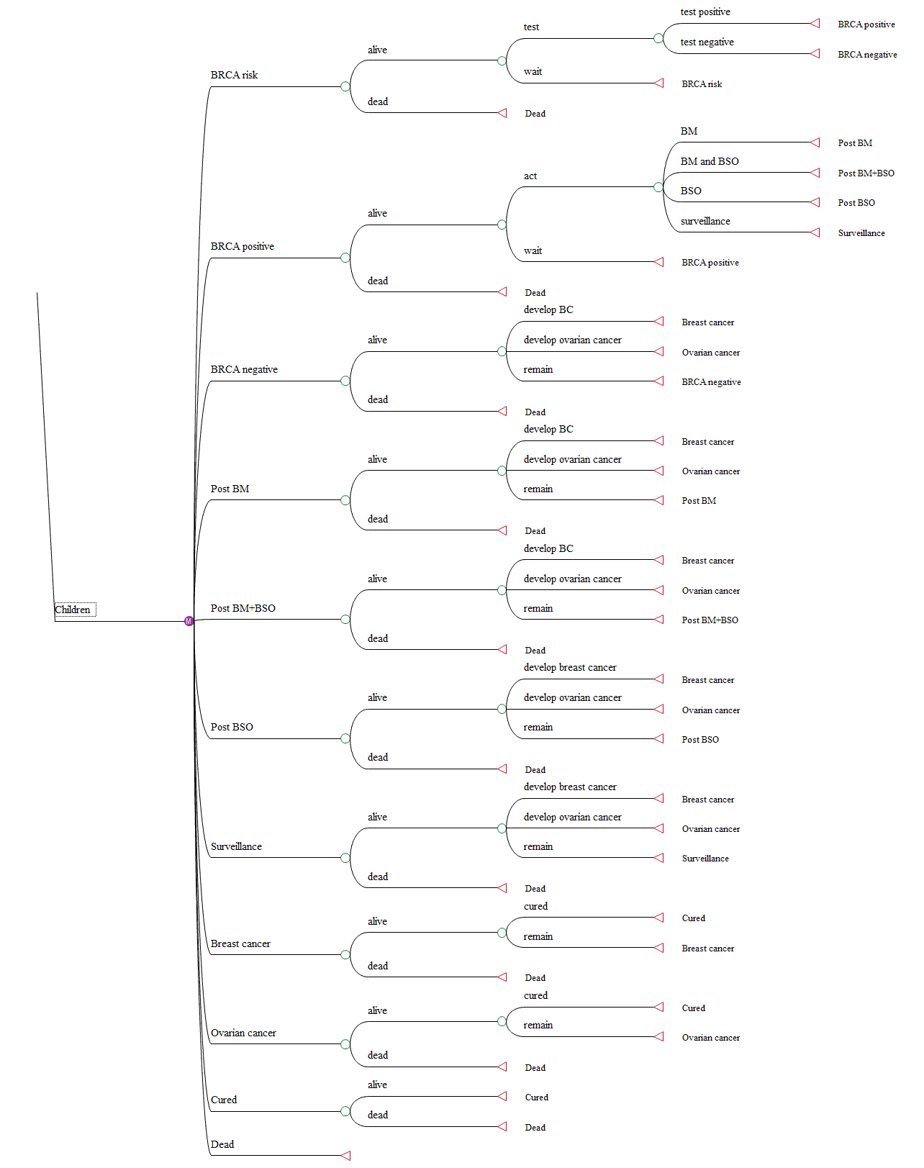
CM = contralateral mastectomy, BSO = salpingo-oophorectomy, BC = breast cancer

Input parameters
Table 5.1 summarises the input parameters in the model.

Table 5.1: Input parameters used in the model
Probabilities
Variable | Value | Source
Probability of BRCA1 or BRCA2 mutation positive | Affected individual: 15% | Advice from working group  Sensitivity analysis for affected individual: 10-20%
Probability of BRCA1 or BRCA2 mutation positive | Family members: 50% | Advice from working group  Sensitivity analysis for affected individual: 10-20%
Proportion to undergo BSO only if BRCA1 or BRCA2 positive | Affected individuals and family members: 40% | Advice from working group  Sensitivity analysis: 52% (Collins, Milne et al. 2013)
Proportion to undergo mastectomy with BSO if BRCA1 or BRCA2 positive | Affected individuals and family members: 40% | Advice from working group  Sensitivity analysis: 16% (Collins, Milne et al. 2013)
Proportion to undergo mastectomy alone if BRCA1 or BRCA2 positive | Affected individuals and family members: 0% | Advice from working group  Sensitivity analysis: 28% (Collins, Milne et al. 2013)
Population risk of new incidence of breast cancer | Age dependent, see Table 4 | AIHW Breast cancer overview 2012 (AIHW 2012)
Risk of new incidence of breast cancer if BRCA1 or BRCA2 positive | Affected individual: 1.7% (15- year risk is 22.6%) | CUC Section 2.2.2 and (Rhiem, Engel et al. 2012); the 15-year risk of breast cancer in BRCA positive affected individuals with age at 1st cancer diagnosis between 40 to 49 years is 23.2% for BRCA1 and 22% for BRCA 2. The weighted average risk (assuming 54% BRCA1 and 46% BRCA2 is 22.6%. If the age at diagnosis is <40 years old is 40.8% for BRCA1 and 20.9% for BRCA 2, the weighted average risk is 31%.
Risk of new incidence of breast cancer if BRCA1 or BRCA2 positive | Family members: Age dependent, see Table 5.1 | Age dependent; The age-specific of breast cancer in BRCA1 or BRCA1 mutation carriers was based on 65% or 45% penetrance respectively by age 70 (Antoniou, Pharoah et al. 2003). Weighted average is 55%.
Population risk of new incidence of ovarian cancer | Age dependent, see Table 5.2 | AIHW Ovarian cancer overview 2010 (AIHW 2010)
Risk of new incidence of ovarian cancer if BRCA1 or BRCA2 positive | Age dependent, see Table 5.2 | The age-specific ‘inherited risk’ of ovarian cancer in mutation-carriers was based on 39% or 11% penetrance for BRCA1 or BRAC2 respectively by age 70 (Antoniou 2003). Weighted average is 25%.
Ovarian cancer risk reduction with BSO only | 80% reduction | CUC Section 3.2
Breast cancer risk reduction with BSO only | 50% reduction | CUC Section 3.2
Ovarian cancer risk reduction with mastectomy only | 90% | CUC and (Collins, Milne et al. 2013)
Breast cancer risk reduction with mastectomy only | 0% reduction | (Collins, Milne et al. 2013)
Ovarian and breast cancer reduction with mastectomy+BSO | 90% reduction | CUC Section 3.2
Cancer risk reduction with surveillance | 0% reduction | Assumption
Mortality of breast cancer | Five-year survival is 90% (annual mortality = 2.1%) | AIHW Breast cancer overview 2012 (AIHW 2012)
Mortality of ovarian cancer | Five-year survival 43% (annual mortality = 15%) | AIHW Ovarian cancer overview 2010 (AIHW 2010)
Utility values
Utility for no breast cancer | 1.0 | Utility for no breast cancer
Utility for breast cancer | 0.80 | Based on Manchanda 2015 (Manchanda, Legood et al. 2015)
Utility of ovarian cancer | 0.63 | Based on Manchanda 2015: 70% advance disease with utility= 0.55 and 30% of early stage utility = 0.81; weighted average = 0.63 (Manchanda, Legood et al. 2015)
Utility for death | 0.0 | Assumption
Disutility from BSO | 0.0 | Assumption – whilst there may be initial disutility from surgeries the long term effects on utility is uncertain.
Disutility from mastectomy | 0.0 | Assumption – whilst there may be initial disutility from surgeries the long term effects on utility is uncertain.
Costs
Cost of BRCA test | Affected individuals: initial = $1,500  Confirmatory = $350 (only in those testing positive)  Family members: $350 | Costs provided by the RCPA. RCPA also suggested a profit margin of 10-15%. A margin of 15% was assumed in the base case, resulting in costs of $1,725 for initial and $402.50 for confirmatory and family testing.  Sensitivity: assume a 10% margin, resulting in costs of $1,650 for initial and $385 for confirmatory and family testing.
Cost of genetic counselling | $263.90 | MBS item 132, on advice from working group. Sensitivity: MBS item 133 with a cost of $132.10
Cost of Breast Cancer Treatment | Year 1: $24,510.10  Years 2-5: $175.50 | Review of interim funded service: Breast MRI MSAC application no 1098.1, February 2014.
Cost of ovarian Cancer Treatment | Year1: $20,000  Year 2-5: $5,000 | Lifetime cost is around $40,000 (adjusted for 2016); $20,000 first year and $5,000 in each following year for five years (Gordon, Scuffham et al. 2010)
Cost of BSO | $8,621 | Weighted value of AR-DRG N05A and N05B by number of separations in Round 17 of National Hospital Cost Data Collection.
Cost of contralateral mastectomy | $8,747 | AR-DRG J06B in Round 17 of National Hospital Cost Data Collection.
Cost of bilateral mastectomy | $15,586 | Estimated by adding total average cost of one separation of AR-DRG J06B (as for contralateral mastectomy) and the average direct cost of one separation of AR-DRG J06B (to reflect mastectomy of second breast) from Round 17 of National Hospital Cost Data Collection.
BSO = salpingo-oophorectomy, CUC = Clinical Utility Card, RCPA = the Royal College of Pathologists of Australia,
The model uses the age-specific incidence of both breast and ovarian cancers reported in Antoniou 2003 (Antoniou, Pharoah et al. 2003). Although these estimates represent incidence from England and Wales and may not be representative of the Australian population, the cumulative incidence in that study was confirmed in a meta-analysis by Chen and Parmigiani (Chen and Parmigiani 2007) and an Australian study (Suthers 2007). Among carriers of BRCA1 or BRCA2 mutations, the cumulative lifetime risk of developing breast cancer is 50–60% and the equivalent risk of ovarian cancer is 20–40%. The impact of using an age-specific incidence versus a fixed relative risk is tested in a sensitivity analysis.
Table 5.1 shows the age specific incidence of breast cancer in the general population and in family members who are BRCA positive.

Table 5.1: Age-dependent breast cancer risk in family members
Age | Population risk of breast cancerª | BRCA positive family members (Antoniou, Pharoah et al. 2003) | BRCA positive family members (6.3 fixed relative risk)^{b}
20 | 0.000013 | 0.0002 | 0.0000832
25 | 0.000083 | 0.001146 | 0.0005312
30 | 0.000274 | 0.005647 | 0.0017536
35 | 0.000605 | 0.012164 | 0.003872
40 | 0.001229 | 0.019929 | 0.0078656
45 | 0.001989 | 0.028687 | 0.0127296
50 | 0.002429 | 0.023035 | 0.0155456
55 | 0.00262 | 0.027836 | 0.016768
60 | 0.003456 | 0.031005 | 0.0221184
65 | 0.0037 | 0.029828 | 0.02368
70 | 0.003175 | 0.03029 | 0.026
75 | 0.002894 | 0.028451 | 0.02845102
ª AIHW Breast cancer overview 2012 (AIHW 2012)
^{b} Based on cumulative lifetime risk of 60% for BRCA1 mutation compared with 9.3% for Australian population
Table 5.2 presents age-specific ovarian cancer incidence probands and family members who are BRCA positive

Table 5.2: Age-dependent ovarian cancer risk in family members
Age | Population risk of ovarian cancerª | BRCA mutation carriers (Antoniou, Pharoah et al. 2003)
20 | 0 | 0.0011
25 | 0.000008 | 0.001208
30 | 0.000016 | 0.002047
35 | 0.000043 | 0.002932
40 | 0.00006 | 0.004979
45 | 0.000126 | 0.008542
50 | 0.000153 | 0.008649
55 | 0.000239 | 0.012789
60 | 0.000298 | 0.012474
65 | 0.000295 | 0.016037
70 | 0.000361 | 0.020754
75 | 0.000448 | 0.0011
ª AIHW Breast cancer overview 2010 (AIHW 2010)
The base-case analysis considered the uptake rate of preventative strategies advised by the working group as 40%, 40%, 20% for mastectomy plus BSO, BSO alone, or surveillance, respectively. However, some individuals may prefer to have mastectomy alone in order to preserve fertility or hormonal regulation to avoid surgically induced menopause. An Australian study by Collins et al. 2013 on 325 women with BRCA mutations showed that 242 women opted for either mastectomy alone, BSO alone, mastectomy plus BSO, or a non-surgical intervention (Collins, Milne et al. 2013). The remainder (83 individuals) opted for tubal ligation, which is outside of the preventative strategies in the CUC. Of the 242 women who opted for interventions that are in line with the CUC recommendations, 69 (28%) underwent mastectomy alone, 125 (52%) had BSO alone, and only 38 (16%) went for mastectomy plus BSO. These percentages are used in a sensitivity analysis.
The model assumes that the disutility from mastectomy or BSO may be offset by the utility from the assurance these procedures provide by lowering cancer risk.
Continuous surveillance is considered part of the management of affected individuals. Surveillance may be taken by family members as part of Breast Screening program and it is assumed therefore that it does not represent a cost-offset (cost of $0 in the base-case). However, the model assumes that proband’s children who test positive may prefer to have closer monitoring until they act and undertake a preventative intervention. Close surveillance may also be an option for family members who opt for BSO alone as well as for family members of affected individuals who are not tested (in the comparator arm). Thus, a cost of $90 for mammography (MBS item 59300) is applied to surveillance in those subgroups in a sensitivity analysis.

Results of the economic evaluation

Base-case analysis
The base-case analysis includes testing affected individuals and proband’s first degree family members (i.e., female siblings and female children) with the assumptions listed in Table 2.1: start age of 40 years for affected individuals and proband’s siblings, 10 years for proband’s children, discount rate 5% for QALY’s and life-years gained but not for cancer events. Table 6.1 summarises the incremental costs and effects of genetic testing in the base-case analysis where the affected individuals, proband’s female siblings and female children are included.
Table 6: Results of affected individuals + proband’s female siblings + proband’s female children
 | Genetic Test | No testing | Increment | Incremental Cost/Effect
Cost | $7,788 | $4,318 | $3,470 | -
QALYs | 22.45 | 22.26 | 0.19 | $18,283/QALY gained
Life-years | 22.56 | 22.41 | 0.14 | $23,971/ Life-year gained
Breast cancer | 0.28 | 0.35 | -0.07 | $53,202/ breast cancer avoided
Ovarian cancer | 0.04 | 0.08 | -0.04 | $79,477/ ovarian cancer avoided
Breast cancer+ ovarian cancer | 0.32 | 0.43 | -0.11 | $32,000/cancer avoided
QALY = Quality-adjusted life-year
Genetic testing results in an incremental cost of around $3,500 and an additional 0.19 QALYs with an estimated ICER of around $18,000 per QALYs gained. Further, genetic testing reduces breast cancer and ovarian cancer events with around $53,000 per breast cancer event avoided and $80,000 per ovarian cancer event avoided, which is approximately $32,000 ($3,500/0.11) per cancer (breast or ovarian) event avoided. At a willingness-to-pay threshold of $50,000, genetic testing for BRCA mutation in affected individuals and proband’s first degree female family members is cost-effective compared with no testing.

Scenario analysis
Tables 6.2 to 6.5 summarise the results of the economic evaluation when various cohorts are included in the model
Table 6.2: Results of affected individuals only
 | Genetic Test | No testing | Increment | Incremental Cost/Effect
Cost | $6,012 | $3,397 | $2,614 | -
QALYs | 17.42 | 17.29 | 0.12 | $21,303/QALY gained
Life-years | 17.51 | 17.42 | 0.09 | $27,695/Life-year gained
Breast cancer | 0.22 | 0.25 | -0.03 | $85,533/ breast cancer avoided
Ovarian cancer | 0.03 | 0.05 | -0.03 | $100,160/ ovarian cancer avoided
Breast cancer+ ovarian cancer | 0.25 | 0.30 | -0.06 | $44,000/cancer avoided
QALY = Quality-adjusted life-year

Table 6.3: Results of affected individuals + proband’s female siblings
 | Genetic Test | No testing | increment | Incremental Cost/Effect
Cost | $7,230 | $4,080 | $3,150 | -
QALYs | 19.50 | 19.33 | 0.17 | $18,241/QALY gained
Life-years | 19.60 | 19.47 | 0.13 | $23,875/ Life-year gained
Breast cancer | 0.25 | 0.30 | -0.05 | $68,850/ breast cancer avoided
Ovarian cancer | 0.03 | 0.07 | -0.03 | $91,950/ ovarian cancer avoided
Breast cancer+ ovarian cancer | 0.28 | 0.37 | -0.08 | $39,000/cancer avoided
QALY = Quality-adjusted life-year
Table 6.4: Results of affected individuals + proband’s female children
 | Genetic Test | No testing | Increment | Incremental Cost/Effect
Cost | $6,570 | $3,636 | $2,934 | -
QALYs | 20.37 | 20.23 | 0.14 | $20,987/QALY gained
Life-years | 20.47 | 20.36 | 0.11 | $27,368/ Life-year gained
Breast cancer | 0.26 | 0.31 | -0.05 | $58,641/ breast cancer avoided
Ovarian cancer | 0.03 | 0.07 | -0.04 | $82,647/ ovarian cancer avoided
Breast cancer+ ovarian cancer | 0.29 | 0.38 | -0.09 | $34,000/cancer avoided
QALY = Quality-adjusted life-year
Table 6.5: Results of affected individuals + proband’s siblings (male and female)ª + proband’s female children + female children of siblings who test positive (first and second degree family members)
 | Genetic Test | No testing | Increment | Incremental Cost/Effect
Cost | $8,324 | $4,509 | $3,815 | -
QALYs | 24.81 | 24.61 | 0.20 | $18,752/QALY gained
Life-years | 24.92 | 24.77 | 0.16 | $24,613/ Life-year gained
Breast cancer | 0.31 | 0.39 | -0.08 | $47,219/ breast cancer avoided
Ovarian cancer | 0.05 | 0.1 | -0.05 | $74,545/ ovarian cancer avoided
Breast cancer+ ovarian cancer | 0.36 | 0.49 | -0.13 | $29,000/cancer avoided
QALY = Quality-adjusted life-year
ª Proband’s male siblings will not be included in the model but the cost of testing them will be included to inform the need to test their children.
Genetic testing is cost-effective for all groups (scenarios) including affected individuals alone or with cascading to include first and second degree family members.
Table 6.6 summarises the incremental costs and effects for the possible testing scenarios. That is, this table shows the additional costs, additional QALYs and ICER of adding each step of the cascade to the previous step of the cascade.
Table 6.6: Incremental costs and effects for testing various groups
 | Cost | QALY | Incremental cost | Incremental effect | ICER/QALY
Affected individuals only | $6,012 | 17.42 | - | - | -
Affected individuals + proband’s female siblings | $7,230 | 19.50 | $1,218 | 2.08 | $586
Affected individuals + proband’s female siblings+ proband’s female children | $7,788 | 22.45 | $558 | 2.95 | $189
Affected individuals + proband’s siblings (male and female) + proband’s female children + female children of siblings who test positive | $8,324 | 24.81 | $536 | 2.36 | $227
QALY = Quality-adjusted life-year; ICER = incremental cost-effectiveness ratio
Genetic testing of affected individuals plus proband’s first and second degree family members is the most cost-effective option since it provides an additional 2.36 QALYs at an incremental cost of $536 (ICER = $227/QALY) compared with testing affected individuals plus proband’s first degree female family members.
Table 6.7 summarises the results when a fixed relative risk factor of 6.3 is applied to the general female population breast cancer risk, instead of using age-specific estimates.
Table 6.7: Results of applying fixed relative risk factor of 6.3 to population risk of breast cancer
 | Genetic Test | No testing | Increment | Incremental Cost/Effect
Cost | $7,691 | $4,140 | $3,552 | -
QALYs | 22.46 | 22.27 | 0.19 | $19,046/QALY gained
Life-years | 22.56 | 22.42 | 0.14 | $24,641/ Life-year gained
Breast cancer | 0.27 | 0.33 | -0.06 | $61,790/ breast cancer avoided
Ovarian cancer | 0.04 | 0.08 | -0.04 | $71,000/ ovarian cancer avoided
Breast cancer+ ovarian cancer | 0.31 | 0.42 | -0.11 | $32,000/cancer avoided
QALY = Quality-adjusted life-year
The results of the evaluation are not sensitive to applying a fixed relative risk rate of 6.3 to the risk of breast cancer in the general female population in Australia.
Table 6.8 presents the results of applying preventative strategies uptake as reported in Collins 2013 (28% mastectomy alone, 52% BSO alone, 16% mastectomy plus BSO, and 4% surveillance) instead of 40% mastectomy plus BSO, 40% BSO alone, 20% surveillance in the base-case analysis (Collins, Milne et al. 2013).
Table 6.8: Results of applying preventative strategies uptake as in Collins 2013ª
 | Genetic Test | No testing | Increment | Incremental Cost/Effect
Cost | $7,725 | $4,318 | $3,450 | -
QALYs | 22.41 | 22.26 | 0.15 | $22,348/QALY gained
Life-years | 22.52 | 22.41 | 0.11 | $31,094/ Life-year gained
Breast cancer | 0.27 | 0.35 | -0.08 | $44,514/ breast cancer avoided
Ovarian cancer | 0.06 | 0.08 | -0.02 | $179,262/ ovarian cancer avoided
Breast cancer+ ovarian cancer | 0.33 | 0.43 | -0.10 | $34,500/cancer avoided
QALY = Quality-adjusted life-year
ª28% mastectomy alone, 52% BSO alone, 16% mastectomy plus BSO, and 4% surveillance
Genetic testing remains cost-effective compared with no testing when a different uptake of preventative strategies is applied. The reduction in BSO procedures (with reduced uptake of mastectomy plus BSO) results in lower effect on ovarian cancer events avoided (0.02 versus 0.04 in the base-case), and consequently an increased ICER.

Markov traces
Survival
Figure 6.9 illustrates the survival curves for probands (genetic Testing group) and affected individuals who are BRCA carriers (No Testing) compared with the general Australian female population.
Figure 6.9: Survival curve for probands with and without genetic testing
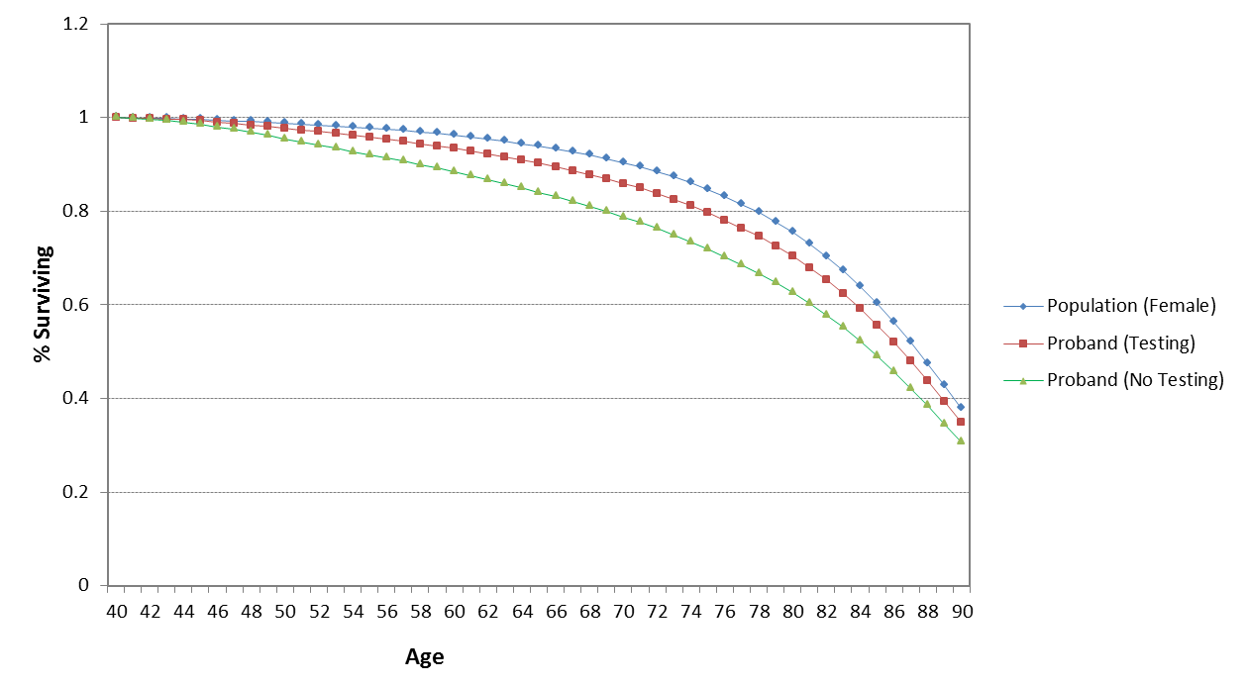
Figure 6.10 presents the survival curves for proband’s female siblings with or without genetic testing compared with the general population
Figure 6.10: Survival curves for proband’s female siblings with or without genetic testing
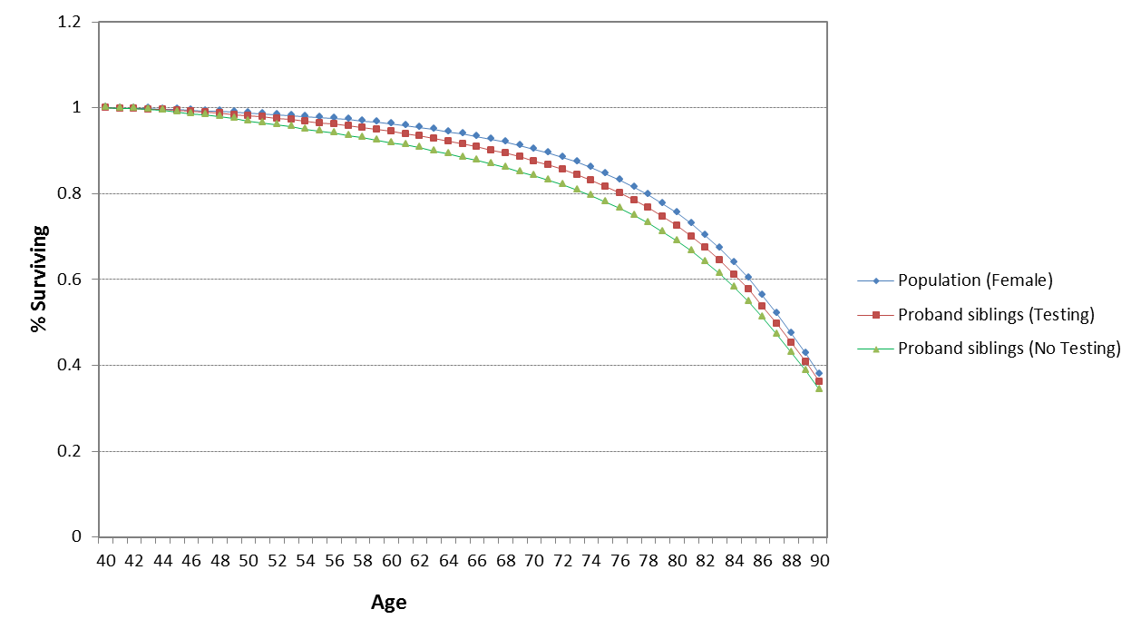
Figure 6.11 presents the survival curves for proband’s female children with or without genetic testing compared with the general population
Figure 6.11: Survival curves for proband’s female children with or without genetic testing
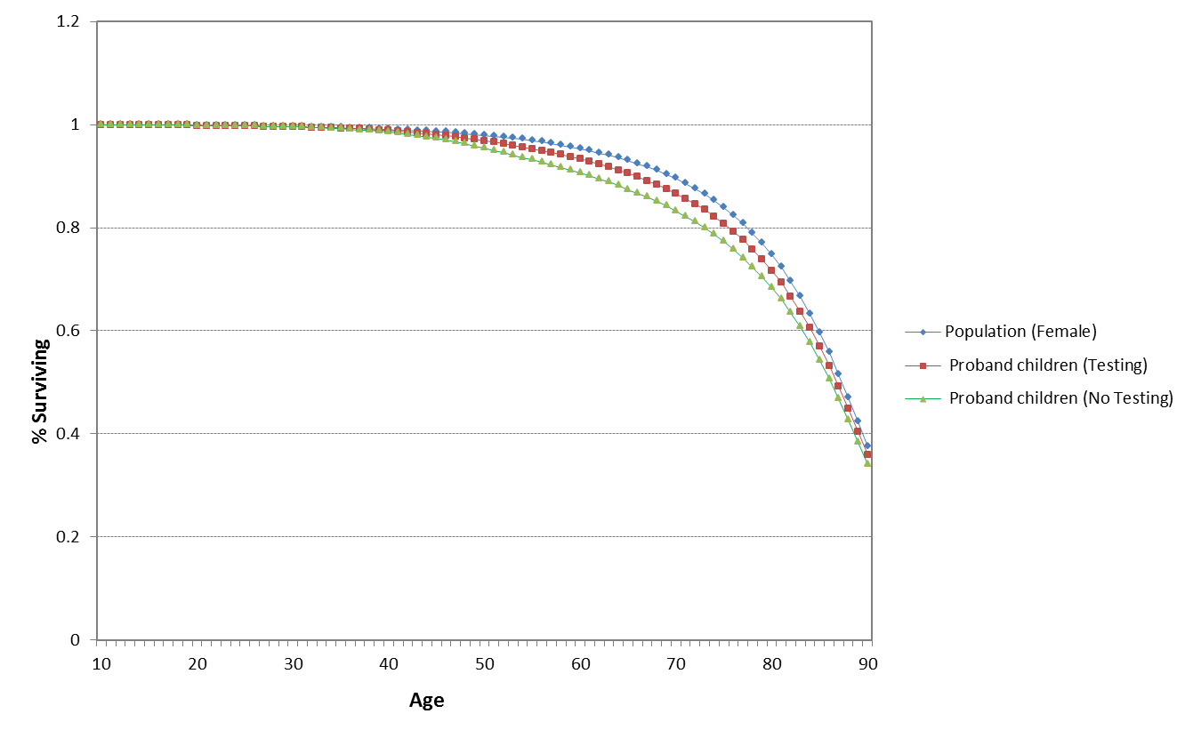
Probands and their family members have reduced survival compared to the general Australian population; however, probands and their family members who undertake genetic testing have improved survival compared with no testing.
Breast cancer
Figure 6.12 depicts the cumulative breast cancer risk in probands with and without genetic testing compared with the cumulative breast cancer risk in the general Australian female population.
Figure 6.12: Cumulative breast cancer risk in probands with and without genetic testing
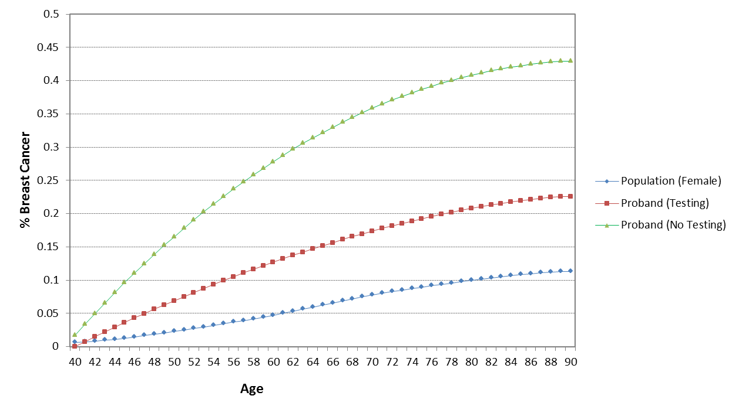
The 15-year cumulative breast cancer risk (Age 55) in probands ranges from 20% to 40%.
Figure 6.13 illustrates the cumulative breast cancer risk in proband’s female children (and female siblings) who carry BRCA mutation with and without genetic testing compared with the cumulative breast cancer risk in the general Australian female population.
Figure 6.13: Cumulative breast cancer risk in proband’s children who carry BRCA mutation with and without testing
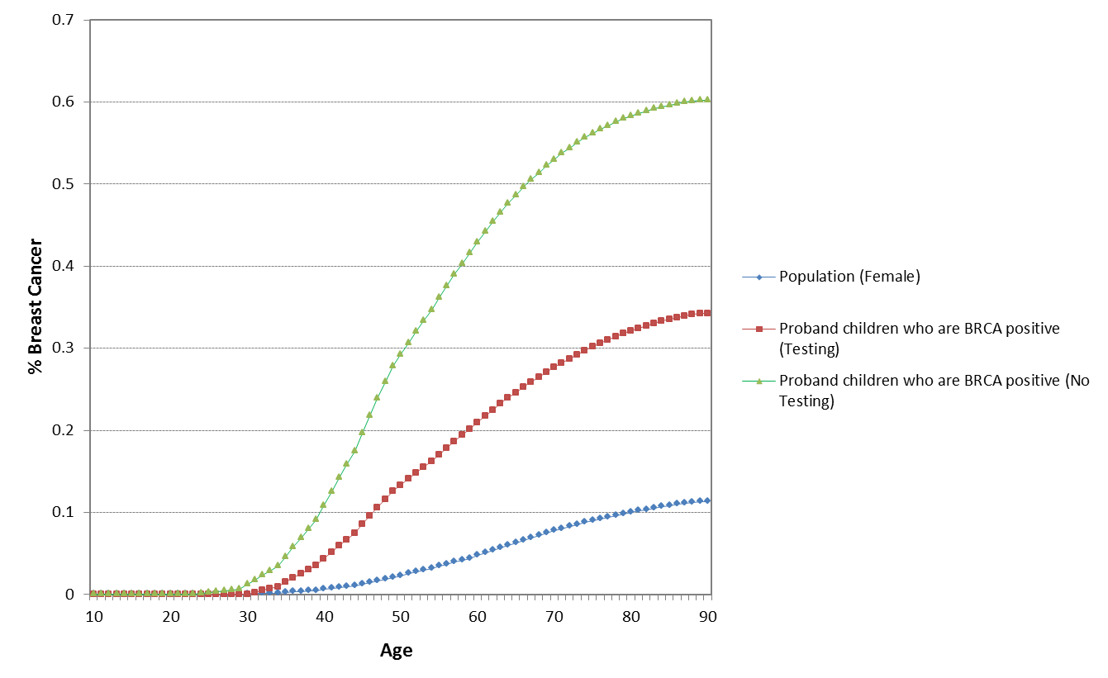
The cumulative risk of breast cancer in BRCA1 or BRCA2 positive proband’s female children (and female siblings) is 55% at the age of 70 years. With genetic testing, the cumulative incidence of breast cancer in this group is reduced to 30% at the age of 70 years.
Ovarian cancer
Figure 6.14 shows the cumulative ovarian cancer risk in probands with and without genetic testing compared with the cumulative ovarian cancer risk in the general Australian female population.
Figure 6.14: Cumulative ovarian cancer risk in probands with and without genetic testing
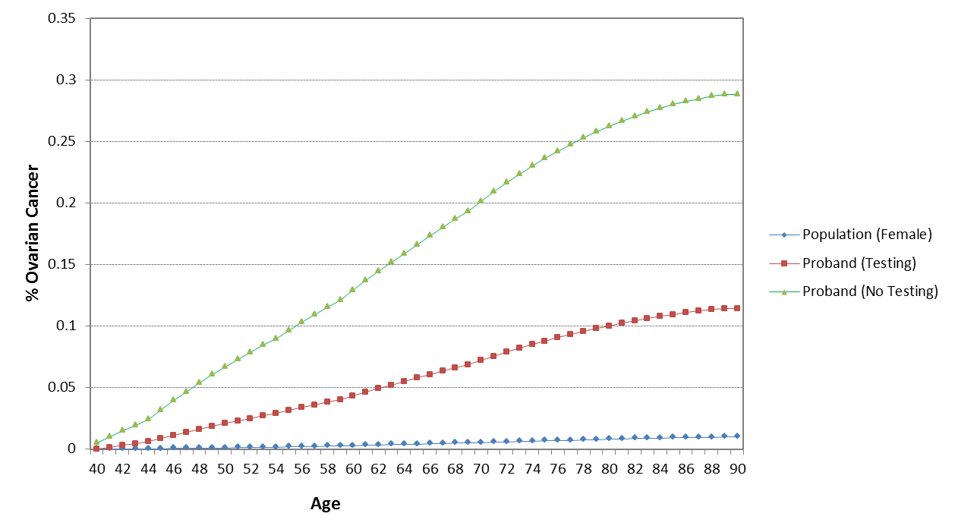
Figure 6.15 illustrates the cumulative ovarian cancer risk in proband’s female children (and female siblings) who carry BRCA mutation with and without genetic testing compared with the cumulative ovarian cancer risk in the general Australian female population.

Figure 12: Cumulative ovarian cancer risk in proband’s children who carry BRCA mutation with and without testing
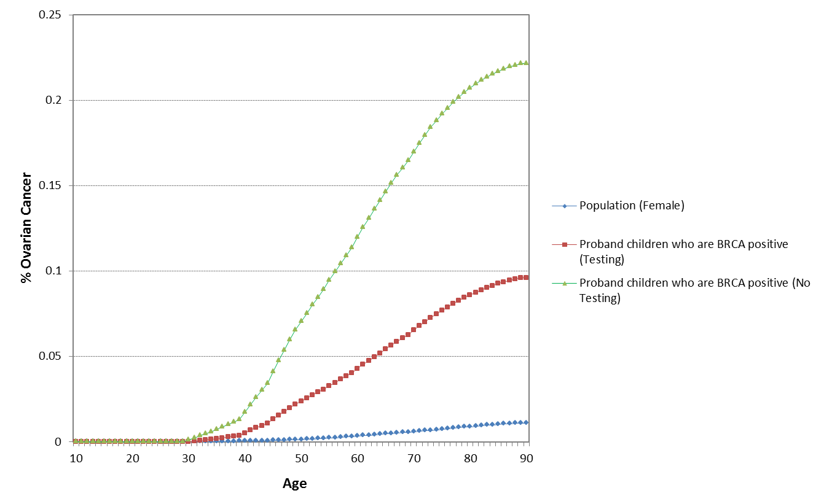
The cumulative risk of ovarian cancer in probands and proband’s family members who carry BRCA1 or BRCA2 mutation is around 20% at the age of 70 years. Genetic mutation testing results in reduced cumulative risk at around 10% for both probands and family members who carry the mutation.
The results of the model are in line with international evaluations. A review of published analyses did not identify any integrated economic model to assess the cost-effectiveness of a genetic testing program for BRCA mutation. Nevertheless, in the economic evaluations of BRCA mutation genetic testing in affected individuals or family members compared with no testing, genetic testing resulted in QALY gains ranging from 0.06 to 0.32 and was cost-effective with ICERs ranging from $9,000 to $50,000 per QALY gained. Table 6.9 summarises the results of international economic evaluations of BRCA mutation genetic testing with costs and ICERs converted to 2015 Australian dollars.
Table 6.9: Results of international economic evaluations of BRCA mutation genetic testing
Study | Population | Country | Cost (AUD 2015) | QALY | Life-year | ICER
Balmana (Balmana, Sanz et al. 2004) | Affected individuals and women with family history, 30 years old | Spain | Euro 823  (AUD2,096) | - | 0.19 | AUD11,032/LY
Holland (Holland, Huston et al. 2009) | Women with family risk of breast and/or ovarian cancer, 35 years old | Unites States | USD1,000  (USD1,724) | 0.2 | - | AUD8,620/QALY
Kaldate (Kaldate, Huston et al. 2014) | Women at high risk based on family history, 35 years old | Unites States | USD9,844  (AUD15,685) | 0.32 | - | AUD49,016/QALY
NICE (NICE 2013) | Affected individuals , 40-49 years old | United Kingdom | GBP1,086  (AUD 2,580) | 0.062 | 0.09 | AUD43,000/QALY
NICE (NICE 2013) | Women with relatives who tested positive, 40-49 years old | United Kingdom | GBP1,108  (AUD 2,625) | 0.1 | 0.09 | AUD26,250/QALY
AUD = Australian Dollar, USD = United States Dollar, GBP = Great Britain Pound, QALY = quality-adjusted life-year, ICER = incremental cost-effectiveness ratio, NICE = the National Institute for Health and Care Excellence

Sensitivity analysis
Figure 7.1 is a tornado diagram (one-way sensitivity analysis) illustrating the sensitivity of the model to the various model variables for the base-case scenario.
Figure 7.1: Tornado diagram of the results sensitivity to model variables 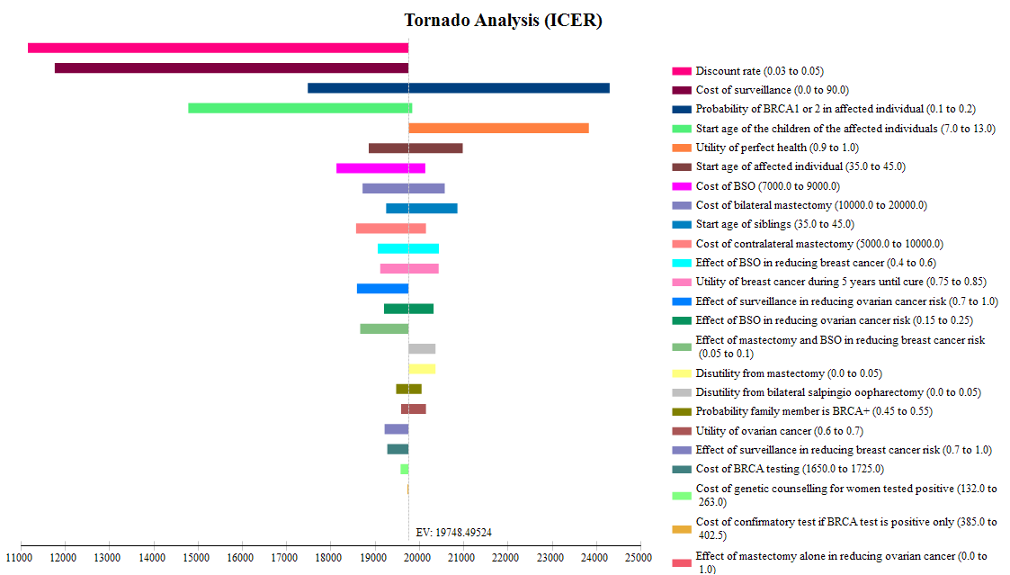
From the tornado diagram, the ICER is most sensitive to discount rate, cost of surveillance and the probability of BRCA mutation positive in affected individuals. Table 7.1 presents a univariate sensitivity analysis of these key variables.
Table 7.1: Univariate sensitivity analysis
 | Incremental costs | Incremental QALY | ICER/QALY
Base case | $3,470 | 0.19 | $18,283
Discount rate 3% | $3,216 | 0.32 | $10,192
Applying surveillance cost ($90) to proband’s children who test positive, family members who opt for BSO only in the Testing arm, and to family members in the No Testing arm | $3,274 | 0.19 | $17,253
Probability BRCA mutation positive in affected individuals 10% | $2,888 | 0.13 | $22,828
Probability BRCA mutation positive in affected individuals 20% | $4,052 | 0.25 | $16,012
QALY = quality-adjusted life-year, ICER = incremental cost-effectiveness ratio, BSO = salpingo-oophorectomy
The sensitivity analysis informs that genetic testing is cost-effective compared with no testing with an ICER ranging from $10,000/QALY gained to $23,000/QALY gained.

Financial implications
An epidemiological approach was used to estimate the financial implications of testing affected individuals who meet the eligibility criteria specified in Section 1.5 of the CUC and for family members of those who are positive for mutations in BRCA1 or BRCA2.

8.1 Justification of the selection of sources of data
Table 8.1.1 outlines the sources of data used to inform the financial estimates.
Table 8.1.1: Variables used in estimates of financial impact of genetic testing
Variables assumed for women affected with breast cancer and are eligible for testing
Variable | Value | Source/comment
Incident breast cancer diagnoses | Sensitivity  2012 14,610  2013 14,940  2014 15,270  2015 15,600  Sensitivity: allow for “catch-up” testing among women who were incident diagnoses in the 4 years prior to the year of interest for the first two years of the estimates.  Base case  2016 15,930  2017 16,250  2018 16,570  2019 16,890  2020 17,210  Base case: assume only incident breast cancer is tested in each year | AIHW, Breast cancer in Australia: an overview, p135. Estimated number of new cases of breast cancer. Although refers to cases and not patients, considered to be a good proxy for patients as few women diagnosed with cancer in both breasts. The incident population is considered to be those most likely to be tested.
Incident ovarian cancer diagnoses | Base case  2016 1,520  2017 1,550  2018 1,580  2019 1,610  2020 1,640 | AIHW Cancer incident projections.  Cases assumed to be proxy for patients with ovarian cancer.
Proportion women meeting the phenome criteria for testing eligibility | Base case: 10%  Sensitivity analysis: 5% | Values of 5-10% meeting eligibility were reported by the working group, who subsequently nominated 10% as the base case
Uptake of the test | Sensitivity  2012 20%  2013 20%  2014 20%  2015 20%  Sensitivity only related to breast cancer.  Base case  2016 70%  2017 70%  2018 80%  2019 90%  2020 90% | Assumption. For Year 1, assume that 10% of incident population in 2012 2013, 2014 and 2015 are eligible and test 20% of those diagnosed in those years. For Year 2, assume that 10% of incident population in 2013, 2014, 2015 are eligible and test 20% of those diagnosed in those years and 20% of those eligible but not tested in 2016.
Cost of the test for affected women | Initial $1,500 (+ profit margin)  Confirmatory: $350 (+profit margin)  Base case: 15% margin resulting in cost of initial test of $1,725 and confirmatory test of $402.50.  Sensitivity: 10% margin resulting in cost of initial test of $1,650 and confirmatory test of $385 | RACP indicated profit margin of 10-15%
Proportion of affected women tested who are BRCA 1 or BRCA2 positive | Base case: 15%  Sensitivity: 10% and 20% | Working group
Cost of genetic counselling for affected women | MBS 132 = $263.90  Base case: Assume all done as out-patients and attract a rebate of $224.35 (85%)  Sensitivity: Assume all tests conducted as an inpatient and attract a rebate of $197.95 (75%); | Working group
Variables assumed for family members
Variable | Value | Source/comment
Family members tested per Proband | Siblings: 0.8 females  Sensitivity: 0.6, 1.0 assumption  Children: 1  Sensitivity: 0.8, 1.2 assumption | Australian Institute of Family Studies
Cost of genetic test for family members | Confirmatory: $350 (+profit margin)  Base case: 15% margin resulting in cost of $402.50  Sensitivity: 10% margin resulting in cost of $385 | RACP indicated profit margin of 10-15%
Cost of genetic counselling for family members | MBS 132 = $263.90  Base case: Assume all done as out-patients and attract a rebate of $224.35 (85%)  Sensitivity: Assume all tests conducted as an inpatient and attract a rebate of $197.95 (75%); MBS item 133 (fee=$132.10; 85%=$112.30) | Working group
Variables assumed for women affected with breast cancer and are eligible for testing and family members
Variable | Value | Source/comment
Cost of BSO | $8,621 | Weighted value of AR-DRG N05A and N05B by number of separations in Round 17 of National Hospital Cost Data Collection
Cost of contralateral mastectomy | $8,747 | AR-DRG J06B in Round 17 of National Hospital Cost Data Collection.
Cost of bilateral mastectomy | $15,586 | Estimated by adding total average cost of one separation of AR-DRG J06B (as for contralateral mastectomy) and the average direct cost of one separation of AR-DRG J06B (to reflect mastectomy of second breast) from Round 17 of National Hospital Cost Data Collection.
Variables assumed for women affected with breast cancer and are eligible for testing and family members
Variable | Value | Source/comment
Cost of BSO | $8,621 | Weighted value of AR-DRG N05A and N05B by number of separations in Round 17 of National Hospital Cost Data Collection
Cost of contralateral mastectomy | $8,747 | AR-DRG J06B in Round 17 of National Hospital Cost Data Collection.
Cost of bilateral mastectomy | $15,586 | Estimated by adding total average cost of one separation of AR-DRG J06B (as for contralateral mastectomy) and the average direct cost of one separation of AR-DRG J06B (to reflect mastectomy of second breast) from Round 17 of National Hospital Cost Data Collection.
BSO = bilateral salpingo-oophorectomy

8.2 Estimation of use and costs of the proposed test
Table 8.2.1 summarises the number of patients affected by breast and ovarian cancer who are anticipated to be eligible for the test and the siblings and children of the affected patients.
Table 8.2.1: Estimated number of affected individuals tested
Proband
 |  | 2016 | 2017 | 2018 | 2019 | 2020
A | Incident cases of breast cancer | 15,930 | 16,250 | 16,570 | 16,890 | 17,210
B | Incident cases of ovarian cancer | 1,520 | 1,550 | 1,580 | 1,610 | 1,640
C | Number eligible for testing (A+B)*10% | 1,745 | 1,780 | 1,815 | 1,850 | 1,885
D | Uptake rate | 70% | 70% | 80% | 90% | 90%
E | Number of initial tests (C*D) | 1,222 | 1,246 | 1,452 | 1,665 | 1,697
F | Number of women positive for BRCA1 or BRCA2 mutation (15% assumed positive) | 183 | 187 | 218 | 250 | 254
G | Number of confirmatory tests and genetic counselling (F) | 183 | 187 | 218 | 250 | 254
Siblings
H | Number of female siblings per Proband | 0.8 | 0.8 | 0.8 | 0.8 | 0.8
I | Number of sibling tests (100% uptake) (F*H) | 147 | 150 | 174 | 200 | 204
J | Number of siblings positive for BRCA1 or BRCA2 mutation (50% assumed positive) | 73 | 75 | 87 | 100 | 102
K | Number of sibling confirmatory tests and genetic counselling (J) | 73 | 75 | 87 | 100 | 102
Children
L | Number of female children per Proband | 1 | 1 | 1 | 1 | 1
M | Number of future children tests (100% uptake) (F*L) | 183 | 187 | 218 | 250 | 254
N | Number of children positive for BRCA1 or BRCA2 mutation (50% assumed positive) | 92 | 93 | 109 | 125 | 127
O | Number of future confirmatory tests and genetic counselling (N) | 92 | 93 | 109 | 125 | 127
Totals
Total Number of initial tests (F) | 1,222 | 1,246 | 1,452 | 1,665 | 1,697
Total Number of confirmatory/sibling tests (G+I+K) | 403 | 411 | 479 | 549 | 560
Total Number of genetic counselling (G+K) | 257 | 262 | 305 | 350 | 356
Number of future children tests (M+O) | 275 | 280 | 327 | 375 | 382
Total Number of future genetic counselling (O) | 92 | 93 | 109 | 125 | 127
Table 8.2.2 outlines the costs applied to the financial estimates. These are unchanged from the initial assessment. Net present values for testing and counselling are calculated for the children who will not incur costs to government immediately.
Table 8.2.2: Test and counselling costs applied in the financial estimates
 | Cost | Net present value  (10 yrs)
Initial test
Cost of test | $1,725
Patient co-pay | $78
Net cost Govt per initial test | $1,647 | n/a
Confirmatory or family member
Cost of test | $403
Patient co-pay | $60
Net cost Govt per confirmatory test | $342 | $210
Genetic counselling (MBS 132)
Cost | $264
Patient co-pay | $40
Net cost per genetic counselling session | $224 | $138
Table 8.2.3 presents the results of the costs of testing and counselling for proband and siblings over the next five years.
Table 8.2.3: Estimated cost to MBS of test and genetic counselling
 |  | 2016 | 2017 | 2018 | 2019 | 2020
 | Proband and siblings
A | Number of initial tests | 1,222 | 1,246 | 1,452 | 1,665 | 1,697
B | Net cost Govt per initial test | $1,647 | $1,647 | $1,647 | $1,647 | $1,647
C | Cost Govt (net co-pay) for initial testing (A*B) | $2,011,322 | $2,051,664 | $2,390,863 | $2,741,589 | $2,793,457
D | Number of sibling/confirmatory testing | 403 | 411 | 479 | 549 | 560
E | Net cost Govt per sibling/confirmatory test | $342.12 | $342.12 | $342.12 | $342.12 | $342.12
F | Cost Govt (net co-pay) for sibling/confirmatory testing (D*E) | $137,907 | $140,673 | $163,930 | $187,978 | $191,534
G | Total cost Govt (net co-pay) for all testing (C+F) | $2,149,229 | $2,192,337 | $2,554,793 | $2,929,567 | $2,984,991
H | Number of genetic counselling (proband & siblings) | 257 | 262 | 305 | 350 | 356
I | Net cost per genetic counselling session | $224 | $224 | $224 | $224 | $224
J | Cost Govt (net co-pay) for genetic counselling (H*I) | $57,540 | $58,694 | $68,398 | $78,432 | $79,916
 | Total cost (net co-pay) of testing and genetic counselling (Q+J) | $2,206,769 | $2,251,031 | $2,623,192 | $3,007,999 | $3,064,907
The total costs to government range from $2.2 million to $3.1 million over the next five years.

8.3 Estimation of changes in use and cost of other procedures
Costs for preventive surgeries were included in the financial estimates. The following tables provide the estimates of women that would be expected to have various surgeries.
Table 8.3.1: Estimated number of surgeries among women affected with breast cancer and determined to be positive for BRCA1 or BRCA2 mutations
Proband | 2016 | 2017 | 2018 | 2019 | 2020
Number of women positive for BRCA1 or BRCA2 mutation | 183 | 187 | 218 | 250 | 254
Number having CM+BSO (40% assumed) | 73 | 75 | 87 | 100 | 102
Proportion opting for BSO | 40% | 40% | 40% | 40% | 40%
Number having BSO (40% assumed) | 73 | 75 | 87 | 100 | 102
Siblings
Number of siblings positive for BRCA1 or BRCA2 mutation | 73 | 75 | 87 | 100 | 102
Number having BM+BSO (40% assumed) | 29 | 30 | 35 | 40 | 41
Number having BSO (40% assumed) | 29 | 30 | 35 | 40 | 41
Total for CM+BSO | 103 | 105 | 122 | 140 | 143
Total for BSO | 103 | 105 | 122 | 140 | 143
BSO = bilateral salpingo-oophorectomy; CM = contralateral mastectomy
Table 8.3.2: Estimated cost of elective surgeries for mastectomy and bilateral salpingo-oophorectomy
 | Cost | Net present value (20 yrs)
Proband
Cost of CM+BSO | $17,008
Cost of BSO | $8,621
Cost of CM | $8,747
Siblings/ Children
Cost of BM+BSO | $24,207 | $9,123
Cost of BSO | $8,621 | $3,249
Cost of BM | $15,586 | $5,874
BM = bilateral mastectomy; BSO = bilateral salpingo-oophorectomy; CM = contralateral mastectomy
The total costs to government for preventive surgeries in affected individuals and siblings are presented in Table 8.3.3.

Table 8.3.3: Estimated cost of elective surgeries among women determined to be positive for BRCA 1 or 2 mutations
 |  | 2016 | 2017 | 2018 | 2019 | 2020
 | Proband
A | Number for CM+BSO | 73 | 75 | 87 | 100 | 102
B | Cost per CM+BSO | $17,008 | $17,008 | $17,008 | $17,008 | $17,008
C | Cost of CM+BSO (A*B) | $1,246,516.32 | $1,271,518 | $1,481,737 | $1,699,099 | $1,731,244
D | Number for BSO | 73 | 75 | 87 | 100 | 102
E | Cost per BSO | $8,621 | $8,621 | $8,621 | $8,621 | $8,621
F | Cost of BSO (D*E) | $631,833.09 | $644,506 | $751,062 | $861,238 | $877,532
G | Number for CM | 0 | 0 | 0 | 0 | 0
H | Cost per CM | $8,747 | $8,747 | $8,747 | $8,747 | $8,747
I | Cost of CM (G*H) | $0 | $0 | $0 | $0 | $0
J | Total cost of proband surgery (C+F+I) | $1,878,349 | $1,916,024 | $2,232,798 | $2,560,337 | $2,608,776
 | Siblings
K | Number for CM+BSO | 29 | 30 | 35 | 40 | 41
L | Cost per CM+BSO | $24,207 | $24,207 | $24,207 | $24,207 | $24,207
M | Cost of CM+BSO (K*L) | $709,652.41 | $723,886 | $843,566 | $967,312 | $985,612
N | Number for BSO | 29 | 30 | 35 | 40 | 41
O | Cost per BSO | $8,621 | $8,621 | $8,621 | $8,621 | $8,621
P | Cost of BSO (N*O) | $252,733.24 | $257,802 | $300,425 | $344,495 | $351,013
Q | Number for BM | 0 | 0 | 0 | 0 | 0
R | Cost per BM | $15,586 | $15,586 | $15,586 | $15,586 | $15,586
S | Cost of BM (Q*R) | $0 | $0 | $0 | $0 | $0
T | Total cost of sibling surgery (M+P+S) | $962,386 | $981,689 | $1,143,990 | $1,311,807 | $1,336,625
 | Total cost of surgery (J+T) | $2,840,735 | $2,897,713 | $3,376,789 | $3,872,144 | $3,945,401
BM = bilateral mastectomy; BSO = bilateral salpingo-oophorectomy; CM = contralateral mastectomy
A summary of the total costs of testing, counselling and preventive surgeries to affected individuals and siblings are presented in Table 8.3.4.
Table 8.3.4: Summary of net costs to Government
 | 2016 | 2017 | 2018 | 2019 | 2020
Cost Govt (net co-pay) for genetic counselling | $57,540 | $58,694 | $68,398 | $78,432 | $79,916
Total cost Govt (net co-pay) for testing | $2,149,229 | $2,192,337 | $2,554,793 | $2,929,567 | $2,984,991
Total cost of proband surgery | $1,878,349 | $1,916,024 | $2,232,798 | $2,560,337 | $2,608,776
Total cost of sibling surgery | $962,386 | $981,689 | $1,143,990 | $1,311,807 | $1,336,625
Total cost to Govt (net co-pay) | $5,047,513 | $5,148,752 | $5,999,991 | $6,880,155 | $7,010,320
The total expected costs to Government are $5.0 million in year 1 to $7.0 million in year 2.
8.4 Sensitivity analyses
Costs to Government for children will not be incurred in the next 10 years because we have assumed that children are currently 10 years old and they would be tested at age 20 years (when informed consent would occur). Further, we assumed that preventive surgery would not occur until age 30 years. The following calculations of costs for these future events have been brought forward to the present value using Net Present Value formula.
Table 8.4.1: Children-related costs – Net Present Value for future costs
 |  | 2016 | 2017 | 2018 | 2019 | 2020
A | Number of future children tests | 275 | 280 | 327 | 375 | 382
B | NPV cost Govt (net co-pay) per children test | $210 | $210 | $210 | $210 | $210
C | Cost Govt (net co-pay) for children testing (A*B) | $57,725 | $58,882 | $68,617 | $78,683 | $80,172
D | Total number of future genetic counselling | 92 | 93 | 109 | 125 | 127
E | NPV cost per genetic counselling session | $138 | $138 | $138 | $138 | $138
F | Cost Govt (net co-pay) for future counselling (D*E) | $12,616 | $12,869 | $14,997 | $17,197 | $17,522
G | Number for CM+BSO | 37 | 37 | 44 | 50 | 51
H | NPV cost per CM+BSO | $9,123 | $9,123 | $9,123 | $9,123 | $9,123
I | Cost of CM+BSO (G*H) | $334,326 | $341,031 | $397,414 | $455,712 | $464,334
J | Number for BSO | 37 | 37 | 44 | 50 | 51
K | NPV cost per BSO | $3,249 | $3,249 | $3,249 | $3,249 | $3,249
L | Cost of BSO (J*K) | $119,066 | $121,454 | $141,534 | $162,296 | $165,366
M | Number for BM | 0 | 0 | 0 | 0 | 0
N | NPV cost per BM | $5,874 | $5,874 | $5,874 | $5,874 | $5,874
O | Cost of BM (M*N) | $0 | $0 | $0 | $0 | $0
 | Total cost of children testing and surgery (C+F+I+L+O) | $523,732 | $534,237 | $622,561 | $713,888 | $727,394
BM = bilateral mastectomy; BSO = bilateral salpingo-oophorectomy; CM = contralateral mastectomy
The results of the sensitivity analyses are provided in Table 8.4.2.

Table 8.4.2: Results of sensitivity analyses of financial estimates
 | 2016 | 2017 | 2018 | 2019 | 2020
Base case - total costs to Govt | $5,047,513 | $5,148,752 | $5,999,991 | $6,880,155 | $7,010,320
Incident of breast cancer includes 'catch up' cases from 2012-2015 (10%) and 20% uptake | 5,397,050 | 5,413,769 | 5,999,991 | 6,880,155 | 7,010,320
Proportion assumed to be eligible for testing 5% (base 10%) | 2,523,756 | 2,574,376 | 2,999,995 | 3,440,077 | 3,505,160
Proportion of affected women tested who are BRCA 1 or 2 positive 10% (base 15%) | 4,035,449 | 4,116,390 | 4,796,948 | 5,500,633 | 5,604,699
Proportion of affected women tested who are BRCA 1 or 2 positive 20% (base 15%) | 6,059,577 | 6,181,115 | 7,203,033 | 8,259,677 | 8,415,941
Preventive surgery proportions 16% BSO+CM, 52% BSO, 28% CM (base 40%/40%/0%) both proband & siblings | 4,907,772 | 5,006,209 | 5,833,881 | 6,689,677 | 6,816,239
Cost of test $1650 (base $1725) | 4,955,900 | 5,055,302 | 5,891,091 | 6,755,280 | 6,883,082
Cost of confirmatory or sibling test $385 (base $403) | 5,040,459 | 5,141,557 | 5,991,606 | 6,870,539 | 7,000,523
Cost of counselling 75% rebate (base 85% rebate) | 5,040,735 | 5,141,838 | 5,991,933 | 6,870,915 | 7,000,906
No. of siblings tested for proband 0.6 (base 0.8) | 4,784,000 | 4,879,955 | 5,686,753 | 6,520,967 | 6,644,336
No. of siblings tested for proband 1.0 (base 0.8) | 5,311,026 | 5,417,550 | 6,313,229 | 7,239,343 | 7,376,304
Children costs included (all NPV) | 5,571,247 | 5,682,991 | 6,622,555 | 7,594,045 | 7,737,716
Adding children costs and No. of children tested for proband 0.8 (base 1.0) | 5,466,500 | 5,576,143 | 6,498,042 | 7,451,267 | 7,592,237
Adding children costs and No. of children tested for proband 1.2 (base 1.0) | 5,675,994 | 5,789,839 | 6,747,067 | 7,736,823 | 7,883,195
BM = bilateral mastectomy; BSO = bilateral salpingo-oophorectomy; CM = contralateral mastectomy
Compared with the results in the base case, these sensitivity analyses show that the results are most sensitive to the proportion assumed to be eligible for testing at 5% (base 10%) which halves the total cost, and the proportion of affected women tested who are BRCA1 or BRCA2 positive at 10% or 20% (base 15%) ranging from $4.0 million to $6.1 million in the first year.

References
AIHW (2010). Ovarian cancer in Australia: an overview. Canberra, Australian Institute of Health and Welfare.
AIHW (2012). Breast cancer in Australia an overview. Canberra, Australian Institute of Health and Welfare.
Antoniou, A., P. D. Pharoah, et al. (2003). "Average risks of breast and ovarian cancer associated with BRCA1 or BRCA2 mutations detected in case Series unselected for family history: a combined analysis of 22 studies." Am J Hum Genet 72(5): 1117-1130.
Balmana, J., J. Sanz, et al. (2004). "Genetic counseling program in familial breast cancer: analysis of its effectiveness, cost and cost-effectiveness ratio." Int J Cancer 112(4): 647-652.
Chen, S. and G. Parmigiani (2007). "Meta-analysis of BRCA1 and BRCA2 penetrance." J Clin Oncol 25(11): 1329-1333.
Collins, I. M., R. L. Milne, et al. (2013). "Preventing breast and ovarian cancers in high-risk BRCA1 and BRCA2 mutation carriers." Med J Aust 199(10): 680-683.
Gordon, L. G., P. A. Scuffham, et al. (2010). "Medical costs and outcomes for Australian women with ovarian cancer: a patient-level analysis over 2.5 years." Int J Gynecol Cancer 20(5): 757-765.
Hayes, A., R. Weston, et al. (2010). Families then and now: 1980-2010, Australian Institue of Family Studies.
Holland, M. L., A. Huston, et al. (2009). "Cost-effectiveness of testing for breast cancer susceptibility genes." Value Health 12(2): 207-216.
Kaldate, R., A. Huston, et al. (2014). "Cost effectiveness analysis of genetic testing for breast and ovarian cancer susceptibility genes: BRCA1 and BRCA2." Breast J 20(3): 325-326.
Manchanda, R., R. Legood, et al. (2015). "Cost-effectiveness of population screening for BRCA mutations in Ashkenazi jewish women compared with family history-based testing." J Natl Cancer Inst 107(1): 380.
NICE (2013). Familial breast cancer: Classification and care of women at risk of familial breast cancer and management of breast cancer and related risks in people with a family history of breast cancer. London, The National Institute for Health and Care Excellence
Rhiem, K., C. Engel, et al. (2012). "The risk of contralateral breast cancer in patients from BRCA1/2 negative high risk families as compared to patients from BRCA1 or BRCA2 positive families: a retrospective cohort study." Breast Cancer Res 14(6): R156.
Suthers, G. K. (2007). "Cancer risks for Australian women with a BRCA1 or a BRCA2 mutation." ANZ J Surg 77(5): 314-319.

