1205a

Final Decision Analytic Protocol (DAP) to guide the assessment of a review of Medicare- funded wrist surgery services

1 February 2013

Table of Contents
MSAC and PASC 3
Purpose of this document 3
Purpose of application 4
Intervention 4
Description 4
Fractures of the distal radius, the distal ulna and the ulna styloid 6
Administration, dose, frequency of administration, duration of treatment 7
Co-administered interventions 8
Background 9
Current arrangements for public reimbursement 9
Regulatory status 10
Patient population 10
Proposed MBS listing 10
Clinical place for proposed intervention 12
Clinical management algorithm 13
Comparator 17
Clinical claim 18
Outcomes and health care resources affected by introduction of proposed intervention 19
Outcomes 19
Health care resources 19
Proposed structure of economic evaluation (decision-analytic) 24
Clinical research questions for public funding: 25
Decision analytic diagram 26
References 28
Appendix 1: Information from the MBS 29
Appendix 2: Information from the AIHW 34

MSAC and PASC

The Medical Services Advisory Committee (MSAC) is an independent expert committee appointed by the Australian Government Health Minister to strengthen the role of evidence in health financing decisions in Australia. MSAC advises the Commonwealth Minister for Health and Ageing on the evidence relating to the safety, effectiveness, and cost-effectiveness of new and existing medical technologies and procedures and under what circumstances public funding should be supported.

The Protocol Advisory Sub-Committee (PASC) is a standing sub-committee of MSAC. Its primary objective is the determination of protocols to guide clinical and economic assessments of medical interventions proposed for public funding.

Purpose of this document

This document is intended to provide a draft decision analytic protocol that will be used to guide the assessment of an intervention for a particular population of patients. The draft protocol will be finalised after inviting relevant stakeholders to provide input to the protocol. The final protocol will provide the basis for the assessment of the intervention.

The protocol guiding the assessment of the health intervention has been developed using the widely accepted “PICO” approach. The PICO approach involves a clear articulation of the following aspects of the research question that the assessment is intended to answer:

Patients – specification of the characteristics of the patients in whom the intervention is to be considered for use;
Intervention – specification of the proposed intervention
Comparator – specification of the therapy most likely to be replaced by the proposed intervention
Outcomes – specification of the health outcomes and the healthcare resources likely to be
affected by the introduction of the proposed intervention

Purpose of application

A proposal for an application requesting a review of Medicare-funded wrist services was received from

The Australian Hand Surgery
Society by the Department of Health and Ageing in January 2012.

Services for wrist fractures are currently reimbursed through the MBS via a range of items (MBS items
47360-47375). This proposal relates to a review of current wrist fracture MBS items, and a proposal for five new items, to align Medicare-funded wrist therapeutic surgical procedures more closely with

current
clinical practice. These items would be used in a broad patient population, although it is

suggested that the
population
to benefit
most would
be the younger and middle-aged
who are

subject
to high-energy trauma and intra-articular fracture. PBAC
greed that
current practice has

changed significantly in the past 5-10 years.

This decision analytical protocol has been drafted to guide the assessment of the safety, effectiveness

and cost-effectiveness of Medicare-funded wrist services in order t regarding public funding of the interventions. This is the first of six Society.

Intervention
inform MSAC’s decision-making eviews from the Australian Hand

Description
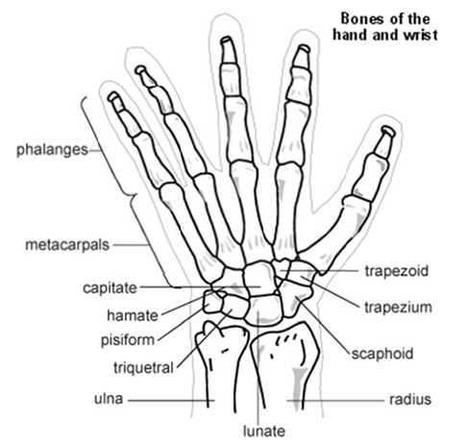
Figure 1: The anatomy of the wrist and hand (Diagram © Egton Medical Information Systems Ltd 2012, as distributed at http://www.patient.co.uk/health/Scaphoid-Fracture.htm, used with per mission.)

The wrist is a complex joint which is required to be both strong and flexible. It is composed of the distal ends of the radius and ulna, eight carpal bones, and the proximal bases of the five metacarpal bones (Kijima and Viegas 2009). As shown in Figure 1, there are eight carpal bones arranged in two rows. The radiocarpal joint is the joint between the scaphoid lunate and the distal radius. The ‘wrist’ joint is a composite joint requiring complex interactions between all of the component bones. The distal radius and ulna are covered in articular cartilage and meet at the distal radioulnar joint (DRUJ). At the distal end of the ulna is a styloid process which provides attachment to the ulnocarpal ligaments and the radioulnar ligaments. The stability of the wrist is dependent upon a number of ligaments. The extrinsic ligaments connect the distal radius and ulna to the carpal bones, while the intrinsic ligaments have their origins and insertions into the carpal bones (Kijima and Viegas 2009).

Wrist fractures are usually defined as occurring in the distal radius within three centimetres of the radiocarpal joint, where the lower end of the radius articulates with two (the lunate and the scaphoid) of the eight bones forming the carpus (Handoll 2008) and the distal ulna. Fractures of the ulna can also occur. The majority of wrist injuries are closed injuries, the external skin remaining intact (Handoll et al 2008). Wrist fractures may be intra-articular (where the articular surface is disrupted) or extra-articular. Due to the intricate three-dimensional anatomy of the hand, and the multiple bones and surfaces which may be involved, together with potential soft tissue injury, wrist fractures may be complex in nature.

In the past, surgeons have classified fractures based on clinical appearance, and named after those who first described them. Some common eponymous naming conventions include (Abraham and Scott 2010):

• Colles’ fracture: may demonstrate a dinner-fork deformity, commonly seen as a result of a fall on an outstretched hand, involving the fracture of the distal radial metaphysis and can be associated with a fracture of the ulnar styloid.
• Smith’s (or reverse Colles’) fracture: a transverse fracture of the metaphysis of the distal radius following a fall on the upper surface of the hand.
• Barton’s fracture: a distal radius fracture with dislocation of the radiocarpal joint, usually as a result of a high-energy impact to the radiocarpal joint.
• Hutchison’s fracture: caused by a direct fall on the radial side of the wrist causing a fracture through the radial styloid process.

The introduction of X-rays and other more detailed imaging methods has made it clear that classical deformity can be associated with a range of fracture patterns. As a result, a range of newer classification systems have been developed (Handoll et al 2008).

In the short-term, fractures of the wrist may be associated with swelling and pain, with possible neurovascular complications, vasomotor instability and significant intra-articular and extra-articular injury. Late complications include midcarpal instability (dynamic instability resulting from malaligned bones in the midcarpal joint within the wrist) (Handoll et al 2008). Malunions of the distal radius may also lead to late distal radioulnar instability due to dorsal angulation of the radius increasing the stress on the DRUJ ligaments. Post-traumatic arthritis may occur, months to years from the injury.

Treatment of a wrist fracture is dependent upon whether the bone fragments have become displaced. Fracture reduction is the alignment of displaced bony fragments. The wrist may then be immobilised usually in a plaster cast. The basic treatment options available for fracture repair are conservative (non-operative), where reduction of the displaced fracture is via manipulation, and subsequent stabilisation in a plaster cast or other external brace; or a range of operative or open techniques (Handoll and Madhok 2008). Specifically:

• closed (with traction and manipulation) or open (including arthroscopically-assisted) reduction if the bone fragments are displaced (percutaneous Kirschner wires (K-wires) could be used to move the bony fragments into place);
• external splintage: immobilisation or support, or both (plaster of Paris cast, brace, bandage);
• external fixation using percutaneous pins or wires fixed externally with plaster or use of another external frame (as an aid to closed reduction);
• percutaneous pinning;
• bridging fixation (pins are placed further from the more fragile end of the fractured bone with external component bridges and immobilises the wrist joint);
• internal fixation with pins, nails, screws and plates;
• internal fixation and external fixation can be applied together for stabilisation of a very complex and unstable fracture; however, the quality of current internal fixation devices mean this is becoming less common;
• replacement of lost bone stock (metaphyseal defect) by temporary bone scaffold (bone graft)
material or any other suitable substance (bone cement or substitute);
• immobilisation (approximately 6 weeks), followed by rehabilitation

Ligament injuries are common with intra-articular fractures and would need to be repaired in addition to the fracture. Clinical judgement is required at all times in deciding whether or not an intra-articular fracture can be treated conservatively or requires surgery. Exercises and other physical interventions are used to help restore function and speed up recovery (Handoll et al 2006).

Fractures of the distal radius, the distal ulna and the ulna styloid

The distal radius and distal ulna are covered in articular cartilage and play a role in smooth forearm rotation. An intra-articular fracture here requires an increased level of skill and difficulty to repair compared to a fracture elsewhere in the radius or ulna.

The ulna styloid is not intra-articular but is part of the distal ulna and is the attachment for multiple ligaments that support and restrain the movement of the DRUJ required for forearm stability and forearm rotation. It also contains ligaments that help support the ulnar side of the wrist joint. Repair of ulnar styloid fractures are very different to fractures of the distal ulna as they involve joint stability. Where there is no instability repair of the ulna styloid is relatively straight forward and is used to prevent pain from a non-united fracture. Repair of an ulna styloid fracture where there is instability of the DRUJ is a much more complex issue with a longer rehabilitation equivalent to that seen with a full reconstruction of the DRUJ.

Compared to fractures elsewhere at the radius and ulna, intra-articular fractures of the distal radius and distal ulna require more detailed imaging, more accurate bone re-alignment and reduction, the use of intra-operative radiology, and a greater requirement for internal fixation. Rehabilitation may also be more complex.

In current clinical practice the management of undisplaced stable fractures are the same, whether they are intra-articular or extra-articular. Therefore closed reduction and cast immobilization for intra- and extra-articular fractures are very similar in practice. The main difference for intra-articular fractures would be the addition of a CT scan to accurately assess the suitability of the fracture for closed reduction and more frequent radiological assessment to ensure that the reduction is maintained during the healing period.

No additional training is required for most of these fractures beyond normal continuing medical education and attendance at clinical meetings. Newer approved implants are used for the fixation with newer surgical techniques. A number of workshops are provided by the implant distributors with instruction from experienced surgeons. The practice would need to have access to imaging services such as computed tomography (CT), magnetic resonance imaging (MRI) and intra-operative X-ray.

Administration, dose, frequency of administration, duration of treatment

Wrist services are likely to be administered once per event due to bone damage as a result of injury or trauma. The procedure undertaken would reflect the location and complexity of the fracture. Simpler fractures which are non-articular could be treated with closed reduction (if required) and cast immobilisation by general practitioners (GPs) in an out-of-hospital setting. This may be more common in rural settings. More complex procedures, including fractures in an intra-articular location, would be performed in the operating theatre of a specialised practice by hand or orthopaedic surgeons with a particular expertise in the treatment of fractures of this type. This is the same as for current fracture management. A narrative detailing the provision of a complex wrist fracture repair by a specialist surgeon is provided below.

Prior to the fracture service delivery an initial consultation where the interview is performed assessing the mechanism of injury, basic health issues and suitability for the proposed treatment. An initial X- ray would usually be undertaken where the need for further detailed investigation is determined. This initial consultation would take 15-20 minutes. If a CT scan were to be provided at the time of the consultation this would allow a further assessment of the finer details of the fracture (additional 15 minutes consultation time). If a CT scan needs to be arranged at another time then an additional consultation of 15-20 minutes will be required. Once a decision to operate has been made then the full service is discussed including an outline of the procedure, postoperative course, possible risks and complications and expected outcome.

Time taken for a surgical procedure has a wide variation depending on the experience of the surgeon and the support team, the complexity of the fracture and unpredictable variables in reassembling a complex 3 dimensional puzzle. This procedure requires hospital admission with an overnight stay, either general or regional anaesthesia depending on the anaesthetic assessment. The procedure may require one or two different surgical approaches with the possibility of biological or synthetic bone

grafting. The total surgical time would range from 90-120 minutes. The surgical procedure requires a surgical exposure, either a dorsal or volar approach or separate radial or ulnar approaches or combinations, with dissection of tissues to expose the bone and fracture. Vital nerves, vessels and tendons need to be protected throughout the exposure. The fracture is identified and the joint surface exposed without excessive soft tissue dissection which would devascularise the fragments. Preliminary fixation may be required with temporary wire fixation or the application of an external fixateur. This initial fixation is then checked with X-ray. Once satisfactory position is achieved then the definitive fixation of the fracture is applied with the number and configuration of plates and screws determined by the fracture anatomy. When the fracture is stabilised, further assessment is performed with X-rays. At times an arthroscopic assessment of the joint surface is needed. Once the fracture is satisfactorily stabilised, any associated ligamentous and soft tissue injuries are addressed. The wound is closed, and dressings and splint immobilisation is applied.

Aftercare would involve a number of stages. The patient is reviewed in the immediate post-operative period to look for possible immediate complications such as bleeding, nerve injury and compartment syndromes (10 minutes). The patient is then reviewed in the hospital the following morning for assessment of pain relief, any complications and suitability for discharge. The results of the procedure are again explained to the patient along with their pain relief and what to look out for if complications develop. Two weeks after discharge, the patient is reviewed, sutures are removed and the wound is checked. If the fracture was deemed stable at the time of surgery then the patient would start a program of graded mobilisation. If it was determined that further supplementary support was needed then a splint or cast would be applied (15 – 20 minutes). Following this the patient would usually be seen at the six week mark where X-rays would be used to determine the union of the fracture and to assessed mobilisation. Subsequent consultation to assess progress and modify treatment and therapy would occur over the next three months or so. The total time involved from initial meeting to discharge excluding complications and additional non-standard treatments would be in the range of 6
- 7 hours.

Co-administered interventions

The co-administered interventions for fractures of the wrist will vary depending on the type, location and complexity of the fracture. Simple fractures may require no, or closed, reduction, and will heal successfully with cast immobilisation and little or no additional rehabilitation.

More complex fractures (intra-articular or comminuted fractures) will require additional intervention. Due to the need for very accurate reconstitution of the joint surface there is an increasing use of intra-operative radiology and image intensification. Radiology is most commonly used in the initial imaging of a suspected fracture. In the case of a more complex fracture, more detailed imaging can be achieved using CT, or using MRI for suspected soft tissue injury. Intra-operative X-ray is used during the open procedure to establish correct alignment during pre- or final fixation of the bone fragments. Peri-operative radiology may also be used for closed reduction to assess the accuracy of the reduction once the cast is applied. At times an arthroscopic assessment of the joint surface is needed. Physiotherapy is required for the recovery of wrist function.

Background

Current arrangements for public reimbursement

The current MBS item numbers cover the treatment but do not explicitly cover fractures of the ulna, nor of any intra-articular fractures of the radius and ulna. They also do not cover current clinical practice including the use of new terminology and newer fracture management techniques and technologies, or more detailed imaging requirements. Current MBS items related to wrist surgery are shown in Table 1. Specifically, items 47360 to 47375 cover the proposed medical service.

The age and gender distribution of the services provided under current MBS items are shown in Appendix 1 (Figure 3 to Figure 8). For certain items (47360, 47363, 47369), the majority of the services are provided to the 5-14 age group, with a small increase in older people aged 55 years or greater. For item number 47375, the number of services increase with age, with the majority of services provided to females in the 55-64 age group.

Table 1: Current MBS item descriptors for therapeutic procedures on wrist fractures
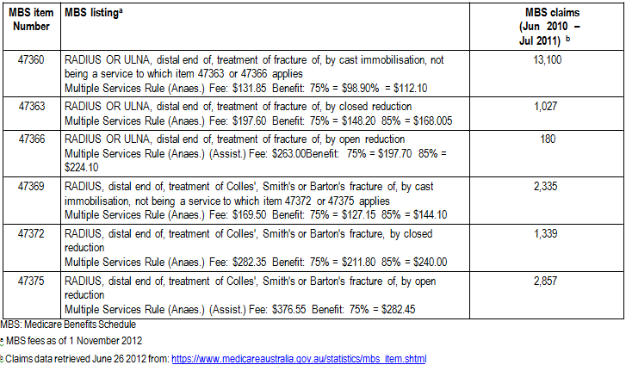
Current MBS items for bone grafting (47726 and 47729) and for wrist ligament repair (49215) or DRUJ reconstruction (46345) are shown in Appendix 1. Depending on the extent of the injury, these items may need to be used in addition to the items for bone fixation. However, this DAP is focused on the fracture repair of wrist bones. Synthetic bone substitutes would be injected at the site at the time of surgery and would therefore be covered within existing or proposed MBS items for bone fracture repair. Clinical input suggests that the use of newer devices for fixation (for example locking plates) in the wrist has allowed bone grafts to be less commonly required.

In certain instances, removal of the implant used for fracture fixation is necessary as they can impinge on tendon or joint movement. The current MBS items for this service are 47924, 47927 and
47930.

Note that the MBS items for treating a child’s fracture of the distal radius (50508, 50512, see
Appendix 1) are not part of the proposed changes.

Regulatory status

The applicant has advised that there is no new technology associated with the proposed assessment. The proposed medical service is a therapeutic surgical procedure. There is no designated change to health service provision.

There are a number of varied devices and technologies which are used during the alignment, fixation and stabilisation of bones in the wrist joint. According to the applicant the most common prostheses currently used for distal radial and intra-articular fractures are locking plate devices. These provide the best immediate stability, resistance against pull-out of screws and loss of fixation. Most surgical implant companies produce sets of implants that have the same basic structure but differ only in very slight plate modification. There is no difference between any of the plating systems on the market. The choice of plate design used is made according to surgeon preference. According to the applicant, all commonly available devices are TGA approved. Most implants described in the literature are available in Australia although they may be marketed under a different name. In general, the minor design variations between different brands are not significant. For the purposes of the DAP, all devices reflected in the international literature should be considered appropriate for inclusion.

Currently, wires are rarely used for the treatment of wrist fractures, and external fixateurs are similarly only used in a few special indications. Bone morphogenic proteins are not commonly used for the treatment of fractures of the wrist, and its use is in general experimental, therefore their use is excluded from this DAP.

Patient population

Proposed MBS listing

The applicant proposes that five new items are needed to address specific intra-articular fractures of the distal radius, distal ulna, and of the ulna styloid (Table 2). The proposed items, covering the treatment of intra-articular fractures, are in addition to existing items for the treatment of distal radius and ulna fractures. The use of more specific items would make the selection of item number for the treatment of these fractures more clinically relevant and more truly reflect the clinical practice.

As a result of these new items, and to bring existing items in line with current clinical practice, the applicant has proposed changes to the existing MBS items and fees (Table 3). The current items for treatment of distal radius and ulna fractures (47360, 47363, 47366, 47369, 47373, 47375) would be streamlined, mainly through the removal of the eponymous naming conventions that relate primarily to fracture appearance. There is no existing single item for internal fixation of an ulna styloid fracture

where there is some distal radioulnar instability. The current items used would be 47366 (Radius or Ulna, distal end of, treatment of fracture) or 46345 (distal radioulnar joint, reconstruction or stabilisation of) or possibly both numbers.

Together, the new items and changes to current item description and fees reflect services that are provided by GPs in an out-of hospital setting, and surgical procedures that would be conducted by specialists in a hospital setting.
Table 2: Proposed MBS item descriptors for therapeutic procedures on the wrist
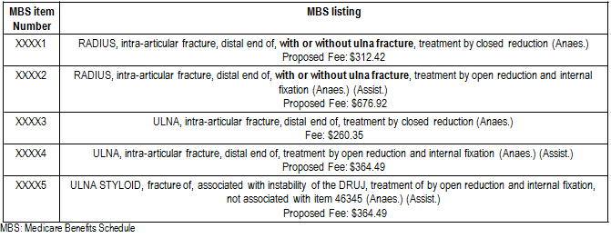
Table 3: Proposed changes to existing MBS item descriptors for therapeutic procedures on the wrist
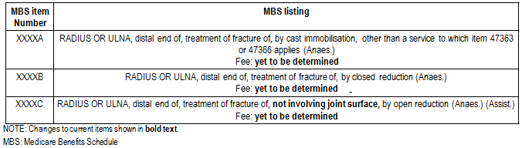

o The fees for all the proposed items for the purposes of the assessment and economic evaluation will be determined with the input of the ESC at a later date. Where a suggested fee has been proposed it will be noted; however, the current fees will be used as benchmarks for all new items.
o An undisplaced intra-articular fracture can be treated with cast immobilisation and no reduction. Under the proposed items this service would be provided by XXXXA above.
o The General Medical Services Table (GMST) definition of a
o closed reduction includes percutaneous fixation or external splintage by cast or splints; and
o open reduction includes any internal or external fixation.

Clinical place for proposed intervention

Wrist injuries can lead to significant problems. Complications from the injury itself can result in increased morbidity, with long-term functional impairment, pain and deformity (Handoll and Madhok
2008). In addition to soft tissue injury there can be injury to blood vessels, tendons and nerves. Median nerve dysfunction is a common complication. One major complication is reflex sympathetic dystrophy (RSD), also referred to as algodystrophy, Sudeck’s atrophy, complex regional pain syndrome and shoulder-hand syndrome. Serious cases of RSD require many months of therapy to alleviate symptoms (pain, tenderness, impairment of joint mobility, swelling, dystrophy, vasomotor instability) (Handoll et al 2006). Late complications include midcarpal instability and post-traumatic arthritis, which can occur several months or years after injury (Handoll and Madhok 2008). The accurate reduction of the joint surface to anatomical alignment is essential for preservation of function and minimisation of long-term disability.

Appendix 2 shows data from the Australian Institute of Health and Welfare (AIHW) hospital data cubes. In 2009-10, there were 21,796 separations by principal diagnosis of fracture at hand and wrist level (not involving the radius and ulna), and 37,980 fractures of the forearm, including 22,887 at the lower end of the radius and 4,432 at the lower end of both the radius and ulna. The lower end of the ulna is not recorded separately. For the radius, 540 fractures are recorded at the lower end with volar angulation and intra-articular fracture.

AIHW separation statistics by procedure show that in 2009-10 there were a total of 16,860 closed reduction of a fracture of the radius. Of these, 13,892 were of the distal radius; 2,058 were of the distal radius with internal fixation. There were a total of 10,486 open reduction of fracture of radius. Of these, 98 were at the distal radius; 9,001 were of the distal radius with internal fixation.

Similar data is available for the ulna. In 2009-10, there were a total of 3,356 closed reduction of fracture of the ulna or olecranon. Of these, 2,713 were of the distal ulna; 181 were of the distal ulna with internal fixation. There were a total of 3,403 open reduction of fracture of the ulna or olecranon. Of these, 65 were at the distal ulna; 1,075 were of the distal ulna with internal fixation.

Fractures of the distal radius and ulna are the most common type of fractures in patients younger than 75 years of age (Abraham and Scott 2010). Australian epidemiological data show that among those aged 35 and older, age-adjusted Colles’ fracture incidence (per 10,000 per year) was 17 for females and 4 for males (Sanders et al 1999). This compared with 25 and nine respectively for hip fracture. The rate of Colles’ fracture increased in women from 35 to the over-90 age group, but did not increase in men except in the oldest age group (85+) (Sanders et al 1999). In a UK study, the incidence of distal forearm fracture was 36.8/10,000 person-years in women and 9.0/10,000 person- years in men (O’Neill et al 2001).

In children, fractures of the distal radius and forearm are the most common skeletal injury requiring surgical care (Bae 2008). Children between 5-14 years of age have been shown to have the largest proportion (26%) of all hand and forearm fractures in the Unites States (Chung and Slipson 2001). For younger adults, injuries to the wrist area may commonly occur as a result of sports injuries, including throwing sports, tennis and golf (Brukner 1998). Almost 700,000 Australians (approximately

3%) are believed to have been diagnosed with osteoporosis (AIHW 2012). Fractures after minimal trauma are a hallmark of this condition.

The applicant states that the population to benefit from fixation of intra-articular fractures would be younger and middle-aged adults who are subject to high energy trauma. These patients are often in their productive years and require accurate and stable fracture fixation to return them to employment and prevent subsequent degeneration and lost productivity. The elderly require accurate and stable fixation of their extra-articular fractures to minimise their period of incapacity and hence minimise their reliance on respite and temporary accommodation away from home.

Epidemiological data has not been identified which shows the proportion of all patients with distal radius and distal ulna fractures that have these fractures located in intra-articular locations, or at the ulna styloid.

Clinical management algorithm

The clinical management algorithm for a fracture of the wrist (that is intra-articular or ulna styloid fracture, and/or instability) is shown in Figure 2a and 2b. Figure 2a shows the current pathway available for treatment of a wrist fracture, and Figure 2b shows the pathway including the proposed services. The criteria required for the use of the new procedures would be the radiological evidence of an intra-articular extension of a fracture of the distal radius or ulna and the presence of clinically relevant instability of the DRUJ with reference to a fracture of the ulna styloid. The difference for the new service is in the actual surgical technique, degree of difficulty, accuracy of preoperative assessment and intensity of the postoperative management. The actual degree of difficulty will be dependent on the clinical presentation of the fracture, and is likely to vary between patients. The assessment of an intra-articular fracture and its characterisation is important for preoperative planning to help determine the implant required and the surgical approach. Whilst plain radiographs are adequate for an extra-articular fracture, a CT scan is usually required for accurate assessment and planning for an intra-articular fracture.

The new services would be used in addition to the currently available interventions and MBS items.

According to the applicant, the clinical pathway for the treatment of a patient with an intra-articular distal radius fracture would be:

• Assessment by examination and plain radiology.
• Referral to a specialist hand or orthopaedic surgeon.
• Reassessment of the nature of the fracture and CT scanning if necessary to properly characterise the fracture.
• Surgical reconstruction of the fracture.
• Postoperative review at one week, further review at two weeks to assess the reconstruction, and regular follow-up during the healing process for three months.
• Regular monitoring of wound healing, fracture union and soft tissue mobilisation with referral to hand therapy if the mobilisation process is inadequate.
• Possible removal of the fracture fixation at a later date if clinically indicated.

• The new clinical pathway involves the surgical technique changes required for reconstruction of a comminuted intra-articular fracture (that is, involving crushed or splintered bone).

Issues that have guided the structure of the current algorithms include:

• An undisplaced intra-articular fracture can be treated by simple cast immobilisation. However, these fractures are unstable and the treatment may later change to open reduction and internal fixation.
• Peri-operative imaging could be used (by a specialist) for checking the accuracy of a closed reduction.
• Ligament injuries would be dealt with separately and are not considered in the below algorithms, or in the proposed item numbers. However, ligament injuries should be reported in the assessment report and costs associated with the treatment of ligament injuries (including relevant MBS items) should be accounted for in the economic evaluation. Similarly, the use of autologous or synthetic bone grafts should be reported in the assessment report and accounted for in the economic evaluation (including the use of relevant MBS items).
• An external fixateur can be used in addition to internal fixation should the additional support be required. However, in current clinical practice the use of this combination is rare due to the quality of current internal fixateur devices.

Figure 2a: Clinical management algorithm for a fracture of the wrist, with current services

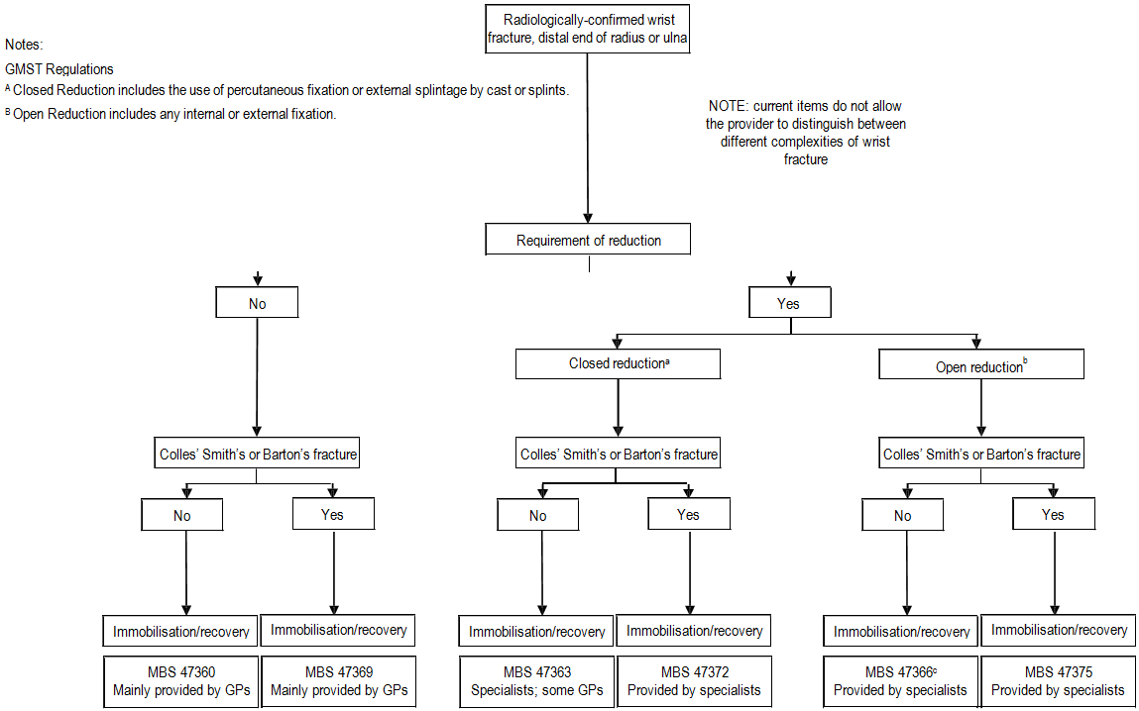

Figure 2b: Clinical management algorithm for a fracture of the wrist, with proposed service

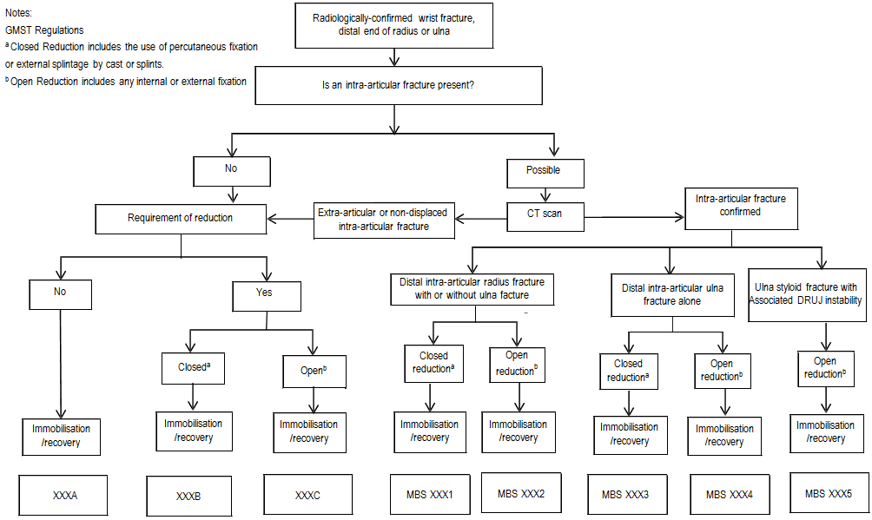

Comparator

The applicant has provided the following six current MBS items as comparator procedures (Table 4). Note that MBS data shows that a majority of services for items 47360, 47369 and to a lesser extent
47363 are performed out of hospital by GPs.

Table 4: Current MBS item descriptors for current and potential comparator procedures

MBS item  Number | MBS listinga | MBS claims (Jun 2010 – Jul 2011)b
47360 | RADIUS OR ULNA, distal end of, treatment of fracture of, by cast immobilisation, not being a service to which item 47363 or 47366 applies  Multiple Services Rule (Anaes.) Fee: $131.85 Benefit: 75% = $98.90% = $112.10 | 13,100
47363 | RADIUS OR ULNA, distal end of, treatment of fracture of, by closed reduction  Multiple Services Rule (Anaes.) Fee: $197.60 Benefit: 75% = $148.20 85% = $168.005 | 1,027
47366 | RADIUS OR ULNA, distal end of, treatment of fracture of, by open reduction  Multiple Services Rule (Anaes.) (Assist.) Fee: $263.00Benefit: 75% = $197.70 85% =  $224.10 | 180
47369 | RADIUS, distal end of, treatment of Colles', Smith's or Barton's fracture of, by cast immobilisation, not being a service to which item 47372 or 47375 applies  Multiple Services Rule (Anaes.) Fee: $169.50 Benefit: 75% = $127.15 85% = $144.10 | 2,335
47372 | RADIUS, distal end of, treatment of Colles', Smith's or Barton's fracture, by closed reduction  Multiple Services Rule (Anaes.) Fee: $282.35 Benefit: 75% = $211.80 85% = $240.00 | 1,339
47375 | RADIUS, distal end of, treatment of Colles', Smith's or Barton's fracture of, by open reduction  Multiple Services Rule (Anaes.) (Assist.) Fee: $376.55 Benefit: 75% = $282.45 | 2,857
MBS: Medicare Benefits Schedule
a MBS fees as of 1 November 2012
b Claims data retrieved June 26 2012 from: https://www.medicareaustralia.gov.au/statistics/mbs_item.shtml

The comparator procedures do not refer to the explicit location of the fractures (that is intra-articular and ulna styloid). Therefore they do not reflect the increase in complexity of the treatment requirement in certain locations, which would involve the use of internal fixation and more detailed imaging, both before and during the procedure. Overall, the comparator is likely to be a simpler fracture repair, utilising less detailed imaging (both pre-and intra-operatively), with possibly less use of devices for internal fixation. The comparator procedure in the presence of distal radioulnar instability would be item 47366 and/or 46345 (distal radioulnar joint, reconstruction or stabilisation of).

In summary there are three clinical comparator procedures:

• Cast immobilisation (no reduction)
• Closed reduction, cast immobilisation
• Open reduction, cast immobilisation

Note: As stated by the applicant, there is no change in clinical approach between current and proposed services. There may be more peri- and post-operative imaging; however, these items are claimed separately to the proposed procedural services. Therefore the comparator services are identical to the proposed services at a clinical and therapeutic level.

Clinical claim

The applicant wishes to bring MBS items for wrist fracture in line with current clinical practice, and to more accurately reflect the more complexity injuries which are not currently included on the MBS. The applicant claims that specific MBS items for intra-articular fracture of the distal radius, distal ulna, and fracture of the ulna styloid, will improve the treatment of these more complex fractures. This will in turn aid in the recovery and the long-term prognosis of the injury. In addition, existing MBS items do not account for the increased complexity of current clinical practice and are ambiguous.

The accurate reduction and stable internal fixation of an intra-articular fracture of the distal radius has been shown in clinical and experimental studies over the past 15 years to significantly improve the outcome and reduce the morbidity following intra-articular fractures. The development of new techniques and implants has, however, made this aim more complex and involved with increased preoperative assessment, increased operating time and skill and more intense post-operative management. This increased effort has led to better outcomes when compared to older more traditional techniques, with fewer complications and hence fewer salvage procedures. The safety when performing these procedures is equivalent to existing procedures.

The clinical benefits expected and reflected in published literature following accurate repair of intra- articular fractures are a more rapid return to work and activities of daily living, reduced risk for subsequent degenerative changes in the joint and the need for salvage surgery and hence lost function. These benefits are most obvious when seen in the target population of young active and productive patients.

Table 5: Classification of an intervention for determination of economic evaluation to be presented
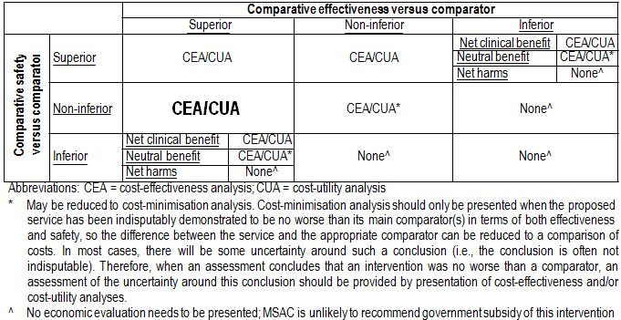

Outcomes and health care resources affected by introduction of proposed intervention

Outcomes

The applicant did not provide specific outcomes. Suggested outcomes are shown below. Primary effectiveness (from Handoll et al 2008):
• Patient functional assessment (including quality of life)
• Grip strength
• Range of movement

Secondary effectiveness:

• Residual soft tissue swelling
• Pain
• Return to work, school or study
• Anatomical outcomes (radiological and imaging outcomes)
• Duration of the surgical procedure
• Resource use (use of fixateur devices, use of radiology or other imaging, use of autologous or synthetic bone grafts, hospital stay, number of outpatient visits, physiotherapy)
• Ligament injury and repair
• Secondary or revision surgery

Adverse events:

Including but not limited to:

• Surgical damage to blood vessels, tendons or nerves
• Long-term pain
• Clicking
• Post-traumatic arthritis
• Residual finger stiffness
• Infection (pin or wire)
• Soft tissue injury or additional fractures from external fixation
• Swelling, dystrophy, vasomotor instability
• Reflex sympathetic dystrophy
• Malunion and loss of reduction

Health care resources

The internal fixation of intra-articular fractures of the distal radius and ulna and extra articular fractures require the use of an assistant to help with exposure, reduction and fixation of these fractures. An anaesthetist and standard theatre nursing staff are required. Because of the complexity of these procedures and the need for accuracy, the use of intra-operative radiology is almost

mandatory. As part of the preoperative assessment of patients with intra-articular fractures a CT scan would usually be required for accurate surgical planning. In the post-operative period it would be at times necessary to use the skills of a qualified hand therapist to assist in the rehabilitation of the hand and wrist after this injury and surgery.

The assessment of an intra-articular fracture and its characterisation is important for preoperative planning to help determine the implant required and the surgical approach. Whilst plain radiographs are adequate for an extra-articular fracture, a CT scan is usually required for accurate assessment and planning for an intra-articular fracture.

The healthcare resources delivered with the comparator are similar for the new procedures with perhaps less reliance on intra-operative radiology. At the moment it is unclear whether the resources required for cast immobilisation and closed reduction is different in the current and proposed settings.

The healthcare resources have been grouped according to the following:

• Comparator 1: Cast immobilisation (no reduction) current
• Comparator 2: Closed reduction current
• Comparator 3: Open reduction current
• Intervention 1: Cast immobilisation (no reduction) proposed
• Intervention 2: Closed reduction proposed
• Intervention 3: Open reduction proposed

Issues to consider in terms of healthcare resources:

• According to the applicant, treatment of intra-articular fractures would involve the addition of a pre-operative CT scan, increased operating, anaesthetic and theatre time, the use of intra- operative radiology, together with perhaps a few more postoperative reviews and slightly longer therapy and rehabilitation. The internal fixation devices are the same as currently used for extra-articular fractures.
• Closed reduction involves the manipulation of the fracture, therefore this procedure requires anaesthesia.
• For the purposes of the assessment, it is acknowledged that the resources used for each comparator procedure is exactly the same as those for the paired intervention. Ligament repair would be undertaken as a separate procedure and is not under review.
• The applicant has advised that internal fixateurs would need to be removed at a rate of approximately 10%, due to infection of if the device rubs against tendons. There would be no difference in this rate between intra- and extra-articular fractures.

Table 6: List of resources to be considered in the economic analysis
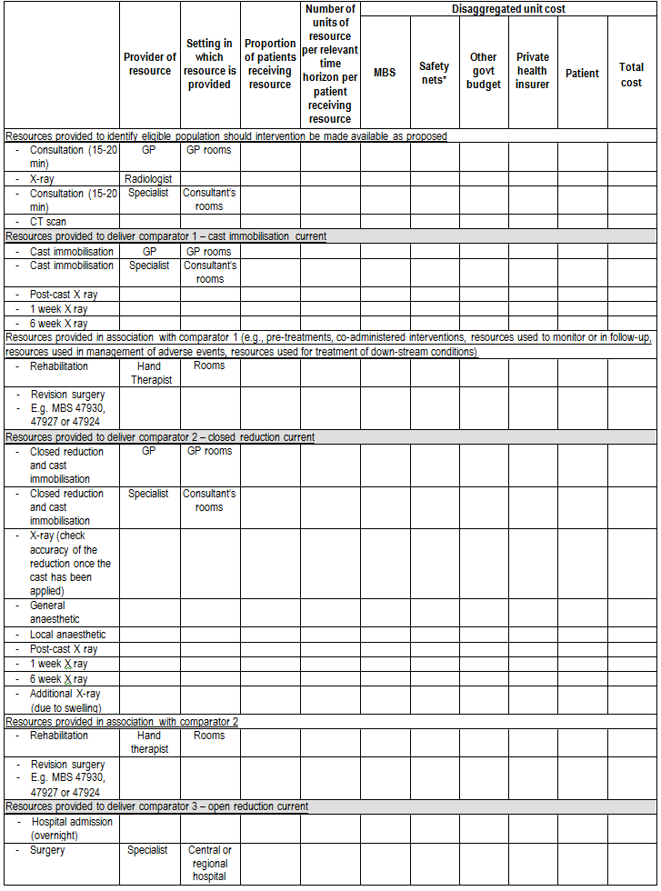

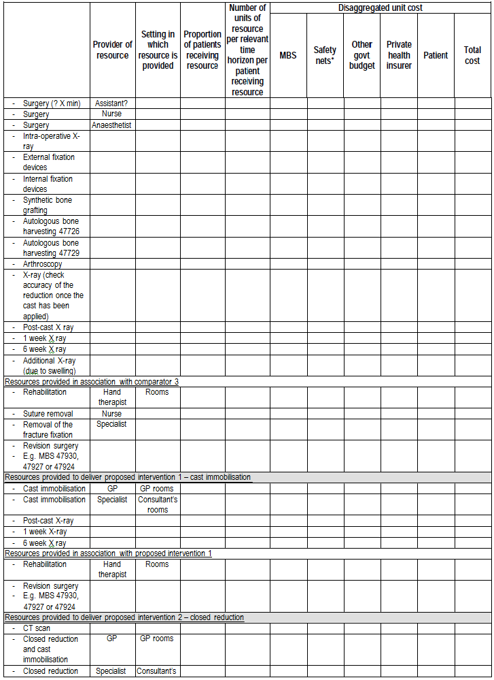

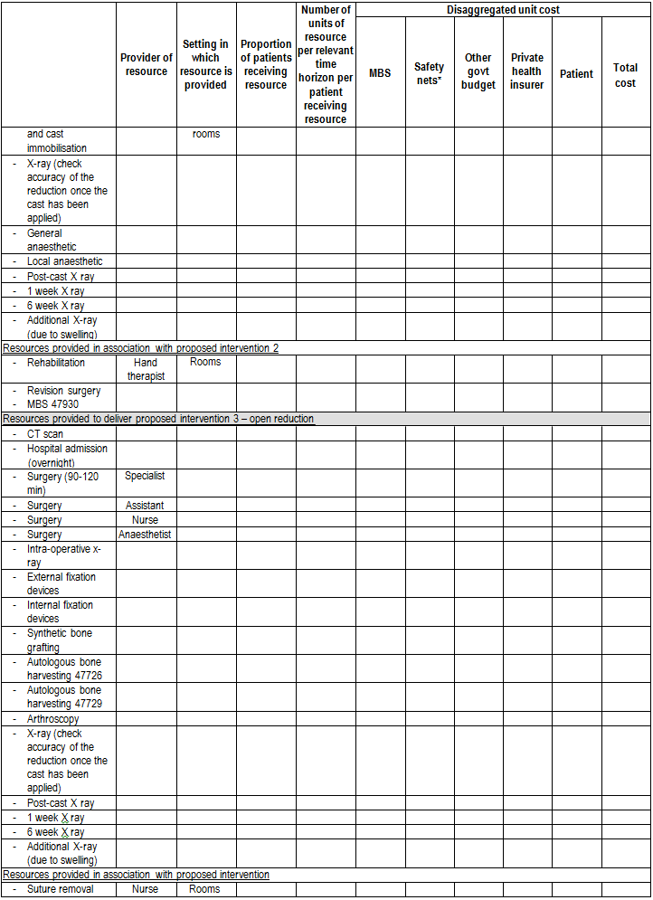

 | Provider of resource | Setting in which resource is provided | Proportion of patients receiving resource | Number of units of  resource per relevant  time  horizon per patient receiving resource | Disaggregated unit cost
 |  |  |  |  | MBS | Safety nets* | Other govt budget | Private health insurer | Patient | Total cost
‐ Rehabilitation | Hand therapist
‐ Removal of the fracture fixation | Specialist
‐ Revision surgery
‐ E.g. MBS 47930,
47927 or 47924

• Clinical input and information from the assessment phase will be required to confirm the proportion of units for the current and proposed procedures.
• Other potentially relevant healthcare resources related to fracture repair such as day theatre usage, attending nursing staff, potential follow-up procedures (plaster casts, analgesics) will be common across paired procedures.

Proposed structure of economic evaluation (decision-analytic)

Due to the wide proposed changes to both new and existing items, there are three PICO tables to account for all interventions and populations of interest (Table 7 to Table 9). Due to the difficulties in accurately defining, both clinically and for the purposes of the review, the specific intervention and comparator these will be kept broad.

There are three clinical procedures as interventions:

• Cast immobilisation (no reduction)
• Closed reduction, cast immobilisation
• Open reduction, cast immobilisation

There are three clinical comparator procedures:

• Cast immobilisation (no reduction)
• Closed reduction, cast immobilisation
• Open reduction, cast immobilisation

Table 7: Suggested summary of extended PICO to define research question that assessment will investigate: cast immobilisation of fracture of the wrist

Patients | Intervention | Comparator | Outcomes to be assessed | Healthcare resources to be considered
Patients with a fracture  of the wrist  Subgroups: Fracture of the distal radius or ulna not involving the joint | Cast immobilisation  (this could be undertaken by a GP or by a specialist, possibly after a CT scan) | Any other intervention.  NB there is likely to be no comparator for this population. | Primary outcomes:  Patient functional assessment (including quality of life)  Grip strength  Range of movement | The healthcare  resources are similar in both current and future situations.

surface  Fracture of the distal radius or ulna involving the joint surface, undisplaced |  |  | Secondary outcomes:  TBC (please see above) Safety outcomes:  All safety issues and  adverse events (please see above).

Table 8: Suggested summary of extended PICO to define research question that assessment will investigate:
closed reduction of fracture of wrist

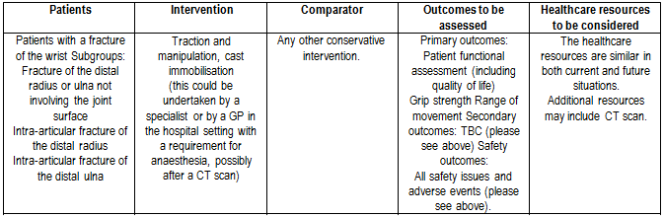

Table 9: Suggested summary of extended PICO to define research question that assessment will investigate: open reduction of fracture of the wrist
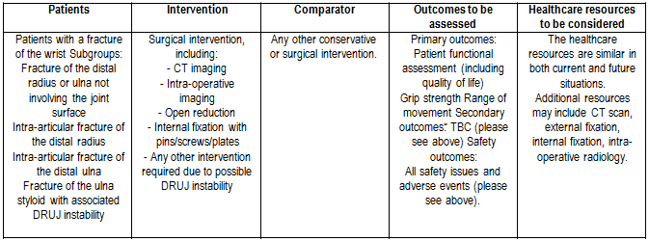

Clinical research questions for public funding:

Due to the variety of wrist fractures and the variety of procedures under investigation, it is proposed to separate the clinical questions according to the complexity of wrist fracture – whether it involves the intra-articular surfaces or the ulna styloid, or if it does not involve the joint surface. The questions should align to the populations as represented in the proposed MBS items.

PASC acknowledges that there may be no comparative evidence for some or all of the following clinical questions. Safety, effectiveness and cost information may only be available in absolute terms, obtained from case series and cohort studies. In this case, the applicability and methodological quality of these level IV studies should be comprehensively explained.

Clinical research questions for wrist fractures, no reduction

a) What is the safety of current clinical practice cast immobilisation compared with alternative methods for fractures of the wrist which do not require reduction?

b) What is the effectiveness of current clinical practice cast immobilisation compared with alternative methods for fractures of the wrist which do not require reduction?

c) What is the cost-effectiveness of current clinical practice cast immobilisation compared with alternative methods for fractures of the wrist which do not require reduction?

Separate for fractures of the distal radius or ulna not involving the joint surface, and fractures of the distal radius or ulna involving the joint surface but undisplaced.

Clinical research questions for wrist fractures, closed reduction

d) What is the safety of current clinical practice closed reduction repair compared with alternative methods for fractures of the wrist?
e) What is the effectiveness of current clinical practice closed reduction repair compared with
alternative methods for fractures of the wrist?
f) What is the cost-effectiveness of current clinical practice closed reduction repair compared with alternative methods for fractures of the wrist?

Separate for fracture of the distal radius or ulna not involving the joint surface; intra-articular fracture of the distal radius with or without ulna; intra-articular fracture of the distal ulna.

Clinical research questions for wrist fractures, open reduction

g) What is the safety of current clinical practice open reduction repair compared with alternative methods for fractures of the wrist?
h) What is the effectiveness of current clinical practice open reduction repair compared with alternative methods for fractures of the wrist?
i) What is the cost-effectiveness of current clinical practice open reduction repair compared with
alternative methods for fractures of the wrist?

Separate for fracture of the distal radius or ulna not involving the joint surface; intra-articular fracture of the distal radius with or without ulna; intra-articular fracture of the distal ulna; fracture of the ulna styloid with associated DRUJ instability.

In terms of fractures of the ulna styloid involving instability of the DRUJ, it is important to establish the relationship between new item XXXX5 and the existing item 46345 which may currently be used where reconstruction or stabilisation of the DRUJ is required.

Decision analytic diagram

The decision analytic diagram(s) need to account for the following variables:

• Whether the fracture is intra-articular or extra-articular

• Whether the fracture involves the distal ulna, the distal radius or the ulna styloid
• Whether the procedure involves no reduction, closed reduction or open reduction
• Whether the procedure involves external fixation, internal fixation, bone graft (autologous or synthetic), detailed CT scan, intra-operative radiology
• All relevant new and existing MBS numbers should be considered, together will all other resources relevant for service provision.

References

Abraham, M. K. and S. Scott (2010). "The emergent evaluation and treatment of hand and wrist injuries." Emerg Med Clin N Am 28: 789-809.

Australian Institute of Health and Welfare 2012. Australia’s health 2012. Australia’s health series no.13. Cat. no. AUS 156. Canberra: AIHW.

Bae, D. S. (2008). "Pediatric distal radius and forearm fractures." J Hand Surg Am 33(10): 1911-1923. Brukner, P. (1998). "Stress fractures of the upper limb." Sports Med 26(6): 415-424.
Chung, K. C. and S. V. Spilson (2001). "The frequency and epidemiology of hand and forearm fractures in the United States." J Hand Surg Am 26A: 908-915.

Handoll, H. H., J. S. Huntley, et al. (2008). "Different methods of external fixation for treating distal radial fractures in adults." Cochrane Database Syst Rev(1): CD006522.

Handoll, H. H. and R. Madhok (2008e). "Conservative interventions for treating distal radial fractures in adults." Cochrane Database Syst Rev(2): CD000314.

Handoll, H. H., R. Madhok, et al. (2006). "Rehabilitation for distal radial fractures in adults." Cochrane
Database Syst Rev(3): CD003324.

Kijima, Y. and S. F. Viegas (2009). "Wrist anatomy and biomechanics." J Hand Surg Am 34A: 1555-
1563.

O'Neill, T. W., C. Cooper, et al. (2001). "Incidence of distal forearm fracture in British men and women." Osteoporosis Int 12: 555-558.

Sanders, K. M., E. Seeman, et al. (1999). "Age- and gender-specific date of fractures in Australia: A
population-based study." Osteoporosis Int 10: 240-247.

Schmittenbecher, P. P. (2005). "What must we respect in articular fractures in childhood?" Injury 36: S-A35-S-A43.

Appendix 1: Information from the MBS

Table 10: Current MBS item descriptors for relevant procedures on the wrist

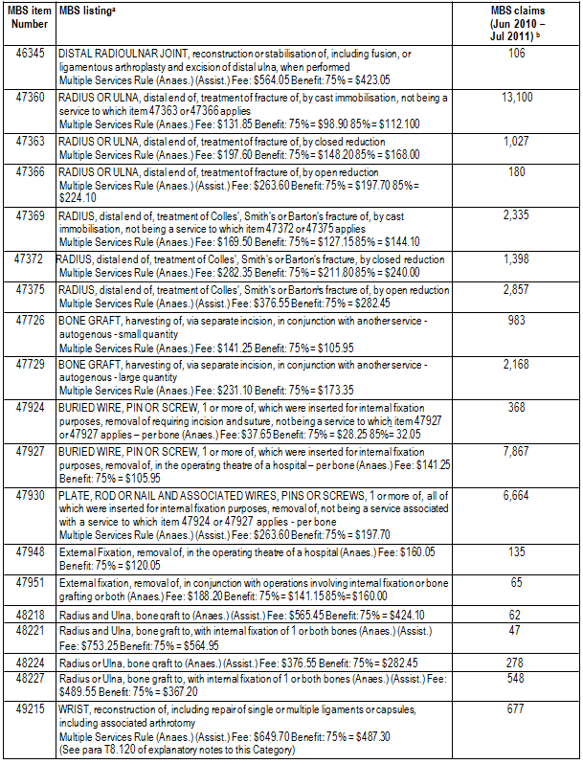

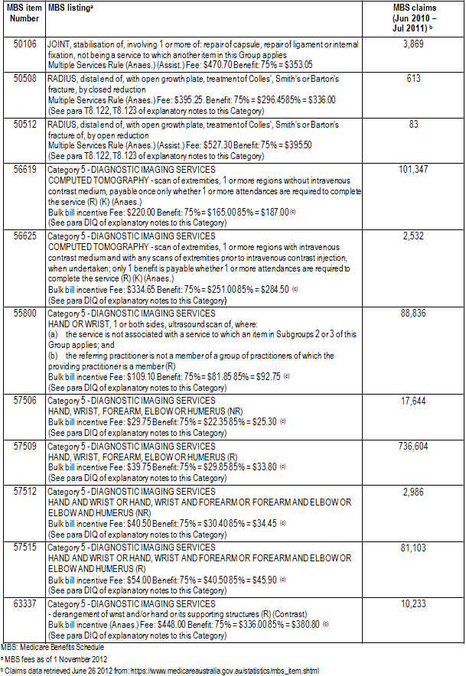
Figure 3: Services for MBS item 47360 in 2010-2011 shown according to age and gender
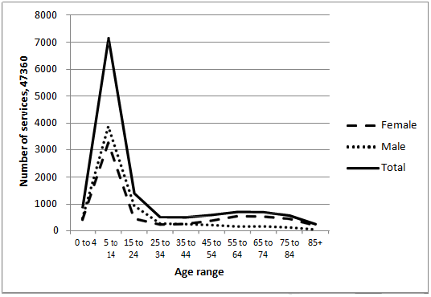

Figure 4: Services for MBS item 47363 in 2010-2011 shown according to age and gender
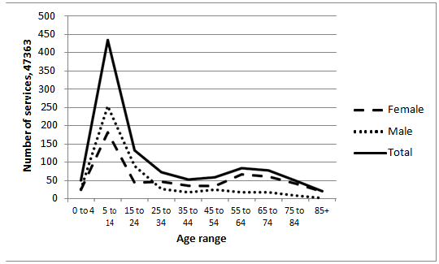

Figure 5: Services for MBS item 47366 in 2010-2011 shown according to age and gender
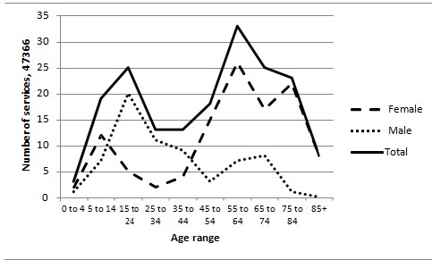

Figure 6: Services for MBS item 47369 in 2010-2011 shown according to age and gender

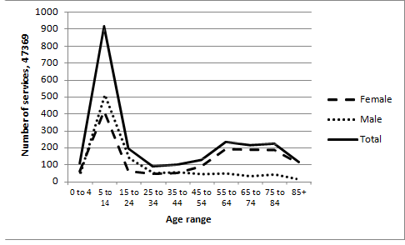

Figure 7: Services for MBS item 47372 in 2010-2011 shown according to age and gender
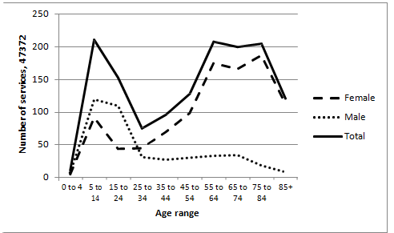

Figure 8: Services for MBS item 47375 in 2010-2011 shown according to age and gender
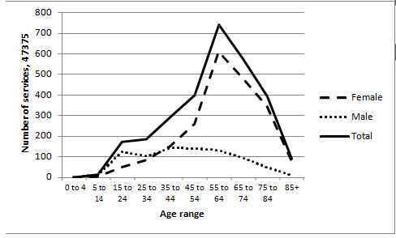

Appendix 2: Information from the AIHW

Table 11: AIHW separation statistics by principal diagnosis, fracture at wrist and hand level (S62)

ICD-10- AM | Description | AIHW separations  2008-09a | AIHW separations  2009-10a
S62 | Fracture at wrist and hand level | 21,301 | 21,796
S62.0 | Fracture of navicular (scaphoid) bone of hand | 1,229 | 1,185
S62.1 | Fracture of other carpal bone(s) | 290 | 301
S62.2 | Fracture of first metacarpal bone | 1,458 | 1,487
S62.3 | Fracture of other metacarpal bone | 6,305 | 6,268
S62.4 | Multiple fractures of metacarpal bones | 525 | 546
S62.5 | Fracture of thumb | 1,899 | 2,001
S62.6 | Fracture of other finger | 9,064 | 9,522
S62.7 | Multiple fractures of fingers | 139 | 140
S62.8 | Fracture of other and unspecified parts of wrist and hand | 392 | 346
AIHW: Australian Institute of Health and Welfare
ICD: International Classification of Diseases
a Separation data retrieved June 26 2012 from: http://www.aihw.gov.au/hospitals-data/

Table 12: AIHW separation statistics by principal diagnosis, fracture of forearm (S52)

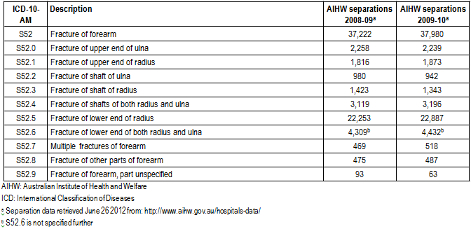

Table 13: AIHW separation statistics by principal diagnosis, fracture of lower end of radius (S52.5)

ICD-10- AM | Description | AIHW separations  2008-09a | AIHW separations  2009-10a
S52.5 | Fracture of lower end of radius | 22,253 | 22,887
S52.50 | Fracture of lower end of radius, unspecified | 7,076 | 7,350
S52.51 | Fracture of lower end of radius with dorsal angulation | 11,392 | 11,782
S52.52 | Fracture of lower end of radius with volar angulation | 1,182 | 1,083
S52.53 | Fracture of lower end of radius with volar angulation and intra-articular fracture | 533 | 540
S52.59 | Other and multiple fractures of lower end of radius | 2,070 | 2,132
AIHW: Australian Institute of Health and Welfare
ICD: International Classification of Diseases
a Separation data retrieved June 26 2012 from: http://www.aihw.gov.au/hospitals-data/

Table 14: AIHW separation statistics by procedure, procedures on musculoskeletal system (XV)

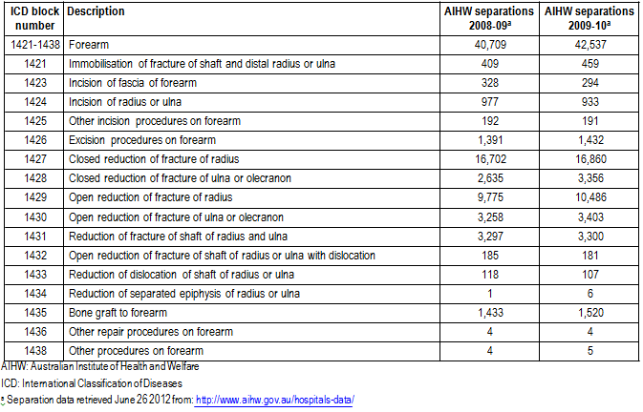

Table 15:AIHW separation statistics by procedure, 1428 closed reduction of fracture of ulna or olecranon

ICD procedure code | Description | AIHW separations  2008-09a | AIHW separations  2009-10a
47363-01 | Closed reduction of fracture of distal ulna | 2,023 | 2,713
47363-03 | Closed reduction of fracture of distal ulna with internal fixation | 131 | 181
47381-01 | Closed reduction of fracture of shaft of ulna | 192 | 170
47381-03 | Closed reduction of fracture of shaft of ulna with internal fixation | 32 | 29
47385-01 | Closed reduction of fracture of shaft of ulna with dislocation | 74 | 61
47385-03 | Closed reduction of fracture of shaft of ulna with dislocation and internal fixation | 10 | 11
47396-00 | Closed reduction of fracture of olecranon | 73 | 88
47396-01 | Closed reduction of fracture of olecranon with internal fixation | 100 | 103
AIHW: Australian Institute of Health and Welfare
ICD: International Classification of Diseases
a Separation data retrieved June 26 2012 from: http://www.aihw.gov.au/hospitals-data/

Table 16: AIHW separation statistics by procedure, 1430 open reduction of fracture of ulna or olecranon

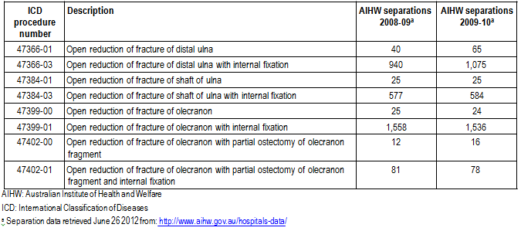
Table 17:AIHW separation statistics by procedure, 1427 closed reduction of fracture of radius

ICD procedure code | Description | AIHW separations  2008-09a | AIHW separations  2009-10a
47363-00 | Closed reduction of fracture of distal radius | 13,557 | 13,892
47363-02 | Closed reduction of fracture of distal radius with internal fixation | 2,280 | 2,058
47381-00 | Closed reduction of fracture of shaft of radius | 435 | 468
47381-02 | Closed reduction of fracture of shaft of radius with internal fixation | 39 | 32
47385-00 | Closed reduction of fracture of shaft of radius with dislocation | 34 | 52
47385-02 | Closed reduction of fracture of shaft of radius with dislocation and internal fixation | 7 | 6
47405-00 | Closed reduction of fracture of radial head or neck | 283 | 284
47405-01 | Closed reduction of fracture of radial head or neck with internal fixation | 67 | 68
AIHW: Australian Institute of Health and Welfare
ICD: International Classification of Diseases
a Separation data retrieved June 26 2012 from: http://www.aihw.gov.au/hospitals-data/

Table 18: AIHW separation statistics by procedure, 1429 open reduction of fracture of radius
